Author1 Name: First M. Last;Author2 Name: First M. Last;Author3 Name: First M. Last;Author4 Name: First M. Last;Author5 Name: First M. Last

FAMU-FSU College of Engineering  2525 Pottsdamer St. Tallahassee, FL. 32310

Team ##: Project Name

8/28/2017

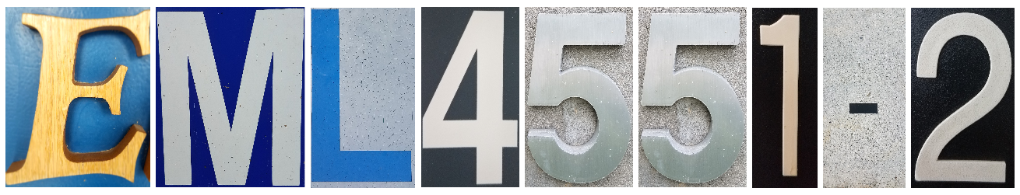

# Abstract

The abstract is a concise statement of the significant contents of your project. The abstract should be one paragraph of between 150 and 500 words. The abstract is not indents.

*Keywords*: list 3 to 5 keywords that describe your project.

# Disclaimer

Your sponsor may require a disclaimer on the report. Especially if it is a government sponsored project or confidential project. If a disclaimer is not required delete this section.

# Acknowledgement

These remarks thanks those that helped you complete your senior design project. Especially those who have sponsored the project, provided mentorship advice, and materials. 4

* Paragraph 1 thank sponsor!
* Paragraph 2 thank advisors.
* Paragraph 3 thank those that provided you materials and resources.
* Paragraph 4 thank anyone else who helped you.

Table of Contents

Abstract ii

Disclaimer iii

Acknowledgement iv

List of Tables vii

List of Figures viii

Notation ix

Chapter One: EML 4551C 1

1.1 Project Scope 1

1.2 Customer Needs 1

1.3 Functional Decomposition 1

1.4 Target Summary 1

1.5 Concept Generation 1

Concept 1. 1

Concept 2. 1

Concept 3. 1

Concept 4. 1

Concept n+1. 1

1.6 Concept Selection 2

1.8 Spring Project Plan 2

Chapter Two: EML 4552C 3

2.1 Spring Plan 3

Project Plan. 3

Build Plan. 3

Appendices 4

Appendix A: Code of Conduct 6

Appendix B: Functional Decomposition 7

Appendix C: Target Catalog 8

Appendix A: APA Headings (delete) 8

Heading 1 is Centered, Boldface, Uppercase and Lowercase Heading 8

Heading 2 is Flush Left, Boldface, Uppercase and Lowercase Heading 8

Heading 3 is indented, boldface lowercase paragraph heading ending with a period. 8

Appendix B Figures and Tables (delete) 9

Flush Left, Boldface, Uppercase and Lowercase 10

References 11

# List of Tables

Table 1 *The Word Table and the Table Number are Normal Font and Flush Left. The Caption is Flush Left, Italicized, Uppercase and Lowercase* 10

# List of Figures

Figure 1. Flush left, normal font settings, sentence case, and ends with a period. 9

# Notation

|  |  |
| --- | --- |
| A17 | Steering Column Angle |
| A27 | Pan Angle |
| A40 | Back Angle |
| A42 | Hip Angle |
| AAA | American Automobile Association |
| AARP | American Association of Retired Persons |
| AHP | Accelerator Heel Point |
| ANOVA | Analysis of Variance |
| AOTA | American Occupational Therapy Association |
| ASA | American Society on Aging |
| BA | Back Angle |
| BOF | Ball of Foot |
| BOFRP | Ball of Foot Reference Point |
| CAD | Computer Aided Design |
| CDC | Centers for Disease Control and Prevention |
| CU-ICAR | Clemson University - International Center for Automotive Research |
| DDI | Driver Death per Involvement Ratio |
| DIT | Driver Involvement per Vehicle Mile Traveled |
| Difference | Difference between the calculated and measured BOFRP to H-point |
| DRR | Death Rate Ratio |
| DRS | Driving Rehabilitation Specialist |
| EMM | Estimated Marginal Means |
| FARS | Fatality Analysis Reporting System |
| FMVSS | Federal Motor Vehicle Safety Standard |
| GES | General Estimates System |
| GHS | Greenville Health System |
| H13 | Steering Wheel Thigh Clearance |
| H17 | Wheel Center to Heel Pont |
| H30 | H-point to accelerator heel point |
| HPD | H-point Design Tool |
| HPM | H-point Machine |
| HPM-II | H-point Machine II |
| HT | H-point Travel |
| HX | H-point to Accelerator Heel Point |
| HZ | H-point to Accelerator Heel Point |
| IIHS | Insurance Institute for Highway Safety |
| L6 | BFRP to Steering Wheel Center |
|  |  |
|  |  |
|  |  |

# Chapter One: EML 4551C

## 1.1 Project Scope

## 1.2 Customer Needs

## 1.3 Functional Decomposition

## 1.4 Target Summary

## 1.5 Concept Generation

### Concept 1.

### Concept 2.

### Concept 3.

### Concept 4.

### Concept n+1.

## 1.6 Concept Selection

## 1.8 Spring Project Plan

# Chapter Two: EML 4552C

## 2.1 Spring Plan

### Project Plan.

### Build Plan.

# Appendices

# Appendix A: Code of Conduct

# Appendix B: Functional Decomposition

# Appendix C: Target Catalog

# Appendix A: APA Headings (delete)

# Heading 1 is Centered, Boldface, Uppercase and Lowercase Heading

## Heading 2 is Flush Left, Boldface, Uppercase and Lowercase Heading

### Heading 3 is indented, boldface lowercase paragraph heading ending with a period.

#### Heading 4 is indented, boldface, italicized, lowercase paragraph heading ending with a period.

##### Heading 5 is indented, italicized, lowercase paragraph heading ending with a period.

See publication manual of the American Psychological Association page 62

# Appendix B Figures and Tables (delete)

The text above the cation always introduces the reference material such as a figure or table. You should never show reference material then present the discussion. You can split the discussion around the reference material, but you should always introduce the reference material in your text first then show the information. If you look at the Figure 1 below the caption has a period after the figure number and is left justified whereas the figure itself is centered.

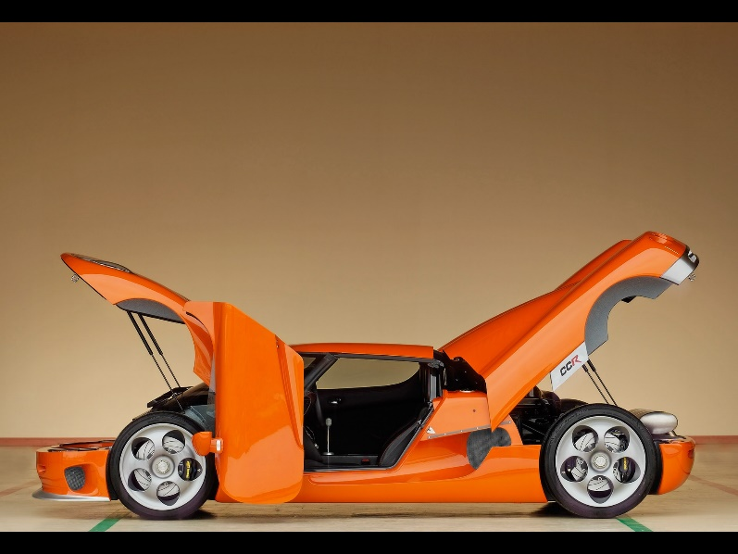

Figure 1. Flush left, normal font settings, sentence case, and ends with a period.

In addition, table captions are placed above the table and have a return after the table number. The second line of the caption provided the description. Note, there is a difference between a return and enter. A return is accomplished with the shortcut key shift + enter. Last, unlike the caption for a figure, a table caption does not end with a period, nor is there a period after the table number.

Table 1  
*The Word Table and the Table Number are Normal Font and Flush Left. The Caption is Flush Left, Italicized, Uppercase and Lowercase*

|  |  |
| --- | --- |
| Level of heading | Format |
| 1 | **Centered, Boldface, Uppercase and Lowercase Heading** |
| 2 | Flush Left, Boldface, Uppercase and Lowercase |
| 3 | Indented, boldface lowercase paragraph heading ending with a period |
| 4 | Indented, boldface, italicized, lowercase paragraph heading ending with a period. |
| 5 | Indented, italicized, lowercase paragraph heading ending with a period. |

# References

**There are no sources in the current document.**