­­­­­­

Author 1: Michael A. Small; Author2: William R. Abraira; Author 3: Robert T. Montuoro; Author 4: Vincent D. Grimes; Author 5: Joesph B. Godio

FAMU-FSU College of Engineering  2525 Pottsdamer St. Tallahassee, FL. 32310

Team 504: The Examination of Occupant and Vehicle Responses to Low Speed Rear-End Crashes

9/18/2018

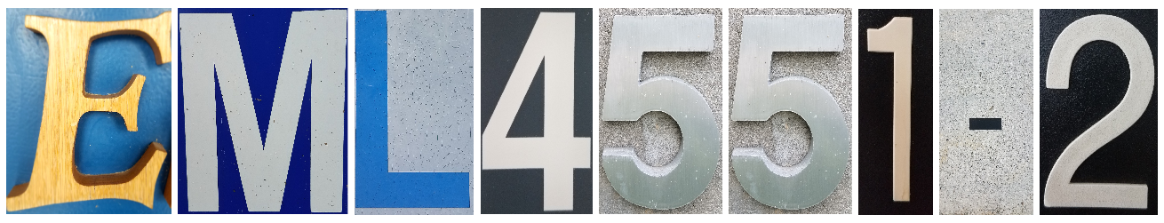

# Abstract

Partnered with Cummings Scientific, our project is to further the knowledge of low speed rear impact collisions. To complete this, we are looking at the relation of the impact forces and injuries of the occupant. At speeds less than 7 mph, the bumper is designed to hold its shape, instead of crumbling like in high-speed collisions. By not deforming, the passenger feels more of the forces that are not absorbed by the bumper. The main goals of the project are to make a model that shows the forces felt by a passenger for a range of low speed collisions and to find a relationship between the driver and car during said event. From live crash testing, we are making a model to show the responses in these collisions. The movements of both the car and the person will be measured, and, with the data interpreted in a computer program, we can see the forces experienced by the car and passenger. This project looks at the effect of bumper structure with repeated testing to explore how our results compare with other known data. After testing, data will be collected and analyzed in a software package that will inspect the impact and determine the forces applied to the cars. Data also looks at how the human body responds; it focuses on whiplash as it is a major physical injury claimed in these types of cases. Our data is used to create an equation that states the forces experienced by the car passengers. The results of this project will be used by medical experts and expert witnesses to support claims that the forces experienced could cause whiplash.

*Keywords*: whiplash, crashes, dynamic, modeling

## Project Scope

### Project Description

The main goal of the project is to find an empirical formula used for calculating the impact velocities based on low speed crashes. The project focuses on furthering the knowledge of low speed rear-end collisions that continues from a previous project done for Cummings Scientific. This process involves further testing of collisions and finding trends and results to test if current models are relevant in low speed crashes.

### Key Goals

The primary goal of the project is to develop a method to calculate forces and velocities of cars collisions at low speed. The process of collecting data involves inspecting the impact of cars and determining the effects of speed through empirical models and analysis using last year’s deliverable. Once completed, our results will help to validate expert witness worth in a law case and further the knowledge of low speed crashes.

A secondary goal is to use the collected data from tests to create a correlation between the reaction of the human body in various low speed collisions. In these types of crashes, the human body can experience a wide variety of effects, most notably whiplash. Using our recorded data, we hope to find how the human body reacts in these crashes.

### Markets

A key market for this project includes plaintiffs and defendants that require technical evidence of damages and injuries from vehicular accidents. Another market for this project is engineering and forensic consulting firms specializing in accident reconstruction, vehicle and passenger response in accidents, and passenger safety in the automotive industry. Our data also has a stake in safety codes that have the potential to change future automotive legislation.

### Assumptions

In this project, many factors are kept constant during testing and processing. Every vehicle tested will have the same height and weight so the impact result of each vehicle will be repeatable. This allows all of our data to model the same collision, such as hitting a compact vehicle versus hitting a semi-truck. Wind resistance is neglected because we will be going at a low enough speed that the drag will be minimal; all testing done will also be in the same weather conditions. Because the testing rig is built, the future crashes can happen within short proximity from starting the project.

### Stakeholders

The individuals who have a direct concern with this design project are: our sponsors, Cummings Scientific, and our advisor, Dr. Shane McConomy. The varying professors that have direct ties to our subject matter including: Dr. Simone Hruda, Dr. Johnathan Clark, and Dr. Patrick Hollis. In addition, other accident reconstruction firms would benefit from the data produced.

## Customer Needs

When first meeting with our sponsor, Cummins Scientific, we asked questions pertaining to the specifications of the project. The questions asked, the response of our sponsor, and our interpretation of his needs are all shown below in the table.

|  |  |  |
| --- | --- | --- |
| Question Asked | Sponsor Response | Interpretation of Need |
| What was the primary goal of last year’s project? | Last year’s project was tasked with creating an interchangeable bumper mount to help in analyzing low speed collisions. | Along with our current project, we are utilizing last team’s product to help with our end goal of collecting more data on low speed crashes. |
| What is the main goal of our project? | The main goal of the project is to add to the number of crashes obtained last year, take damage profiles and estimate the change in velocity during impact. | He wants us to obtain data that can be compared to already known data. This can be obtained by using models or empirical analysis of the crashes and their conditions. |
| What are some of the factors in the low speed equations we are observing? | You will be analyzing the damage profiles and passenger responses to the low speed vehicle collisions. | We need to observe the profiles of multiple crashes and determine a method or trend that relates them all. In the end, there should ideally be a single relationship between the crashes that happen at a similar speed. |
| What is the speed of the cars we are analyzing? | The cars will be moving at approximately 7-10 mph. | All of the crashes will be done at low speeds so background knowledge of this condition should be researched. |
| What resources do we have access to? | We have a test course and basic accelerometers. | Testing can be done in their range, but current equipment, such as the accelerometers, can be updated to take more accurate measurements. |
| What are we supposed to have concluded at the end of the project? | We would like to see a mathematical model and possible trends in the collisions. If possible, find trends for the passengers during collisions. | The end goal is to determine a relationship between low impact collisions and the a body’s response to it. |

## 1.3 Functional Decomposition

In this project, there are two main goals: to develop an empirical model for low speed collisions and to analyze the occupant’s reaction. These components together cover the physical testing and analytical calculations that are needed to draw conclusions. A depiction of the functional decomposition is shown in the figure below.

The analysis of low speed collisions involves two components that work simultaneously to give us the data we desire. For developing the empirical model, the previously obtained data from last year’s model and the current data need to be obtain. Both sets need to work on the same program so they can be processed in a modeling software. The data will be handled in MaDyMo, a dynamics modeling program that will be able to use the accelerometer data and calculate the functional output of testing. Finally, the task is to find trends in the data and compare it to known results. The market for low speed rear-end crashes has not been explored as extensively as high speed crashes, so accurate data is necessary for expanding the knowledge of the field.

In accompaniment to the empirical model, the analyze of the occupant was also tasked. In this case, the passenger needs to be observed, the car dynamics need to be tracked, and the measurements from the trial need to be obtained. The passenger needs to be oriented in a similar way each trial so the movement tracking will all be based on the same testing conditions. The car needs to have a regulated constant speed and the type of car needs to be maintained. These measurements can then be interpreted and distributed.

## Target Summary

Due to our project being primarily experimental, we are not giving a physical deliverable to Cummings Scientific. Because of this, we are more oriented with how we plan to validate a function, or a metric, than we are with finding specific values used to design around, or a target. Last year focused more on targets with the parameters of the interchangeable bumper mount, such as its weight, size, and dimensions. As noted in section **1.3 Functional Decomposition**, the project is broken into two main components: developing an empirical model and analyzing occupant response. Each of the functions are listed below along with the target or metric we are attempting to meet.

|  |  |
| --- | --- |
| Function | Target/Metric |
| Obtain Data from Previous and New Trials | Combine new data and old data in to one empirical formula |
| Track Motion of Occupant | Combine our camera tracking, accelerometer, and speed of cars to create a simulation of what the occupant is experiencing |
| Regulate Speed of Moving Data | Maintain a speed under seven miles per hour |
| Maintain Similar Testing Conditions | Start test with the back axle of the car being hit is 10 meters away from the front axle of the car that is hitting it |
| Obtain Measurements | Transmit data to a laptop in the vehicle in real time |
| Interpret Electronic Data to Physical Meaning | Run our results through MaDyMo to create a simulation of the crash |
| Distribute in an Accessible Format | Reduce our data to as few variables as possible to make our equation easy to understand |

Although the primary functions are listed above, there are certain aspects of experimentation that need to be taken into account. First, the crash testing needs to be handled in a closed track with safety measures taken into place. Even at low speed, safety needs to be a priority because a multitude of things could go wrong, such as the improper loading of the bumper or the failure of a car/the bumper rig. Furthermore, the loading and unloading of the bumper should take place within a finite amount of time. To decrease the intervals between trials and use our time in the best manner, the bumper replacement should run smoothly. Ideally, the change would take place around five minutes so we could have the remainder of time to focus on experimentation. Finally, we will have an ample number of trials so we can find clear trends in the data. Last year tested eleven times, and, because our sole goal is to add to the number of trials, we hope to add at least thirty different runs.

* + 1. **Methods of Validation**

Listed below are each of the functions previously stated and the methods we will use for validation.

** Find Trends in Data**

A method in finding trends in data would be to repeat tests with the same or slightly different testing conditions such as changing the occupant’s orientation or the speed of the moving vehicle. With everything else being fixed, the results should accuratly reflect how the low speed, and solely the low speed, is a factor in rear impact collisions.

** Track Motion of Occupant**

Through attached accelerometers, the occupant’s motion will be tracked into a dynamic modeling program called MaDyMo. To maintain the same testing conditions, the occupant needs to be oriented in a similar way for each trial. The accelerometers will show us how the occupant moves in the crash and to what degree the human body reacts to the impact.

**1.4.1.3 Guide Movement Through Seat**

In conjunction with an occupant’s seating orientation, the seat of the vehicle must be positioned in the same orientation for each trial to ensure constant testing conditions. To assure that impact is guided through the seat, the seat must be secured to the floor of the vehicle.

**1.4.1.4 Align Occupant in Similar Manner**

Like tracking the motion of the occupant, the alignment of the occupant must stay consistent in each trial to maintain the same testing conditions. Whether the occupant sits in an upright position or lays head back on the head-rest, this alignment must be the same for each trial to maintain testing conditions.

**1.4.1.5 Regulate Speed of Moving Vehicle**

Testing will involve two occupants as one of them operates the moving vehicle and the other one sits in the stationary vehicle. Thus, regulating the speed of the moving vehicle will be on the driver. The speed can also be regulated as our desired change in speed is approximately between 5-7 mph and this is tracked from accelerometers attached to the vehicle.

** Maintain Similar Testing Conditions in Tracking the Car**

Using the same vehicles in each trial aids in maintaining testing conditions as different vehicles can change the dynamics of the collision, thus, changing the obtained data. This will be aided by the use of the interchangeable bumper mount. This assures that each impact hits the same place on the bumper and all test conditions with the frontal car remain the same. It is also important to connect the accelerometers to the car at the same position each time which will be checked before each run.

** Distribute in an Accessible Format**

By using the MaDyMo dynamic modeling program, the obtain data can be distributed in an accessible form with the use of animation display, contour and graph plotting, and energy flow analysis.

The conditions we decided upon were based off the guidelines and conditions set by our sponsor and some recommendations by our advisor. With this information our team came up with the values and constants for this project to ensure that the tests are similar each time. The important factors for our project are maintaining a change in velocity between five and seven miles per hour and making it so a test can be quickly performed to maximize the number of tests done in a short amount of time.

Along the course of these project, we will be expected to validate our design and findings. Some things that may be helpful or necessary in this validation would be utilizing data previously performed and calculated for similar, high speed rear-end collisions. This data will be used to compare trends and similarities to our new data in order to synthesize a useable model and so our data can be used in further cases. Another piece of data that will help validate our new findings is the information collected by the previous senior design team that performed this project. This data will not only help improve and increase the amount of trials collected, which will help give us more complete data, but also helps ensure our new findings are consistent with previous findings. Finally, using the same test bumper mount and similar accelerometer configuration as the previous team will help keep findings consistent and ensure our findings do not differ drastically, therefore changing the entire outcome of the task at hand. It is important to note our team will be using the same bumper mount as used before, however, we will be using an updated sensor rig and configuration. These changes have been agreed upon by the group and sponsor in order to improve the results of our data and ease of use of the system.

* + 1. **Mission Critical Targets and Metrics**

One mission critical target is to complete enough tests to create a correlation between our test parameters and the results. This can be done by picking up where last years left off and just improving on the hardware being used. Another mission critical target is to be able to set up or breakdown a test in under five minutes. This is to be done so we can perform as many tests as possible in a short period of time. A mission critical target is to remain classified as a low speed collision. This target is achieved as the maximum change in velocity of the vehicle is 7 mph.

## Concept Generation

Due to our project being primarily experimentation driven, we are producing a final product. However, the project has multiple elements that need to be refined before the project can be conducted. Listed below are the concepts in which we need to evaluate and a table with potential solutions for the problem. Although they are solely rough drafts, the ideas should give us a range of possible ways to better our project.

### Concept 1. How to properly place the sensors on the occupant

|  |
| --- |
| Concept Solution |
| 1. Attach sensors with medical tape |
| 1. Develop harnesses and straps which will be custom fit to the occupant, with sensors attached via hook and loop |
| 1. Develop sensor integrated clothing, such as t-shirt and ballcap |
| 1. Develop harness and strap system with sensors attached via industrial strength glue |
| 1. Develop sensor headwear, like a headband, snuggly tied around the occupant's head |
| 1. Attach sensor to occupant’s forehead with tape |
| 1. Integrate sensors into the occupant’s clothing by using zip ties |
| 1. Integrate sensors into the occupant’s clothing by using hair pins |
| 1. Attach sensors into the occupant’s clothing by using staples |
| 1. Integrate sensors into the occupant’s clothing by sewing |
| 1. Use lasers that are installed in the car as opposed to the accelerometers used in previous trials |
| 1. Instead of worrying about quality of sensor placement, put an abundant amount threaded into the occupant’s clothes so if one is to fall, there would be more to catch the movement |
| 1. Have the occupant wear an external safety mesh, such as a vest or overalls, that already have sensors in the fabric |
| 1. Generate an exoskeleton that has hooks for sensor holding. This can provide the most accurate movement because the exoskeleton wraps around the user’s entire body |
| 1. Install excess pockets on the occupant’s clothing so each sensor can be placed in a pocket |
| 1. Have an Arduino mounted to eliminate vibrations and allow for testing data to be obtained accurately |

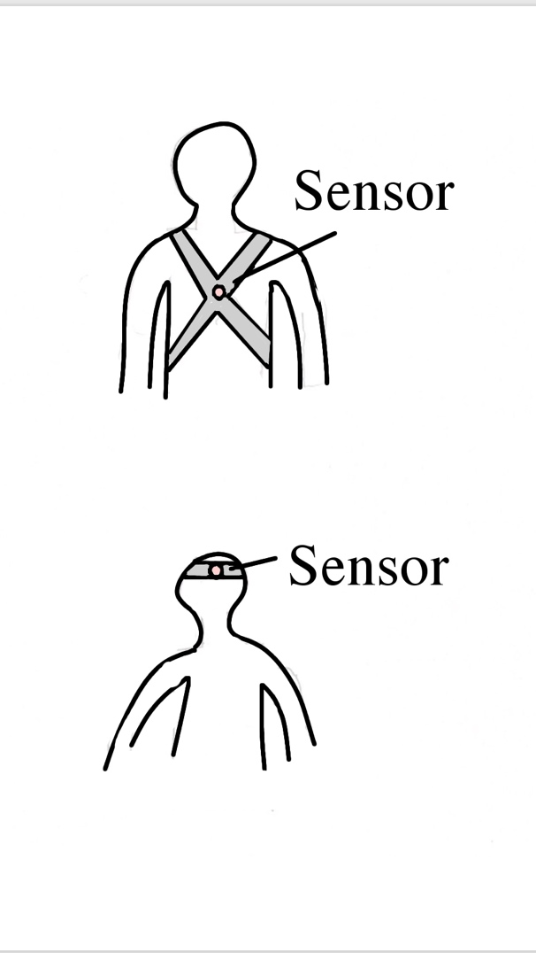

1.4. Letting the occupant have a wearable that encompasses the sensors

By wearing the sensor in such a way, the center of the occupant's body is always regulated. Although this will not measure the occupants head, the sensor position is steady and has little room for error because of its positioning.

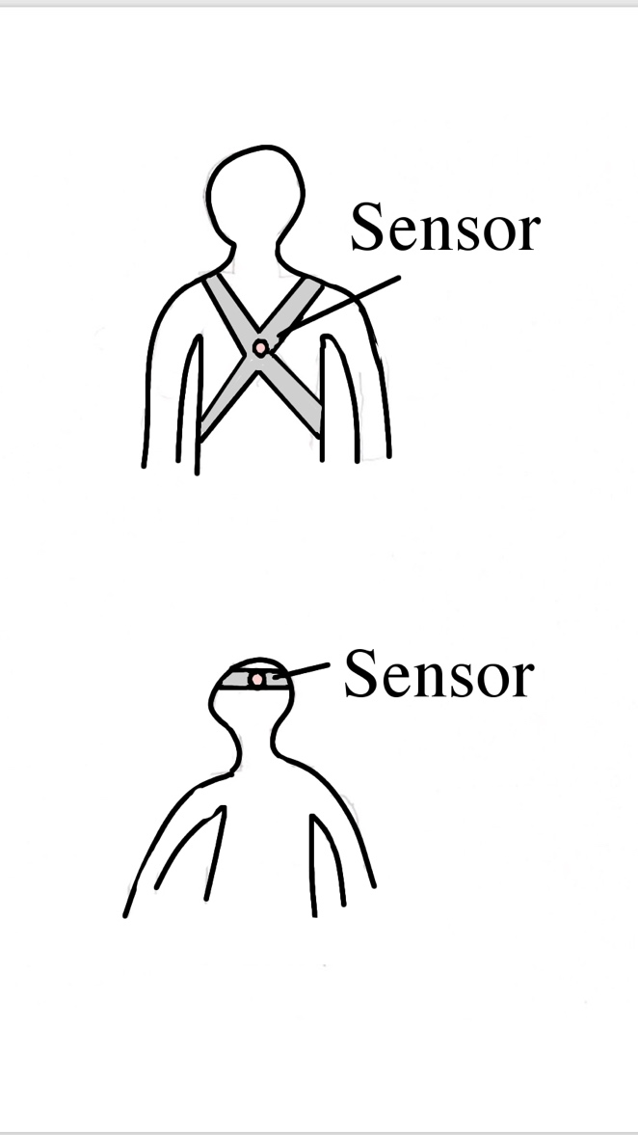

1.5a. Give the occupant a headband that has the sensors inside of it

This method allows the top portion of the occupant’s head to be examined through testing. There is more wiggle room for the sensor to fail due to the single strap that is keeping the sensor in place. This method is a simple way to monitor the head motion of the driver without equipping the driver with an involved strap device.

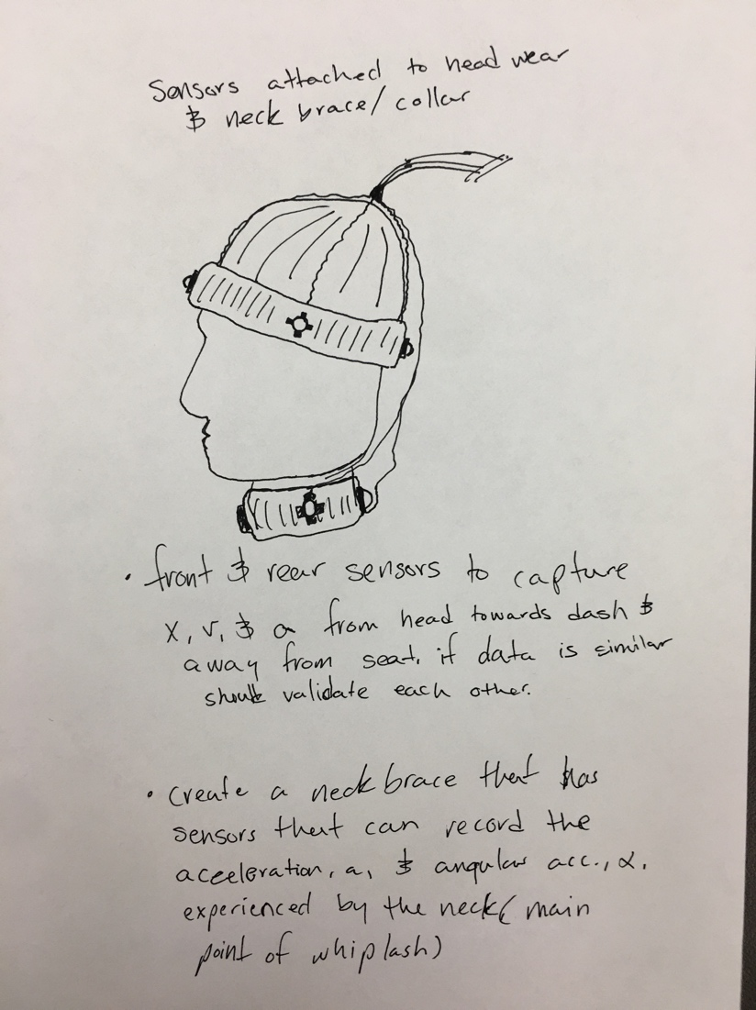

1.5b Headband and collar with various sensors attached.

Similar to what is mentioned above, the drawing in 1.5b incorporates a string of sensors around the occupant's head and neck with wiring around the back of the occupant’s head. This method is an extreme step up from 1.5a, yet the setup of this wearable is much more involved. This way accurate recordings of acceleration on the occupant’s neck can be observed and analyzed.

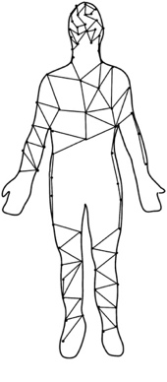  
1.14. The idea of using an exoskeleton type mesh to cover the occupant and analyze the motion of the driver

This exoskeleton is the most accurate yet is the most difficult to execute. This mesh is individual sensors that are positioned at key point on the occupant's body. In order to keep the sensors in place, they are attached in a mesh that the user wears while undergoing the crash. This allows most every point of the occupant’s body to be measured with little room for error.

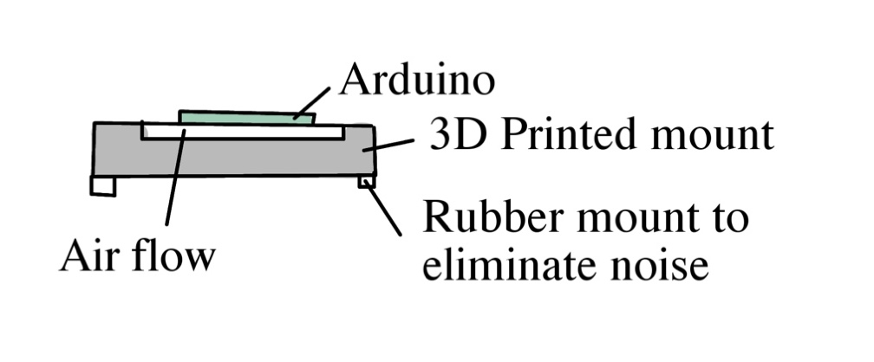

1.16 Use a mounted Arduino to collect the information and eliminate vibrational noise

As opposed to a cardboard mount, the 3D printed mount allows for the Arduino controller to eliminate some experimental error due to noise and vibration.

### Concept 2. How to test if the bumper mount affects the dynamics of the car

|  |
| --- |
| Concept Solution |
| 1. Compare a test results to another test result without using the bumper mount |
| 1. Implement vibration monitoring on the vehicle with and without the bumper mount |
| 1. Measure the kinematics of the vehicle with and without the bumper mount |
| 1. Perform the fishhook maneuver or the swept path analysis to examine the roll stability of the bumper mount |
| 1. Examine vehicle’s shift in weight distribution when braking |
| 1. Perform computer simulated J-turn to examine the effects of pitch rate of the bumper mount |
| 1. Do two sets of tests, one with the bumper mount and one without, and analyze the total results after all experimentation is complete |
| 1. Have a driver take cars with and without the bumper mount installed in an obstacle course to and examine how the driver completes each trial |
| 1. Take each dimension of the car and map the overall measurements of the car; the forces that the car undergoes such as drag effects, frictional effects, and gravitational effects can then be calculated for each car |

The main idea we had to test if the dynamic system changed when the bumper mount was attached was to chalk the trucks tires and apply the brakes, so It is static. Then we would run a test and compare those results to the same test performed with the bumper mount. This will tell us if the bumper changes the dynamics of the car. If there is a difference but it is very consistent we can just filter the noise out and our test would be valid.

### Concept 3. What materials/how to create the camera mount

|  |
| --- |
| Concept Solution |
| 1. Utilize fixed-point mount, with multiple ground points, which attaches to windows and/or windshield of vehicle |
| 1. Utilize gimbal mount stabilizer to maintain camera stability and focus |
| 1. Utilize fixed-point mount which attaches to the dashboard using suction cups |
| 1. Develop a harness and strap fitted to the occupant with a camera integration mount |
| 1. Utilize camera clamps to mount camera onto steering wheel, rear view mirror, or side mirrors |
| 1. Develop a headwear that integrates a camera mount (head strap, hat) |
| 1. Use a bungee cord type mount that attaches to multiple areas of the car which allows the camera to rotate and examine more of the car |
| 1. Develop a very loose, high speed rotational gimbal to attach to the camera which is positioned in the passenger seat and is attached to the windows |
| 1. Install a 360-degree camera that is positioned hanging from the top of the car so the entire car and be recorded during the crash test |
| 1. Have an external camera attached to different points around the car so the outside can be modeled through the crash |
| 1. 3D print a standard camera mount and implement one of the ideas above so the project will be more cost efficient and more money can be allocated elsewhere |
| 1. Use metal bars that attach to the plastic hardware in the car and have them all lead to the camera for maximum stability and durability |

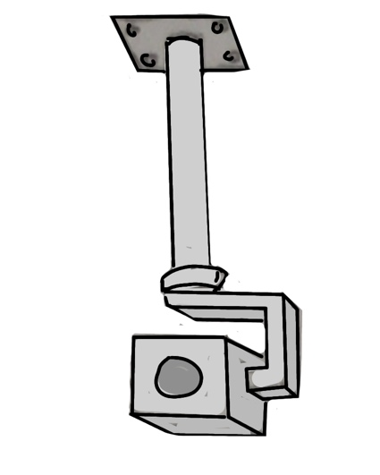

3.2. The idea of using a gimbal to stabilize the camera to track the motion of the driver

Stemming from the roof of the car, the gimbal allows the camera to freely rotate and record the occupant of the car without being disturbed by outside forces. Although relatively expensive, the gimbal helps for accurate monitoring of the car without making extreme renovations to the car.

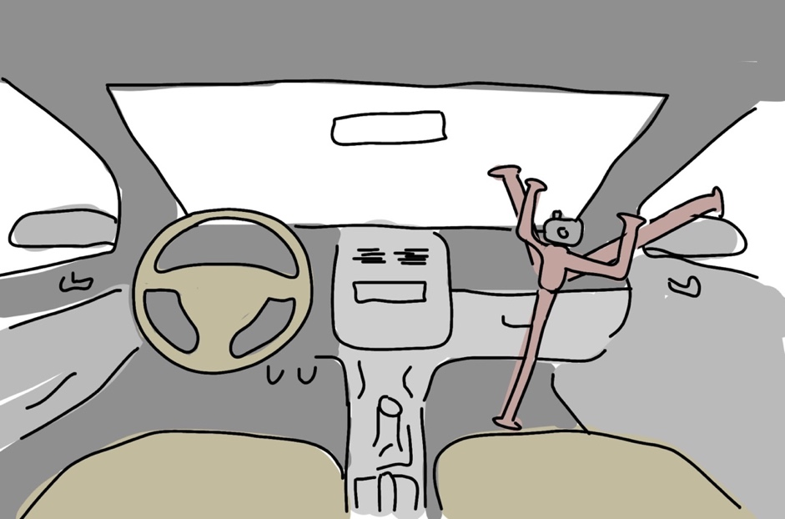

3.12. Incorporate metal bars at the main windows and passenger side floor to hold the camera

Using a more straightforward approach, this concept depicts a camera being mounted by three different locations of the car: the windshield, the passenger side window, and the passenger side floorboard. Although it is susceptible to vibrational disturbance, this approach is easy to execute, cheap, and does not make any modifications to the car.

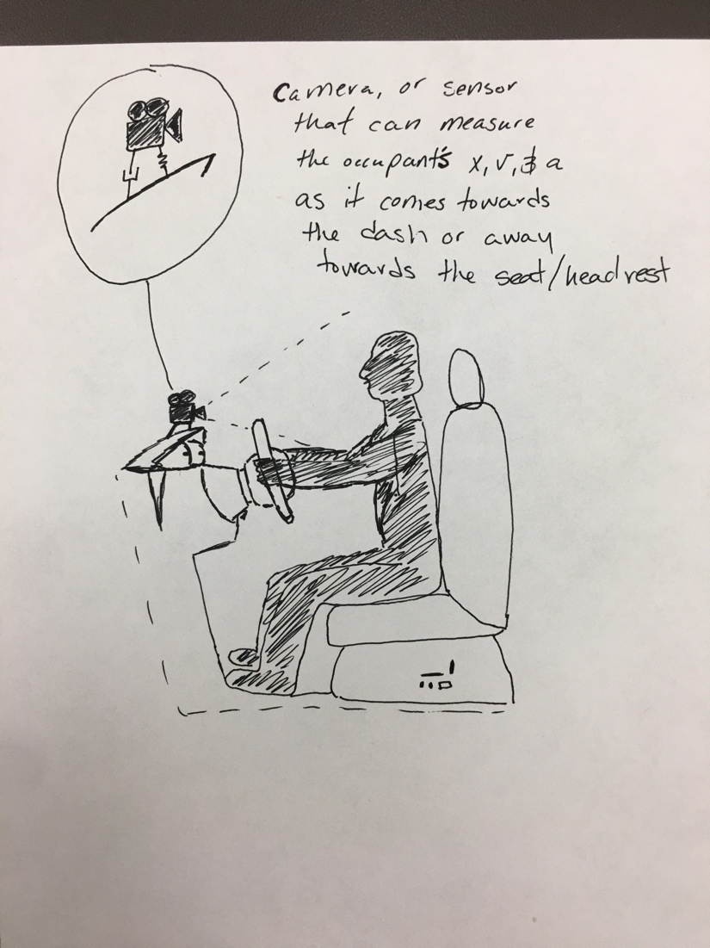

3.12 Sensor mount attached to the dashboard to track occupant motion.

This concept has a camera or sensor attached to the dashboard to record the position, velocity, and acceleration of the occupant during the impact. This design will allow for our team to look back and analyze the how the impact caused dynamic changes to the occupant, and which point was the highest value. The camera being mounted with a damper and spring will allow for vibrational affects to be minimal for the recording process.

### Concept 4. Ways to better the bumper mount so it is easier to maintain/more functional in our experimentation

|  |
| --- |
| Concept Solution |
| 1. Make the mount out of lighter material so the excess weight is not added to the car |
| 1. Allow the bumper to protrude less from the rear of the car so the dynamics model is more similar to that of a regular car |
| 1. Use less pieces when fabricating the bumper mount so more can be created to test multiple cars at the same time |

### Concept 5. How to maintain the same testing conditions

|  |
| --- |
| Concept Solution |
| 1. Establish consistent starting points for vehicle being driven and vehicle being rear-ended |
| 1. Establish “crash-zone guide” using spray paint or tape, on the ground to ensure vehicle collisions are at the same location on vehicle |
| 1. Create a speedometer guide/cutout to ensure driver of crash vehicle is maintaining established speed conditions |
| 1. Create a passenger guide to ensure the initial testing conditions (specified clothing, same passengers, seating alignment) |
| 1. Use the same vehicles in each test |
| 1. Establish consistent sensor conditions (position, attachment to occupant) |
| 1. Take images of each test before and after to see where the car began and where the car finished testing |
| 1. Use laser sensors to accurately line up the cars and testing conditions |
| 1. Conduct all the tests on the same day/weekend to ensure that weather conditions do not affect the conclusions of the tests |
| 1. Conduct tests in a sealed testing location to ensure that weather or environmental factors do not affect the tests |
| 1. Account for the gas lost in each test by ensuring the car is at the same gas level at the beginning of each trial |
| 1. Regulate the same test driver and ensure the items in the car do not come and go as to ensure the weight of each test is the same |
| 1. Monitor the tire pressure and tire tread to ensure each test only relies on the speed of the car |
| 1. Testing on either the pavement or dirt must be maintained in every test |

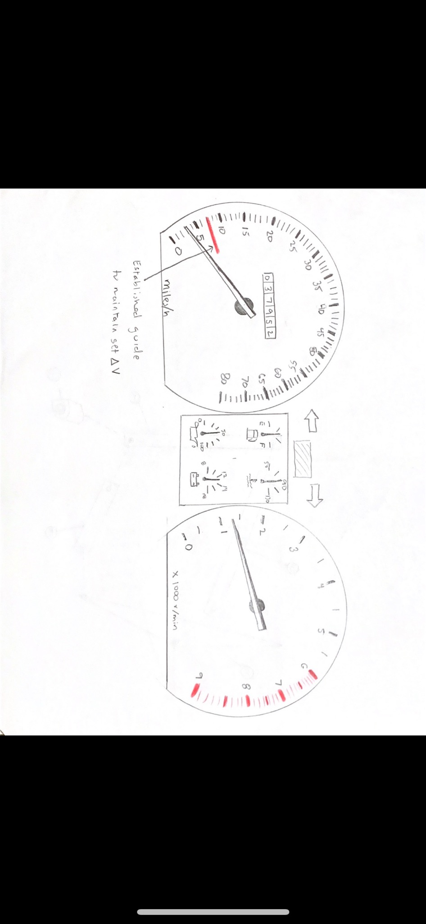

5.3 Create a physical guide to ensure the speed is within the required range

This idea, however simple, will still be a smart and easy way to assure the driver of crash vehicle will maintain an established speed when collision occurs. The guide/marker may also be substituted with a cutout, in order to eliminate any accidental speeds above, or below the set delta V.

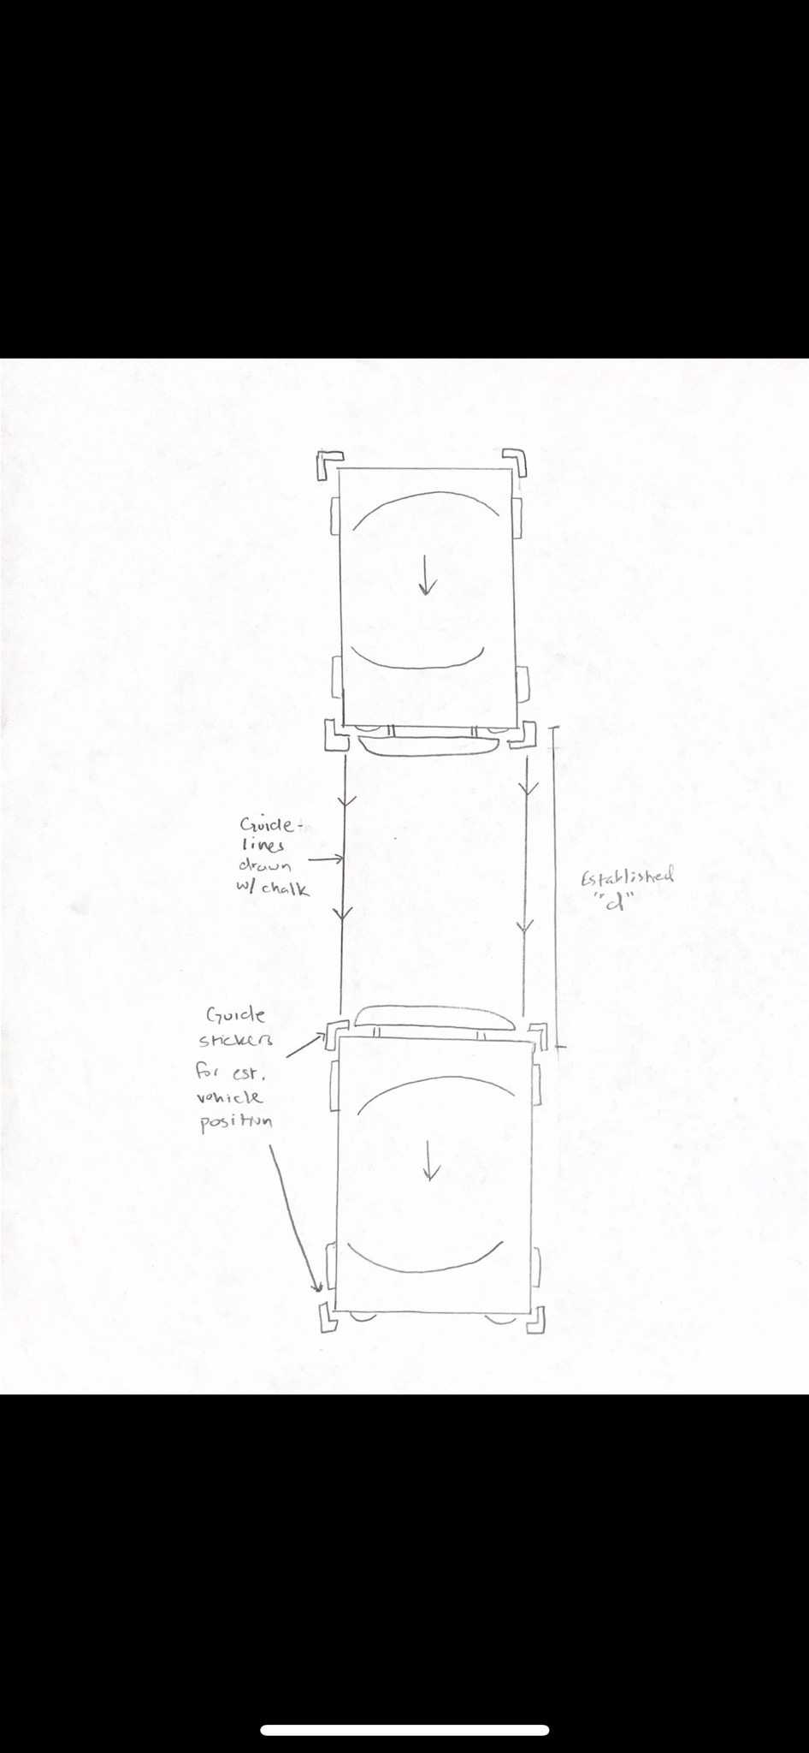

5.7/8 Allow the test course to have physical boundaries and starting conditions

This concept design will utilize tape and/or sidewalk chalk to establish a pre-determined start and endpoint for each vehicle during testing. Once a set distance is chosen, each vehicle will be boxed in using tape and chalk will be used to draw guidelines to ensure both vehicles are colliding at the same spot each time a test is run.

## Concept Selection

After developing the concepts in section 1.5, the concept selection was done to weigh our top concepts against each other and develop a solution to our proposed design problems. From the tables above in **1.5 Concept Generation**, we have five unique problems in experimentation that we need to work towards finding solutions. Because Concept 3. is the only idea that involves us crafting/building a unique device, we will be discussing how we went about solving that problem with a House of Quality, Pugh Chart, and Analytical Hierarchy Process. Although the other concepts were important in experimentation, our thought process on our final designs and reasonings behind it will be noted later in the section.

### 1.6.1 Camera Mount

To begin with the decision-making product, we first needed to meet with our sponsor, Beau Biller of Cummings Scientific, to find their requirements for the camera mount. Beau stated that the mount should be positioned in the car, should not obstruct the view of the driver, should provide accurate footage that is not affected by the vibrations of the car or the resultant crash, should be relatively small and should not involve complete renovations to the car.

From his descriptions, our interpreted customer needs were given to the table. In accompaniment with the customer needs, the engineering characteristics that pertained to the mount were determined. The main factors that had to go into designing the mount were the weight of the mount, the size, the orientation and how it faced the occupant, the durability of the mount through testing, the install time, the probability of it failing, and the mount rigidity.

Given the engineering characteristics we were able to quantify how the customer requirements pertained to the aforementioned characteristics. As shown in the figure, each requirement was compared to the characteristics and a value was assigned to present how relevant they two traits were. A breakdown of our interpretation is seen in the graph. Once the logistics were designed, the relative weights were determined, and the overall rank order was found; we calculated that the most important values were the probability of the mount failure, the weight, and the size.

The House of Quality used to find how the customer requirements compare to the engineering characteristics

After the engineering characteristics and weights were determined, the top five characteristics were then compared to our top five concepts for the camera mount. As seen in the table below, our concepts from left to right (1 to 5) were roof mounted gimbal, fixed three arm mount, the sensor attached to the dash cam, the headband mount, and the suction cup windshield mount, which we chose as the datum. Compared to the suction cup mount, the other concepts were given pluses, minuses, or left blank to present how they compared to the datum. The results are shown below.

The initial Pugh Chart used to compare our generated concepts

After the initial ranking was done, a secondary Pugh Chart was made to compare the top three designs: the roof mounted gimbal, the sensor attached to the dash cam, and the headband mount, respectively. The new datum of the gimbal was ranked against the other concepts and the results are shown in the table below.

The secondary Pugh Chart used to further separate our concepts

When analyzing the results, it appeared that every concept had positives and negatives in different areas. Although each design seemed to fair even, our final camera mount design chosen was the roof mounted gimbal. The gimbal required a little more installation process than the dash cam and headband mounts, but it overall proved to be easy to maintain, allowed accurate recording because neglected the vibrations of the car, and is non-obtrusive to the occupant.

The Analytical Hierarchy Process (AHP) is an effective tool in handling complex decision making with an analytical method that works alongside logic or “gut”. This process reduces complex design decisions into series of pairwise comparisons and then analyzing the results. In addition, AHP provides a useful technique in checking consistency on decision making and reducing the bias within the process. The initial step into the pairwise comparison process involves choosing a hierarchy of selection criteria based on upon design characteristics. Since our design problem involves creating a camera mounting device, the determined design criteria are: weight, size, orientation, durability, install time, probability of mount failure, and material rigidity. By comparing these criteria with each other it establishes a weighted matrix that indicates ranking options of solutions to our proposed design problems. As pairwise comparisons are performed, inconsistencies may arise. Consistency checks are examined alongside pairwise comparisons to reduce biases of the decision maker. The two tables below show the final ranking of our design selection criteria which results in a final design alternative that secures the camera mount onto the dashboard. As this is an extended process, solutions to the AHP are in Appendix B.

In the table below, the final three concepts were analyzed to ensure that our decision had evidence to back up our claims as it being superior. Each of the concepts was ranked with the selection criteria and the overall weights of the characteristics were determined.

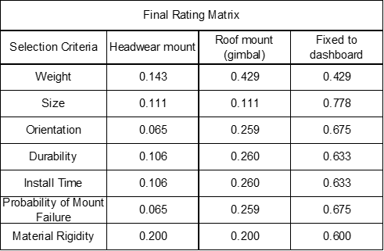

The Analytical Hierarchy Process which was used to calculate the weight of the selection criteria

After the weights were determined, the overall alternative value was concluded and shown in the table below. With our calculations, the headwear mount was given a value of 0.099, the roof mounted gimbal was given 0.262, and the camera fixed to the dashboard was 0.640. Although the dashboard camera had its perks and was titled as the best alternative, we decided to continue with the roof mounted gimbal; this was primarily done because the gimbal is free of the vibrational effects of the car and can provide the most accurate footage. Although the fixed to dashboard camera was considered, we believed our intuition of using the roof mounted gimbal would prove to have a better result than the dashboard mounted camera.

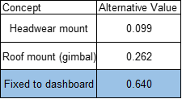

The outcomes of the AHP table

### 1.6.2 How to properly place the sensors on the occupant

Associated to data collection, sensors are needed to track the responsive motion of the occupant from the impact of the crash. Brainstormed in concept generation, tracking the occupant’s motion could be done so by attaching sensors to the occupant. A potential solution could be the headwear mount shown in Figures 1.5a and 1.5b as it depicts how it would be worn by our test driver. This concept was designed to measure the position, velocity, and acceleration of the occupant’s head during and after the crash. The idea seemed sound but following our analysis it was deemed as not the best fit for our project. The sensors would measure all the desired variables but would also have too much noise, since they would be measuring these variables with respect to the occupant’s body and not the car. We decided that this flaw is critical to our project since it would give us skewed values and we would rather measure the occupant’s position, velocity, and acceleration with respect to the ground and car. It is at this point we realized that the gimbal would be the better design than the headwear mount. The gimbal design is considered a better design as it has a more accurate monitoring system and reduces disturbances from the occupant response. This design requires little to no renovation to install into the vehicle. However, the cost of this design is more expensive. Another concept generated consisted of integrating the sensors into the occupant’s clothing via clips, harness and straps, and zip-ties. But this method may provide inaccurate results as the sensors are susceptible additive motion from the occupant’s motion. The last general concept brainstormed involved mounting the sensors onto the dashboard. Being placed here reduces interference with the occupant but increases the chance of inaccurate results as the collision may cause vibration. In all, the gimbal design provides the most accurate results at a cost.

### 1.6.3 How to test if the bumper mount affects the dynamics of the car

If budget and time was no issue, an easy way to test the mount is to have multiple cars at our disposable, install the mount on a majority of the cars, and do rear end crash testing on the bumper at low and high speeds. With this knowledge, we can analyze the data and see if the bumper has any true affect on the cars.

Because of those limitations, our testing will have to be simple low speed tests with and without the bumper. Taking the car accelerometer data along with the occupant data, we can conclude if the bumper mount affects the results of low speed tests.

### 1.6.4 Ways to better the bumper mount

Because last year’s primary goal was to create the bumper mount, this year’s team has no current plans to change the mount. When testing begins, if the team finds certain aspects of the bumpers mount that we feel can be changed to better our results, we will perform tests and consult with our advisor/sponsor to determine if the alterations should be made.

### 1.6.5 How to maintain the same testing conditions

Maintaining consistent and predetermined test conditions is a beneficial step in the concept selection process and will yield more consistent and reliable results from testing. Many of the ideas and concepts in this section will be utilized to help maintain desired conditions. We will establish a set start zone and crash zone for the vehicles being used. This will be done using tape or stickers, “boxing” in each vehicle at a distance of 40 feet, as shown in figure 5.7/8. Spray paint, or sidewalk chalk will be used to draw guidelines to help the driver of the crash vehicle maintain a consistent track and crash point for each test. We will also use a template to create a guide for the speedometer of the crash vehicle to ensure the driver maintains a consistent impact speed, as shown in figure 5.3. The driver and monitoring equipment of the vehicle being rear-ended will be checked and, if needed, reset or adjusted, to ensure proper and consistent conditions are maintained. The test location will be at Dr. Cummings Property, and will be outside, on a paved driveway. This eliminates using an indoor, or sealed test location, however, we will monitor weather during testing and ensure it does not change. This will be the only test location used, unless any unforeseen circumstances would necessitate a change.

# Appendix A: Code of Conduct

## Mission Statement

Our mission as a team is to work professionally and efficiently to provide the best product possible. We hope to provide our sponsoring company, Cummings Scientific, with equations and models that accurately analyze low speed crashes as set forth in the project description. In order to meet the needs specified by Cummings Scientific and our sponsor, Beau Biller, we will work in close accord with him and our advisor, Shane McConomy.

## Team Roles

Vincent Grimes: Project Manager

Michael Small: Timeline Lead

Robert “Todd” Montuoro: Design Engineer

Joseph Godio: Model Manager

William Abraira: Financial Overseer

The project manager is in charge of overseeing the project in its entirety. This individual helps serve as a leader that speaks in emails, gathers the information for the meeting, and works with the timeline lead to ensure the project is running smoothly. If any internal problems arise in the group, the project manager helps to settle disputes in a calm demeanor whether it is with group members or the sponsor/advisors.

The timeline lead is in charge of tasks pertaining to the flow of the project. This member will focus on the Gantt Chart and specifically making sure each assignment is done in a timely manner. Aside from group tasks, he will see that meetings are scheduled so that the group and the sponsor/advisor are routinely updated on all group activities.

The design engineer is tasked with developing the certain formulas to mirror the data in low speed crashes. He is in charge of creating a basis of experimentation that will be further used to increase the knowledge of low speed crashes. The design engineer is familiar with various CAD programs and can use them effectively for the task at hand.

The model manager helps to simulate low speed crashes and predict how the real-life tests will unravel. With an understanding of different CAD programs and simulation softwares, the model manager will produce and run accurate models that can translate to real-life work. Working closely with the design engineer, the two will help with the understanding of the engineering behind the project.

The Financial Overseer works with the monetary aspect of the project. He manages the flow of money whether it means the receiving or spending on the materials for the project. With help from the other members, this individual will make all the final purchases and will help with the receiving of goods on time and ensure that the project is fiscally responsible.

Every task given will be allocated in a certain department, whether it be related to the timeline, design, project, model, or financial aspects. In order to complete the task effectively and efficiently, the lead in each department will then delegate tasks to other team members evenly. Although each team member is a leader in a specific role, every member will assist in each aspect of the project.

## Communication

In order to talk between members, a combination of phone calls between each other and group messaging will be used to be in direct contact with each other. Messages sent within the group message must be acknowledged by all members, so that everyone can be on the same page and know what is going on. For sharing files and varying types of computer documents, email will be used with every member of the group being carbon copied (CC) to the document using their respective FSU email account. If a file is too large to be sent through email, a Dropbox will be used to disperse the information. When speaking to sponsors and advisors, an email chain will be used which includes every group member and Dr. McConomy. Each group member will be responsible for checking his email regularly for updates regarding the team or project.

In order to ensure the message is seen by all members, each group member is required to respond within 24 hours after the receiving of the message. If a group member fails to recognize the email within that time frame, he will be asked to respond to the email by the initial sender. Time conflicts will be managed internally by the group. If a member is unable to respond for emergency reasons, then he will report to the group as soon as time allows. In the case that further conflict exists which cannot be resolved by the group members, Dr. McConomy will be addressed.

In companionship with technological means, the team with have a weekly meeting that occurs Thursday. Extending from the Senior Design time slot of 2:00PM to 6:00PM, the meeting may exceed time and continue until all members agree to disband. There will also be occasional meetings occurring any weekday after 5:00PM. These will help to plan future meetings and will act as a benchmark to see where each team member is in his own respective task. If the team feels that additional meetings need to be scheduled, they will work together to plan an appropriate time and date that works for all teammates.

## Dress Code

For weekly team meetings, casual wear is acceptable. Business casual attire is to be worn for all sponsor and advisor interactions whereas formal attire is to be worn for presentations. Unless otherwise stated 24 hours prior to assembly, all members will abide by the rules set in the **Dress Code** section. The attire is subject to change based on what type of meeting, whether it is deemed casual or professional.

## Attendance Policy

Attendance is mandatory to all group meetings unless the group is given warning 24 hours prior to the assembly. If a meeting is missed, the member will be updated on what was discussed at his earliest convenience by either the text message group or by email. Similarly, attendance is mandatory to all sponsor and advisor meetings. If a meeting is to be missed for an emergency, the group member will contact the others as soon as possible. In case of a problem persisting, Dr. McConomy will have the final say on a group problem. Attendance will be kept electronically in a group word document alongside written in the Timeline Lead’s notebook. In case problems arise, the members can refer to the document and notebook about attendance issues.

## Statement of Understanding

Each group member is aware of the group’s task at hand and the policies laid out in the project charter. Every group member is to follow the project charter and be responsible with his set assigned tasks. In addition, all members will adhere to future changes in the charter and will work as a cohesive unit to find a solution to their task at hand. By signing below, each group member recognizes his responsibilities as a team player and agrees to adhere to the Code of Conduct at all times.

x (Joseph Godio)

x (Michael Small)

x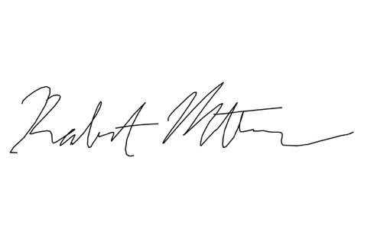(Robert Montuoro)

x(Vincent Grimes)

x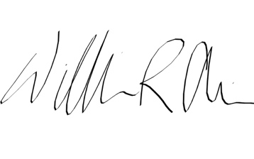 (William Abraira)

# Appendix B: Functional Decomposition

# Appendix C: Target Catalog

|  |  |
| --- | --- |
| Sub-Systems and Respective Metric Value | |
| Sub-System | Metric |
| Number of Previous Trials | 11 |
| Number of Trials | 30 |
| Time for Bumper to be Replaced | 5 min |
| Starting Distance Between Cars (Back Tire of Front Car to Front Tire of Back Car) | 10 m |
| Speed of Front Car (Stationary) | 0 mph |
| Speed of Back Car | 5-7 mph |
| Number of Accelerometers on Occupant | 3 |
| Price of Single Accelerometer | $50 |
| Number of Bumpers | 30 |
| Price of Single Bumper | $20 |

|  |  |
| --- | --- |
| Functional Questions and Answers | |
| Question | Y/N |
| Will all the tests be conducted in the same day? | N |
| Is the representative, Beau Biller, going to be the driver in the trials? | Y |
| Is the processing software, MaDyMo, easily available? | Y |
| Will the data be compared to other low speed test results? | Y |
| Will the data be compared to high speed test results? | Y |

# Appendix D Figures and Tables

**Criteria Comparison matrix[C]**

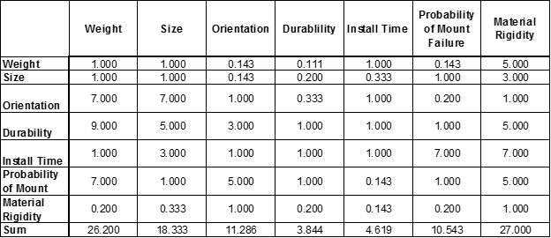**Normalized Criteria Comparison Matrix [NormC]**

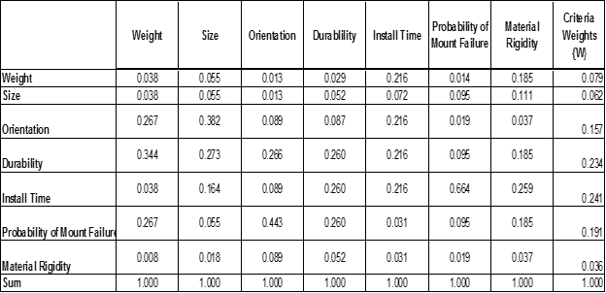**Consistency Check**

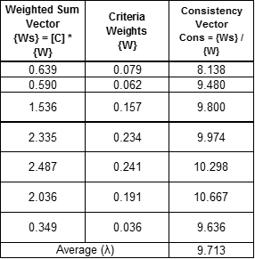

**Consistent Comparison**

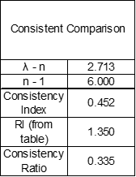

**Design Alternatives AHP**

**Weight Comparison**

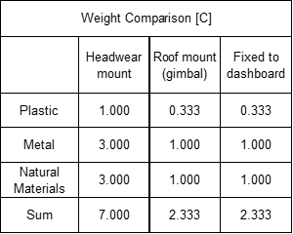

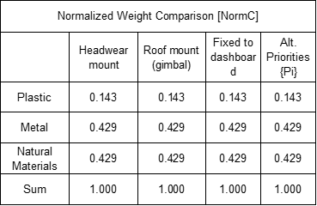

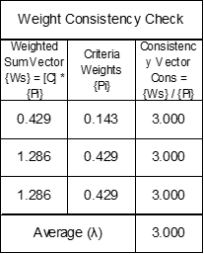

**Size comparison**

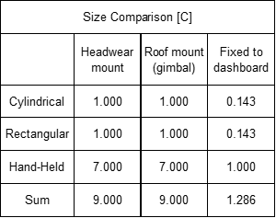

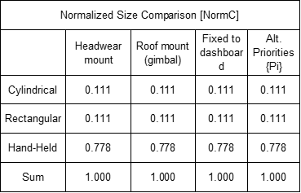

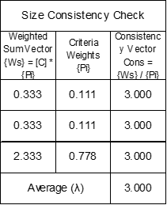

**Orientation Comparison**

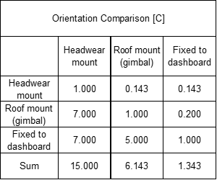

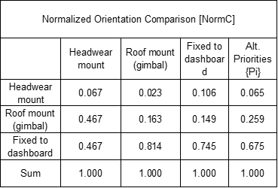

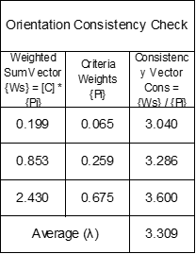

**Durability Comparison**

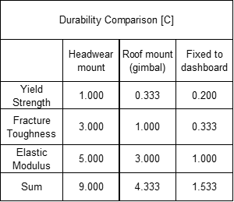

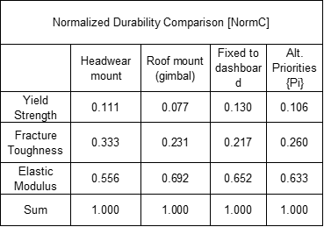

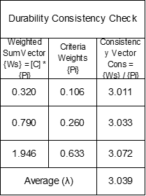

**Install Time Comparison**

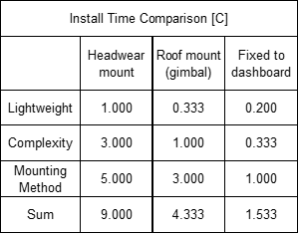

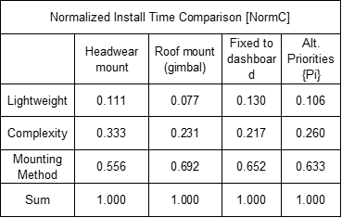

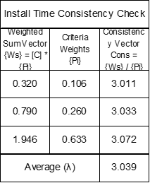

**Probability of Mount Failure Comparison**

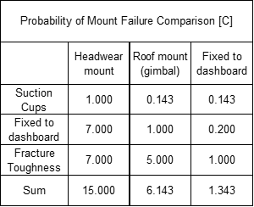

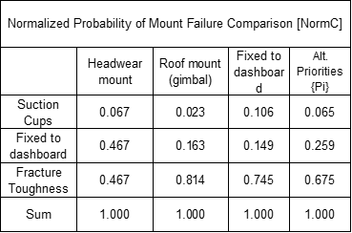

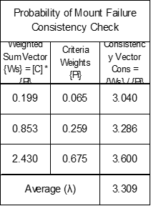

**Material Rigidity Comparison**

