## 1.7 Spring Project Plan

**Task Table**

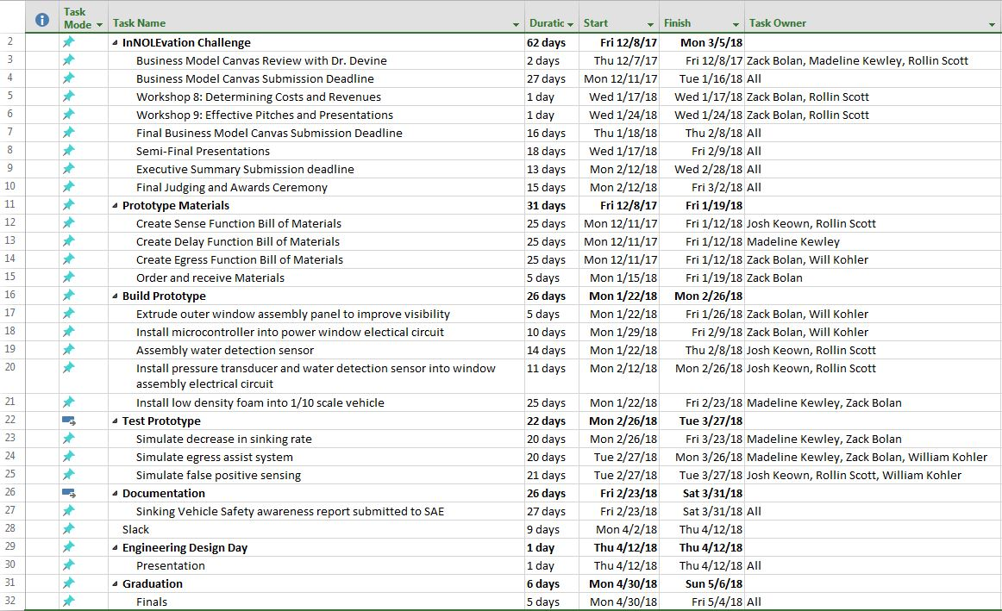

Figure 11: Spring project plan task table

**Gant Chart**

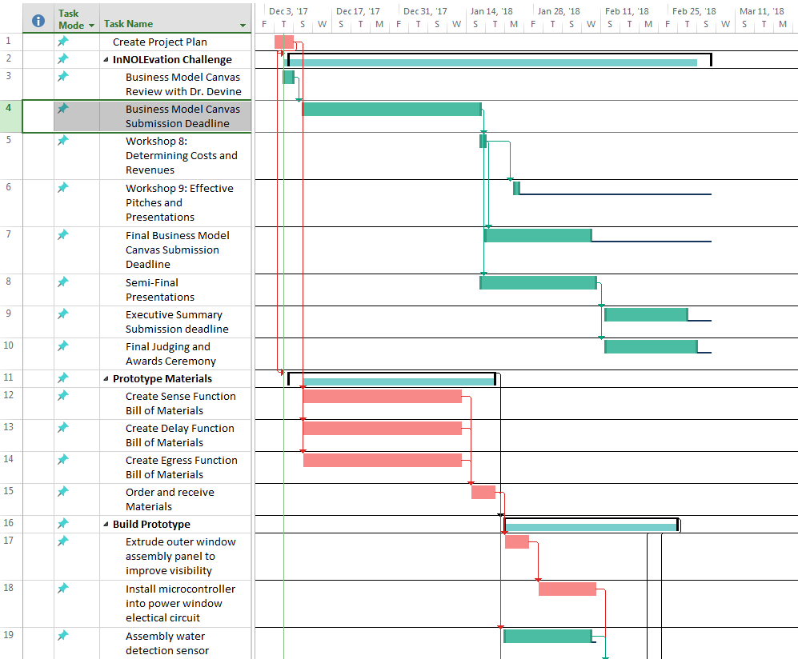

Figure 12: Gantt chart Tasks 1-19 (12/7/17-3/11/18)

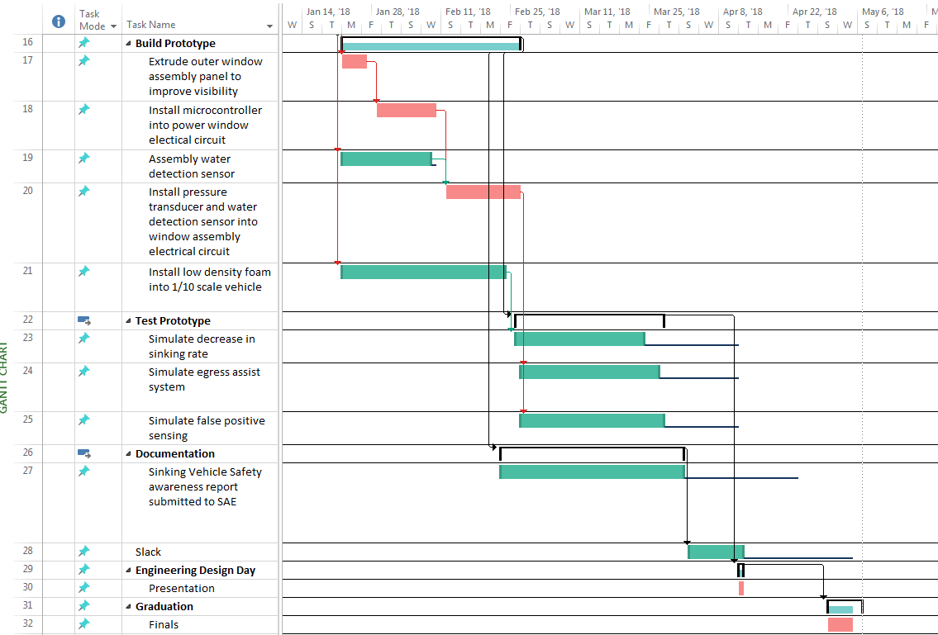

Figure 13: Gantt chart tasks 16-32 (1/14/17-5/4/17)

**Plan Review**

Before completing our Spring Project Plan, the team determined the events that needed to take place to complete our project and organize these tasks into a Gantt chart. These events and the timelines we associated with each of these events can be seen in the table above. We also took the time to assign which team members would responsible for each task. Additionally we also determined which events would lead us through our critical path that ultimately finishes with our graduation. This critical path can be seen above in the Gantt Chart in red. We also discussed any possible chances of bottle necking that we could face. As a team we felt that the biggest chance of this occurring was a result of not receiving all materials to build the prototype in time. To account for this, we integrated some slack time into our project plan. This slack time can be seen in the nine days prior to Engineering Design Day from Monday, April 2nd through Friday, April 12th.