**Operation Manual**

**Team 32**

**Sinking Safety Autonomous Vehicle Egress System**

**SSAVES**



Zack Bolan [ztb13@my.fsu.edu](mailto:ztb13@my.fsu.edu)

Madeline Kewley [mrk13@my.fsu.edu](mailto:mrk13@my.fsu.edu)

Rollin Scott [rollin1.scott@famu.edu](mailto:rollin1.scott@famu.edu)

Josh Keown [jdk14f@my.fsu.edu](mailto:jdk14f@my.fsu.edu)

William Kohler [wlk14@my.fsu.edu](mailto:wlk14@my.fsu.edu)

Faculty Advisor:

Dr. Shayne McConomy

Sponsor:

Dr. Michael Devine

Instructor:

Dr. Shayne McConomy

Date Submitted: Friday, March 30th, 2018

Table of Contents

Abstract…………………………………………………………………………………………………….3

Functional Analysis……………………………………………………………………………………….4

Product Specification……………………………………………………………………………………..5

Project Assembly………………………………………………………………………………………....6

Operation Instruction……………………………………………………………………………………..9

Troubleshooting…………………………………………………………………………………………12

Appendix………………………………………...……………………………………………………….13

**Abstract**

Globally, each year, sinking car crashes claim the lives of 5,000 people. In Florida alone a death from a sinking car occur nearly every week. Sinking vehicle deaths are preventable as they are a result of drowning rather than as a result of trauma sustained during the crash. Current products are available to help people escape sinking cars. But do not address crash safety effectively. The Sinking Safety Autonomous Vehicle Egress System (SSAVES) introduces a system designed specifically to increase survivability in sinking car crashes. This technology does not add any potential hazards to the escaping passengers unlike others on the market. SSAVES integrates a series of systems that work together to: (1) determine the sinking emergency, (2) increase the flotation of the car, and (3) help passengers escape. The sensing module includes a pressure and water detection sensors to detect a sinking situation. By integrating these two sensors into one module, any false positives that occur because of every day driving do not alert the system. The sensing module also finds the car in real-time and shares this information with first responders. Once this module determines a sinking situation, it sends a signal to the egress module. This module activates a solenoid pin to safely and swiftly allow the driver side window to drop into the open position. This open window provides a safe means of egress for the passengers. The third and final module uses a low-density foam to increase the buoyancy of the car. Increasing the buoyancy gives the passengers more time to escape through the open window. SSAVES enables the passengers to escape their sinking car within 90 seconds.

**Introduction**

Every year vehicle submersion fatalities take up to 5,000 lives when all industrialized nations are taken into consideration. In the state of Florida alone, one person a week dies as a result of this type of accident. All of these deaths are completely preventable and are a result of drowning and are not due to trauma sustained during the accident. This creates a need for an increase in the neglected issue of sinking vehicle safety and an innovative design to save thousands of lives that would have otherwise been lost.  
 To help increase the safety in sinking vehicles, this engineering design team has developed SSAVES (Sinking Safety Automated Vehicle Egress System) which focuses on increasing the survivability of passengers in sinking vehicle accidents. In brief, SSAVES incorporates a pressure transducer sensor and a water detection sensor to activate an egress system once sinking conditions are recognized. The egress system includes a modified window regulator track which houses a microcontroller that when sinking conditions are identified will control the power window module and safely drop the window glass allowing the passengers to escape without breaking the glass or adding any other potential hazards. Also, SSAVES integrates low density closed cell urethane foam that will increase the buoyancy force of the vehicle thus delaying the rate of the sink. This delay will allow the passengers more time to escape the sinking vehicle safely. SSAVES allows for an instant means of escape the moment the sinking situation is recognized allowing all passengers to escape the vehicle in less than 90 seconds without adding potential hazards such as broken glass from shattering the car window. SSAVES is an innovative and cost effective approach to improving sinking vehicle safety and is unlike any other product currently on the market.

**Functional Analysis**

The purpose of the product is to increase survivability in sinking vehicle accidents by incorporating a system of functions designed to delay the rate of sink, sense the vehicle is in a sinking situation, and assisting the passengers in egress. After consulting with the customer and determining our customer needs, Team 32 developed the core SSAVES functions and identified their overlapping aspects. Figure 1 below outlines the functional decomposition of the SSAVES product. From analysis of this figure, team 32 noticed that the sensing function plays a role in several key aspects in our design showing how significant this function is to the product. The sensing function consists of a pressure transducer and water detection sensor as well as the vehicles existing gps subsystems to recognize rollover, detect a sinking situation by evaluating water content and pressure changes, as well as transmits gps location to first responders. The egress function which uses a redesigned window regulator track and microcontroller to open the window creating a outlet for egress for the passengers. The delay function uses low density urethane foam to increase the buoyancy force of the vehicle to allow the passengers more time to escape. Also, the low density foam has comparable thermal and acoustic properties as the existing insulation in the vehicle so no loss of vehicle attributes is lost when incorporating the delay function into vehicle manufacturing.

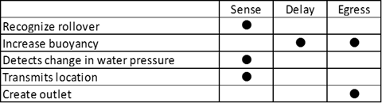

Figure 1: SSAVES functional decomposition

**Product Specification**

S.S.A.V.E.S incorporates a pressure transducer sensor and a water detection sensor to activate the egress system once sinking conditions are recognized. The egress system will use a modified window regulator track which includes microcontroller that controls the power windows when a sinking situation is sensed that will safely drop the window glass allowing the passengers to escape without breaking the glass or adding any other potential hazards. Also, S.S.A.V.E.S integrates low density closed cell urethane foam that will increase the buoyancy force of the vehicle thus delay the rate of the sink allowing the passengers more time to escape the sinking vehicle safely.

**Delay Function**

Low density closed cell urethane foam was chosen as the insulation to increase the buoyancy in a sinking vehicle due to its extremely low density, water resistivity, and comparable acoustic and thermal properties. This type of foam is used the in marine boat industry and shown below in Figure 2. The foam is installed in the areas previously insulated by the original manufacturers insulation such as the front fender, hood, side panels, roof, floor, and trunk. More details are outlined in the delay product operation section.



Figure 2: Closed cell urethane foam

**Sensing Function**

The sensing function includes components that measure water content, the pressure and change, and change in elevation. The Arduino Uno Rev3 shown in Figure 3 was chosen as the ideal microcontroller for sensing function for its functionality with multiple sensing components, cost, and small size. The arduino is housed and placed about 1 meter up from the bottom of the frame in the vehicle side panel to ensure sensing can be done before the water reaches that height. The arduino is integrated with the water detection sensor, pressure transducer, and the vehicle power switch relay module to control the egress function once sinking conditions are sensed from the two sensors.

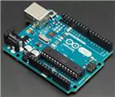

Figure 3: Arduino Uno Rev3

The pressure transducer chosen was the BMP180 GY68 Barometer Pressure transducer due to its measurement accuracy, precision, and size. The pressure transducer is small enough to fit within the housing of the microcontroller allowing ease of installation. A pressure increase of about 68 kPa significant enough to warrant a reaction from the sensor while operating within the expected working range of the pressure transducer. The pressure transducer is show below in Figure 4.

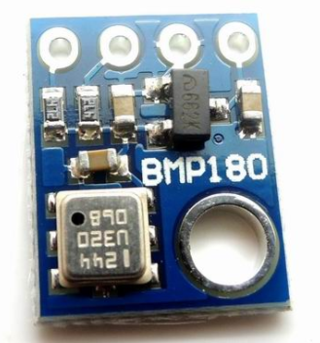

Figure 4: BMP180 GY68 Barometer Pressure sensor

The water detection sensor chosen was the Phantom YoYo High Sensitivity Water Sensor due to its measurement accuracy, cost, and size. The water sensor is small enough to fit within the wheel well of the vehicle at a height of 0.6 m. Once the water level has reached the height of the sensor while the vehicle is operating will activate a positive signal from the sensor. The water sensor is show below in Figure 5.

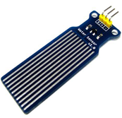

Figure 5: Phantom YoYo High Sensitivity Water Sensor

**Egress Function**

The egress function includes a window regulator and motor subassembly from the vehicle original equipment manufacturer. The sub assembly consists of a driver gear, motor, regulator arms, and regulator track. The regulator track on the sub assembly is used to house the microcontroller described above. The window regulator subassembly is shown below in Figure 6.

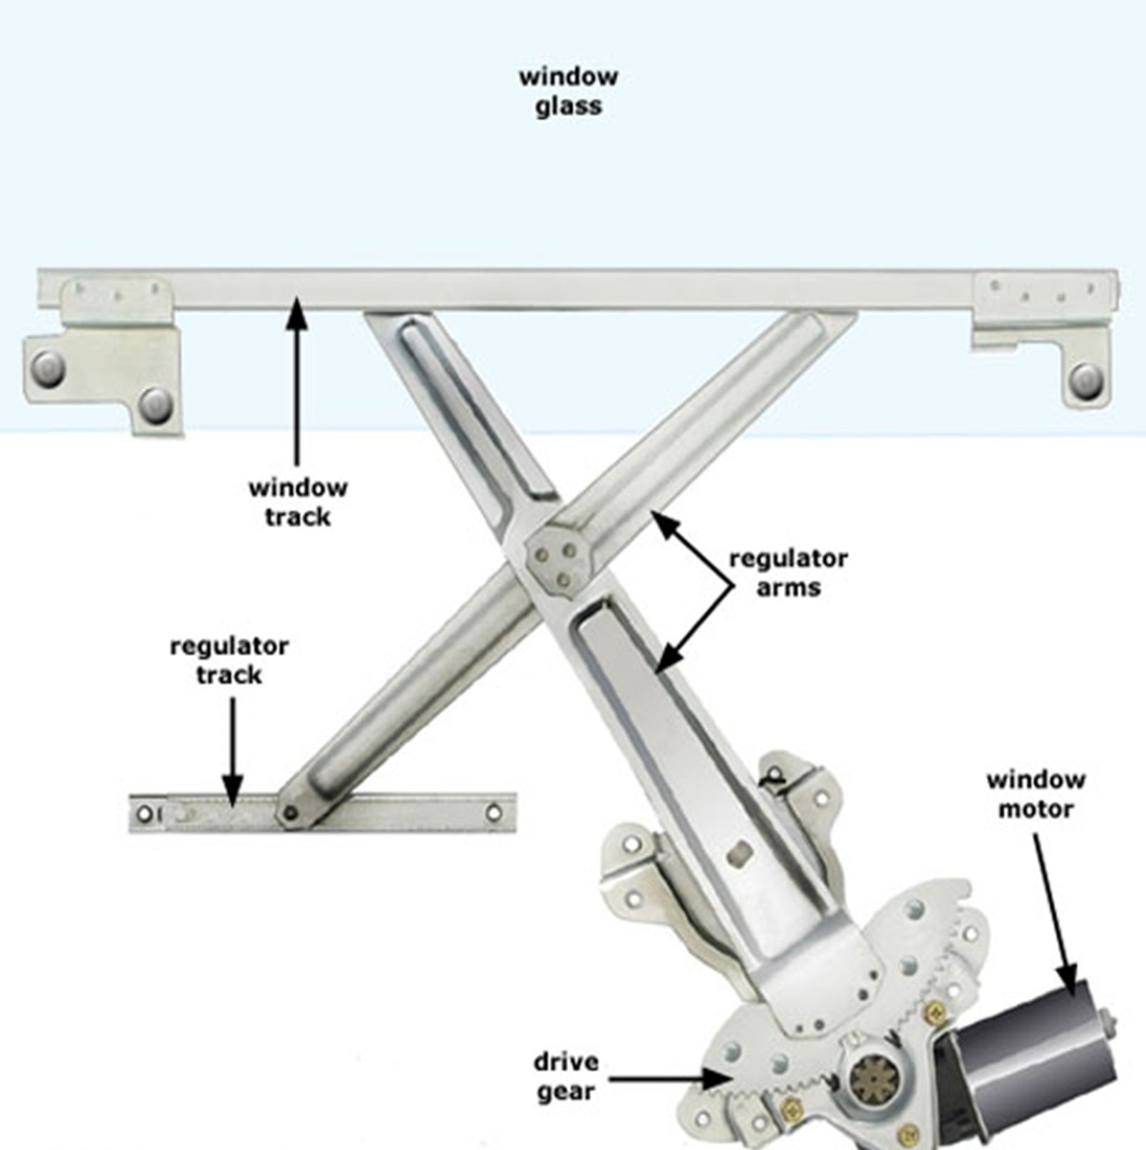

Figure 6: Window Regulator and Motor Subassembly

**Product Assembly**

**Delay Function**

The delay function will use a low density, closed cell urethane foam to replace the existing foam in the vehicle. This foam density is significantly less than water’s and will allow the vehicle to sink at a slower rate providing the passengers with more time to escape. The installation process will consist of the foam being sprayed into the designated areas during the vehicle manufacturing process at the original equipment manufacturers facility. This particular foam will then expand to take up the given room in the various areas as highlighted below. Once the foam is set, the remaining assembly of the vehicle can continue as usual. The locations of where the foam is installed is shown below in Figure 7.

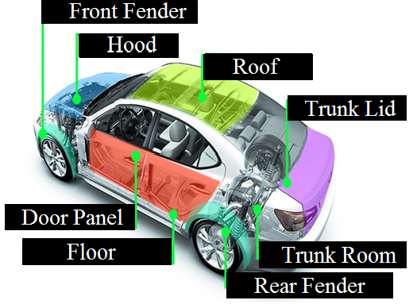

Figure 7: Closed cell urethane foam installation locations

**Sensing Function**

The sensing function will use an Arduino microcontroller, water level sensor, and barometric pressure sensor to ensure that water is indeed in the car as well as measure the difference in air pressure. The use of both water level sensor and barometric pressure sensor eliminates the possibility of having a false positive within the system. The water level sensor senses water but does not warrant a reaction from the system until the water level has reached 0.51m. The system will not react, however, until the pressure reads 110 kPa, which is the pressure warranting a reaction from the system. The Arduino software comes with a COM serial monitor, which acts as simulated data that has been sent to First Responders via connections with Toyota’s SafetyConnect or OnStar. Also, the sensing function will be connected to the window regulator’s geared motor and will be programmed to turn the motor accordingly, to drop the window, as well as allowing the user to be able to roll up the window (for demonstration purposes only). The sensing components will be placed in the undercarriage near the bottom of the driver’s door, which can be seen in Figure 8.

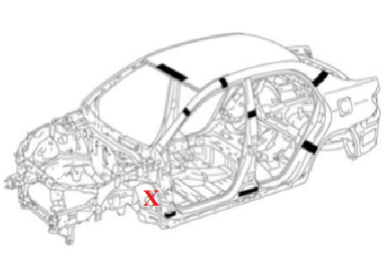

Figure 8. Location of the sensing function’s components

**Egress Function**

The egress function incorporates the existing window regulator and motor sub assembly, and power switch relay module integrated with the Arduino microcontroller and sensors to roll down the window when sinking conditions are met. The microcontroller is housed in the driver side side panel at a height of the power window switches to ensure the controller will function and roll the window down before the water reaches it. The installation of the microcontroller in the side panel will occur during the vehicle original equipment manufacturers door assembly process by bolting it to the frame.

**Operation Instruction**

1. Water detection sensor and Pressure transducer requirements are met
   1. Water level must reach 0.51 m
   2. Pressure must increase by 110 kPa
2. Signal received on the arduino microcontroller board
3. Signal sent to the power window relay module
4. Closed cell foam delays the rate of sink
5. If you are ***not*** in a sinking vehicle emergency, use the window switch to close the window
6. If you are in a sinking vehicle emergency, exit the vehicle through the opened window using the following guidelines:
   1. Driver exits the vehicle first
   2. Front seat passenger assists in helping backseat passengers out
   3. Front seat passenger exits

**Troubleshooting**

Disassemble the driver’s door to where only the connections are showing. Then, gently pull the water level sensor component from the undercarriage so that it hangs from the car. To ensure that the water level sensor works correctly, let the water sensor sit within a bucket (that has a height of at least 0.7m) and fill the bucket with water.

***The Water Level Sensor Test:***

At 0.51m, the water level sensor’s corresponding LED should switch on. Although this is not visible to the owner or passengers of the car when driving, the LED is integrated into the circuit strictly for troubleshooting purposes. If the LED does not switch on at the appropriate water level, the microcontroller might need to be recalibrated/reprogrammed or the water level sensor may need to be replaced. Be sure to wipe the water level sensor dry so as to not cloud any data readings or input from dried water or excess dirt.

***The Pressure Sensor Test:***

To ensure the pressure sensor works properly, gently pull down the ribbon cable attached to this small chip and vary its altitude to see if the air pressure changes any, since it picks up the slightest change in pressure.

***The Window Motor Test:***

Finally, to ensure that your window power switch works, simply roll the driver’s window all the way down and roll it back up. This ensures that the window’s gear motor works properly.

To ensure the entire system works, complete the three tests regarding the water level sensor, pressure sensor, and window motor. If any of these tests fail, take the car to the vehicle original equipment manufacturer for a mechanic to replace parts or troubleshoot it with better equipment. If the tests give accurate results, your car’s system should work. DO NOT DRIVE YOUR CAR INTO WATER TO SEE IF THE SYSTEM WORKS!

**Appendix**

See troubleshooting section for SSAVES function maintenance. Otherwise seek more information from each components original equipment manufacturer’s documentation using the links below.

**I. Component Operation Manual**

1. **Arduino Uno Rev3:** https://www.arduino.cc/en/uploads/Main/Arduino_Uno_Rev3-schematic.pdf
2. **Phantom YoYo High Sensitivity Water Sensor:** h**t**tps://www.emartee.com/Attachment.php?name=42240.pdf
3. **BMP180 GY68 Barometer Pressure Sensor:** https://cdn-shop.adafruit.com/datasheets/BST-BMP180-DS000-09.pdf
4. **2003 Toyota Corolla Power Window Sub Assembly:** <https://techinfo.toyota.com/t3Portal/resources/jsp/siviewer/index.jsp?dir=ncf/NCF221U&href=xhtml/NCF221U_0045.html&locale=en&User=false&publicationNumber=NCF221U&objType=ncf&t3id=NCF221U_0045&docTitle=Power+Window+System+%282003+Corolla%29&home=favorites>
5. **2003 Toyota Corolla Electrical Components** <https://techinfo.toyota.com/t3Portal/resources/jsp/siviewer/index.jsp?dir=ewd/EWD484U&href=xhtml/EWD484U_0029.html&locale=en&User=false&publicationNumber=EWD484U&objType=ewd&t3id=EWD484U_0029&docTitle=Power+Window+%282003+Corolla%29&home=favorites>