## 1.5 Concept Generation

## Function: Delaying sink

## Description:

Decreasing the rate at which the vehicle sinks will provide more time for egress for the passengers in a sinking vehicle. The buoyancy force of this function will be comprised of one system in place to increase the buoyancy of the vehicle and increase the time the passengers have to escape. Four viable concepts were generated during our ideation phase. Decreasing the rate at which the vehicle sinks is not required as part of the project scope but will prove very valuable when giving distressed passengers a few more moments time to escape.

# Table 1: Delay sink concept generation

|  |  |  |
| --- | --- | --- |
| System | Concept | Metrics |
| Vehicle Insulation | Replace foam in vehicle with lower density foam | Time (s) to sink a specific depth,  Acoustic (Hz), thermal (k) properties, density (ρ) |
| Vehicle Insulation | Replace and add in additional lower density foam to empty spaces in vehicle | Time (s) to sink a specific depth,  Acoustic (Hz), thermal (k) properties, density (ρ) |
| Vehicle Insulation | Vehicle water ballast | Time (s) to sink a specific depth, Acoustic (Hz), thermal (k) properties, density (ρ) |
| Vehicle Safety system | Deploy flotation device | Time (s) to sink a specific depth,  Time (s) to deploy flotation device |

### System: Vehicle Insulation

The insulation system is comprised of different materials placed throughout the vehicle between the vehicle frame and interior to provide ideal thermal and acoustic properties. Specifically, areas under the hood, interior side, and floor panels utilize foam used to trap and reduce the heat from the engine. The foam also acts as an acoustic damper to suppress noise from the engine. These properties must be taken into account to ensure our design concept does not take away from the vehicle’s original thermal and acoustic properties.

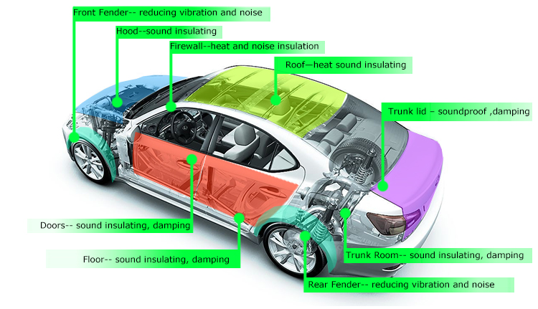  
Figure 1: Vehicle Insulation system

### Concept 1: Replace existing insulation in vehicle with lower density material

Replacing the existing material in the vehicle with low density foam will increase the buoyancy force therefore allowing the vehicle to sink at a slower rate. The standard insulation material is currently used throughout the vehicle and can be replaced in key areas such as under the hood, front and rear fender, interior floor, side panels, and trunk. Also the replacement material must be comparable in acoustic and thermal properties to ensure the vehicle is not hindered from our design concept. Several materials have been researched for use in the vehicle.

Closed cell urethane foam has been researched as a viable low density foam option. The foam has a density of 2 lb/ft^3 which is much less dense than water at 62.4 lb/ft^3.  It has an R-value of 7 per inch which is comparable to other types of insulation. The foam is mixed and molded into a desired shape to fill voids for flotation and is relatively inexpensive. However when urethane foam absorbs water, the buoyancy force decreases significantly.

Expanding epoxy foam was also researched as a viable option but is much more expensive than urethane foam. Epoxy foam does operate better at higher strength and temperatures and is more water resistant.

Low density egg crate shape soundproofing foam is another option in areas that thermal insulation is not a priority, such as the trunk or cabin. The egg crate shape foam acts as a sponge to absorb sound as most of the material is comprised of pockets of air. The pockets of air will prove to decrease the average density of the vehicle allowing an increase in buoyancy.

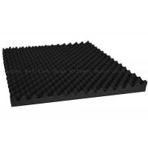

Figure 2: Low density egg crate shaped foam

**Concept 2: Replace existing and add additional lower density material in vehicle**

This design concept is similar to concept 1 but includes adding additional foam to areas occupied by only air between the vehicle’s frame and side panels. However, adding in additional foam must not hinder the car in any ways especially thermal and acoustic properties. Additional areas aside from under the vehicle hood, and interior panels must be investigated to ensure it will provide more buoyancy without affecting these qualities. Similar foams will be investigated for use as discussed in concept 1.

Soundproofing techniques provide examples of additional areas where low density sound proofing foam could be applied to reduce the average density of the vehicle and further sound proofing the vehicle comparable to standard options from the Toyota corolla.

After discussion during our staff meeting, it was brought to our team's attention that all areas even if only occupied by air are designed with a specific purpose such as acoustic dampening. By adding in foam to these areas, the dampening in the vehicle may be thrown off and hinder the original vehicle design. Extensive investigation must be done to ensure that any areas with newly added foam do not hinder the vehicle’s properties.

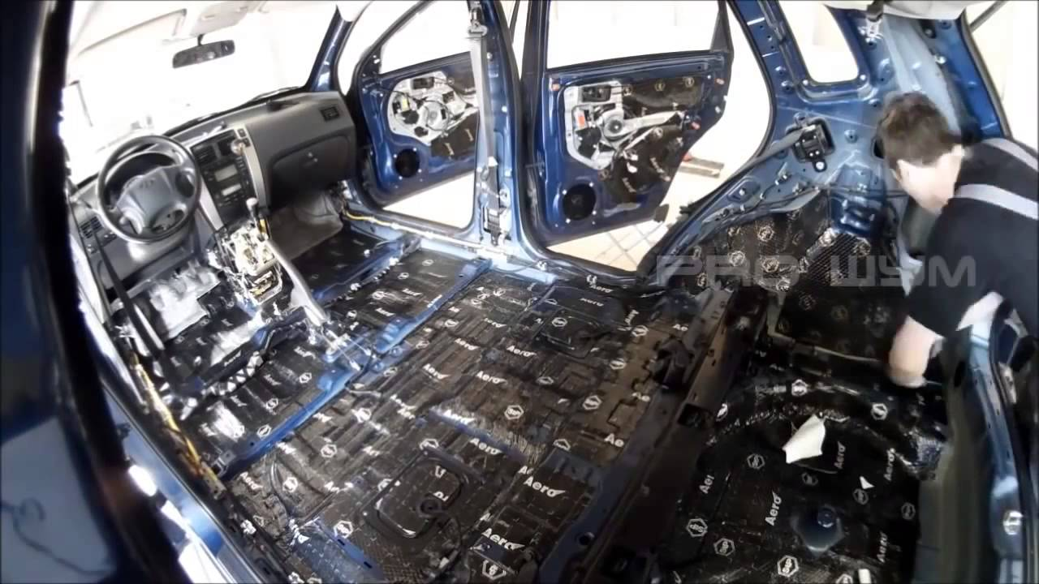Figure 3: Cabin Interior Insulation

**Concept 3: Vehicle air ballast tank**

Marine vehicles use water ballast tanks to increase stability and buoyancy. A ballast tank is a compartment within a floating structure that holds water, which is used as ballast to provide stability for a vessel. This component of marine vehicles could be applied to our project but as an air ballast tank. By sealing areas in the vehicle so water cannot occupy those areas, the trapped air will increase the force of buoyancy and decrease the rate of the sink. Areas that could be potentially be sealed are pockets between the frame and interior. Other areas, such as the exhaust system, could provide more volume for the air to be used as a ballast but could prove to be unsafe for the vehicle if the exhaust system is accidentally sealed during normal operation.

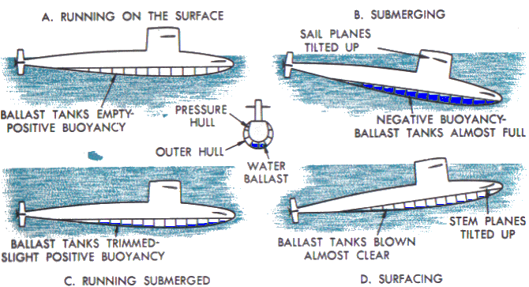

Figure 4: Water Ballast principles

### System: Vehicle safety systems

The vehicle safety systems include components such as seat belts and airbags. Airbags could prove useful in creating buoyancy in a sinking vehicle and should be investigated. Although no additional safety hazards, such as a instantly deployed airbag, should be added to the system in order to abide to our customer restraints. By adjusting the way in which the airbags are activated, they could prove useful in delaying the rate at which the vehicle sinks.

**Concept 4: Deploy flotation device**

Several components already installed in the vehicle could be used as a flotation device to increase buoyancy of the vehicle and delay the sink. Airbags could be inflated slowly to increase buoyancy of the vehicle by trapping pockets of low density air but not add any potential safety hazards that usually accompany a airbag deployed at full velocity. The airbags would continue to stay inflated in this case instead of slowly deflating immediately after a car accident. However, each deployed air bag would have to be replaced and could prove very costly to the operator of the vehicle.

In addition to the airbags, more buoyancy can be achieved by putting an inflatable flotation device similar to an airbag in the underneath the frame of the car. Upon the vehicle sinking, it would be deployed and inflated to increase the buoyancy of the vehicle. This would be necessary if the buoyancy force from deploying the airbags was not great enough to make a real impact in delaying the sink.

**Function: Sensing sinking vehicle**

## Description:

Sensing the vehicle condition can provide the passengers with appropriate assistance especially in life threatening situations. This function will be comprised of one system in place to provide the passengers with contact with emergency first responders and signal a means to egress the vehicle. After refining initial concepts, three viable concepts were generated for this function. The vehicle electrical system is required to validate our design as it will be integrated with our design concepts in order to achieve the top priority of the project scope, saving lives in a sinking vehicle scenario.

# Table 2: Sensing sinking vehicle concept generation

|  |  |  |
| --- | --- | --- |
| System | Concept | Metrics |
| Vehicle Electrical System | Install a pressure transducer underneath the body of the vehicle | Pressure (kPa) |
| Vehicle Electrical System | Install a force transducer along the vehicle suspension springs | Force (kN) |
| Vehicle Electrical System | Utilize existing GPS location device on vehicle | Change in elevation (m) |

### System: Vehicle electrical system

Most vehicle’s electrical systems made after fall 2009 come equipped with a variety of sensors to help aid the driver. Such sensors include GPS location and force transducers. The GPS location sensor is used to provide vehicle navigation. Force transducers detect large forces which are indicative of a vehicle accident. Toyota’s Safety Connect program utilizes the GPS location and force transducer data to send emergency first responders to the location of the vehicle in the event of an accident. While most new vehicles come equipped with a variety of sensors, more can be done to detect if a large body of water is involved during an accident.

**Concept 1: Installing a pressure transducer**

The pressure transducer works by converting pressure into an analog electrical signal. This is achieved by physically deforming strain gages that are bonded into the diaphragm of the pressure transducer that are wired into a Wheatstone Bridge configuration. The pressure being applied to the pressure transducer produces a deflection of the diaphragm. The deflection or strain will produce a proportional electrical resistance to the applied pressure. Figure 1 below shows a schematic drawing of a standard pressure transducer.

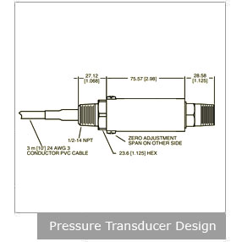

Figure 5: Pressure transducer design from Omega.com

The electrical signal can then be used to alert first responders that the vehicle is potentially sinking in a large body of water. The signal could also be used as a means to begin the automatic window drop function discussed in the assisting in egress section. The signal would be sent to an intermediate computer that would also be connected to the window position switch. The window would drop as normal if a signal is received that the car is underwater a signal that the car is in water.

Installing the pressure transducer along the undercarriage is the preferred location for this concept since most vehicles enter water in the upright position. Figure 6 below shows the preferred location for the pressure transducer. The concept will focus on making a meaningful impact on the number of vehicle deaths involving water. Vehicles entering water in other orientations will be beyond the scope of the current project but may be addressed during future projects.

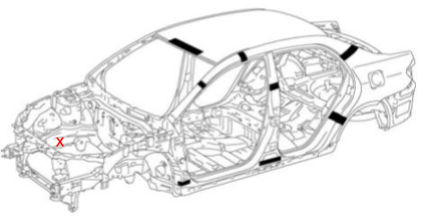

Figure 6: Body outline of 2009 Toyota Corolla from slideshare.net indicating location of pressure transducer.

### Concept 2: Installing a force transducer on the suspension springs

This force transducer would work with the suspension system used in the vehicle. When a vehicle’s weight is equally distributed between four tires on the ground and their suspensions, the springs are compressed to a standard point. However if the same vehicle is sinking, the amount of force on the tires from the water would be significantly less and would result in a spring that was elongated. The force transducer would be able to detect this difference in length by monitoring the amount of force the spring was enduring. When the force on all four tires’ springs dipped below a calculated point and stayed there for a given amount of time, it would be able to determine if the vehicle is sinking.

### Concept 3: Utilize existing GPS technology

Global Positioning System (GPS) technology is steadily advancing, particularly in the automotive industry. Toyota launched their Safety Connect system in 2009 which has four major functions, all of which include the use of GPS technology: Automatic Collision Notification, Emergency Assistance Button, Roadside Assistance, and Stolen Vehicle Locator.

To make these efforts possible, GPS systems must depend on reliable networks which include ground stations, satellites, and receivers. There are over 30 navigation satellites hovering in space and the ground stations use radar to reassure the overall system that the satellites are in their “assigned” spots in space. Receivers, particularly built in receivers in an automobile, listen for signals from the satellites. Once four or more distances are collected by the receivers from the satellites, the receivers then send a signal to first responders or the GUI (Graphical User Interface i.e. built-in touchscreens on consoles) to display the location of the car, navigate accordingly, or assist in /perform the task at hand.

By “piggybacking” off of the already existing GPS technology and wiring, a pressure sensor can be used in conjunction with this GPS technology in its own module to effectively and efficiently send a signal to the Response Center so that First Responders can be alerted in a timely manner. The latitude and longitude of a vehicle’s location is included among the numerous data that is collected and used by Toyota. If the coordinates of the vehicle could bypass the Response Center and go directly to First Responders when the pressure difference of the water is first detected, this would help reduce the response time of emergency personnel.

**Concept 4: Combining Pressure Transducer and Water Detection System**

The pressure differential system uses a pressure transducer to measure the difference in the atmospheric and water pressure which allows the group members to set a critical pressure point signaling that the car is sinking and not experiencing other case scenarios (i.e. heavy rains or going through a car wash). Once the water is detected, a signal will be sent to the egress system, in a timely manner, and passengers can begin their escape, allowing time for all 3 passengers to get out of the car. The conjunction of water detection and pressure differential systems can also send a more accurate GPS location to First Responders, including depth by using the pressure transducer’s pressure difference, in a timely manner, with the water detection and pressure transducer working together to ensure the car is sinking as soon as the water is detected.

**Function: Assisting in egress**

## Description:

Assisting the passenger in egress is essential to increasing the survival rate in sinking vehicle accidents. This function will focus on modifying the various exits throughout the vehicle as well as creating a new means of egress that will make it easier for passengers to escape while sinking. Three feasible concepts were generated during our ideation phase. Considering that many people become trapped inside the vehicle while it is sinking, a system designed to assist all passengers in egress is required for our project scope to increase the chance of saving lives.

# Table 3: Assisting in egress concept generation

|  |  |  |
| --- | --- | --- |
| System | Concept | Metrics |
| Vehicle Window Regulator system | Manual window dropper | Time (s) for egress, Time (s) to fully open window |
| Vehicle Window Regulator system | Automatic window dropper | Time (s) for egress, Time (s) to fully open window |
| Vehicle electrical system | Underwater door opening mechanism | Time (s) for egress, Time (s) to fully open door, Force (kN) to open door while vehicle is submerged |

### System: Automatic Window Regulator System

Most cars manufactured in the past 10 years are equip with power window regulators used to open and close the window using a button. The automatic window regulator system is used throughout the vehicle and allows the passengers to open or close the windows with a push of the button as opposed to physically cranking the window. Our concepts would allow for the window to drop to allow for the passengers’ egress but would not affect the window regulator system’s current function.

The first design concept question was how the passenger should exit. One option was for the system to break the windows. However, one of the project constraints was to not add any potential hazards such as broken glass to the situation. Thus, focusing on the window regulating system will provide an opportunity to open a window for the passenger quickly and safely.

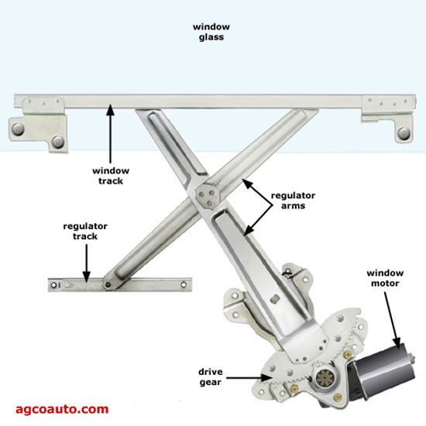

Figure 7: Vehicle Window Regulator system

### Concept 1: Manual Window Dropper

The manual window dropper will function using a lever near the bottom corner of the driver side window that will drop the driver side front window. This design concept would not be a part of the vehicle’s system that included the sensor as it relies on the passenger to engage. This could be useful in the event that the electrical system fails due to impact or water damage but the system would rely on a distressed vehicle operator to have to activate the lever quickly in order to survive. Once the manual window dropper is activated a signal would be sent to first responders similar to Toyota's safety connect.

Precautions must be taken to ensure the window will still drop even if the water level has risen to the height of the window. As the water level increases in height on the window pressure forces will continue to rise, risking failure in the dropper mechanism and failing to drop the window for the sinking passengers.

### Concept 2: Automatic Window Opener

This concept would work with the window regulator system and would automatically drop the window. The window dropper would be integrated with the sensing system that would be able to detect the vehicle sinking. This system would include the sensor as previously mentioned that would signal the window dropper to activate automatically in the event that the vehicle is sinking.. By automatically dropping the window, the passenger would have a means to escape the vehicle without having any direct interaction with the window itself.

During the first minute of the sink, the passengers in the vehicle have the highest chance of survival as the water level will not at the top of the window. Once the water level is near the top of the window, pressure forces are exerted against the window and could prevent it from being dropped. To ensure this is not the case, the automatic window dropper must drop the window at full velocity within 0.5 seconds of the sensor sensing that the vehicle is sinking.

Special precautions must be taken to ensure the automatic window dropper does not accidentally activate due to a splash of water or hitting a speed bump.

### Concept 3: Underwater Door Opening mechanism

An underwater door opener concept would be integrated into the electrical systems of the vehicle so that enough power could be produced to force open the door while the vehicle is sinking. This mechanism would assist the passengers in opening the door despite the growing force of the water pressure on the outside of the door as the vehicle is sinking. The opener would be placed within the door frame and as the sensors detect the sink of the vehicle, this mechanism would begin to expand. As it expands, the door would open and create a means of escape.

It becomes increasingly more difficult for the door of a car to open as a car sinks. This means that the car door must be opened almost instantly upon impact with the water. The automatic door opening system must be activated the instant that the sensor network senses that the car is in water, and it must open the door in less than 4 seconds to ensure that the passengers can escape. The door opener must work very quickly because if the door is open it allows much more water to enter the cabin of the vehicle than if only a window is open, causing the passengers to have less time to escape from the vehicle before it fills completely with water.

Precautions must be taken to ensure that the automatic door opener can withstand the force of water outside of the vehicle even after the water reaches the top of the door. As previously stated, as the water level rises the amount of force needed to open the car door also rises.

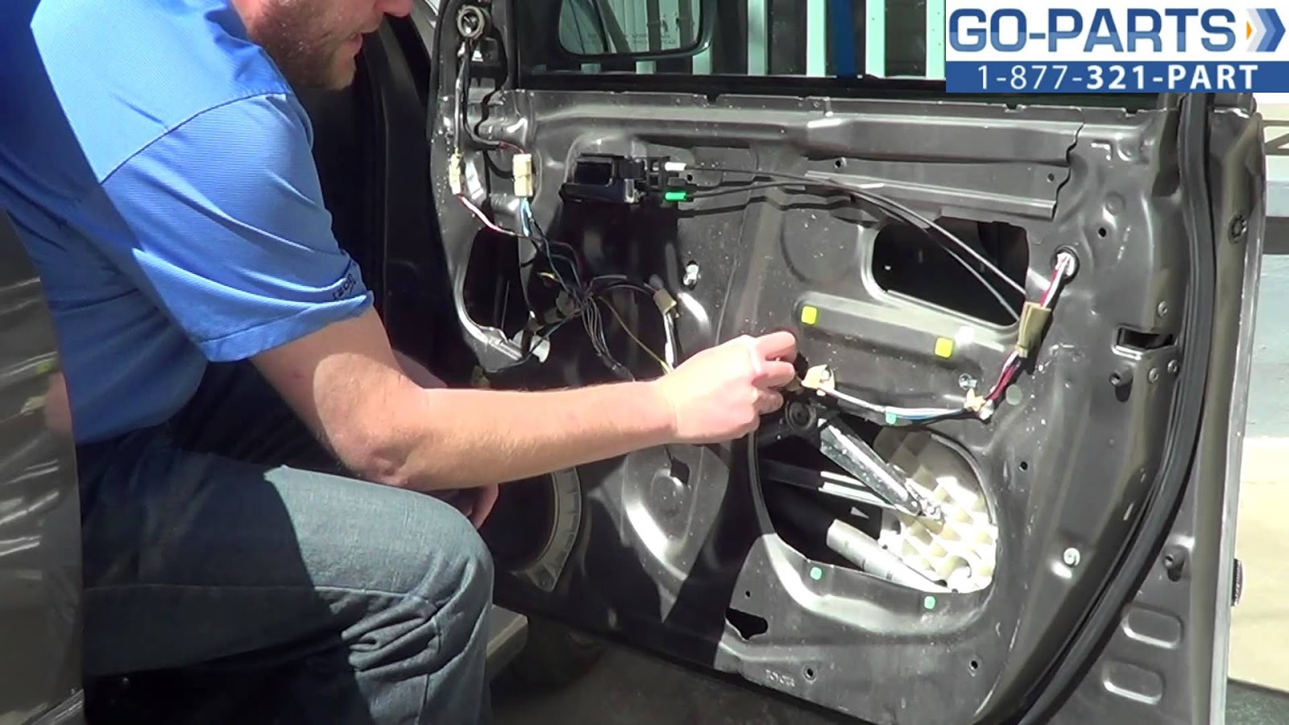Figure 6: Installed Window Regulator