**Powerflex Arm**

Project Plans and Product Specs

**Group # ECE-8**

**Team Members:**

Ryan Whitney

Derek Pridemore

Robert Slapikas

Jared Andersen

Donglin Cai

**Advisors:**

E.C.E. – Dr. Hooker

M.E. – Hollis

**Due Date: 10/9/2015**

Table of Contents

**1.** **Abstract** 3

**2.** **Introduction** 3

**3.** **Project Definition** 3

3.1 Background 3

3.2 Needs Statement 4

**Required Capabilities** 4

**Desired Capabilities** 4

3.3 Objectives and Goals 4

**4.** **Constraints** 5

4.1 Design Specifications 5

4.2 Performance Specifications 5

**5.** **Methodology** 6

5.1 Schedule 6

5.2 Resource Allocation 7

**6.** **Conclusion** 7

**7.** **References** 8

# **Abstract**

The power arm is a device that fits over the arms of the user and uses electromechanical actuators to add to their strength. It either contains a strong exoskeleton to help bear loads or it uses straps to attach to the user’s body and increases the torque generated by the user's skeleton.

# **Introduction**

This power arm will be usable for several groups of consumers like rehabilitation use, military use, and civilian use such as increased lift for warehouse workers. The power arm will use actuation to increase the lift capacity and endurance. It will be lightweight and allow for a high natural flexibility, something other powered orthotics do not consider. For this project, the power arm is only looking at the bicep contraction movement. The power arm will increase over all biomechanical efficiency and make lifting easier for the user.

# **Project Definition**

## 3.1 Background

For this project the range of motion of the human arm was looked at, and a range of 55 – 180 degrees was found [1]. Looking at different methods of actuation two methods were decided upon as practical: artificial muscles and motors. Motors have extensive research and proven properties while artificial muscles are relatively new and only have minimal research [3]. The artificial muscles would be much more cost effective, more lightweight, and require less power than the motor [2]. The motor would have a much easier control method, the range of motion will be better, and the frame would be more stable.

## 3.2 Needs Statement

People sometimes need assistance with moving their arms under load. Current strength-assisting orthotics are bulky, expensive, or not user friendly.

### **Required Capabilities**

The primary objective of this project is to come up with a strength-assisting orthotic that is minimally bulky and inexpensive.

### **Desired Capabilities**

This project should ideally be user friendly: easy to modify, safe, ergonomic, and dependable under a wide range of use cases.  It should be light, strong, and long lasting.

## 3.3 Objectives and Goals

Our minimum objective is to have a function prototype lift a paper cup, however our goal is to be able to lift and support 20 pounds.

# **Constraints**

## 4.1 Design Specifications



## 4.2 Performance Specifications

* Range of motion about 130 degrees from a fully extended arm (~180 degrees) to a contracted arm (~55 degrees)
* Lift/carry 20 pounds
* Have a battery life of 6-8 hours for civilian and 13-15 for military
* Have a lifespan of at least 3-6 months

# **Methodology**

## 5.1 Schedule

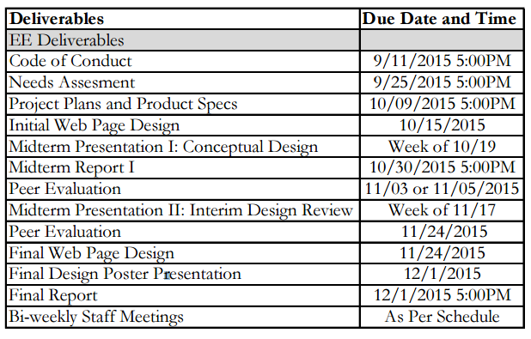

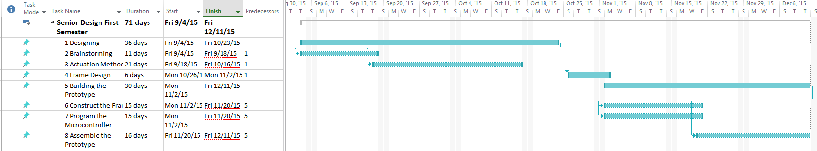

Our Gant Chart will be updated as soon as a method of actuation has been decided.

## 5.2 Resource Allocation

Ryan Whitney –Ryan performed research and calculations vital to the project moving forward and helped give values to the ideas. He worked on the Code of Conduct and the Needs Analysis papers. He designed the artificial muscle version of the prototype and will continue to do research and updates to it. He is currently working on the design for the power arm and will continue to do so.

Robert Slapikas –Robert also performed research and calculations vital to forward progress and gave vital insight into the mechanical process of the design. He makes sure that all of the calculations are correct and also worked on both previous papers. He will continue to provide oversight on the mechanical design and financial aspect of the project.

Derek Pridemore –Derek has performed research for both methods of actuation and helped find the right equations for Ryan to use. Derek also worked on both previous papers. He has made rough designs for the motor version of the project and built the webpage for the team and project. He also keeps note of meeting minutes and will continue to update the webpage.

Jared Andersen –Jared has performed research for both methods of actuation and worked on both papers as well. He also helped design the motor version of the prototype and added to the design of the artificial muscle version. He will work on the midterm presentation.

Donglin Cai –Donglin has helped develop the artificial muscle design and added to the background research for this method. He also worked on the previous two papers. He will work on the midterm presentation.

# **Conclusion**

Our team is making solid progress towards the design of an initial prototype. By next week we will be done with developing the math behind each method of actuation and determine which one we will use for this project. At that point we will then start a complete design of the prototype which will include but not be limited to: the shape of the arm design, material of the arm, material of the actuators, type of microcontroller, type of driver board, and a feedback system.

# **References**

1. Banchadit, W., A. Temram, T. Sukwan, P. Owatchaiyapong, and J. Suthakorn. "Design and Implementation of a New Motorized-mechanical Exoskeleton Based on CGA Patternized Control." 2012 IEEE International Conference on Robotics and Biomimetics (ROBIO) (2012): n. pag. Web.
2. Ranjan, Ranjeet, and Praveen Dhyani. *Theoretical and Experimental Modeling of Air Muscle* 2.4 (2012): n. pag. *IJETAE*. International Journal of Emerging Technology and Advanced Engineering, 4 Apr. 2012. Web. 5 Sept. 2015.
3. Universiteit Brussel, Department Of Mechanical Engineering, Vrije, and Pleinlaan 2 B-1050 Brussels. *Pneumatic Artificial Muscles: Actuators for Robotics and Automation* (2012): n. pag. Print.