Team 5 - Operations Manual

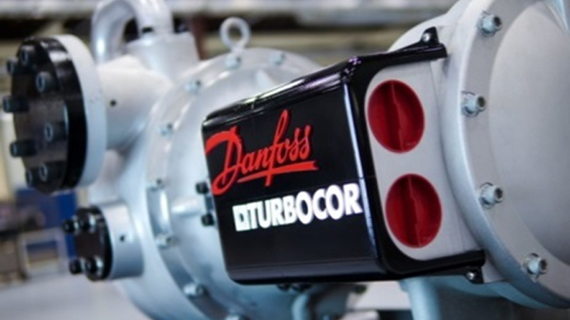

Figure 1: Danfoss Turbocor Centrifugal Compressor

Team Number: 5

Submission Date: Friday 4/1/2016

Submitted To: Dr. Gupta

Authors: Luis Mendez (lm13r@my.fsu.edu), Beau Rodgers (ber13@my.fsu.edu), Keenan Cheeks (kmc11j@my.fsu.edu), Brian Roberts (bpr13b@my.fsu.edu).

Faculty Advisor: Dr. Chiang Shih

Table of Contents

Abstract iv

Acknowledgements v

1 Functional Analysis 6

2 Project Specification 7

3 Project Assembly 8

4 Operations Instructions 9

5 Trouble Shooting 10

6 Regular Maintenance 11

7 Spare Parts 12

# **Abstract**

Senior design Team 5 has been given the task of working with Turbocor on developing new systems that will assist the teams learning process and use general and specific concepts that the students will have learned in their coursework. The team’s initial meeting with Turbocor dictated that the team was to work on a data analysis in order to predict failure modes of the Turbocor compressors. Bi-weekly meetings are held in which the team and their advisor, Dr. Shih, and their instructor, Dr. Gupta, discuss the merits and progress of the project. The team is to design and integrate a system for determining real time efficiency of the compressor in application as a stepping stone to reach Turbocor’s initial goal of predicting failure modes. The system to be integrated will consist of temperature sensors through the condenser units of existing HVAC systems and an external mass flow meter to determine the mass flow of water through the condenser unit. The integration of this system will require several steps to calculate the temperature differential from existing sensors and use collected mass flow data to determine efficiency. Once real-time efficiency can be determined accurately, the team can then use this information in conjunction with operating data to help predict failure modes for their compressors.

# **Acknowledgements**

We would like to acknowledge and thank Dr. Gupta, Dr. Shih and the many engineers at Turbocor thus far for guidance and suggestions for the design project. We are grateful for Turbocor engineers that have taken time away from their projects in order to guide this design team in a productive direction and for the opportunity provided to us through both or faculty advisor and the Danfoss Turbocor company. Furthermore, we are extremely excited and thankful for Turbocor’s willingness to grant the entire design team access to their on-site testing facilities and resources.

# Functional Analysis

The external mass flow sensor package coupled with Turbocor’s existing temperature sensors will extract data in real-time from the HVAC system. With Turbocor’s onboard compressor processing unit, that data will be used in conjunction with the necessary thermodynamic correlations to calculate the efficiency of Turbocor’s compressors in the industry standard kW per TON of cooling capacity. More specifically, the mass flow sensor will use ultrasonic transducers in order to find the time it takes for an ultrasonic pulse from one transducer to reach another transducer both down and up-stream. The transducers send a current correlated to this time to the mass flow sensor which can use the time difference to find the velocity of the water based on factors such as pipe diameter, pipe thickness, pipe material, and the physical properties of water. After the velocity and mass flow rate of the water are found the mass flow sensor will send a voltage directly into Turbocor’s compressor. Turbocor’s compressor code will be alternated to receive this new input and calculate each parameter needed for the final efficiency calculation. Finally, the efficiency will be output by the compressor to a computer which can place it into a csv file to be plotted vs time for long term monitoring of the compressor unit.

# Project Specification

The two main components of the system are the sensor itself and the mounting bracket. The sensor was chosen to meet the requirements of the compressor, pipes commonly used and environment.

## Sensor Properties

The Dalian Hipeak TDS-100F mass flow sensor package was chosen after research and analysis of requirements. In addition the type M1 and type L1 transducer were chosen. It has the following relevant properties:

|  |  |
| --- | --- |
| **Operating Power** | Ac 85-264 V or DC 8-36 V |
| **Accuracy** | Better than 1% |
| **Output** | Analog 0-24 mA |
| **Acceptable Pipe Diameters** | 15-6000 mm |
| **Keypad Menu** | Allows :  Monitoring of equipment  Manual input of parameters  View of data log |
| **Measureable Flow** | 0-2777.77 L/s |

Table 1: Sensor Properties

## Compressor Control Input

In order to interface with the compressor control board one of the unused temperature and pressure sensor inputs was repurposed. Normally a resistive type sensor is used in this location. The connection on the board consists of a +5V supply, ground and two voltage inputs for the pressure and temperature. Our design required converting the analog current signal to a voltage in order to allow the control board to use the value.

## Transresistive Circuit

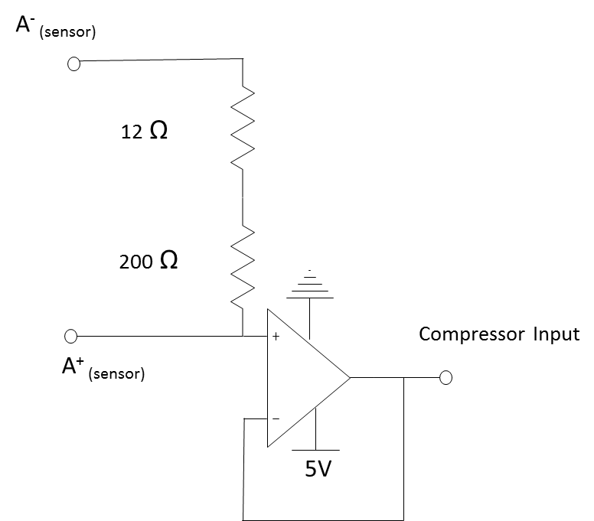A simple transresistive circuit was designed. It includes a unity gain buffer to help isolate the sensor from the compressor. This was done in order to prevent electromechanical interference from affecting the sensor package or feedback to damage the control board. Figure # shows the circuit diagram. This package also allows the grounds for the devices to be tied together so that the voltage provided has the same reference point. The actual circuit built had a total resistance of 208.33 Ω.

Figure : Transresistive Circuit

## Mass flow rate vs. Voltage

After collecting data and combing through the sensor documentation it was determined that the sensor output is linear. At a flow rate of 0 L/s the output is 4 mA. At the maximum flow rate of 2777.77 L/s the output is 24 mA. The circuit devised converts this to a 0-5 V scale so that the calibration function can be described through Eq. 1 where *x* is the voltage input:

$\dot{V}=(666.64 \frac{(\frac{L}{s})}{V}) (x-0.8332 V)$ Eq.1

## Bracket Mounting System

The bracket system consists of 3 main components made from aluminum. The first component of the bracket will attach to the pipe via band clamps that fit easily through designed grooves as shown in Figure 2. The second piece of the system shown in Figure 3 is a quick release mechanism typically used for easy removal of steering wheels in cars and trucks. This piece has been modified to allow the sensor to be positioned at any angle on the pipe meaning that it can always be easily read and worked on. In addition to angle adjustment, the quick release system will allow for the sensor to be completely removed from the pipe without the need for any tools. The final piece to the bracket is responsible for securing the sensor tightly with screws, washers and nuts as shown in Figure 4. The complete assembly is shown in Figure 5.

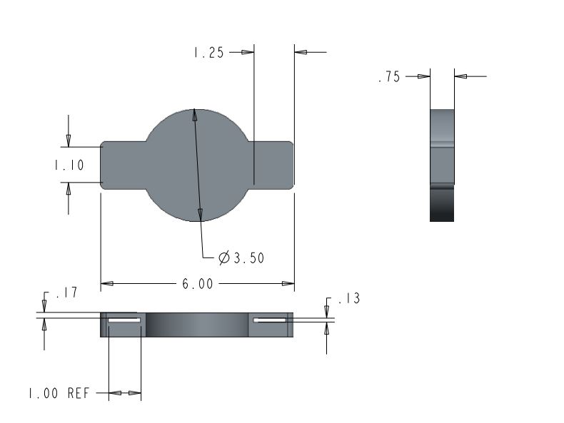

Figure 3: Pipe clamp; Allows the mass flow meter to be placed directly onto the pipe.

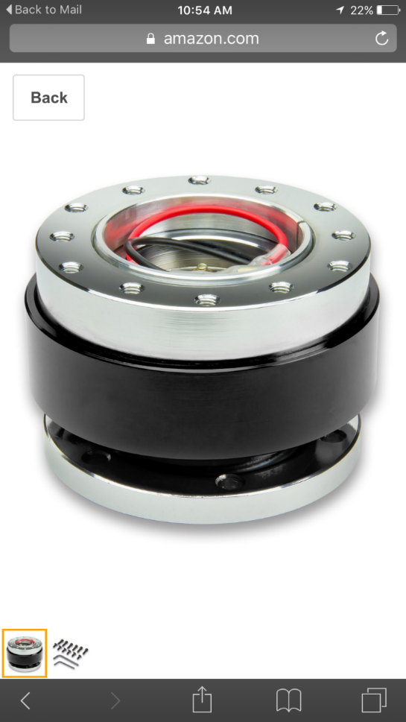

Figure 4: Quick release mechanism use to connect the entire system together while allowing for easy removal.

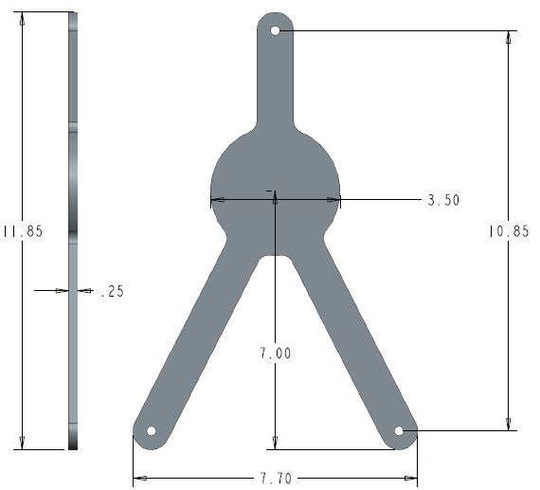

Figure 5: Mass Flow Sensor clamp; used to secure the sensor to the quick release.



Figure 6: The complete bracket assembly with sensor attached. 1 shows the quick release system that allows for quick removal of the sensor from the pipe. 2 shows the slotted groves that allow band clamps to attach the bottom portion of the bracket to the pipe. Finally, 3 shows the front of the bracket where the hardware attaches the sensor to the bracket system.

# Project Set up Procedure

To begin installation of the sensor package (although it is not necessary for operation of the sensor) it is advised that the system be shut down so that the sensor may be zeroed to the new HVAC system for increased accuracy. The next step in the installation is to attach the base of the bracket to the pipe where desired via band clamps. Next, the sensor must be securely attached to the front of the bracket and snapped onto the base using the quick release system. After the sensor has been attached to the pipe it can now be wired and turned on using a standard 120 Volt outlet. On startup of the sensor the user will be prompted to insert the physical properties of the pipe including its inner and outer diameters and its material. It is important to know the schedule pipe on which the sensors are being mounted for accurate dimensions of the pipe. After the pipe parameters are input into the sensor, it will automatically calculate the distance that the transducers must be spaced apart to get the correct time differential between pulses. It is extremely important to note that the distance is measured from the inner edges of each transducer and they must be mounted on the same axis. Care must be taken when placing them so that accuracy is upheld. For better understanding this topic, refer to the trouble shooting section of this manual

Also important to note, the sensor takes into account whether a transducer is located up stream or downstream of the pipe and must be wired into the sensor accordingly. The Mass flow sensor will now read the velocity of the fluid flowing through it and output numerous statistics and measurements that aid in monitoring the system. This will complete the installation of the sensor package and will provide the efficiency of the compressor in addition to Turbocors current compressor monitoring processes.

The sensor module can display data in different units. The current output of the data is not affected by the units used in the sensor set-up and will function regardless. However, if the user would like to change the units displayed on the LCD build into the module, refer to the sensor instruction manual to do so.

# Operations Instructions

The sensor package requires little to no hands on operation. After the sensor has been set up and put in place it will be able to read every metric that is necessary to calculate the compressor efficiency.

# Trouble Shooting

During the initial set up and installation of the mass flow sensor there are important parameters that need to be taken into account. Ignoring or overlooking these parameters could lead to inaccurate data flow and cause unnecessary red flags. Common problems that can arise and troubleshooting solutions follow.

## Incorrect Mass Flow Rate

### Transducer Piping Contact

To ensure an accurate flow rate the transducer and pipe must be in direct contact with no obstructions. It is necessary to clean the pipe and apply a dielectric grease/silicone compound to the side of the transducer that is in contact with the pipe. 3M silicone paste was provided by Turbocor for our application.

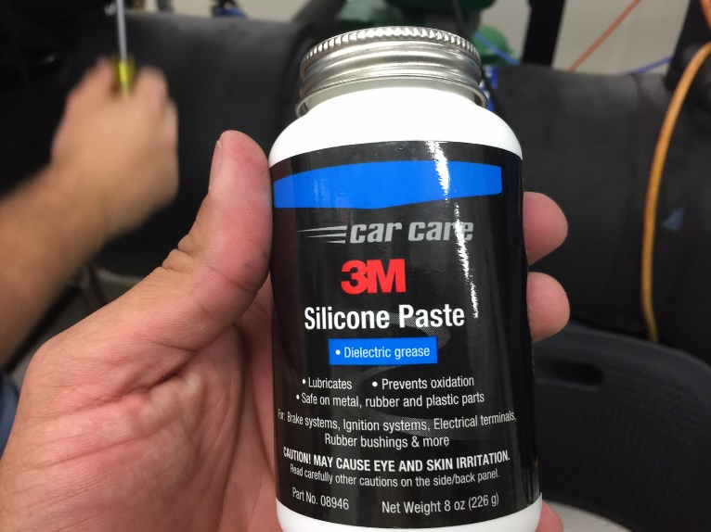

Figure 6: 3M silicone paste

### Transducer Spacing

Transducer spacing on the piping system depends solely on the input pipe dimensions. Once the parameters are input, the system will specify the distance apart the transducers should be. This distance is measured between the front faces of the transducers. It should be noted that if the transducers are not within ±3 inches of the specified measurement the flow meter will not display a reading. While calibrating the sensor, the transducer distance was varied slightly and revealed a 2% error in the mass flow rate per half inch of distance error between the transducers. A caliper should be used to measure this distance.

### Transducer Wiring

Once the transducers are mounted on the pipe, it is necessary to wire them into the TDS-100 board. The orientation of the transducers upstream or downstream in the flow determines which port to wire them into. The power supply 120V cord must also be wired into the board. The figure below shows how the three cords were connected.

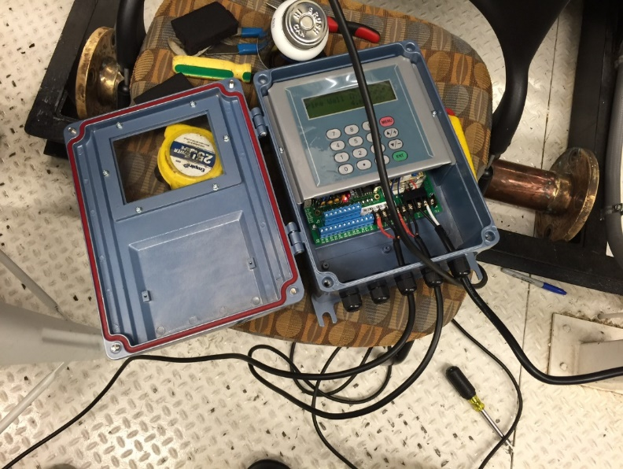

Figure 7: Wired Sensor Module

### Pipe Specifications

After the board is powered and the transducers are mocked up to the pipe, it is necessary to input certain parameters about the system. Material of the pipe, inner and outer diameter of the pipe, and liquid in the pipe. It is imperative that the pipe parameters be accurate and be input correctly. If the pipe has an interior liner, the sensor takes this into account and this parameter must also be input. Erroneous pipe dimensions will have a drastic effect on the flow that the sensor is reading.

### Transducer Mounting

It is necessary to mount the transducers on a section of pipe that is straight and free of sharp bends or valves within 5 diameters upstream or 10 diameters downstream. These obstructions cause turbulence in the flow and will give inaccurate readings. It should be noted that the pipe orientation is negligible. The figure below shows a team member mounting the transducers on a stainless steel pipe at a 45 degree angle.

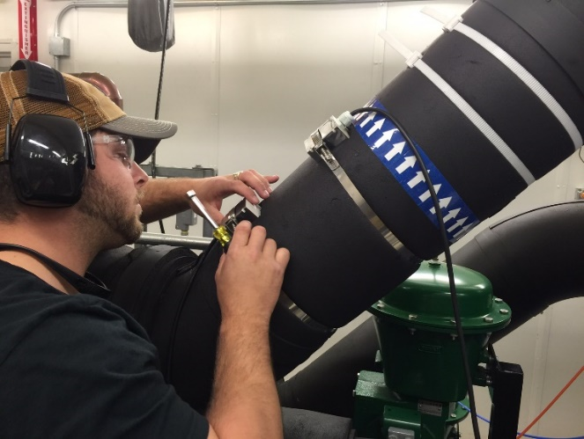

Figure 8: Transducer mounting

### Set Sensor Zero

Although not necessary, zero the sensor in place when the system is off and no mass flow is detected. This is step can (in some cases) improve sensor accuracy for the particular application.

# Regular Maintenance

## Minor maintenance

Once the transducers are in place the system requires little to no maintenance throughout the life of the system. If vibrations in the piping system are evident the sensor spacing should be checked on a yearly basis, and tightened accordingly. This could cause error in the mass flow rate readings. The gasket that seals the TSD-100 board should be checked every 5 years and replaced if it becomes non-resilient. This ensures no debris get inside the system.

# Spare Parts

With the rugged design of both the mass flow sensor and the bracket system, the sensor package will rarely need to have parts replaced. As outlined in the maintenance section, a spare housing gasket should be kept to be replaced every 5 years per the maintenance schedule. Dielectric grease should be kept in stock as well. If the sensors have to be adjusted, the previous residue should be cleaned off and a fresh coat re-applied to the bottom surface of the transducers before mounting them back to the pipe surface.