Pedibus - Spring 2015 Operations Manual

Kyle Anderson#1, Stephen Avery #2, Alejandro San Segundo #3, Brett Willenbacher #4

*# Mechanical Engineering Department, FAMU-FSU College of Engineering  
2525 Pottsdamer Street, Building A, Suite A229*

*Tallahassee, Florida; United States 32310-6046*

1kca10@my.fsu.edu

2 sja12@my.fsu.edu

3as10s@my.fsu.edu

4 blw11c@my.fsu.edu

**April 3, 2015**

**Mr. Ronald Goldstein:** Project Sponsor

**Dr. Chiang Shih:** Project Mentor/Mechanical Engineering Chair

**Dr. Nikhil Gupta:** Project Co-Mentor

**Mr. Keith Larson:** Project Advisor

***Team Biography***—

**Mr. Ronald Goldstein:** Founder of Capital City Pedicabs, has traveled all around the United States working in a variety of industries including hospitality, imports, real estate and public service. It was during a family vacation in 2005 that the seed was planted for the pedicab business [1].

**Kyle Anderson:** Kyle is a senior seeking his B.S. degree in Mechanical Engieering at the FAMU/FSU College of Engineering. Being involved with SAE his entire college career, Kyle proves to be a key aspect to the vehicle designing and leadership of the project. His experience consists mostly of hands-on builds.

**Stephen Avery:** Stephen is a senior seeking his B.S. degree in Mechanical Engieering at the FAMU/FSU College of Engineering. Being the chassis designer for SAE Baja 2014-2015 vehicle and SAE Senior member, he brings a lot to the table with the structure and safety of the project.

**Alejandro San Segundo:** Alejandro is a senior seeking his B.S. degree in Mechanical Engieering at the FAMU/FSU College of Engineering. With past professional and leadership experience involving fast paced professional environments, his skills bring a strong contribution for the Pedibus project. Alejandro also has a strong background in cycling and ergonomic design, which is a large majority of the Pedibus project.

**Brett Willenbacher:** Brett is a senior seeking his B.S. degree in Mechanical Engieering at the FAMU/FSU College of Engineering. With track courses in both vehicle and machine design, he helps bring the transportation aspect of the project to life.

Table of Contents

I. FUNCTIONAL ANALYSIS OF PEDIBUS 2.0 1

II. PRODUCT SPECIFICATIONS 1

A. FRAME 1

B. POWERTRAIN 2

C. BRAKES AND WHEELS 3

D. TOWING TORSION AXLE 3

E. STEERING 4

III. FINAL PRODUCT ASSEMBLY 4

IV. OPERATION INSTRUCTIONS 5

V. TROUBLESHOOTING 6

VI. MAINTENANCE 6

VII. PARTS PROCUREMENT 6

Appendix A 7

Appendix B 12

Appendix C 13

**TABLE OF FIGURES**

Figure 1. *CAD Renderings of Pedibus frame* 2

Figure 2. *Bicycle cranks mounts on frame* 2

Figure 3. *CAD rendering of rear axle assembly* 3

Figure 4. *Wheels utilized on Pedibus* 3

Figure 5. *CAD render of steering assembly and rack and pinion* 4

Figure 6. *CAD render of complete vehicle assembly* 4

Figure 7. *The Pedibus 2.0 after completion of fabrication* 5

# FUNCTIONAL ANALYSIS OF PEDIBUS 2.0

The Pedibus 2.0 is a multi-user pedal powered vehicle made for the sole purpose of customer entertainment. The vehicle consists of a ladder style steel frame similar to those used in commercial automotive applications. It features a bench seating arranged that accommodates ten peddlers with extra room for non-pedaling passengers. The Pedibus 2.0 project is sponsored by Ron Goldstein, owner of Capital City Pedicabs. The main scope of the Pedibus is to serve as a leisure vehicle in which riders can enjoy refreshments while pedaling around the Tallahassee downtown area. More specifically, the vehicle will serve as a bar on wheels that will attend customers while transporting them between destinations. As of now, the sponsor has no exact business model as to how this vehicle will be implemented into the fleet or which areas it will service.

The functionality and operation of the vehicle itself is quite simple. The customers will board the vehicle and situate on a spot on the bench depending on whether they’re pedaling of not. If pedaling, the passenger will situate themselves in front of a crank. Upon the cranks are mounted in such way that upon pedaling the chain will transfer the motion to one of two drive shafts that run under the frame along the length of the vehicle. The chains are mounted on the shaft with freewheels which not only prevent back drivability but also allow for riders to hold different pedaling cadences. These shafts connect to the transaxle on the back of the vehicle with spur gears which transfer the motion through the transaxle and subsequently to the wheels. This is the scope overview for how the Pedibus works under standard operation. The passengers hold no responsibility other than pedaling. The driver of the vehicle has a set of simple controls to operate which include: a hand brake, a brake pedal, the steering, the shifter and turn signals. The manual transaxle implemented allowed for the vehicle to have six forward speeds and a reverse gear. This gave a vehicle better maneuverability which the ability to reach comfortable cruising speeds but also having low gears for better torque output for hill climbing. The vehicle driver is responsible for understanding the dynamics of a manual transmission in order to efficiently shift the vehicle into the appropriate gear ratios depending on the current driving conditions.

The Pedibus 2.0 was also designed to be free weight towable; which means that it can be towed by any truck with a standard hitch mount. A torsion axle was added to the design in order to eliminate the need for added suspension on the frame. The versatility of the towing allows the sponsor to expand his business model further than the confines of Tallahassee. The sponsor has plans of utilizing this vehicle in nearby towns such Panama City and Pensacola.

The following document outlines the specifics regarding the operation and maintenance of the Pedibus 2.0 vehicle.

# PRODUCT SPECIFICATIONS

The Pedibus 2.0 is composed of several, semi-complicated subsystems with many specifications each. The following subsections are a breakdown of the specific components utilized in the Pedibus project.

## FRAME

The frame of the Pedibus is a ladder style frame fabricated of A500 box steel. The vehicle, and frame, length is 16ft with a max with of about 100in. Staying under 102in. of vehicle width was crucial in order to stay in regulation with the Florida towing laws which states that vehicle must be under said length to be legally registered as a towable trailer. The CAD renders of the finalized frame design is depicted in figure 1. These frame renders show the width of the vehicle under the allowed legal limit as well as depict the ladder style after much optimization and simplification.

**Figure 1.** *CAD**renderings of Pedibus frame showing both a skew angled view of the entire frame structure as well as a cross sectional front view which shows the dimensions of the frame.*

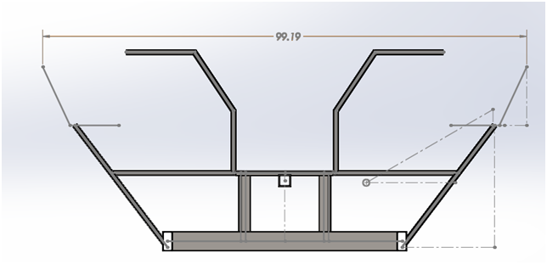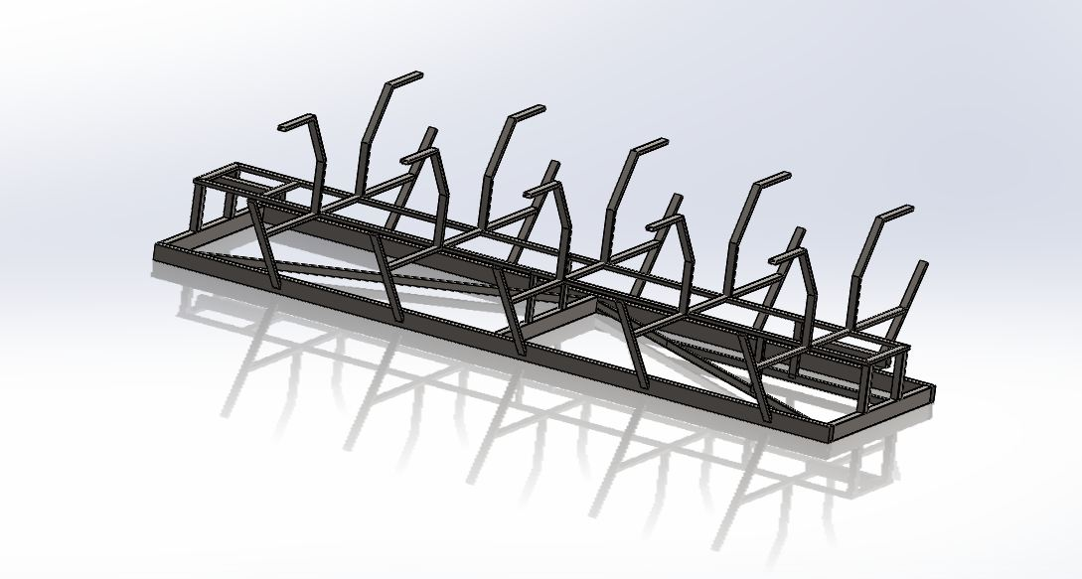

## POWERTRAIN

The powertrain of the vehicle includes several different components that efficiently transfer the power input from the pedals to the wheels of the vehicle. The cranks are mounted of the bottom brackets attached to the frame as seen in figure 2. The single speed bicycle chain utilized connects the crank to one of the two drive shafts under the vehicle.

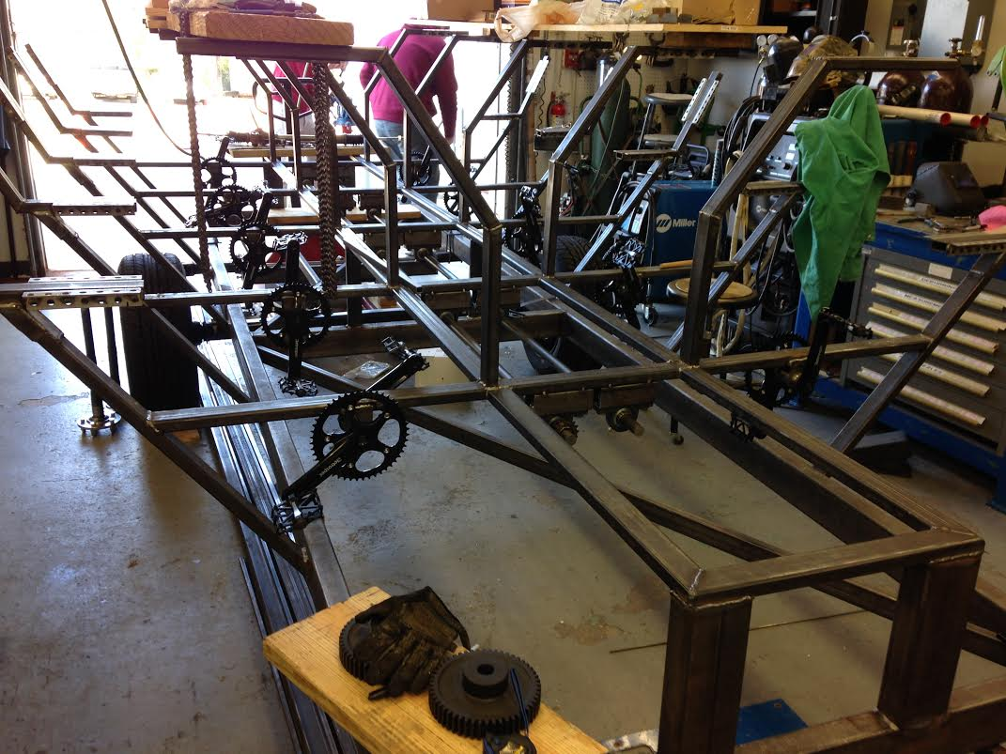

**Figure 2.** *Mounted bike cranks on frame after alignment with driveshaft freewheels*

The 1 inch cold rolled steel shafts run the length of the vehicle and connect to the transaxle. The transaxle used is a Peerless 820 lawnmower transaxle that feature 6 forward speed and a reverse gear. The transaxle acts as an integrated transmission and differential. The system was mounted to the rear of the frame using independently supported axle shafts. A render of the Peerless 820 transaxle as well as the integrated system that was mounted to the vehicle is shown below in figure3**.** Further specifics of the actual transaxle can be found in the manufacturer’s user manual for the part.

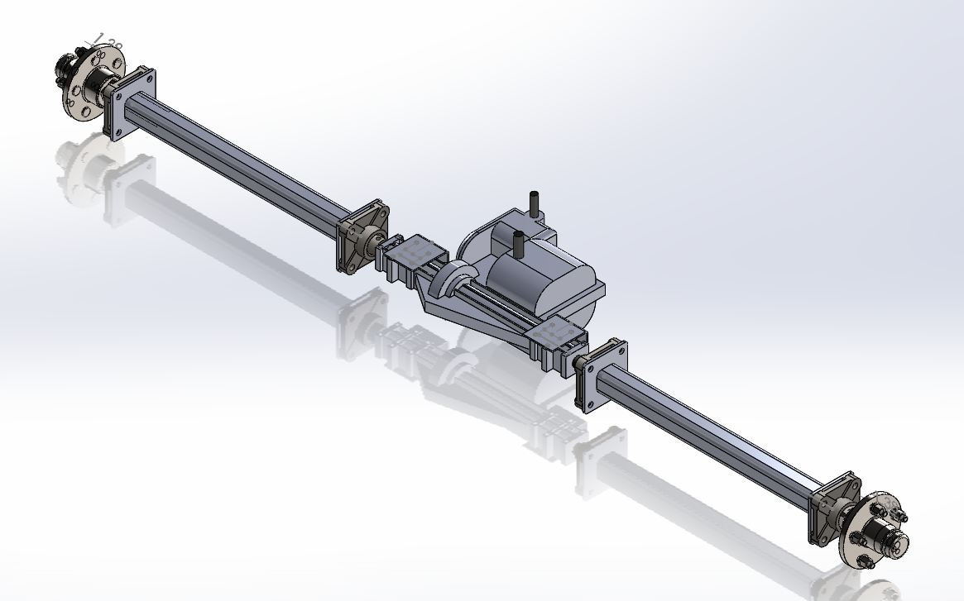

**Figure 3.** *CAD rendering of rear axle Pedibus subsystem. The render includes the Peerless transaxle as well as the mounted shafts and the wheel mounts.*

## BRAKES AND WHEELS

The Pedibus design utilized automotive brake systems. These are hydraulic disc brakes that work simultaneously from the brake pedal. The vehicle features 10in. disc brakes in the front axle and 8in. discs on the rear axle. Besides the hydraulic normal operation breaking system, an emergency hand brake was implemented to the bus. It is a mechanical car hand brake that is connected via steel cable from the cockpit to the rear right wheel. The Pedibus also features 10in. electric drum brakes that were mounted onto the torsion axle; this will allow for safer towing.

The Pedibus features 16” trailer wheels with a 5 on 4.5” bolt on pattern. The wheels utilized on the project are shown in figure 4 below.

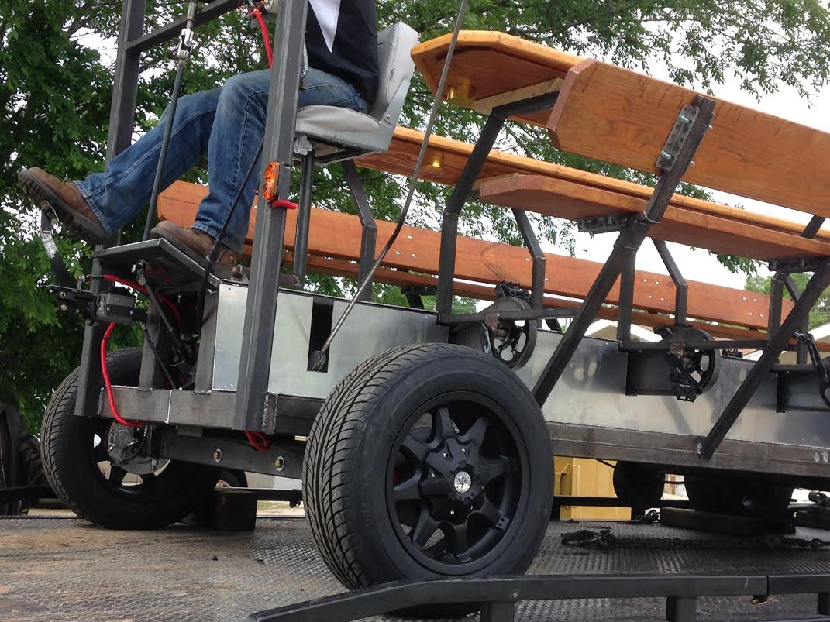

**Figure 4.** *16” trailer wheels utilized on the fabrication of the Pedibus.*

## TOWING TORSION AXLE

A rubber torsion axle was implemented onto the design to allow for the ability of towing. It is attached to the frame on a 2:3 ratio from the front, as it is standard for single axle towing platforms. The rubber torsion axle is rated by the manufacturer for a maximum load of 3500lbs, which more than enough for what is needed in this application.

## STEERING

The Pedibus features a custom fabricated rack and pinion steering with a straight axle set up. The steering design implemented allows for a curb to curb of under 45ft, which is comparable to that of a Ford F150. Figure 5 below shows a render of the steering design implemented as well as the actual rack and pinion system that purchased.

***Figure 5.*** *CAD render of steering Pedibus steering assembly as well as the rack and pinion system implemented on the product.*

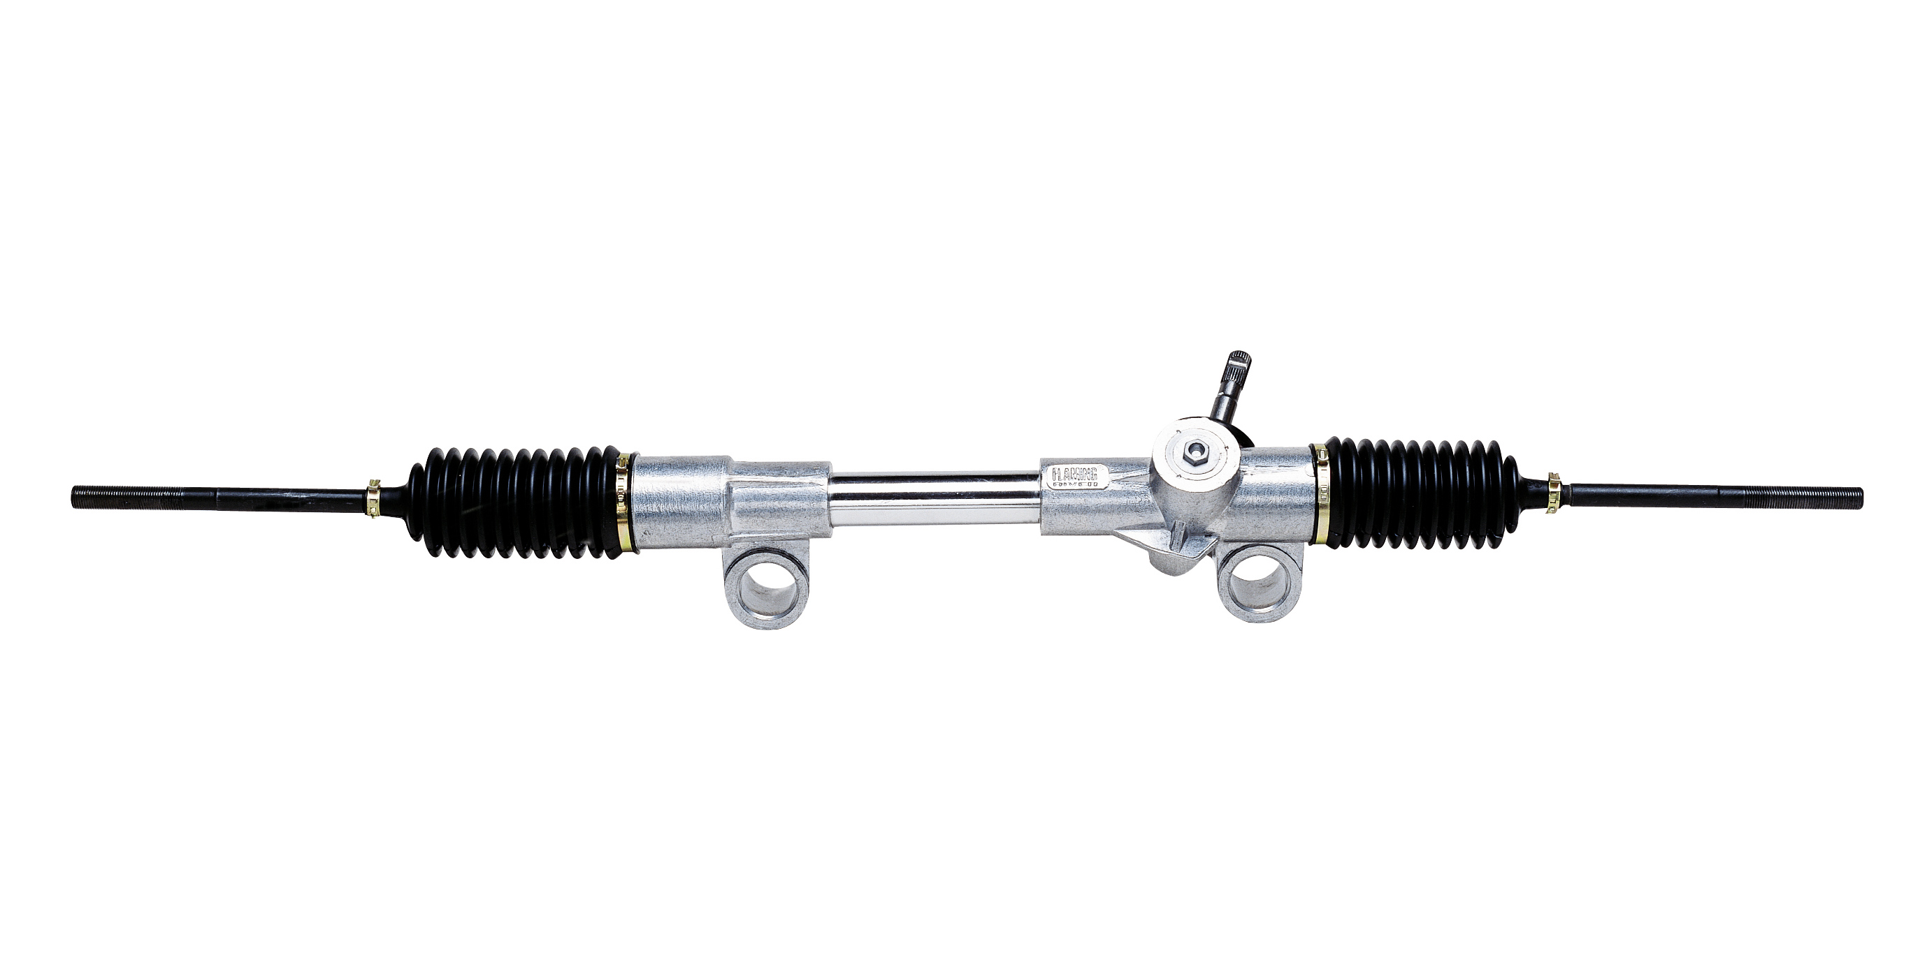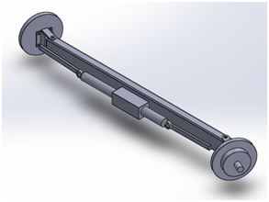

# FINAL PRODUCT ASSEMBLY

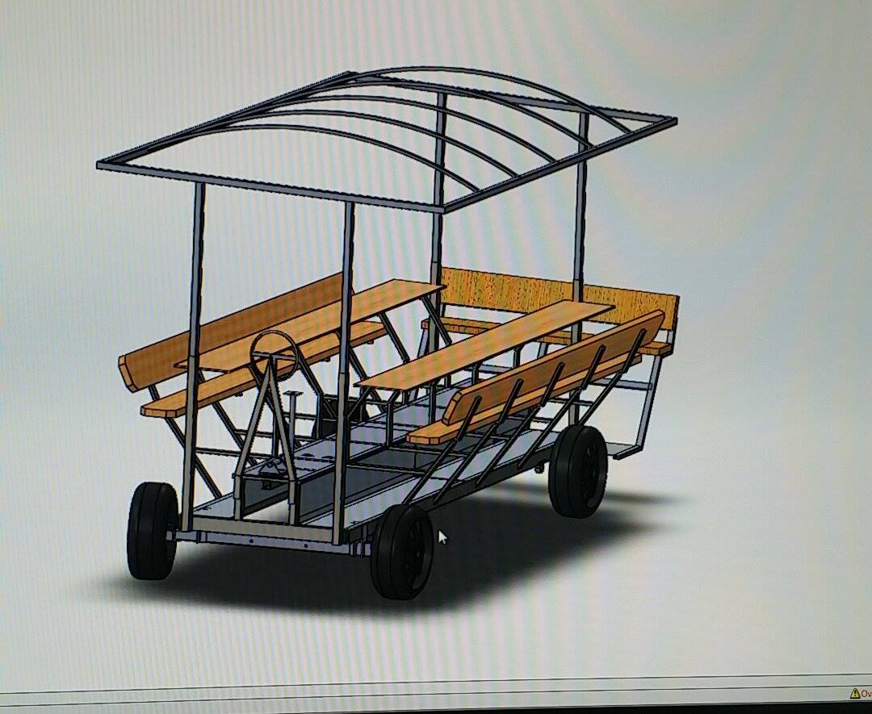The final vehicle design render is depicted in figure 6 below. This figure shows the overall render of the vehicle which includes the mounted bar tops, benches, and roof awning. The main subcomponents, such as the steering and the powertrain, can be seen in these renderings as well as they’re placement on the vehicle. Other render views of the vehicle from different angles are found in Appendix C.

***Figure 6****. CAD render of entire, finalized Pedibus assembly including all main subcomponents*

The vehicle CAD model is, as expected, not a perfect replica of the physical vehicle as there were slight changes that occurred upon manufacturing that were not drastic enough to merit a re-render of the Pedibus in the CAD program. Figure 7shows pictures of the physical vehicle after its finalized fabrication and assembly.

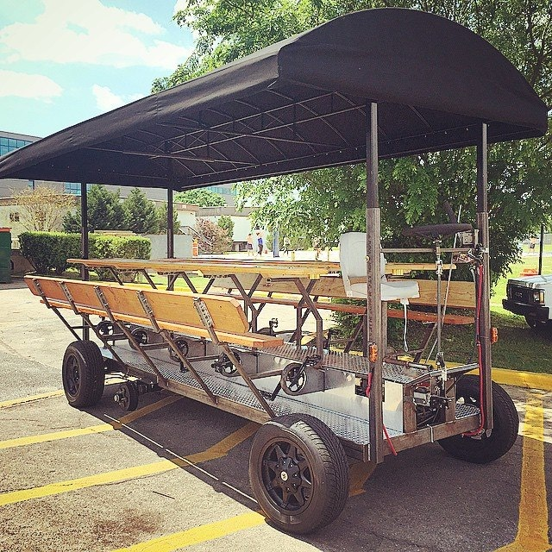

***Figure 7.*** *Completed Pedibus 2.0 vehicle*

# OPERATION INSTRUCTIONS

Prior to vehicle operation, there is a simple check list that the operator must check in order to ensure safe and successful operation. The actual checklist that has been handed off to the sponsor is shown in Appendix A. This checklist includes simple task such as checking the tire air pressure, checking for leaks in the brake lines as well as battery charge status. The pre-operation completion of this checklist is crucial in order to ensure safe operation.

Upon usage, the vehicle operation is relatively simple. The passenger have the sole responsibility of pedaling, all other operation of the vehicle will be performed by either the bartender of the driver. The passengers must stay alert for any further instructions from the driver during vehicle operation.

The driver has responsibilities similar to those of any driver of a commercial vehicle. The operator is in charge of steering the vehicle as well as maintain a safe route while in motion. The operator is also responsible for the controls of the vehicle. These include: turn signals, which the driver must utilize accordingly during operation, a regular foot pedal brake similar to that of a car, and an emergency hand brake leaver that will lock the wheels in the need of a sudden stop. The diver must also understand the working of manual transmission and he or she will be responsible for shifting between the different speeds of the gearbox depending on the driving conditions. The gear box shifts linearly with the reverse gear being in the most upright position of the shifter, followed by neutral and the six forward speeds subsequently. When vehicle is parked, the hand brake must be engaged in order to reduce load on the transaxle as well as to avoid any undesired rolling.

Upon flatbed towing of the vehicle, the operator must ensure that the emergency brake is engaged. When free weight towing the vehicle, the operator must switch the rear wheels of the bus from rear axle onto the torsion axle. After that, he or she must hitch the Pedibus onto the towing vehicle and connect the trailer lights into the tow plug on the towing vehicle. This is crucial as it will activate the electric towing brakes as well as the brake and turn signals fot he Pedibus while in tow. Before towing, the operation must ensure that the roof awning of the vehicle is either removed completely of the tarp covering untied and take off. This is of most importance as failure to do so will create large amounts of wind resistance, a parachute effect, while in tow and can cause the vehicle to bounce or flip.

# TROUBLESHOOTING

Troubleshooting of the Pedibus is complicated to predict and thus a solution will most likely have to be generated upon inspection of the particular failure. The general design of all subsystems utilized on the vehicle closely resemble those on many commercial vehicle. The team worked hard to ensure simple and common designs that any car mechanic would be able to repair and work on. Upon failure of any particular component that was outsourced, it is most advised to contact manufacturer for either repair or replacement of the part.

# MAINTENANCE

The regular maintenance of the Pedibus is simple and any person with slight mechanical knowledge can perform it. The following text breaks down the maintenance into the main subcomponents and explains what the procedure for each case is.

*Steering Components:*

Steering Rack: Never. If problem occurs contact automotive repair specialist

Heim Joints: 6 months. Grease with Automotive Bearing Grease.

Steering U-joints: Never. Replace if failure occurs.

Steering Mount Bushings: Pre-lubricated, Impregnated Brass/Bronze. Oil or replace when worn

*Pedaling Components:*

Cranks: Pre-lubricated, replace if failure occurs.

Driveshaft Pillow Block Bearings: 6 months. Grease with Automotive Bearing Grease.

Freewheels: Never. Replace if failure occurs.

Bicycle Chains: Check tension before every use. Lubricate with 80w90 or equivalent every 3 months.

*Drivetrain Components:*

Transaxle: Never. Pre-lubricated. Contact Lawn and Garden Service Professional if problems occur.

Axle Support Bearings: 6 Months. Grease with Automotive Bearing Grease.

Driveshaft Gears: 6 months. Automotive Bearing Grease.

Transaxle Chain: 3 Months, Lubricate with 80w90.

*Brakes and Tires:*

Brake Fluid: Dot 3 Brake Fluid. Bleed yearly. If brakes feel soft check fluid and bleed again.

Brake Pads: Inspect for consistent wear and replace when worn once yearly.

Tires: Check tire pressure before each use.

Tire Replacement: Replace when tread depth is below 1/16”, if sidewall damage occurs, or every 7 years

Tire Rotation: Check tread depth at 3 points widthwise, if difference is more than 1/16” rotate tires.

Following the advised maintenance schedule will ensure proper function throughout the life of the vehicle. Most components utilized were outsourced, off the shelf part. This allows for easy and quick replacement of any damaged parts which will ensure minimal vehicle downtime as well as ease of repair.

# PARTS PROCUREMENT

One of the main scopes of the team was to utilize as little custom fabrication of any of the components and to integrate as many off the shelf parts as possible. This was done in order to facilitate the possible replacement of any part on the vehicle. A complete procurement list of all the specific parts purchased for the full fabrication of the Pedibus as well as information on the vendors and cost is located in Appendix B of this document.

# Appendix A

Pedibus 2.0 pre-operation checklist

1. Check tire pressure (40psi)
2. Check brake line for leaks
3. Pump brake pedal to ensure proper bleed and function
4. Check handbrake cable and proper brake engagement
5. Inspect steering assembly for damaged/broken parts
6. Check all 10 bicycle chains for lubrication, tension, and proper engagement
7. Check that cranks are tighten onto bottom brackets
8. Check battery charge status
9. Check for burnt out bulbs in brake lights and turn signals
10. Inspect frame for any corrosion of damage
11. Inspect proper fastening of roof pins
12. Check for damage to wood on benches (water damage)

# Appendix B

# Appendix C

The following are the CAD renderings for the final assembly of the Pedibus 2.0. These renders do not show the roof awning as it was outsourced.

