**FAMU/FSU College of Engineering**

**Department of Mechanical Engineering**

**Midterm Report 1**

**Team #22: Development of Functional Pedibus**

**Names:**Kyle Anderson (kca10)   
Stephen Avery (sja12)

Alejandro San Segundo (as10s)

Brett Willenbacher (blw11c)

**Date:** 10/31/14

****Table of Contents****

Abstract v

1 Introduction 1

1.1 Objective 1

1.2 Background 1

1.3 Problem Statement 1

2 Project Definition 2

2.1 Background Research 2

2.2 Need Statement 2

2.3 Goal Statement and Objectives 3

2.4 Project Constraints 3

3 Design and Analysis 4

3.1 Mechanical Design Concepts 4

3.2 Material Selection 4

3.3 Frame Design 4

3.3.1 Box Style Frame 5

3.3.2 C-style frame 5

3.3.3 Supported Ladder Style Frame 6

3.3.4 Frame Design Selection 7

3.4 Peddler Input 7

3.4.1 Crossed Chain Linkage 7

3.4.2 Dual Drive Shaft Chain Drive 8

3.4.3 Pump Motion Crankshaft Linkage 8

3.4.4 Peddler Input Selection 9

3.5 Drivetrain 9

3.5.1 Solid Rear Axle 10

3.5.2 Hydrostatic Rear Transaxle 10

3.5.3 Manual Rear Transaxle 10

3.5.4 Drivetrain Selection 10

3.6 Suspension 11

3.6.1 Dual Leaf Sprung Solid Axle 11

3.6.2 Front Leaf Sprung Axle 11

3.6.3 Suspension Selection 12

3.7 Steering 12

3.7.1 Existing Vehicle Components 12

3.7.2 Trailer Hub “Cut and Weld” 12

3.7.3 Custom CNC Components 12

3.8 Brakes and Tires 13

3.8.1 Hydraulic Front and Mechanical Rear 13

3.8.2 4-wheel Hydraulic Disc 13

3.9 Ergonomics 13

3.10 Electronics 16

4 Specifications and Analysis 17

4.1 Frame Specifications 17

4.2 Drivetrain Specifications 17

4.3 Transaxle Specifications: 17

4.4 Brakes and Tires 18

4.5 Steering 18

5 Methodology 20

5.1 Schedule 22

5.2 Resource Allocation 22

6 Conclusion 24

7 References 25

****Table of Figures****

Figure 1. Box style frame render 5

Figure 2. C style frame render 6

Figure 3. Ladder style frame render 6

Figure 4. Crossed chained linkage 8

Figure 5. Dual drive shaft chain drive 8

Figure 6. Bench ergonomic cushion side view 8

Figure 7. Standard passenger riding style 15

Figure 8. Recumbent passenger riding style 15

Figure 9. Hybrid passenger riding style 16

Figure 10. Process flow chart 21

Figure 11. Gantt chart 22

****Table of Tables****

Table 1. Frame material decision matrix 4

Table 2. Frame design decision matrix 7

Table 3. Peddler input decision matrix 9

Table 4. Drivetrain decision matrix 11

# ****Abstract****

Capital City Pedicabs has sponsored a project to create a human powered vehicle. The team responsible for the development of this project has reached a milestone. Therefore, a reporting of the current progress and the future plans regarding the project has been outlined. Current progress includes the design concepts and selection of components for major subsystems, including, material selection, frame, and drivetrain. Additionally, the current design progress of the remaining subsystems has been outlined, focused primarily on, steering, brakes, ergonomics, and suspension. In light of recent team restructuring, the design aspects regarding electronics is in the process of being re-evaluated. A structured schedule explaining the steps required to complete the project within the deadline, including design and fabrication schedules is also included. The team is preparing for the next progress milestone by finalizing the existing designs and ordering components in preparation for fabrication.

# **Introduction**

## **Objective**

The objective of this project is to develop a fully functioning, multi-person, pedal powered vehicle. This vehicle is designed to be used as an entertainment revenue tool by Capital City Pedicabs, our sponsor. Therefore, considerations such as safety of riders, comfort, user fatigue, and entertainment value must all be considered. This creates an interesting project for this year’s senior design team assigned to the Pedibus.

## **Background**

This is the second year that the Pedibus project has been presented to the FAMU/FSU College of Engineering. The vehicle produced by the previous team, while functional, failed to meet the sponsor’s desires as far as marketability. Issues such as reliability, ease of use, and user comfort, along with the lack of available entertainment, made the previous version less marketable. This year’s goal is to create a better design that also incorporates many of the revenue generators and attractions that were not present previously, while still maintaining a reliable and safe vehicle.

## **Problem Statement**

Since this is the second year of this project, it was possible to evaluate the previous team’s work and decide what needed to be changed. Last year’s project was successful in terms of meeting the initial goals, however, considerations such as being able to transport the vehicle were not considered. Therefore, this year’s main objective is to create a more usable and marketable design. This year’s Pedibus will also have a larger footprint in order to incorporate more peddlers while increasing the entertainment value and stability of the vehicle. Additionally, the ability to transport the vehicle without the need of a flatbed is another design concern. This feature will allow the sponsor to maintain a lower overhead cost, increasing profits.

# **Project Definition**

## **Background Research**

The concept of a multi-user bike utilized for leisure and group entertainment is an existing concept. Typically, this type of vehicle is used as a mobile attraction, often including on board entertainment and refreshments. In other cities this type of vehicle has existed through a variety of different names (i). This business model is a fairly recent development for major cities in the United States. A handful of private investors have had one of these vehicles fabricated to fit a specific business model. These vehicles vary in design and performance since there is no single manufacturer that has monopolized production. Although different in detail, all party bikes share several characteristics, such as the seating arrangements and similar frame construction. The current project sponsor, Ron Goldstein, owner of Capital City Pedicabs, has requested an original design based on the aforementioned vehicles as a new venture for Capital City Pedicabs. This is a unique design challenge due to the environmental constraints present in Tallahassee. Because of the custom nature of these machines, literature regarding the design specifications is difficult to source, therefore the team will be working closely with the sponsor to ensure an acceptable product. The fabrication of this project was attempted last year by another senior design team and some of their design concepts will be implemented into this build, but most of the final product will remain original and one of a kind.

## **Need Statement**

The Pedibus project is sponsored by Ron Goldstein, owner of the Capital City Pedicabs. The sponsor wants to have a fully functional multi-user bike in order to institute a new business model to the city of Tallahassee. While this project was completed by the previous team, the product that was delivered was not satisfactory. Many of the design objectives originally set in place by Mr. Goldstein, were not met. This led to the sponsor having to hire a third party fabricator in order to complete the vehicle.

*“Currently, the sponsor is without a usable vehicle to support this new business model.”*

## **Goal Statement and Objectives**

The Pedibus senior design team plans to deliver a fully-functional and optimized Pedibus to Ron

Goldstein by March 14, 2015. The goal of this project is to design and fabricate a multi-person, human powered vehicle. This vehicle should be able to support the sponsor’s business model as well as operate efficiently under Tallahassee’s unique needs.

1. Accommodate a minimum of 10 occupants powering the vehicle
2. Accommodations for additional occupants, other than those powering the vehicle
3. Simple construction for easy maintenance, fabrication, and reproduction
4. Ability to be transported by a standard full-size pickup truck
5. Modular accessories to allow for accessory expansion post-fabrication
6. Able to transverse a 8% grade comfortably

## **Project Constraints**

The primary constraint of this project is to deliver a functioning Pedibus to Capital City Pedicabs by March 14, 2015. This constraint is to ensure that the vehicle is built, operational, and tested prior to the debut at Spring Time Tallahassee. Additionally, the vehicle must be simple to fabricate and reproduce, using a simple design and as many off the shelf components as possible. The design constraints set in place by the sponsor are fairly relaxed however, the following additional constraints are listed below.

1. Shop drawings must be made for all fabricated components
2. Must be moveable by a single rider and a driver
3. <1499 lbs rolling weight
4. Able to hold 3000 lbs payload safely
5. Must meet all regulations for homemade trailer
6. Must be safe to tow on the freeway

Many of the design concepts shown below have special considerations in order to meet the criteria defined above.

# **Design and Analysis**

## **Mechanical Design Concepts**

The Pedibus contains a number of various subsystems. All of which require some form of design analysis in order to most efficiently plan the construction of the vehicle. The following sections discuss the various subsystems that have design considerations constructed and organized in order to report the project progress in an efficient manner.

## **Material Selection**

Several materials were considered for the primary build material. These materials include A500 Box Steel, 6061 Aluminum Box, and a mix of both materials. All of the materials have different advantages and disadvantages but it is important to note that aluminum can not directly be attached to steel components via the welding resources available. This requires the construction of various brackets and fasteners which will increase the cost and complexity of the project.

Below a design matrix can be seen that directly compares the aforementioned materials.

Table 1. *Frame material decision matrix*

|  |  |  |  |  |  |
| --- | --- | --- | --- | --- | --- |
|  | **Weight** | **Cost** | **Rigidity** | **Machinability** | **Weighted Sums** |
| **A500 Steel** | 5 | 9 | 9 | 7 | 119 |
| **6061 Aluminum** | 8 | 6 | 4 | 4 | 94 |
| **Hybrid** | 7 | 7 | 6 | 3 | 89 |
| **Weight Decision** | **5** | **3** | **2** | **7** |  |

## **Frame Design**

The team developed three design ideas for the frame. These three design ideas include a box style frame, supported ladder frame, and a C frame. These three designs will be discussed in detail in the next few paragraphs.

### **Box Style Frame**

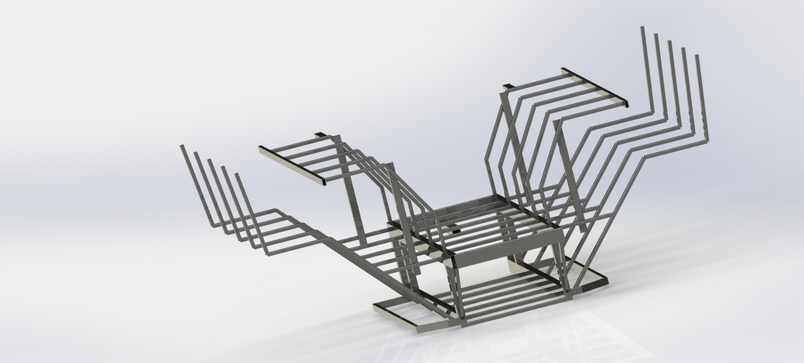The box style frame consists of a central rectangular box structure with supports extending out from the side. This design allowed for all of the drive and electrical components to be contained inside the box section of the frame. Additionally, this design had the best separation of the passengers from any moving parts and was therefore considered one of the safer designs. However, this design used significantly more material and had a much larger foot print than desired.

Figure 1. *Box style frame render*

### **C-style frame**

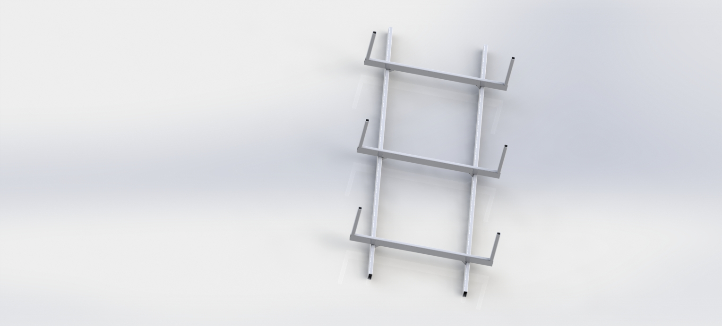This frame design was the simplest of the three and consisted of primarily 2x4 and 2x2 members cut at 90º angles and arranged in a horizontal C shape. This design is very similar to the stringer setup on some boats. While this design allowed for the most variability in component selection it was also the least durable in terms of not allowing the frame to flex. Additionally, the frame offered no built in separation of components from the peddlers.

Figure 2. *C style frame render*

### **Supported Ladder Style Frame**

The ladder style frame is a mix of the two frames mentioned above. It has a wider center to center width of the primary lower frame rails. This allowed for greater axle support, a wider track width, and more subtle angles than either of the two previous designs. It also gave some degree of separation of components from the peddlers, less moment on the seats, and greater support of the seat tubes than either of the two previous designs.

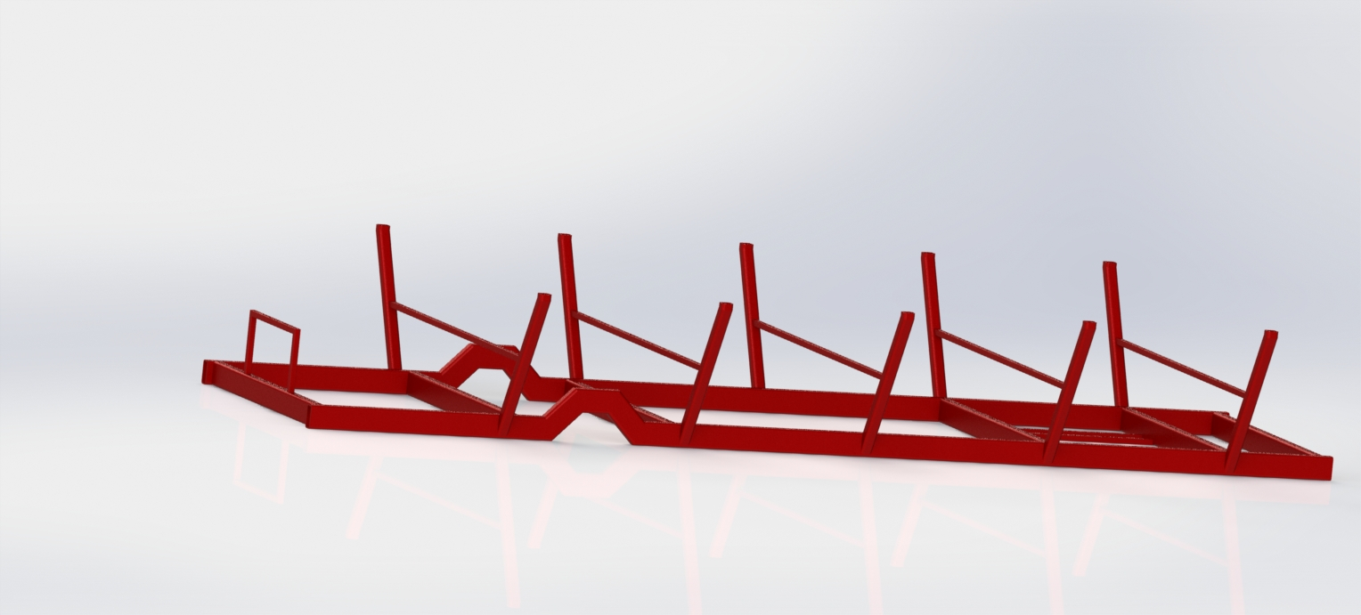

Figure 3. *Ladder style frame render*

### **Frame Design Selection**

Ultimately, the Supported ladder style frame was chosen due to the simplicity and ease of manufacturing of the design. Additionally, this design offered the best mix of efficient space utilization and structural rigidity. Below a design matrix outlining the major pros and cons of each style is shown.

Table 2. *Frame design decision matrix*

|  |  |  |  |  |  |  |
| --- | --- | --- | --- | --- | --- | --- |
| **Frame Design Decision Matrix** | | | | | | |
|  | **Strength** | **Fabrication** | **Complexity** | **Weight** | **Cost** | **Weighted Sums** |
| **Box-Style Frame** | 8 | 6 | 4 | 4 | 7 | 170 |
| **C-Style Frame** | 2 | 9 | 9 | 7 | 4 | 160 |
| **Supported Ladder Frame** | 6 | 7 | 6 | 5 | 6 | 183 |
| **Weight Decision** | **6** | **8** | **4** | **5** | **7** |  |

## **Peddler Input**

As a subsection of the drivetrain components some design analysis was performed on how peddlers would input power into the drivetrain. For this three designs were developed and considered. All designs also include a free-wheel device for each peddler as a safety measure in order to prevent injuries to a rider.

### **Crossed Chain Linkage**

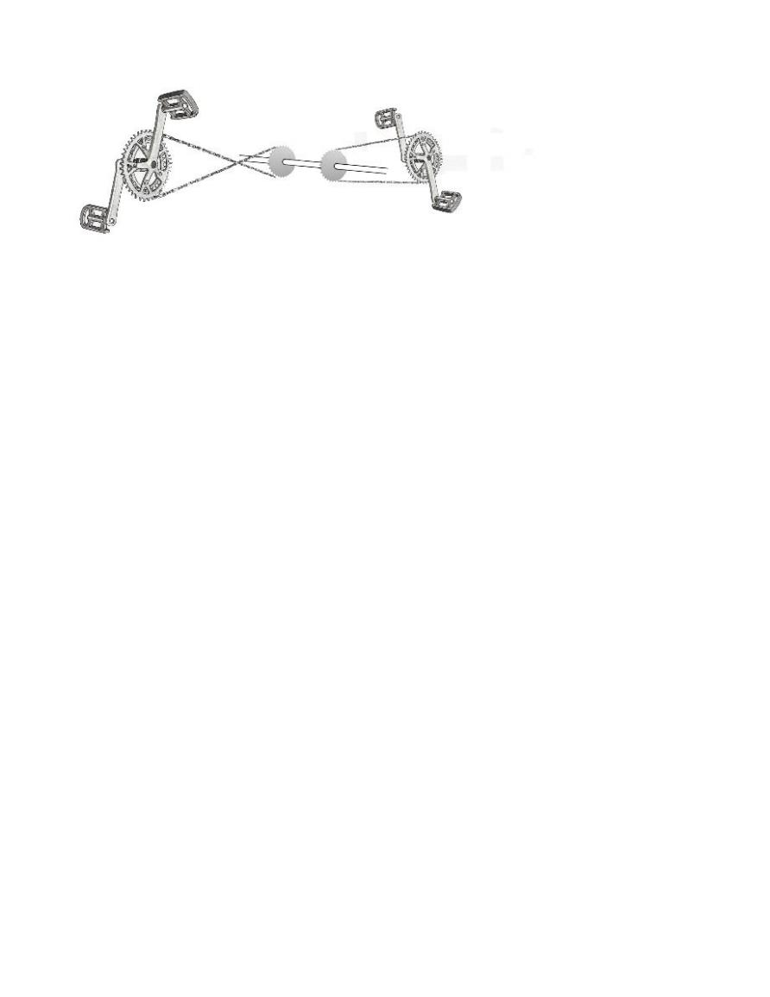The previous year Pedibus used a cross chain linkage to connect the peddle cranks on one end and a driveshaft on the other. This design was very simple and allowed for a single driveshaft to be used for the entire bus. However, this design also had some problems, especially in regards to reliability. Chain wear was more extensive due to the chains on one side of the bus rubbing up against a wear material. Additionally, this repair material was custom fabricated and has to be replaced when the system wears down. This resulted in less reliability, higher downtimes, and more repair costs.

Figure 4*. Crossed chained linkage*

### **Dual Drive Shaft Chain Drive**

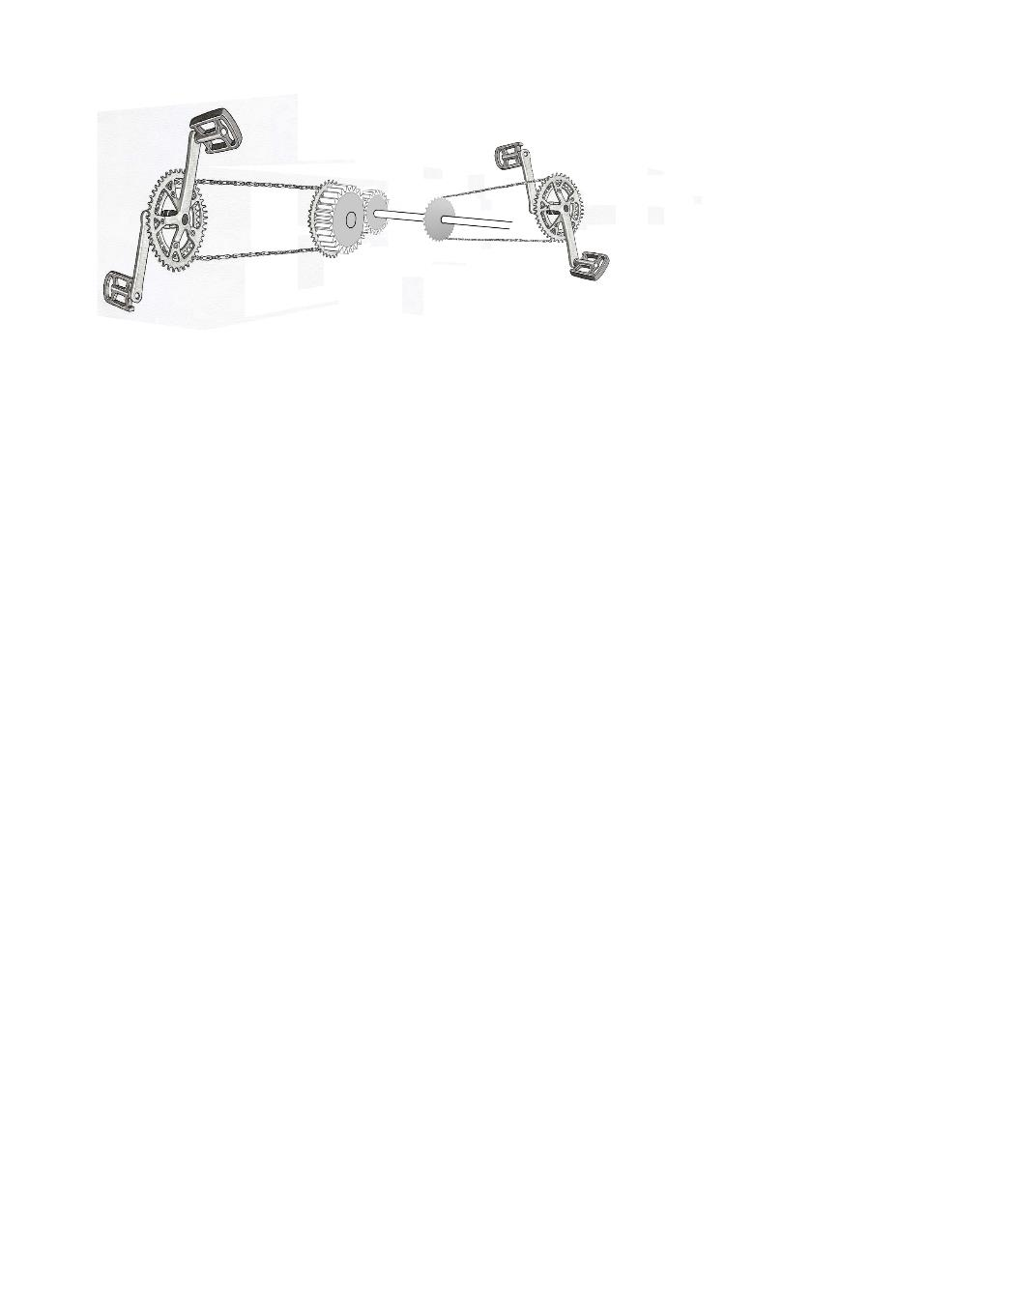The second design that was considered consisted of two parallel drive shafts attached to the cranks on either side of the Pedibus. These drive shafts would then be interconnected by a spur gear in order to make the power output in the same direction. This design is slightly more complex but also does not require chains to be crossed. This results in much higher reliability and durability albeit at an increase in complexity and cost.

Figure 5. *Dual drive shaft chain drive*

### **Pump Motion Crankshaft Linkage**

In an effort to develop a more original design, a crankshaft driven crank system was considered. This design operates similar to a crankshaft from an internal combustion engine. The power is supplied from a piston, down a connecting rod, in which is connected to a rotating shaft off center. As the piston moves up and down it forces the crankshaft to rotate. Instead of using a combustive gas, the idea of using people as pistons was brought about. Centralizing a crank shaft to the rear transaxle, by giving the peddlers a “connecting rod” to push on with their feet, it would supply mechanical power to the bus. This idea mainly focused on how more torque could be applied to the wheels which can then be turned into speed, via correct gearing and design. The fall back this particular set up has is the fact that the system will be able to be back driven. The ways to prevent it from being back driven complicates the design considerably. Additionally, the ability to build and manufacture such a design is somewhat complicated. Especially, when considering available off the shelf components that would be used in other design ideas. Not using off the shelf components presents a conflict with the sponsors design constraints. With an original design, maintenance is also complicated considerably.

### **Peddler Input Selection**

For the peddler input decision, it was ultimately chosen to utilize the dual drive shaft configuration. While this design was more complicated than the crossed chain design it also adds a level of stability and reliability that is lost by crossing the chains. The third design was heavily considered due to the novelty and apparent simplicity of the concept. However, because this design would require a fair amount more custom fabrication than the previous two options, the dual drive shaft was chosen.

Table 3. *Peddler input decision matrix*

|  |  |  |  |  |  |
| --- | --- | --- | --- | --- | --- |
| **Peddler Input Design Decision Matrix** | | | | | |
|  | **Safety** | **User Comfort** | **Complexity** | **Reliability** | **Weighted Sums** |
| **Cross Chained Linkage** | 6 | 6 | 7 | 2 | 132 |
| **Dual Drive Shaft Chain Drive** | 6 | 7 | 4 | 7 | 161 |
| **Pump Motion Crankshaft Linkage** | 4 | 4 | 1 | 8 | 120 |
| **Weight Decision** | **9** | **6** | **4** | **7** |  |

## **Drivetrain**

For the purpose of this report the drivetrain section deals primarily with power delivery from the end of the driveshaft to the driven wheels. All of the peddler input methods outputs directly to a driveshaft that can be connected to some sort of axle in order to transmit power to the wheels. Additionally, all of our designs were made assuming a rear wheel drive configuration for simplicity. A front wheel drive system was considered but was rejected due to significant amount of additional complexity involved.

### **Solid Rear Axle**

The initial design consideration regarding the drivetrain was to use an automotive rear axle. While this system was very durable and was a commonly used solution for this type of vehicle (CITE THIS) there were some disadvantages. The most important of which was the lack of reverse gear. If this design were to be used an additional gearbox would also be used in order to allow for the vehicle to travel in reverse. Additionally, the lack of multiple forward gears was a serious disadvantage in the area of which the bus is being designed for. Multiple forward gears allows for the bus to be operated in more locations including areas with hills.

### **Hydrostatic Rear Transaxle**

Another drivetrain configuration that was considered consisted of a hydrostatic transaxle and possibly accompanying pump. This transaxle acted similar to an automatic transmission in a car but using a hydraulic continuously variable transmission. This would have allowed the bus to be driven without the need of being shifted while still having the advantages of being able to traverse multiple landscapes.

### **Manual Rear Transaxle**

The second transaxle that was considered was a full manual geared rear transaxle. This transaxle shared the same footprint as the Hydrostatic transaxle discussed above. It is less complicated but it also requires a clutch system in order to change gears on the fly. Because of this it has a significantly higher torque rating than the equivalent hydrostatic model.

### **Drivetrain Selection**

Due to the additional benefits that the manual rear transaxle had over the single speed rear axle it was chosen over the other options. The hydrostatic transaxle would have been an excellent choice, however, there were very few options that would be strong enough at a reasonable price. Unfortunately, the manual transaxle generates additional design difficulties that are not present in the other two options, but it offered the most useful options to make the Pedibus more rider friendly.

**Table 4.** *Drivetrain decision matrix*

|  |  |  |  |  |  |  |  |
| --- | --- | --- | --- | --- | --- | --- | --- |
|  | **Durability** | **Cost** | **Modularity** | **User Fatigue** | **Maintenance** | **Complexity** | **Weighted Sums** |
| **Hydrostatic Transaxle** | 2 | 8 | 6 | 6 | 4 | 2 | 110 |
| **Manual Transaxle** | 7 | 5 | 9 | 9 | 8 | 3 | 168 |
| **Vehicle Axle** | 8 | 6 | 2 | 2 | 7 | 8 | 162 |
| **Weight Decision** | 8 | 4 | 2 | 6 | 6 | 2 |  |

## **3.6** **Suspension**

When considering the suspension for the Pedibus project, the cost, viability, and necessity of the suspension was analyzed. Initially, the suspension design was to have both front and rear axles to be directly mounted to the frame, essentially eliminating the suspension. However, after discussing the design further, especially, with respect to the feasibility of towing the suspension was re-evaluated. Currently, a suspension design has not been finalized but several designs have been considered.

### **Dual Leaf Sprung Solid Axle**

When the suspension redesign began the initial concept included front and rear suspension utilizing eye-slipper leaf springs. This concept added significant complexity to the drivetrain. In order to utilize a rear suspension either the transaxle would have been able to move in the vertical direction, requiring u-joints on the driveshaft. Additionally, another consideration would have been to move to axle shafts that utilized a CV-joint to apply power to the wheels.

### **Front Leaf Sprung Axle**

The second design concept that is currently being considered, is to only implement a front suspension. This consideration was made as the bus while in use does not require suspension. However, when being towed, the axle that is on the ground would benefit greatly from a simple suspension. This design concept has significantly less complexities then the first concept but also lacks the additional comfort that a rear suspension would add.

### **Suspension Selection**

At this point the suspension design is still being analyzed as it is a fairly recent consideration. Currently, the front only leaf sprung suspension is the likely selection due to the simplicity of the system.

## **Steering**

The steering for this particular vehicle is the last thing to be designed. A rack and pinion with custom made tie rods will be used to turn the wheels, uprights, spindle and hubs for steering. All inboard steering components have been selected. However, the sourcing and designing of uprights, hubs, and spindles is still being determined. Although many design ideas have been contemplated, all design concepts have been narrowed down to a few basic designs.

### **Existing Vehicle Components**

The original idea was to use specific working dimensions, wheel base and track width, so that the front upright, bearings, and hubs spindles can be sourced from a pre-existing road vehicle. This would simplify fabrication if these components could be bolted into place without the need of additional fabrication. This would also provide a front hub bearing that could handle the weight and highway speeds expected for this vehicle.

### **Trailer Hub “Cut and Weld”**

The second consideration is trailer hubs as a potential for this design. Since trailer hubs are usually held straight, steering components for these hubs would need to be fabricated. A “cut and weld” design is being considered. This means a simple, two dimensional, sheet metal frame or bracket would be cut and welded into place. The manufacturing of this is less involved and would only require basic shop tooling. This allows the design to not use, expensive, and difficult to reproduce CNC parts.

### **Custom CNC Components**

The final idea that is being considered is complete CNC uprights, hubs, and spindles. Designs would be drawn from scratch and all parts would be made at the College of Engineering machine shop. Although the complexity of the designs is not particularly involved, the fabrication would be time consuming. The use of a CNC also increases future complications and costs if one of the steering components were to fail, or if the sponsor chose to have the vehicle reproduced. Original designs make parts unique and one of a kind; making them harder to replace. In the spirit of the project constraints this design concept will only be considered if the other two concepts are not viable.

## **Brakes and Tires**

Currently, the brakes are still being evaluated. The current design considerations are listed in the next two subsections.

### **Hydraulic Front and Mechanical Rear**

In order to allow for the front brakes to be used as trailer brakes as well as operating as the primary brakes for the Pedibus while in use, hydraulic disc brakes were considered. Disc brakes were specifically chosen over drums in the front to avoid having to modify a drum brake setup that is designed to self-energize in one direction. This is because if the front brakes were to be used for both trailer and vehicle brakes, the brakes would need to operate in both directions. Additionally, in order to use disc brakes that could also be actuated by the tow vehicle either a hydraulic surge brake actuating trailer hitch, or an electric-over-hydraulic trailer brake system would have to be implemented. With regards to the mechanically operated rear brake, this was considered primarily as a backup to the front system in case of failure. This mechanical system would feature self-energizing drum brakes operating in the forward direction of the bus. This system would be sufficient to stop the bus under human power only, in the case of front brake failure.

### **4-wheel Hydraulic Disc**

This system would institute hydraulic discs on all 4 wheels. The bus would be fitted with a master cylinder operated by the driver of the bus while in use. Additionally, either a hydraulic surge brake actuating trailer hitch, or an electric-over-hydraulic brake controller would be installed inline to the primary master cylinder. This would allow the brakes to be utilized by the tow vehicle as well. In order to implement this system, without the trailer brake actuator and the manual master cylinder interacting with each other, a 2-way hydraulic valve would have to be installed. Additionally, a parking/emergency brake would be installed in the stock brake location of the transaxle. This brake would be manually actuated and separate from the hydraulic system, so that in the case of failure the vehicle would still be able to be stopped.

## **Ergonomics**

Ergonomics is a serious consideration for this vehicle as the vehicle might be in use for an extended period of time. Therefore, the team has researched the difference between different types of bicycle riding positions in order to determine a comfortable design that is compact enough to fit on the bus. The three rider positions are listed below. The pedaling platform design has been chosen in order to best accommodate a wide range of peddlers of different sizes. The crank mount positioning on the frame has been strategically calculated to be 30 inches from the hipbone of the rider, as shown in the figure below. This length is the average extended leg length for a 5’0 height person. The downward angle has also been chosen to comfortably accommodate a person up to a height of 6’5.

Figure 6. *Bench ergonomic cushion side view*

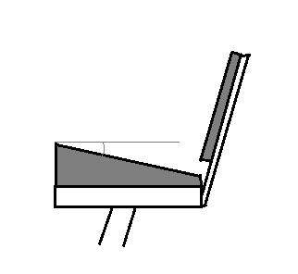

Θ

### **Standard Riding Style**

A standard riding style would be where the rider’s legs are nearly directly below the tailbone. While this design is the most compact, it is also very difficult to implement given that the team has decided to use bench seating in the vehicle. This means that the riders’ legs would have to tuck behind the bottom of the bench seat. This would lead to a very uncomfortable riding position leading to heavy rider fatigue. A diagram showing this type of riding position is shown below.

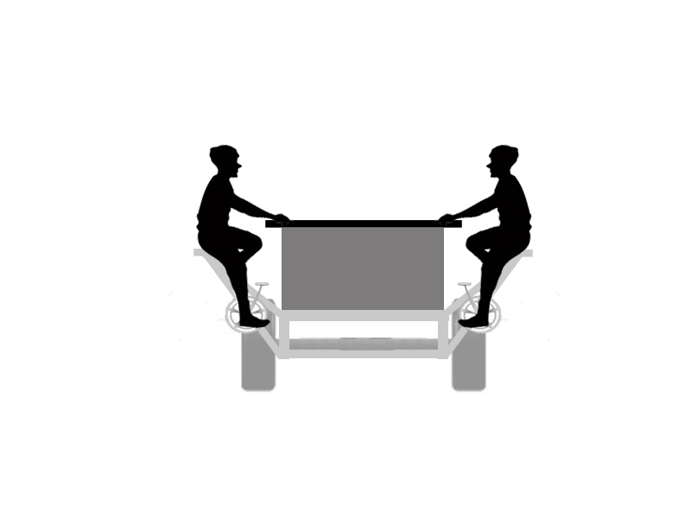

Figure 7. *Standard passenger riding style*

### **Recumbent Riding Style**

A recumbent riding style works better with a bench seating design. However, this riding position requires a significant amount more space. Additionally, the riding position would make adjustments very difficult for people of different sizes. The angle of the back and bottom of the bench, as well as the height of the crank would be critical to the success of this design. A diagram showing this style of riding position is shown below.

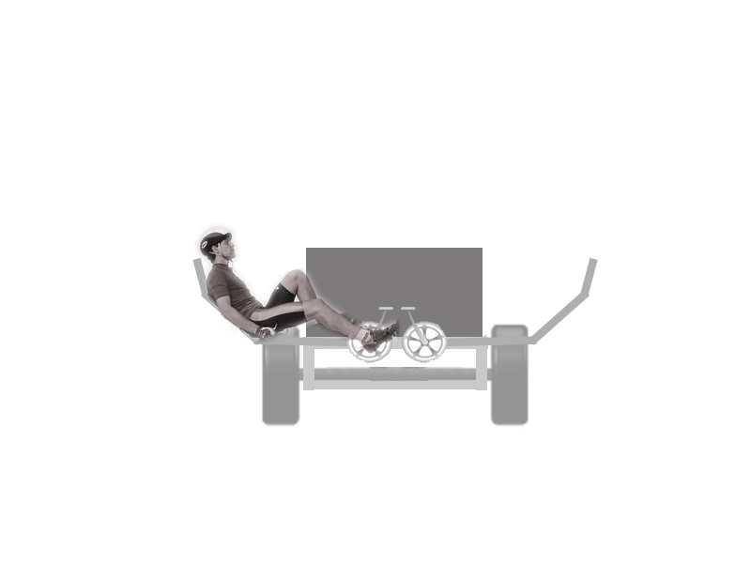

Figure 8. *Recumbent passenger riding style*

### **A Hybrid Riding Style**

In order to incorporate a riding position that will fit in the vehicle while still minimizing the fatigue of the riders, a hybrid position may need to be required. This design is less compact than a standard position but much more comfortable. Additionally, it does not take up nearly as much space as the recumbent riding style. The angle of the seat back and seat bottom will also be less critical to the overall user experience. This design does have some drawbacks in the fact that the ergonomic positioning would have to be designed by the team instead of going with standard dimensions. While of the shelf components can still be used, the components may have to be mounted in a non-standard orientation.

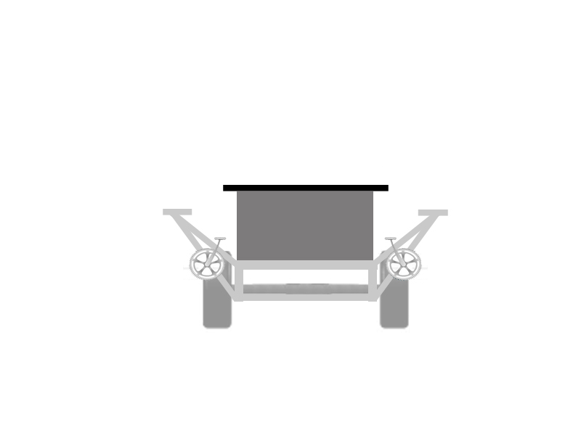

Figure 9. *Hybrid passenger riding style*

To further increase the comfort level of the rider, an inclined cushion will be added to the bench. This will simulate the angled seat from a recumbent stationary bicycle and provide proper support for the rider. Adding the cushion will not only prevent the riders’ legs from falling asleep, but it will also create the perfect alignment angle for comfortable riding. This angle, used for correct recumbent bicycle size fitting, is usually 90°; and it is the angle the back and legs of the rider make when the crank arms are in neutral position. A closer proximity to this angle will ensure a more comfortable pedaling experience.

## **Electronics**

At this time electronics for the project are being reconsidered. This is due to a team restructuring that resulted in the reallocation of electrical engineers to other senior design projects. The mechanical design aspect of this project is the main focus of this team, however, the mechanical designs will be made with respect to the possibility of fitting electronics to the Pedibus post fabrication.

# **Specifications and Analysis**

Much of the componentry for the Pedibus has been selected, or has some set parameters in order to make selection of dependent componentry possible. This section refers to the specifications that are already determined. It is important to note that while most of the below specifications will not change, some parameters may change slightly as the design process continues.

## **Frame Specifications**

1. Material: A500 Structural Box Steel
   1. Primary Construction: 2x4x0.125” Rectangle Tube
   2. Secondary Construction: 2x2x0.125” Square Tube
   3. Density: 0.284 $\frac{lb}{{in}^{3}}$
   4. Yield Strength: 45.7 x 103 psi
2. Dimensions:
   1. Length: ~180 in
   2. Width: ~ 92 in
   3. Height: TBD
   4. Seat Spacing: 32 in
   5. Weight: ~ 654 lbs
   6. Rolling Weight: <1499 lbs

## **Drivetrain Specifications**

1. Desired Cadence: 70 RPM
2. Desired Input RPM: 1000 RPM
3. Gear Ratios:
   1. Number of Speeds: 6-N-R
   2. Chain Ring Ratio: 42T/16T
   3. Clutch Pulley Ratio: 10.0:5.5
   4. Top Speed: 21.9 MPH

## **Transaxle Specifications**

1. Peerless-Gear 820-040
   1. Input Gear Ratio: 2.08:1
   2. 1st Gear Ratio: 4.55:1
   3. 2nd Gear Ratio: 2.33:1
   4. 3rd Gear Ratio: 1.50:1
   5. 4th Gear Ratio: 1.00:1
   6. 5th Gear Ratio: 0.79:1
   7. 6th Gear Ratio: 0.61:1
   8. Reverse Gear: 2.00:1
   9. End Gear Ratio: 8.02:1
   10. Axle shaft diameter: 1 in
   11. Axle length: 30-1/4 in
   12. Mounting hole configuration: 16-3/4 in x 2-1/2
   13. Case width: 20 in
   14. Case length: 18 in
   15. Max Input RPM: 2000 RPM
   16. Max Output Torque: 450 lb-ft
   17. Weight: 57 lbs
2. Clutch Type: Mechanically Actuated Friction Belt

## **Brakes and Tires**

1. Front Brakes: 12” Disc Brakes
2. Rear Brakes: 12” Disc Brakes or Self-Energizing Drum Brakes
3. Parking/Emergency Brake: Cable Operated, inboard or Drum
4. Rim Diameter: 16”
5. Tires: 175-60-R16 Radial
6. Brake Actuation: Hydraulic

## **Steering**

1. Lockable: Yes
2. Steering Type: Rack and Pinion
3. Front Axle: Straight Steer Axle
4. Track Width: 72 in
5. Wheelbase: ~105 in
6. Ackerman Angle: TBD

# **Methodology**

To build a design and build any vehicle from scratch, the process flow seems to have a consistent structure from idea to final product. The team must brainstorm and come up with designs for all subsystems of the vehicle. Once brainstorming is finished, all members can now visualize how the product will operate. At this point, design subsystems can be split up and members can work separately, to cover more ground in a shorter period of time. Each member will bring forth ideas and designs during team meetings, so that the entire team can decide what designs to use. From there, revisions shall be made to all designs. This step may be repeated several times until a design is agreed upon as being final.

Once all designs have been finalized in CAD, structural analysis will be done in the computer to check structural integrity of the frame. This will insure that the frame or other components will not fail under use or heavy load.

As designs are finalized, components will be sourced to meet the needs of the designs. Some of this process may happen during design to ensure that components are available for the specific design requirements set forth. Some designs will also directly depend on parts sourced. In this case parts will be sourced first and designs will be made around sourced parts. From the final design stage, materials can be sourced and ordered to begin the build process. As soon as components and materials are delivered, the build process can begin.

As the fabrication step begins certain issues may arise. These issues will be addressed accordingly and alterations will be made in the designs to match the final product. Other minor structural tests will take place as the build continues. The final testing phase will occur when the vehicle is deemed usable. A final test will occur again after the product is deemed complete.

As the product nears completion, various designs and entertaining devices have been discussed to improve the vehicle post-fabrication. The group calls these devices collectively as “The lipstick on the pig.” Once “the pig”, the bus, is nearly built and finished, the “lipstick” will be added to really make the bus a fun product that the sponsor can market to the community. This will all be done before March 14, 2015.

Brainstorm

Design

Sketches

Final

Design

Computer

Structural

Analysis

Project

Build

Component

&

Material

Sourcing

Real

Life

Scenario

Testing

Reveal



Accessory Add-ons

Figure 10. *Process flow chart*

## **Schedule**

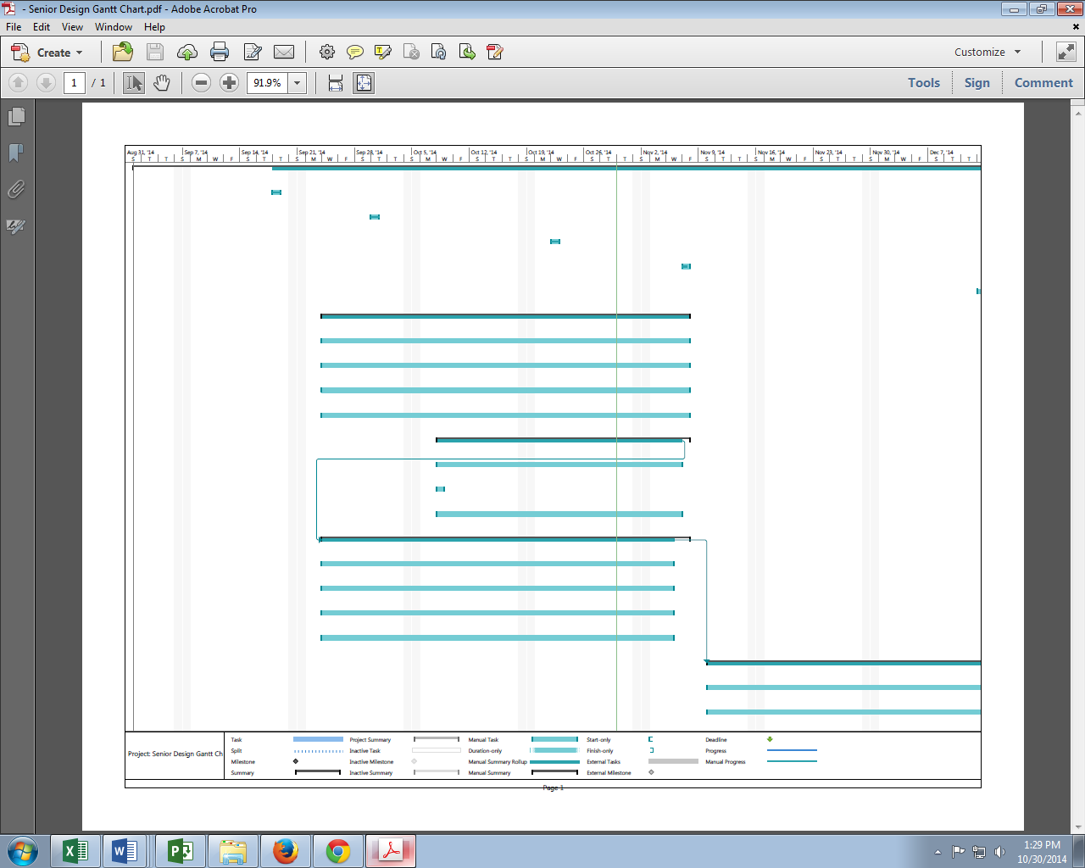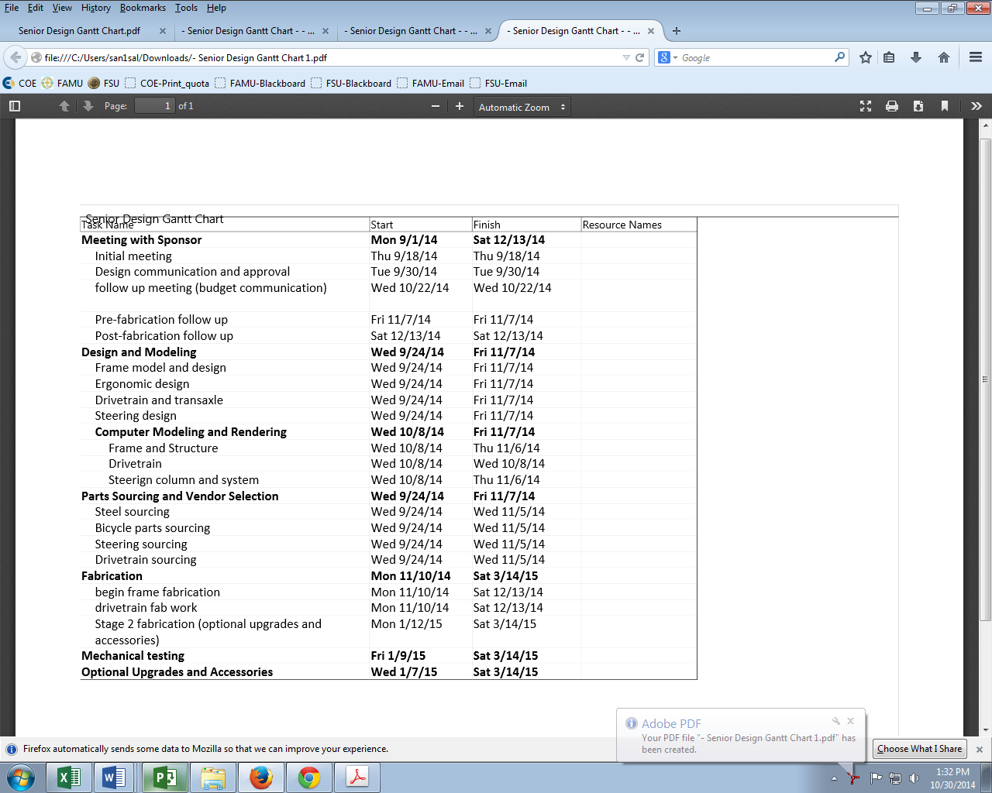

Figure 11. *Gantt chart*

## **Resource Allocation**

In order to meet the time requirements set in place by the sponsor a strict schedule has been instituted. Along with the schedule that was created, various tasks were outlined in order to maintain forward progress, and remain organized. Below is a work breakdown structure that outlines the tasks at hand, and who is responsible in completing those tasks.

1. Design and Solid Model Completion
   1. Frame Model Draft (Finished)
      1. Subsystem Creation
         1. Ergonomics draft
            1. Component Selection (Alejandro: 5 hours)
         2. Steering Draft
            1. Geometry Calculations (Anderson: 5 hours)
            2. Component Selection (Anderson: 5 hours)
2. Shop Drawing Creation
   1. Finalize Frame (All Team Members: 2 hours)
      1. Finalize Drivetrain (Avery: 1 hour)
      2. Finalize Ergonomics (Alejandro: 1 hour)
      3. Finalize Steering (Anderson: 1 hour)
   2. Create Assembly (Avery: 5 Hours)
      1. Make Drawing Packet (Anderson, Avery: 20 hours)
3. Part Source and Vendor Selection
   1. Metal Source (Anderson: 1 hour)
   2. Steering Source (Anderson: 1 hour)
   3. Ergonomics Source (Alejandro: 1 hour)
4. Fabrication
   1. Meet with sponsor to discuss budget after component selection and source (TBA)
      1. Finish any necessary design changes required by sponsor (TBA)
   2. Order necessary components (All Team Members: 10 hours)
   3. Begin fabrication (All Team Members: TBA)
   4. Finish stage 1 fabrication (The Pig) (All Team Members: 100 hours)
   5. Begin Stage 2 fabrication (The Lipstick) (All Team Members: TBA)
   6. Finish Stage 2 fabrication by March 14, 2015 (All Team Members: 25 hours)
5. Mechanical Testing
   1. Initial team mechanical testing (All Team Members: 5 hours)
   2. Fix any design problems found (All Team Members: TBA hours)
   3. Allow sponsor and other interested parties to test (TBA: 5 hours)
   4. Consider design recommendations (All Team Members: 2 hours)
   5. Make final changes before Springtime Tallahassee (Deadline: 03/14/15)

# **Conclusion**

Senior Design Team #22 has made significant progress on the Pedibus project. Many iterations of the various subsystems have been discussed. The team is nearly ready to finalize the main subsystems required to begin fabrication. This is a necessary step in order to meet the deadline of March 14, 2015.

At this point a schedule for completion has been determined and tasks have been assigned in order to move forward on the project. This methodology is set in place in order to make sure that the project is completed, affectively, by the deadline.

For the rest of this semester the team will continue to finalize designs and will begin the fabrication of the frame and some of the dependent subsystems. Research on vendors has been completed and the parts are ready for purchase. The team expects to begin fabrication work within the next two weeks. At this point the team expects to have a frame completely finished by the end of the fall semester.

This goal will ensure that there will be enough time to complete the remaining subsystems.

# **References**

*Car and Driver*. N.p., n.d. Web. <http://media.caranddriver.com/images/12q3/474782/2013-ram-hd- frame-rear-axle-max-towing-rating-photo-476280-s-520x318.jpg>

i Pedal Crawler | Custom Party Bike Manufacturer. 2013. *Pedal Crawler | Custom Party Bike Manufacturer*. <http://www.pedalcrawler.com/>.

ii The Party bike <http://www.thepartybike.com/index.php/the-party-bike/>.

iii PedalPub. The Bike with the Barrel. 2013. *PedalPub. The Bike with the Barrel*.  http[://www.pedalpub.com/](http://www.pedalpub.com/).

"Home." *Capital City Pedicabs*. Ron Goldstein, n.d. Web. 25 Oct. 2014. <http://www.capitalcitypedicabs.com/CCPedicabs/home.html>.