Pedibus - Spring 2015 Design for Manufacturing, Reliability & Economics

Kyle Anderson#1, Stephen Avery #2, Alejandro San Segundo #3, Brett Willenbacher #4

*# Mechanical Engineering Department, FAMU-FSU College of Engineering  
2525 Pottsdamer Street, Building A, Suite A229*

*Tallahassee, Florida; United States 32310-6046*

1kca10@my.fsu.edu

2 sja12@my.fsu.edu

3as10s@my.fsu.edu

4 blw11c@my.fsu.edu

**April 3, 2015**

**Mr. Ronald Goldstein:** Project Sponsor

**Dr. Chiang Shih:** Project Mentor/Mechanical Engineering Chair

**Dr. Nikhil Gupta:** Project Co-Mentor

**Mr. Keith Larson:** Project Advisor

***Team Biography***—

**Mr. Ronald Goldstein:** Founder of Capital City Pedicabs, has traveled all around the United States working in a variety of industries including hospitality, imports, real estate and public service. It was during a family vacation in 2005 that the seed was planted for the pedicab business [1].

**Kyle Anderson:** Kyle is a senior seeking his B.S. degree in Mechanical Engieering at the FAMU/FSU College of Engineering. Being involved with SAE his entire college career, Kyle proves to be a key aspect to the vehicle designing and leadership of the project. His experience consists mostly of hands-on builds.

**Stephen Avery:** Stephen is a senior seeking his B.S. degree in Mechanical Engieering at the FAMU/FSU College of Engineering. Being the chassis designer for SAE Baja 2014-2015 vehicle and SAE Senior member, he brings a lot to the table with the structure and safety of the project.

**Alejandro San Segundo:** Alejandro is a senior seeking his B.S. degree in Mechanical Engieering at the FAMU/FSU College of Engineering. With past professional and leadership experience involving fast paced professional environments, his skills bring a strong contribution for the Pedibus project. Alejandro also has a strong background in cycling and ergonomic design, which is a large majority of the Pedibus project.

**Brett Willenbacher:** Brett is a senior seeking his B.S. degree in Mechanical Engieering at the FAMU/FSU College of Engineering. With track courses in both vehicle and machine design, he helps bring the transportation aspect of the project to life.

Abstract— ***Capital City Pedicabs has sponsored a project to create a multi user, pedal powered vehicle known as the Pedibus. The following document outlines the manufacturing process associated with the fabrication of the vehicle as well as an optimization analysis of the process. The reliability of the vehicle’s design and performance are also outlined with explications regarding possible reliability concers. The cost report regarding the project is analyzed and compared to current industry competitors to determine team’s efficiency. The Pedibus 2.0 has been fully fabricated and finalized at this point and the project manufacturing process complete.***

Table of Contents

I. DESING FOR MANUFACTURING 1

A. FRAME MANUFACTURING 2

B. SUBCOMPONENT MANUFACTURING 2

1. STEERING 3

2. DRIVETRAIN 3

C. WOODEN COMPONENTS 4

D. ROOF AWNING 5

II. RELIABILITY 5

A. EXPECTED LIFE CYCLE 5

B. FRAME FEA 5

C. POSSIBLE RELIABILITY CONCERNS 6

III. ECONOMIC ANALYSIS 6

A. MANUFACTURING COST OF PEDIBUS 2.0 6

B. INDUSTRY COST COMPARISON 7

IV. CONCLUSION 8

Appendix A 9

Appendix B 15

**TABLE OF FIGURES**

Figure 1. *Finalized Pedibus 2.0* 1

Figure 2. *Pedibus frame CAD renders* 2

Figure 3. *Fabricated frame* 2

Figure 4. *CAD render of steering assembly* 3

Figure 5. *Cranks and bottom brackets mounted on frame* 3

Figure 6. *Driveshaft with freewheel mounted* 3

Figure 7. *Rear axle subassembly CAD rendering* 4

Figure 8. *Finished bar top and stained benches* 4

Figure 9. *Pedibus 2.0 fabrication cost breakdown* 6

Figure 10. *Pedibus 2.0 fabrication cost comparison to insdustry competition* 7

# 

# DESING FOR MANUFACTURING

The Pedibus 2.0 project was extremely intense in actual fabrication work and much more than any other project required hands on machining and fabrication. The overall fabrication process starting with the frame and ending with the final product took approximately 3 months. The Pedibus fabrication from start to finish required an approximated 800 hours of actual manual labor distributed between the four team members. The Pedibus required extensive custom fabrication as machining, thus the process took the majority of the semester. The main reason for this was that all of the fabrication was distributed among only four team members, two of which were not very proficient machinist. The build could have been accelerated a significant amount with the addition of extra team members as well as the help of machinists at the shop dedicated to this project only. The lack of ability to work over the weekends or after hours greatly hindered the team’s ability to speed up the build, especially when the hour that the shop is open coincides with classes.

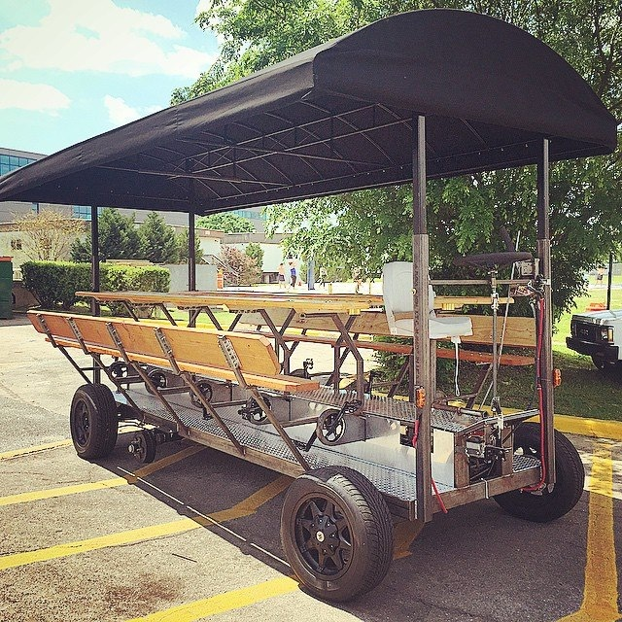The build began with the fabrication of the fame, followed by the seat post and bar structure. This was then followed by the integration of the torsion axle, transaxle mounts, and drive shafts. The cranks were then mounted on the bottom brackets and aligned, corresponding freewheels on the shafts. This was followed by the fabrication of the steering system and its integration to the vehicle. The benches where cut and stained over the weekends and then mounted onto the posts. The transaxle gearing ratio was determined and the gearbox assembled in unison to the fabrication fo the coupling mechanisms between the drive shafts and the transaxle. The breaking system was the assembled and mounted onto the frame followed by the necessary brake lines. Meanwhile, the wiring for all the lights was being doen as well as the fabrication of the instrument cluster and installation of lights. All chains and gears were then mounted and fastened. The last component fabricated was the emergency brake and the mount for the leaver. The rest of the build was integration rather than fabrication. The bar top was mounted on the vehicle, followed by the stained benches, the floorboards and the roof. Lastly, the brakes were bled, and all systems tested. The final Pedibus build is shown below in figure 1.

**Figure 1.** *Finalized Pedibus 2.0*

The following breakdown is to further outline the manufacturing of the subcomponents of the Pedibus including the frame, steering and powertrain.

## FRAME MANUFACTURING

The frame of the Pedibus was the first thing that was manufactured. The steel was order and cut at the school shop and then tacked in place. Once the finalized design was agreed upon and approved by the sponsor the frame was the fully welded in place. The chassis consists of a ladder style frame of approximately 100 inches in width and 16ft in length. The following figures show the CAD rendering for the frame of the vehicle prior to fabrication

**Figure 2.** *CAD renders of the Pedibus frame; one being a front cross sectional view with dimensions and a skew angle view of the frame.*

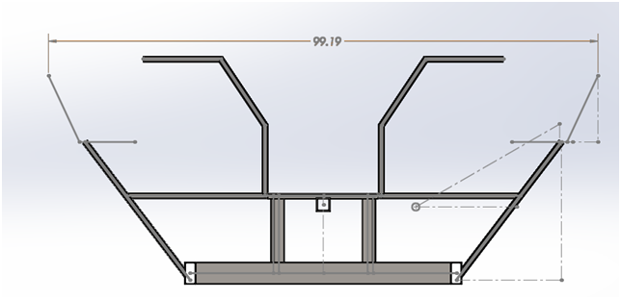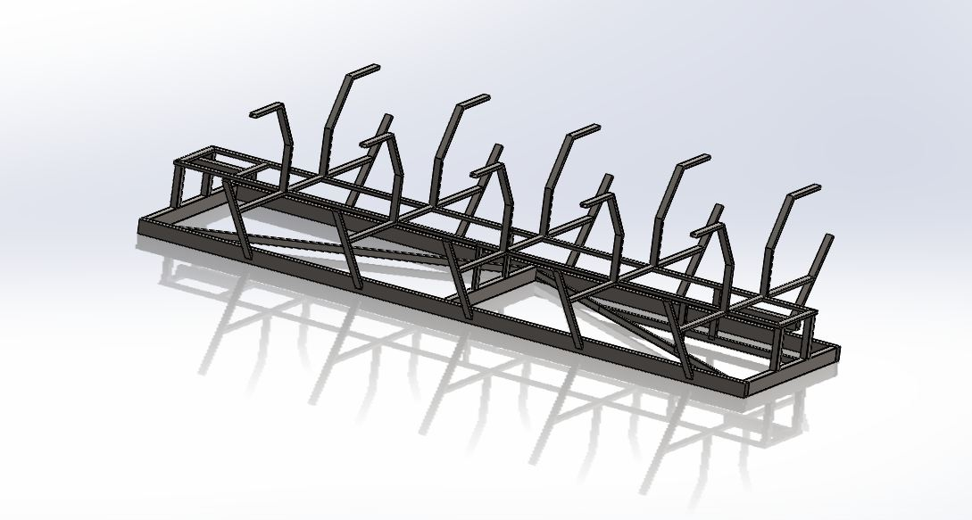

The main frame fabrication took, from start to finish, approximately 3 weeks. This includes the time for welding and cutting but not the weekends. The frame was not fully finished until the end of the fabrication process as there were consistently components being worked on in parallel and well as parts being mounted on. The following images show the fabricated frame of the Pedibus prior to adding the floorboards or any wooden components.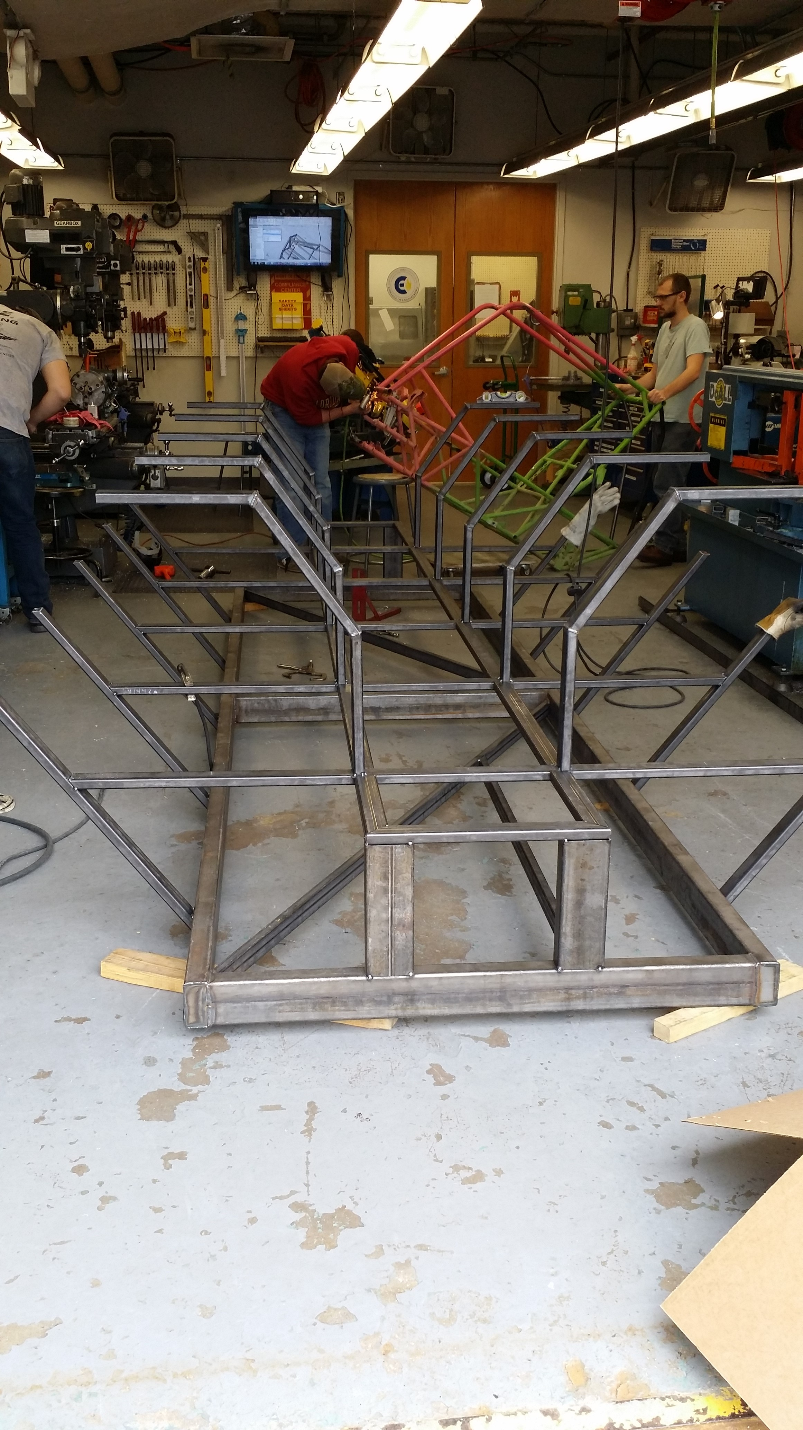

**Figure 3.** *Fabricated Pedibus frame before the addition of the subcomponents or wooden components.*

## SUBCOMPONENT MANUFACTURING

Running in parallel to the fabrication of the frame and the integration of outsourced components, many of the subassemblies had to be partially machined and fabricated. This process took approximately the length of the entire build, 2.5 months, as is was an ongoing process throughout the entire fabrication. The following two sections outline the detailed manufacturing of the steering as well as the drivetrain subassemblies.

### STEERING

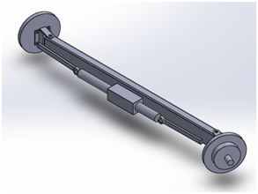The Pedibus features a custom fabricated rack and pinion steering with a straight axle set up. The steering design implemented allows for a curb to curb of under 45ft, which is comparable to that of a Ford F150. The fabrication of this subsystem required extensive machining as many parts required milling. The rack and pinion system was outsourced and integrated onto an axle built in house. The axle consisted of a piece of box steel mounted onto the frame. The steering rack and pinion was adapted onto this shaft and integrated onto the front wheel mounts. The steering rods as well as the u-joints were fed through the frame and secured with brass bushings. The steering took a team member solely dedication to its fabrication about two weeks to complete. Figure 4 below shows a render of the steering design implemented on the vehicle.

**Figure 4.** *CAD render of rack and pinion steering assembly for Pedibus.*

### DRIVETRAIN

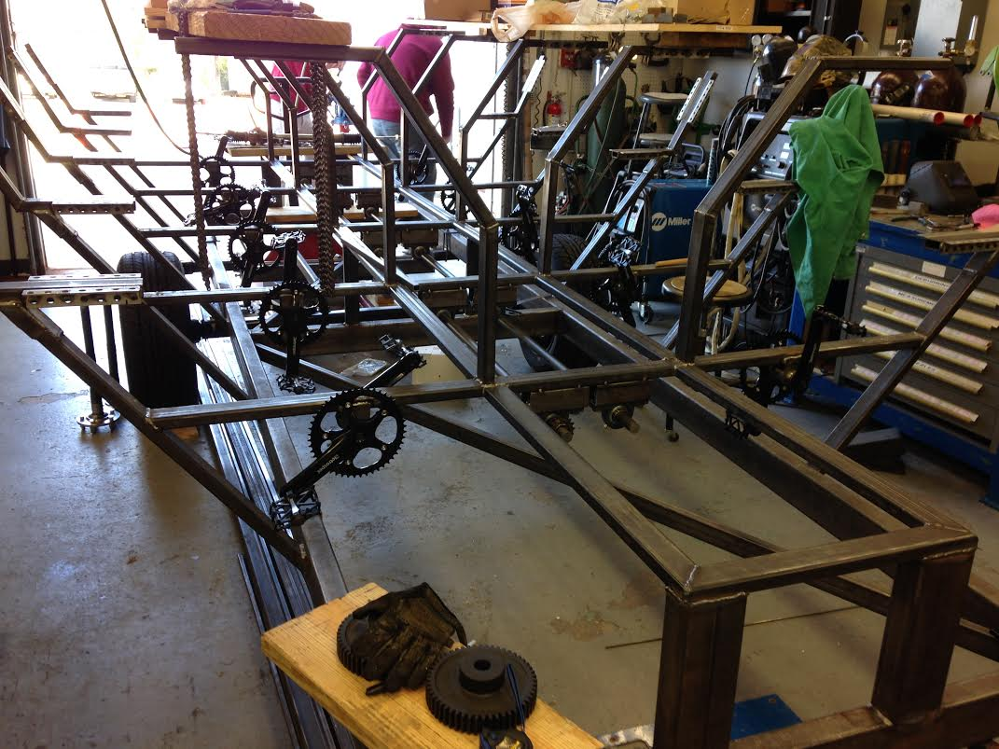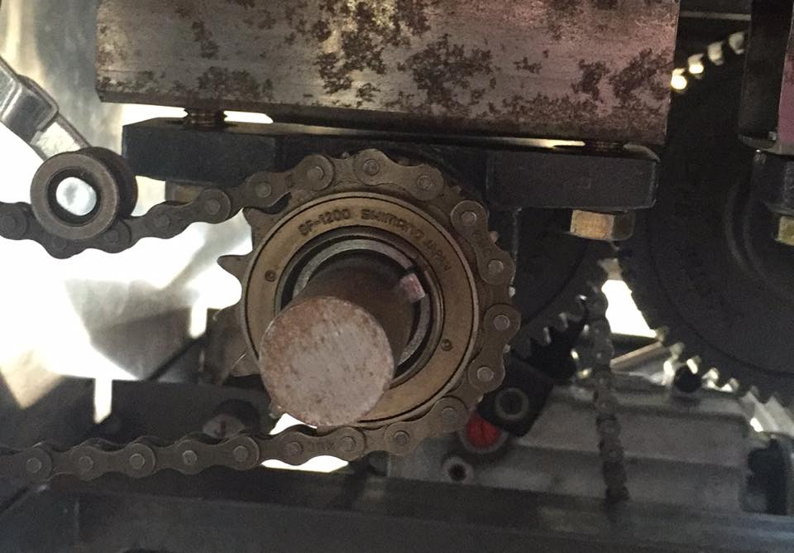The powertrain of the vehicle includes several different components that efficiently transfer the power input from the pedals to the wheels of the vehicle. The cranks are mounted of the bottom brackets attached to the frame as seen in figure 5. The single speed bicycle chain utilized connects the crank to one of the two drive shafts under the vehicle as seen in figure 6 below.

**Figure 5*.*** *Cranks mounted onto frame and aligned with respective freewheels on driveshaft*

**Figure 6.** *Mounted drive shaft with freewheel and chain mounted*

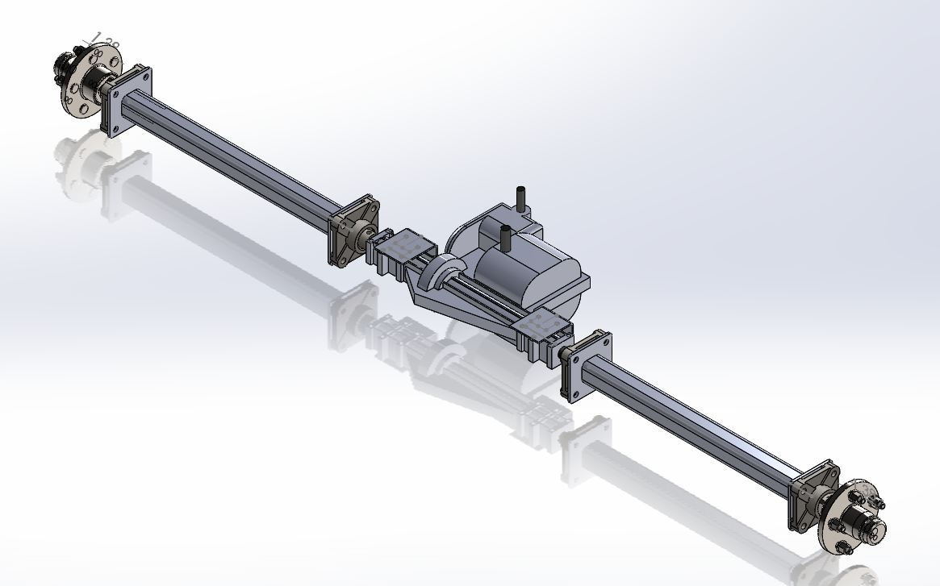The 1 inch cold rolled steel shafts run the length of the vehicle and connect to the transaxle. These shafts were ran using pillow blocks mounted on the underside of the frame as seen in figure 6 above. The transaxle used is a Peerless 820 lawnmower transaxle that feature 6 forward speed and a reverse gear. The transaxle acts as an integrated transmission and differential. The system was mounted to the rear of the frame using independently supported axle shafts. A render of the Peerless 820 transaxle as well as the integrated system that was mounted to the vehicle is shown below in figure **7.**

**Figure 7.** *CAD render of rear axle assembly including the transaxle, mounted shafts and wheel mounts.*

## WOODEN COMPONENTS

The wooden components of the Pedibus include the bar top as well as the benches. The bench fabrication was very simple and straight forwards. The planks of wood were bought, sanded, stained and then mounted to the bench brackets using quarter inch bolts. The bar was outsourced as per request of the sponsor, this was because of the professional cosmetic finish the sponsor desired on this component of the vehicle. The integration of the bar top to the frame was simple and required just a few nuts and bolts going from the underside of the bar to the brackets. Figure 8 below shows the mounted benches on the frame as well as the mounted bar top.

Figure 8. *Finished bar top and benches of the Pedibus*

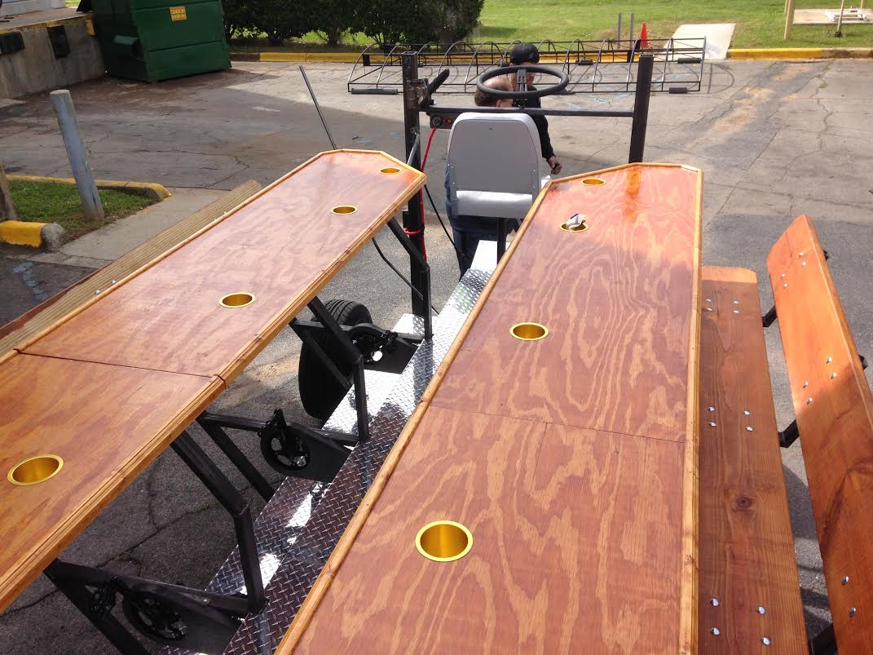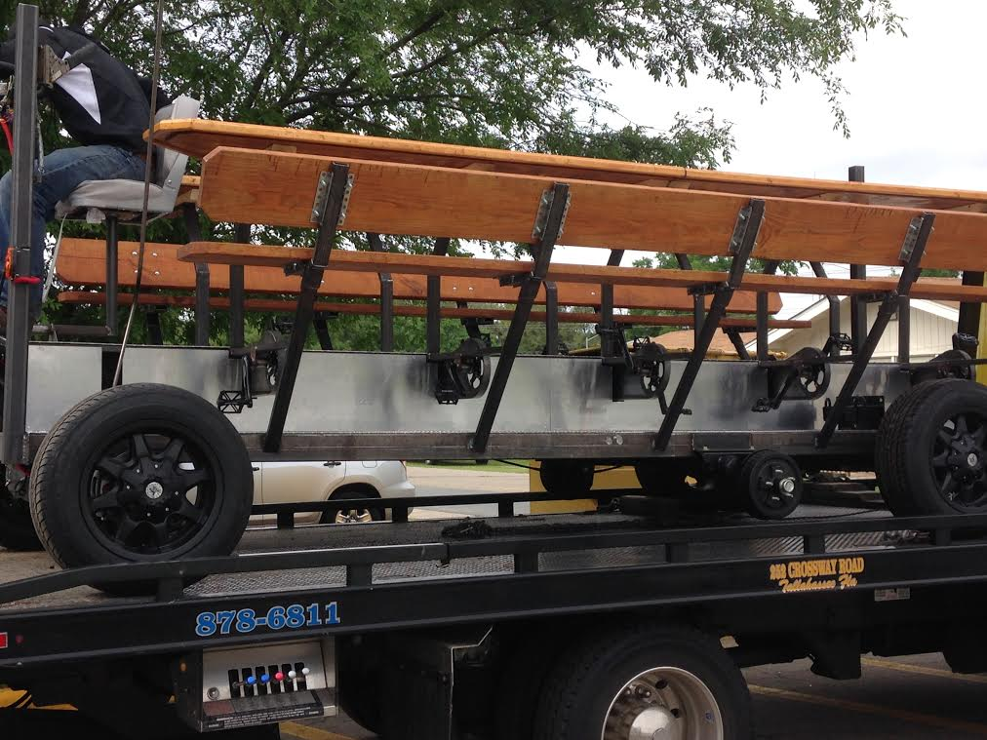

## ROOF AWNING

The roof of the vehicle, both the structure and the frame construction, was outsourced locally in Tallahassee. This was done in order to speed up the overall fabrication process as well as to relieve some workload from the team. The desired dimensions were sent to the sponsor who took care of the local outsourcing of this part. The roof assembly can be seen in any of the finalized pictures of the Pedibus.

# RELIABILITY

## EXPECTED LIFE CYCLE

The Pedibus is a very robustly built vehicle that will perform well over time. There are not many parts subjected to extreme wear and tear. The team expects the Pedibus to continue to perform as long as proper maintenance is given periodically to the vehicle. Some parts are expected to have a shorter life cycle than that of the entire vehicle and should be replaced when appropriate due to age and wear. These include parts like the benches and bar top which will be exposed to sun and water as well as the bike chains which will stretch. All of the off the shelf components utilized are automotive or trailer grade and have been rated for much more strenuous usage than what these will ever see on this vehicle. The team is confident in the robust build of the vehicle and its performance reliability.

Other careful considerations and calculations were performed in order to ensure the safety and reliability of the vehicle. These include FEA calculation of the frame structure as well and

## FRAME FEA

For the purpose of this report a factor of safety is assumed at 1.3 and that the frame performs similarly and effectively in all bracing configurations in the vertical loading direction based on previous finite element analyses. This assumption will be tested at a later date after the deadline of this report. Bench rigidity testing in the long horizontal direction still needs to be analyzed however, torsional stiffness of the frame with various bracing configurations have been analyzed.

The vertical loading tests were produced in the standard bracing configuration containing no cross bracing on the primary lower frame. The frame was fixed in the vertical and horizontal directions, roughly at the location of the front and rear axles. It was then loaded with 4,500 lbf evenly across the 10 bench seat supports. An additional 500 lbf was applied to the 10 bar top mounts. The maximum deformation was found to be 0.892 in. This deformation was seen at the center of the vehicle at the top of the seat post. The primary frame of the vehicle had a maximum deformation of less than 0.7 in over the entire 180 in frame length.

The torsional loading was performed in 3 different lower frame bracing configurations. Additionally, these three configurations were tested with and without the middle vertical frame supports attached to the bar top supports.

table I

Finite Element Results

|  |  |  |  |  |
| --- | --- | --- | --- | --- |
|  | Max. Disp (in) | Weight (lbs) | Test type | Load (lbf) |
| Standard w/o bar bracing | 13.43 | 599 | torsional | 10000 |
| Standard w/ bar bracing | 12.65 | 630 | torsional | 10000 |
| Full Cross Bracing w/bar bracing | 12.18 | 682 | torsional | 10000 |
| Full Cross Bracing w/o bar bracing | 12.74 | 650 | torsional | 10000 |
| Half Cross Bracing | 14.85 | 560 | torsional | 10000 |
| bi-directional bracing | 14.48 | 584 | torsional | 10000 |

The results indicate that the current frame bracing that was being considered is sufficiently rigid under torsion. However, it was also found that the additional vertical supports offered only a marginal increase is rigidity. If the lower bracing were to be changed to a lighter 1x2x.125 diagonally oriented bracing configuration, a potential weight savings of 90 lbs with an acceptable very small loss in rigidity. This configuration would also save costs because the metal usage is significantly less.

The frame FEA analysis proved successful giving the team a confident result on the reliable structural performance of the frame. The team estimated a factor of safety of 1.3 for the structural yield of the frame. The detailed views of the FEA testing are found in Appendix A of this document.

## POSSIBLE RELIABILITY CONCERNS

Current reliability concerns are very similar to those an automotive manufacturer would take into account. The testing and calculations have been done in order to ensure that the Pedibus will function and perform as well as it is intended too. There are outside factors that can’t always be anticipated from the drawing board, and thus one must use engineering intuition towards minimizing these possible future failures. The team is confident in the structural stability of the frame well and in the performance of the different subcomponents. The team has possible concerns with fatigue failure from the overloading the powertrain, such as the fatigue failure of the shifter of chains. The main concern of the team is failure of a part due to improper use or overlooking routine maintenance. The vehicle will be stored outdoors and thus the components will be exposed to the elements, making it difficult to predict their performance in the far future.

# ECONOMIC ANALYSIS

## MANUFACTURING COST OF PEDIBUS 2.0

The fabrication of the Pedibus proved to be quite expensive compared to the norm seen in senior design projects. This is due to not only the extensive list of parts on the vehicle but also the amount of material utilized in the fabrication. The team was given no budget by the sponsor but was told to try and under thirteen thousand; which the team successfully did. Not accounting for the cost of labor, which in the case of a usual machinist is around $20 to $25 per hour, the Pedibus 2.0 vehicle had a net cost of $11,053.20. This value reflects all parts and materials purchased as well as the outsourced components such as the roof and bar top. A detailed procurement list containing all purchased parts along with all important information and cost is located in Appendix B of this document. The invoices for the outsourced roof awning as well as the bar top are located in Appendix B of this document; these receipts reflect the cost of material as well as labor. A graphical representation of the cost break down of the Pedibus 2.0 with major pertinent components is shown below in the figure; this graph shows a comparison of the cost of all major components compared to one another, not including labor costs or the additional cosmetic add-ons such as powder coating.

**Figure 9.** *Graphical comparison of the cost breakdown for the cost of all parts and materials used for the fabrication of the Pedibus 2.0.*

If the Pedibus were to be outsourced to a third party machinist, not involved with the University, the cost of production would be much higher to account for hours of hand labor. Distributed amongst the four team members, the Pedibus fabrication process took an estimated 800 hours of labor. The team estimates that an outsourced fabrication of a comparable vehicle, assuming an average of $22.50/hour, would have a total cost of around $29,000.

## INDUSTRY COST COMPARISON

The Pedibus, is a one of a kind, custom build multi-user pedal powered vehicle. Although there are vehicles similar in concept the Pedibus, they are also custom fabricated to order and none are the same to each other. This is because there are currently no mass productions of this type of vehicle in the market. All of the existing multi-user, pedal powered, entertainment vehicles are made to order and built with the scope of the particular sponsor. There are a few shops around the United States that have been known to produce these type of vehicles, but none with a fully standardized design. The team reached out to one of these machine shops, Atek customs, which offered a quote for a similar vehicle ranging around $50,000.

The Pedibus 2.0 turned out to be a much cheaper build than the outsourced competitor with the added bonus of innovative features never seen on a vehicle of this type before. This was mainly due to the team’s effort to outsource parts with the best possible price to value ratio as well as not receiving any pay for the hours of labor invested into this project. Even when accounting for the hours of labor, the Pedibus 2.0 still proves to be a cheaper option by almost $20,000. One must note that the compared vehicles are fully finished with all cosmetic and entertainment accessories. This means that the vehicles are powder coated, have lights, stereos and finished bar backs. The team worked towards simplicity of the design and thus the team members are confident that this vehicle could be finished with all the cosmetic and entertainment accessories for well under the $50,000 price tag of the competition. The following schematic shows a visual comparison between the costs of the Pedibus and other industry manufacturers. It clearly shows the team’s efficient use of the budget as the total cost of the Pedibus 2.0 is much cheaper than the competition.

**Figure 10.** *Schematic comparison of the cost break down of the Pedibus 2.0 compared to other manufactures in the industry.*

# CONCLUSION

The team completed the fabrication successfully and on time. The sponsor is more than pleased with the result and looks forward to introducing the vehicle into the Tallahassee night life. The entire fabrication process of the Pedibus 2.0 took the team an approximate three months from beginning to completion. The process could be speed up if a greater number of people were involved in the fabrication process. Overall the team is very pleased with the outcome of the final product and the manufacturing quality of the vehicle. The total cost of the project hovers around $11,000 with over 800 hours of manufacturing labor; making this one of the biggest mechanical engineering senior design projects. In comparison to similar vehicles manufacturers the Pedibus proved to be a very efficient design with proficient machining by keeping the total cost roughly $20,000 below the competitions manufacturing price, accounting for cost of labor but no profit margin. The Pedibus was overall successful design that evolved into a successful vehicle; both the team and the sponsor are pleased and proud of the project conclusion.

# **Appendix A**

The following images represent the FEA testing that was performed on the frame of the Pedibus. All testing proved successful as team saw no failures. The following pictures depict both the vertical loading tests as well as torsional loading.

*Vertical Loading*

The vertical loading tests were produced in the standard bracing configuration containing no cross bracing on the primary lower frame. The frame was fixed in the vertical and horizontal directions, roughly at the location of the front and rear axles. It was then loaded with 4,500 lbf evenly across the 10 bench seat supports. An additional 500 lbf was applied to the 10 bar top mounts. The maximum deformation was found to be 0.892 in. This deformation was seen at the center of the vehicle at the top of the seat post. The primary frame of the vehicle had a maximum deformation of less than 0.7 in over the entire 180 in frame length.

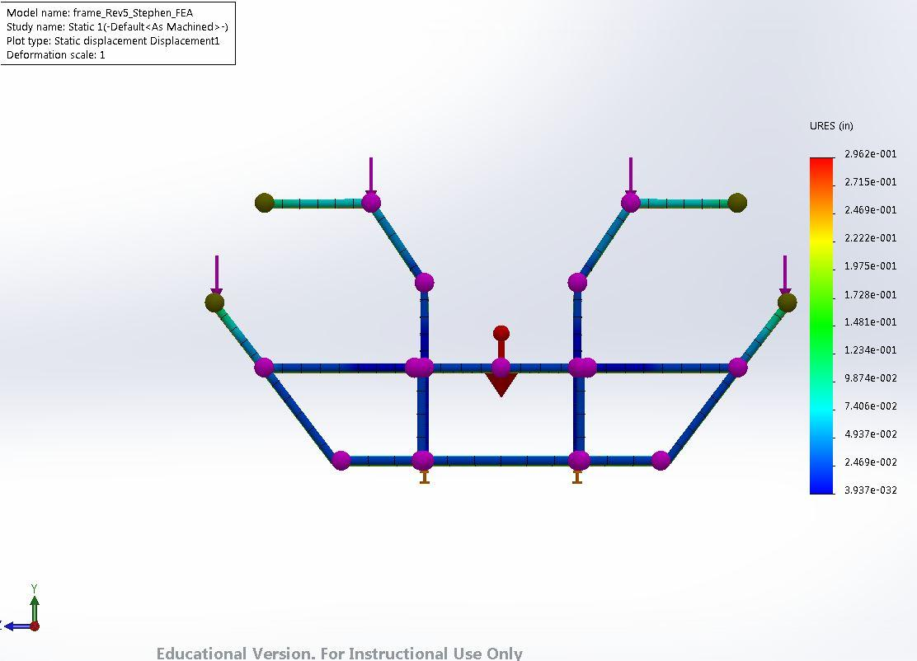

Vertical Displacement, 5000 lbf, Front View

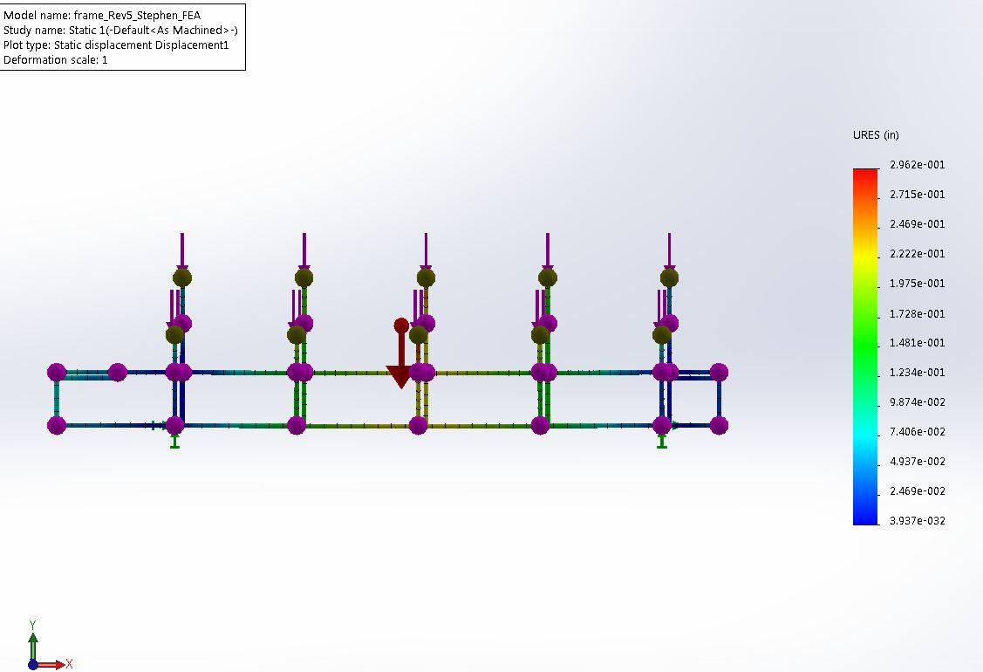

Vertical Displacement, 5000 lbf, Front View

1. *Torsional Loading*

The torsional loading was performed in 3 different lower frame bracing configurations. Additionally, these three configurations were tested with and without the middle vertical frame supports attached to the bar top supports. The visual results are as follows.

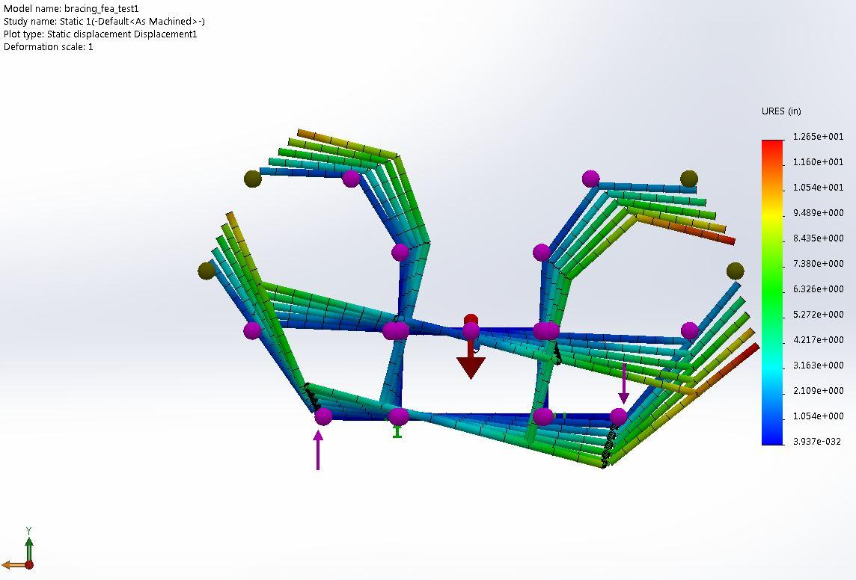

Torsional Displacement Horizontal Bracing w/ vertical supports: 10000 lbf (front view)

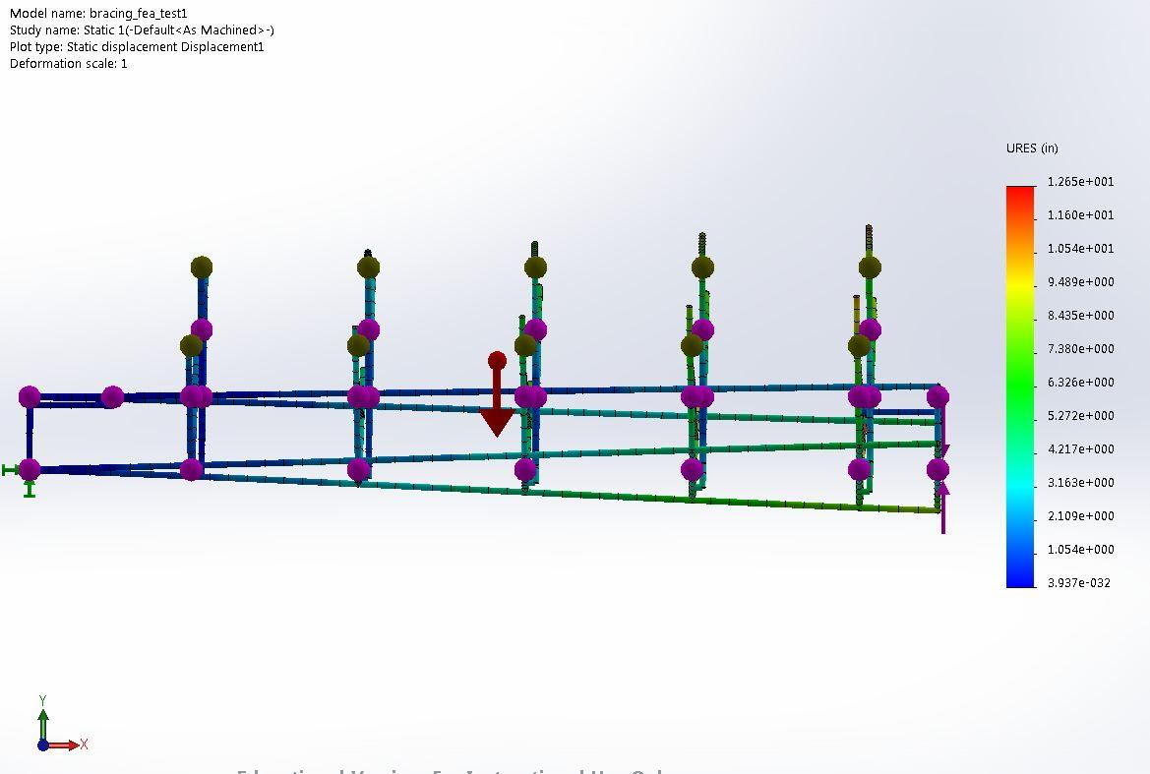

Torsional Displacement Horizontal Bracing w/ vertical supports: 10000 lbf (side view)

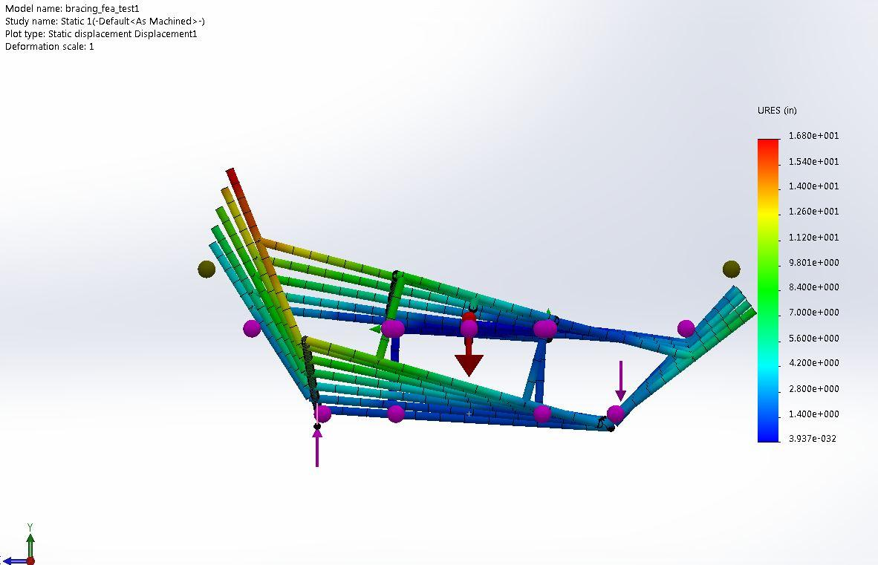

Torsional Displacement Horizontal Bracing w/o vertical supports: 10000 lbf (front view)

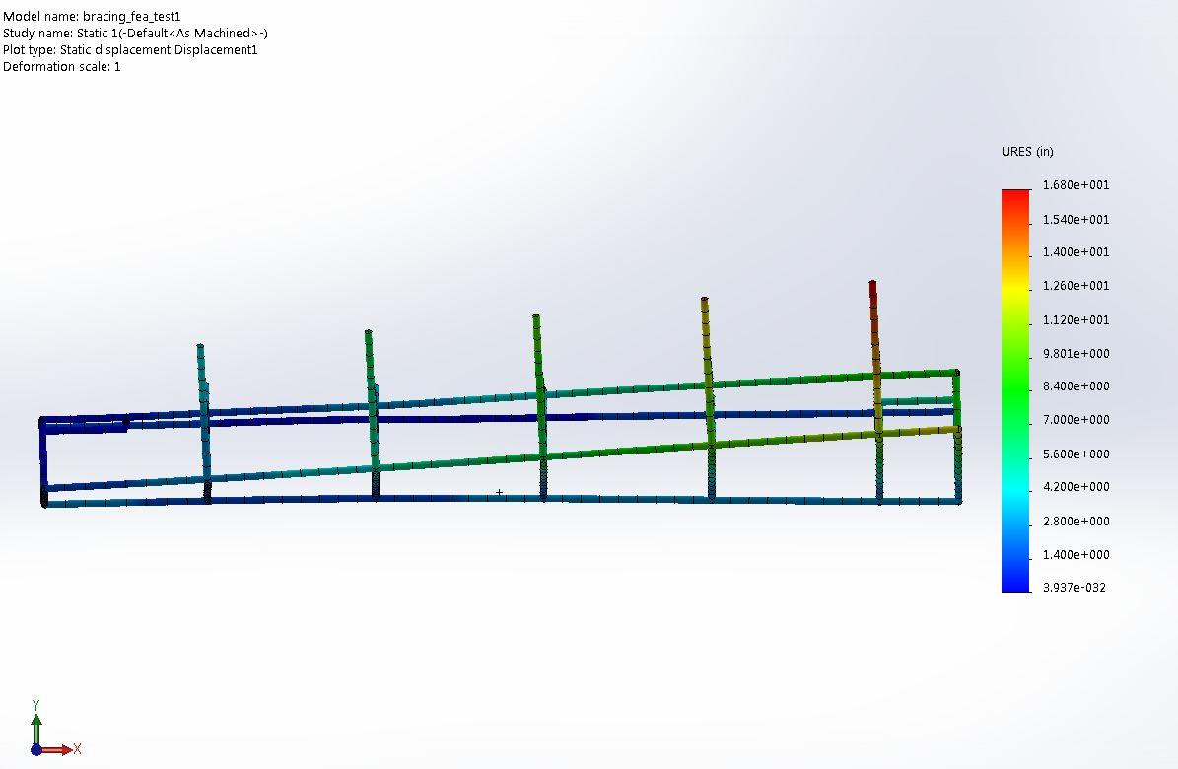

Torsional Displacement Horizontal Bracing w/o vertical supports: 10000 lbf (side view)

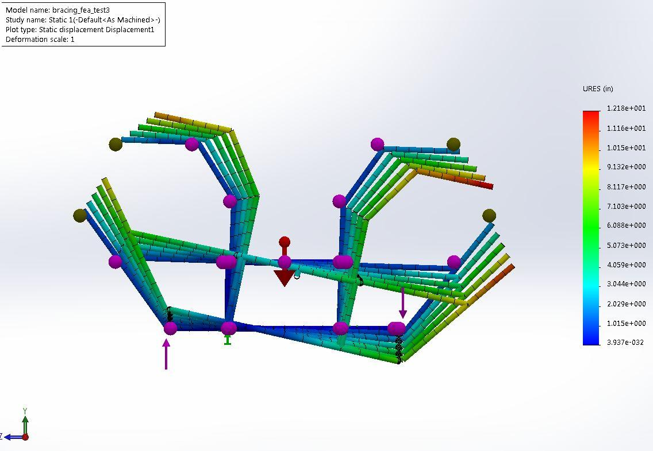

Torsional Displacement Full Cross Brace w/ vertical supports: 10000 lbf (front view)

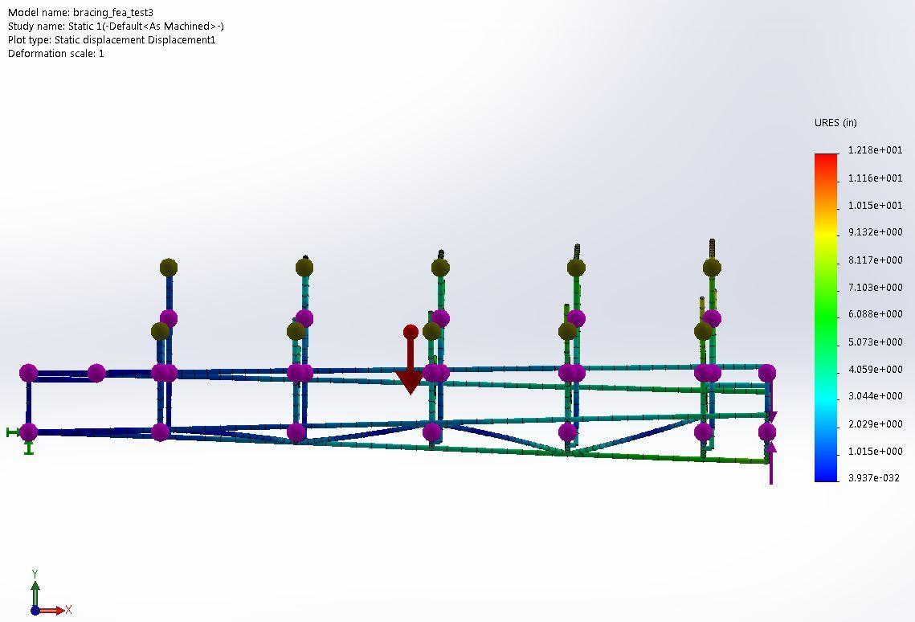

Torsional Displacement Full Cross Brace w/ vertical supports: 10000 lbf (side view)

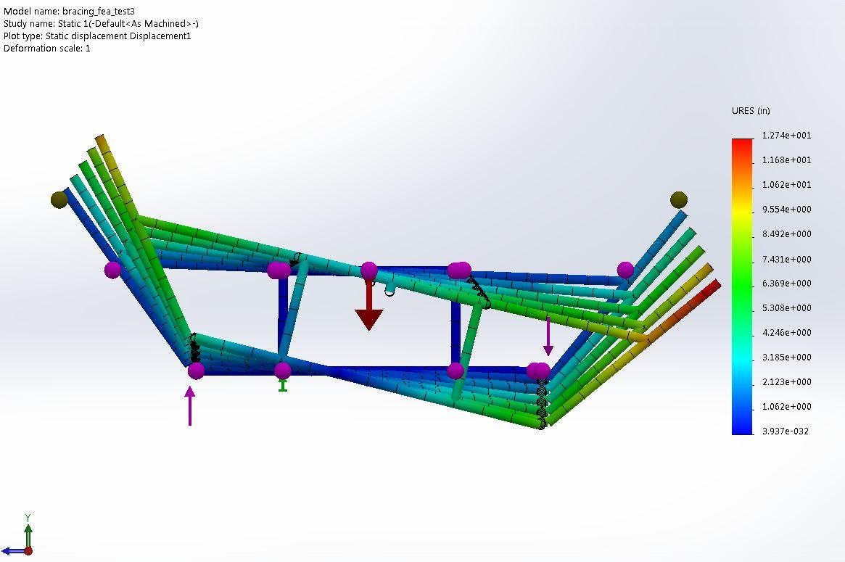

Torsional Displacement Full Cross Brace w/o vertical supports: 10000 lbf (front view)

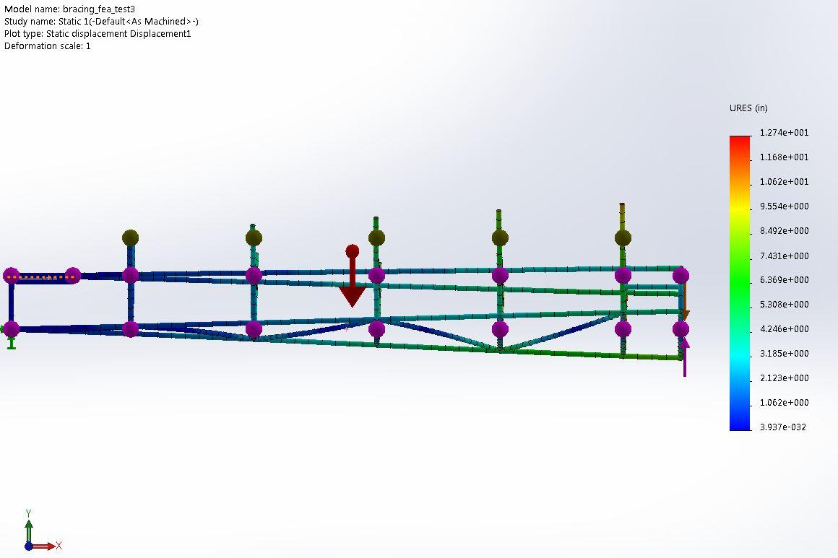

Torsional Displacement Full Cross Brace w/o vertical supports: 10000 lbf (side view)

For the half cross bracing a model without vertical supports was not made as the design eliminated mounting points for the vertical supports.

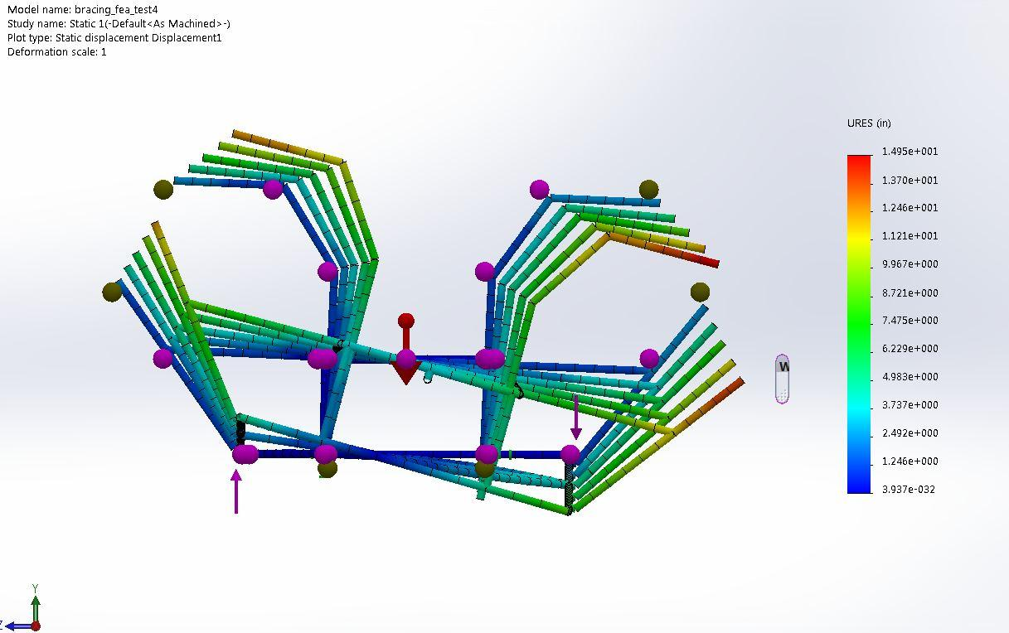

Torsional Displacement Half Cross Brace: 10000 lbf (front view)

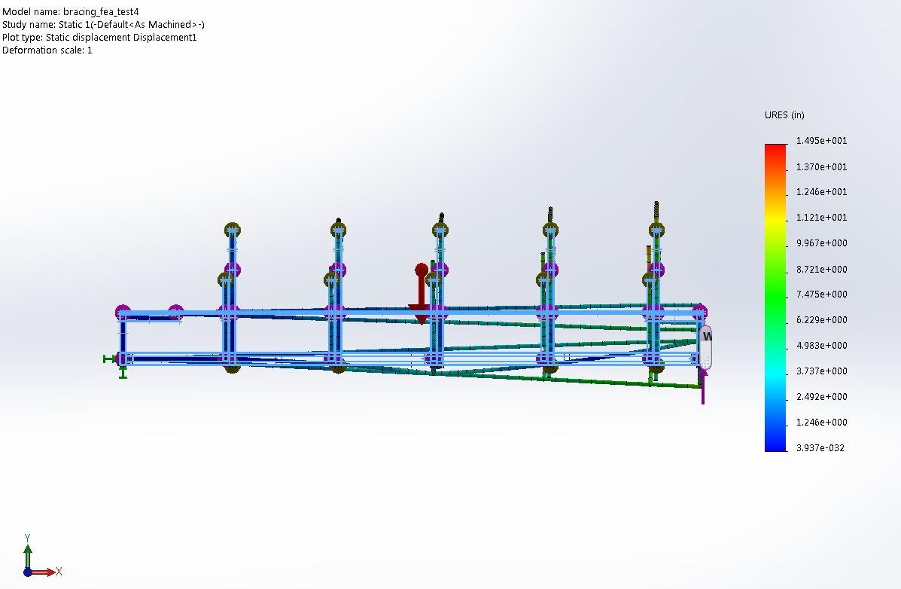

Fig. 12. Torsional Displacement Half Cross Brace: 10000 lbf (front view)

# **Appendix B**

The following is a procurement list that shows all the parts that were used on the Pedibus 2.0 fabrication. This list includes information regarding costs, shipping, purchase source and other pertinent financial information of the parts and materials utilized of the build. The list also shows a breakdown cost analysis of the different major subcomponents of the project as well as a total value for all the parts outsourced.

|  |  |  |  |  |  |  |  |  |  |  |  |  |  |  |  |
| --- | --- | --- | --- | --- | --- | --- | --- | --- | --- | --- | --- | --- | --- | --- | --- |
| **Part** | **Brand** | **In-Store/Online** | | **Ordering Source** | **Source Part #** | **Price Per Unit** | | **Quantity** | **Shipping Price** | | **Total Price** | | **Order Date** | | |
| 2x4x1/8 Construction Box Steel (A500) | N/A | In-Store | | Sabel | N/A | $84.48 | | 3 | $5.00 | | $258.44 | | 11/19/2014 | | |
| 2x1x1/8 Construction Box Steel (A500) | N/A | In-Store | | Sabel | N/A | $58.56 | | 8 | $5.00 | | $473.48 | | 11/19/2014 | | |
| 6 Speed Transaxle | Peerless | Online | |  | N/A | $697.00 | | 1 | $39.00 | | $736.00 | | 11/25/2014 | | |
| Floor Mount Brake Pedal | Wilwood | Online | | Amazon.com | B003XVLGN8 | $59.27 | | 1 | $0.00 | | $59.27 | | 11/19/2014 | | |
| 1" Bore Master Brake Cylinder | Wilwood | Online | | Amazon.com | B003XVJOHS | $48.05 | | 1 | $0.00 | | $48.05 | | 11/19/2014 | | |
| 5-Hole Brake Drum | AL-KO | Online | | Amazon.com | B001IN5KUI | $34.95 | | 2 | $20.25 | | $90.15 | | 11/19/2014 | | |
| 10" Trailer Electric Drum Brake (Left & Right) | TruRyde | Online | | Amazon.com | B0098M5LUK | $67.90 | | 2 | $0.00 | | $135.80 | | 11/19/2014 | | |
| Rubber Torsion Trailer Axle | Reliable | Online | | Amazon.com | B000F5861K | $249.99 | | 1 | $50.70 | | $300.69 | | 11/19/2014 | | |
| Trailer Spindle (#84) | Shadow | Online | | Amazon.com | B009COAXVQ | $44.33 | | 2 | $9.50 | | $98.16 | | 11/19/2014 | | |
| Spindle Bearings | Western Prime | Online | | Amazon.com | B00MMSOZAO | $12.95 | | 2 | $3.50 | | $29.40 | | 12/3/2014 | | |
| 10" Trailer Disc Brake Assemblely (1 Axle Kit) | Kodiak | Online | | Amazon.com | B006UH5IMC | $237.95 | | 1 | $26.50 | | $264.45 | | 11/19/2014 | | |
| Bicycle Crank | Retrospec | Online | | Amazon.com | B00FNT1BJ2 | $35.99 | | 10 | $0.00 | | $359.90 | | 11/19/2014 | | |
| Bicycle Pedal | Coromose | Online | | Amazon.com | B00LXQBXDS | $11.31 | | 10 | $1.00 | | $114.10 | | 11/19/2014 | | |
| Bicycle Bottom Bracket | Sunlite | Online | | Amazon.com | B003COD29C | $15.20 | | 10 | $0.00 | | $152.00 | | 11/19/2014 | | |
| Bicycle Free Wheel | Shiamno | Online | | Amazon.com | B001GSSIIG | $24.65 | | 10 | $0.00 | | $246.50 | | 11/19/2014 | | |
| Bicycle Chain | KMC | Online | | Amazon.com | B0013C7M6E | $7.37 | | 12 | $0.00 | | $88.44 | | 11/19/2014 | | |
| Wheels/Tires |  | In-Store | | Discount Tire |  | $169.85 | | 4 | $0.00 | | 679.4 | | 12/24/2014 | | |
| Freewheel Sprocket Adaptor | N/A | Online | | Staton-Inc | N/A | $11.69 | | 10 | $10.12 | | 127.02 | | 1/16/2015 | | |
| Lawn Mower Idler | ICpower1 | Online | | Amazon.com | B001V6OE1S | $11.91 | | 1 | $3.99 | | $15.90 | | 1/14/2015 | | |
| Pillow Block Mounted Bearing | Hub City | Online | | Amazon.com | B00ECZZG7G | $16.97 | | 10 | $0.00 | | $169.70 | | 1/14/2015 | | |
| Spur Gear | Martin | Online | | Amazon.com | B004BDO0EY | $89.65 | | 2 | $0.00 | | 179.3 | | 1/14/2015 | | |
| Bottom Bracket Shell | N/A | Online | | Amazon.com | B001GSSL1A | $10.06 | | 10 | $0.00 | | 100.6 | | 1/16/2015 | | |
| 1" Bore Diameter Sheave | TB Woods | Online | | Amazon.com | B003N17P0Q | $17.35 | | 1 | $0.00 | | 17.35 | | 1/14/2015 | | |
| 5/8" Bore Diameter Sheave | TB Woods | Online | | Amazon.com | B003N17JRU | $17.09 | | 1 | $0.00 | | 17.09 | | 1/14/2015 | | |
| Hitch Mount Receiver | PMD Products | Online | | Amazon.com | B00PB7UV1A | $20.99 | | 2 | $25.00 | | 66.98 | | 2/4/2015 | | |
| Trailer Swivel Mount Jack | Flagline | Online | | Amazon.com | B000CQOIVO | $29.59 | | 1 | $0.00 | | 29.59 | | 2/4/2015 | | |
| Husky Ball Coupler | Husky | Online | | Amazon.com | B004OK86O4 | $18.49 | | 1 | $0.00 | | 18.49 | | 2/4/2015 | | |
| Towing Trailer Lights | ucostore | Online | | Amazon.com | B0041AOHZ2 | $31.95 | | 1 | $5.99 | | 37.94 | | 2/4/2015 | | |
| Driver Seat | Wise Economy | Online | | Amazon.com | B00LG7VIRU | $34.00 | | 1 | $0.00 | | 34 | | 1/26/2015 | | |
| Rear Axle Shaft | Dorman | Online | | Amazon.com | B000C14QES | $102.86 | | 2 | $0.00 | | 205.72 | | 1/26/2015 | | |
| Rear Disc Brake Rotor | Dura International | Online | | Amazon.com | B00BLYZ9P0 | $26.66 | | 2 | $0.00 | | 53.32 | | 1/26/2015 | | |
| 30 mm Mounted Bearing | VXB | Online | | Amazon.com | B002BBOF5W | $17.79 | | 2 | $0.00 | | 35.58 | | 1/26/2015 | | |
| 5/8 Mounted Bearing | SKF | Online | | Amazon.com | B00DBNPQ5M | $47.35 | | 2 | $9.95 | | 104.65 | | 1/26/2015 | | |
| Right Rear Disc Caliper | ARC | Online | | Amazon.com | B0001YFTXQ | $60.61 | | 1 | $0.00 | | 60.61 | | 26-Jan | | |
| Left Rear Disc Caliper | ARC | Online | | Amazon.com | B0001YFTYK | $59.95 | | 1 | $0.00 | | 59.95 | | 26-Jan | | |
| Seat Swivle | Springfield Marine | Online | | Amazon.com | B000KKB811 | $24.60 | | 1 | $9.08 | | 33.68 | | 1/26/2015 | | |
| Bench Seat Wood Planks (2x10x16) | ACQ Top Choice | In Store | | Lowes |  | $19.97 | | 4 | $0.00 | | 79.88 | | 2/5/2015 | | |
| Bar Top Wood Planks |  | In Store | | Lowes |  | $19.97 | | 4 | $0.00 | | 79.88 | | 2/5/2015 | | |
| Bench 3/8 by 2.5" Carriage Bolts (Box of 100) | HM | In Store | | Lowes |  | $37.00 | | 1 | $0.00 | | 37 | | 2/5/2015 | | |
| Bench 3/8" Washers (Box of 100) | HM | In Store | | Lowes |  | $11.00 | | 1 | $0.00 | | 11 | | 2/5/2015 | | |
| Bench 3/8 Hex Nuts (Box of 100) | HM | In Store | | Lowes |  | $10.00 | | 1 | $0.00 | | 10 | | 2/5/2015 | | |
| 1-1/4" x 3ft 12 GA Bench Brackets |  | In Store | | Lowes |  | 11.15 | | 6 | 0 | | 66.9 | | 2/5/2015 | | |
| 1-1/4" x 6ft 12 GA Bench Brackets |  | In Store | | Lowes |  | 22.59 | | 2 | 0 | | 45.18 | | 2/5/2015 | | |
| ^^LOWES TAX AMOUNT |  |  | |  |  | $23.37 | | 1 | $0.00 | | 23.37 | |  | | |
| 1/8 X 8ft Sheet Metal |  | In Store | | Kelly Sheet Metal |  | $31.18 | | 1 | $0.00 | | 31.18 | | 2/2/2015 | | |
| 1" Round Driveshaft Steel (20') |  | In Store | | Sabel Steel |  | $34.01 | | 2 | $10.00 | | 78.02 | | 2/9/2015 | | |
| 3/4" Round Steering Column Steel (20') |  | In Store | | Sabel Steel |  | $19.07 | | 1 | $0.00 | | 19.07 | | 2/9/2015 | | |
| 2" x 1/4" Square Tubing |  | In Store | | Sabel Steel |  | $80.40 | | 1 | $0.00 | | 80.4 | | 2/9/2015 | | |
| 1/4" Coil Plate (for mounting brackets) |  | In Store | | Sabel Steel |  | $45.89 | | 1 | $0.00 | | 45.89 | | 2/9/2015 | | |
| Steering 3/4"-10x5.5" Hex Cap Screw |  | Online | | Fastenal.com | 13374 | $4.79 | | 2 | $10.84 | | 20.42 | | 1/26/2015 | | |
| Steering 3/4"-10 Nylon Nut |  | Online | | Fastenal.com | 169783 | $2.86 | | 4 | $0.00 | | 11.44 | | 1/26/2015 | | |
| 3/8"-16x2"x7" U Bolts (with nuts and washers) |  | Online | | Fastenal.com | 156516 | $11.34 | | 4 | $0.00 | | 45.36 | | 1/26/2015 | | |
| ^^FASTENAL TAX AMOUNT |  |  | |  |  | $5.80 | | 1 |  | | 5.8 | | 1/26/2015 | | |
| Steering Rack & Pinion |  | Online | | Summitracing.com | HFM-HEXSR2 | $123.45 | | 1 | $0.00 | | 123.45 | | 1/26/2015 | | |
| Steering Wheel |  | Online | | Summitracing.com | REB-270-8675 | $41.97 | | 1 | $0.00 | | 41.97 | | 26-Jan | | |
| U Joint |  | Online | | Summitracing.com | UIS-8052510 | $22.99 | | 2 | $0.00 | | 45.98 | | 1/26/2015 | | |
| Rear Brake Pads | Dura Int | Online | | Amazon.com | B001UCGPVU | $15.13 | | 1 | $1.59 | | 16.72 | | 2/25/2015 | | |
| Sheave | TB Woods | Online | | Amazon.com | B003N17JU2 | $6.01 | | 1 | $0.00 | | 6.01 | | 2/25/2015 | | |
| McMaster Order (**see invoice**) |  | Online | | McMaster.com |  |  | |  |  | | $142.48 | | 2/17/2015 | | |
| Chain Tensioners | Razor | Online | | Amazon.com | B008BPNIVY | $14.51 | | 10 | $24.39 | | $169.49 | |  | | |
| McMaster Order (**see invoice**) |  | Online | | McMaster.com |  |  | |  |  | | $10.48 | | 2/24/2015 | | |
| McMaster Order (**see invoice**) |  | Online | | McMaster.com |  |  | |  |  | | $259.64 | | 2/23/2015 | | |
| U-Joint, 9/16 In 26-Spline to 3/4 Round | Sweet Mfg | Online | | Speedway.com | 91032237 | $49.99 | | 1 | 7.3 | | $57.29 | | 2/23/2015 | | |
| Fastenal Order (**see invoice- 106648) |  | In Store | | Fastenal |  |  | |  |  | | $23.18 | | 2/24/2015 | | |
| Fastenal Order (**see invoice- 106537) |  | In Store | | Fastenal |  |  | |  |  | | $17.47 | | 2/20/2015 | | |
| Cold Rolled 1" Shafts |  | In Store | | Sabel Steel |  |  | |  |  | | $97.76 | | 2/16/2015 | | |
| 2 x 1 Rectangular tubing |  | In Store | | Sabel Steel |  |  | |  |  | | $117.12 | | 2/16/2015 | | |
| Lowes Order (**see invoice- 02707) |  | In Store | | Lowes |  |  | |  |  | | $72.48 | | 2/25/2015 | | |
| Lowes Order (**see invoice- 67005) |  | In Store | | Lowes |  |  | |  |  | | $241.22 | | 2/25/2015 | | |
|  |  |  | |  |  |  | |  |  | | | | | | | | | |  | |  |
|  |  |  | |  |  |  | |  | **Total Price** | | | **$7,635.23** | | |  | | |
| **Steel** | | | 1155.47 | |  | |  | | |  | | |  |  | | |  | | |  | | |  |
| **Misc. Materials** | | | 1046.27 | |  | |  | | |  | | |  |  | | |  | | |  | | |  |
| **Misc. Parts** | | | 4035.38 | |  | |  | | |  | | |  |  | | |  | | | | | | | |  |  |
| **Transaxle, Brakes & Wheels** | | | 1397.68 | |  | |  | | |  | | |  |  | | |  | | | | | | | |  |  |
| **Roof** | | | 2945.50 | |  | |  | | |  | | |  |  | | |  | | | | | | | |  |  |
| **Bar Top** | | | 472.50 | |  | |  | | |  | | |  |  | | |  | | | | | | | |  |  |
| **Total** | | | **$11,052.80** | |  | |  | | |  | | |  |  | | |  | | | | | | | |  |  |

The following two scans show the invoice for the outsourcing of the roof awning as well as the bar top respectively. Both of these costs are included in the price breakdown of the project and these include material and labor costs.

