Pedibus- Final Report

Kyle Anderson#1, Stephen Avery #2, Alejandro San Segundo #3, Brett Willenbacher #4

*# Mechanical Engineering Department, FAMU-FSU College of Engineering  
2525 Pottsdamer Street, Building A, Suite A229*

*Tallahassee, Florida; United States 32310-6046*

1kca10@my.fsu.edu

2 sja12@my.fsu.edu

3as10s@my.fsu.edu

4 blw11c@my.fsu.edu

**Mr. Ronald Goldstein:** Project Sponsor

**Dr. Chiang Shih:** Project Mentor/Mechanical Engineering Chair

**Dr. Scott Helzer:** Project Coordinator/Instructor

**Dr. Nikhil Gupta:** Project Co-Mentor

**Mr. Keith Larson:** Project Advisor

Table of Contents

**Abstract**

**1** **Introduction**

1.1 Objective

1.2 Background

1.3 Problem Statement

**2** **Project Definition**

2.1 Background Research

2.2 Need Statement

2.3 Goal Statement and Objectives

2.4 Project Constraints

**3** **Design and Analysis**

3.1 Mechanical Design Concepts

3.2 Material Selection

3.3 Frame Design

3.3.1 Box Style Frame

3.3.2 C-style frame

3.3.3 Supported Ladder Style Frame

3.3.4 Frame Design Selection

3.4 Peddler Input

3.4.1 Crossed Chain Linkage

3.4.2 Dual Drive Shaft Chain Drive

3.4.3 Pump Motion Crankshaft Linkage

3.4.4 Peddler Input Selection

3.5 Drivetrain

3.5.1 Solid Rear Axle

3.5.2 Hydrostatic Rear Transaxle

3.5.3 Manual Rear Transaxle

3.5.4 Drivetrain Selection

3.6 Suspension

3.6.1 Dual Leaf Sprung Solid Axle

3.6.2 Front Leaf Sprung Axle

3.6.3 Suspension Selection

3.7 Steering

3.7.1 Existing Vehicle Components

3.7.2 Trailer Hub “Cut and Weld”

3.7.3 Custom CNC Components

3.8 Brakes and Tires

3.8.1 Hydraulic Front and Mechanical Rear

3.8.2 4-wheel Hydraulic Disc

3.9 Ergonomics

3.10 Electronics

**4** **Specifications and Analysis**

4.1 Frame Specifications

4.2 Drivetrain Specifications

4.3 Transaxle Specifications:

4.4 Brakes and Tires

4.5 Steering

**5** **Methodology**

5.1 Schedule

5.2 Resource Allocation

**6** **Conclusion**

**7** **References**

Table of Figures

Figure 1. Example of block diagram (Biometric system design).

Figure 2. Example Gantt Chart from online

Table of Tables

Table 1. Example design decision matrix with three designs and five weighted design criteria.

For figure (or table) click insert and select caption**. In caption window, select label as figure (or table) and click ok. To add the table of figures (or table of tables) click insert and then index and tables. From the pop out window select the table of figures (or table of tables) and click ok.

* If there is no table or figure (which is highly unusual), then you do not make a table of tables or table of figures.

** Guidelines depend on system and the software version under use. In order to avoid conflict, do a Google search specific to one’s system (Mac vs. Windows) and software version in use.

***Abstract*— Capital City Pedicabs has sponsored a project to create a human powered vehicle. Existing pedal powered vehicles are either too expensive or do not meet the performance needs of the customer. The solution is to design and fabricate a cost effective solution for a pedal powered vehicle, paying close attention to fabrication difficulties and reproducibility. Current progress includes the design concepts and analyses of the selected subsystems. The team is entering the fabrication phase and has begun the procurement process. Therefore, the budget and resource allocations to date are also discussed. A structured schedule explaining the steps required to complete the project within the deadline, including design and fabrication schedules is included.**

***Acknowledgements***—

**Mr. Ronald Goldstein:** Project Sponsor

**Dr. Chiang Shih:** Project Mentor/Mechanical Engineering Chair

**Dr. Scott Helzer:** Project Coordinator/Instructor

**Dr. Nikhil Gupta:** Project Co-Mentor

**Mr. Keith Larson:** Project Advisor

**Mr. Jeremy Phillips**: Machine Shop Director

**Mr. James Gillman:** Machine Shop Operator

**Mr. Ricardo Aleman:** Project Teaching Assistant

**Mr. Samuel Botero:** Project Teaching Assistant

**Mr. Yuze Liu:** Project Teaching Assistant

***Team Biography***—

**Mr. Ronald Goldstein:** Founder of Capital City Pedicabs, has traveled all around the United States working in a variety of industries including hospitality, imports, real estate and public service. It was during a family vacation in 2005 that the seed was planted for the pedicab business [1].

**Kyle Anderson:** Kyle is a senior seeking his B.A. degree in Mechanical Engieering at the FAMU/FSU College of Engineering. Being involved with SAE his entire college career, Kyle proves to be a key aspect to the vehicle designing and leadership of the project. His experience consists mostly of hands-on builds.

**Stephen Avery:** Stephen is a senior seeking his B.A. degree in Mechanical Engieering at the FAMU/FSU College of Engineering. Being the chassis designer for SAE Baja 2014-2015 vehicle and SAE Senior member, he brings a lot to the table with the structure and safety of the project.

**Alejandro San Segundo:** Alejandro is a senior seeking his B.A. degree in Mechanical Engieering at the FAMU/FSU College of Engineering. With past professional and leadership experience involving fast paced professional environments, his skills bring a strong contribution for the Pedibus project. Alejandro also has a strong background in cycling and ergonomic design, which is a large majority of the Pedibus project.

**Brett Willenbacher:** Brett is a senior seeking his B.A. degree in Mechanical Engieering at the FAMU/FSU College of Engineering. With track courses in both vehicle and machine design, he helps bring the transportation aspect of the project to life.

1. Introduction

# Objective

The objective of this project is to develop a fully functioning, multi-person, pedal powered vehicle. This vehicle is designed to be used as an entertainment revenue tool by Capital City Pedicabs, our sponsor. Therefore, considerations such as safety of riders, comfort, user fatigue, and entertainment value must all be considered. This creates an interesting project for this year’s senior design team assigned to the Pedibus.

* 1. *Motive*

This is the second year that the Pedibus project has been presented to the FAMU/FSU College of Engineering. The vehicle produced by the previous team, while functional, failed to meet the sponsor’s desires as far as marketability. Issues such as reliability, ease of use, and user comfort, along with the lack of available entertainment, made the previous version less marketable. This year’s goal is to create a better design that also incorporates many of the revenue generators and attractions that were not present previously, while still maintaining a reliable and safe vehicle.

* 1. *Problem Statement*

Because this is the second year of this project, it was possible to evaluate the previous team’s work and decide what needed to be changed. Last year’s project was successful in terms of meeting the initial goals, however, considerations such as being able to transport the vehicle were not considered. Therefore, this year’s main objective is to create a more usable and marketable design. This year’s Pedibus will have a larger footprint in order to incorporate more peddlers while increasing the entertainment value and stability of the vehicle. Additionally, the ability to transport the vehicle without the need of a flatbed is another design concern. This feature will allow the sponsor to maintain a lower overhead cost increasing profits.

1. Project Definition
   1. *Background Research*

The concept of a multi-user bike utilized for leisure and group entertainment is an existing concept. Typically, this type of vehicle is used as a mobile attraction, often including on board entertainment and refreshments. In other cities this type of vehicle has existed through a variety of different names [1]. This business model is a fairly recent development for major cities in the United States. A handful of private investors have had one of these vehicles fabricated to fit a specific business model. These vehicles vary in design and performance since there is no single manufacturer that has monopolized production. Although different in detail, all party bikes share several characteristics, such as the seating arrangements and similar frame construction. Capital City Pedicabs, has requested an original design based on the aforementioned vehicles as a new business venture. This is a unique design challenge due to the environmental constraints present in Tallahassee. Because of the custom nature of these machines, literature regarding the design specifications is difficult to source, therefore the team will be working closely with the sponsor to ensure an acceptable product The fabrication of this project was attempted last year by another senior design team and some of their design concepts will be implemented into this build, but most of the final product will remain original and one of a kind.

* 1. *Need Statement*

The Pedibus project is sponsored by Ron Goldstein, owner of the Capital City Pedicabs. The sponsor wants to have a fully functional multi-user bike in order to institute a new business model to the city of Tallahassee. While this project was completed by the previous team, the product that was delivered was not satisfactory. Many of the design objectives originally set in place by Mr. Goldstein, were not met. This led to the sponsor to have to hire a third party fabricator in order to complete the vehicle.

**“Currently, the sponsor is without a usable vehicle to support this new business model.”**

* 1. *Goal Statement and Objectives*

The goal of this project is to design and fabricate a multi-person, human powered vehicle. This vehicle should be able to support the sponsor’s business model as well as operate efficiently under Tallahassee’s unique needs.

1. Accommodate a minimum of 10 occupants powering the vehicle
2. Accommodations for additional occupants, other than those powering the vehicle
3. Simple construction for easy maintenance, fabrication, and reproduction
4. Ability to be transported by a standard full-size pickup truck
5. Modular accessories to allow for accessory expansion post-fabrication

* 1. *Project Constraints*

The primary constraint of this project is to deliver a functioning Pedibus to Capital City Pedicabs by March 14, 2015. This constraint is to ensure that the vehicle is built, operational, and tested prior to the debut at Spring Time Tallahassee. Additionally, the vehicle must be simple to fabricate and reproduce, using a simple design and as many off the shelf components as possible. The design constraints set in place by the sponsor are fairly relaxed however, the following additional constraints are listed below.

1. Shop drawings must be made for all fabricated components
2. Must be moveable by a single rider and a driver
3. <1499 lbs rolling weight
4. Able to hold 3000 lb payload safely
5. Must meet all regulations for homemade trailer
6. Must be safe to tow on the freeway
7. Many of the design concepts shown below have special considerations in order to meet the criteria defined above.

1. Design and Analysis
   1. *Mechanical Design Concepts*

The Pedibus contains a number of various subsystems. All of which require some form of design analysis in order to most efficiently plan the construction of the vehicle. The following sections discuss the various subsystems that have design considerations constructed and organized in order to report the project progress in an efficient manner.

* 1. *Material Selection*

Several materials were considered for the primary build material. These materials include A500 Box Steel, 6061 Aluminum Box, and a mix of both materials. All of the materials have different advantages and disadvantages but it is important to note that aluminum can not directly be attached to steel components via the welding resources available. This requires the construction of various brackets and fasteners which will increase the cost and complexity of the project. Below a design matrix can be seen that directly compares the aforementioned materials.

Table I

Material Selection Matrix

|  |  |  |  |  |  |
| --- | --- | --- | --- | --- | --- |
|  | Weight | Cost | Rigidity | Machinability | Weighted Sums |
| A500 Steel | 5 | 9 | 9 | 7 | 119 |
| 6061 Aluminium | 8 | 6 | 4 | 4 | 94 |
| Hybrid | 7 | 7 | 6 | 3 | 89 |
| Weight Decision | 5 | 3 | 2 | 7 |  |

* 1. *Frame Design*

The team developed three design ideas for the frame. These three design ideas include a box style frame, supported ladder frame, and a C frame. These three designs will be discussed in detail in the next few paragraphs.

1. *Box Style Frame*

The box style frame consists of a central rectangular box structure with supports extending out from the side. This design allowed for all of the drive and electrical components to be contained inside the box section of the frame. Additionally, this design had the best separation of the passengers from any moving parts and was therefore considered one of the safer designs. However, this design used significantly more material and had a much larger foot print than desired.

Fig. 1. Box Style Frame Rendering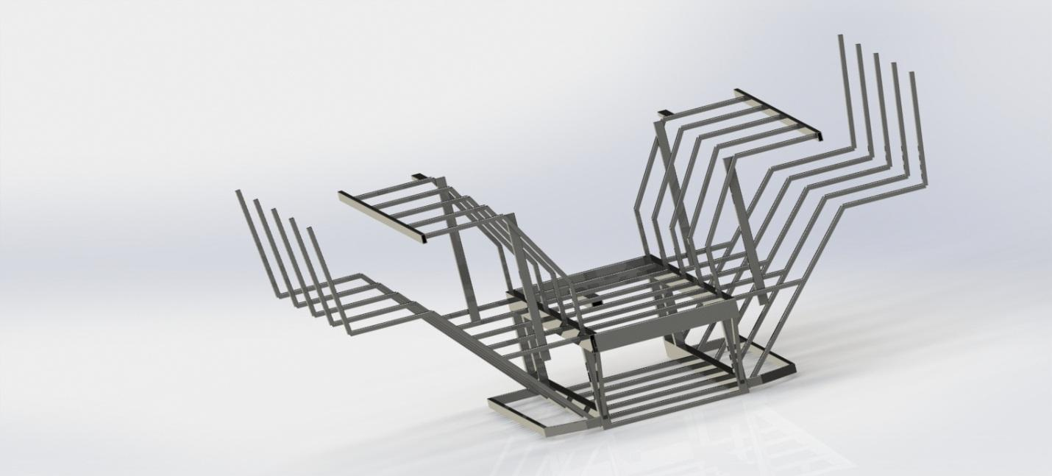

1. *C-style frame*

This frame design was the simplest of the three and consisted of primarily 2x4 and 2x2 members cut at 90º angles and arranged in a horizontal C shape. This design is very similar to the stringer setup on some boats. While this design allowed for the most variability in component selection it was also the least durable in terms of not allowing the frame to flex. Additionally, the frame offered no built in separation of components from the peddlers.

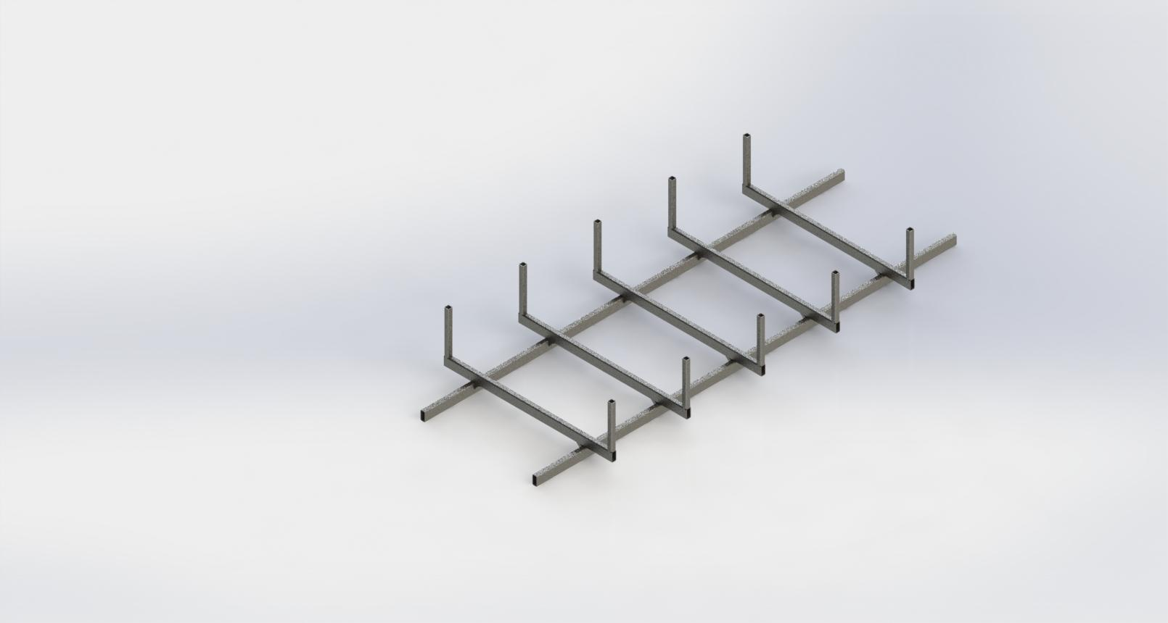

Fig. 2. C-Style Frame

1. *Supported Ladder Style Frame*

The ladder style frame is a mix of the two frames mentioned above. It has a wider center to center width of the primary lower frame rails. This allowed for greater axle support, a wider track width, and more subtle angles than either of the two previous designs. It also gave some degree of separation of components from the peddlers, less moment on the seats, and greater support of the seat tubes than either of the two previous designs.

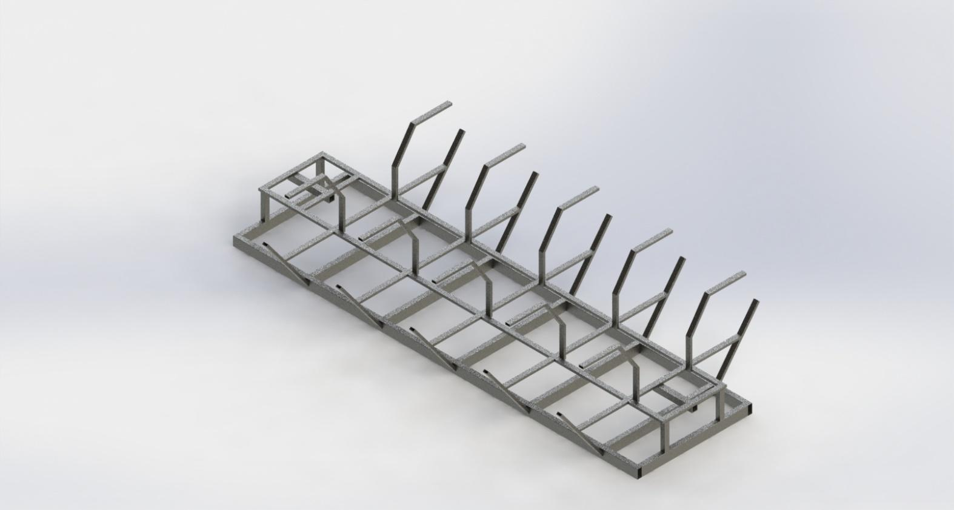

Fig. 3. Supported Ladder Style Frame

1. *Frame Design Selection*

Ultimately, the Supported ladder style frame was chosen due to the simplicity and ease of manufacturing of the design. Additionally, this design offered the best mix of efficient space utilization and structural rigidity. Below a design matrix outlining the major pros and cons of each style is shown.

Table II

Frame Decision Matrix

|  |  |  |  |  |  |  |
| --- | --- | --- | --- | --- | --- | --- |
|  | Strength | Fabrication | Complexity | Weight | Cost | Weighted Sums |
| Box-Style Frame | 8 | 6 | 4 | 4 | 7 | 170 |
| C-Style Frame | 2 | 9 | 9 | 7 | 4 | 160 |
| Supported Ladder Frame | 6 | 7 | 6 | 5 | 6 | 183 |
| Weight Decision | 6 | 8 | 4 | 5 | 7 |  |

* 1. *Peddler Input*

As a subsection of the drivetrain components some design analysis was performed on how peddlers would input power into the drivetrain. For this three designs were developed and considered. All designs also include a freewheel device for each peddler as a safety measure in order to prevent injuries to a rider.

1. *Crossed Chain Linkage*

The previous year Pedibus used a cross chain linkage to connected to peddle cranks on one end and a driveshaft on the other. This design was very simple and allowed for a single driveshaft to be used for the entire bus. However, this design also had some problems, especially in regards to reliability. Chain wear was more extensive due to the chains on one side of the bus rubbing up against a wear material. Additionally, this repair material was custom fabricated and has to be replaced when the system wears down. This resulted in less reliability, higher downtimes, and more repair costs.

Fig. 4. Crossed Chain Linkage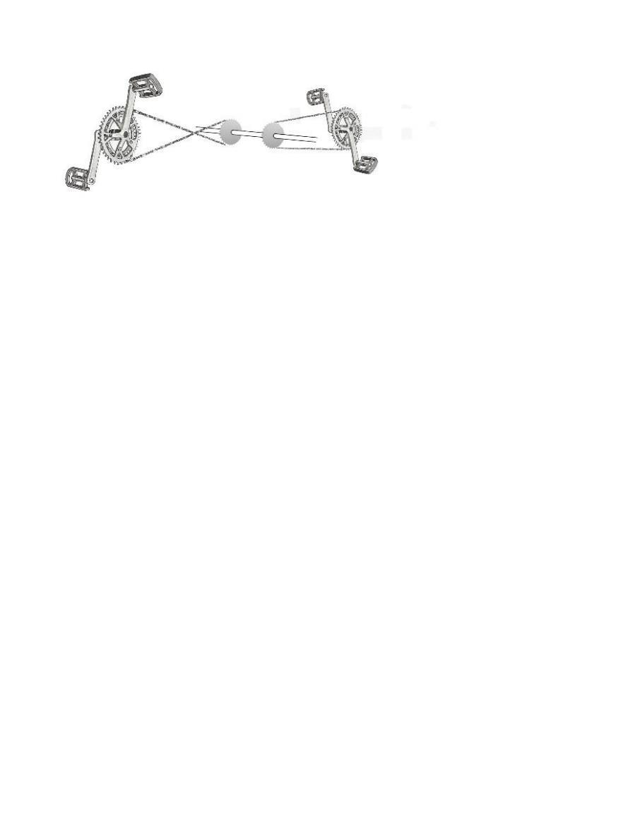

1. *Dual Drive Shaft Chain Drive*

The second design that was considered consisted of two parallel driveshafts attached to the cranks on either side of the Pedibus. These driveshafts would then be interconnected by a spur gear in order to make the power output in the same direction. This design is slightly more complex but also does not require chains to be crossed. This results in much higher reliability and durability albeit at an increase in complexity and cost. This design is the final choice that will be implemented onto the Pedibus. This will increase chain stability since the chains will no cross and the entire system will be aligned. Not crossing the chain will also reduce the price of the design since extra parts, such as chain tensioners and guides, will not need to be implemented onto the design. Overall this is clearly the best design choice from an engineering and a financial standpoint.

.

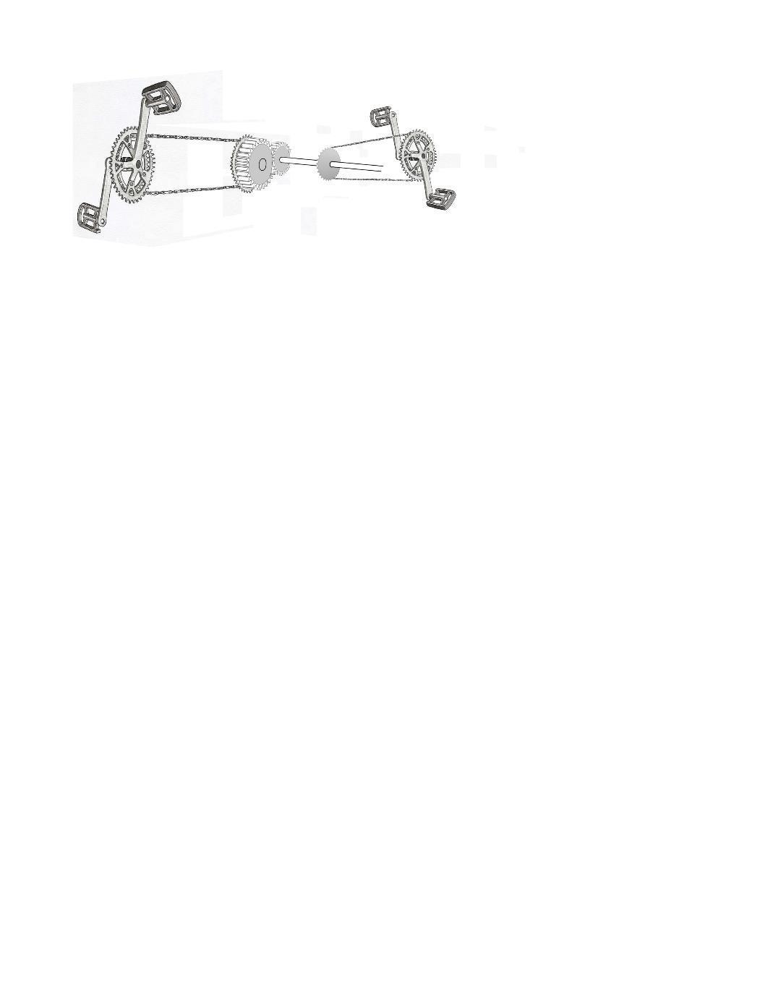

Fig. 5. Dual Drive Shaft Chain Drive

1. *Peddler Input Selection*

For the peddler input decision, it was ultimately chosen to utilize the dual drive shaft configuration. While this design was more complicated than the crossed chain design it also adds a level of stability and reliability that is lost by crossing the chains. The third design was heavily considered due to the novelty and apparent simplicity of the concept. However, because this design would require a fair amount more custom fabrication than the previous two options, the dual drive shaft was chosen.

Table III

Peddler Input Decision Matrix

|  |  |  |  |  |  |
| --- | --- | --- | --- | --- | --- |
|  | Safety | User Comfort | Complexity | Reliability | Weighted Sums |
| Cross Chained Linkage | 6 | 6 | 7 | 2 | 132 |
| Dual Drive Shaft Chain Drive | 6 | 7 | 4 | 7 | 161 |
| Weight Decision | 9 | 6 | 4 | 7 |  |

* 1. *Drivetrain*

For the purpose of this report the drivetrain section deals primarily with power delivery from the end of the driveshaft to the driven wheels. All of the peddler input methods outputs directly to a driveshaft that can be connected to some sort of axle in order to transmit power to the wheels. Additionally, all of our designs were made assuming a rear wheel drive configuration for simplicity. A front wheel drive system was considered but was rejected due to significant amount of additional complexity involved.

1. *Solid Rear Axle*

The initial design consideration regarding the drivetrain was to use an automotive rear axle. While this system was very durable and was a commonly used solution for this type of vehicle (CITE THIS) there were some disadvantages. The most important of which was the lack of reverse gear. If this design were to be used an additional gearbox would also be used in order to allow for the vehicle to travel in reverse. Additionally, the lack of multiple forward gears was a serious disadvantage in the area of which the bus is being designed for. Multiple forward gears allows for the bus to be operated in more locations including areas with hills.

1. *Hydrostatic Rear Transaxle*

Another drivetrain configuration that was considered consisted of a hydrostatic transaxle and possibly accompanying pump. This transaxle acted similar to an automatic transmission in a car but using a hydraulic continuously variable transmission. This would have allowed the bus to be driven without the need of being shifted while still having the advantages of being able to traverse multiple landscapes.

1. *Manual Rear Transaxle*

The second transaxle that was considered was a full manual geared rear transaxle. This transaxle shared the same footprint as the Hydrostatic transaxle discussed above. It is less complicated but it also requires a clutch system in order to change gears on the fly. Because of this it has a significantly higher torque rating than the equivalent hydrostatic model.

1. *Drivetrain Selection*

Due to the additional benefits that the manual rear transaxle had over the single speed rear axle it was chosen over the other options. The hydrostatic transaxle would have been an excellent choice, however, there were very few options that would be strong enough at a reasonable price. Unfortunately, the manual transaxle generates additional design considerations regarding the transaxle that are less relevant in the other two options, but it offered the most useful options to make the pedibus more rider friendly.

Table IV

Drivetrain Decision Matrix

|  |  |  |  |  |  |  |  |
| --- | --- | --- | --- | --- | --- | --- | --- |
|  | Durability | Cost | Modularity | User Fatigue | Maintenance | Complexity | Weighted Sums |
| Hydrostatic Transaxle | 2 | 8 | 6 | 6 | 4 | 2 | 110 |
| Manual Transaxle | 7 | 5 | 9 | 9 | 8 | 3 | 168 |
| Vehicle Axle | 8 | 6 | 2 | 2 | 7 | 8 | 162 |
| Weight Decision | 8 | 4 | 2 | 6 | 6 | 2 |  |

* 1. *Suspension*

When considering the suspension for the pedibus project, the cost, viability, and necessity of the suspension was analysed. Initially, the suspension design was to have both front and rear axles to be directly mounted to the frame, essentially eliminating the suspension. However, after discussing the design further, especially, with respect to the feasibility of towing, the suspension was re-evaluated. The following designs have been considered.

1. *Dual Leaf Sprung Solid Axle*

When the suspension redesign began the initial concept included front and rear suspension utilizing eye-slipper leaf springs. This concept added significant complexity to the drivetrain. In order to utilize a rear suspension either the transaxle would have been able to move in the vertical direction, requiring u-joints on the driveshaft. Additionally, another consideration would have been to move to axle shafts that utilized a CV-joint to apply power to the wheels.

1. *Front Leaf Sprung Axle*

The second design concept that is currently being considered, is to only implement a front suspension. This consideration was made as the bus while in use does not require suspension. However, when being towed, the axle that is on the ground would benefit greatly from a simple suspension. This design concept has significantly less complexities then the first concept but also lacks the additional comfort that a rear suspension would add.

1. *Torsion Trailer Axle Suspension*

The third and final design selected was from already existing trailer parts. The torsion axle selected is a bolt on part that will take little alteration to the design of the frame of the vehicle. Tabs will welded to the frame so the axle can be attached to the frame and out of the way of normal operations. The axle will only be in use while towing. While in normal operation, the axle may either stay on the vehicle, or can be removed. To tow the vehicle, the wheels from the rear of the bus will be removed and attached to the towing axle. Eliminating the need for additional wheels.

1. *Suspension Selection*

As one can see from the below decision matrix, the final selection was the Trailer Torsion axle. Key factors to this decision is the fabrication requirements to the chassis, overall strength, and ease of maintenance compared to the other options. This was the option that the team was most likely going to use and the matrix proves that it is the correct choice.

Table V

Suspension Design Decision Matrix

|  |  |  |  |  |  |  |  |
| --- | --- | --- | --- | --- | --- | --- | --- |
| Set Up | Fabrication Requirements | Cost | Complexity | Maintenance | Weight | Strength | Weighted Sums |
| Dual Leaf Sprung Solid Axle | 2 | 3 | 2 | 4 | 4 | 3 | 98 |
| Front Leaf Sprung Axle | 6 | 6 | 5 | 6 | 6 | 7 | 208 |
| Torsion Trailer Axle Suspension | 8 | 4 | 8 | 7 | 4 | 6 | 215 |
| Weight Decision | 8 | 6 | 4 | 5 | 3 | 8 |  |

* 1. *Steering*

The steering for this particular vehicle is the last thing to be designed. A rack and pinion with custom made tie rods will be used to turn the wheels, uprights, spindle and hubs for steering. All inboard steering components have been selected. However, the sourcing and designing of uprights, hubs, and spindles is still being determined. Although many design ideas have been contemplated, all design concepts have been narrowed down to a few basic designs.

1. *Existing Vehicle Components*

The original idea was to use specific working dimensions, wheel base and track width, so that the front upright, bearings, hubs spindles, etc, can be sourced from a pre-existing road vehicle. This would simplify fabrication if these components could be bolted into place without the need of additional fabrication. This would also provide a front hub bearing that could handle the weight and highway speeds expected for this vehicle.

1. *Trailer Hub “Cut and Weld”*

The second consideration is trailer hubs as a potential for this design. Since trailer hubs are usually held straight, steering components for these hubs would need to be fabricated. A “cut and weld” design is being considered. This means a simple, two dimensional, sheet metal frame or bracket would be cut and welded into place. The manufacturing of this is less involved and would only require basic shop tooling. It also allows for flexibility in how the vehicle turns and an optimum steer radius can be achieved. This design still avoids the need of complicated three dimensional parts that would require a CNC.

1. *Custom CNC Components*

The final idea that is being considered is complete CNC uprights, hubs, and spindles. Designs would be drawn from scratch and all parts would be made at the College of Engineering machine shop. Although the complexity of the designs is not particularly involved, the fabrication would be time consuming. The use of a CNC also increases future complications and costs if one of the steering components were to fail, or if the sponsor chose to have the vehicle reproduced. Original designs make parts unique and one of a kind; making them harder to replace. In the spirit of the project constraints this design concept will only be considered if the other two concepts are not viable.

1. *Steering Selection*

The selection of the steering was less straightforward then many other design subsystems this vehicle consists of. The original plan was for sourcing of already existing components from existing road vehicles. After some thinking and group discussion the idea of the Cut and Weld uprights started to seem more realistic. As the decision matrix below shows, Cut and Weld became the final design path that will be taken to allow the vehicle to steer.

Table VI

Steering Design Decision Matrix

|  |  |  |  |  |  |
| --- | --- | --- | --- | --- | --- |
| Set Up | Fabrication Requirements | Cost | Complexity | Ease of Implementation | Weighted Sums |
| Pre-existing Vehicle Parts | 8 | 6 | 6 | 2 | 144 |
| Cut and Weld | 6 | 6 | 7 | 7 | 169 |
| CNC parts | 2 | 2 | 4 | 8 | 106 |
| Weight Decision | 8 | 5 | 6 | 7 |  |

* 1. *Brakes*

Different brake systems will be used for the operational and towing use of the Pedibus. Below are the two different transportations and the brake systems that will go along with each of them.

1. *Operational Use*

10” hydraulic disc brakes will be used on both of the axles during operational use. The size of the brakes were chosen based on the necessary brake force required to stop the Pedibus and by common availabity. These brakes will be operated by a pedal to master cylinder system. With a pedal ratio of 6:1, the driver will have ease applying force to the brakes. Hydraulic brake lines will run from the master cylinder to each of the four disc brakes. One of the main concerns for this project is making it as easy to maintain as possible. Disc brakes have much lower maintenance requirements when compared to drum brakes. Also, with low speeds during operational use, the brake disc life span will be much longer than that of a standard vehicle.

1. *Towing*

While being towed, there will be one separate axle on the ground. This is necessary because the transaxle’s inability to handle highway speeds. For this separate axle, a torsion bar will be used to help act like a suspension. Because of the weight of the Pedibus, 10” electric drum brakes will be used on the two tires during the towing. These electric brakes will be controlled by an in-cab remote. This remote will be tuned depending on the overall weight of the Pedibus and the driver’s preferences.

* 1. *Ergonomics*

Ergonomics is a serious consideration for this vehicle as the vehicle might be in use for an extended period of time. Therefore, the team has researched the difference between different types of bicycle riding positions in order to determine a comfortable design that is compact enough to fit on the bus. The three rider positions are listed below. The pedalling platform design has been chosen in order to best accommodate a wide range of peddlers of different sizes. The crank mount positioning on the frame has been strategically calculated to be 30 inches from the hipbone of the rider, as shown in figure 6 below. This length is the average extended leg length for a 5’0 height person. The downward angle has also been chosen to comfortably accommodate a person up to a height of 6’5.

1. *Standard Riding Style*

A standard riding style would be where the rider’s legs are nearly directly below the tailbone. While this design is the most compact, it is also very difficult to implement given that the team has decided to use bench seating in the vehicle. This means that the riders’ legs would have to tuck behind the bottom of the bench seat. This would lead to a very uncomfortable riding position leading to heavy rider fatigue. A diagram showing this type of riding position is shown below.

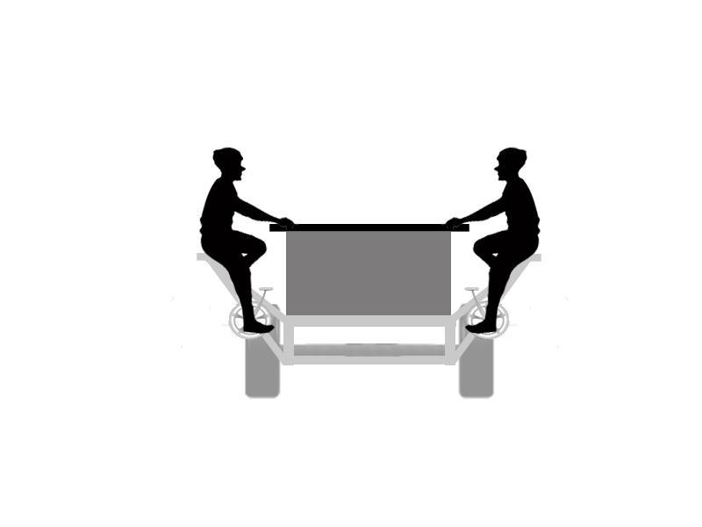

Fig. 6. Upright Riding Style

1. *Recumbent Riding Style*

A recumbent riding style works better with a bench seating design. However, this riding position requires a significant amount more space. Additionally, the riding position would make adjustments very difficult for people of different sizes. The angle of the back and bottom of the bench, as well as the height of the crank would be critical to the success of this design. A diagram showing this style of riding position is shown below.

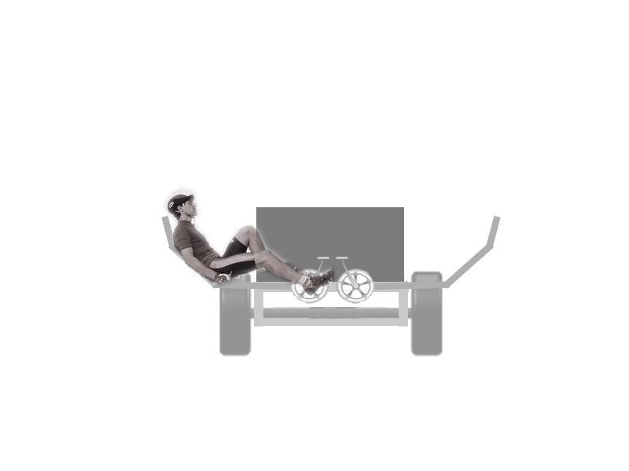

Fig. 7. Recumbent Riding Style

1. *Hybrid Riding Style*

In order to incorporate a riding position that will fit in the vehicle while still minimizing the fatigue of the riders, a hybrid position may need to be required. This design is less compact than a standard position but much more comfortable, like the recumbent stance. In a nutshell, this design is a mixture of both the standard and the recumbent stance. Additionally, it does not take up nearly as much space as the recumbent riding style. The angle of the seat back and seat bottom will also be less critical to the overall user experience. This design does have some drawbacks in the fact that the ergonomic positioning would have to be designed by the team instead of going with standard dimensions. While off the shelf components can still be used, the components may have to be mounted in a non-standard orientation.

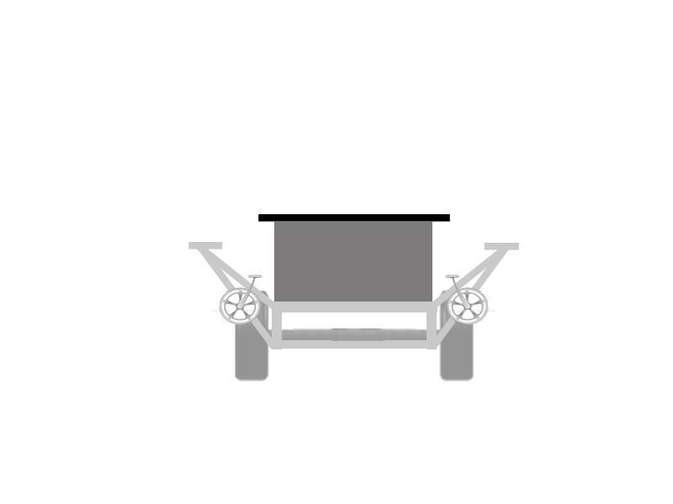

Fig. 8. Hybrid Riding Style

In order to further increase the comfort level of the rider, an inclined cushion will be added to the bench. This will simulate the angled seat from a recumbent stationary bicycle and provide proper support for the rider. Adding the cushion will not only prevent the riders’ legs from falling asleep, but it will also create the perfect alignment angle for comfortable riding. This angle, used for correct recumbent bicycle size fitting, is usually 90°; and it is the angle the back and legs of the rider make when the crank arms are in neutral position. A closer proximity to this angle will ensure a more comfortable pedalling experience. The placement of this angled bench cushion is shown below in figure 9. The angle of the seat will be about 20º from the horizontal, which will bring the rider closer to a correct stance hip angle and thus ensuring comfort.

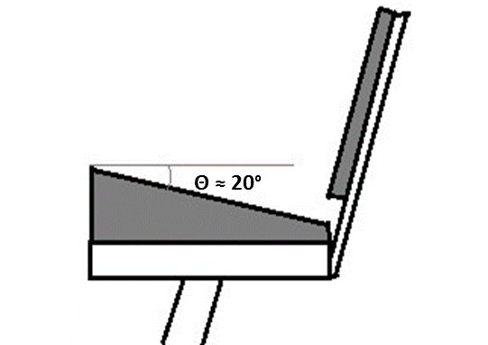

1. Risk and reliability Assessment
2. Design for Manufacturing

The entirety of this project is to produce a final product that is usable and is also capable of being easily mass produced on a later date. In order for the design to be easily reproducible, the team has gone through many designs and considerations. One example is the type of materials the frame will be constructed of. A500 box steel is the material of choice with only two sizes to choose from, 2”x4”x1/8” and 2”x1”x1/8”. Although the frame could have used thinner wall and different size tubing in other areas, this would further complicate designs. The entirety of the frame was designed for simplicity, including the geometry of the welded on components. As many pieces were welded at ninety degree angles as possible with easy to reach welds.

To further ease the mass production of this product, most parts are bought from a supplier instead of being custom manufactured. Therefore, the need for in house fabrication and machining was drastically reduced. The sponsor requested to have this thing built at a place where the only tooling required is a welder, saw, and a plasma table. There is a shop in Tallahassee that has these tools where this project could be reproduced in the future. The exact tooling of this shop has been a constraint of the team, with some flexibility. Some machining can be out sourced if needed, although not preferred. Therefore the only parts being built by the team is the frame, roof, seating, and all tabs that are used to bolt on the other components.

One last major request the sponsor had for future manufacturing of the Pedibus is for all parts to be logged of cost and where he will be able to order them in the future. The team has allocated this job to a team member, as the financial advisor. This member is in charge of all ordering, and records all purchases for costs and where all parts are coming from. Once the product is final this will be submitted into a final report.

The last objective for the team will be to make a build packet. Everything that will be needed for the build of the Pedibus will be in the contents of this packet. The packet will include engineering drawings, step by step manuals for building and operating, as well as all the sourcing for the parts needed to construct the Pedibus. This will be a packet that will answer all questions one would have to build this product. Therefore future building of the product should require nothing more than giving the builder the packet and money for the build.

1. Procurement:
   1. *Purchase orders and machining*

As stated earlier, one of the main focuses on this project is the ability to easily reproduce the design. With this being said, all components must be available by a local vendor or easily accessible online. For the sake of large order purchases and time constraints, most of the Pedibus parts were purchased using Amazon.com. These parts were then sourced to provide local vendors for the sponsor to keep on hand for future purchases.

|  |  |  |  |  |  |  |  |  |  |  |  |  |  |
| --- | --- | --- | --- | --- | --- | --- | --- | --- | --- | --- | --- | --- | --- |
| **Part** | **Brand** | **Manufacture Part #** | **In-Store/Online** | **Ordering Source** | **Source Part #** | **Price Per Unit** | | **Quantity** | **Shipping Price** | **Total Price** | | **Order Date** | |
| 2x4x1/8 Construction Box Steel (A500) | N/A | N/A | In-Store | Sabel | N/A | $84.48 | | 3 | $5.00 | $258.44 | | 11/19/2014 | |
| 2x1x1/8 Construction Box Steel (A500) | N/A | N/A | In-Store | Sabel | N/A | $58.56 | | 8 | $5.00 | $473.48 | | 11/19/2014 | |
| 6 Speed Transaxle | Peerless | 820-040 | Online |  | N/A | $697.00 | | 1 | $39.00 | $736.00 | | 11/25/2014 | |
| Floor Mount Brake Pedal | Wilwood | 3401289 | Online | Amazon.com | B003XVLGN8 | $59.27 | | 1 | $0.00 | $59.27 | | 11/19/2014 | |
| 1" Bore Master Brake Cylinder | Wilwood | 2606766 | Online | Amazon.com | B003XVJOHS | $48.05 | | 1 | $0.00 | $48.05 | | 11/19/2014 | |
| 5-Hole Brake Drum | AL-KO | 545LB3E | Online | Amazon.com | B001IN5KUI | $34.95 | | 2 | $20.25 | $90.15 | | 11/19/2014 | |
| 10" Trailer Electric Drum Brake (Left & Right) | TruRyde | 23158-C9 | Online | Amazon.com | B0098M5LUK | $67.90 | | 2 | $0.00 | $135.80 | | 11/19/2014 | |
| Rubber Torsion Trailer Axle | Reliable | 129287 | Online | Amazon.com | B000F5861K | $249.99 | | 1 | $50.70 | $300.69 | | 11/19/2014 | |
| Trailer Spindle (#84) | Shadow | ST-SP20484F | Online | Amazon.com | B009COAXVQ | $44.33 | | 2 | $9.50 | $98.16 | | 11/19/2014 | |
| Spindle Bearings | Western Prime | BK-3500 | Online | Amazon.com | B00MMSOZAO | $12.95 | | 2 | $3.50 | $29.40 | | 12/3/2014 | |
| 10" Trailer Disc Brake Assemblely (1 Axle Kit) | Kodiak | 2/HRCM-10-DAC | Online | Amazon.com | B006UH5IMC | $237.95 | | 1 | $26.50 | $264.45 | | 11/19/2014 | |
| Bicycle Crank | Retrospec | 3020M-10-48 | Online | Amazon.com | B00FNT1BJ2 | $35.99 | | 10 | $0.00 | $359.90 | | 11/19/2014 | |
| Bicycle Pedal | Coromose |  | Online | Amazon.com | B00LXQBXDS | $11.31 | | 10 | $1.00 | $114.10 | | 11/19/2014 | |
| Bicycle Bottom Bracket | Sunlite |  | Online | Amazon.com | B003COD29C | $15.20 | | 10 | $0.00 | $152.00 | | 11/19/2014 | |
| Bicycle Free Wheel | Shiamno | ISF120016 | Online | Amazon.com | B001GSSIIG | $24.65 | | 10 | $0.00 | $246.50 | | 11/19/2014 | |
| Bicycle Chain | KMC | Z410 112L BLK | Online | Amazon.com | B0013C7M6E | $7.37 | | 12 | $0.00 | $88.44 | | 11/19/2014 | |
|  |  |  |  | | | |  | | **Total** | | **$3,454.83** | |

1. Safety Issues
   1. *Finite Element Analysis*

For the purpose of this report a factor of safety is assumed at 1.3 and that the frame performs similarly and effectively in all bracing configurations in the vertical loading direction based on previous finite element analyses. This assumption will be tested at a later date after the deadline of this report. Bench rigidity testing in the long horizontal direction still needs to be analyzed however, torsional stiffness of the frame with various bracing configurations have been analyzed. The results of the initial vertical loading tests are below.

1. *Vertical Loading*

The vertical loading tests were produced in the standard bracing configuration containing no cross bracing on the primary lower frame. The frame was fixed in the vertical and horizontal directions, roughly at the location of the front and rear axles. It was then loaded with 4,500 lbf evenly across the 10 bench seat supports. An additional 500 lbf was applied to the 10 bar top mounts. The maximum deformation was found to be 0.892 in. This deformation was seen at the center of the vehicle at the top of the seat post. The primary frame of the vehicle had a maximum deformation of less than 0.7 in over the entire 180 in frame length. See fig. 1.

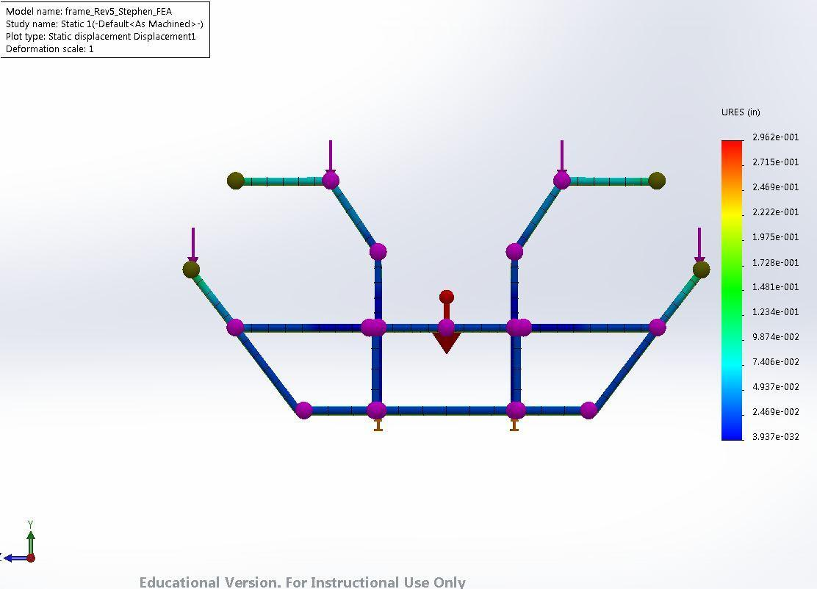

Fig. 1. Vertical Displacement, 5000 lbf, Front View

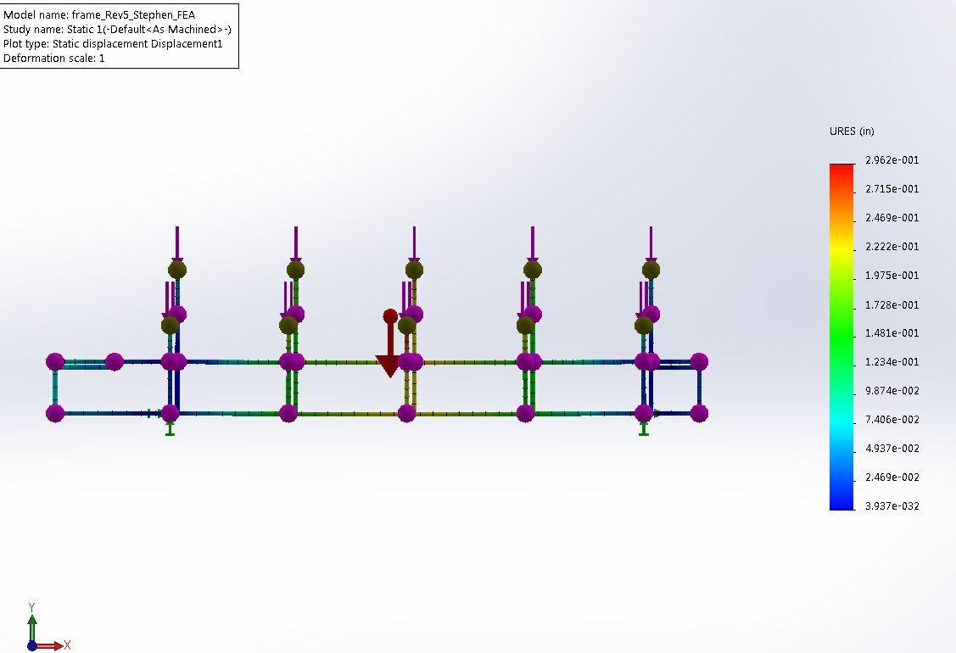

Fig. 2. Vertical Displacement, 5000 lbf, Front View

1. *Torsional Loading*

The torsional loading was performed in 3 different lower frame bracing configurations. Additionally, these three configurations were tested with and without the middle vertical frame supports attached to the bar top supports. The visual results are as follows.

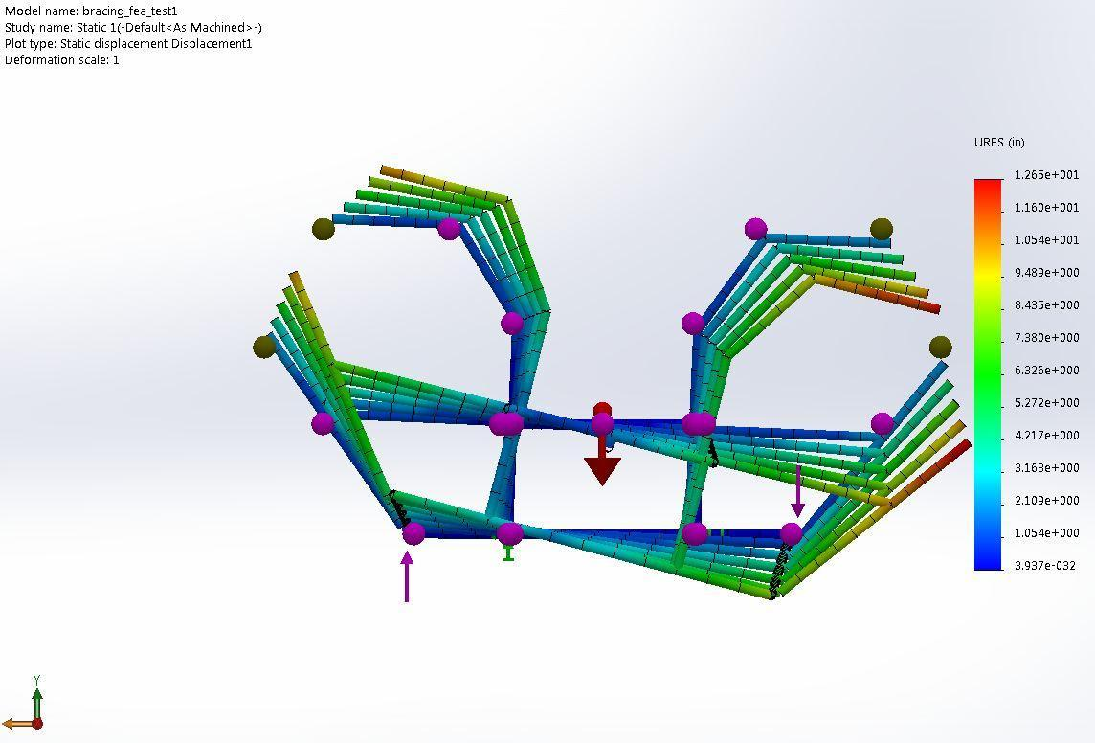

Fig. 3. Torsional Displacement Horizontal Bracing w/ vertical supports: 10000 lbf (front view)

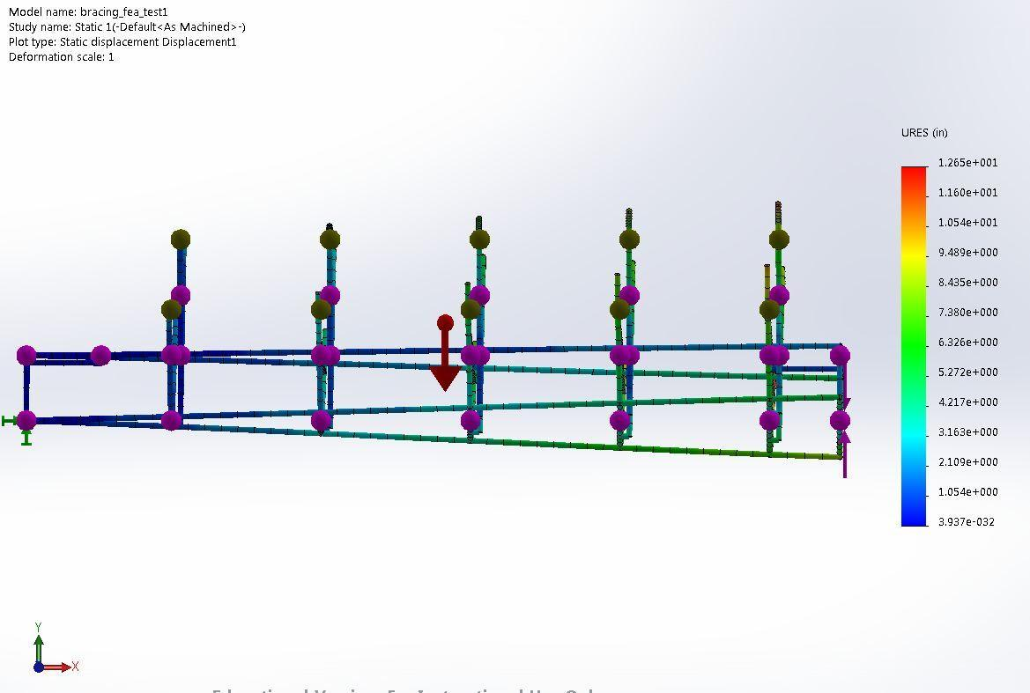

Fig. 4. Torsional Displacement Horizontal Bracing w/ vertical supports: 10000 lbf (side view)

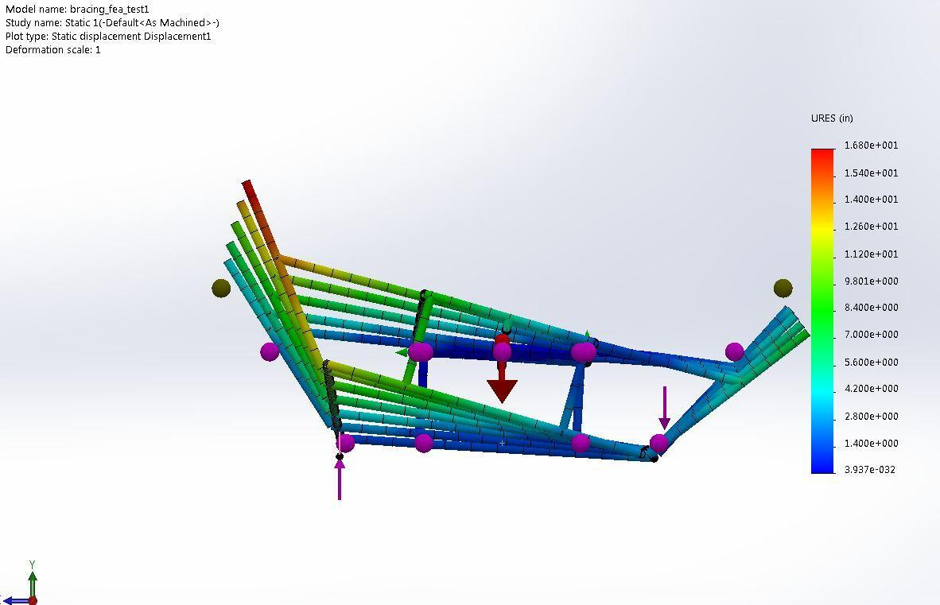

Fig. 5. Torsional Displacement Horizontal Bracing w/o vertical supports: 10000 lbf (front view)

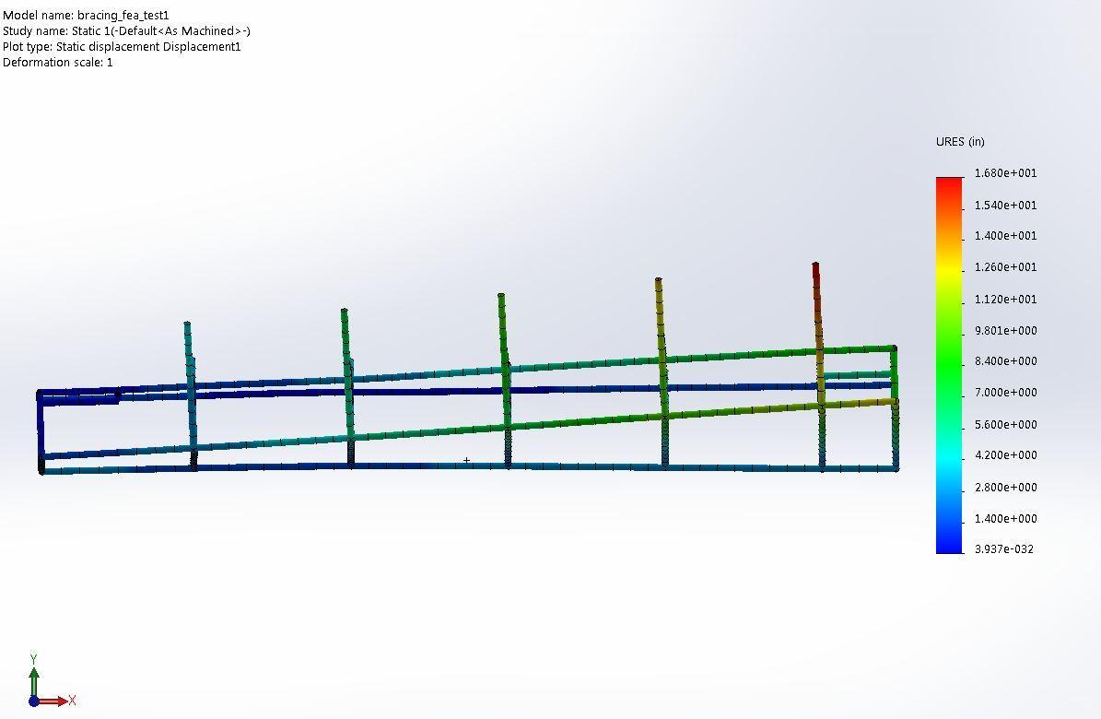

Fig. 6. Torsional Displacement Horizontal Bracing w/o vertical supports: 10000 lbf (side view)

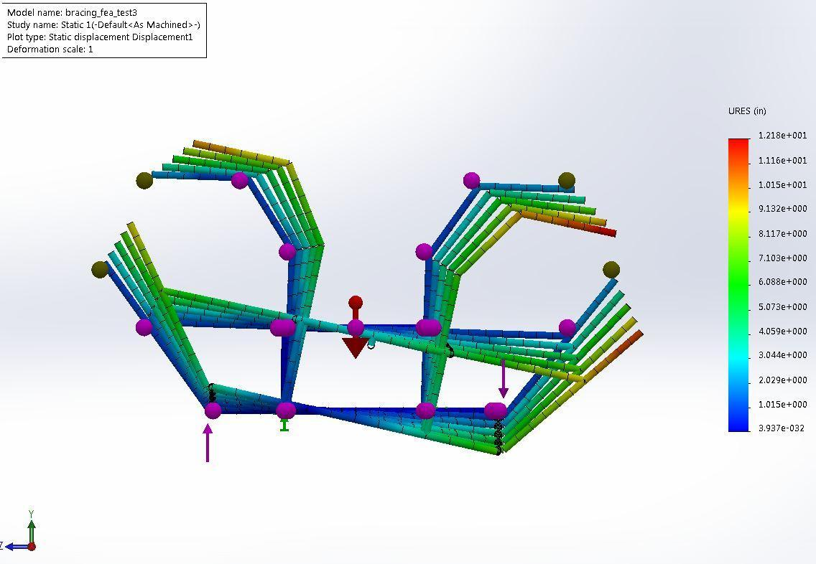

Fig. 7. Torsional Displacement Full Cross Brace w/ vertical supports: 10000 lbf (front view)

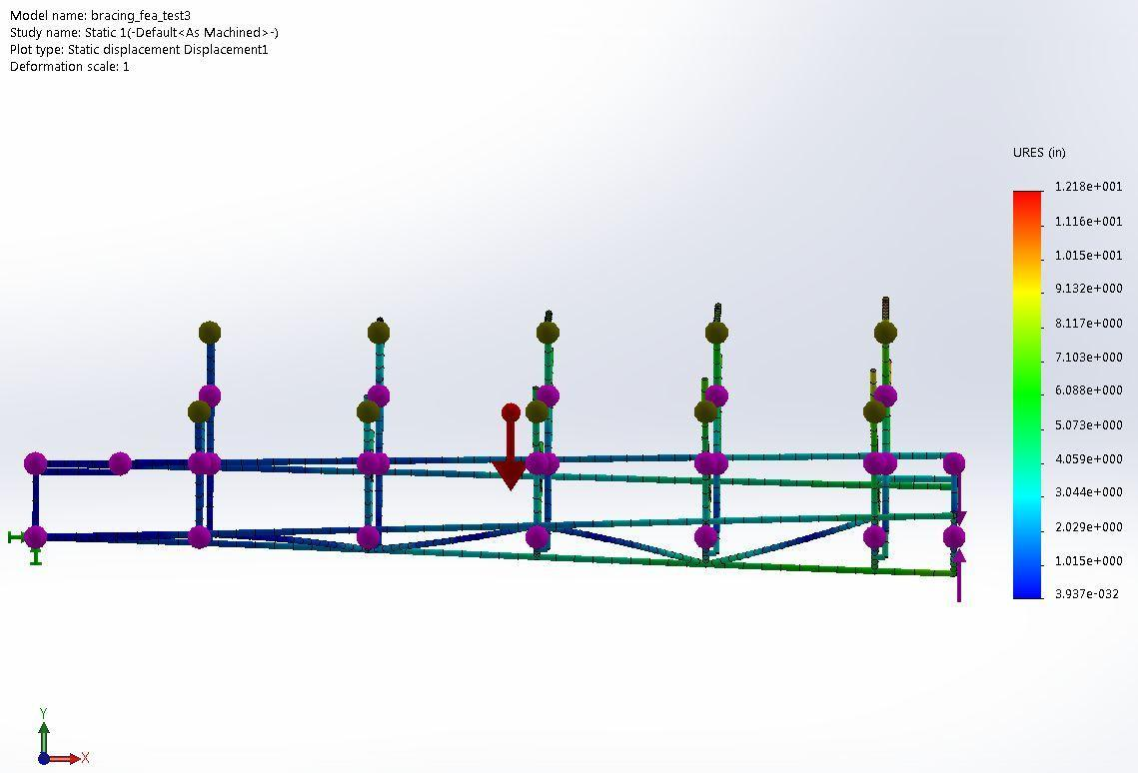

Fig. 8. Torsional Displacement Full Cross Brace w/ vertical supports: 10000 lbf (side view)

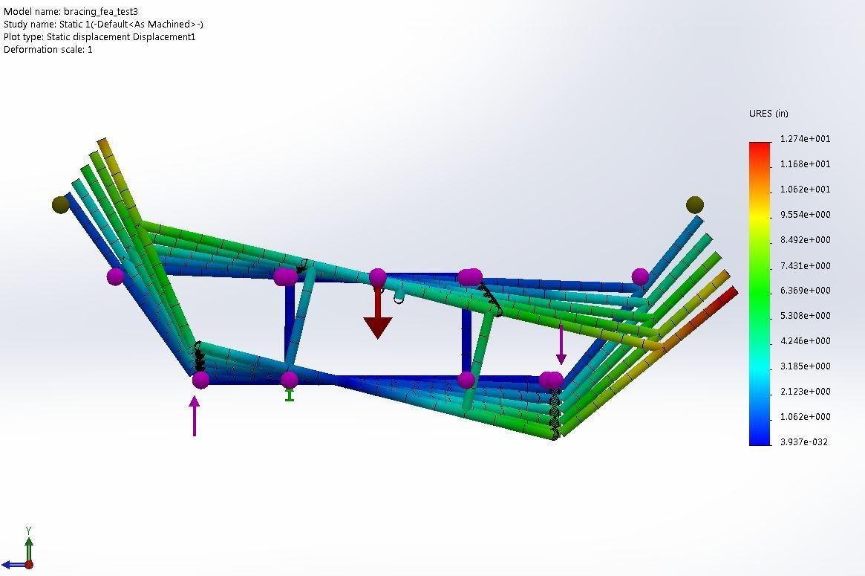

Fig. 9. Torsional Displacement Full Cross Brace w/o vertical supports: 10000 lbf (front view)

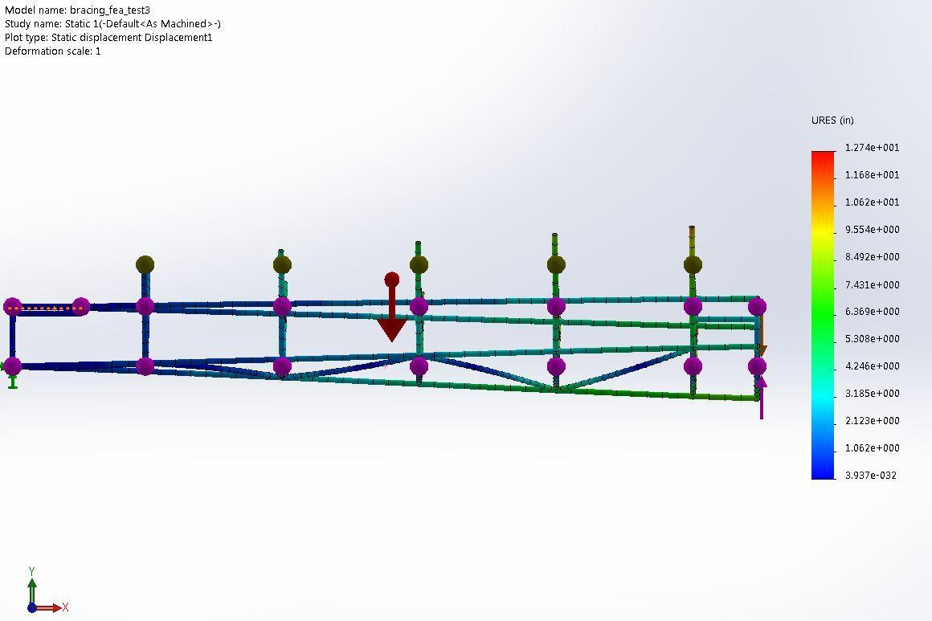

Fig. 10. Torsional Displacement Full Cross Brace w/o vertical supports: 10000 lbf (side view)

For the half cross bracing a model without vertical supports was not made as the design eliminated mounting points for the vertical supports.

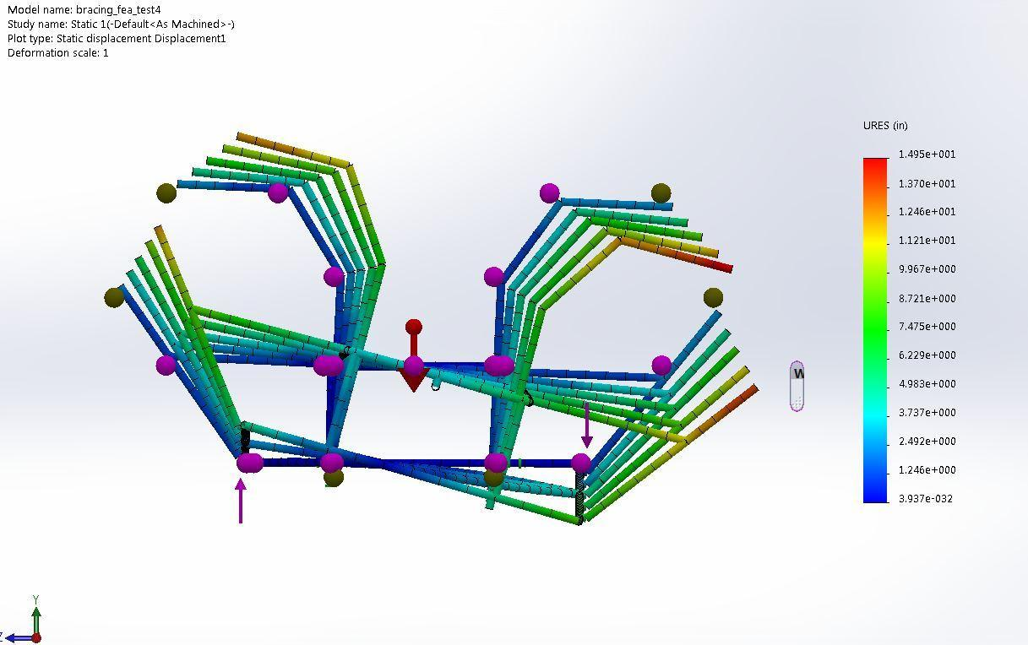

Fig. 11. Torsional Displacement Half Cross Brace: 10000 lbf (front view)

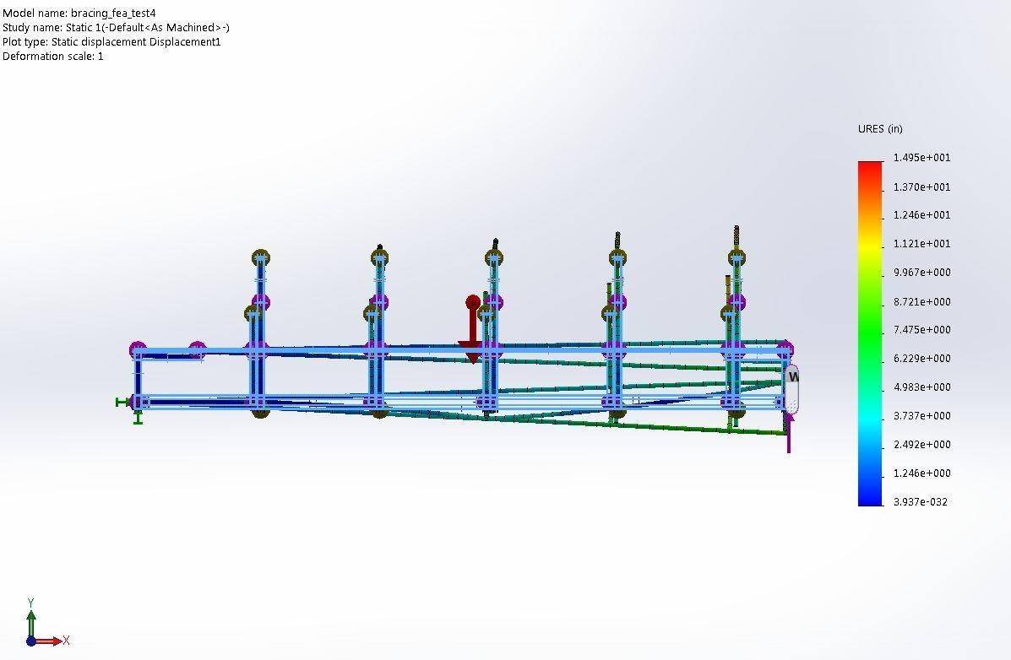

Fig. 12. Torsional Displacement Half Cross Brace: 10000 lbf (front view)

table vii

Finite Element Results

|  |  |  |  |  |
| --- | --- | --- | --- | --- |
|  | Max. Disp (in) | Weight (lbs) | Test type | Load (lbf) |
| Standard w/o bar bracing | 13.43 | 599 | torsional | 10000 |
| Standard w/ bar bracing | 12.65 | 630 | torsional | 10000 |
| Full Cross Bracing w/bar bracing | 12.18 | 682 | torsional | 10000 |
| Full Cross Bracing w/o bar bracing | 12.74 | 650 | torsional | 10000 |
| Half Cross Bracing | 14.85 | 560 | torsional | 10000 |
| bi-directional bracing | 14.48 | 584 | torsional | 10000 |

1. *Finite Element Conclusion*

The results indicate that the current frame bracing that was being considered is sufficiently torsionally rigid. However, it was also found that the additional vertical supports offered only a marginal increase is rigidity. If the lower bracing were to be changed to a lighter 1x2x.125 diagonally oriented bracing configuration, a potential weight savings of 90 lbs with an acceptable very small loss in rigidity. This configuration would also save costs because the metal usage is significantly less.

* 1. *Passenger Safety*

The safety of the passengers while the utilizer the Pedibus is a huge concern for the team. There are several small design considerations that have been implemented in order to maintain a good safety protocol. The first was adding a back rest to the seat, this is part of the bench style sitting, which will ensure that the passengers do not fall off the vehicle during a turn or slant on the road. A seat belt mechanism will also be implemented onto the sitting arrangement. This is mainly to avoid passengers sliding off the bench in case of a sudden stop or collision. The next safety feature is trivial, which is ensuring that all moving components that could potentially harm a rider have a cover around it, i.e, chains, freewheels, shafts, etc. These will also be labelled with safety stickers as well so riders are aware of potentially dangerous moving objects, as well as other potentially dangerous areas on the Pedibus. The last safety implementation for the riders is the addition of a handrail around the bar top. This will provide the riders with extra stability and support while pedalling and also serve a good hold in case of a collision or sudden stop.

1. Future plans for prototype

The size and cost of this project does not permit a prototype. Therefore the first prototype will be the final product this senior design team will see. Although the sponsor could have changes made to this revision or revisions to come, these changes will not encompass the seniors working on the project currently. The final product will start fabrication December 11, 2014. This will continue to finalization before March 14, 2015. For further time lines and due dates, refer to the Gantt chart seen in figure X.

1. Gantt chart

The team’s project schedule is divided into two separate phases. Phase 1 is the design of the vehicle itself, such as the chassis, transmission, frame, etc. Phase 1 fabrication includes the actual construction of this portion of the design. Phase 1 is scheduled to take place in the fall semester. The Phase 2 of the project will be the implementations of the accessories to the vehicle. These include sound systems, TV’s, lights, etc. Phase 2 fabrication will encompass the addition of these accessories to the Pedibus. Because of this timeline, the phase 1 fabrication and phase 2 design will overlap.

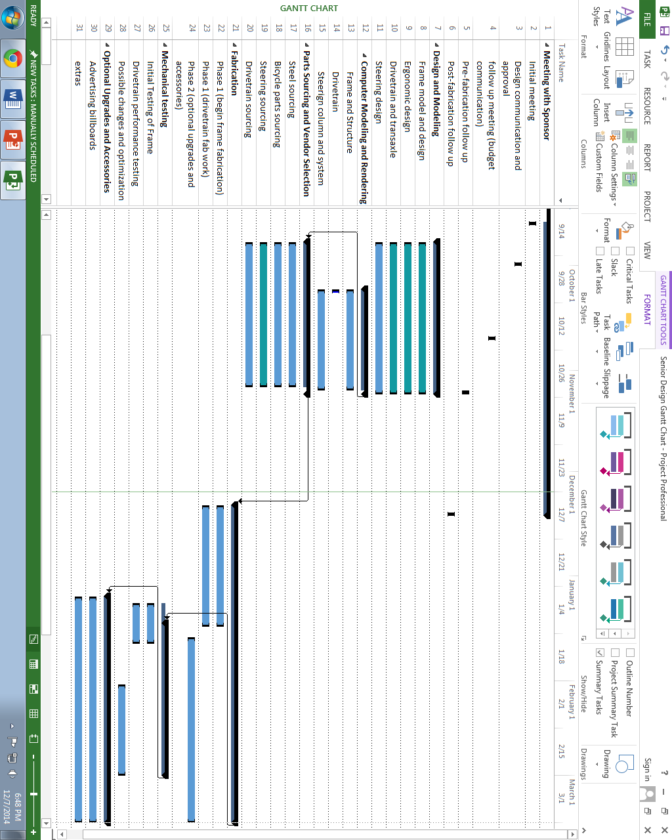

1. resources
   1. *Allocations*

In order to meet the time requirements set in place by the sponsor a strict schedule has been instituted. Along with the schedule that was created, various tasks were outlined in order to maintain forward progress, and remain organized. Below is a work breakdown structure that outlines the tasks at hand, and who is responsible in completing those tasks.

* 1. *Design and Solid Model Completion*
  2. *Frame Model Draft (Finished)*

1. *Subsystem Creation*
2. *Ergonomics draft*
3. *Component Selection (Alejandro: 5 hours)*
4. *Steering Draft*
5. *Geometry Calculations (Anderson: 5 hours)*
6. *Component Selection (Anderson: 5 hours)*
   1. *Shop Drawing Creation*
7. *Finalize Frame (All Team Members: 2 hours)*
8. *Finalize Steering (Anderson: 1 hour)*
9. *Create Assembly (Avery: 5 Hours)*
10. *Make Drawing Packet (Anderson, Avery: 20 hours)* 
    1. *Part Source and Vendor Selection*
11. *Metal Source (Anderson: 1 hour)*
12. *Steering Source (Anderson: 1 hour)*
13. *Ergonomics Source (Alejandro: 1 hour)*
    1. *Fabrication*
    2. *Meet with sponsor to discuss budget after component selection and source (TBA)*
14. *Finish any necessary design changes required by sponsor (TBA)*
    1. *Order necessary components (All Team Members: 10 hours)*
    2. *Begin fabrication (All Team Members: 12/09/14)*
15. *Finish stage 1 fabrication (The Pig) (All Team Members: 100 hours)*
16. *Begin Stage 2 fabrication (The Lipstick) (All Team Members: TBA)*
17. *Finish Stage 2 fabrication by March 14, 2015 (All Team Members: 25 hours)*
    1. *Mechanical Testing*
18. *Initial team mechanical testing (All Team Members: 5 hours)*
19. *Fix any design problems found (All Team Members: 5 hours)*
20. *Allow sponsor and other interested parties to test (TBA: 5 hours)*
21. *Consider design recommendations (All Team Members: 2 hours)*
22. *Make final changes before Springtime Tallahassee (Deadline: 03/14/15)*
23. Budget

So far, a total of $3,454.83 has been spent on the project. Our team was never given a set budget for the project. This is because of the sponsor’s request for a high quality product that will outlast a product with a given small budget. He has made it very clear that although money is always in mind, he wants the Pedibus to be more on the high end for constant use. All sourced parts are pre-approved by the sponsor via email or phone call. With purchase approval, the parts are ordered, with a receipt and sourcing information immediately saved and sent to the sponsor. As seen in Table ???, an excel log is kept for sourcing and budgeting, with an updated total cost displayed at the bottom of the sheet. With more parts to be sourced and ordered, the total cost will build during the continuation of the project.

1. Methodology

To build a design and build any vehicle from scratch, the process flow seems to have a consistent structure from idea to final product. The team must brainstorm and come up with designs for all subsystems of the vehicle. Once brainstorming is finished, all members can now visualize how the product will operate. At this point, design subsystems can be split up and members can work separately, to cover more ground in a shorter period of time. Each member will bring forth ideas and designs during team meetings, so that the entire team can decide what designs to use. From there revisions shall be made to all designs. This step may be repeated several times until a design is agreed upon as being final.

Once all designs have been finalized in CAD, structural analysis will be done in the computer to check structural integrity of the frame. This will insure that the frame or other components will not fail under use or heavy load.

As designs are finalized, components will be sourced to meet the needs of the designs. Some of this process may happen during design to ensure that components are available for the specific design requirements set forth. Some designs will also directly depend on parts sourced. In this case parts will be sourced first and designs will be made around sourced parts. From the final design stage, materials can be sourced and ordered to begin the build process. As soon as components and materials are delivered, the build process can be begin.

As the fabrication step begins certain issues may arise. These issues will be addressed accordingly and alterations will be made in the designs to match the final product. Other minor structural tests will take place as the build continues. The final testing phase will occur when the vehicle is deemed usable. A final test will occur again after the product is deemed complete.

As the product nears completion, various designs and entertaining devices have been discussed to improve the vehicle post-fabrication. This will all be done before March 14, 2015.











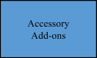

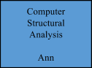













## 

1. Conclusion

Senior Design Team #22 has made significant progress on the Pedibus project. At this point a schedule for completion has been determined and tasks have been assigned in order to move forward on the project. This methodology is set in place in order to make sure that the project is completed, affectively, by the deadline. Many of the components have been ordered and the team will begin fabrication in the coming weeks.

.

Appendix

Detailed product specifications

FEM, Modeling and other structural and analytical work

Programming details

Standards and Codes used

Frame Specifications

1. Material: A500 Structural Box Steel
   1. Primary Construction: 2x4x0.125” Rectangle Tube
   2. Secondary Construction: 2x2x0.125” Square Tube
   3. Density: 0.284 $$\frac{lb}{{in}^{3}}$$
   4. Yield Strength: 45.7 x 103 psi
2. Dimensions:
   1. Length: ~180 in
   2. Width: ~ 92 in
   3. Height: TBD
   4. Seat Spacing: 32 in
   5. Weight: ~ 654 lb
   6. Rolling Weight: <1499 lbs

## Drivetrain Specifications

1. Desired Cadence: 70 RPM
2. Desired Input RPM: 1000 RPM
3. Gear Ratios:
   1. Number of Speeds: 6-N-R
   2. Chain Ring Ratio: 42T/16T
   3. Clutch Pulley Ratio: 10.0:5.5
   4. Top Speed: 21.9 MPH

## Transaxle Specifications:

1. Peerless-Gear 820-040
   1. Input Gear Ratio: 2.08:1
   2. 1st Gear Ratio: 4.55:1
   3. 2nd Gear Ratio: 2.33:1
   4. 3rd Gear Ratio: 1.50:1
   5. 4th Gear Ratio: 1.00:1
   6. 5th Gear Ratio: 0.79:1
   7. 6th Gear Ratio: 0.61:1
   8. Reverse Gear: 2.00:1
   9. End Gear Ratio: 8.02:1
   10. Axle shaft diameter: 1 in
   11. Axle length: 30-1/4 in
   12. Mounting hole configuration: 16-3/4 in x 2-1/2
   13. Case width: 20 in
   14. Case length: 18 in
   15. Max Input RPM: 2000 RPM
   16. Max Output Torque: 450 lb-ft
   17. Weight: 57 lbs
2. Clutch Type: Mechanically Actuated Friction Belt

## Brakes and Tires

1. Front Brakes: 12” Disc Brakes
2. Rear Brakes: 12” Disc Brakes or Self-Energizing Drum Brakes
3. Parking/Emergency Brake: Cable Operated, inboard or Drum
4. Rim Diameter: 16”
5. Tires: 175-60-R16 Radial
6. Brake Actuation: Hydraulic

## Steering

1. Lockable: Yes
2. Steering Type: Rack and Pinion
3. Front Axle: Straight Steer Axle
4. Track Width: 72 in
5. Wheelbase: ~105 in
6. Ackerman Angle: TBD
7. Steering Radius: <23.5’

# References

Rear axle

<http://media.caranddriver.com/images/12q3/474782/2013-ram-hd-frame-rear-axle-max-towing-rating-photo-476280-s-520x318.jpg>

* Pedal Crawler | Custom Party Bike Manufacturer. 2013. *Pedal Crawler | Custom Party Bike Manufacturer*. <http://www.pedalcrawler.com/>.
* The Party bike <http://www.thepartybike.com/index.php/the-party-bike/>.
* PedalPub. The Bike with the Barrel. 2013. *PedalPub. The Bike with the Barrel*. <http://www.pedalpub.com/>.
* <http://www.capitalcitypedicabs.com/CCPedicabs/home.html>
* Grainger Industrial Supply - MRO Supplies, MRO Equipment, Tools & Solutions. *Grainger Industrial Supply* <http://www.grainger.com/Grainger/wwg/start.shtml>.

1. Page Layout

An easy way to comply with the conference paper formatting requirements is to use this document as a template and simply type your text into it.

1. *Page Layout*

Your paper must use a page size corresponding to US Letter which is 215.9mm (8.5") wide and 279.4mm (11") long. The margins must be set as follows:

* Top = 19mm (0.75")
* Bottom = 25.4mm (1")
* Left = Right = 17.3mm (0.68")

Your paper must be in two column format with a space of 4.22mm (0.17") between columns.

1. Page Style

All paragraphs must be indented. All paragraphs must be justified, i.e. both left-justified and right-justified.

1. *Text Font of Entire Document*

The entire document should be in Times New Roman or Times font. Type 3 fonts must not be used. Other font types may be used if needed for special purposes.

Recommended font sizes are shown in Table I.

1. *Title and Author Details*

Title must be in 24 pt Regular font. Author name must be in 11 pt Regular font. Author affiliation must be in 10 pt Italic. Email address must be in 9 pt Courier Regular font.

TABLE I  
Font Sizes for Papers

|  |  |  |  |
| --- | --- | --- | --- |
| **Font Size** | **Appearance (in Time New Roman or Times)** | | |
| **Regular** | **Bold** | **Italic** |
| 8 | table caption (in Small Caps),  figure caption,  reference item |  | reference item (partial) |
| 9 | author email address (in Courier),  cell in a table | abstract body | abstract heading (also in Bold) |
| 10 | level-1 heading (in Small Caps),  paragraph |  | level-2 heading,  level-3 heading,  author affiliation |
| 11 | author name |  |  |
| 24 | title |  |  |

All title and author details must be in single-column format and must be centered.

Every word in a title must be capitalized except for short minor words such as “a”, “an”, “and”, “as”, “at”, “by”, “for”, “from”, “if”, “in”, “into”, “on”, “or”, “of”, “the”, “to”, “with”.

Author details must not show any professional title (e.g. Managing Director), any academic title (e.g. Dr.) or any membership of any professional organization (e.g. Senior Member IEEE).

To avoid confusion, the family name must be written as the last part of each author name (e.g. John A.K. Smith).

Each affiliation must include, at the very least, the name of the company and the name of the country where the author is based (e.g. Causal Productions Pty Ltd, Australia).

Email address is compulsory for the corresponding author.

1. *Section Headings*

No more than 3 levels of headings should be used. All headings must be in 10pt font. Every word in a heading must be capitalized except for short minor words as listed in Section III-B.

1. *Level-1 Heading*: A level-1 heading must be in Small Caps, centered and numbered using uppercase Roman numerals. For example, see heading “III. Page Style” of this document. The two level-1 headings which must not be numbered are “Acknowledgment” and “References”.
2. *Level-2 Heading:* A level-2 heading must be in Italic, left-justified and numbered using an uppercase alphabetic letter followed by a period. For example, see heading “C. Section Headings” above.
3. *Level-3 Heading:* A level-3 heading must be indented, in Italic and numbered with an Arabic numeral followed by a right parenthesis. The level-3 heading must end with a colon. The body of the level-3 section immediately follows the level-3 heading in the same paragraph. For example, this paragraph begins with a level-3 heading.
4. *Figures and Tables*

Figures and tables must be centered in the column. Large figures and tables may span across both columns. Any table or figure that takes up more than 1 column width must be positioned either at the top or at the bottom of the page.

Graphics may be full color. All colors will be retained on the CDROM. Graphics must not use stipple fill patterns because they may not be reproduced properly. Please use only *SOLID FILL* colors which contrast well both on screen and on a black-and-white hardcopy, as shown in Fig. 1.

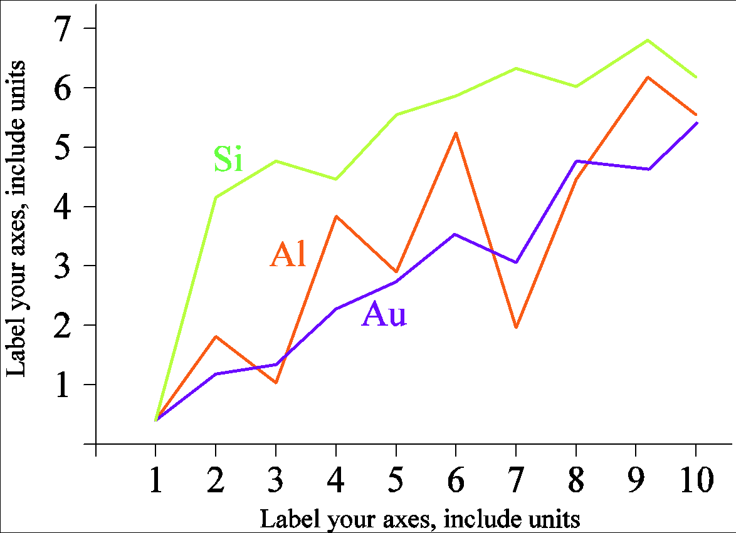

Fig. 1. A sample line graph using colors which contrast well both on screen and on a black-and-white hardcopy

Fig. 2 shows an example of a low-resolution image which would not be acceptable, whereas Fig. 3 shows an example of an image with adequate resolution. Check that the resolution is adequate to reveal the important detail in the figure.

Please check all figures in your paper both on screen and on a black-and-white hardcopy. When you check your paper on a black-and-white hardcopy, please ensure that:

* the colors used in each figure contrast well,
* the image used in each figure is clear,
* all text labels in each figure are legible.



Fig. 2. Example of an unacceptable low-resolution image

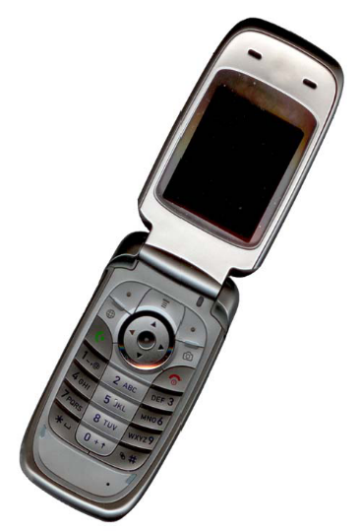

Fig. 3. Example of an image with acceptable resolution

1. *Figure Captions*

Figures must be numbered using Arabic numerals. Figure captions must be in 8 pt Regular font. Captions of a single line (e.g. Fig. 2) must be centered whereas multi-line captions must be justified (e.g. Fig. 1). Captions with figure numbers must be placed after their associated figures, as shown in Fig. 1.

1. *Table Captions*

Tables must be numbered using uppercase Roman numerals. Table captions must be centred and in 8 pt Regular font with Small Caps. Every word in a table caption must be capitalized except for short minor words as listed in Section III-B. Captions with table numbers must be placed before their associated tables, as shown in Table I.

1. *Page Numbers, Headers and Footers*

Page numbers, headers and footers must not be used.

1. *Links and Bookmarks*

All hypertext links and section bookmarks will be removed from papers during the processing of papers for publication. If you need to refer to an Internet email address or URL in your paper, you must type out the address or URL fully in Regular font.

1. *References*

The heading of the References section must not be numbered. All reference items must be in 8 pt font. Please use Regular and Italic styles to distinguish different fields as shown in the References section. Number the reference items consecutively in square brackets (e.g. [1]).

When referring to a reference item, please simply use the reference number, as in [2]. Do not use “Ref. [3]” or “Reference [3]” except at the beginning of a sentence, e.g. “Reference [3] shows …”. Multiple references are each numbered with separate brackets (e.g. [2], [3], [4]–[6]).

Examples of reference items of different categories shown in the References section include:

* example of a book in [1]
* example of a book in a series in [2]
* example of a journal article in [3]
* example of a conference paper in [4]
* example of a patent in [5]
* example of a website in [6]
* example of a web page in [7]
* example of a databook as a manual in [8]
* example of a datasheet in [9]
* example of a master’s thesis in [10]
* example of a technical report in [11]
* example of a standard in [12]

1. Conclusion

The version of this template is V3. Most of the formatting instructions in this document have been compiled by Causal Productions from the IEEE LaTeX style files. Causal Productions offers both A4 templates and US Letter templates for LaTeX and Microsoft Word. The LaTeX templates depend on the official IEEEtran.cls and IEEEtran.bst files, whereas the Microsoft Word templates are self-contained. Causal Productions has used its best efforts to ensure that the templates have the same appearance.

Causal Productions permits the distribution and revision of these templates on the condition that Causal Productions is credited in the revised template as follows: “original version of this template was provided by courtesy of Causal Productions (www.causalproductions.com)”.

Acknowledgment

The heading of the Acknowledgment section and the References section must not be numbered.

Causal Productions wishes to acknowledge Michael Shell and other contributors for developing and maintaining the IEEE LaTeX style files which have been used in the preparation of this template. To see the list of contributors, please refer to the top of file IEEETran.cls in the IEEE LaTeX distribution.

References

[1] Ron’s bio

1. S. M. Metev and V. P. Veiko, *Laser Assisted Microtechnology*, 2nd ed., R. M. Osgood, Jr., Ed. Berlin, Germany: Springer-Verlag, 1998.
2. J. Breckling, Ed., *The Analysis of Directional Time Series: Applications to Wind Speed and Direction*, ser. Lecture Notes in Statistics. Berlin, Germany: Springer, 1989, vol. 61.
3. S. Zhang, C. Zhu, J. K. O. Sin, and P. K. T. Mok, “A novel ultrathin elevated channel low-temperature poly-Si TFT,” *IEEE Electron Device Lett.*, vol. 20, pp. 569–571, Nov. 1999.
4. M. Wegmuller, J. P. von der Weid, P. Oberson, and N. Gisin, “High resolution fiber distributed measurements with coherent OFDR,” in *Proc. ECOC’00*, 2000, paper 11.3.4, p. 109.
5. R. E. Sorace, V. S. Reinhardt, and S. A. Vaughn, “High-speed digital-to-RF converter,” U.S. Patent 5 668 842, Sep. 16, 1997.
6. (2007) The IEEE website. [Online]. Available: http://www.ieee.org/
7. M. Shell. (2007) IEEEtran webpage on CTAN. [Online]. Available: http://www.ctan.org/tex-archive/macros/latex/contrib/IEEEtran/
8. *FLEXChip Signal Processor (MC68175/D)*, Motorola, 1996.
9. “PDCA12-70 data sheet,” Opto Speed SA, Mezzovico, Switzerland.
10. A. Karnik, “Performance of TCP congestion control with rate feedback: TCP/ABR and rate adaptive TCP/IP,” M. Eng. thesis, Indian Institute of Science, Bangalore, India, Jan. 1999.
11. J. Padhye, V. Firoiu, and D. Towsley, “A stochastic model of TCP Reno congestion avoidance and control,” Univ. of Massachusetts, Amherst, MA, CMPSCI Tech. Rep. 99-02, 1999.
12. *Wireless LAN Medium Access Control (MAC) and Physical Layer (PHY) Specification*, IEEE Std. 802.11, 1997.