

**Team 5 - Magnet Insertion Process**

**Product Specifications**

**October 11, 2013**

**EML 4551 Senior Design Fall 2013**

**Turbocor Director of Technical Operation: Paul Lugjuraj**

**Faculty Advisor: Dr. Simone Peterson Hruda**

Group Members:

Jaro Volny

Henry Ferree

Timothy Blum

**Index: Page:**

1. Project Scope 1
   1. Problem Statement 1
   2. Justification/Background 1
   3. Objectives 2
   4. Methodology 2
   5. Constraints 3
   6. Expected Results 3

**Project Scope:**

**Problem Statement:**

Magnets need to be properly placed on the axial bearing.  Location and orientation are critical to the assembly and operation of the compressor.

**Justification/Background:**

Turbocor is a leading manufacturer of magnetic bearing centrifugal compressors. Using magnet technology allows for the benefit of having a levitating shaft within the compressor. This innovative design eliminates the need to use oil for shaft components. The ability to remove oil from the compressor design adds a multitude of benefits. The levitating shaft experiences less resistance to rotation by being immersed in air instead of a more viscous oil, which increases the efficiency of the compressor. Additionally, no maintenance is needed to change oil or re-lubricate components, which saves on cost of the machine. Finally, magnetic bearing compressors draw less current than standard compressors, resulting in savings in energy consumption. These positive aspects of oil free compressors have been noticed by consumers who need a powerful compressor for their cooling devices or pneumatic needs. Over the past two decades, Turbocor has grown in the market of sustainable, energy efficient compressors and presently has over 30,000 compressors in service.

With the implement of inserting magnets in a shaft and its bearings, the compressors are able to have a highly efficient levitating shaft. Handling the magnets is a primary concern due to their strength; the magnets are strong enough to latch to metal far away and may break into many pieces because of its brittleness, thus destroying the magnets. Proper placement is necessary to ensure that the magnets have their correct polarity and no magnets are misaligned; if these errors were to occur then the bearings are wasted, the compressors will not work properly, and time with money is lost.

Turbocor has experimented with different processes for mounting the magnets on the bearing. The current process requires a technician to place the magnets by hand. The process involves removing the magnets from the magnet stack and placing them on the plate and then checking the polarity. This accounts for the majority of the worker’s time that could be spent performing other tasks. Turbocor has looked into automating this process. They purchased an automated magnet insertion machine custom made for them by Industrial Automation. The machine is pneumatically driven and loads the magnets onto the bearing and also checks for polarity. The machine is designed to work for different bearing sizes. However, roughly a year ago the machine began experiencing many faults and control issues. It currently can only load magnets for one bearing size. Attempting to load magnets for other size bearings results in machine faults. The machine is presently idle and has not been in the product line for the past eight months. The challenge for the design team is to understand the current processes and develop the optimal process for placing the magnets on the bearing.

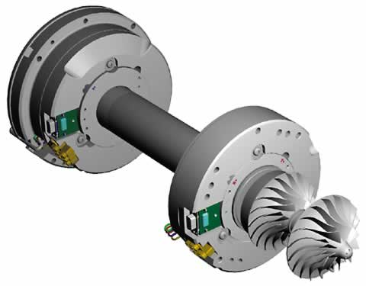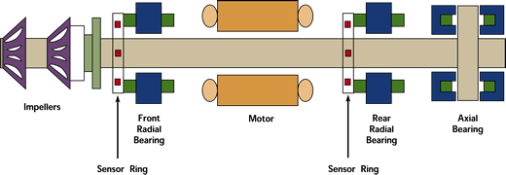

**Objectives:**

* Devise an ergonomically friendly process that properly inserts magnets into an

axial bearing

* Magnet polarity orientation should match design specifications
* Magnets are inserted without any misalignment
* Operating Technician can perform the process without risk of bodily harm or

injury.

**Methodology:**

* Gain a better understanding of existing automated mechanism
* Decide on best process for magnet insertion
  + New tools for technician
  + Repair/improve existing automation mechanism
  + Create a new manually operated mechanism
* Review Mechanical systems & research existing mechanisms
* Break down manufacturing process steps

Once an insertion process has been chosen:

* Brainstorm for possible design solutions
* Create individual designs
* Create a Decision matrix
* Decide on a design

Once a specific design is chosen:

* Construct in CAD
* Simulate functionality
* Theoretical force analysis
* Evaluate materials needed
* Purchase relevant materials
* Build prototype
* Test physical product
* Analyze & compare to existing mechanism
* Make changes or adjustments if needed
* Test for reliability’

**Constraints:**

* Must develop process that works for the different compressor bearing sizes and magnet sizes.
* Process/design must be simple, ergonomic and safe for technician.
* Process must insert, check for and verify the proper magnet orientation and polarity.
* Design must insert the brittle magnets without damaging them.
* Design must be within a reasonable budget for company.

**Product Specifications:**

In recent meetings, both the team and sponsor have been leaning towards developing a new process that will minimize the technician’s work input by utilizing mechanical systems to insert the magnets onto the bearings. With this comes many constraints that need to be considered, such as three different bearing sizes and two different magnet sizes and orientations. Additional design concerns include ergonomics of the system, the fracture brittleness of the magnets and precision of the insertion. With these items in mind, a tentative project schedule has been developed to assist the team, sponsor and mentor in understanding what tasks need attention and when.

**Design Specifications:**

The final design for the magnet inserter needs to be able to hold the bearing in place properly, so neither the bearing nor the machine will move relative to one another. This is accomplished by making sure the device has the correct dimensions to hold each of the three bearings. The bearings diameters range from 5.357 in to 6.375 in. The magnets need to be placed at their specific desired location around the bearing. Each of the bearings will have their own specified place where they will be place around the bearing. The angle at which the magnet inserter moves is different between the bearings and it also has different angles within the same bearing due to the fact that the spacing between the magnets may vary; the angles between the magnets for the big bearing are28 degrees with no spacing and 32 degrees with the spacing, for the small bearing the angles are 38 degrees while touching and 54 degrees with the spacing, and for the twin bearing the angles between the magnets are 52 degrees and 38 degrees both containing spacers between the magnets. Since this machine is designed to be ergonomically friendly to the person using it, the force it takes to insert the magnet should be able to be repeated throughout the day, so the amount of force necessary for a person to repeat throughout a work day is not to exceed 110N or 24lbf. The machine may be placed on the floor in the working area of the plant so the machine needs to not take up an area more than a square meter.

**Performance Specifications:**

The final developed magnet insertion process will be able to insert two different magnet sizes properly into three different sized bearings. Primarily, the process will be safe to operate by a technician, and will insert the magnets correctly every time. The mechanism will require minimal force input by a technician, and only will function when the magnets are loaded into the inserter with proper orientation. It is important that the mechanism rotates and holds the bearing in place with enough time for the actuation mechanism to insert the magnet into the desired slot using sufficient force without damaging the magnet. This device also will be able to reject the spacers between each magnet in the stack as the magnets are inserted into their respective slots in the bearing. It is also very important that the mechanism’s components are made of non-ferrous materials to reduce the amount of magnetic attraction within the system.

**Project Plan:**

The project plan Gantt chart has been separated into two sections. The first is the deliverable dates assigned for the senior design course. These deliverables require team communication and collaboration to create the reports and presentations. Knowing the duration of these responsibilities will help the team assign resources within the work breakdown structure. The second section is the more technical project work that will occur outside of the senior design timeslot. This includes creating parts for the system and running analysis on the system assembly in CAD programs. The chart also includes the regular team meetings with the sponsor, mentor and staff. The sponsor has notified the team of a goal to have the final drawings to them by the end of the fall semester. The sponsor also has a machine shop on site for the team to access. For this reason, a drawing development timeline has been established that will include time to create the preliminary drawings, have them evaluated by the sponsor and then time to revise and edit the drawings before submitting the final package. The intention of this plan is to allow for a seamless transition into the spring semester, where all parts and components are ready and need to be assembled. The initial prototype can be assembled, analyzed and the design iterated throughout the next semester. A spring timeline has yet to be established.

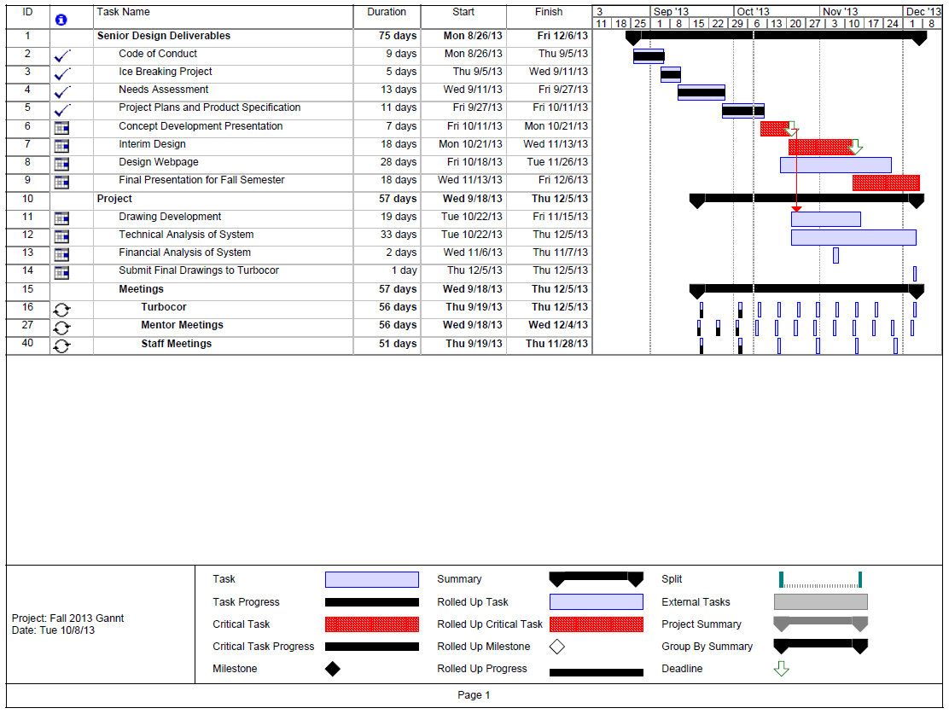

Figure 2013 Fall Gantt Chart