“Wear It” Baseball Vest, Impact Reduction Design

Define Phase Report

By

Garth Fletcher IE

Maria Cristina Miro IE

Cecilia Wong IE

Kyler Hast ME

Kyle Meredith ME

Ryne Wickery ME

Sponsor: Gavin Boone

Faculty Advisors: Dr. K. Amin, Dr. D. Olawale

A report submitted to

Dr. Okenwa Okoli, Dr. Kamal Amin

Industrial & Manufacturing Engineering Department

Mechanical Engineering Depatrment

FAMU – FSU College of Engineering

Tallahassee, FL

October 24, 2013

**TABLE OF CONTENTS**

LIST OF TABLES………………………………………………………………….…4

LIST OF FIGURES……………………………………………………………………4

ABSTRACT…………………………………………...………………………………5

1. INTRODUCTION…………………………………………………………………6
2. PROJECT DEFINITION………………………………………………………….6
   1. BACKGROUND INFORMATION……………………...…………………..7
   2. PROJECT SCOPE.……………………………………………..…………….8
   3. PROJECT ASSUMPTIONS………………………………………………….9
   4. PROJECT DELIVERABLES…..………………………………………...…10
   5. OBJECTIVES…..………………………………………………………...…11
   6. CONSTRAINTS…..……………………………………………………...…11
3. TEAM ORGANIZATION…………………………………………..…………...12
4. PROJECT CHARTER AND BUSINESS SIGNIFICANSE…………………….13
   1. PROJECT CHARTER………………………………………………………13
      1. BUSINESS CASE……………………………………………………13
      2. OPPORTUNITY STATEMENT………..…………………………...16
      3. GOAL STATEMENT…………………...…………………………...16
      4. PROJECT PLAN………………………………………..……….…..17
      5. TEAM SELECTION…………………………………………………19
   2. BUSINESS SIGNIFICANCE………………………………..……………...19
5. ANALYSIS OF CUSTOMER REQUIREMENTS……………………………...20
   1. CRITICAL CUSTOMER REQUIREMENTS (CCR)….…………………...21
   2. FISHBONE………………………………………………………………….22
   3. MEETING CCR……………………………………………………..………24
   4. SIPOC……………………………………...……………………….....…….25
6. DESIGN CONCEPTS…………………………………………………………....26
   1. DESIGNS……………………………..…………………………….....…….26
   2. SELECTION…….………………………………………………….....…….29
7. CONCLUSION………………………………………………………….....…….30
8. REFERENCES………………………………….………………………..…...….31

APENDIX

1. FISH BONE…………………………………….……………………………32
2. COMPLETE LIST OF THE SCOPE OF THE PROJECT [SOW}…….……33
3. HOUSE OF QUALITY………………………………………………………34
4. TEAM 26 GANNT CHART…………………………………………………35

**LIST OF TABLES**

**Table 2-3.** Boys’ and Teen boys’ for growing boys and young men that have not yet reached full adult stature, measurements guide.

**Table 4-1.** Sports-related SCI by age at time of injury.

**Table 4-2.** List of Tasks, Sub-Tasks & WBS.

###### **Table 4-3.** Threats and Opportunity Matrix.

**Table 5-4.** SIPOC Diagram

**LIST OF FIGURES**

**Figure 3-1.** Project organization chart.

**Figure 6-1.**  Design Concept 1

**Figure 6-2.** Design Concept 2

**Figure 6-3.** Design Concept 3

**Abstract**

Mr. Gavin Boone is a graduate student at Florida State University, candidate for a Masters in Business Administration. He currently works as an executive sale professional at SANOFI, a leading global health care company that discovers, develops, produces and markets innovative therapies to help protect and health and enhance people’s lives. [1].

This senior design group has been assigned to work with Mr. Gavin Boone in the development of a prototype vest, which will serve as a protective gear for baseball players when they are batting. In order to accomplish our goal we will take into account the following considerations, safety, player performance, and quality. Currently there is no official protective gear used by baseball players to prevent them selves from injuries caused by the baseball when they are batting.

In order to create a vest that will provide the best protection to the baseball player, the group will have to identify the forces related to the baseball impact, as well as the most common injuries caused by the impact when the players are batting. After analyzing the critical areas of the human body that are affected by these injuries, the group will develop a series of vest designs that will attempt to protect those critical parts of the body. The most optimal designs will later undergo a series of tests to measure their effectiveness as protective gear.

1. **Introduction**

The project sponsor is Mr. Gavin Boone, a Florida State graduate student and high school baseball coach. This senior design group has been assigned to work with Mr. Boone in the development of a prototype vest for his full patent. This prototype vest will serve as protective gear for baseball players when they are batting. Mr. Boone has submitted a provisional patent to the U.S. Patent Office, with a set of preliminary drawings and descriptions to offer a better protection to baseball players.

The project group will have to create and test a prototype vest based on his submitted design, and we may use the materials he recommended or our own set of selected materials. With the evidence from the experimentation Mr. Boone will submit a full patent of this new product to protect baseball players by the end of June 2014.

1. **Project Definition**

There is a need in the baseball community for a protective vest for a batter that extends to cover the back of the neck and the entire spinal region so that when the baseball makes contact, there is no extensive injury to the wearer. Protective gear designers have not come up with a batting protection vest that offers adequate protection, and is aesthetically pleasing enough to get athletes to wear it.

The “Wear It” vest project will focus on the design of a batting vest that will have a neck protection feature to cover the neck area unprotected by the helmet, as well as the entire back area of the player. The team biggest concern will be to find a set of materials that will be able to absorb the impact of the ball when it hits the players’ body. We will also take into consideration how our design may constraint the player performance by the added weight, while the player is twisting the torso when batting, as well as when he is running to first base.

* 1. **Background Information**

During a freshman game at Lincoln High School, a pitch in the back of the neck/helmet area struck one player. It was the second time the same player had been hit in that same area by the ball. The concern and fear on his parents face and friends was the original motivation for Mr. Boone to design something to protect the neck of the players that were taking one for the team.

As a parent Mr. Boone is concerned for his son safety. During the 2013 season, Graham Boone was hit by one pitch, he remained in the ground for several minutes after being struck in the earhole of the helmet and was advised to sit out for the rest of the game. Every season Graham continues to receive more and more hits by the pitches. During the last baseball season Graham was hit 11 times, two times more than the previous season (9 hits in the 2012 season). This increase in injuries is not ignored by the parents, but some coaches and even other players encourage their teammates to “wear” the pitches that come on the inside, in order to get a free base.

In baseball, a free base is a precious gift; it results in a greater likelihood of scoring and even perhaps winning the game. But the desire to win should not mean that the r. Okenwa Okolitheythe client'’orr forels will be searched t practices this sport. w product to protect baseball players.our daplayer’s health should be put at risk. Mr. Boone decided that if the players, and coaches were going to continue this pattern of encouraging the players to “wear the pitch” whether it be intentional o not, he would need to find a protective option for the batters to protect their spine, neck, ribs, and back of the helmet since by turning their backs to the pitch these areas of major concern are exposed.

This turning the back on the pitch is the method that is being coached as “an attempt” to avoid being hit by the pitch, and the officials are excepting “this effort” and granting the players a free base as long as the player is not extended over the strike zone. The encouragement by teammates to take one for the team and the will to win is more than enough to insure that the players will be hit by more and more pitches in the near future.

* 1. **Project Scope**

This project will initially focus on the study of the forces related to the baseball impact and its relation to the body capability to withstand such forces. We will also study the body motions that are related to the batting motion, so we can gain a better understanding of the mechanics in this type of movements. By getting quantitative data explaining this subjects, we will be able to develop an engineering perspective of what is going on while a player is batting.

Our next step will be to analyze possible materials that could work for our prototype. Based on the information previously collected, we will consider each possibility by their unique properties as well as their ability to be molded into a desired form. Because our vest will be closely attached to the body, we will want a material that is bendable, without breaking or cracking easily. We will also consider our material based on our customer material requirements of lightweight, impact resistance, flexibility, transparency, durability, etc.

Next, we will obtain samples of our selected material to perform a series of test to ensure that our selection will be the most suitable to defeat the impact forces of the ball. We will perform impact tests by recreating the pitch. Also the impact test will serve to measure the durability of our material, if its easily shattered we will require a design that allows parts to be changed after every material fail. We will perform thermal tests to measure the energy stored in the material by impact. We will also require testing the vest capability to perform in different weathers, depending on the seasons.

After selecting a series of possible materials, we will consider the human factor into our vest design. We will accomplish this task through a series of surveys among FSU students that play in intramural baseball leagues. In these surveys, we will consider the player acceptance of a protective device. One of our main concerns is that even if we develop a successful design, the players will continue to play unprotected when they bat.

We want to accomplish the best fit to the human body for our vest. Taking into consideration the ergonomics in our task, we have to design the vest based on the average human dimension with its standard range of variation. Having a design that fits our target population body, helps to measure the comfort ability of the vest.

* 1. **Project Assumptions**

Some assumptions need to be taken into account for the design of the “Wear It” protective batting vest. For our initial step, we will use the standard weight and dimension of a baseball according to the rules of the high school leagues. Additionally, we will take into consideration the average dimensions of a teenage baseball player as shown below in Table 2-3, and their standard variation for the type fasteners we will use in our vest design.

***Table 2-3.*** *Boys’ and Teen boys’ for growing boys and young men that have not yet reached full adult stature, measurements guide. All measurements are in inches.*

|  |  |  |  |  |  |  |  |  |
| --- | --- | --- | --- | --- | --- | --- | --- | --- |
| Sizes | 7 | 8 | 10 | 12 | 14 | 16 | 18 | 20 |
| Chest | 26 | 27 | 28 | 30 | 32 | 33 1/2 | 35 | 36 1/2 |
| Waist | 23 | 24 | 25 | 26 | 27 | 28 | 29 | 30 |
| Hip | 27 | 28 | 29 1/2 | 31 | 32 1/2 | 34 1/4 | 35 1/2 | 37 |
| Neck Band | 11 3/4 | 12 | 12 1/2 | 13 | 13 1/2 | 14 | 14 1/2 | 15 |
| Approx. Height | 48 | 50 | 54 | 58 | 61 | 64 | 66 | 68 |
| Shirt Sleeve | 22 3/8 | 23 1/4 | 25 | 26 3/4 | 29 | 30 | 31 | 32 |

Also, we will make assumptions on what we will consider to be extensive injuries that the players encounter during the game. This will be of high importance to determine the material we will use, because our material selection is based on the impact strength level we want to defeat.

* 1. **Project Deliverables**

This project team reports to Dr. Kamal Amin for the Mechanical Engineering department, and to Dr. David Olawale for the Industrial and Manufacturing Engineering department. The communication with our project advisors has been very satisfying, mostly through staff meetings and email for additional concerns that come up during the week. In our initial organization stage, we had a communication deficiency regarding the arrangement of our biweekly meetings, but we have successfully overcome the issue. The project team has successfully completed all reports required by the senior design courses, and we continue to work on our individual project tasks.

The communication with our project sponsor, Mr. Gavin Boone have been in the majority by email and all the information needed from both parts has been delivered in a timely manner. Every two weeks, we have a meeting with Mr. Boone to provide updates on the project progress. This meetings count also with the presence of our project advisors to take advantage fully, of Mr. Boone time.

* 1. **Objectives**

There are multiple goals we hope to achieve by the end of our senior design period (end of spring 2014). These include:

1. Determine the ideal material for our vest, and verity it’s suitable for prototyping.
2. Choose design for the protective vest with detailed description.
3. Analyze materials to determine the best choice for protective vest.
4. Analyze designs to determine best choice for protective vest.
5. Construct / Test / Analyze a prototype.
6. Determine manufacturing characteristics of production.
   1. **Constraints**

Our vest must be designed to meet a number of constraints. These constraints will dictate certain characteristics of our product such as impact resistance, thermal properties, aesthetic qualities, etc. They include:

* Must withstand an impact from a pitch up to 100 mph.
* Thermodynamically suitable to be worn in temperature exceeding 100 degrees, and worn for 30 minutes.
* Must be lightweight.
* Vest has to be transparent on the back do that the name and number can be seen.
* Must be easy to take on and off.
* The vest must not impair the swinging motion of the player.
* Vest must last a minimum of 3-5 years

1. **Team Organization**

This project is a team effort, in which all the team members will have the same opportunity to express their ideas, as well as making decisions. We have appointed two members as project leaders for each class, Ryne Wickey for mechanical and Cecilia Wong for industrial. They both work hand in hand to coordinate tasks and objectives for the project. Also, they are in charge of coordinating the project presentations and reports, as well as making sure all the deliverables requested in our senior design courses are fulfilled.

The overall organization, as depicted below in Figure 3.1, represents the hierarchy of responsibilities regarding this project. As this is an Industrial Engineering lead project, the project lead is Dr. Okenwa Okoli, the Chari of the Industrial and Manufacturing Engineering department. Next in the chain is our project sponsor Mr. Boone, and our project advisors as mentioned before, Dr. Amin and Dr. Olawale.

***Figure 3-1.*** *Project organization chart.*

We have an overall leader, Cecilia Wong that is in charge of communicating with our sponsor and advisors and able a constant communication between the mechanical and industrial students. As well as being in charge of setting meeting times and places. We will have a secretary, that will make sure all topics and ideas discussed during our meetings whether be group meetings, staff meetings with the advisors or meetings with our sponsor Mr. Boone, be recorded for later recall.

Each member will be able to take constructive criticism and learn for mistakes. The team will work in a positive manner and not be negative to anyone. If there is something bothering one of the team members they have the right to speak their mind without negative ramifications.

# 4. Project Charter and Business Significance

## 4.1 Project Charter

The project charter is a tool that announces all the details about a new project, in this case about “Wear It”, by providing an outline that gives a sense of direction for the project from beginning to end.

The project charter is further developed in the points below, and it includes, among others, the reasons for undertaking the project, the objectives of the project, the target project benefits, the directions toward the solution, identities of the team members, and overall project scope.

### 

### 4.1.1 Business Case

As a consequence of the fact that baseball players are now being encouraged by teammates and coaches to “wear” the pitches that came inside because a free base in baseball results in a greater likelihood of scoring and winning the game, a new protective option for the batters to protect their spine, neck, ribs, and back of their helmet was idealized. This is then where the concept of “Wear It” came from; a new batting vest that will significantly protect the players' critical body areas mentioned before.

“Sports can contribute to neck injuries of varying degrees of severity, including neck fractures and cervical spinal cord injuries (SCIs). A fractured (broken) neck is a very serious matter, but in many cases, the patient can make a full recovery and regain all neurological function. A neck fracture can sometimes lead to a complete SCI, which will result in some degree of paralysis or even death. Sports-related cervical injuries can be categorized in the following terms: acute cervical sprains/strains including whiplash injury, cervical fractures and dislocations, nerve root or brachial plexus injuries, intervertebral disc injuries, and cervical stenosis” (The National Spinal Cord Injury Statistical Center).

Consequently, this project is being undertaken because of the recent concern and fear that has arisen due to players being severely struck during the baseball games. “According to the U.S. CPSC (Consumer Product Safety Commission), there were an estimated 14,390 neck fractures treated at U.S. hospital emergency rooms in 2009. Of these, an estimated 2,692 were sports-related” (ibid.). These numbers show that injuries in young athletes are on the rise; this is a problem that needs correction.

“Wear It” will intend to significantly reduce the number of injuries in baseball players by efficiently protecting these areas that are at risk when batting.

From a business standpoint, “Wear It” will address the need for a batting vest. As of today, there is no strong competitor on the market, which increases the success probability of this project. It will be erroneous to say that there is nothing like it on the market because there is, but of the few batting vests out there, none provides all the specifications that our does, making it easier for us to achieve our business objective.

For example, consider 'COOPER Batting Vest', made out of “foam and poly core with a VELCRO brand hook-and-loop closure and an adjustable rear web strap” for a price of $39.95 (Flag House). Another option is the 'Batting Vest BV-1530 by Adams OS', a one size fits all protection device “designed for youth baseball/softball players that aids the frontal chest and rib cage region of the player” for $49.99 (Diamond Sport Gear). However, the design that resembles the most to ours is the 'Evoshield', “a custom-forming chest/rib protector with DSP technology that is ergonomically designed to follow the rib line and the back rib cage to allow natural athletic movement, and is made of a thin, lightweight composite material, covered in a breathable mesh top and a soft polymer backing” (Baseball Plus Store). This vest is the most expensive of all the three options, at a price of $89.99.

This vest aims to target baseball players principally in two main categories. First, youth baseball; that is, teens and high-school players ranging from ages 13-18 that play mainly for fun and at school. Second, college and major leagues. Players in this second category are mainly adults and ranging from ages 18-45. Statistics reported by the National Spinal Cord Injury Statistical Center at the University of Alabama at Birmingham are shown on the next page in Table 4-1 and they assert that indeed this is the age range at which more spinal cord injuries occur, confirming that there is a desperate need for a protective batting vest like “Wear It”.

***Table 4-1.*** *Sports-related SCI by age at time of injury.*

|  |
| --- |
| Ages 0-15: 23.9 percent |
| Ages 16-30: 14.4 percent |
| Ages 31-45: 6.9 percent |
| Ages 46-60: 3.8 percent |
| Ages 61-75: 2.2 percent |
| Ages 76-98: 0.6 percent |

### 4.1.2 Opportunity Statement

To reduce the risk of pain, suffering, disability, death, and overall injuries in baseball players, specifically in batters in player pitch leagues (60-100 mph), as a result of being struck by a pitch in high-risk areas like the neck, spine, ribs or back of the helmet.

### 4.1.3 Goal Statement

To create (conceptualize, design, analyze, evaluate, manufacture and market) a batting vest that protects baseball players, aimed specifically at batters in high-school, college and/or major leagues, that are currently being struck by pitches in dangerous, critical areas such as the back of the neck, spine, ribs and head region. It should decrease the number of injuries in athletes significantly, and be ready no later than June 2014.

The effectiveness of the batting vest should be a result of interrelated characteristics like protection, comfort, style, and practical elements which will hopefully encourage baseball players, parents, league officials and coaches to seek the protective advantages that this new protective batting vest, “Wear It”, has to offer.

### 4.1.4 Project Plan

In order to fulfill our objectives and goals for this project, a project plan was put together considering five major tasks we came up with, each with various sub-tasks, which needs to be done in order to achieve successful completion. The tasks are basically divided into two semesters, Fall 2013 (includes tasks 1 to 3) and Spring 2014 (includes tasks 4 and 5), as seen in Table 4-2 below.

***Table 4-2.*** *List of Tasks, Sub-Tasks & WBS.*

|  |  |  |  |  |  |
| --- | --- | --- | --- | --- | --- |
| **WBS** | **TAKS** | **DURATION** | **DATES** | | **Person In Charge** |
| **(days)** | **START** | **END** |
| 1 | Organize Project Team | 5 |  |  |  |
| 1.1 | Introduction | 1 | 18-Sep | 18-Sep | Team |
| 1.2 | Selection of team leaders | 1 | 18-Sep | 18-Sep | Team |
| 1.3 | Meet with advisors and sponsor | 3 | 18-Sep | 20-Sep | Cecilia/Ryne |
|  |  |  |  |  |  |
| 2 | Design | 28 |  |  |  |
| 2.1 | Get the "voice of the customer" from sponsor | 7 | 26-Sep | 2-Oct | Cecilia |
| 2.2 | Develop design alternaties | 11 | 4-Oct | 4-Oct | Team |
| 2.3 | Choose final designs | 3 | 15-Oct | 17-Oct | Team |
| 2.4 | Aim for design optimization | 7 | 18-Oct | 25-Oct | IE |
|  |  |  |  |  |  |
| 3 | Material | 35 |  |  |  |
| 3.1 | Material research | 14 | 21-Oct | 4-Nov | Team |
| 3.2 | Material Selection | 14 | 4-Nov | 18-Nov | Team |
| 3.3 | Material purchase | 7 | 18-Nov | 25-Nov | Team |
|  |  |  |  |  |  |
| 4 | Prototype | 51 |  |  |  |
| 4.1 | Prototype Construction (Generation I) | 20 |  |  |  |
| 4.2 | Prototype Testing | 9 |  |  |  |
| 4.2.1 | Impact Test | 4 |  |  |  |
| 4.2.2 | Thermal Test | 2 |  |  |  |
| 4.2.3 | Comfortability Test | 1 |  |  |  |
| 4.2.4 | Market Test | 2 |  |  |  |
| 4.3 | Need of modifications (only small ones) | 7 |  |  |  |
| 4.4 | Fina Prototype (Generation II) | 15 |  |  |  |
|  |  |  |  |  |  |
| 5 | Manufacturing | 21 |  |  |  |
| 5.1 | Manufacturing plannification | 14 |  |  |  |
| 5.2 | Aim for lean production (Six Sigma) | 7 |  |  |  |
|  |  |  |  |  |  |
|  | **TOTAL** | 140 |  |  |  |
|  |  |  |  |  |  |

As seen in Table 4-2 on the previous page, the (1) first task is to organize the project team. This includes introducing the team members to one another taking into account that they belong to different engineering departments and they don't necessarily know each other, and then selecting who the team leaders would be. The next step consists of meeting with each of the departments' advisors.

The (2) second task is to come up with various designs for the batting vest in order to select the most effective one. The sub-tasks for the design phase are getting the “voice of customer” from the sponsor, coming with design alternatives, evaluating and analyzing each design to decide which the best alternative is, aiming for design optimization.

Next, the (3) third task involves the material for the vest, including material research, material selection, and ultimately material purchase considering costs, suppliers, shipping times, etc.

Fourth, (4) we plan to have a prototype that will assist in the selection of the final design. The sub-tasks for this task are building an initial prototype (denoted Generation I) and performing impact, thermal, comfortability and market tests. Then, if any small modifications are needed, the plan is to construct a second and final prototype (denoted Generation II).

Lastly, the fifth (5) task is the manufacture of the batting vest and it mainly includes the planning of the manufacturing process aiming lean production using Six Sigma procedures.

To simplify the planning of the project, our team members decided that a Gantt chart was to be produced. It is a simple scheduling tool that shows the tasks and sub-tasks against time, the responsible member that is assigned for each of them, the start and end dates scheduled for each task and sub-task, and finally, the milestones and resources relevant to a task or sub-task. Our Gantt chart is shown in Appendix D.

### 

### 4.1.5 Team Selection

Team members include three Industrial Engineering students Garth Fletcher, Maria Miro, and Cecilia Wong; and three Mechanical Engineering students Kyler Hast, Kyle Meredith, and Ryne Wickery.

Fletcher, Miro and Wong posses well-grounded background in investment planning and project responsibility, resource planning, lean production application, ergonomics, and product life-cycle management that is helpful when designing “Wear It”. Wong is also a Green Belt certified in Six Sigma, which will help us ensure that the DMADV project methodology is applied towards “Wear It” to make certain that there is process improvement and minimum variability.

Likewise, Hast, Meredith and Wickery have an understanding of concepts including mechanics, thermodynamics, and materials science, which are also necessary for this project, bringing to a conclusion that to successfully complete this project, a joint contribution of skills provided by both the Industrial and Mechanical students will be required.

## 4.2 Business Significance

The encouragement by teammates to take one for the team and also the will to win is more than enough to ensure that baseball players will continue to be hit by more an more pitches in the near future. The major impact that “Wear It” will have is that it will not only protect the player in the process, but also the league, the coaches, the school systems, the FHSAA (Florida High School Athletic Association), and all the other stakeholders in the game of baseball.

Businesswise, the major impact that the project will have will be its profitability. As mentioned previously, there is no direct competition for “Wear It”, so the launch of such new product will hopefully be successful. It is expected to become a popular gear in baseball leagues if the baseball stakeholders get to seek the protective advantages that it has to offer. Consequently, if it succeeds, it will generate revenues and definitely be profitable.

As shown below in Table 4-3, there are both short and long term threats and opportunities that will be faced whether the project is accomplished or not.

###### **Table 4-3.** Threats and Opportunity Matrix.

|  |  |  |
| --- | --- | --- |
|  | **Threats** | **Opportunity** |
| Short Term | **Short Term Threats:** Failure to come with an effective vest design. Difficulty to decide the optimal materials. Not able to complete the product. Losing money and time. | **Short Term Opportunities:** Meeting market demand on time. Reducing baseball-related injuries in athletes. |
| Long Term | **Long Term Threats:** Low sales and profits due to difficulty to appropriately market the batting vest. People's rejection of the vest. Bad reputation. | **Long Term Opportunities:** Enforcement of the batting vest by standard baseball rules. Increased sales and profits. Keeping new customers coming. Significant reduction in injuries in baseball players. |

**5. Analysis of Customer Requirements**

The “Wear It” senior design team is responsible for the design of the batting vest taking into consideration the analysis of four critical customer requirements. These requirements are: safety, fit, functionality, and affordability. The design and performance specifications were expressed to us through a design our client had sketched previously.

**5.1 Critical Customer Requirements**

**Safety:** The main role of the vest is to keep players safe from the impact of baseballs during the game, while ensuring that the product does not inflict any injures on the players’ critical parts of the body like the back of the neck, spine and ribs. Therefore, safety is a very important concern for the design team as we have to deal not only with the pitch impact that may affect a player when batting, but also with other safety issues like ensuring that the product is safe to be used in different thermal conditions and that it is safe to wear in various high-activity scenarios.

**Fit:** As the product will be worn in high-action, high-impact situations, it is important that the vest fits to the body of the wearer the most exact way possible. In considering the fit, we are not only taking into account the sizing of the product but also the weight, which has to be extremely light to allow players to pitch, catch, run and dive without impediment. In addition to that, the product also needs to be designed to be comfortable since the players cannot afford to become “overheated” while wearing the vest. This will require the design team to pay very close attention to the material being selected for the production of the vest.

**Functionality:** The whole concept of vest rests on the product’s ability to protect its wearer. Therefore, it is very important that the product contains the safety features necessary to protect the neck, the back and shoulders of the player who wears this vest. This product must be a high-performance, high-quality product that parents and players can repose confidence in. In designing the vest, the team will need to consider the areas that are critical of the body that need to be protected and ensure that adequate support is provided to these high-risk body parts.

**Affordability:** One key requirement for the design team is that the product cost fall into the range a parent in a normal middle-class family could afford. That is, we want to aim to a reasonable price that will make “Wear It” accessible to all and every single kid in a high school that practices the sport. This is a key consideration for the design team, meaning that the product not only needs to perform at the highest level, but that affordability is a key concern. While the quality of the design should not be compromised, the team has to be mindful that the parents of the baseball players of all ages and at all levels of the sport are considered part of “Wear It” vest’s target market. To accomplish this task we have to ensure that the materials that are used in the design of the product not only are performing well but also have a price not too high, thereby keeping unit costs of the vest down. It is very important that the product is accessible to the intended consumers because a big part of accessibility is the ability of them to purchase.

**5.2 Fishbone**

The Fishbone diagram, as seen in Figure 5-1, is the team problem solving approach in coming up with identifying the potential factors required in order to solve the primary goals of the “Wear It” vest. It shows the key relationships among the major categories, which are: Safety, Materials, Players Performance, Quality, Cost, and Extra Features.

**Safety** is one of our major concerns in designing this vest. The team has to ensure that the vest protects players from the impact of baseballs in the upper body, thereby reducing risk of injury during game play and enabling players to play longer. Another key safety feature is ensuring that the product adjusts to changing temperatures, preventing the player from both “overheating” while playing in extreme heat and insulating when playing in colder climate conditions. This challenge will be addressed through materials’ selection and the overall design of the vests.

**Material** is also a major concern because we want to produce a vest that is lightweight, wear resistant, flexible and that can absorb the impact of 60mph-110mph baseballs. The team will look at alternate solutions for materials for the design of the vest for it should comply with the customer’s specifications mentioned previously and also provide thermal safety and allow player’s mobility. The size and fit should also comfortable for the players. The different options for materials will be searched considering if they are affordable, strong, durable, easy to maintain, and so forth.

**Players Performance** is one of the central concerns for the team. Will the vests be too heavy? Will players be able to run, stretch and dive comfortably? The design team’s major challenge is to make sure that the design and fit of the product does not negatively impact the player’s performance. The product should allow the player to be able to move freely (mobility) and should not add significant weight to the player. The fit is also a key influencer of player’s performance as the product cannot be cumbersome but should fit the player’s body, enabling free movement while wearing the vest.

**Quality** is also a major concern. We have previously discussed how important it is that the product not only functions properly and provides the player with added safety, but we have also discussed affordability as another major concern. The design team has to seek to balance these very important elements in designing a product that is of the highest quality and also affordable. The product should be able to stand up to the wear and tear of multiple games since the idea is not that parents would need to replace this vest every few games. Therefore, the quality aspect of the product encompasses several elements that are considered in the design.

**Cost** will definitely be a consideration for the “Wear It” design team. Firstly, the cost of the materials will have to be kept relatively low so that when manufacturing costs are added to the equation, the product remains affordable for the average family. In order for cost per unit to remain low, the manufacturing processes have to be efficient therefore keeping manufacturing costs low. This means minimizing both fixed and variable manufacturing costs and ensuring that the manufacturing process utilizes as many automated processes as possible to keep labor hours low in the manufacturing plant.

**Extra Features** of the vest include ease of maintenance and comfort. As it has been stressed previously, the vest should be comfortable for the wearer and should stand up to wear and tear. Part of that is ensuring that the product is easy to clean/maintain. This will largely be dependent on the materials used for the product and so is another consideration for materials selection.

All of the categories that have discussed in this section can be seen in the fishbone diagram on Appendix A providing visual representation of all the main customer requirements.

**5.3 Meeting Customer Requirements**

The team has already gathered key insights from the client and has a clear picture of the client’s needs and what the key design features are. We have already formulated ideas and design concepts to meet the needs of the customer requirements. We will use our fish bone and house of quality as methods to meet our customer requirements. The fish bone, as explained previously will help us determine the priority of each of our customer requirements.

The house of quality allows us to have a quantitative value to measure the priorities of our customer. We will give a value between the range of 1 to 5 to indicate what we consider are the most important constraints we have to take into consideration. This will help us choose among designs that may not fulfill all our needs but do cover the most important ones. After we have classified all ours customer requirements, we will look into our variables. The “How’s” with which we will be able to control our product to have the most desirable outcome. The relationship between our CCR and our “How’s” allows us to have a better idea of how we can affect our product by making small modifications to our variables. But, we have to be careful on how we change our variables. We have to pay attention to the relationships between the “How’s” with each other. Having a stronger material, or a bigger piece may compromise the flexibility aspect of our vest design.

The client requirements, our “What’s”, are placed on the left hand side of the matrix and the list of variables, our “How’s” is displayed across the top of the interrelationship matrix. The measures we find are that the relationships between the vest size and collar size, collar size and collar shape, vest shape and collar shape, and hard material and safety have a strong positive correlation. Other positive correlations are hard materials and collar size, soft materials and collar size, collar size and vest shape, soft materials and impact strength, collar size and stiffness, and hard materials and stiffness. The other measures we find had a negative impact or no correlation at all. We have to pay great attention to our negative relationships, because they will be critical at the moment of defining the final characteristics our protective vest will have.

This project team will move in the direction of maximizing and improving hard material, soft materials, and impact strength, since they are the key quality characteristics required to successfully complete the design of the vest. On the other hand, we will want to minimize vest size, collar size and stiffness in order to provide the players greater comfort while they are wearing the protective vest.

**5.4 SIPOC**

The SIPOC diagram is a step-by-step process that ensures that all factors are in place to help the team be organized in order to provide a better service to our customer.

**Table 5-4.** SIPOC Diagram

|  |  |  |  |  |
| --- | --- | --- | --- | --- |
| Supplier | Input | Process | Output | Customer |
| * Provider * Raw Materials * Supplier * Manufactures | * Information * Material * Resources * Equipment * Testing | * Manufacturing | * Product * Report * Increase Quality | * Customer   (Baseball players) |

**6. Design Concepts**

The team has begun to formulate three primary design concepts. These take into account the goal of the product, and were formed to theoretically satisfy the objectives defined for our project.

**6.1 Designs**

Figure 6-1 below shows the design that Mr. Boone presented to us at our initial meeting. This design is characterized by a vest constructed of a padded material to protect the ribs and spine. However the top portion of the vest would be constructed of a hard polymer of some sort, to protect the neck from impact.

Figure 6-2 is the second design concept that the team constructed. This design differs rather drastically from the first in its geometry and also its construction. Rather than being constructed wholly from a padded material, the concept behind this vest is characterized by a thin lightweight material that covers larger/thicker-padded regions. In this fashion, padding is only utilized in the key hazard areas, keeping the vest lighter cooler for the player to wear. Also, a large portion of the vest has been removed in the area of the player’s torso that faces away from the incoming ball. Theoretically this should make the vest lighter, and also keep the player cooler, making the vest more comfortable and appealing to players.

Figure 6-3 is our final design concept. The concept behind this design in similar to that presented to us by our sponsor (Figure 6-1) however, a few key changes have been made to the vest. Geometrically the vest is very similar to the original design. The differences lie in the method of padding the vest, and the construction of the neck region of the vest. The padding of the original vest was utilized by using a thick padded material for the whole vest. In the third design concept, many individual pads are placed throughout the vest. The act of separating the padding into multiple small pieces theoretically should give the vest a better tendency to move and conform to the players figure throughout the entire batting motion. Another difference lies in the neck region of the vest. Rather than a tough rigid polymer, the neck region will be constructed of padding similar to the rest of the vest therefore making it smaller. This should give the neck area better compatibility with the helmet as the player bats, runs, and possibly slides.

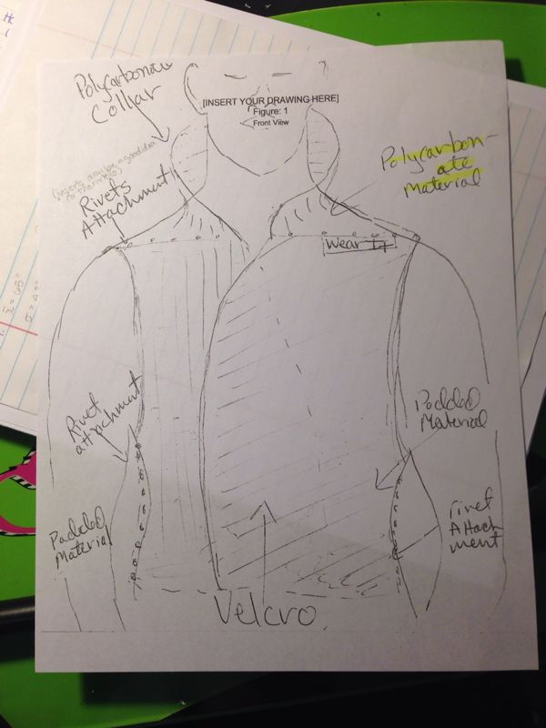

**Figure 6-1.**  Design Concept 1

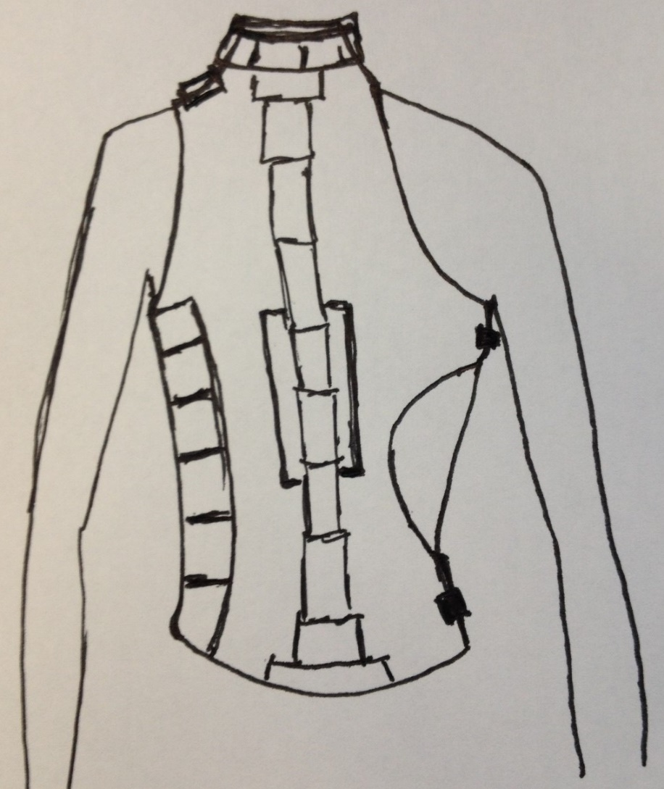

**Figure 6-2.** Design Concept 2

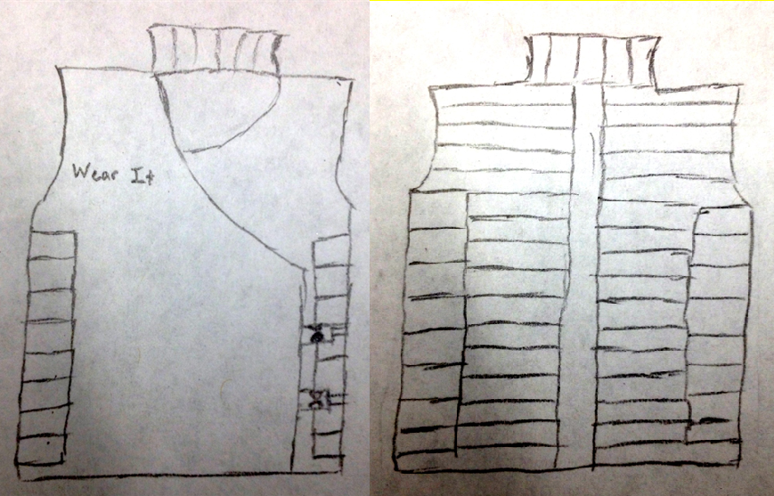

**Figure 6-3.** Design Concept 3

**6.2 Selection Criteria**

The selection of our design and material has not been completed, because there is still a large degree of testing (materials, construction, impact, etc.) that still needs to be completed. However, the selection of our design will be based on a few standard criteria. The first is safety factor. The most important aspect of the vest, also the factor driving this project, is that the vest must protect a batter from hazardous impact of a baseball. The ability of the player to perform while wearing the vest is also a major concern. If a player cannot hit as well, run as fast, or stay cool while wearing the vest, they likely will never be persuaded to wear the vest for protection. Ideally the vest will also be of good quality, and also cost efficient. These things are often found independent of each other, so the selection of our material and geometry of the vest will be a maximum combination of these stipulations.

**6. Conclusion**

The “Wear It” project has successfully completed the first task in our schedule, and we continue to work concurrently in the second and third tasks. We were able to determine the main priorities to be considered in our design process, which are the impact safety property of the vest, how it may affect the player performance due to movement limitation and the weight requirement of our customer. We will continue to analyze data regarding the motion of the baseball players as they are batting and proceed with the material final selection.

We are now to be focused on the dynamics of the player and of the baseball, and how they interaction will determine the success of our protective vest.  Once the analysis of the impact of a ball against an object from many different angles and speeds, it will be compared to possible materials.  The impact forces will be compared to the materials strength and see which materials can withstand the impact and have a safety factor.  Once the material is chosen, it will be used to construct the best possible vest for safety, comfort, and aesthetics.

**7. References**

“Batting Vest BV-1530 by Adams OS”. Web. 20 Oct. 2013.

<http://www.diamondsportgear.com/cgi-bin/commerce.cgi?preadd=action&key=2723>.

“Body Measurement Charts: Imperia Measures - Inches”. Web. 22 Oct, 2013.

<http://www.sewingpatterns.com/simplicity-charts2.html#unisex>

“COOPER Batting Vest”. Web. 20 Oct. 2013. <http://www.flaghouse.com/COOPER-Batting-Vest-Small-Medium-item-7936+SM+MED#sthash.QIKdM0e3.dpuf>.

“Evoshield”. Web. 20 Oct. 2013. <http://www.baseballplusstore.com/products/Evoshield-a100-chest-and-back-guard.html>.

The National Spinal Cord Injury Statistical Center, University of Alabama at

Birmingham, NSCISC 2009 Annual Statistical Report and Facts at a Glance,

February 2010.

<<http://www.aans.org/Patient%20Information/Conditions%20and%20Treatments/Sports->[Related%20Neck%20Injury.aspx](http://www.aans.org/Patient%20Information/Conditions%20and%20Treatments/Sports-Related%20Neck%20Injury.aspx)>.

**Appendix A**



**Appendix B**

**Complete List of Project Scope**

1. Meet with the entire group for team organization.
2. Meet with our sponsor for customer requirements.
3. Determine the primary focus points.
4. Develop a schedule for the project development.
5. Research for background information on baseball motions and forces.
6. Consider the ergonomic and mechanical aspect of our task, vest design.
7. Research possible products like our product in the market for ideas.
8. Analyze materials that could be used for our product.
9. Select a set of materials for testing, based on our task constraints.
10. Purchase samples of our selected materials.
11. Perform impact and thermal test on each material.
12. Analyze the human relation with our materials properties.
13. Create a set of designs that provide the best ergonomic match.
14. Match our design with the materials to see if it is feasible the construction of a prototype.
15. Build a prototype.

**Appendix C**

House of Quality

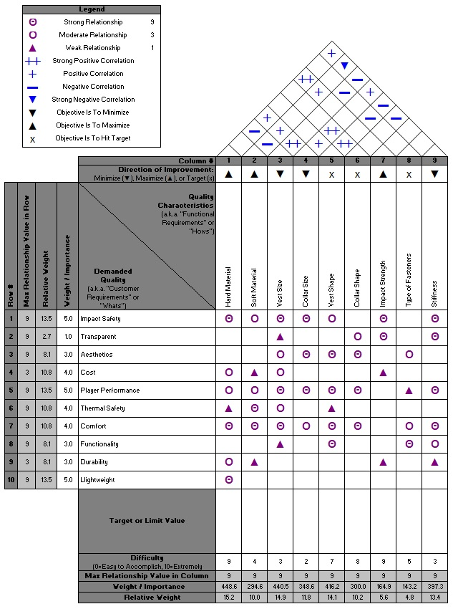

**Appendix D**

