Impact Analysis

The radius of a baseball is 1.45 inches with a mass of 5 ounces. One of the main objectives of this project is that the vest designed must be able to absorb the impact of a baseball at 100 miles per hour. The energy of the baseball can be calculated to see what the vest must with stand during impact. The energy was calculated by using the equation one half the mass time the velocity squared.

$$E=\frac{1}{2}*mass*{velocity}^{2}$$

The calculated energy for a ball traveling at 100 miles per hour was 141.6 J. This value will be later used to compare a materials properties and thickness to see if it can with stand the impulse of energy.

Since a baseball is made of multiple components some assumptions had to be made. For this system it was deemed to be a one dimensional system, that is uniform, elastic and a constant force is applied. The system is modeled to be one dimensional because when an impact wave runs through the baseball it moves in all three directions. Therefore modeling the impact wave in three dimensions would be hard to model. When the force is applied to the batter or the vest it will be modeled as a uniform constant force. To find the force applied to a batter, the impact time had to be calculated. To find the impact time the problem had to be broken down to see how impact waves affect a baseball. So research on the speed of sound of materials was done. The speed of sound of materials is the travelled distance of the impact wave through a material during a period of time. A baseball is made of three main components: leather casing, thread or wool string wrapped around core, and a rubber core. The speed of sound for leather and wool/cotton was not found in much research. The speed of sound of rubber was found to be 60 meters per second. So another assumption was made the baseball would be modeled as a solid rubber sphere. The speed of sound of a leather or wool/cotton would be much slower than that of rubber because when the material experiences a force the particles in rubber go back to their resting position quicker than leather and wool/cotton would. So this impact time may be slightly shorter in this system than in reality. The equation used to find the impact time is two times the diameter of the baseball divided by the speed of sound of rubber.

$$∆t=\frac{2*diameter}{C_{rubber}}$$

The impact time equals 0.002455 seconds. With the impact time calculated the force from the impact can be calculated. The force that is felt is equal to the mass of the baseball times the change in velocity divided by the impact time.

$$F=\frac{mass*∆v}{∆t}$$

The force that a human or the vest would feel from the baseball hitting them would be 2581 N or 580.2 lbf. From research done it take about 3,300 N (741lbf) force to cause a rib to be cracked. So this force may not be high enough to break a rib but will may still cause bruising and large amount of pain.

Once the force by the 100 mile per hour pitch was found more research need to be done to find how the baseball’s geometry would be affected by the ball striking a surface. A chart was found that compared the force applied on the ball and the deflection of the baseball.

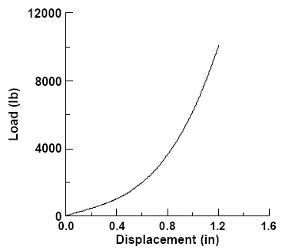

Figure : Chart comparing force load vs. displacement

From this chart, knowing the force that the ball will be under it can be correlated to the chart. With a force of 580.2 lb. the displacement of the baseball will be close to 0.4 inches. The displacement of 0.4 inches will also be radius of the surface area of the contact area. The radius now the compressed surface area can be calculated as pi times the compressed radius squared.

$$A_{compressed}={radius}^{2}*π$$

The compressed surface area is 0.503 in2. With the surface area, stress can be calculated.

$$σ=\frac{F}{A_{compressed}}$$

The calculated stress is 7.958 MPa which then could be used to help find better possible materials for the vest.

Above in the material selection section, carbon fiber reinforced polymer (CFRP) was chosen as the material selected. CFRP is a very strong light material, but depending on the thickness of the plate of CFRP will tell if it is strong enough to withstand the energy. The plates of CFRP was decided to have a thickness of 0.25 inches. A simple equation energy relating material properties and the thickness.

$$E_{CFRP}=tensile strength*thickness*A_{compressed}$$

The energy that a 0.25 inch plate of CFRP could withstand is 2059 J. As calculated earlier the energy of the baseball traveling a 100 miles per hour was 141.6 J. So a CFRP plate with would have a safety factor of 14.5. A rib plate and a back plate were placed into *Autodesk Inventor* to see how the force calculated above would affect the plates.

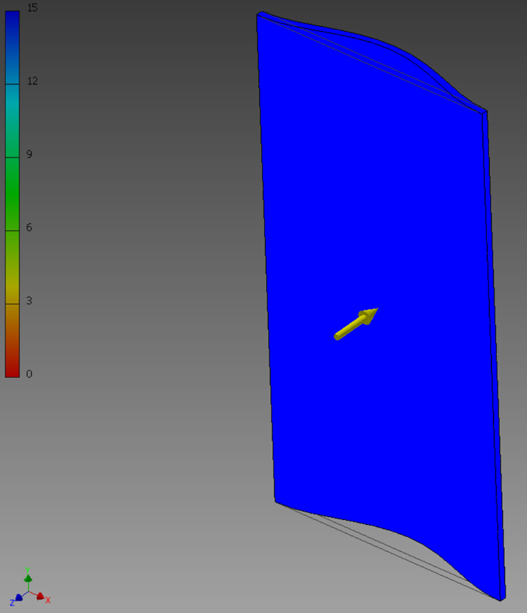

Figure : Factor of safety for back plate.

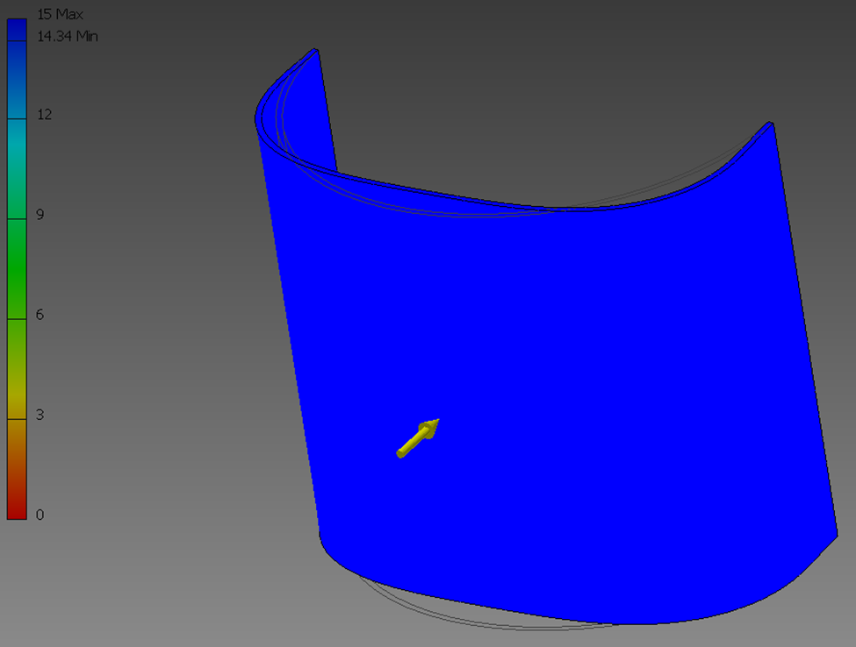

Figure : Factor of safety for rib plate.

As seen in the figures above, the factor of safety for both plates are 15 which is a very high factor of safety. The displacement of both plate s were also put into consideration, because you do not want the plates to deflect so much it is hitting the batter at a too high of force.

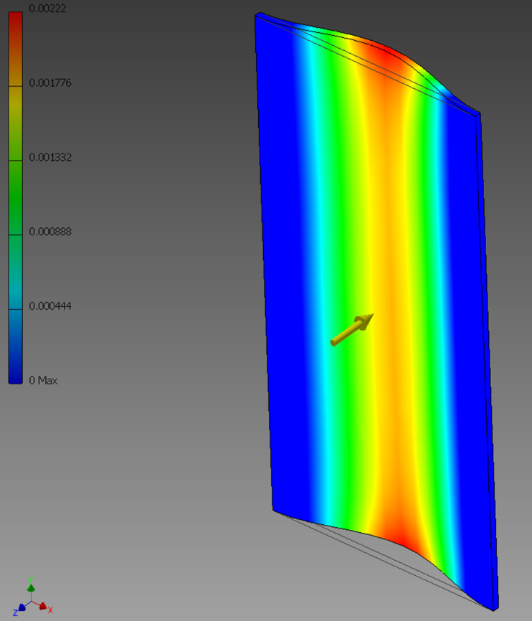

Figure : Displacement of back plate (in)

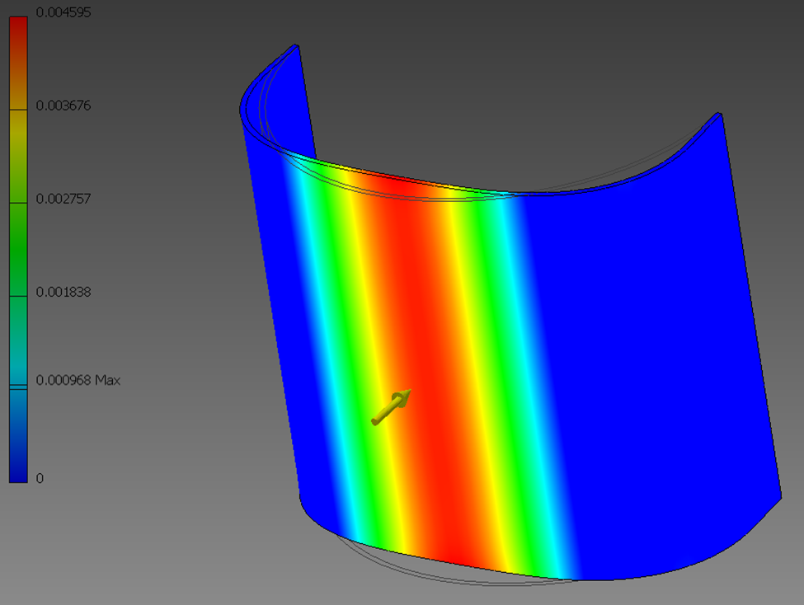

Figure : Displacement of rib plate (in)

In the back plate the displacement is at its highest point is 0.002 inches. In the rib plate the displacement at its highest point is 0.0046 inches. Both of these values are very low and would not affect a batter because the material would not displace into the batter’s body.