Preliminary Design of “Wear It” Protective Collar

Design Phase Report

By

Garth Fletcher IE

Maria Cristina Miro IE

Cecilia Wong IE

Kyler Hast ME

Kyle Meredith ME

Ryne Wickery ME

Sponsor: Gavin Boone

Faculty Advisors: Dr. K. Amin, Dr. D. Olawale

A report submitted to

Dr. Okenwa Okoli, Dr. Kamal Amin

Industrial & Manufacturing Engineering Department

Mechanical Engineering Department

FAMU – FSU College of Engineering

Tallahassee, FL

March 7, 2014

**TABLE OF CONTENTS**

LIST OF FIGURES………………………………………..……………………….……….…3

LIST OF TABLES……………………………………….….………………………......….…3

ABSTRACT…………………………………………….…….…………………………….…4

1. INTRODUCTION. ……………………………………………………….………….……5
2. DEFINE PHASE. …………………………………………………………………………6
   1. Project Scope……………………………………………………………...……….….6
   2. Background………………………………………………………….…..……...….…6
   3. Objectives………………………………………………………….......… .…. .….….7
   4. Customer Requirements…………………………………………………...………….7
      1. House of Quality………………………………………………………………8
   5. Current Market Options…………………………………………..………………..…9
3. MEASURE PHASE……………………………………………………………..……….10
   1. Impact Analysis……………………………………………………………..……….10
   2. Ergonomics……………………………………………………………………….…12
4. ANALYZE PHASE………………………………………………………………….…..13
   1. Research on Material……………………………………………………………..…14
   2. EVA Foam…………………………………………………..…………………....…14
   3. High-Density Polyethylene……………………………………………………….…15
   4. Testing…………………………………………………………..………..……….…15
5. DESIGN PHASE…………………………………………………………………..…….16
   1. OBJECTIVES OF THIS PHASE……………………………………………...……16
   2. PUGH MATRIX…………………………………………………………………….16
      1. Criteria and Concepts Identification. ……………………………………..…16
      2. Selecting Solutions to Implement …………………………………...………18
   3. MATERIALS STRUCTURES..……………………………………….……………19
      1. Joining the Materials ……………………………………………………...…20
      2. Collar Attachment……………………………………………………………21
   4. IMPLEMENTING IMPROVEMENTS…………………….………………………23
      1. CAD Designs…………………………………………………..………….…24
   5. COLLAR ERGONOMICS…………………………………….………………...….27
6. CONCLUSION……………………………………………………..………………...….29

APPENDIX

1. Fish Bone……………………………………………………………….………...…….…30
2. House of Quality……………………………………..…………………..….……….31
3. Mathematical Solutions……………………………………………..…….…………32

WORKS CITED……………………………………………..………………..….….………34

**List of Figures**

**Figure 1.** EvoShield geometry, a) front and b) back.

**Figure 2**. Chart comparing force load vs. displacement.

**Figure 3**. Back view of the musculoskeletal system.

**Figure 4.** Crown Neck plate with foam liner.

**Figure 5**. Arced neck plate with foam on edges.

**Figure 6.** Front view of the flat neck plate with foam liner.

**Figure 7.** Back view of the flat neck plate with foam liner.

**Figure 8.** Top view of the flat neck plate design.

**List of Tables**

**Table 1.** EvoShield testing results.

**Table 2.** Pugh Matrix.

**Table 3.** Improvements to Flat Plate Collar.

**Table 4.** Body measurement of boys age 14 -18, Inch Units

**Abstract**

This senior design group, “Wear It Baseball Protection Collar”, has been assigned to work with Mr. Gavin Boone, a MBA graduate student at Florida State University, in the development of a collar piece that will serve as a protective gear for baseball players when they are batting. In order to accomplish this goal, the most relevant considerations taken into account are safety, player performance, adjustability, level of comfort, aesthetics, and weight of the piece.

The concept of a protective collar itself arose due to the need in the baseball community for a protective gear of this nature that extends to cover the back of the neck. Baseball protective gear designers have not come up with a neck protection. Protective vests in the market have done the torso and back areas, but no vest to date has made something with the neck covered to provide protection to the this critical part of the players’ body.

In order to succeed and accomplish all the objectives, the group will have to complete several tasks. First, identify the forces related to the baseball impact, as well as the forces that cause injuries by the impact of the ball. After analyzing these, the group developed a series of collar piece designs that will attempt to protect the neck as most as possible. Material selection is one of the biggest concerns for the team because they needed to find a set of materials that will be able to absorb the impact of the ball when it hits the players’ body. Materials needed to be selected according to some parameters such as properties, densities, cost, and durability. Now that design and material selection has been completed, the most optimal designs will undergo a series of impact tests to measure their effectiveness as protective gear.

**1. Introduction**

The team has been following a Six Sigma approach to accomplish their task of designing a protective collar. They successfully completed the Define, Measure, and Analyze phases; and are now presenting the Design phase report. In overall, it includes a detailed description of the concepts and attachment designs including advantages, disadvantages, and research supporting the team’s claims. It also contains thorough description of the tool (Pugh Matrix) and procedure applied to select the solution to be implemented, as well of course of the final design and its ergonomics.

The team had come up with three collar designs during the Analyze phase. They used these three concepts as a starting point to produce a first Pugh Matrix, in order to scratch out the weakest designs. The team then created a second matrix with possible alterations that could be done to the strongest/best design. They worked this second Pugh Matrix only to find out that one of those new concepts was indeed the best solution.

After the final design has been thoroughly defined, the report passes on to the final material structure. The team conducted researched during the previous phase to come up with the best materials: EVA foam and high-density polyethylene and Mr. Gavin Boone already made orders for the two materials. It is now the team focus on the forms of attachment of the collar to the vest, and how the two materials selected are going to be attached to each other. This phase symbolizes the team's finalization of the design and all it encompasses.

**2. Define Phase**

**2.1 Project Scope**

This team was assigned to develop a design for a collar that will cover and protect the neck and head areas that are prone to receiving hits from the baseball when players are at the batting position. In our studies, the team will be measuring the main elements that surround the players being injured. The team will be calculating the speed of the ball and the impact that it creates on the body. Another focus will be on the motion of the body during game time, the type of materials being used for the vest, the design of the vest so that players will be comfortable and give exceptional performance and the life span of the vest. By gathering quantitative data explaining these subjects, an engineering perspective can be develop of what is going on while a player is batting.

**2.2 Background Information**

Although parents and coaches are aware of the types of injuries players sustain throughout baseball, they continue to let their children play such sports. It has become evident that sometimes coaches encourage the players to turn their backs to the pitch in an effort to avoid the hit and be awarded a free base as long as their body is not extended over the strike zone; they “wear” the pitch to advance in the game. This is then where the concept of “Wear It” came from.

Research has shown that there were an estimated 14,390 neck fractures treated at U.S. hospital emergency rooms in 2009. Of these, an estimated 2,692 were sports-related” (ibid.). These numbers show that injuries in young athletes are on the rise; this is a problem that needs correction according to the U. S. CPSC (Consumer Product Safety Commission). It is desired by Mr. Boone that with the design of an adequate protective vest/collar the number associated to baseball injuries be decreased, and the safety of the players ensured.

The “Wear It” vest/collar aims to target baseball players, statistics reported by the National Spinal Cord Injury Statistical Center at the University of Alabama at Birmingham has shown that the highest level of injuries is in children who are now learning the sport and are between the ages of 0 to 15 years old. Also the study has shown a decline in the number of injuries in the upper age bracket as one gets older. By creating this vest, many young players will benefit from it significantly since they will be stronger and have fewer injuries to attend to during games.

**2.3 Objectives**

There are multiple goals the team is working on to achieve by the end of the senior design period (end of spring 2014). These include:

1. Analyze materials to determine the best choice for protective vest/collar.
2. Determine the ideal material for our vest/collar, and verity it’s suitable for prototyping.
3. Analyze designs to determine best choice for protective vest/collar.
4. Choose design for the protective vest/collar with detailed description.
5. Construct/Test/Analyze a prototype.

**2.4 Customer Requirements**

The basic characteristics Mr. Boone required for the vest were for it to withstand an impact from a pitch up to 100 mph, be lightweight (under 7 pounds), easy to take on and off, and that it must not impair the movement of the players. Also, in his project proposal he indicated the desire for the product life to be between 3-5 years.

A fish bone diagram (Appendix A) was used to identify the potential factors required in order to solve the primary objectives of the “Wear It” vest/collar project. In this case, *safety* is considered the key element. Identify the injuries that occur from the batting of the ball to the initial running to the base line is the main component that will determine the needed strength of the vest. Players are hit in several areas including the neck to the low part of the body therefore the vest will be design to fit the human torso and will be designed to have a close fit to the human body.

In order for the vest to provide the required protection, the *material* selected shall be light, flexible, impact resistance, and durable. The material chosen can affect the player’s performance; therefore, the design and fit of the product has to be perfect to fit the player. *Quality* is another major factor. Players would be confident that their vest/collar is durable and would be able to last after several impacts and the effect of wear.

It is important to consider the *cost* of the product, since our focus market is middle class family; the vest/collar has to be affordable to meet the needs of every player but at the same time profitable. The team shall also consider *extra features* to the vest/collar. Every generation has different taste buds, color scheme and style; therefore the vest/collar needs to be customizable or unique for every age group.

**2.4.1 House of Quality**

The team uses a House of Quality matrix to define the relationship between the customer requirements and the technical capabilities. Our customer requirements, the “What’s”, have been expanded to cover impact safety, aesthetics, cost, player performance, comfort, functionality, lightweight and durability. And the team decided to define the technical requirements as hard material, padding, collar size, collar shape, impact strength, ease of use, flexibility, and weight. The matrix will indicate which technical requirements, the “How’s”, is most relevant for our product/process design and optimization.

The team used a correlation of requirements to identify the most important customer requirements with a rating from 1 to 5. In the analysis eleven negative and thirteen positive correlations were identified with Vest Size having a weight of 527.6, Vest Shape a weight of 621.4 and Weight with a weight of 589.7. The results indicate that these three variables are the most significant tools we have to produce a vest that will comply with our customer requirements. Since, the scope of our project has changed to focus on the design of a collar instead of a full vest, the new variables that hold higher weights are Weight having a weight of 589.7, Padding having a weight of 475.9 and Collar Shape having a weight of 437.9. The rest of the data results can be seen in Appendix B.

It is a challenge to implement and create a vest/collar that will meet the need of every player since every one may have different criteria to be met. This venture was a challenge in determining what kind of analysis was needed to perform and how that analysis corresponded to a possible material selection. The team spent quantitative time analyzing the key elements that affected both the customer and the producing team. These elements are safety, cost, impact resistance, flexibility, mobility, weight, material, design, use, strength, durability, shape and size.

**2.5 Current Market Options**

There are other produces on the market that are similar to the protect vest that team is designing. One of the companies that produce a similar vest is the EvoShield. EvoShield is a company from Georgia that specializes in sports protection for multi-sport. EvoShield order winning criteria is to produce a custom fit baseball vest to customers by using a substance that turns gel into a harden material. The Gel is called “Gel-to-Shell” technology, which is patented by EvoShield. The soft composite material reacts to air that turn the material to a hard shell that forms the shape of the players. The EvoShield is lighter, thinner and is very flexible; it also can withstand tough conditions, easy to clean and engineered to withstand high impact. It is proven that the EvoShield vest disperse the force of the impact better than the other protective gears that uses hard plastic and EVA foam.

[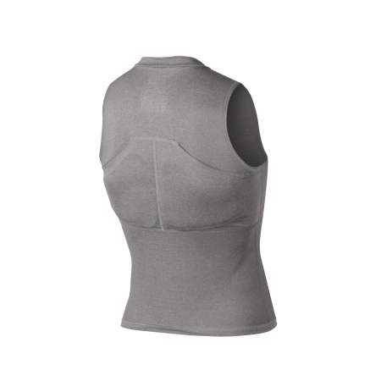](http://cdn1.evoshield.com/media/catalog/product/cache/1/image/1350x1350/9df78eab33525d08d6e5fb8d27136e95/A/1/A100-2.png?rand=0.47798985178494246) [](http://cdn1.evoshield.com/media/catalog/product/cache/1/image/1350x1350/9df78eab33525d08d6e5fb8d27136e95/A/1/A100-2.png)

a) b)

***Figure 1****. EvoShield geometry, a) front and b) back.*

Below is a table that shows evidence of the EvoShield’s Chest and Back guard. The EvoShield generates 4 millimeters less of the back-face deformation, than the other produces on the market. Back-face deformation is when a non-penetrating projectile hits the rear of a strike plate. It measures how far an object is allowed to bulge against a protective surface. The item tested were EvoShield’s Chest/Rib Guard, a competing Batter’s Chest Guard, a catcher’s chest Guard and a bare subject. The NIJ is set to 44mm.

***Table 1.*** *EvoShield testing results.*

|  |  |  |  |
| --- | --- | --- | --- |
| **Sample Number** | **Impact #** | **Impact Velocity (MPH)** | **Deformation (mm)** |
| No Protector | 1 | 61.61 | 15.22 |
| Evoshield Chest/Rib Guard Test 1 | 1 | 63.37 | 5.99 |
| Evoshield Chest/Rib Guard Test 2 | 1 | 61.48 | 5.28 |
| Evoshield Chest/Rib Guard Test 3 | 1 | 61.12 | 5.3 |
| Batter's Chest Protector (current market competitor) | 1 | 62.36 | 9.52 |
| Catcher's Chest Protector 1 (currently available in the market) | 1 | 65.42 | 9.58 |
| Catcher's Chest Protector 2 (currently available in the market) | 1 | 65.71 | 6.55 |

**3. Measure Phase**

**3.1 Impact Analysis**

One of the main objectives of this project is that the vest/collar must be able to absorb the impact of a baseball at 100 mph. For it, we need to know the energy of the baseball, which can be calculated by using the equation seen below:

$$E=\frac{1}{2}*mass*{velocity}^{2}$$

The calculated energy for a ball traveling at 100 miles per hour was 141.6 J.

Since a baseball is made of multiple components, some assumptions had to be made. For this system, it was deemed to be a one-dimensional system; uniform, elastic and having a constant force being applied. The system is modeled to be one-dimensional because when an impact wave runs through the baseball it moves in all three directions. Therefore, modeling the impact wave in three dimensions would be hard to model. When the force is applied to the batter or the vest, it will be modeled as a uniform constant force.

A baseball is made of three main components: leather casing, thread or wool string wrapped around core, and a rubber core. The speed of sound for leather and wool/cotton was not found through research, but the speed of sound of rubber was found to be 60 meters per second. So it was assumed that the baseball would be modeled as a solid rubber sphere. The speed of sound of a leather or wool/cotton would be much slower than that of rubber because when the material experiences a force, the particles in rubber go back to their resting position quicker than leather and wool/cotton would. The equation used to find the impact time is two times the diameter of the baseball divided by the speed of sound of rubber.

$$∆t=\frac{2*diameter}{C_{rubber}}$$

The impact time equals 0.002455 seconds. With the impact time calculated the force from the impact can be calculated. The force that is felt is equal to the mass of the baseball times the change in velocity divided by the impact time, as seen below.

$$F=\frac{mass*∆v}{∆t}$$

The force that a human or the vest/collar would feel from the baseball hitting them would be 2581 N or 580.2 lbf. From research, it takes about a 3,300 N (741lbf) force to cause a rib to be cracked. Hence, this force may not be high enough to break a rib but may still cause bruising and large amount of pain.

Once the force by the 100 mph pitch was found, more research was needed to find how the ball striking a surface would affect the baseball’s geometry. A chart was found that compared the force applied on the ball and the deflection of the baseball.

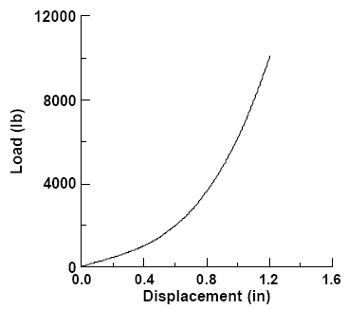

**Figure 2**. Chart comparing force load vs. displacement.

From this chart on Figure 2, knowing the force the ball will be under, it can be correlated to the chart. With a force of 580.2 lb. the displacement of the baseball will be close to 0.4 inches. The displacement of 0.4 inches will also be radius of the surface area of the contact area. The radius, now the compressed surface area, can be calculated as pi times the compressed radius squared (see equation below).

$$A_{compressed}={radius}^{2}*π$$

The compressed surface area is 0.503 in2. With the surface area, stress can be calculated.

$$σ=\frac{F}{A_{compressed}}$$

The calculated stress is 7.958 MPa, which then could be used to help find better possible materials for the vest (full calculations are presented in Appendix C).

**3.2 Ergonomics**

The nature of the “Wear It” project requires that a person wear the product. This means that the interface between the human body and the vest/collar be taken into consideration, the geometry of the vest/collar will be determined by the form of the body part in contact with. To find the optimal geometry for the vest, the team will consider anthropometrics to best fit the body. Also it is necessary to consider the ranges of body movements into de design process, to provide a vest/collar that protects the players without reducing its ability to perform successfully. Studying the different parts of the body that take part into the swinging motion can provide detailed information regarding the range of moment that must not be impaired. The main parts to consider are the neck, shoulders, arms, and torso.

The vest/collar design should allow rotation of the head to both sides. Also, the collar height and shape should be designed to not affect/injure the jaw. The vest armholes should not cover the shoulder area to allow full rotation of the shoulder and free movement of the arms.

In order to provide a more natural fit and comfort to the players, the study of the arrangement of the body’s bones, muscles, and joints was performed to provide a basic layout for the vest. The main muscle groups that the team will consider are shown in Figure 3. To allow the player to rotate the head without impairment the bottom part of the collar should follow a curve similar to that of the levator scapulae, avoiding any type of friction or stiff bulky pieces. The team will procure that the vest design will accommodate to the body geometry.

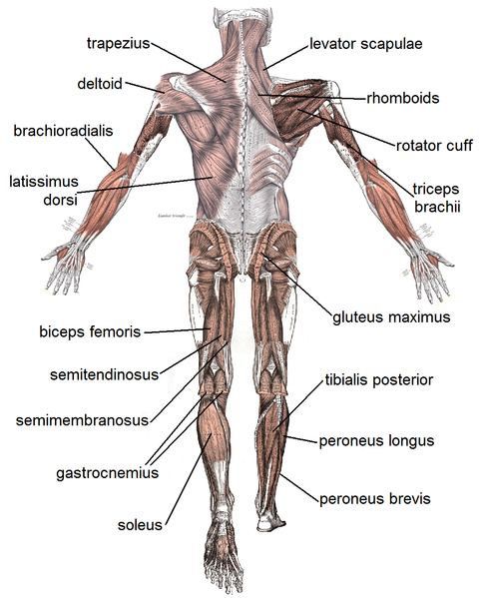

***Figure 3****. Back view of the musculoskeletal system.*

**4. Analyze Phase**

For the Analyze Phase, the team mainly works on redirecting the project and analyzing materials to do final selection. The project was redirected and adjusted by the advise of both the sponsor and advisors. It was brought to the team’s attention a specific area of the vest that is not necessarily covered by other vests that have been produced in the past: the neck. The team had always planned to incorporate a neckpiece to the design of the vest, whether it be an add-on piece or an extension of the vest, but never made it a priority. So, after analyzing the critical areas of the human body that are affected when playing baseball, the team developed a series of collar designs that will attempt to protect the main critical area, the neck. Other change to the project was made due to time constraints. Therefore, the project was redirected to a Design Tread Study, consisting basically an analysis of material selected and a finalized design.

Another adjustment that was made was regarding the selection of materials. The team initially decided to pursue the use of a carbon fiber shell with padded backing to absorb and cushion the impact of the baseball. However, it was brought to the team’s attention that the use of carbon fiber was not acceptable due to the characteristic of carbon fibers decreasing strength upon multiple impacts. For this reason, the team continued to analyze various types of materials in order to aid in the selection of a material/composite that will be suitable for the intended impact characteristics. Two new materials were selected: EVA foam for the padding; and high-density polyethylene (HDPE) for the hard plates.

**4.1 Research on Material**

As mentioned before, the Analyze phase report consisted in its majority on material selection, and in the research and analysis that the team conducted to support their decision of using these. The team decided to use the combination of the EVA foam and HDPE plates because the use of a hard polymer will allow the distribution of the impact load, while the softer, closed-cell, recoverable EVA foam will serve to absorb the impact energy of the baseball once it has been distributed by the hard plate.

**4.2 EVA Foam**

Before the team ultimately selected the padding material, they studied the general aspects of all foams in order to make a good material choice. This being said, foams can be classiﬁed into two categories based on cell structure: closed-cell and open-cell structures. The team focused on this parameter after the advice of several instructors from the College of Engineering that a closed-cell foam would work best for this project.

Research conducted by the team proved that polymeric foams have a large number of applications as shock absorbers, from the packaging of goods to personal protection. Their function is to minimize the kinetic energy produced by an impact. The selection of a material for a particular application is supposed to be based on the energy which it can absorb and the critical stress which the protected object/body can support. That being said, the team decided that they needed to address the force of the impact of the ball, 581 *lbf* [Mills, pg. 23 (2003)].

Recovery of the deformation after impact was a key point for the team to consider. The reason is that the life span of the product is 3 years, so it is aimed to keep it functioning despite repeated compressions by the ball. Polyethylene foams show a viscoelastic recovery of the deformation after the impact and therefore the foam in multiple impacts does perform fairly well.

So, after an extensive research about different foams’ properties, behaviors, and applications, the team selected EVA as its foam material for the protective collar. Ethylene vinyl acetate copolymer, better known simply as EVA, is a copolymer that is part of the polyolefin family, characterized by its toughness, flexibility and resistance to chemicals and abrasion [Verdejo (2003)].

There are many different kinds of EVA commercially available because the properties of EVA are modified by the content of VA. The team selected EVA from Foam Order.com. It is sold in 40”x80” sheets, of 1/2” thickness, at a market price of $35.55 (Foam Order).

**4.3 High Density Polyethylene**

As mentioned earlier, for the second part of the design the team selected high density polyethylene (HDPE). The team conducted research to find an ideal hard plate: one that will stay firm and will not deform at a large rate, should not be so hard that it is brittle and scatter after impact, and is lightweight so it does not interferes with the player’s ability.

This material was decided to be a good choice. Polyethylene is a thermoplastic, which means that it can be heated to a specific temperature, and becomes pliable or moldable. The polymer chains in the polyethylene have intermolecular forces, which allow the polymer to be formed when heated. When the polymer cools, the intermolecular interaction grows stronger and do not affect the physical properties. Polyethylene is known for its large strength to density ratio. This polymer’s tensile strength ranges from 600 psi to 6,000 psi depending on the density, and for such is one of the most common types of plastics used in the world today for it is resistant to water, acids, and most solvents.

Some of the applications of polyethylene are hardhats, water pipes, natural gas pipes, storage sheds, fuel tanks for vehicles, bull riding vests, and ballistic plates. On further research into the ballistic plates made for protective vests, it is shown that it is a durable and reliable material. These ballistic plates made of HDPE are made to stop all ‘Level 3 Threats’, which consist of handguns and most rifles, but are still lightweight weighing 3.2 lbs; hence, it will work for this project.

There are different types of polyethylene depending on the molecular weight, branching and density. The team selected to buy 24”x48” (1/4” thick) HDPE sheets from U.S. Plastic Corporation, at $25.09 (U.S. Plastic Corp.).

**4.4 Testing**

The team mentioned their desire of performing compressive experiments that would involve the measurement of the deformation suﬀered by the material to applied forces. The interest of these experiments is in the type of applied stress to which the foam is subjected. Among the diﬀerent experiments to study this response are: creep and impact tests. “Impact tests are designed to measure the resistance to failure of a material to a suddenly applied force. The test measures the impact energy, or the energy absorbed prior to fracture. The most common methods of measuring impact energy are: the Charpy Test and the Izod Test” (Azom).

“Impact energy is a measure of the work done to fracture a test specimen. When the striker impacts the specimen, the specimen will absorb energy until it yields. At this point, the specimen will begin to undergo plastic deformation at the notch. The test specimen continues to absorb energy and work hardens at the plastic zone at the notch. When the specimen can absorb no more energy, fracture occurs” (ibid.).

The idea behind compression and impact testing is pretty simple once the results from the computer analysis with FEA are completed. It is important that the FEA results translate into real life acceptable values in order to perform the experiments.

**5. Design Phase**

**5.1 Objectives of this Phase**

This design phase directs the team into finalizing the design for the protective “Wear It” vest/collar prototype. The team is now focused on the optimization of Mr. Boone initial design by:

1. Brainstorm potential vest/collar designs.
2. Compare designs and choose the most optimal solution.
3. Analyze the design for potential improvements.
4. Analyze the materials interphase between the two.
5. Analyze possible attachment solutions to the collar.

**5.2 Pugh Matrix**

**5.2.1 Criteria and Concepts Identification**

The criteria chosen for the Pugh matrix resemble the customer requirements that were used in the House of Quality. The criteria is: cost, adjustability, level of comfort, ease of maintenance, safety, aesthetics, lightweight, durability, player performance, and functionality. The matrix shows the ranking given to each of the criterion by the team based on importance, on a scale 1-10, 10 being the highest and 1 being the lowest. This being said, the ultimate objective of the collar is to provide the player with the greatest protection possible. For this reason, the team ranked 'Safety' a 10. 'Adjustability', 'Lightweight' and 'Player Performance' got a 9 because they are considered the second most important aspect of the project. The lowest score, 4, was assigned to 'Ease of Maintenance' because even though the ideal situation will be that the collar doesn't absorb sweat, it might still get dirty. Still, cleaning it should not be an issue for the user.

The team felt appropriate to use the original design provided by the sponsor as the datum for the Pugh matrix. Mr. Boone's design was originally of both, the vest and the collar. However, for the purpose of building this matrix, the team considered only the collar piece and not the entire vest. The three concepts shown in the top of the matrix correspond to the three designs the team came up with. These are: (1) the crown-like shape, (2) arched shaped, and (3) flat neck shape. For explanation purposes, let's refer to each concept by its number (1, 2 or 3).

***Table 2.*** *Pugh Matrix.*

|  |  |  |  |  |  |
| --- | --- | --- | --- | --- | --- |
| Evaluation Matrix |  | CONCEPTS | | | |
| CRITERIA | Importance Rating | Mr. Boone's Design | Crown-like shape | Arched shape | Flat neck shape |
| Cost | 6 | DATUM | S | + | + |
| Adjustability | 9 | S | - | S |
| Level of Comfort | 7 | - | - | - |
| Ease of Maintenance | 4 | + | + | + |
| Safety | 10 | S | - | + |
| Aesthetics | 7 | S | - | - |
| Lightweight | 9 | + | + | + |
| Durability | 6 | S | - | + |
| Player Performance | 9 | + | - | S |
| Functionality | 8 | S | - | + |
|  |  |  |  |  |  |
| Sum of Positives |  | DATUM | 3 | 3 | 6 |
| Sum of Negatives |  | 1 | 7 | 2 |
| Sum of Sames |  | 6 | 0 | 2 |
| Weighted Sum of Positives |  | 22 | 19 | 43 |
| Weighted Sum of Negatives |  | 7 | 56 | 14 |
| Total |  |  | 15 | -37 | 29 |

**5.2.2 Selecting Solutions to Implement**

Regarding 'Cost', concept (1) would represent the same cost. On the other hand, (2) requires less amount of material because the padding is only located on the edges of the collar and not on the entire piece. Also, (3) would be cheaper to manufacture because its shape is way simpler than the one of the datum. It being flat means that it won't require being bended. Adjustability' will remain the same on (1) and (3), but will decrease in (2) because it is hollow on the back of the neck. The 'Level of Comfort' is expected to decrease in the three of them. However, they all seem to be easier to maintain because of the simpler shape they have. This is why the team assigned '+' to all of them in 'Ease of Maintenance'.

Regarding safety, the most relevant criterion, the team considers that in concept (3) protection of the neck is greater than when wearing the datum because it raises up in the middle section of the neck with the purpose that if the ball strikes the plate, the impact could be reinforced by the helmet.

With respect to 'Aesthetics', the team felt that (1) had relatively the same aspect as the sponsor's design. On the other hand, (2) and (3) wouldn't look too appealing to have users wanting to wear them. All three concepts seem to be more "Lightweight' than the datum because they require less material, so that is why the team assigned them a '+'.

Concerning durability, the three concepts had different results. Concept (1) was assigned an 'S' because of its similarity to the datum so they are assumed to have the same durability. Concept (2) has lower durability because its arched shape makes it less suitable to withstand multiple hits. It could break easier. Concept (3) seems to have greater durability also because of its simple shape and form.

The same occurred with 'Player Performance'; they all three resulted in different values. The one that seems to hinder player performance the most is (2) because of its doughnut-like shape, which may be uncomfortable when playing and running. Contrarily, (1) was considered the most comfortable one.

Lastly, 'Functionality' was examined, (2) scored worse than the datum because of its shape that may result awkward to some players, while (3) seemed to be the most functional because it can protect the entire neck region of the player and still be wearable.

After analyzing the given scores, one concept emerged clearly as the strongest with a score of 29, compared to 15 and -37. This concept is the third, the flat neck shaped collar.

For this reason, the team decided to consider having possible alterations of this concept in the hopes of looking for new concepts, strengths and weaknesses. Then, the second matrix has concept (3) as the datum as it was selected the best concept, and has six other new concepts that derived from it. These six new concepts are: (a) cut front edges, (b) add slight crown curve to the flat collar design, (c) create slight angle on front edges, (d) two layers of padding, (e) two layers of HDPE, and (f) Sandwich of padding, HDPE, and padding.

**5.4 Materials Structure**

As has been mentioned previously, the decided hard polymer material chosen is going to be a high-density polyethylene (HDPE), with a soft shell EVA foam attached to it on the inside. After determining what our group was going to use for a material, the next step was deciding on the thickness that our collar would consist of. The team went over many articles and papers trying to understand the research on vests and protective materials for the vest/collar, with most of the ideas and understanding coming from the company EVOShield, which produces protective gear for many different sporting disciplines. The choices that the group has made for thickness sizes of the materials are as follows: a ¼ inch thick sample of EVA foam, and a ¼ inch thick sheet of HDPE. There are a couple things that the team is able to do with these samples, the main one being that we can finally start to run some physical tests and get some real, true values that we can communicate to our sponsor. It is still being decided upon by the team as to what the area of the sample test will be, but having 2 sheets of the polyethylene does in fact give the team the opportunity to possibly test on a little bit of a larger surface, therefore ensuring that the values received from various testing processes is accurate.

The main set-up of the team’s collar is going to be the hard polyethylene on the outside, with the EVA foam attached using some kind of resin or glue on the inside, closest to the player’s neck/spine region. The team feels that is the best possible way to design the collar guard because it gives the player the opportunity to still have a good amount of mobility. The group understands that it is not always possible to achieve maximum comfortability while being active in sporting events, but with this collar design, it will be as close to ideal as possible. The EVA foam sets up for a nice buffer in between the hard plate and the player’s body, should a ball come flying toward that area. The dissipated energy that we expect to see from this combination of materials is something the team is hoping to prove with mathematical analysis from the stress properties of the material, and the tests run in the near future. The team has analyzed many materials such as alloys, silicon, carbon fiber, polycarbonates and natural rubber, and after a lot of research, realized that polyethylene’s strength to density ratio is much greater than that of the other possible materials entertained. It is one of the most consistently used materials today, and most other practical applications use about the same size and thickness for their specific actions that the team plans to. A ¼ inch thick high-density polyethylene plate should definitely be able to get the job done for the product, while also maintaining the relative lightweight of the overall vest.

**5.4.1. Joining the Materials**

Because the collar will be constructed of a combination of foam and hard polymer, a need has risen to join the two materials securely. This process is somewhat imperative because the adhesive used between the two materials must be flexible and must not hinder the collars ability to absorb the impact energy. If an adhesive were chosen that hardened in a stiff manner, the adhesive would likely crack or lose adhesion as the collar flexed under impact. Also, a stiff adhesive would possibly distort the energy transfer process through the collar. This could hinder the collar’s energy absorption characteristics in an undesirable fashion. Guided by these factors, the team has selected Titebond© Contact Cement as the adhesive to join the foam and the polymer. The contact cement attaches securely to each of our materials, and allows for a very strong connection between the two. Along with providing a relatively strong bond the contact cement will maintain a rubber-like characteristic even after it has dried. This will allow the contact cement to stay intact and retain its adhesion characteristics even under impact and flexing of the collar. Also, the contact cement will provide a thin rubber-like layer between the two materials making up the collar. Because of this, the layer of adhesive between the materials will not alter the energy absorption characteristics of the collar whereas a stiff adhesive might.

Contact cement is a neoprene rubber or latex adhesive, which is kept in a liquid state by various solvents until it is applied to a surface. At this point, the solvent evaporates and the rubber adhesive dries between the surfaces creating a strong flexible bond. Contact cement is used for any number of applications currently, from securing countertops and floor tiles, to use in arts and crafts. The unique benefit of contact cement is its ability to be used in nonporous materials (such as the EVA foam and the polymer).

The application of a contact adhesive is unique to that of conventional glues. In a conventional gluing process, glue is applied to a surface, which is then mated to another surface, and then usually clamped or secured until the glue has dried, providing the adhesive bond. However, when using nonporous materials, conventional glue is undesirable and sometimes impossible to use because when the two surfaces are joined, the moisture content of the glue has no possibility to evaporate. This ends up leaving the adhesive surfaces in a weak mess. To use contact cement, the team must follow an adhesion process slightly different to that of using conventional glues. When connecting two surfaces through the use of contact cement, the first step is to apply the adhesive to both prepared surfaces (roughed/cleaned) in a thin layer. This first layer on each surface is then allowed to dry to the touch. At this point, another thin layer is applied to each surface. This next layer is also given the opportunity to dry to the touch. As soon as the second layer is dry to the touch, the two surfaces are joined together, and must be clamped or secured in a tight fashion to allow the two surfaces of adhesive to mesh. Because a large portion of the contact cement moisture was removed before joining, the two surfaces create a quick, strong bond between themselves. However, at this point the adhesive is still not completely dry, so it must remain clamped together for a minimum of a few hours until the remaining moisture content in the adhesive has evaporated away. At this point, if executed properly, the EVA foam and the hard polymer of the collar should be securely fastened together in a fashion that will allow the collar to absorb impact without the materials losing adhesion.

**5.4.2 Collar Attachment**

As far as the concept of how the collar is going to be attached to the overall vest, the team has not exactly made that decision a priority at this point. Many ideas have been discussed between the team and the advisors/teaching assistants, but a lot of discrepancies still lie in front. The main issues being: does the team want to sell just the collar as its product, or figure out a way to attach it to the vest and sell it overall as a completely new vest? If that is the choice, does the team sell it in a two-piece fashion where the collar is detachable, or should they attach it completely without option for removal?

The team agrees that there are multiple ways to attach the collar to the vest, including the possibility of adding Velcro to the top of the vest and the bottom of the collar, as well as incorporating push buttons on both the vest and the collar in order to make the collar easily detachable. Also, the collar may have a series of clips in strategic positions to maintain the collar in place; another option would be a zipper arrangement like those of detachable hoodies in certain coats. These options definitely need to be analyzed by the team to determine if there’s any further reality to them, at this point the group is in the beginning stages of our attachment process. The team still has to determine if these options will provide the needed support for the collar to stay in place when players are running, or if the impact causes if to shift its neutral position. The team will assess the impact of the design in the player and his performance while in the game. At this point, this remained an issue the team needed to work more on.

One option that the team has discussed and seems to be leading the conversation is the idea of sewing the collar completely to the vest. These days, when thoughts of items like a neck guard for goalies and football players comes to mind, the team began to realize that those are detachable products. This might actually hurt our product, if it is detachable; it in fact decreases the value of the guard to the customer. Speaking strictly business, the opportunity for monetary growth does not in fact come from selling just a single guard, it comes from attaching it to the vest and selling the entire piece at once. While the group does have many ideas for the possible attachment of the color, there is by no means a definitive option at this point and that will be determined sometime in the near future. The team understands that it will be difficult to make this kind of attachment a real possibility, but is willing to look at all aspects of design and attachment from researchers to determine the best possible way to advertise and finalize our product. The group at this point is very much focused on the testing side of the project, and if all goes according to plan, which is believed to occur, then we will move forward with the prototyping of the vest and ensuring that it is not only safe for every player wearing, but that it is aesthetically pleasing to them as well.

**5.5 Implementing Improvements**

A second Pugh matrix was developed to analyze possible improvements to the design that was selected from the first matrix. To further expand the details that may be improved within our selected collar, six new concepts have been integrated into the Pugh matrix to further develop the collar design into its most optimal form.

***Table 3.*** *Improvements to Flat Plate Collar.*

|  |  |  |  |  |  |  |  |  |
| --- | --- | --- | --- | --- | --- | --- | --- | --- |
| **Evaluation Matrix** |  | CONCEPTS | | | |  |  |  |
| CRITERIA | Importance  Rating | Flat neck shape | Cut front edges | Add slight crown curve to the flat collar design | Create slight angle on front edges | Two layers of padding | Two layers of HDPE | Sandwich of padding, HPDE, and padding |
| Cost | 6 | DATUM | - | - | - | - | - | - |
| Adjustability | 9 | S | + | + | - | - | - |
| Level of Comfort | 7 | + | + | + | + | - | S |
| Ease of Maintenance | 4 | S | - | S | S | S | - |
| Safety | 10 | + | + | + | + | + | + |
| Aesthetics | 7 | S | + | + | - | - | - |
| Lightweight | 9 | S | S | S | - | - | - |
| Durability | 6 | S | S | S | + | + | + |
| Player Performance | 9 | + | + | + | - | - | - |
| Functionality | 8 | S | + | S | + | + | + |
|  |  |  |  |  |  |  |  |
| Sum of Positives |  | DATUM | 3 | 6 | 5 | 4 | 3 | 3 |
| Sum of Negatives |  | 1 | 2 | 1 | 5 | 6 | 6 |
| Sum of Sames |  | 6 | 2 | 4 | 1 | 1 | 1 |
| Weighted Sum of Positives |  | 26 | 50 | 42 | 31 | 24 | 24 |
| Weighted Sum of Negatives |  | -6 | -10 | -6 | -40 | -47 | -44 |
| **Total** |  |  | 20 | 40 | 36 | -9 | -23 | -20 |

From this matrix, it is believed that further improvements can be made to the flat plate shape collar, and the team looks forward to navigate such possibilities in more detail. By having a partial incorporation of the initial designs, the crown-shape, into our improved selection, some considerations have to be made since we are considering an improvement as the combination of two original designs.

**5.5.1 CAD Design**

The team explained that these collars would be analyzed using Finite Element Analysis (FEA) to determine which alternative is the best for this project. The team started working on the FEA with the support of peers and professors, especially Dr. William Oates. FEA would allow the team to determine the actual material dimension (thickness) to be used. However, in the entire CAD drawings two important assumptions were made: the foam being ½ inches thick and the plate being ¼ inches thick.

The first design consisted of a crown-like plate with a foam liner on the inside. The second design showed an arced type plate, in which if a baseball struck the plate, the impact would disperse over the whole plate. Lastly, the third consisted of a flat neck plate design, that would have the plate and foam are raised up in the middle section of the neck with the purpose that if the ball strikes the plate, the impact could be reinforced by the helmet. This design was believed to provide more protection for the neck region. Still, further research was needed to support the team’s decision in the case of chosing this collar design.

In the figure below show the different types of possible designs that could be put into FEA analysis. The foam in all these CAD drawings are ½ in thick and the plates are ¼ in. The polyethylene plate will stop the impact and EVA foam will absorb most of the energy from the impact. In figure 4, show a crown like plate with a foam liner on the inside.

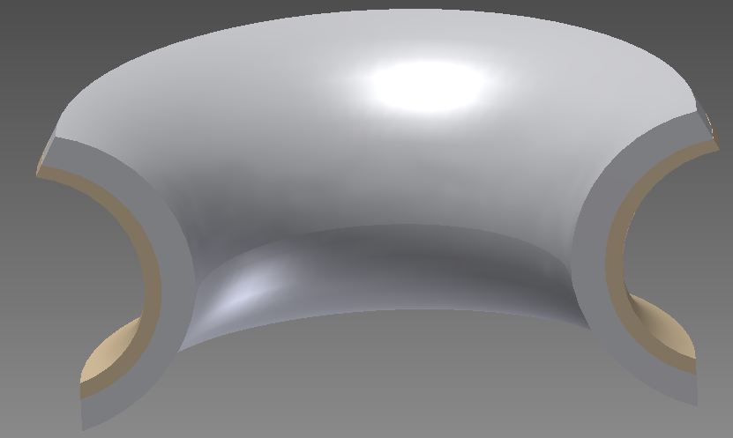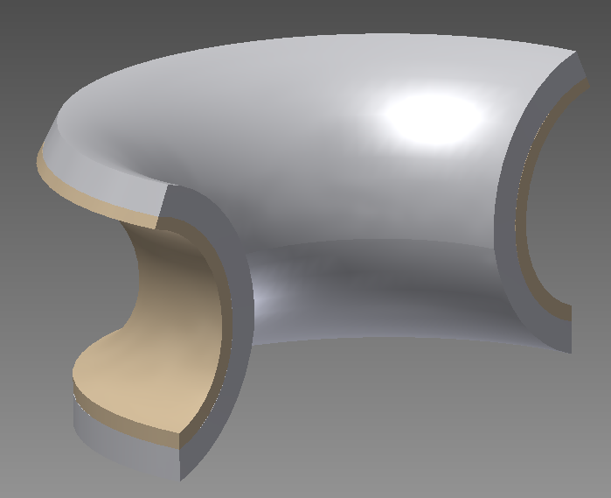

***Figure 4.*** *Crown Neck plate with foam liner.*

This design makes an easy transition for extra EVA foam to come off the neck plate and cover the shoulders, chest and shoulder blades. This would help in the corporation the collar to a protective vest. The biggest down fall to this design is with the geometry of the crown shape it makes it extremely hard to have an extended plate in the back for support. There would have to be a sharp turn/ edge in the forming of the plate leaving a risk for higher forces if the ball struck this region. Even though it fully protects the neck there is not a big overlap with the helmet, which could be used for a second impact absorber.

Figure 5 shows the arced type plate. With the design of the plate if a ball struck the plate the impact would disperse over the whole plate. The foam would be the buffer between the player and hard plate just in case the force is strong enough to cause the plate to push up against the player. Also with this design if the ball strikes the plate it would deflect up or down way from the neck region.

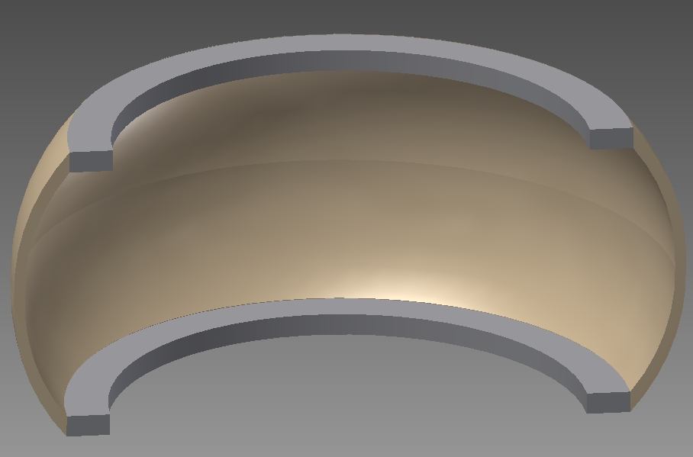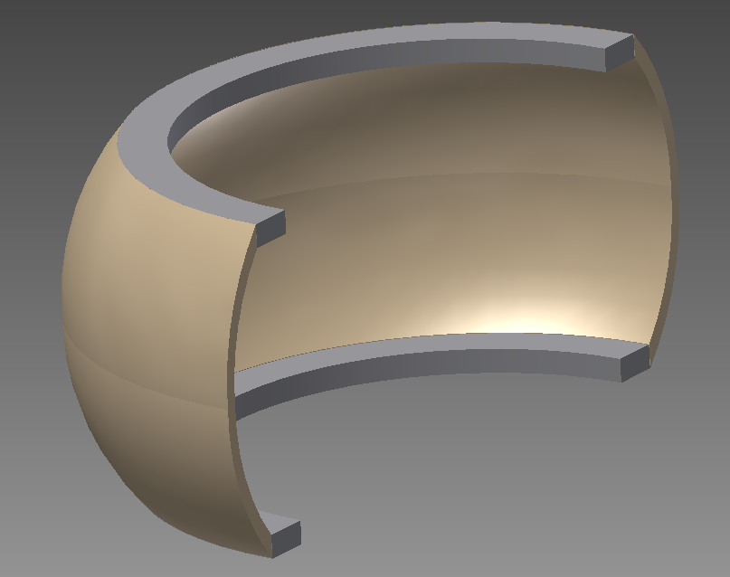

***Figure 5****. Arced neck plate with foam on edges.*

The downfall to this neck design is the geometry of the plate. With the plate having a C-shape, if struck by a pitch the two edges would be the only thing to come in contact with the player. There is less surface area; so more energy and force will be concentrated in those two areas. Also with less surface area, there will be less foam to absorb the impact. With the C-shape plate facing in to the neck it is hard to make or assemble support pieces that would connect the collar to a protective vest. This shows that this collar would be the hardest

In figures 6 and 7, the flat neck plate design is shown. In the middle section of the plate it raised up, so if the ball strikes the plate the helmet could reinforce the impact. This design gives more protection for the neck region. The sides of the plate are low so the player’s vision is not affected but high enough to protect the whole neck.

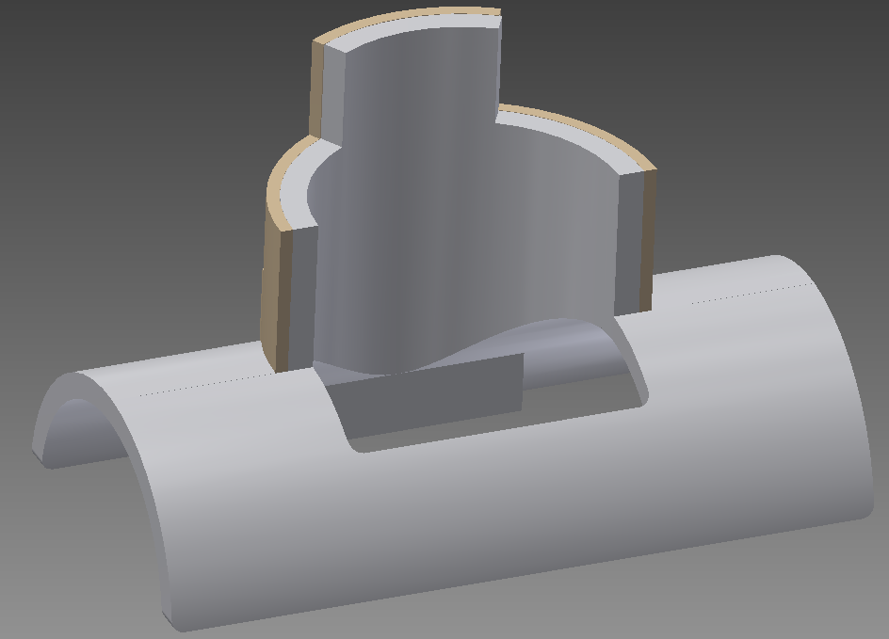

***Figure 6.*** *Front view of the flat neck plate with foam liner.*

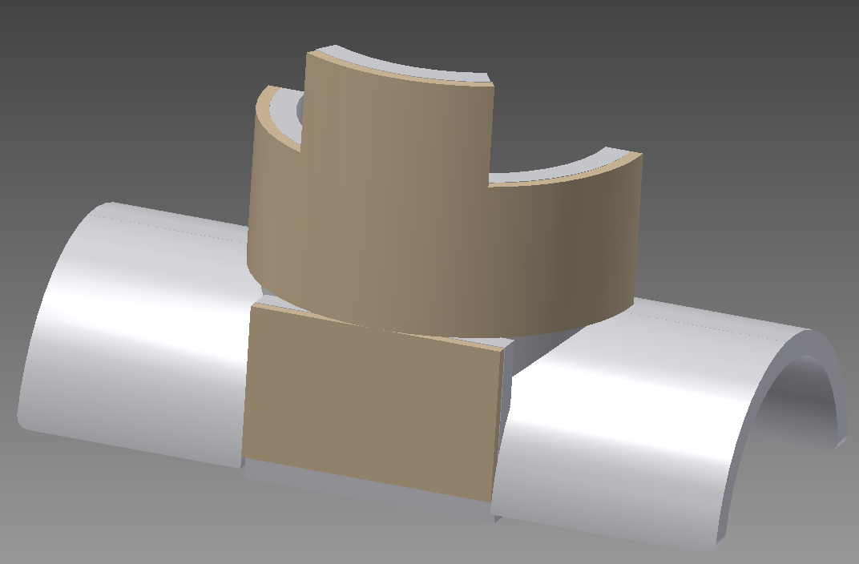

**Figure 7.** Back view of the flat neck plate with foam liner.

The extended piece of polyethylene on the back is for protection and support. The plate would protect part of the spine that starts to run down into the back. The extension also helps support the collar system from falling over and makes it easier to connect to a protective vest.

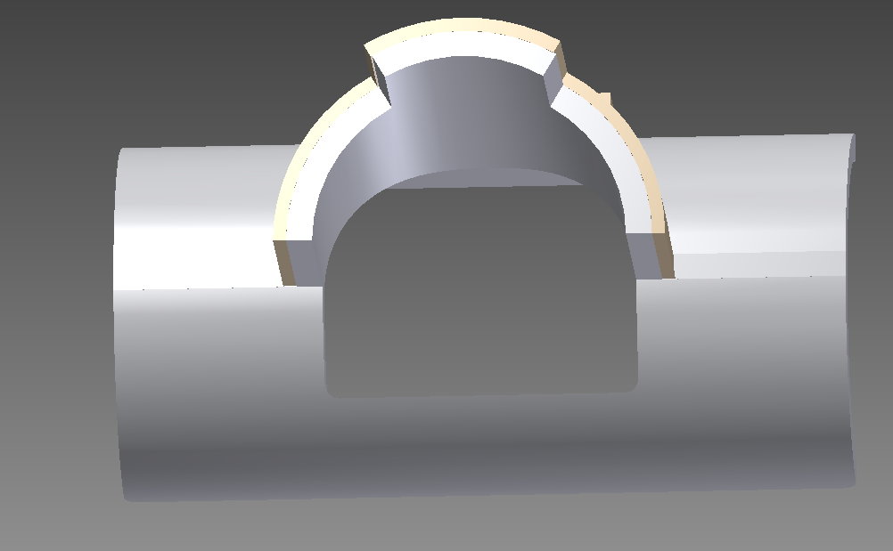

***Figure 8.*** *Top view of the Flat plate design.*

The EVA foam has a large surface area over the polyethylene plate, which will be able to disperse an impact more and less energy and force will be transfer to the batter. The foam was extended over the shoulders and lays over part of the chest and shoulder blades. All the extra foam helps the collar sit upright on the player and will be easier to corporate the collar with a protective vest. If the protective vest is made of nylon, the foam on the shoulders could be pressed down snug and stop the collar from moving.

The flat neck plate design is the final design chosen for this project. The neck plates cover the neck but do not hinder the batter’s vision. The neck plate is designed so it overlaps with the helmet so the helmet would also lessen the impact. With the extra foam to support the system it is easiest of the three designs to corporate with a protective vest. The arced neck plate was too hard to corporate with a protective vest. The crowned neck plate was similar to the flat neck plate other than the extended plate on the back of the collar, which would make it harder to design. Also it did not have the extra overlap that goes over the helmet to help reduce the impact.

**5.6 Collar Ergonomics**

In reference to the ergonomics of the protective collar, the team look at different data collected to get the collar geometry of the boy’s neck ranging in ages from 14 to 18 year-olds, since the team is designing the collar for boys in High School or under. The data was taken from American Society for Testing Materials, an international organization that publishes consensus. The table below shows the different sizes of the boy’s body measurements from age 14 to 18.

***Table 4.*** *Body measurement of boys.*

|  |  |  |  |
| --- | --- | --- | --- |
| **Parameters** | **Avg. measurements in inches** | | |
| Age (years) | 14 | 16 | 18 |
| Neck Base Girth | 13 ¼ | 13 ¾ | 14 ¼ |
| Mid-Neck Girth | 12 | 12 ½ | 13 |
| Neck Length | 8 ½ | 8 ¾ | 9 |
| Cervical Height | 53 | 55 ¼ | 57 ½ |

The table indicates the girth of certain parts of the body, this represents the average thickness of such areas. By knowing the thickness at the base of the neck and the mid-neck the team can determine the angle in which the vest would be “molded” to provide an accurate fit, without suffocating the player with the collar. Also, since the difference in thickness is taken into consideration, a more natural appereance can be given to the final prototype by a natural curve on the neck.

The team will use all the geometries provided to design a final prototype for testing. The Senior Design group will then modified the size and shape of the collar to get the best fit every age group, and allow agility of the players head and neck. The team will inspect more to see how the collar will react to the impact, if there will be any discomfort of the collar and materials the affects the players after impact.

**6. Conclusion**

Up to this point, in the design phase, the “Wear It” team has finalized the material selection, the prototype design, and procurement of the materials. The ball will hit the plastic material first, and it will spread the force from the impact of the ball. Then, the foam will serve as padding or cushioning to spread this force. The team selected EVA foam due to its current use in sports related gear, as well as the properties that it offers that suit perfectly to this collar design. The HDPE was chosen primarily because it is currently used in ballistic vests, indicating it will be successful also in sports protective gear. These two materials have been purchased already and are waiting to be tested.

To help selecting the best design out of several options, the team implemented the Pugh Matrix, a tool used to compare different design concepts, highlighting the strongest and scratching the weakest ones. The Pugh matrix was done twice. The first round indicated that the best concept among the three that the team presented in the Analyze phase, was the flat collar because it was easier to manufacture, provided more safety at the back of the neck, and increased overall functionality.

The team decided to implement alterations to this concept in the hopes of finding one that would be even better. And indeed they discovered, by doing a second Pugh matrix, that by having a crown-like shape made into the flat collar design would be even a better option. This tool, then, indicated the final design the team would aim to produce: a crown-shape like collar, with a higher section at the back of the neck to provide even more protection.

At this phase, the team also had to consider two other aspects of the design: how to join both materials together and what kind of attachment will be used to unite the collar to the vest. For the first, the team decided to use a neoprene-rubber contact cement to join the EVA foam and the high-density polyethylene. This aspect of the design is very important because they need to remain pasted for at least 3 years, the minimum expected life of the vest. The second aspect, how the collar is attached to the vest, is incredibly important too because in the end, the collar needs to fit a vest. Otherwise it will be nonsense to be designing a collar. The form of attachment that is most likely to succeed is the sewing of the collar pieces, which will be within a fabric sleeve, to the vest.

In conclusion, the team has made great advance up to this point. The team is only waiting to start the tests in order to get the experimental data to support their claims.

**APPENDIX A**



**APPENDIX B**

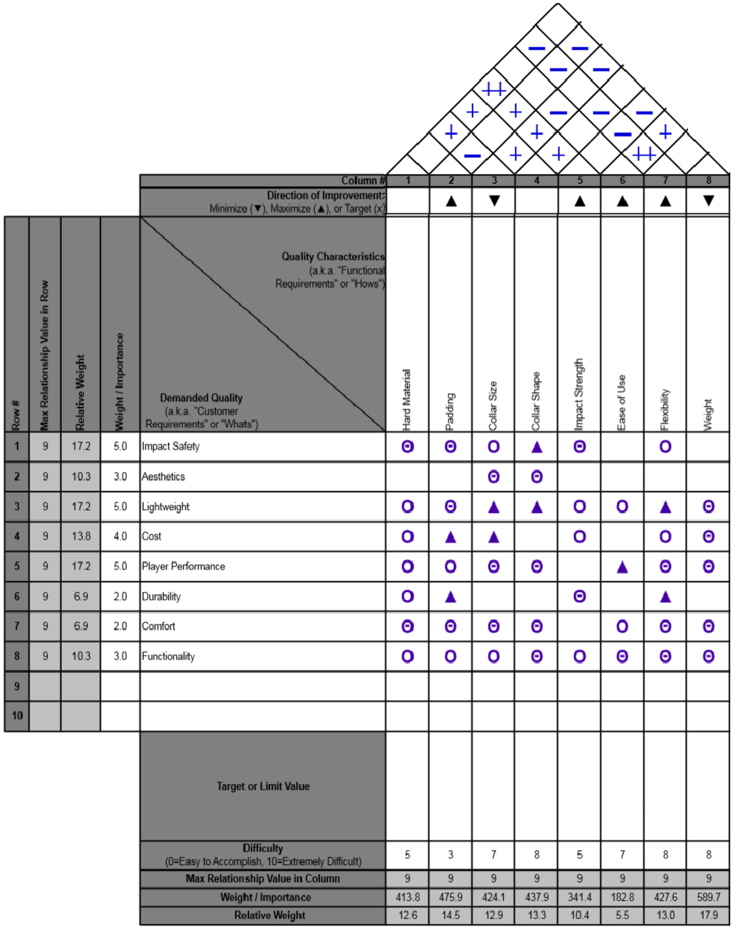

**APPENDIX C**

Weight of baseball

$${mass}_{b}=5 oz$$

Radius of baseball $${Baseball}_{r}=1.45mm$$

Velocity of baseball

$${velocity}_{b}=100 mph$$

Weight of human

$${mass}_{h}=80 kg$$

Impact energy of baseball

$$E=\frac{1}{2}{mass}_{b}{velocity}_{b}^{2}$$

$$E=141.638 J$$

**Assumptions**

1-Dimensional

Elastic

Uniform

Constant Force

Speed of Rubber

$$V_{rubber}=60\frac{m}{s}$$

$$∆t=2\left(2*\frac{{Baseball}_{r}}{V_{rubber}}\right)$$

$$∆t=2.455 {* 10}^{-3}s$$

Cannot find the speed of sound for leather or wool/cotton, so it’s assumed that the baseball is just a rubber ball.

Impact force of baseball

$$∆v=100 mph$$

$${velocity}_{b2}= \frac{{mass}_{h}{velocity}_{h}+{mass}_{b}{velocity}_{b}}{{mass}_{h}+{mass}_{b}}$$

$${velocity}_{b2}= 0.079\frac{m}{s}$$

$$F_{avg}= \frac{{mass}_{b}{velocity}_{b}-{mass}_{b}{velocity}_{b2}}{∆t}$$

$$F_{avg}= 2.576* {10}^{3}N$$

$$F= {mass}_{b}\frac{∆v}{∆t}$$

$$F=2.581*{10}^{3} N=580.183 lbf$$

Compression radius of baseball displaces about 0.4 inches with an approximate load of 600 lbf.

$$r_{compress}=0.4 inches$$

$$A_{compression}=π*r_{compress}^{2}$$

$$A_{compression}=0.503 {inches}^{2}$$

$$σ=\frac{F}{A_{compression}}$$

$$σ=7.958{*10}^{6 }Pa$$

$$σ=7.958 MPa$$

$$thickness=0.25 inches$$

$${tensile}_{CFRP}=100 MPa$$

$$E_{CFRP}={tensile}_{CFRP}*thickness*A_{compression}$$

$$E_{CFRP}=2.059*{10}^{3}J$$

$$safety= \frac{E_{CFPR}}{E}$$

$$safety= 14.539$$

**WORKS CITED**

“Contact Cement”.Titebond. Web <http://www.titebond.com/product.aspx?id=754259a9-824a-4f42-bee4-b302917369ea>

“EVA Foam.” *Metro Foam Products*. Web. 09 Feb. 2014. <<http://metrofoam.com.au/eva-foam.html>>.

“High Density Polyethylene (HDPE) Sheeting.” *U.S. Plastic Corp.* Web. 10 Feb. 2014. <<http://www.usplastic.com/catalog/item.aspx?itemid=23869>>.

“Polyethylene Manufacturing and its Properties”. *Azeem, Abdul*. Web. 11 Feb. 2014

< http://www.academia.edu/3052708/Polyethylene_Maufacturing_and_its_Properties>

#### “Standard Tables of Body Measurements for Boys”. American Society for Testing Materials. Web. <http://www.astm.org/Standards/D6860.htm>

Verdejo, Raquel (2003). *Gas Loss and Durability of EVA foams used in Running Shoes.* Ph.D. Thesis. The University of Birmingham: U.K. <<http://etheses.bham.ac.uk/231/1/Verdejo04PhD.pdf>>.

“Evoshield”. Web. 20 Oct. 2013. <http://www.baseballplusstore.com/products/Evoshielda100-chest-and-back-guard.html>.

The National Spinal Cord Injury Statistical Center, University of Alabama at

Birmingham, NSCISC 2009 Annual Statistical Report and Facts at a Glance,

February 2010. <<http://www.aans.org/Patient%20Information/Conditions%20and%20Treatments/Sports->[Related%20Neck%20Injury.aspx](http://www.aans.org/Patient%20Information/Conditions%20and%20Treatments/Sports-Related%20Neck%20Injury.aspx)>.