“Wear It” – Baseball Protection Collar,

Impact Reduction Design

Analyze Phase Report

By:

Garth Fletcher IE

Maria Cristina Miro IE

Cecilia Wong IE

Kyler Hast ME

Kyle Meredith ME

Ryne Wickery ME

Sponsor: Gavin Boone

Faculty Advisors: Dr. K. Amin, Dr. D. Olawale

A report submitted to

Dr. Okenwa Okoli, Dr. Kamal Amin

Industrial & Manufacturing Engineering Department

Mechanical Engineering Department

FAMU – FSU College of Engineering

Tallahassee, FL

February 14th, 2013

**TABLE OF CONTENTS**

List of Tables……………………………………..…………………………………………….…2

List of Figures…….…………………………….…………………………………………………2

Acknowledgement………………………………………………………………………………...3

Abstract…...…………………………………….………………...……………………………… 4

1. Introduction …………………………………………………...……..…………………………5

2. Adjustments and Modifications……………………………...…………………………………5

3. Padding Material Selection………………………………...……………...……………………7

3.1 General Aspects of Foams……………………………...…………………………………7

3.1.1 Compressive behaviour…………………………...…………………………….…7

3.1.2 Impact Response…………………………………...………………………………8

3.1.3 Recovery Characteristics …………………...……………………..………………9

3.2 Selection: EVA Foam …………………...…………………………….…….………9

4. Hard Plate Material Selection..…………...……….…………………………………………..12

4.1 General Aspects of Hard Plates…………………...……………………………………..12

4.2 Selection: High Density Polyethylene…………………...………………………………12

5. Collar Design …………………...…………………………………………………………….14

6. Planned Testing Methods (How will it be tested?) …………..……………...………………..18

6.1 Compresive Tests…………………...………………………………………………...…19

6.2 Impact Tests…………………...………………………………………………………...19

7. Testing Parameters (What will be tested?) ………..…………...……………………………..21

7.1 Energy Absortion…………………...…………………………………………………...21

7.2 Load Distribution…………………...…………………………………………………...23

7.3 Spected Results……………………...…………………………………………………..23

8. Further Work …………………...……………………………………………………………..24

8.1 Procurement..…………………………….……………….…………………….………..24

8.2 Actual Testing…………………………………………...………………………………25

8.3 Cost and Ergonomic Analysis…………………………...………………………………26

8.4 Business Plan..………………...……………………………………………………...…26

9. Conclusion…………………...…………………………………………………………..……27

Works Cited……………………..……………………………………………………………….28

Appendix A. Gantt Chart……………………...…………………………………………………30

**List of Tables**

**Table 1.** EVA foam characteristics.

**Table 2.** Different types of Polyethylene based on density and molecular weight.

**Table 3.** High-density and Low-density polyethylene properties.

**Table 4.** Applications of polymeric foams.

**Table 5.** EVA price sheet by thickness.

**Table 6.** High Density Polyethylene (HDPE) Sheeting.

**List of Figures**

**Figure 1.** Example of the celular structure of foams. Left: open cell, and right: closed cell.

**Figure 2.** Compressive behaviour of polymeric foams showing three regions.

**Figure 3.** Typical stress-strain curves of a EVA foam from compresion test (a) and simple shear test (b).

**Figure 4**. Effects of the increase of the VA content on the EVA properties.

Figure 5: Crown Neck plate with foam liner (front view).

Figure 6: Crown-Neck plate with foam liner (side view).

Figure 7: Arced neck plate with foam on edges (front view).

Figure 8: Arced neck plate with foam on edges (side view).

Figure 9: Flat neck plate with foam liner (front view).

Figure 10: Flat neck plate with foam liner (side view).

**Figure 11.** Impact response of an EVA foam at room temperature, as a force-displacement curve and as a stress-strain curve.

**Figure 12.** Foam deformation regions.

**Figure 13.** Gantt chart.

**Acknowledgment**

The team will like to acknowledge and extend their gratitude to the following professors at the FAMU-FSU College of Engineering who provided constructive advice and suggestions on the materials for this project. Sincere thanks to Dr. Mei Zhang, Dr. Simone Hruda, Dr. Liang Cheng, Dr. Tao Liu, and Dr. Changchun Zeng. Without their attentive guidance and encouragement, the completion of this report would not have been possible.

**Abstract**

This senior design team has been assigned to work with Mr. Gavin Boone in the development of a baseball vest prototype, which will serve as a protective gear for baseball players when they are batting. In order to accomplish the goal, the following considerations will be taken into account: safety, player performance, and quality. Currently, there is no official protective gear used by baseball players to prevent injuries caused by the pitch in the neck region when they are batting.

In order to create a vest that will provide the best protection to the baseball player, this senior design team has selected two types of materials that in unison will prevent injuries incurred by the baseball. Both materials will be tested separately and together to ensure that their properties provide the vest protection simulating circumstances similar of those when there is a ball game. The outcome of the testing will provide with quantity data to verify the performance of the materials selected and that the degree of injury will be largely reduced if players where to be using this type of protective gear.

1. **Introduction**

This senior design team has been assigned to work with Mr. Gavin Boone in the development of a prototype vest, which will serve as a protective gear for baseball players when they are batting. In order to create a vest that will provide the best protection to the baseball player, the team has identified the forces related to the baseball impact, as well as the most common injuries caused by it when the players are batting. After analyzing the critical areas of the human body that are affected by these injuries, the team has develop a series of collar designs that will attempt to protect these main critical area, the neck.

Basically the two desired mechanical characteristics of the impact vest include the ability of the vest to distribute the impact force across the entire impact surface, and also to absorb the energy of the baseball impact. However, the selection of a single material with both capabilities proves to be unreasonable. Therefore, the team has decided to use the combination of different suitable materials. The use of a hard polymer will allow the team to design the vest with the ability to distribute the impact load. This hard material will be paired with a softer, closed-cell, recoverable foam that will serve to absorb the impact energy of the baseball once it has been distributed by the hard plate.

1. **Adjustments and Modifications**

Beginning in the Spring 2014 semester, the project was redirected and adjusted by the advise of both the sponsor and advisors. The sponsor, Mr. Boone, adjusted it as far as the overall direction where he wants the team to direct its focus. For most of the Fall 2013 semester, the team put more of the attention on the actual vest and how to protect the critical areas like the rib cage and spinal cord. Now, it was brought to the team’s attention a specific area of the vest that is not necessarily covered by other vests that have been produced in the past: the neck. The team had always planned to incorporate a neck piece to the design of the vest, whether it be an add-on piece or an extension of the vest, but never made it a priority. It is a priority now.

Mr. Boone emphasized that the neck is the part that can actually cover the patent he is planning on getting and what can make this vest a hit. Also, other vests in the market have done the torso and back areas, but no vest to date has made something with the neck covered. This definitely changed the direction of our project for most of it will be focused on achieving a perfect and successful design for this neck piece. This being said, the neck became a priority and will influence how the team will move forward with the project.

Other modification was made due to time constraints. An issue the team was facing was with the duration of the project. As the end of the Spring 2014 semester approaches, time is of the essence. In order to fully complete the project of constructing a baseball protection vest, many milestones must be reached. Due to the time constraints of the senior design class, the team, advisors, and sponsor decided to prioritize the tasks. In conjunction, they all selected the milestones that must absolutely be attained and which are less important for completion of the project/class purposes. For example, one key criterion that the team would like to meet is the production of a prototype vest. However, with the required material selection that needed to be done, and the testing that must still take place; the prototyping stage will not be attained within the allotted timeframe. Therefore, the project was redirected to a Design Tread Study, consisting basically an analysis of material selected and a finalized vest design.

Another adjustment that was made was regarding the selection of materials for the protection vest. The team initially decided to pursue the use of a carbon fiber shell with padded backing to absorb and cushion the impact of the baseball. However, it was brought to the team’s attention that the use of carbon fiber was not acceptable due to the characteristic of carbon fibers decreasing strength upon multiple impacts. For this reason, the team continued to analyze various types of materials in order to aid in the selection of a material / composite that will be suitable for the intended impact characteristics. Two new materials were selected: EVA foam for the padding; and high density polyethylene for the hard plates.

Lastly, procurement plans have finally begun as the budget issue was addressed earlier this semester. The team was initially provided no budget for this project. From the beginning it was a goal of the team to complete all project steps possible without the need for spending. However, now the team finalized material selection, and the acquisition of materials becomes necessary, the team has made procurement its next step to pursue because materials are required in order to be tested. At this point the team has a better understanding of what materials will need to be acquired, how much of each material will be required, what experiments will be performed, and what tools/outside labor must be attained to make the vest achievable.

1. **Padding Material Selection**
   1. **General Aspects of Foams**

Before the team ultimately selected the padding for the vest, they studied the general aspects of all foams in order to make a good material choice. Foams are two-phase materials, composed of a solid matrix and a dispersed fluid phase. The properties of foams, then, depend on the properties of the two materials they are made of, being gas one of the most common materials in the majority of foams.

This being said, foams can be classiﬁed based on two diﬀerent parameters: (1) cell structure, and (2) solid matrix. Regarding the cell structure, foams may be divided into two groups: closed-cell and open-cell structures (Figure 1). The team focused on this parameter after the advice of several instructors from the College of Engineering that a closed-cell foam would work best for this project. In closed-cell foams the gas is contained in the cells, just as in a camping mat where the gas pockets are sealed from each other, and so the mat cannot soak up water. On the other hand, in open-cell foams the cells are interconnected.  A sponge is a good example; water can easily flow through the entire structure because the gas pockets connect with each other.

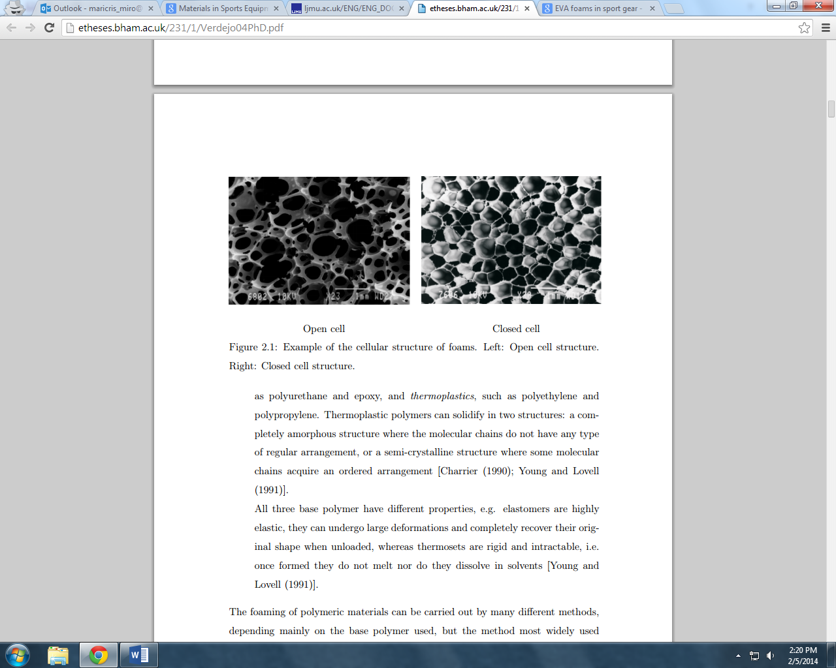

**Figure 1.** Example of the celular structure of foams. Left: open cell, and right: closed cell.

**3.1.1. Compressive behaviour**

The most common mode of deformation in foams is by compression. The compressive behaviour of foams shows three regions (Figure 2). At low strains, the foam deforms in a linear-elastic way; that is, the foam behaves like an elastic material. Then there is a plateau of deformation at almost constant stress. In this region the deformation is elastic but non-linear. Finally, there is a region of densiﬁcation where the stress increases sharply and the foam acts as a solid polymer.

These regions are governed by diﬀerent deformation mechanisms as it was seen in Figure 2. The linear elasticity region is controlled by cell wall stretching in the case of closed cells. The plateau in closed cell foams have a constant slope which accounts for the compression of the gas and the membrane stresses in the cell faces. Lastly, the densiﬁcation is produced by the collapse of cell walls.

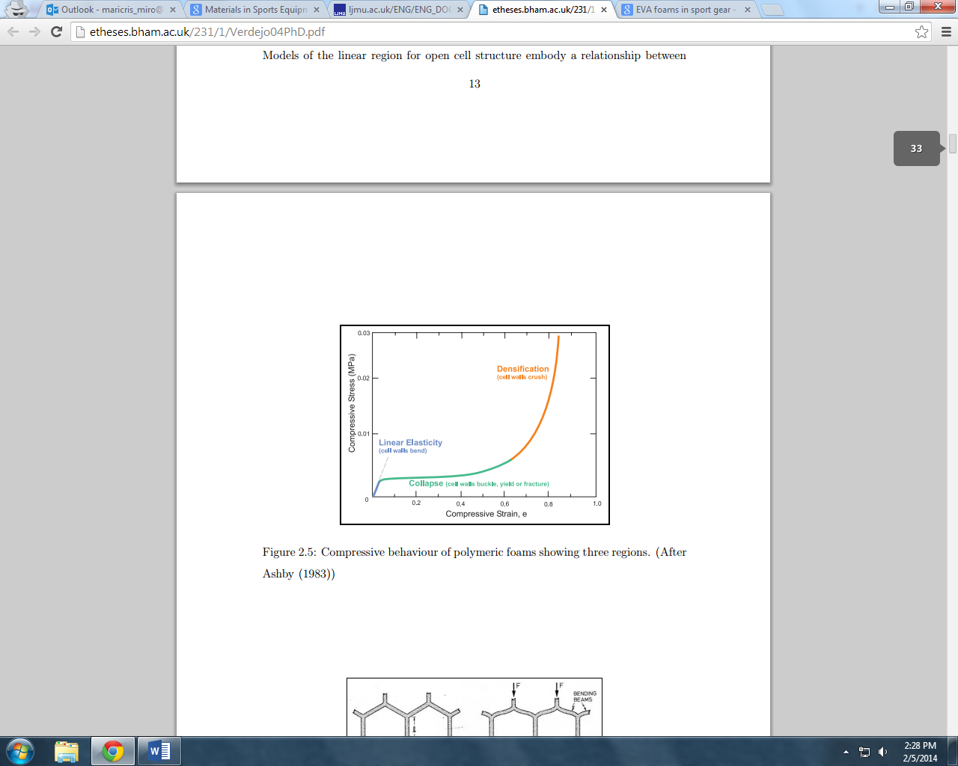

**Figure 2.** Compressive behaviour of polymeric foams showing three regions.

**3.1.2 Impact Response**

Polymeric foams have a large number of applications as shock absorbers, from the packaging of goods to personal protection. Their function is to minimize the kinetic energy produced by an impact to non-damaging or harmless levels for the protected object or body. Therefore, the selection of a material for a particular application is based on the energy which it can absorb and the critical stress which the protected object/body can support. That being said, the team will need to address that the design of the vest for a particular impact velocity (in this case a maximum of 100 *mph*, with an equivalent load force of 581 *lbf*), will require the use of a foam of a specified compressive yield stress to avoid reaching a level where an injury is likely [Mills, pg. 23 (2003)].

“The gas within the cells also contributes to the impact response of foams. In a closed-cell structure, the gas is compressed as the foam deforms, storing energy which is recovered when the load is unloaded” [Verdejo (2003)].

**3.1.3 Recovery Characteristics**

Recovery of the deformation after impact is a key point for the team to consider. The reason is that the vest´s life span is around 3 years, meaning that it will be hit by a baseball several times, not just once. It is aimed to keep functioning despite repeated compressions by the ball.

There has not been much information published on the effects that repeat compressions or “mechanical ageing” have on foams. The literature available shows that the response depends on the type of polymer, for instance, in polystyrene foams the damage occurring in the first impact appears to be permanent and the absorbed energy is largely reduced in subsequent impacts. Polyethylene foams show a viscoelastic recovery of the deformation after the impact and therefore the foam in multiple impacts does perform fairly well, while flexible polyurethane suffers a loss of strength and a permanent decrease in volume. After reviewing this information, the team considered that foam from the polyethylene family would work best for this vest for it will perform well even after multiple impacts.

* 1. **Selection: EVA Foam**

After an extensive research about different foams’ properties, behaviors, and applications, the team selected EVA as its foam material for the baseball vest. Ethylene vinyl acetate copolymer, better known simply as EVA, is a copolymer that is part of the polyolefin family, characterized by its toughness, flexibility and resistance to chemicals and abrasion [Verdejo (2003)].

EVA is obtained by the co-polymerisation of ethylene (E), particularly low density polyethylene (LDPE), with vinyl acetate (VA) under high pressure. Copolymers are the result of a random union of two materials and they exhibit intermediate properties between the two, depending on the proportion. Therefore, the chemical structure of EVA copolymers will be a random distribution of E and VA units, where the VA units usually form the minor component.

The compressive behaviour of foams also occurs in EVA foams. Figure 2 shows the three regions mentioned early (elastic, plateau, and densification) in typical stress-strain curves but in this case, specifically for EVA foams as shown in Figure 3 in next page [Li (2009)].

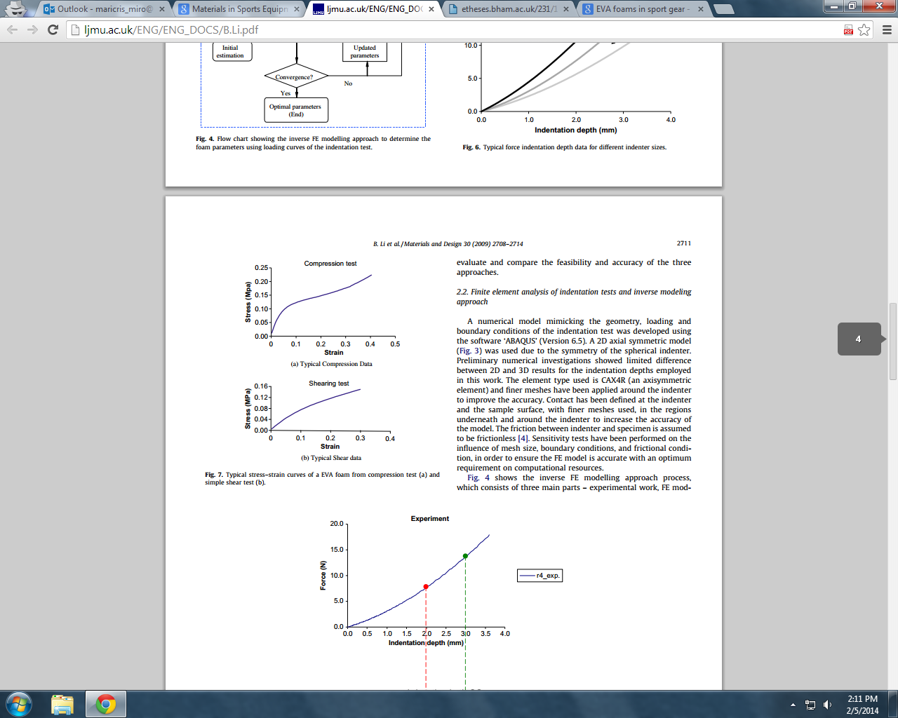

**Figure 3.** Typical stress-strain curves of a EVA foam from compresion test (a) and simple shear test (b).

There are many different kinds of EVA commercially available because the properties of EVA are modified by the content of VA. Thus, this is a key parameter for a correct choice of the copolymer for each particular application. The incorporation of VA reduces the crystallinity of the ethylene, because the VA units break the E segments. Therefore, the higher the percentage of VA, the lower the crystallinity of the copolymer. This reduction of the degree of crystallinity leads to improvements in its flexibility, clarity, and impact strength and to a reduction of its hardness [Verdejo (2003)]. This information provides the bases on which the team will select the EVA foam. Ideally, it would need to have high VA content so that impact strength increases. A summary of the changes in the properties by the introduction of VA is presented in Figure 4.

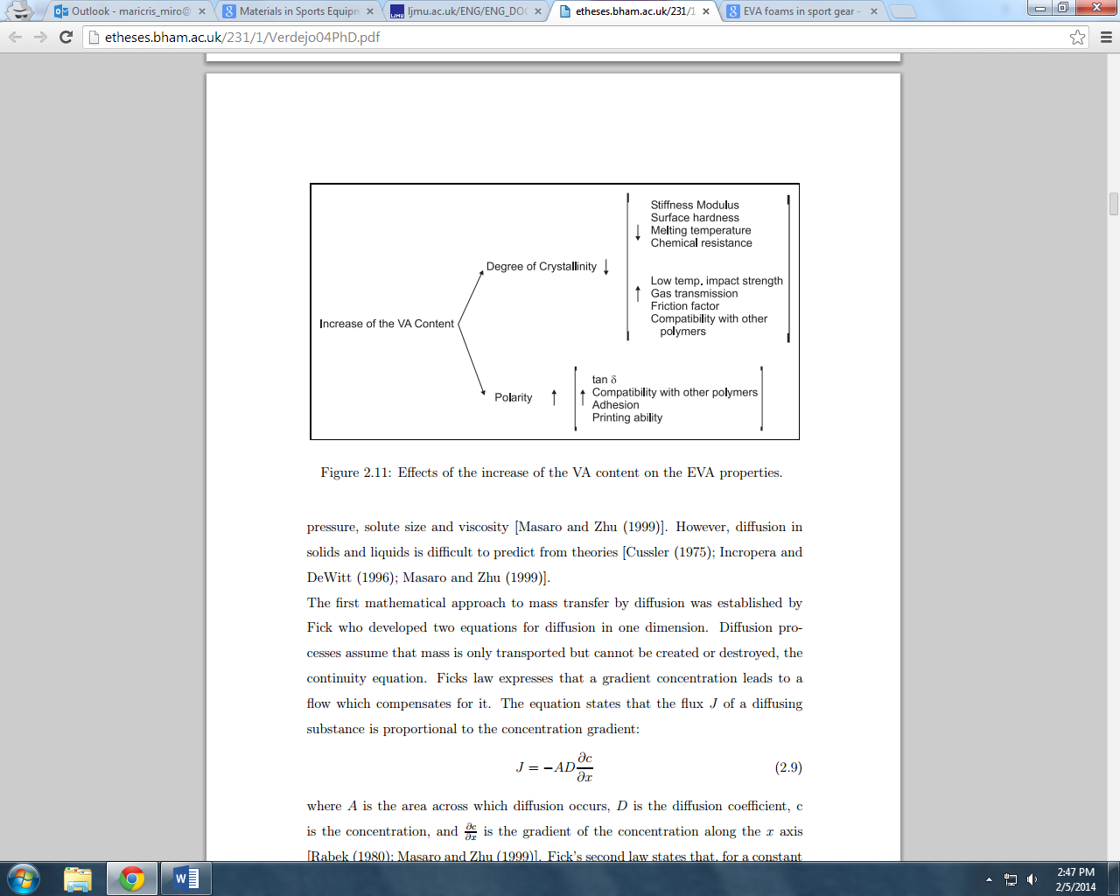

**Figure 4**. Effects of the increase of the VA content on the EVA properties.

Many factors influenced in the group’s decision to work with this material. EVA is a closed-cell foam, with a high level of chemical cross linking. The result is semi-rigid product with a fine uniform cell structure that is suitable for use in a wide variety of situations and applications, including, indeed, a protective baseball vest.

Other reasons for the selection of EVA are that it is widely used in engineering, sport, and biomedical fields. It is typically used as a shock absorber in sports gear and as padding in equipment for various sports. Also, vests currently out in the market are mainly made of EVA foam as well. “The reason for the selection of EVA foam is also related to the durability of the foam and its ability to cushion tens of thousands of impacts” [Mills, pg.21 (2003)].

Some of the benefits of EVA, pertinent to this project, include: good impact absorption, excellent chemical resistance, great weatherproof characteristics, large thermal insulation properties, and suitability for thermo-forming and thermo-moulding (Metrofoam). “EVA foam exhibits good mechanical strength, high buoyancy, low water absorption, and is a lightweight and odorless material” (Atlantic Gasket Corporation). These properties are beneficial to this project as described in Table 1.

**Table 1.** EVA foam characteristics.

|  |  |
| --- | --- |
| **Property of EVA foam** | **Benefit to the Vest** |
| Impact absorption | Good impact absorption is required to absorb the impact of the ball at 100 mph. |
| Weather proof | Being weather resistance it will demonstrate excellent climate, temperature, and aging resistance in outdoor applications that are exposed to extreme conditions, just as in baseball. |
| Thermal insulation | Shows temperature resistance to allow the player remain fresh while playing. |
| Thermo-forming | Capability to be shaped according to the vest design. |
| Mechanical strength | Strong enough to protect the wearer. |
| Low-water absorption | This property will prevent the sweat from the player being absorbed by the vest, hence maintaining it clean. |
| Lightweight | The vest being lightweight is a key design aspect because the wearer needs to be able to run freely without the vest being an impediment. Also, it being lightweight makes it easier for the wearer to put it on and take it off. |

It is important to mention that for a while, the group considered polyethylene (PE) foam might be a good material too, but ended up choosing EVA. One of the main reasons was that even though they are “both similar forms of closed-cell foams, EVA is softer and more resilient than polyethylene. EVA has greater recovery characteristics after compression” (Metrofoam). This is significant because recall that recovery characteristics influenced greatly on the material selection due to the vest’s requirement to recover after being hit several times by the ball. Lastly, “the EVA densities are lower than those of PE foams for the same application, giving a significant weight advantage” [Mills (2003)].

All the facts described in this section were the ones that led the team to select EVA foam as the padding material for the vest, as one of the major applications of this closed-cell polymeric foam is being a shock absorber. The team is confident with its decision and looks forward to the further work that is required to test the material.

1. **Hard Plate Material Selection** 
   1. **General Aspects of Hard Plates**

For the second part of the design it consists of a hard plate. The ideal hard plate is something that will stay firm and will not deform at a large rate. The material should not be so hard that it is brittle and scatter after impact. The plate must be lightweight because that is one of the important constraints. The vest should not be so heavy that it interferes with the player’s ability. A material that would be little weight and firm with a high strength would be a type of polymer.

* 1. **Selection: High Density Polyethylene**

The material that was decided to be a good choice was that of a polyethylene. Polyethylene is a thermoplastic, which means the material can be heated to a specific temperature, and becomes pliable or moldable. The polymer chains in the polyethylene have intermolecular forces, which allow the polymer to be formed when heated. When the polymer cools the intermolecular interaction grows stronger and do not affect the physical properties. Polyethylene is known for its large strength to density ratio. This polymer’s tensile strength ranges from 600 psi to 6,000 psi depending on the density, and for such is one of the most common types of plastics used in the world today for it is resistant to water, acids, and most solvents.

Some of the applications of polyethylene are hardhats, water pipes, natural gas pipes, storage sheds, fuel tanks for vehicles, bull riding vests, and ballistic plates. On further research into the ballistic plates made for protective vests, it is shown that it is a durable and reliable material. These ballistic plates are made to stop all level three threats. Level three threats consist of all handguns and most rifles. The plates are 1.15” with a 10” by 12” cross section and only weigh 3.2 lbs. So theses thick plates can be lightweight and protective.

There are different types of polyethylene depending on the molecular weight, branching and density. They are classified into several categories as described in Table 2.

**Table 2.** Different types of Polyethylene based on density and molecular weight.

|  |  |
| --- | --- |
| **Types of Polyethylene Polymers** | |
| UHMWPE | Ultra High molecular weight polyethylene |
| ULMWPE or PE-WAX | Ultra Low molecular weight polyethylene |
| HMWPE | High molecular weight polyethylene |
| HDPE | High density polyethylene |
| HDXLPE | High density cross-linked polyethylene |
| PEX or XLPE | Cross-linked polyethylene |
| MDPE | Medium density polyethylene |
| LLDPE | Linear low density polyethylene |
| LDPE | Low density polyethylene |
| VLDPE | Very low density polyethylene |

The most important polyethylene grades are HDPE, LLDPE, and LDPE. In the present study the team focused on two of these categories, HDPE and LDPE.

The high-density polyethylene, HDPE, is a polyethylene thermoplastic made from petroleum. It is defined to have a density of greater or equal to 0.941 g/cm­3. It also characterized for a low degree of branching and in return a stronger intermolecular force and tensile strength. It is four times stronger than the low-density polyethylene, toughest, least flexible of the ten types of polyethylene and has the most chemical resistant. While LDPE it’s also made of petroleum, due to its lower density of 0.91 g/cm3 it possesses a lower tensile strength and a increased ductility. Further, a comparison between the two types of polyethylene polymers can be analyzed based on their particular properties as shown in Table 3 on the next page.

**Table 3.** High-density and Low-density polyethylene properties.

|  |  |  |
| --- | --- | --- |
| **Properties** | **High-density (HDPE)** | **Low-density (LDPE)** |
| Melting point | -135 °C | -115°C |
| Crystallinity | Highly crystalline | 50-60% crystalline |
| Flexibility | More rigid than LPDE due to high crystallinity. | More flexible due to lower crystallinity. |
| Strength | Strong, as a result of regular packing of polymer chains | Lower than HDPE, due to irregular packing of polymer chains. |
| Heat Resistance | Useful above 100 – 110 °C | Density drops off dramatically above room temperature (23.5°C) |
| Density | 0.95 – 0.97 g/cm3 | 0.91 – 0.94 g/cm3 |
| Tensile Elongation at Rupture | 653 % | 906 % |
| Tensile Strength | 12.4 MPa | 26.5 MPa |

For this project the material that was chosen was the high-density polyethylene. This material does have a higher density but the difference between the low-density and high density is not large enough to affect the overall weigh to affect the player. This high-density polyethylene’s forming temperature is 295oF. The thickness of the plate for this project would only need around ¼ in. So these plates can be thin but very protective without affect the player.

1. **Collar Design**

After redirecting the project at the beginning of the Spring 2014 semester, the team discovered that the sponsor consider the collar the most significant piece of the vest, and even of the project itself. The reason: there are vests similar to this one currently out there in the market, but none has a collar piece included to provide protection to the neck part of the players’ body. Therefore, the team decided to dedicate and focus all its attention into the collar, and for this reason the CAD drawings below only show this piece. These collars will be ten analyzed using Finite Element Analysis (FEA) and then tested in order to determine which alternative is the best for this project. The team’s plan is to have valid results, derived from the tests that will explained in the next section, that will indicate them which one to select based on which will protect more this critical area of the body.

The figures below show the different types of possible collar designs that could be put into FEA analysis. FEA will allow the team to determine the actual material dimension (thickness). In all these CAD drawings, the foam is ½ inches thick and the plate is ¼ inches thick. Figures 5 and 6 show a crown-like plate with a foam liner on the inside.

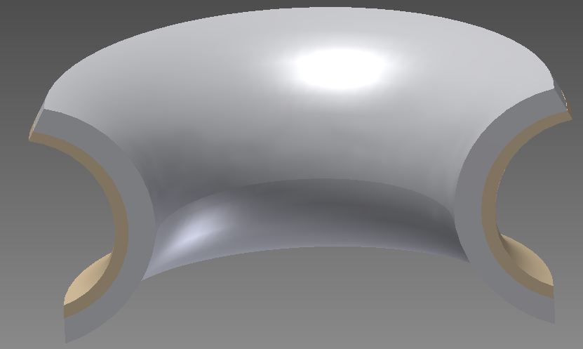

Figure 5: Crown Neck plate with foam liner (front view).

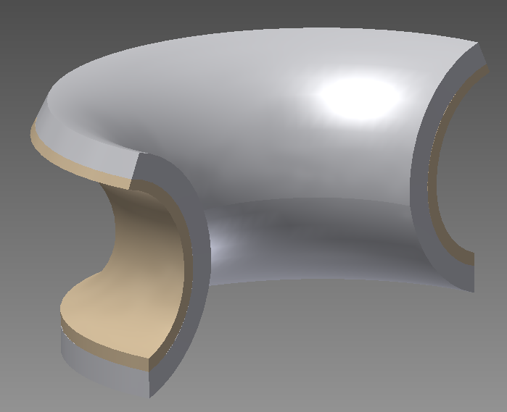

Figure 6: Crown-Neck plate with foam liner (side view).

Figures 7 and 8 show an arced type plate. With this design, if a baseball struck the plate, the impact would disperse over the whole plate. The foam would be the buffer between the player and hard plate just in case the force is strong enough to cause the plate to push up against the player. Also, with this design if the ball strikes the plate, it would deflect up or down way from the neck region.

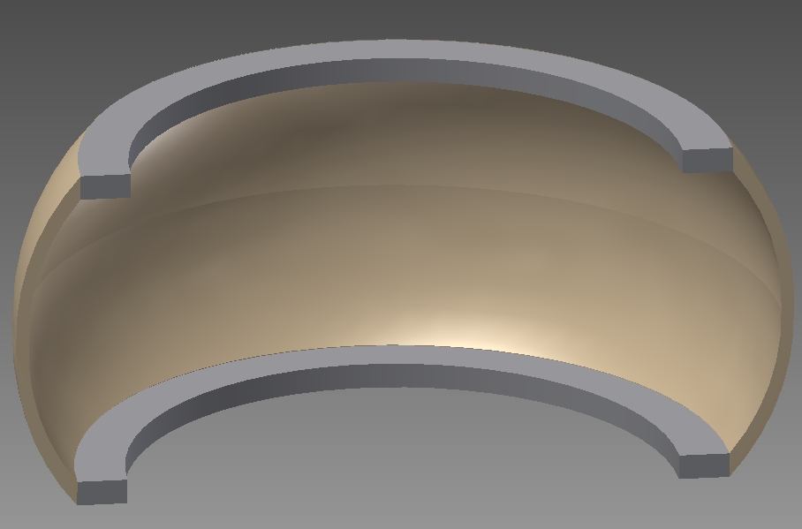

Figure 7: Arced neck plate with foam on edges (front view).

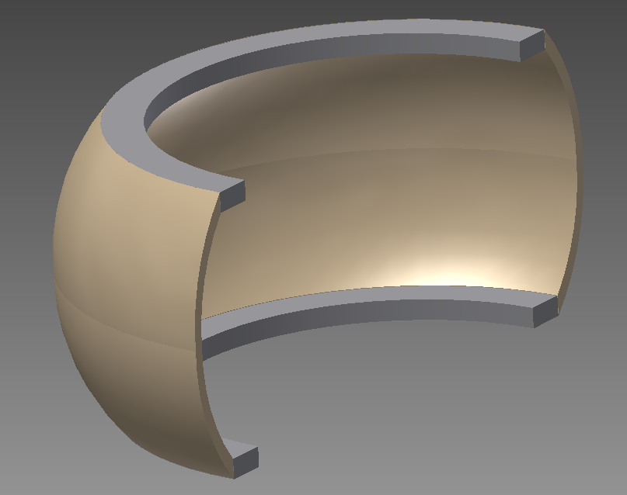

Figure 8: Arced neck plate with foam on edges (side view).

In figures 9 and 10, the flat neck plate design is shown. In the middle section of the neck, the plate and foam are raised up, with the purpose that if the ball strikes the plate, the impact could be reinforced by the helmet. This design is believed to provide more protection for the neck region. This design has low sides so the player’s vision is not affected, and higher center so it is tall enough to protect the whole neck.

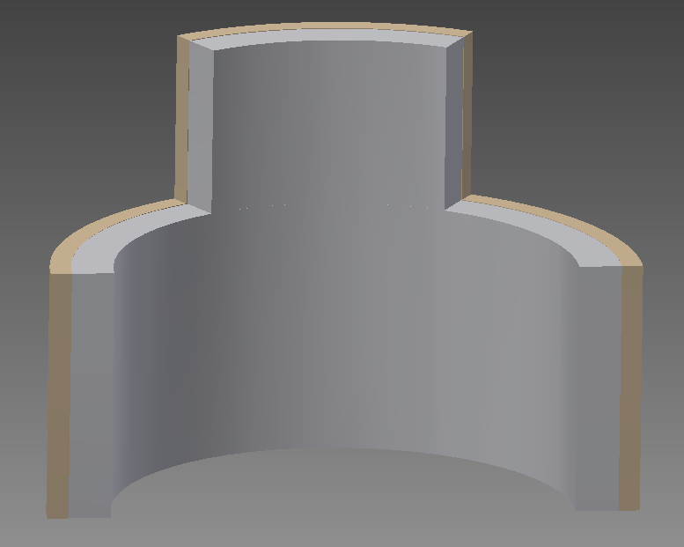

Figure 9: Flat neck plate with foam liner (front view).

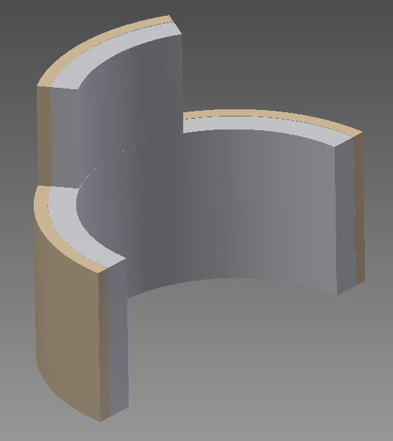

Figure 10: Flat neck plate with foam liner (side view).

1. **Planned Testing Methods (How will it be tested?)**

Material testing is important to predict the material’s performance in service and to aid materials’ development and product design. Throughout this whole design project, the team has tried to determine the best method of testing the sample materials and exactly what properties are been looked for. During most of the Fall 2013 semester, it was unsure of how to approach the analysis. For example, whether to do impact testing analysis, or FEA (Finite Element Analysis), or maybe even energy absorption analysis.

One method the team had not considered until very recently was the possibility of constructing a one-dimensional dynamic system, with damping coefficients for each of the materials, to determine what force the baseball would actually hit the mass (player’s body) with. While talking to Dr. Oates, who specializes in FEM analysis at the FAMU-FSU College of Engineering (COE), he encouraged the team to look into that possibility. The reason for this was mainly because FEA is a relatively long process to analyze, and as mentioned before, the team only has a few more months to generate an acceptable design project/theoretical study before graduation.

The team members are also currently in the process of communicating with Dr. Clark, a Dynamic Systems professor also at the COE, who would be able to help the team set up this kind of controlled system. Once the team is able to determine the damping coefficients for the materials, both the EVA foam layer and the hard plastic shell, they would be able to input a force, in miles per hour, and come up with the amount of force that acts on the body at the point of impact.

Once the dynamic system has been created and analyzed, the next step would be to begin the Finite Element Analysis on the materials selected. This is not a method that comes very easily to the team’s Mechanical Engineers. The reason is that COMSOL Multiphysics software, the program that usually runs this type of analysis, is not a program that is necessary for them to learn in any engineering class; instead, it is simply an elective that some people choose to take. For this reason, they would need some training and a good amount of help from a knowledgeable source, whomever that may be, in order to accurately analyze the materials.

So, the first step towards the FEA is to make a CAD mode and once the model is completed in CAD, it will be inserted into the COMSOL program and run this type of analysis. This process could take a little bit longer than expected and possibly deter the team from the initial goal of creating a vest prototype, but after communicating with the sponsors and advisors, it is believed that it is in all the best interest to verify that the material planned to be used is completely acceptable, so that when moving forward into the production phase, there aren’t any backlashes from bad analysis and design. A successful FEA will give the opportunity to move possibly further into other tests, depending on time constraints with the project, such as compression and impact testing.

* 1. **Compresive Tests**

Compressive experiments involve the measurement of the deformation suﬀered by the material to applied forces. The interest of these experiments is in the type of applied stress to which the foam is subjected. Among the diﬀerent experiments to study this response are: creep and impact tests. In creep experiments, the applied stress is constant or static; they reveal the response of the foams to long and slow compressions. In impact tests, the applied stress is variable or dynamic; they show the response of the foams to short, rapid compressions.

Thus, the type of experiment to be performed is determined by the foam application: the creep experiments are an important characterisation for structural, cushioning and packaging applications, while the impact experiments are important for shock absorbing applications. The team decided they will definitely perform impact experiments in these collars.

* 1. **Impact Tests**

“Impact tests are designed to measure the resistance to failure of a material to a suddenly applied force. The test measures the impact energy, or the energy absorbed prior to fracture. The most common methods of measuring impact energy are: the Charpy Test and the Izod Test” (Azom).

“Impact energy is a measure of the work done to fracture a test specimen. When the striker impacts the specimen, the specimen will absorb energy until it yields. At this point, the specimen will begin to undergo plastic deformation at the notch. The test specimen continues to absorb energy and work hardens at the plastic zone at the notch. When the specimen can absorb no more energy, fracture occurs” (ibid.).

“The Charpy test is most commonly used on metals, but it is also used on polymers, ceramics and composites. The Charpy test is regularly used to evaluate the relative toughness or impact toughness of materials and as such is often used in quality control applications where it is a fast and economical test. It is used more as a comparative test rather than a definitive test” (ibid). The Charpy impact test would be perfect for this project as the team could set the sample material up against a wall, let the instrument swing, and monitor the resulting looks of the layers, as well as the numerical data that comes along with it. This process is not something that would take very long; it would be an experiment that could probably be finished in 1 or 2 days, so it is easily to incorporate.

## Energy absorption can also be analyzed from a test like this. Another impact test, the free fall test, is the most common impact method for foams and consists of a mass (or striker) dropping freely onto the sample from a certain height. During the impact, the striker’s acceleration is measured by an accelerometer planted inside, from where the displacement of the upper surface of the sample is calculated by integrating its signal twice. The results from such experiments might be reported as force-displacement curves or as stress-strain curves and they will show a curve with the loading and unloading cycles (Figure 11). The absorbed energy (Ea) is then calculated as

*Ea* = *Ei* + *Er*

where Ei is the impact energy and Er is the recovery energy, or the energy of the loading and unloading cycle respectively.

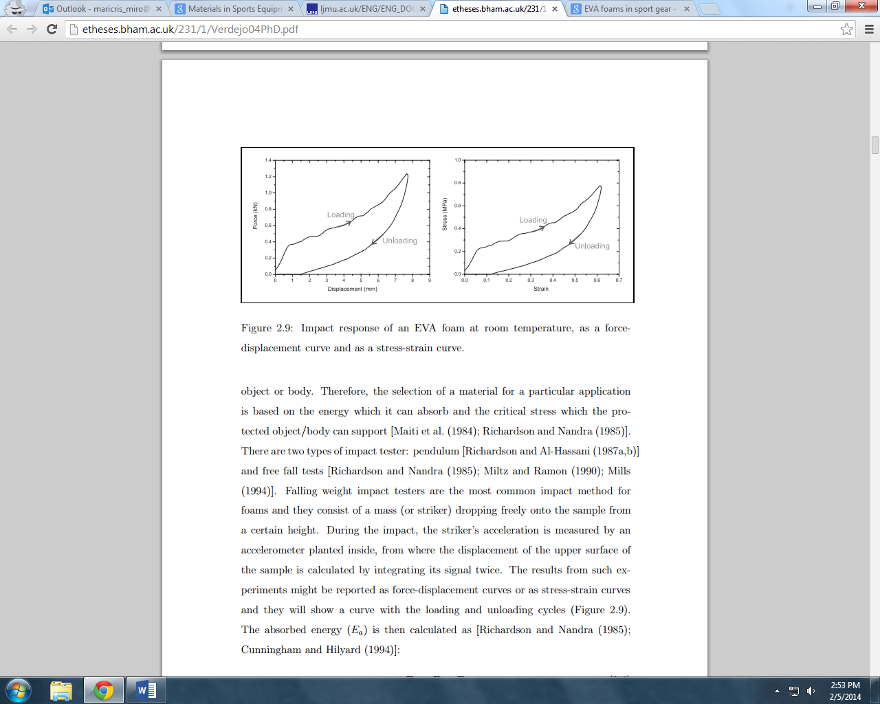

**Figure 11.** Impact response of an EVA foam at room temperature, as a force-displacement curve and as a stress-strain curve.

The idea behind compression and impact testing is pretty simple once the results from the computer analysis with FEA are completed. It is important that the FEA results translate into real life acceptable values in order to perform the experiments.

1. **Testing Parameters (What will be tested?)**

As seen in Table 4, there are many applications of foams, and so, there are different key parameters that must be kept under attention depending on what they are being used for. For this project, which involves padding and sports gear, the team will be focusing on the energy absorption under dynamic situations. This will be one of the key parameters to be bested as all te materials, including the foam, were selected taking into consideration the fact that they must absorb the energy from the baseball.

**Table 4.** Applications of polymeric foams.

|  |  |  |
| --- | --- | --- |
| **Key Parameter** | **Application** | **Example** |
| Thermal Conductivity | Construction | Wall panelling, floor underlayment |
| Insulation | Sandwich structures, imitation wood… |
| Energy absoption (static situation) | Automotive, furniture | Seats, mattresses… |
| Energy absoption (dynamic situation) | Packaging, sports | Pads, sport fences, athletic shoes… |
| Buoyancy | Industrial, sports, leisure | Flotation collars, swin aids, boats… |

* 1. **Energy Absortion**

The first characteristic of the foam that will be tested is its ability to absorb energy. The foam used in the vest, EVA, must be able to absorb the impact energy of the baseball sufficiently to the point that no harmful amount of energy from the impact is transferred to the player. The use of a hard material to disperse the impact force will allow for the use of the total surface area of the foam pad for energy absorption, rather than simply a foam pad with localized absorption.

The energy absorbing capability of foam is directly proportional to the area underneath the stress vs. strain curve of the foam. As foam absorbs energy, it deforms in different fashions. These three regions of foam deformation were shown previously, and are shown again in Figure 12. Recall that in the linear elastic region of impact absorption, the cell walls of the foam bend, in a linear elastic fashion. At this point, strain is linearly proportional to the amount of stress being experienced locally by the foam. In the second region of deformation, or the plateau region, the cell walls of the foam structure begin to collapse. This is when the foam begins to “squish” or experience a reduction in volume. As the cell walls collapse, absorbed energy is being stored into the foam structure. At the final stage of energy absorption, densification, all the cell walls have collapsed, and therefore the foam experiences almost zero further deformation matched by a large increase in stress.

At the point of densification, the foam has absorbed its maximum potential of energy of protection, as any further energy applied to the foam will be transferred rather than being stored into the foam’s molecular structure. Essentially, at the point of densification, the foam is no longer suitable as a shock absorber (or protection). Therefore, the material selection, including both the EVA foam and the high density polyethylene, will have to be tested to determine if they have sufficient properties and volume (thickness) to ensure the maximum impact energy of the baseball is absorbed before densification occurs.

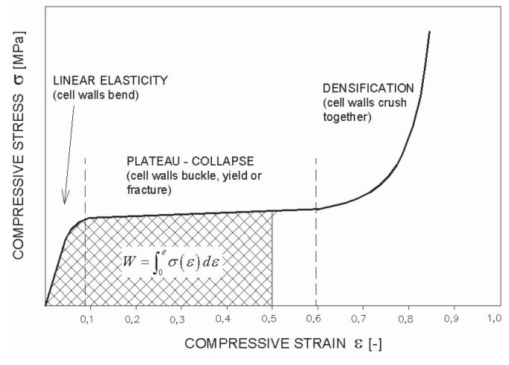

**Figure 12.** Foam deformation regions.

Another factor that will play a key role in the tests is the fact that the foam chosen must have recoverable characteristics. This means that after impact, the foam rebounds to its original shape and is suitable for enduring multiple impacts within its lifetime. Many types of foam (such as Styrofoam for example) experience an indefinite breakdown of the cell structure after the point of densification. This trait is undesirable in our material, as the vest will ideally withstand multiple impacts within its lifetime. So, the team is planning on conducting the appropriate tests needed to determine these characteristics on the EVA foam.

* 1. **Load distribution**

Another characteristic of the impact surface that will be tested is the ability of the surface to distribute the impact force. As discussed earlier, foam can only absorb a specific amount of localized energy before reaching the point of densification (cell walls collapsed and further energy input begins to be transferred). Therefore, in order to absorb as much impact energy as possible, it is desired to spread the load across the entire surface of the foam (de-localize impact) so that the foam will absorb the maximum amount of energy for its volume before the point of densification. It is assumed that a hard thin polymer plate, such as a polycarbonate, will help to distribute the impact load of the baseball.

Load distribution can be judged by the modulus of elasticity. The modulus of elasticity describes the relationship between applied stress and experienced strain in a material within the linear elastic region of the stress-strain curve. As the values of the elastic modulus increases, materials ability to receive stress without deforming increases. This characteristic is highly desirable in a hard polymer material used to distribute impact load. As the polyethylene plate is impacted, ideally it will experience little to no deformation, only a momentum exchange. As this impact energy is transferred through the hard plate, it will be distributed across the entire surface of the plate rather than being localized around the point of impact. This will allow for the impact energy to be spread across the entire foam absorber resulting in maximum energy absorption. That being said, the team is planning to test the material to determine, indeed, its load distribution.

* 1. **Speculated Results**

As explained earlier, the selection of the EVA foam was based mostly on its ability to absorb impact energy. The ability of foams to absorb energy is described by their stress-strain curve. The area underneath the stress-strain curve of foams describes the amount of energy that can be absorbed before complete densification occurs. After performing the tests, the team speculates to get, ideally, a maximized area underneath the stress-strain curve for the relative amount of stress the vest will be enduring. Foam intended to absorb impact cannot be too stiff, as a large portion of the energy would be transferred to the wearer rather than being stored in the cellular structure of the foam. Therefore, the EVA foam selected will also need to show a desirable relationship of the amount of impact energy, to the amount of that energy that is actually stored into the cellular structure of the foam.

The selection of the hard material, the HDPE, was based on its ability to distribute load upon impact. In order to do this, the material needs to be as stiff as possible, without potential of breaking upon impact. This is where the use of a hard polymer becomes desirable. The HPDE will be tested in the hopes that it shows a high modulus of elasticity, meaning that it will be very resistant to permanent localized deformation. This can also be interpreted as being very stiff. Because a polyethylene has very stiff characteristics, it will also have the tendency to spread localized impact energy (such as a baseball) across its entire surface. This is the characteristic of load distribution that is ideal. Secondly, a suitable polymer can probably be found lighter and less expensive than a metal counterpart offering similar characteristics. This would drive the cost of production and the weight of the vest down, both of which are initial goals set for the project.

The team’s speculated results will be analyzed against the actual results after having performed all these experiments. The team will then determine if the materials they selected were the right ones, based on the results from the tests (stress-strain curve, density, fracture mode, etc.), and they will also consider other factors such as cost and ergonomic characteristics.

1. **Further Work**

All the main objectives of this report has been addressed: material selection, collar design, testing methods, testing parameters, and speculated results. However, some further work needs to be carried out in order to move forward and eventually complete the project. These next steps are briefly described below.

* 1. **Procurement**

The next step for the team is to attain the materials either by getting samples from providers or buying them. In the case of the latter, the budget will be provided by the sponsor, Mr. Boone, as he stated that he has some interested customers who should be able to allocate some budget for the project. However, due that the project has been realistically updated to have as the main goal a design trade study (paper study), the quantity and number of materials needed has been drastically reduced to only one sheet of EVA foam and one sheet of high density polyethylene.

The team consider that getting these two materials will not be costly. One 40”x80” EVA sheet (1/2” thick) is at a market price of $35.55 (Foam Order), and a 24”x48” HDPE sheet (1/4” thick) costs $25.09 (U.S. Plastic Corp.). And ideally, the team will only need one sheet of each in order to get various specimens and then test them.

**Table 5.** EVA price sheet by thickness.

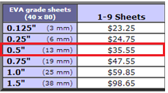

**Table 6.** High Density Polyethylene (HDPE) Sheeting.

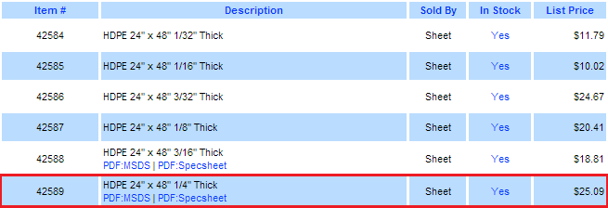

Further shippings cost and delivery time will be taken into consideration for the fulfillment of the testing process. And the final supplier will be selected more likely dependant on its fastets delivery than the overall cost of shipping, for the highly urgency of the needed materials due to our time constrain as mentioned previously.

* 1. **Actual Testing**

Now that the team has finished the material selection for both the padding cushion and the hard material, and has devised a test plan, the material specimens will be tested and evaluated under impact to verify the analytical model of the materials and of the collar designs. All the tests will be performed either at the Mechanical Department of FAMU-FSU College of Engineering or at the High-Performance Materials Institute **(**HPMI).

* 1. **Economic and Ergonomic Analysis**

The Industrial Engineer members of the team will continue to work on an essential part of this project: cost analysis and ergonomics. For the economic analysis the team is aming to be able to justify all the costs considerations taken for the product. This will include justification for equipment and manpower levels (at a manufacturing level), and not only material costs, to make this vest worth investing. Regarding ergonomics, the team will assess the impact of the design in the player and his performance while in the game.

In addition to the ergonomic analysis, the form of attachement of the collar to the rest of the vest will be considered for each of the collar options available. In general, the collar should be able to maintain itself in position by an accurate fit. However the constant movement while running may cause it to fall or become disengaged. To prevent such an event, the collar may have a series of clips in strategic positions to maintain the collar in place, it can also have a zipper arrangement like those of detachable hoodies in certain coats.

* 1. **Business Plan**

The team will start working on a business plan that will represent the culmination of the project, and will include, among others, topics such as the two analysis mentioned in the point above, ethical considerations, environmental considerations, and social and political considerations.

1. **Conclusion**

As previously mentioned, the focus of the project has been redirected into a more specific region that requires specialized protection, the neck area of the players. This new focus also provides for a unique protective feature, which is not currently in any of the market offerings for batter protection. The neck portion of the vest now possesses a higher priority for design and analysis than the other critical areas, the ribs, back, and spine. After the assessment of the neck area is complete, the design of the remainder features will not be considered. It is expected that from the three designs that will be taken into considerations for the collar, testing will provide for a suitable resulting design and geometry.

The analysis testing of our product will be taking up the bulk of this semester, and that is something the team is prepared to take on. It is going to be a lot of work to make sure that these materials that were select are up to par for our sponsor, but research has been done and the team firmly believes that the selection of a EVA foam and a HDPE polymer will proof suitable for the purpose of this vest prototype project. When the compression and impact tests come to fruition and the numbers are available for everyone to see, it will be available for the team to demonstrate with accurate data if the choices where correct and that the vest prototype will be one of success.

Although some delays in the stated project schedule have occurred due to the new direction the project has taken, it is expected that the completion of the testing and analysis will provide for a complete theoretical assessment sufficient for the approval of the vest product.

**Works Cited**

# “Charpy Test - Determination of Impact Energy Using the Charpy Test.” *Azom.* 11 Jun. 2013. Web. 10 Feb. 2014. <<http://www.azom.com/article.aspx?ArticleID=2763>>.

Cheng, Liang. Personal interview. 27 Jan. 2014.

# 

“Closed Cell EVA Foam Rubber*.”* *Atlantic Gasket Corporation.* Web. 09 Feb. 2014. <<http://www.atlanticgasket.com/materials/eva-sponge-rubber-gaskets.html>>.

“Closed Cell Foam, Polyethylene Foam and Yoga Mats.” *Foam Order*. Web. 10 Feb. 2014. <<http://www.foamorder.com/closedcell.html>>.

“EVA Foam.” *Metro Foam Products*. Web. 09 Feb. 2014. <<http://metrofoam.com.au/eva-foam.html>>.

“High Density Polyethylene (HDPE) Sheeting.” *U.S. Plastic Corp.* Web. 10 Feb. 2014. <<http://www.usplastic.com/catalog/item.aspx?itemid=23869>>.

Hruda, Simone. Personal interview. 23 Jan. 2014.

Li, B., Y.D. Gu, R. English, G. Rothwell, and X.J. Ren (2009). *Characterisation of Nonlinear Material Parameters of Foams Based on Indentation Tests.* Technical Report. Liverpool John Moores University: U.K. <<http://ljmu.ac.uk/ENG/ENG_DOCS/B.Li.pdf>>.

Liu, Tao. Personal interview. 27 Jan. 2014.

Mills, N.J. *Polyolefin Foams.* RAPRA Review Report. Vol. 14. No. 11, (2003). <<http://books.google.com/books?id=iIAjTVdK_fYC&pg=PP1&lpg=PP1&dq=Mills,+N.J.+Polyolefin+Foams.+RAPRA+Review+Report.+Vol.+14.+Num.+11,+(2003).&source=bl&ots=r4X4ImLvH7&sig=-jbIMs2SqWvMC6vHsPtkplxCdhA&hl=en&sa=X&ei=iTn4UoXiN4Hj0gH5iIGoBw&ved=0CCsQ6AEwAA#v=onepage&q&f=false>>.

“Polyethylene Manufacturing and its Properties”. *Azeem, Abdul*. Web. 11 Feb. 2014

< http://www.academia.edu/3052708/Polyethylene_Maufacturing_and_its_Properties>

Verdejo, Raquel (2003). *Gas Loss and Durability of EVA foams used in Running Shoes.* Ph.D. Thesis. The University of Birmingham: U.K. <<http://etheses.bham.ac.uk/231/1/Verdejo04PhD.pdf>>.

Zeng, Changchun. Personal interview. 4 Feb. 2014.

Zhang, Mei. Personal interview. 23 Jan. 2014.

**Appendix A**