FAMU-FSU College of Engineering
Department of Electrical and Computer Engineering

PROJECT PROPOSAL AND STATEMENT OF WORK

EEL4911C – ECE Senior Design Project I
Project title: FAMU-FSU Shell Eco-Marathon Solar Car 2014
Team #: 2

Student team members:
- Fritz Jeanty, electrical engineering (Email: Fj08c@my.fsu.edu)
- James Croasmun, mechanical engineering (Email: Jgc10c@my.fsu.edu)
- Zachary Barr, electrical engineering (Email: Zacharywbarr@gmail.com)
- Julia Clarke, electrical engineering (Email: Julia1.clarke@famu.edu)
- David Jolicoeur, mechanical engineering (Email: David1.jolicoeur@famu.edu)
- Jose Cardenal, industrial & manufacturing engineering (Email: jic09c@eng.fsu.edu)
- Wael Nabulsi, electrical engineering (Email: wn11@my.fsu.edu)
- Francois Wolmarans, industrial & manufacturing engineering (Email: fw07@my.fsu.edu)

Senior Design Project Instructor: Dr. Edrington, Chris

− Dr. Frank, Michael
− Dr. Amin, Kamal
− Dr. Hollis, Patrick
− Dr. Okoli, Okenwa

Submitted in partial fulfillment of the requirements for
EEL4911C – ECE Senior Design Project I
October 18, 2013

Project Executive Summary
The Shell Eco-marathon is a long standing competition, in which Shell challenges students and enthusiasts from around the world to push the envelope for energy efficient vehicle designs. The competition gives teams the opportunity to design, build, and test their vehicles in a competitive winner-take-all environment. There are several different categories to compete in depending on the source of power of the vehicle. The current FAMU-FSU College of Engineering 2014 Solar Car team will participate in the solar car division.
The competition has two classes (each with their own rules and regulations) in which teams can compete: Urban Concept and Prototype. The Urban Concept class promotes building a practical vehicle that can operate under normal road driving conditions. Alternatively, the Prototype class encourages participants to stretch the boundaries of efficiency by making ergonomic trade-offs. For both vehicle classes, competitors will use as many attempts as possible in order to see how far the vehicle can run on the equivalent of one liter of fuel. The competition requires that all vehicles have a fixed speed and number of laps. A winner will be named for each class and fuel type, with additional prizes going to teams with a strong consideration for safety, teamwork, design, and technical innovation. The FAMU-FSU 2014 Solar Car team will participate in the prototype class, with a solar-based fuel source.
Over a period of several days, teams will be given several attempts in order to test the vehicles using a pre-determined asphalt track in Houston, Texas. The competition organizers will measure the efficiency of each run, and will then use the best run among the set in order to determine the winners for each class and energy source.

The FAMU-FSU 2014 Solar Car team plans to build a Prototype-class vehicle with a sleek profile, which minimizes nose area in order to minimize the drag on the car. The chassis will consist of carbon fiber due to its low weight and high strength. Additionally, we hope to use lightweight metals (such as aluminum) to build the seat, support structures, and mechanical parts. Based on the rules and regulations of the competition, the team will have several fireproof compartments (separated by bulkheads) in order to protect the driver. A strong consideration is given to safety, including features such as a 5-point safety harness, a roll bar, and an emergency shutdown button.
The team’s primary goal is to place in the top 3 for its class and energy source division. Additionally, the team intends on being strong competitors for the safety, teamwork, and design prizes. Winning teams are awarded a prize of $5000, which could be used by future FAMU-FSU Shell Eco-Challenge teams to improve upon future designs, and purchase high quality components. Furthermore, a prize-winning placement would establish FAMU-FSU as a serious competitor in the American division, and recognize the college and advisors who have invested time and money into the project.

Table of Contents
Project Executive Summary 2
Table of Contents 4
1 Introduction 20
1.1 Acknowledgements 20
1.2 Problem Statement 20
1.2.1 General Problem Statement 20
1.2.2 General Solution Approach 21
1.3 Operating Environment 22
1.4 Intended Use(s) and Intended User(s) 22
1.4.1 Intended User(r) 22
1.4.2 Intended Use(s) 22
1.5 Assumptions and Limitations 23
1.5.1 Assumptions 23
1.5.2 Limitations 24
1.6 Expected End Product and Other Deliverables 24
2 Concept Generation & Selection 24
2.1 Concept Selection Criteria 24
2.2 Concept Selection Criteria Prioritization 25
2.3 Component Alternatives and Generation 26
2.3.1 Seat 26
2.3.1.1 Seat Design 1 28
2.3. 1.1.1 Specifications 29
2.3.1.1.2 Advantages 29
2.3.1.1.3 Disadvantages 30
2.3.1.2 Seat Design 2 30
2.3.1.2.1 Specifications 30
2.3.1.2.2 Adavntages 30
2.3.1.2.3 Disadvantages 31
2.3.2 Roll Bar and Motor Mount 31
2.3.2.1 Roll Bar and Motor Mount Design 1 32
2.3.2.1.1 Specifications 32
2.3.2.1.2 Advantages 33
2.3.2.1.3 Disadvantages 33
2.3.2.2 Roll Bar and Motor Mount Design 2 33
2.3.2.1.1 Specifications 34
2.3.2.1.2 Advantages 34
2.3.2.1.3 Disadvantages 34
2.3.2.3 Roll Bar and Motor Mount Design 3 34
2.3.2.3.1 Specifications 35
2.3.2.3.2 Advantages 35
2.3.2.3.3 Disadvantages 35
2.3.3 Front Wheel Mount and Steering Assembly 35
2.3.3.1 Front Wheel Mount and Steering Assembly Design 1 36
2.3.3.1.1 Specifications 36
2.3.3.1.2 Advantages 36
2.3.3.1.3 Disadvantages 37
2.3.3.2 Front Wheel Mount and Steering Assembly Design 2 37
2.3.3.2.1 Specifications 37
2.3.3.2.2 Advantages 37
2.3.3.2.3 Disadvantages 38
2.3.3.3 Front Wheel Mount and Steering Assembly Design 3 38
2.3.3.3.1 Specifications 38
2.3.3.3.2 Advantages 38
2.3.3.3.3 Disadvantages 39
2.3.4 Front Brakes 39
2.3.4.1 Front Brakes Design 1 39
2.3.4.1.1 Specifications 40
2.3.4.1.2 Advantages 40
2.3.4.1.3 Disadvantages 40
2.3.4.2 Front Brakes Design 2 40
2.3.4.2.1 Specifications 41
2.3.4.2.2 Advantages 41
2.3.4.2.3 Disadvantages 41
2.3.5 Steering System 41
2.3.5.1 Steering System Design 1 42
2.3.5.1.1 Specifications 42
2.3.5.1.2 Advantages 42
2.3.5.1.3 Disadvantages 42
2.3.5.2 Steering System Design 2 43
2.3.5.2.1 Specifications 43
2.3.5.2.2 Advantages 43
2.3.5.2.3 Disadvantages 44
2.3.6 Rear Brakes 44
2.3.6.1 Rear Brakes Design 1 45
2.3.6.1.1 Specifications 45
2.3.6.1.2 Advantages 45
2.3.6.1.3 Disadvantages 45
2.3.6.2 Rear Brakes Design 2 46
2.3.6.2.1 Specifications 46
2.3.6.2.2 Advantages 46
2.3.6.2.3 Disadvantages 46
2.3.7 Component Placement 47
2.3.7.1 Component Placement Design 1 47
2.3.7.1.1 Specifications 48
2.3.7.1.2 Advantages 48
2.3.7.1.3 Disadvantages 48
2.3.7.2 Component Placement Design 2 49
2.3.7.2.1 Specifications 49
2.3.7.2.2 Advantages 49
2.3.7.2.3 Disadvantages 49
2.3.8 Motor Controller: Single Board Controller 50
2.3.8.1 Single Board Controller Design 1 50
2.3.8.1.1 Specifications 50
2.3.8.1.2 Advantages 50
2.3.8.1.3 Disadvantages 51
2.3.8.2 Single Board Controller Design 2 51
2.3.8.2.1 Specifications 51
2.3.8.2.2 Advantages 52
2.3.8.2.3 Disadvantages 52
2.3.8.3 Single Board Controller Design 3 52
2.3.8.3.1 Specifications 52
2.3.8.3.2 Advantages 53
2.3.8.3.3 Disadvantages 53
2.3.8.4 Single Board Controller Design 4 53
2.3.8.4.1 Specifications 54
2.3.8.4.2 Advantages 54
2.3.8.4.3 Disadvantages 54
2.3.9 Motor Controller: Gate Driver 55
2.3.9.1 Gate Driver Design 1 55
2.3.9.1.1 Specifications 55
2.3.9.1.2 Advantages 56
2.3.9.1.3 Disadvantages 56
2.3.9.2 Gate Driver Design 2 56
2.3.9.2.1 Specifications 57
2.3.9.2.2 Advantages 57
2.3.9.2.3 Disadvantages 57
2.3.10 Accessory Battery 57
2.3.11 DC to DC Boost Converter 60
2.3.11.1 DC to DC Boost Converter Design 1 60
2.3.11.1.1 Specifications 60
2.3.11.1.2 Advantages 61
2.3.11.1.3 Disadvantages 61
2.3.11.2 DC to DC Boost Converter Design 2 61
2.3.11.2.1 Specifications 62
2.3.11.2.2 Advantages 62
2.3.11.2.3 Disadvantages 62
2.3.12 Bulkhead Design 62
2.3.13 Solar Panel Placement 63
2.3.13.1 Solar Panel Placement Design 1 63
2.3.13.1.1 Specifications 63
2.3.13.1.2 Advantages 64
2.3.13.1.3 Disadvantages 64
2.3.13.2 Solar Panel Placement Design 2 64
2.3.13.2.1 Specifications 65
2.3.13.2.2 Advantages 65
2.3.13.2.3 Disadvantages 65
2.3.13.3 Solar Panel Placement Design 3 65
2.3.13.3.1 Specifications 65
2.3.13.3.2 Advantages 65
2.3.13.3.3 Disadvantages 66
3 Proposed Design 66
3.1 Overview 66
3.1.1 Seat 67
3.1.2 Comparison Matrix 67
3.2 Roll Bar and Motor Mount 67
3.2.1 Comparison Matrix 68
3.3 Front Wheel Mount and Steering Assembly 68
3.3.1 Comparison Matrix 68
3.4 Front Wheel Brakes 68
3.4.1 Comparison Matrix 69
3.5 Steering System 69
3.5.1 Comparison Matrix 69
3.6 Rear Wheel Brakes 70
3.6.1 Comparison Matrix 70
3.7 Component Placement 70
3.7.1 Comparison Matrix 70
3.8 Overall Electrical Components 71
3.8.1 Motor Controller 71
3.8.2 Motor Controller: Single Board Controller 72
3.8.2.1 Comparison Matrix 72
3.8.3 Motor Controller: Gate Driver 72
3.8.3.1 Comparison Matrix 73
3.8.4 DC to DC Boost Converter 73
3.8.4.1 Comparison Matrix 73
3.8.5 Solar Panel Placement 74
4 Statement of Work (SOW) 74
4.1 Task 1: Project Management 74
4.2 Task 2: Mechanical Component Design 76
4.2.1 Objective 76
4.2.2 Approach 76
4.2.3 Sub-Tasks 76
4.2.3.1 Seat 76
4.2.3.1.1 Objective 76
4.2.3.1.2 Approach 77
4.2.3.1.3 Test/Verification Plan 77
4.2.3.1.4 Expected Outcome 77
4.2.3.2 Roll Bar and Motor Mount 77
4.2.3.2.1 Objective 77
4.2.3.2.2 Approach 77
4.2.3.2.3 Test/Verification Plan 78
4.2.3.2.4 Expected Outcome 78
4.2.3.3 Front Wheel Mounts and Steering Assemblies 78
4.2.3.3.1 Objective 78
4.2.3.3.2 Approach 78
4.2.3.3.3 Test/Verfication Plan 79
4.2.3.3.4 Expected Outcome 79
4.2.3.4 Front Wheel Brakes 79
4.2.3.4.1 Objective 79
4.2.3.4.2 Approach 79
4.2.3.4.3 Test/Verification Plan 80
4.2.3.4.4 Expected Outcome 80
4.2.3.5 Steering System 80
4.2.3.5.1 Objective 80
4.2.3.5.2 Approach 80
4.2.3.5.3 Test/Verification Plan 80
4.2.3.5.4 Expected Outcome 81
4.2.3.6 Rear Wheel Brake 81
4.2.3.6.1 Objective 81
4.2.3.6.2 Approach 81
4.2.3.6.3 Test/Verification Plan 81
4.2.3.6.4 Expected Outcome 82
4.2.3.7 Component Placement 82
4.2.3.7.1 Objective 82
4.2.3.7.2 Approach 82
4.2.3.7.3 Test/Verification Plan 82
4.2.3.7.4 Expected Outcome 82
4.2.3.8 Solar Panel Implementation 83
4.2.3.8.1 Objective 83
4.2.3.8.2 Approach 83
4.2.3.8.3 Test/Verification Plan 83
4.2.3.8.4 Expected Outcome 83
4.3 Task 3: Electrical Component Design 84
4.3.1 Objective 84
4.3.2 Approach 84
4.3.3 Sub-Tasks 85
4.3.3.1 Motor Controller: Board Controller 85
4.3.3.1.1 Objective 85
4.3.3.1.2 Approach 85
4.3.3.1.3 Test/Verification Plan 85
4.3.3.1.4 Expected Outcome 85
4.3.3.2 Motor Controller: Gate Driver 86
4.3.3.2.1 Objective 86
4.3.3.2.2 Approach 86
4.3.3.2.3 Test/Verification Plan 86
4.3.3.2.4 Expected Outcome 86
4.3.3.3 Accessory Battery 86
4.3.3.3.1 Objective 86
4.3.3.3.2 Approach 87
4.3.3.3.3 Test/Verification Plan 87
4.3.3.3.4 Expected Outcome 87
4.3.3.4 DC to DC Boost Converter 87
4.3.3.4.1 Objective 87
4.3.3.4.2 Approach 87
4.3.3.4.3 Test/Verification Plan 88
4.3.3.4.4 Expected Outcome 88
4.3.3.5 Output Voltage Correction 88
4.3.3.5.1 Objective 88
4.3.3.5.2 Approach 89
4.3.3.5.3 Test/Verification Plan 89
4.3.3.5.4 Expected Outcome 90
4.3.3.6 Resistor Correction 90
4.3.3.6.1 Objective 90
4.3.3.6.2 Approach 90
4.3.3.6.3 Test/Verification Plan 90
4.3.3.6.4 Expected Outcome 91
4.4 Safety Testing Plan 91
5 Risk Assessment 92
5.1 Competition Requirements 92
5.2 Chassis Failure 93
5.3 Bulkhead Design and Installation 93
5.4 Motor Controller Failure 93
5.5 DC- Booster Failure 94
5.6 Steering Failure 94
5.7 Braking Failure 95
5.8 Solar Panel Installation Failure 95
6 Qualifications and Responsibilities of Project Team 95
6.1 Team Qualifications 95
6.2 Individual Tasks 96
6.3 Individual Qualifications 98
6.3.1 Fritz Jeanty 98
6.3.2 Francois Wolmarans 99
6.3.3 Jose Cardenal 99
6.3.4 Julia Clarke 100
6.3.5 Zachary Barr 100
6.3.6 Wael Nabulsi 100
6.3.7 David Jolicoeur 101
6.3.8 James Croasmun 101
7 Schedule 101
8 Budget Estimate 103
9 Deliverables 105
10 References 107
11 Appendix 108
11.1 A1: Fish Bone Analysis 108
11.2 A2 House of Quality 109
11.3 A3 Resumes 110
11.4 A4 Gant Chart 120

Table of Figures
Figure 1 Seat Design………………………………………………………………….………….28
Figure 2 Seat Design………………………………………………………………………….………..….28
Figure 3 Last year design1…………………………………………………………………….….……….29
Figure 4 Last year design2………………………………………………………………….…….……….31
Figure 5 Roll Bar and Motor Mount Design1……………………………………………………….…….32
Figure 6 Roll Bar and Motor Mount Design 2…………………………………………………………….33
Figure 7 Roll Bar and Motor Mount Design 3…………………………………………………………….34
Figure 8 Front Wheel Mount and Steering Assembly Design 1……………………………….………….36
Figure 9 Front Wheel Mount and Steering Assembly Design 2……………………………….………….37
Figure 10 Front Wheel Mount and Steering Assembly Design 3……………………………...………….38
Figure 11 Front Brakes Design 1………………………………………………………………………….39
Figure 12 Front Brakes Design 2………………………………………………………………………….40
Figure 13 Steering System Design 1…………………………………………………..…………………..42
Figure 14 Steering System Design 2…………………………………………………..…………………..43
Figure 15 Rear Brakes Design 1…………………………………………………………………………..45
Figure 16 Rear Brakes Design 2…………………………………………………………………………..46
Figure 17 Component Placement Design 1…………………………………...…………………………...47
Figure 18 Component Placement Design 2…………………………………………...…………………...49
Figure 19 TI MSP430……………………………………………………………………………………...51
Figure 20 TI TMS320F28………………………………………………………………….……………...52
Figure 21 ATAVRMC100………………………………………………………………………………...54
Figure 22 IR3230SPBF…………………………………………………………………...…… …55
Figure 23: DRV8301DCA……………………………………………………..…..……….……56
Figure 24 Lead Acid Accessory Battery………………………………………………………...59
Figure 25 ISV005V2……………………………………………………………..………...……60
Figure 26 TCDC-7001……………………………………………………………………...……61
Figure 27 Solar Panel Placement Design 1………………………………………………....……63
Figure 28 Solar Panel Placement Design 2…………………………………………..….….……64
Figure 29 Mechanical block diagram…………………………………………………………….66
Figure 30 Electrical top-level diagram……………………………………………..……….…………71
Figure 31 ISV005V2 Circuit Schematic…………………………………………………………89

List of Table
Table 1: Seat Design comparison matrix………………………………………………...……...……..67
Table 2: Roll Barr comparison matrix……………………………………………................…....……68
Table 3: Front Wheel Mount and Steering Assembly comparison matrix……................…....……….68
Table 4: Front Wheel Brakes comparison matrix………………………………………….…………..69
Table 5: Steering Design comparison matrix………………………………………….………......…..69
Table 6: Rear Wheel comparison matrix……………………………………………..............………..70
Table 7: Component Placement comparison matrix…………………………………...........................70
Table 8: Single Board Controller comparison matrix……………………………….................…........72
Table 9: Gate Driver comparison matrix…………………………………………..........…....………..73
Table 10: DC-DC Converter comparison matrix……………………………..............................……..73
Table 11: Individual Tasks…………………………………..……………………...............….………98
Table 12: A budget estimate of personnel expenditures…………………………..................….……..104
Table 13: A summary of all costs and total estimated project cost………………...............…….……104
Table 14: Deliverables…………………………………..………………………...................….……..106

1 Introduction
  - Acknowledgements
The FAMU-FSU 2014 Solar Car team would like to thank the High Performance Materials Institute (HPMI) at Florida State University (FSU) for their generous donation of the materials necessary to build the vehicle. Additionally, we would also like to thank Dr. Edrington, Dr. Frank, and Dr. Amin for their technical support and guidance throughout the process. Their contributions have been invaluable allowing the team to make the necessary decisions which have carried the project forward. Additionally we would like to thank Dr. Liang, Dr. Okoli, Mr. Allen, and Mr. Horne for their role in the donation of materials and technical assistance in building the carbon fiber chassis.
1.2 Problem Statement
1.2.1 General Problem Statement
The team is required to build a solar-powered electrical vehicle which conforms to the rules and regulations of the Shell 2014 Eco-Challenge competition. The car is required to have several features which will ensure the safety of the driver and reduce the risk of mechanical or electrical failure. There are several dimension limitations including the height, width, ratio of height to track width, wheelbase, total length, and vehicle weight. Additionally, there are minimum standards established for the turning radius, and braking requirements. The primary concern for ranking in the competition is the efficiency of the vehicle, which will be determined by the organizer’s evaluation. The largest problem that has to be solved is striking a balance between the necessary trade-offs for the weight, the cost, and the safety of vehicle.

1.2.2 General Solution Approach
This project is a large and complex undertaking. In in order to determine where and how to begin, the team performed a house of quality analysis with the input of all 3 engineering disciplines. Using the competition rules and regulations as customer requirements and tentative components as quality characteristics used to fulfill those customer requirements; we were able to get a better understanding of how to prioritize objectives. Based on the results, we determined that the cost, weight, and safety of the vehicle were going to be the areas of concern. Ergonomic considerations also ranked high, but due to the nature of the prototype division, there is room for slack in this area.
Cost was kept as a primary concern to ensure that we stayed on (or below) budget. With this in mind we set out to minimize the weight of the overall design. The largest contributor to the weight was the chassis due to its relatively large size. In order to minimize weight it was decided that a low weight yet high strength material was necessary. After consulting with faculty, the 2013 team decided to build the chassis using carbon fiber donated by the High Performance Materials Institute. This decision was made after alternatives were eliminated due to cost or technical difficulty.
Additionally, the team has decided to use aluminum for additional mechanical parts, as well as stationary parts, such as the seat and roll bar. All design specifications fell within the ranges necessary for participation in the competition. The mechanical engineers were able to design a steering mechanism which would allow for separation of the driver from the mechanical and electrical components, and yield the minimum turning radius. For braking, the team decided to implement a regenerative braking system and a dual front/back braking system.

1.3 Operating Environment
The vehicle will operate on an asphalt track which has been set aside for use for the Shell 2014 Eco-Challenge marathon. The race will take place during the summer months in Houston, Texas. Based on our research, we have determined that dusty conditions and heat could be a concern. Additionally, due to the competition being held during the summer months, there exists a possibility of rainfall. The team has planned for the worst by including a comprehensive terrain and weather test in order to ensure that the vehicle is able to operate in adverse conditions.
1.4 Intended Use(s) and Intended User(s)
1.4.1 Intended User(s)
Due to the nature of the competition (race) ergonomic design considerations will be made for two drivers. The team has nominated Julia Clarke as the driver for the competition. In the event of an emergency, they have nominated Jose Cardenal as the backup driver. Using anthropometric data for individuals fitting their description, we will design the internal compartments to maximize their safety, accessibility, and field of vision. By performing an analysis of the user’s anthropometry, posture, and repetitive motion, the team will be able to build a vehicle with tailor-fit ergonomic design. The goal is ensure a good fit for both drivers, which will lead to decreased fatigue and discomfort when operating the vehicle.
1.4.2 Intended Use(s)
The vehicle will be used to compete in the 2014 Shell Eco-Challenge marathon. It will be raced on an asphalt track with the equivalent of 1 liter of fuel in order to determine the efficiency. Based on the regulations of the competition, the team does not intend for the car to exceed a speed of 15 mph. The turning radius will not be smaller than 8 meters at any given time. It is possible that the vehicle could be operated in a high heat or rainy environment.
1.5 Assumptions and Limitations
1.5.1 Assumptions
Various assumptions will be made in order to design and construct the vehicle. Each major component of the vehicle has been broken down into three parts. The first part of each component is the “design and analysis” phase. The team will design and analyze each major component within 9 days of the designated starting point. The second part of each component is the manufacturing of major parts. The team will manufacture in-house parts within 21 days of the designated starting point. The team will manufacture parts which require ordered materials, or components within 30 days of the designated starting point in order to provide a 9 day ordering/shipping period for each part. The third part of each major component is the installation. The team will install each major component of the vehicle within two days of the designated start date.
The team will build the following parts in house: front wheel mount, steering wheel, seat, seat mount rail, front bulkhead, and rear bulkhead. These parts will be built in house in order to minimize the cost of the vehicle while building parts that conform to the competitions rules and requirements. The front wheel, rear view mirrors, steering column, braking system, wiring necessities and, board and accessory battery will be purchased. These parts will be purchased in order to assure quality and reliability.
The team shall not exceed an overall cost of $6,000 in the design and manufacturing phase of the vehicle. Once the design and manufacturing phase is completed the car will be up to date with all competition rules and requirements. Furthermore, costs such as competition transportation will come from department funding.

1.5.2 Limitations
Due to the rules and regulations of the competition the vehicle will have various limitations. Based on the competitions safety regulations the car will have a roll bar which rises a minimum of 5cm over the driver’s head, an escape plan exceeding no more than 10 seconds, fire redundant compartments which separate the driver from all electrical components and from the driving transmission, a 180 degree field of vision, and an emergency shutdown button which turns off all electrical components. Furthermore, based on the dimension and weight limitations placed by the competition the car will have a maximum height less than 100 cm, a minimum vehicle width of 50 cm and a maximum width of 130 cm from the point where the outermost tires touch the ground, a ratio of height divided by track width less than 1.25, a maximum length of 350cm, and a weight less than 140kg. Based on cost limitations, the team shall not exceed $6,000. This limitation is set by the amount of money provided through the project funding.
1.6 Expected End Product and Other Deliverables
The expected end product is a completed and functioning solar-electric powered vehicle which adheres to the rules and regulations of the Shell Eco-Challenge. Additionally the team will produce a technical manual containing the specifications and safety features of the car for Phase II registration by the December deadline. This manual is a check on the team to ensure that they are in compliance with the rules and regulations of the competition.
2 Concept Generation and Selection
2.1 Concept Selection Criteria:
In order to develop the overall concept design for the vehicle, the team employed a fishbone analysis and a house of quality assessment. The fishbone diagram allows for an iterative approach to determining the causes of a series of defined effects. In the case of the solar vehicle, it allowed the team to split the customer requirements into 5 different categories: design limitations, efficiency, operator comfort, safety requirements, and steering & handling.
Using these 5 categories to further clarify the voice of the customer, the team was able to brainstorm ideas on how to approach the design of the vehicle. This process was completed by all of the engineers working on the project in order to promote a concurrent engineering design philosophy. By using a concurrent engineering approach the team will reduce the risk of having a failure or defect in the vehicle once the design phase of the project is completed. Eliminating these errors will reduce the overall cost in the long run.
The fishbone analysis can be found in Appendix 10.1 Fish bone Analysis.
2.2 Concept Selection Criteria Prioritization:
Using the fishbone analysis, the group determined the significant factors in the design the vehicle. More importantly, the group determined how the customer requirements and design factors would interact with each other, by establishing whether relationships existed between them. Each of these relationships was ranked as being a weak, medium, or strong relationship; scores of 1, 3, and 9 were assigned respectively.
After establishing the existence and strength of the relationships between the customer requirements and the design factors (quality characteristics on HOQ), the team ranked the importance of each customer requirement. Each customer requirement was ranked equally (max score) because the competition requires teams to satisfy all rules and regulations in order to participate; based on this it was determined that no preference should be given to one variable over another.
The team then ranked each of the design factors as needing to be maximized, minimized, or being on target. Based on this optimization ranking, the team then determined the level and direction of correlation between each design factor. Each pair was given a rating of being either a positive or negative correlation, with a strength of either weak or strong. By determining the correlation between each design factor, the team was then able to prioritize design factors for the optimization process.
The group then assigned a target value for each of the design factors based on the voice of the customer (Shell rules and regulations), and a difficulty score based on the cost and time necessary to implement each design factor. This allowed us to determine how to optimize the vehicle by prioritizing design factors. The team will optimize the vehicle by making trade-offs in order to enhance a desired component/quality of a system or process. Using these factors, the team decided that the cost, weight, safety, ergonomic design, and regenerative braking were the most important design factors.
Finally, a competitor analysis was performed using the FAMU-FSU 2011 Solar Car as competitor. Ideally the team would have liked to rank the design against other universities, but due to the competitive nature of the project this was not possible. The proposed design ranked as a 5 for each of the Demanded Quality variables, because we have to satisfy each of these requirements in order to compete in the 2014 Shell Eco-Challenge. The former FAMU-FSU car scored low in several categories because their design team was not as multi-disciplinary as the 2014 team, and the competition regulations have become stricter since their entry.
2.3 Component Alternatives and Generation:
2.3.1 Seat:
Comfort, safety, and convenience are all important factors in the ergonomic functionality of the car seat design. The seat must be designed so that the driver’s head will remain at least 5 centimeters below the top of the roll bar. The seat must be positioned so that it will allow the driver to see clearly over the steering wheel as well as reach the accelerator and brake pedals. In addition, the driver's seat must be equipped with an effective safety harness having at least five mounting points to keep the driver in the seat. The 5-point harness must be firmly attached to the vehicle's chassis and fitted into a single buckle. The design of the seat will be optimized so that individuals ranging from 4 ½ feet to 6 feet will be able to drive the vehicle.
There are three key aspects that are necessary for setting the correct seating position shown in Figure 1. The left drawing in Figure 1 shows where the back of the driver should be flush against the seat and the buttocks should be evenly tucked into the corner created at the intersection between the seat bottom and back. The underside of the legs should be in contact with the surface of the seat. The middle drawing in Figure 1 shows the position of the arms. When the driver is fully secured in the seat, and their arms are fully extended the drivers wrists should rest at the top of the steering wheel. This allows the arms to be slightly bent at the elbow when turning. This is important in order to prevent the arms from being overextended during turns. The third and final aspect shown in the right drawing of Figure 1 is the position of the legs. To prevent overextension, the legs should be bent at the knee when any the pedals are fully depressed. There is the possibility that some balanced compromises of these three factors will be needed since the fixed position of the pedals and steering wheel may not be perfectly matched to the driver’s arm and leg lengths or the car needs to meet the physical limitations (max overall height < 100cm) set by the shell-Eco Challenge.
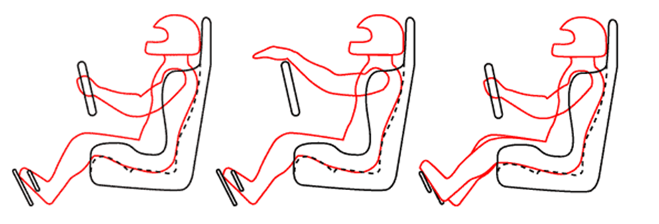
Figure 1 Seat Design
2.3.1.1 Seat Design 1
The initial design for this solar car incorporates a customized race car seat where the back of the seat will sit approximately 25-30 degrees from the horizontal. The driver will essentially be at a lay down position similar to the seat seen in Figure 2.
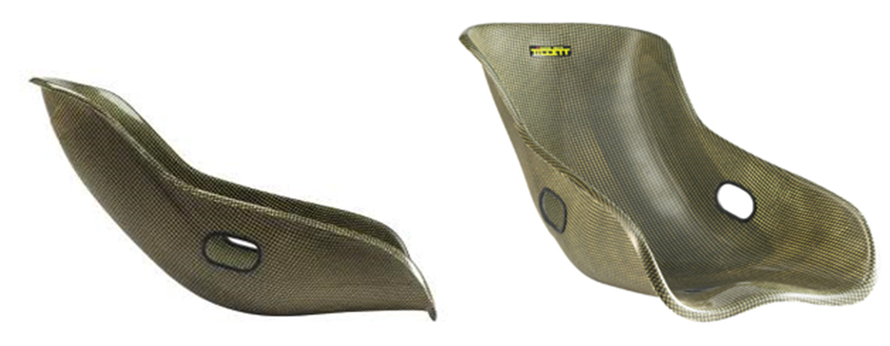
Figure 2 Seat Design

2.3.1.1.1 Specifications
- MIG welded 0.125”thick
- Seat Bottom is contoured to support lower back and hips.
- Between 14.5”- 17.5” ”(standard race car seat sizes) in width
- Between 28”- 36”(standard race car seat sizes) in depth
- Between 20”- 24”( standard race car seat sizes) in height
2.3.1.1.2 Advantages
This design will eliminate the need to cut the roof of the chassis where the photovoltaic solar panels would lay according to last year’s team design shown in Figure 3. In order to maximize the power output from the solar panels, they should lay as perpendicular to the sun’s rays as possible which would be best achieved on the roof of the car as seen in the design below. Also with Design 1, remaining under 100 centimeters for the overall height will be easily achieved since the roll bar would not have to be redesigned.
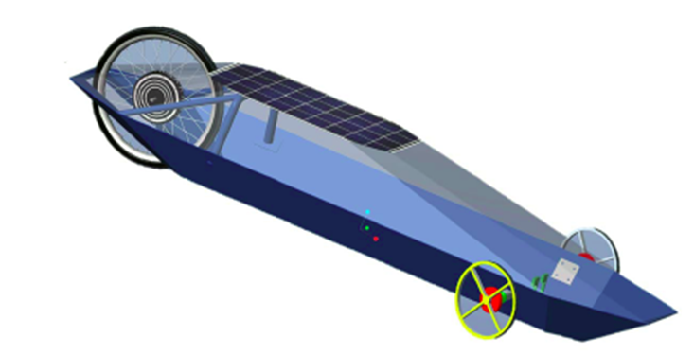
Figure 3 Last year design

2.3.1.1.3 Disadvantages
This lay down car seat design is inconvenient for the driver to get in and out of the vehicle with ease. In addition, at this position, the driver’s feet will be too close to the front of the vehicle near the wheels. Extreme design adjustments would need to be made for the steering and braking systems to accommodate for the drivers legs while maintaining all the Shell-Eco Challenge safety requirements. Installing the 5 point harness around this seat will be more complex.
2.3.1.2 Seat Design 2
2.3.1.2.1 Specification
- Seat side lowers for the lap belts.
- Designed for low horse power cars on small tracks.
- MIG welded 0.125”thick(standard seat thickness)
- Seat Bottom is contoured to support lower back and hips
- Between 14.5”- 17.5”(Kirkey standard race car seat sizes) in width
- Between 22.5”- 25.75”(Kirkey standard race car seat sizes) in depth
- Between 28.5”- 35”(Kirkey standard race car seat sizes) in height
2.3.1.2.2 Advantages
This design for the seat will be mounted on rails that will allow the seat to slide forward and backward from its centered position. The advantage of this is that it will increase the convenience factor in allowing each unique driver to enter and exit the vehicle with less resistance. Ideally, drivers of various heights should be able to operate the vehicle. Considering that all standard cars are driven in this vertical seat position, it will be more comfortable for the average driver. This design also gives more leeway to the design of the steering and braking systems.
2.3.1.2.3 Disadvantages
With this design, cutting the roof of the chassis is unavoidable as seen in Figure 4. The current drag coefficient, C_{d} = 0.155, was determined by the previous design team for an uncut chassis. This value will increase once the top has been cut, thus negatively affecting the aerodynamics of the vehicle. The current roll bar will need to be redesigned to meet the Shell-Eco Challenge specifications.
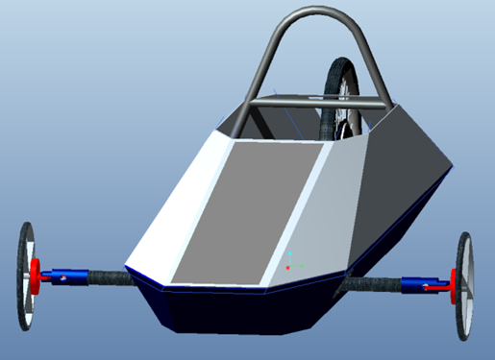
Figure 4 Last year Design
2.3.2 Roll Bar and Motor Mount
The three designs for the roll bar and motor mount must compile with the basic requirements issued by the Shell Eco-Challenge Marathon Competition. The roll bar must be capable of withstanding a static load of 700 N in any direction without deforming. The dimensions of the roll bar will be 5 cm above the drivers head when fully seated, and approximately 2 cm from the shoulders on each side. The intension of this year’s design team is to choose the lightest and strongest material that will provide the safety to the driver during the competition.

2.3.2.1 Roll Bar and Motor Mount Design 1
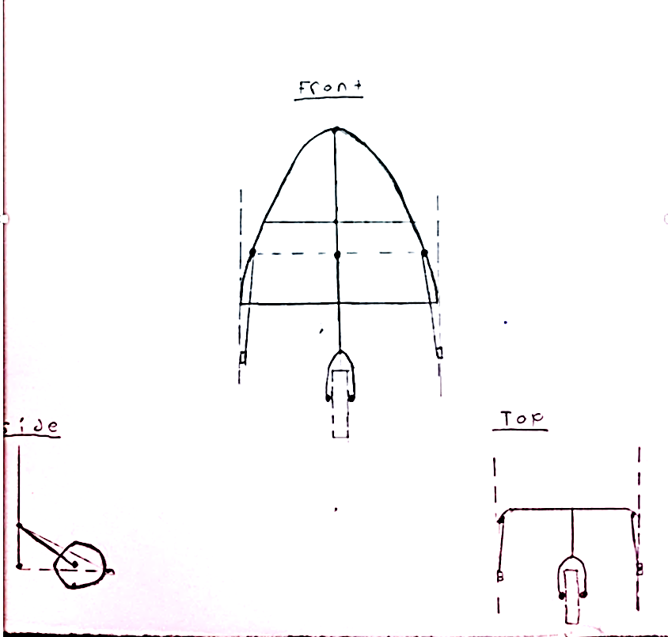
Figure 5 Roll Bar and Motor Mount Design 1
2.3.2.1.1 Specifications
This is a roll bar that is connected to the main chassis with two outer bars that stretch to rear of the vehicle. The strength of the roll bar will be determined once the component material has been selected. The structural integrity of the roll bar will be assisted by cross section that will account for roll over’s and the rigidity of the rear wheel with the motor mount. A similar design to the front suspension of a bike will be used on our rear wheel mount, except no dampers or springs will be used. This section will be connected to the vertical bar that is connected that is perpendicular to the horizontal cross section.

2.3.2.1.2 Advantages
The benefits of this design will mainly account for roll over’s. The entire load will be directed to a point on the bar that is directly above the driver, the vertical bar will withstand the full impact and retain the structure of the roll bar. The other benefit is the bike braking system on the rear wheel can be easily mounted.
2.3.2.1.3 Disadvantages
The key drawbacks of this design are that the rear wheel mount will require more rigidity. In this case more materials are required which will increase the total weight of the car.
2.3.2.2 Roll Bar and Motor Mount Design 2
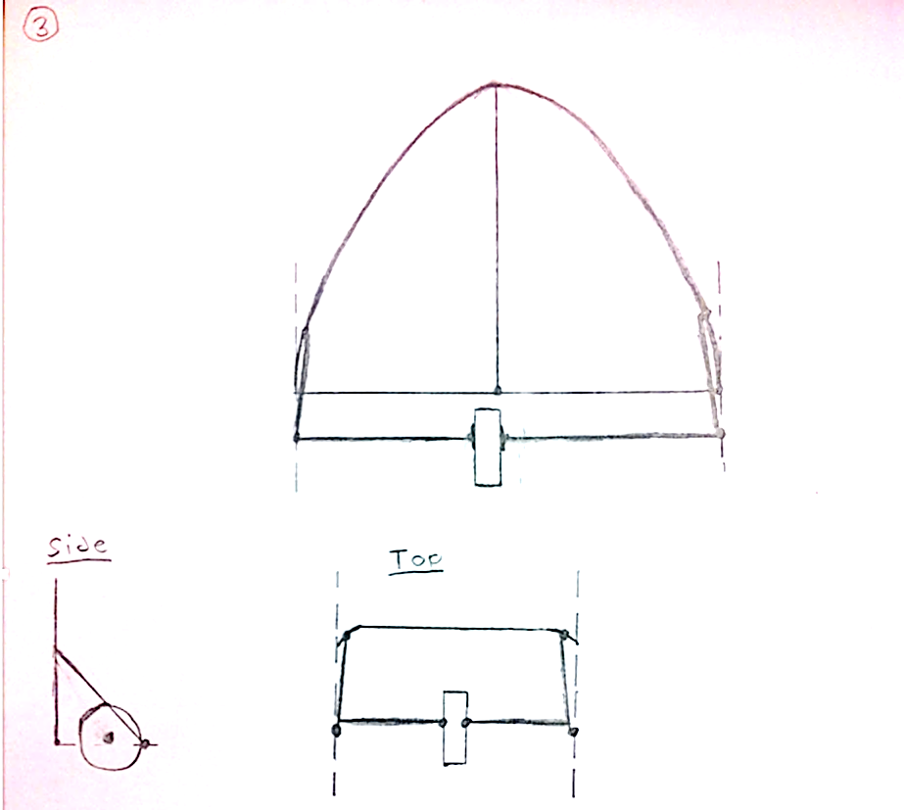
Figure 6 Roll Bar and Motor Mount Design 2

2.3.2.2.1 Specification
The only difference in this design compared to the previous is that the motor and wheel mount will be completely independent of the roll bar. The same structure of the roll bar will be maintained, instead the wheel mounts are mounted directly to the chaise in a horizontal manner.
2.3.2.2.2 Advantages
Less material will be required to construct this design, which means less weight. The load of the motor on the roll bar will be removed giving it a stiffer structure.
2.3.2.2.3 Disadvantages
Implementing a brake system will be more difficult. Supporting the full load on only two horizontal cross bars that are connected to the chassis may fail under larger loads.
2.3.2.3 Roll Bar and Motor Mount Design 3
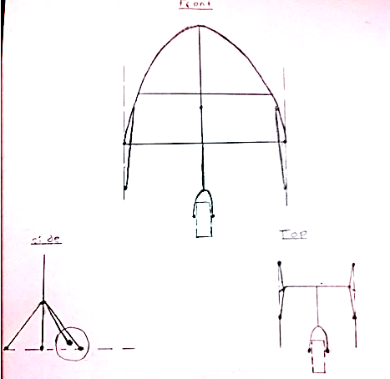
Figure 7 Roll Bar and Motor Mount Design 3

2.3.2.3.1 Specifications
This design is very similar to design one. The only differences is instead of only having two supports mounted to the rear of the chassis, two more supports will be mounted to the front along the shoulders of the driver. The wheel and motor mount are directly supported off the roll bar. There must be extra support in the opposite direction to support the full load that is pushing from the wheel mount.
2.3.2.3.2 Advantages
The benefits of this design are the stability and rigidity of the roll bar. The extra support makes this design the safest and is capable of supporting heavier loads if necessary.
2.3.2.3.3 Disadvantages
The only drawback is the two extra supporters will add more weight, and may cost more money to order and weld onto the roll bar.
2.3.3 Front Wheel Mount and Steering Assembly
The team has considered using aluminum for the construction of the Front Wheel Mount and Steering Assembly. A metal will be required because welding and fastening with the use of bolts will be necessary. Aluminum is a strong enough material to withstand the forces expected to be placed on the car’s axle but also easy to machine and relatively cheap.

2.3.3.1 Front Wheel Mount and Steering Assembly Design 1
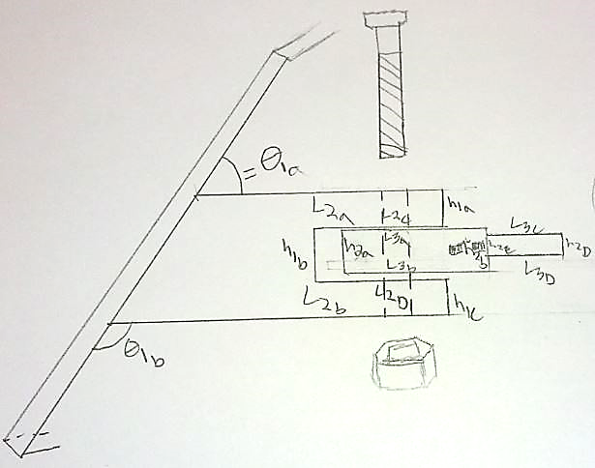
Figure 8 Front Wheel Mount and Steering Assembly Design 1
2.3.3.1.1 Specifications
The simplest design incorporates the front wheel hub with the steering by using it as a casing for the front wheel mount. The wheel mount will be connected to the front wheel hub by a single shaft which will be threaded on the bottom to secure it in the housing. The wheel mount will contain two bearings at the top and bottom. The casing will allow the wheel mount to rotate in the x-axis while restricting its movement in the y and z axis.
2.3.3.1.2 Advantages
Do to the simplicity of the components, the Front wheel hub and wheel mount will be able to be machined in house which will reduce the cost for the component. Using only two bearing in the mechanical system will also reduce the final price. Depending on the forces the sizes of the components can be adjusted to minimize weight and amount of required material.

2.3.3.1.3 Disadvantages
The wheel mount in this design does not rotate therefore a wheel with an in-hub bearing will be required.
2.3.3.2 Front Wheel Mount and Steering Assembly Design 2
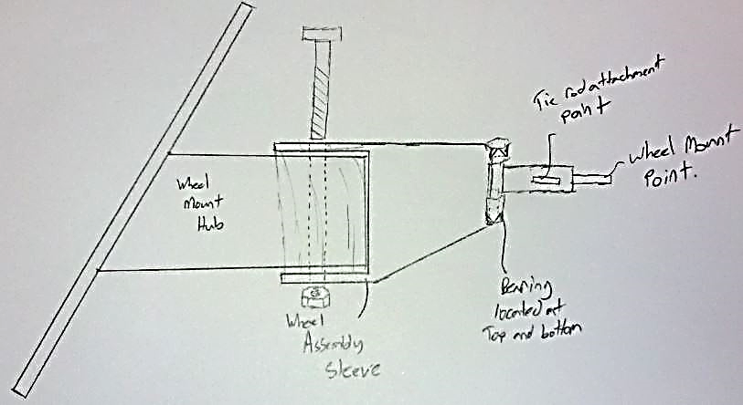
Figure 9: Front Wheel Mount and Steering Assembly Design 2
2.3.3.2.1 Specifications
In this design the front wheel mount will fit over the front wheel hub similar to a sleeve. This piece will then be fastened to the hub. The steering mechanism of this design is contained entirely within the wheel mount. Our wheel mount rod and tie rod attachment point will be connected to a metal shaft. This shaft will be set into two bearing which will allow the rod to rotate in the x axis. This is similar to a door hinge.
2.3.3.2.2 Advantages
With this design the Front Wheel Mount fits over the Front Wheel Hub similar to a sleeve. It can be secured onto the Hub with the use of a nut and bolt or could be welded into place.

2.3.3.2.3 Disadvantages
The forces experienced at the wheel are going to be larger in this design because the overall length is longer than the previous design. The design is more complex and may be out of the scope of our in house machinist which may require it to be ordered which would affect our budget.
2.3.3.3 Front Wheel Mount and Steering Assembly Design 3
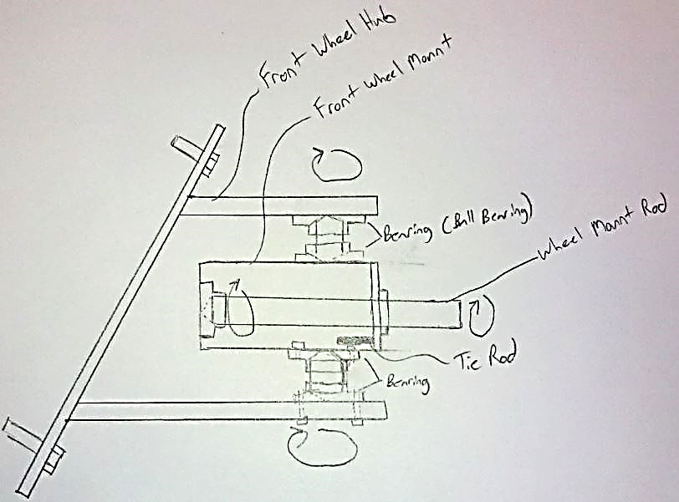
Figure 10: Front Wheel Mount and Steering Assembly Design 3
2.3.3.3.1 Specifications
The most complex of the three designs, it incorporates six bearings. In this design the Wheel Mount is contained within the Wheel Hub. The Wheel mount is capable of rotating in the x-axis and also contains a wheel mount rod which will also be capable of rotating.
2.3.3.3.2 Advantages
With the use of multiple bearings this design should take the least amount of force to turn the wheels. A rotating wheel mount rod would eliminate the need for a wheel with an in-hub bearing. This would be built in shop.

2.3.3.3.3 Disadvantages
The use of six bearing will greatly increase the amount of the budget required to build the Front Wheel Mount and Steering Assembly. All of the bearing would have to be ordered and if any problems would arise the manufacturing time could increase.
2.3.4 Front Brakes
The front brakes are required to be capable of holding our vehicle in place when engaged on a 20 degree incline. Our two brake designs incorporate a hydraulically engaged caliper/shoe combo and a simple bicycle style braking system. For both designs we have included a rotor that will be designed and implemented if our purchased wheels do not already have them installed. The mounts on which our braking systems are contained can be interchangeable from one design to the other. The proposed designs show two different braking systems and two different braking system mounts.
2.3.4.1 Front Brakes Design 1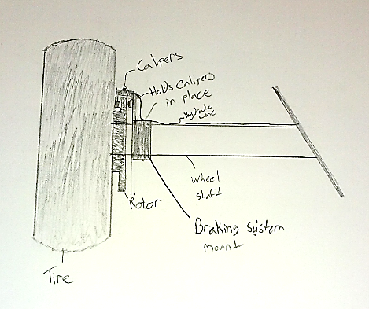
Figure 11: Front Brakes Design 1
2.3.4.1.1 Specifications
A hydraulic braking system is depicted in this design. When the brake pedal is engaged the hydraulic fluid will engage the pistons in the braking system which will cause the braking shoes attached to the calipers to press down onto the rotor slowing and eventually stopping the vehicle. The housing used to support the braking system is a sleeve that goes over the Wheel Mount and can be welded or bolted in place.
2.3.4.1.2 Advantages
Different sizes of shoes and calipers can be chosen for our vehicle depending on our required braking force.
2.3.4.1.3 Disadvantages
Uses hydraulic lines which would need to be properly balanced to ensure they operate correctly.
2.3.4.2 Front Brakes Design 2
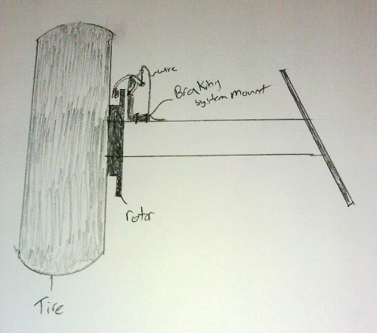
Figure 12: Front Brakes Design 2
2.3.4.2.1 Specifications
A Bicycle Braking system is used in this design. When the brake pedal is compresses the cable goes into tension and pulls the braking pads into the rotor stopping the vehicle. A different style of braking system mount is depicted in this design.
2.3.4.2.2 Advantages
Relatively simple to manufacture and install. Parts can be machined and constructed in house and will not require any parts to be ordered.
2.3.4.2.3 Disadvantages
The braking force will be less than that generated using calipers and hydraulic braking. The braking shoes are smaller than those used in caliper style brakes.
2.3.5 Steering System
It is required by the Shell Eco-Challenge Marathon that our vehicle have a turning radius of 8 meters.
2.3.5.1 Steering System Design 1
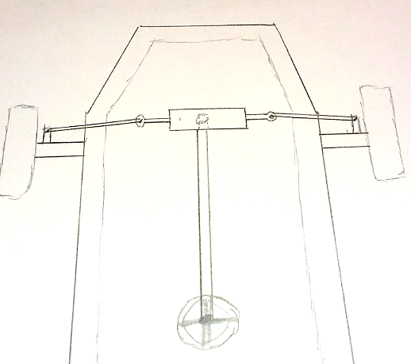
Figure 13: Steering System Design 1
2.3.5.1.1 Specifications
In this design a rack and pinion is used to control the steering of the vehicle. The steering wheel is attached to the steering column which is connects to the rack and pinion. Tie rods connect the rack and pinion to front wheel steering assemblies.
2.3.5.1.2 Advantages
The turning radius of the vehicle can be adjusted by using different types of rack and pinions. The action of steering the vehicle will be a lot smoother with the use of a rack and pinion.

2.3.5.1.3 Disadvantages
The rack and pinion will have to be ordered. This will require the proper steps to be taken to ensure that what is ordered can in fact be implemented in the final design.

2.3.5.2 Steering System Design 2
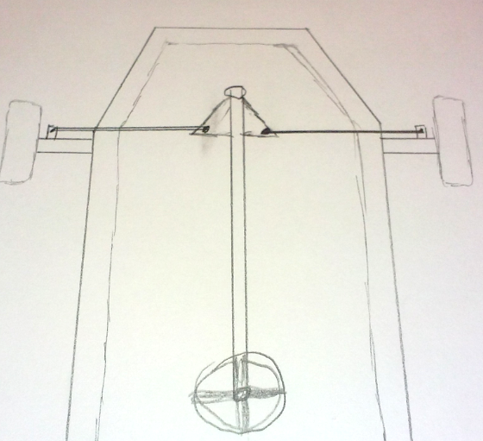
Figure 14: Steering System Design 2
2.3.5.2.1 Specifications
For this design the steering will be controlled entirely by the steering column. The steering column will be attached to a joint which will allow the column to rotate freely. This joint will be attached to the floor of the chassis. Farther down the steering column from the chassis attachment point a plate is connected to the steering column. This plate will allow the vehicle to turn. With the tie rods attached to the plate, when the driver turns the steering wheel they will be turning the plate which will pull/push on the tie rods and turn the vehicle.
2.3.5.2.2 Advantages
Very simple design often used in go-carts. Can be manufactured in house and relatively simple to implement.
2.3.5.2.3 Disadvantages
The amount of force required to turn the car will be more than if a rack and pinion were used. The amount of stress put onto the steering column will increase which may require a thicker material to be utilized for its construction.
2.3.6 Rear Brakes
The rear brakes must be completely independent of the font brakes controlled by a second pedal. They will be directly mounted on the wheel mount assembly. Bike brakes are the choice that will be chosen for the rear brakes. The required stopping force will be supplied by using slightly larger brake shoes. Larger area also means less pressure is required when activating the brake pedal. Some complications that will be encountered in the installation process is the tilting of the brake shoe to the same angle as the wheel mount. This can be done by adding extra links or spacers to accomplish the most effective stopping mechanism on a tilted wheel mount.

2.3.6.1 Rear Brakes Design 1
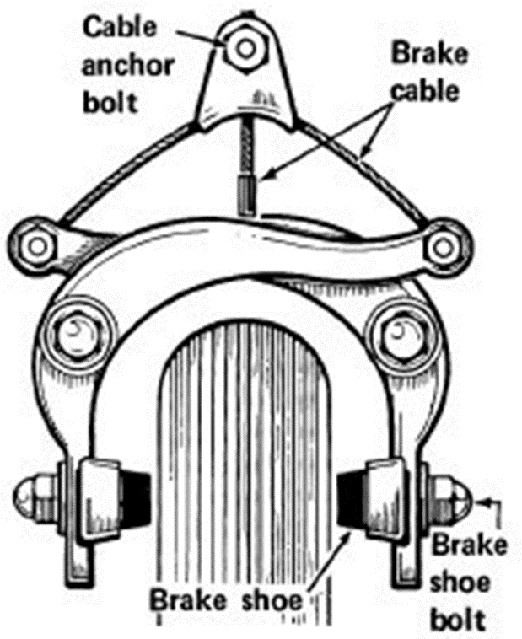
Figure 15: Rear Brakes Design 1
2.3.6.1.1 Specifications
This design uses a newer bike brake system which is bolted directly over the tire. Only one bolt is required which will mount directly on the wheel mount. Once the brake is pressed the brake line is in tension and the levers on the brake shoe are pulled together causing them to press down on the rear wheel and apply the stopping force.
2.3.6.1.2 Advantages
The benefits of this design are its light weight, cheaper than hydraulic brakes and a lot easier to install and adjust.
2.3.6.1.3 Disadvantages
The brake lines could snap if cheap wiring is used, and the braking force may not be enough to support the full weight of the car on 20 degree incline.

2.3.6.2 Rear Brakes Design 2
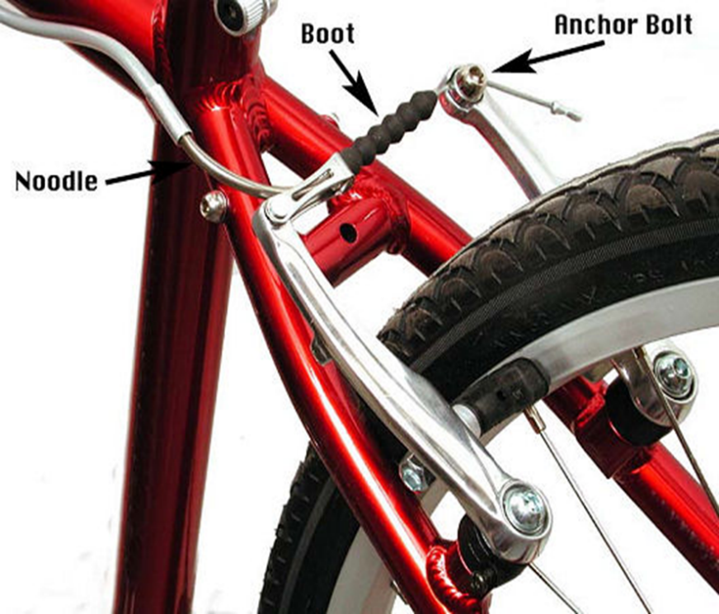
Figure 16: Rear Brakes Design 1
2.3.6.2.1 Specifications
The second design that will be considered is similar to the first one expect it is bolted by two bolts along the wheel mount. The functionality of this design is no different than design one except when the pedal is pressed the two levers are pulled outward while applying force on the wheel rim.
2.3.6.2.2 Advantages
Design 2 can be mounted in multiple locations due to its two bolt system. The brake system is also cheaper than design 1.
2.3.6.2.3 Disadvantages
Brake system might not fit properly or be more complicated to install due to bolting two bolts instead of just one directly above the wheel.

2.3.7 Component Placement
The wiring harness and the placement of each electric component are essential for maintaining safety and a uniform weight distribution. The two designs shown in the figures below are ideas that were concluded after reviewing last year’s design and the new design from this year. The specifications of this year’s design is to organize all the electronics in a fashion that will minimize wire resistance. Restricting current to follow in a loop manner, input current is along the left edges of the car and output current is along the right side. The second specification is placing the battery pack in the front of the car as well as the battery management pack and the transformer. This will minimize the amount of energy required from the motor to mobilize the rear wheel.
2.3.7.1 Component Placement Design 1
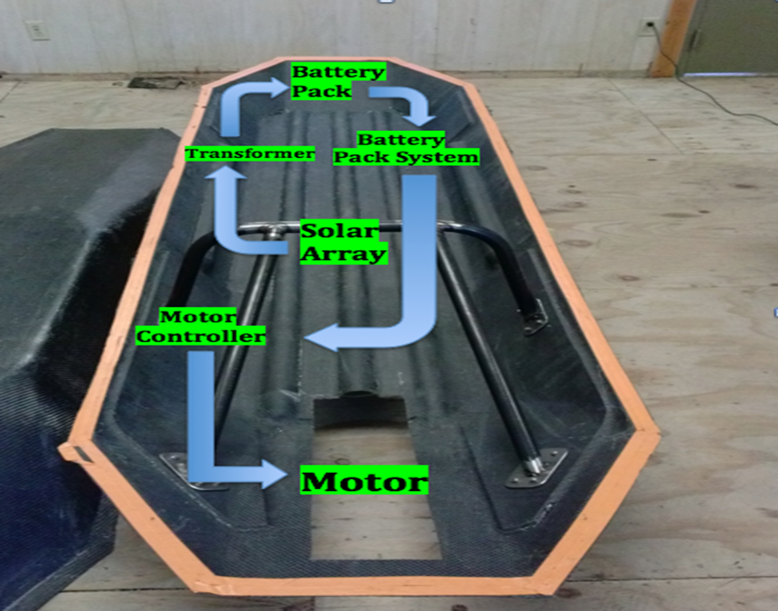
Figure 17: Component Placement Design 1

2.3.7.1.1 Specifications
Design 1 is the design from last year, the battery back, battery management pack system, and transformer are in the front. The solar panel is directly on top of the drivers head. All the wires will be well insulated to prevent voltage build up. The motor controller will be placed in the back of the solar car due to its light weight, and the motor is mounted in the back to the wheel.
2.3.7.1.2 Advantages
The benefit of this design is that the solar panels are flat with respect to the horizon, and are directly perpendicular to the sun light. Sun light absorption is maximized when the solar cells are directly perpendicular to the sun. This means that the energy conversion process will be more efficient.
2.3.7.1.3 Disadvantages
The only drawback with this design is that the driver could not enter and exit the car properly. The solar panels will not allow proper visibility and the drivers head will always be sitting on the roof of the car.

2.3.7.2 Component Placement Design 2
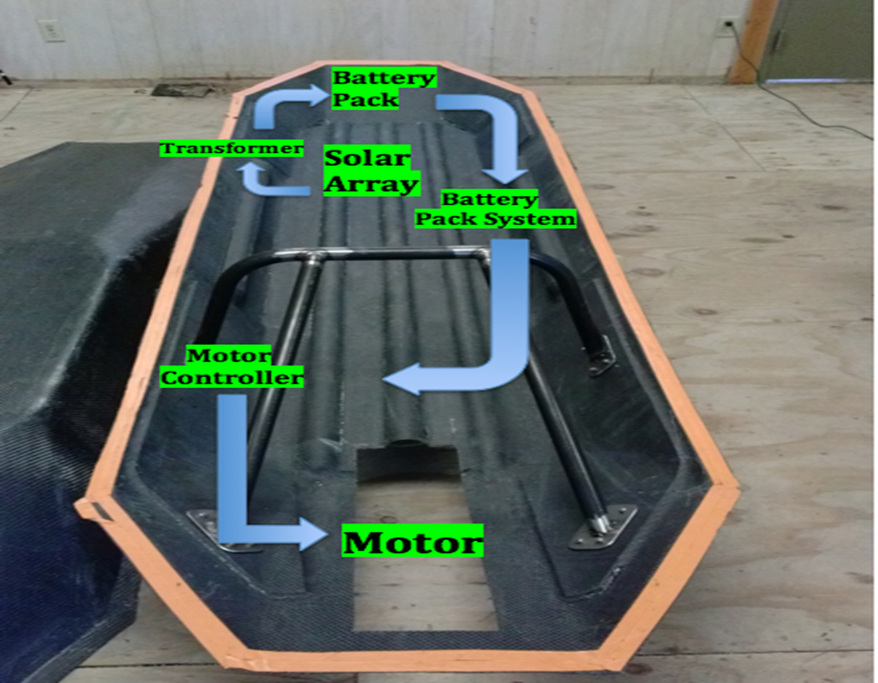
Figure 18: Component Placement Design 2
2.3.7.2.1 Specifications
The only difference in this design is the solar panels will be mounted in a sloped manner on the front of the solar car. The wires will also be well insulated to resist large voltage drops that may lead to excessive heat buildup.
2.3.7.2.2 Advantages
Driver visibility will be maximized to 180 degrees, this is due to constructing a dome directly over the drivers head. The solar panels will be closer to the battery pack and the transformer which will decrease the amount of resistance in the wires.
2.3.7.2.3 Disadvantages
Solar panels efficiency will decrease because they are not directly perpendicular to the sun, and the coefficient of drag may increase slightly due to the solar panels structure and roughness.
2.3.8 Motor Controller: Single Board Controller
After developing an understanding for the control requirements of the motor being used (Golden Motor Magic Pie), a single board controller will be decided upon in order to develop the interface between the driven/power stage of the motor controller and the motor. The preferred features include: Min 24V, USB interface to computer, support 3 phase brushless motors and cost efficient.
2.3.8.1 Single Board Controller Design 1
The RDK-BLDC is one of the closest alternatives to the board controller that accompanied the Golden Motor, the BAC-281. With Screw terminals for power wiring and on board circuit breakers, it would be close to using the BAC-281. Nonetheless, it is not as cost efficient as desired.
2.3.8.1.1 Specifications
- Texas Instruments RDK-BLDC
- Cost: $219
- Advanced motor control for three-phase brushless DC motors up to 36 V, 500 W
- Uses a Stellaris® LM3S8971 microcontroller
- 10/100 Ethernet and CAN interfaces
- Hall effect, quadrature and sensor less operation modes
- JTAG/SWD port for software debugging
- Screw terminals for all power and signal wiring
2.3.8.1.2 Advantages
- Supports and includes a three phase brushless motor
- On board breaking circuit for protection against unsafe current levels
- Screw Terminals would allow for a direct input source for the propulsion battery
2.3.8.1.3 Disadvantages
- At $219 the RDK_BLDC is much more expensive than some of the alternatives.
2.3.8.2 Single Board Controller Design 2
The TI Launchpad is being considered primarily because it is free of cost. Although the group already have one in its possession, the Launchpad is very inconvenient being that it is USB powered and lacks the power to drive the motor.
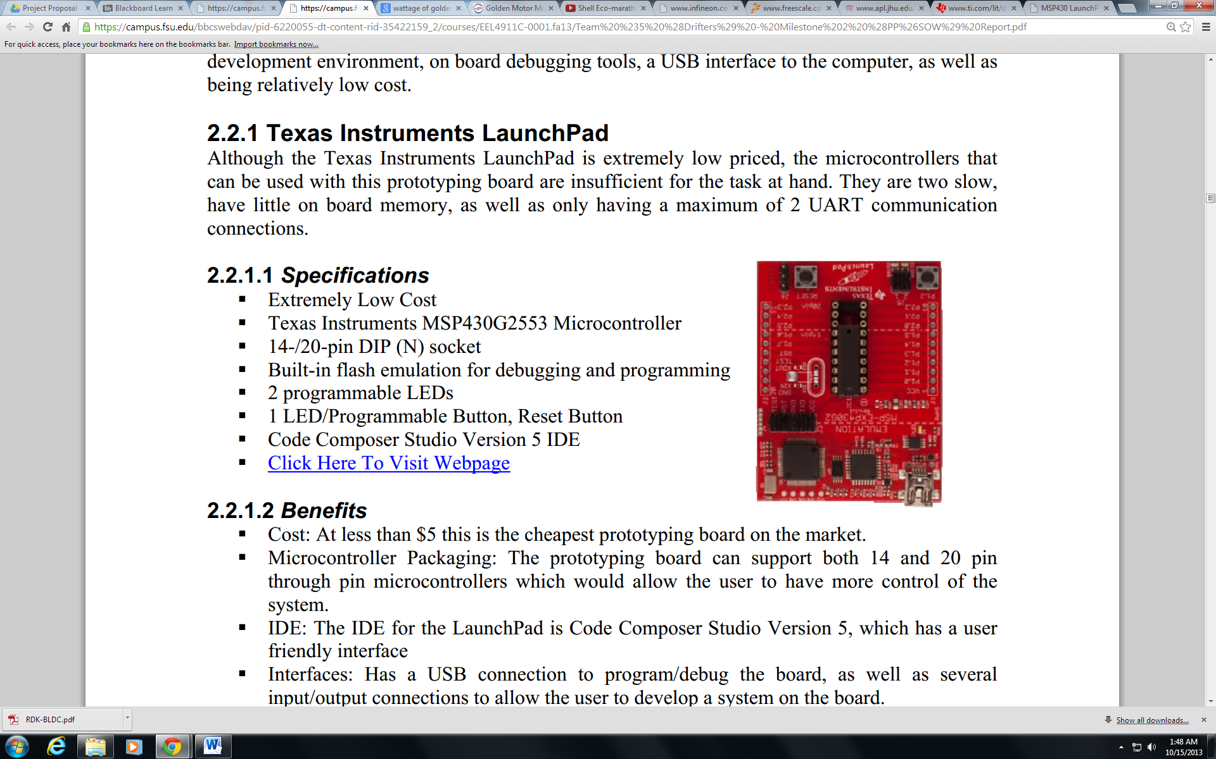
Figure 19: TI MSP430
2.3.8.2.1 Specifications
- Texas Instruments MSP430 LAUNCHPAD
- Cost: $0
- 14/20 pin DIP socket
- Built in flash emulation for debugging and programming
- 1 programmable button
- 1 reset button
2.3.8.2.2 Advantages
- No cost since product is already in groups possession
2.3.8.2.3 Disadvantages
- USB powered: The Launchpad cannot be directly connected to the propulsion battery.
- Does not have the power to drive the motor.
2.3.8.3 Single Board Controller Design 3
TI TMS320F28’s lower-power mode feature can be very helpful to the overall success of the project, especially during the competition. Although this board has a very high cost, the possibility of being able to borrow it from a professor makes it an option.
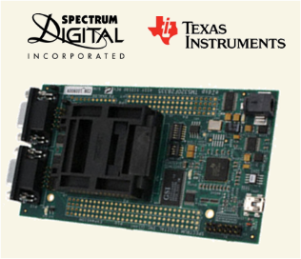
Figure 20: TI TMS320F28
2.3.8.3.1 Specifications
- Texas Instruments TMS320F28
- Cost: $345.31
- 56 General Purpose I/O pins
- Motor Control Peripherals including two event managers
- Idle, standby and Halt modes
- Advance emulation features
- Operate at temperatures ranging from - 40C(-40F) to + 125C(257F)
2.3.8.3.2 Advantages
- Low-Power Modes and Power Savings for less power consumption from propulsion battery.
- Being familiar with the development tools included(C/C++) can make programming less time consuming.
- There is a fair possibility that the TI TMS320F28 could be borrowed from a professor at the University, helping to keep costs low.
2.3.8.3.3 Disadvantages
- At $345, the cost is considerably high.

2.3.8.4 Single Board Controller Design 4
The ATAVRMC100 is being considered for a similar reason that the RDK-BLDC is being considered. It is a very close alternative to the board controller that accompanied the Golden Motor, the BAC-281.
Figure 21: ATAVRMC100
2.3.8.4.1 Specifications
- Power Bridge for BLDC motors
- Zero crossing voltage detection
- Hardware overcurrent detection
- Motor supply voltage measurement
- Operate at temperatures ranging from 0C(32F) to 70C(158F)
2.3.8.4.2 Advantages
- Three phase terminals would allow for a direct connection to the motors phases
- Wiring setup similar to that of the BAC-281, making it much simpler to connect the horn and additional accessories
2.3.8.4.3 Disadvantages
- It is recommended that the board is operated at 16V which is much lower than the 24V propulsion battery
- No protection against inverting power supply polarity

2.3.9 Motor Controller: Gate Driver
In order to generate the necessary voltage and current required to accurately and efficiently drive the IGBT, a Gate Driver will be used. It is preferred that the gate driver is three phase along with an input range within 24V to enable operation from the 24V propulsion battery.
2.3.9.1 Gate Driver Design 1
The IR3230SPBF would be convenient when implementing some of the requirements for the vehicle based on the competition Rules. The shutdown system is one of those requirements.
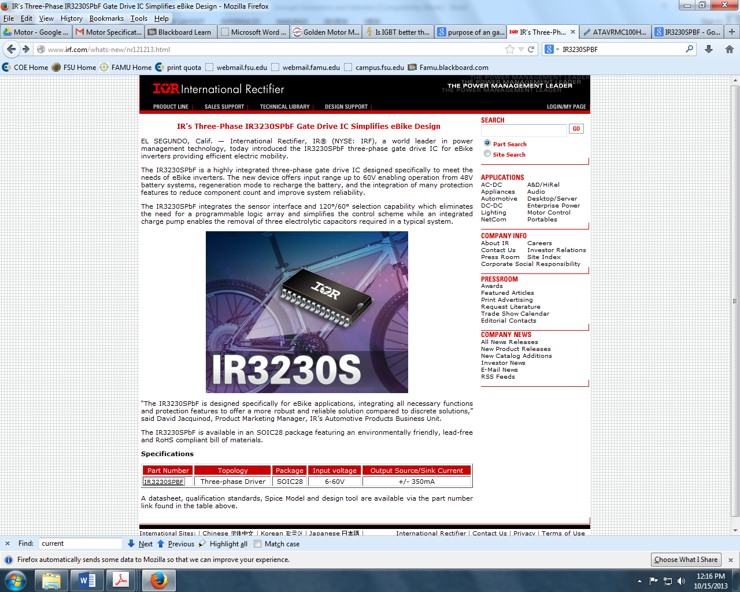
Figure 22: IR3230SPBF
2.3.9.1.1 Specifications
- International Rectifier IR3230SPF
- Cost: $4.10
- 6-60V Operating Supply Voltage
- 1 mA Supply Current
- Operate at temperatures ranging from - 40C(-40F) to + 150C(302F)
- 3 Outputs
- 1.7 mA Output Current
- 5 V Output Voltage
- 1.5 W Power Dissipation
- 80 mV Shutdown Threshold
2.3.9.1.2 Advantages
- Shutdown/Reset capability which may come in handy when implementing the system shutdown button
- Over current protection
- Generally purposed for an e-bike which is convenient since the motor being used was obtained from the golden motor e bike.
2.3.9.1.3 Disadvantages
- At 1.7mA output current, multiple IR3230SPBFs will be required to drive the IGBT driving the 30A motor.
2.3.9.2 Gate Driver Design 2
The DRV8301DCA is well within the voltage range to enable operation from the 24V battery.

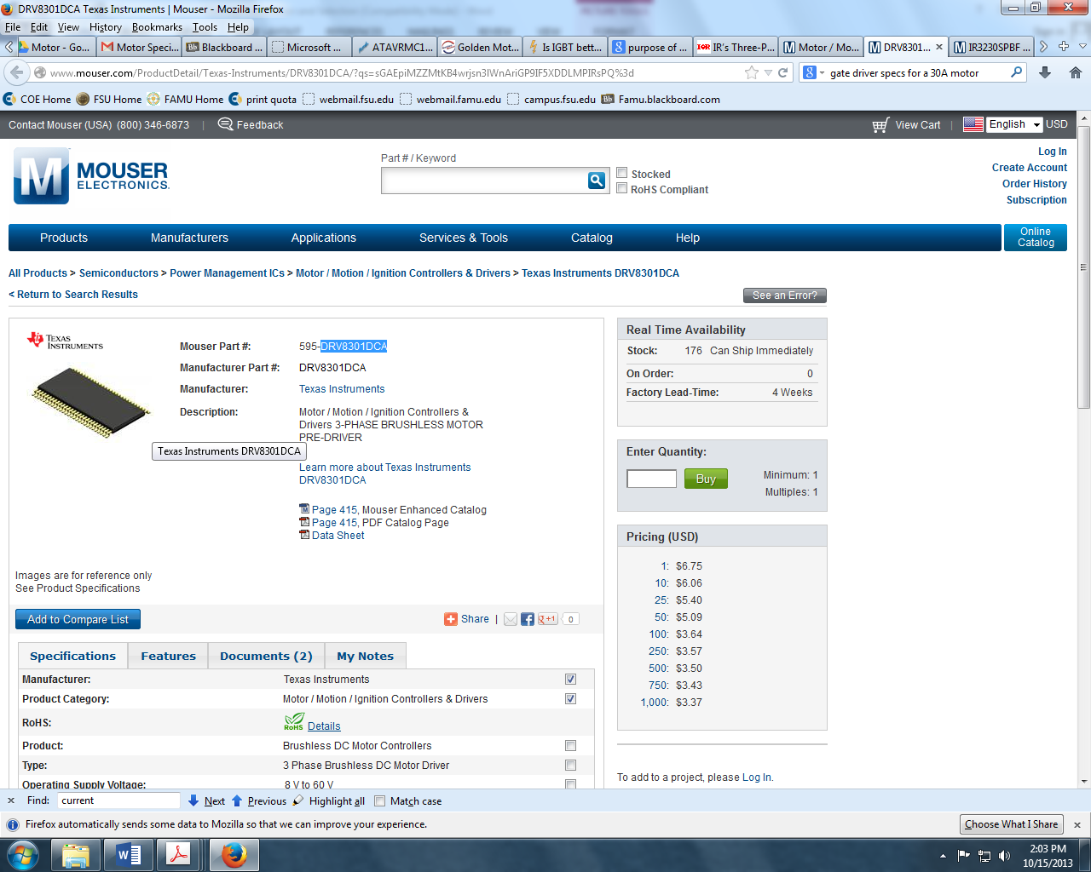
Figure 23: DRV8301DCA

2.3.9.2.1 Specifications
- Texas Instruments DV8301DCA
- Cost: $6.75
- 8-60V Operating Supply Voltage
- 15 mA Supply Current
- Operate at temperatures ranging from - 40C(-40F) to + 125C(257F)
- 3 or 6 PMW Inputs
- 1.7A source gate drive current capability
- Overcurrent protection of external mosfets.
2.3.9.2.2 Advantages
- Current Shunt amplifiers that support bi-directional current sensing
- Over current protection
- Specifically for three phase motor drive applications
- Three half-bridge drivers capable of driving 2 N-type MOSFETs for high and low side
2.3.9.2.3 Disadvantages
- The DRV8301DCA is widely used with MOSFETs instead of IGBTs. IGBTs are being considered more than MOSFETs in this situation since they can operate at higher temperatures.
2.3.10 Accessory Battery
The team considered the necessity of an accessory battery. According to the competition rules and regulations an accessory battery is not required but may be used. According to the rules and regulations if an accessory battery is used it must power the horn and driver ventilation system, however it may not power compressors, blowers, motors, engine cooling systems, or battery management systems.
If an accessory battery is used, it must be short circuit protected. In order to ensure that it is short circuit protected a fuse must be added. The accessory battery must also maintain a negative ground at all times. If an accessory battery is used, it would power the required horn and the desired ventilation system to cool the driver. The maximum nominal voltage of the vehicle cannot exceed 48 volts therefor the electrical engineers have considered the possibility of using a 12V accessory battery.
The team has considered a variety of batteries which can be used as accessory batteries. After consulting with Dr. Weatherspoon it was determined that if an accessory battery is used the amp-hour of the accessory battery must be the same as that of the main battery. After looking up batteries on Digi-Key a 12V lead acid rechargeable battery with a capacity of 20Ah B.B. Battery Co. was determined to be the best fit for the car which can be seen in Figure 2-1. Similar applications for this battery such as powering golf-carts, lawn mowers, and electrical scooters also suggest that this battery will be an appropriate fit for the vehicle. The battery will cost the team $62.06, moreover a separate charger will need to be purchased.
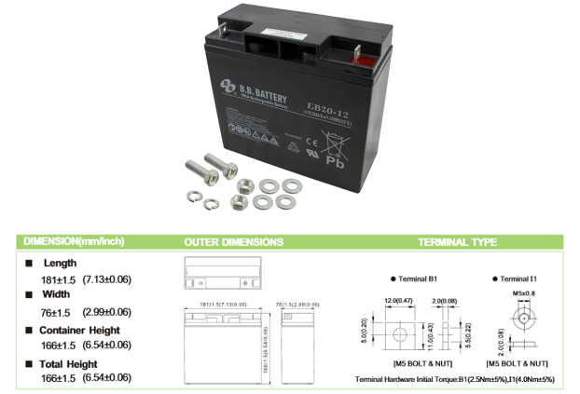
Figure 24: Lead Acid Accessory Battery

The option to forgo an accessory battery has also been considered. By forgoing the accessory battery the horn and ventilation system will have to be hooked up to the primary battery. Hooking additional components such as the horn and ventilation system to the primary battery will essentially draw power from the primary battery causing the car to be less efficient. A competition requirement states “The organizers reserve the right to request that teams install one joule meter in order to measure the amount of energy provided by the accessory battery”. If the amount of energy provided by the accessory battery exceeds the power typically required to operate the starter motor, horn and safety devices the competitor will be disqualified.” In order to avoid being disqualified the due to this stipulation the team has considered forgoing the option of an accessory battery.

2.3.11 DC to DC Boost Converter
2.3.11.1 DC to DC Boost Converter Design 1
A DC-DC converter is a device used to convert Direct Current to Direct Current (DC-DC) in either a higher or lower voltage. This is primarily used in power electronics applications. The STEVAL-ISV005V2 is a Pulse Width Modulation (PWM) mode DC-DC Converter designed to maximize power generated by a photovoltaic energy system. This is accomplished using different transistors and inductors programmed with a Maximum Power Point Tracking (MPPT) Algorithm programmed into the SPV1020 device. The ISV005V2 is shown in Figure 25
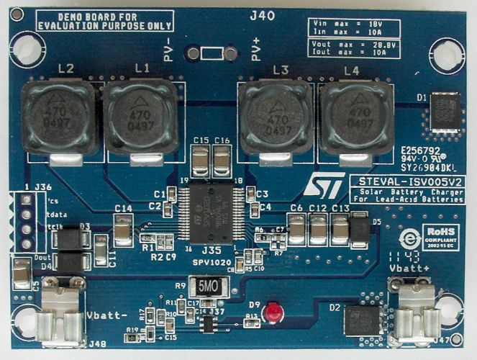
Figure 25: ISV005V2
2.3.11.1.1 Specification
In addition to being specifically designed for Photovoltaic energy conversion, the ISV005V2 also offers the following features:
- ISV005V2 DC-DC Converter
- Cost: $0 (Provided by school)
- Voltage operation 0-40V
- 98% efficient
- Overvoltage, overcurrent, and over temperature protection
2.3.11.1.2 Advantages
The ISV005V2 was purchased by last year’s design team and as a result is not included in this year's budget. In addition, being specifically designed for PV energy conversion, installation time can be almost completely ignored. The efficiency of the ISV005V2 is also extremely high which is incredibly important for the main project objective.
2.3.11.1.3 Disadvantages
Unfortunately, the ISV005V2 output voltage is set to be dependent on the input voltage and maxes out at 28.8V. Greater variability in this regard would be highly desired.
2.3.11.2 DC to DC Boost Converter Design 2
The Tamura TCDC7001 is DC-DC converter manufactured by Tamura specified for use in photovoltaic applications. This DC-DC converter features a wide input voltage and can generate output voltages up to 24V (+/- 5%).
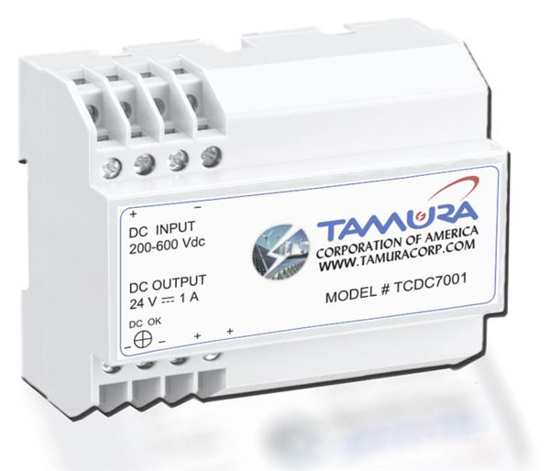
Figure 26: TCDC-7001

2.3.11.2.2 Specification
The Tamura TCDC7001 is specifically designed to boost input voltages from a photovoltaic source such that the may be utilized in other applications. The Tamura TCDC7001 offers the following features:
- Fault protection from overload, short circuit recovery, over voltage and over-temperature
- Wide DC input range
- 80% typical efficiency
- Cost: $90.00
- Height: 2.36in
- Width:3.52in
- Length: 4.13in
2.3.11.2.2 Advantages
The Tamura TCDC7001 is encapsulated in plastic casing, which is beneficial considering that all electrical components need to be protected by a fireproof bulkhead. In addition, the size of the component is very manageable given the small size of the overall car design.
2.3.11.2.3 Disadvantages
Unfortunately, the output voltage from the Tamura TCDC7001is still rated at 24V, which is still lower than what last year’s testing plan hypothesized is required for proper charging of the battery. Also, compared to the ISV005v2, the efficiency is not quite ideal.
2.3.12 Bulkhead Design
For the Shell Eco-Marathon Challenge the vehicle is required to have a permanent bulkhead which completely separates the driver compartment from the energy and propulsion systems. At this point in the design process the final bulkhead design cannot be determined because the placements of the different parts (Motor Controller, DC Booster, Battery, etc.) are not finalized. Once the sitting position of our driver is also determined, and the petals have been considered, the bulkhead can be designed.
2.3.13 Solar Panel Placement
2.3.13.1 Solar Panel Placement Design 1
The initial placement that was considered for the panels was to have them installed on the roof of the chassis. Since the top of the car is made entirely out of carbon fiber, the solar panels would be installed using a solid plate which is shelled out with square compartments for the solar junction boxes that are attached to the panels.
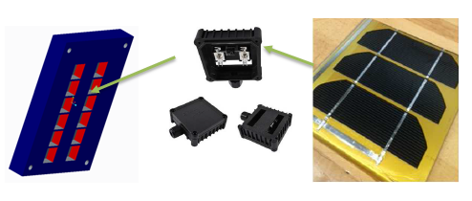
Figure 27: Solar Panel Placement Design
2.3.13.1.1 Specifications
- Surface area of Solar Panels is 0.17 m²
- Mono-crystalline Solar cells
- 0.3 m x 0.7 m shelled plate (approximation)
- To be placed on the hood of the car.

2.3.13.1.2 Advantages
As discussed earlier in the report, the solar panels will be able to produce more voltage when the rays of the sun are as perpendicular to the panels as possible. The average solar energy that is incident to earth’s atmosphere is approximately 1000 W/m². So the maximum power that can ever be produced by the solar cells with an area of 0.17 m² is 170 watts, where that output would only occur on a bright and sunny day with no clouds.
2.3.13.1.3 Disadvantages
The position the driver will have to sit to implement this design would be extremely inconvenient as discussed previously in section 2.3.2.1.3 of this report.
2.3.13.2 Solar Panel Placement Design 2
Another consideration for the placement of the solar panels is to have the panels lay on the hood of the car using a different shelled plate.

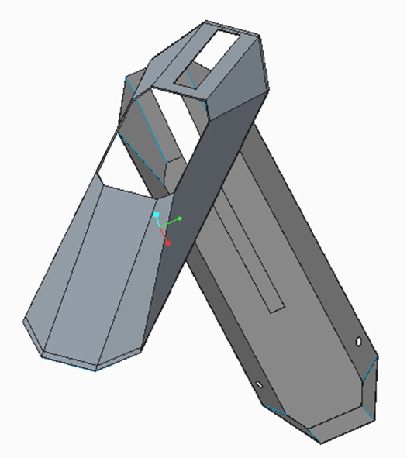
Figure 28: Solar Panel Placement Design 2
2.3.13.2.1 Specification
- Surface area of Solar Panels is 0.17 m²
- Mono-crystalline Solar cells
- 0.3 m x 0.7 m shelled plate (approximation)
- To be placed on the hood of the car.
2.3.13.2.2 Advantages
The benefits for this implementation of the solar panels will be same as those described in Section 2.3.2.2 in which the seat position is directly correlated with the solar cells placement.
2.3.13.2.3 Disadvantages
The main disadvantage is that the panels will lay at an angle down from the sun. So if the sun at noon is facing east, facing west when going around a circular track would slightly diminish the power output.
2.3.13.3 Solar Panel Placement Design 3
The last implementation the team is considering is to design a custom spoiler (racecar wing) at the “trunk” of the car that would hold the solar panels.
2.3.13.3.1 Specification
- Surface area of Solar Panels is 0.17 m²
- Mono-crystalline Solar cells
2.3.13.3.2 Advantages
The benefits for this implementation is that it would allow the panels to sit perpendicular and give the designer for the seat and steering systems more options to choose from.

2.3.13.3.3 Disadvantages
The main disadvantage is that adding a spoiler would add extra weight and increase the drag resistance on the car.
3 Proposed Design
3.1 Overview:
The proposed design selected by the team will maximize the safety and efficiency of the vehicle while minimizing cost. Two top level block diagrams are provided below to show the inner workings and connections of various mechanical components. During the selection process many of the components were selected using a comparison matrix which related our key design features against each proposed component design. In each of the comparison matrices, a higher value corresponds to a more optimal choice.
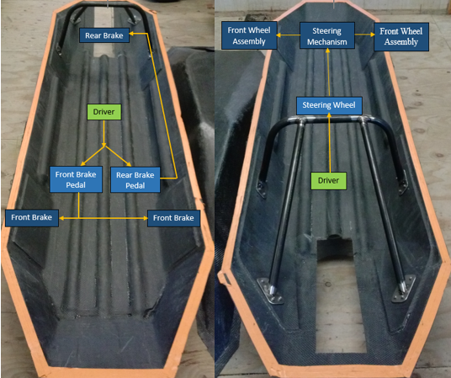
Figure 29: Mechanical block diagram
3.1.1 Seat
The design and implementation of the seat is an essential part of this solar car. This is because all of the key components of the solar car such as the steering column, brake system, roll bar, rear bulk head, and position of the solar cells need to be designed and referenced around the seat. This is one of the primary parts that needs to be manufactured as soon as possible. Based on the comparison matrix, seat design 2 with the standard 20º layback position is the optimum choice; despite the fact that the roof of the car will need to be cut, thus increasing drag. The implementation for this design 2 is simpler than the other because the rails at the bottom of the seat can be mounted directly to the balsa wood on the groundwork of the car. It is also a much safer design that would allow more maneuverability. When strapped down in a laydown position as in seat design 1, exiting the car quickly in case of an emergency, especially if the car were to roll over, would be more difficult. Also, the seat for design 1 would not be able to slide front and back like that in design 2.
3.1.2 Comparison Matrix:
Design Options | Cost | Weight | Safety | Implementation | Total
Seat Design 1 | 1 | 2 | 1 | 1 | 5
Seat Design 2 | 2 | 1 | 2 | 2 | 7
Table 1: Seat Design comparison matrix
3.2 Roll Bar and Motor Mount
Design 3 was chosen because the total benefits outweighed the other two designs. The safety is the most important criteria to impose on the roll bar. The table for the roll bar design shows that the safety of design 3 is the highest out of the other two designs. The benefits can be found in section 2.3.8.3.
3.2.1 Comparison Matrix:
Design Options | Cost | Weight | Implementation | Safety | Total
Design 1 | 1 | 2 | 2 | 2 | 7
Design 2 | 3 | 3 | 1 | 1 | 6
Design 3 | 2 | 1 | 3 | 3 | 9
Table 2: Roll Barr comparison matrix
3.3 Front Wheel Mount and Steering Assembly
The proposed design chosen for the car’s front wheel mount and steering assembly is Design 1. Design 1 was the simplest of the three designs and could be constructed in the Engineering School’s machine shop. Since there are less moving parts and the forces at the point where the wheel connects to the assembly is at a minimum, it ranked the highest of the three designs.
3.3.1 Comparison Matrix:
Design Options | Cost | Weight | Safety | Implementation | Total
Design 1 | 3 | 3 | 3 | 3 | 12
Design 2 | 2 | 1 | 1 | 1 | 5
Design 3 | 1 | 2 | 2 | 2 | 7
Table 3: Front Wheel Mount and Steering Assembly comparison matrix
3.4 Front Wheel Brakes
For the front braking system the team has decided to go with the caliper style braking system with the L- Bracket design. Our comparison matrix showed that both design were equally acceptable for our design. The caliper braking system is capable of producing larger stopping forces than traditional bicycle brakes and therefore was chosen by the group as the proposed design for the vehicle.
3.4.1 Comparison Matrix:
Design Options | Cost | Weight | Safety | Implementation | Total
Design 1 | 1 | 1 | 2 | 2 | 6
Design 2 | 2 | 2 | 1 | 1 | 6
Table 4: Front Wheel Brakes comparison matrix
3.5 Steering System
The proposed design for the steering system is the rack and pinion which was design 1. Although the rack and pinion design will need to be ordered and will in turn cost more than design 2. It makes up for this with its ease of implementation and its increased safety factor. Using a rack and pinion will decrease the amount of force required to steer the car. This increases the vehicle’s maneuverability and thus the safety of our design. Implementing the rack and pinion into the design will only require the team to bolt the steering assembly onto the chassis.
3.5.1 Comparison Matrix:
Design Options | Cost | Weight | Safety | Implementation | Total
Design 1 | 1 | 2 | 2 | 2 | 7
Design 2 | 2 | 1 | 1 | 1 | 5
Table 5: Steering Design comparison matrix

3.6 Rear Wheel Brakes
The braking system must be capable of supporting the full weight of the vehicle on a 20 degree incline. Design 1 shows a higher safety and implementation characters, which means design 1 is a better choice for the rear brake system. More details about the benefits can be found in section 2.3.9.
3.6.1 Comparison Matrix:
Design Options | Cost | Weight | Implementation | Safety | Total
Design 1 | 2 | 2 | 2 | 2 | 8
Design 2 | 1 | 1 | 1 | 1 | 4
Table 6: Rear Wheel comparison matrix
3.7 Component Placement
The parts placement selection was for maintaining safety and a uniform weight distribution in the chassis. Design 2 gives a more uniform weight distribution and decreases the amount of torque required for the motor to mobilize the car.
3.7.1 Comparison Matrix:
Design Options | Cost | Weight | Safety | Total
Design 1 | 1 | 2 | 1 | 4
Design 2 | 2 | 1 | 2 | 5
Table 7: Component Placement comparison matrix

3.8 Overall Electrical Components
The overall electrical design will be designed as illustrated above in the Block Diagram. The solar panels will be connected to the DC-DC converter. The DC-DC converter will increase the solar panel voltage from 12V to 26V in order to power the 24V propulsion battery. The DC-DC converter is connected to the propulsion battery source. 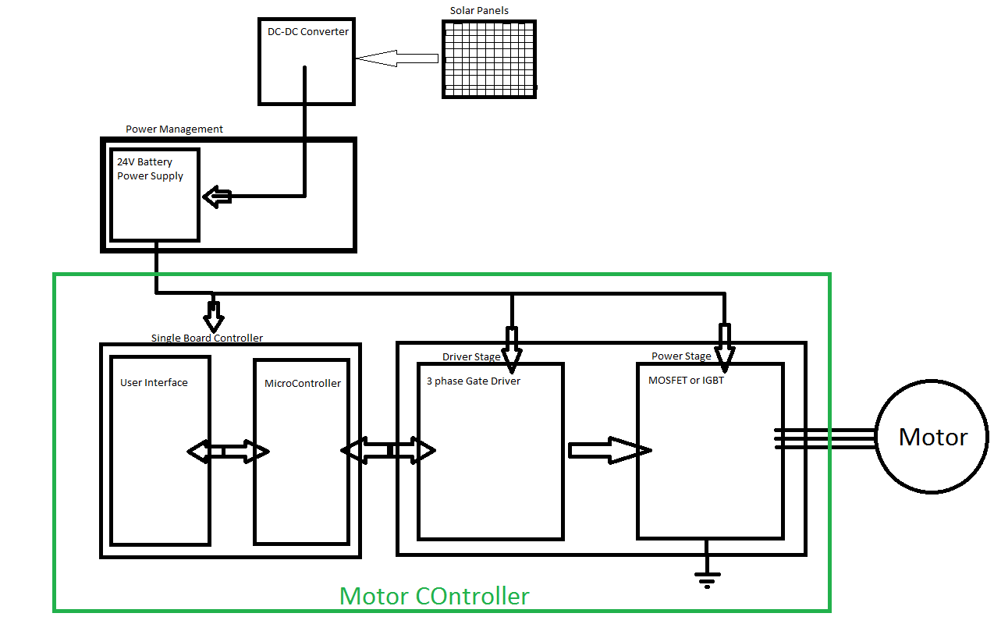
Figure 30: Electrical top-level diagram
3.8.1 Motor Controller
For competition purposes, the three main blocks of the motor controller’s top level block diagram are the single board controller, driver stage and power stage. The user interface communicates over a standard or proprietary field bus that Generates the proper switching patterns to control the motor’s motion based on feedback from the host. The gate drivers generate the necessary voltage and current required to accurately and efficiently drive the MOSFETS or IGBTs in the power stage.
3.8.2: Motor Controller: Single Board Controller
The team is searching for a single board controller that is low in price, yet, efficient. It is especially imperative that the board is capable of implementing the specifications for the overall controller. Nonetheless, the TI RDK-BLDC is the board chosen. It is the second most cost efficient board. With over current protection and direct three phase connections for the motor, the TI RDK-BLDC is the safest and most efficient board.
3.8.2.1 Comparison Matrix
Design Options | Cost | Implementation | Safety | Efficiency | Total
TI RDK-BLDC | 3 | 3 | 4 | 4 | 14
TI Launchpad | 4 | 1 | 1 | 1 | 7
TI TMS320F28 | 1 | 2 | 2 | 2 | 7
ATMEL ATAVRMC100 | 2 | 4 | 3 | 3 | 12
Table 8: Single Board Controller comparison matrix
3.8.3: Motor Controller: Gate Driver
When choosing a gate driver, the same qualities that were considered for the single board controller were also considered for the gate driver. Although the TIDRV8301DCA was more expensive, it was also safer and more efficient.

3.8.3.1 Comparison Matrix
Design Options | cost | implementation | safety | efficiency | total
IR 3230SPBF | 2 | 1 | 1 | 1 | 5
TI DRV8301DCA | 1 | 2 | 2 | 2 | 7
Table 9: Gate Driver comparison matrix
3.8.4 DC to DC Boost Converter
The DC-DC converter is an essential part in the energy conversion system. The main objective of which is to transform the solar energy generated into the appropriate voltage to charge the Li-ion battery. Several DC boosting systems were considered last year in order to make sure that the appropriate system was implemented. However the ISV005V2 was chosen due to its’ built-in MPPT algorithm, safety features, and it’s compatibility with solar systems.
Unfortunately, the ISV005V2 was not successful in charging the battery last year. This was attributed to the converted voltage being too low when connected to the Turnigy watt meter or the internal resistance of the battery. As a result, the proposed solution for this year is to change the output voltage of the converter through either a part replacement or modification of the existing DC-DC converter.
3.8.4.1 Comparison Matrix
Design Options | Cost | Implementation | Safety | Efficiency | total
ISV005V2 | 2 | 2 | 1 | 2 | 7
TCDC-7001 | 1 | 1 | 2 | 1 | 5
Table 10: DC-DC Converter comparison matrix

3.8.5 Solar Panel Placement
As stated in section 2.3.6, optimizing the solar cells voltage output is essential. This is because the voltage output is directly correlated to the amount of sunlight hitting the photovoltaic cells that is converted into electricity to charge the battery. This solar car competition is heavily based on the efficiency of the system as a whole. The fuel economy is defined as the distance traveled over the net propulsion energy (km/KWh). The net propulsion energy is calculated by the motor propulsion energy minus 20% of the solar energy used during the run. This is why it is necessary to have the sun hitting the cells at a prime position at all times. The comparison matrix revealed that placing the solar panel on the hood of the car is the best choice. This is because of the convenience this position allows for other components of the solar car to be implemented. Also the less wiring that can be done from the solar panel to the battery, the better, therefore the battery will be positioned in the front of the car.
4 Statement of Work (SOW)
4.1 Task 1: Project Management
Project Leader - Fritz Jeanty manages the team as whole, develops a plan and timeline for the project, and delegates tasks among group members according to their skills. He finalizes all documents and provides input on other positions when needed. He organizes and plans all meeting and keeps a record of the correspondence of the team. He is responsible for the overall plans and progress of the project.
Lead Mechanical Engineer - James Croasmun leads all mechanical engineering design aspects of the project. He is responsible for keeping a line of communication with the lead ECE, IE, and project leader and relaying all pertinent information to the mechanical engineers. Moreover James is responsible for knowing all design details and presenting each option to the team. He keeps a record of all design documentation and is responsible for the gathering of design documentation for all reports.
Lead Electrical Engineer - Zachary Barr is responsible for all ECE design for the project. He maintains a line of communication with the lead ME, IE, and the project leader. He keeps record of all ECE design documentation for the project.
Financial Advisors - Jose Cardenal and Francois Wolmarans together manage the budget and maintain a record of all transactions made for the project. They will present any product or expenditure requests to the advisor who is then responsible for reviewing the analysis of equivalent/alternative solutions. They relay information to the team and if the request is granted they order it. They will keep a record of the analysis and budget adjustments.
Secretary- Julia Clarke is responsible for recording all meeting minutes. She manages the posting of materials and documents to the website.
Rules Requirements Advisor/PRO-E Manger - David Jolicoeur is responsible for making sure the project is in compliance of the rules for the Shell-Eco Marathon competition. He will inform the team if we do not meet the requirements for the competition. He is also responsible for all designs that will be drawn using Creo Parametric 2.0 and will then present the designs to the team.
Installations Manager - Wael Nabulsi is responsible for the component installation process for the car. He will inform the team when a component needs to be installed, and with the team’s approval will install the component. He is also responsible for making sure the chassis is not affected by the installation of different components.

4.2 Task 2 Mechanical Component Design:
4.2.1 Objective
The goal for the mechanical engineers on this design project is to produce a safe, properly operating vehicle that adheres to all of the qualifications set forth by the Shell Eco-Challenge Marathon Competition. The main objective of this design team is to have a prototype ready and able to compete this summer in the competition. In order to do this the design team will have to be successful in implementing the steering system, braking systems, solar panels, and the bulkhead.
4.2.2 Approach
When designing the individual components of the solar car the team will conform all our designs to fit in with the components created by last year’s design team. The design team will construct the final components of the solar car while maintaining a light weight aerodynamic design. Research will be done with the focus on ensuring that a highly efficient design is maintained. Each component will be built and assembled in Creo Parametric 2.0 to ensure an optimal design for each product. Within this program, the team will be able to test the structural integrity of each part that is to be manufactured. Once tested digitally the final confirmations will come from our mechanical mentor Dr. Hollis and the head machinist.
4.2.3 Sub-Tasks
4.2.3.1 Seat
4.2.3.1.1 Objective
To allow the driver to ride comfortably in the vehicle while maintaining a full range of visibility, the seat will have a 5-point racing harness which will conform to the requirements set by the Shell Eco Challenge Marathon.
4.2.3.1.2 Approach
Research was done on standard racing car seats. The key factors governing seat design are arm position, leg position, and comfort. The ergonomic functionality will be taken into consideration when deciding on the final design.
4.2.3.1.3 Test/Verification Plan
Upon completion of the design a structural analysis will be done on Creo Parametric 2.0 using different materials. A comparison matrix will be completed to decide which material is ideal for this vehicle. The required 5-point harness stress test will be completed once the seat has been constructed and installed using a motor lift located at the College of Engineering
4.2.3.1.4 Expected Outcome
The seat will be capable of handling the 5-point harness stress test and will not deform after long periods of use. It will be able to allow drivers of multiple heights to operate the vehicle. If the seat were to fail a new design would have to be reconstructed, or a new material chosen for the existing design.
4.2.3.2 Roll Bar and Motor Mount
4.2.3.2.1 Objective
The main objective of the roll bar is to keep the driver safe in case of a roll over or a crash, and to support the full weight of the car. If the car was to roll over the roll bar will behave as a damper and absorb the full impact, keeping the drives head protected. The dimensions must be 5 cm above the drivers head, and approximately 2 cm along the shoulders. The structural strength of the roll bar will be tested by applying a static load of 700 N.
4.2.3.2.2 Approach
The first step in the design process is to assemble pro engineering drawings with proper dimensions according to the driver. The dimensions will be recorded with the driver fully seated and fasten with the helmet on. After the proper dimensions are recorded and implemented into the pro engineering drawings they will be verified by the machine shop instructor for production.
4.2.3.2.3 Test/Verification Plan
To test the rigidity and structural strength of the roll bar a computer stimulation program will be used. By inputting the type of material used with all the required dimensions, testing can be done by changing the static loads. After testing on the Adams software, the drawings will be taken to the machine shop instructor to verify the accuracy of the design.
4.2.3.2.4 Expected Outcome
After production is completed the roll bar will be bolted to the chassis and the tallest team member will be used to verify the 5cm clearance gap between the helmet and the roll bar. If the roll bar fails to meet the requirements a new design will be constructed immediately. If the height of the roll bar is two short the arced section will be cut off and replaced by extended bar. If the strength test fails a different material will be selected and implemented into the existing design.
4.2.3.3 Front Wheel mounts and Steering Assemblies
4.2.3.3.1 Objective
To allow the vehicle to meet the requirement of having a maximum turning radius of 8 meters, the front wheel mounts and steering assemblies will be able to withstand all the forces placed on the wheels during operation. The car will be able to properly turn left and right, as well as safely navigate the race track.
4.2.3.3.2 Approach
Research was done on different types of mounting bars and positions for standard vehicles, race cars, and go carts. A simple design which would meet the team’s requirements was chosen. The component will be built in Creo Parametric 2.0 to test the rigidity of the mounts and steering assemblies. Once it has been tested digitally the design will be approved by the team’s mechanical advisor. A comparison matrix will be completed to determine the type of material that should be used to construct the component.
4.2.3.3.3 Test/Verification Plan
Once the front wheel mount and steering assemblies have been constructed they will be installed onto the chassis. Weights will be placed in the hull of the chassis till the car is at its maximum weight and the mounts and assemblies will be checked for any deformation. Once the rigidity of the mounts is proven the turning radius will be checked by pushing the car in a circle first to the left and then to the right. This will ensure that our steering is the same one direction as it is in the other.
4.2.3.3.4 Expected Outcome
The front wheel mounts are expected to successfully support all loads applied to each tire and mount. They will allow the car to have a turning radius of a maximum of 8 meters in both directions. The steering assemblies will work smoothly and efficiently.
4.2.3.4 Front Wheel Brakes
4.2.3.4.1 Objective
To operate independently and correctly from the other mechanical and electrical systems. They will allow the car to navigate the race track safely. The stopping force must be efficient enough to hold the car steady with the driver in the cockpit on a 20 degree incline.
4.2.3.4.2 Approach
Research will be done to verify that the proper caliper and shoe size is obtained so that the required force to hold the car steady on the 20 degree incline test is reached. Once the required forces are known and the size of materials are determined they will be built digitally using Creo Parametric 2.0 to ensure they will fit into our design. The final design will be brought before our mechanical administrator to ensure correctness before an order is placed for the parts
4.2.3.4.3 Test/Verification Plan
Once the parts have been installed onto the chassis, the vehicle will be transported to FAMU campus where the hills will be used to ensure the brakes are capable of holding the vehicle steady on the minimum incline of 20 degrees.
4.2.3.4.4 Expected Outcome
It is expected that the brakes will have no issue holding the car steady at a 20 degree angle. If they do happen to fail the test the shoes and calipers will be returned and a larger set will be ordered.
4.2.3.5 Steering System
4.2.3.5.1 Objective
To allow the driver to maneuver the vehicle safely throughout the course, the rack and pinion steering system will require less force to turn the wheel and will apply a smoother steering action to the design. When connected with the front wheel mounts and steering assemblies, the rack and pinion will allow the car to have a maximum turning radius of 8 meters.
4.2.3.5.2 Approach
Research was done on different types of rack and pinions and their various applications. Once a specific model is identified as a good match for the design in CAD file, it will be added to our Creo Parametric 2.0 digital design if available. If there is not an available CAD file there will be one constructed from the specifications provided by the manufacturer.
4.2.3.5.3 Test/Verification Plan
Once the part has been built digitally it will be included into the assembly on Creo Parametric 2.0. This will ensure that the design will fit into the chassis. Once ordered, the part will be installed into the chassis and hooked to the Front steering assemblies. The turning angles can then be identified and verified to ensure the proper angles is met to ensure a turning radius of 8 meters can be obtained.
4.2.3.5.4 Expected Outcome
The rack and pinion steering system will allow our design to meet the requirement of having a maximum turning radius of 8 meters in both directions. It will also decrease the amount of force required to turn the steering wheel. If the rack and pinion were to fail another module would have to be ordered from the manufacturer which would increase the manufacturing time and cost.
4.2.3.6 Rear Wheel Brake
4.2.3.6.1 Objective
The objective of the rear brakes is to operate fully independently from the front hydraulic brakes. The braking force must be capable of supporting the full weight of the car on a 20 degree incline. The design that was chosen is a bike braking mechanism bolted directly on the wheel mounts, this design was chosen do to its light weight and strength.
4.2.3.6.2 Approach
Bike brakes will be bolted down at an angle due to the wheel mount placement on the roll bar. The first step is to calculate the angle of the incline and to take precise measurements of the gap between the tire and the wheel mount. To account for the spacing extra links or spacers will be added to accomplish the most effective stopping mechanism on the tilted wheel mount.
4.2.3.6.3 Test/Verification Plan
To test the rear braking mechanism the car will be placed on a 20 degree incline with the driver and the rear brakes will be activated. A force analysis calculation will be accomplished to identify the amount of force applied on the rear wheel. The second test will be to calculate the distance and time it takes for the car to fully become immobilized when the brakes are applied. Proper adjustments will be made according to their results if needed.
4.2.3.6.4 Expected Outcome
The brakes must be fully capable of supporting the full weight of the car on a 20 degree incline with any movement. If this test fails new brake design will be required and bigger brake shoes will be used to acquire the proper stopping force.
4.2.3.7 Component Placement
4.2.3.7.1 Objective
Designing and placing each electric component in the proper location is important in maintaining safety. The first idea that comes to mind is how weight distribution can be most uniform, and how can the amount of resistances in the wires be minimized. All the electric components must be well insulated and away from the driver at all times. The electronics must also be covered with a fire retardant material to avoid any flames.
4.2.3.7.2 Approach
After identifying all the requirements a schematic diagram will be constructed to identify the most accurate way to install and avoid any accidents or voltage build up.
4.2.3.7.3 Test/Verification Plan
The car weight will be measured on an engine hoist mechanism to allow the team to verify the accuracy of the weight distribution about the center of gravity. The second test will be to run the car on a sunny day and take measurements of voltage and temperature drops after about two hours of operation.
4.2.3.7.4 Expected Outcome
After installing all the components the temperature in the wires must maintain a constant temperature, and the weight distribution should only be slightly more at the rear of the vehicle. If the temperature rise is significant more insulation will be used to accommodate for excess resistance. Parts will be moved around accordingly if the weight of the rear exceeds the front by a large percent.
4.2.3.8 Solar Panel Implementation
4.2.3.8.1 Objective
The main purpose of the solar panel placement is to find a position that will maximize the efficiency of the photovoltaic solar cells in converting solar energy into electricity. The solar panel must be flush on the surface of the chassis. It must be able to produce 12 volts of electricity consistently in order to maintain full charge of the Lithium-Ion battery.
4.2.3.8.2 Approach
The best approach was to find the simplest and most convenient position on the vehicle chassis that would not significantly decrease the voltage output. Calculations were taken to determine the theoretical voltage output of the solar panels at various angles.
4.2.3.8.3 Test/Verification Plan
Through the use of a comparison matrix, it was determined that placing the panels on the hood of the car would be the suitable design. It will allow the team to place the panels so that the angle between the solar panels and the horizontal is minimized. To test that the panels are capable of charging the battery, the solar panel module will be placed in the sun at the same angle the hood of the car sits from the horizontal, at which point the voltage will be measured using a voltmeter.
4.2.3.8.4 Expected Outcome
The solar panels will not only charge the propulsion battery, they will also maintain its charge so that the vehicle can run as long as there is enough sunlight hitting the panels. If the panels are unable to charge the battery, a new DC to DC boost converter will be purchased or redesigned.
4.3 Task 3: Electrical Component Design:
Jeanty is responsible for all phases of the motor controller and Barr is the head electrical engineer. As a result, Jeanty and Barr are responsible for the selection of electrical components.
4.3.1 Objective
The purpose of the motor controller and every electrical component is to safely drive the motor and ensure the proper operation of the horn and additional accessories in regards to the Shell Eco Marathon Competition. It is imperative to choose the correct components with appropriate electrical specifications while maintaining the integrity of the overall electrical and mechanical design. Failing to choose the correct components can lead to implementation difficulties, destruction of purchased components, increased total cost due to the possible necessity for additional components or incompletion of the project. Each component selection will be approved by a second engineer of the team and discussed with the main advisor to minimize the possibility of improper component selection.
4.3.2 Approach
Cost and efficiency will be the main approach when selecting the electrical component. The electrical components can get expensive, especially when dealing with higher currents. As a result, if a component is already in the possession of the team or can be accessed through the University, those components will be considered in the selection process.

4.3.3 Sub-Tasks
4.3.3.1 Motor Controller: Board Controller
4.3.3.1.1 Objective
The Single Board Controller will be the integrating tool between the selected components for the entire motor controller. The proper selection of the single board controller will dictate the overall progress of the microcontroller.
4.3.3.1.2 Approach
The main approach when considering the board controller will be the board’s compatibility with a 3 phase BLDC motor. Additionally, it must be able to operate at a minimum 24V. The team plans on using the TI Launch Pad and an alternate BLDC motor as trials before operating on the initial motor. This can prevent significant mistakes and damage to the initial motor and motor controller.
4.3.3.1.3 Test/Verification Plan
There will be a thorough check for compatibility between the board controller and the selected gate driver and most importantly, the motor, before purchase. The board must be able to operate at a minimum 24V and three phase.
4.3.3.1.4 Expected Outcome
Purchasing a board controller that is compatible with all other components of the controller in the initial stage will allow additional time for more difficult tasks, such as programming the controller if previous programs cannot be used. If the board is not compatible, a new board must be researched before moving on to any programming or testing.

4.3.3.2 Motor Controller: Gate Driver
4.3.3.2.1 Objective
The gate driver must be able to generate the necessary voltage and current required to accurately and efficiently drive the IGBT. Otherwise, the Pulse width modulation controller will not be able to provide the required output current. As a result, the motor will not operate.
4.3.3.2.2 Approach
It is imperative that the gate driver is able to generate the necessary current to drive the IGBT. The Gate Driver will be selected based on the specifications of the IGBT used.
4.3.3.2.3 Test/Verification Plan
The testing plan for the gate driver is similar to that of the board controller. To avoid unnecessary costs, the specifications will be researched prior to purchasing to ensure compatibility with all other motor controller components.
4.3.3.2.4 Expected Outcome
It is expected that a gate driver compatible with all other components of the controller will be purchased initial. Hence, the proper current will be passed to operate the motor without any difficulties.
4.3.3.3 Accessory Battery
4.3.3.3.1 Objective
The accessory battery is to power all electrical systems and ventilation for the driver so it would not have to be connected to the primary battery. Acquiring an accessory battery will make the car more efficient because it would not draw as much power from the main battery by having certain components hooked up to an accessory battery.

4.3.3.3.2 Approach
The accessory battery would be purchased from a company whose battery meets the needs of the team. The accessory battery would be a 12V lead acid rechargeable battery with a 20Ah capacity.
4.3.3.3.3 Test/Verification Plan
When the selected battery arrives it will be tested to make sure it meets the specifications that were listed on the date sheet. In addition we will simulate a test so that the accessory battery is not in violation of the stipulation listed above that could cause the car to get disqualified.
4.3.3.3.4 Expected Outcome
If the battery acquired does not meet the specifications listed on the data sheet it will be sent back. The team will acquire an accessory battery that is in compliance with all rules that will not get the car disqualified and powers required horn and the ventilation system of the car.
4.3.3.4 DC to DC Boost Converter
4.3.3.4.1 Objective
Last year’s team has chosen to implement a ISV005v2 DC-DC converter. However in the testing phase, they determined that the converter was able to reach only 24 volts (V) or less when connected to the Turnigy watt meter or battery and thus not capable of charging the battery. It was estimated that a voltage of 26 V was necessary in order to achieve a proper battery charge. Thus, the objective of this task is to obtain the desired 26 V from the Solar panels.
4.3.3.4.2 Approach
In order to make sure that the most cost effective decision was made in the energy conversion system, consideration into creating a custom built DC-DC converter through a 3rd party or finding a ready-made converter that satisfied the necessary output voltage. The second option is to adjust the output voltage by rearranging or replacing the voltages affecting the output voltage.
4.3.3.4.3 Test/Verification Plan
Research into both possible courses of action took place along with referencing the test and verification reports detailed in the final report of last year’s senior design. It was determined that the main problem with the existing DC-DC Converter was that when connected in series with the Turnigy meter or batter, the voltage output from the DC-DC converter dropped.
4.3.3.4.4 Expected Outcome
It was determined that the second option of replacing the resistors on the ISV005V2 board was the most beneficial and practical. This was determined by several factors. First, the scarcity of DC-DC converters already designed to boost 12 V to 26V. Secondly, a large amount of time and money would be necessary in order to custom build a DC-DC converter given the specifications.
The existing board is also a very good option due to its’ built in Maximum Power Point Tracking (MPPT) algorithm, and efficiency rating comparable to the ISV005V2.It is advertised that the ISV005V2 operates at an efficiency of 98%. The option of having a custom built DC-DC converter would not guarantee that high level of efficiency or implementations of the MPPT algorithm.
4.3.3.5 Output Voltage Correction
4.3.3.5.1 Objective
In order to sufficiently charge the battery in all situations, the output voltage must be able to reach 26V or higher. A secondary objective is to maintain an efficiency comparable to the original 98%. The integrity of the board protection from current or voltage overload is also paramount to the driver safety.
4.3.3.5.2 Approach
The output voltage of the ISV005V2 is capable of reaching up to 28.8V without damage to the board. In order to change the output voltage, the resistor arrangement on the ISV005V2 must be changed. This can be accomplished with micro soldering. The values of the existing resistors can be found through the schematics provided through the Steval website and are shown in Figure 31. Then the correct values can be calculated, purchased and installed.
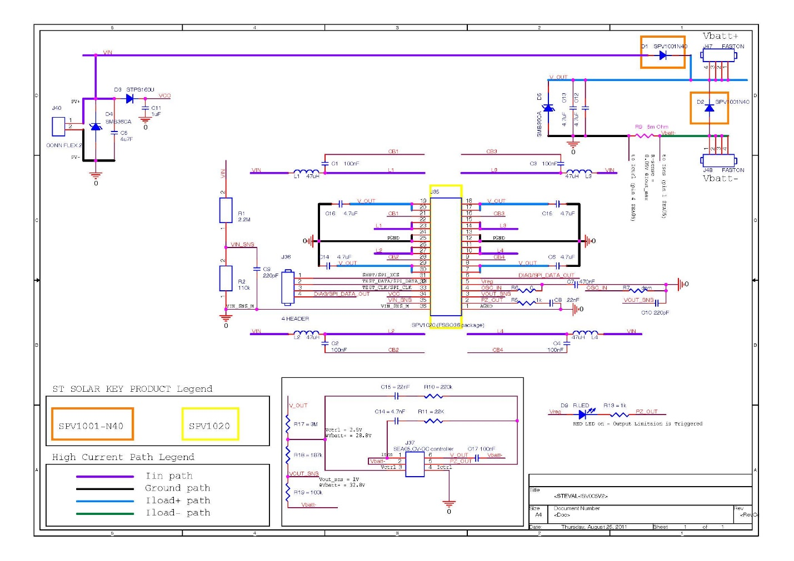
Figure 31: ISV005V2 Circuit Schematic
4.3.3.5.3 Test/Verification Plan
In order to be absolutely sure that the calculations are correct, simulations will be constructed using the MultiSim circuit design program. After a sufficient amount of testing with different combinations of resistor values are conducted, the solution that will require the leas amount of alteration to the board will be chosen as the correct course of action.
4.3.3.5.4 Expected Outcome
The new resistor(s) values will be purchased through a third party such that they are able to fit into the board and are rated to the same current and voltage standards as well as tolerance. This task should take less than a week to accomplish accounting for shipping time.
4.3.3.6 Resistor Correction
4.3.3.6.1 Objective
The main objective is to achieve an output voltage of at least 26V such that the battery is able to be charged. Another objective is to avoid damage to the board’s other components in order to maintain the ISV005V2’s functionality.
4.3.3.6.2 Approach
Micro soldering will be the technique used to replace the resistor(s) so that the correct output voltage can be achieved. Safety precautions for the ISV005V2 board will be the utilizations of a heat sink as well as Helping Hands.
4.3.3.6.3 Test/Verification Plan
First, the heat sink will be used so that the insulation of the board does not melt while changing the resistors. This will be paramount to maintaining functionality after the resistor change. Secondly, Helping Hands are a device that hold the object in place while soldering to avoid error caused by shaky hands or slipping. The Helping Hands will most likely be provided via senior design lab, College of Engineering or privately funded by a group member.

4.3.3.6.4 Expected Outcome
The ideal outcome of this task is for the functionality of the ISV005V2 board to be maintained as well as the output voltage to be increased to the required voltage. The newly soldered DC-DC converter will then be tested to see whether or not the correction was a success.
4.4 Safety Testing Plan:
The team has completed a preliminary safety testing plan. As the project progresses and design decisions have been analyzed and finalized, the group intends to add to the safety testing plan. Below are the safety testing plans as outlined in the Needs and Requirements Analysis:
SR-2.001: A permanent ﬁre retardant Bulkhead must completely separate and effectively seal the vehicle’s propulsion and energy storage systems from the driver’s compartment.
Location: COE parking lot
Tester: All team members
Steps:
- Use pre-certified fire-proof materials to seal the compartments.
- Use a compressed air or liquid test to ensure that compartments are fully sealed.
SR-2.002: Fully harnessed drivers must be able to vacate their vehicle at any time without assistance in less than 10 seconds.
Location: COE parking lot
Tester: All team members
Steps:
- Test the nominated driver with a stop watch to ensure that they are able to exit the vehicle within 10 seconds with the current design.
SR-2.003: The safety harness for the driver must be propriety, i.e. speciﬁcally manufactured for motorsport use, and withstand a force of at least 1.5 times the driver’s weight.
Location: COE parking lot
Tester: All team members
Steps:
- Add additional material to driver while in harness to test whether it can withstand 150% of driver weight.
SR-2.004: Vehicle must be ﬁtted with a ﬁre extinguisher (ABS or BC type) with minimum extinguishing capacity of 2lb.
Location: COE parking lot
Tester: All team members
Steps:
- Ensure that fire extinguisher has an extinguishing capacity of at least 2 lb.
- Make sure that the extinguisher is included in the chassis while maximizing ergonomics.
5 Risk Assessment
5.1 Competition Requirements:
In order to compete in the Shell Eco Challenge Marathon a technical write up for the vehicle is required. The technical write up must include a detailed description of the motor, motor controller, and all electrical and mechanical systems. Most of these components and systems are going to be built by the senior design team but the motor was left to them by last year’s team. The motor that was purchased last year did not come with a technical description nor is one readily available online. The team member assigned to completing the technical write up will need to get in contact with the manufacture to obtain the details required for this competition.
5.2 Chassis Failure:
The chassis to be used by this year’s team was design and manufactured by the previous year’s senior design team. It is a monocoque structure and does not contain any internal frame work. The vehicle’s shell must be able to support the full structural load of all the necessary components without any deformation occurring. If the chassis is not able to support the full load of the necessary components and the driver it will have to be redesigned and remanufactured. This could lead to a total project failure and the design team will not be able to compete in the competition. In order to not jeopardize the structural integrity of the vehicle any drilling into the chassis must be kept to a minimum.
5.3 Bulkhead Design and Installation:
For the Shell Eco Challenge Marathon it requires that a permanent bulkhead be installed that separates the driver from all electrical and propulsion system components. The final layout of the electrical and mechanical systems has not been finalized and is likely to change during the design process which leads the design of the bulkhead to be put off till later in the design process. Leaving a major component that is required to compete till later in the process is risky but by using materials available in the Engineering School machine shop and simple designs the engineering team hopes to minimize this risk. If the design team is not able to complete the bulkhead they will not be permitted to compete in the competition.
5.4 Motor Controller Failure:
New for this year, the competition requires that each team construct their own motor controller. Building and programing a motor controller for a DC Brushless 3 phase motor is new to the design team. If they fail to properly construct the motor controller it could lead to a catastrophic design failure. The vehicle would likely not operate properly and could cause the motor to burn out or even overload the wires and circuits. By starting this process early in the design phase and using a mock motor during the testing phase the team hopes to minimize this risk.
5.5 DC to DC Boost Converter Failure:
The DC- Booster is what will allow the team to charge the propulsion battery from the solar panels. Last year’s design team was not able to charge the battery due to improperly placed resistors on the DC-Booster’s circuit board. If the design team is unable to reorder these resistors properly the panels will not be able to charge the battery during operation which was a key aspect in the design. To ensure this aspect of the design is operating properly it is one of the first tasks scheduled by the team in the design process. Once completed it will be tested to ensure it is operating properly before being installed into the chassis.
5.6 Steering Failure:
The competition requires the design team’s vehicle to have an 8 meter turning radius. By designing the wheel mount and steering assemblies to be capable of a nearly 360 degree rotation the design team will use the steering component, either rack and pinion or plate steering, to limit the turning radius to the required 8 meters. The team will also test the vehicles turning radius prior to competition to ensure it is operating properly. This is a key requirement to compete in the competition and if the design team does not meet the requirement they will not be permitted to compete in the competition.

5.7 Braking Failure:
The competition requires the vehicle to have two operating braking systems, one that acts of the front wheels and one that acts on the back wheels. The systems must be able to be engaged without having to remove a hand from the steering wheel. Each braking system must be capable of holding the vehicle in place on a 20 degree incline which will be tested at the competition. This will be a first time experience for the group members to design and install a fully functioning braking system. With the help of Dr. Hollis, and the knowledge of the required braking force needed to hold the car in place on the incline, the design team is confident they will be able to design and implement an efficient braking design.
5.8 Solar Panel Installation Failure:
Shell Eco Challenge Marathon requires that the solar cells be installed and seated flush with the surface of the car. This is one area of the design process that the team has not yet addressed. The team will need to come up with a plan to meet this requirement. With the help of Dr. Hollis and the staff over at HPMI the team will be able come up with a process to properly seat and anchor our solar panels.
6 Qualifications and Responsibilities of Project Team
6.1 Team Qualification
The current FAMU-FSU College of Engineering 2014 Solar Car team consists of industrial, mechanical, and electrical engineers. Each member of the team possesses specific qualities, skills and abilities which qualify them to work on this project. Industrial engineers will use their cost analysis, ergonomics, manufacturing, quality, and safety skills in order to assure that the vehicle is well built and reliable. Mechanical engineers will use their design knowledge and capabilities in order to create virtual representations of each component of the vehicle. Using these virtual representations testing and analysis will be performed to ensure that every component meets the requirements and fits together properly. Electrical engineers will use their knowledge of electrical components, programing, and wiring in order to build and wire the vehicles electrical components. Using a combination of these skills and abilities the team will design, build, and test a competition ready solar car for the 2014 Shell Eco-marathon.
6.2 Individual Tasks
Task # | Task Name | Assignment
3 | Seat design and analysis | David Jolicoeur &  Francois Wolmarans
4 | Seat manufacture | All industrial and mechanical engineers
5 | Seat installation | All industrial and mechanical engineers
6 | Roll bar design and analysis | Wael Nabulsi &  Jose Cardenal
7 | Roll bar manufacture | All industrial and mechanical engineers
8 | Roll bar installation | All industrial and mechanical engineers
9 | Front wheel mount design and analysis | James Croasmun &  Jose Cardenal
10 | Front wheel mount manufacture | All industrial and mechanical engineers
11 | Front wheel mount installation | All industrial and mechanical engineers
12 | Front wheel steering design and analysis | James Croasmun &  Francois Wolmarans
13 | Front wheel steering manufacture | All industrial and mechanical engineers
14 | Front wheel steering installation | All industrial and mechanical engineers
15 | Front wheel brake design and analysis | David Jolicoeur &  Francois Wolmarans
16 | Front wheel brake manufacturing | All industrial and mechanical engineers
17 | Front wheel brake installation | All industrial and mechanical engineers
18 | Rear wheel mount design and analysis | Wael Nabulsi & Jose Cardenal
19 | Rear wheel mount manufacture | All industrial and mechanical engineers
20 | Rear wheel mount installation | All industrial and mechanical engineers
21 | Rear wheel brake design and analysis | David Jolicoeur & Francois Wolmarans
22 | Rear wheel brake manufacture | All industrial and mechanical engineers
23 | Rear wheel brake installation | All industrial and mechanical engineers
24 | Motor controller design and analysis | Fritz Jeanty
25 | Motor controller manufacture | All electrical engineers
26 | Motor controller installation | All electrical engineers
27 | Solar panel installation | Wael Nabulsi
28 | Tire/wheel design and analysis | Wael Nabulsi & Jose Cardenal
19 | Tire/wheel manufacture | All industrial and mechanical engineers
30 | Tire/wheel installation | All industrial and mechanical engineers
31 | Battery compartment design and analysis | Wael Nabulsi & Jose Cardenal
32 | Battery compartment manufacture | All industrial and mechanical engineers
33 | Battery compartment installation | All industrial and mechanical engineers
34 | Bulk head design and analysis | James Croasmun & Francois Wolmarans
35 | Bulk head manufacture | All industrial and mechanical engineers
36 | Bulk head installation | All industrial and mechanical engineers
37 | Rear mirror design and analysis | James Croasmun & Jose Cardenal
38 | Rear mirror manufacture | All industrial and mechanical engineers
39 | Rear mirror installation | All industrial and mechanical engineers
40 | Testing and tuning | Entire team
41 | Pedal and sensory component installation | All industrial and mechanical engineers
42 | Resistor replacement and mathematics test | Zachary Barr
43 | Installation of new resistors | Zachary Barr
44 | Accessory battery installation | Julia Clarke
45 | DC-DC converter test | Zachary Barr
46 | DC-DC converter installation | Zachary Barr
47 | Propulsion system wiring | Fritz Jeanty
48 | Accessory battery wiring | Julia Clarke
49 | Wiring system isolation | All electrical engineers
50 | System shutdown switch tests | All electrical engineers
51 | System shutdown switch installation | All electrical engineers
Table 11: Individual Tasks
6.3 Individual Qualifications
Tasks were assigned to each team member based on their individual skills and abilities. Each team member’s individual skills, knowledge, and qualifications are listed in Appendix 3 Resumes. Tasks assigned to all engineers within a specific discipline must have at least fifty percent of the engineers from discipline present in order to proceed.
6.3.1 Fritz Jeanty
Fritz Jeanty is studying electrical engineering at The FSU/FAMU College of Engineering. Jeanty is the engineer responsible for the motor controller in this project. Jeanty has taken relevant courses at the FSU/FAMU College of Engineering that qualifies him to work on the motor controller. These courses include: C++ programming, Electronics, Electronics Lab, Digital Logic, Digital Logic Lab, Microprocessor Based System Design and Microprocessor Based System Design Lab.
6.3.2 Francois Wolmarans
Francois Wolmarans is a senior double majoring in Industrial & Manufacturing engineering and Chinese Language & Culture. He is employed by the High Performance Materials Institute as a research assistant for carbon nanotube and grapheme related research projects. His experience in education and research has given him the skill set necessary to participate in a large and complex senior design project. Additionally, he has founded 3 startups of which 2 have been profitable. His experience in starting companies has given him the time management, communication skills, and financial expertise necessary for his role as financial advisor and treasurer for the Solar Car project.
6.3.3 Jose Cardenal
Jose Cardenal is a senior a majoring in Industrial and Manufacturing engineering with minors in math, physics, and business. As a senior industrial engineer with all core courses completed Jose is qualified to supervise and implement ergonomic considerations, planning, scheduling, and cost analysis. He has previously worked as a Process improvement and Analysis engineer at VISA, a Research Assistant at the High Performance Research and Materials Institute, and a Mechanical Engineer at square one armoring services. His previous experience as a process improvement and analysis engineer give him the expertise necessary to assure that the vehicle will reach its optimal capabilities. Furthermore, his work in materials research and manufacturing qualify him to be the lead IE within the team.

6.3.4 Julia Clarke
Julia Clarke attends Florida A&M University and is studying electrical engineering. Julia is responsible for the accessory battery and the emergency shutdown for the project. Julia Clarke is currently enrolled in energy storage and learning about different types of batteries and their pros and cons. Julia has a great interest in batteries that qualifies her to work on this part of the project.
6.3.5 Zachary Barr
Zachary Barr is currently a senior at the FSU/FAMU College of engineering and will be receiving a bachelor’s of science in electrical engineering December 2014. His experience with soldering electronics and Multisim a circuit design program qualify him to be the Lead electrical engineer for the project. As the lead electrical engineer he will be responsible for the DC-DC converter correction, and supervising all electrical aspects of the vehicle.
6.3.6 Wael Nabulsi
Wael Nabulsi is a senior mechanical engineer at the Florida State University. He is the installation manager for all the mechanical components in the car including rear brakes, front brakes, steering, and roll bar. The previous classes and experience acquired through his career will be improvised on this year’s design. All the hands on designs and machining will be completed at the Applied Super Conductivity center where he is currently employed. Wael Has had two semester of hands on machining skills at the ASC, and those skills will be applied to weld, produce, and build any component required to qualify for the solar car completion. Previous courses like intro to mechanical engineering, mechanical engineering tools, and vehicle design have outstandingly prepared him to improve, test, stimulate and develop the wining solar car for the year 2014.

6.3.7 David Jolicoeur
David Jolicoeur is responsible for all the major mechanical designs that need to be tested, approved, and manufactured for the completion of the solar car. This includes the design of the seat, new roll bar, steering systems, bulk heads, and solar panel installation. The various courses that he has passed, including mechanical engineering tools, mechanical systems, dynamic systems, and mechatronics have uniquely prepared him to be an essential part of the American Solar Car Challenge design team. In addition he is currently enrolled in Energy Conversions for Sustainability and Vehicle Design which exclusively complements this Senior Design Project to build a vehicle from a sustainable resource, solar energy.
6.3.8 James Croasmun
James Croasmun is a senior studying mechanical engineering at Famu/Fsu College of Engineering. He is the lead Mechanical Engineer on the Shell Eco-Challenge Marathon Solar Car. He will be graduating spring 2014 with a Bachelors of Science in Mechanical Engineering with a specialization in thermal dynamics. He will also be receiving minors in physics and mathematics. He is responsible for the car’s front wheel mount system and steering assemblies. He will oversee all the projects that are to be completed by the mechanical engineers and will relay information to the project leader Fritz Jeanty. He has passed various courses that have trained him to analyze, design, and construct different types of dynamic systems.

7 Schedule
The team has created a Gant chart to indicate the task by task scheduling from the project start to the project completion. The schedule has been broken down into four main sections: design, manufacturing, installation, and testing. All design aspects must be completed prior to the start of manufacturing in order to adhere to a concurrent engineering design philosophy. According to the Gant Chart schedule the design portion of the project will take place between October 14, 2013, and November 16, 2013. Once all design aspects have been completed the team will begin manufacturing each component of the vehicle According to the Gant chart schedule the manufacturing phase of the project will take place between December 16, 2013 and February 12, 2014. Once the manufacturing has been completed the team will begin the component installation which will last approximately 30 days. Once all components have been installed and the vehicle is fully functioning a 15 day testing period will take place. Based on the Gant Chart results the following steps will be considered the critical path: front wheel mount design and analysis, front wheel steering design and analysis, front wheel brake design and analysis, tire manufacture, component installation, and testing.
The team’s competed Gant chart can be found in Appendix 4 Gant Chart. The teams completed network diagram can be found in Appendix 5 Network Diagram.

8 Budget Estimate
Part # | Part Name | Number of Parts | Estimated Part Cost | Total Cost
1 | Chassis | 1 | Provided | $0.00
2 | Front Wheel Mount | 2 | TBD | $0.00
3 | Front Wheel | 2 | $30.00 | $60.00
4 | Tie Rod | 2 | $30.00 | $60.00
5 | Front Wheel Brake System | 2 | $100.00 | $200.00
6 | Steering Column | 1 | $60.00 | $60.00
7 | Steering Wheel | 1 | TBD | $0.00
8 | Roll Bar/Rear Motor Mount | 1 | $500.00 | $500.00
9 | Rear Wheel Brake | 1 | $30.00 | $30.00
10 | Rear Wheel Tire | 1 | $12.00 | $12.00
11 | Seat | 1 | TBD | $0.00
12 | Seat Mount Rail | 2 | TBD | $0.00
13 | Pedal | 3 | TBD | $0.00
14 | Front Bulk Head | 1 | TBD | $0.00
15 | Rear Bulk Head | 1 | TBD | $0.00
16 | Motor Controller | 1 | $200.00 | $200.00
17 | Wiring (Set) | 1 | $50.00 | $50.00
18 | Bolts (Set) | 1 | $50.00 | $50.00
19 | Clamps (Set) | 1 | $20.00 | $20.00
20 | Horn | 1 | $10.00 | $10.00
21 | Accessory Battery | 1 | $160.00 | $160.00
22 | Rear View Mirror Right | 1 | $15.00 | $15.00
23 | Rear View Mirror Left | 1 | $15.00 | $15.00
24 | Flame Retardant Suit | 1 | $100.00 | $100.00
25 | 5 Point Harness (Seat Belt) | 1 | $80.00 | $80.00
26 | Helmet | 1 | $30.00 | $30.00
27 | Paint | 1 | $120.00 | $120.00
28 | Super Capacitor (Set) | 1 | $50.00 | $50.00
29 | Diode (Set) | 1 | $10.00 | $10.00
30 | Odometer (Set) | 1 | $25.00 | $25.00
31 | Resistor (Set) | 1 | $10.00 | $10.00
 |  | 35 | $1,707.00 | $1,867.00
 | Starting Budget: | $6,000.00
 | Expenditures: | $1,867.00
 | Remaining Budget: | $4,133.00

Table 12: A budget estimate of personnel expenditures

Name | Hours | Hourly Pay | Weekly Pay | Semesterly Pay¹ | Yearly Pay² | Fringe Benefits³
Jose Cardenal | 12 | $30.00 | $360.00 | $5,760.00 | $11,520.00 | $3,340.80
Francois Wolmarans | 12 | $30.00 | $360.00 | $5,760.00 | $11,520.00 | $3,340.80
Zachary Barr | 12 | $30.00 | $360.00 | $5,760.00 | $11,520.00 | $3,340.80
Fritz Jeanty | 12 | $30.00 | $360.00 | $5,760.00 | $11,520.00 | $3,340.80
Julia Clarke | 12 | $30.00 | $360.00 | $5,760.00 | $11,520.00 | $3,340.80
Wael Nabulsi | 12 | $30.00 | $360.00 | $5,760.00 | $11,520.00 | $3,340.80
James Croasmun | 12 | $30.00 | $360.00 | $5,760.00 | $11,520.00 | $3,340.80
David Jolicouer | 12 | $30.00 | $360.00 | $5,760.00 | $11,520.00 | $3,340.80
 |  | $240.00 | $2,880.00 | $46,080.00 | $92,160.00 | $26,726.40
¹ Based on 16 week semester
² Based on 32 week year
³ Calculated as 29% of yearly pay

Table 13: A summary of all costs and total estimated project cost

Expenditure | Cost
Personnel | $92,160.00
Fringe Benefits | $26,726.40
Expenses | $1,867.00
Equipment¹ | $0.00
Sub-Total | $120,753.40
Overhead Costs² | $54,339.03
Total Estimated Project Cost | $175,092.43
¹ Costs exceeding $1000
² Calculated as 45% of direct costs

9 Deliverables
Throughout the course of the project the team will be responsible for submitting a series of deliverables including reports, presentations, and a finalized product. The project will contain three major deliverables or milestones throughout the fall semester. Each milestone will be divided into two parts. Part one will consist of a detailed report, and part two will be a follow-up presentation for the respective report. Furthermore, the team will be responsible for creating and maintaining a team website which displays all current progress, reports, and relevant team information.
Competition deliverables also include a series of registrations. “Phase 1 Registration” includes a statement of motivation, preliminary car model, team name, car name, contact information, vehicle classifications, and a link to documentation and social media website. “Phase 2 Manual Registration” includes a completed vehicle manual with design specifications and drawings.

Deliverable | Due Date
Project Start | 09/09
Milestone 1: Needs Analysis and Required Specifications Report | 09/19
Milestone 1: Needs Analysis and Required Specifications Presentation | 09/23-09/27
Milestone 2: Project Proposal Report | 10/17
Milestone 2: Project Proposal Presentation | 10/21-10/25
Phase 1 Registration | 10/25
Milestone 3: Conceptual/System Level Design Review Report | 11/14
Milestone 3: Conceptual/System Level Design Review Presentation | 11/18-11/22
Peer Evaluation | 12/06
Phase 2 Manual Registration | 12/20
Completed Product | 05/2014
Table 14: Deliverables

10 References
"Adjusting Direct-pull Cantilever Bicycle Brakes ("V-Brakes Â®")." Adjusting Direct-pull Cantilever Bicycle Brakes ("V-Brakes Â®"). N.p., n.d. Web. 17 Oct. 2013.
"How to Repair a Bicycle." HowStuffWorks. N.p., n.d. Web. 17 Oct. 2013.
"UK's Largest Stockist of Tillett Car Seats." Tillett. N.p., n.d. Web. 17 Oct. 2013.
"Shell Eco-Marathon Solar/Battery Powered Car." Solar/Battery Car. N.p., n.d. Web. 17 Oct. 2013.
"Steval." EVAL-ISV005V2 240 W Photovoltaic Battery Charger Based on the SPV1020. Steval, n.d. Web. 17 Oct. 2013. <http://www.st.com/web/catalog/tools/FM116/SC1078/PF253078>.
"Model TCDC-7001." Mouser Elecrtonics. N.p., n.d. Web. 17 Oct. 2013. <http://www.mouser.com/ds/2/397/Tamura%20TCDC7001%20spec%20sheets-217696.pdf>.

11 Appendix
11.1 A1: Fish Bone Analysis
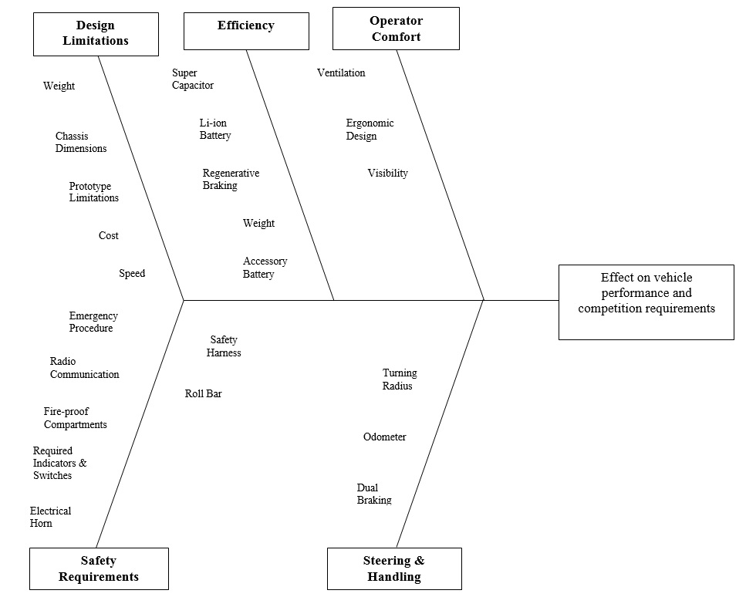

11.2 A2: House of Quality
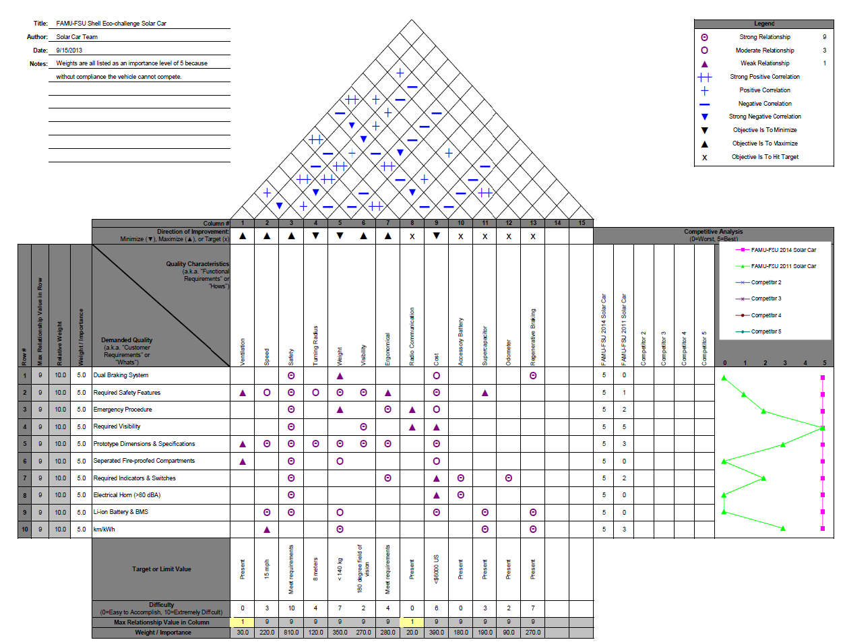

11.3 A3: Resumes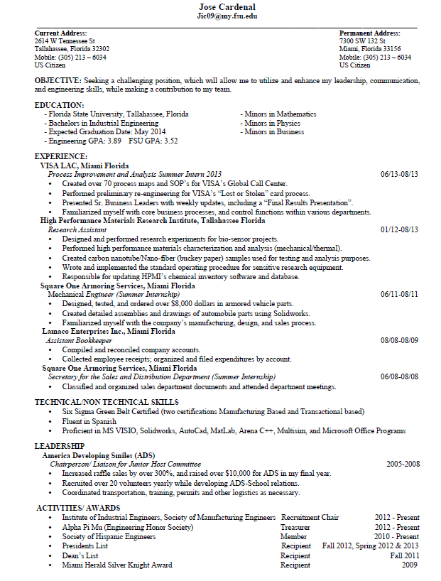








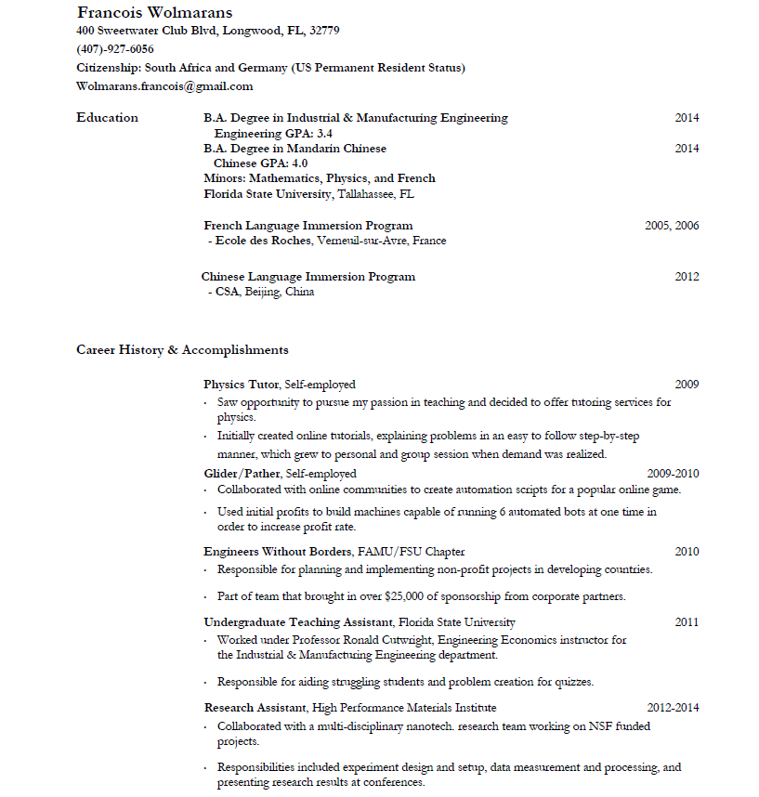




11.4 A4: Gant Chart
