FAMU-FSU College of Engineering
Department of Electrical and Computer Engineering
System Level Design and Review

Solar Flare

EEL4911C – ECE Senior Design Project I
Project title: FAMU-FSU Shell Eco-Marathon Solar Car 2014
Team #: 2

Student team members:
- Fritz Jeanty, electrical engineering (Email: Fj08c@my.fsu.edu)
- James Croasmun, mechanical engineering (Email: Jgc10c@my.fsu.edu)
- Zachary Barr, electrical engineering (Email: Zacharywbarr@gmail.com)
- Julia Clarke, electrical engineering (Email: Julia1.clarke@famu.edu)
- David Jolicoeur, mechanical engineering (Email: David1.jolicoeur@famu.edu)
- Jose Cardenal, industrial & manufacturing engineering (Email: jic09c@eng.fsu.edu)
- Wael Nabulsi, electrical engineering (Email: wn11@my.fsu.edu)
- Francois Wolmarans, industrial & manufacturing engineering (Email:fw07@my.fsu.edu)

Senior Design Project Instructor: Dr. Edrington, Chris
− Dr. Frank, Michael
− Dr. Amin, Kamal
− Dr. Hollis, Patrick
− Dr. Okoli, Okenwa

Submitted in partial fulfillment of the requirements for
EEL4911C – ECE Senior Design Project I

April 28, 2014

Project Executive Summary
The Shell Eco-marathon is a long standing competition, in which Shell challenges students and enthusiasts from around the world to push the envelope for energy efficient vehicle designs. The competition gives teams the opportunity to design, build, and test their vehicles in a competitive winner-take-all environment. There are several different categories to compete in depending on the source of power of the vehicle. The current FAMU-FSU College of Engineering 2014 Solar Car team will participate in the solar car division.
The competition has two classes (each with their own rules and regulations) in which teams can compete: Urban Concept and Prototype. The Urban Concept class promotes building a practical vehicle that can operate under normal road driving conditions. Alternatively, the Prototype class encourages participants to stretch the boundaries of efficiency by making ergonomic trade-offs. For both vehicle classes, competitors will use as many attempts as possible in order to see how far the vehicle can run on the equivalent of one liter of fuel. The competition requires that all vehicles have a fixed speed and number of laps. A winner will be named for each class and fuel type, with additional prizes going to teams with a strong consideration for safety, teamwork, design, and technical innovation. The FAMU-FSU 2014 Solar Car team will participate in the prototype class, with a solar-based fuel source.
Over a period of several days, teams will be given several attempts in order to test the vehicles using a pre-determined asphalt track in Houston, Texas. The competition organizers will measure the efficiency of each run, and will then use the best run among the set in order to determine the winners for each class and energy source.

The FAMU-FSU 2014 Solar Car team plans to build a Prototype-class vehicle with a sleek profile, which minimizes nose area in order to minimize the drag on the car. The chassis will consist of carbon fiber due to its low weight and high strength. Additionally, we hope to use lightweight metals (such as aluminum) to build the seat, support structures, and mechanical parts. Based on the rules and regulations of the competition, the team will have several fireproof compartments (separated by bulkheads) in order to protect the driver. A strong consideration is given to safety, including features such as a 5-point safety harness, a roll bar, and an emergency shutdown button.
The team’s primary goal is to place in the top 3 for its class and energy source division. Additionally, the team intends on being strong competitors for the safety, teamwork, and design prizes. Winning teams are awarded a prize of $5000, which could be used by future FAMU-FSU Shell Eco-Challenge teams to improve upon future designs, and purchase high quality components. Furthermore, a prize-winning placement would establish FAMU-FSU as a serious competitor in the American division, and recognize the college and advisors who have invested time and money into the project.

Table of Contents

Project Executive Summary 2
Table of Contents 4
List of Figures 12
List of Tables 14
1 Introduction 15
1.1 Acknowledgements 15
1.2 Problem Statement 15
General Problem Statement 15
General Solution Approach 16
1.3 Operating Environment 17
1.4 Intended Use(s) and Intended User(s) 17
1.5 Assumptions and Limitations 18
1.6 End Product and Other Deliverables 19
2 System design 20
2.1 Mechanical Overview of the System 20
2.2 Major Components and Requirements of the Mechanical Systems 21
Chassis 21
Roll Bar and Rear Wheel Mount 21
Roll Hoop 22
Steering System 22
Braking System 22
Seat 23
Wheel Systems 23
Bulk Head 23
2.3 Electrical Overview of the System 24
2.4 Major Components and Requirements of the Electrical Systems 25
Solar Panel System 25
Battery System 25
Isolated DC-DC Converter 26
Motor Controller 26
Emergency Shutdown System 27
DC-DC Boost Converter 28
2.5 Performance Assessment and Measurements 29
Center of Gravity (COG) Calculations 29
Weight Ratios Calculations 31
Static Vertical Wheel Load Calculations 32
Turning Radius and Tie Rod Calculations 33
2.6 Design Process 37
Concept Selection Criteria 37
Concept Selection Criteria Prioritization 38
Design Selection 39
3 Design of Major Component Subsystems 41
3.1 Chassis 41
3.2 Roll Bar & Rear Motor Mount 42
3.3 Roll Hoop 45
3.4 Steering System 46
Front Wheel Mount 48
Front Wheel Arm 49
Ball Bearings 50
Tie Rods 51
Rack and Pinion 52
U-Joint 53
Steering Column 54
Steering Wheel 55
3.5 Braking Systems 55
Rear Braking 56
Front Braking 57
Caliper 58
Caliper Mount 59
Front Wheel Arm 60
3.6 Seating System 61
Seat 61
Seat Bracket 62
3.7 Front Wheel Systems 63
3.8 Solar Panel System 64
Solar Array 64
3.9 Battery System and Isolated DC-DC Converter 68
Battery and Battery Management System (BMS) 68
Isolated DC-DC Converter 70
3.10 Motor Controller 71
3.11 Motor 73
3.12 Propulsion System and Emergency Shutdown System 73
3.13 DC-DC Converter 75
SUBSYSTEM: ISV005V2 75
4 Test Plan 77
4.1 Mechanical Tests 77
Roll Bar and Motor Mount 77
Turning Radius 78
Braking Test 79
Front Wheel Mount 80
Front Wheel Arm 81
4.2 Electrical System Tests 82
Solar array & Steval ISV005V2 DC-D Boost Converter 82
Solar Cell Array 84
Steval ISV005V2 DC-DC Boost Converter 85
Solar World Solar Cell 87
Newly constructed solar array 88
Newly constructed solar array with converter and battery 89
Isolated DC-DC Converter 90
Battery Discharge – 1C 91
Battery Discharge – 2C 92
Battery Discharge – 0.5C 93
Battery Charging Capabilities 94
Battery Integration 95
Motor Controller 96
Motor 97
Emergency Shutdown System Test 1 98
Emergency Shutdown System Test 2 100
Emergency Shutdown System Test 3 102
Emergency Shutdown System Future Test Plan 104
4.3 Safety Testing 105
Ventilation 105
Fire Retardant Bulkhead 106
Five Point Harness 107
5 Schedule 109
6 Budget 113
7 Overall Risk Assessment 115
7.1 Technical Risks 115
Competition Requirements 115
Chassis Failure 115
Steering Failure 116
Braking Failure 116
Bulkhead Design and Installation 116
Motor Controller Failure 117
DC-DC Conversion System 117
DC-DC Conversion Stage: ISV005V2 117
Battery Failure 118
Solar Panel Installation Failure 118
7.2 Schedule Risks 118
Ordered Parts 118
Required Equipment 119
Overlooked Designs 119
Testing Phase 119
7.3 Budget Risks 120
Funding Requests 120
Indirect Material Costs 120
Pricing Estimates 120
8 Conclusion 121
9 References 124
Appendix 126
A1: Fish Bone Analysis 126
A2: House of Quality 127
A3: Gantt chart 135
A4: Motor Controller Specs 136
A5: Roll Bar and Rear Wheel Mount 141
A6: Roll Hoop 142
A7: Front Wheel Arm 143
A8: Caliper Mounts 144
A9: Front Wheel Mounts 145
A10: Czochralski Process 146
A11 Solar Cell Technical Specifications 146
A12: Sanyo Denki Fan and Specifications 147
A13: Isolated DC-DC Converter Specifications 148
A14: LM5000 DataSheet 149
A15: Bill of Materials 150
A16 Stress Calculation Results 151
Front Mount Stress Calculation Results and Constants 151
Front Mount Moment Calculation Results and Constants 151
Square Tube Calculation Results and Constants 151
Wheel Hub Bolt Calculation Results and Constants 152
A17 Roll Bar & Front Wheel Mount Test Results 153
A18 Front Wheel Mount Test Results 154
A19 Front Wheel Arm Test Results 155

List of Figures
Figure 1 Block diagram 1 of the mechanical system 20
Figure 2 block diagram 2 of the Mechanical system 20
Figure 3 Block diagram 3 of the Mechanical System 21
Figure 4 Top Level Design of Electrical System [1] 24
Figure 5 Top level design of motor controller 27
[4] Figure 6 Turning Radius Diagram 33
Figure 7 Chassis 41
Figure 8 Roll Bar and Rear Wheel Mount 42
Figure 9 New Roll Bar 44
Figure 10 Roll Hoop 45
Figure 11 Steering System 46
Figure 12 Diagram of the steering System 47
Figure 13 Front Wheel Mount 48
Figure 14 Front Wheel Arm 49
Figure 15 Bearings [11] 50
Figure 16 Tie Rod 51
Figure 17 Rack and Pinion 52
Figure 18 U- Joint [11] 53
Figure 19 Steering Column 54
Figure 20 Steering Wheel 55
Figure 21 Braking System 56
Figure 22 Front Brakes 58
Figure 23 Calipers 58
Figure 24 Caliper Mount 59
Figure 25 Front Wheel Arm 60
Figure 26 Seat 61
Figure 27 Seat Brackets 62
Figure 28 Front Wheel 63
Figure 29 Photo Of The Monocrystanlline Solar Cells [1] 65
Figure 30 Solar Array Configuration Options [1] 66
Figure 31 Demonstration of Solar Panel Implementation [1] 67
Figure 32 Electric Ride LiFePO4 Battery Back [1] 69
Figure 33 Electric Ride LiFePO4 Battery Back [1] 69
Figure 34 Turnigy Watt Meter and Power Analyzer [1] 69
Figure 35Turnigy Monitor Connections [1] 70
Figure 36 Isolated DC-DC Converter Configuration 71
Figure 37 LM25017 Isolated DC-DC Converter [5] 71
Figure 38 Motor Controller (TI DRV 8301 69M-Kit) 73
Figure 39 Propulsion and Shutdown System Diagram 74
Figure 40 ISV005V2 Board [8] 76
Figure 41 Diagram demonstrating the Czochralski process 146
Figure 42 Sanyo Denki Fan 147
Figure 43 Sanyo Denki Fan Specifications 147
Figure 44 Specifications for the LM25017 Isolated DC-DC Converter 148

List of Tables
Table 1 Distance From the Part to the Roll Bar/Motor Mount 29
Table 2 Component Weights 30
Table 3 Moment Calculation Results 30
Table 4 Distance Front the Cars Center of Gravity to the Front of the Vehicle And to the Roll Bar 31
Table 5 Weight Ratios 32
Table 6 Static Vertical Wheel Loads 32
Table 7 Turning Radius Dimensions 34
Table 8 Turning Radiuses for various Wheel Widths 35
Table 9: Overall Project Budget 114
Table 10 Solar Cell Irradiation Profile 146
Table 11 Solar Cell Temperature Coefficients 146
Table 12 Solar Cell Electrical Performance 147

1 Introduction

1.1 Acknowledgements
The FAMU-FSU 2014 Solar Car team would like to thank the High Performance Materials Institute (HPMI) at Florida State University (FSU) for their generous donation of the materials necessary to build the vehicle. We would also like to thank Dr. Edrington and Jesse Leonard for their help with the motor control components and actualization. Additionally, we would also like to thank Dr. Edrington, Dr. Frank, and Dr. Amin for their technical support and guidance throughout the process. Their contributions have been invaluable allowing the team to make the necessary decisions which have carried the project forward. Additionally we would like to thank Dr. Liang, Dr. Okoli, Mr. Allen, and Mr. Horne for their role in the donation of materials and technical assistance in building the carbon fiber chassis. Lastly, we would like to thank Dr. Mei Zhang, Dr. Oscar Chuy, Dr. Helen Li, Hai Hoang Van, Dante Ford, Thierry Kamaranga, Mike Greenleaf, Jeremy Phillips, James in the machine shop, Phil from Foraker, and University Cycle for their contributions in solving technical challenges.

1.2 Problem Statement

General Problem Statement
The team is required to build a solar-powered electrical vehicle which conforms to the rules and regulations of the Shell 2014 Eco-Challenge competition. The car is required to have several features which will ensure the safety of the driver and reduce the risk of mechanical or electrical failure. There are several dimension limitations including the height, width, ratio of height to track width, wheelbase, total length, and vehicle weight. Additionally, there are minimum standards established for the turning radius, and braking requirements. The primary concern for ranking in the competition is the efficiency of the vehicle, which will be determined by the organizer’s evaluation. The largest problem that has to be solved is striking a balance between the necessary trade-offs for the weight, the cost, and the safety of vehicle.

General Solution Approach
This project is a large and complex undertaking. In in order to determine where and how to begin, the team performed a house of quality analysis with the input of all 3 engineering disciplines. Using the competition rules and regulations as customer requirements and tentative components as quality characteristics used to fulfill those customer requirements; we were able to get a better understanding of how to prioritize objectives. Based on the results, we determined that the cost, weight, and safety of the vehicle were going to be the areas of concern. Ergonomic considerations also ranked high, but due to the nature of the prototype division, there is room for slack in this area.
Cost was kept as a primary concern to ensure that we stayed on (or below) budget. With this in mind we set out to minimize the weight of the overall design. The largest contributor to the weight was the chassis due to its relatively large size. In order to minimize weight it was decided that a low weight yet high strength material was necessary. After consulting with faculty, the 2013 team decided to build the chassis using carbon fiber donated by the High Performance Materials Institute. This decision was made after alternatives were eliminated due to cost or technical difficulty.
Additionally, the team has decided to use aluminum for additional mechanical parts, as well as stationary parts, such as the seat and roll bar. All design specifications fell within the ranges necessary for participation in the competition. The mechanical engineers were able to design a steering mechanism which would allow for separation of the driver from the mechanical and electrical components, and yield the minimum turning radius. For braking, the team decided to implement a regenerative braking system and a dual front/back braking system.

1.3 Operating Environment
The vehicle will operate on an asphalt track which has been set aside for use for the Shell 2014 Eco-Challenge marathon. The race will take place during the summer months in Houston, Texas. Based on our research, we have determined that dusty conditions and heat could be a concern. Additionally, due to the competition being held during the summer months, there exists a possibility of rainfall. The team has planned for the worst by including a comprehensive terrain and weather test in order to ensure that the vehicle is able to operate in adverse conditions.

1.4 Intended Use(s) and Intended User(s)
Due to the nature of the competition (race) ergonomic design considerations will be made for two drivers. The team has nominated Julia Clarke as the driver for the competition. In the event of an emergency, they have nominated Jose Cardenal as the backup driver. Using anthropometric data for individuals fitting their description, we will design the internal compartments to maximize their safety, accessibility, and field of vision. By performing an analysis of the user’s anthropometry, posture, and repetitive motion, the team will be able to build a vehicle with tailor-fit ergonomic design. The goal is ensure a good fit for both drivers, which will lead to decreased fatigue and discomfort when operating the vehicle.
The vehicle will be used to compete in the 2014 Shell Eco-Challenge marathon. It will be raced on an asphalt track with the equivalent of 1 liter of fuel in order to determine the efficiency. Based on the regulations of the competition, the team does not intend for the car to exceed a speed of 15 mph. The turning radius will not be smaller than 8 meters at any given time. It is possible that the vehicle could be operated in a high heat or rainy environment.

1.5 Assumptions and Limitations
Various assumptions will be made in order to design and construct the vehicle. Each major component of the vehicle has been broken down into three parts. The first part of each component is the “design and analysis” phase. The team will design and analyze each major component within 9 days of the designated starting point. The second part of each component is the manufacturing of major parts. The team will manufacture in-house parts within 21 days of the designated starting point. The team will manufacture parts which require ordered materials, or components within 30 days of the designated starting point in order to provide a 9 day ordering/shipping period for each part. The third part of each major component is the installation. The team will install each major component of the vehicle within two days of the designated start date.
The team will build the following parts in house: front wheel mount, steering wheel, seat, seat mount rail, front bulkhead, and rear bulkhead. These parts will be built in house in order to minimize the cost of the vehicle while building parts that conform to the competitions rules and requirements. The front wheel, rear view mirrors, steering column, braking system, wiring necessities and, board and accessory battery will be purchased. These parts will be purchased in order to assure quality and reliability.
The team shall not exceed an overall cost of $6,000 in the design and manufacturing phase of the vehicle. Once the design and manufacturing phase is completed the car will be up to date with all competition rules and requirements. Furthermore, costs such as competition transportation will come from department funding.
Due to the rules and regulations of the competition the vehicle will have various limitations. Based on the competitions safety regulations the car will have a roll bar which rises a minimum of 5cm over the driver’s head, an escape plan exceeding no more than 10 seconds, fire redundant compartments which separate the driver from all electrical components and from the driving transmission, a 180 degree field of vision, and an emergency shutdown button which turns off all electrical components. Furthermore, based on the dimension and weight limitations placed by the competition the car will have a maximum height less than 100 cm, a minimum vehicle width of 50 cm and a maximum width of 130 cm from the point where the outermost tires touch the ground, a ratio of height divided by track width less than 1.25, a maximum length of 350cm, and a weight less than 140kg. Based on cost limitations, the team shall not exceed $6,000. This limitation is set by the amount of money provided through the project funding.

1.6 End Product and Other Deliverables
The expected end product is a completed and functioning solar-electric powered vehicle which adheres to the rules and regulations of the Shell Eco-Challenge. Additionally the team will produce a technical manual containing the specifications and safety features of the car for Phase II registration by the December deadline. This manual is a check on the team to ensure that they are in compliance with the rules and regulations of the competition.

2 System design

2.1 Mechanical Overview of the System

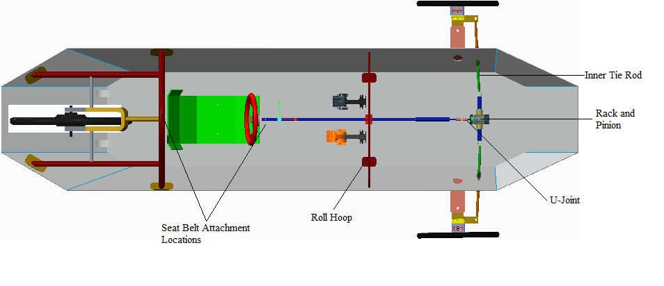
Figure 1 Block diagram 1 of the mechanical system

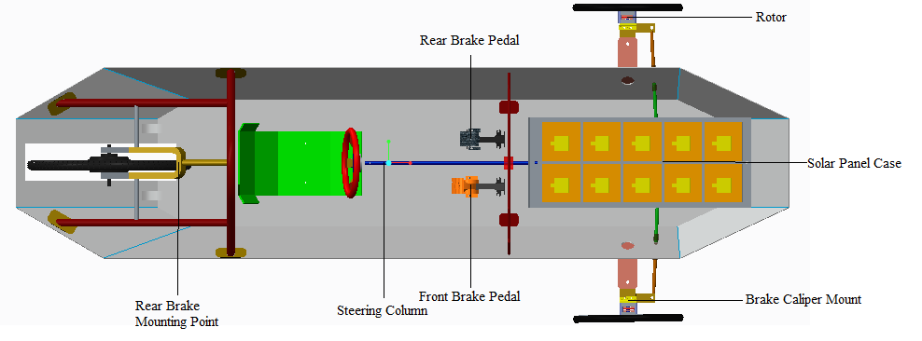
Figure 2 block diagram 2 of the Mechanical system
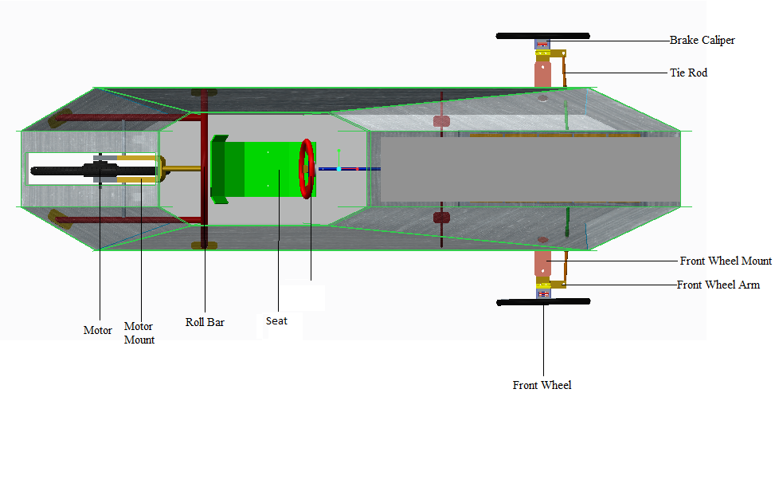
Figure 3 Block diagram 3 of the Mechanical System

2.2 Major Components and Requirements of the Mechanical Systems

Chassis
The rules mandated by Shell Eco-Marathon require that the chassis support the full load of the driver and structural components without deformation. The vehicle’s body must retain its shape during gusts of rain, winds, and any environmental effects that can occur. The vehicle’s body must also be designed with a drag coefficient less than or equal to 0.15. A reduction in the coefficient of drag will increase the overall efficiency and performance.

Roll Bar and Rear Wheel Mount
The roll bar and rear motor mount must be in compliance with the requirements issued by the Shell Eco-Marathon competition. The requirements state that the roll bar must be 5 cm above the drivers head when fully seated, and approximately 2cm from the shoulders on each side. The roll bar must also be capable of withstanding a static load of 700N in any direction without deformation.

Steering System
The Shell Eco-Marathon Competition requires the vehicle to have an 8 meter turning radius which must be properly installed and implemented in order to ensure safety when maneuvering along the track. The steering system includes the front wheel steering assemblies, rack and pinion, steering column, and steering wheel.

Braking System
The Shell Eco-Marathon Competition has various braking requirements which must be met in order for team to compete. The vehicle must have two independent braking systems, one for the front wheels, and the other for the back wheel. Each braking system must be capable of holding the vehicle in place when engaged on a 20 degree incline. The front braking system will use a disc and caliper system and the rear braking system will use a bicycle braking system. Each braking system will be engaged by individual foot pedals.

Seat
Comfort, safety, and convenience are important factors in the ergonomic functionality of the car seat design. The Shell Eco-Marathon Competition requires that the seat must be designed so that the driver’s head will remain at least 5 centimeters below the top of the roll bar. The seat must be positioned so that the driver can see clearly over the steering wheel, as well as reach the accelerator and brake pedals. In addition, the driver's seat must be equipped with an effective safety harness having at least five mounting points to keep the driver in the seat. The 5-point harness must be firmly attached to the vehicle's chassis and fitted into a single buckle. Furthermore, the 5 point harness must be able to hold 1.5 times the drivers weight

Wheel Systems
All types of wheels and tires are permitted however wheels located in the vehicle body must be isolated from the driver by fire-retardant bulkheads. The three wheels must support the full load of the car and driver; furthermore, they must remain in contact with the ground at all times. Based on input from various advisors the teams current proposed design is to use bicycle or wheelchair hubs and rims. These types of wheels will have low weights and small surface contact areas which will lead to smaller values for the static and kinetic frictions. The main difference between the two is that the support rod which runs through the hub is generally larger for wheelchairs than for bicycles.

Bulk Head
The bulkhead must be made from fire retardant material. It will separate the driver from all moving parts, wires, and electrical components. It is required by the Shell Eco-Marathon Competition to have one installed in the chassis in order to pass the safety regulations.

2.3 Electrical Overview of the System
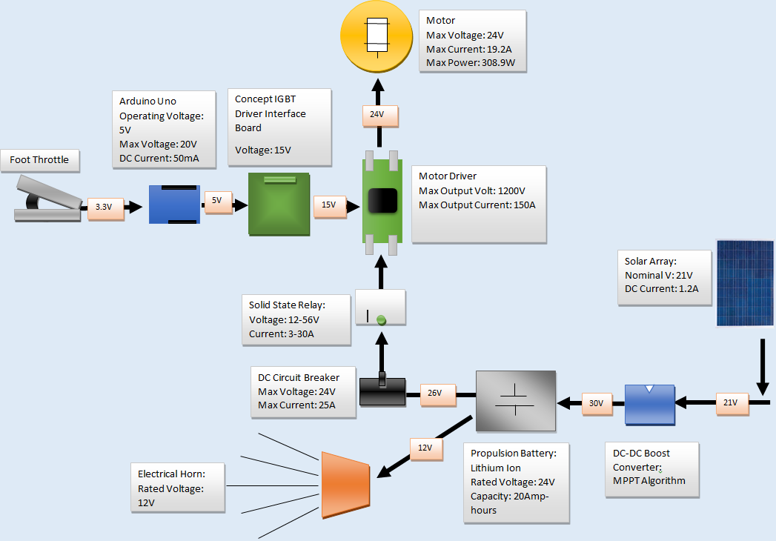
Figure 4 Top Level Design of Electrical System [1]
The electrical system will consist of monocrystalline solar array, a DC to DC boost converter, a 24 volt Lithium Ion Phosphate battery, a motor controller, a 0-5V foot throttle, a 24 volt in-hub motor from Golden Motors, four single pole 25A circuit breaker, a solid state 30A relay, two emergency stop buttons, and a 12V horn.
The solar array has dimensions 20.55 inches by 10.75 inches by 1.125 inches and is encapsulated in Ethylene Vinyl Acetate (EVA). The solar array will be connected to the ISV005V2 DC-DC boost converter. The boost converter will be used to boost the array voltage from 21V to about 30V in order to charge the 24V Lithium Ion battery.
A single pole 25A circuit breaker will be placed immediately after the battery to provide over current protection from the battery. Additional circuit breakers will be placed between each phase of the motor for over current protection as well. A solid state relay will be placed between the circuit breaker and the motor controller. Along with two emergency stop buttons, the relay will serve as the internal and external emergency shutdown system. The battery will also power a 12V horn.
The motor controller will receive input from a 0-3.3V foot throttle. Connected to the motor controller will be a 24V hub BLDC motor. Through the motor driver, the motor controller will provide the necessary current to the motor to speed up to 15mph.

2.4 Major Components and Requirements of the Electrical Systems

Solar Panel System
The Shell Eco – Marathon Competition states the allowable amount of solar energy is 20% of the total propulsion energy consumed; and the total combined surface area of solar cells will be less than 0.17m^2. The solar arrays must not protrude from the vehicle. 125x125mm Mono-crystalline solar cells will be used to provide a high electrical efficiency.
The solar cell array that is used in this car are purchased instead of manufactured. This was because while the array was in the process of being constructed it was found that the typical output power from the array was less than 10W at a maximum while the manufactured option has a 20W output.
The 10W performance from the original solar cells can be attributed to the performance tests performed by the 2012 team. More specifically, the stress tests upon the array likely damaged the crystal structure of the array, thus greatly reducing the efficiency. These stress tests included running over the array with a vehicle, dropping form a 2 story building, and repeated hitting with a hammer.
The new array was chosen because of its dimension, efficiency, and output. The RAMSOND 20W array had a dimension of 20.55”, 10.75”, and 1 1/8” Length width and thickness respectively. This fits the shell eco marathon requirements as well as the area requirements of the chassis. As well as the area, the array has an efficiency of 20%, greater than the previous array. This efficiency allowed the array to output 20W, more than double what the previous array was able to achieve.

Battery System
Shell Eco-Marathon competition states that the vehicle must have one lithium ion battery with a battery management system (BMS). The battery must be in a separated from other compartments by a flame retardant bulk head. A 24V, 20Ah battery pack LiFePO4 battery from electric rider is being used to power the car. The battery pack purchased from Electric Rider contains a BMS that will meet the requirements of the competition and will protect and monitor the entire battery pack as well as individual cells.

Motor Controller

The Shell Eco-Marathon Competition Rules states that “the motor controller must be purpose built” for the competition. To get a clear understanding of the control requirements for the hub motor being used, a block diagram was constructed. It included the board controller, with an integrated user interface and micro controller, and the driver/power stage. Figure 5 illustrates the top level block diagram for the motor controller.
The user interface communicates over a standard or proprietary field bus that generates the proper switching patterns to control the motor’s motion based on feedback from the host. The gate drivers generate the necessary voltage and current required to accurately and efficiently drive the Integrated Gate Bipolar Transistors in the power stage.
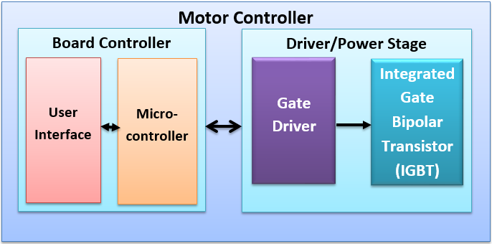
Figure 5 Top level design of motor controller

Motor

The 2012-2013 FAMU/FSU Solar Car team purchased a 24V in-wheel hub motor from Golden Motors. The Shell Eco-Marathon competition has no rule restrictions on electric motors used for the competition. Hence, the motor that was provided by the 2012-2013 team is acceptable for the competition.

Emergency Shutdown System

The Shell Eco-Marathon Competition rules require each team to have an emergency shutdown system to disable the propulsion system of the vehicle by physically isolating the propulsion battery from the vehicle’s electrical system. There will be a both an internal and external emergency shutdown system, where the internal shutdown system is for driver operation. The external emergency shutdown mechanism will be at the rear of the vehicle and permanently installed on a non-detachable part of the vehicle’s body. A 10cm x 3cm red arrow will be positioned on the vehicle body to clearly indicate the exterior position of the emergency shutdown actuator.
The electrical component chosen for this purpose is the Crouzet 84124870. This component is a solid state relay rated at a maximum 30A and operates between 3 and 32V DC. It is rated high enough break the maximum 20A that can be provided to the motor, while taking voltage and current spikes into consideration.

DC-DC Boost Converter

The requirement for the DC-DC conversion system as a whole is the transfer of DC power generated at the solar panels and conversion of this DC power in to a suitable voltage level capable of charging the battery while the car is in use. This was not accomplished last year because the highest voltage level achieved for the DC-DC converter was approximately 24V in the most favorable of conditions.
The ISV005V2 board is currently being used however it is not successful in charging the battery. A part replacement or addition is required to get the ISV005V2 to charge the battery. Initially, a proposed solution was to replace several of the resistors to get the ISV005V2 to charge the battery. However, a new solar array was purchased in order to achieve a greater output. This increase in output was significant more than doubling the output power from 9W to 20W. The ISV005V2 does not have a linear relationship between input and output voltages therefore an increase of just half a volt could help bower the battery.
Thus, the requirements this year is to further boost this voltage to a level of approximately 26V and sufficiently charge the battery while the car is in use. This was be achieved through a solar array and the ISV005V2 DC-DC boost converter. These stages are able to properly boost the DC power created by the solar panels and sufficiently charge the battery.
Requirements specifications: Subsystem: ISV005V2
Thus, the ISV005V2 will be the DC-DC conversion stage after the solar panels. This is in order to take full advantage of the MPPT algorithm inside of the ISV005V2 board. The requirements of this stage are to boost the voltage to a respectable level of at least 26V. This value is based off of a test that was conducted last year in order to charge the battery.

2.5 Performance Assessment and Measurements

Center of Gravity (COG) Calculations
In order to determine the weight ratios for the chassis and normal maximum static loads for each wheel the theoretical center of gravity was calculated. The process was started by first measuring the distance distances from the roll bar/motor mount to each components center of gravity is shown in Table 1. The parts and components which have been considered in the measurements are the larger heavier parts which cause large moments on the chassis.
Part: | Distance taken from roll bar (in)
Battery | 85
Front Mounts | 69.5
Rack and Pinion | 61
Petals | 56
Driver | 21
Roll bar/ Rear Motor Mount | 0
Table 1 Distance From the Part to the Roll Bar/Motor Mount
The next step in the calculation required the weight of each component. Although the majority of these values were known, some values were estimated due to the uncertainty of the materials used for those components. The weight of each component considered in the calculation can be seen in Table 2 Component Weights.
Part: | Weight (lbs)
Battery | 20
Front Mounts | 20
Rack and Pinion | 2.6
Petals | 1.51
Driver | 170
Roll bar/ Rear Motor Mount | 20
Table 2 Component Weights

The moment for each part was then calculated from the roll bar using the Equation 1. The results for these calculations can be seen in Table 3.
Equation 1
$Moment (lbs*in)=Weight(lbs)*Length from roll bar(in)$

Part: | Moment (lbs.*in):
Battery | 1700
Front Mounts | 1390
Rack and Pinion | 158.6
Petals | 84.56
Driver | 3570
Roll bar/ Rear Motor Mount | 0
Table 3 Moment Calculation Results
The distance to the car’s center of gravity from the roll bar was calculated using Equation 2 and the values for its distance from the roll bar and the front of the chassis are displayed in Table 4.
Equation 2 $Distance from roll bar \left(in\right)=\frac{Sum of the moments\left(lbs*in\right)}{Sum of weights\left(lbs\right)}$

Location: | Distance taken from roll bar (in): | Distance from the front x(0) (in):
Car's COG | 14.237 | 82.762
Table 4 Distance Front the Cars Center of Gravity to the Front of the Vehicle And to the Roll Bar

Weight Ratios Calculations
Once the center of gravity was determined, the team used those values in order to calculate the weight ratios. The weight were determined using the cars center of gravity from the motor mount and the measured wheel base as shown in Equation 3 and in Equation 4.
Equation 3 $Front Weight Ratio=\frac{Distance from the Car^{'}s COG to motor mount}{The measured wheel base}$

Equation 4 $Rear Weight Ratio=\frac{Distance from the car^{'}s COG to the front wheel mounts}{The measured wheel base}$

The distance used in Equation 3 is not equal to the distance from the car’s COG to the roll bar/motor mounts COG because the rear wheel is located further back in the chassis than its center of gravity. The calculated weight ratios can be seen in Table 5.

Weight Ratios
Front: | .354
Rear | 0.646
Table 5 Weight Ratios

Static Vertical Wheel Load Calculations
The static vertical wheel loads were calculated using Equation 5 and Equation 6 . The results can be seen in Table 6.
Equation 5
$$Front Static Vertical Wheel Loads \left(lbs\right)=\frac{Maximum load \left(lbs\right)*Distance from motor to COG_{car}\left(in\right)}{Wheel Base (in)}$$

Equation 6
$$Rear Static Vertical Wheel load\left(lbs\right)=\frac{Maximum load \left(lbs\right)*Distance from front mounts to COG_{car}\left(in\right)}{Wheel Base \left(in\right)}$$

Static Vertical Wheel Loads (lbs.)
Front: | 166.232
Rear | 303.782
Table 6 Static Vertical Wheel Loads
These static vertical wheel loads are the maximum loads that will be imposed on the chassis at any given time. The maximum load used in the equation above was the maximum weight of the car allowed by the competition plus the weight of the driver assuming the driver weighs 160 lbs. Although the full magnitude of these forces most likely never be reached the team used the maximum forces that could exist on the system in order to assure quality, safety, and reliability.

Turning Radius and Tie Rod Calculations
According to the competition rules and regulation the vehicle must have at least an 8m turning radius. [4] Figure 11 illustrates how the turning radius of the vehicle was calculated.
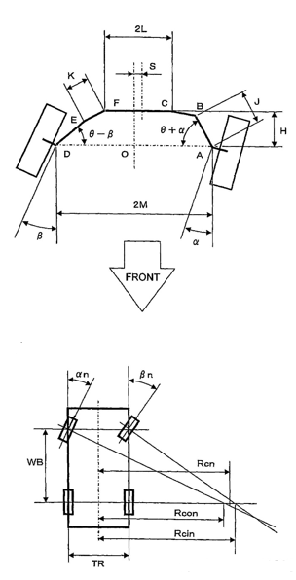

[4] Figure 6 Turning Radius Diagram

The known variables in the above diagrams are M and WB. WB is our measured wheel base for our chassis which is approximately 85.5 in (2.17 m). M is the distance from the center neutral axis of the chassis to the kingpin which the steering assemblies rotate around. These distances for various rim sizes are shown in Table 7.

Wheel Width (in): | M Distance (in): | M (meters)
12 | 16 | 0.406
14 | 16.708 | 0.424
16 | 17.416 | 0.442
18 | 18.125 | 0.4603
20 | 18.833 | 0.478
22 | 19.542 | 0.496
Table 7 Turning Radius Dimensions

The values shown in Table 7 were used along with Equation 7, Equation 8, and Equation 9 to determine the turning radius for a desired maximum turning angle αη and βη. These turning angles in our calculations αη and βη are both equal to 35°.
Equation 7 $R_{cin}=\frac{WB}{\tan\left(βη\right)+M}$

Equation 8 $R_{con}=\frac{WB}{\tan\left(αη\right)-M}$

Equation 9 $Turning Radius R_{cn}=\frac{R_{cin}+R_{con}}{2}$
The team calculated the turning radiuses for various rim sizes with wheel widths ranging from 12-22 inches in order to assure that the best possible turning radius was achieved. The results for these calculations can be seen in Table 8.

Wheel Width (in): | Turning Radius (meters):
12 | 4.676
14 | 4.902
16 | 5.161
18 | 5.463
20 | 5.816
22 | 6.235
Table 8 Turning Radiuses for various Wheel Widths

From the results illustrated in Table 8, it is clear that the turning radius is increasing with rim size. The turning radius increases with rim size because the value of M must increase as the rim increases in order to prevent the wheels from rubbing on the chassis. With the desired maximum turning angle known the tie rod travel distance could be calculated using Equation 10.
Equation 10 $Tie rod travel distance=Sin\left(αη\right)*(L)$

L in Equation 10 is the length from the kingpin to the tie rod connection point on the front wheel arm. Previous equations show that αη is equal to βη; therefore, the tie rod travel distance was calculated to be 2.44 in which corresponds to a total rack travel distance of 4.87in.
Force and Factor of Safety Calculations for Front Mount and Wheel Hub Rod:
The team began to calculate the load per front wheel using Equation 11. Once the load per wheel was calculated the moment was then calculated for the wheel hub and front mount using Equation 11. The length for the front mount in Equation 12 corresponds to the length from the chassis to the kingpin. The length for the bicycle hub bolt in Equation 12 corresponds to the distance from the chassis to the point on the front wheel arm where the wheel hub rod attaches.
Equation 11 $Normal Force Per Front Wheel \left(lbs\right)=\frac{Front Static Vertical Wheel Load}{\# of Wheels}$
Equation 12 $Bending Moment M \left(lbs*in\right)=Force*Length$
The team then calculated the area for square tubing in order to find the direct shear force on the front wheel mount as shown in Equation 13. The area for the circle was then calculated in order to find the direct shear force for the wheel hub bolt as shown in Equation 14. Next the moment of inertia for square tubing was calculated to find the bending stress on the front wheel mount as shown in Equation 15. The moment of inertia for the circle was then calculated in order to find the bending stress for the front wheel hub bolt as shown in Equation 16.
Equation 13 $Area for Square tubing=l_{outer}^{2}-l_{inner}^{2}$
Equation 14 $Area for circle=π*r^{2}$
Equation 15 $Moment of Inertia for Square Tubing=\frac{1}{12}*l_{outer}^{4}-\frac{1}{12}*l_{inner}^{4}$
Equation 16 $Moment of Inertia for Circle=\frac{1}{4}*π*r^{4}$
Once the moments and the moment of inertia were calculated the team found the bending moments using Equation 17, where y is the distance from the neutral axis to the surface.
Equation 17 $σ_{y}=\frac{M*y}{I}$
The direct shear force for each part was then calculated using Equation 18.
Equation 18 $τ_{xy}=\frac{P}{A_{shear}}$
Once the direct shear force was calculated as shown in Equation 18 and normal force was calculated as shown in Equation 17 the principle stresses were calculated using Equation 19. Next the maximum shear force in the plane was calculated as shown in Equation 20. In Equation 17, Equation 19, and Equation 20 $σ_{x}$ is equal to zero because the force acting on each part is acting in the normal axis. Once the car is in motion there will be a $σ_{x}$ however it will be relatively small in comparison to $σ_{y}$.
Equation 19 $σ_{1,2}=\left(\frac{σ_{x}+σ_{y}}{2}\right)±{\left({\left(\frac{σ_{x}-σ_{y}}{2}\right)}^{2}+τ_{xy}^{2}\right)}^{0.5}$
Equation 20 $τ_{\max{in plane}}={\left({\left(\frac{σ_{x}-σ_{y}}{2}\right)}^{2}+τ_{xy}^{2}\right)}^{0.5}$
Equation 21 $σ_{avg}=\frac{σ_{x}+σ_{y}}{2}$
Once the maximum shear force in the plane was calculated the factor of safety per material was determined by using Equation 22. The shear yield strength per material was determined from material strength tables in “Mechanics of Materials” text book. Shear yield strength which were not found in the tables were approximated using Equation 24.
Equation 22 $Factor of Safety=\frac{Yield Shear Strenght}{τ_{\max{in plane}}}$
Equation 23 $τ_{y}=\frac{σ_{y}}{\sqrt{3}}$

Solar Array
The new solar array from RAMSOND was tested on 3/20/2014 during daylight hours. The output was tested and determined to be accurate with the rated values. These values were 20.1V (open Circuit) and short circuit current of 1.27A.
After the installation of the solar cells into the hood of the chassis, the values were measured again to ensure that the array was not harmed in the process. The values did not change, so it is determined that no harm was done in the installation process.

DC-DC Boost Converter
The ISV005V2 DC-DC boost converter was tested both with the solar cell array and in the lab setting. The boost converter was tested with the solar cells and achieved an output voltage of 35V. When in the laboratory setting, a stiff voltage source was applied to the boost converter and it was found that the maximum output voltage, without a load, from the converter was 35V.
Input (V): | Output voltage (V):
7.002 | 12.29
8.002 | 25.16
9.002 | 27.27
10.001 | 30.28
11.001 | 34.84
12.001 | 35.081

All calculation results and constants can be seen in the tables located in appendix A27.

2.6 Design Process

Concept Selection Criteria
In order to develop the overall concept design for the vehicle, the team employed a fishbone analysis and a house of quality assessment. The fishbone diagram allows for an iterative approach to determining the causes of a series of defined effects. In the case of the solar vehicle, it allowed the team to split the customer requirements into 5 different categories: design limitations, efficiency, operator comfort, safety requirements, and steering & handling.
Using these 5 categories to further clarify the voice of the customer, the team was able to brainstorm ideas on how to approach the design of the vehicle. This process was completed by all of the engineers working on the project in order to promote a concurrent engineering design philosophy. By using a concurrent engineering approach the team will reduce the risk of having a failure or defect in the vehicle once the design phase of the project is completed. Eliminating these errors will reduce the overall cost in the long run.
The fishbone analysis can be found in Appendix A1 Fish bone Analysis.

Concept Selection Criteria Prioritization
Using the house of quality, the group determined the significant factors in the design the vehicle. More importantly, the group determined how the customer requirements and design factors would interact with each other, by establishing whether or not relationships existed between them. Each of these relationships was ranked as being a weak, medium, or strong relationship; scores of 1, 3, and 9 were assigned respectively.
After establishing the existence and strength of the relationships between the customer requirements and the design factors (quality characteristics on HOQ), the team ranked the importance of each customer requirement. Each customer requirement was ranked equally (max score) because the competition requires teams to satisfy all rules and regulations in order to participate; based on this it was determined that no preference should be given to one customer requirement over another.
The team then ranked each of the design factors as needing to be maximized, minimized, or being on target. Based on this optimization ranking, the team then determined the level and direction of correlation between each design factor. Each pair was given a rating of being either a positive or negative correlation, with a strength of either weak or strong. By determining the correlation between each design factor, the team was then able to prioritize design factors for the optimization process.
The team then assigned a target value for each of the design factors based on the voice of the customer (Shell rules and regulations), and a difficulty score based on the cost and time necessary to implement each design factor. This allowed the team to determine how to optimize the vehicle by prioritizing design factors. The team will optimize the vehicle by making trade-offs in order to enhance a desired component/quality of a system or process. Using these factors, the team decided that the cost, weight, safety, ergonomic design, and regenerative braking were the most important design factors.
Finally, a competitor analysis was performed using the FAMU-FSU 2011 Solar Car as competitor. Ideally the team would have liked to rank the design against other universities, but due to the competitive nature of the project this was not possible. The proposed design ranked as a 5 for each of the Demanded Quality variables, because we have to satisfy each of these requirements in order to compete in the 2014 Shell Eco-Challenge. The former FAMU-FSU car scored low in several categories because their design team was not as multi-disciplinary as the 2014 team, and the competition regulations have become stricter since their entry. The competed house of quality and reasoning can be found in Appendix A2.

Design Selection
Once the HOQ was completed the team created a comparison matrix template using the most significant factors, in order to rank components against their alternatives in the design selection phase. The comparison matrix was created by assigning normalized percentage weight values, which were derived from our HOQ analysis, to each ranking criteria. Next an optimization legend was created, in order to determine which design was the most optimal for the vehicle. Each component was assigned a ranking relative to its alternatives. A higher score indicates a more optimal solution, while a score of 1 indicates the least optimal solution. The weights were then applied to the relative rankings, which gave us insight into which components best fit the customer’s requirements. The alternative designs were generated based on input received from various advisors and professionals in the respective fields.

3 Design of Major Component Subsystems

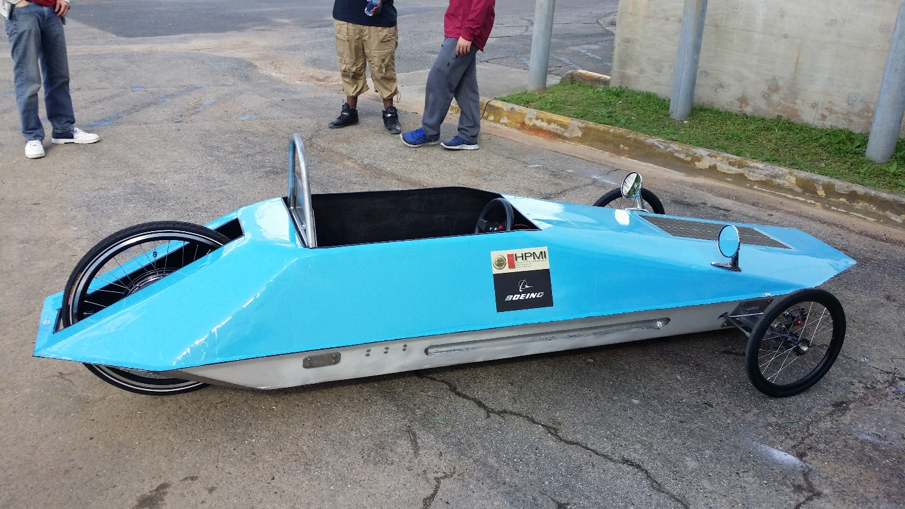
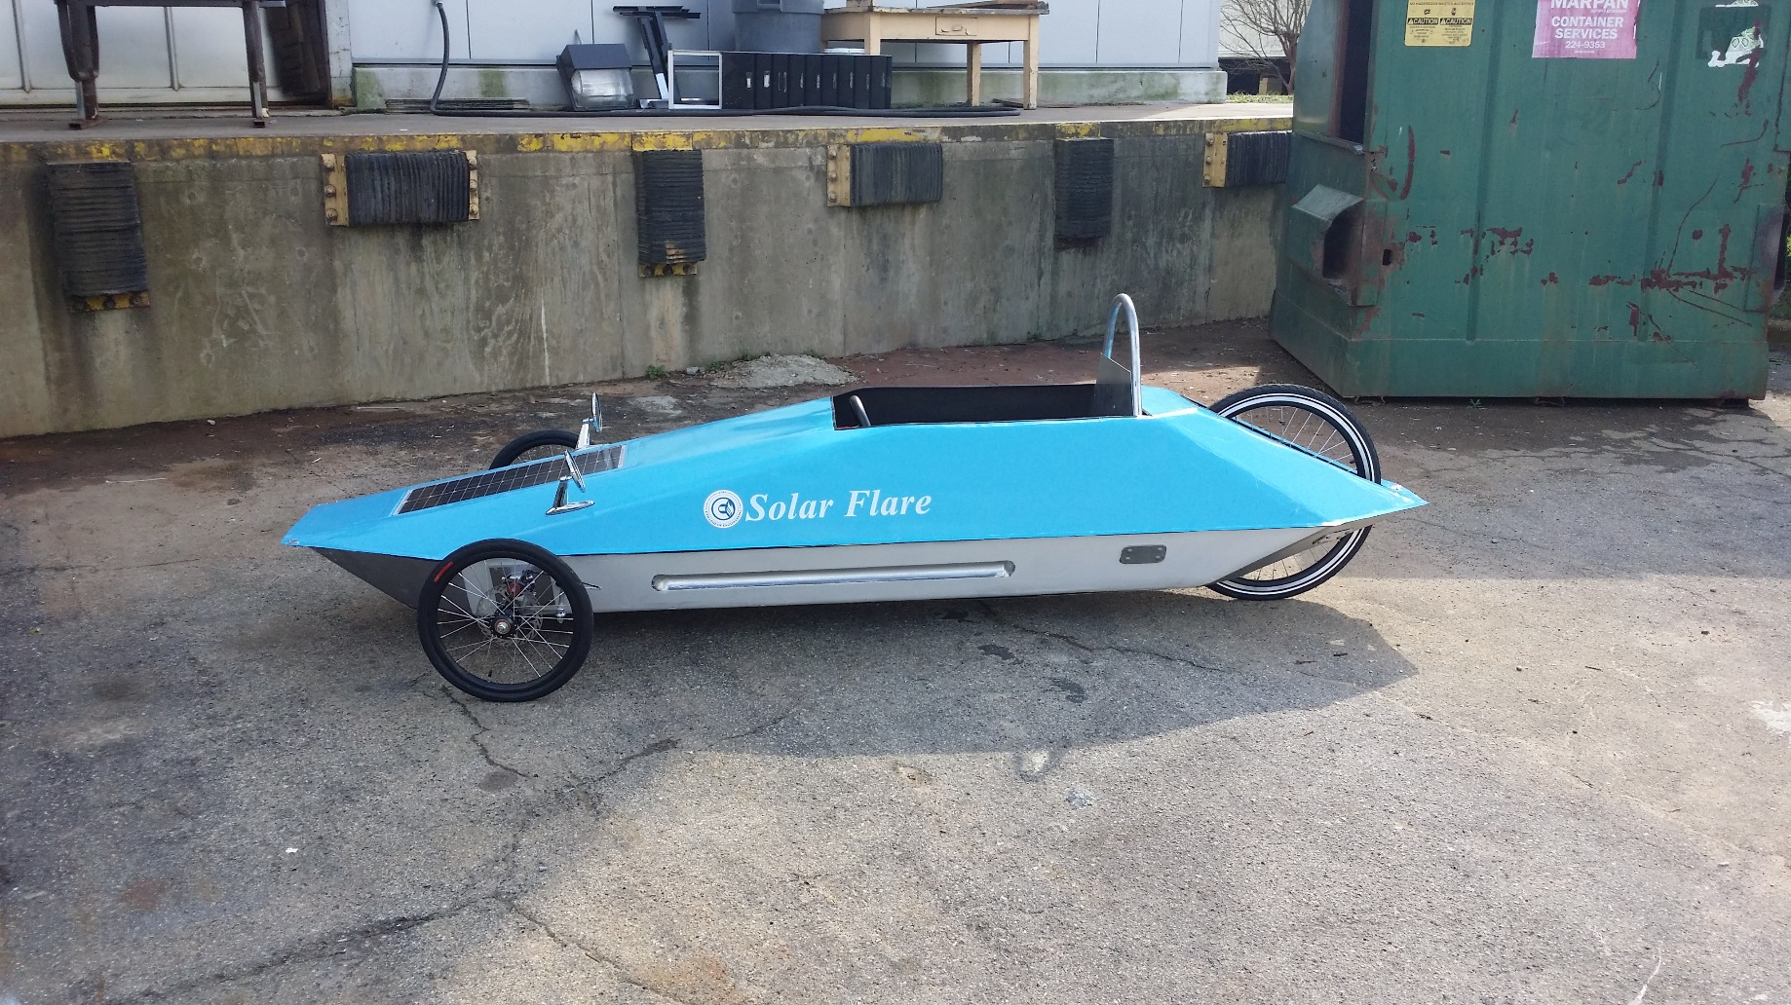
3.1 Chassis

Figure 7 Chassis

The chassis is a carbon fiber molded structure that is responsible for supporting the full load of the car, which can be seen in Figure 12. This includes the driver, seat assembly, roll bar, wheel mount, solar panels, batteries, and all the electrical components. PVC semi circles were added along the bottom and sides of the chassis in order to give the chassis a more rigid form. Furthermore, balsa wood was added to both the bottom and side of the car in order to allow major components to be mounted to the vehicle. The top cover is also part of the chassis, however, the only weight it will support is the solar panel encapsulation box, and the rear view mirrors. The team added thin carbon fiber strips to the bottom if the structure in order to help it maintain its form throughout competition. The top and bottom parts of the chassis were designed to be separated so that the car could easily be worked on, and the electrical components could be seen during competition. The two parts come together and are connected through a series 6 quarter turn fasteners such as those used in NASCAR. The chassis as a whole was aerodynamically designed by last year’s senior design team to minimize coefficient of drag.

3.2 Roll Bar & Rear Motor Mount
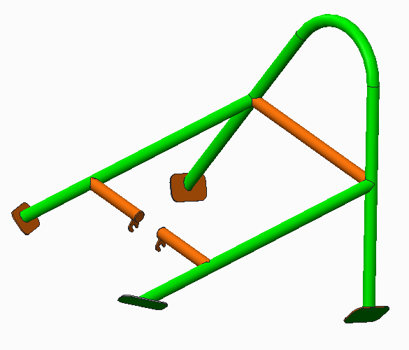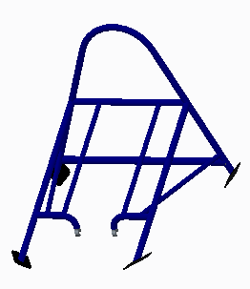
Figure 8 Initial Roll Bar Design Figure 9 Final Roll bar Design

The Shell-Eco Marathon requires that the roll bar must withstand 700N of force in all directions and must sit at least 5cm above the driver’s helmet. Although the roll bar that was left by the previous Solar Car team met the requirements for the 700N of force, it did not meet the height requirements. It also failed to incorporate the rear wheel mount needed for the brushless DC in-hub motor. Figure 8 is the initial design which the team adopted for this car but after completing a stress analysis on the wheel mount, it was quickly determined that sufficient supports were needed to prevent displacement and plastic deformation. Since the solar car has a three wheel trike design, the forces acting on the rear wheel can cause it the wheel to misalign and twist out of plane. After a series of designs for the roll bar and motor mount (seen in Appendix X) were tested and compared, the final roll bar design with two triple-truss beams and dropouts for the wheel mount was developed as seen in Figure 9. This design met all the requirements set by Shell and maximized the strength to weight ratio by using 1inch OD chromoly steel pipe (4130 alloy steel) with a thickness of .065 inches. The final installed roll bar and motor mount can be seen in Figure 10.
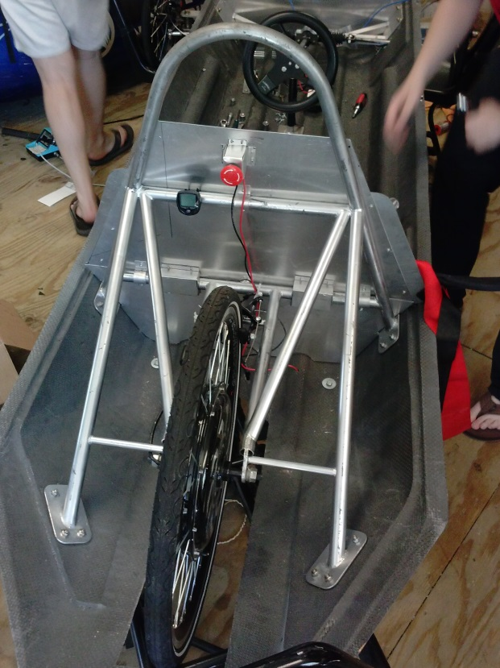
Figure 10 Final Roll Bar Design Installed

Dropouts
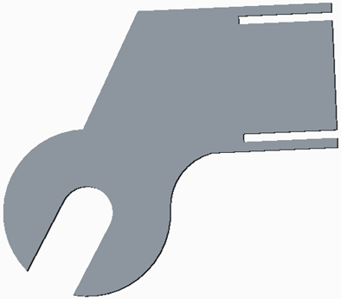
Figure 11 Initial Dropout Figure 12 Final Dropout

The initial dropout design can be seen in Figure 11. The slits were removed and put into the actual roll bar to the dropout as seen in Figure12 in order to allow get the maximum strength from the dropouts. The installed dropouts can be seen in Figure 13.
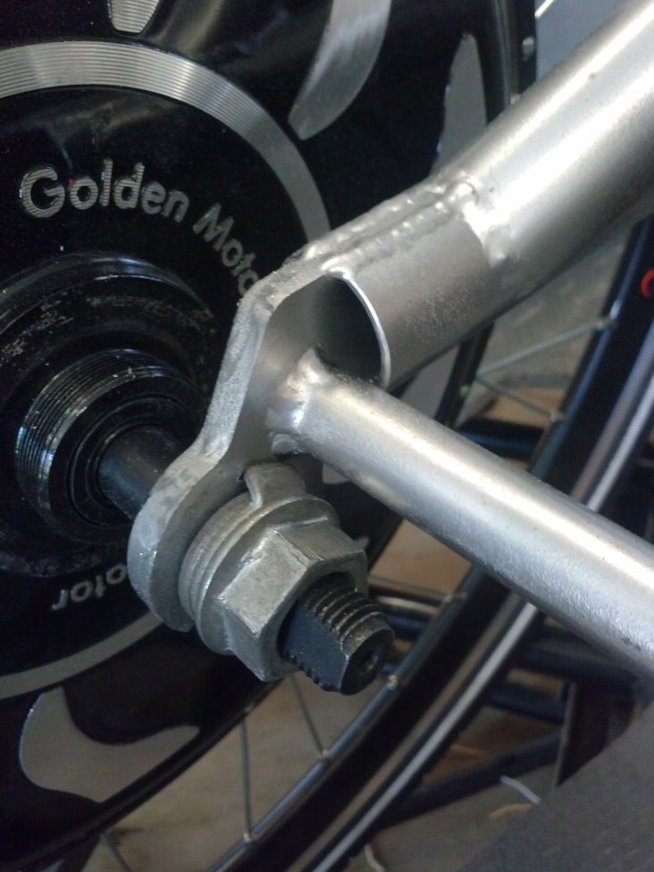
Figure 13 Installed Dropouts

3.4 Steering System
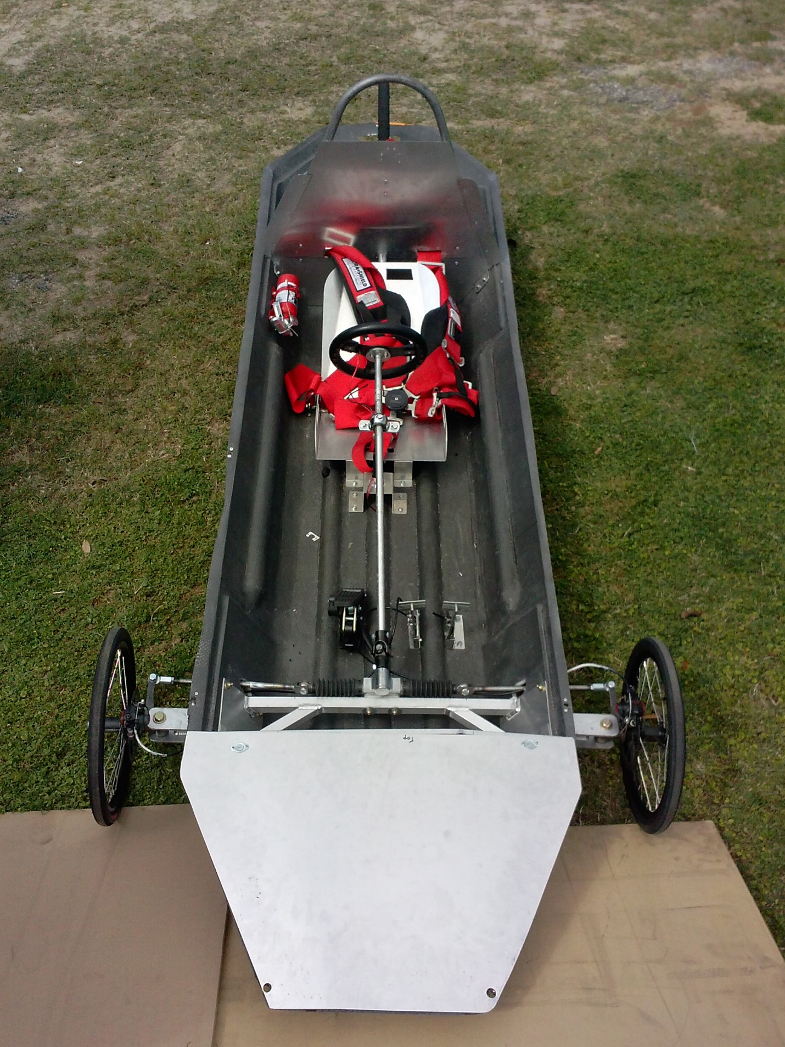
Figure 14 Steering System
The steering system for the vehicle will allow the design to meet the Shell Eco-Challenge Marathon requirement of a maximum turning radius of 8 meters. It contains eight subcomponents (Front wheel mounts, Spindles, Tie Rods, Rack and Pinion, Steering Column, Steering Wheel, Front wheels) and is connected to the front wheel mount by a single bolt. The system incorporates a rack and pinion steering system, which decreases the amount of force required to turn the wheel, and thus the force required to steer the car. The full steering system can be seen in Figure 10. Using this steering system the team was able to meet the Shell Eco Marathon requirement achieving a 3.66m turning radius.

Front Wheel Mount
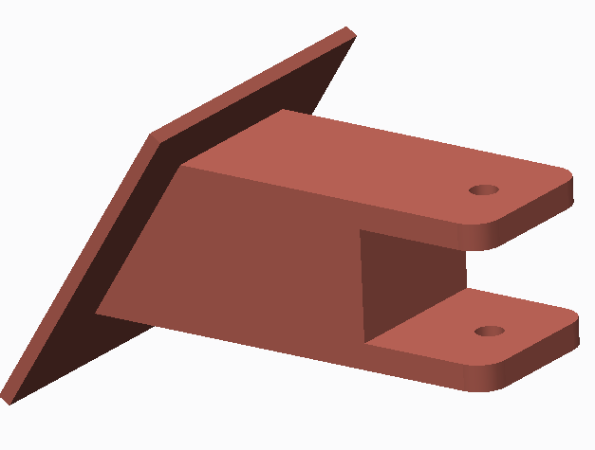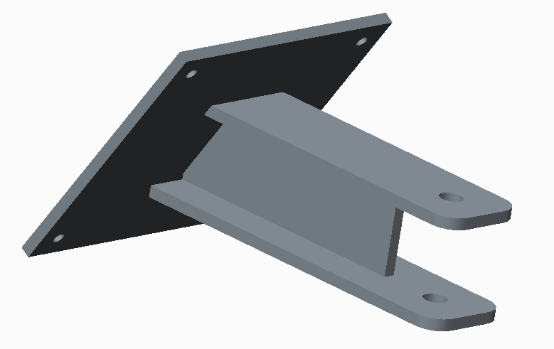

Figure 16 Initial Front Wheel Mount Design Figure 17 Final Wheel Mount Design

The original design for the wheel mount, shown in Figure 12 , was made of solid aluminum. It was capable of withstanding the forces not only associated with the full weight of the chassis and driver but also the forces experienced during braking and cornering. Due to the size of the part and the amount of material required to manufacture it, several design variations were explored until the final wheel mount design, shown in Figure 13, was chosen. The volume of the final design was $18.37 in^{3}$ compared to the original design $33.84 in^{3}$. With almost half the volume of the initial design, the final product is both light weight and fully capable of supporting the entire load the chassis. The final design installed on the chassis is shown in Figure 14.
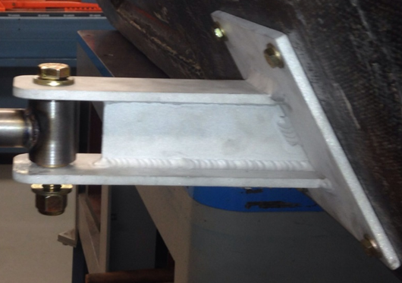
Figure 18 Mounted Front Wheel Mount

Spindles
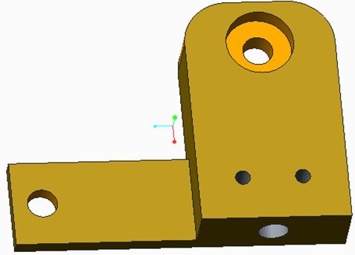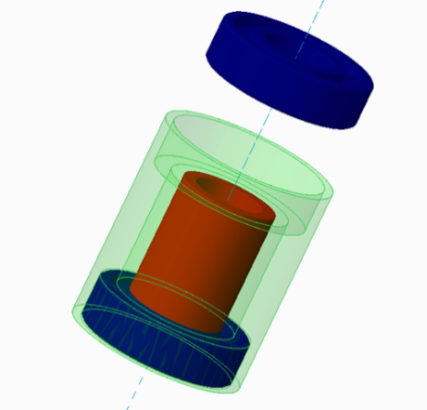
Figure 19 Spindle

The initial spindle design was made with aluminum in an attempt to reduce the weight of the part. Unknown to the team at the time, the aluminum spindle would require an axel to be press fitted into the part. This requirement forced the team consider other designs and materials. The final spindle design, shown in Figure 15, is made of steel with an aluminum spacers. The kingpin is inserted with a washer above and below the bearings to hold the unit in place; the washers allow it to rotate with very little resistance. By using steel the team has greatly increased the ease of installing the brake mounts and wheel axels, which are also steel in order to allow them to be welded together. The final assembly can be seen in Figure 16.
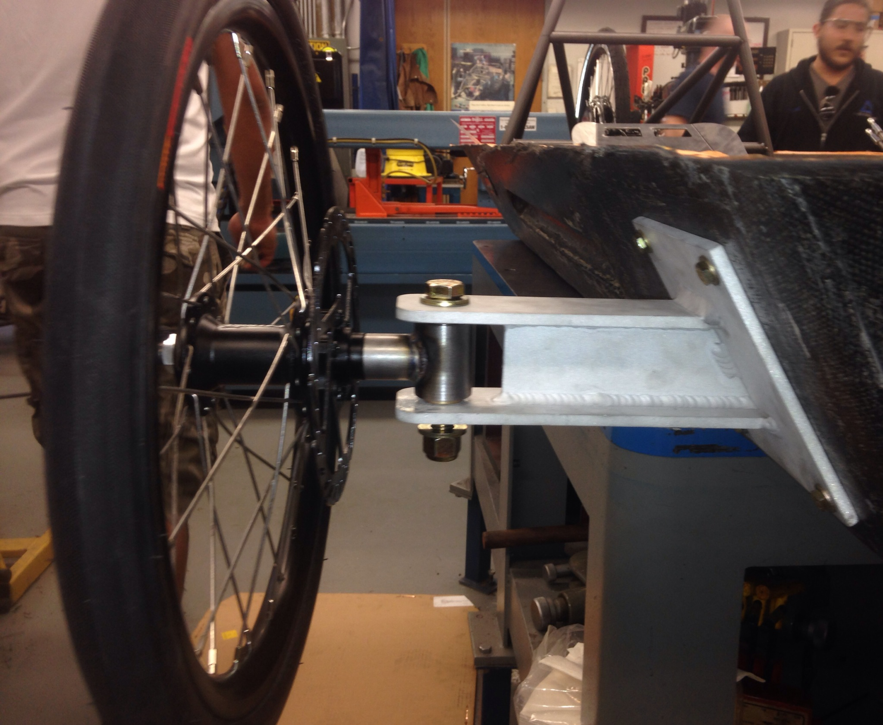
Figure 20 Installed Spindle

Spindle Arms
The spindle arms are the points where the tire rods connect to the spindles on both sides of the car. Since the spindles were made of steel, the spindle arms were also made of steel in order for them to be welded together. Fortunately the small amount of force experienced by the spindle arms during use allowed the spindles to maintain a slim design and keeping the weight of the component down.

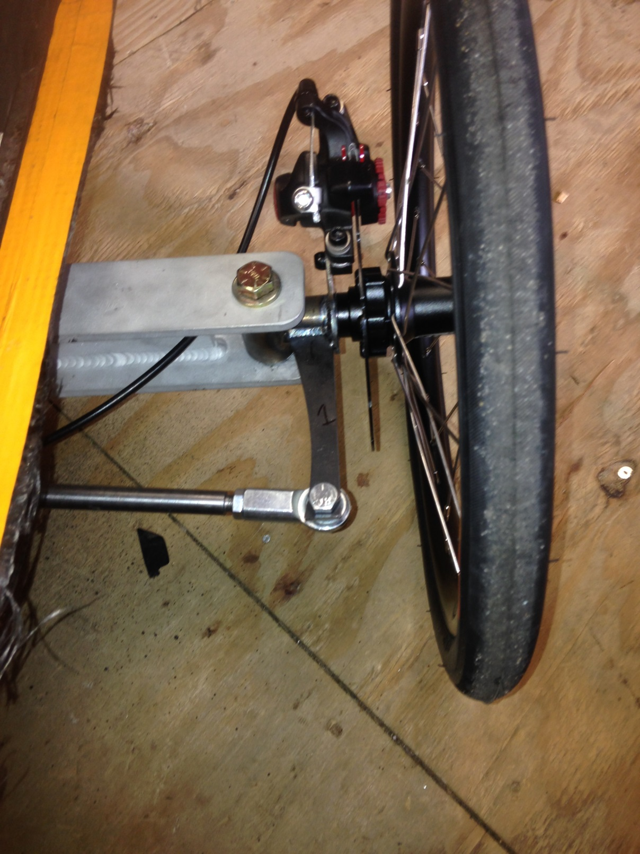
Figure 21 Spindle Arms

Tie Rods
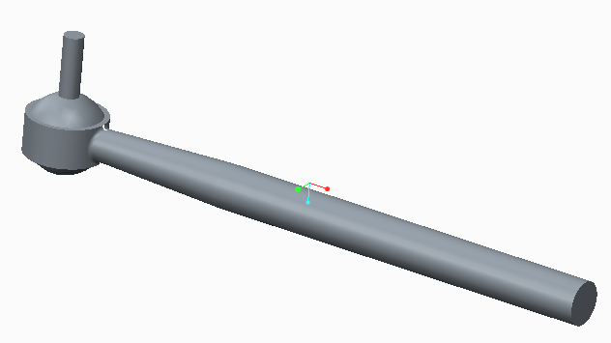
Figure 22 Tie Rod

The tie rods connect the spindle arms to the rack and pinion. When the driver turns the steering wheel it causes the rack and pinion to pull the first tie rod and push the second which steers the car. The team selected an adjustable tie rod which was cut to the desired length 14 inches and can be adjusted 1 inch in either direction once it has been installed. This design allows the team to easily adjust the angle of the tires in order to assure that the car is properly oriented and the tires are aligned.

Rack and Pinion
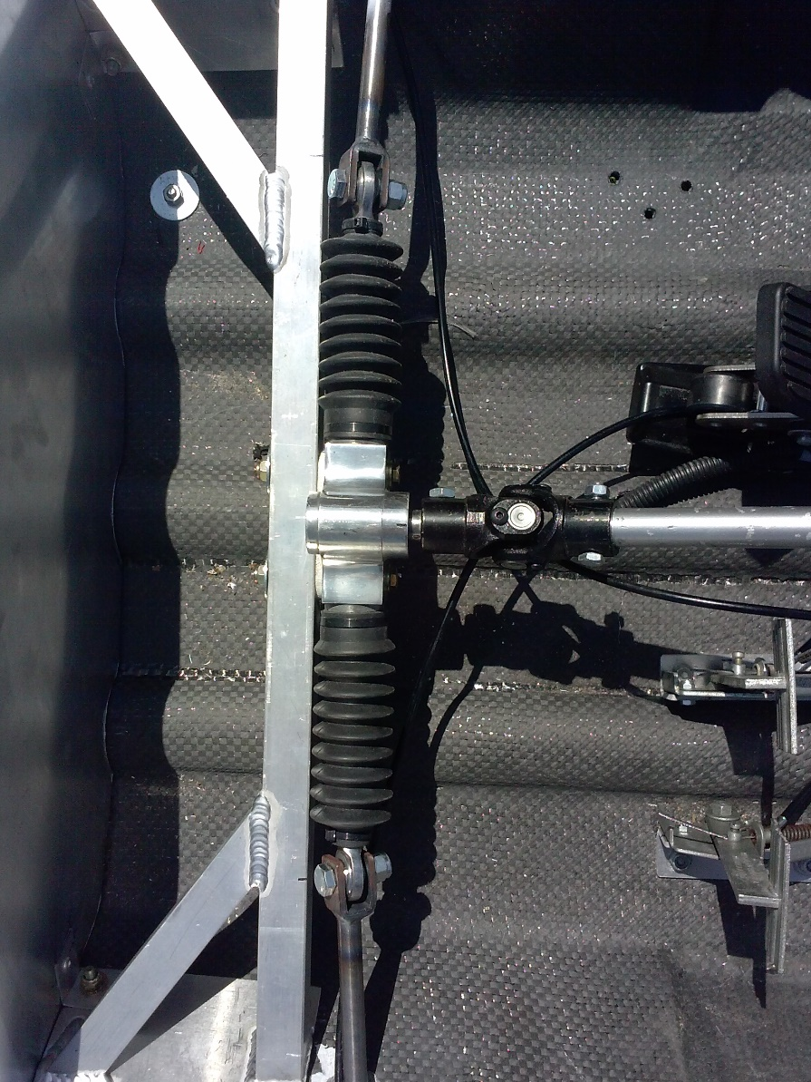
Figure 23 Rack and Pinion

The rack and pinion takes the input from the driver turning the steering wheels, and either pushes or pulls the corresponding tie rod. The use of a rack and pinion makes steering smoother and requires less input force from the driver on the steering wheel in order to maneuver the vehicle. Furthermore, the maximum travel distance on the tie rod limits movement of the wheels preventing them from colliding with the chassis. Based on the turning radius calculations the team selected a rack and pinion with a travel distance of 4.25 inches and attached it to the center of the truss. This rack and pinion allows the team to have a 3.66m turning radius while preventing the wheels from colliding with the chassis. It is attached to the steering column through a u-joint which allows the steering wheel to be angled towards the driver.

Steering Column
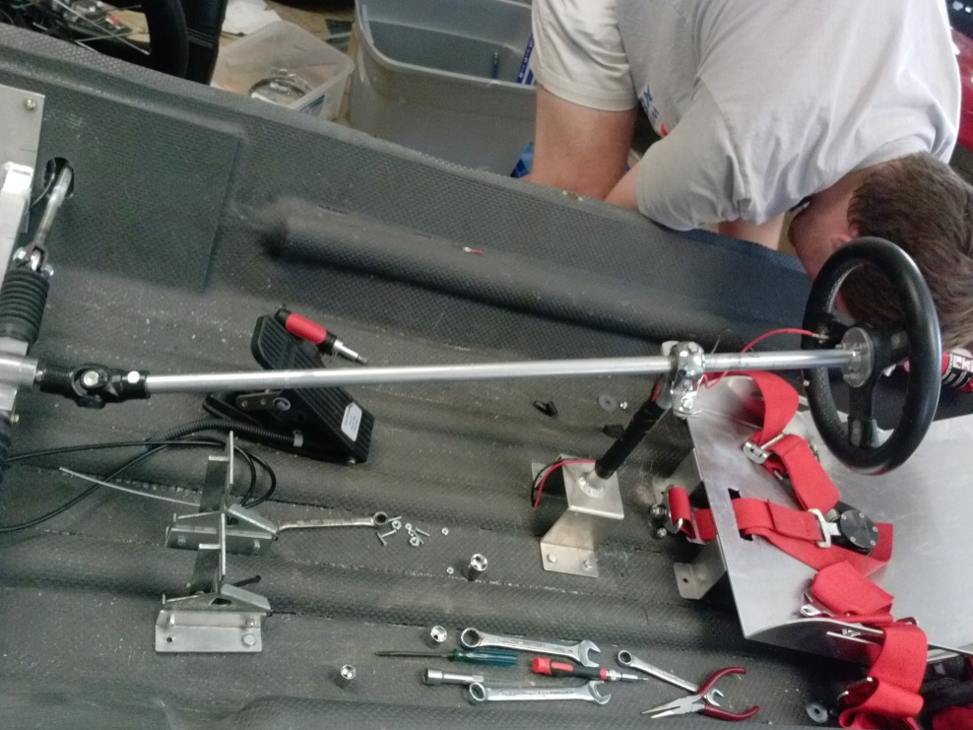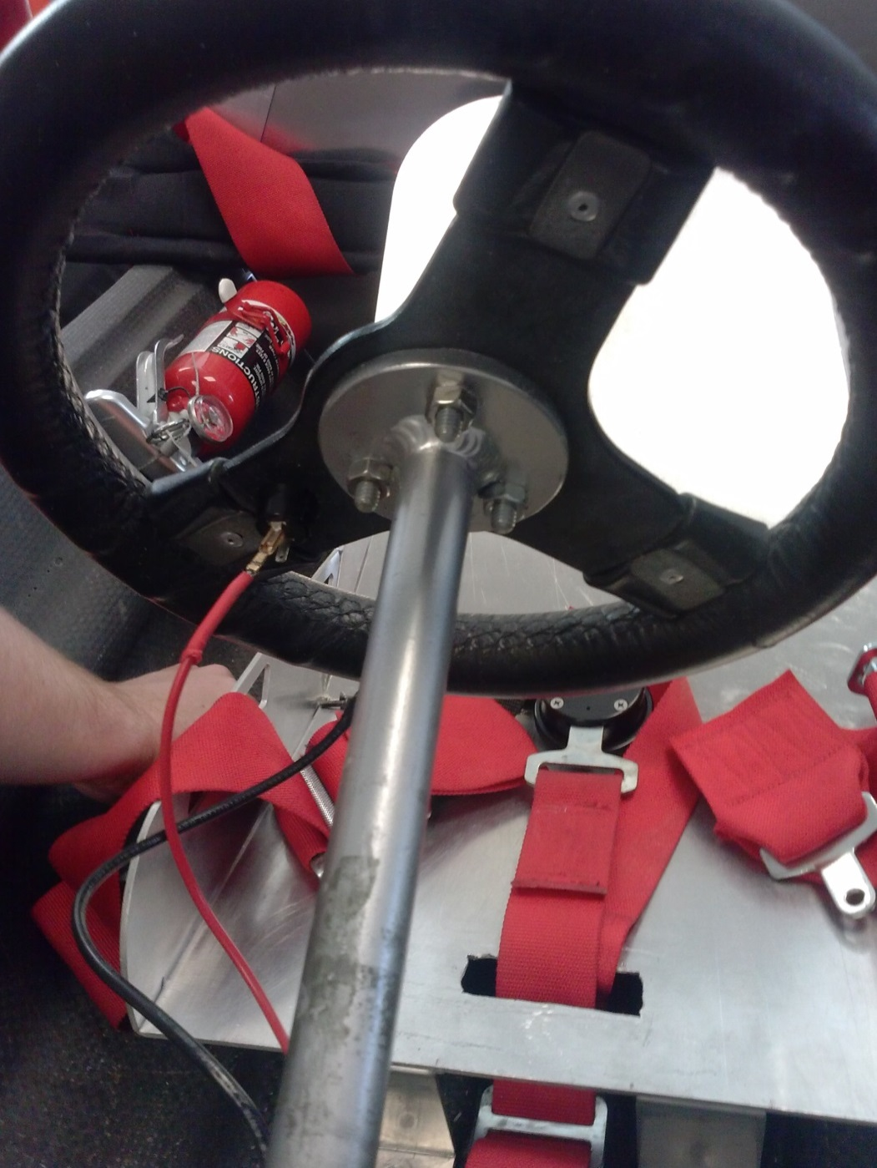
Figure 25 Steering Column
The team had originally purchased a steering column with a pre-welded steering wheel mount. The downside of the purchased column was that it was made from stainless steel and was much heavier than anticipated. The team was able to use material, provided by Jeremy Philips in the machine shop, to construct a steering column and steering wheel mount. The water jet located in the machine shop was used to cut out the steering wheel mount which was then welded by onto the steering column as seen in Figure 21.

Steering Wheel
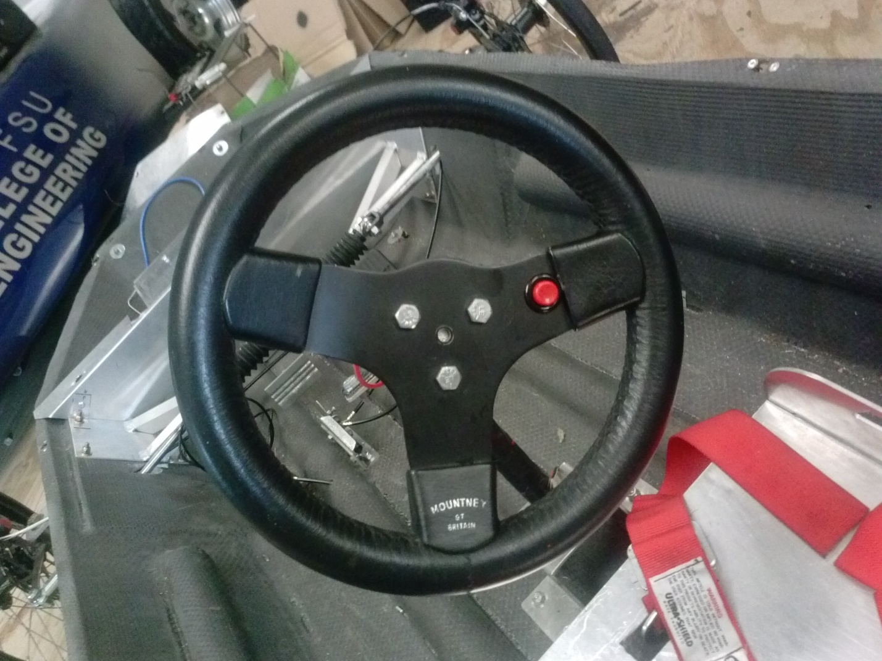
Figure 26 Steering Wheel
The team purchases a standard go-kart steering wheel from summit racing. The steering wheel takes the input from the driver and transfers it to the steering column. The steering wheel sits within comfortable reach of the driver and can be turned fully from lock to lock, with the driver fully strapped into the seat.

Wheel System
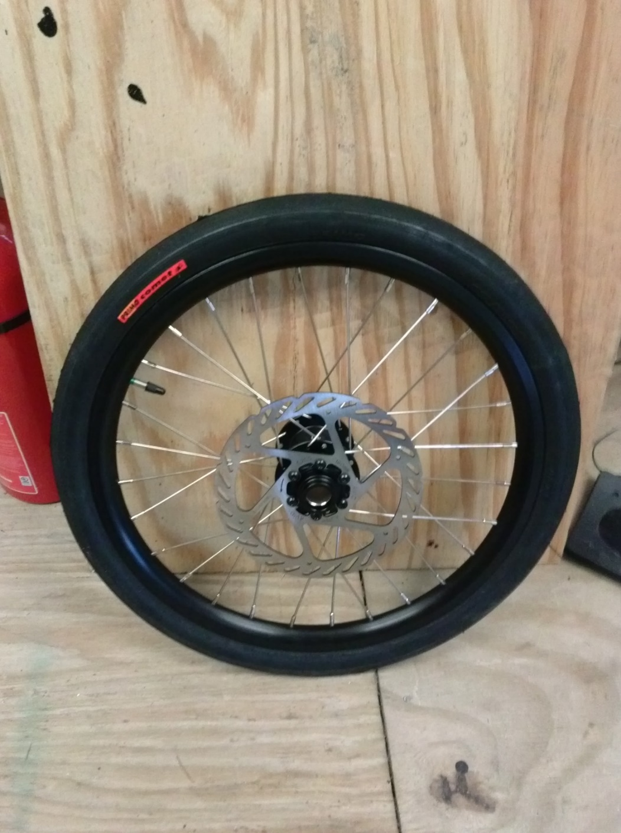
Figure 32 Front Wheel
The team has decided on using trike rims and hubs for this application. These types of wheel hubs come equipped with bearings, and require minimum amounts of force to spin. This will require less power from the motor to move the vehicle. Trike hubs are better equipped for this application because they are designed to withstand a force on only one side of the wheel, whereas with bicycle wheels the force is split on either side of the wheel. The wheel axels are connected to our system by screwing into the front wheel arm of the steering assembly.
Each front wheel must be capable of withstanding 81.3 lbs. which is common for trike wheels. If a failure were to occur between the wheel and our front wheel arm (the piece the wheel screws into), the hub bolt would need to be replaced with one of the same dimensions but made from stronger material. This would be a cheap easy fix and the chance of failure is low, because the forces have been calculated for this connection point.
Advantages:
- The front wheel hubs come with ins talled bearings and rims.
- Connects easily to our steering assembly.
- Very light weight high performance wheels with pre attached rotors.

3.5 Braking Systems
The braking systems incorporated in the solar car are two independently functioning systems that will be tested and modified on a 20° incline. In order to meet the shell eco marathon each braking system must be capable of immobilizing the car on the 20°incline. Each system must also have an independent pedal which can be engaged without the driver having to remove their hands from the steering wheel.
For the rear braking system the team decided to utilize bicycle brakes. The pressure applied by the rear brakes can also be adjusted by changing the cable tension when the braking pedal is fully engaged. For the front brakes (the primary braking system), the cable braking system with calipers and shoes was chosen. The competition rules stipulate that the primary braking system needs to be reliable, and be able to stop the vehicle in a reasonable time frame. If the force applied by the calipers is less than desired, the purchased calipers can be adjusted to apply higher forces with only a turn of a dial.

Rear Braking
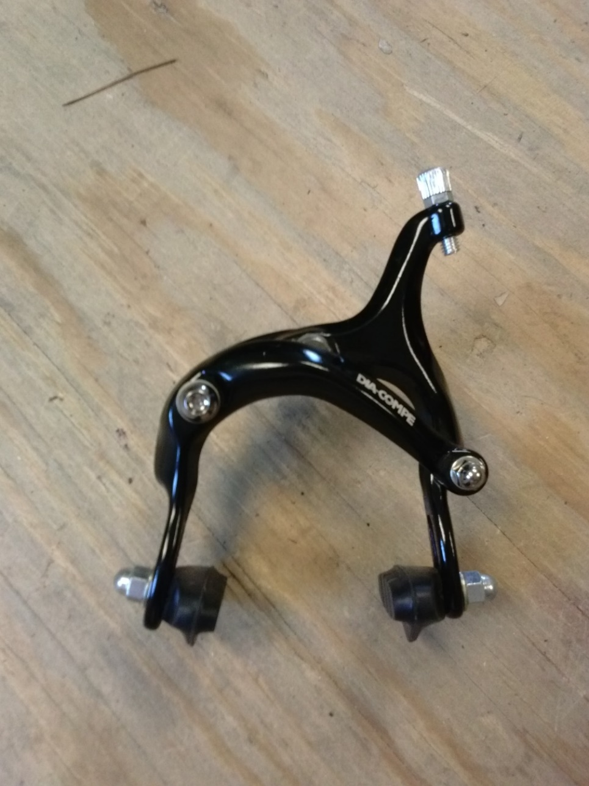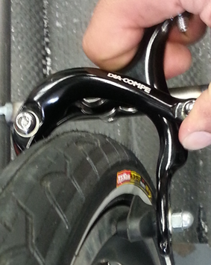
Figure 27 Braking System

The rear brake will be controlled by the left brake pedal in the car. It is directly mounted on the roll bar assembly. Bicycle brakes were chosen for the rear braking system. The required stopping force will be supplied by the driver as the braking pedal is engaged. The pedal pulls the brake line taunt which causes the rear brake to apply pressure on either side of the rear wheel successfully stopping the car. The rear braking system was capable of passing the 20̊ degrees braking test required by the Shell Eco-Marathon Competition.
Advantages:
- Simple to install and adjust to meet requirements.
- Light weight mechanism that mounts directly to the roll bar/motor mount.
- Cost is cheap and the mount parts were machined in house.

Front Braking

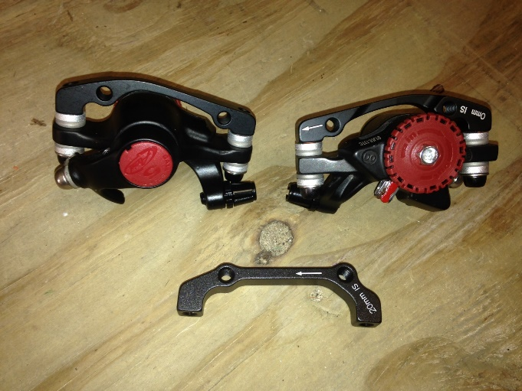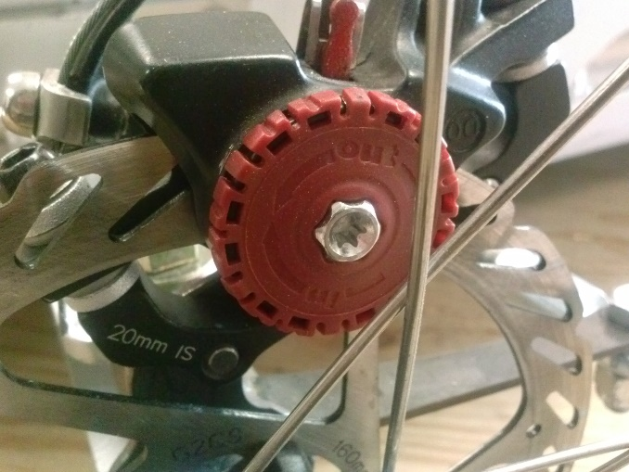
Figure 28 Front Brakes
Front brake design incorporates a brake line engaged caliper/shoe combo, which will apply stopping force through cables when activated. Even though the Shell Eco-Challenge Completion only measures the cars efficiency and not speed, having caliper style brakes will allow the car to stop immediately at low speeds which improves the safety of the design. When the brake pedal is engaged the brake line will activate the braking system, which will cause the braking shoes attached to the calipers to press down onto the rotor, thereby slowing and eventually stopping the vehicle. The bracket used to support the braking system is welded to the spindle to ensure the brakes remain properly aligned over the rotor.

Advantages:
- Turn dial on brake allows for easy balancing without cable modifications.
- Better at managing heavier loads than the standard bicycle brake system.

3.6 Seating System

Seat
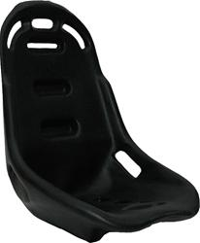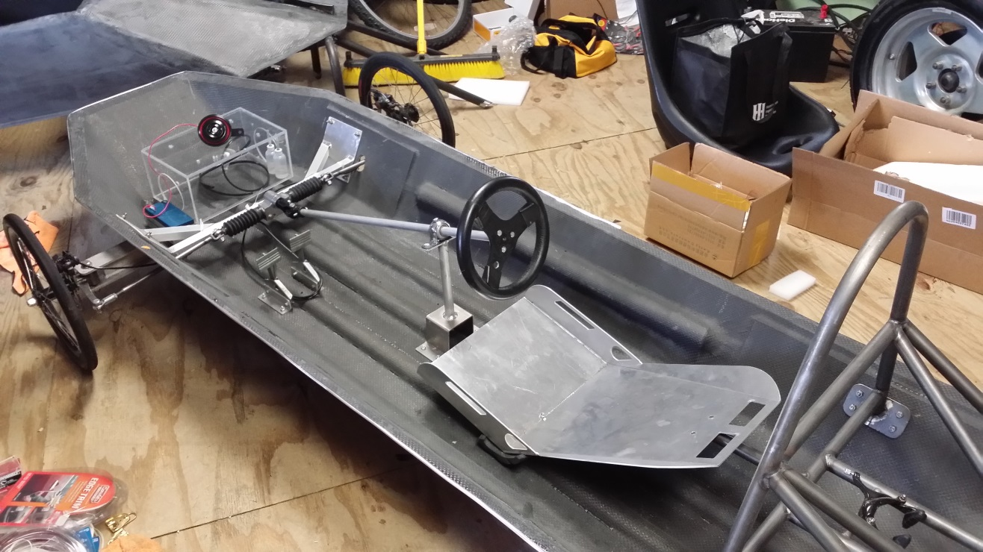
Figure 30 Seat
Comfort, safety, and convenience are all important factors in the ergonomic considerations of the car seat design. The seat was designed so that the driver’s head will remain at least 5 centimeters below the top of the roll bar when fully strapped into the chassis. The seat is positioned so that it will allow the driver to see clearly over the steering wheel as well as reach the accelerator and brake pedals. In addition, the driver's seat is equipped with an effective safety harness having at least five mounting points to keep the driver in the seat. The design of the seat will be optimized so that individuals ranging from 4 ½ feet to 6 feet will be able to drive the vehicle with proper brake and throttle pedal placement.

5 Point Harness

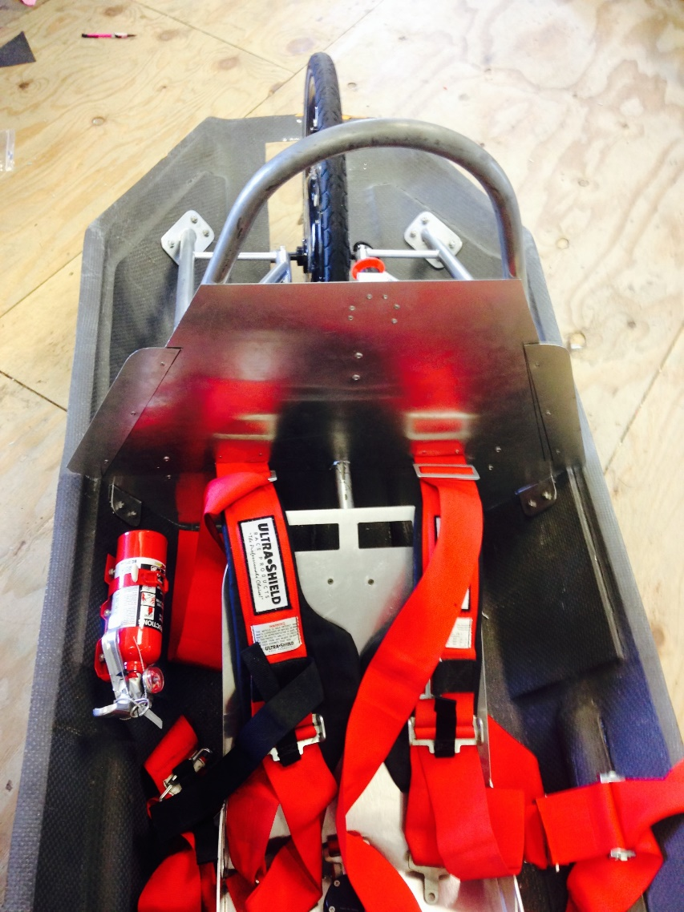
Figure 31 5 Pont Harness

The five point harness was donated to the team by Dustin Banks a friend of the team. It is firmly attached to the vehicle's chassis and fitted into a single buckle. Three belts are attached to the balsa wood floor and two belts are attached to the roll bar as seen in Figure 31. The five point harness is capable of withstanding 1.5 times the weight of the driver as per shell eco rules. The harness is equipped with three custom made attachment brackets which allow the belts to self-align in accordance to the direction of the force applied. Finite element analysis in Creo simulation insured that the mounts would not break under the pressure of the car during the five point harness test.

3.7 Bulk Head

The purpose of the bulkhead is to separate the driver from propulsion system and the electrical components in the vehicle. The key to the bulkhead is using a fire resistant material which will provide enough time for the driver to safely exit the vehicle in the case of a fire. The team chose to create 2 separate bulkheads using aluminum sheeting with a thickness of .032 inches. Figure 33 shows the rear bulkhead which separates the driver from the propulsion system. Figure 33 shows the front bulkheads which encloses the Lithium Ion battery compartment and other major electrical components.
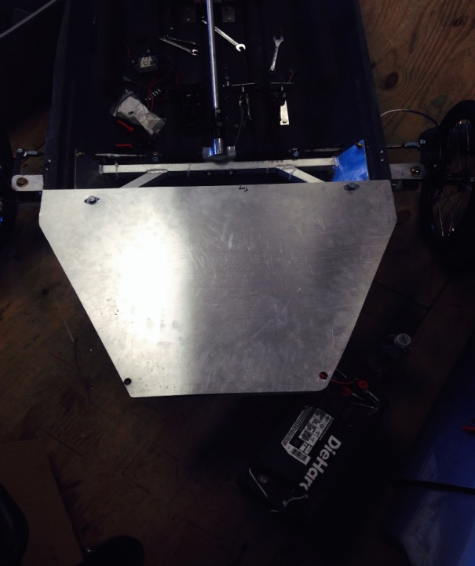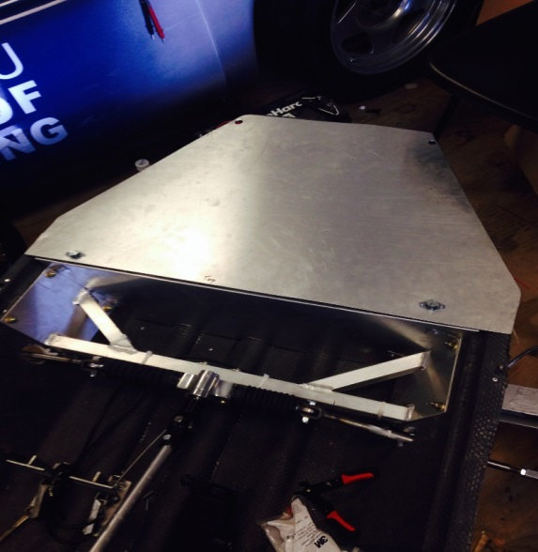
Figure 33 Front Bulkhead
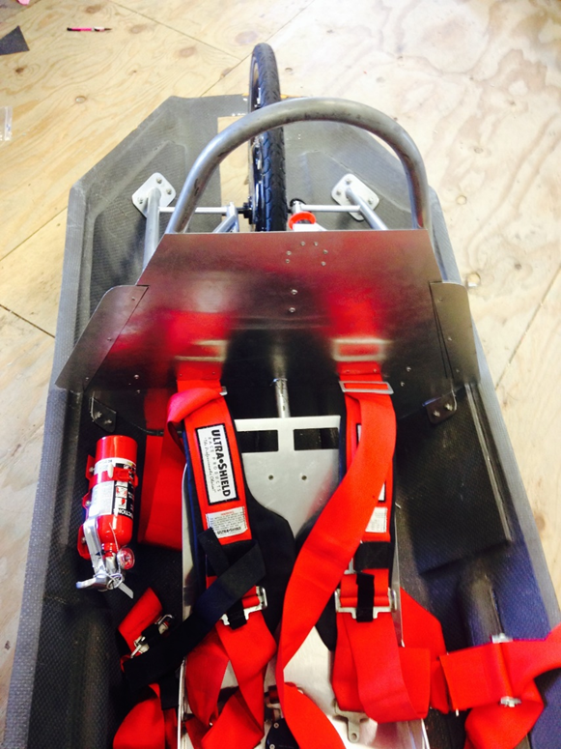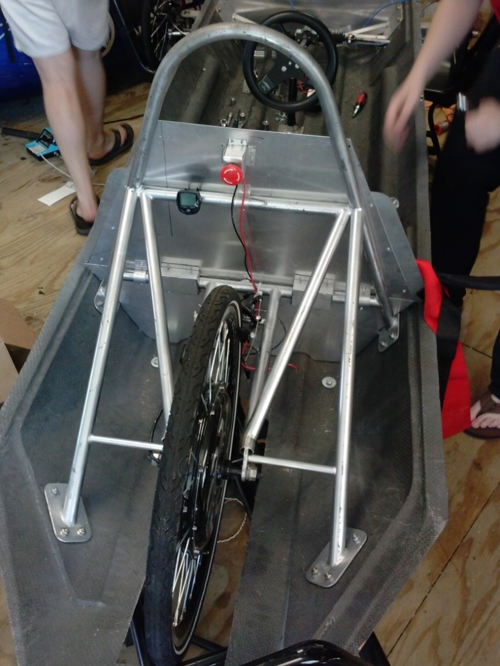
Figure 34 Rear Bulkhead

3.8 Solar Panel System

Solar Array

The majority of the decision-making and selection for the solar array was completed by the 2012 FAMU-FSU solar car team. However, the solar array constructed last year is not going to be used for several reasons. First, the implementation plan using last year’s panels would not work given the carbon fiber chassis and its inability to be drilled into repeatedly. Secondly, the array constructed last year uses unnecessarily large diode boxes that would not be able to fit into the car during implementation. Thirdly, the amount of unnecessary wiring between each cell created another problem given the contest requirement that all electrical wiring be free from fire risk. Initially, the 2014 solar car team had decided to manufacture a brand new array but ultimately after several testing phases, and with considerations for time, and output a new commercial array was purchased.
Thus the 2014 FAMU-FSU solar car team has elected to purchase a new RAMSOND 20W solar array. This will make the implementation of the solar array on the hood of the car possible because the RAMSOND array is encapsulated in EVA already.
The 2014 team consulted with the engineering college faculty during the selection process in order to narrow down choices until a final decision was made. Three different types of solar panels were considered: monocrystalline, polycrystalline, and thin film solar panels. After the faculty consultation, it was decided that monocrystalline was the best fit for the project. The term monocrystalline is self-explanatory; the cell consists of a single silicon crystal. Monocrystalline cells are the most efficient of the available panel types, because their production process forms an almost perfect crystal lattice which minimizes interference of the electron flow through the material.
By minimizing the interference of the electron flow, monocrystalline panels have the highest efficiency (15-20%) among the possible selections. The largest drawback is the cost because of the expensive production process involved with drawing out the silicon ingot. Although monocrystalline is more expensive, it was selected because of the superior efficiency which is the main criteria used for ranking in the competition. Polycrystalline and thin film (amorphous) solar panels were ruled out because their efficiencies are typically in the range of 12-14% and 6-8%, respectively. Another consideration in selecting the solar array was the space limitations imposed by the Shell organization. The solar panels have to fit into a limited area (no larger than 0.17 m²), so it made sense to maximize the efficiency in the small allotted area by selecting the monocrystalline.
There were several different orientations of which to choose from for the wiring of the solar array. The most likely scenario is to wire them in series. This will minimize the amount of diodes necessary while also maximizing the voltage output.
The 2012 solar car team made the decision to include a “solar junction box” for each module, which consisting of a diode. The 2013 team has decided that these diode boxes are much too large for the purpose of this project and as such wanted to replace them with more efficient and smaller sized diodes. This component was used to solve problems related to partial shading of the cells and to correct loss of power. Another diode was added to the end terminal of the solar array, which serves as a protection diode for unwanted back current flow into the modules array.¹
The solar array was mounted on the top-front chassis of the car, as depicted in the figure below of the car. This location was picked because it is the area of the car which maximized the incidence angle of light hitting the solar panel. The alternatives were the back or side of the car, which both had severe limitations for setting up the solar array in the desired configuration. Additionally, mounting the solar panels on the rear or side of the car would lead to non-optimal angle of incidence, which lead to a lower power output.
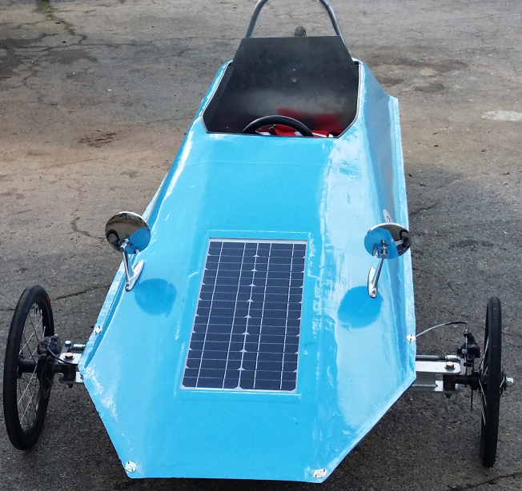
Figure 33 Demonstration of Solar Panel Implementation [1]
The competition rules concerning solar panel mounting has changed from 2012, so as to not allow independent structures; that is to say that the solar panels have to sit flush with the chassis. Once installed, the solar panels sit flush with the chassis as seen in figure 33.
The solar panel array is now considered finished and implemented into the car. Thus the energy conversion system is also considered finished and in the testing phase.

3.9 Battery System and Isolated DC-DC Converter

Battery and Battery Management System (BMS)
After consulting with faculty for guidance on the battery selection and by using a decision matrix; the lithium iron phosphate battery from Electric Rider was chosen because of its small size, low weight, and cost being under $500 (including shipping). The selected battery is 6x10.25x3.5 inches, 24V, 20Ah and a weight of 10 lbs. The battery can be seen in Figure 37.
As previously stated, the Shell Eco-Marathon competition requires that all batteries have a battery management system. The BMS is required to have cell under/over voltage limits, over current limits, and over temperature limits. The battery pack purchased from Electric Rider contains a BMS that will meet the requirements of the competition, and will protect and monitor the entire battery pack as well as individual cells. After consulting with faculty the 2012-2013 solar car team also decided to purchase a watt meter which can be seen in and a power analyzer which can be seen in Figure 39. These two components will be used as a visual display of the batteries health and performance level during the car operation. The 130A-watt meter and power analyzer was purchased from Turnigy. The device rating is 60V, 130A, 6554W and 65Ah which is within the range of the battery specification. Figure 39 shows the device display and Figure 40 shows the connection with the battery and motor.
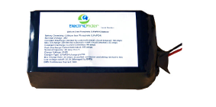
Figure 34 Electric Ride LiFePO4 Battery Back [1]
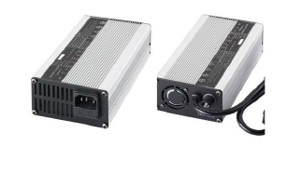
Figure 35 Electric Ride LiFePO4 Battery Back [1]
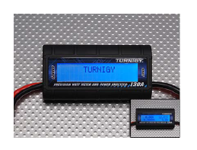
Figure 36 Turnigy Watt Meter and Power Analyzer [1]

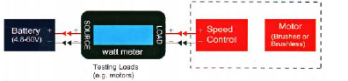
Figure 37Turnigy Monitor Connections [1]

Isolated DC-DC Converter
The team came together to discuss which components would be attached to the isolated DC-DC. After consulting with various advisors it was decided that the ventilation system, and the odometer would be connected to the isolated DC-DC converter. In the event the team attaches an odometer, the isolated DC-DC converter is subject to change. A block diagram of the isolated DC-DC converter configuration is illustrated in Figure 4136. The input to the converter is the 24V primary battery, and the output to the converter is the ventilation system. The Sanyo Denki fan was selected as a ventilation system due to its low price and appropriate specifications which can be seen in Appendix A23.
The appropriate DC-DC converter was selected by taking the fan’s voltage rating of 12V and a current rating of 600mA into consideration. After taking the fan specifications and advisor consultations into consideration the team selected the Texas Instruments LM25017. This converter has a minimum input voltage of 9V and a maximum output voltage of 48V, which is well within the range of the battery. The minimum output voltage is 1.25V, the maximum output voltage is 40V, and the converter has a maximum output of 6.25A. All of these specifications fall within the appropriate ranges necessary in order to operate the ventilation system. The isolated DC-DC converter is relatively inexpensive with a cost of $3.15. Specifications for the isolated DC-DC converter can be seen in Appendix A24.

Ventilation System
Isolated DC-DC Converter
Battery

Figure 38 Isolated DC-DC Converter Configuration

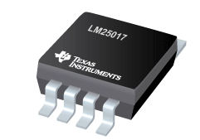
Figure 39 LM25017 Isolated DC-DC Converter [5]

Advantages
- Low Cost
- Met all specifications of the battery and ventilation system
Many isolated DC-DC converters were compared but the converter that was chosen contained all the specifications the team needed. In the future the team would like to add an odometer. In the event an odometer is added, the selected isolated DC-DC converter is subject to change.

3.10 Motor Controller

Several changes were made to the design of the motor controller. Initially, there were many single-board computers that were considered. With competition rule restrictions in mind and after receiving expert advice from Dr. Chuy and Dr. Edrington, the TI RDK-BLDC, TI MSP430 Launch Pad, TI TMS320F2808, and the ATMEL ATAVRMC100 were amongst the final four board computer options. A decision matrix was then used to make a decision between the four board controllers. In the decision matrix, 4 factors were considered: safety, cost, efficiency, and implementation difficulty. Safety carried the most weight, followed by cost, efficiency and implementation, weighing at 0.432, 0.208, 0.187 and 0.173 respectively.
Initially, the TI RDK-BLDC scored the greatest score in the decision matrix. Due to competition rules, the TI RDK-BLDC was disqualified. The other boards were also disqualified since they were either discontinued or out of stock. There would be a 10-14 week delay before receiving the board which posed an issue for the purpose of completing the project. However, with the consultant of Jesse Leonard, a PH.D student who works at Center for Advanced Power Systems (CAPS) that has great experience with motor controllers, the Texas Instruments DRV8301 69M kit has been chosen to serve as the motor controller. Jesse has previous experience controlling induction motors, with similar specifications as the hub motor used in this project, with boards in the same family as the TI DRV8301 69M-kit. With features including screw terminals for all power and signal wiring, three phase terminals that allow a direct connection to the motor’s phases, and 60V input and 40A output, the DRV8301 was a safe and easy component to integrate into the system. However, the DRV8301 would also be disqualified from the competition.
Competition rules states “The motor controller MUST be purpose-built for the Shell Eco-marathon.” Shell encourages the use of sub-components such as single-board computers, power stages, etc. After consulting with Dr. Chuy and Dr. Edrington once again, a new design was formulated for the motor controller. An individual micro-controller and motor driver was integrated into a single motor controller and tested.

Micro Controller

With time restrictions, the most convenient choice of a micro controller was the Arduino Uno. An Arduino Uno was already in the team’s possession. Moreover, with an open-source electronic prototyping platform based on flexible easy to use hardware and software, it makes coding and integrating the Arduino into a motor controller simple. The Arduino is based on the ATmega328. It has an operating voltage of 5V. It has 6 analog input pins where the throttle may be connected along with 6 PWM output pins.
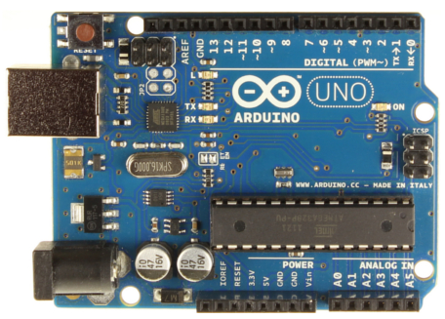
Figure: Arduino Uno
Some features that make the Arduino Uno suitable to integrating into the motor controller include:
- Operating Voltage | - 5V
- Input Voltage (recommended) | - 7-12V
- Input Voltage (limits) | - 6-20V
- Digital I/O Pins | - 14 (of which 6 provide PWM output)
- Analog Input Pins | - 6
- DC Current per I/O Pin | - 40 mA
- DC Current for 3.3V Pin | - 50 mA

Motor Driver

The Arduino alone is not capable of producing the necessary amount of power to drive the motor. Therefore, the Concept Driver 2SD316EI will be integrated to amplify the PWM signal from the Arduino. Like the Arduino, time restrictions played a major role in the selecting the Driver 2SD316EI. Dr. Edrington was able to lend the team three Driver 2SD316EI. This allowed the team to save on additional costs and avoid delays with the project from shipping and delivery time. The Driver 2SD316EI has a voltage rating of 1200V and a current rating of 150A.

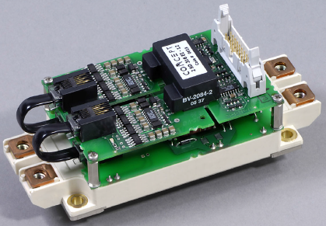
Figure: 2SD316EI IGBT Driver with Infineon Module FF150R12ME3G
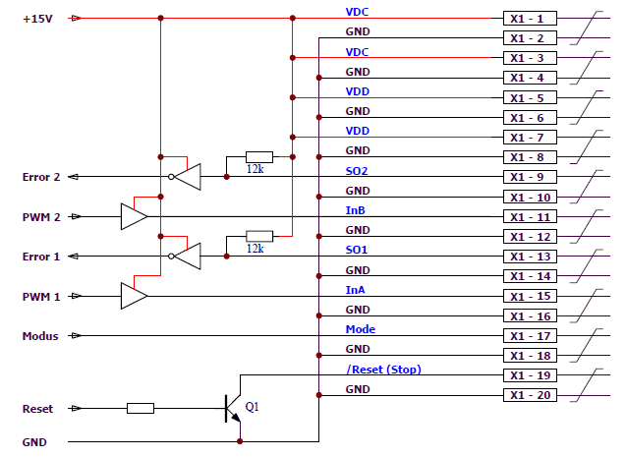
Figure: Recommended User Interface of 2SD316EI Drivers

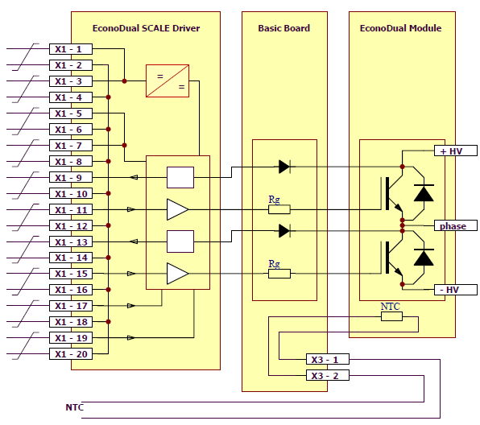
Figure: Block Diagram of Scale Driver, Basic Board, and IGBT Module

Figure _ displays the motor controller for one phase of the motor. The Arduino is supplied with 5V. The PWM output pins from the Arduino are connected to input A on the drivers. The drivers’ mode selection jumpers are set to half-bridge mode and the input pin B is set to high to enable both channels on the IGBT driver. Using ribbon cable connectors, the IGBT driver is connected to a custom made IGBT driver interface board designed by Jesse Leonard, a PhD student working at the Center of Advanced Power Systems. The driver plug is supplied with 15V to power the driver. The DC bus on the driver is supplied with 24V from the battery. The drivers provide an amplified PWM signals from the Arduino to the motor through the AC gates.
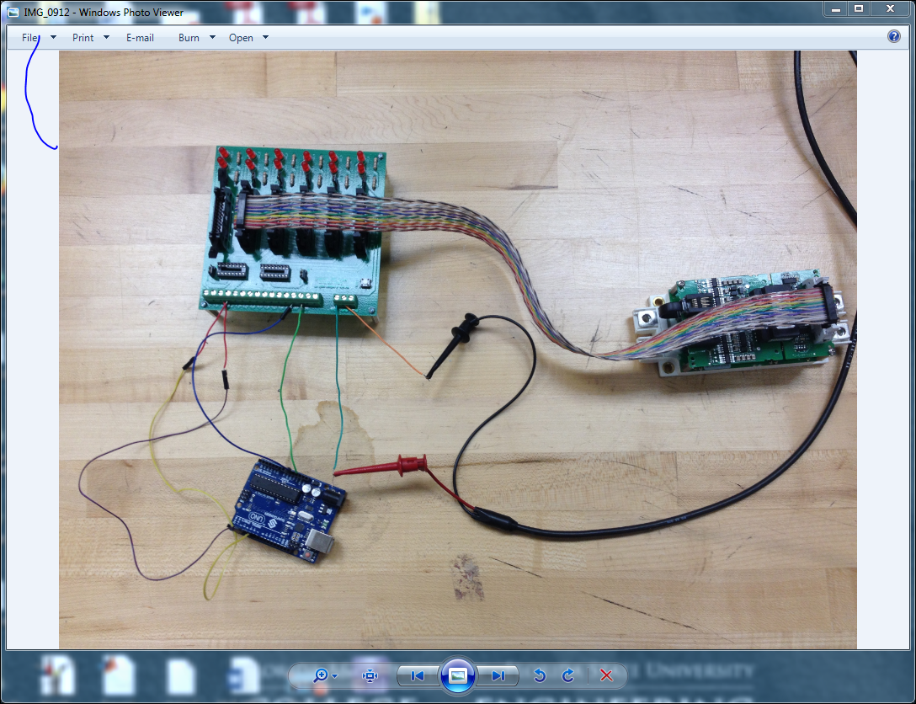
Figure: Integrated micro controller and driver into Motor Controller

Figure 40 Motor Controller (TI DRV 8301 69M-Kit)

3.11 Motor

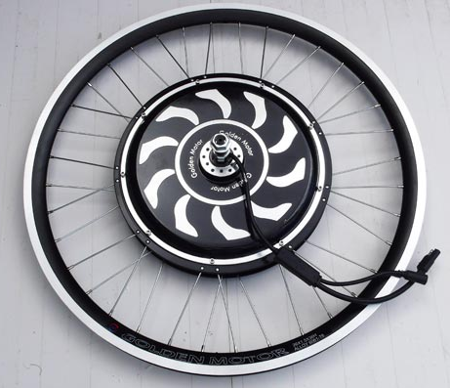
Figure: Golden Motor 24V hub motor

The motor that will be used the 24V hub motor from Golden Motors. Tests conducted by golden motors reveal that the Maximum voltage, current and power ratings for the motor is 24.07V, 19.18A and 308.88W. Refer to the Motor Controller Specifications in the Appendix for additional data on the motor’s performance test.

3.12 Emergency Shutdown System
The emergency shutdown system isolates the battery from the rest of the electrical systems. When enabled, the emergency shutdown system will disable the propulsion system. The main component in the emergency shutdown system is the solid state relay. Two stop buttons are connected in series from terminal 2, +Vcc. The two stop buttons are then connected in series with the motor controller which is used to cut off the power supply from the battery to the motor controller when enabled. A wire loops back to terminal 3, +Vcc, from the motor controller. Terminals 1 and 4, -Vcc, are connected and run through the ground of the motor controller and the battery respectively.
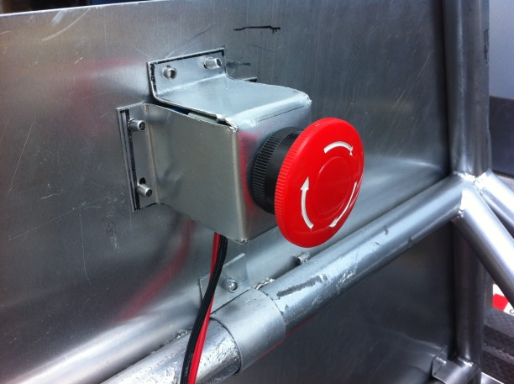
Figure: Emergency Stop Button

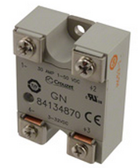
Figure: Crouzet 84134870

The Crouzet 84124870 is a solid state relay rated at a maximum 30A and operates between 3 and 32V DC. It is rated high enough break the maximum 20A that can be provided to the motor, while taking voltage and current spikes into consideration.

Additionally, three circuit breakers will be placed in each of the phases to ensure a maximum level of protection for the motor. When the breaker senses a current of greater than 30A, the breaker will open the circuit. This will prevent any current from the battery to flow through the motor and possibly causing irreparable damage.

3.13 DC-DC Converter

The purpose of the DC-DC converter is to take the DC power being transmitted from the solar panels and boost is using a MPPT (Maximum Power Point Tracking) algorithm such that it is able to charge the vehicles battery while in use. In order for this to happen, the output voltage form the DC-Dc converter must be constantly above the 24V of the lithium- ion battery.
Currently, the preexisting ISV005V2 board is rated to accept maximum voltages of up to 18V and output voltages of up to 28.8V. This is where the error lies in charging the battery. The previous solar panel inputs of 8-9V and 3-3.5A will only generate the output voltage of 24V because the input voltage is nowhere near its maximum. However, the new solar array will be able to generate a much higher voltage, capable of being properly boosted via the ISV005V2 and eventually charging the battery.
This design will ensure that the DC power leaving the solar panels will enter the ISV005V2 board at the closest possible value to the maximum, which will ensure that the maximum output voltage of 28.8V can be achieved. Once this output voltage can be achieved, the battery can be properly charged while the car is in use.

SUBSYSTEM: ISV005V2

The ISV005V2 board is a DC-DC converter that was previously used in last year’s senior design team. This component was not considered a success because it was unable to charge the battery when connected to a stiff voltage source.
However, when connected to the newly installed RAMSOND 20W solar panels the output is 30V which is successful in charging the battery.
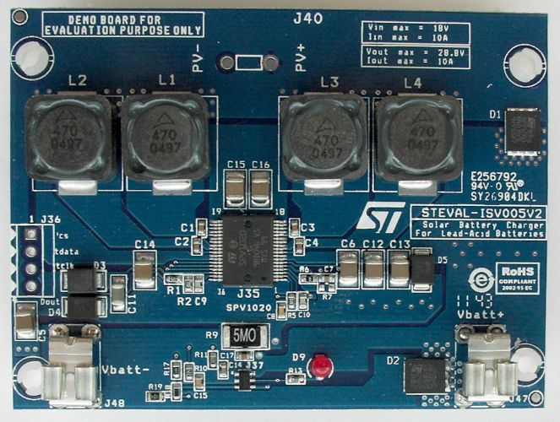
Figure 42 ISV005V2 Board [8]

4 Test Plan

4.1 Mechanical Tests

Roll Bar and Motor Mount
TEST ITEM (TITLE):
Roll Bar
TEST CASE DESCRIPTION: TEST TYPE: TEST RE-TEST
X
A Creo Parametric simulation will be run. A 700 N force will be applied in all directions to satisfy the eco shell competition rules. The Creo will also test the rear motor wheel mount connection points. The wheel mounts must have enough strength to support the full load of the car with the driver at all times therefore the simulation will include the appropriate forces (forces will account for weight of the car and the driver) on each of the wheel mount connection points.
EXPECTED RESULTS:
The anticipated results is the roll bar design with the wheel mounts will be strong enough to keep the driver safe and support the load of the car at all times.
ACTUAL RESULTS:
Roll Bar design was capable of withstanding 700N of force in all directions. Creo Parametric simulation results can be seen in Appendix D1.
STATUS: PASSED FAILED
X
FAILURE CAUSE(S):
N/A

SUGGESTED SOLUTION(S):
N/A
COMMENTS:
According to the competition rules and regulations the roll bar must be able to withstand 700N of force in all directions.

Turning Radius
TEST ITEM (TITLE):
Turning radius
TEST CASE DESCRIPTION: TEST TYPE: TEST RE-TEST
X
The turning radius test will be performed in the FAMU-FSU college of engineering parking lot of building B. A tape measurer, the car with driver, and a 10 1b bag of sand will be used to complete this test. The car will first be aligned in straight line, next the sand will be displaced on the ground in the turning direction. Once the driver turns the wheels and accelerates the tires will leave a mark on the sand. The tire threads on the sand will be measured from the center point of the car along the curvature of the circle to verify that the turning radius is less the eight meters.

EXPECTED RESULTS:
The car will have a turning radius of approximately 7 meters.
ACTUAL RESULTS:
Turning radius of 3.66m. Passes the minimum 8m turning radius requirement imposed by shell.
STATUS: PASSED FAILED
X
FAILURE CAUSE(S):
N/A
SUGGESTED SOLUTION(S):
N/A
COMMENTS:
According to the competition rules and regulations the car must have a minimum turning radius of 8 m.

Braking Test
TEST ITEM (TITLE):
Rear Brakes/Front Brakes
TEST CASE DESCRIPTION: TEST TYPE: TEST RE-TEST
X
This test will be performed on a 20 degree slope or hill. The front and rear brake will be independently activated to ensure the stopping accuracy of each one. The location of the test is to be determined. The driver will drive the car up a hill and come to a complete stop. A second member of the team will then mark the position of each tire. The rear brakes will then be activated. The rear brakes will then be unactuated and the front brakes will be activated. A second team member will mark the position of the car after the activation of each braking system to assure that the car has not moved.
EXPECTED RESULTS:
The car will be stationary on a 20 degree incline once the rear brakes and the front brakes are activated.

ACTUAL RESULTS:
The car was able to maintain a stationary position on a 20 degree incline with both the front and the rear brakes independently engaged.
STATUS: PASSED FAILED
X
FAILURE CAUSE(S):
N/A
SUGGESTED SOLUTION(S):
N/A

COMMENTS:
According to the competition rules and regulations the car must be able to remain at a complete stop on a 20 degree angle using either of the two braking systems.

Front Wheel Mount
TEST ITEM (TITLE):
Front Wheel Mount
TEST CASE DESCRIPTION: TEST TYPE: TEST RE-TEST
X
The front wheel mounts will be tested using a Creo Parametric simulation. Simulation tests with multiple loads in the vertical and horizontal directions will be applied to the front wheel mounts. The loads applied during simulation testing will be double the loads expected during competition.
EXPECTED RESULTS:
The anticipated results and outcome should satisfy that the wheel mount geometry and strength will be sufficient to support the full load of the car.

ACTUAL RESULTS:
Front wheel mounts were capable of widsthanding all forces applied during usage. Simulation results can be seen in Appendix D2.

STATUS: PASSED FAILED
X
FAILURE CAUSE(S):
N/A
SUGGESTED SOLUTION(S):
N/A

COMMENTS:
Car has already been tested and run using mounts.

Front Wheel Arm
TEST ITEM (TITLE):
Wheel Arms
TEST CASE DESCRIPTION: TEST TYPE: TEST RE-TEST
X
The front wheel arms will be tested using a Creo Parametric simulation. The wheel arms are connected to the front wheels mounts through a pin joint. Simulation tests with various loads applied to the front wheel arm will be run. This test will assure that the wheel arms can handle all loads which will be applied during competition.
EXPECTED RESULTS:
The wheel arm design will endure all forces applied during the simulation without the material breaking or deforming.
ACTUAL RESULTS:
Simulation results can be seen in Appendix D3.
STATUS: PASSED FAILED
X
FAILURE CAUSE(S):
N/A
SUGGESTED SOLUTION(S):
N/A
COMMENTS:
Car has already been tested and run using wheel arms.

4.2 Electrical System Tests

Solar array & Steval ISV005V2 DC-D Boost Converter
TEST ITEM (TITLE):
Solar array & Steval ISV005V2 DC-DC Boost converter

TEST CASE #: TEST DATE:

3/15/2014
TEST CASE DESCRIPTION: TEST TYPE: TEST RE-TEST
X
The objective of this test is to determine if the solar cell array constructed by last year’s solar car team are operational and to measure their output in a cloudy condition with the ISV005V2 DC-DC converter attached. The DC-DC converter should boost the output voltage to a level that is possible to charge a 24V battery.

EXPECTED RESULTS:
The final report for last year’s solar car design team stated that the solar cell arrangement would output approximately 8V and 2-3A depending on conditions. The report also went on to say that the DC-DC converter would only boost up to 24V and thus not quite high enough to charge the 24V lithium-Ion battery. The converter is attached to the output of the solar cells and its voltage is measured.

ACTUAL RESULTS:
The output from the DC-Dc boost converter is 35V. This is more than sufficient voltage needed to charge the battery and should drop when connected to the load.
STATUS: PASSED FAILED
X

FAILURE CAUSE(S):
Voltage is rated more than high enough to charge battery
SUGGESTED SOLUTION(S):
Use CAPS testing equipment to test the power inside of battery before and after charging.

COMMENTS:

Solar Cell Array

TEST ITEM (TITLE):
Solar Cell Array

TEST CASE #: TEST DATE:

3/12/2014

TEST CASE DESCRIPTION: TEST TYPE: TEST RE-TEST

X
The objective of this test is to determine if the solar cell array purchased by this years team will output the rated power.

EXPECTED RESULTS:
The solar cell array will output at least 21V open circuit and 1.2A short circuited
ACTUAL RESULTS:
The output is what the product is rated for and operates as advertised.
STATUS: PASSED FAILED
X

FAILURE CAUSE(S):

SUGGESTED SOLUTION(S):

COMMENTS:
The conditions for this experiment were precisely ideal. The sun was shining and the solar array had a perfect angle of incidence.

Steval ISV005V2 DC-DC Boost Converter

TEST ITEM (TITLE):
Steval ISV005V2 DC-DC Boost converter

TEST CASE #: TEST DATE:

1/17/2014
TEST CASE DESCRIPTION: TEST TYPE: TEST RE-TEST
X
The objective of this test is to determine what outputs can be expected from the ISV005V2 DC-DC boost converter when various inputs are used. This will help in determining the minimal voltage needed when leaving the solar array. The DC-DC converter need to charge a 24V battery so anything above the threshold of 26V would be necessary in charging the battery.

EXPECTED RESULTS:
The DC-DC converter output will be at least 24.5V when an input of 8V is used. This is anticipated due to the test with the solar array and DC-Dc converter previously completed. Able to boost the input voltage received from a DC power supply.

ACTUAL RESULTS:
Vin(V) | Vout (V)
6.003 | 5.832
7.002 | 12.29
8.002 | 25.16
9.002 | 27.27
10.001 | 30.28
11.001 | 34.84
12.000 | 35.081
It would seem that the output voltage does not react to the input voltage linearly. This is very helpful because all the solar array needs to do is reach a certain voltage to properly be boosted and eventually charge the lithium ion battery.

STATUS: PASSED FAILED
X

FAILURE CAUSE(S):

SUGGESTED SOLUTION(S):
Either replace diode boxes with smaller and more efficient ones or possibly create new array all together.

COMMENTS:
Greater than 12V will still yield 35V. It would appear that this is the greatest open circuit voltage.

Solar World Solar Cell
TEST ITEM (TITLE):
Solar World Solar Cell

TEST CASE #: TEST DATE:

1/30/2014
(ex: BS-001) (ex: 01/01/12 – 11:30 AM)

TEST CASE DESCRIPTION: TEST TYPE: TEST RE-TEST
X
The objective of this test is to determine what output can be expected from a solar world manufactured monocrystalline solar cell.
The solar cell was soldered using the typical soldering technique. That is, with flux paste, tabbing wire and a soldering iron on both sides. Due to inclement weather conditions, the solar cell will be tested in the senior design lab using a halogen lamp. When weather permits, more tests in the real world environment will take place. The solar cell needs to operate before a solar array design can take place. The output voltage and current from this cell will help in determining what orientation each cell will have. More specifically if the cells will all be in series or either a parallel and series combination.

EXPECTED RESULTS:
The solar cell will output some voltage when the halogen lamp is placed directly above the solar cell.

ACTUAL RESULTS:
Vout | Iout | Power
0.565 V | 1.76 A | 0.994 W
Thus the solar cell was soldered correctly and is outputting almost 1 Watt of power. This is good news as 10 solar cells are going to be integrated into a single array which will hopefully be able to generate 10W of power.

STATUS: PASSED FAILED
X

FAILURE CAUSE(S):

SUGGESTED SOLUTION(S):
Need to reach at least 10V output when 10 solar cells are connected.

COMMENTS:
A series combination might be the most ideal combination, however further research must be conducted.

Isolated DC-DC Converter

TEST ITEM (TITLE):
Isolated DC-DC Converter Test

TEST CASE #: TEST DATE:

TBA

TEST CASE DESCRIPTION: TEST TYPE: TEST RE-TEST
Using a stiff voltage source to simulate a 24 V input from the battery and a load the converter will be tested to ensure that it reduces the voltage from the battery to supply the proper voltage to the load.
EXPECTED RESULTS:
The isolated DC-DC converter will properly reduce the input voltage to the voltage needed to supply the load.
ACTUAL RESULTS:
TBA

STATUS: PASSED FAILED

FAILURE CAUSE(S):

SUGGESTED SOLUTION(S):

COMMENTS:

Horn

TEST ITEM (TITLE):
Horn Test

TEST CASE #: TEST DATE:
1
2-28-14

TEST CASE DESCRIPTION: TEST TYPE: TEST RE-TEST
The horn was connected to the accessory battery. Using a push button to press the horn it should sound.
EXPECTED RESULTS:
Horn should sound
ACTUAL RESULTS:
The horn sounded

STATUS: PASSED FAILED

FAILURE CAUSE(S):

SUGGESTED SOLUTION(S):

COMMENTS:

The previous year’s team tested the battery their results are below.

Battery Discharge – 1C

TEST ITEM (TITLE):
Battery Discharge – 1C

TEST CASE #: TEST DATE:
BS-01
1/31/13 – 9:00am

TEST CASE DESCRIPTION: TEST TYPE: TEST RE-TEST
Connect the battery to the BK Precision 2400W Programmable DC Electronic Load and observe the battery discharge for the 1C battery rating.
EXPECTED RESULTS:
When the battery is supplied 20A with a nominal voltage of 24V, the battery should be able to supply power for 1 hour before it is fully discharged.
ACTUAL RESULTS:
The elapsed test time was 51:20. The simulation was set up to end when the battery reached 20V. Data results plotted in MATLAB

STATUS: PASSED FAILED
X

FAILURE CAUSE(S):

SUGGESTED SOLUTION(S):

COMMENTS:
Battery may not have been fully charged, will retest when batteries are confirmed to be fully charged to check validity. Once the initial test was over the testing was quickly continued until the battery management system cutoff at 17.8V.

Battery Discharge – 2C

TEST ITEM (TITLE):
Battery Discharge – 2C

TEST CASE #: TEST DATE:
BS-02
1/31/13 – 2:30pm

TEST CASE DESCRIPTION: TEST TYPE: TEST RE-TEST
Connect the battery to the BK Precision 2400W Programmable DC Electronic Load and observe the battery discharge for the 2C battery rating.
EXPECTED RESULTS:
When the battery is supplied 40A with a nominal voltage of 24V, the battery should be able to supply power for 30 minutes before it is fully discharged.
ACTUAL RESULTS:
The elapsed test time was 22:31. The simulation was set up to end when the battery reached 16.8V. Data results plotted in MATLAB

STATUS: PASSED FAILED

FAILURE CAUSE(S):

SUGGESTED SOLUTION(S):

COMMENTS:
During testing the wires being used to connect the thick gauge main battery wires to the electronic load became very hot at this high current. To continue testing at a higher current the supplemental wires will need to be replaced with a higher gauge wire. Should probably even consider using a higher gauge wire when connecting the battery in the final design of the car.

Battery Discharge – 0.5C

TEST ITEM (TITLE):
Battery Discharge – 0.5C

TEST CASE #: TEST DATE:
BS-03

TEST CASE DESCRIPTION: TEST TYPE: TEST RE-TEST
Connect the battery to the BK Precision 2400W Programmable DC Electronic Load and observe the battery discharge for the 0.5 battery rating. Record the total elapsed time and the voltage cutoff.
EXPECTED RESULTS:
When the battery is supplied 10A with a nominal voltage of 24V, the battery should be able to supply power for 1:30 before it is fully discharged. Voltage cutoff should be at the BMS rating of 16.8V
ACTUAL RESULTS:
TBA

STATUS: PASSED FAILED

FAILURE CAUSE(S):

SUGGESTED SOLUTION(S):

COMMENTS:

Battery Charging Capabilities

TEST ITEM (TITLE):
Battery Charging Capabilities

TEST CASE #: TEST DATE:
BS-04

TEST CASE DESCRIPTION: TEST TYPE: TEST RE-TEST
Connect the battery to the BK Precision 2400W Programmable DC Electronic Load and the battery charger to the battery. Use the constant voltage mode to record how long it takes to charge the fully discharged battery.
EXPECTED RESULTS:
Elapsed time should be 5 hours
ACTUAL RESULTS:
TBA

STATUS: PASSED FAILED

FAILURE CAUSE(S):

SUGGESTED SOLUTION(S):

COMMENTS:

Battery Integration

TEST ITEM (TITLE):
Battery Integration

TEST CASE #: TEST DATE:
BS-05

TEST CASE DESCRIPTION: TEST TYPE: TEST RE-TEST
Connect the battery with the converter and solar array and place in sun and with artificial light in lab to test the charging abilities of the battery with the solar array.
EXPECTED RESULTS:
The solar array will charge the battery.
ACTUAL RESULTS:
TBA

STATUS: PASSED FAILED

FAILURE CAUSE(S):

SUGGESTED SOLUTION(S):

COMMENTS:

Motor Controller

TEST ITEM (TITLE):
Motor Controller

TEST CASE #: TEST DATE:
1
01/17/14

TEST CASE DESCRIPTION: TEST TYPE: TEST RE-TEST
Test Objective:
The team was considering using a number pad key board as an input into the motor controller to control the speed of the motor by simply typing in the revolutions per minute value desired.

Test Description/Requirements:
Using the instaSpin software motor testing, the TI DRV8301 69M-kit is used to spin the motor at a desired speed in revolutions per minute.

EXPECTED RESULTS:
Upon the motor identification test through instaSpin software, the motor should be recognized by the TI DRV8301 69M board. Once the board identifies the motor, a speed value can be typed in and the board will read that value to control the motor.
ACTUAL RESULTS:
Requirement for Success:
The motor should accelerate then maintain the desired speed.

Actual Results:
The test was a success. After typing the desired speed, motor accelerated to the rpm entered.

STATUS: PASSED FAILED
X
FAILURE CAUSE(S):

SUGGESTED SOLUTION(S):

COMMENTS:
At a desired 4000rpms, the motor did not seem to be rotating at that speed (to the naked eye).

TEST ITEM (TITLE):
Motor Controller

TEST CASE #: TEST DATE:
2
04/14/14

TEST CASE DESCRIPTION: TEST TYPE: TEST RE-TEST
Test Objective:
Test the output gate of the IGBT Driver using a function generator

Test Description/Requirements:
Using a function generator, a square wave will is applied to Input A on the IGBT driver. Mode selection is in H-Bridge mode. Therefore, Input B is set to high to enable the AC gates. An oscilloscope is connected to the AC gates to read the output.
EXPECTED RESULTS:
An amplified square wave should be detected on the oscilloscope.
ACTUAL RESULTS:
Requirement for Success:
An amplified square wave should be detected on the oscilloscope.

Actual Results:
The oscilloscope was detecting only noise from the gate.

STATUS: PASSED FAILED

X

FAILURE CAUSE(S):
Input B was enabled high. However, it was connected to the 5V supply on the interface board.
SUGGESTED SOLUTION(S):
15V is needed for Input B.
COMMENTS:

TEST ITEM (TITLE):
Motor Controller

TEST CASE #: TEST DATE:
3
04/14/14

TEST CASE DESCRIPTION: TEST TYPE: TEST RE-TEST
Test Objective:
Test the output gate of the IGBT Driver using a function generator

Test Description/Requirements:
Using a function generator, a square wave will is applied to Input A on the IGBT driver. Mode selection is in H-Bridge mode. Therefore, Input B is set to high at 15V to enable the AC gates. An oscilloscope is connected to the AC gates to read the output.
EXPECTED RESULTS:
An amplified square wave should be detected on the oscilloscope.
ACTUAL RESULTS:
Requirement for Success:
An amplified square wave should be detected on the oscilloscope.

Actual Results:
The oscilloscope was detecting only noise from the gate.

STATUS: PASSED FAILED

X
FAILURE CAUSE(S):

SUGGESTED SOLUTION(S):
Amplitude of square wave was only 500mV.
Jesse: 500mV pk-pk is not enough. It should be 15V.
The maximum Voltage from the function generator is 10Vpk-pk.
COMMENTS:

TEST ITEM (TITLE):
Motor Controller

TEST CASE #: TEST DATE:
4
04/15/14

TEST CASE DESCRIPTION: TEST TYPE: TEST RE-TEST
Test Objective:
Test the output gate of the IGBT Driver using a function generator

Test Description/Requirements:
Using a function generator, a square wave will is applied to Input A on the IGBT driver. Mode selection is in H-Bridge mode. Therefore, Input B is set to high at 15V to enable the AC gates. An oscilloscope is connected to the AC gates to read the output. Amplitude on function generator is set to 10Vpk-pk
EXPECTED RESULTS:
An amplified square wave should be detected on the oscilloscope.
ACTUAL RESULTS:
Requirement for Success:
An amplified square wave should be detected on the oscilloscope.

Actual Results:
The oscilloscope picked up an amplified square wave signal.
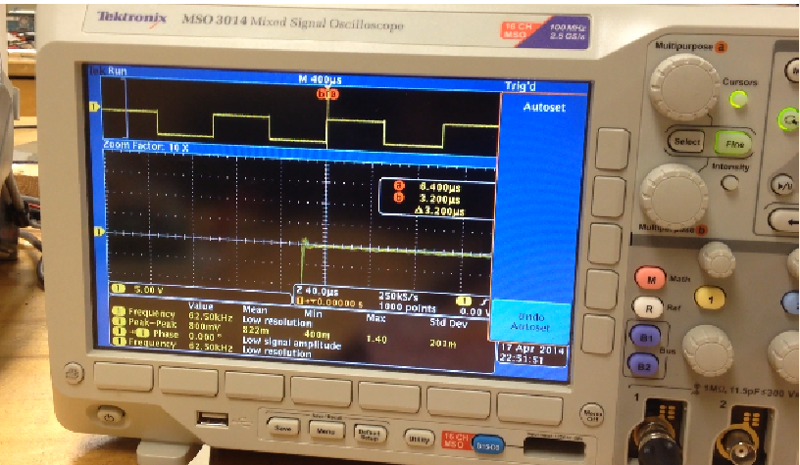
STATUS: PASSED FAILED
X

FAILURE CAUSE(S):

SUGGESTED SOLUTION(S):

COMMENTS:

TEST CASE #: TEST DATE:
5
04/17/14

TEST CASE DESCRIPTION: TEST TYPE: TEST RE-TEST
Test Objective:
Test the output gate of the IGBT Driver using the Arduino

Test Description/Requirements:
Using the Arduino, a square wave will is applied to Input A on the IGBT driver through the PWM. Mode selection is in H-Bridge mode. Therefore, Input B is set to high at 15V to enable the AC gates. An oscilloscope is connected to the AC gates to read the output.
EXPECTED RESULTS:
An amplified square wave should be detected on the oscilloscope.

ACTUAL RESULTS:
Requirement for Success:
An amplified square wave should be detected on the oscilloscope.

Actual Results:
The oscilloscope picked up an amplified square wave signal.

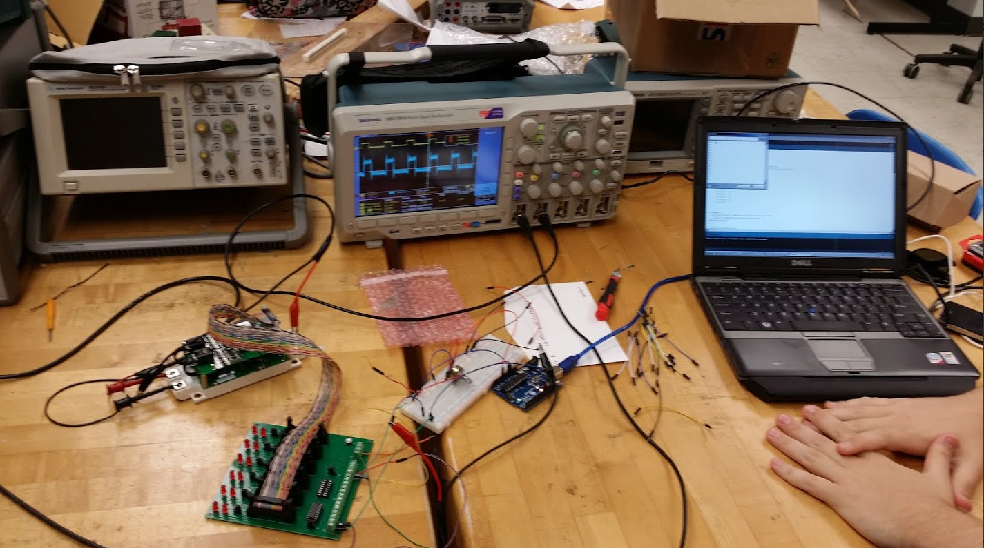
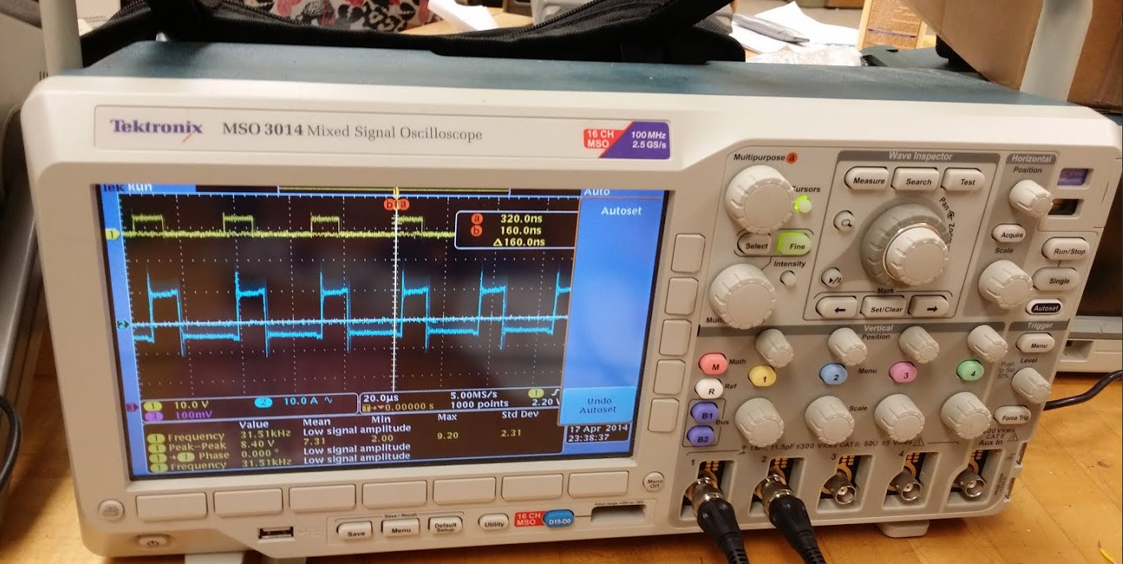
STATUS: PASSED FAILED
X

FAILURE CAUSE(S):

SUGGESTED SOLUTION(S):

COMMENTS:

Motor
TEST ITEM (TITLE):
Motor

TEST CASE #: TEST DATE:

01/17/14

TEST CASE DESCRIPTION: TEST TYPE: TEST RE-TEST
Test Objective:
The objective of this test is to verify that the hub motor is capable of obtaining and maintaining a speed of 15mph.

Test Description/Requirements:
The equipment required for this test is the hub motor, a bike, the propulsion battery, BAC-281P (motor controller provided with the motor), throttle, and a vehicle. The motor is mounted onto a bike. The battery is connects to the BAC-281P. The battery and motor controller are placed into a back pack and mounted onto the riders back (David Jolicoeur). The Rider mounts the bike and ride alongside a vehicle moving at approximately 15mph.

EXPECTED RESULTS:
After observing the motor’s rotational speed with no load, it is expected that the motor will not be able to reach 15mph with a 220lb load. (David is approximately 200lbs. The battery is approximately 20lbs)

ACTUAL RESULTS:
Requirement for Success:
The motor should be able to travel parallel with a moving vehicle traveling at 15mph.

Actual Results:
The motor took some time to accelerate with the 220lb load. After about 10 seconds, the motor sped up and was able to remain parallel with the vehicle moving at approximately 15mph. The test was successful.

STATUS: PASSED FAILED
X
FAILURE CAUSE(S):

SUGGESTED SOLUTION(S):

COMMENTS:
This test was performed without the motor controller that will be used in the competition.

Emergency Shutdown System Test 1
TEST ITEM (TITLE):
Emergency Shutdown

TEST CASE #: TEST DATE:

04/4/14

TEST CASE DESCRIPTION: TEST TYPE: TEST RE-TEST
This was a test of the internal shut down switch. This switch is located underneath the driver’s seat near the thighbone in order to have the maximum convenience when driving.
this test used the TI DRV8301 Motor controller in order to simulate a real emergency.
EXPECTED RESULTS:
The motor controller will stop operating and the motor will stop spinning as well.

ACTUAL RESULTS:
The motor and motor controller both stopped working immediately upon pressing the internal shut down switch.

STATUS: PASSED FAILED
X
x
FAILURE CAUSE(S):
N/A
SUGGESTED SOLUTION(S):
N/A
COMMENTS:

Emergency Shutdown System Test 2

TEST ITEM (TITLE):
Emergency Shutdown External Switch

TEST CASE #: TEST DATE:

04/04/14

TEST CASE DESCRIPTION: TEST TYPE: TEST RE-TEST
The purpose of this test is to test the external shutdown switch. This switch si located on the rear of the car and is accessible at all times outside of the car.
The testing situation is exactly the same as the one used for the internal switch.
EXPECTED RESULTS:
The motor controller will stop operating and the motor will stop spinning as well.

ACTUAL RESULTS:
The motor and motor controller both stopped working immediately upon pressing the internal shut down switch.

STATUS: PASSED FAILED
X

FAILURE CAUSE(S):
N/A

SUGGESTED SOLUTION(S):
N/A

COMMENTS:

4.3 Safety Testing

Vacation Test

TEST ITEM (TITLE):
Driver Vacation Test
TEST CASE DESCRIPTION: TEST TYPE: TEST RE-TEST
The driver will sit in the car fully harnessed, and exit the car three times. A second member of the team will use a stopwatch determine the time from the moment the driver begins to remove the 5 point harness to the moment both of the drivers feet are on the ground outside of the car.
EXPECTED RESULTS:
The fully harnessed driver will escape the vehicle in less than 10 seconds.
ACTUAL RESULTS:
The driver and the backup driver were both able to successfully vacate the vehicle within 6 seconds, which meets the shell eco marathon standards.
STATUS: PASSED FAILED
X
FAILURE CAUSE(S):
N/A
SUGGESTED SOLUTION(S):
N/A

COMMENTS:
According to the competition rules and regulations the fully harnessed driver must be able to vacate the vehicle at any time without assistance in less than 10 seconds.

Five Point Harness
TEST ITEM (TITLE):
Safety Harness Test
TEST CASE DESCRIPTION: TEST TYPE: TEST RE-TEST
The completed car will be manually lifted from the five point harness using a steel pipe to hold the car up from both sides. The car will be held in the air for 30 seconds. Once the car is lowered each of the five points of contact will be checked to assure that none have failed.
EXPECTED RESULTS:
The safety harness will withstand the downward force of the car without the failure of any of the points of contact.
ACTUAL RESULTS:
The car was successfully lifted from the five point harness without any breakage or deformation.
STATUS: PASSED FAILED
X
FAILURE CAUSE(S):
N/A
SUGGESTED SOLUTION(S):
N/A
COMMENTS:
According to the competition rules and regulations the safety harness must withstand a force of at least 1.5 times the driver’s weight; furthermore the car will be lifted off the ground from the five point harness.

5 Schedule
The team created a Gantt chart to indicate the task by task scheduling from the project start to the project completion. The schedule has been broken down into four main sections: design, manufacturing, installation, and testing. All design aspects must be completed prior to the start of manufacturing in order to adhere to a concurrent engineering design philosophy.
According to the initial Gantt chart schedule the design portion of the project will take place between October 14, 2013, and November 16, 2013. Once all design aspects have been completed the team will begin manufacturing each component of the vehicle according to the Gantt chart schedule. The manufacturing phase of the project will take place between December 16, 2013 and February 12, 2014. Once the manufacturing has been completed the team will begin the component installation, which will last approximately 30 days. Once all components have been installed and the vehicle is fully functioning a 15 day testing period including all tests covered in the testing section of the report will take place. Based on the Gantt chart the following steps will be considered the critical path: front wheel mount design and analysis, front wheel steering design and analysis, front wheel brake design and analysis, tire manufacture, component installation, and testing. The team’s completed Gantt chart can be found in Appendix A3 Gantt Chart.
The team has currently completed the design and analysis phase on time for all major components listed in the Gantt chart. The milestone 1 “Needs and Analysis” report and presentation have both been completed; moreover milestone 2 “Project Proposal” and milestone 3 “System Level Design and Review” reports and presentations have also been completed.
With the design and analysis phase of the project completed the team moved on to the manufacturing phase which has also been completed. Based on the final designs from the design and analysis phase the team selected one of two “manufacturing methods” to be used based on the component. In order to adhere to time constraints and remain on schedule the team decided to order as many “off the shelf” parts as possible. Other components of the vehicle which are specific to the vehicle size, dimensions, and material specifications were manufactured in house with the help of the FAMU-FSU college of engineering machine shop. Based on the results from the design and analysis phase of the project the team selected and ordered the following components “off the shelf”:
- Steering wheel
- Rack and pinion
- Front Brakes (2 brakes)
- Rear Brake
- Brake Lines (3 brake lines)
- Rotors
- Wheel Hubs
- Tires and tubes
- Solar Panels
- DC-DC Converter
- Circuit Breakers
- Manual Kill Switch (2: 1 internal, 1 external)
- Latches
- Fire Extinguisher
- Seat Belt
- Horn & Horn Button
- Wires
- Brake Pedals (2: 1 rear, 1 Front)
- Power Pedal (Throttle)
Based on the custom nature of the vehicle the team decided that the following components were going to be manufactured in house:
- Roll Bar
- Motor Mounts
- Truss
- Front Wheel Mounts
- Front Brake Mounts
- Spindles
- Rear Brake Mount
- Seat & Seat Mounts
- Front Bulkhead
- Rear Bulk Head
- Custom Brackets
- Steering Column Support
- Battery Compartment
In order to manufacture each of these components the team first placed material orders. Due to a delay in the release of the funds allocated to the solar car project, the team had to fund an account that is currently being reimbursed in order to begin receiving materials and components as soon as possible. Although the team originally intended to manufacture all components prior to commencing the installation phase, Jermy (lead engineer in the machine shop) suggested that it would be more productive to manufacture and install the components that were to be built in house simultaneously. Furthermore, it was suggested that certain custom components had to be manufactured and installed simultaneously in order to assure proper fits, and that custom brackets and mounting plates required to fit the vehicles unique size and geometry had been overlooked. Due to the lost time from budget issues and the need for certain custom parts and mounting brackets to be manufactured and installed simultaneously the team meshed the two phases. The meshing of the manufacturing and installation phases, allowed the team to commence the installation phase of the project early and recuperate some of the lost manufacturing time from the budget allocation issues and shipment setbacks. The early start of the installation phase for these major components kept the team on track assuring that the critical path was not broken.
With the design, manufacturing, and installation phases of the project completed the team commenced the testing phase of the project. The testing phase of the project includes a compliance full compliance check of all competition rules and regulations, the testing of all major components. The team originally intended to have a 15 day testing period, however the team portable was broken into, and the car was damaged which set the team back. Fortunately many of the major tests for were performed prior to the incident. All remaining tests will be performed in the week leading up to the competition 04/21/14 - 04/21/25. The full testing plan and results can be seen in the testing portion of the report.

6 Final Budget & Justification
The project started with an allotted budget of $6000. Additionally, Dr. Okoli made a verbal agreement to pay for the Eco-marathon travel costs (up to $3000) on the conditions that the team secured an external sponsor and “made mission” for the project. Of the allotted $6000 only $1,530.13 has been spent (see table 9). About $1,200 was spent on the steering, propulsion, and structural systems of the solar car, and about $330 was spent on the motor controller. The team was fortunate to receive in-kind donations from the 2013 solar car team in the form of the chassis, rear wheel and in-hub motor. Solar panels, wires, and tabbing materials were donated to the team by Justin Vandenbroeck (IE ‘14), and we would like to kindly thank him for his donation and aid in this project.
We anticipate approximately $800-1000 in additional costs in order to procure all remaining components and services for the project. In the event of component defects or breakage the remaining expenditures may increase. Travel costs are estimated to be approximately $4000 based on our road travel plan, this includes transportation, accommodation, and provisions. The team could have spent more money on the project, but doing so would have required a re-design from the original conception phase. Unfortunately the 2013 team had multiple setbacks, and time did not permit our team to deviate too much from the original design whilst mid-project. As a result the plan continued as left off by the 2013 team, with a couple of modifications where improvement was feasible. A large consideration in not restarting the design was due to the time constraints, and the fact that the Shell Eco-marathon will be eliminating the solar car category after the 2014 competition. As a result, we thought that leftover money could be better spent if allocated to a future Eco-marathon senior design team for the electric vehicle category.
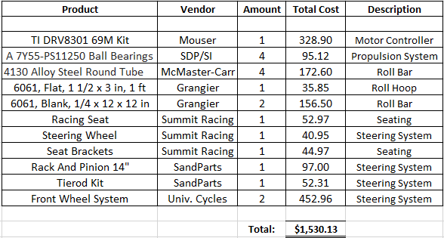
Table 9: Overall Project Budget

8 Conclusion
The team is required to build a solar-powered electrical vehicle which conforms to the rules and regulations of the Shell 2014 Eco-Challenge competition. The car is required to have several features which will ensure the safety of the driver and reduce the risk of mechanical or electrical failure. There are several dimension limitations including the height, width, ratio of height to track width, wheelbase, total length, and vehicle weight. Additionally, there are minimum standards established for the turning radius, and braking requirements.
After establishing the existence and strength of the relationships between the customer requirements and the design factors (quality characteristics on HOQ), the team ranked the importance of each customer requirement. Each customer requirement was ranked equally (max score) because the competition requires teams to satisfy all rules and regulations in order to participate; based on this it was determined that no preference should be given to one customer requirement over another. The primary concern for ranking in the competition is the efficiency of the vehicle, which will be determined by the organizer’s evaluation.
Once the HOQ was completed the team created a comparison matrix template using the most significant factors, in order to rank components against their alternatives in the design selection phase. The comparison matrix was created by assigning normalized percentage weight values, which were derived from our HOQ analysis, to each ranking criteria. Next an optimization legend was created, in order to determine which design was the most optimal for the vehicle. Each component was assigned a ranking relative to its alternatives. A higher score indicates a more optimal solution, while a score of 1 indicates the least optimal solution. The weights were then applied to the relative rankings, which gave us insight into which components best fit the customer’s requirements. The alternative designs were generated based on input received from various advisors and professionals in the respective fields. The largest design problem that had to be solved was striking a balance between the necessary trade-offs for the weight, the cost, and the safety of vehicle.
The team decided to split the design work into two categories: mechanical and electrical components. After consulting with the advisors for the project on the status and validity of their designs, the team went to work simulating the mechanical and electrical behavior of the car’s components. Various measurements were checked in order to ensure the safety, speed, low weight, and affordability of the vehicle. Mechanical components that were designed include: a roll bar and rear wheel mount, a roll hoop, a steering system, a braking system, a seat, the wheels, and a bulkhead. Electrical components that were designed include: the solar panel system, the propulsion system, the motor controller, the single board computer, and the DC-DC converter. Each component had its own unique design limitations which had to be considered before designs could be finalized.
Budgeting thus far consists of the procurement costs for the mechanical and electrical components, as well as the materials cost for components that have to be manufactured. The total amount spent on the project thus far summed to $1530.13. Additionally we anticipate travel costs at approximately $4000. This puts us at below the $6000 budget allotted to the project.

The measurements performed by the team included: center of gravity calculations, a weight distribution, static vertical wheel load calculations, turning radius and tie rod calculations, static and dynamic load bearing analysis, and the turning radius calculation. These measurements will allow the team to finish the Measure step of their Define, Measure, Analyze, Design, Verify (DMADV) design process. In this phase, Analyze, we were able to ensure that our finalized design meets all the requirements per the simulations recommended by faculty advisors. Once their approval was earned, the team moved on to analyzing the design for small improvements which could lead a cumulative gains in the efficiency of the vehicle. Such improvements include the new solar array, the solar implementation plan, the new roll bar design, and the simplified steering system.

9 References
[1] FAMU-FSU 2012 Solar Car Final System Design Review Report, Bosworth et al, April 2013.
[2] "TMS320F2808." Data Sheet. Texas Instruments, n.d. Web. 14 Nov. 2013. <http://www.ti.com/lit/ds/symlink/tms320f2808.pdf>.
[3] " DRV8301." Data Sheet. Texas Instruments, n.d. Web. 14 Nov. 2013. <http://www.ti.com/lit/ds/symlink/tms320f2808.pdf>.
[4] "Turning Radius Calculation, Steering Assistance and Parking Assistance Employing Turning Radius Function." - Patent #07706943. N.p., n.d. Web. 14 Nov. 2013.
[5] "LM25017(ACTIVE)48V, 650mA Wide Vin Synchronous Step-down Regulator with Integrated MOSFETs." Converter (Integrated Switch). N.p., n.d. Web. 14 Nov. 2013.
[6] "SANYO DENKI - SANACE FANS - 109BF12HC2 - DC BLOWER, 120 X 32MM, 12V." 109BF12HC2. N.p., n.d. Web. 14 Nov. 2013.
[7] LM5000. Digital image. Www.ti.com. Texas Instruments, n.d. Web. 14 Nov. 2013. (<http://www.ti.com/lit/ds/symlink/lm5000.pdf>.)
[8] "The Voltage Divider Rule." The Voltage Divider Rule. N.p., n.d. Web. 14 Nov. 2013. <http://www.aikenamps.com/VoltageDividerRule.htm>.
[9] "ISV005V2." Data Sheet for ISV005V2. Steval Microelectronics, n.d. Web. 14 Nov. 2013. <http://www.st.com/st-web-ui/static/active/en/resource/technical/document/data_brief/DM00047381.pdf>.
[10] Online Metals store, Metals and Plastics, November 11, 2013. (http://www.onlinemetals.com/index.cfm)
[11] Defense Pricing and Acquistions, Defence Pricing, July 23, 2013. (http://www.acq.osd.mil/dpap/cpf/docs/contract_pricing_finance_guide/vol3_ch6.pdf)
[12] "Small Mechanical Components: Precision Gears, Gear Assemblies, Timing Belts, Timing Belt Pulleys and Couplings - SDP/SI." Small Mechanical Components: Precision Gears, Gear Assemblies, Timing Belts, Timing Belt Pulleys and Couplings - SDP/SI. N.p., n.d. Web. 14 Nov. 2013. <http://www.sdp-si.com/>.

Appendix

A: IE

A1: Fish Bone Analysis
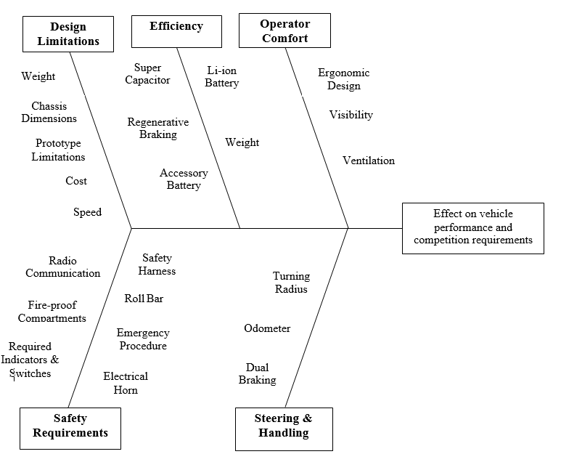

A2: House of Quality
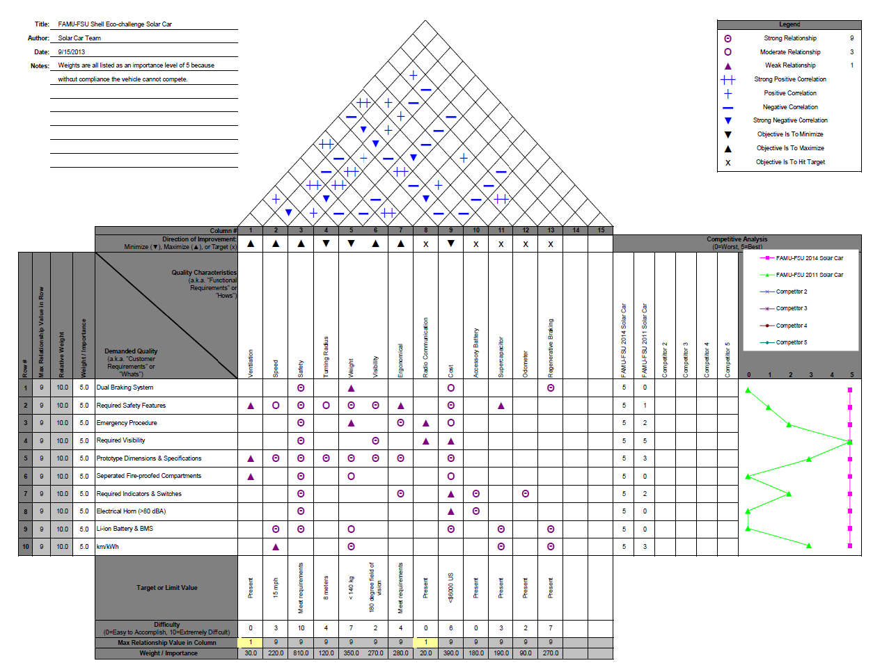

The group began by comparing the required dual braking system to each of the thirteen quality characteristics. After careful analysis the following relationships were established:
- Strong relationship with safety, because having dual braking systems adds extra safety measures to the car.
- Weak relationship with weight, because adding a secondary braking system will slightly increase the cars weight.
- Moderate relationship with cost, because the dual braking system will moderately increase the cars cost.
- Strong relationship with regenerative braking system, because the braking systems will be directly related to regenerative braking.

The required safety features were then compared to each of the thirteen quality characteristics. A roll bar, 5 point seat belt, rear view mirrors, turning radius requirements, and bulkheads were considered when establishing the following relationships:
- Weak relationship with ventilation, because having a ventilation system will increase the operational safety when operating in extreme environments.
- Moderate relationship with speed, because adding these safety features moderately increases the vehicles weight which ultimately decreases the vehicles speed.
- Strong relationship with safety, because each of these safety features adds an extra level of operational safety.
- Moderate relationship with turning radius, because increased turning radius increases the cars maneuverability which affects the overall safety of the driver.
- Strong relationship with weight, because adding these safety features will significantly increase the cars weight.
- Strong relationship with visibility, because safety features such as the rear view mirrors will directly affect the driver’s visibility.
- Weak relationship with ergonomic aspects of the car because implementing all of the safety features will make it more difficult to design the car in an ergonomic manner due to space restrictions.
- Strong relationship with cost, because implementing each safety feature will significantly increase the cost of the project.
- Weak relationship with a super capacitor, since the addition of a super capacitor increases the probability of an overload.

Required emergency procedures were compared to each of the thirteen quality characteristics. The addition of a ten second escape plan, and an electrical shutdown switch were considered when establishing the following relationships:
- Strong relationship with safety, including a ten second escape plan and having emergency shutdown switches will significantly increase the operational safety.
- Weak relationship with weight, because including these emergency procedures will slightly increase the cars weight due to extra parts.
- Strong relationship with ergonomic aspects, because including these emergency procedures will directly affect the ergonomic design of the car.
- Weak relationship with radio communication because having radio communication will make following emergency procedures easier at the time of an emergency.
- Moderate relationship with cost, because adding the extra parts necessary to incorporate these emergency procedures will moderately increase the cost of the project.

Required visibility was compared to each of the thirteen quality characteristics. The addition of rear view mirrors and a 180 degree field of vision were considered when establishing the following relationships:
- Strong relationship with safety because having the required visibility specs met significantly increases the operational safety of the vehicle.
- Strong relationship with visibility because having the required visibility specs met significantly increases the driver’s visibility.
- Weak relationship with radio communication because radio communication will allow the pit crew to help the driver with their surroundings.
- Weak relationship with cost because having the required visibility specs met will slightly increase the project’s cost. For example rear view mirrors will need to be purchased.

Required vehicle dimensions were compared to each of the thirteen quality characteristics. After careful analysis the following relationships were established:
- Weak relationship with ventilation, because the constricted size of the car limits the types of ventilation which can be used.
- Strong relationship with speed, because the vehicles dimensions directly affect the vehicles speed. The larger the vehicle, the slower it will run due to the limited engine size and energy capabilities.
- Strong relationship with safety, because the larger the car the more safe it will be. Inversely the smaller the car the less safe it will be.
- Strong relationship with turning radius because the turning radius is directly affected by the vehicle dimensions.
- Strong relationship with weight because the larger the car the more it will weigh, and vice versa, the smaller the car the less it will weigh.
- Strong relationship with visibility because the dimensions of the car will directly affect the drivers visibility. The shape and dimensions can also add blind spots in the driver’s field of vision.
- Strong relationship with ergonomic aspects of the car dimension limits will directly affect the ergonomic design capabilities. The smaller the car the more difficult it will be to implement an ergonomic design.
- Strong relationship with cost because the larger the car the more material is used which increases the cost of the project, and vice versa the smaller the car the less material that is used, and the cheaper the cost of the project.

Separated fire proof compartments were compared to each of the thirteen quality characteristics. The fire retardant bulk heads were also considered when making these correlations. After careful analysis the following relationships were established:
- Weak relationship with ventilation, because the separate fire proof compartments make it more difficult to add ventilation to the car. Furthermore, the separated fire proof compartments take up a considerable amount of space which also decreases the ventilation possibilities.
- Strong relationship with safety, because having the separate fire proof compartments will directly increase the operational safety of the vehicle.
- Moderate relationship with weight, because adding the materials necessary to implement the separate fire proof compartments and the bulkheads will moderately increase the weight of the vehicle.
- Moderate relationship with cost, because adding the materials necessary to implement the separate fire proof compartments and the bulkheads will moderately increase the cost of the project.

Required indicators and switches were compared to each of the thirteen quality characteristics. The escape latch indicators and red arrows, the system shutdown switch, and the system shut down indicators were considered when establishing the following relationships:
- Strong relationship with safety, because the switches and indicators considered directly increase the operational safety during an emergency.
- Strong relationship with ergonomic design, because the location of the switches must be easily accessible to the driver of the car.
- Weak relationship with cost, because the switches and indicators considered should be fairly inexpensive to implement.
- Strong relationship with the odometer, because it is an indicator that is highly desired.
- Strong relationship with the accessory battery, because the accessory battery will power the additional indicators and switches.

The electric horn was compared to each of the thirteen quality characteristics. After careful analysis the following correlations were made:
- Strong relationship with safety, because having an electric horn will allow the driver to safely pass other vehicles on the track.
- Weak relationship with cost because the electric horn will be fairly inexpensive to implement.
- Strong relationship with the accessory battery, because the electric horn will be powered by the accessory battery.

The Li-Ion battery and the battery management system were compared to each of the thirteen quality characteristics. After careful analysis the following relationships were established:
- Strong relationship with speed, because the power which the battery produces, directly affects the vehicles speed.
- Strong relationship with safety, because implementing the battery and battery management system means having specialized safety precautions such as fire retardant bulk heads.
- Moderate relationship with weight because the battery weighs approximately 10lbs.
- Strong relationship with cost, because the Li-Ion Battery is one of the most expensive components in the vehicle.
- Strong relationship with a super capacitor, because the super capacitor will help charge the battery.
- Strong relationship with the regenerative braking, because the regenerative braking will help charge the battery.

The vehicles efficiency was compared to each of the thirteen quality characteristics. In terms of the competition the vehicles efficiency will be measured in km/kWh. After careful analysis the following relationships were established:
- Weak relationship with speed, because the speed at which the vehicle travels will affect the vehicles overall efficiency.
- Strong relationship with weight, because the vehicles weight will directly affect the efficiency. The lighter the vehicle the more efficient it will be.
- Strong relationship with a super capacitor, because the super capacitor will help charge the battery, thus increasing the distance traveled.
- Strong relationship with the regenerative braking, because the regenerative braking will help charge the battery, thus increasing the distance traveled.

Next it was determined that each functional requirement had to be ranked according to the HOQ optimization criteria. The direction of improvement for each variable was ranked as requiring minimization/maximization; in the case of a binary variable, each characteristic was simply marked to indicate that the requirement has been fulfilled. The results were as follows:

- Ventilation: Maximize
- Speed: Maximize
- Safety: Maximize
- Turning Radius: Minimize
- Weight: Minimize
- Visibility: Maximize
- Ergonomics: Maximize
- Radio Communication: On target
- Cost: Minimize
- Accessory Battery: On target
- Super capacitor: On target
- Odometer: On target
- Regenerative Braking: On target

The correlations between the quality characteristics was assessed based on the optimization criteria in order to determine the nature and strength of their relationship.

The ventilation variable shared the following correlations:
- A weak positive relationship with safety, because proper ventilation will help to ensure that the driver can operate the vehicle with full awareness of their surroundings.
- A strong positive relationship with ergonomics, because it ensures the comfort of the driver.
- A weak negative relationship with cost, because creating proper ventilation will require additional tool work and possibly procurement.
- A strong positive relationship with the accessory battery, because the ventilation may run off of the accessory battery.

The speed variable shared the following correlations:
- A strong negative relationship with the safety, because increasing the speed requires a reduction of materials used for the chassis, thereby reducing the overall safety of the driver in case of an accident.
- A strong positive relationship with the weight, because decreasing the weight will lead to a faster top speed.
- A weak negative relationship with ergonomics, because improving the ergonomics will require additional material which increases the weight.
- A strong positive relationship with the accessory battery, because the ventilation will run on the accessory battery.
- A strong negative relationship with cost, because increasing the speed will require additional mechanical and electrical parts.
- A weak positive relationship with the super capacitor, because the super capacitor will help to store additional power for the motor.
- A weak positive relationship with the regenerative braking, because it will help to generate additional power for the motor.

The safety variable shared the following correlations:
- A weak positive relationship with the turning radius, because the car needs to be able to safely navigate turns.
- A strong negative relationship with the weight, because the additional safety features will add additional weight to the car.
- A strong positive relationship with visibility, because the driver needs to be able to see everything within a 180 degree field of vision.
- A strong positive relationship with ergonomics, because it is directly related to all indicators and gauges that provide the operator with necessary information.
- A weak positive relationship with radio communication, because it will allow the pit crew to keep in contact with the operator in case of an emergency.
- A strong negative relationship with cost, because each additional safety consideration requires additional purchasing or modification.
- A weak positive relationship with the accessory battery, because the additional battery will power all of the safety components.
- A weak positive relationship with the super capacitor, because the super capacitor increases the risk of fire hazard.
- A weak positive relationship with the regenerative braking, because adding the additional components would increase the probability for mechanical error.

The turning radius variable shared the following correlations:
- A weak negative relationship with the weight, because adding the additional mechanical parts would cause a small increase in weight.
- A weak negative relationship with the cost, because procuring the additional parts would also increase the cost.

The weight variable shared the following correlations:
- A weak negative relationship with visibility, because adding the additional Plexiglas cover would increase the weight.
- A weak negative relationship with ergonomics, because adding additional material to increase the ergonomics would increase the weight.
- A strong positive relationship with cost, because reducing the weight would require much more expensive materials (i.e. Al honeycomb).
- A strong negative relationship with the accessory battery, because the additional battery adds significant weight to the vehicle.
- A weak negative relationship with the super capacitor, because it will add additional weight to the vehicle.
- A weak negative relationship with the odometer, because installing it will require additional parts which will add to the weight.
- A weak negative relationship with the regenerative braking, because the additional parts will increase the weight.

The visibility variable shared the following correlations:
- A strong positive relationship with ergonomics, because it allows for clear vision of the race track which is essential to human factors design.
- A weak negative relationship with the cost, because the Plexiglas cover and machining will cost additional money.

The ergonomics variable shared the following correlations:
- A strong negative relationship with cost, because increasing the comfort of use for the operator will increase costs.
- A weak positive relationship with the accessory battery, because some components (such as ventilation) will operate off of the additional battery.
- A weak positive relationship with odometer, because the odometer is an indicator which increases the safety of use for the operator.

The radio communication variable shared the following correlations:
- A weak negative relationship with the cost, because procuring the equipment will add to the costs.

The cost variable shared the following correlations:
- A weak negative relationship with the accessory battery, because the additional battery will add to the cost.
- A weak negative relationship with the super capacitor, because the additional electrical parts will add to the cost.
- A weak negative relationship with the odometer, because the additional equipment will add to the cost.
- A weak negative relationship with the regenerative braking, because the additional mechanical equipment will add to the cost.

The accessory battery variable shared the following correlations:
- A strong positive relationship with the odometer, because the odometer will be powered using the additional battery.

Lastly, a competitor analysis was done using the FAMU-FSU 2011 solar car as a competitor. Using the requirements for participation in the 2014 Shell Eco-Solar challenge, we ranked both designs side by side. The 2014 solar car design scored a 5 in each category, and showed great improvement over the previous design.

A3: Gantt chart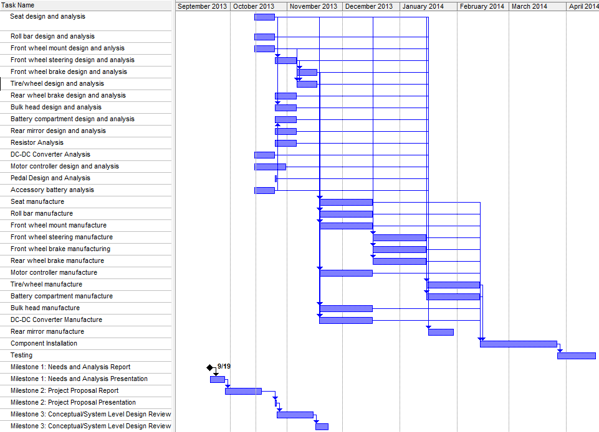

B: Part Dimensions and Specs

B1: Roll Bar and Rear Wheel Mount

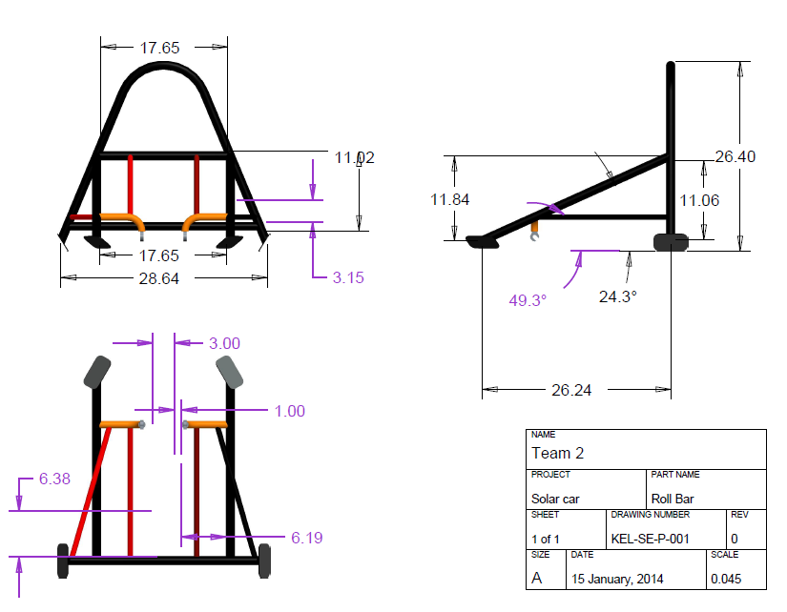

B2: Front Wheel Arm

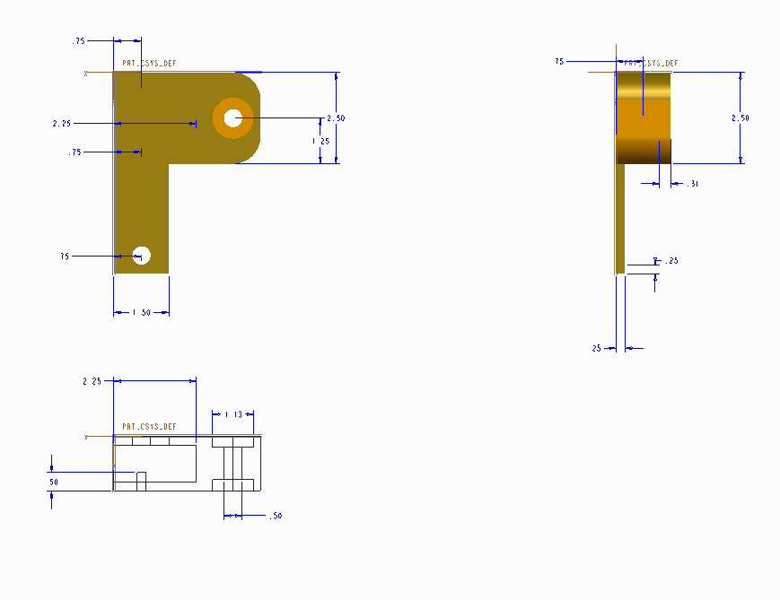

B3: Front Wheel Mounts

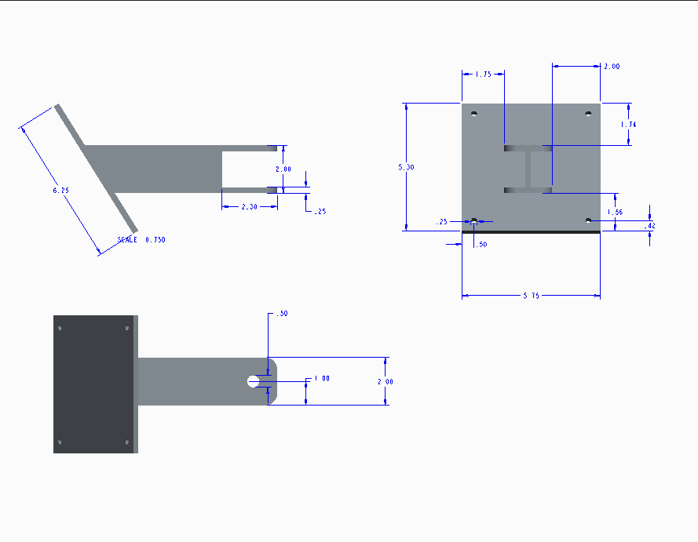

C: User’s Guide
This is an original section added for the final report. This section needs to be a complete user’s guide for your system. Assume the reader is familiar with the overall goals and requirements of the system, but not familiar with your system in particular. In other words, assume that this user’s guide will be used independent of the rest of this report.

The following is a minimum list of items that must be included in this appendix. You will need to determine if any other information needs to be included to make a complete user’s guide for your particular system.
- Description of your system. Include pictures and graphics identifying the major parts of the systems and user controls.
- List of items included in your system (components, battery chargers, attachments, etc.) including photographs.
- Specifications for your system detailing its capabilities, limitations, size, etc.
- Operating instructions. Complete description of how to set up and operate the system. Graphics and pictures as appropriate.
- Basic maintenance guide for the system. E.g. how to recharge batteries, clean sensors, etc.

Basically, make this contain all the information you would want in a user’s guide for a system you had just purchased.

D: Complete Test Reports

D1: Roll Bar & Front Wheel Mount Test Results

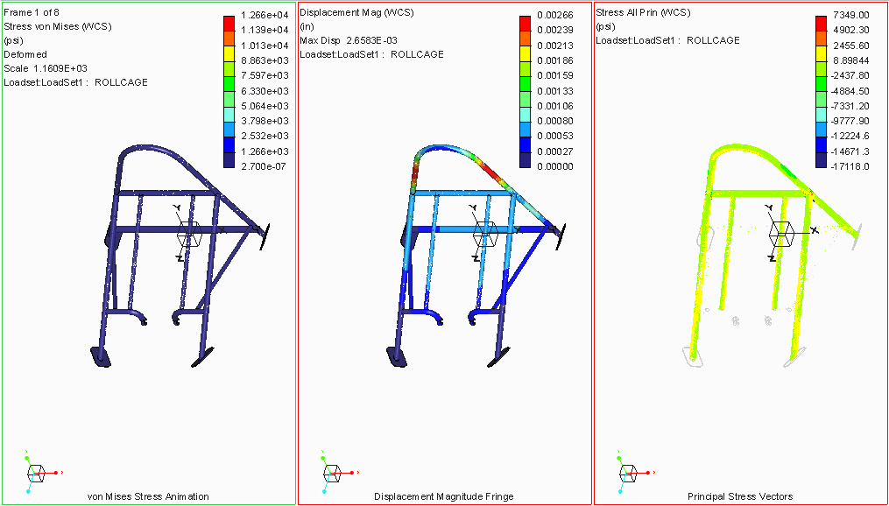

D2: Front Wheel Mount Test Results

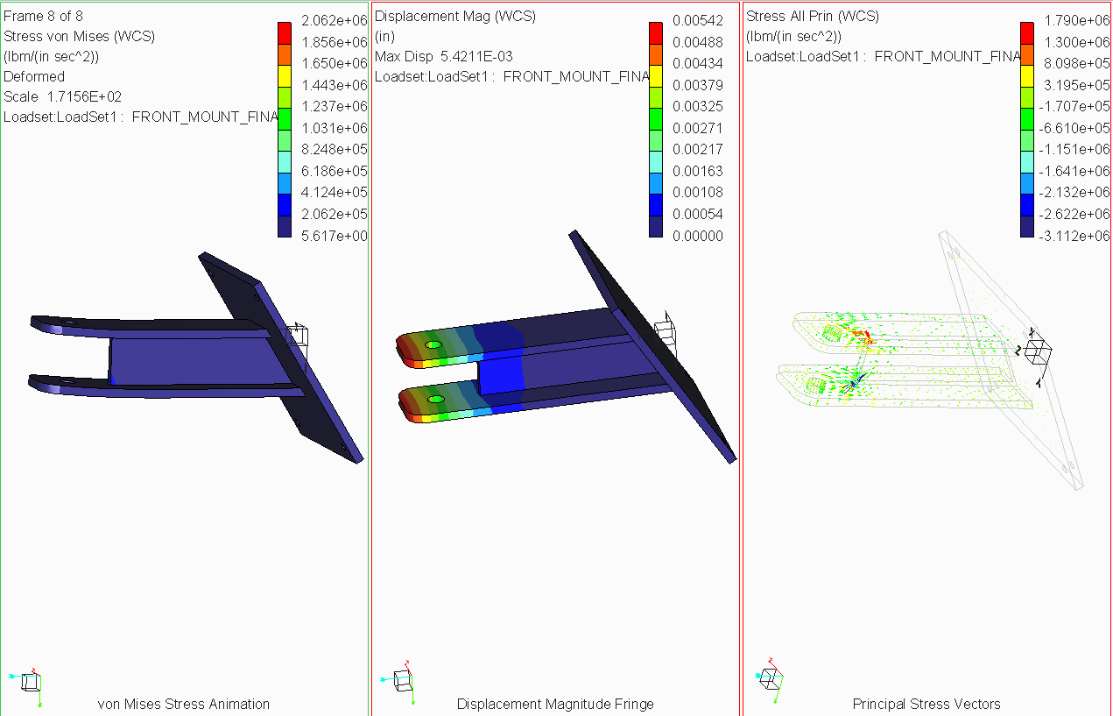

D3: Front Wheel Arm Test Results

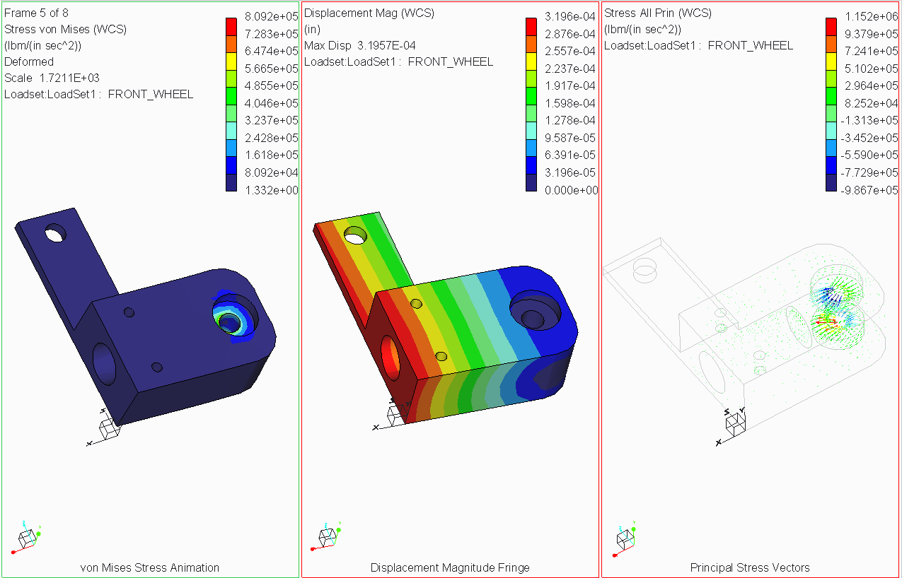

D4: Front Mount Stress Calculation Results and Constants
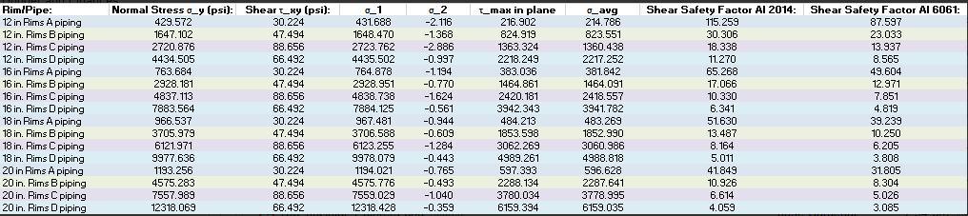

D5: Front Mount Moment Calculation Results and Constants

D6: Square Tube Calculation Results and Constants

D7: Wheel Hub Bolt Calculation Results and Constants
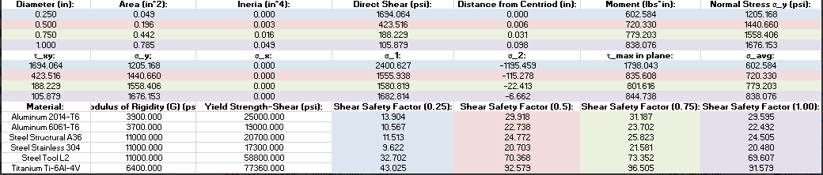

E: Software

E1: Code
/*
ECE Senior Design Team #2 Solar Car
Motor Controlling Code
Author(s): Zachary Barr (EE)

This code has two main functions
First function is to read analog signal from foot pedal throttle
Second function is to output three phase signal to power BLDC thr

open loop control used
*/

//Set LED output Pin
//To be used for debugging purposes int led1 = 0;
int led2 =1;
int led3 =2;
int led4 =3;
int led5 =4;
int led6 =5;

void setup() {
// initialize serial communication at 9600 bits per second:
//This is standard code form Arduino website
Serial.begin(9600);

//These are the PWM outputs
//Send these to the Motor Driver pinMode(9,OUTPUT);
pinMode(10,OUTPUT);
pinMode(11,OUTPUT);

//Adjust PWm freuqncies to approx 32KHz
TCCR1B = TCCR1B & 0b11111000 | 0x01;
TCCR2B = TCCR2B & 0b11111000 | 0x01;

//Set pin direction for LED
//LED are for debugging purposes
//They represent the different coils
//Odd numbers are positive, even are negative pinMode(led1, OUTPUT);
pinMode(led2, OUTPUT); pinMode(led3, OUTPUT); pinMode(led4, OUTPUT); pinMode(led5, OUTPUT); pinMode(led6, OUTPUT);

}

//main loop void loop() {

// read the input on analog pin 0:
int sensorValue =analogRead(A0);
// print out the value to serial monitor for debug purposes
Serial.println(sensorValue);
delay(1); // delay in between reads for stability

//this is for Debugging purposes
//LED's blink to simulate motor if (sensorValue >15){
//Simulate rotor switching
//Delay function in order ot watch LED

//case 1
//LED for debugging purposes, analog write is pwm output
//9,10,11 are phases a,b,c respectively digitalWrite(led1, HIGH);
digitalWrite(led5, LOW); analogWrite(9,sensorValue); analogWrite(10,0); analogWrite(11,255); delay(175);

//case 2
digitalWrite(led2, HIGH); digitalWrite(led6, LOW); analogWrite(9,sensorValue); analogWrite(10,250); analogWrite(11,0);
delay(175);

//case 3
digitalWrite(led3, HIGH); digitalWrite(led1, LOW); analogWrite(9,0); analogWrite(10,250); analogWrite(11,sensorValue);
delay(175);

//case 4
digitalWrite(led4, HIGH); digitalWrite(led2, LOW); analogWrite(9,250); analogWrite(10,0); analogWrite(11,sensorValue);
delay(175);

//case 5
digitalWrite(led5, HIGH); digitalWrite(led3, LOW); analogWrite(9,250); analogWrite(10,sensorValue); analogWrite(11,0);
delay(175);
//case 6
digitalWrite(led6, HIGH); digitalWrite(led4, LOW); analogWrite(9,0); analogWrite(10,250); analogWrite(11,sensorValue);
delay(175);
}
}

F: Data Sheets

F1: Aluminum sheets 0.032 inch thickness (Bulkhead & Bottom Plate)
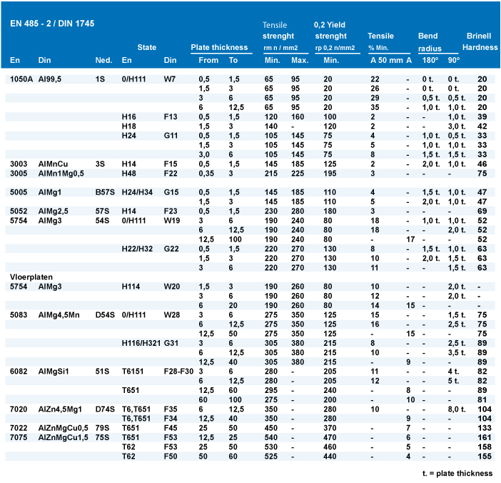

F2: Chromaly Steel Pipe 1 inch thickness (Roll Bar)
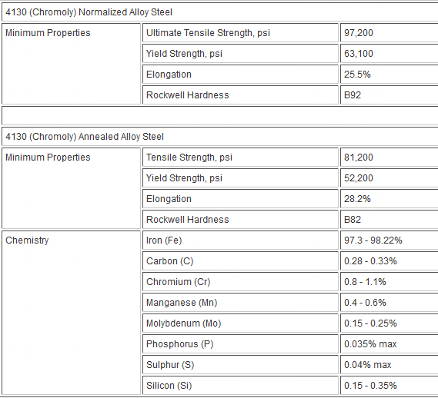

F3: Aluminum Square Rods (Truss)
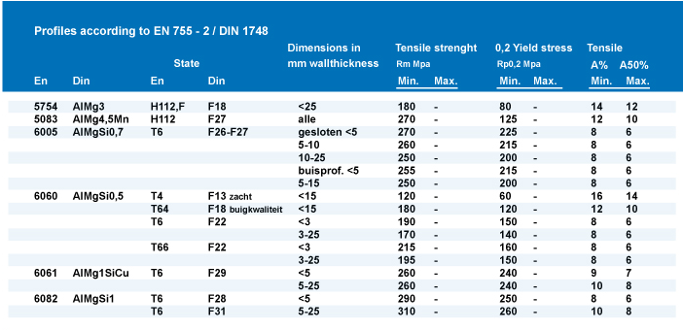

F4: Carbon Fiber
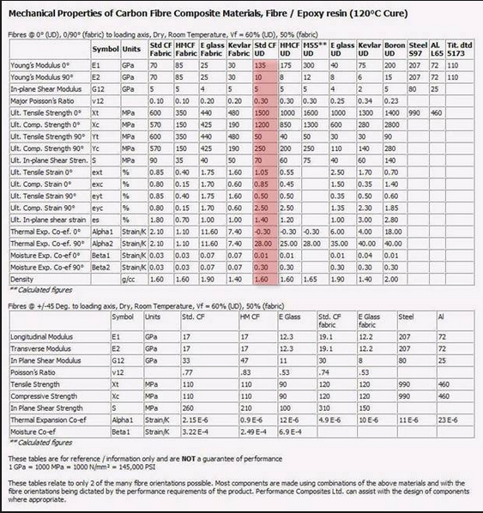

F5: Balsa Wood
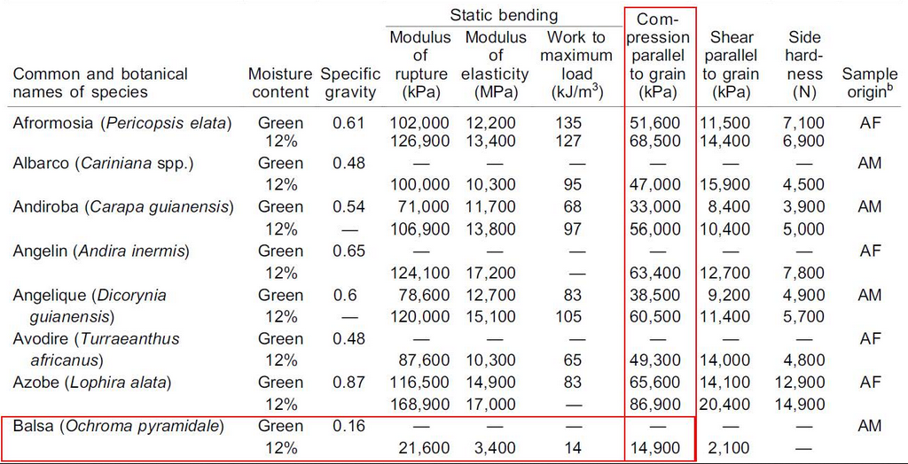

F6: PVC Pipe (Chassis)
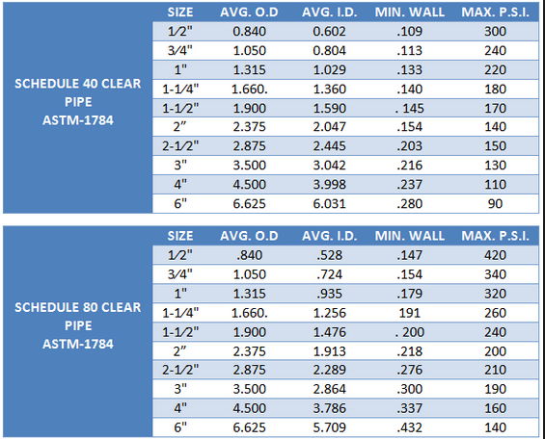

F7: 1/8 inch aluminum Sheet (Seat)

F8: Aluminum Rod (Steering Column)
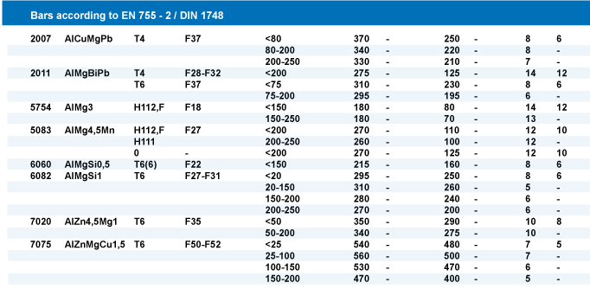

F9: LM500 Specs
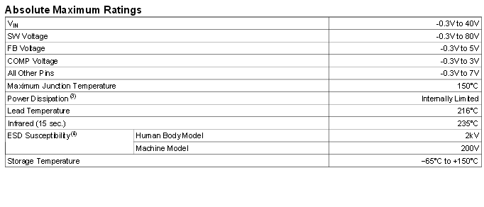

F10: Motor Specs

电机试验记录表
生产厂家:GoldenMotor.com型号:MagicPie 编号:F0001150001 日期:2009年11月21日 操作者:
说明 | 转矩(N.m) | 转速(r/min) | 输出功率(W) | 电压(V) | 电流(A) | 输入功率(W) | 效率(%)
转矩(torque)Max | 22.63 | 130 | 308.88 | 23.86 | 19.18 | 457.53 | 67.5
转速(revolution)Max | 0.00 | 178 | 0.00 | 24.07 | 0.94 | 22.65 | 0.0
输出功率(Output)Max | 22.63 | 130 | 308.88 | 23.86 | 19.18 | 457.53 | 67.5
电压(Voltage)Max | 0.00 | 178 | 0.00 | 24.07 | 0.94 | 22.65 | 0.0
电流(Current)Max | 22.63 | 130 | 308.88 | 23.86 | 19.18 | 457.53 | 67.5
输入功率(Input)Max | 22.63 | 130 | 308.88 | 23.86 | 19.18 | 457.53 | 67.5
效率(efficiency)Max | 8.94 | 159 | 148.78 | 23.99 | 8.14 | 195.38 | 76.1
1 | 0.00 | 178 | 0.00 | 24.07 | 0.94 | 22.65 | 0.0
2 | 0.13 | 177 | 2.43 | 24.07 | 1.05 | 25.19 | 9.7
3 | 0.26 | 177 | 4.86 | 24.07 | 1.15 | 27.73 | 17.5
4 | 0.39 | 177 | 7.27 | 24.07 | 1.26 | 30.27 | 24.0
5 | 0.52 | 176 | 9.68 | 24.07 | 1.36 | 32.81 | 29.5
6 | 0.66 | 176 | 12.09 | 24.07 | 1.47 | 35.35 | 34.2
7 | 0.79 | 176 | 14.48 | 24.07 | 1.57 | 37.89 | 38.2
8 | 0.92 | 176 | 16.87 | 24.06 | 1.68 | 40.43 | 41.7
9 | 1.05 | 175 | 19.25 | 24.06 | 1.79 | 42.96 | 44.8
10 | 1.18 | 175 | 21.62 | 24.06 | 1.89 | 45.50 | 47.5
11 | 1.31 | 175 | 23.99 | 24.06 | 2.00 | 48.04 | 49.9
12 | 1.22 | 175 | 22.36 | 24.06 | 1.92 | 46.30 | 48.3
13 | 1.17 | 175 | 21.46 | 24.06 | 1.88 | 45.33 | 47.3
14 | 1.09 | 175 | 20.01 | 24.06 | 1.82 | 43.78 | 45.7
15 | 1.01 | 175 | 18.56 | 24.06 | 1.75 | 42.23 | 44.0
16 | 0.92 | 176 | 16.92 | 24.06 | 1.68 | 40.48 | 41.8
17 | 0.84 | 176 | 15.47 | 24.07 | 1.62 | 38.93 | 39.7
18 | 0.81 | 176 | 14.92 | 24.07 | 1.59 | 38.35 | 38.9
19 | 0.72 | 176 | 13.28 | 24.07 | 1.52 | 36.61 | 36.3
20 | 0.64 | 176 | 11.81 | 24.07 | 1.46 | 35.06 | 33.7
21 | 0.53 | 176 | 9.79 | 24.07 | 1.37 | 32.93 | 29.7
22 | 0.44 | 177 | 8.14 | 24.07 | 1.30 | 31.18 | 26.1
23 | 0.31 | 177 | 5.74 | 24.07 | 1.19 | 28.66 | 20.0
24 | 0.18 | 177 | 3.34 | 24.07 | 1.09 | 26.14 | 12.8
25 | 0.10 | 177 | 1.86 | 24.07 | 1.02 | 24.59 | 7.6
26 | 0.00 | 178 | 0.00 | 24.07 | 0.94 | 22.65 | 0.0
27 | 0.09 | 177 | 1.67 | 24.07 | 1.01 | 24.40 | 6.9
28 | 0.28 | 177 | 5.19 | 24.07 | 1.17 | 28.08 | 18.5
29 | 0.39 | 177 | 7.22 | 24.07 | 1.26 | 30.21 | 23.9
30 | 0.55 | 176 | 10.16 | 24.07 | 1.38 | 33.31 | 30.5
31 | 0.65 | 176 | 12.00 | 24.07 | 1.46 | 35.25 | 34.0
32 | 0.86 | 176 | 15.83 | 24.07 | 1.63 | 39.32 | 40.3
33 | 1.09 | 175 | 20.01 | 24.06 | 1.82 | 43.78 | 45.7
34 | 1.05 | 175 | 19.29 | 24.06 | 1.79 | 43.00 | 44.8
35 | 1.21 | 175 | 22.18 | 24.06 | 1.92 | 46.10 | 48.1
36 | 1.50 | 174 | 27.40 | 24.06 | 2.15 | 51.72 | 53.0
37 | 1.74 | 174 | 31.70 | 24.06 | 2.34 | 56.37 | 56.2
38 | 1.65 | 174 | 30.09 | 24.06 | 2.27 | 54.62 | 55.1
39 | 1.86 | 174 | 33.83 | 24.06 | 2.44 | 58.69 | 57.6
40 | 2.12 | 173 | 38.44 | 24.05 | 2.65 | 63.72 | 60.3
41 | 2.22 | 173 | 40.21 | 24.05 | 2.73 | 65.66 | 61.2
42 | 2.38 | 173 | 43.02 | 24.05 | 2.86 | 68.76 | 62.6

说明 | 转矩(N.m) | 转速(r/min) | 输出功率(W) | 电压(V) | 电流(A) | 输入功率(W) | 效率(%)
43 | 2.61 | 172 | 47.05 | 24.05 | 3.04 | 73.21 | 64.3
44 | 2.88 | 172 | 51.74 | 24.05 | 3.26 | 78.43 | 66.0
45 | 2.98 | 171 | 53.48 | 24.05 | 3.34 | 80.36 | 66.5
46 | 3.18 | 171 | 56.93 | 24.04 | 3.50 | 84.23 | 67.6
47 | 3.45 | 170 | 61.56 | 24.04 | 3.72 | 89.45 | 68.8
48 | 3.58 | 170 | 63.77 | 24.04 | 3.83 | 91.97 | 69.3
49 | 3.74 | 170 | 66.49 | 24.04 | 3.95 | 95.06 | 69.9
50 | 4.04 | 169 | 71.56 | 24.04 | 4.20 | 100.86 | 71.0
51 | 4.41 | 168 | 77.76 | 24.03 | 4.49 | 108.01 | 72.0
52 | 4.35 | 168 | 76.76 | 24.03 | 4.45 | 106.85 | 71.8
53 | 4.65 | 168 | 81.75 | 24.03 | 4.69 | 112.65 | 72.6
54 | 5.08 | 167 | 88.83 | 24.03 | 5.03 | 120.95 | 73.4
55 | 5.27 | 167 | 91.93 | 24.02 | 5.19 | 124.62 | 73.8
56 | 5.37 | 166 | 93.56 | 24.02 | 5.27 | 126.55 | 73.9
57 | 5.70 | 166 | 98.90 | 24.02 | 5.53 | 132.92 | 74.4
58 | 5.74 | 166 | 99.54 | 24.02 | 5.57 | 133.70 | 74.5
59 | 6.07 | 165 | 104.83 | 24.02 | 5.83 | 140.06 | 74.8
60 | 6.36 | 164 | 109.43 | 24.01 | 6.07 | 145.66 | 75.1
61 | 6.61 | 164 | 113.37 | 24.01 | 6.27 | 150.48 | 75.3
62 | 6.87 | 163 | 117.44 | 24.01 | 6.48 | 155.50 | 75.5
63 | 7.31 | 162 | 124.26 | 24.00 | 6.83 | 163.98 | 75.8
64 | 7.33 | 162 | 124.57 | 24.00 | 6.85 | 164.37 | 75.8
65 | 7.66 | 162 | 129.62 | 24.00 | 7.11 | 170.73 | 75.9
66 | 8.12 | 161 | 136.59 | 24.00 | 7.48 | 179.59 | 76.1
67 | 8.14 | 161 | 136.89 | 24.00 | 7.50 | 179.98 | 76.1
68 | 8.50 | 160 | 142.28 | 23.99 | 7.79 | 186.91 | 76.1
69 | 8.59 | 160 | 143.61 | 23.99 | 7.86 | 188.64 | 76.1
70 | 8.94 | 159 | 148.78 | 23.99 | 8.14 | 195.38 | 76.1
71 | 9.16 | 158 | 152.00 | 23.99 | 8.32 | 199.62 | 76.1
72 | 9.56 | 158 | 157.80 | 23.98 | 8.64 | 207.32 | 76.1
73 | 9.96 | 157 | 163.53 | 23.98 | 8.97 | 215.01 | 76.1
74 | 10.04 | 157 | 164.67 | 23.98 | 9.03 | 216.55 | 76.0
75 | 10.43 | 156 | 170.18 | 23.97 | 9.35 | 224.05 | 76.0
76 | 10.58 | 155 | 172.28 | 23.97 | 9.47 | 226.94 | 75.9
77 | 10.99 | 155 | 177.97 | 23.97 | 9.80 | 234.82 | 75.8
78 | 11.46 | 154 | 184.41 | 23.97 | 10.18 | 243.85 | 75.6
79 | 11.56 | 153 | 185.76 | 23.96 | 10.26 | 245.77 | 75.6
80 | 12.00 | 153 | 191.68 | 23.96 | 10.61 | 254.23 | 75.4
81 | 12.13 | 152 | 193.41 | 23.96 | 10.72 | 256.72 | 75.3
82 | 12.50 | 151 | 198.30 | 23.96 | 11.01 | 263.83 | 75.2
83 | 12.70 | 151 | 200.92 | 23.95 | 11.17 | 267.67 | 75.1
84 | 13.29 | 150 | 208.54 | 23.95 | 11.65 | 278.99 | 74.7
85 | 13.40 | 150 | 209.94 | 23.95 | 11.74 | 281.10 | 74.7
86 | 13.89 | 149 | 216.13 | 23.94 | 12.13 | 290.50 | 74.4
87 | 13.95 | 148 | 216.88 | 23.94 | 12.18 | 291.65 | 74.4
88 | 14.29 | 148 | 221.10 | 23.94 | 12.46 | 298.17 | 74.2
89 | 14.63 | 147 | 225.28 | 23.94 | 12.73 | 304.69 | 73.9
90 | 15.10 | 146 | 230.96 | 23.93 | 13.11 | 313.69 | 73.6
91 | 15.15 | 146 | 231.56 | 23.93 | 13.15 | 314.65 | 73.6

说明 | 转矩(N.m) | 转速(r/min) | 输出功率(W) | 电压(V) | 电流(A) | 输入功率(W) | 效率(%)
92 | 15.42 | 145 | 234.78 | 23.93 | 13.37 | 319.82 | 73.4
93 | 15.82 | 145 | 239.48 | 23.92 | 13.69 | 327.49 | 73.1
94 | 16.12 | 144 | 242.97 | 23.92 | 13.93 | 333.23 | 72.9
95 | 16.46 | 143 | 246.87 | 23.92 | 14.20 | 339.74 | 72.7
96 | 16.78 | 143 | 250.50 | 23.91 | 14.46 | 345.86 | 72.4
97 | 17.32 | 141 | 256.51 | 23.91 | 14.90 | 356.19 | 72.0
98 | 17.37 | 141 | 257.06 | 23.91 | 14.94 | 357.15 | 72.0
99 | 17.64 | 141 | 260.02 | 23.91 | 15.16 | 362.31 | 71.8
100 | 18.02 | 140 | 264.12 | 23.90 | 15.46 | 369.57 | 71.5
101 | 18.34 | 139 | 267.53 | 23.90 | 15.72 | 375.69 | 71.2
102 | 18.90 | 138 | 273.38 | 23.89 | 16.17 | 386.39 | 70.8
103 | 19.00 | 138 | 274.41 | 23.89 | 16.25 | 388.30 | 70.7
104 | 19.29 | 137 | 277.38 | 23.89 | 16.48 | 393.84 | 70.4
105 | 19.88 | 136 | 283.30 | 23.89 | 16.96 | 405.10 | 69.9
106 | 20.05 | 136 | 284.98 | 23.88 | 17.10 | 408.35 | 69.8
107 | 20.48 | 135 | 289.16 | 23.88 | 17.44 | 416.55 | 69.4
108 | 20.60 | 135 | 290.32 | 23.88 | 17.54 | 418.84 | 69.3
109 | 21.02 | 134 | 294.31 | 23.87 | 17.88 | 426.85 | 68.9
110 | 21.30 | 133 | 296.92 | 23.87 | 18.10 | 432.19 | 68.7
111 | 21.75 | 132 | 301.06 | 23.87 | 18.47 | 440.77 | 68.3
112 | 22.01 | 132 | 303.40 | 23.87 | 18.68 | 445.72 | 68.1
113 | 22.43 | 131 | 307.14 | 23.86 | 19.01 | 453.72 | 67.7
114 | 22.63 | 130 | 308.88 | 23.86 | 19.18 | 457.53 | 67.5

F11: Arduino Uno

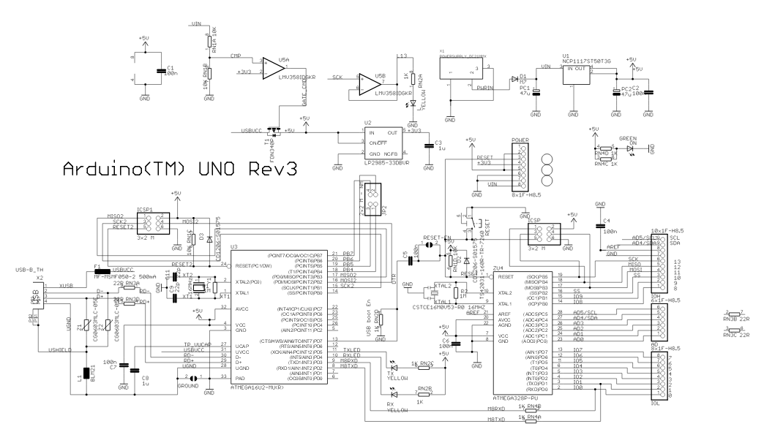
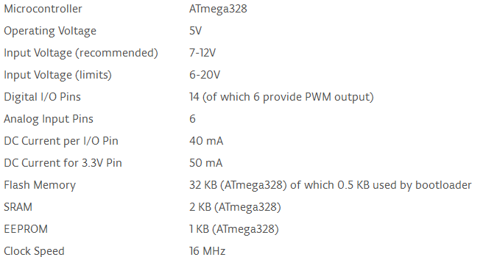

F12: 2SD316EI IGBT Driver with Infineon Module FF150R12ME3G

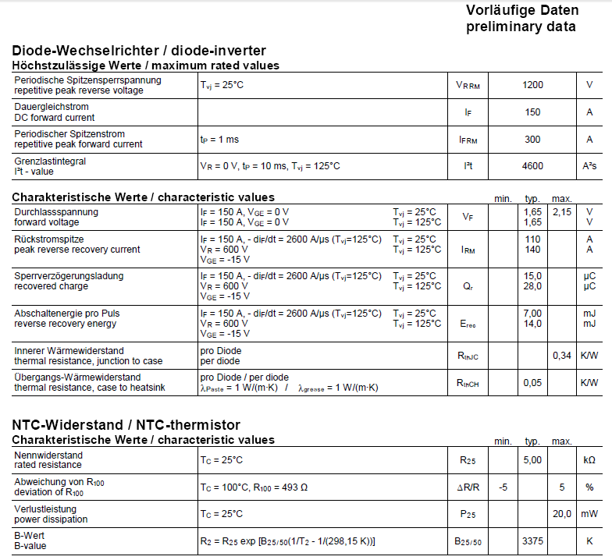

F13: Crouzet 84134870
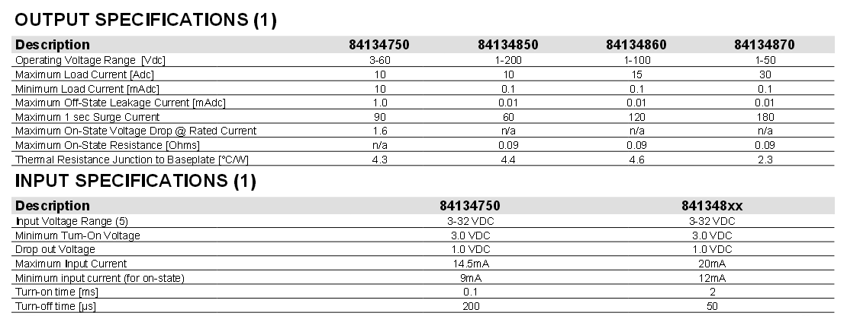

G: Miscellaneous

G1: Czochralski Process

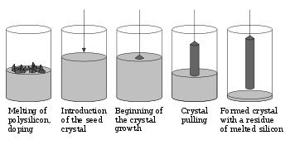
Figure 47 Diagram demonstrating the Czochralski process
The Czochralski process is a process used in the production of monocrystalline solar cells. Briefly, the process consists of dissolving by melting the silicon in the crucible. The seed crystal used form the crystal is introduced in order to begin crystal growth. The seed is then pulled from the crucible which forms the silicon crystal.

G2: Bill of Materials

