|  |
| --- |
| Logo2.png |
| Deliverable #2 |
| Product Specification and Project Plan |
|  |
|  |
| **10/11/2013** |

**Team 19: Self-Stabilizing Pool Table**

**Norman Gross**

**Alexander York**



|  |
| --- |
|  |

Table of Contents

1.0 Introduction 3

2.0 Product Specification 3

3.0 Functional Diagram 5

4.0 Project Scope 7

5.0 Project Budget 7

6.0 Project Plan 8

7.0 Gantt Chart 9

# Introduction

The problem that was recognized is the amount of space that is required to own a traditional billiards table. The project is to have a self-leveling table that has the ability to automatically store itself in a space with the footprint of a large bookshelf. This device will allow users to own a billiards table without the sacrifice to the space that owning one consumes. The total floor footprint will be decrease by up to 75%.

# Product Specification

**Customer Needs**

By focusing on the needs of the customer we are able to tailor design requirements that fit the customer’s desires. The following is a list of specific needs that the customer desires, based upon customer and market research:

1. Easy to move
2. Must be able to stow away to save space
3. The operation of the system should create minimal noise
4. Needs to be a regulation sized table
5. Easy to use by the average person
6. Must feel no different than a regular pool table
7. System needs to be aesthetically appealing
8. System needs to be durable (long-lasting)

From the previous list of customer expectations, the following design requirements have been created:

**Mechanical Design Requirements**

**System housing**

The system housing will contain the pool table when it is in its stowed position. The Dimensions of the Stowed System will be: 2ft x 4.5ft x 8ft (LWH) This is to provide enough space for the pool table as well as the lifting mechanism that will be contained in the housing as well. The lifting mechanism within the housing is required to have a form of safety redundancy in the event of catastrophic failure.

**Pool Table**

As per regulation the table dimensions must follow these requirements:

* + 1. Must have a length to width ratio of 2:1
    2. Outside dimensions: 86 inches x 48 inches
    3. Playing Field: 78 inches x 39 inches
    4. Height Restriction: Between the range of 29 inches to 31 inches

A goal of this project is to make this system as portable as possible. The Maximum table weight is restricted to 750lbs. This is the average weight of existing tables, so the desired outcome is to be below this limit.

The leveling requirements are as followed: A tolerance of +/- 0.25 degrees from the horizontal. This value was determined from the lowest average coefficient of kinetic friction between a pool ball and a felt table top. This tolerance ensures that the tilt of the table will not affect game play. Another feature built into the table will be its ability to absorb shock and vibration experienced during an average game of billiards.

**Electronics and Controls Requirements**

Since this system must be built to last more than 3 years the power supply will not be a battery source due to its degradation over time. The supplied power will come from a standard 120v grounded outlet, which means that the pool table must be tethered through some means.

This project will contain a certain degree of programming in order to meet the customer expectations. The needed control algorithms will be created primarily for the leveling controls. Subsequent controls will be derived from the height adjustment of the table. As far as the vertical stowing is concerned, simple bumper switched could delegate the on and off controls for the lifting mechanism.

The operation of this system must be user friendly which means that any input needed from the user must be as simple and clear as possible. The simplest of systems may use a push-button control, more advanced possibilities may incorporate an easy to use touch screen Graphical User Interface.

# Functional Diagram

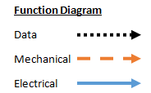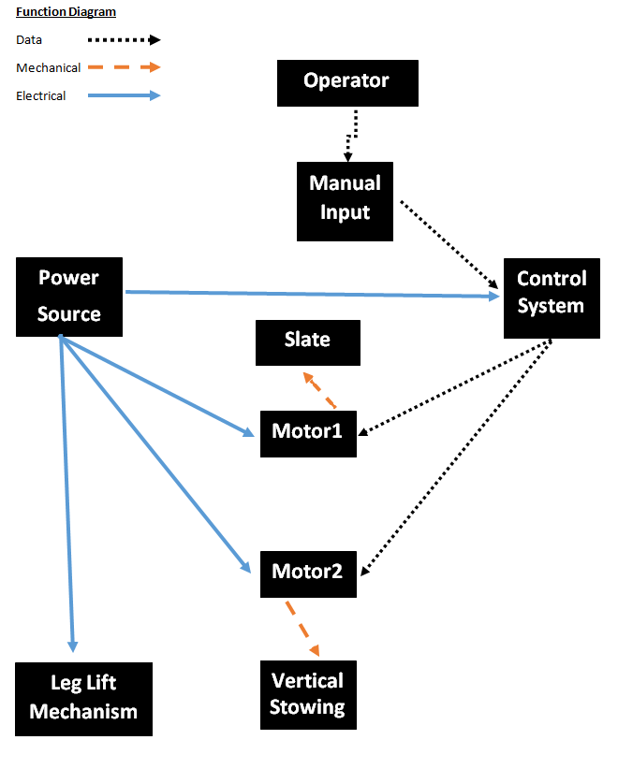

**Detailed Description**

Operator: This device begins with the player. The user must decide perform the following options: release the table from its housing, stow it back into the housing, or stabilize the slate again.

Manual Input: After the user has decided to either release the table from its housing, stow it back into the housing, or stabilize the slate again. He or she will input one of the commands with either a push button or GUI interface.

Power Source: Will come from a standard 120v AC wall outlet. An electrical circuit will be set up to dedicate the distribution of power.

Control System: The control system will be a carefully selected microcontroller which will have the capabilities to control the mechatronic system used to stabilize the slate, the vertical stowing process, and the leg extending and retracting process

Leg Lift Mechanism: Since the table will be stowed in a housing that is smaller in width than the actual table height, the legs must be retracted on and extended by some leg lift mechanism.

Motor 1: Receives information from the control system and is used to stabilize the slate on which the game is to be played.

Slate: Is a single piece slate which is to be leveled and locked to a secure and accurate playing position.

Motor 2: Receives information from the control system and is used to vertically stow the table into its respective housing.

Vertical Stowing: Is the process of hiding the table into its housing with the use of a motor, a control system, and a combination of mechanical linkages.

# Project Scope

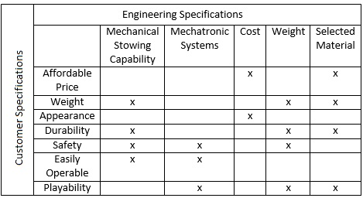The project is to design an affordable and visually appealing pool table with two very interesting characteristics. The table must be capable of stowing itself vertically into a respective housing which will decrease the occupied floor space by a significant amount. The table must also be able to level its slate to a fraction of a degree by a process as simple as pressing a button. Safety is another key factor in the designs specifications, because the raising and lowering of such a heavy table could result in catastrophic consequences if failure were to occur. Also along with being visually appealing the table must also be durable enough to last more than the average ten year life span of a pool table.

# Project Budget

To date there is immediate access to $3000.00 in funding for this project. We plan on creating sponsorship proposals to solicit for additional funding. Having a larger designated budget will allow for a wider range of materials that can be implemented in the design. During production of the tables, each will be targeted to be sold at around $5000.00. The desired projected profit for each table is estimated to be $1000.00. Therefore by subjecting the prototype to a $3000.00 budget allows for a $1000.00 margin for possible improvements.

# Project Plan

# Gantt Chart

