|  |
| --- |
| Logo2.png |
| Deliverable #7 |
| Spring 2014 Final Report |
|  |
|  |
| **4/17/2014** |

**Team 19: Self-Stabilizing Pool Table**

**Norman Gross**

**Alexander York**



|  |
| --- |
|  |

Table of Contents

1.0 Introduction 3

2.0 Motivation 3

3.0 Project Scope 3

4.0 Design Criteria 4

5.0 Design & Analysis 5

6.0 Prototype Details 6

Functional Diagram 8

Design for Manufacturing 9

Marketing 10

Marketing Strategy 10

Promotional Tools 10

Objectives 11

Promotional Expenses 11

Safety 12

Resources 12

Future Work 13

Appendix 13

# Introduction

Since the late 1900s, the game of Pocket Billiards (commonly referred to as Pool) has been around for leisure entertainment. For over a century, the love of this game comes from the laid back social atmosphere of friends and family since it requires at least 2 people to play. According to the National Sporting Goods Association survey of sports participation, there are over 21.8 million active Billiard and Pool participants within the United States each year. Statistics from the Sports Business Research Network estimates $268 Million dollars in sales last year from consumer expenses for pool tables and supplies alone.

# Motivation

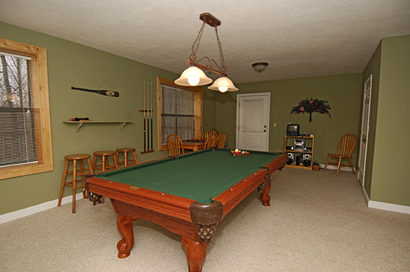The regulation size of a pool table can vary from 7 to 9 feet in length. Thus, owning one means designating a space equal to the size of a master bedroom. Once the table is installed in the house, this space can no longer be used for any other purpose. After the purchasing of the table, conflicts often arise due to either the growth of the family or the need to repurpose the room. The lack of useful space is the main reason people decided to sell their pool tables at a loss of up to 90% of its value.

Figure 1: Standard pool table in a home.

# Project Scope

This project provides the solution to this problem. The goal is develop a prototype to reduce the footprint of the pool table by up to 75%. This will give the table a capability of vertically stowing itself in a discrete housing in case the additional space is needed. Along with its storage ability, the table will also have a self-stabilization feature that levels the slate-top to have a perfectly horizontal playing field. The design of this table will have both the look and the feel of a standard slate pool table.

# Design Criteria

**System housing**

The system housing will contain the pool table when it is in its stowed position. The Dimensions of the Stowed System will be: 2ft x 4.5ft x 8ft (LWH) This is to provide enough space for the pool table as well as the lifting mechanism that will be contained in the housing as well. The lifting mechanism within the housing is required to have a form of safety redundancy in the event of catastrophic failure.

**Pool Table**

As per regulation the table dimensions must follow these requirements:

* + 1. Must have a length to width ratio of 2:1
    2. Outside dimensions: 86 inches x 48 inches
    3. Playing Field: 78 inches x 39 inches
    4. Height Restriction: Between the range of 29 inches to 31 inches

A goal of this project is to make this system as portable as possible. The Maximum table weight is restricted to 750lbs. This is the average weight of existing tables, so the desired outcome is to be below this limit.

The leveling requirements are as followed: A tolerance of +/- 0.25 degrees from the horizontal. This value was determined from the lowest average coefficient of kinetic friction between a pool ball and a felt table top. This tolerance ensures that the tilt of the table will not affect game play.

# Design & Analysis

In order to assist in the development of this project, the system was broken down into discrete sections. Focusing on the main objectives, there are three main components of the system: The vertical stowing capability, the self-leveling features, and the transitional phase between the two.

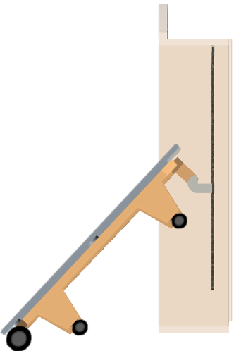**Stowing Design**

**Internal Pulley System**

This concept was generated based upon the principle of the pulley. Pulleys have been used for centuries to reduce the amount of work required to move an object. This design utilizes a simple winch to apply a force to a cable through a series of pulleys to that are attached to the lifting hook used to raise the table. In the figure to the right the simplest design can be seen. The platform that is being raised has two hooks which attach themselves to the end of the table.

**Structural Design**

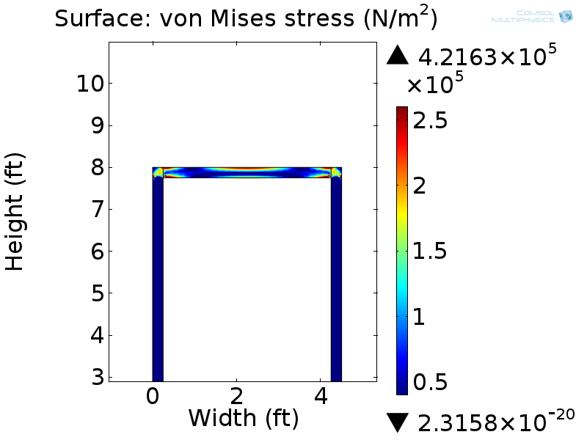All of the applied forces due to the lifting of the table will be applied to an inner steel frame. This structural design was chosen to reduce the stresses upon the housing. To determine the effect of the applied load of the pool table upon this housing a finite element analysis was performed. Seen in the figure to the right, the maximum induced stress that the frame would experience is 50 kPa which is well within steel’s capabilities to absorb this stress without deformation.

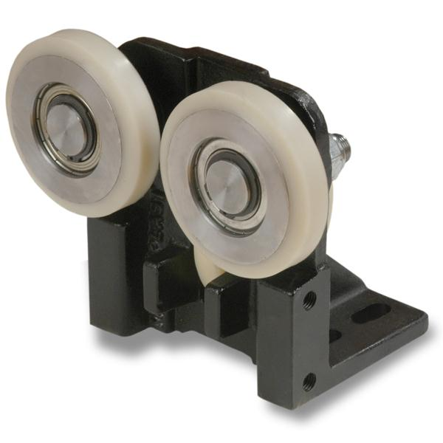Not only will having a steel frame remove the stress off the outer structure, it will also act as a guide for the lifting platform that will be used to raise the pool table. Inspired by the linear guides that are used to allow smooth motion of an elevator, our system will utilize similar concepts. Using a roller guide mechanism seen in Figure (), when translating upon the inner frame these guides will allow seamless motion and alleviate any induced moments caused by the pool table.

**Spatial Orientation**

As seen in the previous figures the table is also equipped with 2 sets of caster wheels. One set is used for the transition from the housing to the floor. These wheels were implemented in order to create a smooth transition during stowing instead of damaging the table. The other set of caster wheels are placed under the table, which allows for the table to be moved to the users desired position for comfortable gameplay.

**Self-Stabilizing**

After the user has placed the table in their desired position, at this point they are ready to play. In order to do so the will operate a two button user interface equipped with an LCD screen which receives data from a microcontroller located inconspicuously under the table top resulting in a discrete operating system.

This user interface will receive data from a user and sensorial information from 3 inclinometer sensors in order to perform a control algorithm which will stabilize the table perfectly with the horizontal by driving the stepper motors used as the terms of locomotion with the electric tongue jacks used for linear actuation.

# Prototype Details

**How It Works**

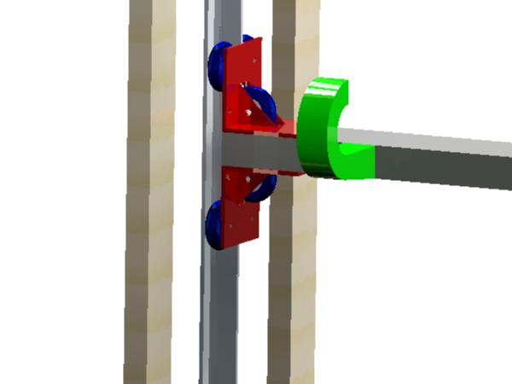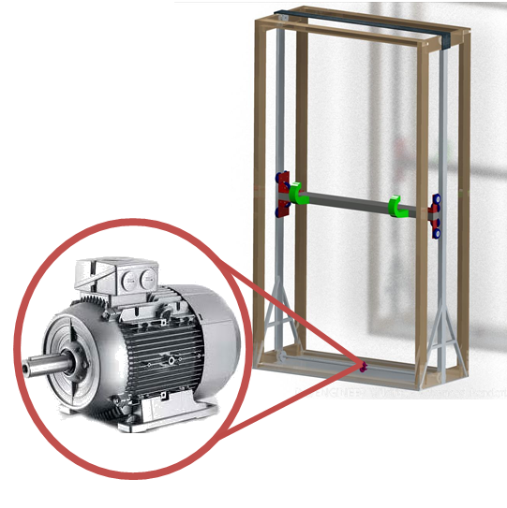

**Prototypes Details:**

Machining, 3D printing, Assembly, Testing, and Analysis were all major key aspects in the prototyping of this system. The housing used to store the system, for instance is no ordinary housing.

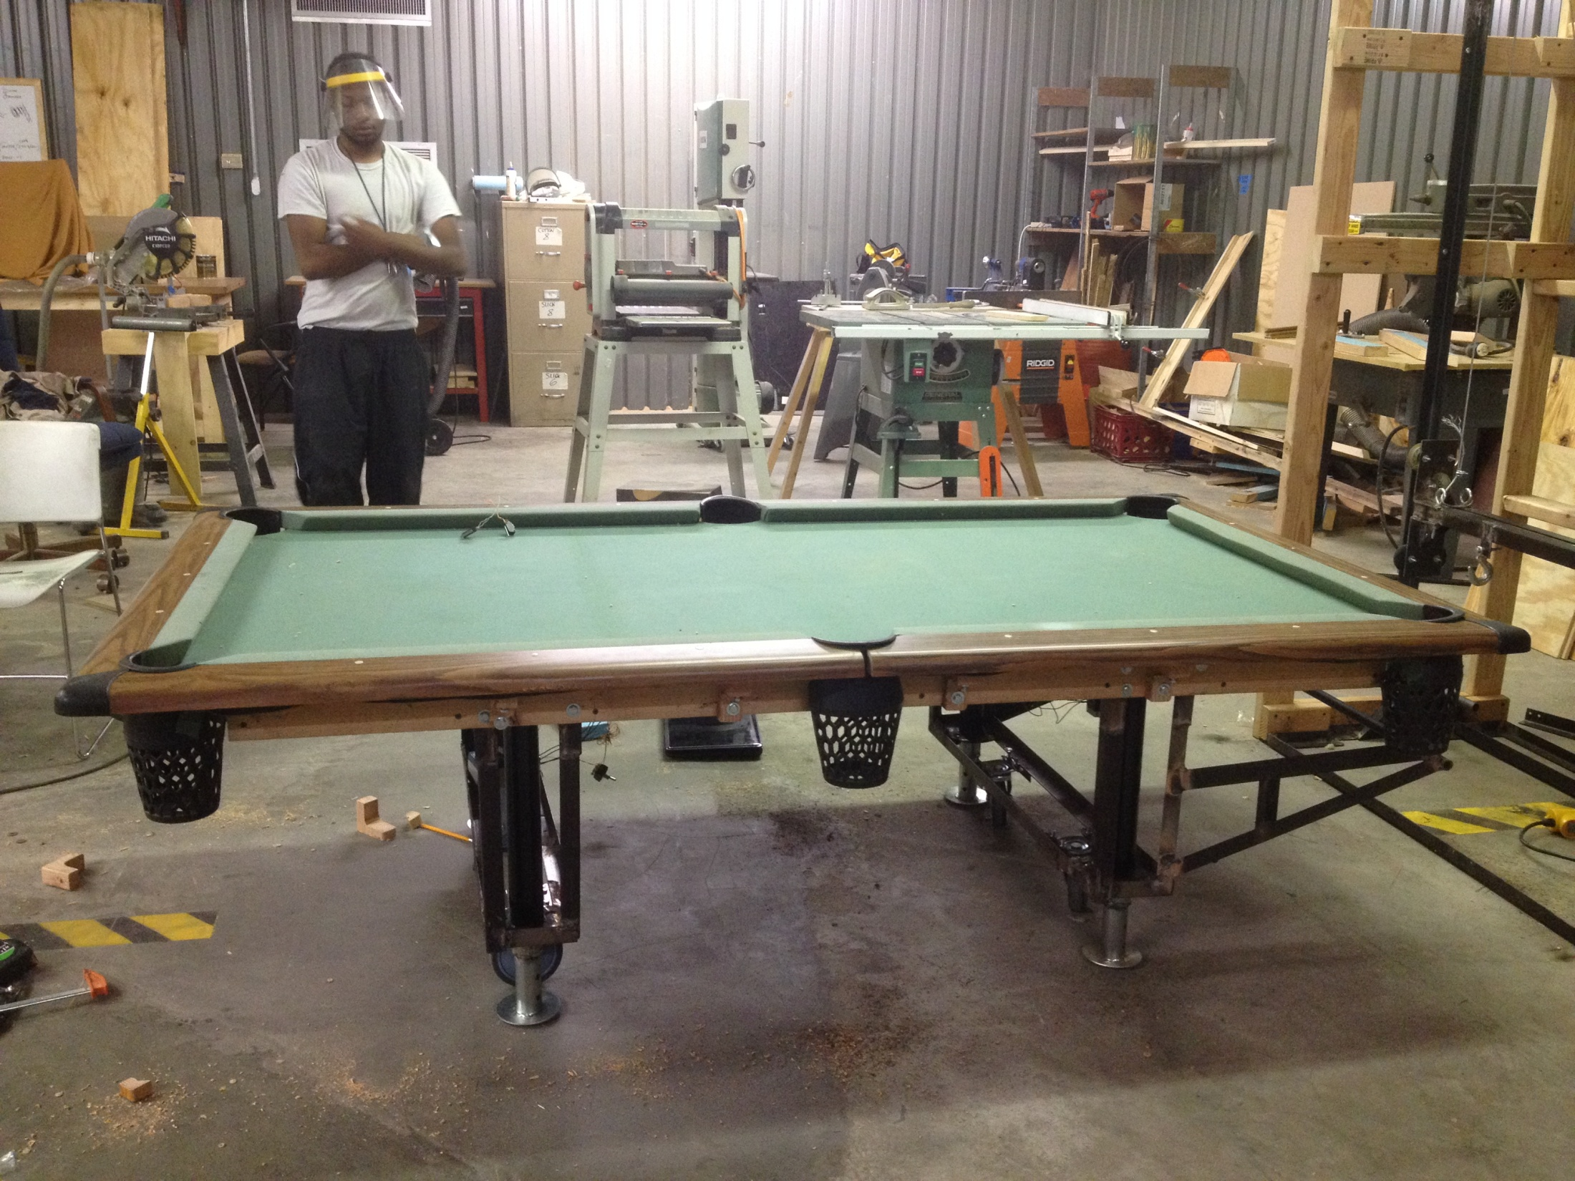

The housing in this project is actually part of the system. There is an internal frame made of steel and external frame made of wood for structural support. This internal frame is what the pulley system is attached to in order to raise and store the table vertically.

Much wood working, welding, and machining was done in order to create both of these frames and also the frame of the table.

Motor couplers and mounts were also 3D printed then machined in order to attach the new motors to the tongue jacks to be controlled by the microdragon microcontroller during testing.

Below is a functional diagram and state flow chart to explain the Stowing process

### Functional Diagram

### 

**State Diagram**

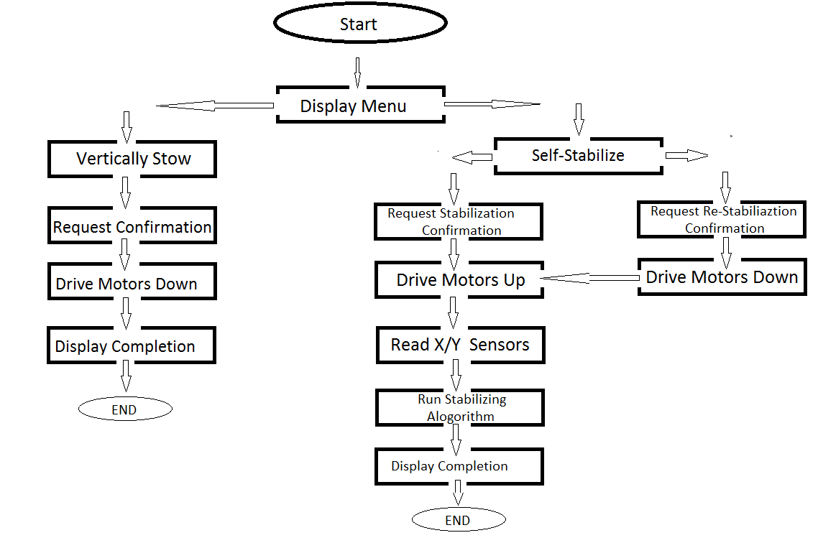

**Detailed Description**

Operator: This device begins with the player. The user must decide perform the following options: release the table from its housing, stow it back into the housing, or stabilize the surface again.

Manual Input: After the user has decided to either release the table from its housing, stow it back into the housing, or stabilize the surface again. He or she will input one of the commands with either a push button or GUI interface.

Power Source: Will come from a standard 120v AC wall outlet. An electrical circuit will be set up to dedicate the distribution of power.

Control System: The control system will be a carefully selected microcontroller which will have the capabilities to control the mechatronic system used to stabilize the surface, the vertical stowing process, and the leg extending and retracting process

Leg Lift Mechanism: Since the table will be stowed in a housing that is smaller in width than the actual table height, the legs must be retracted on and extended by some leg lift mechanism.

Motor 1: Receives information from the control system and is used to stabilize the surface on which the game is to be played.

Surface: Is a single piece surface which is to be leveled and locked to a secure and accurate playing position.

Motor 2: Receives information from the control system and is used to vertically stow the table into its respective housing.

Vertical Stowing: Is the process of hiding the table into its housing with the use of a motor, a control system, and a combination of mechanical linkages.

# Design for Manufacturing

The components of this system were designed and chosen to optimize manufacturability. Every part of this system was created from off the shelf products so that manufacturing of this product would require minimal machining. Once all parts of the system are acquired the estimated manufacturing time is less than two weeks. This is a necessary time frame when this product is considered for production and commercialization.

# Marketing

### Marketing Strategy

Instead of utilizing a pull strategy to advertise our product within mass publications, we will implement a push strategy, targeting places of business that have large capitalization and individuals with high-earning wages. The market development of our product will not only stimulate awareness within the billiards industry but the benefits will differentiate our product amongst competitors. The personal selling tactic will also be put in place due to the advanced technology of our product and its expensive value. In addition to our customer segment, below are other potential clients:

1. Sports bars
2. Billiards Clubs
3. Hotel chains
4. Luxury Clubs
5. Apartment complexes

Sports bars are ranked the highest priority since our product can add instant value to their business. For example: Miller’s Ale House is a franchise headquartered in Jupiter, Florida. As a part of the Miller’s Experience each franchise location is required to have at least two pool tables and several arcade games. The amount of extra seating that these pool tables consume is equivalent to 40 additional seats. The value that our stowaway billiards table adds to these types of businesses will pay for itself in little time.

### Promotional Tools

Through our promotional strategy of personal selling, Beyond Innovation, LLC will advertise the products we have to select audiences that purchase consumer products in large quantities. Printed advertisements within high end magazines such as the Robb Report magazine will be one of our communication channels. This publication has 184,000 print subscriptions, catering to a select audience whose average household income is $364,000, and average household net worth of $1.8 million.

Creating partnerships with owners and managers of targeted establishments such as well-known sports bars and exclusive hotel chains will be a part of our promotional strategy as well. Utilizing demonstration videos displaying the functionality of our pool tables during the buyer decision process with potential investors will display our product’s unparallel benefits.

Moreover, showcasing our product through social media accounts such as Facebook, Twitter, Vine, and Pinterest will inform not only other potential clients, but the entire consumer population without the expense of mass media advertisements. With frequency in mind in regards to how often buyers are actually exposed to our product, a pulse strategy will best suit our product so that we maintain concentrated advertisement efforts while having a semblance of continuity, upholding the image of luxury to select audiences.

### Objectives

Through marketing and communication efforts, B.I. Tables will achieve its main objective in which we will be recognized as the established premium quality brand within the billiards industry.

Beyond Innovation, LLC is the only organization since the 1800s to ever implement a multifunctional product in the billiards industry that displays unparallel technology catered to family and businesses.

### Promotional Expenses

As part of our promotional efforts, we will create a communications budget where our marginal costs of revenues coincide with marginal costs of advertising. Due to the select appeal of our budget allocation, on an annual basis our organization will utilize publications designed for luxury items, catered to consumers with high levels of disposable income. Since publications of this caliber are promoted annually, the marketing expenses that our organization will endure will be surpassed by the amount of expected revenues we plan to receive.

# Safety

If the winch fails then it can be easily replaced at a minimal cost to the customer. Should there be a failure to occur, then the safety backup system using the ratcheting mechanism, as mentioned with the forklift concept, can be easily implemented.

# Resources

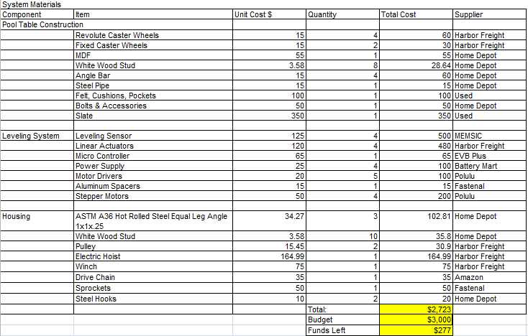

# Future Work

# The future development of this project will be to replace the Medium Density Fiberboard with a slate rock playing surface. This prototype solves a problem that is commonly experienced with those who own a pool table. Additional development will be to create a final product that has been designed for greatest manufacturability.

# Appendix

**INSERT INFORMATION**

**INSERT INFORMATION**