Submission Date: October 25, 2013

Pedibus Development

Midterm Report

Sponsor:

Ron Goldstein Capital City Pedibus

Facultiy Advisor:

Dr. Patrick Hollis

Team:

Andrew Galan Team Leader amg10x@my.fsu.edu

John Hassler Web Design Officer jdh03c@my.fsu.edu

James McCord Financial Officer jtm09f@my.fsu.edu

Onyewuchi Ebere Lead M.E. ebere.onyewuchi@yahoo.com

**Abstract**

Capital City Pedicab Company and its owner Ron Goldstein have entrusted the Florida State University mechanical engineering department to aid and assist in their overall goal in setting up a manufacturing station of fully operating pedibus system in the southeast region of the United States. A development of a pedibus transportation vehicle involves various amounts of mechanical components and evaluations. The pedibus operates like that of a normal bike, it involves a steering system, drive train, braking system, peddling station, and sometimes it involves some type of alcohol distribution system. Team 18 has taken on the task of completing the design of the pedibus development project and will take all the necessary steps to make positive that the model is fun, eco-friendly, and most of all safe to the public and environment. This midterm report will show the progress that has been taken into reaching the final goal that Capital City Pedicab Company has sought after and involve detailed designs, concepts, and evaluation methods. The sections provide information that will aid in the selection process; and also provide future plans and goals to finish the completed working model.

**Table of Contents**

1.0 Project Overview pg. 3

1.1 Project Goal pg. 3

1.2 Project Objectives pg. 3

1.3 Constraints pg. 4

2.0 Design Components and Concepts pg. 4

2.1 Frame Design and Material Selection pg. 4

2.2 Power Linkage pg. 7

2.3 Peddling Station pg. 12

2.4 Braking System pg. 14

2.5 Steering pg. 15

2.6 Tire Selection pg. 17

3.0 Future Plans pg. 18

4.0 Conclusion pg. 19

5.0 References pg. 19

6.0 Appendix pg. 20

7.0 Gantt Chart pg. 21

**1.0 Project Overview**

**1.1 Project Goal**

The primary goal of the pedibus development project is to have a fully detailed and operable design to aid in the production of future manufacturing and assembly. The sponsor has asked for a potential fully functional ready-to-ride model to be completed and operating by the springtime of 2014. It is the teams’ objective to fulfill the request of the sponsor and provide the company with fully detailed designs, costs analysis, and maintenance needs.

**1.2 Project Objective**

The main objective of this project is to design a pedal powered multi passenger vehicle that can eventually be reproduced for tour rides and manufactured for sale. To accomplish this objective the project will include:

* Developing a number of price points relating to the size of the vehicle and number of passengers vs. material and construction costs so that a final frame size can be chosen based on cost. Time constraints will also be taken into account for the final frame size so that a working prototype can be built before the end of the 2014 spring semester.
* Picking a base frame structure for optimal strength and minimum weight.
* Designing a power drive system, including the linkages from the pedals to the drive shaft.
* Designing a steering and braking system, with minimal cost.
* Integration of a power generation system to charge a battery that powers vehicle lights.
* Provide Capital City Pedicab Company with a fun and eco-friendly entertainment console.

All aspects of the design are to have safety and ease of maintenance as high priorities.

**1.3 Constraints:**

* Starting budget of $2000.00
* Manufacturing costs must be low enough that it is cost effective to produce for sale
* The finished pedibus prototype must have a low enough total weight that it can be powered by one or two people peddling.
* The pedibus must be designed so that maintenance is simple and inexpensive
* All design efforts should be undertaken to make the pedibus street legal and safe to operate on public roads.

**2.0 Design Components and Concepts**

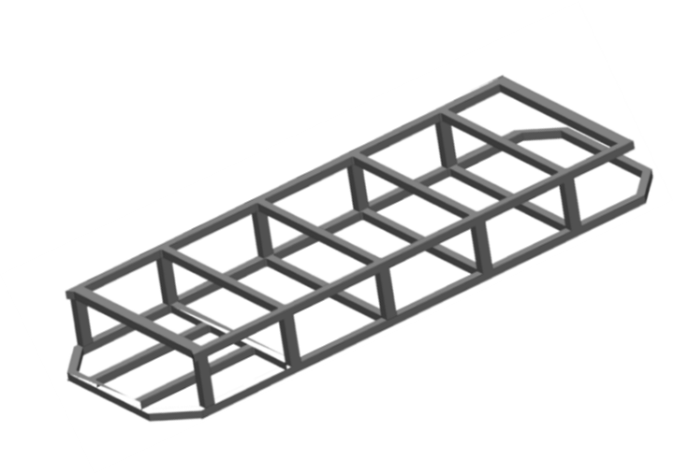**2.1 Frame Design and Material Selection**

Figure 1. Model of Structural Frame

Shown above is the Initial design for the frame that will be have stress strain analysis performed on it to dial in the best final design that accomplishes the teams overall goals for the design of the frame. There are 3 main goals trying to be achieved in the design of the frame, high rigidity and strength, low total weight, and minimal total cost. Strength is very important for the safety of the passengers and driver of the vehicle and also to ensure required maintenance stays at a minimum. The frame also needs to be lightweight, since it will be human powered this is an important factor. The pedibus is primarily a recreational vehicle used for tours and it is more ideal for the passengers to be focused on the sights and socializing with other passengers than focusing on how exhausted they are from propelling the vehicle up the last hill. Constraining these two previous factors is the budget, typically the stronger and lighter the material the more expensive it is. Due to the monetary constraints the logical approach would be to both explore alternative structural materials, and perform stress analysis with COMSOL or FEA then tweak the design to add or subtract cross members and supports accordingly. This will aid in finding a middle ground between cost and weight that satisfies the teams overall goals for the frame.

There are four materials that could potentially work as structural material for the pedibus, Steel, Aluminum, Carbon fiber, and Bamboo. Steel is widely used in commercial pedibusses. Most commercial pedibusses carry 14 to 18 passengers. The pedibus that will be produced for this project will carry 6 passengers plus a driver, needing much less reinforcement larger commercial models. This allows for the possibility of using a lighter material with less strength to optimize weight efficiency. Shown below is a table of the advantages and disadvantages of the different materials in question.

Table 1. Advantage and Disadvantage of Frame Materials

|  |  |  |  |  |
| --- | --- | --- | --- | --- |
| **Material** | **Steel** | **Carbon Fiber** | **Aluminum** | **Bamboo** |
| **Advantages** | Widely used in Commercial Models | Extremely Strong, extremely light | Very strong  Light weight | Durable, weather proof |
| Easy to weld and repair | High level of toughness | Impact resistant | Extremely light weight |
| Excellent Material Properties | Aesthetically nice finish | Less expensive than steel | Cheap, renewable resource |
| **Disadvantages** | Relatively Heavy | Brittle | Difficult to repair | Too flexible |
| Moderately expensive | Extremely expensive | Difficult to Weld | Unclear fastening method |
| May rust depending on type | Requires high skill level | Hard to reshape | Unclear material properties for FEA |

Taking into account the prices, strengths, and weights of the materials in question we were able to quickly rule out Carbon fiber and bamboo. Carbon fiber would definitely yield an ultra-light vehicle, but it is way too expensive to be considered as a realistic contender. The budget would be more than depleted from the frame alone. Bamboo would really capitalize on the eco-friendly initiative that our sponsor Ron Goldstein is trying to exemplify. But it is an unrealistic approach due to the amount of time it would take to master the science of fastening beams to one another in a manner which we would feel confident to allow Ron Goldstein to put his company name on.

Steel, aluminum or a combination of the two is what the final frame design will consist of, a frame entirely of steel is what the team is trying to avoid, and a complete frame of aluminum would be ideal. COMSOL or FEA stress analysis of the frame will ultimately decide which material and arrangement of cross beams will be in the final frame design.

**2.2 Power Linkage**

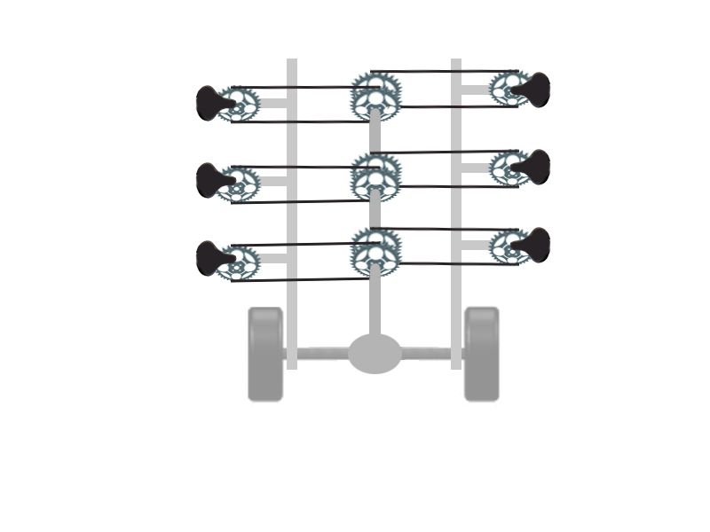Viewing the information posted on several different pedibus manufacturers’ websites it was observed that they use cold rolled steel drive shafts and the rear differential from an automobile. Thought the final decision has yet to be made we are currently planning on using the same components. What isn’t made clear on the manufacturer’s website is how they link the pedaling power from the passengers to the drive shaft. Figure 2 is a simple diagram of how our team initially visualized the linkage between the pedaling stations and the drive shaft. For this setup to be affective the peddling stations on the left side of the pedibus must be slightly offset from the peddling stations on the right side of the pedibus. The purpose of this offset is to provide room for all the gears on the drive shaft. One problem that is immediately apparent with this design is that passengers on opposite sides of the pedibus can’t both pedal forward. To address this issue we developed three different designs for the linkage between the pedals and the drive shaft.

Figure 2. Initial Power Linkage Design

**2.2.1 Power Linkage Design #1**

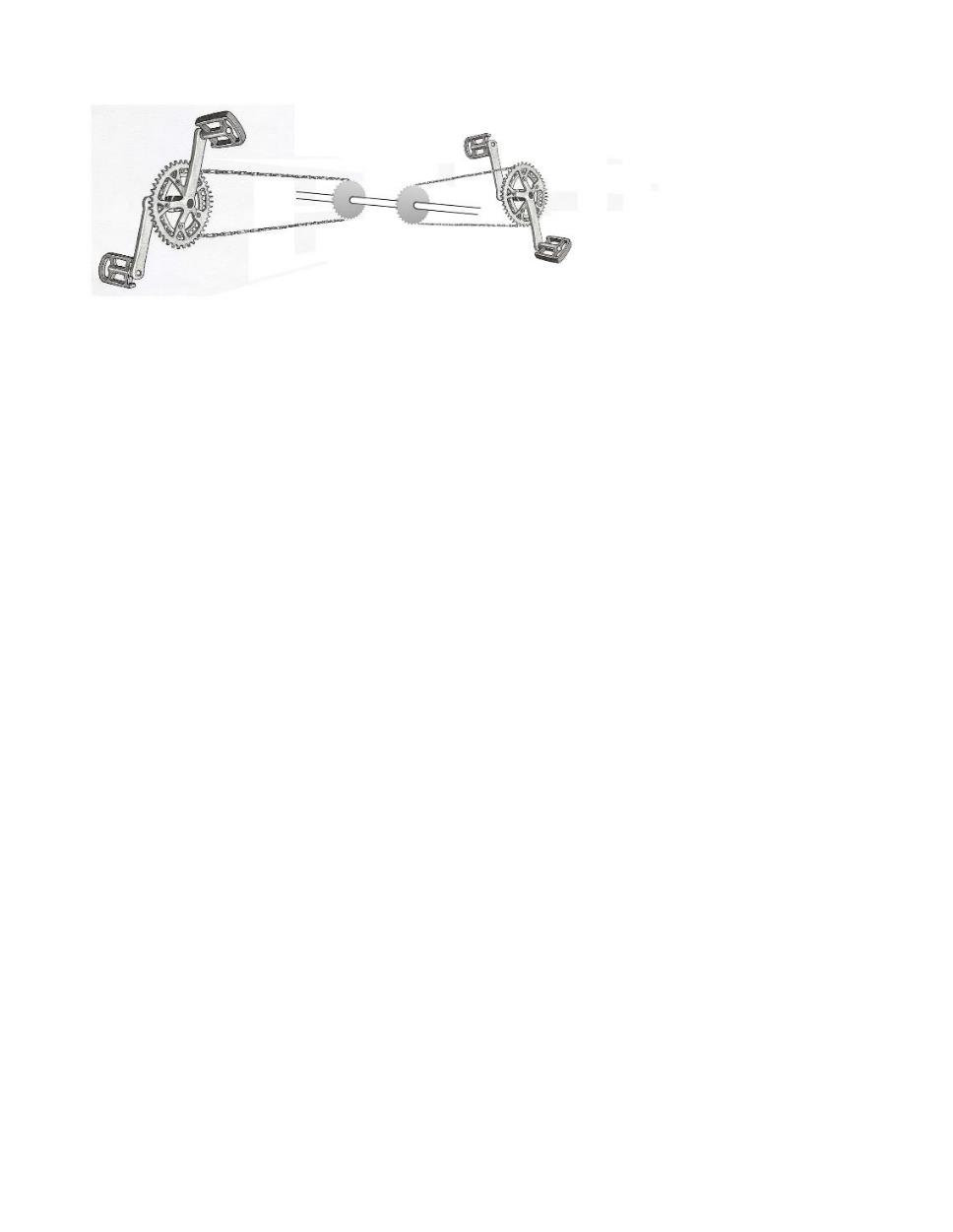

Figure 3. Power Linkage Design #1

Design one is to directly link the pedals to the drive shaft as seen in Fig. 3. Passengers on one side of the pedibus will pedal forward while passengers on the other side of the pedibus will peddle backwards. The positive aspects of this design are that it is the simplest linkage possible. Due to its simplicity it can be easily implemented and requires no additional parts or special manufacturing procedures. The lack of additional parts also makes this design the cheapest to implement. The negatives to this design is that it is less comfortable for a passenger to pedal backwards than it is to pedal forward. This design would effectively make one side of the pedibus more comfortable and thus more desirable than the other side. An ideal design will have all of the pedaling station equal in comfort and the amount of power they can input to the drive shaft. All commercially available pedibus have all of the passengers pedal forward and without implementing a similar setup our pedibus might be viewed as an inferior product by the end consumer.

**2.2.2 Power Linkage 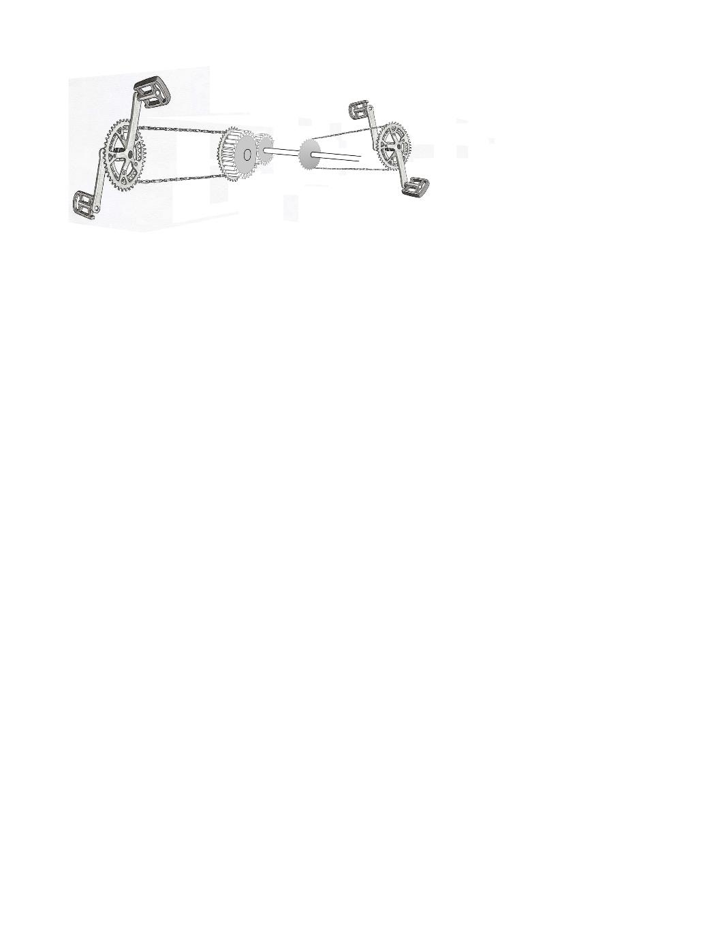Design #2**

Figure 4. Power Linage Design #2

Design two will have the bike chains from one side of the pedibus link to a gear that turns another gear on the drive shaft. The gears are the same diameter and number of teeth so all pedaling station are still inputting nearly the same amount of power to the drive shaft but because there is now a gear between the pedaling station and the drive shaft the direction of rotational input is now reversed. The positive aspects of this design are that now all passengers can pedal forward and the pedaling stations are all identical to each other regardless of which side of the pedibus they are on. The disadvantages to this design are that it is a more complicated design and requires more components to implement. This design would be more expensive due to the increased number of parts and the increased amount of time required to assemble them. Also, because there are more moving parts, the maintenance on the machine will be more complex and the time between maintenance checks will be reduced.

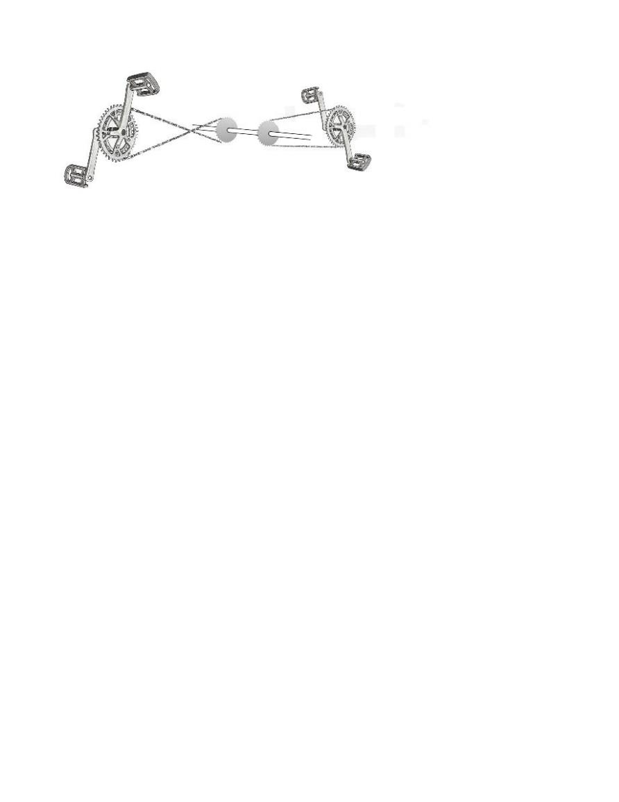**2.2.3 Power Linkage Design #3**

Figure 5. Power Linkage Design #3

Design three is two flip the chains on one side of the pedibus as they connect to the drive shaft. By flipping the chains the rotational input to the drive shaft is effectively reversed. The benefits to this design is that all passengers can pedal forward and that it requires very few additional components over design one. Slightly longer lengths of chain will be required for all the pedaling stations on one side of the pedibus to account for the longer distance required to cross the chains. The negative aspects of this design are minimal. Without adding some additional parts to keep the chain links from rubbing against each other as they cross the life span of the bike chains will be reduced. To counter this some system must be implemented to guide the chains around eachother. The pedibus team was advised by a local bike manufacturer that using pulley wheels to guide the chains would be affective and would only have a small effect on the lifespan of the bike chain.

Table 2. Decision Matrix for Power Transmission Design

|  |  |  |  |  |  |  |  |
| --- | --- | --- | --- | --- | --- | --- | --- |
| Power Linkage Design |  | Power Transmission Performance requirements | | | | |  |
|  | Comfort | Maintenance | Cost | simplicity | reliability | Weighted Score |
| Weight | 0.9 | 0.5 | 0.5 | 0.7 | 0.7 |  |
| Design #1 |  | 4 | 8 | 9 | 9 | 8 | 24 |
| Design #2 |  | 8 | 5 | 5 | 4 | 5 | 18.5 |
| Design #3 |  | 8 | 7 | 8 | 8 | 8 | 25.9 |

Table 2 is a decision matrix for the power linkage designs that the pedibus teams developed. Comfort, simplicity and reliability were given higher weights than maintenance and cost since the difference in maintenance and cost is not as great from one design to another. Design three, which involves crossing the chains on one side of the pedibus, has the highest weighted score and is the design he team will move forward with.

**2.3 Pedaling Station**

The pedaling station is where the person sits and pedals on the pedibus. All currently manufactured pedibus systems have pedaling stations based on traditional bicycle style pedaling. The pedaling stations face inward towards the center of the vehicle where passengers face a table much like sitting on a bar stool at a bar top table. In the design of the pedibus peddling station it was important to the development team to not immediately do what all other pedibus manufacturers did without exploring other designs and options. The team attempted to design a station from the ground up based on three characteristic that were determined to be the most important aspects of the pedaling station.

The important design aspects for the pedaling station are:

* It needs be comfortable to use for several hours at a time
* The passenger needs to be able to sit and pedal at the same time
* The seating must be stable in case of sharp turn or emergency stops.

The pedaling station needs to be comfortable for extended use because many pedibus systems currently in operation are being used for scenic or city tours. The tours can last as long as four hours and it is important that the passengers not become uncomfortable in that amount of time due to some flaw in the design of the pedaling station. The pedaling station must be designed so passengers can sit and pedal at the same time. This means the seating cannot be so restrictive to leg motion that the passenger cannot input power to the vehicle through pedaling. The passenger must be stable enough in the peddling station that if the pedibus makes an emergency stop or a sharp turn the passenger doesn’t fall out of the vehicle.

**2.3.1 Pedaling Station Design #1**

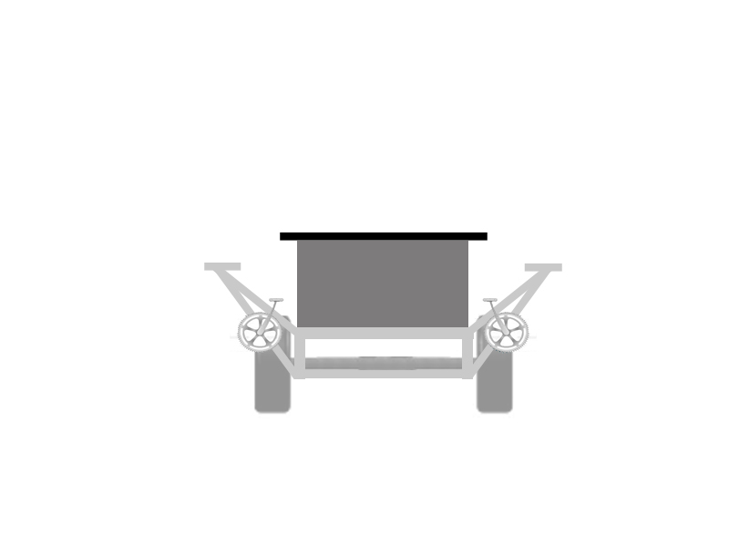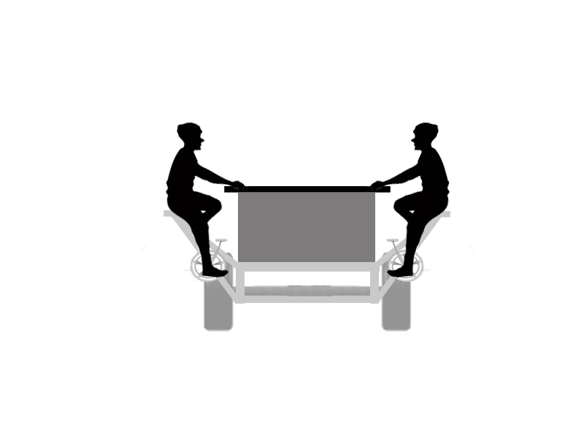

Figure 6. Bicycle Style Pedaling Station

Design one is a pedaling station based on a regular bicycle type pedaling system. This is very similar to the pedaling station used in all of the commercial pedibuses currently available. This design has the benefit of being very familiar as it uses a pedaling method like that of a traditional bicycle which most people have ridden before. Another benefit to this design is that with a table or bar top on the main body of the pedibus it is similar to sitting at a bar on a stool. This encourages the social interaction this is in line with the recreational purpose of this vehicle. The passengers are also further off the ground in this type of pedaling station, increasing their field of view which is complementary to scenic or city tours. A negative aspect to this design is that there is no back to the seating. Passengers will run the risk of lower back pain on long rides without lower lumbar support. Another negative aspect to this design is that there are different designs that make it possible for the passenger to input more power to the pedals than is possible with this design.

**2.3.2 Pedaling Station Design #2**

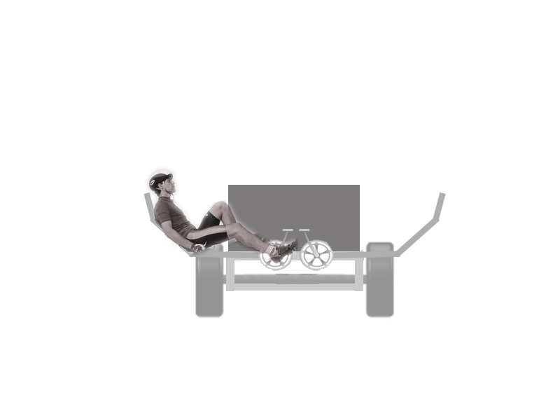

Figure 7. Recumbent Style Pedaling Station

Design two is a pedaling station based on a recumbent style bicycle pedaling system. Figure 7 shows how this design would look from the front or rear of the vehicle. An advantage to this design is the comfortable seating. The passenger will be reclined with back and head support which will make for comfortable use for long periods of time. The passenger can also input more power to the pedals than with design one. In pedaling station design one the limiting factor on the amount of force the passenger could input to the pedals is the passenger’s weight. This is due to the fact that on a traditional bicycle the rider is pushing down against gravity. In a recumbent style bicycle the rider is pushing against the back of the bike seat which is fixed in place. Thus in a recumbent bicycle the limiting factor on the amount of force a rider can input on the pedals is the amount of force the rider can generate with a single leg. The majority of the walking populace can generate more force with their legs than they weight.

A disadvantage to this design is that it is a less social type of seating than pedaling station design one. A passenger could talk with the passengers to their left or right but a conversation with the passenger reclining on the opposite side of the pedibus would be difficult. The passengers are also lower to the ground and in a reclined position making for poorer viewing angles and less conducive seating for scenic or city tours. Perhaps the biggest negative aspect of this design is that the thing further out from the center of the vehicle is the back of the passengers head. With this peddling station design the width of the vehicle is close to seven feet making it difficult to keep in a single traffic lane. The first part of the vehicle that would move into the oncoming traffic lane would be the head rests and the head of the passengers on one side of the pedibus. This is incredibly unsafe as the risk to severe injury or death is high.

**2.3.3 Pedaling Station Design Selection**

Table 3. Decision Matric for Pedaling Station Design

|  |  |  |  |  |  |  |  |  |
| --- | --- | --- | --- | --- | --- | --- | --- | --- |
| Pedaling Station Design |  | Performance Requirements | | | | | |  |
|  | Comfort | safety | stability | Power | Social interaction | Viewing angle | Weighted Score |
| Weight | 0.8 | 0.9 | 0.8 | 0.3 | 0.5 | 0.5 |  |
| Bicycle Style |  | 7 | 8 | 7 | 7 | 9 | 8 | 29 |
| Recumbent Style |  | 9 | 2 | 8 | 10 | 5 | 5 | 23.4 |

Table 3 is a decision matric for the two different pedaling station designs. The design criteria of comfort, stability, and safety are given high weights as they are the most important aspect of the design. Also considered with lower weights were total power generated, how conducive the seating was to social interaction, and the viewing angle the pedaling station design allowed for. The traditional bicycle style seating had the highest weighted score and is the design the team will move forward with. While recumbent seating did have higher scores in most of the categories it is a much less safe design than the traditional bicycle style of seating.

**2.4 Braking System**

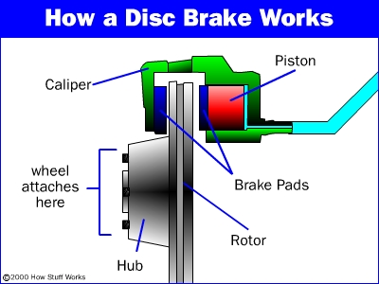 The braking system of the pedibus has to be capable of bringing a heavy sprung structure to a complete stop, while reaming safe for the passengers and driver. During evaluation of multiple braking designs, the team found that the best and most effective source of braking is to include the system of hydraulic disc brakes. Disc brakes consist of three main components: the brake pads, a caliper, and a rotor. The system operates like that of a normal bicycle brake. As the brake pedal is pushed down the push rod, connected to a spring coil, contracts and forces braking fluid out of a master cylinder. Once the fluid leaves the master cylinder it travels through a hydraulic brake line into the secondary cylinders that contact the brake pads. The pressure from the moving fluid causes the brake pads to compress along the sidewalls of the rotor, or disc brake, and thus reduce kinetic energy. As long as force is applied to the brake pedal the pressure of the fluid will remain constant on the pads. This force causes friction between the pads and discs and eventually will bring the vehicle to a smooth and complete stop. The rate at which the vehicle slows down is due to the amount of pressure that the driver exerts on the brake pedal. A figure of the detailed system may be seen in the fig. 8.

Figure 8. Hydraulic Braking

**2.5 Steering System Design**

Two designs are to be taken into consideration when dealing with steering of the pedibus. The system has to be smooth and efficient, while also trying to limit the use of power steering. The designs that were proven to be the easiest to maintain and operate are the rack-and-pinion steering system and also the recirculating-ball steering system.

**2.5.1 Rack-and-Pinion Steering**

The rack-and-pinion steering system, seen in fig. 9, is one of the most common steering systems used in earlier cars and almost all of the current pedibus models. It is simple in that contains a gear set that is enclosed in a metal tube. At the end of each rack, is attached a tie rod that connects to the steering rod, located on the spindle. The pinion gear is attached to the steering shaft, which allows the rack to transition horizontally as the steering wheel turns/rolls the pinion gear. This allows conversion of rotational motion of the steering wheel into linear motion that is needed to turn the wheels. Since the gear ratio of the pinion to the rack is low, this provides less effort to turn the wheels with respect to the steering wheel.

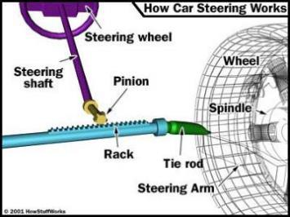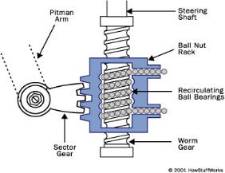

Figure 9. Rack and Pinion Steering

Figure 10. Circulating Ball Steering

**2.5.2 Recirculating-ball Steering**

Typically used in larger vehicles, such as trucks and SUVs, the recirculating-ball steering is another simple system similar to that of the rack-and-pinion. The steering contains a worm gear that is used when a large gear reduction is needed. It consist of a metal gear block that has a threaded hole through it that allows transition along the worm gear, along the lower end of the drive shaft, as seen in fig. 10. The block has gear teeth cut into the outside with engages a sector gear that moves the pitman arm. When the wheel turns, it turns the worm gear that remains in a fixed location, so upon spinning the block moves which then turns the wheels. To reduce friction and wear on the gear teeth within the block, the spacing between the worm gear teeth and threaded hole contain multiple ball bearings. With the absence of the bearings slop would be felt that will make the steering feel loose. Slop is caused when the gear teeth come out of contact with another for a slight moment when the steering wheel is turned due to the change of direction.

**2.5.3 Steering Design Selection**

Table 4. Decision Matrix for Steering Method

|  |  |  |  |  |  |  |
| --- | --- | --- | --- | --- | --- | --- |
|  |  | Design Criteria | | | |  |
| Steering Design |  | Simplicity | Cost | Maintenance | Reliability | Weighted Score |
|  | Weight | 0.9 | 0.7 | 0.5 | 0.5 |  |
| Rack and pinion |  | 9 | 8 | 8 | 7 | 21.2 |
| recirculating ball |  | 7 | 6 | 6 | 7 | 17 |

The team used a weighted decision matrix to decide on the best type of steering to use for the pedibus. Simplicity of design and cost were weighted more heavily than reliability and maintenance. Rack and pinion steering received the highest score from the decision matrix. The simplicity of the rack and pinion design and its lower cost over recirculating ball steering makes rack and pinion the steering method the team will move forward with.

**2.6 Tire Selection**

In order to minimize cost, weight, and energy required to propel the pedibus, a research on tires was conducted and table 5 shows some brief representation the findings.

Table 5. Tire Radius and Cost

|  |  |  |
| --- | --- | --- |
| Tire type | size | Cost($) |
| Convectional light vehicle tire | 14R/15R | 139 |
| Light weight vehicle Spare tires | 14R | 70 |
| Motor cycle tires | 16R | 40 |
| Power bike tires | 16R | 160 |
| Scooter tires | 7R | 35 |

From table 5 it can be seen that the cost of a tire can vary as much as one hundred dollars per tire. This represents a total cost difference of four hundred dollars for all four tires necessary to run the pedibus. When considering the total cost of manufacturing a pedibus the impact of tire cost is minimal. Tire weights for all different types of tires were not readily available but it can be safely assumed that the difference in weight won’t be more than one or two hundred pounds. The total loaded weight of the pedibus will be between 2,400 and 3,000 pound. This means tire selection will affect the total weight of the pedibus by less than ten percent. Based on the small effect tire selection has on total cost and total weight for the pedibus the team determined that a tire would later need to be chosen on different criteria more important to the function of the pedibus. Once a frame material and final design is chosen tire selection will be reassessed under the criteria of radius and the total weight it can carry.

**3.0 Future Plans**

Pertaining to the limited time leading up to the end of the fall semester it is the teams’ best effort to come to as close to possible in satisfying the goal of the pedibus development. To reach this goal the following future plans will be approached:

* Perform further material property analysis on selected structural material.
* Build and test a working peddling station that will provide not only comfort but also output maximum performance.
* Begin to design and test selected drive trains, steering control, and braking systems using data analysis and simulating computer programs.
* Provide a detailed cost analysis and progress agenda to the sponsor.

Eventually, throughout the spring semester if the budget is still within means, the full-size model will begin to undergo the construction process and run real-life situation testing.

**4.0 Conclusion**

Designs have been chosen for the power linkage between the pedals and the drive shaft, the pedaling station, and the steering/braking method. Though an initial frame design has been created the team has not yet performed the analysis on the forces the frame is subject too. Once that is done the team can make the final decision between steel and aluminum for the structural frame.

**5.0 References**

* Pedal Crawler | Custom Party Bike Manufacturer. 2013. *Pedal Crawler | Custom Party Bike Manufacturer*. <http://www.pedalcrawler.com/>.
* The Party bike <http://www.thepartybike.com/index.php/the-party-bike/>.
* PedalPub. The Bike with the Barrel. 2013. *PedalPub. The Bike with the Barrel*. <http://www.pedalpub.com/>.
* <http://www.capitalcitypedicabs.com/CCPedicabs/home.html>
* Pedibus - Beer bike, pubcrawler, pedibus, bike bar, cycle pub, cycling pub, cycling bar, bike pub, bike car. <http://www.pedibus.co.uk/>.
* Grainger Industrial Supply - MRO Supplies, MRO Equipment, Tools & Solutions. *Grainger Industrial Supply* <http://www.grainger.com/Grainger/wwg/start.shtml>.

**6.0 Appendix**

CAD Diagram of Structural Frame

