Final Report

**Senior Design (EML4551) -Fall 2013**

***Restatement of project scope and plan for shape conformable battery pack***

Faculty advisors: Dr. Jim Zheng & Dr. Chiang Shih

***Team members:***

Jenna Pine – Team Leader (ME)

Niraj Thakker – Communications (ME)

Jinchen Yu – Webmaster (ME)

David Goss – Treasurer (IE)

Roberto Moutran (IE)

Brian Rainbeau (EE)



**Needs Assessment:**

Batteries are usually an afterthought in technology and robotics. Engineers and scientists make a design, then determine the power needs, and finally just attach a battery. The system is not usually designed with the battery shape in mind. But, as technology advances, there is a demand for lightweight, high powered devices. As these systems are designed, there is not always physical space for a battery. This justifies the need for a conformable battery.

**Project Scope:**

**Problem Statement:**

The main objective of this project is to design a battery that can be integrated in to the wing of a UAV system. The battery can form around the wing, make up the wing, or fit inside the wing. The focus is that the battery be conformable (not cylindrical or flat rectangular). The goal will be to fly this plane for at least five minutes. The ideal battery design will be a easily deformed, lightweight battery. The success of this project would signify a milestone in battery technology and could give rise to new products.

**Background Information:**

Before going into specific project requirements, it is important to become familiar with the general working principles behind batteries. In simple terms, a battery is a device that stores chemical energy in the form of electrons. This chemical energy can be converted into electrical energy (electron flow) in order to supply power to a device and thus perform work. The smallest unit in which this energy conversion takes place is known as a battery cell.

A battery cell consists of two electrically-conductive materials. These materials are known as electrodes, and they have different energy levels. The electrode with the higher energy level is known as the anode or positive terminal, whereas the electrode with the lower level is known as the cathode or negative terminal. Because electrons flow from materials with high energy levels to materials with low energy levels, the anode and the cathode have to be isolated from each other within the cell in order to prevent direct electron transfer. This is typically done through the use of a separator material.

The generic single-cell battery interfaces with the load device through a pair of terminals which are connected to the anode and the cathode. These terminals act as an open circuit that is completed at one end by the load. As electrons flow out of the anode, the atoms in the material find themselves short an electron and become positively charge ions. These ions are capable of flowing through an electrolyte medium past the separator and into the cathode, thus completing the circuit at the other end. This electrolyte medium can be a paste (known as a dry electrolyte) or a liquid (known as a wet electrolyte) and its primary function is to facilitate the transfer of ions between electrodes. The choice of electrode material for each terminal will determine whether a single electrolyte can be used for both, or different electrolytes will be required for each electrode.

Once the circuit is closed, chemical oxidation (loss of electrons) occurs in the anode material and the released electrons flow through the load into the cathode terminal. Upon arrival at the cathode terminal, chemical reduction occurs (gain of electrons). It is this movement of electrons through the load that generates power. Figure 1 illustrates this whole process.

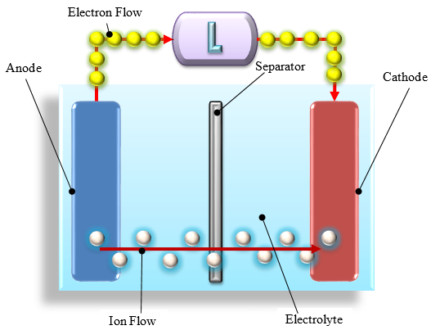

Figure 1: Basic Battery Configuration

Batteries can be classified by their reusability as follows:

* **Primary.** In this type of battery, the electrochemical reactions that take place within the cell are irreversible. Once all electrons have flowed from the anode into the cathode, the battery is spent and has to be disposed. One of the most common examples of primary types is the cylindrical alkaline battery, which is available in many stores and used to power a wide range of devices.
* **Secondary.** In a secondary battery, the electrochemical reactions are reversible through the application of a reverse current (typically done through a charger device). At the end of this process, the battery is ready to be used again. Lithium-ion batteries are a good example of secondary types. They are used in a wide range of consumer electronics in which rechargeability is an important consideration, such as cell phones, laptops and tablets.

A pouch cell is a battery encased in a flexible pouch made out of a foil material. This third type will be the focus of this project. In a pouch cell, anode and cathode sheets are layered in the desired configuration (this can be series or parallel) and isolated from each other by separator paper. The cell is then wrapped in a flexible, foil-like material that acts as the pouch. Liquid Electrolyte is injected and the pouch is closed with an air-tight seal in order to keep moisture out. Two tabs serve as the interface between the anode and cathode terminals. Figure 2 shows a working lithium ion pouch cell made at the battery lab in the Aero-Propulsion, Mechatronics and Energy (AME) building at the FAMU-FSU College of Engineering. Figure 3 shows a cross section view of a cell pouch.

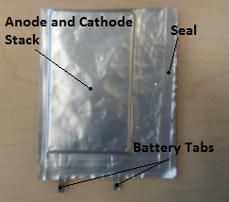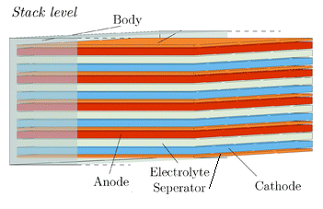

Figure 2: lithium Ion pouch cell

Figure 3: Cross section of pouch cell

**Design: Flexible Thin Cells:**

The design chosen involves the creation of very thin cell pouches. Because the thickness of the stack inside the pouch is very small, a certain level of bendability is present in the cell pouch. Figure 4 shows possible ways to take advantage of this flexibility by lining the inside and the outside the airfoil with the cell pouches. The conformability requirement is once again satisfied because the cells conform to the surface in which they are layered.

Thin Cells

Figure 4: Thin flexible cells

**Design benefits:**

* Cheap and easy to make. The small amount of material per pouch dramatically speeds up the battery making process.
* In theory, these thin cells could be used to layer the outside area of the wing and function as a skin, or be used to line up the inside.

**Issues and limitations:**

* Unknown cell response. Significant testing will be required to determine how the degree of bendability affects cell performance.
* Potentially time consuming due to testing requirement to determine bending limitations

# **Procurement**

All materials were discussed and approved by sponsor prior to submission. The RC plane, extra wing sets, and foam glue were purchased from HobbyTown USA. The anodes and cathodes were purchased from MTI Corporation. The AME battery lab is supplying the separator paper, Lithium hexaflourophosphate (LiPF6) electrolyte, and the laminated foil pouch material. Table 1 outlines the current standings of all purchases made. The total budget for this project is $2000.

|  |  |  |  |
| --- | --- | --- | --- |
| **Table 1 – Total Items ordered** | | | |
| **Description** | **Quantity** | **Unit price ($)** | **Total($)** |
| Ares Gamma 370 RTF plane | 1 | 129.99 | 129.99 |
| Wing Set | 2 | 39.98 | 79.96 |
| Large EPP foam glue | 2 | 9.98 | 19.96 |
| Li-Ion Battery Cathode - Aluminum foil double coated LiFePO4 | 3 | 79.95 | 239.85 |
| Li-Ion Battery Anode -Copper foil double side coated Graphite | 3 | 59.95 | 179.85 |
| **TOTAL** | | | **($649.61)** |

# **References**

1 *A superstore for material researchers and engineers*.(2013) Retrieved from MTI Corporation: http://www.mtixtl.com/index.aspx

2 *Agents Classified by the IARC Monographs*. (2013) Retrieved from International Agency for Research on Cancer: http://monographs.iarc.fr/ENG/Classification

3Amin, D. (2013, August). *EML4551C-Senior Design Project 1 .* Retrieved September 22, 2013, from Blackboard: https://campus.fsu.edu/webapps/portal/frameset.jsp?url=%2Fwebapps%2Fblackboard%2Fexecute%2Flauncher%3Ftype%3DCourse%26id%3D_6389491_1%26url%3D

4*BYD Company Limited*. (2012) Retrieved 10 19, 2013, from http://bydit.com/doce/products/Li-EnergyProducts/

5Ismail, M. H. (2003). Designing lithium ion batteries for high power applications. *PECon 2003 National Proceedings*, (pp. 289 – 291).

6Kam, K. C. (2012). Electrode Materials for Lithium Ion Batteries. *Material Matters*.

7*Learn about Batteries*.(2010) Retrieved September 21, 2013, from Battery University: http://batteryuniversity.com/learn/article/is_lithium_ion_the_ideal_battery

8Linden, D. (2002). *Handbook of Batteries.* New York: McGraw-Hill.

9Q. Wang, P. P. (2012, 06 15). *Thermal runaway caused fire and explosion of lithium ion battery*. Retrieved from ScienceDirect: http://www.sciencedirect.com/science/article/pii/S0378775312003989

10Server Experts. (2011). *LiPo Batteries and Charging for your Model RC Airplane*. Retrieved September 21, 2013, from L.I. Foam Flyers: http://www.longislandelectricrcairplanes.com/learnbatteries.php

11Zheng, H., Liu, G., Crawford, S., & Battaglia, V. S. (2010). *Fabrication Procedure for Lithium-ion Rechargeable Coin Cells.* Berkeley: Lawrence Berkeley National Laboratory.