­Deliverable #2 – Project Plans and Project Specifications

**Senior Design (EML4551) -Fall 2103**

*Team #15 Conformable Battery Pack*

Faculty advisors: Dr. Jim Zheng & Dr. Chiang Shih

*Team members:*

Jenna Pine – Team Leader (ME)

Niraj Thakker – Communications (ME)

Jinchen Yu – Webmaster (ME)

David Goss – Treasurer (IE)

Roberto Moutran - Industrial Engineer

Patrick De La Llana – Electrical Engineer

Brian Rainbeau – Electrical Engineer



**Needs Assessment:**

Batteries are usually an afterthought in technology and robotics. Engineers and scientists make a design, then determine the power needs, and finally just attach a battery. The system is not usually designed with the battery shape in mind. But, as technology advances, there is a demand for lightweight, high powered devices. As these systems are designed, there is not always physical space for a battery. This justifies the need for a conformable battery.

**Project Scope:**

**Problem Statement:**

The main objective of this project is to design a battery that can be integrated in to the wing of a UAV system. The battery can form around the wing, make up the wing, or fit inside the wing. The focus is that the battery be conformable (not cylindrical or flat rectangular). The goal will be to fly this plane for at least five minutes. The ideal battery design will be an easily deformed, lightweight battery. The success of this project would signify a milestone in battery technology and could give rise to new products.

**Justification/Background:**

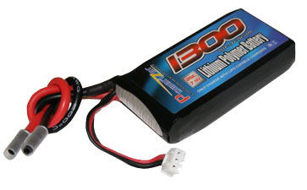 The term battery was first used by Benjamin Franklin in 1749. He connected glass capacitors that he used in his experiments with electricity [2]. A true battery wasn’t created until later by Alessandro Volta. In 1798, Volta built a “Voltaic pile” or the first real battery. He stacked copper zinc plates separated with cardboard disks saturated with an electrolyte (acid solution) [5]. The voltage across this stack was 1.1v. Thankfully, battery technology has come a far way in materials and in size. Today, Nickel-Cadmium, Nickel metal hydride, and Lithium batteries are used.

*Figure 1 Example of Lithium Polymer battery*

Lithium is the metal with the highest electrochemical potential and lowest density. In terms of energy-to-weight it is the best. G.N Lewis started experimenting with Lithium batteries in 1912 [2]. But, it wasn’t until the 1990’s when they became popular. As consumer technology increases, so do battery demands. Today, Lithium batteries are used in many products because of their performance.

Typically, Lithium polymer (LiPo) batteries are use for RC planes. They are lighter and have a better energy density compared to other types of batteries. There will need to be two batteries since they will be integrated into the wings. This will balance the UAV system for flight. Normally an RC plane has just one battery, so the power will need to be split between the 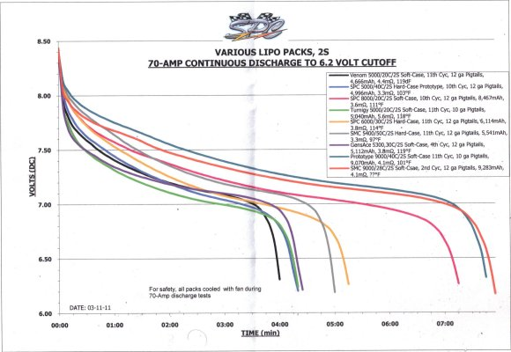two.

LiPo batteries are comprised of cells. The nominal voltage from a single cell is 3.7v [4]. This is important for safety to make the correct battery with the correct number of cells for the plane. Fires and explosions can occur if the incorrect power is being used. Figure 1 shows Time versus Voltage for various batteries [3]. From that data, it can be seen that at least a 2S or 2-cells must be used. Figure 1 shows a typical 2 cell LiPo battery.

*Figure 2 Time versus Voltage (various batteries*)

**Objectives:**

* Build a battery that can be integrated into the wing of a UAV system
* Utilize existing technology to stay under budget
* Develop uniquely shaped battery or formable battery
* Design must be safe for operator and should not explode or catch fire
* The battery must satisfy the power need of the RC plane
* Battery is to be detachable for charging

**Methodology:**

Understanding battery technology and the manufacture process is essential to this project. Creating a different type of battery is difficult and requires planning to succeed. The following methodology will be used:

* Research batteries technology and materials
* Understand physical and chemical properties of batteries
* Learn battery manufacture process
* Comprehend physical and aerodynamic principles of RC planes
* Theorize plan of action based off desired results

Once due diligence is completed, the team can move forward to:

* Start calculating hypothetical battery needs (using standards for various planes)
* Design various types of batteries for the application
* Create decision matrix using designs
* Choose RC plane

The battery will need to be tested for safety before any field tests can be performed. Additionally, members form the team will have to learn to pilot an RC plane. Then:

* Raw materials can be purchased
* RC plane can be purchased
* Prototype batteries (2-6) can be made
* Plane to be modified for battery
* Field test
* Analyze Results
* Modify design or plane selection if necessary
* Run many field tests in various conditions for diverse statistical data
* Examine data and formulate conclusions

This project will be ready for review after these steps have been taken. Parts of this process may need to be repeated as needed.

**Project Constraints:**

* Project budget $2000
* Limited research or experience available
* Mass of each battery should not exceed 100 grams
* RC plane should be able to fly outside under reasonable conditions
* Battery must not explode or catch fire
* Enough power must be supplied for at least a 5 minute flight without switching batteries or recharging
* To be completed by Spring 2014

**Assign Resources:**

The team has decided on finishing up certain tasks before the end of the semester. Each member is responsible for his/her task and is responsible for finishing it up before the due date. In need of help, the person responsible for the task will seek help from the group and the task will then become a group task and not an individual task. The assigned tasks are divided into two categories. First category is tasks related to deliverable, for example, presentation and reports. For the deliverable category, the dates for each deliverable are listed. The second category called the project category includes research and development part of the project. The dates for these are not fixed and are set weekly.

**Deliverable Tasks:**

* **Needs assessment 09/27/2013**
* Research on batteries – Entire Team
* Project goals and constraints and methods – Jenna Pine
* Final edit of the report – Niraj Thakker
* **Project Plan and Specification 10/11/2013**
* Deliverable and Assign resources – Niraj Thakker
* Design and Performance Specification – Brian Rainbeau, David Goss, Patrick De La Llana, Roberto Moutran and Niraj Thakker
* Final edit of the report – Jenna Pine
* **Initial Web Page Design 10/18/2013**
* Webpage layout and uploading of documents – Jianchen Yu
* **Midterm Presentation and Report 1 10/22/2013**
* Aerodynamic aspect of the project – Niraj Thakker and Jenne Pine
* Battery and Circuit aspect of the project – Patrick De La Llana and Brian Rainbeau
* Material aspect of the project – Roberto Moutran
* Financial aspect of the project – David Goss
* Presenters – Jenna Pine, Patrick De Llana, Roberto Moutran
* **Peer Evaluation 10/29/2013**
* Attendance check – Niraj Thakker
* Tasks delivered – Jenna Pine
* Final Evaluation – Entire Team
* **Midterm Presentation and Report 2 11/12/2013**
* Aerodynamic aspect of the project – Niraj Thakker and Jenne Pine
* Battery and Circuit aspect of the project – Patrick De La Llana and Brian Rainbeau
* Material aspect of the project – Roberto Moutran
* Financial aspect of the project – David Goss
* Presenters – Niraj Thakker, Jianchen Yu, David Goss, Brian Rainbeau
* **Peer Evaluation 11/26/2013**
* Attendance check – Niraj Thakker
* Tasks delivered – Jenna Pine
* Final Evaluation – Entire Team
* **Final Web Page Design 11/26/2013**
* Webpage layout and uploading of documents – Jianchen Yu
* **Final Presentation and Report 11/12/2013**
* Aerodynamic aspect of the project – Niraj Thakker and Jenne Pine
* Battery and Circuit aspect of the project – Patrick De La Llana and Brian Rainbeau
* Material aspect of the project – Roberto Moutran
* Financial aspect of the project – David Goss
* Web design aspect of the project – Jianchen Yu
* Presenters – Entire Team

**Project Tasks:**

Given the size of the team, we decided on creating two separate teams with two separate tasks. Team A includes Niraj Thakker and David Goss, whose task would be the aerodynamics part of the project. Team B includes the rest of the team, whose task is to develop a conformable battery that will be placed in the RC plane’s airfoil. Since the main aspect of the project is conformable battery pack, this semester’s concentration will be to come up with a battery shape to fit into a chosen RC plane. The project tasks are divided into battery tasks and aerodynamic tasks. The tasks shows below will be done chronologically, however they are still susceptible to change.

* **Choosing an Appropriate battery type (Battery Task)**
* Research on Lithium Ion batteries – Entire team
* Research on Lithium Polymer Battery – Jenna Pine and Niraj Thakker
* **Making a normal shaped battery using Dr.Zheng’s Lab (Battery Task)**
* Rectangle shaped lithium Ion batteries of appropriate power – Jenna Pine, David Goss and Roberto Moutran
* Appropriate voltage done by calculation – Patrick De La Llana and Brian Rainbeau
* **RC Plane (Aerodynamics Task)**
* Researching on different RC plane design – Entire Team
* Choosing an initial design to order – Niraj Thakker and David Goss
* **Flight Test (Aerodynamics Task)**
* Installing the made battery in the plane – Entire team
* Aerodynamic calculations before flight – Niraj Thakker
* First test flight with non-conformable battery – Entire Team
* **Shaping the battery (Battery Task)**
* Choosing an appropriate spot for the conformable battery in the wing – Niraj Thakker
* Designing various shapes to fit the wing – Jenna Pine, David Goss and Roberto Moutran
* Connecting the batteries to the control system – Patrick De La Lana, Brian Rainbeau and Jianchen Yu
* **Battery Check (Battery Task)**
* Checking the power output of the conformable battery – Entire team
* **Flight Test (Aerodynamics Task)**
* Installing the conformable battery in the test plane – Entire team
* Aerodynamic calculation before flight – Niraj Thakker
* Flight test with conformable battery – Entire team

All the projects task and the progress will be updated by Jianchen Yu on the group website. The goal is to finish up the tasks by the end of the semester so next semester the group can have a definite shape, a definite plane and can work on the detachable wing design.

**Product Specification:**

Since the main scope of the project is related to making conformable batteries, all the project specifications are of battery design and performance. Once the battery design is chosen, the team will work on a RC plane to suit the battery. This semester’s concentration is on battery design and hence this report is limited to specifying the battery needs. However a few requirements which were put forth by the sponsors are summarized in RC plane design specification and performance specifications

**RC Plane Specifications**

* **Design Specification**
* Needs to have a detachable from the plane.
* The plane needs to have multiple wings.
* The battery needs to be installed inside the wing or as the wing.
* The voltage input of the control system of the plane needs to match the voltage output of the battery
* **Performance Specification**
* The plane has to take off, stay in the air for 5 minutes and land safely
* The weight of the battery needs to be balanced in order for the plane to be stable
* If the battery is the wing, it needs to be well insulated
* The airfoil has to be stay stable throughout the flight

**Battery Specifications**

* **Design Specification**

There are two battery technologies that can be used to accomplish the design goals. One is a lithium Ion type battery with a cathode made from LiFePO4 (lithium iron phosphate) coated on Aluminum foil, and an anode made from Graphite coated on a copper foil substrate. The electrolyte would be liquid LiPF6 (Lithium hexafluorophosphate). The anode and cathode would be cut into the shape of the cross section of an airfoil (Figure 1), and layered together with a thin (<50µm) Polyethylene terephthalate (PET) separator in series.

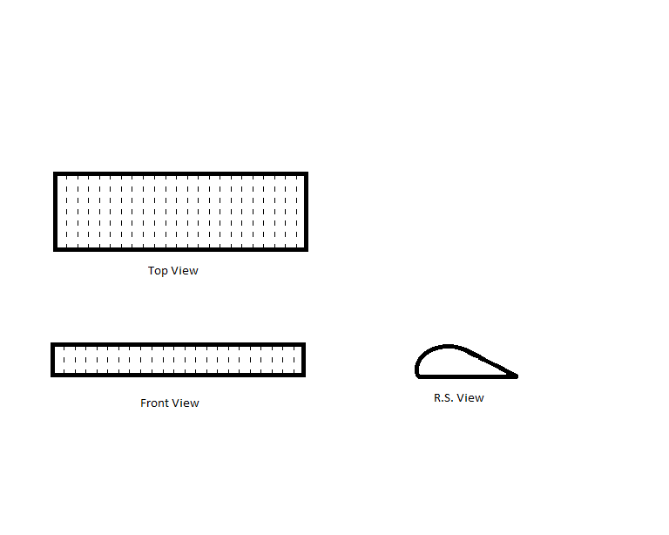

***Figure 3: Lithium Ion Battery Layers***

Once the stacks are layered they would be injected with electrolyte and hermetically sealed together in thicker PET.

The second option would be to produce a Lithium Gel Polymer Battery, which on account of its mechanical properties, can be formed into the shape of a wing. A gel electrolyte would be mixed with a dry solid polymer in these proportions:

30% PVdF (Polyvinylidene fluoride),

60% EC (ethylene carbonate)(used as a plasticizer), and

10% LiBF4 (Lithium tetrafluoroborate) (1).

The above materials would have to be heated for 60 minutes at 170°C, then the solution would be poured on a very thin separator sheet like (PET). A doctor blade could be used to get the product under 50μm. The sheet would then be dried in a dry room for 3-4 hours (1).

* **Performance Specification**
* The battery must be able to be integrated into the wing of a UAV system.
* The Battery must be uniquely shaped or shape conformable, i.e. not cylindrical or box shaped.
* The design must be safe for an operator and should not explode or catch fire.
* The battery must satisfy the power need of the RC plane, such that the plane is able to take off, sustain flight for a minimum of five minutes, and land.
* The battery is able to be detached for charging.

**Sources:**

1Amin, D. (2013, August). *Project #15 - Senior Design Project Definition.* Retrieved September 22, 2013, from Blackboard: https://campus.fsu.edu/bbcswebdav/pid-6173804-dt-content-rid-35084798_2/courses/EML4551C-0001.fa13/15-%20Conformable%20batteries%20Senior%20Design%20Project%20Outline%20conformable%20batteries.pdf

2Linden, D. (2002). *Handbook of Batteries.* New York: McGraw-Hill.

3Server Experts. (2011). *LiPo Batteries and Charging for your Model RC Airplane*. Retrieved September 21, 2013, from L.I. Foam Flyers: http://www.longislandelectricrcairplanes.com/learnbatteries.php

4Unknown. (2010, October). *Learn about Batteries*. Retrieved September 21, 2013, from Battery University: http://batteryuniversity.com/learn/article/is_lithium_ion_the_ideal_battery

5Unknown. (2013). *Battery History*. Retrieved September 22, 2013, from Enegizer: http://www.energizer.com/learning-center/Pages/facts-history-care.aspx