­Deliverable #1 – Needs Assessment

**Senior Design (EML4551) -Fall 2103**

*Team #15 Conformable Battery Pack*

Faculty advisors: Dr. Jim Zheng & Dr. Chiang Shih

*Team members:*

Jenna Pine – Team Leader (ME)

Niraj Thakker – Communications (ME)

Jinchen Yu – Webmaster (ME)

David Goss – Treasurer (IE)

Roberto Moutran - Industrial Engineer

Patrick De La Llana – Electrical Engineer

Brian Rainbeau – Electrical Engineer



**Needs Assessment:**

Batteries are usually an afterthought in technology and robotics. Engineers and scientists make a design, then determine the power needs, and finally just attach a battery. The system is not usually designed with the battery shape in mind. But, as technology advances, there is a demand for lightweight, high powered devices. As these systems are designed, there is not always physical space for a battery. This justifies the need for a conformable battery.

**Project Scope:**

**Problem Statement:**

The main objective of this project is to design a battery that can be integrated in to the wing of a UAV system. The battery can form around the wing, make up the wing, or fit inside the wing. The focus is that the battery be conformable (not cylindrical or flat rectangular). The goal will be to fly this plane for at least five minutes. The ideal battery design will be a easily deformed, lightweight battery. The success of this project would signify a milestone in battery technology and could give rise to new products.

**Justification/Background:**

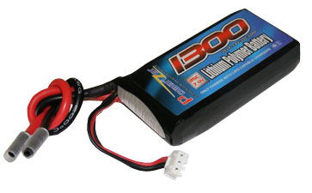 The term battery was first used by Benjamin Franklin in 1749. He connected glass capacitors that he used in his experiments with electricity [2]. A true battery wasn’t created until later by Alessandro Volta. In 1798, Volta built a “Voltaic pile” or the first real battery. He stacked copper zinc plates separated with cardboard disks saturated with an electrolyte (acid solution) [5]. The voltage across this stack was 1.1v. Thankfully, battery technology has come a far way in materials and in size. Today, Nickel-Cadmium, Nickel metal hydride, and Lithium batteries are used.

*Figure 1 Example of Lithium Polymer battery*

Lithium is the metal with the highest electrochemical potential and lowest density. In terms of energy-to-weight it is the best. G.N Lewis started experimenting with Lithium batteries in 1912 [2]. But, it wasn’t until the 1990’s when they became popular. As consumer technology increases, so do battery demands. Today, Lithium batteries are used in many products because of their performance.

Typically, Lithium polymer (LiPo) batteries are use for RC planes. They are lighter and have a better energy density compared to other types of batteries. There will need to be two batteries since they will be integrated into the wings. This will balance the UAV system for flight. Normally an RC plane has just one battery, so the power will need to be split between the 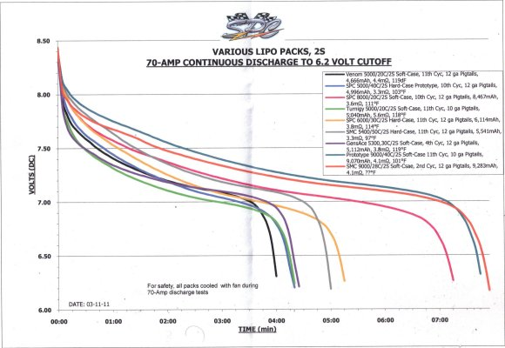two.

LiPo batteries are comprised of cells. The nominal voltage from a single cell is 3.7v [4]. This is important for safety to make the correct battery with the correct n umber of cells for the plane. Fires and explosions can occur if the incorrect power is not being used. Figure 1 shows Time versus Voltage for various batteries [3]. From that data, it can be seen that at least a 2S or 2-cells must be used. Figure 1 shows a typical 2 cell LiPo battery.

*Figure 2 Time versus Voltage (various batteries*)

**Objectives:**

* Build a battery that can be integrated into the wing of a UAV system
* Utilize existing technology to stay under budget
* Develop uniquely shaped battery or formable battery
* Design must be safe for operator and should not explode or catch fire
* The battery must satisfy the power need of the RC plane
* Battery is to be detachable for charging

**Methodology:**

Understanding battery technology and the manufacture process is essential to this project. Creating a different type of battery is difficult and requires planning to succeed. The following methodology will be used:

* Research batteries technology and materials
* Understand physical and chemical properties of batteries
* Learn battery manufacture process
* Comprehend physical and aerodynamic principles of RC planes
* Theorize plan of action based off desired results

Once due diligence is completed, the team can move forward to:

* Start calculating hypothetical battery needs (using standards for various planes)
* Design various types of batteries for the application
* Create decision matrix using designs
* Choose RC plane

The battery will need to be tested for safety before any field tests can be performed. Additionally, members form the team will have to learn to pilot an RC plane. Then:

* Raw materials can be purchased
* RC plane can be purchased
* Prototype batteries (2-6) can be made
* Plane to be modified for battery
* Field test
* Analyze Results
* Modify design or plane selection if necessary
* Run many field tests in various conditions for diverse statistical data
* Examine data and formulate conclusions

This project will be ready for review after these steps have been taken. Parts of this process may need to be repeated as needed.

**Constraints:**

* Project budget $2000
* Limited research or experience available
* Mass of each battery should not exceed 100 grams
* RC plane should be able to fly outside under reasonable conditions
* Battery must not explode or catch fire
* Enough power must be supplied for at least a 5 minute flight without switching batteries or recharging
* To be completed by Spring 2014

**Final Results:**

At the end of the design period the team will have integrated a battery into a UAV wing. The RC plane will be able to fly for at least 5 minutes at a time and safely land. The battery shall be removable to allow for charge. Exact battery specifications will be provided and all materials will be listed. The battery will be made to safely fly the RC plane.

**Sources:**

1Amin, D. (2013, August). *Project #15 - Senior Design Project Definition.* Retrieved September 22, 2013, from Blackboard: https://campus.fsu.edu/bbcswebdav/pid-6173804-dt-content-rid-35084798_2/courses/EML4551C-0001.fa13/15-%20Conformable%20batteries%20Senior%20Design%20Project%20Outline%20conformable%20batteries.pdf

2Linden, D. (2002). *Handbook of Batteries.* New York: McGraw-Hill.

3Server Experts. (2011). *LiPo Batteries and Charging for your Model RC Airplane*. Retrieved September 21, 2013, from L.I. Foam Flyers: http://www.longislandelectricrcairplanes.com/learnbatteries.php

4Unknown. (2010, October). *Learn about Batteries*. Retrieved September 21, 2013, from Battery University: http://batteryuniversity.com/learn/article/is_lithium_ion_the_ideal_battery

5Unknown. (2013). *Battery History*. Retrieved September 22, 2013, from Enegizer: http://www.energizer.com/learning-center/Pages/facts-history-care.aspx