Automation of the RIDFT
Define Phase

By
Chelsea Armbrister
Brian LaTulip
Joseph Gwaltney
Daniel Escobedo
Divyesh Bhakta
Luis Sura

A report submitted to
Dr. Okenwa Okoli
Industrial & Manufacturing Engineering Department
FAMU – FSU College of Engineering
Tallahassee, FL
October 25th 2011

This report is the first of five progress reports. It defines the opportunities and constraints of automating the RIDFT following the Six Sigma methodology of “Define, Measure, Analyze, Design and Validation” (DMADV). The approach and deliverables the team will provide at the termination of the project, as well as, a detailed description of the customer requirements are provided.

TABLE OF CONTENTS
LIST OF TABLES……………………………………………………………………………iii
LIST OF FIGURES…………………………………………………………………………..iii
ABSTRACT
- INTRODUCTION…………………………………………………………………………..5
2. PROJECT DEFINITION……………………………………………………………………6
2.1 PROJECT SCOPE, ASSUMPTIONS AND DELIVERABLES…………………...7
2.1.1 PROJECT SCOPE ………………………………………………………..7
2.1.2 ASSUMPTIONS………………………………………………………….8
2.1.3 DELIVERABLES…………………………………………………………9
3. TEAM ORGANIZATION…………………………………………………………………...10
4. PROJECT CHARTER AND BUSINESS SUGNIFICANCE……………………………....12
4.1 PROJECT CHARTER……………………………………………………………..12
4.1.1 BUSINESS CASE……………………………………………………….12
4.1.2 OPPORTUNITY STATEMENT………………………………………..12
4.1.3 GOAL STATEMENT…………………………………………………...12
4.1.4 TEAM SELECTION ……………………………………………………13
4.2 BUSINESS SIGNIFICANCE……………………………………………………..13
5. ANALYSIS OF CUSTOMER REQUIREMENTS………………………………………..14
5.1 CRITICAL COSTOMER REQUIREMENTS (CCR)……………………………14
5.2 MEETING CCR ………………………………………………………………….15
6. CONCLUSION…………………………………………………………………………….17
7. REFERENCES …………………………………………………………………………….18

LIST OF TABLES
Table 2-1………………………………………………………………………………………...8
Table 2-2………………………………………………………………………………………...8
Table 2-3………………………………………………………………………………………...9
Table 4-1………………………………………………………………………………………..13

LIST OF FIGURES
Figure 2-1………………………………………………………………………………………7
Figure 3-1…………………………………………………………………………………….10
Figure 3-2……………………………………………………………………………………..11
Figure 5-1……………………………………………………………………………………..14
Figure 5-2……………………………………………………………………………………..15
Figure 5-3 …………………………………………………………………………………….16

ABSTRACT

The Resin Infusion between Double Flexible Tooling (RIDFT) is a process by which fiber composite molds are made. By definition, the RIDFT decouples the infusion stage from the formed geometry, yielding a simpler ‘flat’ resin flow. Upon observation and operation of the rift it becomes obvious that there are setbacks involved with this process.
Because of the motions needed for operation of the RIDFT. It is labor intensive and time consuming. Specifically, the portion of the process where the two frames housing the silicon membranes are mounted and dismounted as well as replaced. Therefore, there is a need to improve this process in order to reduce and enable safe manpower utilization which includes a shorter processing time.
It was determined that an automated lift system is needed for the correction of such problems coupled with an suitable ergonomic handling system, which can be retrofitted to the current RIDFT machines for each frame, providing desirable position for optimal vacuum, disassembly and working space. In addition to this, a method in which to provide precise fiber placement must also be constructed.

- INTRODUCTION
In the world of manufacturing, the use of fiber composite polymers has become a cutting edge practice. These materials are sought after for their high strength, resistance to corrosion, electrical and thermal insulation, as well as being light weight. Because of its properties, composites have become constructive and necessary in variety of areas. This includes the use of such material in the production of medical equipment (i.e. X-ray equipment), aerospace (airplanes), civil infrastructural systems (retrofitting bridges), and in the creation of robots.
Many processes have been investigated for the safe and rapid development of fiber composite polymers. Previous methods include open mold techniques i.e. hand lay-ups and liquid composite molding (LCM) techniques such Resin Transfer Molding (RTM). However, numerous have failed to match the demands for mass production and yield long production periods and high emission rates of volatile compounds. At the High Performance Materials Institute, Dr. Okenwa Okoli has revolutionized the way in which fiber Composite Polymers are produced with the creation of the Resin Infusion between Double Flexible Tooling (RIDFT) process which produces such composites inexpensively.
Currently, the operation of the machine involves the manual positioning and removal of the top and bottom frames. Because the operation is manual, the constant motion comes at a great risk and arduous labor to the operator as well as a delay in production time therefore; it is in this aspect that Dr. Okoli seeks our assistance.

- PROJECT DEFINITION
The purpose of this project is to design and implement an automated system for the RIDFT machines that will stably, safely and accurately place the top and bottom frames, in order to assure optimal vacuum, disassembly and working space. Moreover, this automated system must encompass a ergonomic handling system. A methodology must also be developed and implemented to accurately place the fiber between the two silicon membranes.
There are six major steps to the RIDFT manufacturing process.
Step 1: Load the fiber into the machine.
Step 2: Secure the fiber properly into the machine.
Step 3: Infuse resin into machine until fibers are thoroughly wet using the vacuum process.
Step 4: Vacuum seal the two chambers with fiber secured inside.
Step 5: Vacuum the resonated fibers to ensure that fibers are forming around the male mold piece.
Step 6: De-mold the part carefully.
As illustrated by the process, it is seen that the operator is subjected to certain factors such as heavy lifting and replacement of the silicone sheets during the procedure. The procedure also involves a significant amount of time. Figure 1 further describes the RIDFT process.

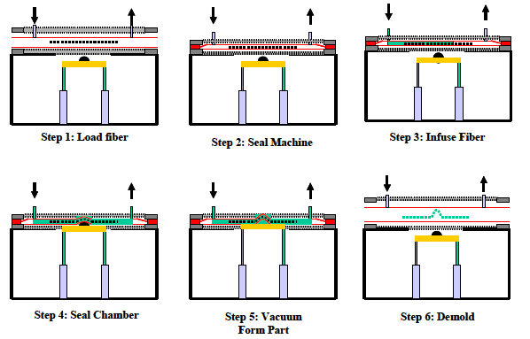
Figure 2-1: The RIDFT process

2.1 PROJECT SCOPE, ASSUMPTIONS AND DELIVERABLES

2.1.1 PROJECT SCOPE

The team will observe and perform the RIDFT process. This will help us identify the motions of the operator and allow us to perform a series of ergonomic measurements. These measurements will include time studies, identification of ergonomic risk factors and activity charts. These measurements will quantify the need for safety, loss of productivity (time) and provide resources for ergonomic handling system. For example, when operator grasps or releases the frame during the lifting process, this movement can be timed and quantified as sown in Table 1.

Table 2-1: Release motion of the operator
Case | Time | Description
1 | 2.0 | Normal release performed by opening fingers as independent motion
2 | 0 | Contact release

After this, the team will perform measurements that are required for automation. We will measure optimal angles and distances required for lifting the top and bottom sheets as well as the force needed to hold the sheet in place for easy removal. A review and analysis of various mechanisms for stable motion will be compared, selected and implemented (Refer to Table 2) . Materials will then be ordered in a timely manner for prototyping and testing.
Table 2-2: Brainstorming methods of lifting top and bottom sheets
 | Advantages | Disadvantages
Hydraulic Pump System | - Rudimentary Mechanism already in place | - Complex Controls  - Unstable vertical motion
Four Bar linkage system | - Stable  - Will perform exact motion for lifting | - Complex analysis required.

Finally, the team will assess the fiber placement. This however, is request that may not fulfilled due to time constraints.

2.1.2 ASSUMPTIONS
Some assumptions need to be taken into account for the automation of the Resin Infusion between Double Flexing Tool (RIDFT) machine and the mold placement methodology. These assumptions are:
- The order of operation is unaltered.
- The method for resin injection and flow is optimal.
- The equipment, i.e. the silicon membrane sheets , corresponding frames and
chamber, will remain the same.
- The current method for carbon fiber placement will continue to be implemented.
- The current RIDFT process requires more than one operator and is time consuming as well as labor intensive.
- Mold placement methodology is currently unsound.

    - DELIVERABLES
Upon completion of each deliverable a member from the group will provide Dr. Okenwa Okoli with a hard copy of said deliverable for approval through means of his signature. The group will also take into consideration any constructive criticism and adjust the deliverable to meet the customer’s needs and wants given that they are feasible. The mechanical and Industrial engineers have separate deliverables and deadlines and have thus combined them in Table 1.
Table 2-3: Updated deadlines for Mechanical and Industrial Engineering personnel
Deliverables | Due Date
Needs Assessment Report/Project Scope | 09/29/2011
Product Specification/Project Procedures/  Project Plan | 10/13/2011
Define Phase Report | 10/25/2011
Concept Design/Presentation | 10/27/2011
Concept Generation and Concept Selection | 10/27/2011
Interim Design/ Presentation | 11/15/2011
Final Design Package | 11/29/2011
Updated Interim Powerpoint Presentation | 01/15/2012
3rd Updated Interim Powerpoint Presentation | 02/15/2012
Final Report/Instruction Manual/  Powerpoint Presentation | 04/15/2012
- TEAM ORGANIZATION
In this segment, the responsibilities of each member are shown. The team reports directly to the sponsor, Dr. Okoli from the Industrial Engineering Department and Dr. Hovsapian from the Mechanical Engineering Department. This is demonstrated in Figure 2.
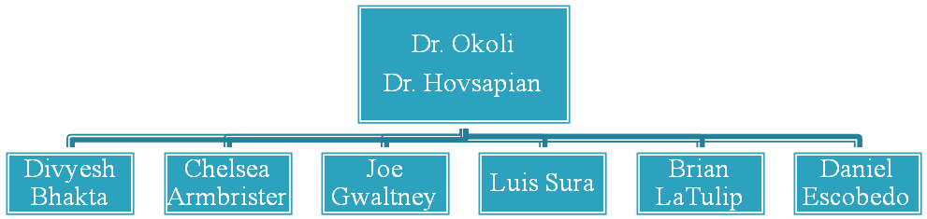Figure 3-1: Organization of Team
Project Lead

Team

Luis Sura and Brian Latulip are in charge of analysis and selection of specific automatic system that will lift the RIDFT frames. Daniel Escobedo is heading the material analysis and material selection. Joe Gwaltney and Chelsea Armbrister lead the time study, ergonomic design. Team member Divyesh Bhakta tests and runs needed simulations of the RIDFT procedure and application of six sigma methodologies.
Team will assemble at least once a week for reporting purposes. Current meetings are held every Wednesday in which there are brainstorm ideas for designs, updates on progress and final deliverables decisions. Figure 3 illustrates a timeline of the project development throughout the entire year. If any changes are made to the timeline, an updated version will be sent to the sponsor.
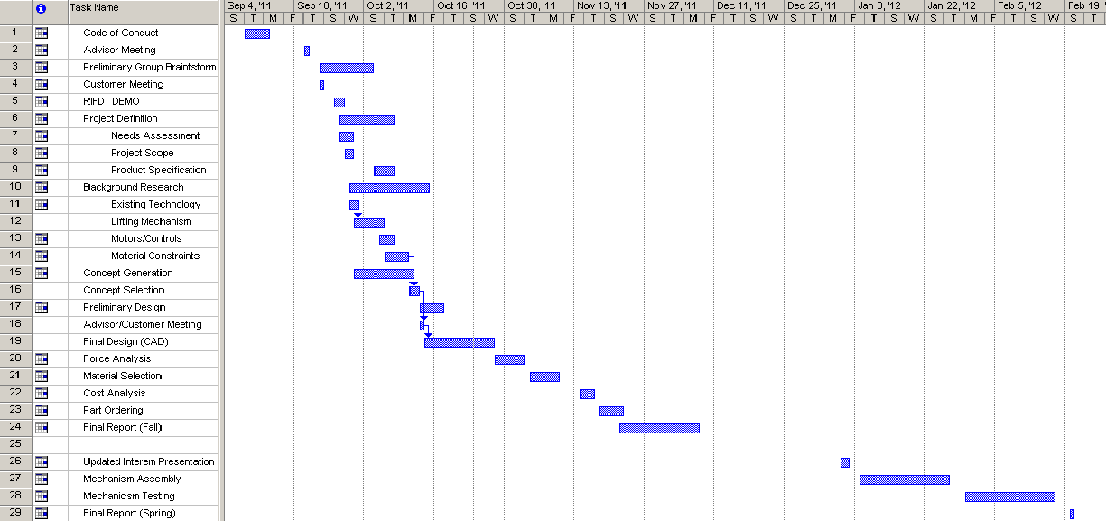

Figure 3-2: Project Timeline

- PROJECT CHARTER AND BUSINESS SUGNIFICANCE
4.1 PROJECT CHARTER
Deliver a fully automatic system that will safely and efficiently improve the RIDFT process.
4.1.1 BUSINESS CASE
Automation of RIDFT for the purpose of commercial production. This will enhance the products reputation and increase market share thus making the product more profitable for the sponsor.
4.1.2 OPPORTUNITY STATEMENT
As aspiring engineers we seek to improve and showcase our qualifications in the development of this automatic system. Through innovation, we seek to t reduce time and manpower needed to safely run the RIDFT process thus increasing the productivity and efficiency of carbon fiber composite materials and satisfying the needs of the customer.
4.1.3 GOAL STATEMENT
Use six sigma techniques to mechanize the RIDT.
4.1.4 PROJECT PLAN
Apply 6 Sigma methodologies to improve the operation of RIDFT process.
4.1.5 TEAM SELECTION
Teams were selected based on project requirements of the sponsor. As a result a team of six was selected. They are listed below.
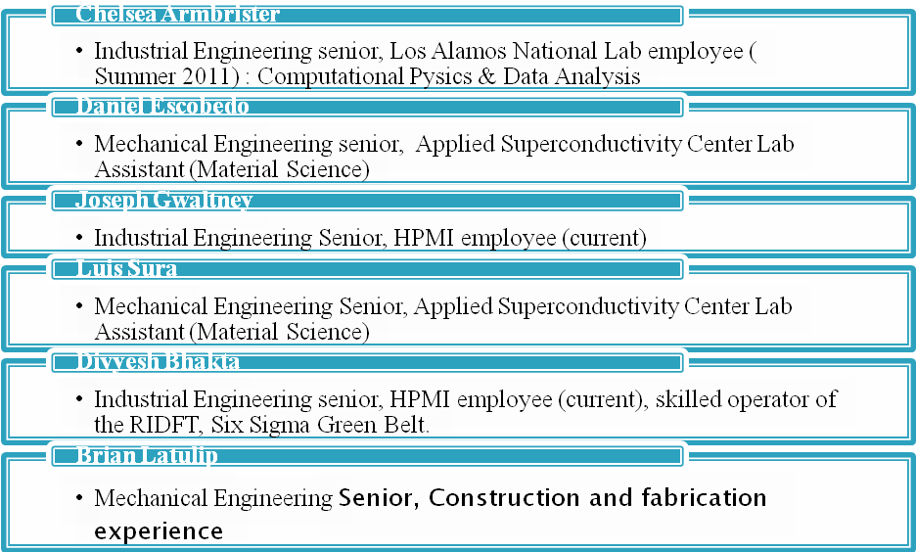
4.2 BUSINESS SIGNIFICANCE
Table 4-1 summarizes the implications of the RIDFT project from a business perspective.
Table 4-1: Threat Opportunity matrix for the RIDFT project.
 | THREATS | OPPORTUNITY
SHORT TERM | - Loss of charter  - Inability to automate  - Incorrect fiber placement | - Successful Automation  - Accurate Fiber placement  - Safe for operator  - Customer satisfaction
LONG TERM | - Customer loss  - Loss of team credibility  - Loss of time and resources  - Remains Unsafe for operator | - Customer retention  - RIDFT’s reputation enhanced.  - Increase Productivity of RIDFT  - Increase efficiency of RIDFT
- ANALYSIS OF CUSTOMER REQUIREMENTS
The project sponsor calls for an improved machine for Resin Infusion between Double Flexing Tooling that is innovative and commercially viable. This can be best described with a quality deployment function, voice of customer tree and fishbone diagram.
  - CRITICAL CUSTOMER REQUIREMENTS
As a team we had to identify potential causes of low productivity and safety concerns that are associated with the RIDFT process. We did this in the form of a fish bone diagram in Figure 5-1. As seen in figure, causes are summarized into four categories: Man, Machine, Material and Method.

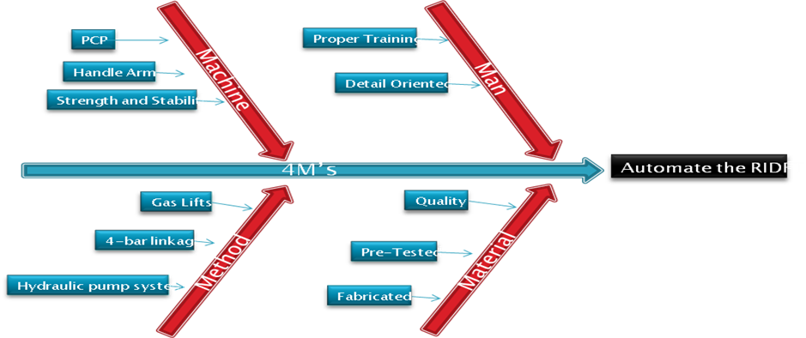

Figure 5-1: Fishbone diagram for automation of the RIDFT

  - MEETING CRITICAL CUSTOMER REQUIREMENTS
In order to meet customer requirements, the voice of the customer must be understood. This can be illustrated in figure 5-2. The customer also requires also have to be translated to company goals. In this case, we will compare customer requirements against technical requirements in a quality function deployment diagram. Refer to Figure 5-3.
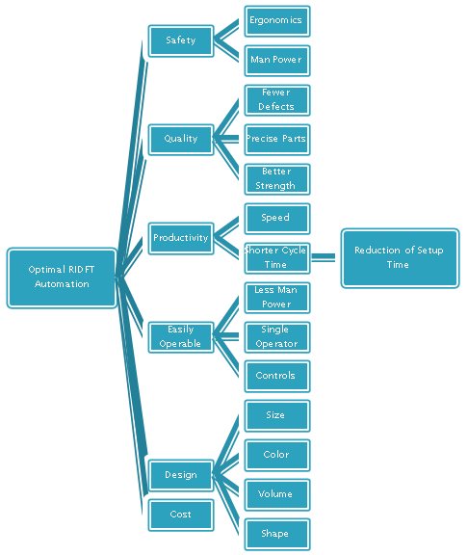
Figure 5-2: Voice of Customer tree
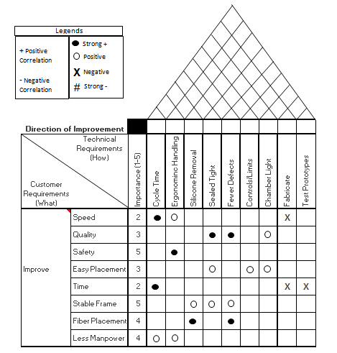
Figure 5-3: House of Quality Diagram
- CONCLUSION
The Florida State University High Performance Materials Institute’s Dr. Okenwa Okoli has developed a brilliant process that simplifies the production of composite material. However, the current process is time consuming and labor intensive. In acknowledgement of these issues and factors that surround them , it has been concluded that automation is the only apparent solution.
Now that the problem has been defined, the team will proceed to the next step in problem solution (measurement). With the information given by sponsor, we will shave production time and reduce the manpower required for use.

- REFERENCES
Augustine Ogom Nwabuzor. Develoipment of the RIDFT Process Incorporation of Ultraviolet Curing Technique (2004) < http://etd.lib.fsu.edu/theses/available/etd-04202004-035547/unrestricted/AugustineNwabuzorThesis.pdf>
Hrones, John Anthony., and George Larsen. Nelson. Analysis of the Four-bar Linkage Its Application to the Synthesis of Mechanisms. [Cambridge]: Published Jointly by the Technology of the Massachusetts Institute of Technology, and Wiley, New York, 1978. Print.
Okenwa Okoli Ph.D. Composites Cheap and Quick – Doing it the RIDFT Way < http://www.nsrp.org/Ship_Production_Panels/Ship_Design/downloads/090308_High_Performance_Materials.pdf>

