Needs Assessment/Project Scope

EML 4551C – Senior Design – Fall 2011 Deliverable

Team # 27

Chelsea Armbrister, Divyesh Bhakta, Daniel Escobedo, Joseph Gwaltney,
Brian LaTulip, Luis Sura
Department of Mechanical/Industrial and Manufacturing Engineering,
Florida State University, Tallahassee, FL

Project Sponsor
High Performance Materials Institute



Project Advisor(s)

Dr. Nicholas Bembridge
Dr. Peter N. Kalu
Department of Mechanical Engineering

Dr. Okenwa Okoli
Department of Industrial and Manufacturing Engineering

Reviewed by Advisor(s):
Needs Assessment
The Resin Infusion between Double Flexible Tooling (RIDFT) process decouples the infusion stage from the formed geometry, yielding simpler ‘flat’ resin flow. The issue with this process is that it is very labor intensive and time consuming. Specifically, the portion of the process where the two frames housing the silicon membranes are mounted and dismounted as well as replaced. Therefore, there is a need to automate this process in order to reduce and enable safe manpower utilization which includes a shorter processing time. The proposed project is to design an automated lift system with an appropriate ergonomic handling system, which can be retrofitted to the current RIDFT machines for each frame, providing desirable placement for optimal vacuum, disassembly and working space. In addition, a method in which to provide accurate fiber placement must also be developed.
Project Scope
Project Statement
The emphasis of this project is to design and implement an automated four bar linkage system that can be retrofitted to the current RIDFT machines that will stably, safely and accurately place the two aforementioned frames, in order to assure optimal vacuum, disassembly and working space. Moreover, this automated linkage system must have an ergonomic handling system. A methodology must also be developed and implemented to accurately place the fiber between the two silicon membranes.
Justification/Background
The demand for creating polymer composite materials has increased significantly over the years and has lead to the creation of many manufacturing processes. These processes include: (LCM) liquid composite molding, (RTM) Resin Transfer Molding, (VARTM) Vacuum Assisted Resin Transfer Molding, (SCRIMP) Seemann Composite Resin Infusion Molding Press, and (RIFT) Resign Infusion between Flexible Tooling. In this case, the procedure of interest is the RIDFT process.
The RIDFT produces an effortless even resin flow by decoupling the diffusion stage from the formed geometry thus significantly improving upon polymer manufacturing processes. The RIDFT’s sponsor is Dr. Okoli. He has selected a team of multidisciplinary engineering students to design and implement a system that will increase the efficiency of the machine thus improving the effectiveness of the operator and the safety of the operation. The team has been briefed on such requirements as conveyed by the sponsor and the decision to automate the RIDFT has been made.
The engineers have observed the various aspects of operating the RIDFT and targeted the necessary areas for improvement. Each individual will either observe or partake in the operation of the RIDFT. Currently, the machine is not designed for a single operator but rather requires the use of multiple operators or extended periods of use by a single operator. This delays the production process as well as introducing safety issues all of which the team seeks to resolve.
Objective
To automate the RIDFT process a motorized system will be designed. The ultimate goal is to design a method to lift and replace the large diaphragm frames and return them to their initial position. In addition to automating the plate removal and placement process we need to devise a method of locating the position of the fiber sheets. Other issues to overcome include ensuring the proper sealing of the diaphragms as well as ease of removal/replacement. It is our goal to make the process simple and fail proof to eliminate user error. To ensure the design is effective the six sigma process will be utilized.
Methodology
Using the six sigma methodology, this team will eliminate unnecessary operator tasks, allow for more accurate fiber placement and improve upon operation safety. In order to do this, there must be a clear understanding of the RIDFT process. There are six major steps to the RIDFT manufacturing process.
Step 1: Load the fiber into the machine.
Step 2: Secure the fiber properly into the machine.
Step 3: Infuse resin into machine until fibers are thoroughly wet using the vacuum process.
Step 4: Vacuum seal the two chambers so that the fiber is secured inside.
Step 5: Vacuum the resonated fibers so that the fibers are forming around the male mold piece.
Step 6: De-mold the part carefully.
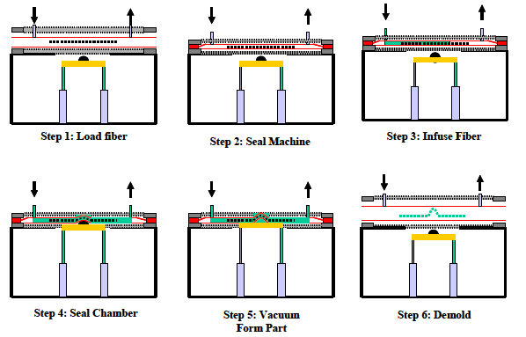
As illustrated by the process, it is seen that the operator is subjected to certain factors such as heavy lifting and replacement of the silicone sheets. The plan of action is to improve this process by constructing an automated motor driven system that will seal the chamber and de-mold the part with limited interaction between operator and machine.
Constraints
There are several constraints to consider when building an automated system. The motor-driven arm must be able to place the frames on the machine with even weight distribution. It must also be able to remove the frame when the molding process is complete with even weight distribution. There are also safety considerations as the sheets are heavy, cumbersome and not easy lifted by the operator. The new RIDFT automation system must be safe enough for only one machine operator. The machine operator should be able to produce more parts per day without an increase in labor costs. Fortunately, cost should not be a major constraint for this team. Despite previous attempts to automate, will not be referencing past endeavors, but will rather be starting a new automation processes. This may require new materials. The final constraint is time. We only have five months until our objective must be successfully completed.
Expected Results:
By the end of the senior design project a completed semi automatic resin infusion machine will be implemented and ready for use. It will be ergonomic for minimal operator effort and maximum comfort and safety while in use. The machine will consist of a motor driven gear system that raises the frames away from the mold chamber in a smooth and efficient manner. The product will be mobile for quick transportation, and will be kept down to a minimum weight. Simplicity throughout the design and operation will be among top priorities. The deliverables set in place by the group will help keep the project on track and will factor in possible roadblocks that will need to be worked out throughout the design, assembly, and completion aspect.

