**Automation of the RIDFT**

*Design Phase*

By

Divyesh Bhakta

Chelsea Armbrister

Brian LaTulip

Joseph Gwaltney

Daniel Escobedo

Luis Sura

|  |
| --- |
| A report submitted to  Dr. Okenwa Okoli  Industrial & Manufacturing Engineering Department  FAMU – FSU College of Engineering  Tallahassee, FL  March 1st 2012 |
|  |

|  |
| --- |
| This report is the fourth of five progress reports. The design phase is the fourth phase from the Six Sigma methodology of “Define, Measure, Analyze, Design and Validation”(DMADV). This phase is used to help create a design that meets our customers and businesses requirements. In this phase we will design the prototype and include simulations to optimize our design. |
|  |

Contents

1. Abstract 3

2. Introduction: 4

3. Investigation of Previous Concepts 5

4. Problem solving: The Trolley 6

4.1 Pugh Analysis 7

4.2 Generation of Components 8

4.2.1 Lifting and Lowering 8

4.2.2 Hook and Ratchet Concept 8

4.2.3 Hook and Ratchet Revised 10

4.2.4 Mounting and Dismounting 11

4.2. 5 Trolley Movement 11

5. Problem Solving: Expenditures 12

5.1 Material Selection 13

5.2 Vender Selection 14

6. Plan of Action 15

7. Conclusion 17

8. Reference 18

Table 1 : Comparison of Designs 5

Table 2 : Pugh Analysis 7

Table 3 : Vender Selection Criterion 15

Figure 1 : Final design off-center view 7

Figure 2 : Safety Mechanism 9

Figure 3 : Hook 10

Figure 4 : Wheel Sizing 12

Figure 5 : Pareto chart for old design 13

Figure 6 : Parteo Chart for Trolley Design 14

# Abstract

In this phase we will be designing the model to customer specifications. Our customer wants us to design a model that will semi-automate the RIDFT. The design we have in mind should be able to decrease operating manpower, decrease operating time, and increasing efficiency.

Based on our objectives, the most appropriate course of action at this point is to generate various concepts. These concepts will be explored, modified and reviewed. Following this, the solution that is most applicable to the problem will be chosen.

Our task is to chose the best concept for the RIDFT and design it so that it can simply be implemented next semester for the next team. This is the improve phase but it’s an update of our project because we are actively improving upon our ideas.

# Introduction:

Due to the changes in the scope of the project, the stages that are most relevant to the design must now be explored. The following stages are most relevant to this design project.

1. Discussion of design: an early statement of design goals
2. [Analysis](http://en.wikipedia.org/wiki/Analysis): analysis of current design goals
3. [Research](http://en.wikipedia.org/wiki/Research): investigation similar design solutions in the field or related topics
4. [Specification](http://en.wikipedia.org/wiki/Specification) : specifying requirements of a design solution for a product or service.
5. [Problem solving](http://en.wikipedia.org/wiki/Problem_solving): [conceptualizing](http://en.wikipedia.org/wiki/Conceptual) and [documenting](http://en.wikipedia.org/wiki/Document) design solutions
6. [Presentation](http://en.wikipedia.org/wiki/Presentation): presenting design solutions

At this point, project goals that have been identified, analyzed and specified in stages 1-3 can now be solved though conceptualization and documentation of design solutions.

# Investigation of Previous Concepts

Before ideas can be formed, similar designs must be reviewed and rated against project objectives. In doing this, past inaccuracies can be avoided. For example, the current RIDFT machine is manually operated which rates this design lower in terms of factors such as speed and safety. Below is a table that rates the quality of the actual, old and prospective design concepts.

|  |  |  |  |
| --- | --- | --- | --- |
| **Column1** | **Actual** | **Old Design** | **Trolley** |
| Speed | 4 | 6 | 9 |
| Quality | 5 | 7 | 7 |
| Safety | 2 | 5 | 9 |
| Simple Placement | 0 | 10 | 10 |
| Budget | 10 | 0 | 5 |
| Time | 4 | 6 | 8 |
| Stability | 3 | 8 | 9 |
| Fiber Placement | 0 | 4 | 6 |
| Man power | 2 | 7 | 8 |
| Ease of Assembly | 4 | 6 | 9 |

Table : Comparison of Designs

As seen in the table, the quality of the original, old, and trolley designs are rated on a scale of 1 – 10 as they pertain to technical objectives. Through investigations such as these areas of improvement are targeted and can be improved upon. For example, the ‘simple placement’ rating for the current RIDFT contains a low rating because the plates require manual lifting and alignment however, the rating is higher for the old design because it was automated.

# Problem solving: The Trolley

Through the utilization of tools similar to the decision matrix in Table 1, it is obvious that the Trolley design should be further investigated. In theory, this new design will be able to achieve all of our customers’ requirements while remaining below our $5,000 budget.

This design incorporates four hydraulic cylinders, two on each side of the portable trolley. Each cylinder will utilize the adjustable safety lock, found in the design above, and will be controlled through a two way solenoid switch valve that will dictate the vertical motion. The trolley system will be supported on six wheels, three for each side, with the middle wheel larger than the two exterior wheels for a wider range of motion. Moreover, the track mounted onto the wheels will have a “C” cross section in which wheels will be mounted in order to allow for easy mounting and dismounting. The entire trolley system will be maneuvered through a handle located at one of the ends of the trolley. In order to provide precise placement, an I-beam track will be installed to each side of the RIDFT as a guide for the trolley. To assure that the trolley will not move an L shaped foot latch will be installed at the bottom of the trolley, just as an added safety precaution. [1] [2] [3][6]

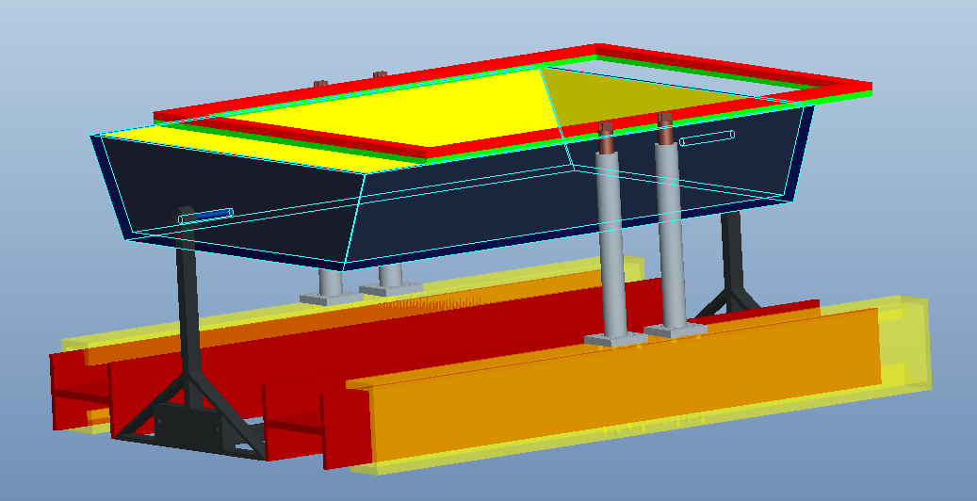

Figure : Final design off-center view

## 4.1 Pugh Analysis

|  |  |  |  |  |
| --- | --- | --- | --- | --- |
| **Pugh Analysis** | **Importance** | **Maintain Current RIDFT System** | **Build A New System** | **Integrate Trolley System** |
| **Speed** | **2** | S | D A T U M | S |
| **Quality** | **4** | S | S |
| **Safety** | **5** | - | + |
| **Easy Placement** | **3** | - | + |
| **Time** | **2** | + | - |
| **Stability** | **5** | - | + |
| **Fiber Placement** | **3** | - | + |
| **Manpower** | **4** | - | + |
| **Ease to Assemble** | **3** | + | - |
|  |  |  |  |  |
| **Sum of +** |  | 2 | D A T U M | 5 |
| **Sum of S** |  | 2 | 2 |
| **Sum of -** |  | 5 | 2 |
| **Weighted +** |  | 5 | 20 |
| **Weighted -** |  | 20 | 5 |
| **Ranking** |  | **-15** | **15** |

Table : Pugh Analysis

The Pugh Analysis table (Table 2) is like a Pros VS Cons table that is used to evaluate many options against each other. Ranking the criteria will help us focus on critical problems. This chart will show the positive and negative aspects of each creating a score system. This chart gives the team a holistic view of the needs vs. alternatives at hand.[4]

## 4.2 Generation of Components

In the design of the trolley, there are various design factors to be considered in the devising of its components. For example, safety is a primary decision factors thus the components that are relevant to the safety of the operator but be carefully assessed. The following functions of the trolley were reviewed and improved.

### 4.2.1 Lifting and Lowering

Lifting and lowering the mounting plates for the RIDFT machine is an essential process for the automation of the RIDFT. This process has to be stable and safe for operator use. A solution to this can be found in the review of the past design. In the past design, the use hydraulic cylinder for the vertical motion was mentioned. The same will be used for the trolley will be implemented.

Eight cylinders, four per frame, will be utilized due to the fact that angled motion is no longer desired. Instead, a linear up and down vertical motion will be used for simplicity. This also provides fewer loads on the total system.

### 4.2.2 Hook and Ratchet Concept

The hook and ratchet lift system for lifting and lowering the RIDFT plates will consist of framework similar to rungs on a ladder, parallel to each hydraulic cylinder (refer to figure 3 ). As the frames move upward, a hook will ratchet onto each “rung,” preventing the frames from crashing down on the operator. For visualization, the concept is similar to the safety mechanism used to lift and lower cares in auto repair shop lifts.

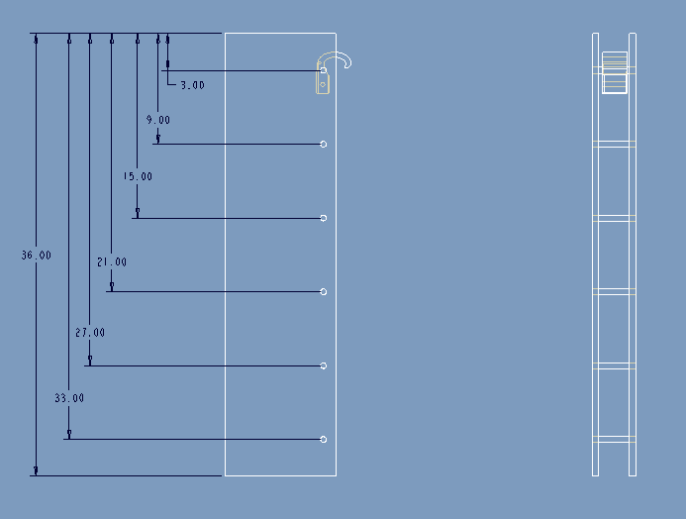

Figure : Safety Mechanism

In generating the lift concept, the downward motion proved difficult. Initially, the operator would have to manually insert a pin into each pinhole at critical heights along the frame’s structure. This would prevent the frames from crashing down on the operator. The problem with this concept arose with the realization that that operator would be placed in a potentially dangerous situation with the plates near his or her head, while then removing the pin, hole by hole, as the frames were being lowered. This led to the need for an overhaul of the downward safety measures.

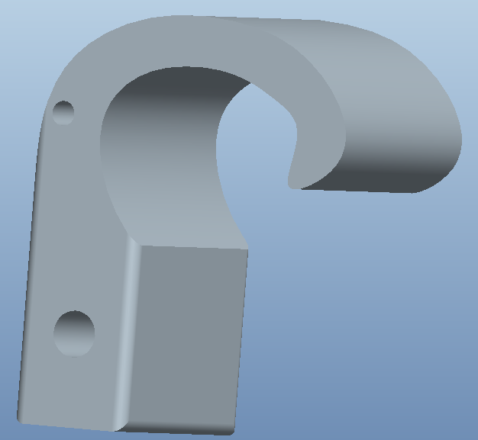

Figure : Hook

### 4.2.3 Hook and Ratchet Revised

To achieve both upward and downward motion that would be safe for the operator, it was decided that hook and ratchet system for the lifting motion required additional measures for the lowering motion. In order to lower the plates, the operator will now employ a hand lever similar to a bicycle to disengage safety hooks, while flipping another switch that allows downward motion for the frames. When the operator stops pushing the frame switch, the frames will stop moving. In the event that his or her hand slips from the brake lever, the hooks will automatically engage onto the rung system. This double preventative measure not only allow the operator to be far from placing their head under the frames while in motion, but also gives two additional forms of safety to prevent the frames from crashing down unexpectedly and causing serious bodily harm to the controller.

### 4.2.4 Mounting and Dismounting

The mounting system for the plates, for the most part is predetermined by the connection outlet found on every hydraulic cylinder. This outlet forms a flattened “U-shape” that supports a cylindrical draw pin which is used to secure any connecting piece to the hydraulic ram. The proposed solution for the mounting of the current aluminum frames that support the silicon membranes onto the hydraulic rams is to weld rectangular aluminum tabs at each hydraulic ram location along the edge of the thicker side of the plates.

On each of these tabs, there will be a welded male equivalent piece to the aforementioned U shape that will fit snuggly. This snug fit will allow for little to no pivot motion. Once these metal tabs with the male U-shaped connectors are fitted to both plates the mounting and dismounting of the plates should be unproblematic as the operator only has to pull or insert the cylindrical draw pins found in the U-shaped connection slot on the top of the hydraulic ram for assembly and disassembly.

### 4.2. 5 Trolley Movement

In order for the Trolley design to function properly a method for relocation and adjustment is required. To properly align the Trolley with the RIDFT, Caster wheels will be placed at all four corners with two rigid wheels mounted midway lengthwise. The middle wheels are slightly larger diameter and rigid to reduce the vehicles turning radius. The height difference creates a teetering effect which will allow the front most wheels to mount on the I-beams.

The material selection for the wheels is limited by manufacturer availability. All six wheels must be made of highly durable rubber and feature hardened ball bearings. The wheel hub connecting the wheel to the base of the trolley must be a durable metal capable of withstanding high compressive and torsional stress.

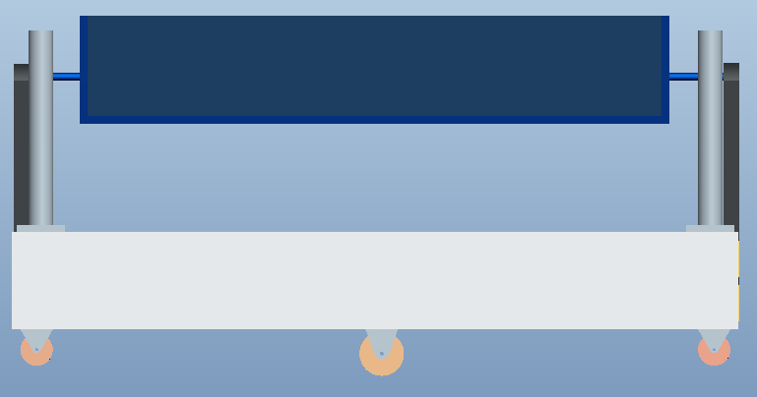

Figure : Wheel Sizing

# Problem Solving: Expenditures

The allotted budget is $3000-$5000, as redefined by the customer. The materials needed for the final design should be able to be completed with a total cost just under $4000. The most expensive component is the amount of bulk metal needed to complete the framework of the system, totaling over $1900 for various Aluminum rods, sheets, and I beams.

The hydraulic system, which consists of eight cylinders, solenoid valves, and a control unit, account for about $1500 of the budget. Both aspects are crucial for the design, and could not be made with cheaper materials. The remaining $1000 will be allocated for machining costs, which will be calculated once the entire design is finalized.

## 5.1 Material Selection

Materials needed for the Trolley design have not yet entirely be selected as some of the design aspects are currently under review. Estimates of materials however have to be considered in order to stay within budget constraints. In order to this, the quantity of materials needed is measured against estimated cost. This is done through the use of Pareto charts of the old design and the estimated materials needed for trolley concept. [5]

Figure : Pareto chart for old design

The left vertical represents the cost of the materials. The right vertical axis is the cumulative percentage of the total cost Notice that the parts are in decreasing order. Because of this, the cumulative function is a [concave function](http://en.wikipedia.org/wiki/Concave_function). In order to lower the cost of parts by 80%, it is sufficient to eliminate or re evaluate the Spur Gear, Pinion, Drive Shaft and Dc Motor (first four items). Figure 2 represents the Pareto chart for the trolley design.

The purpose of the Pareto chart is to highlight the most important among a (typically large) set of factors. In [quality control](http://en.wikipedia.org/wiki/Quality_control), it often represents the most common sources of defects, the highest occurring type of defect, or the most frequent reasons for customer complaints, and so on. Wilkinson (2006) devised an algorithm for producing statistically-based acceptance limits (similar to confidence intervals) for each bar in the Pareto chart.

Figure : Parteo Chart for Trolley Design

## 5.2 Vender Selection

Vender selection is another critical aspect in determining the overall cost of the design. The objective in this case, would be to successfully produce low cost high quality materials needed for the assembly of the trolley. Vender selection can be complex as a variety of criterions must be measured. Below is a vender selection criterion table that will be used to select vendors for the materials used in the automation of the RIDFT.

|  |  |  |  |
| --- | --- | --- | --- |
| Rank | Factor | Mean Rating | Evaluation |
| 1 | Quality | 3.5 | Incredibly Important |
| 2 | Price | 3.48 | Incredibly Important |
| 3 | Delivery | 3.45 | Incredibly Important |
| 4 | History of Performance | 2.998 | Incredibly Important |
| 5 | Warranties /Claim Policies | 2.84 | Incredibly Important |
| 6 | Production Facilities | 2.77 | Important |
| 7 | Desire for Customers | 2.65 | Important |
| 8 | Technical capability | 2.54 | Important |
| 9 | Procedural Compliance | 2.48 | Important |
| 10 | Location | 2.35 | Fairly Important |
| 11 | Reputation | 2.22 | Fairly Important |

Table : Vender Selection Criterion

For example, McMaster Carr is an expected vendor based on criteria such as shipping time, availability of various components needed, and material quality.

# Plan of Action

In this phase of design it is important to implement time constraints for solving the problem given. This can be done by forming a plan in which all necessary materials and documents are completed within the allotted time.

**Project = Time X Scope X Cost X Quality**

A time line has been produced for the duration of the design process in Figure 3.

|  |  |  |  |  |  |  |  |  |  |  |  |  |
| --- | --- | --- | --- | --- | --- | --- | --- | --- | --- | --- | --- | --- |
| |  |  |  |  |  |  | | --- | --- | --- | --- | --- | --- | | Improve Report |  | Material / Stress Analysis |  | ME Walkthrough/Report/Webpage/Operations Manual |  | | **March 1** |  | **March 19 – 23** |  | **April 3 – 5** |  | |
| http://www.teach-nology.com/web_tools/materials/timeline/line.gif |
| |  |  |  |  |  |  | | --- | --- | --- | --- | --- | --- | |  | **March 12 – 16** |  | **March 26 – 29** |  | **April 10 – 12** | |  | Bill of Materials / Cost Analysis |  | Control Phase Paper And Presentation/CAD Finalized |  | Final Presentation/Assembly Manual/Final Paper | |

**Figure 3: Project Timeline**

# Conclusion

In this report, various concepts were generated, explored and modified. These ideas were expressed in detail. At this juncture, concept exploration is imperative as the final design will be reviewed and subsequently implemented by a future team of aspiring engineers.

With this said, the design process is ongoing thus there are still aspects of the design that need to be adjusted before a final design is organized. The concepts that were generated are based on the objectives of the project. The objectives will ultimately aid in the completion of the task which is the automation of the RIDFT.

# Reference

[1]

<https://by2prd0510.outlook.com/owa/redir.aspx?C=Alz1SIzFEkKtvMLZ2wUWCsJbNbhVy84IPFisF7uL8syOkpTqbpZK7PWG999LoOIGKBmsW1ROWUE.&URL=http%3a%2f%2fgrabcad.us2.list-manage.com%2ftrack%2fclick%3fu%3d605fd44bf90e91bf54858ea5f%26id%3db63bf3e87d%26e%3d1fd95a51e4>

[2]

"Car Lift Safety Features." *Car Lift Safety*. Web. 16 Mar. 2012. <http://www.bendpak.com/best-car-lift-guide/car-lift-safety/>.

[3]

*HowStuffWorks*. Web. 16 Mar. 2012. <http://science.howstuffworks.com/transport/engines-equipment/hydraulic1.htm>.

[4]

Powerpoints given on Senior Design Class IE on Improve Phase

[5]

"Pareto Chart." *Wikipedia*. Wikimedia Foundation, 03 Nov. 2012. Web. 16 Mar. 2012. <http://en.wikipedia.org/wiki/Pareto_chart>.

[6]

<http://grabcad.com/library/sovella-table-06-updated-01-07-12?utm_source=GrabCAD+engineers&utm_campaign=ed1c696ac2-GrabCAD_Insider&utm_medium=email>