**Verify Phase for Automated Palm Pruner**

Spring 2011 – March 27, 2012

Submitted By:

Obie Abakporo

Bill Carpenter

William Craig

Juan Antonio Rojas

Christopher Xavier Smith

Sarah Trayner

*Dr. Okenwa Okoli*

*Industrial and Manufacturing Engineering Department*

*FAMU – FSU College of Engineering*

Table of Contents

Introduction 3

Requirements 4

Sponsor 4

Business 4

King Climber Product Design 6

King Climber Interactions 9

Human Interaction 9

King Climber’s Response to Human Command 10

Tool Selection 13

Gantt Chart 13

Parts and Assembly Process Chart 14

Pilot Testing 15

Obstacles Encountered 17

External 17

Internal 17

Cost Analysis 20

Machine Aspect 20

Human Labor Aspect 21

Breaking Even 23

Conclusion 26

Appendix 27

# Introduction

The goal of our project is to develop a computer-integrated robot that will be able to climb a 60 ft. oil palm and harvest the fruits efficiently and economically. For this process, we are utilizing DMADV, also known as Define, Measure, Analyze, Design, and Verify. DMADV is utilized when a product or process is not in existence and needs to be developed. The product that we are creating is a semi-autonomous palm pruner aimed at minimizing the amount of work completed by the worker, as well as, improving the overall process safety. We are on the last phase of this process methodology, known as verify. In the previous phase, we designed, developed, and chose the best cutting arm for the King Climber. We were able to accomplish this by implementing various tools such as: the critical customer requirements chart, the Pugh Matrix, and the Evaluation Matrix. These can be referenced in the Appendix.

The main goal of this phase is to analyze and verify all aspects of the King Climber design in order to ensure that the production process and the design are completely compatible. This can be accomplished by double checking calculations, updating and finalizing the cost analysis, as well as testing our product via pilot runs. However, if our product does not check out, we must identify potential solutions to find better ways to accomplish the end result.

This phase is most crucial in that it could make or break a project. If all aspects of the King Climber check out, the product will be handed over to our sponsor to utilize.

# Requirements

## Sponsor

As stated in previous phases, the main goal of our project is to ultimately satisfy our sponsor. Therefore, we must take initiative to implement our sponsors needs and wants into the development and fabrication of the oil palm pruner. To ensure that we meet these needs and requirements, we have maintained constant communication with our sponsor via meetings and emails. Some qualities that our sponsor deemed necessary include that it must be cost effective, rely on minimal manpower, and be time efficient. The palm pruner must possess all of these qualities, but also take into account the close proximity and height of the palms, the damage that could occur to the palm from the semi-autonomous robot, the labor difficulty, as well as the overall safety of the operator. This information was obtained from the initial define phase via house of quality, voice of the customer, and the overall analysis of the customer requirements.

## Business

The success of our semi-autonomous robot depends on its ability to meet product development targets. By taking a business approach on this product, we can meet the demands of both customer and market, as well as, our product and process requirements. Due to increasing labor costs and a continuous decrease in the seasonal workforce, we believe that the King Climber would be a valuable asset to plantation owners or administrators. The semiautonomous robot would replace the declining workforce and allow for a constant rate of fruit palms to be harvested. This is an enormous advantage in that the average person can only harvest 2 to 3 fruit bunches per hour and faces exhaustion throughout the entire task.

Revenue will be achieved via successful selling of the King Climber machines. However, initial costs will be more expensive than future costs due to the fact that we are not purchasing parts and materials in bulk. Once the prototype has been properly tested, we will be able to consider a large scale production. Having a large scale production would mean that we will save money by ordering large quantities of exact parts needed to fabricate the palm pruner. As a result, this will lead to a constant influx of revenue as well as a decrease in the overall fabrication time. Completions of this verify phase will ensure that our prototype works and that we have met the needs of our sponsor and our target market.

# King Climber Product Design

The King Climber concept design was designed and chosen in the measure phase via various tools. Basically, the semi-autonomous robot will climb up and down the palm tree in an inch worm fashion and cut down the palm fruits utilizing a cutting arm. Visualization of the actual cutting will be achieved through the use of a detachable remote controlled camera. The camera will be placed on the mainframe of the palm pruner respective of the area to be cut. This will ensure that the fruits will be extracted from the palm effectively and efficiently.

Our King Climber concept design consists of five major components. These are depicted on the next page in Figure 1. Keep in mind that this Pro-Engineer image excludes the cutting arm. From top to bottom, the upper frame consists of a circular track for the manipulator arm followed by four guiding rods secured to each corner of the lower frame. The guiding rods allow for alignment of the two top and bottom frames. Another major component is the upper frame. The main purpose of the upper frame is to guide the device up and down the palm tree. Moving downwards, vertical actuators are placed on the adjacent side of the hinges along the centerline of the frame. This allows the entire device to be lifted upwards. Finally, the last major component in this design consists of multiple thick horizontal rods placed into the square frame. They are placed into the square frame via grappling plates attached to the horizontal actuators. This is the force that keeps the semiautonomous robot attached to the palm tree. Analysis of the design completed in the measure phase can be referenced in the Appendix. This section provides more information on the Pro-Engineer model and utilizes Finite Element Analysis to portray various loads and stresses on the semi-autonomous robot.

**Figure 1: Pro-E Model for King Climber**

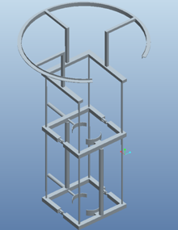

5

4

3

2

1

|  |  |
| --- | --- |
| Part # | Description |
| 1 | Circular track |
| 2 | Guiding rods |
| 3 | Upper frame |
| 4 | Vertical actuators |
| 5 | Square frame |

Found on the next page, Figure 2 portrays the cutting arm concept design chosen for the King Climber. Analysis of the cutting arm can be found in the Appendix. The cutting arm is able to function by using a DC motor coupled with a large circular saw blade attached to a square tube shaft. The saw blade will travel around the tree by use of castor wheels located on the circular track. One of these castor wheels will be powered by a geared DC motor. The shaft will be able to extend, retract, and rotate to maneuver the blade into the optimal cutting position. Based on the user’s preference, the camera can be mounted on either the cutter shaft or the aluminum housing. Due to the existing time constraint, the cutting arm will not be fabricated by our projected deadline. This will be a continued project for next year’s senior design team.

**Figure 2: Cutting Arm Concept**

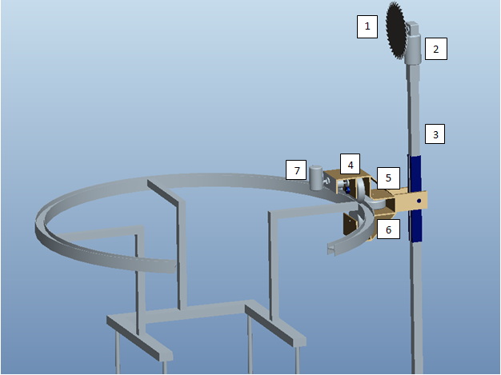

|  |  |
| --- | --- |
| Part # | Description |
| 1 | 8.25” Saw Blade |
| 2 | DC Saw Motor |
| 3 | Al. Shaft |
| 4 | Geared DC Motor |
| 5 | Castor Wheels |
| 6 | Al. Housing |
| 7 | Camera |

# King Climber Interactions

There are various functions and actions involved in operating the King Climber. This section is provided to descriptively layout each process. These processes can be broken down into two main categories: 1) Human Interaction with the King Climber and 2) King Climber’s Response to Human Command. Each category will be broken down into the procedural steps necessary to accomplish the task of harvesting the oil palm tree’s fruit. These process requirements will aid in the understanding of the overall concept of the King Climber. We will begin with Human Interaction.

## Human Interaction

1. **Transportation of the King Climber and components (generator, remote controller, etc) to site.**

This involves the most physical portion of the operation for the human. The device will have to be carried to the plantation and set up for installation.

1. **Attach King Climber to tree.**

Attach device to the base of the tree by the four v-shaped grapplers (two at the top and two at the bottom).

1. **Set up connections.**

Make sure all of the proper connections are made between the King Climber and its components.

1. Verify generator is running and King Climber is getting power by checking if the power indicator light is on.
2. Verify camera is powered up and is working properly
3. Verify remote is connected and cutter device is functioning properly.
4. **Double Check Connections.**

Verify all of the components and electrical feeds are installed and attached properly.For example, make sure the grapplers are secured to the tree trunk.

1. **Attach Cutting Track.**

Place cutting track onto guiding rods.

1. **Start Ascension.**

Push the “climb up” button to initiate the robot’s systematic ascension up the tree. This will start the process.

1. **Fruit Harvesting.**

Once the robot has reached the top of the tree, use the remote controller to maneuver the camera and cutter arm to remove the desired fruit from the tree.

1. **Start Descent.**

Push the “climb down” button to initiate the robot’s systematic descent down the tree. This will end the process.

1. **Detach King Climber.**

Remove the device from the trunk of the tree. Move to the next tree and repeat steps 3-7.

Obviously, the most crucial functions are carried out by the device itself due to the autonomous nature of the King Climber. As a result, this is where the focus of the procedure will reside. The following will describe the King Climber’s response to human command.

## King Climber’s Response to Human Command

1. **Establish all Connections.**

Connect all of the components appropriately. For example, make sure that the remote is effectively sending signals to the camera and control arm before the climber begins ascent.

1. **User Presses “Climb up” Button.**

Once the “climb up” button is pressed by the user, the King Climber springs into action. This starts the climbing process.

1. **Ascension.**

The King Climber will begin climbing by completing a sequence that will be repeated (looped, in programming code) until the desired distance is traveled along the tree. This is accomplished by the top two grappler arms releasing their grasp and then retracting in the same fashion as the top two did previously. Now, the support arms will also retract, bringing the bottom grappling arms upwards toward the rest of the machine resulting in the original position (in regards to proximity from the top two grappling arms), but just further up the tree. Now, the bottom grappler arms extend and re-establish a secure grip on the tree trunk. These motions will be reoccurring until the King Climber arrives at the top of the tree. (No human interaction involved for the duration of this step)

1. **Fruits of our Labor.**

Now that the King Climber is at the top of the tree the operator must command the device to remove the fruit from the tree through remote communication. The camera will be mounted on the cutter (manipulator) arm, which revolves around the circular cutting track. The user will maneuver the camera to view the fruits to harvest and push the “harvest” button to begin the cutting of each bushel of fruit from the tree.

1. **Cutting the Fruit.**

Once the “harvest” button is pushed, the cutting tool will start spinning in the manner of a circular saw blade and gradually separate the fruit from the tree.

1. **Descent.**

Now that the desired fruit is cut from the oil palm tree it is now time to climb down the tree. Once the user presses the “Climb down” button, the King Climber will begin its descent of the tree in essentially the same manner that it did during the ascent process. The only difference is that instead of the top two grappling arms retracting and releasing first, they will follow the motion of the bottom two grappling arms. In other words, the bottom grapplers will release, retract, and the support arms will extend downwards first, while the top grappler arms remain secured to the trunk of the tree. Then, the grasp of the bottom two grapplers will be re-established and the top two grapplers willthen release, retract, and follow the support arms down, then re-establish a secure grasp on the tree themselves. This will be repeated until the device reaches the base of the tree again. (No human interaction involved for the duration of this step)

1. **Turn off Power.**

Shut down all electrical components before removing and transporting device from tree to tree.

1. **Detach King Climber.**

Remove the device from the trunk of the tree. Move to the next tree and repeat steps 2-7.

# Tool Selection

Throughout this project, we have utilized various tools in order to aid in the fabrication of the King Climber. Tools include, but are not limited to, a comprehensive Gantt chart, a process chart, a thorough cost analysis, as well as, prototype pilot testing. These tools allow us to analyze various process operations, as well as, aid in the development of our semi-autonomous robot.

## Gantt Chart

The use of a Gantt chart is crucial for every project because it allows for the planning and management of various tasks. By referencing our Gantt chart, we can monitor the achievement of project goals, as well as, see if we are up to date on all of our deadlines. According to our Gantt chart in Figure 3, we are approximately 3 days behind our goal of testing our prototype. This is due to the fact that we have encountered numerous obstacles, which will be discussed in the obstacles encountered section. A complete Gantt chart can be found in the Appendix.

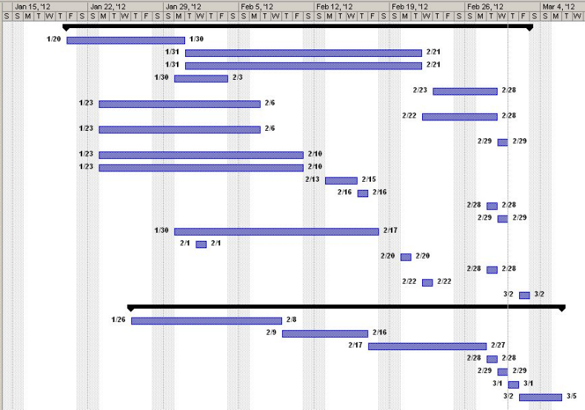**Figure 3: Gantt chart**

## Parts and Assembly Process Chart

Below, Chart 1 describes the specific parts and individual assembly processes needed to complete the fabrication of the King Climber. In order to accurately verify the function and use of each part, we have consistently utilized the help of our advisors. This is beneficial for us in that it will allow us to complete this project in the most efficient manner.

**Chart 1: Parts and Assembly Process**

|  |  |  |  |
| --- | --- | --- | --- |
| **Part** | **Assembly Location & Description** | **Testing Process** | **Advisors** |
| Actuators | Both horizontal and vertical actuators will be connected to the frame of the King Climber by attaching them to mounting brackets and then, drilling them to the frame.  This will be done in HPMI. | Brought to the electrical lab and connected to a variable power source to verify proper functionality. | Dr. Chuy: *Assistant Scholar Scientist (ME)*  Mr. Ford: *COE* *Electrical Specialist (EE/CE)* |
| Frame | The frame will be constructed out of aluminum tubing and cut into proper lengths for construction.  This will be done in the COE Machine Shop. | We performed the proper stress calculations and verified material properties. | Jeremy: *COE Machine Shop Lead Specialist*  Jerry Horne: *Machine Shop Specialist (HPMI)* |
| Circular Cutting Track | Material partitioned and effectively welded (as well as bended) to form the desired semi circular shape of the cutting track.  This will be done at Kelly’s Sheet Metal Inc. | N/A | Dr. Kosaraju: *Adjunct Faculty (ME)*  Jerry Horne: *Machine Shop Specialist (HPMI)*  Dr. Hovsapian: *Adjunct Faculty (ME)* |
| Guiding Rods | Connected to the frame via mounting brackets, actuators, and then, drilling to frame.  This will be done at HPMI. | We performed the proper stress calculations and verified material properties. | Jerry Horne: *Machine Shop Specialist (HPMI)* |
| Microcontrollers | Will be wired to the King Climber.  This will be done in HPMI and ME Megatronics Lab | Created circuit schematics and wiring diagrams with assistance from Dr. Chuy in the ME Megatronics Lab. | Dr. Chuy: *Assistant Scholar Scientist (ME)* |
| Cutting Mechanism | Will be attached to the circular track and have mobility along the circular track via wheeled mounts.  This will be done in HPMI and COE Machine Shop. | N/A | Dr. Kosaraju: *Adjunct Faculty (ME)*  Jerry Horne: *Machine Shop Specialist (HPMI)*  Dr. Hovsapian: *Adjunct Faculty (ME)*  Dr. Shih: *Professor (ME)* |

## Pilot Testing

Pilot testing is a small scale preliminary study done to improve upon the study design before a full scale implementation of the project. It is essentially the first look as to how the product will function. This step is crucial because it provides valuable insight as to how the product will turn out. If problems due result, it allows for necessary changes or implementations that must be made to the prototype. The prototype that we will be testing is the King Climber.

Not only will pilot testing show any indiscretions, it will also give us a necessary performance result. These results will help us gage how effective the King Climber will be in the business world. The results produced from this, will be compared to current methods in order to accurately understand the effectiveness of the product. Unfortunately, as mentioned earlier, we are slightly behind schedule, approximately 3 days. The pilot testing will take place on the March 29th and 30th . Since oil palms are not native to our location, we will select a tree that is similar. The King Climber will be attached to the base of the selected oil palm and will climb to the top. All actions of the King Climber will be noted and monitored, including the set up time, the actual climb time, and the break down time. This will provide a rough estimate of the total time the product requires in order to complete the task of climbing the oil palm. Also, keep in mind, the actual cutting process of the fruit palms is not included in this pilot test due to the time constraint. The main goal of this pilot test is to make sure that the King Climber can ascend and descend the palm tree in a safe, timely manner.

# 

# Obstacles Encountered

We encountered both external and internal obstacles involving the fabrication of the original King Climber prototype. External obstacles were due to the actual obtaining and fabricating of materials from third parties and internal obstacles were due to multiple disagreements among team members. The causes for these disagreements were rooted in the team members’ lack of knowledge for other engineering disciplines, i.e. electrical engineering.

## External

Two major external obstacles encountered involved the Kottler Metal Company, as well, as the use of various machine shops here at the college of engineering. Our first major concern was the fabrication of the circular metal track. The original plan was to obtain a straight H track of aluminum and have it bent into a semi circle. From research we found that local companies could not accomplish this task, however, we found that the Kottler Metal Company could bend the five foot semi circular track of aluminum. Our mechanical lead sent email after email to the Kottler Metal Company, but this proved futile because he never received a response. Later, we found that calling the company multiple times was the better way to contact them. In the end, we did not choose to utilize this company because they consistently gave vague quotes regarding costs, time durations, etc. Due to our existing time constraint, we had to choose the more costly method of ring construction in order to make up for the wasted time attempted at building a relationship with Kottler Metal. For this, we utilized the machine shop at the college of engineering. While the requested work was completely corrected, it was never completed in a timely manner. As a result, we had to consistently follow up on a daily basis to ensure the completion of our parts.

## Internal

Our team encountered internal problems due to the existing lack of knowledge involving electronic applications. Our team is composed of three industrial engineers and three mechanical engineers. The industrial engineers are highly efficient at the commercial side of things, budgeting, work flow, progress reports, process/cost analysis, etc, and the mechanical engineers are outstanding at actual designing, fabricating, constructing, and materials researching. However, we realized that even having this combined knowledge between both disciplines; we lack knowledge on the electronics and coding aspect of the King Climber. Incorporating an electrical engineer would have bridged the existing knowledge gap.

The electrical aspect has continuously played a major role in the building of our prototype. From the onset of the project, we have underestimated the scope and complexity of the electrical parts. We knew that actuators used 12V DC power and through the use of energy analysis, we found that the actual climbing process requires approximately less than 1000 Watts. Similarly, we researched that our prototype would require a micro-controller, known as a dragon board, as well as a motor driver for each actuator. Operation of the dragon board would not be a problem due to the constant communication with Dr. Chuy. Immediately after Christmas break, we ran into our first electronics problem. The generator that we had selected for the outputted DC power was insufficient to run the actuators. This is because, the generator needed to draw a full 600 watts from the DC output. Our solution was to find two unique and very specific power supplies to run the actuators. These could only be purchased from a company based in Oregon. As a result, the company would have to be put into the university purchase order system which would be a timely process. In order to solve this problem, we made a special request with our project sponsor to purchase these specific power supplies on a personal credit card in order to avoid the month delay by going through the university purchasing protocol. After we received the power supplies, we began the initial testing of the actuators and motor drivers in order to obtain necessary voltages and amperages at various points in the circuit. After this, we started the code for the input commands of the switches. Soon after, we ran into yet another problem. This time, it involved the code for the micro controller using Pulse Width Modulation, also known as PWM. The motor drivers that we had ordered, specifically stated, "Designed using a motor controller and Pulse Width Modulation (PWM) you are able to control the speed of your actuator in either direction." However, after testing, we found that it would not accept PWM signals from the micro-controller. This was a problem because this meant that we could not run the code in a semi-autonomous manner. PWM was actually referring to a physical knob on the motor controller that internally used PWM to adjust speed. Through a phone call, we confirmed with the supplier that there was no way to wire the motor controller to accept PWM from our micro-controller. The solution to this was to order 8 electromechanical switches to control the motor controllers from our micro-controller. These switches should be the last issue we encounter.

# Cost Analysis

## Machine Aspect

Using a bill of materials is essential for any business, and for building any product. For this verify phase, new expenditures have been added. All are based on the electronic aspect of our machine and come from the same vendor, McMaster Carr. Total expenditures regarding necessary materials can be found in the Appendix. Like in the previous design phase, some parts may or may not include the fabrication and assembly fee. From the updated bill of materials, we created and calculated a new future worth value of our innovative product. The flow chart can be found in Figure 4. A 500% mark-up percentage is still being used because it was one of our sponsor’s requirements for the actual selling price of the product. Also, using a five-year span cash flow diagram did an accurate comparison between human labor cost and machine cost. The cash flow diagram can be found in Figure 4. For the machine aspect, the new selling price for the King Climber should be approximately $13,042.32and the future value to be approximately $\$339,100.32$.

*Selling Price**=**Total Cost (1 + Mark-Up Percent)*

*=* $2,173.72*(1+5)*

*= $13,042.32*

$Future Value=PV (1+rt$*)*

$FV=\$13,042.32(1+(5)(5)$*)*

$$FV=\$339,100.32$$

**Figure 4: Present/Future Flow Chart**

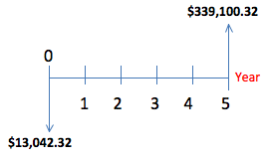

As expected, the future value increased again in this verify phase. The increase in future value is a projection of the increase in selling price. To be precise, the selling price increased from $11,617.62 to $13,042.32 and the future value increased $302,058.12 to $339,100.32. The selling price is higher because we are adding the electronic kit, including seven new products that will make the King Climber work as we expected to. The cutting tool is the only missing product that will increase the cost and selling price of our prototype.

## Human Labor Aspect

From Chart 2 below, we were able to describe a real life situation that we have been using since the analyze phase. The situation is based on an oil palm farm employing 16 palm pruners who can each harvest eight oil palm trees a day cutting approximately five bunches per tree. This results in approximately a salary of $80.00 per day at $2.00 per bunch cut. This may not seem as an expensive cost; however, when compared to the actual application of the King Climber to existing oil palms, results show an increase in potential profit. An increase in profit can be seen, since in this real life situation costs of health care are neglected, and with the use of the King Climber they will be reduced or eliminated. The cost to employ 16 palm pruners is approximately $307,200.00. From this, we can calculate a future worth cash flow diagram based on a five-year period utilizing a 5% interest rate. Figure 5 shows the resulting cash flow diagram. The future worth value for labor we obtained was of $384,000.

**Chart 2: Summary of Process Times**

|  |  |  |
| --- | --- | --- |
| **Time** (**in minutes)** | **Process** | |
| **Machine** | **Human** |
| **Climb** | 13.5 | 10 |
| **Cut** | < 5 per bunch | 1 per bunch |
| **Descend** | 13.5 | 10 |
| **Unhook** | 5 | 10 |
| **Transport** | 2 | < 1 |
| **Setup** | 5 | 10 |
| **Total** | 44 | 42 |

$$FV=PV \left(1+rt\right)$$

$$FV=\$307,200\left(1+(0.05)(5)\right)$$

$FV=\$384,000$

**Figure 5: Present/Future Flow Chart**

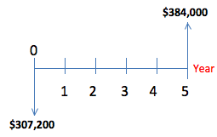

## Breaking Even

Based on the updated information above, a new break even chart can be created. An oil palm farm utilizes 8 King Climber palm pruners can be expected to collect approximately 39.744 metric ton of palm oil, 12.096 metric ton of kernel oil, and 120.96 metric ton of kernel cake. So, if one metric ton of oil palm costs $1,020.54, one metric ton of kernel oil costs $1,366.00 and one metric ton of kernel cake costs $175.00, an oil palm farm will make approximately $939,017.73 in a year [2,3,4]. Because only 2 operators are needed for each King Climber, the cost for labor will be approximately $307,200.00 per year. Figure 4, below, portrays a break even chart for potential plantation owners who invest in purchasing 8 King Climber palm pruners. This break even chart shows that plantation owners will break even before the 1st month of operation. Keep in mind, there is a fixed labor cost of $25,600 per month.

**Figure 4: Break Even for Palm Farms Purchase of Machine**

We have also included a break even chart to show how many King Climber machines must be purchased in order to start obtaining profit. Company X is renting a facility found in a third world country where every meter square of construction costs $1500.00. Assuming that this facility is 750m2, the construction of this facility is $1,125,000.00 and it is being rented at 1% a month. This means that Company X is spending $11,250.00 a month in rent. Other expenditures include: $350 electricity, $100 phone plan, $200 cell phone plan, $70 water usage, $400 gas usage, $600 per employee, $600 per secretary, and $1,500. Company X makes use of 8 employees and 1 secretary. So, according to all these costs the fixed cost of operation per month is $19,270.

Our break even chart found on the next page, in Figure 5, shows that if Company X sells 18 King Climber palm pruners for $13,042.32 costing approximately $2,173.72 each, the company can break even at 2 King Climber palm pruners. As a result, the break even chart suggests that Company X will earn approximately $234,761.76 in sales with a fixed cost of $19,270. This is accomplished by assuming a contribution margin of $10,869.

**Figure 5: Break Even for Selling Machine**

# Conclusion

The DMADV (define, measure, analyze, design, and verify) six sigma methodology has been extremely useful in the development and fabrication of the King Climber prototype. DMADV is utilized when a new product or process must be created in order to provide a solution to an existing problem. Basically, when implementing DMADV, you must define the customer needs, measure specifications, analyze the overall problem, design to improve on the customer needs, as well as verify that the product works. Currently, all results show that the King Climber prototype is promising when it comes to solving the problem of finding a way to accurately and efficiently climb oil palm trees. The next step will be to conduct pilot testing, as well as, create a business approach into selling this new, innovative product.

# Appendix

1. Bill of Materials

|  |  |  |  |  |
| --- | --- | --- | --- | --- |
| **Vendor Name** | **Product Description** | **Quantity** | **Unit Price** | **Extended Unit Price** |
| **Grainger** | Square Tube, AL, 1.75'' Inside Sq, 6ft | 6 | $33.55 | $201.30 |
| **Grainger** | DAYTON Ball Bushing Bearing, Closed, Bore 3/4 In | 4 | $20.62 | $82.48 |
| **EVBplus.com/ Wytec Motorola** | Dragon12P-USB-SM Microcontroller | 1 | $159.00 | $159.00 |
| **Sunpentown** | 1000W 2.0HP Power Generator | 1 | $180.00 | $180.00 |
| **Firgelli Auto** | 30" Stroke 100lb Fast Force Actuator | 2 | $169.99 | $339.98 |
| **Firgelli Auto** | 6" Stroke 100lb Fast Force Actuator | 2 | $159.99 | $319.98 |
| **Firgelli Auto** | Mounting Bracket | 8 | $9.00 | $72.00 |
| **Firgelli Auto** | Speed Controller Motor Driver | 4 | $39.00 | $156.00 |
| **Firgelli Auto** | Wiring and Control Kit | 2 | $18.00 | $36.00 |
| ***Firgelli Auto*** | *Shipping Charge* |  |  | *$134.92* |
| **McMaster Carr** | Multipurpose Aluminum (Alloy 6061) 1/4" Thick * 3" Width * 6' Length | 1 | $23.00 | $23.00 |
| **McMaster Carr** | Multipurpose Aluminum (Alloy 6061) 1/4" Thick, 3" Width, 3' Length | 2 | $40.35 | $80.70 |
| **McMaster Carr** | General Purpose Low-Carbon Steel Round Tube, 1.625" OD x 1.25" ID | 1 | $20.91 | $20.91 |
| **McMaster Carr** | Flexible Multiconductor Cable Shielded, 20/7 AWG, .39" OD, 600 VAC, Gray | 40 | $3.61 | $144.40 |
| **McMaster Carr** | Three Conductor Power Cord NEMA 5-15 Plug, SVT-Round, 18/3 AWG, 6'7" Length | 2 | $3.56 | $7.12 |
| **McMaster Carr** | Indoor/Outdoor Extension Cord NEMA 5-15, SJTW, 16/3 AWG, 50' Length, Orange | 1 | $20.87 | $20.87 |
| **McMaster Carr** | Outlet Box with Knockouts | 1 | $4.24 | $4.24 |
| **McMaster Carr** | Illuminated Rocket Switch White, DPDT, on-OFF-on, 5 AMP | 1 | $17.80 | $17.80 |
| **McMaster Carr** | 22mm Panel Cutout Plastic Switch 1-3/16" Dia, Proj Head, SPST-NO, Momentary, Black | 1 | $14.34 | $14.34 |
| **McMaster Carr** | 22mm Panel Cutout Plastic Switch 1-3/16" Dia, Proj Head, SPST-NO, Momentary, Red | 1 | $14.34 | $14.34 |
| **McMaster Carr** | 22mm Panel Cutout Plastic Switch 1-3/16" Dia, Proj Head, SPST-NO, Momentary, Green | 1 | $14.34 | $14.34 |
| **Kelly Sheet Metal, Inc.** | Fabrication and welding of metal material, labor cost by the hour | 2 | $65.00 | $130.00 |
| **TOTAL COST** |  |  |  | **$2,173.72** |

1. Purchase Specifications

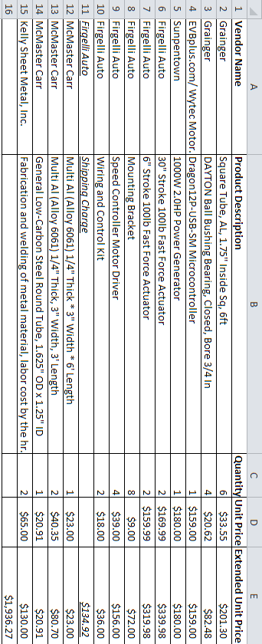

1. Gantt Chart

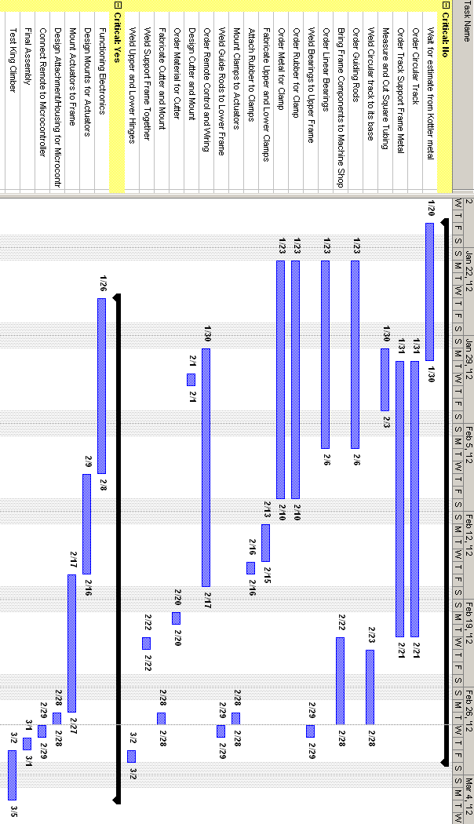

1. Break Even Calculations  
     
    **P (Unit Sale Price)=** *$11,617.62*

***V (Unit Variable Cost)*** *=* $1,936.27

**X (unit sales)** = 8

**Fixed Cost (FC)** = **Labor Cost (for 16 palm pruners)**  = $307,200

**Total Fixed Cost (TFC)** = (P-V) * X

Total Fixed Cost = (*$11,617.62 -* $1,936.27) x 8

**TFC** = $77,450.80

**Unit Contribution (C)** = TFC/X

Unit Contribution= $77,450.80 / 8

**C**  = $9,681.35

**Break Even (in Sales**) (BE) = FC / (C/P)

Break Even (in Sales) = $307,200 / ($9,681.35/*$11,617.62)*

**BE** = $368,640.00

**SP** (**Selling Price**) = $11,617.62

**C(q) (Cost producing “q” units)** = FC + V (q)

**C(q) =** 307,200 + 1,936.27(q)

**R(q) (Revenue selling “q” units)** = SP (q)

**R(q)** = 11,617.62 (q)

**P(q) (Profit producing and selling “q” units)** = R(q) – C(q)

**P(q)** = 11,617.62 (q) – [ 307,200 + 1,936.27(q) ]

**C(q) = R(q)**

307,200 + 1,936.27(q) = 11,617.62 (q)

**q** = 31.7 **~ 32 = BE (in units)**

1. Pro-E Screen Shot Picture Simulations from Beginning to End
   1. Robot Extended Compact 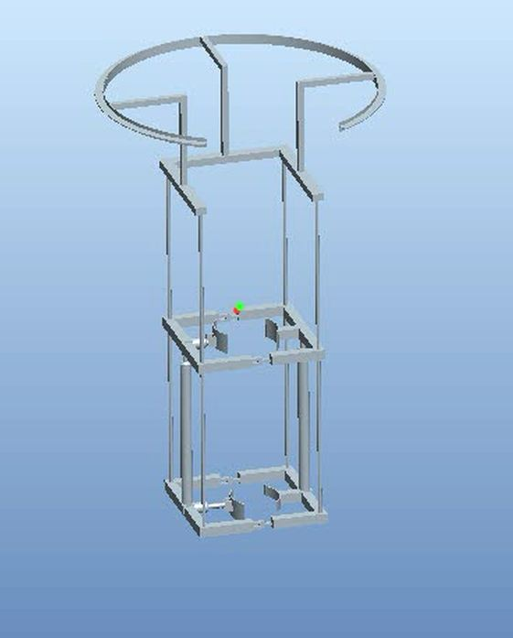
   2. Compact Top Clamp

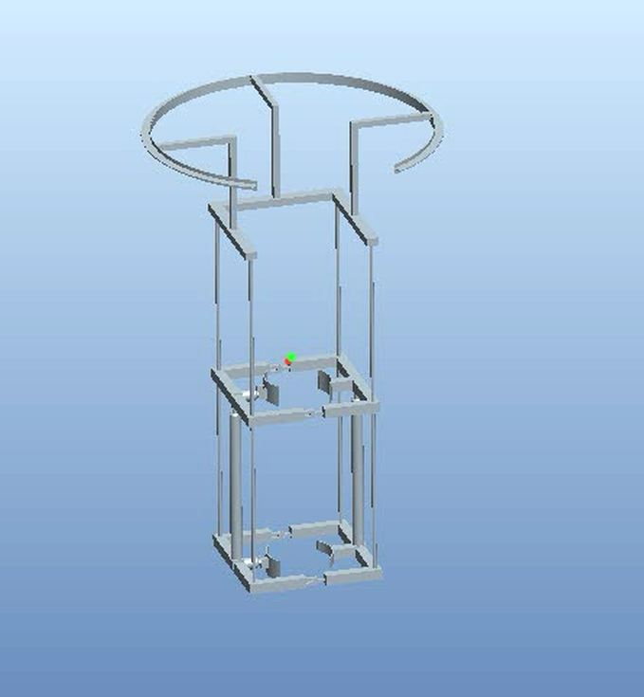

* 1. Compact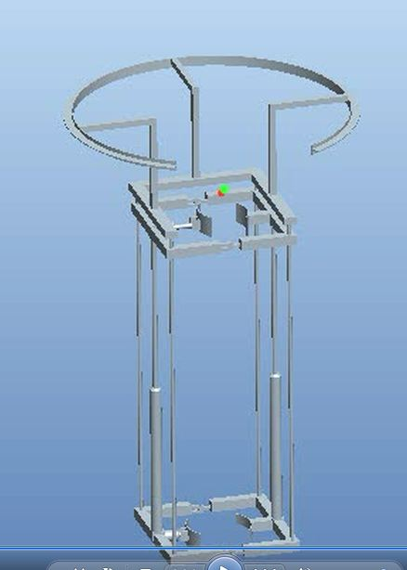
  2. Extended Top Clamped



* 1. Extended Top Open



1. Finite Element Analysis
2. Lower actuator frame

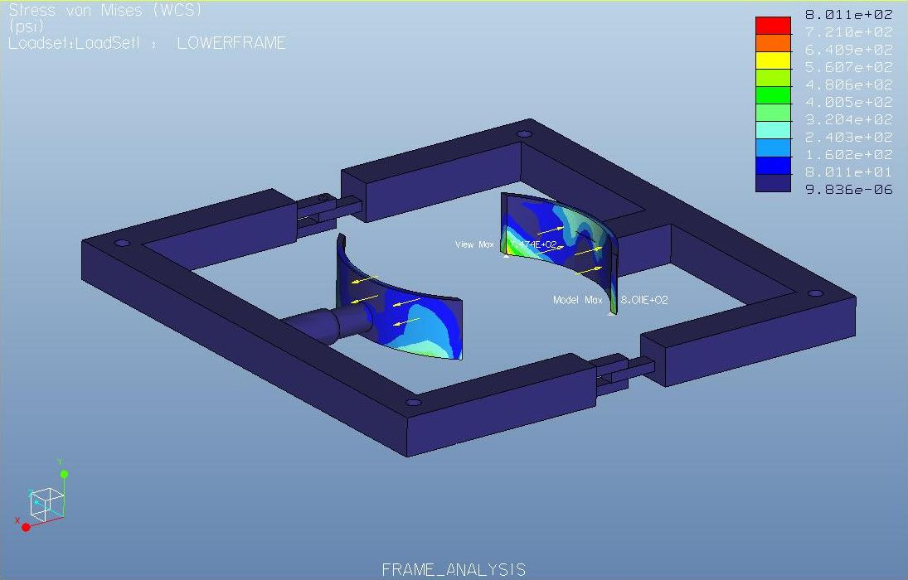

1. Lower frame  
     
   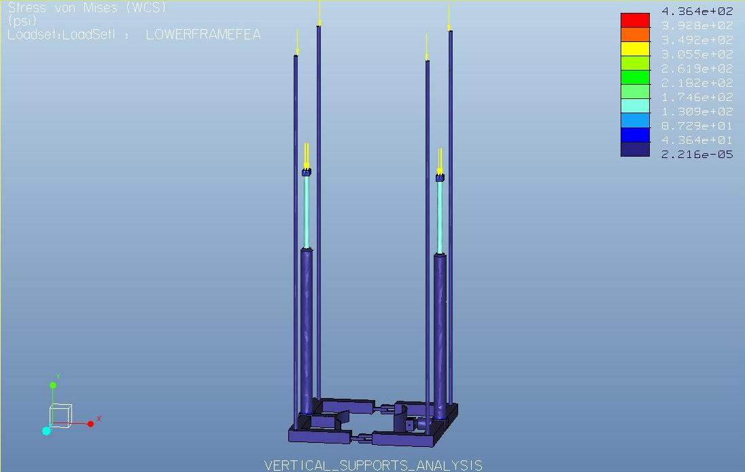
2. Manipulator Track

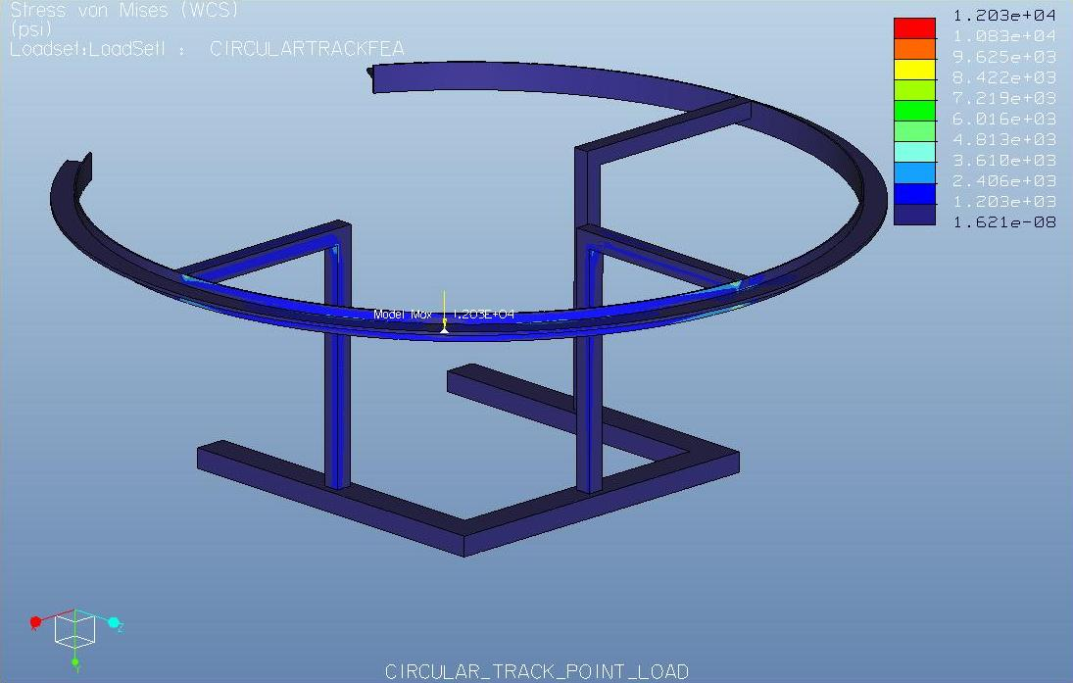

1. Sponsor Questionnaire  
     
   Sponsor Questionnaire: Group and Dr. Okoli
2. What is the average time for a worker to climb up a tree?  10 min

1. What is the average time for a worker to cut a palm oil’s fruit bunches?1.0 min per bunch

1. What is the average time it takes to walk from oil palm to oil palm? Depends on population density – say less than 1 min

1. What is the average setup time before going up a tree? 10 min

1. What is the average number of workers working in one hr? Depends on population density – pick an arbitrary number

1. What is the average number of trees that can be cut in one hr? Depends on number of bunches

1. What is the average distance between trees? ~ 10 ft.

1. What is the number of hours that workers work? ~ 6 hr

1. What is the average salary for a palm pruner? $2 per bunch cut

1. What is the physical stress on the body of a palm pruner from climbing up a tree? Just imagine!
2. References
3. “FAO Corporate Document Repository: Small-scale palm oil processing in Africa...” Food and Agriculture Organization of United Nations (FAO). 2012 <http://www.fao.org/DOCREP/005/Y4355E/y4355e03.htm#TopOfPage>
4. “Palm Kernel Cake.” Alibaba.com. 2012

<http://www.alibaba.com/product-tp/120498560/Palm_Kernel_Cake.html>

1. “Palm Kernel Oil Monthly Price - US Dollars per Metric Ton.” Index Mundi. January 2012 <<http://www.indexmundi.com/commodities/?commodity=palm-kernel-oil>>
2. “Palm oil Monthly Price - US Dollars per Metric Ton.” Index Mundi. January 2012 <http://www.indexmundi.com/commodities/?commodity=palm-oil&months=60>