Design Phase for Automated Palm Pruner

Spring 2011 – March 1, 2012

Submitted By:

Obie Abakporo
Bill Carpenter
William Craig
Juan Antonio Rojas
Christopher Xavier Smith
Sarah Trayner

Dr. Okenwa Okoli
Industrial and Manufacturing Engineering Department
FAMU – FSU College of Engineering
Table of Contents
Introduction 3
Requirements 4
Sponsor 4
Business 4
Product Design 6
Cutting Arm Designs 8
Tool Selection 11
Gantt chart 11
Critical Customer Requirements Chart 12
Pugh Matrix 13
Evaluation Matrix 15
Fabrication Objectives 17
Cost Analysis Update 19
Machine Aspect 19
Human Labor Aspect 21
Effects on Oil Palm Price 22
Breaking Even 23
Next Phase 26
Appendix 27

Introduction

The goal of our project is to develop a computer-integrated robot that will be able to climb a 60 ft. oil palm and harvest the fruits efficiently and economically. For this process, we are utilizing DMADV, also known as Define, Measure, Analyze, Design, and Verify. DMADV is utilized when a product or process is not in existence and needs to be developed. The product that we are creating is a semi-autonomous palm pruner aimed at minimizing the amount of work completed by the worker, as well as, improving the overall process safety. We are on phase four of this process methodology, known as design. Previously, in the analyze and measure phases, we developed and designed alternatives, created high-level designs, and, ultimately, chose the best concept design, King Climber. Also, we utilized various tools in order to assess and determine our customers’ needs and requirements. These tools include the application of engineering analysis, Pro-Engineer simulations, selection matrixes, as well as a thorough cost analysis. These can be referenced in the Appendix.
The main goal of this phase is to design, develop, and choose the best cutting arm concept design that will enable optimal cutting conditions for our semiautonomous palm pruner. This directly affects the success of our product, in that, by being able to cut down fruit palms in a timely and efficient manner, secures the products entrance into the market. By taking a business approach on this product, we can meet the demands of both customer and market, as well as, our product and process requirements. Also, for this phase, we will provide an up-to-date cost analysis pertaining to recent expenditures, as well as, the present and future worth of this new, innovative product.

Requirements

Sponsor

As previously stated, the main goal of our project is to ultimately satisfy our sponsor. Therefore, we must take initiative to implement our sponsors needs and wants into the development and fabrication of the oil palm pruner. To ensure that we meet these needs and requirements, we have maintained constant communication with our sponsor via meetings and emails. Some qualities that our sponsor deemed necessary include that it must be cost effective, rely on minimal manpower, and be time efficient. The palm pruner must possess all of these qualities, but also take into account the close proximity and height of the palms, the damage that could occur to the palm from the semi-autonomous robot, the labor difficulty, as well as the overall safety of the operator. This information was obtained from the initial define phase via house of quality, voice of the customer, and the overall analysis of the customer requirements.

Business

Due to increasing labor costs, as well as, a continuous decrease in the seasonal workforce, the King Climber would be a valuable asset to plantation owners or administrators. The semiautonomous robot would replace the declining workforce and allow for a constant rate of fruit palms to be harvested. This is an enormous advantage in that the average person can only harvest 2 to 3 fruit bunches per hour and faces exhaustion throughout the entire task.
Revenue will be achieved via successful selling of the King Climber machines. However, initial costs will be more expensive than future costs due to the fact that we are not purchasing parts and materials in bulk. Once the prototype has been properly tested, we will be able to consider a large scale production. Having a large scale production would mean that we could save money by ordering large quantities of exact parts needed to fabricate the palm pruner. This will lead to a constant influx of revenue as well as a decrease in the overall fabrication time. Utilizing concurrent engineering through every phase, as well as, careful planning will ensure that we meet the needs of our sponsor and our target market.
The driving force behind the creation of this semiautonomous robot is rooted in the current value of palm oil. To put this in perspective, a metric ton of crude oil is worth approximately $764 and a metric ton of oil palm costs $1,020.54 [1,4]. Palm oil has been steadily increasing for the past 12 years due to its unlimited applications in various industries. Currently, there is a higher demand in the health foods sector.

Product Design

The product we are developing is based on the King Climber concept design chosen in the measure phase. Basically, this semi-autonomous robot will climb up and down the palm tree in an inch worm fashion and cut down the palm fruits utilizing a cutting arm. Visualization of the actual cutting will be achieved through the use of a detachable remote controlled camera. The camera will be placed on the mainframe of the palm pruner respective of the area to be cut. This will ensure that the fruits will be extracted from the palm effectively and efficiently. In this phase, we have designed, developed, and have chosen the appropriate cutting arm necessary in order to obtain optimal results. The selection process for the cutting arm can be found in the section entitled Tool Selection.
Our King Climber design concept consists of five major components. These are depicted on the next page in Figure 1. From top to bottom, the upper frame consists of a circular track for the manipulator arm followed by four guiding rods secured to each corner of the lower frame. The guiding rods allow for alignment of the two top and bottom frames. Another major component is the upper frame. The main purpose of the upper frame is to guide the device up and down the palm tree. Moving downwards, vertical actuators are placed on the adjacent side of the hinges along the centerline of the frame. This allows the entire device to be lifted upwards. Finally, the last major component in this design consists of multiple thick horizontal rods placed into the square frame. They are placed into the square frame via grappling plates attached to the horizontal actuators. This is the force that keeps the semiautonomous robot attached to the palm tree. Analysis of the design completed in the measure phase can be referenced in the Appendix. This section provides more information on the Pro-Engineer model and utilizes Finite Element Analysis to portray various loads and stresses on the semi-autonomous robot.
Figure 1: Pro-E Model for King Climber
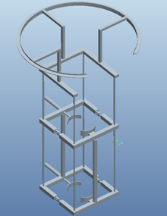
1
2
3
4
5
Part # | Description
1 | Circular track
2 | Guiding rods
3 | Upper frame
4 | Vertical actuators
5 | Square frame

This product will be beneficial to society in that it will help expand the business market. Specifically, it will affect markets in Indonesia, Malaysia, West Africa, and both Central and South America. The successful development of this design will become a valuable and profitable asset for the Florida State University Engineering Department.

Cutting Arm Designs

Both cutting arm concept designs were created via Pro-Engineer software in order to properly represent and understand the overall concept. Concept 1 is depicted in Figure 2 below.
Figure 2: Cutting Arm Concept 1
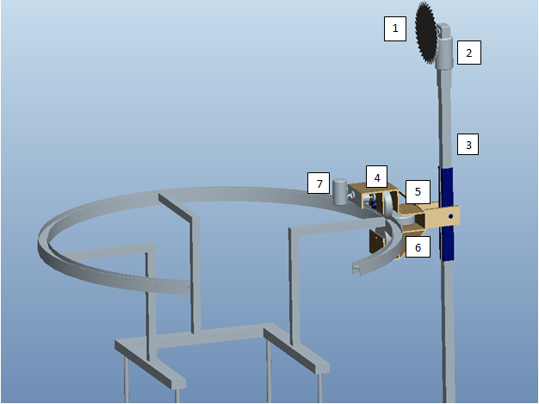

Part # | Description
1 | 8.25” Saw Blade
2 | DC Saw Motor
3 | Al. Shaft
4 | Geared DC Motor
5 | Castor Wheels
6 | Al. Housing
7 | Camera

Figure 2, cutting arm concept 1 will utilize a DC motor coupled with a large circular saw blade attached to a square tube shaft. The saw blade will travel around the tree by use of castor wheels located on the circular track. One of these castor wheels will be powered by a geared DC motor. The shaft will be able to extend, retract, and rotate to maneuver the blade into the optimal cutting position. Based on the user’s preference, the camera can be mounted on either the cutter shaft or the aluminum housing.
Figure 3: Cutting Arm Concept 2
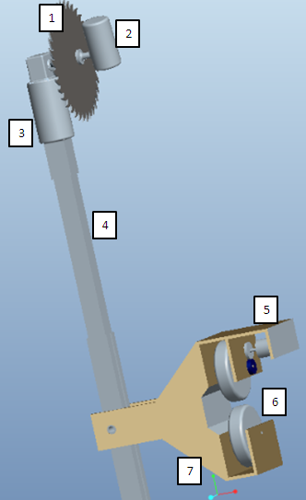
Part # | Description
1 | 8.25” Saw Blade
2 | Camera
3 | DC Saw Motor
4 | Al. Shaft
5 | Geared DC Motor
6 | Castor Wheels
7 | Al. Housing

Figure 3, cutting arm concept 2, will also utilize a DC motor coupled with a large circular saw blade attached to a square tube shaft. Similar to concept 1, we will utilize castor wheels located on a circular track. However, there will only be two castor wheels on this design. The camera will be placed adjacent to the blade in order to get an up close view of the cutting process. The cutting arm will be able to extend and retract.

Tool Selection

For this design phase, we utilized various tools and techniques to aid us in the selection of the cutting arm for the King Climber. Tools include, but are not limited to, an updated Gantt chart, a Critical Customer Requirements flow chart, a Pugh matrix, as well as, an Evaluation matrix. These tools allow us to analyze our customer’s needs and requirements, while, at the same time, aid in the development of our semiautonomous robot.

Gantt chart

For every project it is crucial to construct a Gantt chart and follow the timeline accordingly. A Gantt chart is crucial because it allows us to view start and finish dates of all major tasks, as well as, to have a breakdown of the project structure. Microsoft Project was utilized to create this Gantt chart. On the next page, Figure 4 depicts the initial Gantt chart created at the beginning of the semester in order to build and test our prototype. We are currently two weeks behind schedule as a result of complications involving on-campus shops, as well as, obtaining the essential materials needed from specific suppliers. However, at the moment, this is trivial due to the fact that we incorporated a two week cushion for unforeseen dilemmas. This benefits us in that we can use this cushion to get back on our projected track of completion.

Figure 4: Gantt chart
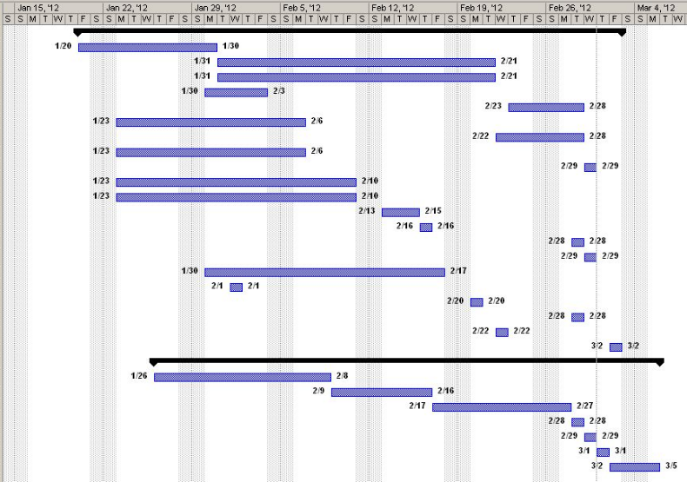
Our Gantt chart represents the current spring semester up to the required testing date (March 5) of our prototype. A complete Gantt chart can be found in the Appendix.

Critical Customer Requirements Chart

After speaking with Dr. Okoli about the cutting arm, we created a critical customer requirements chart in order to accurately describe his needs and wants. First of all, Dr. Okoli wanted there to be a way to control the cutting arm. Secondly, he wanted to have visualization at the top of the palm in order to see what was actually being cut. In order to achieve this, we implemented a camera, as well as, a remote control for the cutting arm. One concern that we have regarding the camera is its overall durability, durability in the sense that it will be able to withstand various weather conditions, as well as, the actual climbing movement up the palm tree. The remote control will allow the operator to control the cutting arm of the palm pruner. With the help of the camera, the operator can use the remote control to guide the cutting arm as they see fit. The combination of the cutting arm and camera is the next best thing to physical interaction. Figure 5 depicts Dr. Okoli’s critical customer requirements.
Figure 5: Critical Customer Requirements Chart
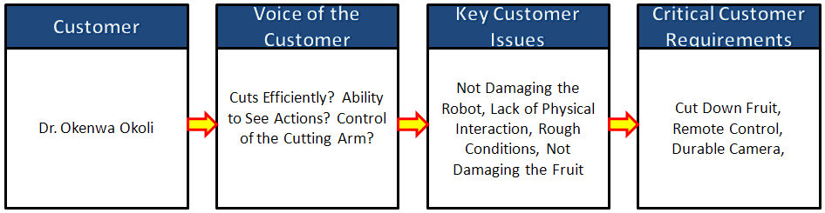

Pugh Matrix

To better compare the two concepts for the cutting arm, we implemented a Pugh Matrix. These matrices are very helpful in deciding the appropriate choice. Based on the sum values, we will be able to determine which design will be the better choice. First, we must add up all the positive, same, and negative signs per column. After we get a numerical value based on the concept selection key, we must multiply those values by the weights that we assigned to each of the respective criteria. Once we do this step, we can compare the concepts with a more relative scale.
Concept 1 scored better with the durability since the camera is placed in a safer location. If the camera is directly next to blade, as in concept 2, then there is a chance of the camera being damaged due to the debris from the cutting process. Concept 1 also scored better with mobility. The reason for this is the extra wheel. This allows concept 1 to have a larger degree of freedom. Both of these reasons lead to concept 1 scoring higher on effectiveness as well.
However, concept 2 scored better with visibility because the camera would be right next to the cutting tool. This would allow the operator to see exactly what he is cutting. Also, it scored higher on complexity because the design is simpler than the first concept. This is because it has less wheels, as well as, less degrees of freedom. Both designs scored the same as far as speed is concerned.
After we completed the Pugh Matrix for the cutting arm, we compared the weighted scores. Concept 1 scored 7, while concept 2 scored -7. The concept with the highest weighted value will be the determining factor. Therefore, based on our Pugh Matrix, concept 1 will be the best choice. Figure 6 on the next page shows the Pugh Matrix comparing both concepts. As you can see, concept 1 appears more promising because it has more positive signs.

Figure 6: Pugh Matrix
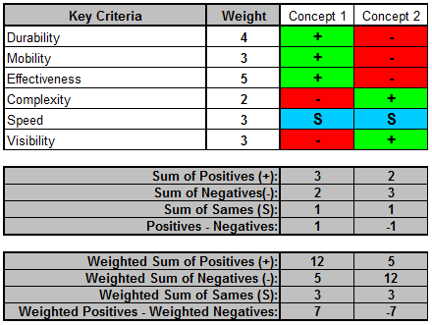
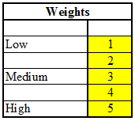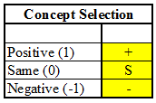
Matrix Keys:

Evaluation Matrix

After we decided which cutting arm to choose, we created an evaluation matrix to help us better assess our choice. We gave ratings to each category based upon a 1-4 number scale. The lower end (1) is associated with a major weakness, while the higher end (4) distinguishes a major strength. Also, we implemented a weighted percentage that correlates to each category. Each category is broken down by importance and the higher percentage values show which categories are more critical.
Once we have the rating and weight, we multiply them together to get the actual weighted score. The total weighted score will be the key part in assessing our concept designs. The cutting arm we chose scored a value of 2.77 out of a possible 4.0, which is a very good score. This score shows that we have made the correct choice. Figure 7 describes how we reached the score of 2.77.
Figure 7: Evaluation Matrix
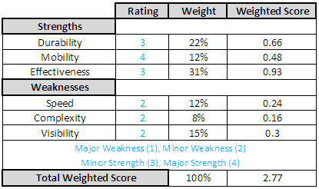

Fabrication Objectives

Chart 1 below portrays the specific parts and individual assembly processes needed to complete the fabrication of the King Climber. We have consistently utilized the help of our advisors in order to ensure that we will not encounter unexpected problems.
Chart 1: Parts and Assembly Process
Part | Assembly Location & Description | Testing Process | Advisors
Actuators | Both horizontal and vertical actuators will be connected to the frame of the King Climber by attaching them to mounting brackets and then, drilling them to the frame.  This will be done in HPMI. | Brought to the electrical lab and connected to a variable power source to verify proper functionality. | Dr. Chuy: Assistant Scholar Scientist (ME)  Mr. Ford: COE Electrical Specialist (EE/CE)
Frame | The frame will be constructed out of aluminum tubing and cut into proper lengths for construction.  This will be done in the COE Machine Shop. | We performed the proper stress calculations and verified material properties. | Jeremy: COE Machine Shop Lead Specialist  Jerry Horne: Machine Shop Specialist (HPMI)
Circular Cutting Track | Material partitioned and effectively welded (as well as bended) to form the desired semi circular shape of the cutting track.  This will be done at Kelly’s Sheet Metal Inc. | N/A | Dr. Kosaraju: Adjunct Faculty (ME)  Jerry Horne: Machine Shop Specialist (HPMI)  Dr. Hovsapian: Adjunct Faculty (ME)
Guiding Rods | Connected to the frame via mounting brackets, actuators, and then, drilling to frame.  This will be done at HPMI. | We performed the proper stress calculations and verified material properties. | Jerry Horne: Machine Shop Specialist (HPMI)
Microcontrollers | Will be wired to the King Climber.  This will be done in HPMI and ME Mechatronics Lab | Created circuit schematics and wiring diagrams with assistance from Dr. Chuy in the ME Mechatronics Lab. | Dr. Chuy: Assistant Scholar Scientist (ME)
Cutting Mechanism | Will be attached to the circular track and have mobility along the circular track via wheeled mounts.  This will be done in HPMI and COE Machine Shop. | N/A | Dr. Kosaraju: Adjunct Faculty (ME)  Jerry Horne: Machine Shop Specialist (HPMI)  Dr. Hovsapian: Adjunct Faculty (ME)  Dr. Shih: Professor (ME)

Cost Analysis Update

Machine Aspect

Similarly to the previous Analyze phase, we are taking into consideration a scenario in which eight oil palms, having five fruit bunches each, are being harvested in order to compare the process times for both machine and human. From Chart 2 below, we can see that it will take the machine and humans 8.5 and 6.12 hours, respectively, to complete the task of harvesting the fruits from each palm tree. However, for the human aspect, we are not considering how fatigue and lack of endurance could affect the overall performance.
Chart 2: Process Times
Time (in minutes) | Process
Time (in minutes) | Machine | Human
Climb | 13.5 | 10
Cut | < 5 per bunch | 1 per bunch
Descend | 13.5 | 10
Unhook | 5 | 10
Transport | 2 | < 1
Setup | 5 | 10
Total | 44 | 42

For this phase, there have been new expenditures that must be taken accounted for. Total expenditures regarding necessary materials are presented in Chart 3 below. Crucial parts that link the upper frame with the circular frame have been added, as well as, ball bearings to aid the movement of the horizontal and vertical actuators. In addition, some parts may or may not include the fabrication and assembly fee.
Using the updated bill of materials found in Chart 3, we can calculate a new future worth value of our innovative product. We have chosen a 500% mark-up percentage because it was requested as one of our sponsor’s requirements for the actual selling price of the product. Also, we have chosen the cash flow diagram to represent a five year span in order to make an accurate comparison with the five year cash flow diagram representing the human labor cost. For the machine aspect, we have calculated that the selling price should be approximately $11,617.62 and the future value to be approximately $302,508.12.
Chart 3: Bill of Materials for Machine
Vendor Name | Product Description | Quantity | Unit Price | Extended Unit Price
Grainger | Square Tube, AL, 1.75'' Inside Sq, 6ft | 6 | $33.55 | $201.30
Grainger | DAYTON Ball Bushing Bearing, Closed, Bore 3/4 In | 4 | $20.62 | $82.48
EVBplus.com/ Wytec Motorola | Dragon12P-USB-SM Microcontroller | 1 | $159.00 | $159.00
Sunpentown | 1000W 2.0HP Power Generator | 1 | $180.00 | $180.00
Firgelli Auto | 30" Stroke 100lb Fast Force Actuator | 2 | $169.99 | $339.98
Firgelli Auto | 6" Stroke 100lb Fast Force Actuator | 2 | $159.99 | $319.98
Firgelli Auto | Mounting Bracket | 8 | $9.00 | $72.00
Firgelli Auto | Speed Controller Motor Driver | 4 | $39.00 | $156.00
Firgelli Auto | Wiring and Control Kit | 2 | $18.00 | $36.00
Firgelli Auto | Shipping Charge |  |  | $134.92
McMaster Carr | Multipurpose Aluminum (Alloy 6061) 1/4" Thick * 3" Width * 6' Length | 1 | $23.00 | $23.00
McMaster Carr | Multipurpose Aluminum (Alloy 6061) 1/4" Thick, 3" Width, 3' Length | 2 | $40.35 | $80.70
McMaster Carr | General Purpose Low-Carbon Steel Round Tube, 1.625" OD x 1.25" ID | 1 | $20.91 | $20.91
Kelly Sheet Metal, Inc. | Fabrication and welding of metal material, labor cost by the hour | 2 | $65.00 | $130.00
TOTAL COST |  |  |  | $1,936.27

Selling Price = Total Cost (1 + Mark-Up Percent)

= $1936.27 (1+5)

= $11,617.62

)

)

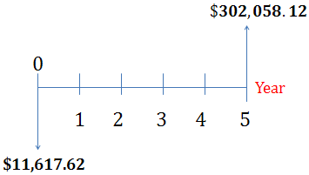

As expected, the future value increased as a result of the increased cost of materials for the initial King Climber prototype. To be precise, the selling price increased from $9,595.08 to $11,617.62 and the future value increased $249,472.08 to $302,058.12. This is because we have not added the cutting tool, the circular track for the manipulator arm, and the actual manipulator arm. Based on these present calculations, we believe that the King Climber will sell for more than estimated at the present moment.

Human Labor Aspect

We believe that the cost of human labor will continue to increase in the following years. This view has been described in the previous analyze phase. In order to accurately recap our assumption, we must state the situation presented in the previous analyze phase. The situation is based on an oil palm farm employing 16 palm pruners who can each harvest eight oil palm trees a day cutting approximately five bunches per tree. This results in approximately a salary of $80.00 per day at $2.00 per bunch cut. This may not seem as an expensive cost; however, when compared to the actual application of the King Climber to existing oil palms, results show an increase in potential profit. The cost to employ 16 palm pruners is approximately $307,200.00. Keep in mind that this cost neglects health care costs from accidents climbing up and down the tree which would be ultimately charged to the farm administrator. From this knowledge, we can calculate a future worth cash flow diagram based on a five year period utilizing a 5% interest rate. From these, we obtain a future value of $384,000.

0
1 2 3 4 5
Year
$384,000

$307,200

Effects on Oil Palm Price

Chart 2 suggests that the King Climber can successfully harvest eight oil palms; having five fruit bunches each, at a rate of 8.5 hours per day. This rate is based on the King Climber machine operating at optimum capacity. Each fruit bunch weighs approximately 27kg, 23% consists of palm oil and 7% of kernel oil [3]. The rest is used for cattle food. This means that in a day’s work, the King Climber could extract up to 540kg of fruit bunches. Broken down, this means that 124.2kg of palm oil, 37.8kg of palm kernel oil, and approximately 378kg for cattle food could be manufactured and produced each day utilizing the King Climber.
To put this into perspective, if eight King Climbers are utilized by one farm, in one month they will have collected approximately 0.9936 metric ton of palm oil, 0.3024 metric ton of kernel oil, and 6,652.8lbs of cattle food. If one metric ton of oil palm costs $1,020.54 , one metric ton of kernel oil costs $1,366.00 and one pound of cattle food costs $1.60 , an oil palm farm will make $13,031.02 a month and in a year, $156,372.24 [2,4,5]. Since, only two operators are needed for each King Climber, the cost will be approximately $307,200.00 in labor. This suggests that oil palm farms will start and continue noticing an increase in profit after 27 months of utilizing the King Climber.

Breaking Even

Based on the previous information, a break even chart will be created for the actual selling of the King Climber. Basically, if an oil palm farm utilizes 8 King Climber palm pruners, in one month, approximately 0.9936 metric ton of palm oil, 0.3024 metric ton of kernel oil, and 6,652.8lbs of cattle food will be collected. If one metric ton of oil palm costs $1,020.54, one metric ton of kernel oil costs $1,366.00 and one pound of cattle food costs $1.60, an oil palm farm will make approximately $13,031.02 in one month and in a year, approximately $156,372.24 [2,4,5]. Because only 2 operators are needed for each King Climber, the cost for labor will be approximately $307,200.00. This suggests that there is potential profit to be made by utilizing a King Climber palm pruner. According to our break even chart found on the next page, if we sell 64 King Climber palm pruners for $11,617.62 costing only approximately $1,936.27 each, we can break even at 32 King Climber palm pruners. As a result, the break even chart suggests that we will earn approximately $368,640 in sales with a fixed cost of $307,200. We accomplish this by assuming a contribution margin of $9,681.35.
Figure 8: Break Even for Selling Machine
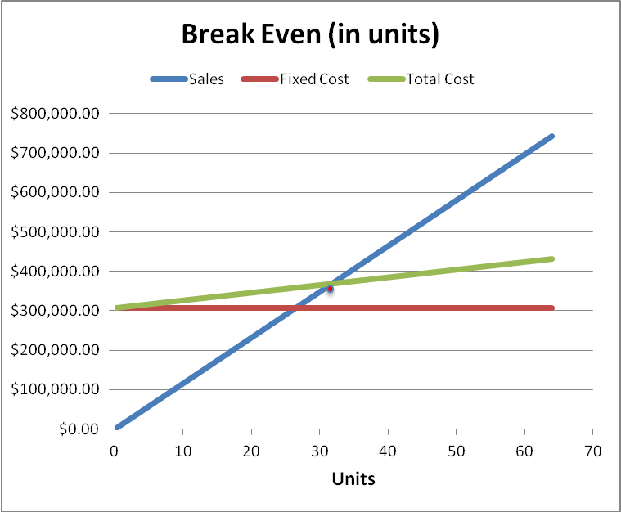

Figure 9, below, portrays a break even chart for plantation owners who decide to invest in purchasing 8 King Climber palm pruners. This break even chart shows that plantation owners will break even at about 27 months and then, begin to make profit. This is a situation where the administrator experiences a fixed labor cost of $307,200.
Figure 9: Break Even for Palm Farms Purchase of Machine
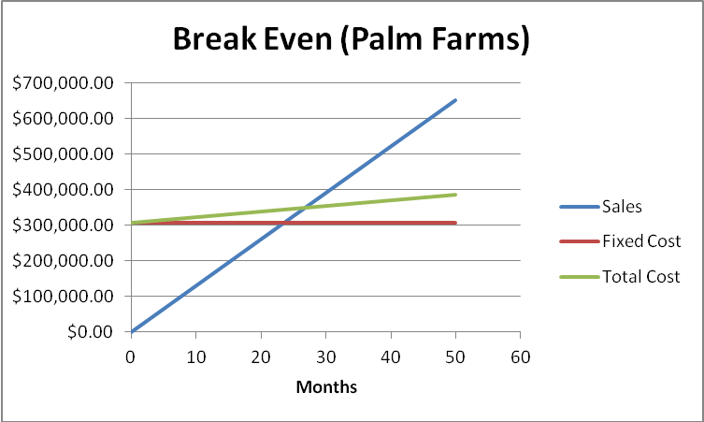

Next Phase

Now that we have finished the design phase, our group can move on to the verify phase of the DMADV process. Currently, we have ordered and received our parts for the frame, actuators, generator, switches, cables/wires, cords, and cable box. Also, we have cut and welded our frame and have tested our actuators. Our main accomplishment in this design phase was choosing the concept design for the cutting arm, as well as starting the fabrication and assembly of the King Climber. By the end of the verify phase, the King Climber should be assenting its way to the top of an oil palm tree.

Appendix

- Purchase Specifications

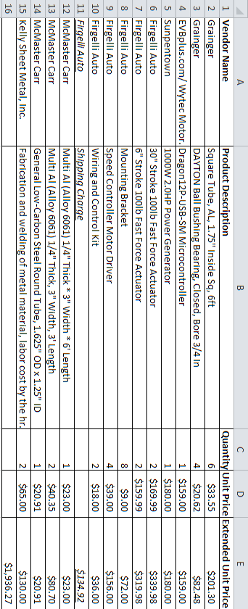

- Gantt Chart

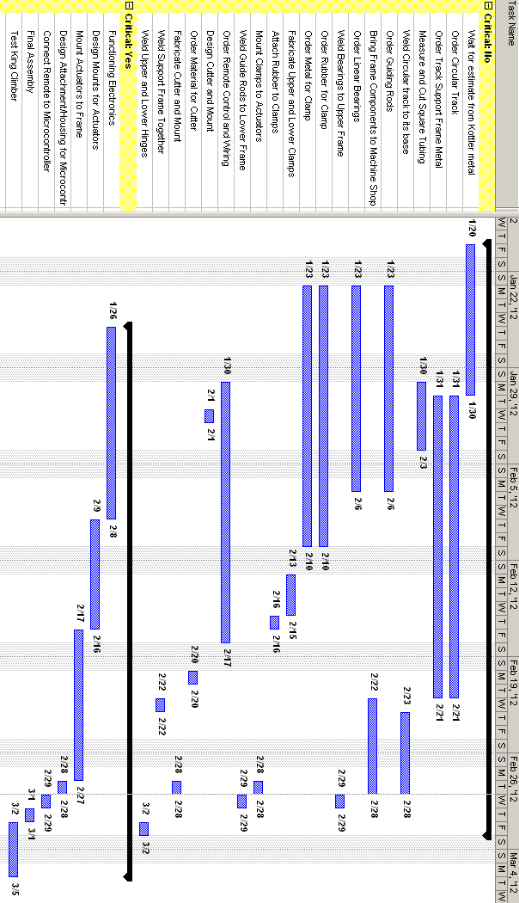

- Break Even Calculations
P (Unit Sale Price)= $11,617.62
V (Unit Variable Cost) = $1,936.27

X (unit sales) = 8

Fixed Cost (FC) = Labor Cost (for 16 palm pruners) = $307,200

Total Fixed Cost (TFC) = (P-V) * X

Total Fixed Cost = ($11,617.62 - $1,936.27) x 8

TFC = $77,450.80

Unit Contribution (C) = TFC/X

Unit Contribution = $77,450.80 / 8

C = $9,681.35

Break Even (in Sales) (BE) = FC / (C/P)

Break Even (in Sales) = $307,200 / ($9,681.35/$11,617.62)

BE = $368,640.00

SP (Selling Price) = $11,617.62

C(q) (Cost producing “q” units) = FC + V (q)

C(q) = 307,200 + 1,936.27(q)

R(q) (Revenue selling “q” units) = SP (q)

R(q) = 11,617.62 (q)

P(q) (Profit producing and selling “q” units) = R(q) – C(q)

P(q) = 11,617.62 (q) – [ 307,200 + 1,936.27(q) ]

C(q) = R(q)

307,200 + 1,936.27(q) = 11,617.62 (q)

q = 31.7 ~ 32 = BE (in units)

- Pro-E Screen Shot Picture Simulations from Beginning to End
  - Robot Extended Compact 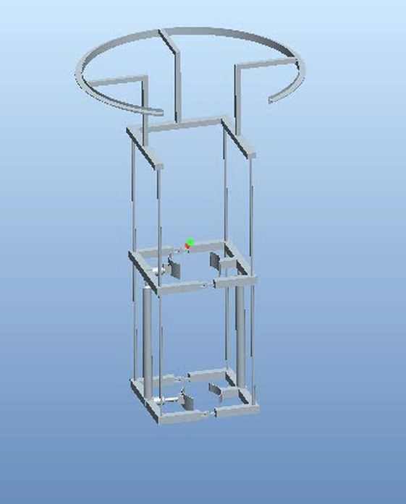

  - Compact Top Clamp

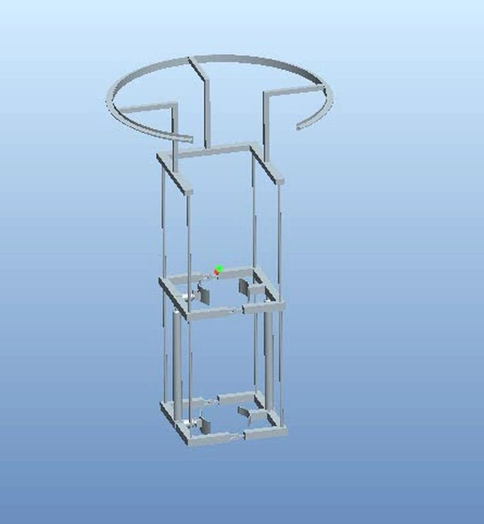

  - Compact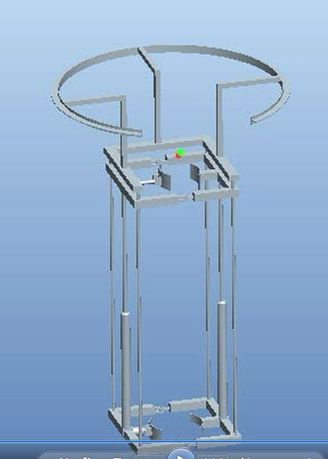

  - Extended Top Clamped

  - Extended Top Open

- Finite Element Analysis

- Lower actuator frame

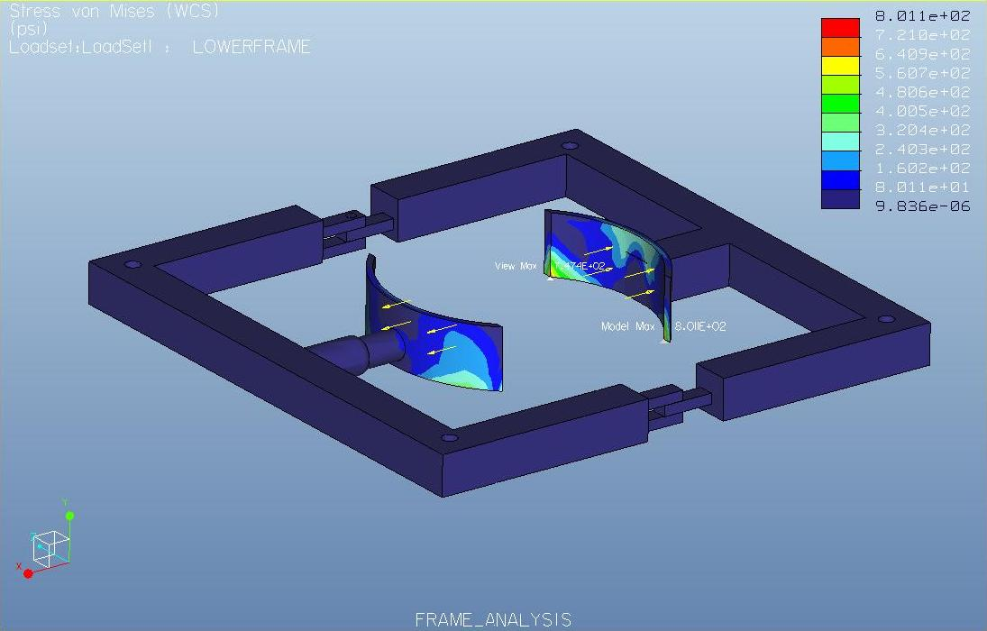
- Lower frame
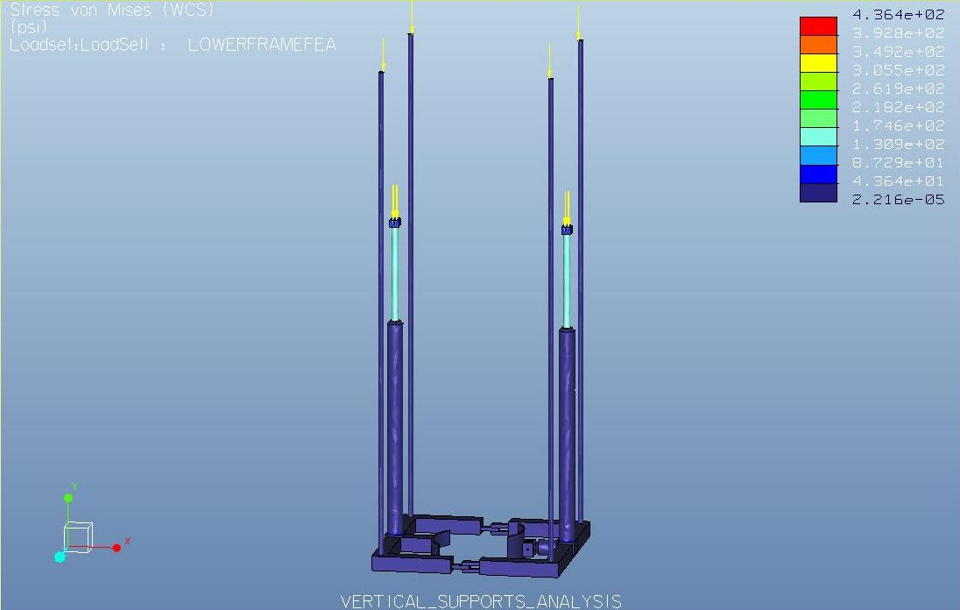

- Manipulator Track

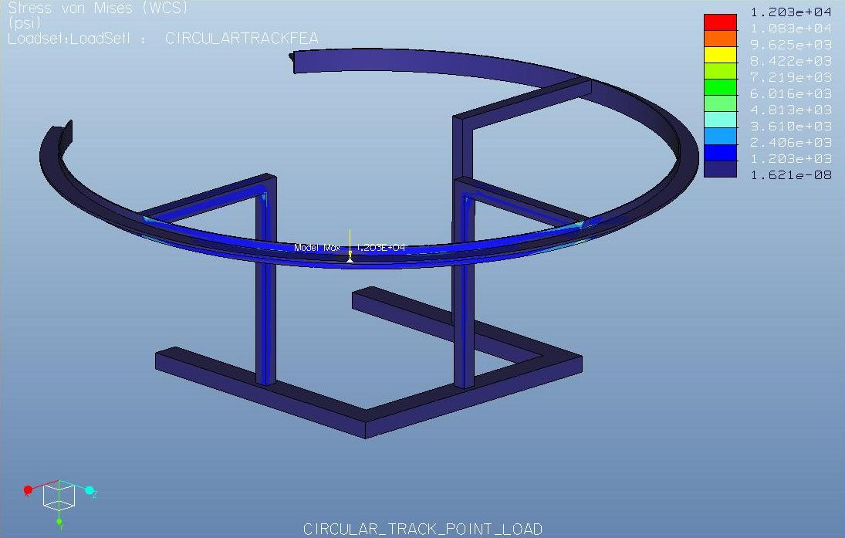

- Sponsor Questionnaire
Sponsor Questionnaire: Group and Dr. Okoli
- What is the average time for a worker to climb up a tree? 10 min

- What is the average time for a worker to cut a palm oil’s fruit bunches?1.0 min per bunch

- What is the average time it takes to walk from oil palm to oil palm? Depends on population density – say less than 1 min

- What is the average setup time before going up a tree? 10 min

- What is the average number of workers working in one hr? Depends on population density – pick an arbitrary number

- What is the average number of trees that can be cut in one hr? Depends on number of bunches

- What is the average distance between trees? ~ 10 ft.

- What is the number of hours that workers work? ~ 6 hr

- What is the average salary for a palm pruner? $2 per bunch cut

- What is the physical stress on the body of a palm pruner from climbing up a tree? Just imagine!

- References

“Crude Oil (petroleum) Monthly Price - US Dollars per Barrel.” Index Mundi. January 2012
< http://www.indexmundi.com/commodities/?commodity=crude-oil>

- Davison, Craig. “Cattle costs rising, but local farmers still seeing profits.” The News and Advance. Media General Communications Holdings, LLC. 2012. February 29, 2012
<http://www2.newsadvance.com/business/2012/feb/29/cattle-costs-rising-local-farmers-still-seeing-pro-ar-1729011/>

“FAO Corporate Document Repository: Small-scale palm oil processing in Africa...” Food and Agriculture Organization of United Nations (FAO). 2012 http://www.fao.org/DOCREP/005/Y4355E/y4355e03.htm#TopOfPage

“Palm Kernel Oil Monthly Price - US Dollars per Metric Ton.” Index Mundi. January 2012 http://www.indexmundi.com/commodities/?commodity=palm-kernel-oil

“Palm oil Monthly Price - US Dollars per Metric Ton.” Index Mundi. January 2012 <http://www.indexmundi.com/commodities/?commodity=palm-oil&months=60>

