Define Phase Report for IE

Senior Design Class

________________________________________________

*Define Phase*

By

Bill Carpenter

Christopher Xavier Smith

Juan Antonio Rojas

William Craig

Obie Abakporo

Sarah Trayner

A report submitted to

Dr. Okenwa Okoli

Industrial & Manufacturing Engineering Department

FAMU – FSU College of Engineering

Tallahassee, FL

October 25, 2011

This report is the first of five progress reports. It defines the opportunities and constraints of the following the Six Sigma methodology of “Define, Measure, Analyze, Design and Validation” (DMADV). The approach and deliverables the team will provide at the termination of the project, as well as, a detailed description of the customer requirements are provided.

**TABLE OF CONTENTS**

LIST OF TABLES...............................................................................................................i

LIST OF FIGURES............................................................................................................i

ABSTRACT.......................................................................................................................1

1. INTRODUCTION.........................................................................................................2
2. PROJECT DEFINITION..............................................................................................3
   1. Parts of the Project...............................................................................................4
   2. Project Scope, Assumptions and Deliverables…..................................................4
      1. Project Scope……………………………………………………………….…4
      2. Project Specification………………………..……………………………..…..4
      3. Assumptions………………………………...…………………………………5
      4. Deliverables……………………………………………………………………5
      5. Constraints…………………………………..…………………………………7
3. TEAM ORGANIZATION...........................................................................................8
   1. Communication……………………………………..…………………………………8
   2. Roles……………………………………………………………………………………8
   3. Dress Code………………………………………….…………………………………9
4. PROJECT CHARTER AND BUSSINESS SIGNIFICANCE......................................10
   1. Project Charter..................................................................................................10
      1. Business Case……….……..………………………………………………….10
      2. Opportunity Statement……..……….…………………………………………10
      3. Goal Statement…………….………..…………………………………………11
      4. Project Scope……….………………………………………………………….11
      5. Budget…………………………………………………………………………..11
      6. Project Plan…………….………………………………………………………12
      7. Team Selection………..………………………………………………………14
   2. Business Significance……………..………………………………………………….15
      1. Strength/Weakness/Opportunity/Threat Analysis ………...………………15
      2. Threat Opportunity Matrix……………………………………………………16
5. ANALYSIS OF CUSTOMER………………………………………………………….17
   1. Critical Customer Requirements (CCR)……………………………………17
   2. Meeting CCR…………………………………....…………………………………18
   3. SIPOC………………………………………………………………………………19
6. CONCLUSION………………………………………….…………………………………20
7. REFERENCES……………………………………………………………………………21

APPENDIX…………………………………………………………………………………….22

1. COMPLETE LIST OF THE PROJECT SCOPE………………………………….22
2. VOICE OF THE CUSTOMER TREE………………………………………………23
3. HOUSE OF QUALITY……………………………………………………………… 24

**LIST OF TABLES**

Table 2.1: World Palm Oil Output……………………………………………………………3

Table 2.2: IE Deliverable Schedule……………….…………………………………………5

Table 2.3: ME Deliverable Schedule ………………………………………………………..5

Table 2.4: 3E Project Milestones……………………………………………………………..6

Table 2.5: Subdivision of Tasks………………………………………………………………6

Table 4.1: Milestones………………………………….……………………………………..12

Table 4.2: Tasks………………………………………….……………………………………12

**LIST OF FIGURES**

Figure 4.1: Gannt Chart…………………………………………………….…………………13

Figure 4.2:Strength/Weakness/Opportunity/Threat Analysis …………..………………..15

Figure 4.3: Threat/ Opportunity Matrix. …………………………………….……………….16

Figure 5.1: Critical Customer Requirement Chart………………………...………………..17

Figure 5.1.b: Fish Bone Diagram…………………………………………….………………17

Figure 5.3: SIPOC for the Overall Process………………………………...……………….19

Figure B: Voice of Customer Tree…………………………………………..……………….23

Figure C: House of Quality………………………………………………….………………..24

ABSTRACT

3E Engineering is dedicated to creating effective, efficient, and economical solutions to global problems. The team is comprised of six senior engineering students committed to solving the problem posed to us by the industrial engineering department. Over the past ten years the human labor force in the southern hemisphere for harvesting oil palm fruits has declined. That has caused a great need for more efficient harvesting methods to harvest the oil palm fruits to maximize palm oil production. 3E Engineering will develop a mechanized climbing robot to harvest the oil palms and solve the labor deficiency.

**1. Introduction**

**.**

The Palm Harvester project is based on helping the Oil palm harvesting in different regions of the world. These regions are: West Africa (from Angola to Gambia), Central and South America, Malaysia, Indonesia, Papua New Guinea, Sumatra, and Kalimantan (Indonesian portion of Borneo). Methods of harvesting the oil palm are scarce. For this reason our group will develop a Computer-integrated robot that can climb the oil palm and harvest the fruits as efficient as possible.

Our oil palm harvester should not exceed $2,000.00, which deletes the use of a tractor or any automobile with a cutting tool. So, a climbing robot is the most inexpensive and efficient device to harvest the oil fruits. The robot is not supposed to harm the palm, and safety to the operator and the device are essential for the completion of our project. For these reasons the broad concept of our design is a two-piece retractable robot with clamps that secure the up-down movement of the robot along the palm.

**2. Project Definition**

. . . .

*2.1 Parts of the project*

The sponsor of our project is Dr. Okenwa Okoli, Associate Professor of the FAMU-FSU College of Industrial and Manufacturing Engineering. His research interests include the characterization of polymer composites and the development of liquid molding techniques for the cost-effective production of composites. His work has led to the development of a novel composite manufacturing technique known as the Resin Infusion between Double Flexible Tooling (RIDFT).

The Semi-autonomous oil palm pruning project arises from the need to mechanize the harvesting of the oil palm seeds to increase productivity and to eliminate the dangers and costs of the humanized approach. 3E is currently developing a semi-autonomous oil palm pruning prototype to be ready for production by the spring of 2012. The countries listed in Figure 2.1 will be the markets we target for the sale of our palm pruning robot.

|  |  |  |
| --- | --- | --- |
| Country/Region | Palm Oil Output  (million metric tonnes) | World Share |
| Malaysia | 14,962,000 | 44% |
| Indonesia | 14,000,000 | 42% |
| Nigeria | 800,000 | 2% |
| Thailand | 685,000 | 2% |
| Columbia | 661,000 | 2% |
| Papua New Guinea | 310,000 | 1% |
| Cote D’Ivoire | 260,000 | 1% |
| Brazil | 160,000 | 0% |

Table 2.1: World Palm Oil Output

http://www.americanpalmoil.com/publications/GOFB/GOFB_Vol4Issue2_2007-pullout.pdf

*2.2 Project Scope*

2.2.1 Project Scope

We will conduct background research on the oil palm tree (size and shape, tree spacing, leading producers, etc.). After researching, we will evaluate different concept design needs with house of quality and fish bone diagrams. Next, we will identify any and all risks associated with oil palm harvesting and develop necessary safety constraints.

Development of minimal requirements for semi-autonomous robot specifications will be the next task followed by developing a plan for implementing controls. We now need to identify an optimum way for efficiency (hydraulic or electric) and recognize error reduction factors. With that being done, we can now Identify procedures and skill training and develop a schedule for milestones as well as a critical path.

Material Selection will be the next task to accomplish alongside the determination of manufacturing technologies to obtain material. We can now determine and reduce the overall process time and establish shipment and receiving dates. The final task of team 3E is to identify instruction protocol and implement simplification.

2.2.2. Project Specification

Our main goal for elaborating a new patent for an oil palm harvester is to minimize the amount of work done by a palm harvester by using a robotic prototype that climbs oil palms and cuts down the needed fruits to produce oil.

A regular palm harvester must climb oil palms all day. So, by the end of each day the harvester does not operate as efficiently as the beginning. Also as years pass his body might be subject to shearing, which develops in low efficiency of his body for the given task. Our palm harvester will allow operators to go years of labor without the shearing effect that normal harvesting methods present.

An electric plant will be use to replace the force exerted by the operator in climbing the palm. The climbing movement will undergo a clamping and pulling movement of two separate bases where the cutting tool will be placed. When the whole machine reaches the top of the palm’s trunk the cutting tool will be able to rotate along one of the bases and cut where the operator commands it.

As soon as all fruits have been harvest from a given palm, our palm harvester will undergo the same movement but just going the opposite direction. So, the operator can grab it and transport it to another palm to be harvest. This will increase harvesting of the palm oil, making this business to flourish and also increasing the working life of an operator.

2.2.3. Assumptions

There are certain assumptions that must be made before the semi-autonomous palm pruner can be designed and produced. The first assumption being that the spacing between oil palm trees in the plantations is not large enough to allow a wheeled-mechanical device of necessary size to operate. That assumption led us to design a robot that will climb each tree. The next assumption made was that the oil palm trees could not sustain any damage from our product that would affect future palm oil production.

2.2.4. Deliverables

Team 3E will be delivering several items to our sponsor throughout the course of the project. Even though this is a joint project between the mechanical and industrial departments, the project is led and sponsored by the Industrial engineering department and we will be following their deliverable schedule.

|  |  |
| --- | --- |
| Industrial Engineering Department Deliverable Schedule: | |
| Deliverable: | Due Date: |
| Define Phase Report | 10/25/2011 |
| Measure Phase Report | 12/6/2011 |
| Project Completion | 12/8/2011 |

Table 2.2: IE Deliverable Schedule

|  |  |
| --- | --- |
| Mechanical Engineering Department Deliverable Schedule: | |
| Deliverable: | Due Date: |
| Team Code of Conduct | 9/13/2011 |
| Needs Assessment/Project Scope | 9/20/2011 |
| Product Specification/Project Plan | 10/13/2011 |
| Concept Generation and Selection | 10/25/2011 |
| Final Design Package | 12/6/2011 |

Table 2.3: ME Deliverable Schedule

We also have our own milestones with completion dates set, these items include: Background Research including market analysis, oil palm properties, existing harvesting techniques, and patents. Next, we will focus on conceptual design generation and comparisons, comprehensive business plan, machine design including drawings, bill of materials, and cost estimate. The purchase materials, Fabrication of prototype and prototype testing will come before the completed report and the overall completion of the project.

|  |  |  |  |
| --- | --- | --- | --- |
| 3E Incorporated Timeline | | | |
| Milestones | Responsible | Due | Status |
| Project Start | 3E | 9/14/2011 | Complete |
| Research | 3E | 9/28/2011 | In Progress |
| *Market Analysis | CD |  |  |
| *Oil Palm Properties | ED |  |  |
| *Existing Harvesting Methods | 3E |  |  |
| *Patents | 3E |  |  |
| Conceptual Design | 3E | 10/5/2011 | In Progress |
| Business Plan | CD | 11/2/2011 | Incomplete |
| Machine Design | ED | 11/2/2011 | Incomplete |
| *Drawings | ED |  |  |
| *Bill of Materials | ED |  |  |
| *Cost Estimate | ED |  |  |
| Purchase Materials | 3E | 11/18/2011 | Incomplete |
| Fabrication & Testing | 3E | Jan-Feb | Incomplete |
| Write Up | 3E | March | Incomplete |
| Project Complete | 3E | 3/30/2012 | Incomplete |

Table 2.4: 3E Project Milestones

|  |
| --- |
| 3E = Entire Team |
| CD = Commercial Design Team |
| EDD = Engineering and Design Team |

Table 2.5: Subdivision of Tasks

2.2.5. Constraints

For our Palm Harvester project our major constraints are the budget and not being able to see an actual oil palm. Apart from having a $2,000.00 budget to manufacture our oil palm harvester, safety is a major concern. The harvester has to be operated by different people; they have to feel comfortable using our device and be able to operate it properly. The last constraint is the different milestones to deliver throughout our project, but mainly completing our oil palm harvester by March 3rd, 2012 with all the specifications that we previously established.

**3. Team Organization**

**.**

*3.1. Communication*

The most vital attribute to a successful team is the chemistry amongst the team members. This chemistry can only be created and maintained by great communication throughout the team. It is the responsibility of each team member to keep an open line of communication with their constituents. General contact information will be exchanged (phone number and email address) and used to contact one another for group meetings, updates, etc…every member will be expected to respond in a reasonable timeframe (approximately 24 hours) and will be held accountable to do so. Members that fail to comply with these guidelines will receive a deduction in their individual evaluation in regards to their team effort, or more appropriately lack of. In courtesy, members should notify the team thirty minutes in advance in the case of an absence. Without this notification it will be assumed that this member has neglected his/her duties which will consequently be reflected in their individual evaluation accordingly.

*3.2. Roles*

3E Coordinator, Engineering and Design Team – Christopher Xavier Smith, ME

Manages the team as a whole, including, but not limited to developing a plan and timeline for the project, delegating tasks among group members according to their abilities, finalizing all documents, and providing input on other positions where needed. The team leader is responsible for promoting cohesiveness within the group and teamwork.

ME Lead, Engineering and Design Team – William Craig, ME

Manages the mechanical design process. Checks for consistencies between sketches and 3D modeling in the areas of geometry, failure criteria, and integration of components. Creates sketches and CAD models for the design concepts.

Secretary, Commercialization Engineering Team – Obiechina Abakporo. ME

Participates in all aspects of organizing, planning, and the setting up of meetings. In addition, the administrator is in charge of all record keeping including logging all the meeting times.

IE Lead, Engineering and Design Team – Sarah Trayner, IE

Takes charge in the design of the Industrial Engineering aspects of the project. Keeps a constant line of communication with the lead ME. Responsible for knowing all details of the design and presenting the options for each aspect to the team for the decision process.

Treasurer, Commercialization Engineering Team – Juan Rojas, IE

Manages the budget and maintains a record of all credits and debits to our account. Any product or expenditure requests must be presented to the advisor, who is then responsible for reviewing and analyzing the proposed solution. They then relay the information to the team and if the request is granted, orders the selection.

Engineering and Design Team – Bill Carpenter, IE

Manages the industrial design process. Checks for consistencies between sketches and 3D modeling in the areas of geometry, failure criteria, and integration of components.

*3.3. Dress Code*

The dress code will be determined according to the event. Normal meetings and work sessions casual attire is appropriate. Business casual is the required dress code for presentations or meetings with outside professionals. Business professional will be determined on an as needed basis.

**4. Project Charter and Business Significance**

**.**

*4.1. Project Charter*

4.1.1. Business Case

The justification of this project is to design a more efficient, cost effective, safer alternative to pruning oil palm trees. Because the current methods for accomplishing this feat are so primitive, dangerous, and ineffective our team has proposed some designs to satisfy this need. The oil extracted from these trees support the livelihood of different people all around the world, from households, villages, communities, all the way to entire countries. In other words, the demand for our product is and will continue to be great and consequently improve the infrastructure of that particular area. If a design that eliminates human injury/fatalities, decreases the workload (input), while simultaneously increases the production (output), is achieved why wouldn’t it be beneficial?! From a business standpoint, consumer standpoint, or any standpoint for that matter! Not to mention that palm oil imports have doubled in the U.S since 1999 (with a huge upsurge in 2005) and new plantations are being financed in Malaysia, Indonesia, etc…so, the business is not only flourishing but, it’s also expanding. Strictly speaking from the time saved and exponential increase in harvest alone, one can’t go wrong with this design.

4.1.2. Opportunity Statement

Palm oil, a source of high levels of natural antioxidants, promises an attractive business for green enterprises aside from the fact that it has a cheap pricing for production. Cheap pricing is essential for the development of palm oil products in the food market. It also has a part on soup manufacturing and for these reasons we can deduct that palm oil has a huge future. To help the growth and maturity of palm oil, new methods for efficient and fast fruit harvesting have to be developed. Methods to harvest medium sized oil palms have been developed but there is still a constraint that harvesters deal with in harvesting 40-60 ft. tall palms, this is where our patent for an oil palm harvester can be better appreciated and acknowledged.

Our oil palm harvester will also provide additional long lasting jobs as opposed to when harvesters use climbing techniques to harvest oil palms. Jobs will last longer because injuries in the will decrease in the long run and the need of human assistance to move the harvester from palm to palm still remains. Depending on the extent of the oil palm farm that is being worked on, farm managers (with counsel from 3E) have to determine the necessary amount of oil palm harvester operators to maintain a high productivity of palm oil.

As has been said, the oil palms are only bred in tropical climates such as Indonesia, Malaysia, West Africa, and both Central and South America. Yes, oil palms can only grow in selective parts of the worlds but, this does not mean that there can’t be other countries where oil palm fruits can be processed for their use in different products, just like the Rotterdam refinery. So, whenever there is a surplus for palm oil, different refineries can evolve to balance the market. This gives a wide variety of space for the palm oil industry to flourish.

4.1.3. Goal Statement

The main goal of Team 3E is to make the most efficient and reliable oil palm harvester in the market today. A palm harvester that will maintain and keep providing jobs in the respective field is essential. Inevitably, as oil palm harvesting further develops it will create more jobs outside the field for the manufacturing and processing of palm oil and palm oil related products while still boosting its infrastructure. With the flourishing of the palm oil market we can expect that our oil palm harvester will be economically liable. At the same time that the oil palm harvester increases productivity by performing a steady work day efficiency, the amount of work that is done by the harvester when they climb the palm will continue decreasing with further method developments.

4.1.4. Project Scope

The palm oil business is booming without displaying any trace of losing momentum. Still, there is an avenue that needs dramatic improvement and that is where team 3E comes in!! Currently, the harvesting methods for oil palm seeds are dangerous, time consuming, and simply out-dated especially in this day and age. The oil palm industry is in dire need of a more efficient, effective, and economical device to accomplish this common task. A semi-autonomous palm pruner will solve all of these problems! Not only will our mechanism be able to ascent and descent each tree quickly and effortlessly but, it is also manageable (in terms of mass and size) and can successfully strip each tree of the fruit it is bearing with one climb! This essentially means that fatalities due to climbing the trees are eliminated, physical labor is exponentially decreased, productivity is dramatically increased, and the demand of our product is sustained indefinitely as long as the trees exist.

4.1.5. Budget

Our project’s budget has a maximum of $2,000.00 provided by the school. From what is provided we will need to buy a cutting tool, clamps, hydraulic system for the movement of the robots and a computer-integrated device from where the operator can control the cutting tool.

For the development of our oil palm harvester, since there is no way to see an oil palm first-hand, a trip to a nursery might be arranged. The nursery will be located in Tallahassee so money for gasoline will be our only concern.

4.1.6. Project Plan

**Milestone Spreadsheet**

|  |
| --- |
| 3E = Entire Team |
| CD = Commercial Design Team |
| EDD = Engineering and Design Team |

*Key

Table 4.1: Tasks

|  |  |  |  |
| --- | --- | --- | --- |
| 3E Incorporated Timeline | | | |
| Milestones: | Team Responsible: | Due Date: | Status: |
| Project Start | 3E | 9/14/2011 | Complete |
| Research | 3E | 9/28/2011 | Complete |
| *Market Analysis | CD | 9/28/2011 | Complete |
| *Oil Palm Properties | ED | 9/28/2011 | Complete |
| *Existing Harvesting Methods | 3E | 9/28/2011 | Complete |
| *Patents | 3E | 9/28/2011 | Complete |
| Conceptual Design Selection | 3E | 10/5/2011 | Complete |
| Business Plan | CD | 10/23/2011 | Complete |
| IE Deliverable | 3E | 10/25/2011 | Complete |
| 1st Presentation | 3E | 10/27/2011 | In Progress |
| Machine Design | ED | 11/2/2011 | Incomplete |
| *Drawings | ED | 11/2/2011 | In Progress |
| *Bill of Materials | ED | 11/2/2011 | Incomplete |
| *Cost Estimate | ED | 11/2/2011 | In Progress |
| Purchase Materials | 3E | 11/18/2011 | Incomplete |
| Fabrication & Testing | 3E | Jan-Feb | Incomplete |
| Write Up | 3E | March | Incomplete |
| Project Complete | 3E | 3/30/2012 | Incomplete |

Table 4.2: Milestones

**Gannt Chart**

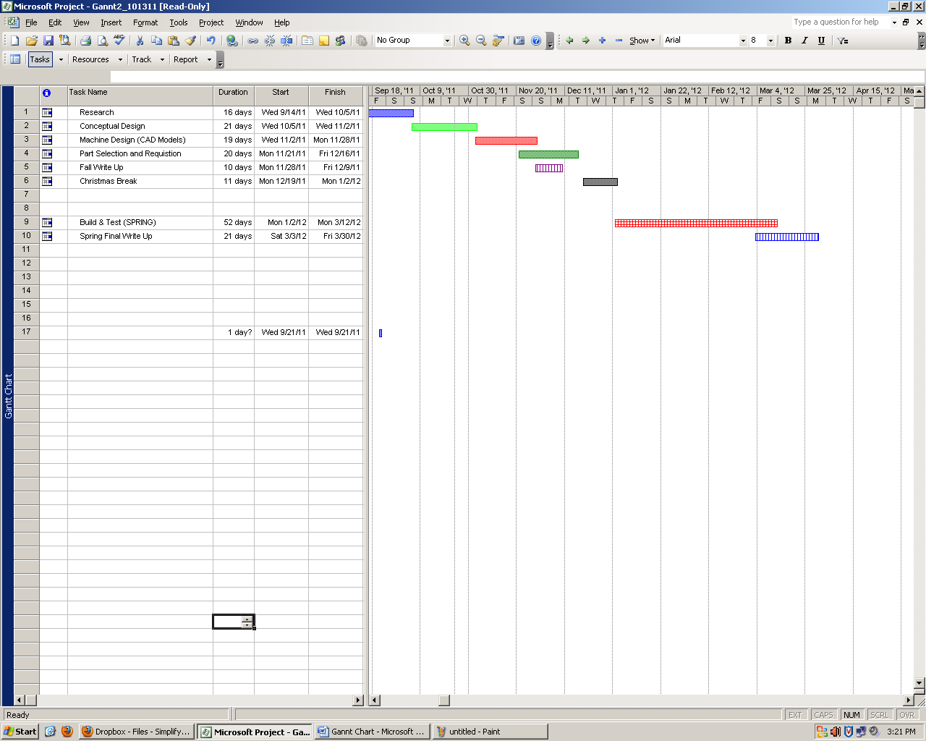

Figure 4.1: Gannt Chart

4.1.7. Team Selection

* Obie Abakporo

Current Position: Secretary, Commercialization Engineering Team ME Lead

Experience: Lead Mechanical Engineer (NASA Research Project), Robotics Lab Manager (Dr. Moore)

* Bill Carpenter

Current Position: Engineering and Design Team

Experience: Restaurant Management

* William Craig

Current Position: Engineering and Design Team ME Lead

Experience: Constructed Rudimentary Submersible ROV (Remotely operated vehicle

* Juan Rojas

Current Position: Commercialization Engineering Team IE Lead

Experience: Panama Forestation Company

* Xavier Smith

Current Position: 3E Team Coordinator, Engineering and Design Team

Experience: ASME President

* Sarah Trayner

Current Position: Engineering and Design Team

Experience: Research Assistant (Dr. Okoli)

*4.2. Business Significance*

4.2.1. Strength/Weakness/Opportunity/Threat Analysis (SWOT)

|  |  |  |
| --- | --- | --- |
|  | **Helpful to Objective** | **Harmful to Objective** |
| **Internal Origin**  **(Team Attributes)** | **Strengths:**   * **Diverse group** * **Member’s personal experiences and skills** * **Advisor owns oil palm farm (familiarity with trees)** * **Number of team members** * **Multiple advisors** | **Weaknesses:**   * **No physical contact with oil palm tree** * **Time conflicts** * **Lack of programming experience** * **Advisor owns oil palm farm (narrow thinking)** |
| **External Origin**  **(Environmental Attributes)** | **Opportunities:**   * **High demand** * **Growing industry** * **Lack of effective methods** * **Durable fruit** * **Valuable to import** * **Nutritional value exceeds other oil sources** | **Threats:**   * **$2000 budget** * **Tree texture** * **Plantation location** * **Movement of mechanism** * **Material acquisition** * **Customer satisfaction/approval** |

**Figure 4.2:** Strength/Weakness/Opportunity/Threat Analysis (SWOT)

4.2.2. Threat/Opportunity Matrix

|  |  |  |
| --- | --- | --- |
|  | **Threats**  **(Project Unsuccessful)** | **Opportunities**  **(Project Successful)** |
| **Short Term**  **Consequences** | * **Loss of money** * **No development in oil palm harvesting methods** * **Injuries for palm climbing continue** * **Loss of credibility as engineers and university standards** * **Removed from project** * **Bad grade on project!** | * **Efficient use of capital** * **New method for oil palm harvesting** * **Satisfied customer** * **Effective and rewarding teamwork** * **Milestones and benchmarks fulfilled** * **Good grade on project!!** |
| **Long Term**  **Consequences** | * **Customer’s oil palm business remains the same and losing business opportunities to more efficient oil palm farms** * **Loss of 3E reputation** * **Less competition in the market for better products to be created** * **Loss of Customer/Investors** | * **Group 3E, recognition in the oil palm industry and for job applications** * **Concept design for further modification** * **Customer’s oil palm business increase in productivity** * **Global renown of 3E success for innovation** |

**Figure 4.3 : Threat Opportunity Matrix**

5. Analysis of Customer Requirements

*5.1 CRITICAL CUSTOMER REQUIREMENTS*

**Figure 5-1.a: Critical Customer Requirement (CCR) Chart**

**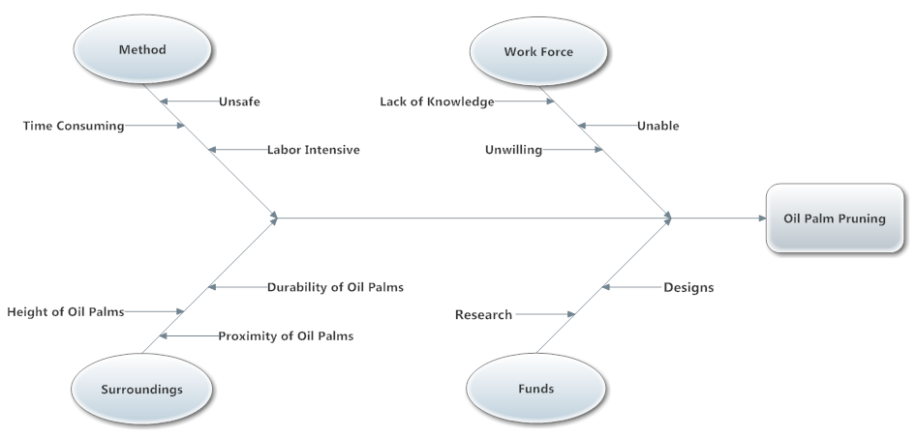  
Figure 5-1.b: Fish Bone Diagram**

The figure 5-1.a depicts a CCR chart that is a very important tool in determining the best way to please the customer. After meeting with Dr. Okoli, it was evident that the labor force was dwindling (as referenced in Fig. 5-1.b) and it was becoming very difficult to harvest the oil palms. It is very important to Dr. Okoli, that he receives a product that most importantly, retrieves the fruit from the towering trees. This being said, the main goal of this project is to create a device that can get the fruit down without having to send a worker all the way to the top of the tree. Although, Dr. Okoli expressed the importance of it being inexpensive; the more relevant assignment is actually retrieving the fruit.

After the aspect of inexpensively retrieving the fruit is taken care of, the next important requirement is that of course it be safe and easy to use. Not only should it be easy to use, it should also be easy to transport. The last requirement on our list of objectives is time efficient. If the product does not harvest enough fruit to provide a profit or even pay for itself, it is basically worthless in the oil palm harvesting process.

Figure 5-1.b shows multiple issues with designing this product; the first being the characteristics and layout of the oil palms. The trees are too close to each other to drive a tractor or other vehicle in between. Despite the lack of space, the oil palm could easily be damaged if the vehicle were to make contact with it’s trunk. Along with these difficulties associated with the oil palm, the height of the tree is also an issue that must be dealt with.

*5.2 MEETING CCR*

With most of the details and concerns listed, the main objective to meet the CCR is to harvest the fruit without having to use workers to climb the tree. Since there is no way to use an attachment to a vehicle, this device has to be transportable. With the oil palms being so closely planted, the product cannot be attached to a motorized wheel base, due to the chance of damaging the oil palm. This means the workers must be able to transport it. That makes one of the requirements of this product to be light weight.

With the lack of work force that is upon this industry, it is assumed that the product should be able to be transported by two workers. A device such as a “robot,” that is not cumbersome, is the ideal the goal. This will meet the requirements of harvesting the fruit along with the dealing with the problem of the lack of work force. A semi-autonomous robot that could be carried from the base of one tree to another, by the workers; then climbs to the top; cuts the fruit; and then returns back down the tree is the objective to meet the CCR. This also would take care of the safety and ease of use for the workers. They no longer have to use the skill to climb the oil palms, as well as, it is typically more safe to be on the ground rather than scaling 40-60 foot tall trees.

We are currently looking at three different methods in our conceptual design phase. The first being a hydraulic based robot that can climb to the top. The second being a crank system based robot that can also climb to the top of the oil palm. The third and final one being a system of wheels and springs that allow the wheels to keep pressure on the trunk by the springs, and then wheel itself to the top.

All three designs will be able to harvest the fruit once it reaches the top. All three will basically be designed with the same concept of a robotic cutting arm and camera attached to the robot. They will all, as of now, have a semi-circular track attached to the top of the device so that the robot, with the cutting arm and camera, will be able to almost encircle the top of the oil palm. This will make sure that the robot has harvest the whole tree and not just one side of it.

*5.3 SIPOC*

**Figure 5-3: SIPOC for the Overall Process**

The chart in figure 5-3 shows the SIPOC tool used for the process of oil palms. This is important because it shows all the different important factors that go into the entire process. The products produces by palm oil is very versatile. This makes the customers of the product pretty much the general public as a whole. But to be more exact: the palm oil is essentially used for bio-fuels; both oils are used in margarine, cooking oil, fats, ice cream etc.; and palm kernel cake is used to make animal food. All three of these products; palm oil, palm kernel oil and palm kernel cake; are all outputs based off the process listed above in figure 5-3. The items needed for this process are the oil palms, fruit, and all the appropriate tools. The suppliers of all these are the farm owner and the workers to help harvest the fruit. This helps break down all the factors so it is easier to improve the process.

There will also be another SIPOC formed when we know what materials are needed for the actual robot. Once that is established, we will create a SIPOC for the Prototype.

6. Conclusion

.

3E Engineering has high expectations for its upcoming robot prototype. We realize that this first climber is just the first step towards a much larger solution. With the support of our sponsor, the Industrial Engineering Department, we hope to solve the oil palm harvesting deficiencies of the southern hemisphere in the most effective, efficient, and economical way possible with the resources and time provided.

**APPENDIX**

1. COMPLETE LIST OF THE SCOPE OF THE PROJECT

* Research oil palm (size, height, spacing, etc)
* Identify the concept designs for palm harvesting techniques
* Evaluate concept design needs (house of quality, fish bone)
* Identify risks for harvesting oil palm tree
* Develop safety constraints for Oil palm tree
* Develop minimal requirements for semi-autonomous robot specifications
* Develop plan for implementing controls
* Identify optimum way for efficiency (hydraulic or electric)
* Identify error reduction factors
* Management of equipment
* Identify procedures and skill training
* Develop schedule for milestones as well as critical path
* Determine material selection
* Determine manufacturing technologies to obtain material
* Determine and reduce process time
* Determine shipment and receiving dates
* Identify instruction protocol and implement simplification

1. VOICE OF CUSTOMER TREE

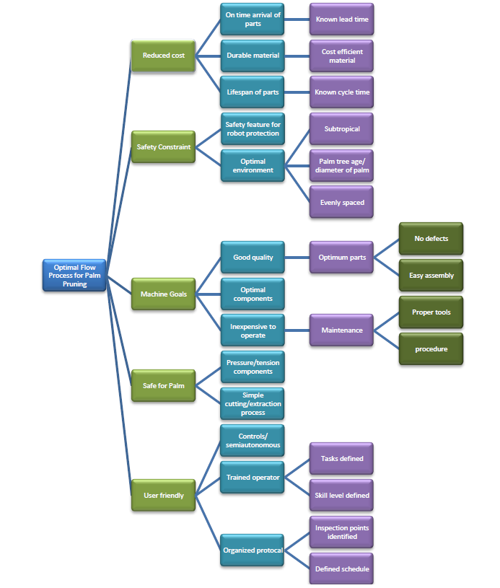

C. HOUSE OF QUALITY

