Analyze Phase for Automated Palm Pruner

Spring 2011 – February 2, 2012

Submitted By:

Obie Abakporo
Bill Carpenter
William Craig
Juan Antonio Rojas
Christopher Xavier Smith
Sarah Trayner

Dr. Okenwa Okoli
Industrial and Manufacturing Engineering Department
FAMU – FSU College of Engineering
Table of Contents
Introduction 3
Requirements 5
Sponsor 5
Business 5
Product Design 8
Tool Selection 10
Gantt chart and Critical Path Analysis 10
Cost Analysis 14
Machine Aspect 14
Human Aspect 20
Sponsor Questionnaire 23
Interactions 24
Human Interaction with the King Climber 24
King Climber’s Response to Human Command 25
Analysis Factors and Objectives 28
Fishbone Diagram 28
Potential Problems and Theoretical Solutions 30
Next Phase 33
Appendix 34

Introduction

The goal of our project is to develop a computer-integrated robot that will be able to climb a 60 ft. oil palm and harvest the fruits efficiently and economically. For this process, we are utilizing DMADV, also known as Define, Measure, Analyze, Design, and Verify. DMADV is utilized when a product or process is not in existence and needs to be developed. The product that we are creating is a semi-autonomous palm pruner aimed at minimizing the amount of work completed by the worker, as well as, improving the overall process safety. We are on phase 3 of this process methodology, known as analyze. Previously, in the measure phase, we assessed and determined the customer needs and specifications through the use of various tools such as engineering analysis, Pro-Engineer simulations, selection matrixes, as well as a thorough cost analysis.
The main goal of this analyze phase is to develop and design alternatives, create high-level designs, and, ultimately, choose the best design. Also, for this phase, we must analyze various process options so that we can satisfy our customer’s needs. Due to the time constraint for ordering and assembling the semi-autonomous robot, we had to intertwine this phase with the measure phase in order to meet our final deadline. Because of this restraint, we have already developed and analyzed high-level designs in the measure phase as well as deduced the best design to be the King Climber design concept. Supporting information validating our concept selection can be referenced in the Appendix under the section titled Measure Phase. Supporting information includes, but is not limited to tools such as the Fishbone Diagram, the Voice of Customer Tree, as well as the House of Quality.
For this analyze phase, our main goal is to provide a business oriented approach aimed at meeting the demands of the customer and the market, the product/process requirements, as well as to provide an accurate cost analysis pertaining to present and future worth of this new, innovative product.

Requirements

Sponsor

As previously stated, the main goal of our project is to ultimately satisfy our sponsor. Therefore, we must take initiative to implement our sponsors needs and wants into the development and fabrication of the oil palm pruner. Some qualities that the sponsor deemed necessary include that it must be cost effective, rely on minimal manpower, and be time efficient. The palm pruner must possess all of these qualities, but, also, take into account the close proximity and height of the palms, the damage that could occur to the palm from the semi-autonomous robot, the labor difficulty, as well as the overall safety of the operator. This information was obtained from the initial define phase via house of quality, voice of the customer, and the overall analysis of the customer requirements.

Business

The success of our semi-autonomous robot depends on its ability to meet product development targets. According to The New Product Development Business Value Research Series by the Aberdeen Group, “most companies miss their development targets, which negatively affect the success of the new product” [1]. The main factors that affect the product’s success include the product’s development, the product’s cost, the potential revenue, and the actual quality of the product. As a result, there are specific steps we must take in order for our product to be successful in the market. Steps include: understanding the market, having a representative engineering design, establishing procurement, ensuring manufacturing engineering, actual manufacturing, being able to finance, as well as obtaining legal rights.
By being able to understand the market, we can figure out what exactly motivates the customer to purchase the product. This allows us to quantify the market opportunity, which will ultimately allow us to commercialize our product. Palm oil promises an attractive business for green enterprises from the fact that it has a cheap pricing for production. Cheap pricing is essential for the development of palm oil products in the food market. Palm oil can be used in foods such as balance bars, ice cream, and sodas to name a few, as well as, personal care products, etc. Because palm oil can be utilized in so many products, a new innovative way to efficiently cut down the palm oil fruits is necessary in order to take advantage of the growing market. This product would be purchased by owners of palm oil plantations located in subtropical regions because they rely heavily on the use of manpower. Every day, less people want to climb oil palm trees because it is unsafe, timely, and is not cost effective.
After figuring out our target market, we can utilize engineering analysis to create a design that meets both our business requirements and our sponsor requirements. For our product, the business requirements and the sponsor requirements encompass similar aspects. Aspects include that it must be cost effective, have high quality, and comply with standards regarding safety. These aspects were kept in mind during the previous measure phase. After conducting an efficient engineering analysis, procurement must be established. Procurement is important because it ensures that goods are obtained in order to aid in the preparation and processing of the product. It includes purchase planning, supplier research, selection, financing, etc. This step aids our product in being able to actually enter the market. Also, in order for our product to enter the market we must undergo manufacturing engineering. The goal of manufacturing engineering is to ensure manufacturability and utilize tooling that will ensure that optimal cost and quality is achieved. Basically, manufacturing engineering allows for the ease of manufacturability. Finally, the last steps necessary for a product to be successful in the market is to be able to actually manufacture and finance the product, as well as to obtain legal rights. By obtaining legal rights, we can protect our product.

Product Design

The product we are developing is based on the King Climber design concept created and chosen in our previous measure phase. Basically, this semi-autonomous robot will move up the palm tree in an inchworm fashion and cut the fruit palm down utilizing a cutting arm. Visualization of the actual cutting is achieved through the use of a remote controlled camera, which allows us to cut the fruits down efficiently. This product will be beneficial to society in that it will help expand the business market. Specifically, it will affect markets in Indonesia, Malaysia, West Africa, and both Central and South America. Also, the successful development of this design will become a valuable and profitable asset for the Florida State University Engineering Department.
In order to illustrate our design concept, we have created a Pro-Engineer model to illustrate the five major components to this design. The five components are depicted in Figure 1 below. The first component is located at the top having a separate frame and consists of the track for the manipulator arm. Below this, there are four guiding rods secured to each corner of the lower frame which keeps the top and bottom frames aligned. Another major component is the upper frame. The upper frame guides the device up the palm tree. Moving downwards, vertical actuators are placed on the adjacent side of the hinges along the centerline of the frame. This allows the entire device to be lifted upwards. Finally, the last major component consists of multiple thick horizontal rods that are placed into the square frame. They are placed into the square frame utilizing grappling plates attached to the horizontal actuators and are the mechanism that provides the required force to keep the device attached to the tree. Analysis of the design completed in the measure phase can be found in the Appendix under Concept 1: King Climber. This section provides more information on the Pro-Engineer model and utilizes Finite Element Analysis to portray various loads and stresses on the semi-autonomous robot.
Figure 1: Pro-E Model for King Climber
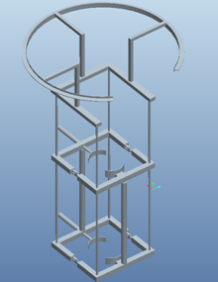

Tool Selection

After utilizing various tools and charts in our measure phase, we realized that we would have to conduct a thorough analysis of the information obtained. Also, for this phase, we realized that we would have to expand upon our engineering analysis and include a comprehensive Gantt chart and critical path, a cost analysis, as well as a sponsor questionnaire. These tools would allow us to analyze various process options, as well as, to aid in the development of our semi-autonomous robot.

Gantt chart and Critical Path Analysis

Both the Gantt chart and the Critical Path Analysis are powerful tools that are necessary for this project in order to help plan and manage various tasks. They allow us to monitor the achievement of project goals, as well as, allow us to see if we are behind when it comes to meeting deadlines. If we do become behind, we can take remedial action in order to get back on track. Out of both the Gantt chart and the Critical Path Analysis, the Gantt chart is easier to identify missed deadlines and obstacles because it shows the relationship between task and time. Our Gantt chart can be seen below in Figure 2, and a larger version can be seen in the Appendix. By analyzing the critical path, we can deduce bottlenecks that could lead to potential delays in our project. Bottlenecks are considered tasks that limit the performance of the entire system. This is because one task may depend upon the completion of another task, and cannot be completed unless the previous task has been finished. Our Critical Path Analysis can be seen below in Figure 3, and a larger version can be seen in the Appendix. Both of these tools prove most crucial in that, without either a Gantt chart or a critical path, the project would be unorganized and unsuccessful.

Figure 2: Gantt chart
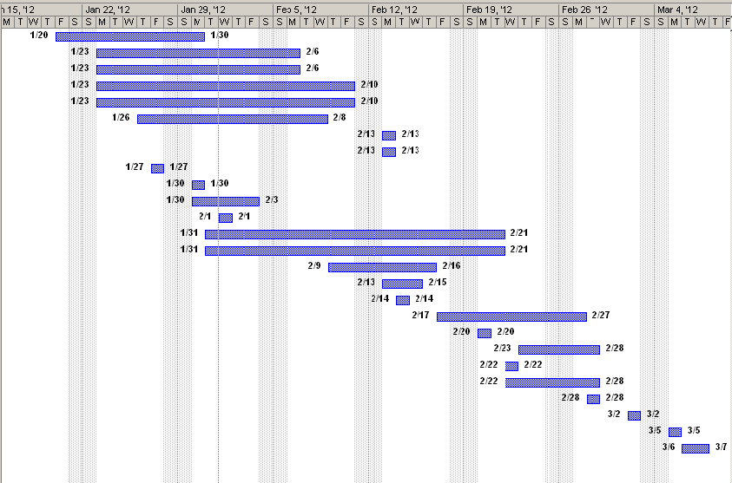

Figure 3: Critical Path Analysis
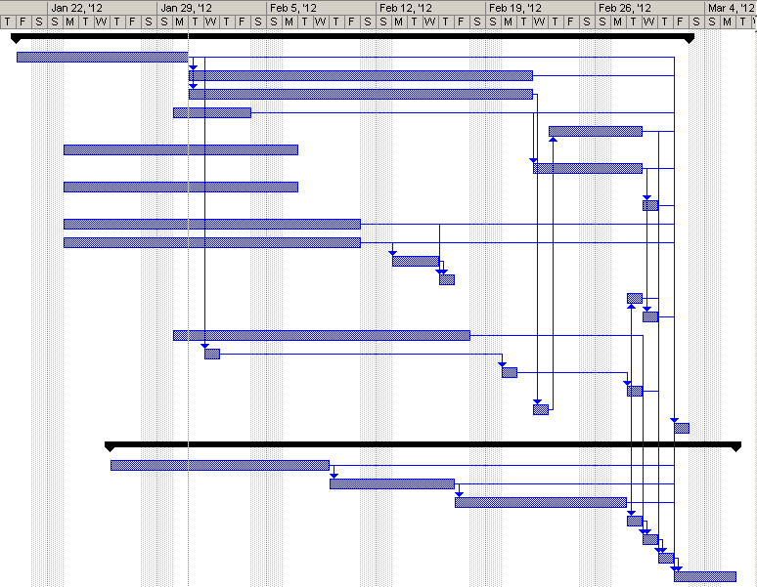

From our Critical Path Analysis, we found that not every task in the construction process needs to be completed sequentially. For example, we can order all of our materials simultaneously, since none of these tasks need to be completed before the next can begin. Then, we must wait for the necessary components to arrive before subsystems such as the support frame for the circular track and the upper and lower frames can be fabricated. Even though these subsystems must be completed and assembled before the final assembly can take place, they are not dependent on each other and, thus, can occur simultaneously. On the other hand, tasks such as attaching clamps to the actuators have several predecessors that must be completed before the task can be completed. Those predecessors are: order material for clamps, fabricate clamps, and mount actuators to frame, which has its own predecessors. Below, Figure 3 shows our Critical Path Analysis. This was beneficial for our project because it showed us the resources needed to execute our project, as well as, where we can take advantage of parallel activity. Overall, this is useful tool that continues to help us figure out the most efficient path to completing our project on time.

Cost Analysis

Machine Aspect

One important facet of this project is being able to compare the machine to current human methods. The best way to get information is by going straight to the source, Dr. Okoli. He is our sponsor and it is important that we cater his needs. In doing this, we asked specific questions to figure out how the project directly related to his oil palm farm. Now we can compare our calculations to the methods currently in place.
We are going to analyze our machine concept first, The King Climber. Time will be one of the main comparing factors. Previously in our measure phase, we calculated a time of 0.075 ft/sec for the robot to climb the oil palm. Therefore, an estimate for the King Climber to climb a 40-60 foot tree would be roughly 9-13.5 minutes respectively. Once the robot has reached the top of the tree, it will then need to cut down the fruit, which will take some skill. This is because they need to be familiar with using a remote controlled camera. It is estimated that it will take 5 minutes per fruit bunch. The same exact loop that was used to climb the tree will be reversed to lower the robot. As a result, the time to climb and the time to descend from the tree will be equivalent. Once the robot has reached the base of the tree, it can be unhooked which is estimated to be 5 minutes. This means that there would be no significant difference in the process of walking from tree to tree. Whether the worker is carrying a robot or his own climbing tools, he is still carrying around equipment which means the time it takes to travel to each tree will be dependent on the distance between the trees. The only difference is that the robot is designed to be easily transported by two employees. Once the robot and the employees have made it to the base of the next tree, it will take another 5 minutes to attach the robot safely to the oil palm.
Now that the King Climber has been assessed, we must look at the information related to the current method of human climbers. The time it would take a human worker to climb an oil palm is 10 minutes. Once the worker makes it to the top of the tree, it only takes him a total of 1 minute per bunch to be cut down. Once the bunches have been cut down, the worker descends in the same manner in which he climbed to the top. This means that the time for a human to climb a tree and descend down should relatively be the same time, 10 minutes. Again the time between the trees varies depending on the distance between the trees, but should be equivalent to the times of transporting the King Climber making that time irrelevant. Once the worker has made it to the base of the next tree, it will take him 10 minutes to get set up and ready to make his next climb. Below, Figure 4 provides a summary on the process times.
Figure 4: Process Times
Time (in minutes) | Process
Time (in minutes) | Machine | Human
Climb | 13.5 | 10
Cut | < 5 per bunch | 1 per bunch
Descend | 13.5 | 10
Unhook | 5 | 10
Transport | 2 | < 1
Setup | 5 | 10

Assuming a tree has five bunches per tree, it would take a human 45 minutes to cut down all bunches. So for a group of ten trees, it would take roughly 7.65 hours (45*10 + 1*9). Whereas, for our robot, it is estimated that it would take 10.63 hours (62*10 + 2*9). We were told the workers only work for 6 hours, so let us compare 8 trees instead. The times for the King Climber and the human are 8.5 and 6.12 hours respectively. So when comparing just the times of a controlled group, 8 trees with 5 bunches per tree; we see that the current human method has lower times i.e. 6.12 hrs. < 8.5 hrs. So theoretically, the human can perform the job faster. This does not take into consideration the actual fatigue that a human would encounter. The King Climber, on the other hand, only fatigues the worker by transportation. This gives the robot a huge advantage, because it can maintain pace as well as prevent injuries that are caused by such a rigorous task. Although the machine would take a couple hours longer to do the same task, the physical labor is so much lower that the extra two hours would not be very much a hindrance to the worker.
Next, we must conduct a thorough cost analysis regarding machine costs. This includes obtaining exact prices for materials, controlling expenditures, as well as, being able to analyze potential profit. By obtaining exact prices for materials we can create a bill of materials. A bill of materials is important because it lists the individual parts and quantity of each needed to build the semi-autonomous robot. Also, by knowing exact prices for materials, we can make sure that we are within our budget constraint of $2000. After we figure out the total cost to build the semi-autonomous robot, we will sell this product to companies for 5 times the cost to build the robot. By having a selling price, we can use economic analysis to figure out the potential profit that can be made by the development of this semi-autonomous robot. Conducting an in-depth economic analysis would set the foundation for the business aspect of this project. Chart 1 portrays a Bill of Materials which includes all necessary parts and costs.

Chart 1: Bill of Materials
Vendor | Product | Quantity | Unit Price | Extended Unit  Price
Grainger | Square Tube, AL, 1.75'' Inside Sq., 6ft | 6 | $33.55 | $201.30
EVAplus/Wytec Motorola | Dragon12P-USB-SM Microcontroller | 1 | $159.00 | $159.00
Sunpentown | 1000W 2.0HP Power Generator | 1 | $180.00 | $180.00
Firgelli Auto | 30" Stroke 100lb Fast Force Actuator | 2 | $169.99 | $339.98
Firgelli Auto | 6" Stroke 100lb Fast Force Actuator | 2 | $159.99 | $319.98
Firgelli Auto | Mounting Bracket | 8 | $9.00 | $72.00
Firgelli Auto | Speed Controller Motor Driver | 4 | $39.00 | $156.00
Firgelli Auto | Wiring and Control Kit | 2 | $18.00 | $36.00
Firgelli Auto | Shipping charge | - | - | $134.92
TOTAL COST |  |  |  | $1599.18

After we have figured out our total material cost, we must project the products financial growth. According to Chart 1, the total material cost to build our semi-autonomous palm pruner is $1599.18. In order to effectively impact the market, we must choose a mark-up percentage that ensures that we have chosen a fair selling price to our consumers. Usually, the mark-up percent is the suggested amount that a team wants to earn from a given project. In this case, since we are being sponsored by Dr. Okenwa Okoli, he, alone, gets to determine the actual markup percent. Because the King Climber is an extremely innovative product for such a broad target market, Dr. Okoli chose a 500% markup. With this number in mind, we were able to put a monetary selling price of $9,595.08 on the King Climber. We have deemed this the monetary selling price and not the final selling price because some of the machine parts have not been taken into consideration such as the blade of the cutting apparatus.
After we have determined the selling price for the King Climber, we then calculated the Return of Investment (ROI). The ROI is the same as the Mark-up Percent because it states a ratio of gain from a given product. As a result, the ROI is actually a checking device that clarifies all information so that it matches previous facts. Since the Mark-up percent and the ROI match, we can now determine the value of the King Climber after a specific amount of years. This can be done using the future value formula.
Basically, future value of a product can be predicted using several tools. However, since this is a hypothetical case of the King Climber working, we will use the simple interest analysis tool. We are using this tool because after the prototype is developed, we cannot reduce its final cost. As previously stated, the interest will be 500%, ROI, and we will calculate the information based on a five year period. We will then put this information into the Future Value Formula.
Below shows the steps when calculating the selling price, the return of the investment (ROI), as well as, the future value.
Selling Price = Total Cost (1 + Mark-Up Percent)

= $1599.18 (1+5)

= $9,595.08

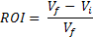

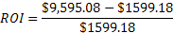

FV = Future value
PV = Present value
r = Annual interest rate
t = Time in years

Figure 5: Future Worth Projection

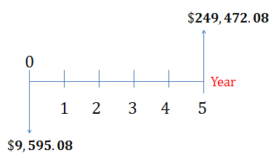

Figure 5 shows that the King Climber will be worth approximately $249,472.08 after five years. This shows that this is a great business opportunity to become involved in. However, we must realize that the selling price will increase when all parts have been included in the total cost. This is because the selling price is dependent on the future value in that, if the selling price increases, so does the future worth. Our group continues to implement concurrent engineering techniques to ensure that we can constantly improve aspects of our product in order to achieve the highest quality and profit attainable.

Human Aspect

Now that the King Climber has been assessed, we must look at the information related to the current method of human climbers. The time it would take a human worker to climb an oil palm is 10 minutes. Once the worker makes it to the top of the tree, it will only take him a total of 1 minute to cut a bunch down. Once the bunches have been cut down, the worker descends in the same manner in which he climbed to the top. This means that the time for a human to climb a tree and descend down should relatively be the same time, 10 minutes. Again the time between the trees varies depending on the distance between the trees, but should be equivalent to the times of transporting the King Climber making that time irrelevant. Once the worker has made it to the base of the next tree, it will take him 10 minutes to get set up and ready to make his next climb.
Oil palm farms, like any other type of farm, depend on various factors such as the: size of the farm, the manpower available to maintain it, the pay rate, the numerous harvesting methods, etc. Due to these limiting factors, we must evaluate the oil palm farm based on arbitrary numbers provided by our sponsor Dr. Okoli. He is a valid resource when obtaining needed information because he personally owns an oil palm plantation.
For our project, we will create a hypothetical case in which we will study a palm oil farm that consists of 20 palm pruners. This scenario will be used so that we can obtain a better understanding when it comes to conducting an accurate economic analysis. Also, in order to conduct an accurate economic analysis, we will need to figure out the amount of palm fruits that can be harvested at a given time period, the actual pay rate of the pruner, as well as the benefits they receive from their employer. Obtained from our sponsor questionnaire, we found that the average salary of a palm pruner is $2.00 per fruit bunch they cut. Also, we found that the palm pruner climbs up the oil palm consisting of approximately 5 fruit bunches every 45 minutes. This means that 8 palms can be harvested in 6.12 hours resulting in a total earning of $80.00. From this information, we can deduce the amount that Dr. Okoli, an oil palm farm administrator, pays for labor cost. From this information, we will evaluate an oil palm farm consisting of 20 employees working a 6-hour shift per day. Results from this information reveal that a normal farm administrator spends approximately $1,600.00 in labor cost per day. This means that in a 5 day working week, approximately $8000.00 is spent on labor cost and in one month approximately $32000.00 is spent. Keep in mind that all 20 of these workers are performing consistently. From this present value, we can calculate a future projection of the total expenditure an oil palm administrator spends in 5 years. Once again, we calculated the future worth of the labor cost. We chose a simple interest rate of 5% due to the fact that labor has a very low increase rate. Using the formula on future worth found in the previous section, we calculated a total labor cost of $864000.00 in a period of 5 years. This is shown in Figure 6. Also, a summary of the previously discussed information comparing both the human and machine aspects can be found below in Figure 7.

Figure 6: Future Worth Projection

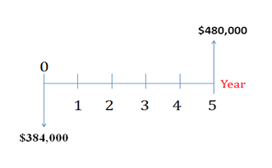

Figure 7: Comparison Chart

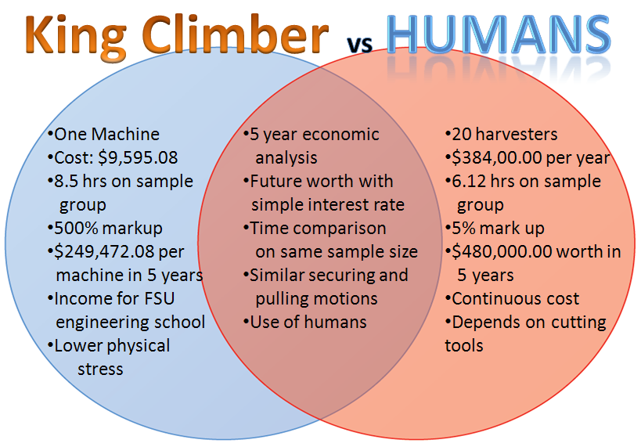

Sponsor Questionnaire

Finally, the last major tool that will be utilized in this analyze phase is a sponsor questionnaire. Our sponsor questionnaire can be found in Appendix G. A sponsor questionnaire is beneficial in that it allows us to see any missed or hidden needs of our sponsor. Also, it allows us to make sure that we have met all of our sponsor’s needs and requirements. This tool is most important because our main goal throughout this project is to ultimately satisfy the customer by addressing and achieving all of their needs.

Interactions

There are many functions and actions involved in the operation of the King Climber. This section is provided to descriptively layout each process. These processes can be broken down into two major categories: 1) Human Interaction with the King Climber and 2) King Climber’s Response to Human Command. Each category will then be broken down into the procedural steps necessary to accomplish the task of harvesting the oil palm tree’s fruit. We will begin with Human Interaction.

Human Interaction with the King Climber

- Transportation of the King Climber and components (generator, remote controller, etc...) to site.
This involves the most physical portion of the operation for the human. The device will have to be carried to the plantation and set up for installation.
- Attach King Climber to tree.
Attach device to the base of the tree by the four v-shaped grapplers (two at the top and two at the bottom).
- Set up connections.
Make sure all of the proper connections are made between the King Climber and its components.
- Verify generator is running and King Climber is getting power by checking if the power indicator light is on.
- Verify camera is powered up and is working properly
- Verify remote is connected and cutter device is functioning properly.
- Double Check Connections.
Verify all of the components and electrical feeds are installed and attached properly. For example, make sure the grapplers are secured to the tree trunk.
- Attach Cutting Track.
Place cutting track onto guiding rods.
- Start Ascension.
Push the “climb up” button to initiate the robot’s systematic ascension up the tree. This will start the process.
- Fruit Harvesting.
Once the robot has reached the top of the tree, use the remote controller to maneuver the camera and cutter arm to remove the desired fruit from the tree.
- Start Descent.
Push the “climb down” button to initiate the robot’s systematic descent down the tree. This will end the process.
- Detach King Climber.
Remove the device from the trunk of the tree. Move to the next tree and repeat steps 3-7.
Obviously, the most crucial functions are carried out by the device itself due to the autonomous nature of the King Climber. As a result, this is where the focus of the procedure will reside. The following will describe the King Climber’s response to human command.

King Climber’s Response to Human Command

- Establish all Connections.
Connect all of the components appropriately. For example, make sure that the remote is effectively sending signals to the camera and control arm before the climber begins ascent.
- User Presses “Climb up” Button.
Once the “climb up” button is pressed by the user, the King Climber springs into action. This starts the climbing process.
- Ascension.
The King Climber will begin climbing by completing a sequence that will be repeated (looped, in programming code) until the desired distance is traveled along the tree. This is accomplished by the top two grappler arms releasing their grasp and then retracting in the same fashion as the top two did previously. Now, the support arms will also retract, bringing the bottom grappling arms upwards toward the rest of the machine resulting in the original position (in regards to proximity from the top two grappling arms), but just further up the tree. Now, the bottom grappler arms extend and re-establish a secure grip on the tree trunk. These motions will be reoccurring until the King Climber arrives at the top of the tree. (No human interaction involved for the duration of this step)
- Fruits of our Labor.
Now that the King Climber is at the top of the tree the operator must command the device to remove the fruit from the tree through remote communication. The camera will be mounted on the cutter (manipulator) arm, which revolves around the circular cutting track. The user will maneuver the camera to view the fruits to harvest and push the “harvest” button to begin the cutting of each bushel of fruit from the tree.
- Cutting the Fruit.
Once the “harvest” button is pushed, the cutting tool will start spinning in the manner of a circular saw blade and gradually separate the fruit from the tree.

- Descent.
Now that the desired fruit is cut from the oil palm tree it is now time to climb down the tree. Once the user presses the “Climb down” button, the King Climber will begin its descent of the tree in essentially the same manner that it did during the ascent process. The only difference is that instead of the top two grappling arms retracting and releasing first, they will follow the motion of the bottom two grappling arms. In other words, the bottom grapplers will release, retract, and the support arms will extend downwards first, while the top grappler arms remain secured to the trunk of the tree. Then, the grasp of the bottom two grapplers will be re-established and the top two grapplers will then release, retract, and follow the support arms down, then re-establish a secure grasp on the tree themselves. This will be repeated until the device reaches the base of the tree again. (No human interaction involved for the duration of this step)
- Turn off Power.
Shut down all electrical components before removing and transporting device from tree to tree.
- Detach King Climber.
Remove the device from the trunk of the tree. Move to the next tree and repeat steps 2-7.

Analysis Factors and Objectives

Fishbone Diagram

The diagram below is a comparison analysis fishbone chart used to compare and contrast the traditional form of harvesting oil palms by local labor force with our new robotic method of harvesting. The top of the chart shows the human method in blue. It is broken down into two halves of the harvesting process. The first part is the actual climbing method. This method consists of having a human climber utilize two straps in order to shimmy up the tree while alternating each strap in tension. This method of climbing requires skill, as well as, practice and a single mistake can send the climber plummeting to the ground.
Figure 7: Comparison Fishbone
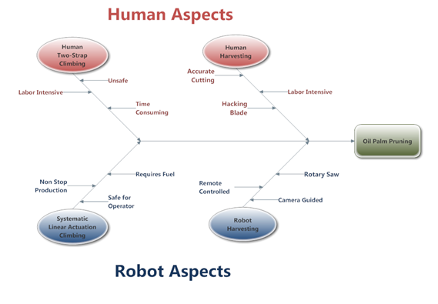
The average speed for the climbing method is approximately 0.03 m/s. Not only is this method unsafe, it is also very labor intensive. A worker can only complete about two to four trees per day before they become tired and physically weak. As a result, this becomes a safety issue. Next, we will compare this to the bottom section of the fishbone chart shown in red. This section represents the robotic method of climbing. The semi-autonomous robot we have designed uses electric actuators to systematically force its way up the tree. This method moves the cutting mechanism up the tree with a speed of 0.022 m/s. Because this is a robot climbing up the palm and not a human, there are many added benefits. The first benefit being that it is completely safe for the operator. Everything the user needs to do is based on the ground a safe distance away from the tree and the equipment. Also, another advantage over the human climbing method is that a robot will never get tired. The King Climber design allows for a continuous method of production. The only drawbacks are that the system requires fuel for the electric generator and is slightly slower than a skilled human climber.
Next, we will compare and contrast the cutting process of the two different harvesting methods. The human climber is physically at the top of the tree with straps that allow him to navigate around the full circumference of the fruit bearing section, and by use of visual inspection, he can select the fruits to be harvested. The man in the tree can check for ripeness and then chop the fruits off with a hacking blade by hand. This process is more accurate but also more labor intensive. The robot in comparison is being guided by the ground based user that is selecting fruit by sight alone from the input of the camera. After selecting a fruit, the same user needs to maneuver the rotary cutting blade mounted to the 270 degree track by remote control to physically make the cut. As a result, this process is more time consuming then having an actual human climber complete the task. However, utilizing a semi-autonomous robot avoids all risks associated with the human climbing aspect.

Potential Problems and Theoretical Solutions

In our analysis of our chosen design, all possibilities have been covered to ensure completion by the deadline to guarantee customer satisfaction. Some of these possible problems have been analyzed and solutions have been created if those problems come to bear.
- Metal Bending Complications – Welding Semi-Circles
The cutter will be revolving on an aluminum circular track. This means that the aluminum will have to be bent. We do not have access to machinery with that type of capability. This means that we will have to seek out the services of another entity to accomplish this task for us. In the event that we cannot locate a local metal bending facility or find one that suits our budget, we cannot just abandon the project. We will have to make the proper adjustments. Instead of having the circular track as one piece, we can construct it out of several smaller pieces and weld them together to create our circular track. This will not be as aesthetically pleasing, but it will suffice in getting the job done and will be substantially cheaper.
- Manipulator Arm Difficulties- Simplify the design
The manipulator arm is a component that we will have to construct ourselves. As of now, our design is complex, but it is nothing that we are not capable of manufacturing as long as the budget permits. In the event that we cannot afford the necessary parts to fabricate the current manipulator arm design, we will have to produce a more simplistic design. The alternatives will likely consist of an arm with fewer joints, allowing for fewer degrees of freedom. This will no doubt cause the arm to be less effective, but it will still be capable of harvesting the fruit, it would just take more time. Also, purchasing a cutter tool that translates back and forth as oppose to one that revolves would be another alternative. Again, this will take longer, but it is an option that would suffice.
- Actuator Weakness -Weight Reduction
The next problem that we could encounter is that our estimations were off in the original design and the prototype weighs more than the designed 200 pounds. This could happen from leaving the weight of certain parts out or by thinking that the electronics, weight of wiring, or controls maybe be more than expected. Actuators too weak for climbing would be catastrophic for the function of the prototype.
The solution to such a problem would be to reduce the weight by removing all non essential parts. These may include the second camera, extra supports, or lastly the guiding rods. If this doesn't fix the problem a more permanent solution could be to make a reduction in the size and thickness of the frame itself. That solution would be a major adjustment and should be kept as a last resort because it would put us over budget and past deadline.
- Electronic Problems -Enlist outside help
Finally, one of the last problems we can try to foresee is that we could have problems with our electronics or programming. This has been a major concern from the start of the project being that the group is comprised of industrial engineers and mechanical engineers who have taken minimal classes on programming. We currently have an outline of the program that we would like to run, but without further specifications from the actuators, we cannot finish the coding. Also there is no guarantee that the code will run after it is written or that the hardware will be wired correctly.

If any of these problems delay progress concerning the completion of our prototype, the solution is to immediately ask for help from the multiple resources we have here at the engineering campus. These resources include the use of office hours, aid from other students, etc.

Next Phase

Now that we have finished the analyze phase, our group will move on to the design phase of the DMADV process. We have ordered and received our parts for the frame, actuators, and generator. We are only waiting on the new purchase orders that we have placed for our rubber and clamps, as well as, finalizing the design for the cutting arm. We are currently setting up times to fabricate our robot. Also, we will reference tools discussed in the Analyze phase such as the Critical Path Analysis to ensure that everything continues in a smooth manner.

Appendix
- House of Equality
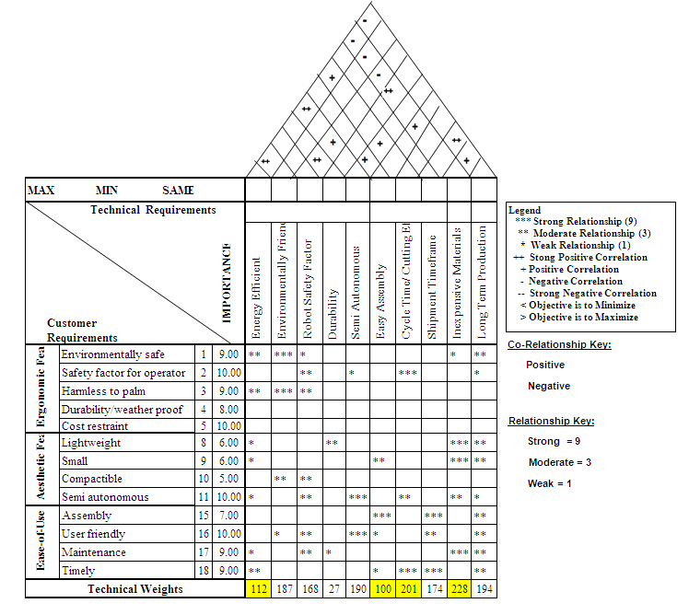
- Venn Diagram
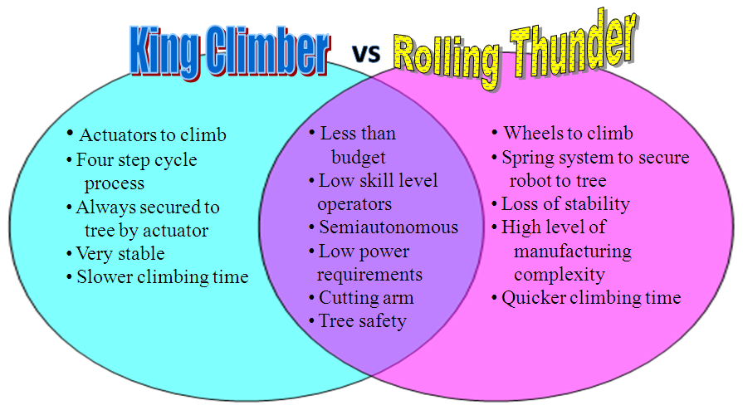

- Pugh Selection Matrix
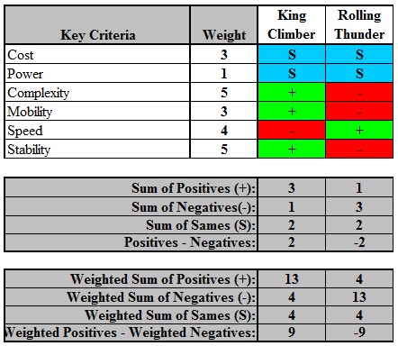
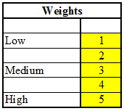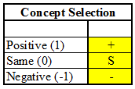
Matrix Keys:
- Traditional Selection Matrix
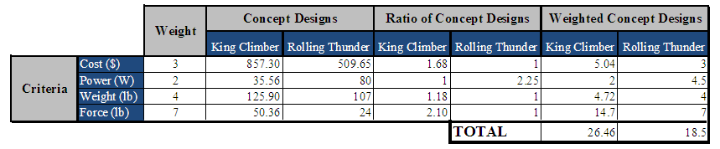

- Pro-E Screen Shot Picture Simulations from Beginning to End
  - Robot Extended Compact 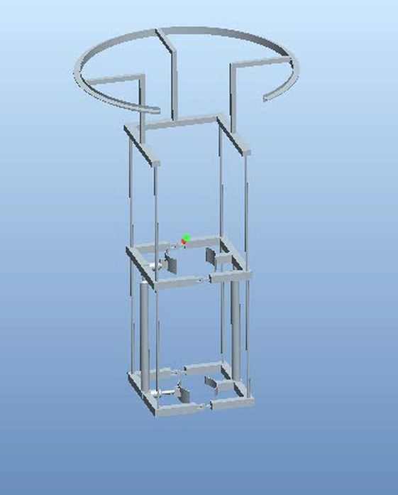

  - Compact Top Clamp

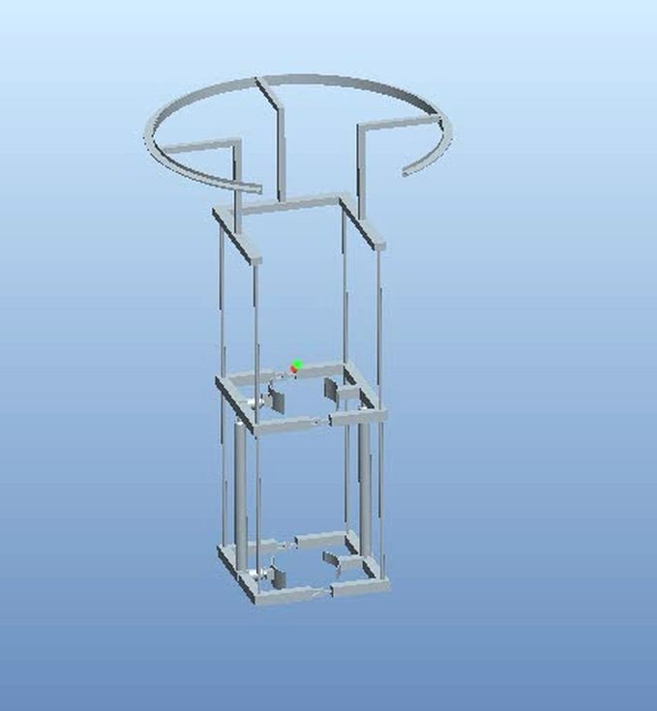

  - Compact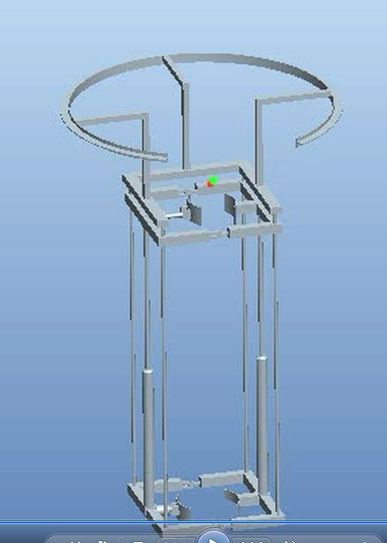

  - Extended Top Clamped

  - Extended Top Open

- Finite Element Analysis

- Lower actuator frame

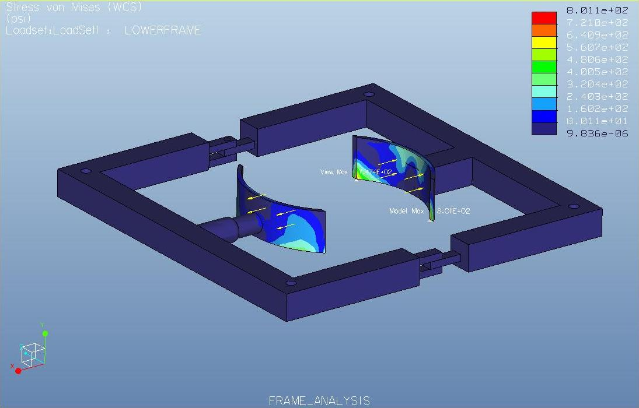
- Lower frame
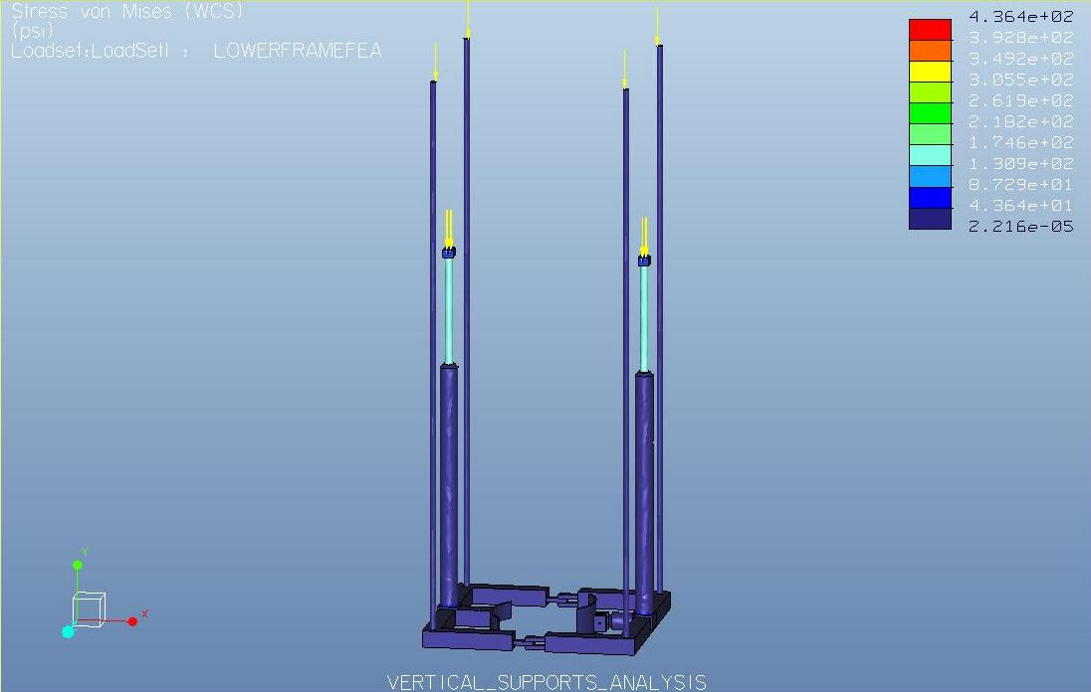

- Manipulator Track

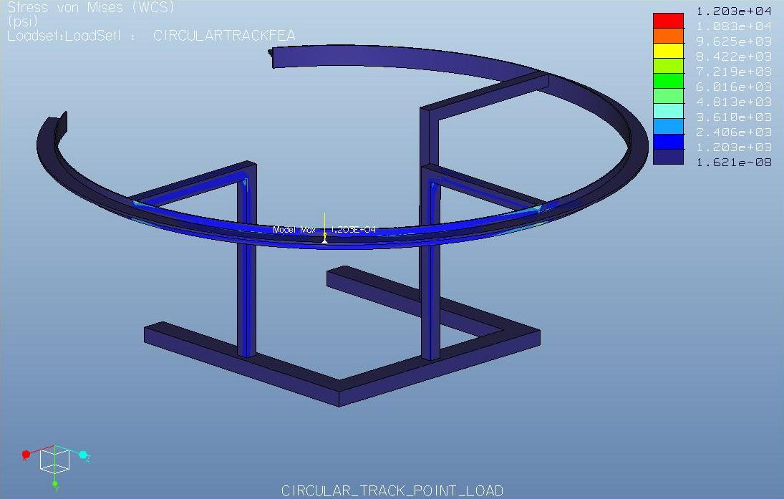

- Sponsor Questionnaire
Sponsor Questionnaire: group and Dr. Okoli
- What is the average time for a worker to climb up a tree? 10 mins

- What is the average time for a worker to cut a palm oil’s fruit bunches?1.0 min per bunch

- What is the average time it takes to walk from oil palm to oil palm? Depends on population density – say less than 1 min

- What is the average setup time before going up a tree? 10 mins

- What is the average number of workers working in a 1 hr? depends on population density – pick an arbitrary number

- What is the average number of trees that can be cut in 1hr? Depends on number of bunches

- What is the average distance between trees? ~ 10 ft.

- What is the number of hours that workers work? ~ 6 hrs

- What is the average salary for a palm pruner? $2 per bunch cut

- What is the physical stress on the body of a palm pruner from climbing up a tree? Just imagine!

H) Gantt Chart

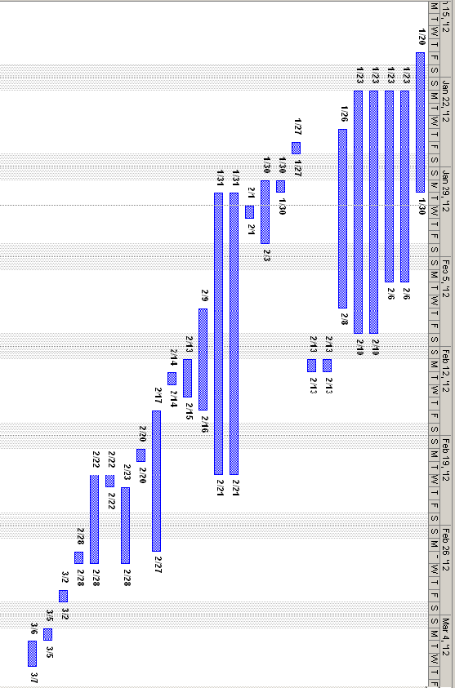

- Critical Path Analysis

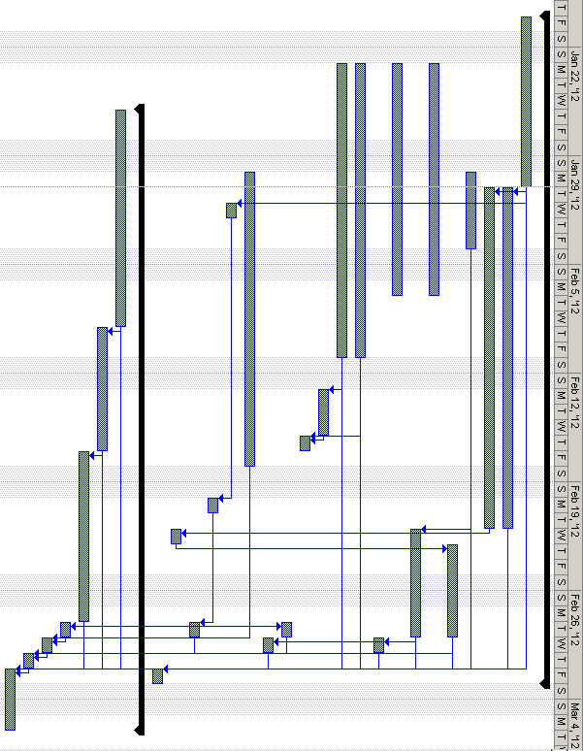

- References

- Aberdeen Group. (2005). New Product Development: Profiting from Innovation.The New Product Development Business Value Research Series, Boston, MA.

