**King Climber**

**Operations Manual**

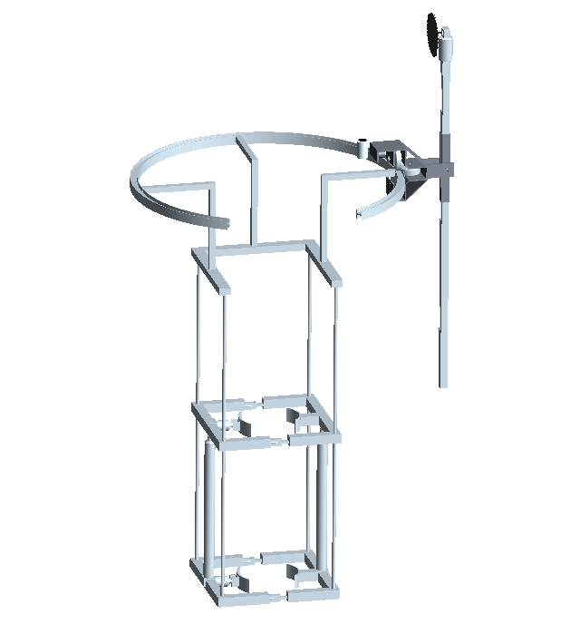

**3E Inc.**

**Obie Abakporo**

**William Craig**

**Xavier Smith**

**Introduction**

Congratulations, you are now the new proud owner of a King Climber prototype. This device is fairly simple to assemble and will climb your tallest oil palm trees and cut down the fruits for you. Please follow the assembly manual section for directions on how to put this large box of components together. The following sections labeled process manual and functional diagram will explain how to operate the device to get it to harvest your profitable fruits. We have made sure that this product is as safe as possible using RULA and NIOSH standards. I hope you will enjoy your new device for years to come.

**King Climber Assembly Manual**

Once purchased, the King Climber has to be assembled. This will be described in the following steps:

|  |
| --- |
| **Tools Required:** |
| ½” Socket |
| Socket Wrench |
| ½” Wrench |
| Drill (*Not necessary, but could make job easier)* |

**Exploded View**

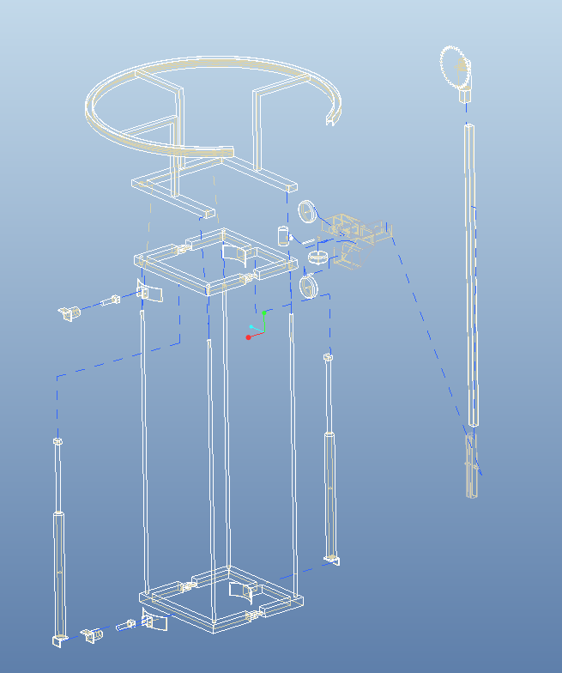

**Frame Assembly**

*Step 1* - Remove all of the structural components from the box, this includes: two metal rectangular frames, four ball bushing bearings, four guide rods, eight corner brackets, sixteen 5/16” bolts, eight actuator plugs, four v-shaped grappler arms (two already mounted to frame), and four actuators (two horizontal and two vertical). *Set aside/leave the electrical components in the box, we will return to them later…..*

*Step 2 -* Now, we will begin assembly. Place one of the four guide rods into the hole at each corner of the bottom frame and attach one of the eight corner brackets to at the end of each guide rod. Then, bolt the bracket down onto the frame using a ½ inch socket and/or wrench (two bolts per bracket). Make sure rods are secure.

*Step 3 -* Attach the two vertical actuators (the longer ones) to the middle of the bottom frame, on top of the v-shaped grappler arms (with the motor of the actuators closest to the bottom frame). After fitting the bracket hinge into the slot and inserting one of the actuator plugs, repeat this step for the other vertical actuator.

*Step 4 -* Grab the top frame and insert it over the guide rods (similar to the bottom, one rod at each corner). Next, grab the four ball bushing bearings and place one over each guide rod and slide it into place (each hole in the frame is a opening designated to a bearing). Secure by bolting down the bracket in the same fashion explained earlier with two bolts per bracket. Don’t forget to insert the top end of the actuators to the bracket on the bottom of the top frame and insert the actuator plug to secure it.

*Step 5 -* Attach the two horizontal actuators (the shorter ones) to the top of the mounting blocks (the protruding portion of each frame), one to the bottom frame and one to the top frame with both of the motors facing out of the frame. Secure them by sliding the bracket hinge of the actuator into the slot on the frame and inserting the actuator plug into place. Verify security.

*Step 6 -* Take the two unattached v-shaped grappling arms and secure them to ends of the horizontal actuators (the ends facing inwards of the frame). Lastly, insert the final two actuator plugs in the same fashion as detailed before. Setup complete!

*Moving on to the electrical components……*

**Electrical Connections**

*Step 1 -* Gather all electrical components which include: generator, remote control, extension cord, and cable wire.

*Step 2 -* Plug the micro controller, and both power supplies into the surge protection strip. Plug the extension cord into the generator and start the generator. Ensure the connection to the remote control is the

*Step 3 -* Verify the generator and other components are all receiving power. The remote control is what will be used to regulate/control the power the King Climber will receive through its established power connections.

**King Climber is ready for deployment!!**

**King Climber’s Process Manual**

1. **Establish all Connections.**

Connect all of the components appropriately. For example, make sure that the remote is effectively sending signals to the camera and control arm before the climber begins ascent.

1. **User Presses “Climb up” Button.**

Once the “climb up” button is pressed by the user, the King Climber springs into action. This starts the climbing process.

1. **Ascension.**

The King Climber will begin climbing by completing a sequence that will be repeated (looped, in programming code) until the desired distance is traveled along the tree. This is accomplished by the top two grappler arms releasing their grasp and then retracting in the same fashion as the top two did previously. Now, the support arms will also retract, bringing the bottom grappling arms upwards toward the rest of the machine resulting in the original position (in regards to proximity from the top two grappling arms), but just further up the tree. Now, the bottom grappler arms extend and re-establish a secure grip on the tree trunk. These motions will be reoccurring until the King Climber arrives at the top of the tree. (No human interaction involved for the duration of this step)

1. **Fruits of our Labor.**

Now that the King Climber is at the top of the tree the operator must command the device to remove the fruit from the tree through remote communication. The camera will be mounted on the cutter (manipulator) arm, which revolves around the circular cutting track. The user will maneuver the camera to view the fruits to harvest and push the “harvest” button to begin the cutting of each bushel of fruit from the tree.

1. **Cutting the Fruit.**

Once the “harvest” button is pushed, the cutting tool will start spinning in the manner of a circular saw blade and gradually separate the fruit from the tree.

1. **Descent.**

Now that the desired fruit is cut from the oil palm tree it is now time to climb down the tree. Once the user presses the “Climb down” button, the King Climber will begin its descent of the tree in essentially the same manner that it did during the ascent process. The only difference is that instead of the top two grappling arms retracting and releasing first, they will follow the motion of the bottom two grappling arms. In other words, the bottom grapplers will release, retract, and the support arms will extend downwards first, while the top grappler arms remain secured to the trunk of the tree. Then, the grasp of the bottom two grapplers will be re-established and the top two grapplers willthen release, retract, and follow the support arms down, then re-establish a secure grasp on the tree themselves. This will be repeated until the device reaches the base of the tree again. (No human interaction involved for the duration of this step)

1. **Turn off Power.**

Shut down all electrical components before removing and transporting device from tree to tree.

1. **Detach King Climber.**

Remove the device from the trunk of the tree. Move to the next tree and repeat steps 2-7.

**Device Functional Diagram**

The functional diagram depicts the flow of operation with the use of a palm pruning device. You need the functions to be simple enough that anyone can learn it quickly and the steps to be logical in order. The harvester was designed to have three buttons on the remote cover all the required operations of the climber.

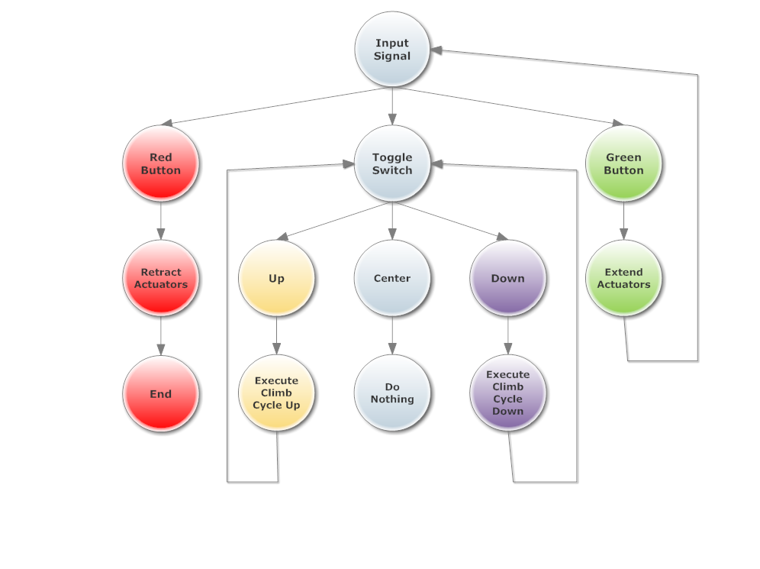

**Circuit Diagram**

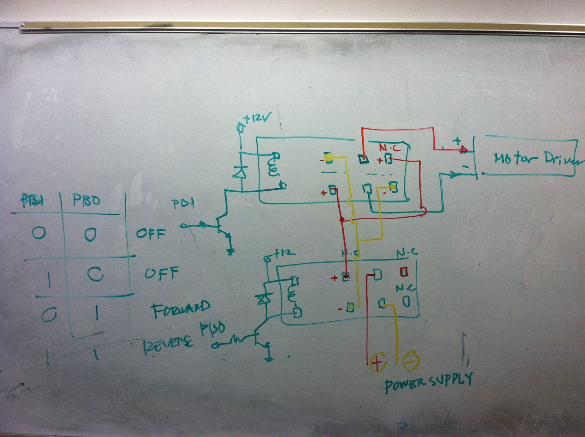

This circuit schematic that illustrated the possible switches, transistors, diodes, and op-amps needed to be constructed on the dragon board to perform the desired tasks. This is the circuit schematic that is implemented on the actual dragon board (microcontroller).

**List of Materials**

|  |  |  |  |  |
| --- | --- | --- | --- | --- |
| Vendor Name | Product Description | Quantity | Unit Price | Extended Unit Price |
| Grainger | Square Tube, AL, 1.75'' Inside Sq, 6ft | 6 | $33.55 | $201.30 |
| Grainger | DAYTON Ball Bushing Bearing, Closed, Bore 3/4 In | 4 | $20.62 | $82.48 |
| EVBplus.com/ Wytec Motorola | Dragon12P-USB-SM Microcontroller | 1 | $159.00 | $159.00 |
| Sunpentown | 1000W 2.0HP Power Generator | 1 | $180.00 | $180.00 |
| Firgelli Auto | 30" Stroke 100lb Fast Force Actuator | 2 | $169.99 | $339.98 |
| Firgelli Auto | 6" Stroke 100lb Fast Force Actuator | 2 | $159.99 | $319.98 |
| Firgelli Auto | Mounting Bracket | 8 | $9.00 | $72.00 |
| Firgelli Auto | Speed Controller Motor Driver | 4 | $39.00 | $156.00 |
| Firgelli Auto | Wiring and Control Kit | 2 | $18.00 | $36.00 |
| *Firgelli Auto* | *Shipping Charge* |  |  | *$134.92* |
| McMaster Carr | Multipurpose Aluminum (Alloy 6061) 1/4" Thick * 3" Width * 6' Length | 1 | $23.00 | $23.00 |
| McMaster Carr | Multipurpose Aluminum (Alloy 6061) 1/4" Thick, 3" Width, 3' Length | 2 | $40.35 | $80.70 |
| McMaster Carr | General Purpose Low-Carbon Steel Round Tube, 1.625" OD x 1.25" ID | 1 | $20.91 | $20.91 |
| McMaster Carr | Flexible Multiconductor Cable Shielded, 20/7 AWG, .39" OD, 600 VAC, Gray | 40 | $3.61 | $144.40 |
| McMaster Carr | Three Conductor Power Cord NEMA 5-15 Plug, SVT-Round, 18/3 AWG, 6'7" Length | 2 | $3.56 | $7.12 |
| McMaster Carr | Indoor/Outdoor Extension Cord NEMA 5-15, SJTW, 16/3 AWG, 50' Length, Orange | 1 | $20.87 | $20.87 |
| McMaster Carr | Outlet Box with Knockouts | 1 | $4.24 | $4.24 |
| McMaster Carr | Illuminated Rocket Switch White, DPDT, on-OFF-on, 5 AMP | 1 | $17.80 | $17.80 |
| McMaster Carr | 22mm Panel Cutout Plastic Switch 1-3/16" Dia, Proj Head, SPST-NO, Momentary, Black | 1 | $14.34 | $14.34 |
| McMaster Carr | 22mm Panel Cutout Plastic Switch 1-3/16" Dia, Proj Head, SPST-NO, Momentary, Red | 1 | $14.34 | $14.34 |
| McMaster Carr | 22mm Panel Cutout Plastic Switch 1-3/16" Dia, Proj Head, SPST-NO, Momentary, Green | 1 | $14.34 | $14.34 |
| Kelly Sheet Metal, Inc. | Fabrication and welding of metal material, labor cost by the hour | 2 | $65.00 | $130.00 |
| TOTAL COST |  |  |  | **$2,173.72** |

# 

# **Health and Safety**

# 

The King Climber was designed and developed in order to replace the diminishing workforce of the palm plantation industry. Not only is the King Climber a safer alternative to prune palms, it is user friendly and provides an easier workspace for the worker. When designing the King Climber, we took into consideration ergonomic regulations such as appropriate lifting of the arms, legs, and back. By limiting the stress on the body, we can prevent the occurrence of repetitive strain injuries which could ultimately lead to long term disability.

In order to accurately assess the King Climber, we utilized the National Institute of Occupational Safety and Health (NIOSH), as well as, the Rapid Upper Limb Assessment (RULA). When we first used NIOSH to analyze the lifting procedures of the King Climber, we found that the lifting index calculated was too high. This was due to the fact that the King Climber was extremely heavy for one worker to transport from tree to tree. This was an easy solution in that we made it necessary that the King Climber must be transported by a minimum of two workers. Also, an alternative to lifting and carrying the King Climber would be to install outdoor wheels to the bottom of the robot. Because of the time constraint, the wheels will not be installed; however, this will be an option when purchasing the King Climber. In order to make sure that the King Climber does not cause harm to the upper body, we implemented a RULA assessment. Conducting a RULA assessment is necessary because it estimates the risks of developing work-related upper limb disorders. Our King Climber scored a 2 on the RULA assessment. This means that the worker has minimal action and is working in the best posture with little or no risk of injury from their work posture tasks are limited.