Concept Generation and Selection

**EML 4551C – Senior Design – Fall 2011 Deliverable**

Team #16

**Amy Eckerle**

**Andrew Whittington**

**Philip Witherspoon**

*Department of Mechanical Engineering, Florida State University, Tallahassee, FL*

*Project Sponsor*

Dr. Ulf Trociewitz



*Project Advisor*

**Dr. Eric Hellstrom**

*Department of Mechanical Engineering*

**Introduction**

The National High Magnetic Field Laboratory (NHMFL) and the Applied Superconductivity Center (ASC) have identified some weaknesses in existing critical current probes. A critical current probe is used to test samples of superconducting material. These tests determine the sample’s resistance to varying current at a temperature of 4.2K. Liquid helium is used to obtain 4.2K. Each sample will have a critical current at this temperature which will cause it to leave the superconducting state. This data is recorded by a computer during the test and can be analyzed by the experimenter.

There is some concern over the rate of burn off of the liquid helium as the cost of liquid helium is rather high. Critical current probes are placed in a bath of liquid helium inside a dewar and extend out of the dewar into ambient temperature. This creates a major temperature gradient which could be overcome to reduce the consumption of the helium.

This paper looks into the different sources of heat leaks and proposes potential improvements to the additional design. There are multiple constraints on the probe design due to the existing dimensions of the dewar, which may not be altered. Helium conservation is the largest objective of redesigning the existing probe. The most effective method to begin designing a probe which will conserve helium is to identify all of the heat leaks into the system. Other objectives for this project include being able to test 6-8 short samples, 1 spiral sample, deliver 1000 Amps to the samples, and remain durable.

**Objectives**

* Conserve helium
* Test 6-8 short samples
* Test one spiral sample
* Deliver 1000 Amps to the samples
* Durability

Heat leaks into the system may be identified simply. Any portion of the system which is in room temperature that extends into the liquid helium inside the dewar is a potential heat leak. This includes the current leads and the casing. There is also a difference between the static and dynamic load heat leaks. Figure 1 shows a very simple set up of a critical current probe. The current leads act as a static heat leak when there is no current passing through them and a dynamic leak when they are in use.

Heat Leaks

* Current Leads
  + Static
  + Dynamic
* Casing



Figure 1-Simple Probe Schematic

Several concepts have been generated to reduce the consumption of helium and improve the design of this probe.

**Over view**

For superconducting magnet design critical current, or IC , measurements are essential. To test IC short samples of superconductors are tested at a certain magnetic field passing as much current through them as possible. In order to conduct this test the short samples are mounted onto a probe and are submerged in liquid helium bath. The short samples must be at 4K-4.2K to be in the superconducting state, the samples are brought to and maintained at this temperature by the use of liquid helium. Liquid helium is currently $5 per liter and will most likely continue to increase in price. IC measurement test at the ASC, more specifically our sponsor’s test, take on average 3 hours to conduct with an average liquid He consumption of 150 liters. This amounts to $750 a test because of liquid helium alone. For this reason a need for a probe that consumes a little helium as possible is needed.

During this stage of the project concepts on how to conserve liquid helium by reducing the transfer of heat from the ambient air, 298K, to the inner He bath at 4.2K. Many concepts have been generated and are presented as means to conserve He. These concepts look at different parts and areas of the existing probe in an attempt to look at all possible heat leaks the probe has. These concept are presented as options and will need further thought, research, and experimentation before accepted as a viable means of conserving liquid helium.

**Concept #1 – Heat exchanger**

Of the identified heat leaks the copper current leads are thought to be the largest source of heat transfer from the ambient temperature to the liquid helium bath. The copper leads are exposed to the ambient air temperature only at the top of the probe, see Figure 1. At this point the copper is at the maximum temperature difference of 298K as compared to the liquid helium bath 4K at the bottom. If the copper at this point were to be cooled and thus the temperature gradient reduced then the rate at which liquid helium is being burned off would decrease.

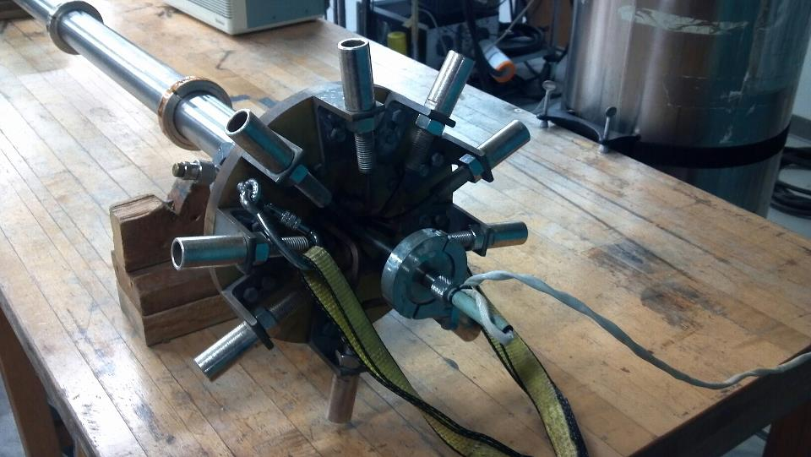

Copper current leads

Current lead connectors

Figure 1: Top view of probe showing exposed current leads

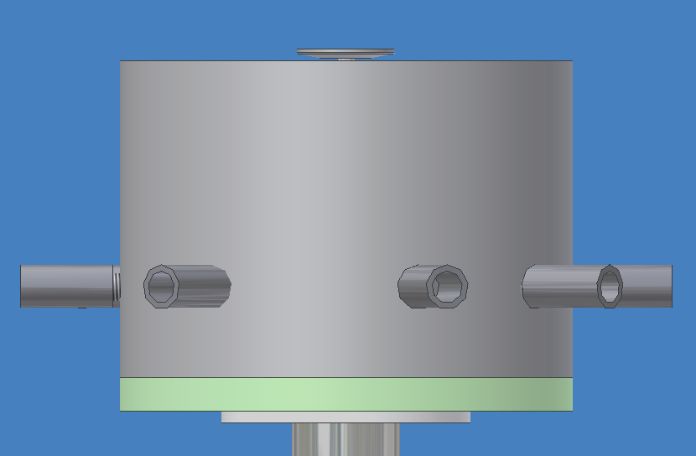

To cool the current leads at the top a cylindrical cap would be made to cover the current leads while leaving the current connection exposed out of the side, see figure 1. The cap would be air tight and around the protruding current connections and at the base of the top flange. This cap would be insulated so to keep the volume inside the cap cooled. This cylindrical heat exchanger would be cooled by the escaping helium gas burned off from the liquid helium bath. The gaseous helium would travel the cylindrical stainless steel tubing cooling the copper leads all the way up to the top. A vent will be at the top of the cylindrical heat exchanger to allow the excess helium gas to escapes so pressure does not build inside the probe, cryostat, or heat exchanger, see figure 3.

Figure 2: Side view of heat exchanger

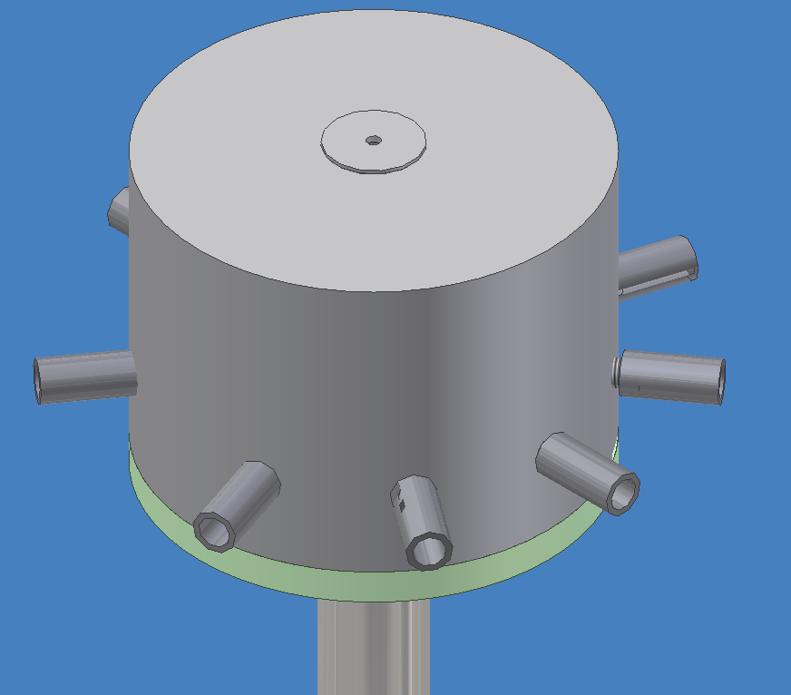

Figure 3: Angled top view of the heat exchanger on top of the probe

**Concept #2 – Spoke thermal cap**

During testing a large portion of the stainless steel tube is exposed to the ambient air. Stainless steel is fairly ideal for all the requirements needed from this part of the probe. For this reason we have decided to not try and replace the stainless steel but rather impede the thermal conductivity of the stainless steel. To accomplish this, a modification of an already existing component of the current probe would be implemented, see figure 4.

This part is called the current lead support. Acting as a spacer for the current leads as they travel through the probe this spacer could also hinder the thermal conduction of the stainless steel tube. The current lead support is made of a fibrous material called G-10 that has a thermal conductivity of .27 W/m(K) which I is much lower than that of stainless steel at 16 W/m(K). Extending the square notches so that they protrude through and are flush with the outer diameter of the stainless steel tube will impede the thermal conduction of the tube. This 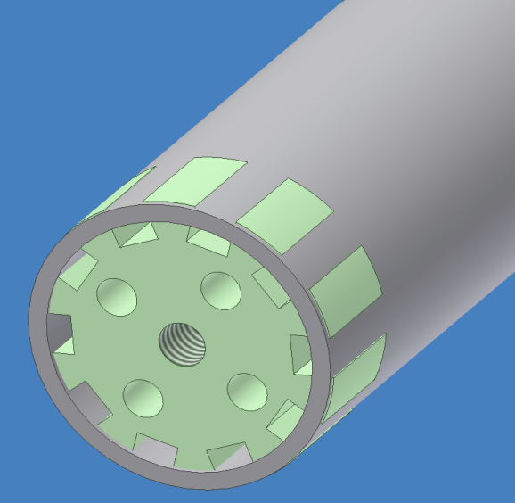is due to the increased thermal resistance from the G-10 because its low thermal conductivity is lower than that of stainless steel. The equation for resistance by conduction from one material to the next is expressed below.

Figure 4: current lead support

$R_{material}=\frac{L}{kA}$ (1)

$R_{total}=R_{1}+R_{2}+R_{1}$ (2)

$R_{total}=\frac{L_{1}}{k_{1}A_{1}}+\frac{L_{2}}{k_{2}A_{2}}+\frac{L_{1}}{k_{1}A_{1}}$ (3)

Figure 5: current lead support modification.

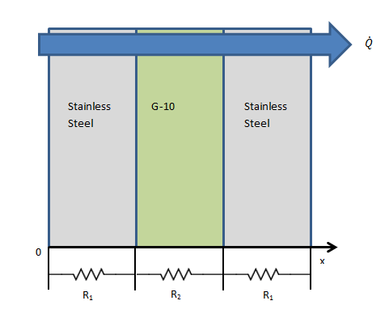(R) in these equations is resistance,(L) is length, (k) is the thermal conductivity, and (A) is the area. This shows as (k) decreases in value the resistance increases which proves, in theory, that interrupting the stainless steel with G-10 will increase the thermal resistance. With the increase thermal resistance more liquid helium can be save during Ic measurement test.

Figure 6: Thermal heat conduction through Stainless steel and G-10 layers.

**Concept #3 – Helium gas insulation**

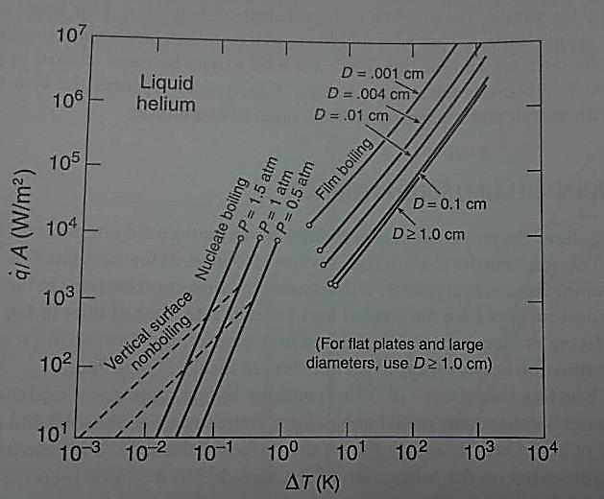Another concept is using the burn off gas to create an insulating layer between the leads and the liquid helium. If the heat transfer rate between the leads and the liquid helium exceed about 10^4 watts per meter kelvin, then Film boiling will occur which means a constant layer of liquid gas at the contact point of the lead. Figure 1 shows the rate of heat transfer at different stages of boiling and how the rate at which heat transfer increases due to temperature difference will slow down during film bonding. The way the probe is positioned vertically in the cryogenic fluid, allows for the highest heat transfer rate due to the fact that the gas is being evaporate directly up and not being hindered by any outside obstructions, as can be seen in figure 2 (a). Since the object of this project is to decrease the heat transfer rate, the leads could be put at a certain allowable angle (depending on the constraints of the tank) impeding the rate at which the gas that could escape, causing a thin layer of gas to form and insulate the surface. Figure 2 (c) would be showing the ideal horizontal situation, however this would not be practical to the constraints of our design. If this orientation cannot be achieved, small wells placed alongside the leads could trap some of the gas and create pockets of helium gas that could slow down the rate of heat transfer, as shown in figure 2(b).

Figure 7 – Rate of heat transfer with respect to temperature gradient

**figure 8 (a)**

**figure 8 (b)**

**figure 8 (c)**

**Concept #4 - Fins**

By adding fins to the top portion of the copper leads not immersed in the liquid helium, the heat would be taken out of the rod faster and therefore cause a lower temperature gradient by preventing heat being transferred to the lower portion of the rod. Since the main driving force behind the three methods of heat transfer is a temperature gradient, reducing this would in turn reduce the amount of heat transferred at the base of the leads in the fluid. The focus on this part is the copper leads and not the steel casing on the outside, this is because our steel casing is constrained to fit in a certain diameter hole from the tank leaving no space for fin extrusions. The idea is that these fins will provide a greater surface area for the rising cool helium gas to come into contact with and therefore a higher heat transfer rate out of the leads. However optimization and the efficiency of the fins will play a huge role in determining how plausible. For example, adding more copper to the probe would increase its resistance and therefore the power being generated. As seen in figure 2, the fin efficiency can vary with lengths and gap distances.

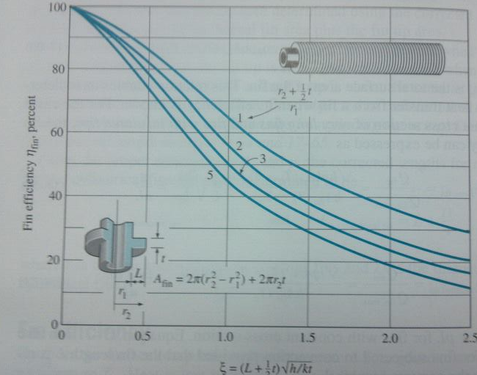

Figure 9 – Graph of circular fin efficiency to effectiveness

**Concept #5– HTS Leads**

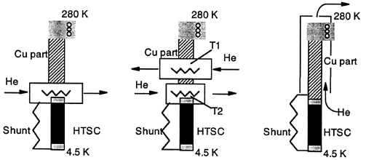

Figure 10: Conceptual Probe Lead

The copper leads cause a high rate of helium consumption. A concept reducing the depletion of helium by the leads will greatly enhance a probe which tests super conductors. To achieve this, high temperature super conducting leads (HTS leads) could be used to replace the standard copper leads. Electrical resistance causes heat which will cause the temperature to rise. This probe needs to be able to test samples at very low temperatures (4.2K). If the leads have a large resistance, they will cause the temperature to rise quickly. This rise in temperature will burn off the liquid helium and require more liquid helium to be put into the system. To reduce the amount of helium needed to keep the system at the prescribed temperature, the resistance in the leads may be reduced. HTS leads function at relatively high temperatures compared to low temperature superconductors. They do not necessary need to be kept at low cryogenic temperatures to retain superconducting qualities. This means that even as the temperature gradient changes from 4.2K (the temperature of liquid helium) to room temperature, there is some point in between that will be suitable to replace the copper leads with non-resistive HTS leads. This should reduce the rate of helium burn off during testing. The placement of the HTS leads is crucial to optimize performance and avoid quenching. Figure 2 shows the basic concept of how the copper leads may be replaced with HTS leads at a certain point to reduce resistance.

The traditional copper leads may be replaced with super conducting leads to reduce the resistance. Low temperature superconductors will not be very effective in this case because of the low temperatures required to keep a zero resistance. HTS leads will be much more effective in reducing the heat generation caused by passing current through the leads because of the larger temperature range they may be exposed to without losing superconducting properties. This is why HTS leads will be used instead of LTS leads. Figure 3 depicts the difference between the two.

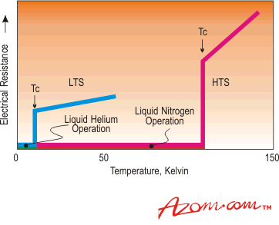

Figure 11: LTS vs. HTS leads

Current Research/Implementation

MarkeTech develops Bi-2223 HTS leads which replace the copper leads at under 77K and reduce the consumption of helium. Table 1 shows this reduction.

Table 1 – Helium Savings from use of MarkeTech HTS leads

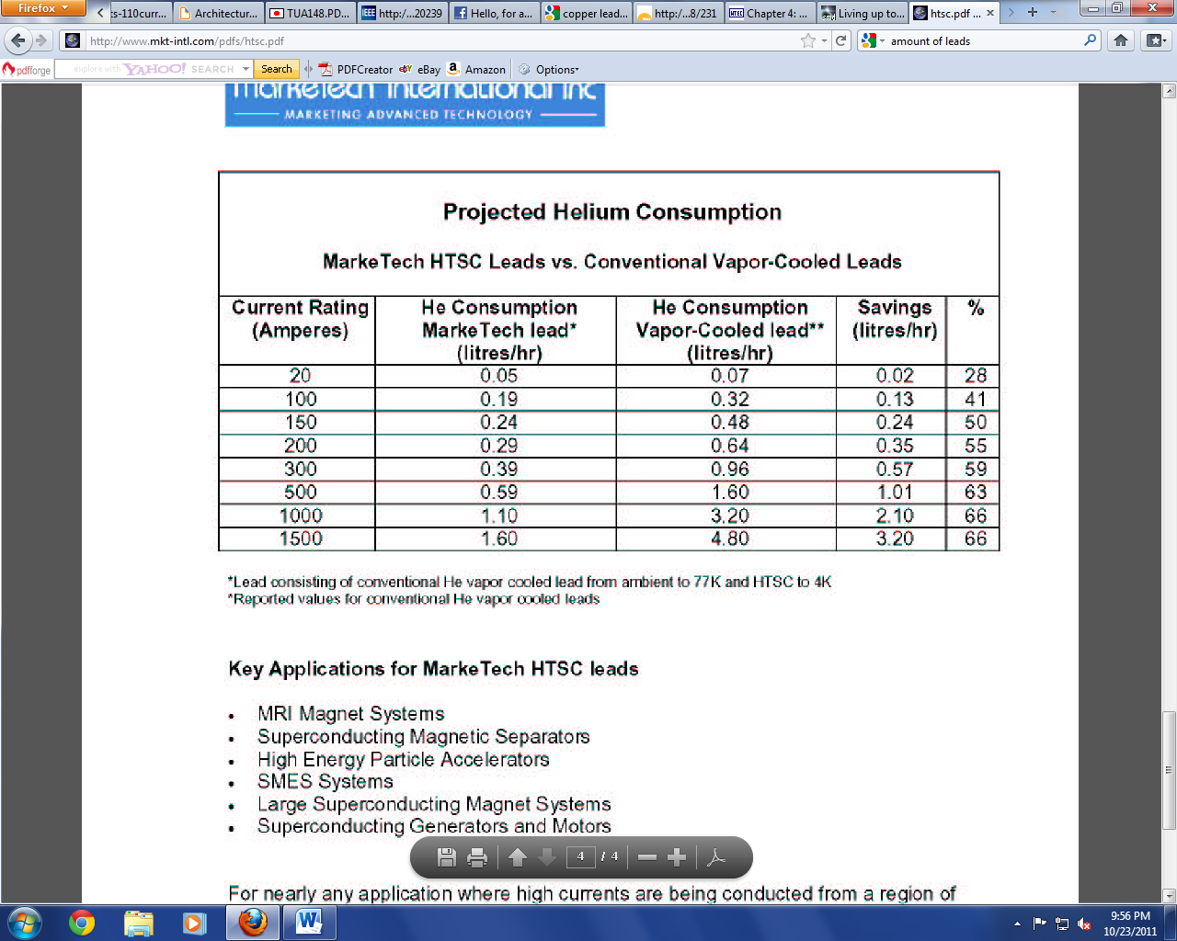

The main objective of replacing the copper leads with HTS leads at some determined position down the probe is to reduce the surface area of the relatively thermally conductive copper. So, the surface area of the copper may be reduced and used solely as structural support for the HTS lead. The current will take the path of the HTS lead because it will provide a path with no resistance. This will leave the reduced area copper as a support only.

**Concept #6 – Structural Support**

The current probe in use at the NHMFL has a stainless steel casing which houses the leads. This casing goes from room temperature all the way down the probe into the liquid helium bath. This makes it a heat leak. There is reason to believe that this casing may be made out of a different material with a lower thermal conductivity. Theoretically, the heat leak would be minimized. This should be analyzed to see if replacing or removing the stainless steel could reduce the consumption rate of the helium. Several materials will be looked at and analyzed to determine the amount of helium which could be saved.

This casing may also be able to be removed completely. The necessity of the casing will need to be analyzed to determine the casing’s function at certain points. Being able to remove part of or all of this casing would eliminate a major heat leak.

The concern may be brought up that HTS leads from the previous concept will not be structurally sound. HTS leads are generally very thin tape or wire. The structural integrity of the HTS leads is low. Thus, using the HTS leads may require some type of structural support. There are forms of structural support that will not create another significant heat leak. Some type of encasement may be used for structural support. Cryosaver current leads employ the use of a fiberglass shell as seen in figure 4.

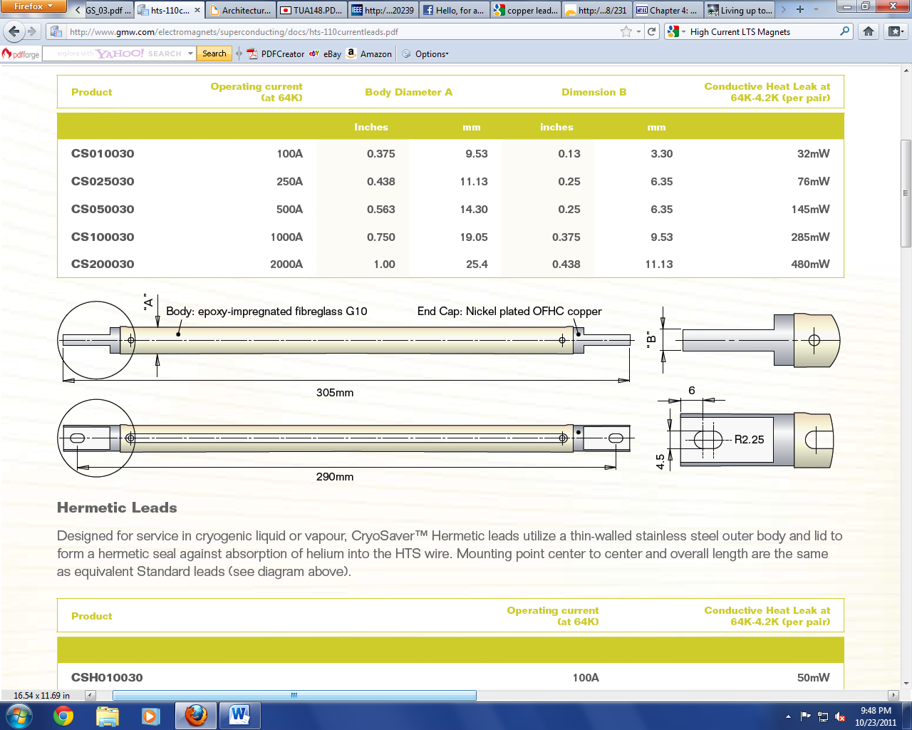

Figure 12: Cryosaver HTS shell

Possible ideas:

* Remove stainless steel casing entirely
* Use less thermally conductive material for:
  + Casing
  + HTS supportive shell

Pros to these ideas:

* Reducing a major heat leak
* Providing durability

If this concept could be further developed and properly implemented, the result should be a probe with reduced heat leaks that can withstand several tests without failure.

**Concept #7- Reducing the amount of leads**

The amount of leads going into the system may be reduced. The fewer leads into the system, the less heat will be generated. If less heat is generated, then less helium will be used. Electrical engineering concepts will be used to explore possibilities for reducing leads.

The process of reducing leads is an optimization problem. The specifications require a holder that can test 6-8 samples during one experiment. A design which tests six samples will require less leads than one which tests eight. This will reduce helium burn off per testing, but may require multiple tests in certain instances. Multiple tests require more pre-cooling and cooling time. So, optimizing the amount of samples being tested versus the amount of tests being done will reduce the depletion of helium.

There also is some interest is designing a probe which tests samples in series. This can be an issue if the samples are not similar but conceptually, one could test multiple samples with only two current leads. Another idea is to create a modular probe. This probe would allow eight samples to be tested, but if only four samples needed to be tested, the experimenter could easily remove the unnecessary leads. This removal of the leads would reduce the heat leak.

* Optimization Problem
  + Less leads = less samples = more tests
  + Must optimize the amount of samples being tested
  + 24 sample probe will not efficiently conserve helium
    - Large amount of heat leak into the system from ambient air
  + 1 sample probe will not efficiently conserve helium
    - Must be pre-cooled and submerged in the liquid helium for a test that takes less than a minute
    - Too much handling
  + Must optimize between 6-8 samples

**Conclusion**

There are several different portions of the existing probe which may be modified to improve the system. The concepts for this project may work together. This means that several of the concepts may be utilized together to meet the objectives of this project. The next step in this design project is to analyze the relevant concepts. The analysis will show the effectiveness of each concept. The implementation cost of each concept will also be explored to avoid exceeding the allowed budget. Any concepts that provides little improvement with a high cost will not be used unless absolutely necessary. The concepts which theoretically provide the highest improvement will be implemented to improve the probe design. We will not limit ourselves to the concepts in this paper as other concepts may be developed while analyzing the concepts seen here.

**References**

*Marketech Products - Refractory Metals, Tungsten, Ceramics, Crystals*. Web. 24 Oct. 2011.

<http://www.mkt-intl.com>.

"Superconductors - An Introduction." *AZoM™ - The A to Z of Materials and AZojomo - The "AZo Journal*

*of Materials Online"* Web. 24 Oct. 2011. <http://www.azom.com/article.aspx?ArticleID=941>.

*GMW Associates - Distributor and Integrator of Sensors, Transducers, Instruments and Systems Based on*

*Magnetics*. Web. 24 Oct. 2011.

<http://www.gmw.com/electromagnets/superconducting/docs/hts-110currentleads.pdf>.

"Chapter 4: HTS Leads." *World Technology Evaluation Center: Index*. Web. 24 Oct. 2011.

<http://www.wtec.org/loyola/scpa/04_04.htm>.

Ekin, J. W. *Experimental Techniques for Low-temperature Measurements: Cryostat Design, Material Properties, and Superconductor Critical-current Testing*. Oxford: Oxford UP, 2006. Print.

Cengel, Yunus A., Robert H. Turner, and John M. Cimbala. *Fundamentals of Thermal-fluid Sciences.* Boston, MA: Mcgraw Hill Higher Education, 2008. Print.