Senior Design Project 9

**Generic Armored Vehicle Power Control Handle**

**Final Design Deliverable**

Client:

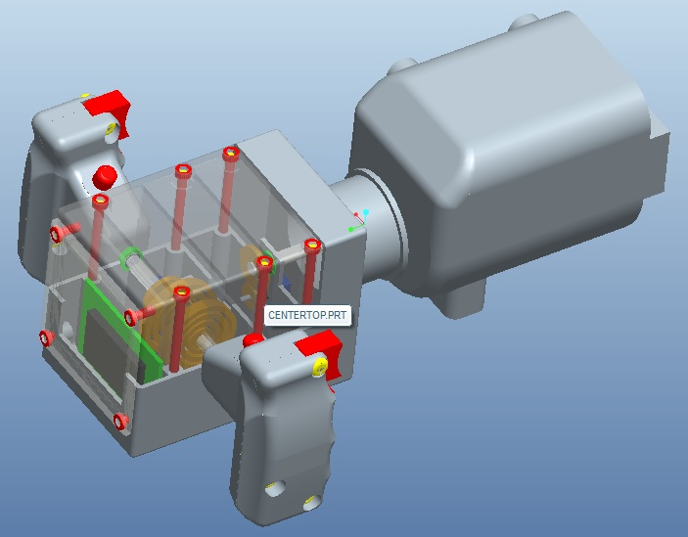

**Group 9:**

Michael D. Brown

William Thornton

Deanna McKenzie

April 12, 2011

Contents

List of Figures 3

1 Introduction 4

2 Design Philosophy 4

3 Design Requirements 4

3.1 Customer Needs 4

3.2 Team Goals 5

4 Design Concepts 5

4.1 Center Body Design 5

4.1.1 Horizontal Separation Center Body 6

4.1.2 Vertical Separation Center Body 6

4.1.3 Partial Top and Back (Hybrid) Separation Center Body 7

4.1.4 Summary 8

4.2 Steering Sensing Methods 8

4.2.1 Concept 1: Resistant material conduction 8

4.2.2 Concept 2: Small Potentiometer 9

4.2.3 Concept 3: Car Steering Wheel sensor 10

4.2.4 Summary 11

4.3 Haptics 12

4.3.1 Vibration 12

4.3.2 Force Feel 13

4.3.3 Friction 13

4.3.4 Summary 14

4.4 Design Concepts for Adaptable Handles 15

4.4.1 Removable Grip Covers 15

4.4.2 Replaceable Handles 16

4.4.3 Concept Comparison 17

4.4.4 Summary 18

5 Final Design 18

5.1 Cost Analysis 18

6 Final Design 19

7 Manufacturing and Assembly 20

7.1 Rapid Prototyping 20

7.1.1 Rapid Prototyping Method 20

7.1.2 Rapid Prototyping the Center Body 21

7.1.3 Rapid Prototyping M1 Abrams Gunnery Handle 22

7.2 Final Mechanical Assembly 23

7.2.1 Centerbody Assembly 23

7.2.2 Mechanical Assembly of M1 Abrams Gunnery Handle 25

7.2.3 Mechanical Assembly of the Handle to the Centerbody 26

7.3 Electronic Assembly 26

8 References 27

9 Appendix 28

9.1 Parts List 29

9.2 Parts Drawings 30

# List of Figures

Figure 1:Horizontal Separation Method 6

Figure 2:Vertical Separation Method 6

Figure 3: Back and Partial Top (Hybrid) Separation Method 7

Figure 4: Drawing of resistive material conduction design 8

Figure 5:Snap in Roller 10 Figure 6: Small Potentiometer 9

Figure 7: Potentiometer, gearing and handle shaft 10 Figure 8: Potentiometer gearing and center shaft 10

Figure 9: Steering Wheel Sensor 10

Figure 10: Vibration motor used for cell phones 12

Figure 11: Vibrating motor from Tickle me Elmo 12

Figure 12: Torsion Spring 13

Figure 13: Fexinol Wire 14

Figure 14: Torsion Spring on Handle 15

Figure 15: Permanently mounted handle with removable cover 16

Figure 16: Removable Handles 17

Figure 17: Final M1A Handle design 18

Figure 18: Final Design Full Assembly 20 Figure 19: Final Design Interior 20

Figure 20: Dimension Elite rapidprototyping machine 21

Figure 21: Prototyped Centerbody 22 Figure 22: CAD Centerbody 22

Figure 23: CAD M1A Handle 23 Figure 24: M1A Prototyped Handle 23

Figure 25: Center Shaft Springs……………….. 24

Figure 26: Handle Shaft Springs………………………………………………………………………………………………………..……24

Figure 27: Mechanical Assembly of Centerbody 25

Figure 28: Exploded view of M1A Handle 25

Figure 29: M1A Handle Detached form centerbody 26

# 

# 1 Introduction

Lockheed Martin currently makes an Advanced Gunnery Training System (AGTS) for the purpose of training troops to operate armored vehicles for the military. As of right now, this training system consists of many different types of heavy handles that currently lack the “feel” of the armored vehicles they are supposed to be mimicking. Our main goal is to design a generic gunnery trainer handle that is both lightweight and compatible with many different simulations. We hope to have a lightweight, fully functional handle with the proper type of feel and an assortment of different “settings” to accurately mimic the armored vehicles’ motions.

# 2 Design Philosophy

Our design aims to both meet and exceed the expectations of the client. As listed above, many requirements were specified by the client, but there was room to design independently, leaving the ability to think critically about what needed to be accomplished. As will be discussed in the Design Concepts section, the problems faced were approached in a professional and all inclusive manner, allowing for a well-rounded design methodology that will both provide a route to the client’s desired outcome and allows for innovative idea generation.

# 3 Design Requirements

## 3.1 Customer Needs

Lockheed Martin has expressed a need for a multi-compatible simulation gunnery control handle for use in training simulators. For ease of transport, assembly, and general use, the client has asked for this “multi-compatible” handle to support both the M1 Abrams and the M2 Bradley gunnery handle configurations. The handle should also be able to not only replicate the shape of each respective handle, but its general “force feel” as well. These handles should attach and detach from a common “center body” designed as per client specs given in the Statement of Work. Lastly, the “force feel” characteristics of each handle calls for a full angle rotation of 150˚ for both that handle shaft and the center shaft.

The client has also specified requirements for engineering materials on some components of a production grade final product. For instance, the center body should be constructed of an engineering plastic to withstand force testing as per specs provided by client. Hardware is to be stainless steel, and the potentiometer is to be attached to the shaft using gears. Both the center shaft and the handle shaft are to be made of stainless steel. It is required that all bearings are ball bearings, and that all springs are to be counter-clock type opposing springs. The handles are to output via USB so as to allow for connection with any type of computer. However after further investigation of the project it was established that a prototype of the final design was not necessary to complete the project, let alone a production grade model. It was simply required that a concept for achieving the above goals be developed and tested.

## 3.2 Team Goals

Even though it was not necessarily a requirement by the sponsor to create a working model of our design, and this project was to develop methods to implement the requirements necessary to properly replicate the gunnery trainer handles. Our group set the goal of having a working prototype ready to present by the end of the Spring 2011 semester for proof of our design concept.

# 4 Design Concepts

There were a few preliminary designs for the various parts of the control handle. Due to the intrinsic complexity of the project, there aren’t a series of solidified full designs for the entire project, but instead a myriad of smaller conceptual designs that could be implemented into the final design. For this reason, the design concepts with be split up into four separate categories, and then specific component designs will be divvied up into those categories depending on their desired applications. The categories to be explored are Center Body Design, Steering Sensing Methods, Haptic Response Methods, and Handle Adaptation Methods.

## 4.1 Center Body Design

One of the main requirements expressed by the client for the Gunnery Control Handle is that the center body of the assembly be made out of an engineering plastic that will stand up to testing as per specs listed in the Statement of Work provided. It was to remain within some previously specified dimensions, and it should be able to contain all of the components necessary for a working control handle. There were three fundamentally different types of center body assemblies considered, mainly distinguishable by the ways in which one can access the inside components. The first method is a horizontal separation method shown in Figure 1 below, wherein the front and back parts of the center body can separate. The second type is a vertical separation shown in Figure 2 below, wherein the top and bottom parts of the center body can separate. Lastly, the third option, shown in Figure 3 below, is a hybrid between the two types of separation with the addition of a detachable back plate.

### 4.1.1 Horizontal Separation Center Body

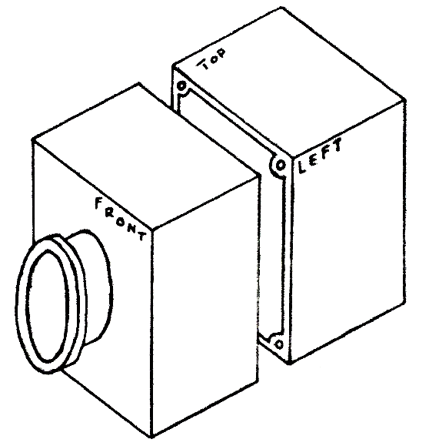

Figure 1:Horizontal Separation Method

The horizontal separation method, as shown in Figure 1 above, allows for the components contained within the center body to be accessed by detaching the back of the center body. This is the basic design of the current trainer handles used for the gunnery simulations. This back portion would be attached using hex screws and possibly, but not necessarily, bolts.

This center body construction would allow for easy access to the components inside the center body, however, since the dimensions provided by the client show the length of the center body longer than the height, this design would force our design to either design components into the part of the body that is disconnected or to make components harder to get to because of a farther distance between them and the opening. These two options depend on where the separation is made and how components are positioned within the center body.

### 4.1.2 Vertical Separation Center Body

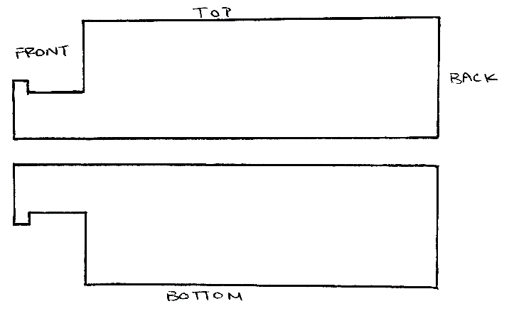

Figure 2:Vertical Separation Method

The vertical separation method, as shown in Figure 2 above, allows for the components contained within the center body to be accessed by detaching the top of the center body. This effect would be achieved by attaching the bottom portion permanently to the center shaft that comes out of the front of the center body. This would allow for the top to be detached to expose the interior. As with the previous design concept, the top portion would be connected using hex screws or bolts.

The vertical separation design will allow for a full view of all components contained within the center body. It does present problems as to how the top section will be detached with the bottom section still secured. This design will also require a fair amount of problems when manipulating the torsions springs what will reside within the front of the center body. These springs will be contained in the circular part of the center body, seen better in Figure 1.

### 4.1.3 Partial Top and Back (Hybrid) Separation Center Body

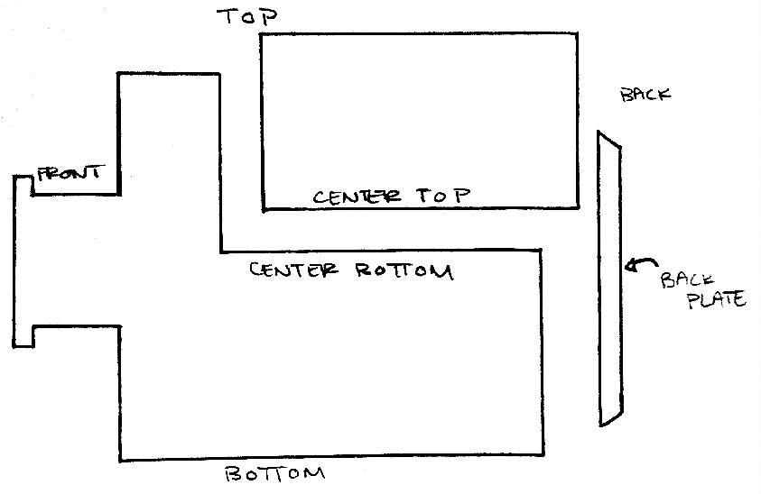

Figure 3: Back and Partial Top (Hybrid) Separation Method

The hybrid separation method is a combination of three parts: the center bottom, the center top and the back plate. The center top will attach to the center bottom and allow for full access to components inside along the length of the center body. The removal of the back plate will also allow access to the back of the center body without removing the center top. As with the other concepts, these components will be secured using hex screws or bolts.

This method employs ideas from both Concepts 1 & 2 and eliminates problems encountered in both of those designs. The design is equipped to allow for full access to all components along the length of the center body while still leaving the front of the assembly closed, eliminating the need to worry about the torsion springs that reside there. Since the micro controller in the final design will be placed near the back of the center body, there is a back plate that can be removed to present quick access to this component and some others if small tweaking is needed. One downside to this design is the need to take off both the back plate and the top when accessing components near the front of the center body.

### 4.1.4 Summary

Both Concepts 1 and 2 have their problems. Concept 1 will not allow proper access to all the components or it will make the component placement a problem when removing the back of the center body. Concept 2 will allow for full access to the components lengthwise, but causes problems due to the springs at the front of the design that would need to be handled every time the top was taken off. Concept 3 is a design that is made to take care of both of these problems while still maintaining the pros of each. The only downside to Concept 3 is the added time in taking off the back plate, but time will also be saved when only the micro controller needs to be accessed because of its position within the center body. For these reasons, Concept 3 is the final concept for the center body of the Gunnery Control Handle.

## 4.2 Steering Sensing Methods

The first concept utilizes the principle of reading a change in voltage by using a large piece of material with a measurable resistance. As can be seen in Figure 4 below, this material wraps around the shaft a full 150 degrees; the full angle rotation required by the client. There is a wire connected to one side of the material with the other end connected to a voltmeter. Another wire connects the voltmeter to a swinging arm which is rigidly attached to the turning shaft. The voltmeter will then be able to measure the voltage across the resistive material. As the control handle turns, so does the shaft. This moves the swinging arm across the resistive material, either increasing or decreasing the resistance. This is in essence a large version of a variable resistor, or a potentiometer. As a side note, some materials that can be used for the resistive material are a doped carbon material, a ceramic-metal composite, or a conductive plastic material.

### 4.2.1 Concept 1: Resistant material conduction

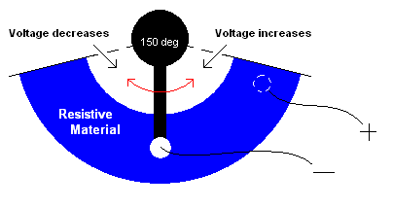

Figure 4: Drawing of resistive material conduction design

This design has many plus sides, one of which is its simplicity. The only moving part is its swinging arm, which is rigidly connected to the shaft. This means that there is no conversion between the angle that the shaft moves and the angle that the swinging arm moves. Another good thing about this design is that it uses very few parts. It uses a swinging arm, two wires, and a curved resistive material. Although this design is promising, it still has some flaws. Firstly, with the exception of the wires, the other parts will have to be fabricated. Even though this is not an insurmountable hurdle, it adds to both the cost and time to this design. Unless common prefabricated materials can be used, these problems will be a base concern going forward from this design. Secondly, this design may be on the large side. Even though there is room in the plastic shell body that contains the shafts, it would be easier to use a smaller component.

### 4.2.2 Concept 2: Small Potentiometer

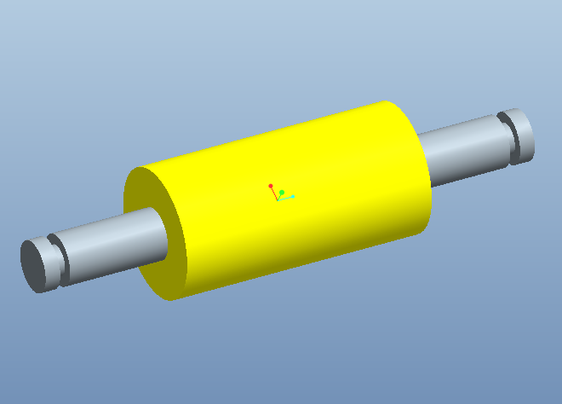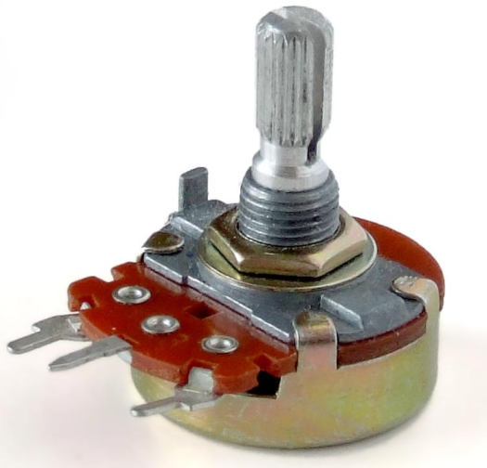

Figure 5:Snap in Roller Figure 6: Small Potentiometer

The second concept for the sensing capabilities of the gunner’s handle utilizes the components found in Figures 5 and 6. Figure 5 shows a small roller like one might see inside a mouse that uses a trackball instead of a laser. These mice have two small rollers that can register the direction of the mouse ball’s movement, and its rotation velocity as well. Figure 6 shows a common potentiometer that can be purchased at any electrical component store. This potentiometer, like the larger one in Concept 1, measures a change in voltage when the rotation arm is twisted. The simulator can then read this voltage change as a change in the steering shaft’s angle. The idea is that the rollers would snap into part of the skeleton design next to whichever steering shaft it is measuring. The axis of the roller will be connected to the rotation arm of the potentiometer, meaning that when the roller is turned by friction with the shaft, the potentiometer’s rotation arm is also turned, changing the voltage reading. This design may need to use gears, if the contact between the shaft and roller doesn’t provide enough friction.

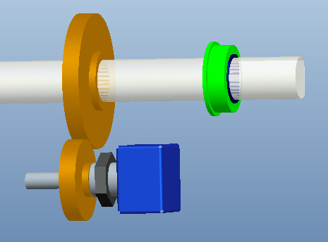 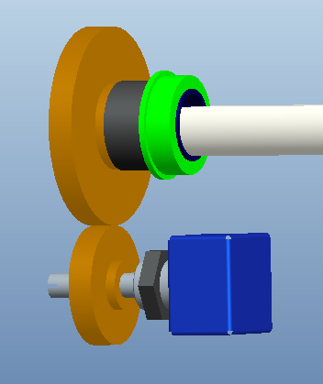

Figure 7: Potentiometer, gearing and handle shaft Figure 8: Potentiometer gearing and center shaft

Gearing, although relatively complicated in design, would not be very hard to implement. There is room in the plastic casing to accommodate gears as long as they aren’t too large. A gear assembly as you might see it in the Gunnery Control Handle is represented above by Figures 7 & 8 above for the shaft controlling connected to the handles and the shaft connected to the center respectively. This configuration is designed for a potentiometer that has at least 250˚ of rotation possible. These gears aren’t shown with teeth.

The best part about this design is the fact that all of its parts are cheap (with the exception of the gears) and can be purchased quickly. If the roller can be integrated into the plastic outer shell of the handle, it is also extremely easy to install and replace. If gears are necessary, they will only need to be secured to the potentiometer shaft and the respective shafts they are reading. One downside to this design is the implementation of a more complicated potentiometer. This potentiometer utilizes more parts than the previously proposed component, which means that there are more parts that can break. However, this problem may be outweighed by the ease and affordability of replacement. Also, this design is moderately more complicated because of the difference in the angular displacement of the roller and the shaft itself. Lastly, it may be necessary to recalibrate this design often, because the design assumes no slip between the roller and the shaft. This problem is, of course, nullified if gears need to be implemented.

### 4.2.3 Concept 3: Car Steering Wheel sensor

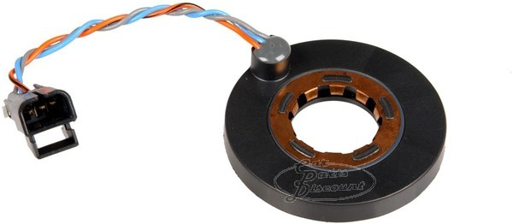

Figure 9: Steering Wheel Sensor

The last of our ideas for sensing methods involve the implementation of a common steering wheel sensor. This would be an extremely easy solution to a complicated problem because it is a one component installation process. The main idea is to simply slip the steering wheel sensor around the shaft whose rotation is being read before it is installed. Like the other concepts, this idea is basically a potentiometer which gives a voltage difference in response to rotation.

This design would be an ideal solution to the problem of sensing shaft rotation because of the devices durability and easy installation, but the installation could become more complicated depending on the steering wheel sensors turning resolution. Most steering wheels are designed to have a full angle turn around 1400 degrees, meaning that our steering wheel (150 degrees full angle) isn’t using the entire capability of the steering sensor. Since the sensor was made to read large full angle turns, the resolution for 150 degrees of turn might be quite low. The installation complication arises when trying to fix this problem. Something like a gearing system would have to be implemented. The sub-components of the steering sensor will complicate any repair that is necessary, but since these sensors cost on average around $30 they can be replaced cheaply. The installation, although difficult, would not need to be done very often since these components are made to be rugged.

### 4.2.4 Summary

In comparison, all of these components have their pros and cons. Concept 1 is simple, and yet it uses materials that will probably not be readily available. It is a very straightforward design and doesn’t need any sort of gearing system to account for low angle resolution. Its installation, although easy to implement, makes for difficult replacement of parts. Concept 2 involves two basic, simple components that are both easily bought and installed. These components are readily available in most places. This concept is designed to use friction with the shaft to turn the potentiometer, but it may be necessary to use gears. Even though it’s simple, the small potentiometers used may not be as durable as needed. This however may be offset by the fact that they’re inexpensive. Concept 3 is both durable and has only one part that needs to be handled. This one component has many subcomponents which heighten the likelihood of malfunction, but this may not be a problem because steering wheel sensors are made to be rugged. This design would also be more difficult to install than the other two, but this may be outweighed by its durability, meaning it won’t have to be replaced often.

Table 1: Decision Matrix

|  |  |  |  |  |  |  |  |
| --- | --- | --- | --- | --- | --- | --- | --- |
|  | **Importance** | **Concept 1** | | **Concept 2** | | **Concept 3** | |
| *Rating* | *Weighted Score* | *Rating* | *Weighted Score* | *Rating* | *Weighted Score* |
| **Durability** | 30% | 7 | 2.1 | 6 | 1.8 | 9 | 2.7 |
| **Ease of Installation** | 30% | 6 | 1.8 | 9.5 | 2.85 | 5 | 1.5 |
| **Affordability** | 25% | 6 | 1.5 | 8.5 | 2.13 | 8 | 2.0 |
| **Simplicity** | 15% | 7 | 1.05 | 7 | 1.05 | 7.5 | 1.13 |
| **Weighted Scores** | NA | **5.48** | | **6.88** | | **6.45** | |

The decision matrix was built by using ratings of importance for each engineering aspect. Durability and ease of installation ranked highest; both holding a weight of 30% each of the total score. Affordability, although important, is not quite as important as either of the first two aspects, which is why its score is only 25%. Simplicity is always important in a design, but since these concepts were scored for their relative simplicity, this weight is of lower importance. This is mostly because even though some of the designs are clearly simpler than others, they are all fairly simple to begin with. After relative scoring was done on a scale of 1 to 10 (1 = very poor; 5 = fair; 10 = excellent), those scores where then multiplied by their importance values and added together for each concept. The Weighted Scores row is the result of those scores. In the end, Concept 2, the concept which utilizes a small roller and potentiometer won for its affordability and ease of installation. Its simplicity was between the other two concepts, and its durability was below that of the other two.

## 4.3 Haptics

Haptic response is the general feel, vibration, or motion that the user of feels from the handles. The concept of haptics with the gunner control handle includes an idea of vibration, force feel, and friction.

### 4.3.1 Vibration

The vibration idea would be similar to a video game controller such that the when the gamer hits an object in the game the remote vibrates, or a cell phone when the user touches their screen the phone vibrates to simulate a button being pressed. This type of response could be applied to the gunners handle, by vibrating the handle in response to rough terrain, or to simulate the recoil felt when firing the vehicles weapons. Vibration could be easily implemented using a simple non-uniform mass attached to a motor. The vibration concept is the simplest and cheapest of the three requiring nothing more than a very small electric motor and an unbalanced mass.

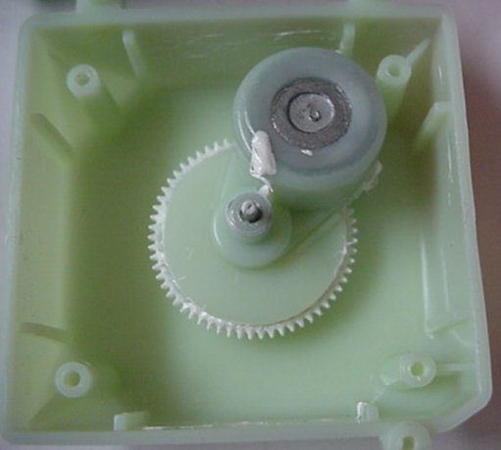 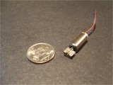

Figure 10: Vibration motor used for cell phones Figure 11: Vibrating motor from Tickle me Elmo

### 4.3.2 Force Feel

Force feel means that the force felt by the user on the handle is realistic. The handle should give a response force that resists the turning of the handles by the user. The handle should at all times try to return to its equilibrium position. This will improve the simulation and provide an accurate learning experience.

One concept to implement the force feel we have investigated using motors to push back on the user. The motors will be controlled by a program that can respond to objects in simulation. These motors would be directly attached to the roll axis and indirectly attached to the pitch axis. The pitch axis motor will use a series of cables and pulleys in order to actuate and apply the force needed.

A draw back to the motors for force feel is the amount of space inside the handle versus the size and power of the motor. Usually the size of the motor is proportional to the amount of power it puts out. The motor controller or encoder will also have to be taken into consideration. The amount of power required to drive motors for both the roll and pitch axes would require an alternative power source. The USB required to connect to the computer is capable of supplying 5V, this would not be capable of supporting all of the required electronics and two motor drivers.

Another very simple force feel haptic response could be accomplished with the use of torsion springs. The springs, pictured below, could be matched too fit the response of the handle being used. The springs would be used to oppose the turning of the handles and return them back to the straight. The springs would be adjusted to match the vehicle by using a completely different spring for every handle configuration. The main issue with this concept is developing a method of changing the springs when to match each vehicle.

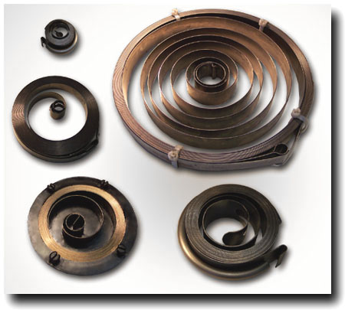

Figure 12: Torsion Spring

### 4.3.3 Friction

The concept of adding friction to the handle’s haptics consists of making the handle feel heavier than it is since it will mostly be plastic. The friction control will add a level of resistance to the simulation experience which in turn adds realism and a sense of driving a heavy object.

An idea of the friction control is trying to “gum up” the controls. In order to implement this we have explored springs to provide this resistance. The springs would be mounted in some way to each axis. Another benefit of the springs is the handle will return to its original position which is be good for encoders and reading positions on potentiometer.

Another concept is using Flexinol wire, a metal wire that contracts when heated and expands when cooled off. This wire would be attached to each shaft and electrical wires on each end of the Flexinol wire to provide heat, the Flexinol will contract and give a resistance to the user. The biggest advantage of this wire is the cost; the flexinol is about $3.00 per meter. The Flexinol wire is also advantageous because it can be implemented into a very small space, this will help with packaging issues that arise from having so many components in the center body. The main draw back to the use of Flexinol to supply a friction response is that the wire is not capable of supplying a force to return the handle to its equilibrium position, which is an implied requirement for creating a realistic handle response.

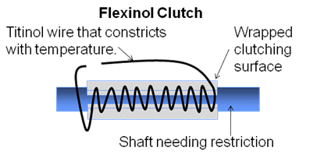

Figure 13: Fexinol Wire

### 4.3.4 Summary

The main issue with selecting a method of achieving haptic response was figuring out what type of haptic response was required by the customer. After talking to our sponsor it became clear that we only needed to replicate the force feel response. We then had to decide whether or not to use motors or torsion springs. The motors would have made changing the feel of each handle configuration very easy. By simply changing the torque supplied by the motor the handles could have any response necessary. However it would also require us to put motors inside the centerbody, and also account for an additional power source to drive the motors. This created a problem because the amount of space inside the center body is very limited. The cost of the motors would also be significantly greater than the of the torsion springs. Torsion springs on the other hand are very inexpensive. The main issue with the torsion spring is making sure they accurately represent each separate handle configuration. After much consideration we decided that the torsion spring concept was far superior to the motors, because of cost, and ease of implementation. It was initially decided that the springs would be located outside of the centerbody. One end will be attached to the shaft and the other will be attached to a peg on the outside of the centerbody. We would use two springs for each handle configuration, they will be in opposing directions in order to create uniform response in both directions. This first design can be seen below in Figure 14.

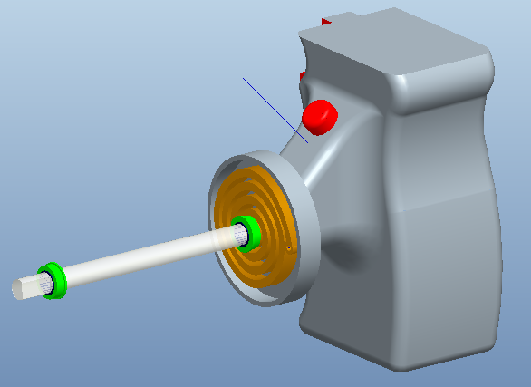

Figure 14: Torsion Spring on Handle

However after further research and testing both the M1 Abrams and M2 Bradley, gunnery handles it was established that the spring response felt by both handles was negligible. It was established that the difference felt by the user could likely be attributed the shape of the handle supplying a different moment on the handle, more so than the actual spring response changing. After these results were confirmed the torsion springs were moved to an internal mounting position for both shafts.

## 4.4 Design Concepts for Adaptable Handles

One of the main goals of this project is to generate a method of making the centerbody so that it can be used to replicate several different vehicles’ gunnery handle configurations. There are several different possibilities that we researched in order to select the best choice for this project.

### 4.4.1 Removable Grip Covers

The first concept, pictured below, is based on having one adjustable centerpiece with a set of handles permanently attached. Since the handles are permanently attached to the center body the grips must be interchangeable. The main idea is to have an entire set of removable grips that can be easily slid over the handle. The advantages of this design are in the simplicity. This design can be changed from one form of machinery to another by simply sliding one set of grips off of the generic handle and replacing them with the appropriate grips. This design easily accomplishes our goal of making a generic trainer that is easily interchangeable for several different training simulations. Another extremely advantageous part of this design is that production of multiple handle configurations can be accomplished by simply making an inexpensive adaptable polymer grip. The replacement grips can be attached through a large variety of simple mechanisms, such as having some form of snaps that fit the grip to the generic handle. The attraction to this design comes from its overall simplicity and it’s relatively low cost of producing multiple grip configurations.

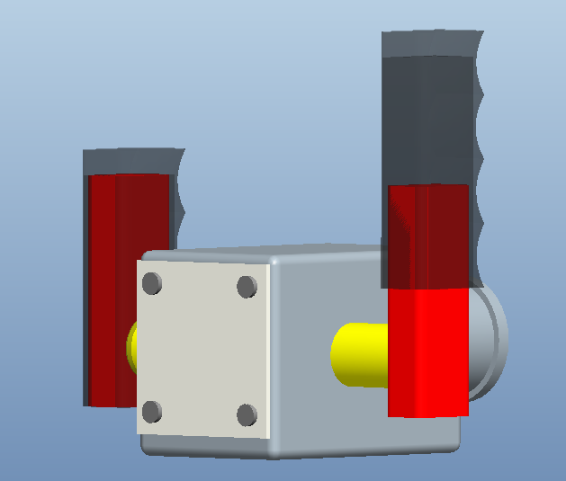

Figure 15: Permanently mounted handle with removable cover

However, like every design there are several inherent disadvantages. The greatest obstacle to overcome if we were to make this concept a reality would be to create a realistic “feel” for each of the different vehicles the trainer is to represent. To accomplish this goal would require the addition of a variable force application to all of the shafts that will resist steering forces in a similar manner as the vehicle it is to represent. While this matter mostly deals with haptics, it incorporates a significant cost to the concept of interchangeable grips that slide over a generic handle. A second issue that arises with this concept is the integration of buttons on the handle. Not all vehicles these simulations emulate have exactly the same button configuration on the handle. The buttons used for firing and other operations can have several different mounting points. With the generic permanently mounted handle it would become quite challenging to make a variable trigger placement. While this design concept is very easy to use interchangeably between vehicles and new grips would be inexpensive to produce there would be significant cost to the design process, to account for these issues.

### 4.4.2 Replaceable Handles

The second concept to make the center body of the trainer interchangeable between vehicles is to use replaceable handles, as seen below. By using a center body that allows the handles to be added and removed with relative ease the handles could easily be designed to represent the desired vehicle. Each removable handle would incorporate a mechanism to imitate the general frictional response to oppose steering inputs that are accompanied by the vehicle it represents. This removes the need to design a variable feel response system that can be adjusted for each type of simulation. This concept would also make replication of all buttons and triggers on the handles possible, with relative ease, making replication of the look and feel of every vehicle that is to be simulated plausible.

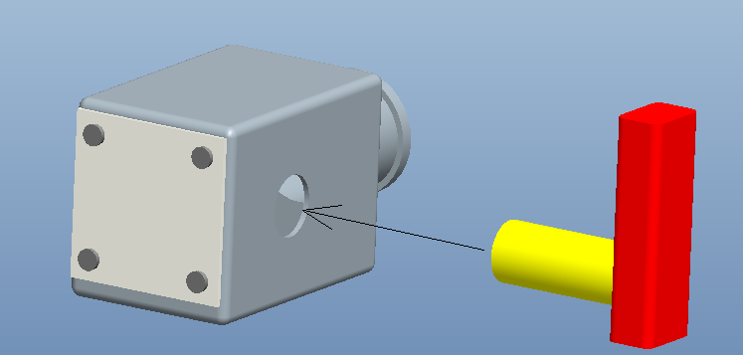

Figure 16: Removable Handles

The concept for this design sounds simple; however, there are many glaring issues that must be dealt with to make this design feasible. The two main concerns with this design are the cost and complexity. The cost of producing many handles would be expensive, because all handles would include full grips, a friction feel device, a set of handles, and a set of buttons. Compared to other concepts that require nothing more than a change of grip covers to switch between vehicle simulations, this concept is also quite complex. This design would also require the addition of an extra attachment to connect the wiring from the handle to the center body of the trainer. The addition of connections into the design makes the wiring more susceptible to exterior elements. The more connections and interfaces between wires, the greater the possibility of failure in the wiring. This design would require some mechanical means of detaching and attaching the handles, and it would also require an extra electrical interface to connect the buttons from the handle to the center body.

### 4.4.3 Concept Comparison

While both concepts would potentially work to accomplish our goal of creating a generic gunnery trainer center body, that is easily interchangeable between vehicle simulations, both designs are different in many ways. The main advantages of the first concept are the simplicity of changing grip configurations. The second idea however is relatively complicated to alternate between vehicles. The production cost of creating auxiliary grip configurations, for the second concept, is many times higher than the cost of producing the additional grip covers that are used in the first concept. When examining only production costs and ease of variability the first concept is far superior to the second concept in every way.

However, production cost is not the only component taken into account in the design process. The complexity of the design can also represent a large portion of the design selection. The second design incorporates a much simpler mechanism to adjust the frictional feel that opposes steering, because the frictional response can be customized to each handle configuration and integrated into each different handle; whereas the first design requires the fabrication of a device to supply a variable friction force to the handle, so that it can be adjusted for each grip configuration. The first device also requires some engineering a way to create the appropriate button configuration for each vehicle, and since the handles are permanent the buttons must either be generically placed or integrated into the removable grips. Both designs have very distinct advantages and disadvantages when evaluated against one another, we must rely on a decision matrix to find which concept best fits our criteria.

### 4.4.4 Summary

While both concepts could potentially work to accomplish our goal, it is necessary to choose which will be implemented in our final design. After researching both ideas, it became increasingly more obvious that the removable handles were our best option. The removable grip covers would not be capable of replicating the overall feel of the correct handle configuration. The removable grip covers would make it much harder to design the haptic response; similarly the button configuration would not be able to exactly match that of all of the handle configurations. It is because of this, and the fact that we must use the removable handles in order to implement the torsion springs to produce our haptic response, that we have selected the removable handle concept as our final design. The removable handles will connect to a permanently mounted shaft using a spacer and a set screw. The buttons will be replicated to match each handle configuration.

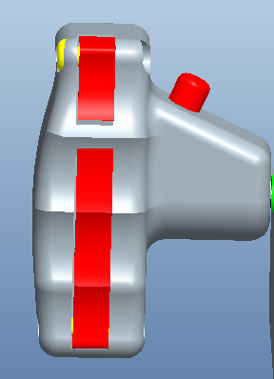

Figure 17: Final M1A Handle design

# 5 Final Design

## 5.1 Cost Analysis

The total cost of our final design is $269.98; this includes all of the parts that we will order off of the internet. However this price does not include the cost of our engineering plastic, the manufacturing cost of creating our centerbody or handles. Other costs that we anticipate will be the hardware used to assemble our controller, the wiring necessary to support the buttons, and the cost of any machining that must be done to our shafts and other parts in order to make them work. This cost analysis is based on the cost of parts for the creation of only one type of handle, if we generate a second handle configuration, the cost will obviously be greater. However we are still well under our budget of $2,500, and expect that we will be able to complete the project with these funds.

Table 2: Cost Analysis

|  |  |  |  |  |  |
| --- | --- | --- | --- | --- | --- |
| **Part** | **Quantity** | **Supplier** | **Pr ice ($)** | **Total Cost ($)** | **Item Number** |
| **Shaft** | **1** | **McMaster-Carr** | **20.25** | **20.25** | **1263K73** |
| **Shaft (Hollow)** | **1** | **McMaster-**  **Carr** | **14.12** | **14.12** | **6100K227** |
| **Bearings** | **4** | **McMaster-Carr** | **8.72** | **34.88** | **57155K338** |
| **Torsion Springs** | **6** | **McMaster-Carr** | **7.88** | **47.28** | **9293K31** |
| **Microcontroller** | **1** | **Pololu.com** | **59.95** | **59.95** | **1615** |
| **Potentiometers** | **2** | **Allied Electronics** | **6.35** | **12.70** | **308NPC250K** |
| **Pinion Gear** | **2** | **SDP-SI** | **13.05** | **26.10** | **S11632-064S018** |
| **Gear** | **2** | **SDP-SI** | **13.56** | **27.12** | **S11632-064S030** |
| **Buttons** | **6** | **McMaster-Carr** | **6.95** | **41.70** | **69755K31** |
| **Total** | **$284.10** | | | | |

# 6 Final Design Summary

The final design for the Gunnery Control Handle, as seen below, was not merely the final product of a singular decision between design choices. However; it is the product of many different design components, integrated into a final product. Firstly, the design of the center body had to be finalized, making sure to take into account space requirements given by the client and necessary for the components to fit. Concept 3 was chosen for its ease of access to the components and its ability to keep the torsion springs in the front of the assembly secure during maintenance. The microcontroller will be constantly cycling through taking readings of the position of each shaft, and whether or not each putton is currently pressed. In order to measure the rotation of each shaft, potentiometers have been implemented to supply the microcontroller with voltage readings. After considering many options, the choice was made as to which type of haptic feedback would be implemented. Internal opposing torsion springs were implemented on both the handle and center shafts, giving a smooth response to axis rotation.

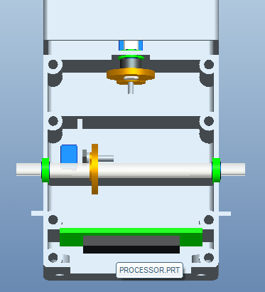

Figure 18: Final Design Full Assembly Figure 19: Final Design Interior

The figure above shows the final assembly attached to the mount. This mount is what ties the control handle into its final application. The handle will be implemented in the design of Senior Design Group 10’s One “Box Gunnery Trainer”. The mount connects our handle to their computer assembly, allowing combat personnel to train on the go.

# 7 Manufacturing and Assembly

## 7.1 Rapid Prototyping

As stated in the Customer Needs section (Section 3.1) it was not necessarily required that a production grade prototype be created to complete this product. However Group 9 set the goal of creating a working rapid prototype that can accurately represent and prove the concepts of the final design. The best method to reproduce the centerbody and handles required to build a prototype of the handles is the process of rapid prototyping. Rapid prototyping is a method used to quickly produce a scale model of a 3-D object.

## 7.1.1 Rapid Prototyping Method

The plastic components of the final design were rapid prototyped using a Dimension Elite Printer, pictured below.

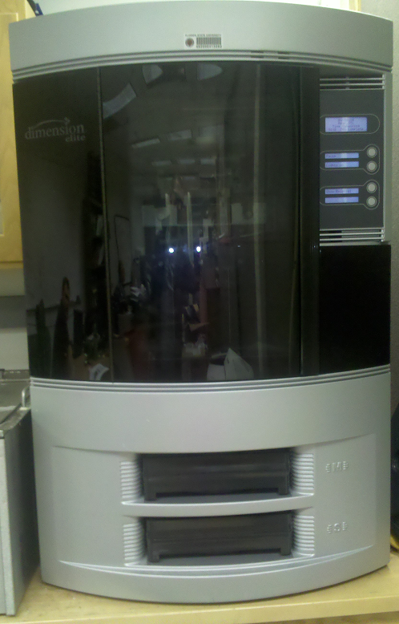

Figure 20: Dimension Elite rapid prototyping machine

This machine is used by first creating a full scale 3-D model of the object, in a CAD program. The part must then be saved as a STL file. The STL file is then uploaded into the Dimension Elite software after which the user must decide placement and orientation of each part on the printing plate. This machine is capable of producing parts that are 10 inches wide, 10 inches thick, and up to 12 inches tall. The orientation is very important because of how the machine creates the parts. The machine “prints” each 3-D part by spraying a layer of liquid plastic down onto a printing plate. The plastic is layered over and over again, so the part is printed one layer at a time, until the whole object has been printed. This machine can be used to create very intricate parts, using a type of filler that allow the printer to create holes and vacancies in the part, the filler is then dissolved using a special solution once the part is fully printed.

For the final product ABSplus Thermoplastic was used to create the parts. While this plastic has similar properties to injection molded plastics, the layering caused by the printing process results in the parts being structurally weak to tension forces and shear forces acting perpendicular and parallel to the layers, respectively. Similarly, the rapid prototyped plastic is not suitable for drilling or tapping, creating difficulty in finding hardware to assemble the parts.

## 7.1.2 Rapid Prototyping the Center Body

The centerbody was recommended to have the same general shape as the centerbody of the M2 Bradley gunner’s handle. It was also required to house almost all of the electrical and mechanical components of the handle. This as a result of these requirements the Pro/E design shown below was created.

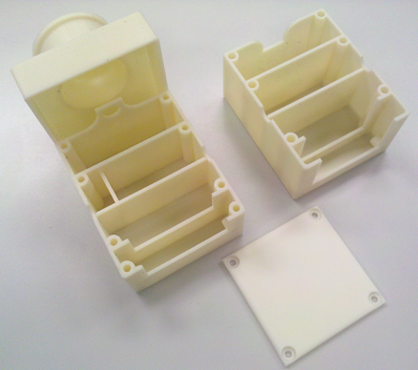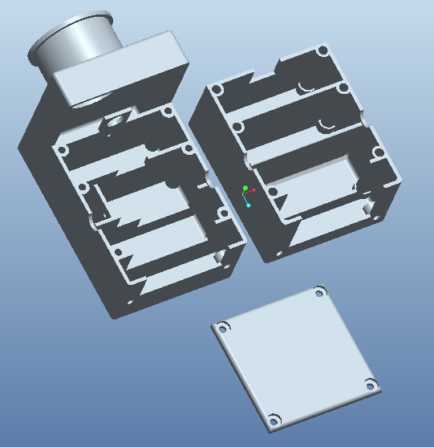

Figure 21: Prototyped Centerbody Figure 22: CAD Centerbody

From the Pro/E model final part was printed in three pieces, due to the limited machinability of the rapid prototyped plastic all holes and vacancies had to be designed in Pro/E before the part could be printed. The printed part, pictured in figure 21, acts as the housing in and around which the rest of the handles could be assembled. Because of unforeseen expansion of the design due to rapid prototype inaccuracies, many holes had to be widened using a Dremel tool.

## 7.1.3 Rapid Prototyping M1 Abrams Gunnery Handle

The M1 Abrams handle was selected as the handle configuration used in the final design to demonstrate the removal and replacement of a handle configuration. Since the M1 Abrams handle is still currently used for military applications, obtaining the dimensions of the handle to replicate in Pro/E was not an option. Instead the handle was replicated based of off one firsthand experience and a picture from the internet.

When creating the handle it was important to have access to the inside of the handle in order to wire each of the three switches found on each side. The issue of ease of access coupled with the need to insert two triggers that will contact the front switches of the handle, led to the handle being created in two separate parts. The large and small trigger were also rapid prototyped in the same manner. The figures below show the Pro/E assembly of the right handle, and the prototyped left handle, respectively. Each handle has the triggers inserted into their proper location.

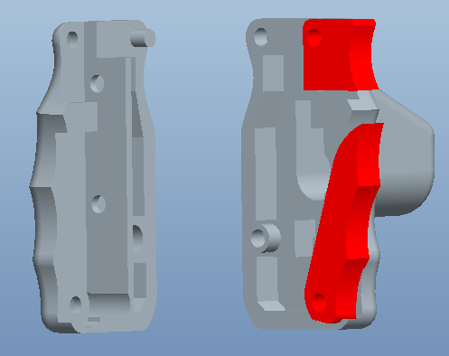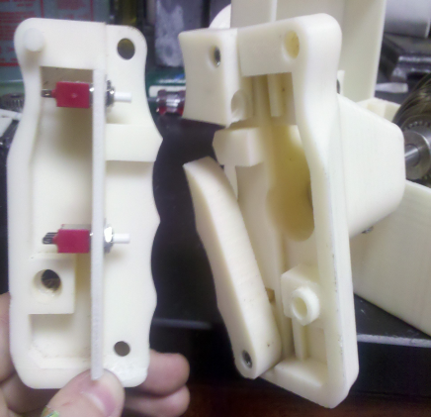

Figure 23: CAD M1A Handle Figure 24: M1A Prototyped Handle

In order to connect each handle to the shaft, and still have enough room for wire connectors, a special bushing was created in order to attach the handle to the shaft. The coupler is permanently mounted to the shaft and can be used for any gunner’s handle.

## 7.2 Final Mechanical Assembly

The final mechanical assembly of the final design can be broken up into three separate parts the centerbody, the handles, and attachment of the centerbody to the handles.

## 7.2.1 Centerbody Assembly

The centerbody houses the majority of the components of the gunnery handle. Pictured below, the centerbody is where the torsion springs are attached to both shafts, and where the shafts are geared to the potentiometers. The data acquisition is also accomplished through the microcontroller located at one end of the centerbody.

The centerbody assembly required mounting the potentiometers to their location in the centerbody skeleton. Originally, these locations were precisely calculated so that the pinion gear on each potentiometer would mesh perfectly with the gear mounted each shaft, but because of slight variation in the rapid prototype, holes needed to be widened in some cases. The gears selected for this cause serve a twofold purpose. They not only fulfill the customer requirement that the potentiometers be geared to the shaft, but allow for full use of the resolution of the potentiometer. The potentiometer resolution is maximized by using the 150° of handle rotation and 290° of potentiometer to create a gear ration of about 1.9:1.

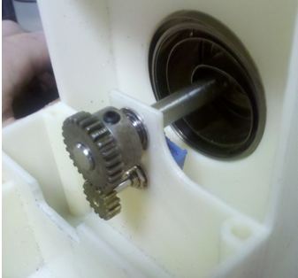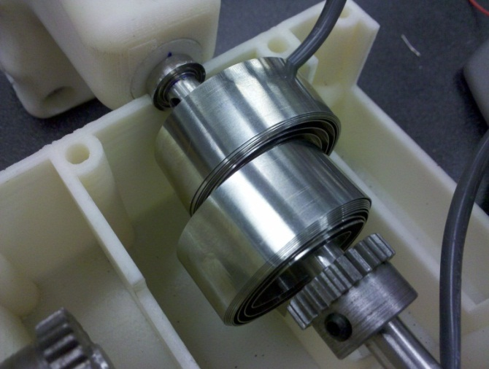

Figure 25: Center Shaft Springs Figure 26: Handle Shaft Springs

Each shaft is also connected to the centerbody by two counter opposing clock type torsion springs, as specified in the requirements. The reason for having two springs per shaft is due to the fact that the torsion springs have very different properties in tension and compression. The spring supplies significantly less resistance to a compressive load; because of this the use of a single spring would result in a different response if the handle were steered right rather than left. The springs can be seen in the figures above, one side of the spring is bolted into a threaded hole in each shaft. The opposite end of each spring is bolted into a hole in the center body. The figure on the above shows the spring mount locations on the handle shaft.

Accessibility to the spring/centerbody attachment was not originally designed for. This was a small oversight which culminated in a small amount of difficulty in attaching the springs on the handle shaft to the centerbody, and a larger amount of difficulty attaching the springs on the center shaft to the centerbody. Attaching the springs on the center shaft to the centerbody involves quite a bit of struggle because the access to the back spring is obstructed by the first. Removing the first spring from the center shaft is not really an option because there is then quite a bit of difficulty in attaching it to the shaft itself. This problem is solvable however and will be discussed in our Proposed Improvements section.

The fully assembled centerbody, with top removed, is pictured below. The figure shows a Pro/E assembly, but the location and of each component is accurate to the real model.

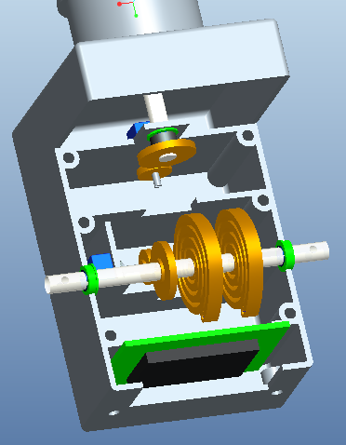

Figure 27: Mechanical Assembly of Centerbody

## 7.2.2 Mechanical Assembly of M1 Abrams Gunnery Handle

In order to create a working M1 Abrams gunnery handle each of the parts had to be attached to their proper locations. Although they have since been added, the handles did not have the two holes that hold the contact switches for the front triggers. These were added by hand after the handles were printed, in order to perfectly match the triggers to the switch position.

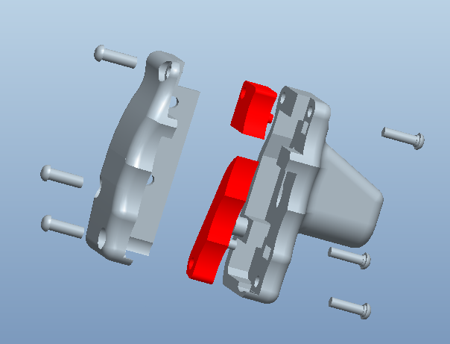

Figure 28: Exploded view of M1A Handle

Once the mechanical assembly of each handle was completed the handles had to be attached to the shaft.

## 7.2.3 Mechanical Assembly of the Handle to the Centerbody

The electrical attachment for the centerbody to the handle was significantly larger than the 5/16th in shaft, so in order for the wire connector to fit into the handle, the handle opening had to be significantly larger than 5/16th of an inch. As a remedy for this issue a plastic bushing was created, as discussed earlier. The allowed the opening on the handle to be 3/4”, supplying enough room for the wire connection.

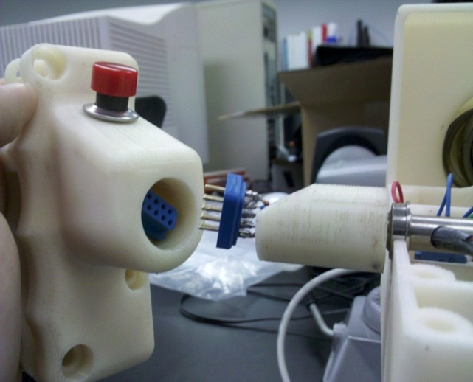

Figure 29: M1A Handle Detached form centerbody

The bushing will remain attached to the shaft even when changing handle configurations. In order to attach the handle to the bushing, simply slide the handle over the bushing and insert the set screw from the bottom.

## 7.3 Electronic Assembly

The customer specified a signal from the handle to a computer via Universal Serial Bus (USB) is necessary. This requirement took quite a bit of research and expertise. In order to send a signal via USB a microcontroller had to be found. This microcontroller needed to be small enough to fit in the center body, have enough pins for analog and digital inputs, provide power to the components in each handle, and plug into a USB port. The microcontroller that fit the criteria the best was the Arduino Uno.

In order to collect the data for the six switches, a simple voltage divider circuit is used for each button that sends a voltage to the digital input pins and is read by the program. Potentiometers are geared to the shafts and are wired with three pins, two for power and one to an analog pin on the Arduino.

The Arduino works well for prototyping because of its open-source platform and easy to use software and hardware. There are 14 digital input/output pins, 6 analog inputs, a USB connection, a power jack, and other components that support the on-board microcontroller. The USB cable is used to power the board and provide power through the Arduino to the components in each handle and the center body.

# 8 References

**Haptics**Gabriel Robles-De-La-Torre. ["International Society for Haptics: Haptic technology, an animated explanation"](http://www.isfh.org/ch.html) <<http://www.isfh.org/ch.html>.>

["Robles-De-La-Torre G. Virtual Reality: Touch / Haptics. In Goldstein B (Ed.), "Sage Encyclopedia of Perception". Sage Publications, Thousand Oaks CA (2009)."](http://www.isfh.org/GR-Virtual_Reality_TouchHaptics2009.pdf)

**Figure 6**  
<http://upload.wikimedia.org/wikipedia/commons/b/b5/Potentiometer.jpg>

**Figure 9**  
<https://www.carpartsdiscount.com/auto/archive/pictures/44276/600/1/P/2CA4435/oldsmobile_intrigue_01_steering_wheel_speed_sensor_oem_26064468.jpg>

**Figure 10**<http://electronics.howstuffworks.com/question368.htm>

**Figure 11**<http://pocketnow.com/thought/how-does-a-cell-phone-vibrate>

**Figure 12**<http://valuablemechanisms.files.wordpress.com/2010/05/clock-spring.jpg>

**Figure 13**Courtesy of Steve Preston (behalf of Lockheed Martin)

# 9 Appendix

## 9.1 Parts List

|  |  |  |  |  |
| --- | --- | --- | --- | --- |
| **Part** | **Description** | **Quantity** | **Prototype Material** | **Production Material** |
| **Handle Shaft** | 5/16 in. hollow shaft | 1 | Stainless Steel | Stainless Steel |
| **Center Shaft** | 5/16 in. solid shaft | 1 | Stainless Steel | Stainless Steel |
| **Bearings** | 5/16. in I.D. ball bearing | 4 | Stainless Steel | Stainless Steel |
| **Torsion Springs** | Constant force wound extension spring | 6 | Stainless Steel | Stainless Steel |
| **Microcontroller** | Arduino Uno | 1 | - | - |
| **Potentiometers** | Variable resistance pot. | 2 | - | - |
| **Pinion Gear** | 18 tooth spur gear | 2 | Brass | Brass/Stainless Steel |
| **Gear** | 30 tooth spur gear | 2 | Stainless Steel | Stainless Steel |
| **Button** | Large thumb button | 2 | - | - |
| **Switch** | Small contact switch | 4 | - | - |
| **Centerbody Top** | Covers centerbody | 1 | ABSplus Thermoplastic | Injection Molded ABS Plastic |
| **Centerbody Base** | House all internal components | 1 | ABSplus Thermoplastic | Injection Molded ABS Plastic |
| **Centerbody Back** | Closes opening in back | 1 | ABSplus Thermoplastic | Injection Molded ABS Plastic |
| **Bushing** | Connect handle to shaft | 2 | ABSplus Thermoplastic | Injection Molded ABS Plastic |
| **M1A Handle Shaftside** | Attaches to the handle shaft | 2* (mirrored) | ABSplus Thermoplastic | Injection Molded ABS Plastic |
| **M1A Handle Outside** | Attaches to the M1A Handle outside | 2* (mirrored) | ABSplus Thermoplastic | Injection Molded ABS Plastic |
| **Small Trigger** | M1A Top Trigger | 2* (mirrored) | ABSplus Thermoplastic | Injection Molded ABS Plastic |
| **Large Trigger** | M1A Bottom Trigger | 2* (mirrored) | ABSplus Thermoplastic | Injection Molded ABS Plastic |

*Mirrored parts must be made for both left and right handles

## 9.2 Parts Drawings

## 

