Conceptual Design
This year’s competition is scored based on three flight missions and a design report. During the conceptual design phase, the objective of each mission is determined in order to establish the critical design requirements. These requirements are then analyzed to determine the parameters that will have the most significant impact on the total flight score. Aircraft configurations are considered and examined based on these parameters.

Mission Requirements
Several design constraints and specifications are imposed by this year’s contest rules, as listed below:
- Can be of any configuration other than rotary wing or lighter than air.
- Must be propeller driven and electric powered by NiCad or NiMH batteries.
- Maximum propulsion battery weight of 3/4 lb.
- Maximum current draw of 20amps.
- Disassembled aircraft and required assembly tools must fit in a commercially produced carry on suitcase of maximum linear dimensions totaling 45 inches; no single dimension can exceed 22 inches.
- Must be hand launched.
- All payloads must be secured and fully contained within the aircraft’s mold lines.
The total flight score equation is $\text{FlightScore}=\frac{M_{1}+M_{2}+M_{3}}{\sqrt{\text{RAC}}}$ where M_{n} represents the nth mission flight score, and RAC represents the maximum empty weight of the aircraft for any of the three missions. For ease of analysis, the RAC can be factored into each individual mission scoring equation to see the direct impact of the empty weight on the mission score, as detailed below. The flight course for all missions is shown in the following figure.
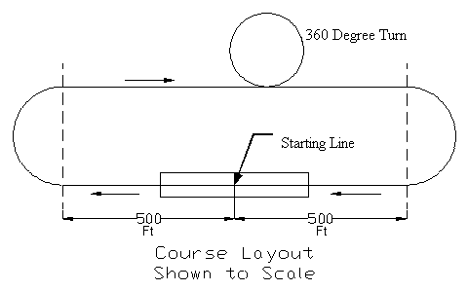
Figure 1: Flight course for all three missions.

Mission One: Dash to Critical Target
In Mission One, the aircraft has four minutes to fly as many complete laps around the flight course as possible without a designated payload. Time starts as soon as the craft leaves the launcher’s hand during the first launch attempt. The scoring equation for Mission One is $M_{1}=\frac{N_{\text{laps}}}{N_{\text{laps}\text{_max}}}×\frac{1}{\sqrt{\text{RAC}}}$ where N_{laps} is the number of laps completed by a specific team and N_{laps_max} is the maximum number of laps completed by any team. In order to maximize the Mission One score, the aircraft is required to feature a lightweight and fast design with high maneuverability.

Mission Two: Ammo Re-Supply
In Mission Two, the aircraft must be loaded with one or more steel bar payloads provided by the team and fly three complete laps around the course. The payload(s) must be a minimum of three inches in width and four inches in length, with a variable thickness which the team selects. The scoring equation for Mission Two is $M_{2}=3×\left(\frac{P}{P+\text{EW}}\right)×\frac{1}{\sqrt{\text{RAC}}}$ where P is the chosen payload and EW is the empty weight of the aircraft for Mission Two. To achieve a high score for Mission Two, the aircraft must have a high payload capacity while maintaining a minimal empty weight.

Mission Three: Medical Supply Mission
In Mission Three, the aircraft must be loaded with a team specified number of golf balls and again fly three complete laps around the flight course. The scoring equation for Mission Three is $M_{3}=2×\left(\frac{N_{\text{balls}}}{N_{\text{balls}\text{_max}}}\right)×\frac{1}{\sqrt{\text{RAC}}}$where Nballs is the number of golf balls carried, and Nballs_max is the maximum number of golf balls carried by any team. To achieve a high score for Mission Three, not only does the aircraft have to have a high payload capacity, but it must also feature a cargo bay or storage area large enough to internally store as many golf balls as capable given the vehicles lift characteristics.

Scoring Analysis
A flight score sensitivity study is used to determine the impact of each scoring parameter on a specific mission score and the impact of each scoring parameter on the total flight score. First, initial assumptions and ranges for certain parameters must be made. This is accomplished by researching performance results from past Design/Build/Fly competitions, as well as reviewing the current capabilities of similar aerial vehicles. For this sensitivity study, a best empty weight of 1 pound and a maximum payload to weight ratio of 3:1 are assumed. The following figures depict 2D contour plots of the variation of mission score versus the scoring parameters for each mission.
Figure 2: Mission 1 Score Vs. EW and Nlaps/Nmax
Figure 3: Mission 2 Score Vs. EW and P/W Ratio
Figure 4: Mission 3 Score Vs. EW and Nballs/Nmax

In order to have a viable chance at winning the competition, it is assumed that a team must score within the top 20% of each mission. From these figures it is evident that to score in this regime for all three missions, the aircraft must have an empty weight of no more than approximately 1.6 pounds. In Mission One it is necessary to achieve at least 80% of the maximum number of laps flown by any team, in Mission Two the aircraft must have a minimum payload to weight ratio of 1.5, and in Mission Three the aircraft must carry at least 75% of the maximum number of golf balls. These graphs also show that Mission 2 is the most crucial mission, as it has the highest possible maximum score. The following figure depicts the impact of the RAC and other scoring parameters on the total flight score. It can be seen that the RAC has the most significant impact on the total flight score as a small change in the RAC results in a considerable change in the flight score.
Figure 5: Percent Change of Total Flight Score Vs. Percent Change of Scoring Parameter
Concept Generation and Selection Process

Figures of Merit
The analysis of each primary aircraft subassembly was evaluated by using figures of merit that were deemed pertinent to the performance of the aircraft. The explanation of each is listed below.
- Weight - The desired overall aircraft weight must be below 1.6 pounds. With this said, the weight of each component is very important and must be minimized.
- Drag - Drag opposes our thrust force generated by the motor which determines the amount of energy must be drawn from the batteries. This is another very important figure that must be minimized.
- Lift - There must be sufficient lift to sustain flight with the maximum desired payload.
- Stability - The aircraft must carry out each required task reliably with very little performance fluctuation.
- Maneuverability - There must be effective control of the aircraft such that each mission can be performed with very little energy consumption or trouble.
- Launch Recovery - Post launch There must be sufficient lift at low velocity to recover quickly from the launch and enough thrust to approach the stall speed before significant altitude is lost.
- Portability - The aircraft must be disassembled and packed into its carry bag with little effort.
- Ergonomics - The aircraft must conform to the launcher's hand to comfortably achieve, during launch, an initial velocity that allows the aircraft to quickly reach the designed stall speed for its given payload.
- Durability - The aircraft must sustain light to moderate handling and the occasional rough landing.
- Storage Capacity - The payload must securely store within the fuselage of the aircraft. It is required that the aircraft hold a maximum payload volume for a given design.
- Complexity - All required assembly must be completed with the available expertise.
- Manufacturability - All manufacturing must be completed with the available facilities

Fuselage Configuration
Three fuselage configurations were considered, they are pictured in Figure 6 and described below.
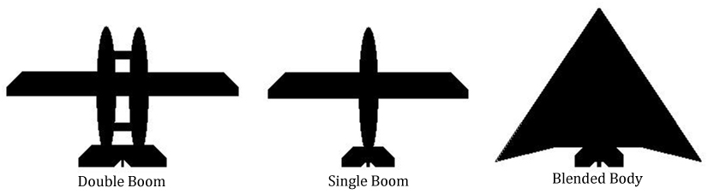
Figure 6: Fuselage Layout

- Single Boom – One fuselage body extends throughout the aircraft.
- Double Boom – Two similar fuselage bodies extend throughout the aircraft.
- Blended Body – Incorporates the wing and fuselage into a single body.

There are several critical parameters to consider when selecting a fuselage configuration: weight, drag, ergonomics, durability, and capacity. Each of these criteria was evaluated with respect to each design concept to determine the most effective option. The results are presented in the following decision matrix:

Figure of Merit | Weighting Factor | Double Boom | Single Boom | Blended Body
Weight | 0.35 | 1 | 3 | 5
Drag | 0.20 | 2 | 4 | 5
Ergonomics | 0.15 | 2 | 5 | 1
Durability | 0.10 | 3 | 4 | 5
Storage Capacity | 0.20 | 5 | 4 | 1
Total | 1.00 | 2.35 | 3.80 | 3.60
Table 1: Fuselage Configuration Decision Matrix

Table 1 illustrates that the most efficient fuselage configuration is the Single Boom layout. The advantages of this design reside primarily in its simplicity, ease of launch, and storage capacity while maintaining minimal drag.
Wing Configuration
The Contest rules state that there can be no rotary wing or lighter than air vehicles. Thusly, our choices are limited to fixed wing designs. The configurations that were considered are visually represented in Figure 7 and described below:
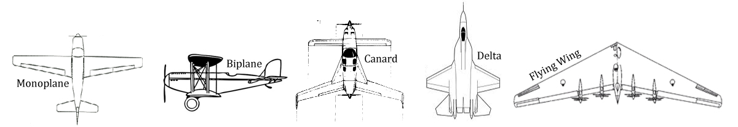
Figure 7: Wing Layout
- Monoplane - A single wing that is positioned perpendicular to the fuselage. Very light, simple design with minimal drag.
- Biplane - Two wings that are stacked one above the other. Provides more lift than the monoplane given all other dimensions are the same. However, this configuration is heavy and induces significant drag.
- Canard - Two wings positioned in parallel, the smaller of the two leading the main wings. Gives the potential to provide more lift and better control characteristics. Unfortunately, it is very easy to design a poor performing and unsafe canard aircraft.
- Delta - Single wing with a linear increase in wing span as it progresses down the fuselage. Provides structural rigidity and high storage volume. Many of the benefits provided by this configuration are divulged at supersonic speeds; which is inapplicable to this design project.
- Flying Wing - Single wing aircraft with integrated body. In its ideal form, this configuration is the most aerodynamically efficient of all that were considered. With that said, it is also the most unstable and difficult to efficiently apply a payload.
These wing configurations each were weighted with regard to their perceived performance. Then they were inserted into a decision matrix against several Factors of Merit (FOM) that were deemed paramount to performance of the aircraft.
Figure of Merit | Weighting Factor | Monoplane | Biplane | Canard | Delta Wing | Flying Wing
Weight | 0.15 | 4 | 1 | 3 | 4 | 1
Drag | 0.20 | 4 | 2 | 2 | 1 | 3
Lift | 0.30 | 3 | 5 | 4 | 3 | 4
Portability | 0.10 | 5 | 2 | 2 | 4 | 1
Stability | 0.15 | 4 | 5 | 3 | 3 | 5
Manufacturability | 0.10 | 5 | 4 | 2 | 3 | 1
Total | 1.00 | 3.90 | 3.40 | 2.90 | 2.85 | 2.90
Table 2: Wing Configuration Decision Matrix
The selected wing configuration from the decision matrix in Table 2 was a monoplane. This design configuration is expected to be the lightest, most easily manufactured, and subject to the least induced drag. Over all, the monoplane is the most widely tested and accepted flight format of all the configurations that were considered; confirming that this configuration is a solid performer and a good selection.

Tail Configuration
The selected tail must possess a series of qualities that will render a stable aircraft that is light weight with low drag properties. There are many tail designs to choose from. It was necessary to analyze the properties of several of these choices and weigh their strengths and weaknesses to arrive at a final selected tail configuration. The tail configurations that were considered are depicted in Figure 8 and described below:
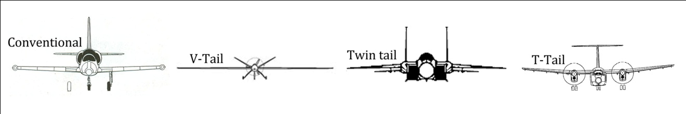
Figure 8: Tail Configuration

- Conventional - Vertical stabilizer is mounted to the fuselage with a 90⁰ offset from the horizontal stabilizers which are mounted to the same general location. Provides little drag and good control. May not be optimal for specific mission parameters requiring extreme stability such as aerial surveillance.
- V-Tail - Two angled fins that extend from the tail with trailing 'ruddervators' that control both pitch and yaw control functions simultaneously. Reduces wetted area of the rear control system which in turn reduces induced drag. Requires more complex control system and induces higher stresses on the fuselage and tail.
- Twin Tail - Tail with two vertical stabilizers. Provides better control with respect to yaw. The increased vertical control surface area also induces additional drag.
- T-Tail - Composed of horizontal stabilizers that are mounted at the tip of a single vertical stabilizer which is connected to the fuselage. Provides a benefit for rear engine aircraft which limits flow interference to the propeller. Induces additional stress on vertical stabilizer which must be accounted for in the final design.
These tail configurations each were weighted with regard to their perceived performance. Then they were inserted into a decision matrix against several Factors of Merit (FOM) that were deemed paramount to performance of the aircraft.

Figure of Merit | Weighting Factor | Conventional | V-Tail | Twin Tail | T-Tail
Weight | 0.15 | 3 | 4 | 3 | 2
Drag | 0.20 | 4 | 5 | 3 | 3
Stability | 0.35 | 5 | 2 | 3 | 3
Maneuverability | 0.20 | 5 | 2 | 4 | 4
Manufacturability | 0.10 | 4 | 2 | 3 | 3
Total | 1.00 | 4.40 | 2.90 | 3.20 | 3.05
Table 3: Tail Configuration

The selected tail configuration pulled from the decision matrix in Table 3 was the conventional tail design. This design, just like the wing configuration, is tried and true. The conventional tail configuration is the most stable, maneuverable, and most easily manufactured for our purposes.

Propeller layout
Five propeller/motor configurations were examined. Each propeller configuration is depicted in Figure 9.
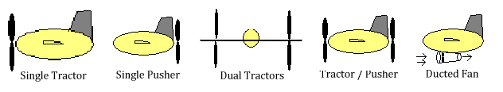
Figure 9: Propeller Configuration

- Single Tractor– Single propeller is placed in front of the fuselage. The motor is mounted behind the propeller and faces forward giving an appearance that the aircraft is "pulled" through the air.
- Single pusher: - Single propeller is situated at the rear of the fuselage. Motor is mounted forward of the propeller facing the rear giving an appearance that the aircraft is "pushed" through the air.
- Double tractor - Two propellers are placed in front of the wings. The motors are mounted behind the propeller pulling the aircraft.
- Ducted fan - Propulsion configuration where a fan is mounted within a cylindrical duct.

The most important FOMs to consider are weight, efficiency, launch recovery and complexity. Each of these is evaluated among several configurations in the following decision matrix:

Figure of Merit | Weighting Factor | Single Tractor | Single Pusher | Dual Tractors | Tractor / Pusher | Ducted Fan
Weight | 0.30 | 5 | 5 | 3 | 3 | 1
Efficiency | 0.30 | 4 | 3 | 3 | 2 | 5
Launch Recovery | 0.30 | 3 | 2 | 5 | 4 | 4
Complexity | 0.10 | 5 | 4 | 2 | 2 | 1
Total | 1.00 | 4.10 | 3.40 | 3.50 | 2.90 | 3.10

Table 4: Propeller Layout Decision Matrix

Table 4 indicates that the best propulsion system configuration is with the single tractor propeller. This design will keep the weight and complexity of the motor and propeller to a minimum while maintaining a good efficiency of the motor and a good recovery time from the launch.

