|  |
| --- |
| Senior design group #3 |
| **Integration of Experimental Propulsion Systems in Micro Air Vehicles** |
| Final Report |
|  |
| October 19, 2010  **Team # 3**  **Group Members:**  Erica Cosmutto  Hunter Metzger  Joel Ware  Kristina De Armas  Michael Isaza  http://cnd.memphis.edu/isdp07/afrl.pnghttp://www.eng.fsu.edu/~arenaal/Solar_Car/images/COE_seal.pngSantiago Baus |

Table of Contents

Executive Summary 4

Introduction 5

Problem Statement 5

Background: 6

Component Selection and Analysis 9

Electric Ducted Fan (EDF) 9

Battery 9

Electric Speed Control (ESC) 10

Material selection 10

Design 11

Fuselage Design 11

Design 1: Inlet Close to Fan 12

Design 2: Inlet Far Away From Fan 14

Design 3: A Separation Rod 16

Calculations: 18

Analysis Using Comsol: 19

Cost Analysis: 19

Weight Analysis 21

Plans for Fabrication and Testing (Spring Semester) 21

Conclusion 22

Acknowledgements 23

References 24

Appendices

Appendix A: Calculations………………………………………………………………………………………………………….25

Appendix B: Pro-E…………………………………………………………………………………………………………………….28

Appendix C: Website………………………………………………………………………………………………………………..29

Table of Figures

Figure 1: Electric Ducted Fan 9

Figure 2: Electric Speed Control 10

Figure 3: Fuselage Design 11

Figure 4: Comsol Representation of Design 1 13

Figure 5: COMSOL Representation of Design 2 15

Figure 6: Comsol Representation of Design 3 17

Figure 7: Fuselage with close intake 28

Figure 8: Fuselage with intake father away 28

Figure 9: Dimensioned Fuselage 28

# Executive Summary

The Integration of Experimental Propulsion Systems in Micro Air Vehicles (MAV) project is sponsored by Eglin Air Force Base. The project is based on the need to improve current MAV designs by using an electric ducted fan as the propulsion system. Electric ducted fans have the potential to be more efficient, capable of higher velocities, quieter, and safer than a basic propeller system. When coupled with a properly designed duct the improvement in performance of the MAV could be very significant.

The goal of the project is to design three MAVs. Once an initial design of the fuselage was created, the position of inlet and duct design was changed to arrive at the other designs. These designs will be tested to see which configuration of inlet position, and duct geometry will produce the best performance. The performance will be based on the efficiency and velocity achieved by the configuration as well as overall weight. The team will then decide on the ‘best’ MAV based on the performance and how well it meets the specifications.

Analysis was performed on three chosen designs. Initial calculations were performed to calculate the pressure drop across the fan. This allowed for flow simulation in COMSOL, where the fan was represented as a pressure difference. From this analysis the flow of air in the duct and across the fan can be visualized. The velocity profile of the flow was then created, showing the maximum velocity the various designs can reach. A maximum velocity of approximately 75 m/s exiting the fan was reached in design 1. As discussed later, a high velocity entering and therefore exiting the fan often means a low efficiency of the fan.

Boundary layer ingestion is utilized in design 2. The boundary layer is passed through the fan. The change in velocity here is greater because of the lower incoming velocity. Meaning the fan did much more work using the same amount of power. This equates into an increase in efficiency.

The third design utilizes a rod that is attached at the hub of the fan. This serves to separate the flow and maximize the amount acting on the fan blades. From the analysis it can be seen that the velocity here is greater than that of the second design, however it is conjectured that it is also less efficient.

# Introduction

The group was assigned this MAV experimental propulsion project by the Eglin Air Force Base in Fort Walton Beach, Florida; more particularly by 1st Lieutenant John Brewer. At Eglin, 1st Lieutenant Brewer is a part of a research team specializing in the advancement of micro air vehicles. As a graduate of the FAMU/FSU College of Engineering and the senior design program, he reached out to our team to create three efficient MAVs using an electric ducted fan and to run various tests to judge their performance.

For the first couple weeks of the project, the group has been creating generic fuselage designs that fit the constraints of the project in order to create a single “base” design, or outer shell, that satisfies our customer. After the base design has been determined, the group will vary different variables of the fuselage in order to build and test different models for the best overall performance.

Another main focus of the project thus far has been component analysis and selection. The micro air vehicle must carry a fan, battery, and speed controller. It has been a task in itself to determine the most efficient combination of components that will maximize the aircraft’s performance and flight time.

After creating multiple designs with varied intake position, fan location, etc, the proceeding plan for the group is to begin work at HPMI (High Performance Materials Institute) to physically build the fuselages. Over the next semester these fuselages will be tested and analyzed in order to determine the best performing fuselage according to a prepared decision matrix.

# Problem Statement

This project consists of designing the fuselage of an MAV with the electronic components to propel the vehicle. The constraints for the project are the design must fit into a 6 inch diameter tube for storage, final weight should not exceed 10 pounds, and the length must be equal to or less than 32 inches. The electronic components that are needed to produce an MAV are: a powerful battery, an electric ducted fan, a speed controller for the fan, and remote controls for the MAV. The MAV fuselage will be produced out of carbon fiber composite to provide a light weight vehicle and durable frame. For the vehicle to fly there needs to be a 4 to 1 ratio of weight to thrust to provide enough power to the MAV. The wings will be provided by the sponsor and a certain area along the fuselage will be designated for the wings. The first eight inches of the MAV is to remain free to put electrical components but does not include the ducted fan. The goal is to build three MAVs that fit within the constraints and are built according to the parameters of motor efficiency, flight velocity, flight time, weight, and durability.

# Background:

The topic of micro air vehicles (MAV) is large and constantly growing and changing. For engineers, the challenge of creating small devices that can fly, reach various speeds and with different maneuverability is an exciting one. As can be imagined, the design possibilities here are endless. There are numerous uses for these MAVs. This includes surveillance, communication, mapping out treacherous terrain, etc.

The main component of any aircraft is its propulsion system. The average MAV uses a propeller at the nose of the plane to accelerate the air. An alternative to this would be to use a ducted fan.

A ducted fan is defined as a fan with duct that has a chord longer than the diameter of the fan. These fans have many advantages over their counterparts, which is usually a simple propeller at the nose of a plane. The use of ducted fans allow for the possibility of vectoring the thrust exiting the plane. This may be something that is looked in to next semester. Noise suppression is also a large advantage of ducted fans. Because of the shroud around the fan and the fact that the fan is fully enclosed in the body of the plane, noise emitted is minimal. Ducted fans also provided better low-speed and static thrust. They can achieve higher thrust per horsepower for a given diameter. This is a huge advantage when size, specifically diameter, is important. As noted above diameter is a constraint for this project.

One disadvantage of a ducted fan is that usually the inlet and exit areas are fixed, resulting in a design of the fan and duct that is optimized for one speed. This is not really an issue for this project because of the relatively small range of velocities. All calculations and visualizations are done for a specific cruise condition.

Thrust is achieved by steadily increasing the momentum of the air passing through.

$T=\dot{m}∆V$ Equation 1

$\dot{m}$ = ρ $V_{1}A$ Equation 2

$ΔV= V_{2}-V_{1}$ Equation 3

T=Thrust

$\dot{m}$ = Mass flow rate

∆V= Change in velocity

V2=Exiting Velocity

V1= Incoming velocity

There is a certain power needed to create this thrust. Power is the rate of change of energy. The change in momentum (thrust) can be equated to power by the equation below (Equation 4).

$P=\frac{1}{2}\dot{m}(V_{2}^{2}-V_{1}^{2})$ Equation 4

P= Power

Equation 3 is simply equation 2 expanded and rearranged to illustrate the effect the change in velocity and the mass flow rate have on the power needed to achieve a certain thrust. It makes sense to aim at keeping the power needed to produce a certain thrust as low as possible. From viewing equations 1 and 5 it is noted that if the mass flow rate is cut in half and the change in velocity is doubled a certain power is required in order to achieve a constant thrust. This power would be larger than the initial value because the change in velocity is squared in the second term, increasing the power required to create the same thrust. The reciprocal is also true, if the mass flow rate is increased and the change in velocity is lowered, the power decreases.

$P=\dot{m}*∆V*V_{1}+\frac{1}{2}{(∆V)}^{2}\dot{m}$ Equation 5

Graph 1: Graph showing the relationship between mass flow and power.

The graph 1, above, shows the relationship between mass flow and the power required divided by the ideal power. As the mass flow is increased the fraction of power is reduced. As seen, increasing the mass flow rate is very effective when the mass flow is initially low. The higher the mass flow rate is the more it has to be increased to achieve the same improvement. At some point the effort it takes to increase the mass flow rate is not worth the decrease in power that is achieved.

Equation 6 shows that if the free stream velocity is decreased, the ideal power required to obtain a certain thrust is also decreased. Furthermore, combining equations 1 and 5, a relationship between the power and thrust is created (equation 7). This also illustrates that if the incoming free stream velocity is lowered the power required is decreased.

$P_{ideal}=T*V_{1}$ Equation 6

$P=TV_{1}+\frac{1}{2}\frac{T^{2}}{\dot{m}}$ Equation 7

V1= Free stream velocity

One way to slow down the average free stream velocity is to have more boundary layer entering the fan. This is called boundary layer ingestion. Boundary layer ingestion increases the efficiency of the fan. Thrust is created by simply increasing the velocity by a constant increment. In other words, the change in velocity creates the force we think of as thrust. Because of this fact, it makes no difference if the incoming velocity is high or low, as long as the change in velocity is the same. We know from the above equations that it takes less power to accelerate a slower incoming velocity than a velocity with a higher speed.

Decreasing the incoming velocity will increase the efficiency of the system but does it a price of a slower exit velocity and thrust. Arriving at a balance between efficiency and exit velocity is the key.

# Component Selection and Analysis

**Electric Ducted Fan (EDF)**

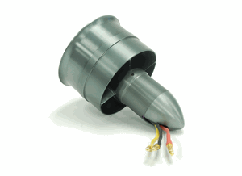The EDF is the first component that was selected because the battery and speed controller must be chosen to accommodate the power of the fan. When sizing a fan, it is important that the group picks a fan powerful enough to fly the aircraft. However, if the EDF creates too much thrust, the vehicle may not be controllable. After speaking with our sponsor, it was agreed upon that a 40% thrust to weight ratio was ideal. Since we know the total weight of the MAV (10lbs.), it is figured that a fan that outputs 1.814kg of thrust is what is needed. The picture above is the fan that was chosen and purchased from hobbypartz.com. It was chosen because it has a maximum thrust output of 2.2kg and fits within the constraints of the fuselage. We figured it was safer to choose a fan that creates more than enough thrust to fly the MAV and gear it down with a speed control to find the optimal amount of thrust during flight. Every fan draws different amounts of power, and this one in particular runs on 55 amps at 22.2 volts. The next step in component selection is to choose a battery that can power this fan.

Figure 1: Electric Ducted Fan

## Battery

Because the battery makes up a great deal of the MAV’s weight, a battery with extremely high energy density is desired. A lithium polymer battery comes to mind because of its high energy content and light weight. Every cell of a lithium polymer battery contains 3.7V, so technically only a six-cell lithium polymer battery is needed to cover the 22.2V required by the EDF. Batteries of this voltage however only have capacities of around 5-6 amp-hours and would give us a flight time of around 5 minutes if the batteries were fully discharged. So for our MAV, we chose to utilize a 6S4PL lithium polymer battery (6 cells in series and 4 cells in parallel). The extra cells that are combined in parallel will add to the capacitance of the battery as a whole without supplying extra voltage that risk frying the motor. This 10 cell battery has a capacitance rating of 8 amp-hours and will give us about 9 minutes of flight time if the fan runs at its maximum speed and the batteries are completely discharged. The battery is also capable of running a maximum continuous current of sixteen times its capacitance which is well over the maximum load of the fan. The team will purchase a battery of this size from thunderpowerrc.com.

## Electric Speed Control (ESC)

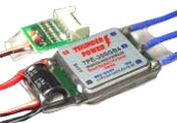The team also found a sufficient speed controller from thunderpowerrc.com. When matching a speed controller, it was important that one was found that covers the maximum voltage and current drawn from the fan so that it can effectively adjust the vehicle’s flight speed. The ESC in the corresponding picture is rated to adjust up to 100A and 44.4 V. It is also a “Smart-Guide” speed controller, meaning that it contains an internal circuit that monitors the voltage of each cell and sends a signal to the user when the voltage of each cell drops to or below 3.4V and risks discharging to the point where it cannot be recharged. The combination of this speed controller with the 6S4PL lithium polymer battery and the 2.2 kg thrust fan we believe gives us the perfect balance between weight and power.

Figure 2: Electric Speed Control

# Material selection

The fuselage frame of the MAV needs to be durable, light weight, and weather resistant so we decided to build the frame out of a carbon fiber composite. Carbon fiber composite is a carbon based cloth that has small fibers which are woven together and combined with a plastic resin to create a light weight and high strength material. The plastic resin that will be used to create the MAV is epoxy. Epoxy has a low density which will make the frame light weight but also durable.

# Design

## Fuselage Design

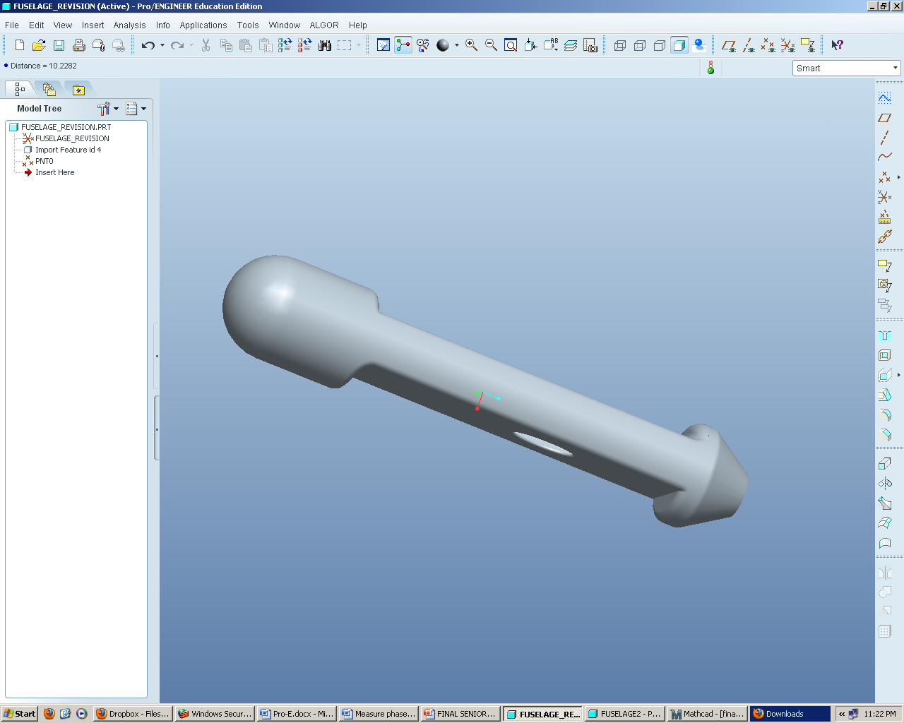Even though the exterior fuselage shape was not the primary focus of the project, an exterior design that is usable for every duct design must be created. The fuselage is constrained to fit inside a cylinder with dimensions of six inches in diameter and 32 inches in length. The team decided it was the best option to make it as close to those dimensions as possible so that there would not be too much excess room for the fuselage to slide around and possibly be damaged. The position of the wings is known by the chord drawing our sponsor has supplied. Figure 3 illustrates the outer shell of the fuselage that the team designed for the project.

Figure 3: Fuselage Design

The fuselage seen above is 32 inches in length and has a maximum diameter of 6 inches. There is 8 inches of room at the front of the fuselage to allow for component storage. The wings will attach to the fuselage at the top and bottom in the area of smaller diameter. In order to actually mount the wings, there is a vertical wall of 0.95 inches in the front and back. The exhaust of the fuselage tapers down to 75% of the fan sweep area to further accelerate the flow out the back. An ellipse was the shape of choice for the intake to best accommodate the laminar flow running along the bottom side of the fuselage. Throughout the project the team will experiment with the location of the elliptical intake and judge where the most beneficial position is located with respect to internal friction and boundary layer development prior to the fan.

## Design 1: Inlet Close to Fan

This design utilizes an inlet as close to the fan as the design would allow. A Pro-e drawing of this design can be seen in Appendix B. This allows for the pressure difference between the fan and the inlet to ‘pull’ more air towards the fan. Mass flow rate as well as incoming velocity is therefore higher because of the inlet position. Looking at the equation for thrust, seen in the background portion, the thrust is directly related to mass flow rate. With the duct before the fan being almost non-existent, there is very little loss associated with friction. Therefore this design would result in a high exiting velocity but not without a price.

There are also a few disadvantages associated with this design. As seen in graph 2, from the velocity profile, the flow is not fully developed. This causes non-uniform incoming flow. Figure 4, below shows the amount of boundary layer entering the fan. Comparing this to design two, it can be seen that there is significantly less boundary layer flow entering the fan. As talked about previously, the more boundary layer that is fed to the fan the less power it takes to produce a certain thrust. Even though there is a high entering mass flow rate and velocity the efficiency for this design would be much lower when compared with design two.

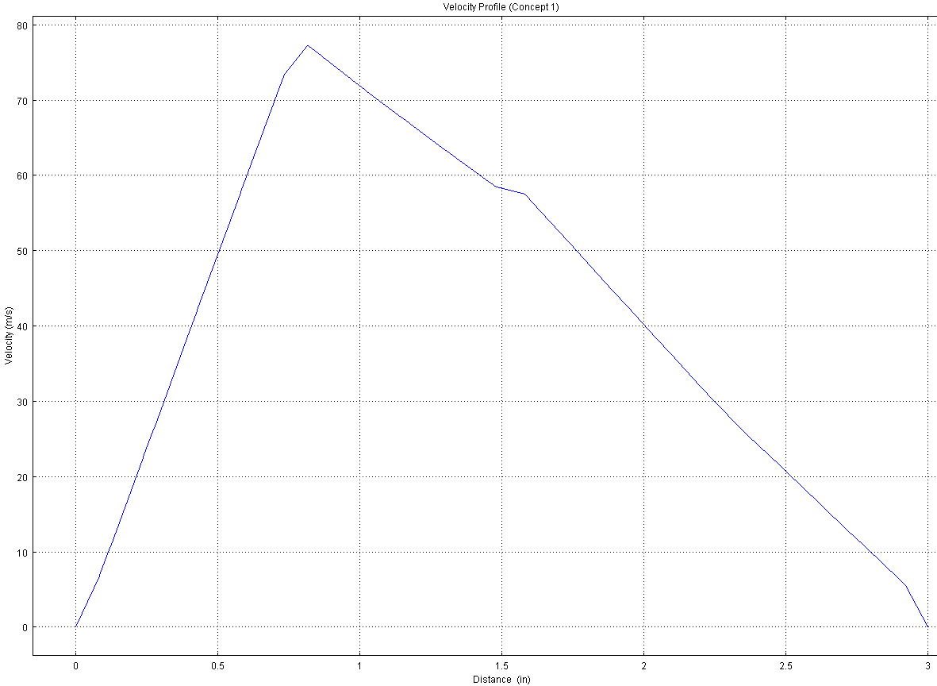

Graph 2: Velocity Profile for Design 1

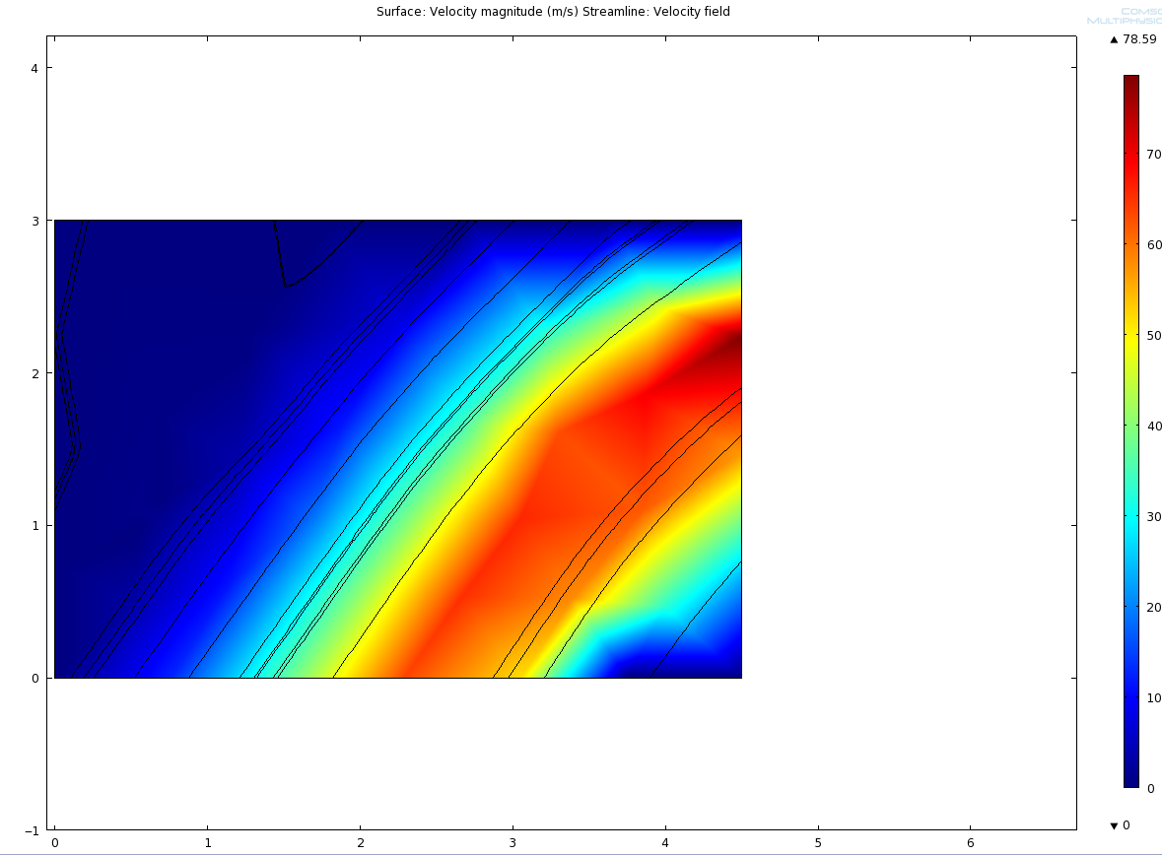

Figure 4: Comsol Representation of Design 1

Figure 4 shows a relatively high velocity of air towards the center of the figure. As discussed in the Comsol section, there is a limitation in the validity of considering that the flow has crossed the fan. In actuality the fan has a hub at its center. The flow would then have to decelerate and go around the hub into the blades. Therefore the figure above is a good representation of the flow before it comes in contact with the fan, but not after.

## Design 2: Inlet Far Away From Fan

The design will consist of the base fuselage design but the duct intake hole will be located 10.5 inches in front of the EDF. A Pro-e drawing can be seen in Appendix B. Concept two uses the same process as design one to draw the air into the intake by having pressure differences at the inlet. By moving the air intake hole the duct will be longer leading up to the EDF. The longer duct will slow down the flow velocity of the air due to friction from the walls which will create a boundary layer within the duct before the fan.

The power that is needed to generate a desired thrust is determined by Equation 4. Equation 4 shows that the slower the velocity that enters the fan than there is less power that is needed to create a desired thrust. Since the boundary layer within the duct slows the velocity of the air entering the fan, the power supplied to the fan will be lower. When less power is consumed by the fan, the battery life during a flight will be lower creating a more efficient MAV. The higher efficiency for the fan will allow for longer flight time since less power is drawn from the battery.

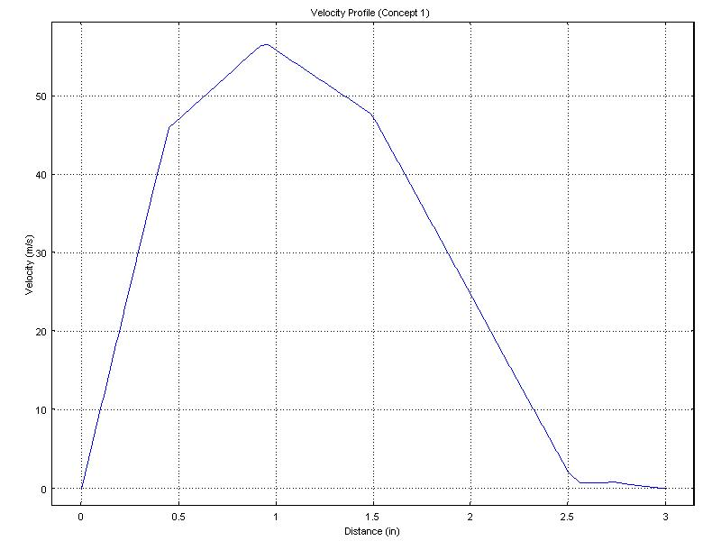

Graph 3: Velocity Profile for Design 2

The drawback from design concept two is the maximum velocity of the MAV is lowered from the creation of the longer duct. Graph 3 shows the velocity profile entering the fan and the velocity profile is lower than the velocity profile for concept one. It makes sense that the higher the velocity that enters the fan, the higher the output velocity of the fan. Since there is a lower velocity entering the fan caused by the boundary layer, the maximum attainable velocity of the MAV will be lower with the creation of the longer duct.

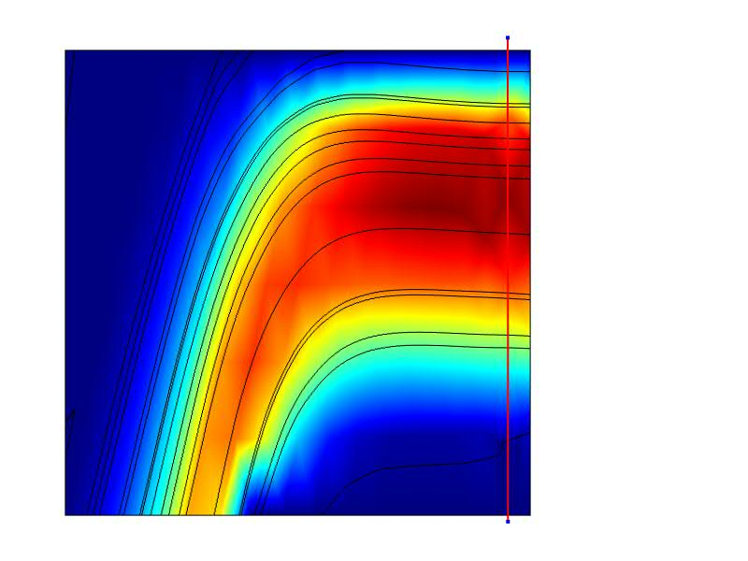

Figure 5: COMSOL Representation of Design 2

The Comsol drawing of design concept two shows the flow of the air as it enters the duct from the intake hole to the EDF. The free stream air outside the MAV will enter the duct and turn towards the fan due to the pressure differences from the outside and inside of the duct. The fan will lower the pressure inside the duct to below the pressure outside of the MAV. This pressure difference will create vacuum in the duct which causes the air will enter into the duct. Since the air flow has time to turn towards the fan, the flow of the air is more uniform across the duct when it enters the fan. When the uniform flow enters the fan, the most air is flowing over the fan blades which increase the efficiency of fan.

## Design 3: A Separation Rod

The idea of the separation rod is to divert the very center oncoming air that would otherwise create a stagnation point at the hub around the hub and into the fan sweep area. As seen in the velocity profile in graph 4, the average velocity, $V_{0}$, of the boundary layer moving through the fan increases. Now when looking at the equation for thrust found in equations 1-3 in the background, it is noted that $V_{0}$ is a function of both the mass flow through the fan and its velocity gradient. However, looking closer at their relationship with ${ V}_{0}$, it is noted that the mass flow actually increases at a greater rate than the decrease in velocity. As a result there is a net increase in thrust output of the fan. So in essence the idea of the separation rod is to increase the thrust output of the EDF at an expense of additional friction along the rod surface.

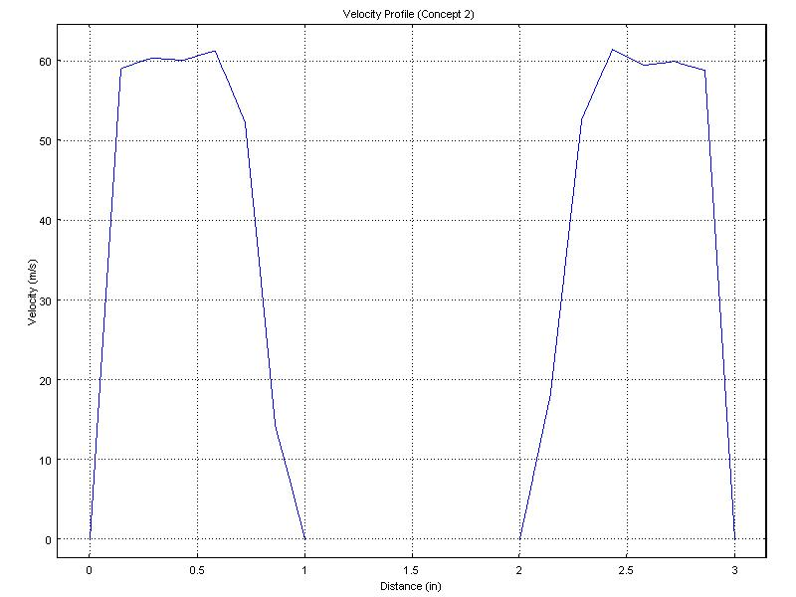

Graph 4: Velocity Profile of Design 3

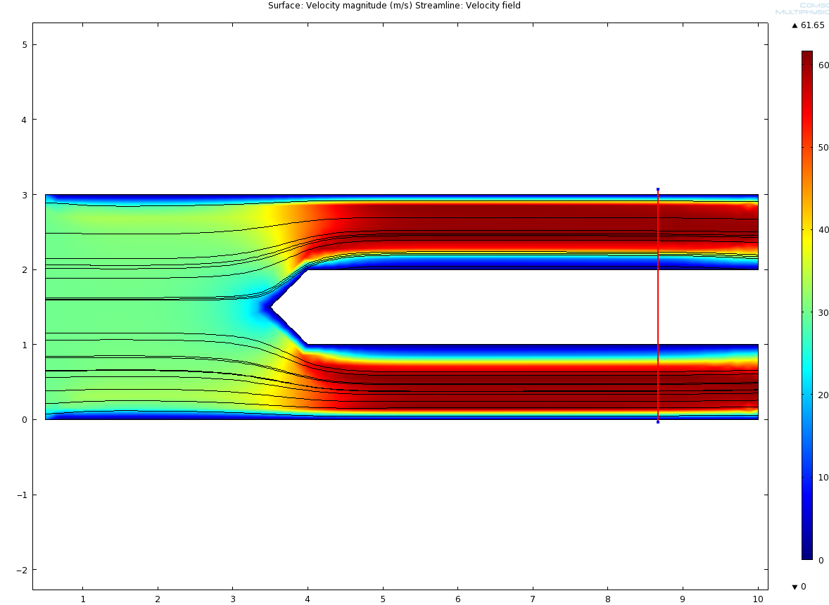

Figure 6: Comsol Representation of Design 3

As illustrated by the flow in figure 6,this is an effective technique however only plausible if utilized within a fully developed boundary layer. The use of this concept not within a fully developed boundary layer results in uneven, unsteady flow around the rod through the fan which severely decreases its efficiency. The fatigue of the fan also increases because of the unbalanced, awkward flow through the sweep area. Along with friction caused by the walls of the rod, an additional stagnation point forms at the front that can be reduced with the shape of a point.

# Calculations:

An approximate flight time of the MAV was be calculated by dividing the capacitance of the entire battery by the average load drawn by the EDF during flight. When taking an average load of 55 amps and a battery capacity of 8 amp-hours, it was calculated that the vehicle will fly for approximately nine minutes. Now, this calculation is correct only if the battery is fully discharged. In reality, a lithium polymer battery cannot be discharged completely otherwise it is no longer rechargeable. With our MAV, the speed controller will cut the current from the battery after each cell is discharged down to 3.4V. All this meaning that the group will not actually get a nine minute flight time from the MAV. Before actually flying the aircraft, projected flight time is somewhat of a guessing game. However when taking a lower, more realistic average EDF load, and considering the 3.4V cut off from the ESC, a projected flight time of 5-8 minutes can be approximated.

From the sponsor it was specified that the thrust needed to be about 40% of the total weight. The MAV should weigh close to ten lbs. From here it was calculated that a thrust of about 1.9 kg was needed. An electric ducted fan (EDF) with a maximum thrust of 2.2 kg was chosen. The sponsor and team decided it would be better to be on the high side than the low, and with the selection limited the EDF shown above was selected.

Once the fan was selected the fan sweep area (FSA) was calculated. The FSA is the area affected by the blades. Ideally the inlet area of air would be equal to the FSA. An ellipse was decided to be the most aerodynamic shape and with the dimensions of, 3.79 in. by 1.895 in. the correct area was reached.

The next step was to find the pressure change across the fan. The torque of the motor was calculated using the RPM. Once the torque was calculated the force on each blade was determined. Knowing the force and area, the change in pressure was calculated to be 2.315 kPa. Using equation 8, the velocity of the air going through the fan was calculated. The mass flow rate was then calculated from this velocity.

A cruise speed of 30 m/s was estimated. Using this and the velocity and mass flow rate calculated the pressure before the fan and at the duct inlet was calculated. These calculated values were then used in COMSOL to arrive at an estimation of the air velocity as it approaches the fan. For a closer look, all calculations can be found in the appendix.

# Analysis Using Comsol:

Initial calculations were performed to calculate the pressure drop across the fan, the pressure before the fan, and the pressure at the inlet. These calculations can be seen in Appendix A. This allowed for flow simulation in COMSOL, where the fan was represented as a pressure difference. An initial velocity of 30m/s, in the x direction, was assumed to be the cruise speed for the simulation. Using the pressures mentioned above the flow enters the inlet because of the difference of pressure and travels along the duct into the fan. From this analysis the flow of air in the duct and across the fan can be visualized.

There is a limitation to the accuracy when considering the visualization across the fan. Because the fan is simulated as simply a pressure drop it does not have the physical attributes that the actual fan has. The hub located at the center of the fan would cause this flow to decelerate and go around the hub to the blades. Therefore the air flow would look very different after physically passing through the fan. Therefore, the Comsol visualizations created allows for a good idea about the characteristics of the flow before it reaches the fan due to the duct but not for the flow as it passes through or after the fan.

Next semester the group will continue learning about Comsol and learn how to use the feature in Comsol that actually allows the user to place a fan where needed. This would be beneficial in visualization of the flow immediately before and after the fan.

# Cost Analysis:

Our budget for the project is $2000, so the goal for the components of the MAV including the battery, EDF and speed controller was to cost roughly $1000. We calculated the costs of the propulsion components and other parts to be $1091.95 which is fits our goal. This leaves roughly a $1000 to spend on the process of building the fuselage frame out of carbon fiber. The addition of the cost of fuselage materials with the component cost can be seen in table 1. Table 2 shows a breakdown of the various items and materials needed to manufacture the three designs.

Table 1: Cost Analysis

|  |  |
| --- | --- |
| Component | Cost ($) |
| EDF | 129.95 |
| Battery | 509.99 |
| Battery Charger | 109.98 |
| Woodworks LipoSack (Storage) | 34.99 |
| ESC | 120.00 |
| Transmitter/ Receiver | 179.97 |
| Industrial Strength Velcro | 7.00 |
| Fuselage Materials | 499.65 |
| **TOTAL** | **1591.53** |

Table 2: Materials Cost Analysis

|  |  |  |
| --- | --- | --- |
| Materials |  | Cost ($) |
| Carbon Fiber | 6 yards | 301.50 |
| Resin | 1 quart | 22.25 |
| Spray Adhesive | 1 can | 12.95 |
| Peel Ply | 2 yards | 22.00 |
| Breather Cloth | 2 yards | 16.00 |
| Flow Media | 2 yards | 75.80 |
| Nylon Bagging Film | 2 yards | 17.00 |
| Vacuum Tubing | 6 ft | 4.35 |
| Yellow Sealant Tape | 2 rolls | 27.80 |
|  | **TOTAL** | **499.65** |

# Weight Analysis

One constraint for our fuselage is that it cannot weigh more than 10 pounds. The weights of the EDF, battery, ESC, and receiver were provided by the manufacturer. The body of the fuselage was calculated to be roughly 1.977 lbs. This ideal total calculated weight is well within the 10 lbs limit. Table 3 shows the weight of each component in the designs.

Table 3: Weight Analysis

|  |  |
| --- | --- |
| **Component** | **Weight (lbs.)** |
| EDF | 0.862 |
| Battery | 2.05 |
| ESC | 0.242 |
| Transmitter/ Receiver | 0.033 |
| Fuselage | 1.977 |
| **TOTAL** | **5.164** |

# Plans for Fabrication and Testing (Spring Semester)

The plan for next semester primarily consists of manufacturing and testing. In order to manufacture the fuselage, a three dimensional mold must be produced in order to infuse the carbon fiber sheets with resin. The Pro Engineering drawings of the exterior of the fuselage have been sent to our sponsor where he will create this mold with their resources at Eglin Air Force Base. After the mold has been created and returned, the team will begin work at HPMI to infuse carbon fiber sheets with epoxy resin over the mold in a process called vacuum bagging. With the completion of the carbon fiber composites, testing of the fuselages will begin.

The goal of the project is to produce three working fuselages that all meet the sponsor’s requirements. However at the end, the team would like to specify which design and model is the best. In order to choose the best fuselage, a decision matrix will be created. The matrix will be a function of efficiency, weight, and max velocity with the corresponding weights of each parameter still to be determined. The weight of the fuselage can be measured with a scale; however the maximum velocity and efficiencies must be tested using a wind tunnel.

The maximum speed a fuselage will be traveling is directly related to the exit velocity leaving the fan. So in essence, the larger exit velocity, the higher velocity of the vehicle. That is without respect to weight of the MAV. In order to calculate the exit velocity from the fan, a pitot static tube will be used inside a wind tunnel to measure the static and dynamic pressures at the back of the fuselage. Equation 8 shows the relationship between the pressure gradient and exit velocity of the fan.

$V_{exit}= \sqrt{2\frac{ΔP}{ρ}}$ Equation 8

Again how important the exit velocity is and the weight it has in the decision of the best performing fuselage is yet to be determined, however it does provide evidence for the speed they will be traveling in relation to the others.

Efficiency of each fuselage is another important parameter to take into account when choosing the fuselage that performs the best. In order to judge efficiency, each fuselage will be mounted inside the wind tunnel and the fan will be turned on. The time it takes discharge each cell of the battery down from 3.7V to 3.4V will be clocked. Essentially the most efficient design will take the longest to discharge the cells to 3.4V while running the same load. Once all of the parameters of the matrix are recorded, the best performing fuselage design can be judged by multiplying the weight of the parameter with its score to find its overall performance rating.

# Conclusion

The procedures followed throughout the first semester of the project provided a great deal of evidence that the group is on pace to produce three fuselages that more than satisfy the sponsor’s requests. After much research the group decided that the most significant parameter that altered a fuselage’s performance was the velocity gradient through the fan; more specifically the air flow’s initial velocity before the fan. Furthermore, the initial velocity of the airflow can be altered by two techniques: adjustment of boundary layer ingestion and a change in the amount of friction through the internal duct.

Therefore, the three concepts proposed to be manufactured, (far inlet location, close inlet location, and separation rod) all change different parameters that affect the overall performance of the micro air vehicle. The design with a close intake is a base design. It contains the least amount of friction inside the duct and feeds a significant amount of boundary layer resulting from the undeveloped flow. The design with an intake location further away feeds the fan less boundary layer but allows for more friction along the walls of the duct. The separation rod is only used in conditions of a fully developed boundary layer. It adds a great amount of friction with the outer surface of the rod, however feeds the fan less of a boundary layer.

All three concepts are easily constructible and provide three distinct plausible solutions to the sponsor’s requirements. After all fuselage concepts are constructed, the team will be left with three different fuselages that perform differently for different reasons. The fuselages then will be tested in multiple ways and judged according to the decision matrix previously discussed. At the completion of the tests, the group is confident three working fuselages can be provided to the sponsor on time, with one fuselage specifically picked out to perform the best.

# Acknowledgements

We would like to acknowledge John Brewer, our sponsor at Eglin Air Force Base, for his patience and advice whiler mentoring us throughout the project. We would also like to acknowledge Dr. Okenwa Okoli, Dr. Hovsapian, Dr. Kosaraju and the TAs for providing aid whenever we needed it. Dr. Englander and Dr. Ahmed also contributed much in guiding the team in the right direction and played a significant role in our progress.

# References

1. "76mm Aluminum Alloy Electric Ducted Fan." *Nitro RC Planes, Inc.* 2010. Web. 05 Oct. 2010. <http://www.nitroplanes.com/lealalel76du.html>.
2. Çengel, Yunus A., and Robert H. Turner. *Fundamentals of Thermal-fluid Sciences*. 3rd ed. Boston: McGraw-Hill, 2001. Print.
3. Draganfly Innovations Inc. *RCToys.com Sells RC Airplanes RC Blimps RC Helicopters & Parts*. 2008. Web. 07 Oct. 2010. <http://www.rctoys.com/pr/category/rc-information/rc-hobby-parts-component-info/>.
4. "Electric Ducted Fan Jet." *RC Hobby Universe Guide to RC Airplanes, Helicopters, Boats, Cars and Trucks!* 2006. Web. 07 Oct. 2010. <http://www.rc-hobby-universe.com/electric-ducted-fan-jet.html>.
5. “Fibre Glast Developments.” 10 October 2010. <http://www.fibreglast.com/contentpages-molding+fibreglass-171.htm>.
6. Fouquet, Chris “Vacuum Bagging” (21 September 1996). 10 October 2010 <http://www.pilotsguide.com/rc/vacbag.shtml>.
7. “Integrating GPS with MAVs.”<http://www.mil.ufl.edu/~number9/mav/>.
8. Marc De Piolenc, F. "Ducted Fan Design, Volume 1 (Revised)." *Google Books*. Web. 29 Nov. 2010. <http://books.google.com/books?id=YcAjcSSP4HMC&printsec=frontcover&dq=Ducted Fan Design Volume 1&source=bl&ots=WtfDi_ZHQZ&sig=4G6VIAKC63HnIZLlQMLFf56LTZ0&hl=en&ei=nYnoTID_GMP6lwewtLGcCw&sa=X&oi=book_result&ct=result&resnum=9&ved=0CEYQ6AEwCA#v=onepage&q=efficiency&f=false>.
9. “RC Hobby Universe.”< http://www.rc-hobby universe.com/electric-ducted-fan-jet.html>.
10. "US Composites." *Fiberglass , Epoxy , Composites, Carbon Fiber - U.S. Composites, Inc.* 2010. Web. 30 Nov. 2010. <http://www.shopmaninc.com/>.

# Appendix A:

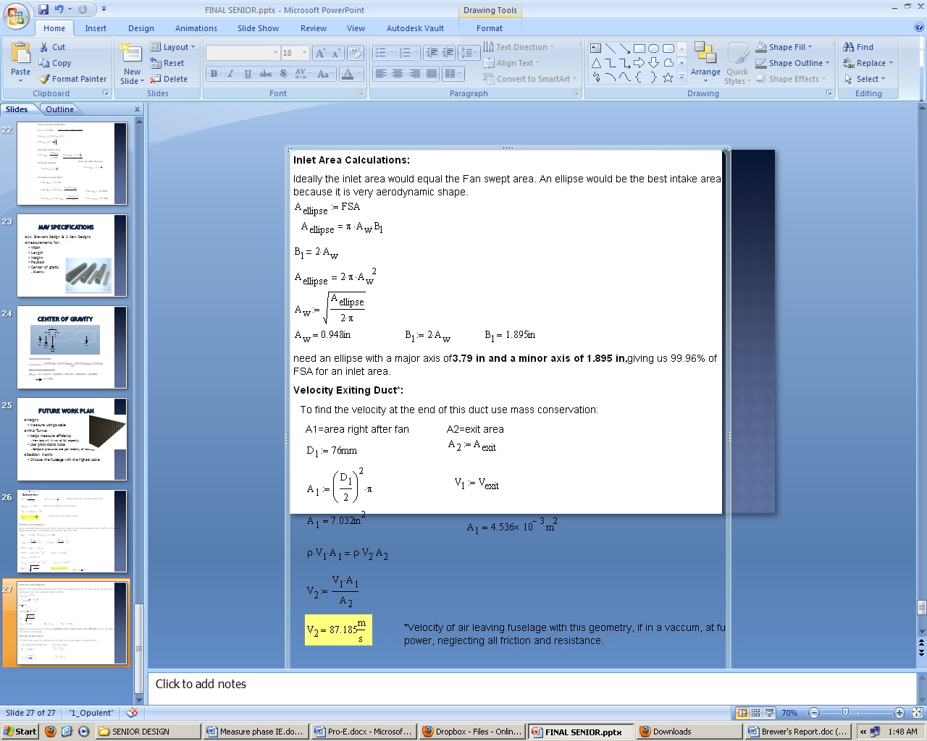

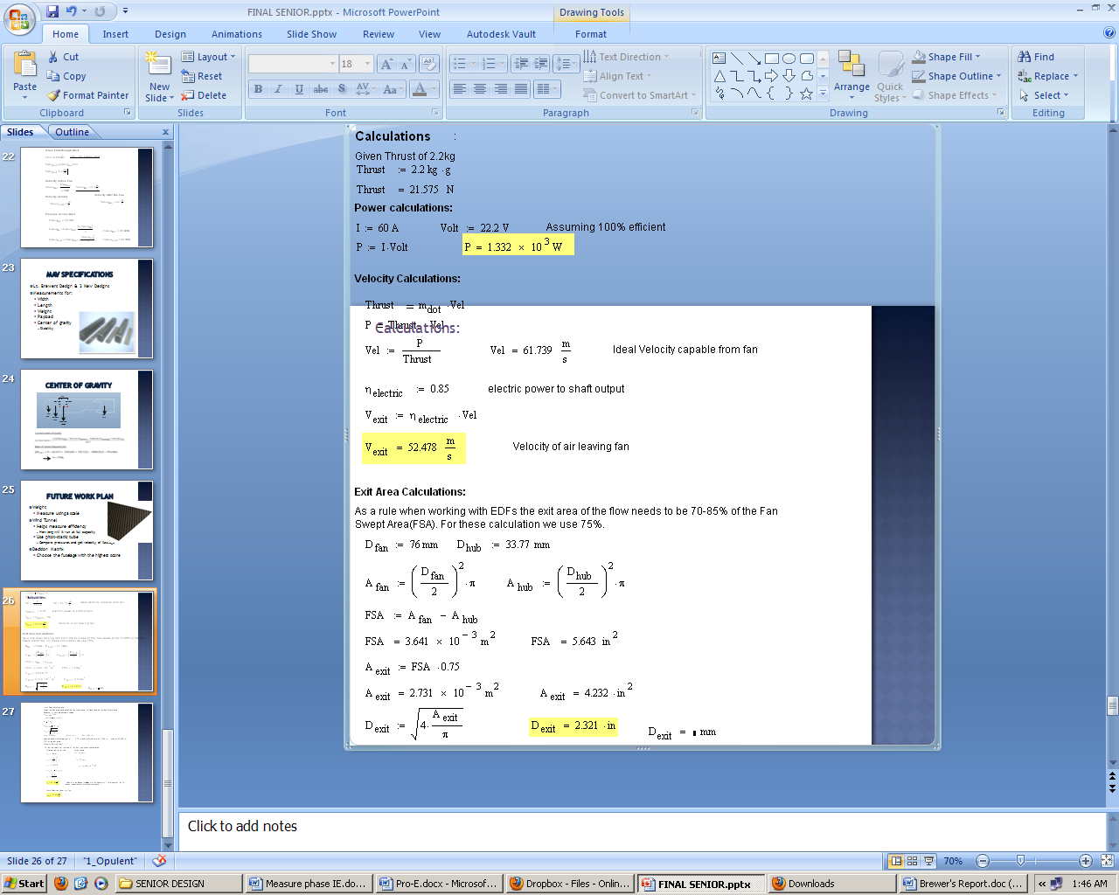

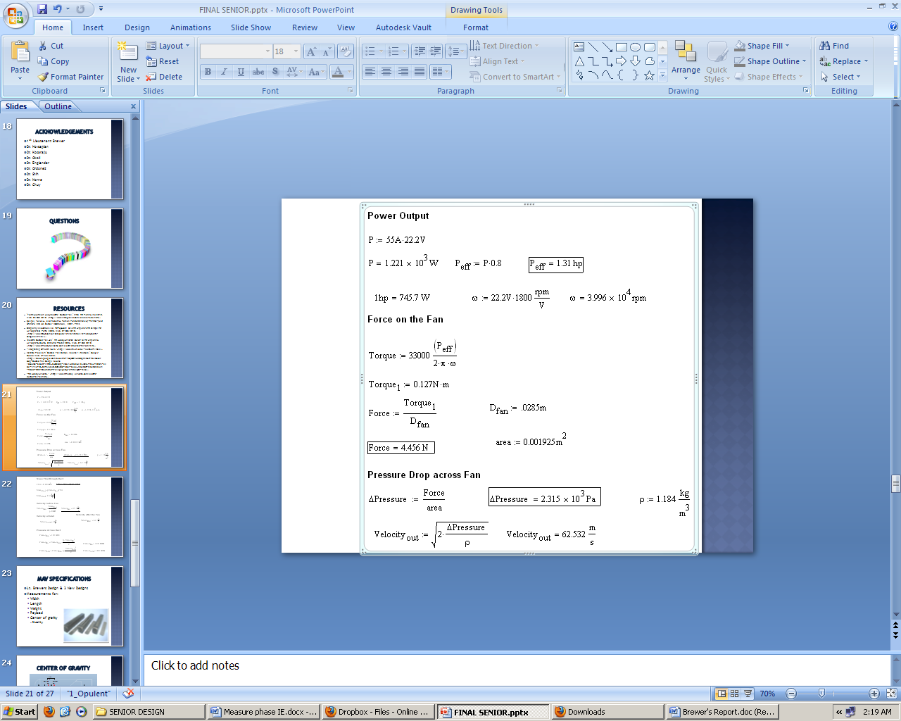

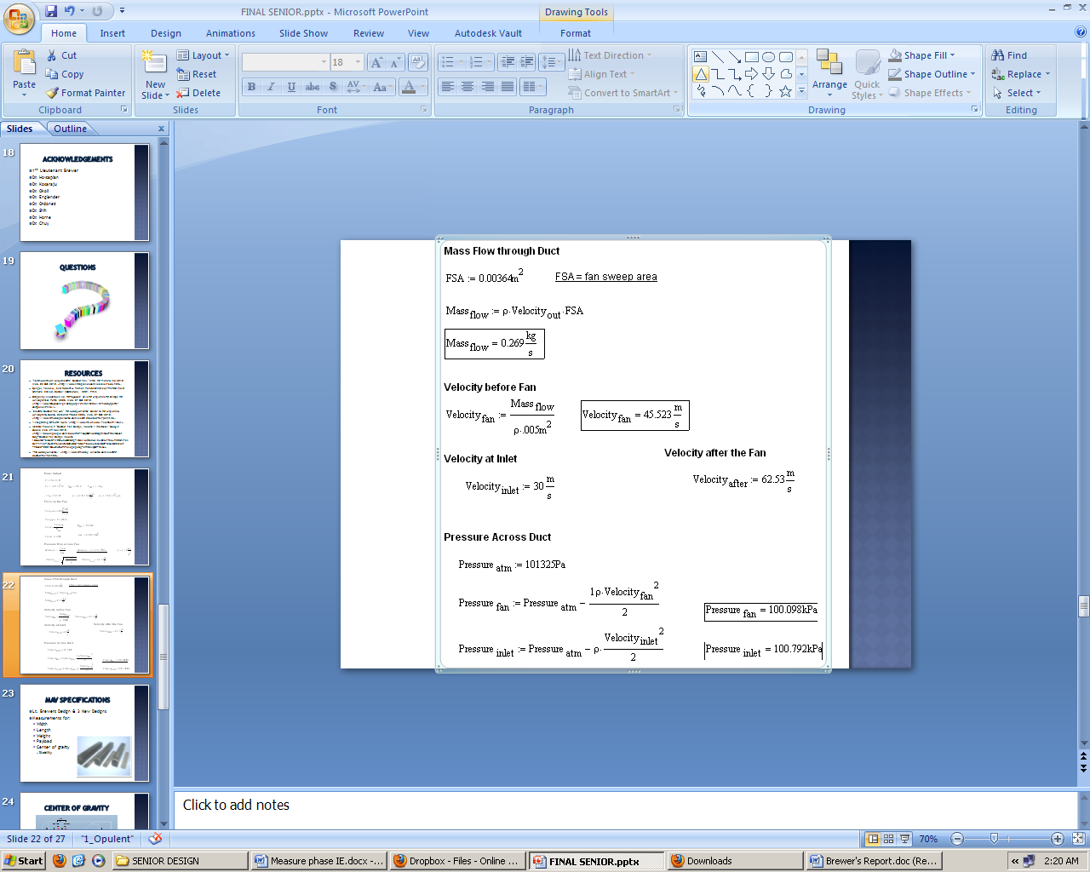

# Appendix B:

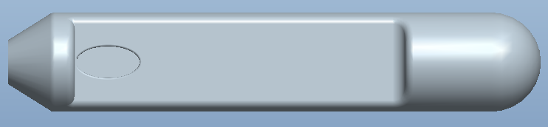

Figure 7: Fuselage with close intake

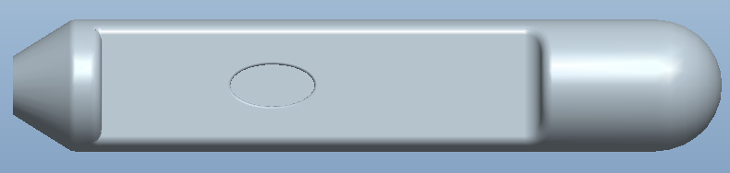

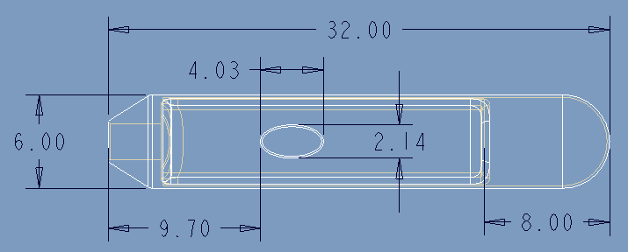Figure 8: Fuselage with intake father away

Figure 9: Dimensioned Fuselage

# Appendix C:

The group’s website is in the progress of being completed. As of now the website is hosted through a site called ‘Wix’. Once it is finished it can easily be transferred to the College of Engineering site.

Website: <http://www.wix.com/isaza_88/group-3-mav>