|  |
| --- |
| Senior design group #3 |
| **Integration of Experimental Propulsion Systems in Micro Air Vehicles** |
| Improve Phase |
|  |
| March 1, 2011  **Team # 3**  **Group Members:**  Kristina De Armas  Michael Isaza  Santiago Baus  Erica Cosmutto  Hunter Metzger  http://www.eng.fsu.edu/~arenaal/Solar_Car/images/COE_seal.pngJoel Ware  **http://cnd.memphis.edu/isdp07/afrl.png** |
| Table of Contents  List of Tables 3  List of Figures 4  1.0 Introduction 5  2.0 Problem Statement 6  3.0 Background Research 7  4.0 Improve Phase 10  4.1 Brewer’s MAV 10  4.1.1 Propeller vs. Electric Ducted Fan 10  4.2 Improving the Fuselage Design and Components 11  4.2.1 Internal Duct Design and Mold 11  4.2.2 Improvement in Components 13  4.3 Improving the Vacuum Bagging Process 13  4.3.1 Materials Used 13  4.3.2 Leaks in Vacuum 14  4.3.3 Resin Pockets 14  5.0 Total Weight and Cost Analysis 14  6.0 Spring Schedule 17  7.0 Conclusion 18  8.0 Acknowledgements 18  9.0 References 20  Appendix A 22  A.1 Pro-E Drawings 22  A.2 Manufacturing Costs 24 |

# List of Tables

Table 1: Cost Analysis 15

Table 2: Weight Analysis 15

Table 3: Cost of Materials to Manufacture 3 Fuselages 16

# List of Figures

Figure 1: Graph showing the relationship between mass flow and power. 8

Figure 2: Initial Internal Duct Design 12

Figure 3: Fuselage Design 12

Figure 4: Electric Ducted Fan Extra Space in End Cap 13

Figure 5: Spring Schedule 17

Figure 6: Fuselage Diameter 22

Figure 7: Fuselage Length 22

Figure 8: Fuselage Dimensions without End Cap 23

Figure 9: Electric Ducted Fan Dimensions 24

# 1.0 Introduction

The group was assigned this MAV experimental propulsion project by the Eglin Air Force Base in Fort Walton Beach, Florida; more particularly by 1st Lieutenant John Brewer. At Eglin, 1st Lieutenant Brewer is a part of a research team specializing in the advancement of micro air vehicles. As a graduate of the FAMU/FSU College of Engineering and the senior design program, he reached out to our team to create three efficient MAVs using an electric ducted fan and to run various tests to judge their performance.

Electric ducted fans have the potential to be more efficient, capable of higher velocities, quieter, and safer than a basic propeller system. When coupled with a properly designed duct, the improvement in performance of the MAV could be very significant. After many failed designs, an initial design of the fuselage was approved by our sponsor. The initial design was used as the basis for the other two designs. One design varies the position of the inlet in relation to the position of the electric ducted fan, while the other design uses a rod to separate the flow of air. These designs will be tested to see which configuration of the inlet position, and duct geometry will produce the best performance. The performance will be based on the efficiency and velocity achieved by the configuration. Then the team will decide on the ‘best’ MAV based on the performance and how well it meets the specifications.

For our Senior Design class, we have been asked to follow the structure of a Six Sigma Methodology referred to as DMAIC. DMAIC stands for Define, Measure, Analyze, Improve and Control. Our previous reports covered the define, measure and analyze phase. In the define phase, we used various tools to identify what was critical to our customer, Eglin. Our conclusion for the define phase was that the weight, width and use of a lithium polymer battery were the most critical factors to consider when designing the fuselage of the MAV. These requirements have all been met in our three current designs of the fuselage. The measure phase assisted us in establishing a basis for our project. Through the use of our Pro-E drawings of the fuselage, we were able to verify that the dimensions met our customer requirements. Next, we used design of experiments along with COMSOL simulations to define the performance standards of the MAV. Then, we calculated the manufacturing cost of producing three fuselages, to ensure we would stay within our recommended budget. In our last report, the analyze phase consisted of a thorough analysis of our current issues, in order to identify what was holding us back from progressing, our proposed spring schedule, final component selection, details on changes made to the fuselage, static thrust test results, manufacturing analysis and updated total weight and cost analysis. Our biggest concern in the analyze phase was the fact that we had not yet received our mold from our sponsor. Fortunately, at this point, we received the mold and have begun to manufacture the fuselages at the High Performance Materials Institute (HPMI).

The improve phase, according to DMAIC Methodology, is used to identify a solution to the problem that the project aims to address. This process involves brainstorming potential solutions, selecting solutions to test, and evaluating the results of the implemented solutions.[13] For our improve phase, we will address the initial issue presented to us by our sponsor which was to improve the design of a MAV by using an electric ducted fan instead of a propeller. In Section 4.1, we will further discuss how our design is an improvement compared to our sponsor’s MAV designed for his senior design project, which flew using a propeller. Next, we will address some of the current problems we are facing, our brainstorming attempts to fix these issues and lastly, how we arrived at our final solution and plan to implement it. Specifically, Section 4.2 will deal with our design and component selection and how we have been working to improve both. Then Section 4.3 will discuss our current, most crucial part of the project, the manufacturing of the fuselage using the vacuum bagging process. Up until now we have manufactured 2 full fuselages, including the top, bottom and end cap, but are always looking to improve the process in order to achieve an optimal product. Therefore, there will be much discussion on the many options we have explored in order to optimize the vacuum bagging process. In this report we will also include an updated total weight and cost analysis and an up-to-date schedule.

# 2.0 Problem Statement

Initially, we were contacted by our sponsor to develop three fuselage designs for a MAV where we could integrate the use of an electric ducted fan along with all the electronic components. During the design phase, we would need to ensure the specifications provided by the sponsor were met and then through analysis, be able to prove the efficiency and effectiveness of each design. Once the designs were approved by the sponsor, we would manufacture all three designs and test them, in order to choose the best performing overall fuselage design.

The specifications provided to us by our sponsor include that the diameter must be ≤ 6”, the length must be ≤ 32”, and the weight must be ≤ 10lbs.[3] The electronic components that are needed to produce an MAV are: a powerful battery, an electric ducted fan, a speed controller for the fan, and remote controls for the MAV. The MAV fuselage will be produced out of carbon fiber composite to provide a light weight vehicle and durable frame. For the vehicle to fly there needs to be a 4 to 1 ratio of weight to thrust to provide enough power to the MAV. The wings will be provided by the sponsor and a certain area along the fuselage will be designated for the wings. The first eight inches of the MAV is to remain free to put electrical components but does not include the ducted fan. The goal is to build three MAVs that fit within the constraints and are built according to the parameters of motor efficiency, flight velocity, flight time, weight, and durability.

There are many issues that we have encountered thus far. Some of the issues were affecting our progression and were addressed in the Analyze Phase where we were able to identify the root causes and solve them. Now we are faced with proving that our electric ducted fan is an improvement from the typical design using a propeller, as well as improving our fuselage design, original components, and manufacturing process. The fuselage design, in specific the internal duct design, has been faced with some tough design issues. Taking into account that our sponsor threw this idea at us last minute, we were forced to use our current fuselage design and incorporate a duct within the constraints of the fuselage design. Some of the components have also been put into question, regarding their effectiveness. Lastly, where one can find the biggest room for improvement thus far, is in the manufacturing process of our fuselage. We have faced many problems, which have affected the outcome of our product. These problems are currently our biggest concern; if we cannot manufacture an optimal fuselage we have no chance of succeeding in the end.

# 3.0 Background Research

The topic of micro air vehicles (MAV) is large and constantly growing and changing. For engineers, the challenge of creating small devices that can fly, reach various speeds with different maneuverability is an exciting one. As can be imagined, the design possibilities are endless. There are numerous uses for these MAVs. This includes surveillance, communication, mapping out treacherous terrain, etc. [5] In this section, we will be specifically focusing on the propulsion system used in our MAV and we will also discuss some background on the vacuum bagging process used to manufacture the fuselage. All calculations and visualizations are done for a specific cruise condition.

Thrust is achieved by steadily increasing the momentum of the air passing through.

$T=\dot{m}∆V$ Equation 1

$\dot{m}$ = ρ $V_{1}A$ Equation 2

$ΔV= V_{2}-V_{1}$ Equation 3

T=Thrust

$\dot{m}$ = Mass flow rate

∆V= Change in velocity

V2=Exiting Velocity

V1= Incoming velocity

There is a certain power needed to create this thrust. Power is the rate of change of energy. The change in momentum (thrust) can be equated to power by the equation below (Equation 4).

$P=\frac{1}{2}\dot{m}(V_{2}^{2}-V_{1}^{2})$ Equation 4

P= Power

Equation 3 is simply equation 2 expanded and rearranged to illustrate the effect the change in velocity and the mass flow rate have on the power needed to achieve a certain thrust. It makes sense to aim at keeping the power needed to produce a certain thrust as low as possible. From viewing equations 1 and 5 it is noted that if the mass flow rate is cut in half and the change in velocity is doubled a certain power is required in order to achieve a constant thrust. This power would be larger than the initial value because the change in velocity is squared in the second term, increasing the power required to create the same thrust. The reciprocal is also true, if the mass flow rate is increased and the change in velocity is lowered, the power decreases.

$P=\dot{m}*∆V*V_{1}+\frac{1}{2}{(∆V)}^{2}\dot{m}$ Equation 5

Figure : Graph showing the relationship between mass flow and power.

The graph 1, above, shows the relationship between mass flow and the power required divided by the ideal power. As the mass flow is increased the fraction of power is reduced. As seen, increasing the mass flow rate is very effective when the mass flow is initially low. The higher the mass flow rate is the more it has to be increased to achieve the same improvement. At some point the effort it takes to increase the mass flow rate is not worth the decrease in power that is achieved.

Equation 6 shows that if the free stream velocity is decreased, the ideal power required to obtain a certain thrust is also decreased. Furthermore, combining equations 1 and 5, a relationship between the power and thrust is created (equation 7). This also illustrates that if the incoming free stream velocity is lowered the power required is decreased.

$P_{ideal}=T*V_{1}$ Equation 6

$P=TV_{1}+\frac{1}{2}\frac{T^{2}}{\dot{m}}$ Equation 7

V1= Free stream velocity

One way to slow down the average free stream velocity is to have more boundary layer entering the fan. This is called boundary layer ingestion. Boundary layer ingestion increases the efficiency of the fan. Thrust is created by simply increasing the velocity by a constant increment. In other words, the change in velocity creates the force we think of as thrust. Because of this fact, it makes no difference if the incoming velocity is high or low, as long as the change in velocity is the same. We know from the above equations that it takes less power to accelerate a slower incoming velocity than a velocity with a higher speed. [10]

Decreasing the incoming velocity will increase the efficiency of the system but does it a price of a slower exit velocity and thrust. Arriving at a balance between efficiency and exit velocity is the key.

For the manufacturing of our fuselage, as stated before, we will be using the vacuum bagging process. Vacuum bagging is a clamping method that uses atmospheric pressure to hold the adhesive or resin-coated components of a lamination in place until the adhesive cures. This method is considered to be very effective due to its wide range of manufacturing possibilities. Vacuum bagging offers many advantages over the customary clamping methods. It allows for the worker to focus more on the structural requirements rather than having to worry about clamping limitations. Other important advantages of the vacuum bagging process are that it allows for an even clamping pressure which delivers a firm and evenly distributed pressure over the entire surface, while not having to worry about the type or the quantity of the material of being laminated. Also, vacuum bagging allows developing material with high fiber to resin ratios due to its ability to control excess adhesive in the laminate. This produces higher strength to weight ratios and favorable cost advantages. Due to its many advantages vacuum bagging is widely used in the composites industry. [8]

# 4.0 Improve Phase

## 4.1 Brewer’s MAV

Initially, as discussed in our define phase, we were contacted by our sponsor to design a MAV that integrates an electric ducted fan and all the necessary components into the fuselage that while meeting the constraints provided. The MAV design was to take into consideration the overall efficiency and effectiveness of using an electric ducted van vs. the usual propeller. Considering our sponsor, Brewer, had also designed a MAV for his senior design project we decided to compare his design to ours in the measurement phase although due to the use of a different propulsion system and different general constraints is difficult to compare. In using this comparison we hoped to achieve a clear picture of how our design is an improvement from the original design created by our sponsor.

Our project is currently not in the testing stage, but ideally, we would like to compare our results against Brewer’s results. This would help us prove that a MAV’s performance can be increased greatly by the use of an electric ducted fan rather than a propeller. In the following section, we will discuss the general advantages of using an electric ducted fan. Once we begin testing, we will be able to report back with numbers that confirm our theory.

### 4.1.1 Propeller vs. Electric Ducted Fan

The main component of any aircraft is its propulsion system. The average MAV uses a propeller at the nose of the plane to accelerate the air. An alternative to this would be to use a ducted fan. A ducted fan is defined as a fan with duct that has a chord longer than the diameter of the fan. These fans have many advantages over their counterparts, which is usually a simple propeller at the nose of a plane. The use of ducted fans allows for the possibility of vectoring the thrust exiting the plane. Noise suppression is also a large advantage of ducted fans. Because of the shroud around the fan and the fact that the fan is fully enclosed in the body of the plane, noise heard is minimal. Ducted fans also provided better low-speed and static thrust. They can achieve higher thrust per horsepower for a given diameter. This is a huge advantage when size, specifically diameter, is important. [10] As noted before, diameter is a constraint for this project.

One disadvantage of a ducted fan is that the inlet and exit areas are usually fixed, resulting in a design of the fan and duct that is optimized for one speed.[10] This is not really an issue for this project because of the relatively small range of velocities.

## 4.2 Improving the Fuselage Design and Components

As far as our main fuselage design, there have not been any changes since the analyze phase. We are still going to produce the 3 designs previously discussed, design 1 with inlet close to the fan and design 2 with the inlet farther away from the fan, both with an internal duct; while design 3 will have the inlet farther away and no internal duct. Pro-E drawings of the main fuselage design including dimensions can be found in Appendix A.1.

In our analyze phase we introduced the idea of adding an internal duct to our design requested by our sponsor. With this idea of an internal duct, came along many complications. Our internal duct design was constrained by our final fuselage design since the mold was already being produced. Due to this, our initial design of the internal duct was a failure. In Section 4.2.1, we will present an in-depth look at our brainstorming efforts and final solution for the design of the internal duct as well as details on the mold for the duct. While in Section 4.2.2, we will discuss the changes made to the transmitter and the issues we are currently facing with the shape of the battery.

### 4.2.1 Internal Duct Design and Mold

As previously stated, the original internal duct design was not optimal due to the constraints implemented by the fuselage design. Since the fuselage design cannot be altered at this point, our only choice was to improve the duct design. In Figure 2, our original duct design can be seen. This design was made while ignoring the constraints of width and shape imposed by the fuselage. Theoretically, this is what an internal duct should look like, shape wise, but this does not work for our MAV.

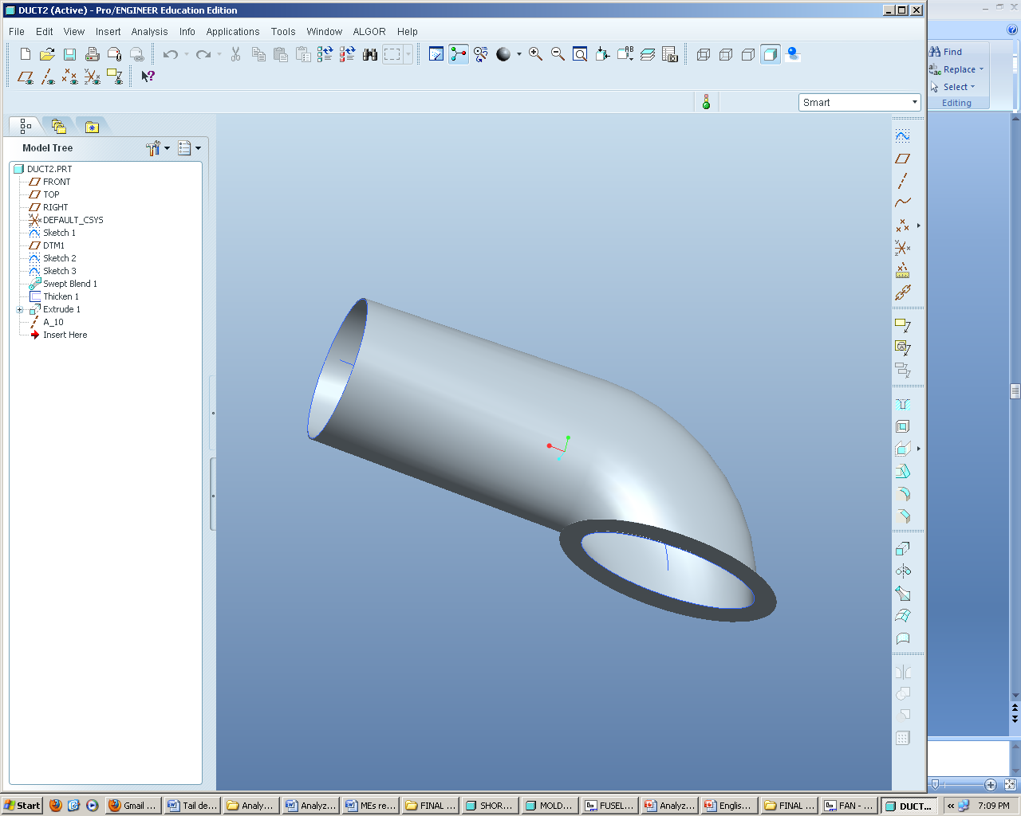

Figure : Initial Internal Duct Design

In Figure 3, the rectangular shape of the fuselage can be seen. This is a good visual of what we are working with and what we must consider when designing the duct.

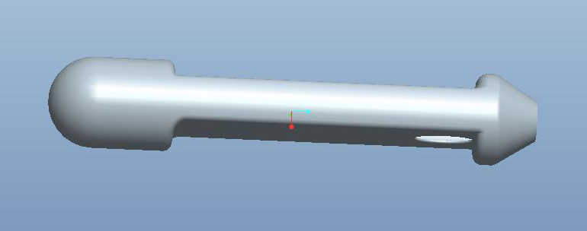

Figure : Fuselage Design

After brainstorming various ideas, we reached a final decision for the internal duct. We decided that a constant area is important to maintain regardless of the shapes we must conform to. Therefore, the duct will begin as an oval shape covering the entire inlet area, then transform into a rectangle in order to take advantage of the whole area and when it reaches the fan it will open into a circular shape in order to wrap around the fan and not restrict air flow. Due to the fact that we left about 3inches of space in the back to move the fan, we are able to use that space to move the fan back and allow the duct to converge into a circular shape. The 3 inch gap can be seen in Figure 4.

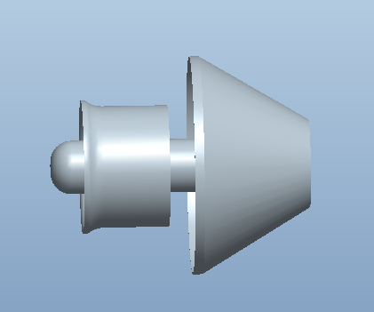

Figure : Electric Ducted Fan Extra Space in End Cap

We are currently in the process of designing the new internal duct using Pro-E. Once we have the design ready we would like to create the mold and begin manufacturing the duct using infused carbon fiber. The issue with the mold we have encountered is that using the 3D printer, cost wise, is not ideal. We would like to use a cheaper option and are looking into using a foam mold.

### 4.2.2 Improvement in Components

## 4.3 Improving the Vacuum Bagging Process

For the past 2 weeks, we have been tirelessly working on manufacturing the 3 fuselages. As previously discussed, we chose the vacuum bagging process to fabricate our carbon fiber parts. This process is known to have a high learning curve and we experienced this first hand. At this point we have just finished our second fuselage including the top, bottom, and end cap. We learned a lot from our first fuselage and made sure to not continue to not repeat the same errors. Some of the problems we encountered and how we improved the process in general can be seen in the following sections.

### 4.3.1 Materials Used

The materials we planned to use in the vacuum bagging process were thoroughly analyzed in our Analyze Phase. Since then, there have been some changes in order to improve the process and produce an optimal part. One of the most important materials used in the vacuum bagging process is the plastic. The plastic must be tough enough to avoid incurring holes from the mold or flow media but must not be too tough or else it will not conform as nicely around the mold once the air is sucked out. The plastic we used for our first fuselage was not tough enough which lead to many leaks when attempting to suck out the air. Every time there was a leak we were forced to throw out the plastic bag and bag the mold all over again. This was a huge waste of material, therefore we decided to use the tough plastic for the second fuselage and that greatly decreased the probability of encountering a leak in the bag.

For the flow media, we were advised by our sponsor to use tulle fabric. Unfortunately, we attempted to use this for our first mold and failed miserably. The tulle is too tightly wound and does not allow the resin to flow. We actually had to pause our infusion process and start from scratch because the tulle was preventing the resin from flowing. So instead of using tulle, we found a looser flow media around the lab and decided to try it out. The new flow media works very well and we will continue to use it for our future fuselages.

Another issue that we ran into, was that the resin was heating up during the infusion process causing an over flow of resin into the bag. Although the heat of the resin assisted in curing the fuselage faster, it negatively affected the fuselage with the resin pockets it produced. We learned that the heating of the resin was due to the amount of catalyst we were mixing in with the resin. Initially we were mixing in 3% of the weight of the resin of catalyst, so we decided to adjust it and add only 2%. This decrease in the catalyst helped reduce the amount of excess resin flowing into the bag and also allowed for the fuselage to cure properly.

### 4.3.2 Leaks in Vacuum

### 4.3.3 Resin Pockets

# 5.0 Total Weight and Cost Analysis

Our allocated budget is $2000, and thus far we are within budget. The breakdown below in Table 3 is the expected total cost along with the total weight thus far. The only money spent thus far is on the components. As for the manufacturing cost, we were kindly offered help from HPMI. They will be covering the cost of the materials needed for the manufacturing of the 3 fuselages. Although this means we would still be within budget, this leaves us with about $894.12 for the parts of the MAV that have still not been determined, such as the fasteners. The total weight, seen in Table 4, as of now is the weight of all the components along with the top half, bottom half, and end cap of the fuselage. The total weight thus far is 5.087 lbs. The remaining weight left within our constraint is 4.923 lbs which is reserved solely for the wings.

Table : Cost Analysis

|  |  |  |  |
| --- | --- | --- | --- |
| **Component** | **Cost ($)** |  |  |
| EDF | 129.95 |  |  |
| Battery | 509.99 |  |  |
| Battery Charger | 109.98 |  |  |
| Woodworks LipoSack (Storage) | 34.99 |  |  |
| ESC | 120.00 |  |  |
| Transmitter/Receiver | 179.97 |
| Industrial Strength Velcro | 7.00 |
| Connection Wires | 14.00 |
| **TOTAL** | **$1105.88** |

Table : Weight Analysis

|  |  |
| --- | --- |
| **Component** | **Weight (lbs.)** |
| EDF | 0.862 |
| Battery | 2.2128 |
| ESC | 0.242 |
| Transmitter/ Receiver | 0.033 |
| Top half | 0.784 |
| Bottom half | 0.775 |
| End cap | 0.1780 |
| **TOTAL** | **5.087** |

We have also decided to present the details on the manufacturing cost once again since there have been some changes. As mentioned before HPMI has generously offered to let us use the materials around the lab at no charge. Even though we are receiving the materials free, we have taken the time to do a thorough cost analysis. When we began to actually work with the materials, we decided to make some changes to the number of carbon fiber layers we needed. For example, we were advised that the fuselage would be durable enough with 3 layers instead of 4, while the end cap would need 2 layers and the tail only 1 layer. These changes resulted in a decrease from $419.73 to $ 332.55 to produce all 3 fuselages. This means the total manufacturing cost for the short duct fuselage is $108.61 and the total cost for the long duct fuselage is $111.97. Appendix A.2 has all the details on the updated manufacturing cost analysis.

After working through the manufacturing process we realized that if the materials aren’t used wisely it can produce a significant amount of scrap which results in a loss of money. Therefore, we all made sure to accurately cut the materials needed for each process in order to reduce scrap. Due to this, even though we reduced the number of layers needed, we decided to leave the amount of materials needed the same in order to account for the scrap. The total material cost is therefore, unaltered and can be seen in Table 4 as $499.65.

Table : Cost of Materials to Manufacture 3 Fuselages

|  |  |  |
| --- | --- | --- |
| Materials |  | Cost ($) |
| Carbon Fiber | 6 yards | 301.50 |
| Resin | 1 quart | 22.25 |
| Spray Adhesive | 1 can | 12.95 |
| Peel Ply | 2 yards | 22.00 |
| Breather Cloth | 2 yards | 16.00 |
| Flow Media | 2 yards | 75.80 |
| Nylon Bagging Film | 2 yards | 17.00 |
| Vacuum Tubing | 6 ft | 4.35 |
| Yellow Sealant Tape | 2 rolls | 27.80 |
|  | **TOTAL** | **499.65** |

# 6.0 Spring Schedule

The schedule for spring has been modified as a result of the delays. Although the delay in mold creation was a huge setback, we all have managed to work effectively as a team in the manufacturing process in order to make up for the time lost. The main concern with the upcoming schedule which should be noted is that the final flight testing at Eglin Air Force Base is on March 21 which is two weeks before the final report and presentation. The updated schedule can be observed in the following figure, Figure2.

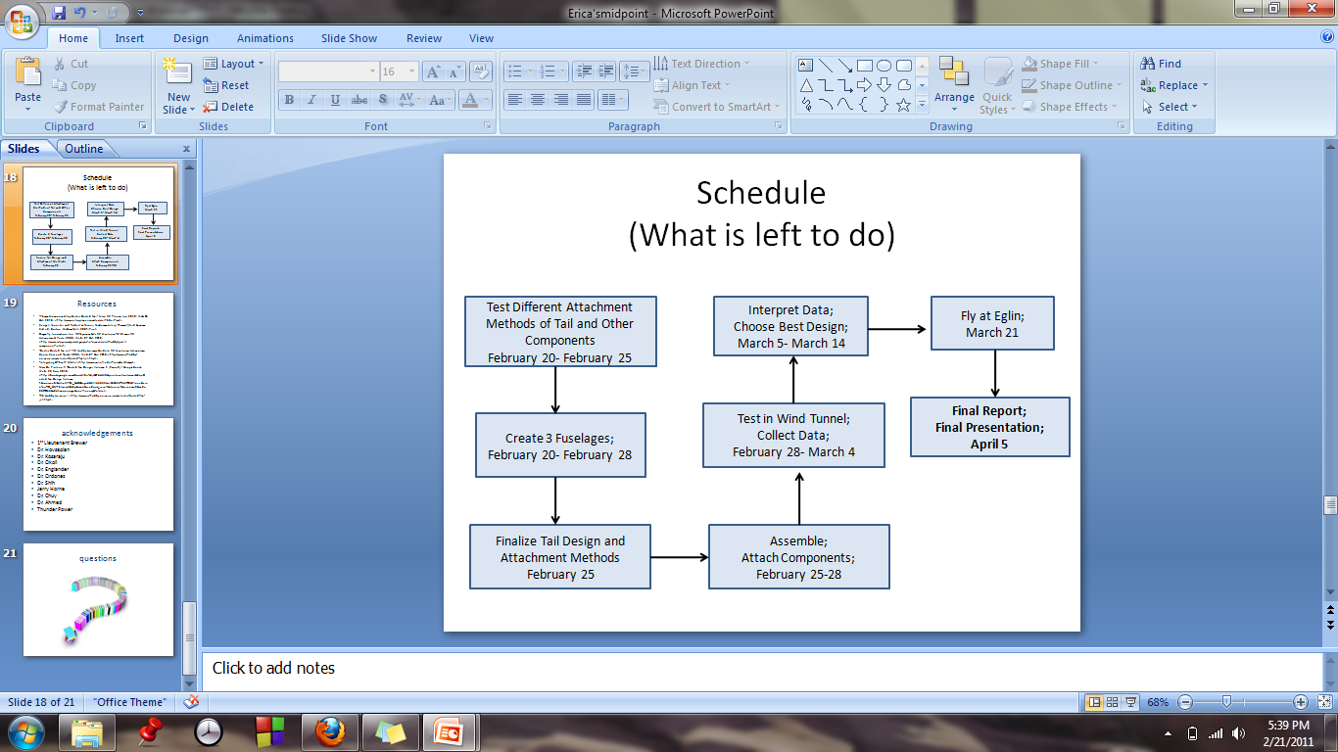

Figure : Spring Schedule

# 7.0 Conclusion

Overall we were able to significantly improve various aspects of our project in the Improve Phase. First we compared our current design to Brewer’s MAV and observed the benefits of using an electric ducted fan versus a propeller. Although we have not been able to collect data related to our MAV we presented information collected through research that explained the benefits. Our plan is to test our MAV as soon as possible and collect data that will prove an electric ducted fan is better than a using a propeller. Next, we discussed some of the problems we have encountered in our design of the internal duct and how we reached the conclusion to keep our internal duct at a constant area while moving the fan back to allow for the shape transformation. We also decided that the 3D printer is too expensive to use to make our mold and will therefore, look into purchasing foam for the mold. Lastly, we went through the improvements we were able to implement in the manufacturing process for our second fuselage. These improvements resulted in a more optimal product. For our third and final fuselage, we hope to use everything we have learned about vacuum bagging and make the best product thus far.

Once we have manufactured all three fuselages, we need to focus on how we are going to attach the top and bottom as well as the end cap. We also need to brainstorm on ideas for the hatch in the nose of the MAV. The hatch will be used to add, remove and rearrange the components. Then we need to test all 3 fuselages effectiveness and choose the final best design. In order to test their effectiveness, we decided to use a decision matrix. This decision matrix will include fuselage weight, efficiency, and velocity. The weight will be obtained using a scale. While the efficiency, will be measured using the wind tunnel. The fuselage will be set-up with all the components on a stand and left to run until the battery dies. The longer the fuselage can run the better the efficiency. And lastly, measurements of the velocity will also be obtained in the wind tunnel. A pitot-static tube will be used to compare pressures in the fuselage and obtain the velocity. Once all three measurements are obtained for the three fuselages, a decision matrix will be created where the fuselage with the highest score will be chosen as the best design. This analysis will be done in the following weeks followed by constructing the decision matrix which will identify which fuselage design is the most efficient.

# 8.0 Acknowledgements

We would like to acknowledge John Brewer, our sponsor at Eglin Air Force Base, for his patience and advice while mentoring us throughout the project. We would also like to acknowledge Dr. Okenwa Okoli, Dr. Hovsapian, Dr. Kosaraju and the TAs for providing aid whenever we needed it. Dr. Englander and Dr. Ahmed also contributed much in guiding the team in the right direction and played a significant role in our progress. Especially during our manufacturing stage, we would like to thank Jerry Horne for all his help and advice on the vacuum bagging process.

# 9.0 References

1. "76mm Aluminum Alloy Electric Ducted Fan." *Nitro RC Planes, Inc.* 2010. Web. 05 Oct. 2010. <http://www.nitroplanes.com/lealalel76du.html>.
2. Brewer, John, Brandon Beir, and Damel Brown. *Eglin AFB Composite Manufacturing*. Tech. Print.
3. Brewer, John. “MAV Specifications.” Personal Interview. 23 September 2010.
4. Çengel, Yunus A., and Robert H. Turner. *Fundamentals of Thermal-fluid Sciences*. 3rd ed. Boston: McGraw-Hill, 2001. Print.
5. Draganfly Innovations Inc. *RCToys.com Sells RC Airplanes RC Blimps RC Helicopters & Parts*. 2008. Web. 07 Oct. 2010. <http://www.rctoys.com/pr/category/rc-information/rc-hobby-parts-component-info/>.
6. "Electric Ducted Fan Jet." *RC Hobby Universe Guide to RC Airplanes, Helicopters, Boats, Cars and Trucks!* 2006. Web. 07 Oct. 2010. <http://www.rc-hobby-universe.com/electric-ducted-fan-jet.html>.
7. “Fibre Glast Developments.” 10 October 2010. <http://www.fibreglast.com/contentpages-molding+fibreglass-171.htm>.
8. Fouquet, Chris “Vacuum Bagging” (21 September 1996). 10 October 2010. <http://www.pilotsguide.com/rc/vacbag.shtml>.
9. “Integrating GPS with MAVs.”<http://www.mil.ufl.edu/~number9/mav/>.
10. Marc De Piolenc, F. "Ducted Fan Design, Volume 1 (Revised)." *Google Books*. Web. 29 Nov. 2010. <http://books.google.com/books?id=YcAjcSSP4HMC&printsec=frontcover&dq=Ducted Fan Design Volume 1&source=bl&ots=WtfDi_ZHQZ&sig=4G6VIAKC63HnIZLlQMLFf56LTZ0&hl=en&ei=nYnoTID_GMP6lwewtLGcCw&sa=X&oi=book_result&ct=result&resnum=9&ved=0CEYQ6AEwCA#v=onepage&q=efficiency&f=false>.
11. “RC Hobby Universe.”< http://www.rc-hobby universe.com/electric-ducted-fan-jet.html>.
12. "US Composites." *Fiberglass , Epoxy , Composites, Carbon Fiber - U.S. Composites, Inc.* 2010. Web. 30 Nov. 2010. <http://www.shopmaninc.com/>.
13. Wiesenfelder, Heidi. "DMAIC Phase 4: Improve Phase of Six Sigma and Its Tools Including Pugh Matrix, FMEA, Control Charts, Pareto Charts, and ANOVA." *Find Health, Education, Science & Technology Articles, Reviews, How-To and Tech Tips At Bright Hub - Apply To Be A Writer Today!* Bright Hub, Inc., 20 Jan. 2010. Web. 28 Feb. 2011. <http://www.brighthub.com/office/project-management/articles/25328.aspx>.

# Appendix A

## A.1 Pro-E Drawings

**Fixed Factors:**

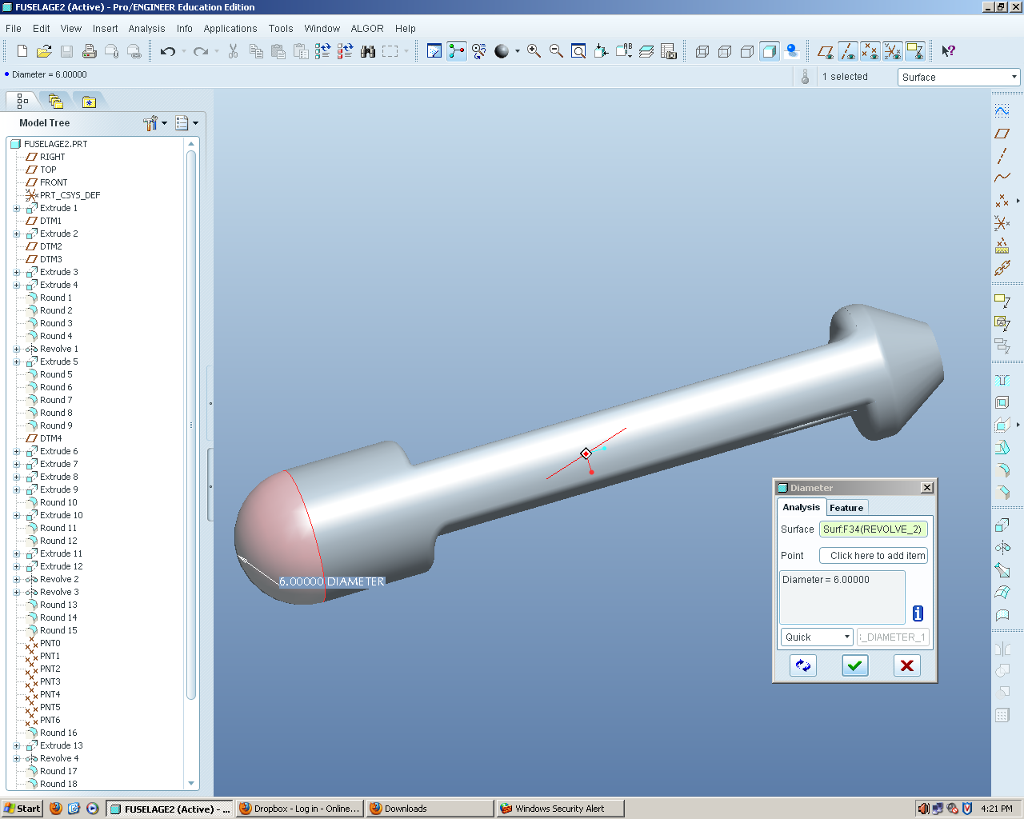

Figure : Fuselage Diameter

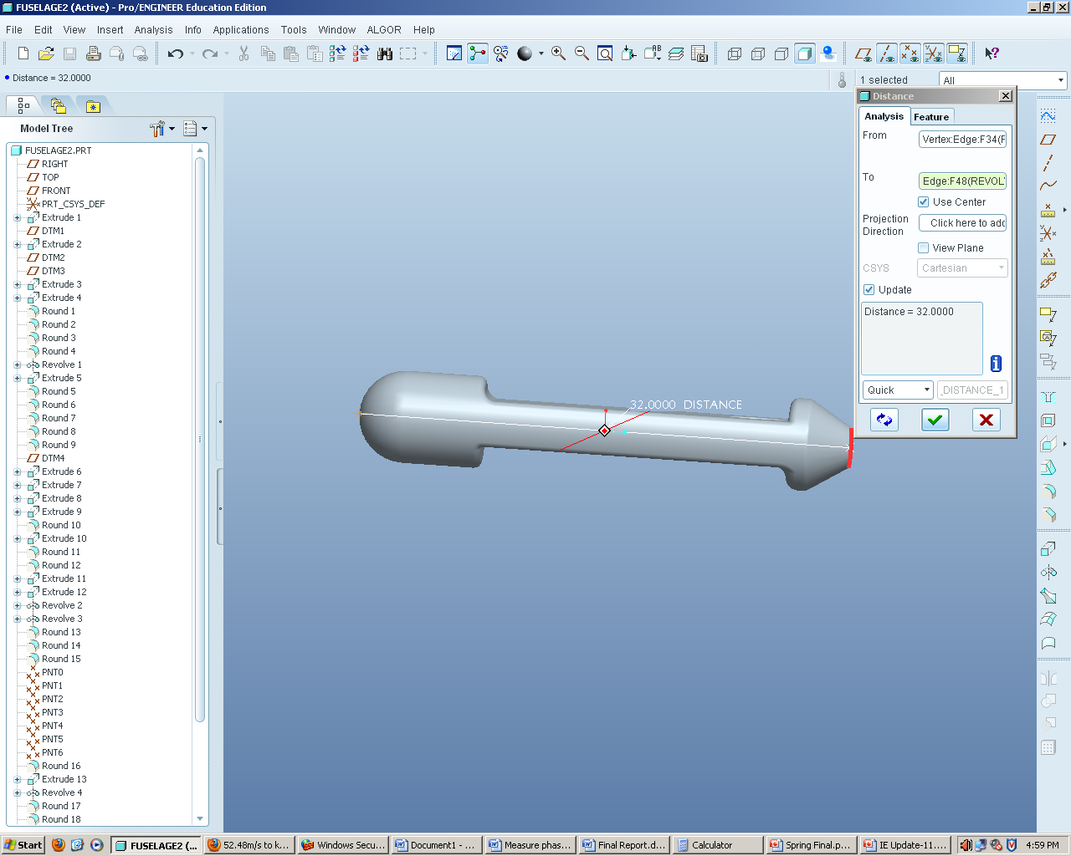

Figure : Fuselage Length

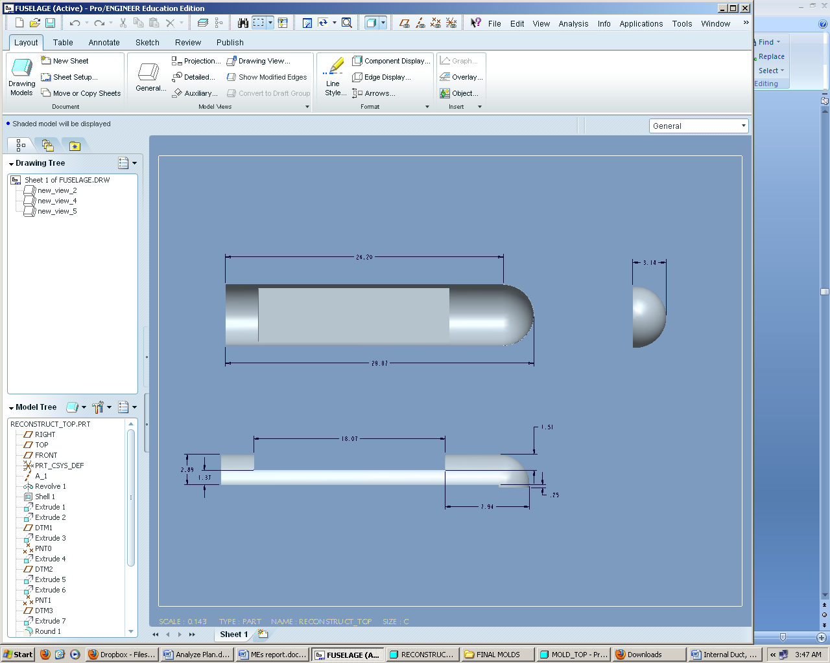

Figure : Fuselage Dimensions without End Cap

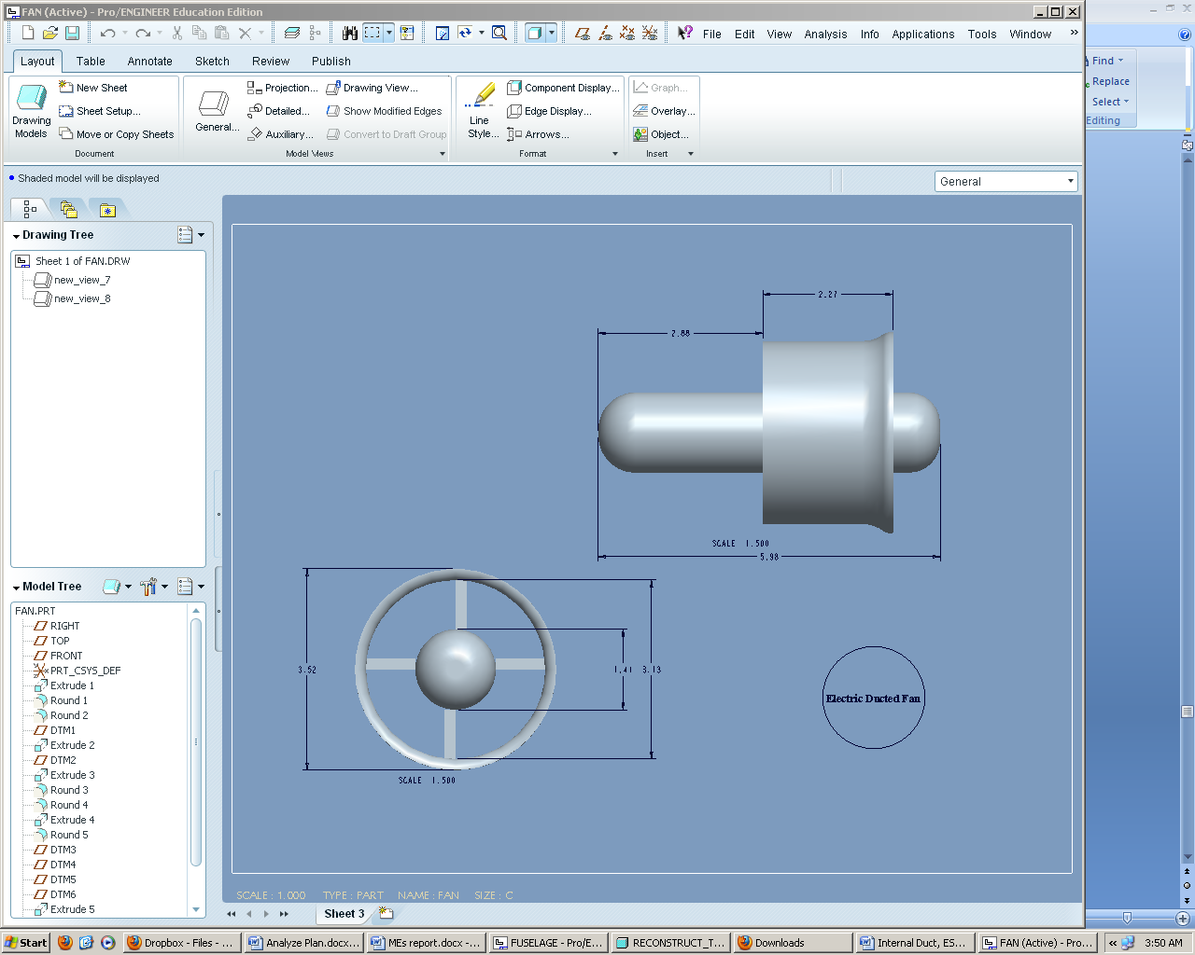

Figure : Electric Ducted Fan Dimensions

## A.2 Manufacturing Costs

**Resin price per pound**

Resin: $\frac{\$22.25 dollars}{quart} *$ $\frac{4 quarts}{1 gallon}*$ $\frac{1 gallon}{9.19 lbs}$ → $\frac{\$9.68 dollars}{lb}$

**Carbon Fiber price per square ft.**

Carbon Fiber (CF): $\frac{\$33.50 dollars}{1 yd. *{50}^{''}width}$ → $\frac{\$2.68 dollars}{sq ft}$

**Peel Ply price per square ft.**

Peel Ply (PP): $\frac{\$5.50 dollars}{1 yd*60" width}$ → $\frac{\$0.37 dollars}{sq ft}$

**Flow Media price per square ft.**

Flow Media (FM): $\frac{\$18.95 dollars}{1 yd*50" width}$ → $\frac{\$1.52 dollars}{sq ft}$

**Yellow Sealant Tape price per roll**

Tape: $\frac{\$6.95 dollars}{25 ft roll}$ → $\frac{\$0.28 dollars}{ft}$

**Nylon Bagging Film price per square ft.**

Vacuum Bag: $\frac{\$4.25 dollars}{1 yd*110" width}$ → $\frac{\$0.15 dollars}{sq ft}$

**Breather Cloth price per square ft.**

Breather Cloth (BC): $\frac{\$4.00 dollars}{1 yd*60" width}$ → $\frac{\$0.27 dollars}{sq ft}$

**Vacuum Tubing price per ft.**

Tube: $\frac{\$1.45 dollars}{ft}$

**Fuselage:**

Surface Area = 2 $πr^{2}+ 2πrh$

= 659.734 ${in}^{2}$

Volume = Surface Area * Thickness of Carbon Fiber

= 659.734 ${in}^{2}$* 0.01 $in$

= 6.59734 ${in}^{3}$

Total Surface Area = 659.734 ${ in}^{2}$ → 4.581 sq ft

Half Surface Area (HSA) = 2.29 sq ft

**Surface Area of Material Used:**

Dimensions of layer used for Fuselage (LF): 35 in x 12 in → 420 $in^{2}$ → 2.92 sq ft.

Dimensions of layer used for Long Duct (LLD): 10 in x 8 in → 80 $in^{2}$ → 0.5556 sq ft.

Dimensions of layer used for Short Duct (LSD): 8 in x 6 in → 48 $in^{2}$ → 0.3333 sq ft.

Dimensions of layer used for Tail (LT); 5 in x 5 in → 25 $in^{2}$ → 0.174 sq ft.

Dimensions of layer used for End Cap (EC); 7 in x 7 in → 49 $in^{2}$ → 0.340 sq ft.

**Quantity of Materials Needed:**

Resin = 6.59734 ${in}^{3}$ → .010499 lbs per fuselage

Resin (LD) = 1.64934 ${in}^{3}$ → .002625 lbs

Resin (SD) = 1.64934 ${in}^{3}$ → .002625 lbs

Resin (EC) = 1.64934 ${in}^{3}$ → .002625 lbs

Resin (Tail) = 0.82467 ${in}^{3}$ → .001313 lbs

Vacuum Bag = (52 in *24 in) → 8.67 sq ft

Vacuum Bag (LD) = (15 in *15in) → 1.56 sq ft

Vacuum Bag (SD) = (15 in *15in) → 1.56 sq ft

Vacuum Bag (EC) = (7 in *7 in) → 0.34 sq ft

Vacuum Bag (Tail) = (10 in *10in) → 0.69 sq ft

Tape = (2 *52 in + 2 * 24 in) → 152 in → 12.67 ft

Tape (LD) = (2 *15 in + 2 * 15 in) → 60 in → 5 ft

Tape (SD) = (2 *15 in + 2 * 15 in) → 60 in → 5 ft

Tape (EC) = (2 *7 in + 2 * 7 in) → 28 in → 2.33 ft

Tape (Tail) = (2 *5 in + 2 * 5 in) → 20 in → 1.67 ft

Tube = 3 ft

CF = 2.92 sq ft (3 layers)

CF (LD) = 0.556 sq ft (2 layers)

CF (SD) = 0.333 sq ft (2 layers)

CF (EC) = 0.340 sq ft (2 layers)

CF (Tail) = 0.174 sq ft (1 layers)

PP = 2.92 sq ft (1 layer)

PP (LD) = 0.556 sq ft (1 layer)

PP (SD) = 0.333 sq ft (1 layer)

PP (EC) = 0.340 sq ft (1 layer)

PP (Tail) = 0.174 sq ft (1 layer)

BC = 2.92 sq ft (1 layer)

BC (LD) = 0.556 sq ft (1 layer)

BC (SD) = 0.333 sq ft (1 layer)

BC (EC) = 0.340 sq ft (1 layer)

BC (Tail) = 0.174 sq ft (1 layer)

FM = 2.92 sq ft (1 layer)

FM (LD) = 0.556 sq ft (1 layer)

FM (SD) = 0.333 sq ft (1 layer)

FM (EC) = 0.340 sq ft (1 layer)

FM (Tail) = 0.174 sq ft (1 layer)

**Total Manufacturing Cost:**

End Cap: = $\left[\left(Resin*.002625 lbs\right)+\left(Vacuum Bag*0.34 sq ft\right)+\left(Tape*2.33 ft\right)+ \left(Tube*3ft\right)+2\left(CF(EC)*CF\right)+\left(PP(EC)*PP\right)+\left(BC(EC)*BC\right)+ (FM(EC)*FM)\right]$

= $\left[\left(Resin*.002625 lbs\right)+\left(Vacuum Bag*0.34 sq ft\right)+\left(Tape*2.33 ft\right)+ \left(Tube*3ft\right)+2\left(CF(EC)*\$2.68\right)+\left(PP\left(EC\right)*\$0.37\right)+\left(BC(EC)*\$0.27\right)+ (FM(EC)*\$1.52)\right]$

= $7.64

Long Duct: = $2\left[\left(Resin*.002625 lbs\right)+\left(Vacuum Bag*1.56 sq ft\right)+\left(Tape*5 ft\right)+ \left(Tube*3ft\right)+2\left(CF(LD)*CF\right)+\left(PP(LD)*PP\right)+\left(BC(LD)*BC\right)+ (FM(LD)*FM)\right]$

= 2[$10.19]

= $20.38

Short Duct: = $2\left[\left(Resin*.002625 lbs\right)+\left(Vacuum Bag*1.56 sq ft\right)+\left(Tape*5 ft\right)+ \left(Tube*3ft\right)+2\left(CF(SD)*CF\right)+\left(PP(SD)*PP\right)+\left(BC(SD)*BC\right)+ (FM(SD)*FM)\right]$

= 2[$8.51]

= $17.02

Tail: = $\left[\left(Resin*.001313 lbs\right)+\left(Vacuum Bag*0.69 sq ft\right)+\left(Tape*1.67 ft\right)+ \left(Tube*3ft\right)+\left(CF(Tail)*CF\right)+\left(PP(Tail)*PP\right)+\left(BC(Tail)*BC\right)+ (FM(Tail)*FM)\right]$

= $5.78

Fuselage = $2\left[\left(Resin*.010499 lbs\right)+\left(Vacuum Bag*8.67 sq ft\right)+\left(Tape*12.67 ft\right)+ \left(Tube*3ft\right)+3\left(CF*LF\right)+\left(PP*LF\right)+\left(BC*LF\right)+(FM*LF)\right]$

= 2 $\left[\$39.08\right]$

= $78.17 per fuselage

**Total Cost of Fuselages:**

Long Duct Fuselage: = Fuselage + Long Duct +Tail + End Cap

= $78.17 + $20.38 +$ 5.78 +$7.64

= $111.97

Short Duct Fuselage: = Fuselage + Short Duct +Tail + End Cap

= $78.17 + $17.02 +$ 5.78 + $7.64

= $108.61

Total Cost: = 1*Short Duct Fuselage + 2*Long Duct Fuselage

= $108.61 + 2*$111.97

= $332.55

**Total Material Cost:**

1. Resin → 1 quart → ($22.25 * 1) → $22.25

2. Spray Adhesive → 1 can → ($12.95 * 1) → $12.95

3. Carbon Fiber → 6 yards → ($33.50 * 9) → $301.50

4. Peel Ply → 2 yards → ($5.50 * 4) → $22.00

5. Breather Cloth → 2 yards → ($4.00 * 4) → $16.00

6. Flow Media → 2 yards → ($18.95 * 4) → $75.80

7. Nylon Bagging Film → 2 yards → ($4.25 * 4) → $17.00

8. Vacuum Tubing → 3 ft → ($1.45 * 3) → $4.35

9. Sealant Tape → 2 rolls → ($6.95 * 4) → $27.80

Total (1-9): $ 499.65