|  |
| --- |
| Senior design group #3 |
| **Integration of Experimental Propulsion Systems in Micro Air Vehicles** |
| Measure Phase |
|  |
| November 30, 2010  **Team # 3**  **Group Members:**  Kristina De Armas  Michael Isaza  Santiago Baus  Erica Cosmutto  Hunter Metzger  http://www.eng.fsu.edu/~arenaal/Solar_Car/images/COE_seal.pngJoel Ware  **http://cnd.memphis.edu/isdp07/afrl.png** |
| Table of Contents  [List of Tables 3](#_Toc278880264)  [List of Figures 4](#_Toc278880265)  [1.0 Introduction 5](#_Toc278880266)  [2.0 Problem Statement 5](#_Toc278880267)  [3.0 Background Research 6](#_Toc278880268)  [4.0 Measurement Plan 9](#_Toc278880269)  [4.1 Design Measurement Plan 9](#_Toc278880270)  [4.1.1 MAV Specifications 9](#_Toc278880271)  [4.1.2 Design of Experiments 10](#_Toc278880272)  [4.1.3 COMSOL Conclusions 12](#_Toc278880273)  [4.2 Manufacturing Measurement Plan 13](#_Toc278880274)  [4.2.2 Manufacturing Cost 13](#_Toc278880275)  [5.0 Total Project Cost Analysis 17](#_Toc278880276)  [6.0 Future Data Collection Plan 18](#_Toc278880277)  [7.0 Conclusion 18](#_Toc278880278)  [8.0 Acknowledgement 19](#_Toc278880279)  [9.0 References 20](#_Toc278880280)  [Appendix A 21](#_Toc278880281)  [A.1 Pro-E Drawings 21](#_Toc278880282)  [A.2 COMSOL Results 26](#_Toc278880283)  [A.3 Design of Experiments Table 30](#_Toc278880284)  [A.4 Manufacturing Costs 30](#_Toc278880285)  [A.5 Calculations 33](#_Toc278880286) |

# List of Tables

[Table 1: John Brewer's MAV 9](#_Toc278880287)

[Table 2: Fixed Factors 10](#_Toc278880288)

[Table 3: Varying Inlet Location for Fuselage Designs 10](#_Toc278880289)

[Table 4: Variable Factors 11](#_Toc278880290)

[Table 5: Results 11](#_Toc278880291)

[Table 6: Cost of Materials to Manufacture 3 Fuselages 16](#_Toc278880292)

[Table 7: Total Cost 17](#_Toc278880293)

[Table 12: DOE Results 30](#_Toc278880294)

# List of Figures

[Figure 1: Relationship Between Mass Flow and Power 8](#_Toc278880295)

[Figure 2: Interaction Plot 11](#_Toc278880296)

[Figure 3: Epoxy Resin 13](#_Toc278880297)

[Figure 4: Spray Adhesive 14](#_Toc278880298)

[Figure 5: Carbon Fiber Fabric 14](#_Toc278880299)

[Figure 6: Peel Ply 14](#_Toc278880300)

[Figure 7: Breather Cloth 15](#_Toc278880301)

[Figure 8: Nylon Bagging Film 15](#_Toc278880302)

[Figure 9: Vacuum Tubing 15](#_Toc278880303)

[Figure 10: Flow Media 16](#_Toc278880304)

[Figure 11: Sealant Tape 16](#_Toc278880305)

[Figure 12: Diameter 21](#_Toc278880306)

[Figure 13: Length 21](#_Toc278880307)

[Figure 14: Inlet- Minor Axis 22](#_Toc278880308)

[Figure 15: Inlet Major Axis 23](#_Toc278880309)

[Figure 16: Exit Area 23](#_Toc278880310)

[Figure 17: Design 1 24](#_Toc278880311)

[Figure 18: Design 1- Inlet Distance 24](#_Toc278880312)

[Figure 19: Design 2 25](#_Toc278880313)

[Figure 20: Design 2- Inlet Distance 25](#_Toc278880314)

[Figure 21: Short Rod COMSOL Representation of Flow 26](#_Toc278880315)

[Figure 22: Short Rod Velocity Profile 26](#_Toc278880316)

[Figure 23: Long Rod COMSOL Representation of Flow 27](#_Toc278880317)

[Figure 24: LongRod Velocity Profile 27](#_Toc278880318)

[Figure 25: Hole Close to Fan COMSOL Representation of Flow 28](#_Toc278880319)

[Figure 26: Hole Close to Fan Velocity Profile 28](#_Toc278880320)

[Figure 27: Hole Farther Away From Fan COMSOL Representation of Flow 29](#_Toc278880321)

[Figure 28:Hole Farther Away From Fan Velocity Profile 29](#_Toc278880322)

# 1.0 Introduction

Our Integration of Experimental Propulsion System in Micro Air Vehicles (MAV) project is sponsored by Eglin Air Force Base. The project is based on the need to improve current MAV designs by using an electric ducted fan as the propulsion system. Electric ducted fans have the potential to be more efficient, capable of higher velocities, quieter, and safer than a basic propeller system. When coupled with a properly designed duct, the improvement in performance of the MAV could be very significant.

The goal of the project is to design three efficient MAVs. After many failed designs, an initial design of the fuselage was approved by our sponsor. The initial design was used as the basis for the other two designs. One design varies the position of the inlet in relation to the position of the electric ducted fan, while the other design uses a rod to separate the flow of air. These designs will be tested to see which configuration of the inlet position, and duct geometry will produce the best performance. The performance will be based on the efficiency and velocity achieved by the configuration. Then the team will decide on the ‘best’ MAV based on the performance and how well it meets the specifications.

For our Senior Design class, we have been asked to follow the structure of a Six Sigma Methodology referred to as DMAIC. DMAIC stands for Define, Measure, Analyze, Improve and Control. Our previous report covered the define phase, where we used various tools to identify what was critical to our customer, Eglin. Our conclusion for the define phase was that the weight, width and use of a LiPo battery were the most critical factors to consider when designing the fuselage of the MAV. These requirements have all been met in our three designs of the fuselage.

This report will cover the measure phase, where we have established a basis for our project. Through the use of our Pro-E drawings of the fuselage, we were able to verify that the dimensions met our customer requirements. Next, we used design of experiments along with COMSOL simulations to define the performance standards of the MAV. Then, we calculated the manufacturing cost of the producing three fuselages, to ensure we would stay within our recommended budget. Lastly, we established a data collection plan that we will implement once the fuselage has been manufactured.

# 2.0 Problem Statement

Initially, we were contacted by our sponsor to develop three fuselage designs for a MAV where we could integrate the use of an electric ducted fan along with all the electronic components. During the design phase, we would need to ensure the specifications provided by the sponsor were met and then through analysis, be able to prove the efficiency and effectiveness of each design. Once the designs were approved by the sponsor, we would manufacture all three designs and test them, in order to choose the best performing overall fuselage design.

The specifications provided to us by our sponsor include that the diameter must be ≤ 6”, the length must be ≤ 32”, and the weight must be ≤ 10lbs.[3] The wings are out of our scope and will be provided by the sponsor. We decided that within our project we would also use John Brewer, our sponsor’s Senior Design MAV specifications to compare our results with his. Although our fuselage will be twice the size of John’s, we will still be able to use this data to show the improvement in the MAV performance based on the use of an electric ducted fan vs. a propeller. An initial collection of this data, along with the data collected from our Pro-E drawings, can be seen in Section 4.1.1 MAV Specifications.

After much discussion, our group decided to focus on the use of COMSOL for the analysis of the effectiveness of each design. Initial calculations were performed to calculate the pressure drop across the fan. This allowed for flow simulation in COMSOL, where the fan was represented as a pressure difference. From this analysis the flow of air in the duct and across the fan can be visualized. The velocity profile of the flow was then created, showing the maximum velocity the various designs can reach. Using the values obtained from COMSOL a design of experiments was used to identify how the inlet position and use of a rod affect the maximum velocity produced. Lastly, the manufacturing of the fuselage was addressed and a final cost was calculated.

# 3.0 Background Research

The topic of micro air vehicles (MAV) is large and constantly growing and changing. For engineers, the challenge of creating small devices that can fly, reach various speeds with different maneuverability is an exciting one. As can be imagined, the design possibilities are endless. There are numerous uses for these MAVs. This includes surveillance, communication, mapping out treacherous terrain, etc. [5]

The main component of any aircraft is its propulsion system. The average MAV uses a propeller at the nose of the plane to accelerate the air. An alternative to this would be to use a ducted fan.

A ducted fan is defined as a fan with duct that has a chord longer than the diameter of the fan. These fans have many advantages over their counterparts, which is usually a simple propeller at the nose of a plane. The use of ducted fans allows for the possibility of vectoring the thrust exiting the plane. This may be something that is looked into during our Analysis Phase. Noise suppression is also a large advantage of ducted fans. Because of the shroud around the fan and the fact that the fan is fully enclosed in the body of the plane, noise heard is minimal. Ducted fans also provided better low-speed and static thrust. They can achieve higher thrust per horsepower for a given diameter. This is a huge advantage when size, specifically diameter, is important.[10] As noted above, diameter is a constraint for this project.

One disadvantage of a ducted fan is that the inlet and exit areas are usually fixed, resulting in a design of the fan and duct that is optimized for one speed.[10] This is not really an issue for this project because of the relatively small range of velocities. All calculations and visualizations are done for a specific cruise condition.

Thrust is achieved by steadily increasing the momentum of the air passing through.

$T=\dot{m}∆V$**Equation 1**

T=Thrust

$\dot{m}$ = Mass flow rate

∆V= Change in velocity

There is a certain power needed to create this thrust. Power is the rate of change of energy. The change in momentum (thrust) can be equated to power by the equation below (Equation 2).

$P=\frac{1}{2}\dot{m}(V_{2}^{2}-V_{1}^{2})$**Equation 2**

P= Power

V1= Incoming velocity

V2= Exiting fan velocity

Equation 3 is simply equation 2 expanded and rearranged to illustrate the effect the change in velocity and the mass flow rate have on the power needed to achieve a certain thrust. It makes sense to aim to keep the power needed to produce a certain thrust as low as possible. From viewing equations 1 and 3 it is noted that if the mass flow rate is cut in half and the change in velocity is doubled a certain power is required. This power would be larger than the initial value because the change in velocity is squared in the second term, increasing the power required to create the same thrust. The reciprocal is also true, if the mass flow rate is increased and the change in velocity is lowered, the power decreases.

$P=\dot{m}*∆V*V_{1}+\frac{1}{2}{(∆V)}^{2}\dot{m}$**Equation 3**

Figure : Relationship Between Mass Flow and Power

Figure 1, above, shows the relationship between mass flow and the power required divided by the ideal power. As the mass flow is increased the fraction of power is reduced. As seen, increasing the mass flow rate is very effective when the mass flow is initially low. The higher the mass flow rate is the more it has to be increased to achieve the same improvement. At some point the effort it takes to increase the mass flow rate is not worth the decrease in power that is achieved.

Equation 4 shows that if the free stream velocity is decreased the ideal power required to obtain a certain thrust is decreased. Furthermore, combining equations 1 and 3, a relationship between the power and thrust is created, equation 5. This also illustrates that if the incoming free stream velocity is lowered the power required is decreased.

$P_{ideal}=T*V_{1}$**Equation 4**

$P=TV_{1}+\frac{1}{2}\frac{T^{2}}{\dot{m}}$**Equation 5**

V1= Free stream velocity

One way to slow down the average free stream velocity is to have more boundary layer entering the fan. This is called boundary layer ingestion. Boundary layer ingestion increases the efficiency of the fan. Thrust is created by simply increasing the velocity by a constant increment. In other words, the change in velocity creates the force we think of as thrust. Because of this fact, it makes no difference if the incoming velocity is high or low, as long as the change in velocity is the same. We know from the above equations that it takes less power to accelerate a slower incoming velocity than a velocity with a higher speed. [10]

Decreasing the incoming velocity will increase the efficiency of the system but does it at a price of a slower exit velocity. Arriving at a balance between efficiency and exit velocity is the key.

# 4.0 Measurement Plan

The measurements are divided into those specific to the design of the MAV and the manufacturing aspects. How will the fuselage be dimensioned, the variable measures for the duct and the areas of both inlet and outlet will be pertinent to the design plan while the material requirements, cost of materials and the process used to produce the MAV will be part of the manufacturing measurement plan.

## 4.1 Design Measurement Plan

The main aspects to be measured in the design measurement portion include: how the design will be dimensioned, the position of the inlet with respect to the fan, and how the use of a rod in front of the fan hub will affect the flight velocity. It is believed that the placement of the inlet will create variability in the velocity exiting the fan and also on the efficiency of the same. The goal is to find a configuration of the before mentioned factors that will have result in a greater velocity exiting the fan and it will be achieved by performing a 2k factor design of experiment and analyzing the results. The results of the experiment will determine what will be the final dimensions for the duct and whether the rod will be used or not in order to maximize velocity.

### 4.1.1 MAV Specifications

Retained by customer

### 4.1.2 Design of Experiments

The factors for the experiment as mentioned before are inlet placement and use of a rod at the hub. Table 4, below, summarizes the factors with their respective codes and their meaning.

Table : Variable Factors

|  |  |  |
| --- | --- | --- |
| Factors | Lower Code | Upper Code |
| Inlet position (X1) | -1 = 4.54” from EDF | +1 = 10.1” from EDF |
| Hub attachment (X2) | -1 = No rod | +1 = No rod |

The factors were taken into consideration, modeled in COMSOL and the results were recorded to analyze their contrast, beta values and test statistic. The information for the experiment can be seen in Appendix A.3 and the following table, Table 5, shows a summary of the results.

Table : Results

|  |  |  |  |
| --- | --- | --- | --- |
|  | X1 | X2 | X1,X2 |
| Contrast | -26.56 | -16.76 | 16.26 |
| Beta | -6.64 | -4.19 | 4.065 |

The beta values from the results above are used to construct the predictive model of the experiment which can be seen in the following equation:

$$E\left(y\right)={-6.64X}_{1}-4.19X_{2}+4.06X_{1}X_{2}$$

The information from appendix A.2 also facilitates the construction of an interaction plot shown in the following figure:

Figure : Interaction Plot

This interaction plot is showing that there is an interaction between the X1 and X2 but since both lines are not heavily intersecting, the interaction is there but not enough to be considered for future review.

By analyzing the results, the group realized that the most important factors were to have a short distance between the inlet and the fan because the beta for X1 is negative therefore signifying that the code for -1 was preferred and the team will also refrain from using the rod. The use of the rod would have been undesirable because including it in the manufacturing would have been very complex. When the manufacturing has to be done, keeping a short distance and not using a rod will be the aspects that the group will be abiding by to have the end product with the best quality as possible for the customer.

The result presented above was conclusive for velocity. The group has also taken into consideration efficiency which theoretically can only be maximized when the boundary layer is largest. [6] The group has no means to measure the efficiency under the conditions mentioned above in a real environment or a simulation so it was inferred theoretically that at larger boundary layers, the efficiency would increase because accelerating slow-moving air takes less work than accelerating fast-moving air.

## 4.1.3 COMSOL Conclusions

Initial calculations were performed to calculate the pressure drop across the fan. This allowed for flow simulation in COMSOL, where the fan was represented as a pressure difference. From this analysis the flow of air in the duct and across the fan can be visualized. The velocity profile of the flow was then created, showing the maximum velocity the various designs can reach. A maximum velocity of approximately 78 m/s exiting the fan was reached in design 1. As discussed later, a high velocity entering and therefore exiting the fan often means a low efficiency of the fan.

Boundary layer ingestion is utilized in design 2. The boundary layer is passed through the fan. The change in velocity here is greater because of the lower incoming velocity. Meaning the fan did much more work using the same amount of power. This equates to an increase in efficiency.

The third design utilizes a rod that is attached at the hub of the fan. This serves to separate the flow and maximize the amount of air the fan blades act on. From the analysis this can be seen that the velocity here is greater than that of the second design and it is conjectured that it also has a higher efficiency.

The fourth design is using the rod while also taking into consideration the boundary layer ingestion. Having a design like this will make it possible to construct a design of experiment that will analyze the different variables even though having this situation will not allow for the flow to develop and will result in a lower velocity after the fan.

## 4.2 Manufacturing Measurement Plan

An important aspect to address is the manufacturing of the fuselage. Although the design might seem like a good idea, we must prove the manufacturability and affordability. Our team has been working closely with HPMI to come up with the best manufacturing plan for our fuselage. The mold for our fuselage will be provided by our sponsor. Below is a description of our manufacturing plan as well as an overall cost for the manufacturing of 3 fuselages. The calculations for the amount of material and individual cost of each fuselage can be found in Appendix A.3.

### 4.2.2 Manufacturing Cost

We will be manufacturing three different fuselage designs at the HPMI building. The process we chose for manufacturing these parts is called Vacuum Bagging or Vacuum Infusion. Vacuum Bagging is basically a clamping method which uses atmospheric pressure to hold resin coated components in the lamination until the adhesive cures.[2] The materials needed for this manufacturing process are the following: Spray Adhesive, Carbon Fiber Fabric, Epoxy Resin, Peel Ply, Breather Cloth, Flow Media, Sealant Tape, Nylon Bagging Film, and Vacuum Tubes. We have researched numerous sources online and found relatively low prices for these materials. Also, we will not be building the molds needed for the vacuum bagging process. We will provide our sponsor with the design specifications for the fuselages and he will then build the mold himself. The materials seen in Figure 2 through Figure 10 can be purchased from either Fibre Glast Developments Corporation ([www.fibreglast.com](http://www.fibreglast.com)) or US Composites ([www.shopmaninc.com](http://www.shopmaninc.com)).

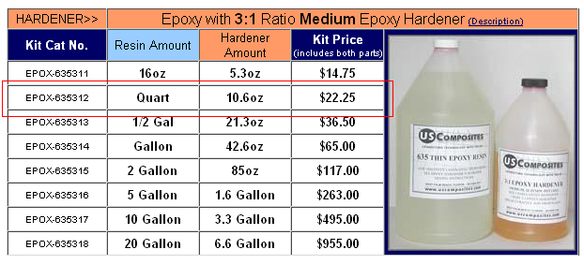

Figure : Epoxy Resin

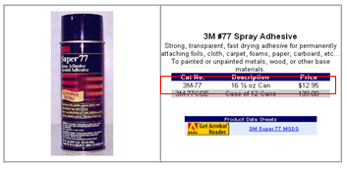

Figure : Spray Adhesive

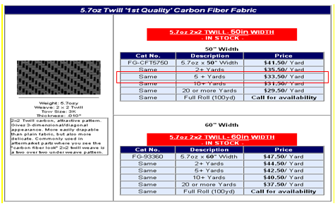

Figure : Carbon Fiber Fabric

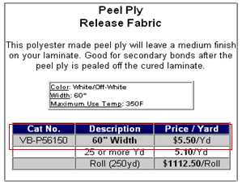

Figure : Peel Ply

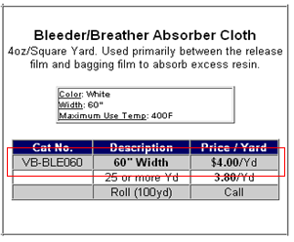

Figure : Breather Cloth

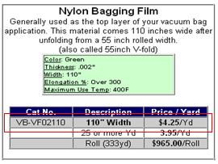

Figure : Nylon Bagging Film

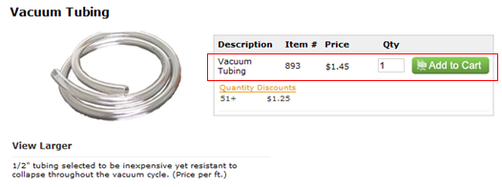

Figure : Vacuum Tubing



Figure : Flow Media

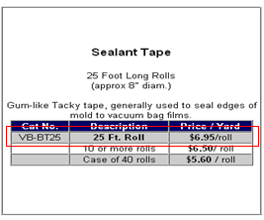

Figure : Sealant Tape

Table : Cost of Materials to Manufacture 3 Fuselages

|  |  |  |
| --- | --- | --- |
| Materials |  | Cost ($) |
| Carbon Fiber | 6 yards | 301.50 |
| Resin | 1 quart | 22.25 |
| Spray Adhesive | 1 can | 12.95 |
| Peel Ply | 2 yards | 22.00 |
| Breather Cloth | 2 yards | 16.00 |
| Flow Media | 2 yards | 75.80 |
| Nylon Bagging Film | 2 yards | 17.00 |
| Vacuum Tubing | 6 ft | 4.35 |
| Yellow Sealant Tape | 2 rolls | 27.80 |
|  | **TOTAL** | **499.65** |

After calculating the right amount of materials needed to manufacture all the fuselages we computed the total material cost to be $499.65, seen in Table 6. The total manufacturing cost for each fuselage is $139.41. As stated before, all the manufacturing costs can be seen in depth in Appendix A.3.

# 5.0 Total Project Cost Analysis

Similar to all projects, it is critical to stay within our budget. Our allocated budget is $2000, and thus far we are within budget. The breakdown below in Table 7 is expected total cost. The only money spent thus far is on the components. As for the manufacturing cost, we are hoping to receive some of these materials from HPMI at no cost. Assuming the worst, we have taken into account all the materials we would need to buy if HPMI had no extra material. The total expected cost for the manufacturing of the three fuselages is $499.65. Giving us a total of $1591.53 estimated total cost thus far. Although this means we would still be within budget, it only leaves us with about $408.47 for the parts of the MAV that have still not been determined, such as the fastners.

Table : Total Cost

|  |  |
| --- | --- |
| Component | Cost ($) |
| EDF | 129.95 |
| Battery | 509.99 |
| Battery Charger | 109.98 |
| Woodworks LipoSack (Storage) | 34.99 |
| ESC | 120.00 |
| Transmitter/ Receiver | 179.97 |
| Industrial Strength Velcro | 7.00 |
| Fuselage Materials | 499.65 |
| **TOTAL** | **1591.53** |

# 6.0 Future Data Collection Plan

In the Measure Phase, it is also critical to set-up a future data collection plan where the data collected in the measure phase could be used to compare the theoretical values vs. the actual values. Once we have manufactured all three fuselages, we need to test their effectiveness and choose the final best design. In order to test their effectiveness, we decided to use a decision matrix. This decision matrix will include fuselage weight, efficiency, and velocity. The weight will be obtained using a scale. While the efficiency, will be measured using the wind tunnel. The fuselage will be set-up with all the components on a stand and left to run until the battery dies. The longer the fuselage can run the better the efficiency. And lastly, measurements of the velocity will also be obtained in the wind tunnel. A pitot-static tube will be used to compare pressures in the fuselage and obtain the velocity. Once all three measurements are obtained for the three fuselages, a decision matrix will be created where the fuselage with the highest score will be chosen as the best design. This analysis will be done in our Analysis Phase and then improved and controlled in the last two phases.

# 7.0 Conclusion

Through the collection of Brewer’s MAV data, the design of experiment and the in depth manufacturing cost analysis, we developed a useful baseline for the entire project. The three final designs of our fuselage, we believe, effectively integrate the use of an electric ducted fan in the MAV. During our Measure Phase, we took several approaches to indentify critical measurements in the designs, in order serve as a basis in the Analyze Phase where we will be able to take further measurements once the fuselages are manufactured and prove the true efficiency of our fuselage.

Brewer’s MAV data serves as a comparison factor when analyzing the overall improvement of our final MAV design. Although his fuselage specifications were significantly smaller and his use of a propeller is not directly related to our project, in our Analyze Phase, we will be able to create a ratio to compare his data with our data of the three fuselage designs.

Initially we were asked to design three fuselages, but when we came across the idea of using design of experiments we realized we would need 2 variables. In order to account for the second variable, against our ME counter parts advice, we decided to include a fourth design that would use a short rod when the inlet was close to the fan. Our ME counterparts, believed the short rod design would be a failure and should not even be analyzed. For the purpose of our analysis we decided to include the fourth design and reached the conclusion that they were correct. The short rod design was producing the worst data. The design of experiments led us to conclude that the design that has the shortest distance between the inlet and the EDF will yield a larger velocity after the fan and the use of a rod will be unnecessary. Lastly, the manufacturing cost analysis provided us with an overall cost analysis for the project, and showed that we are within our allocated budget.

## 8.0 Acknowledgement

We would like to acknowledge John Brewer, our sponsor at Eglin Air Force Base, for his patience and for mentoring us throughout the project. We would also like to acknowledge Dr. Okenwa Okoli and our three TAs for providing us with the proper tools to complete our Measure Phase.

## 9.0 References

1. "76mm Aluminum Alloy Electric Ducted Fan." *Nitro RC Planes, Inc.* 2010. Web. 05 Oct. 2010. <http://www.nitroplanes.com/lealalel76du.html>.
2. Brewer, John, Brandon Beir, and Damel Brown. *Eglin AFB Composite Manufacturing*. Tech. Print.
3. Brewer, John. “MAV Specifications.” Personal Interview. 23 September 2010.
4. Çengel, Yunus A., and Robert H. Turner. *Fundamentals of Thermal-fluid Sciences*. 3rd ed. Boston: McGraw-Hill, 2001. Print.
5. Draganfly Innovations Inc. *RCToys.com Sells RC Airplanes RC Blimps RC Helicopters & Parts*. 2008. Web. 07 Oct. 2010. <http://www.rctoys.com/pr/category/rc-information/rc-hobby-parts-component-info/>.
6. "Electric Ducted Fan Jet." *RC Hobby Universe Guide to RC Airplanes, Helicopters, Boats, Cars and Trucks!* 2006. Web. 07 Oct. 2010. <http://www.rc-hobby-universe.com/electric-ducted-fan-jet.html>.
7. “Fibre Glast Developments.” 10 October 2010. <http://www.fibreglast.com/contentpages-molding+fibreglass-171.htm>.
8. Fouquet, Chris “Vacuum Bagging” (21 September 1996). 10 October 2010 <http://www.pilotsguide.com/rc/vacbag.shtml>.
9. “Integrating GPS with MAVs.”<http://www.mil.ufl.edu/~number9/mav/>.
10. Marc De Piolenc, F. "Ducted Fan Design, Volume 1 (Revised)." *Google Books*. Web. 29 Nov. 2010. <http://books.google.com/books?id=YcAjcSSP4HMC&printsec=frontcover&dq=Ducted Fan Design Volume 1&source=bl&ots=WtfDi\_ZHQZ&sig=4G6VIAKC63HnIZLlQMLFf56LTZ0&hl=en&ei=nYnoTID\_GMP6lwewtLGcCw&sa=X&oi=book\_result&ct=result&resnum=9&ved=0CEYQ6AEwCA#v=onepage&q=efficiency&f=false>.
11. “RC Hobby Universe.”< http://www.rc-hobby universe.com/electric-ducted-fan-jet.html>.
12. "US Composites." *Fiberglass , Epoxy , Composites, Carbon Fiber - U.S. Composites, Inc.* 2010. Web. 30 Nov. 2010. <http://www.shopmaninc.com/>.

# Appendix A

## A.1 Pro-E Drawings

**Fixed Factors:**

**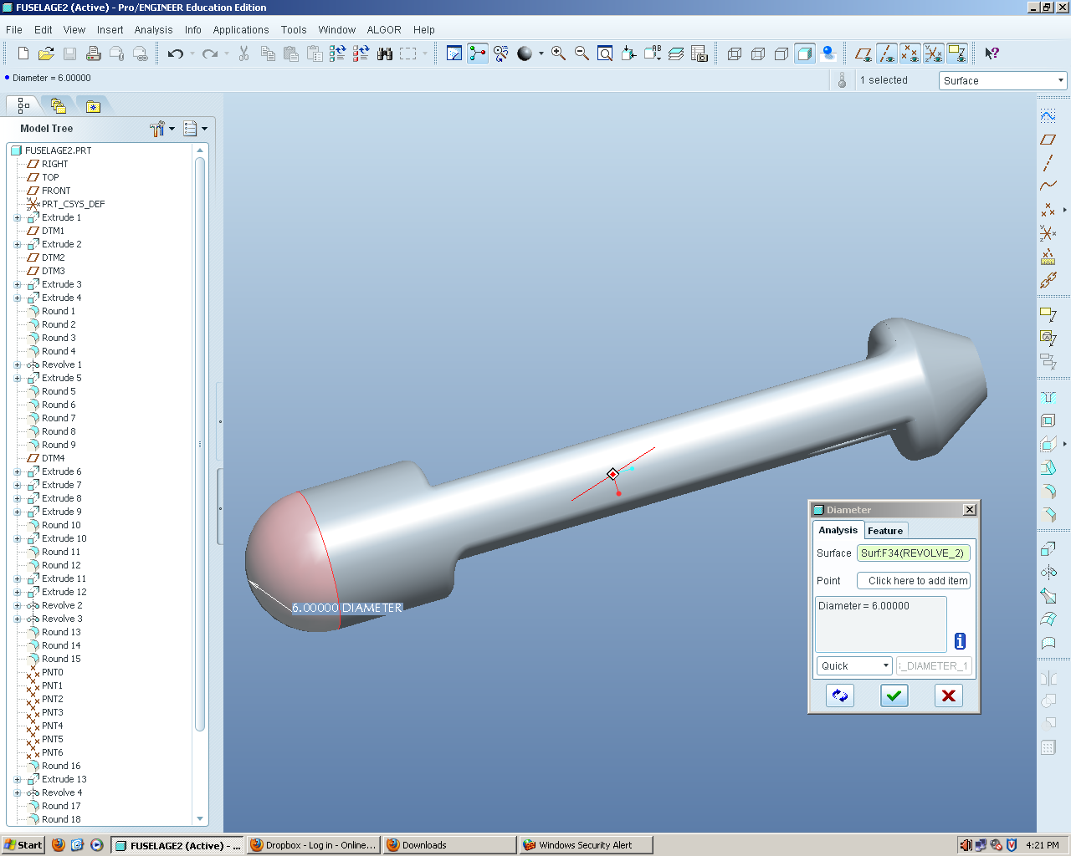**

Figure : Diameter

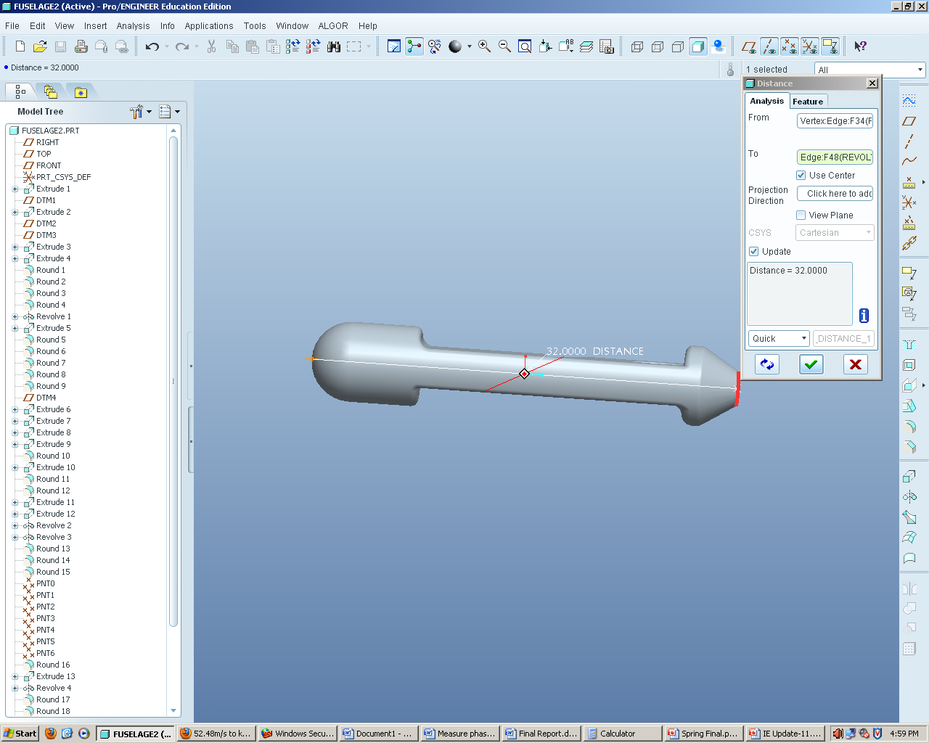

Figure : Length

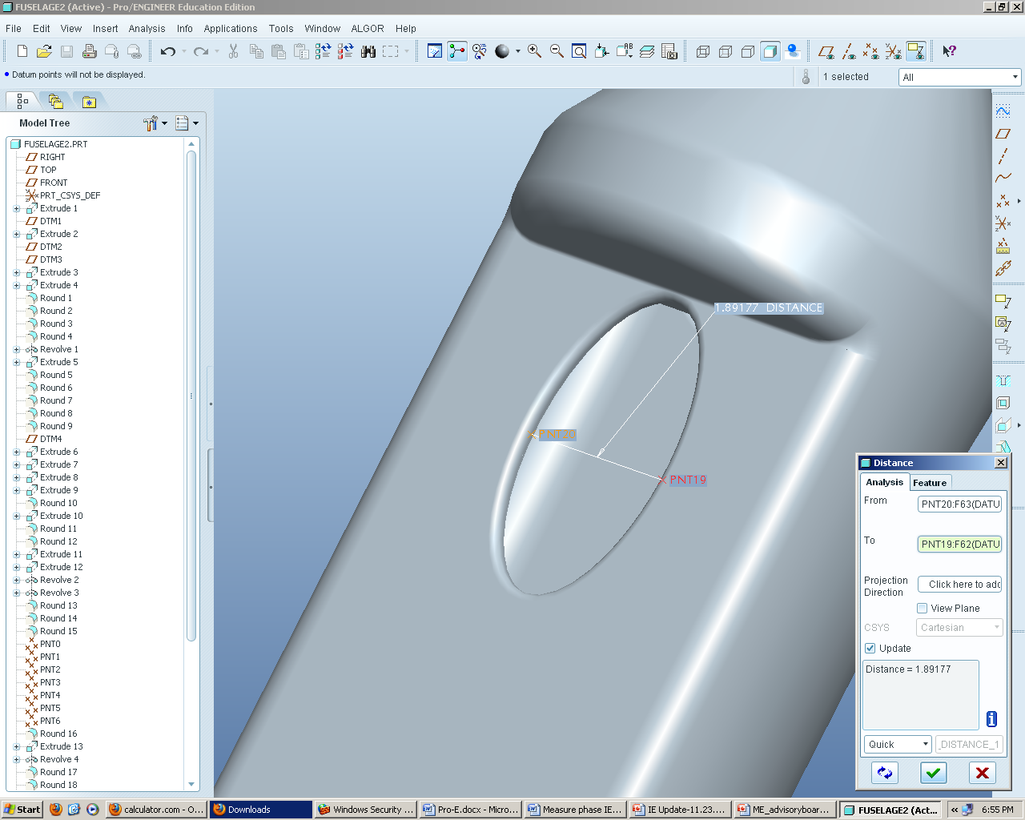

Figure : Inlet- Minor Axis

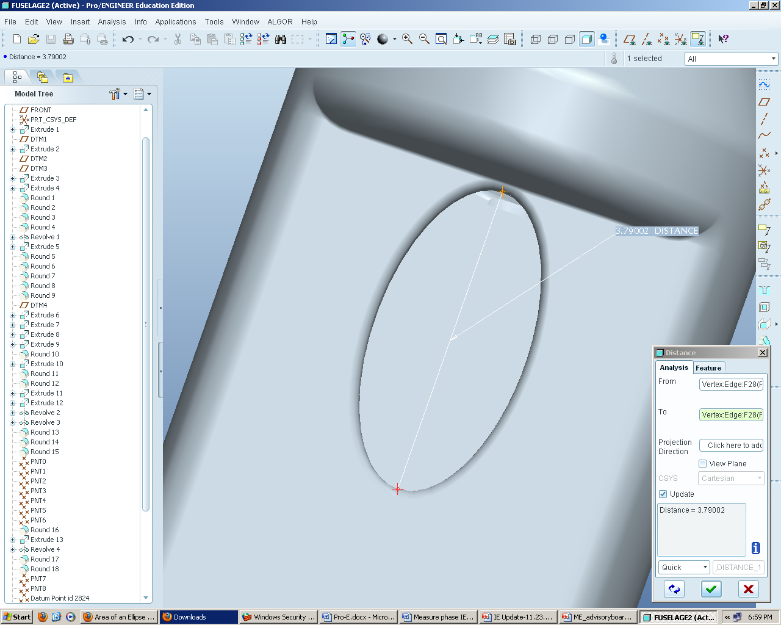

Figure : Inlet Major Axis

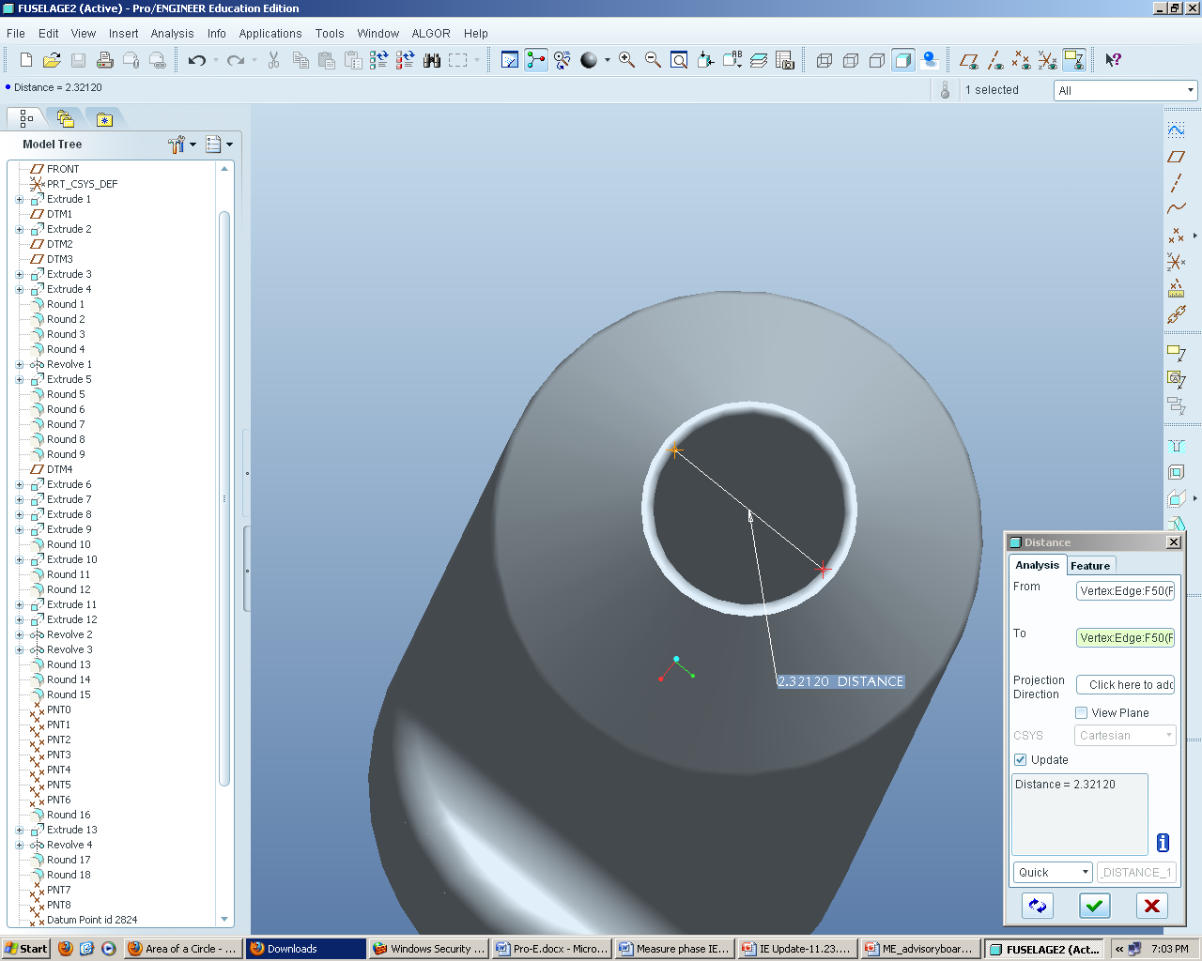

Figure : Exit Area

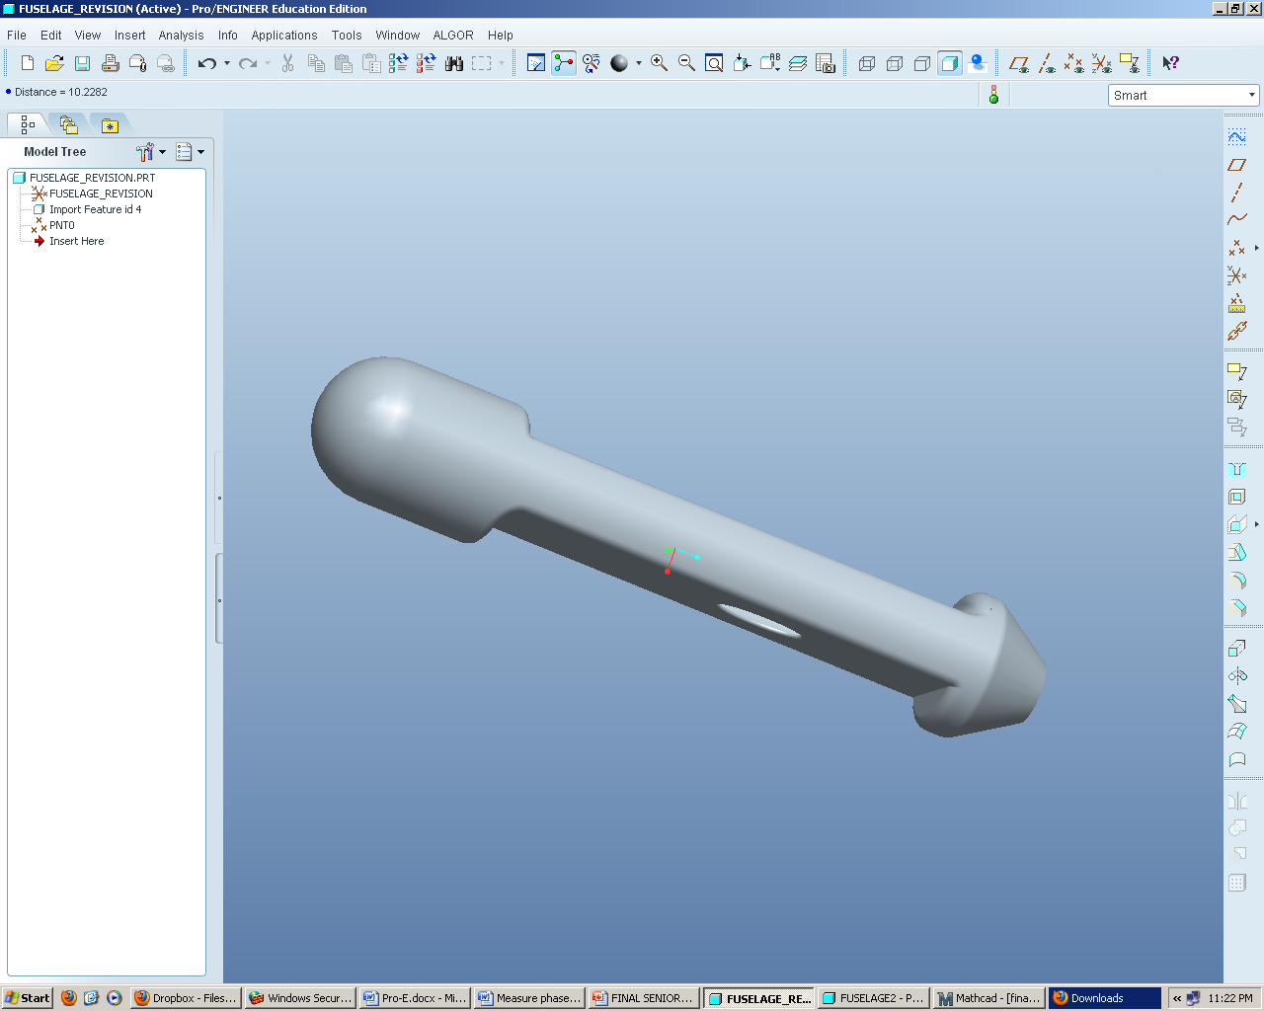

Figure : Design 1

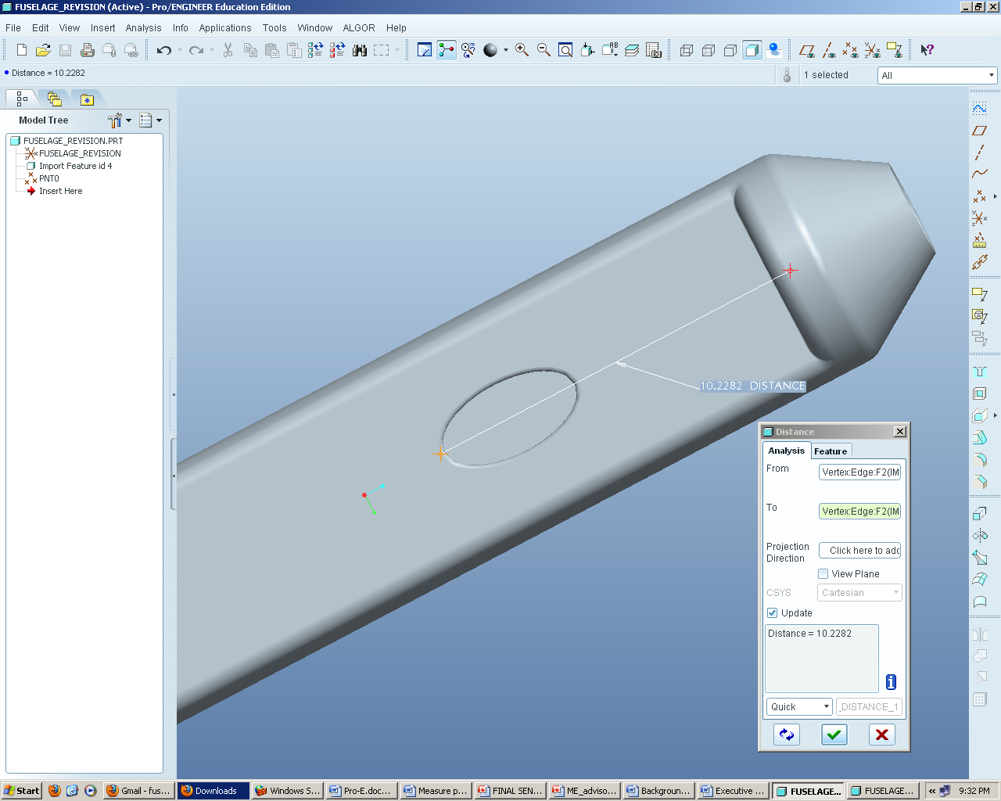

Figure : Design 1- Inlet Distance

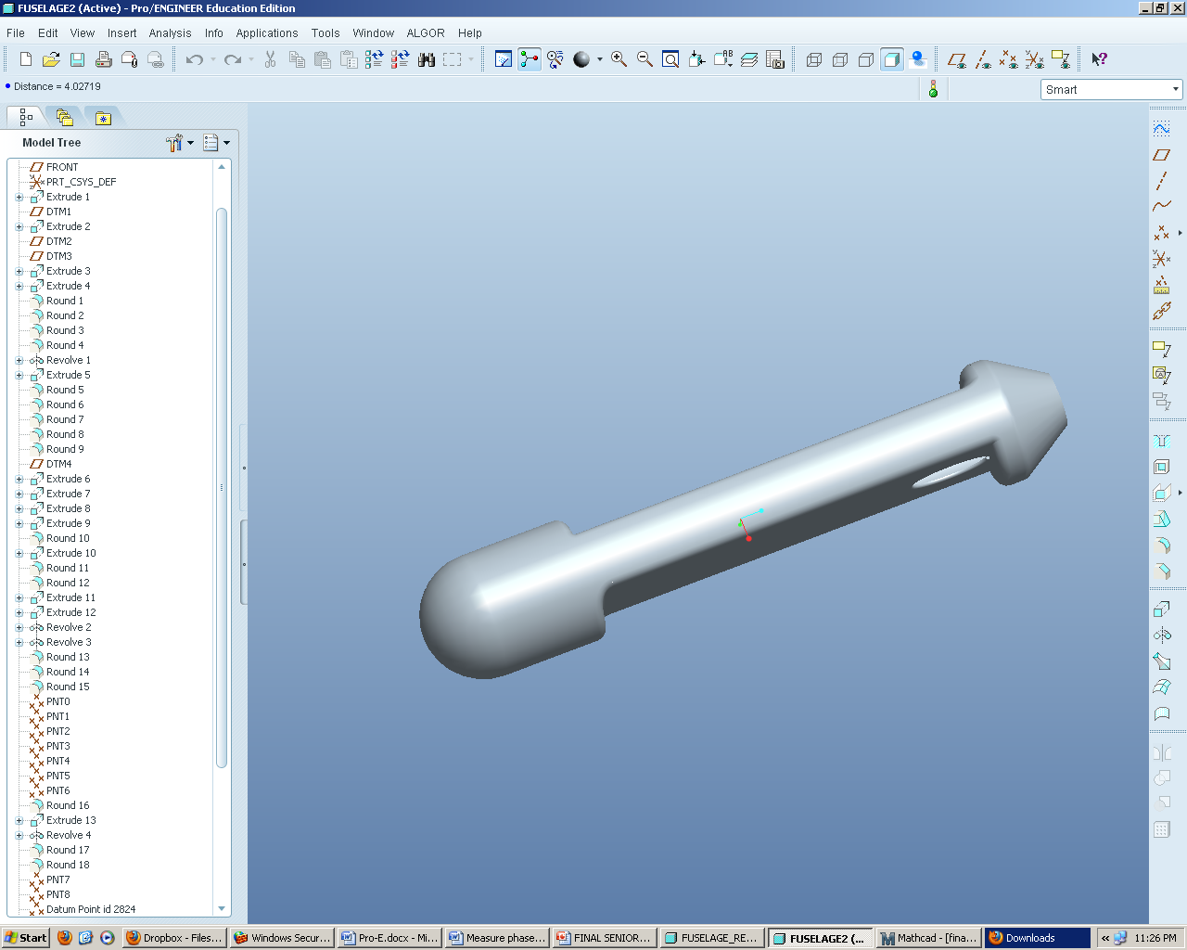

Figure : Design 2

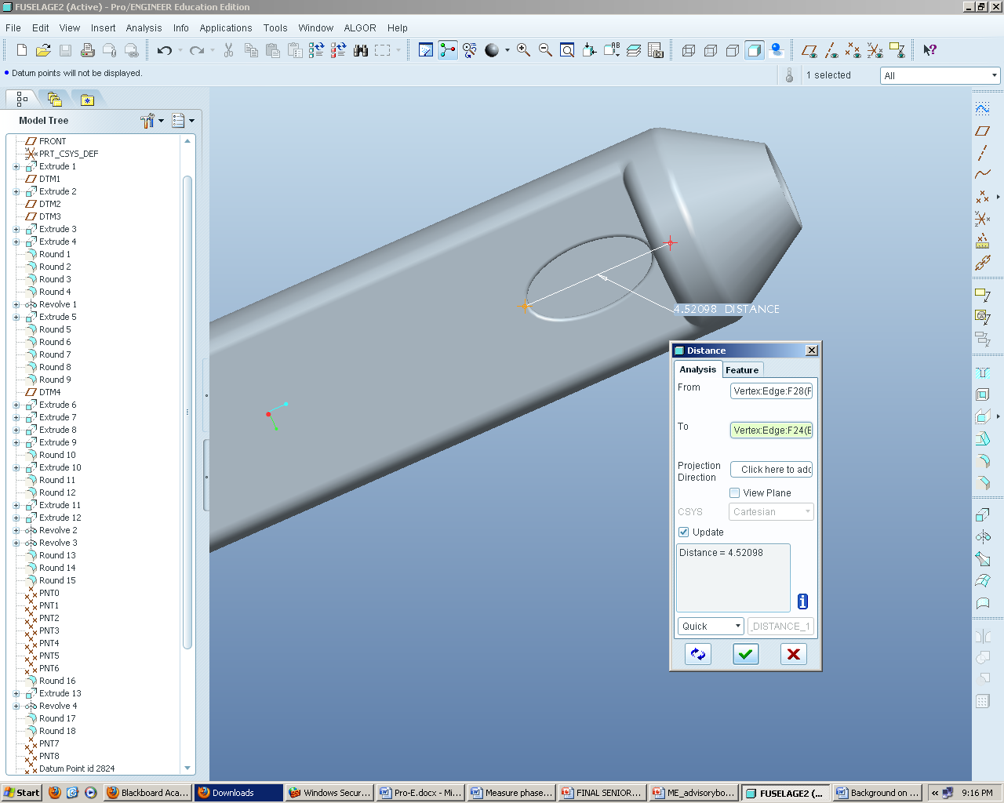

Figure : Design 2- Inlet Distance

## A.2 COMSOL Results

## 

Figure : Short Rod COMSOL Representation of Flow

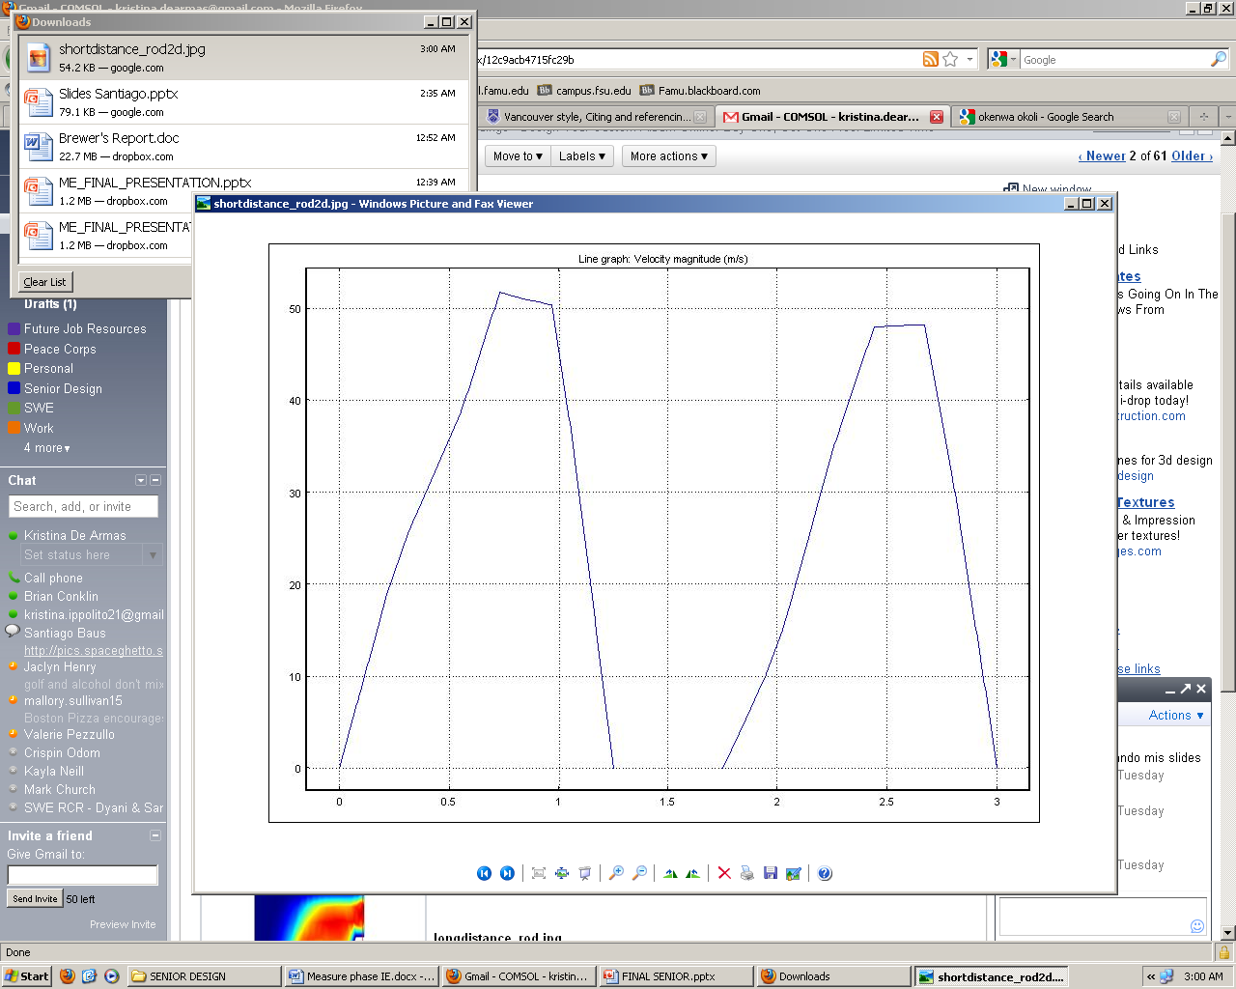

Figure : Short Rod Velocity Profile

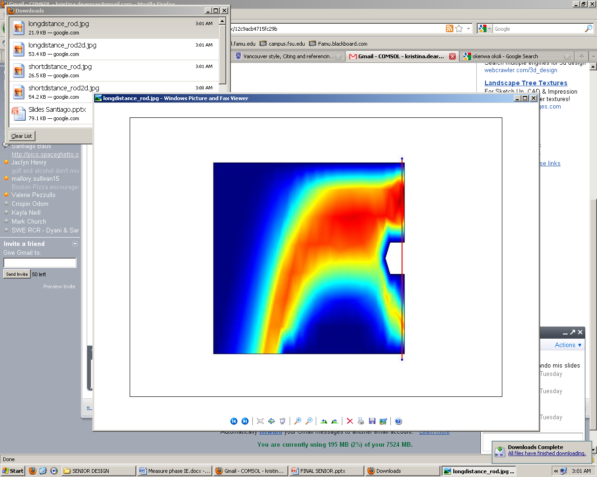

Figure : Long Rod COMSOL Representation of Flow

## 

Figure : LongRod Velocity Profile

## Concept3_streamline.jpg

Figure : Hole Close to Fan COMSOL Representation of Flow

## 

Figure : Hole Close to Fan Velocity Profile

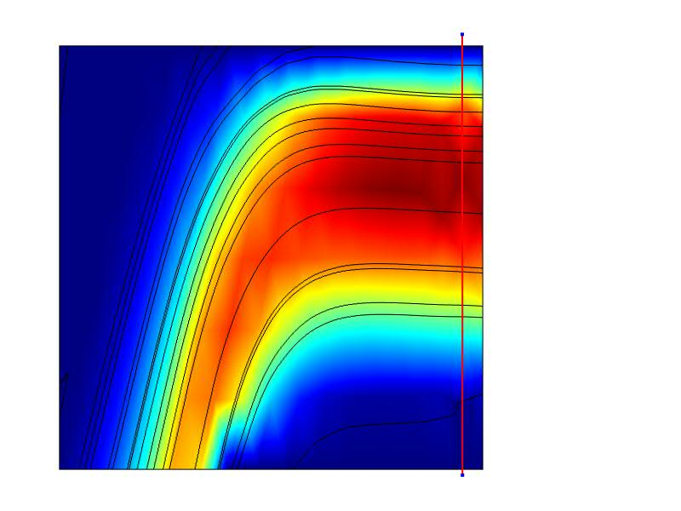

Figure : Hole Farther Away From Fan COMSOL Representation of Flow

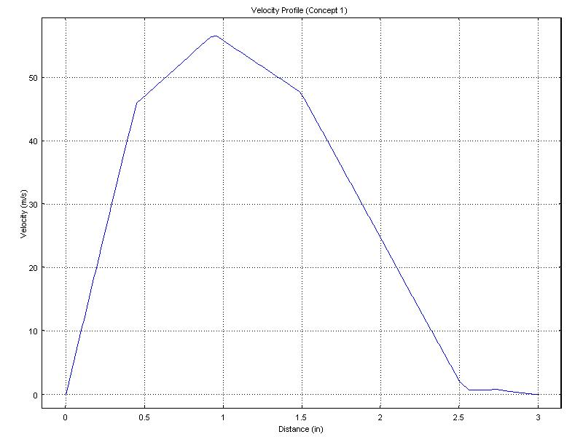

Figure :Hole Farther Away From Fan Velocity Profile

## A.3 Design of Experiments Table

Table : DOE Results

|  |  |  |  |  |
| --- | --- | --- | --- | --- |
| **I** | **X1** | **X2** | **Data** | **X1,X2** |
| 1 | -1 | -1 | 78.59 | 1 |
| 1 | 1 | -1 | 57.18 | -1 |
| 1 | -1 | 1 | 62.08 | -1 |
| 1 | 1 | 1 | 56.93 | 1 |
|  |  |  |  |  |
|  |  |  |  |  |
|  |  |  |  |  |
| **Contrast** | -26.56 | -16.76 | 16.26 |  |
| **Beta** | -6.64 | -4.19 | 4.065 |  |
| **Test Stat** | -0.3252 | -0.20521 | 0.199086 |  |

## A.4 Manufacturing Costs

**Resin price per pound**

Resin: $\frac{\$22.25 dollars}{quart} *$ $\frac{4 quarts}{1 gallon}*$ $\frac{1 gallon}{9.19 lbs}$ → $\frac{\$9.68 dollars}{lb}$

**Carbon Fiber price per square ft.**

Carbon Fiber (CF): $\frac{\$33.50 dollars}{1 yd. *{50}^{''}width}$ → $\frac{\$2.68 dollars}{sq ft}$

**Peel Ply price per square ft.**

Peel Ply (PP): $\frac{\$5.50 dollars}{1 yd*60" width}$ → $\frac{\$0.37 dollars}{sq ft}$

**Flow Media price per square ft.**

Flow Media (FM): $\frac{\$18.95 dollars}{1 yd*50" width}$ → $\frac{\$1.52 dollars}{sq ft}$

**Yellow Sealant Tape price per roll**

Tape: $\frac{\$6.95 dollars}{25 ft roll}$ → $\frac{\$0.28 dollars}{ft}$

**Nylon Bagging Film price per square ft.**

Vacuum Bag: $\frac{\$4.25 dollars}{1 yd*110" width}$ → $\frac{\$0.15 dollars}{sq ft}$

**Breather Cloth price per square ft.**

Breather Cloth (BC): $\frac{\$4.00 dollars}{1 yd*60" width}$ → $\frac{\$0.27 dollars}{sq ft}$

**Vacuum Tubing price per ft.**

Tube: $\frac{\$1.45 dollars}{ft}$

**Fuselage:**

Surface Area = 2 $πr^{2}+ 2πrh$

= 659.734 ${in}^{2}$

Volume = Surface Area \* Thickness of Carbon Fiber

= 659.734 ${in}^{2}$\* 0.01 $in$

= 6.59734 ${in}^{3}$

**Surface Area of Material Used:**

Total Surface Area = 1350.88 ${ in}^{2}$ → 9.38 sq ft

Half Surface Area (HSA) = 4.69 sq ft

**Quantity of Materials Needed:**

Resin = 6.59734 ${in}^{3}$ → .010499 lbs per fuselage

Vacuum Bag = (52 in \*24 in) → 8.67 sq ft

Tape = (2 \*52 in + 2 \* 24 in) → 152 in → 12.67 ft

Tube = 3 ft

CF = 4.69 sq ft (4 layers)

PP = 4.69 sq ft (1 layer)

BC = 4.69 sq ft (1 layer)

FM = 4.69 sq ft (1 layer)

**Total Manufacturing Cost:**

= $2\left[\left(Resin*.010499 lbs\right)+\left(Vacuum Bag*8.67 sq ft\right)+\left(Tape*12.67 ft\right)+ \left(Tube*3ft\right)+4\left(CF*HSA\right)+\left(PP*HSA\right)+\left(BC*HSA\right)+(FM*HSA)\right]$

= 2 $\left[\$69.71\right]$

= $139.41 per fuselage

**Total Cost for 3 Fuselages:**

= 3\*$139.41

= $418.23

**Total Material Cost:**

1. Resin → 1 quart → ($22.25 \* 1) → $22.25

2. Spray Adhesive → 1 can → ($12.95 \* 1) → $12.95

3. Carbon Fiber → 6 yards → ($33.50 \* 9) → $301.50

4. Peel Ply → 2 yards → ($5.50 \* 4) → $22.00

5. Breather Cloth → 2 yards → ($4.00 \* 4) → $16.00

6. Flow Media → 2 yards → ($18.95 \* 4) → $75.80

7. Nylon Bagging Film → 2 yards → ($4.25 \* 4) → $17.00

8. Vacuum Tubing → 3 ft → ($1.45 \* 3) → $4.35

9. Sealant Tape → 2 rolls → ($6.95 \* 4) → $27.80

Total (1-9): $ 499.65

## A.5 Calculations

