Senior design group #3
Integration of Experimental Propulsion Systems in Micro Air Vehicles
Analyze Phase
February 1, 2011

Team # 3
Group Members:
Kristina De Armas
Michael Isaza
Santiago Baus
Erica Cosmutto
Hunter Metzger

Joel Ware

Table of Contents
List of Tables 3
List of Figures 4
1.0 Introduction 5
2.0 Problem Statement 6
3.0 Background Research 7
4.0 Analyze Plan 10
4.1 Current Issues and Proposed Solutions 10
4.1.1 Failure Mode and Effect Analysis 11
4.2 Spring Schedule 12
5.0 MAV Specifications 13
5.1 Component Selection and Analysis 13
5.1.1 Electric Ducted Fan (EDF) 13
5.1.2 Lithium Polymer Battery 14
5.1.3 Electric Speed Control (ESC) 15
5.1.4 Material Selection 15
5.2 Fuselage Design 15
5.2.1 Changes to Fuselage 17
5.3 Testing 18
5.3.1 Static Thrust Test 18
5.3.2 Wind Tunnel 18
6.0 Manufacturing Analysis Plan 18
6.1 Mold Design 19
6.2 Vacuum Bagging Process 19
6.3 Manufacturing Cost 20
7.0 Total Weight and Cost Analysis 24
8.0 Conclusion 25
9.0 Acknowledgements 26
10.0 References 27
Appendix A 28
A.1 Pro-E Drawings 28
A.2 COMSOL Results 33
A.3 Design of Experiments Table 37
A.4 Manufacturing Costs 37
A.5 Calculations 40

List of Tables
Table 1: FMEA Worksheet 12
Table 2: Cost of Materials to Manufacture 3 Fuselages 24
Table 3: Total Cost 24
Table 4: DOE Results 37

List of Figures
Figure 1: Graph showing the relationship between mass flow and power. 8
Figure 2: Spring Schedule 13
Figure 3: Electric Ducted Fan 14
Figure 4: Lithium Polymer Battery 15
Figure 5: Electronic Speed Control 15
Figure 6: Fuselage Design 16
Figure 7: Manufacturing Flow Chart 20
Figure 8: Epoxy Resin 21
Figure 9: Spray Adhesive 21
Figure 10: Carbon Fiber Fabric 21
Figure 11: Peel Ply 22
Figure 12: Breather Cloth 22
Figure 13: Nylon Bagging Film 22
Figure 14: Vacuum Tubing 23
Figure 15: Flow Media 23
Figure 16: Sealant Tape 23
Figure 17: Diameter 28
Figure 18: Length 28
Figure 19: Inlet- Minor Axis 29
Figure 20: Inlet Major Axis 30
Figure 21: Exit Area 30
Figure 22: Design 1 31
Figure 23: Design 1- Inlet Distance 31
Figure 24: Design 2 32
Figure 25: Design 2- Inlet Distance 32
Figure 26: Short Rod COMSOL Representation of Flow 33
Figure 27: Short Rod Velocity Profile 33
Figure 28: Long Rod COMSOL Representation of Flow 34
Figure 29: LongRod Velocity Profile 34
Figure 30: Hole Close to Fan COMSOL Representation of Flow 35
Figure 31: Hole Close to Fan Velocity Profile 35
Figure 32: Hole Farther Away From Fan COMSOL Representation of Flow 36
Figure 33:Hole Farther Away From Fan Velocity Profile 36

1.0 Introduction
The group was assigned this MAV experimental propulsion project by the Eglin Air Force Base in Fort Walton Beach, Florida; more particularly by 1st Lieutenant John Brewer. At Eglin, 1st Lieutenant Brewer is a part of a research team specializing in the advancement of micro air vehicles. As a graduate of the FAMU/FSU College of Engineering and the senior design program, he reached out to our team to create three efficient MAVs using an electric ducted fan and to run various tests to judge their performance.
Electric ducted fans have the potential to be more efficient, capable of higher velocities, quieter, and safer than a basic propeller system. When coupled with a properly designed duct, the improvement in performance of the MAV could be very significant. After many failed designs, an initial design of the fuselage was approved by our sponsor. The initial design was used as the basis for the other two designs. One design varies the position of the inlet in relation to the position of the electric ducted fan, while the other design uses a rod to separate the flow of air. These designs will be tested to see which configuration of the inlet position, and duct geometry will produce the best performance. The performance will be based on the efficiency and velocity achieved by the configuration. Then the team will decide on the ‘best’ MAV based on the performance and how well it meets the specifications.
For our Senior Design class, we have been asked to follow the structure of a Six Sigma Methodology referred to as DMAIC. DMAIC stands for Define, Measure, Analyze, Improve and Control. Our previous reports covered the define and measure phases. In the define phase, we used various tools to identify what was critical to our customer, Eglin. Our conclusion for the define phase was that the weight, width and use of a lithium polymer battery were the most critical factors to consider when designing the fuselage of the MAV. These requirements have all been met in our three current designs of the fuselage. The measure phase assisted us in establishing a basis for our project. Through the use of our Pro-E drawings of the fuselage, we were able to verify that the dimensions met our customer requirements. Next, we used design of experiments along with COMSOL simulations to define the performance standards of the MAV. Then, we calculated the manufacturing cost of the producing three fuselages, to ensure we would stay within our recommended budget. Lastly, we established a data collection plan that we will implement once the fuselage has been manufactured. Our measure
This report will cover the analyze phase. Our ideal analyze phase would have consisted of the initial plan to manufacture the 3 fuselages we have designed and conduct various tests in the wind tunnel to further analyze the fuselages. Then we would report these findings and determine the problems present and the root causes in order to improve our designs. But due to delays in the fabrication of the mold, we were not able to collect this data. Therefore our analyze phase will consist of a thorough analysis of our current issues, in order to identify what is holding us back from progressing, our proposed spring schedule, final component selection, details on changes made to the fuselage, static thrust test results, manufacturing analysis and updated total weight and cost analysis.

2.0 Problem Statement
Initially, we were contacted by our sponsor to develop three fuselage designs for a MAV where we could integrate the use of an electric ducted fan along with all the electronic components. During the design phase, we would need to ensure the specifications provided by the sponsor were met and then through analysis, be able to prove the efficiency and effectiveness of each design. Once the designs were approved by the sponsor, we would manufacture all three designs and test them, in order to choose the best performing overall fuselage design.
The specifications provided to us by our sponsor include that the diameter must be ≤ 6”, the length must be ≤ 32”, and the weight must be ≤ 10lbs.[3] The electronic components that are needed to produce an MAV are: a powerful battery, an electric ducted fan, a speed controller for the fan, and remote controls for the MAV. The MAV fuselage will be produced out of carbon fiber composite to provide a light weight vehicle and durable frame. For the vehicle to fly there needs to be a 4 to 1 ratio of weight to thrust to provide enough power to the MAV. The wings will be provided by the sponsor and a certain area along the fuselage will be designated for the wings. The first eight inches of the MAV is to remain free to put electrical components but does not include the ducted fan. The goal is to build three MAVs that fit within the constraints and are built according to the parameters of motor efficiency, flight velocity, flight time, weight, and durability.
There are many issues that we have encountered thus far. Some of the issues have affected our current status while some have yet to be addressed. Currently, our biggest issue is that we do not have a mold for our fuselage. There are many reasons why our mold creation has been delayed, which will all be discussed in the Section 4.1 Issues, along with some of the proposed solutions. Even if we did have the mold ready, there are still many concerns with the execution of the vacuum bagging process, the availability of the wind tunnel, and the lack of access to the wings. Through this report we will attempt to address these problems, find the root causes, and come up with alternative solutions. We will also address the current state of our project, including some changes and our proposed schedule for the spring semester.

3.0 Background Research
The topic of micro air vehicles (MAV) is large and constantly growing and changing. For engineers, the challenge of creating small devices that can fly, reach various speeds with different maneuverability is an exciting one. As can be imagined, the design possibilities are endless. There are numerous uses for these MAVs. This includes surveillance, communication, mapping out treacherous terrain, etc. [5] In this section, we will be specifically focusing on the propulsion system used in our MAV and we will also discuss some background on the vacuum bagging process used to manufacture the fuselage.
The main component of any aircraft is its propulsion system. The average MAV uses a propeller at the nose of the plane to accelerate the air. An alternative to this would be to use a ducted fan. A ducted fan is defined as a fan with duct that has a chord longer than the diameter of the fan. These fans have many advantages over their counterparts, which is usually a simple propeller at the nose of a plane. The use of ducted fans allows for the possibility of vectoring the thrust exiting the plane. Noise suppression is also a large advantage of ducted fans. Because of the shroud around the fan and the fact that the fan is fully enclosed in the body of the plane, noise heard is minimal. Ducted fans also provided better low-speed and static thrust. They can achieve higher thrust per horsepower for a given diameter. This is a huge advantage when size, specifically diameter, is important. [10] As noted above, diameter is a constraint for this project.
One disadvantage of a ducted fan is that the inlet and exit areas are usually fixed, resulting in a design of the fan and duct that is optimized for one speed.[10] This is not really an issue for this project because of the relatively small range of velocities. All calculations and visualizations are done for a specific cruise condition.
Thrust is achieved by steadily increasing the momentum of the air passing through.
$T=\dot{m}∆V$ Equation 1
$\dot{m}$ = ρ$V_{1}A$ Equation 2
$ΔV= V_{2}-V_{1}$ Equation 3
T=Thrust
$\dot{m}$ = Mass flow rate
∆V= Change in velocity
V₂=Exiting Velocity
V₁= Incoming velocity
There is a certain power needed to create this thrust. Power is the rate of change of energy. The change in momentum (thrust) can be equated to power by the equation below (Equation 4).
$P=\frac{1}{2}\dot{m}(V_{2}^{2}-V_{1}^{2})$ Equation 4
P= Power
Equation 3 is simply equation 2 expanded and rearranged to illustrate the effect the change in velocity and the mass flow rate have on the power needed to achieve a certain thrust. It makes sense to aim at keeping the power needed to produce a certain thrust as low as possible. From viewing equations 1 and 5 it is noted that if the mass flow rate is cut in half and the change in velocity is doubled a certain power is required in order to achieve a constant thrust. This power would be larger than the initial value because the change in velocity is squared in the second term, increasing the power required to create the same thrust. The reciprocal is also true, if the mass flow rate is increased and the change in velocity is lowered, the power decreases.
$P=\dot{m}*∆V*V_{1}+\frac{1}{2}{(∆V)}^{2}\dot{m}$ Equation 5

Figure 1: Graph showing the relationship between mass flow and power.
The graph 1, above, shows the relationship between mass flow and the power required divided by the ideal power. As the mass flow is increased the fraction of power is reduced. As seen, increasing the mass flow rate is very effective when the mass flow is initially low. The higher the mass flow rate is the more it has to be increased to achieve the same improvement. At some point the effort it takes to increase the mass flow rate is not worth the decrease in power that is achieved.
Equation 6 shows that if the free stream velocity is decreased, the ideal power required to obtain a certain thrust is also decreased. Furthermore, combining equations 1 and 5, a relationship between the power and thrust is created (equation 7). This also illustrates that if the incoming free stream velocity is lowered the power required is decreased.
$P_{ideal}=T*V_{1}$ Equation 6
$P=TV_{1}+\frac{1}{2}\frac{T^{2}}{\dot{m}}$ Equation 7
V₁= Free stream velocity
One way to slow down the average free stream velocity is to have more boundary layer entering the fan. This is called boundary layer ingestion. Boundary layer ingestion increases the efficiency of the fan. Thrust is created by simply increasing the velocity by a constant increment. In other words, the change in velocity creates the force we think of as thrust. Because of this fact, it makes no difference if the incoming velocity is high or low, as long as the change in velocity is the same. We know from the above equations that it takes less power to accelerate a slower incoming velocity than a velocity with a higher speed. [10]
Decreasing the incoming velocity will increase the efficiency of the system but does it a price of a slower exit velocity and thrust. Arriving at a balance between efficiency and exit velocity is the key.
For the manufacturing of our fuselage, as stated before, we will be using the vacuum bagging process. Vacuum bagging is a clamping method that uses atmospheric pressure to hold the adhesive or resin-coated components of a lamination in place until the adhesive cures. This method is considered to be very effective due to its wide range of manufacturing possibilities. Vacuum bagging offers many advantages over the customary clamping methods. It allows for the worker to focus more on the structural requirements rather than having to worry about clamping limitations. Other important advantages of the vacuum bagging process are that it allows for an even clamping pressure which delivers a firm and evenly distributed pressure over the entire surface, while not having to worry about the type or the quantity of the material of being laminated. Also, vacuum bagging allows developing material with high fiber to resin ratios due to its ability to control excess adhesive in the laminate. This produces higher strength to weight ratios and favorable cost advantages. Due to its many advantages vacuum bagging is widely used in the composites industry. [8]

4.0 Analyze Plan
The Analyze Plan consist of a thorough analysis of current issues preventing the project from moving forward as well as addressing certain design issues our group is currently facing. We have also taken the liberty of discussing various possible solutions which we hope will get our project back on track. Lastly, a failure mode and effect analysis was used to better depict the design issues.

4.1 Current Issues and Proposed Solutions
As mentioned before, the MAV project is no stranger to issues. The team’s main goal is to prevent any problems that relate to what is critical to quality during the project. Such issues will be discussed in the following section with their respective proposed solution based on the ideas presented by the group members.
- The main concern for the team is that the wings are not part of the scope of the project; hence it is not possible to have actual flight data that permits an insight on the performance of the MAV. A way around this is to perform as many tests as possible that resemble a real life environment while assessing the capabilities of the MAV. Such tests include a static thrust test, a wind tunnel test, to measure efficiency, and a pitot-static tube test.
- As a result of the solution previously mentioned the group is presented with a second problem and that is the current queue to use the wind tunnel. As of now there is no way to speed up or move up the queue but the group is currently working on gaining access to the wind tunnel by contacting those in charge and setting up an appointment.
- Parallel to the before mentioned problems, there is also concern with the fact that the mold has yet to be created. The sponsor volunteered to have the mold done but the designs that have been sent have been not accepted and the sponsor has requested changes be made to the current design. The sponsor specified that a duct had to be manufactured as well so that the air flows directly into the fan. The way that the group had the design was that the fuselage’s inside would be considered as the duct itself. Time has also been an affecting factor. The mold needs to be done as soon as possible so that more tests can be done to assess the MAV capabilities in time for the final presentation. The solution to this problem is to work harder and keep in contact constantly with the sponsor. We have also considered a backup plan of creating our own mold in the 3D printer but currently do not have access to a large enough 3D printer or access to the material needed to create the mold.
- Recently we were informed that the Electronic Speed Control (ESC) needs to be in a ventilated area due to the high temperatures it can reach while running. We had not taken this into consideration when designing our fuselage; therefore, we must now brainstorm and find a solution without having to completely change our design. The team has come up with two suggested approaches to dealing with this:
  - Place the ESC at the exiting hole of the MAV using Velcro so that the exiting air cools the ESC.
  - Locate the ESC inside the fuselage while opening a small vent so that the passing air cools the ESC.
- Placing a rod before the fan as a way to have the air go in directly into the fan sweep area was an idea presented in the previous phase, the problem with this is that the rod adds a manufacturing challenge and presents a risk of damaging the fan. Depending on how the rod will be placed into the duct, the team has to take into consideration that the fan rotates at very high RPMs and the resulting vibration could loosen the rod. If the rod was to detach during flight it would follow the duct’s path and impacting the fan resulting in serious damage.
- Cables Location: Locating the cables to connect the Electric Ducted Fan (EDF) with the ESC and the battery is also another point of concern. The cables from the EDF will need to reach the other components
  - The cables may travel through the inside of the MAV’s fuselage. Traveling through the inside of the fuselage requires a basic rework of the design
  - The cables go outside the body and then re-enter the fuselage to meet with the ESC and battery. Having the cables located outside just require a small opening in the already existing design.
The most recommended course of action is keeping the cables inside the fuselage however a decision is yet to be taken.

4.1.1 Failure Mode and Effect Analysis
Issues 4-6 present problems that are more related to the functionality of the MAV than the project as a whole. For such reason the following FMEA worksheet has been developed in order to have immediate access to viewing the problems in a more organized manner and being able to update as the project continues. The following figure shows a basic FMEA worksheet:

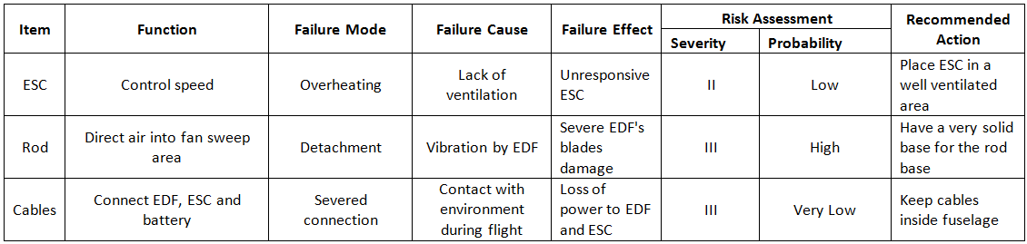
Table 1: FMEA Worksheet
The severity is measured from 1 to 10. In this scale 1 is the lowest damage to the MAV while 10 is complete or partial destruction that will render the MAV inoperable. Given that the material of the fuselage is very resistant, it is assume that a crash will not result in a totaled MAV. For such reason a severity of 10 is not very likely to be achieve but if the internal components are damaged, then severity will also increase. Failure due to the Rod has the highest severity because if such even happened, then the EDF which is an internal and key component would be greatly damaged resulting in complete loss of control of the MAV. Severed cables have a relatively high severity because it will interrupt the connection between the EDF, ESC and power supply resulting in a complete loss of control of the EDF. If such event happened, the MAV would probably crash. The Lowest severity is allocated to a failure in the ESC. If the ESC overheats, it is highly likely that it will run with less power and eventually shut down.
The probability of occurrence is not an actual measure of reliability but rather a subjective approach by the group. The ESC has a high probability of overheating because that was observed during the static test. It was suggested by Dr. Hovsapian that the high RPMs generated by the EDF were going to cause a lot of vibration possibly resulting in the detachment of the rod. Finally, the cables being in contact with the environment in case that they are left outside the fuselage are common sense. By contact to the environment it is inferred that a loose connection may disconnect further due to the drag or if there is a crash with the plane and the area of contact is where the cables are connected then the probability of the connection being severed is high, however the chances of this happening are not very high.

4.2 Spring Schedule
The schedule for spring has been modified as a result of the delays. The updated schedule can be observed in the following figure, Figure2.

Figure 2: Spring Schedule

5.0 MAV Specifications
The main aspects to be measured in the design measurement portion include: how the design will be dimensioned, the position of the inlet with respect to the fan, and how the use of a rod in front of the fan hub will affect the flight velocity. It is believed that the placement of the inlet will create variability in the velocity exiting the fan and also on the efficiency of the same. The goal is to find a configuration of the before mentioned factors that will have result in a greater velocity exiting the fan and it will be achieved by performing a 2^{k} factor design of experiment and analyzing the results. The results of the experiment will determine what will be the final dimensions for the duct and whether the rod will be used or not in order to maximize velocity.

5.1 Component Selection and Analysis

5.1.1 Electric Ducted Fan (EDF)
The EDF is the first component that was selected because the battery and speed controller must be chosen to accommodate the power of the fan. When sizing a fan, it is important that the group picks a fan powerful enough to fly the aircraft. However, if the EDF creates too much thrust, the vehicle may not be controllable. After speaking with our sponsor, it was agreed upon that a 40% thrust to weight ratio was ideal. Since we know the total weight of the MAV (10lbs.), it is figured that a fan that outputs 1.814kg of thrust is what is needed. The picture above is the fan that was chosen and purchased from hobbypartz.com. It was chosen because it has a maximum thrust output of 2.2kg and fits within the constraints of the fuselage. We figured it was safer to choose a fan that creates more than enough thrust to fly the MAV and gear it down with a speed control to find the optimal amount of thrust during flight. Every fan draws different amounts of power, and this one in particular runs on 55 amps at 22.2 volts. The next step in component selection is to choose a battery that can power this fan.

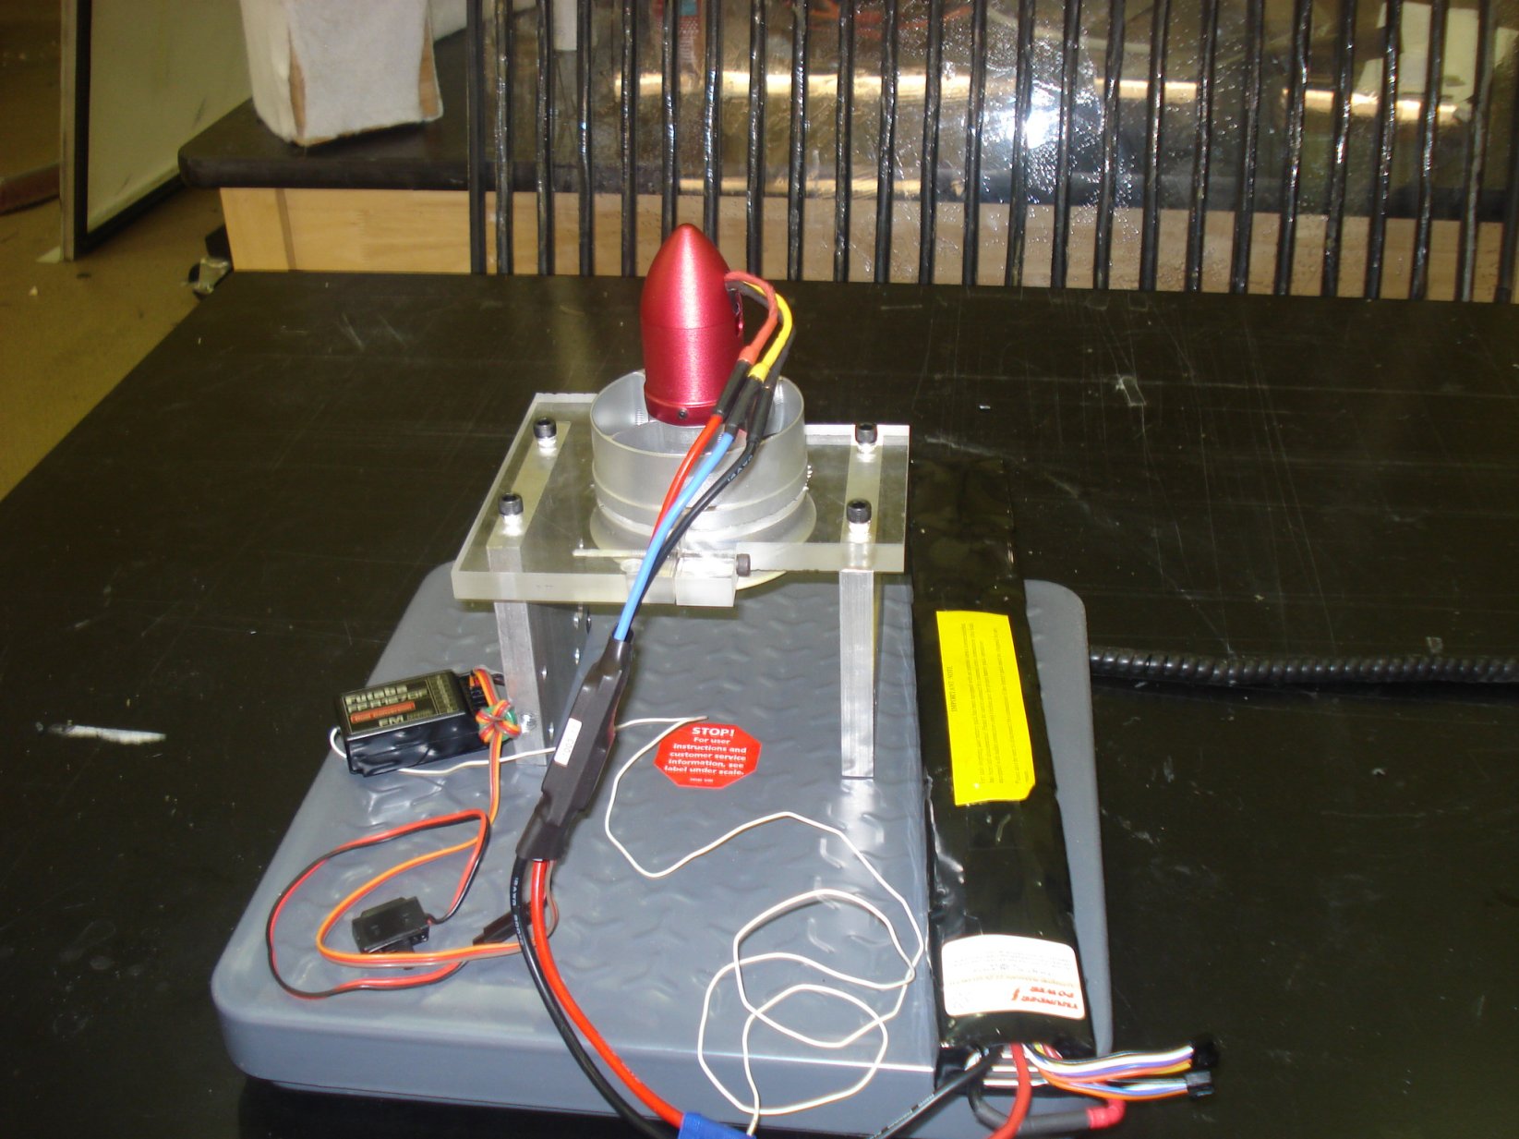
Figure 3: Electric Ducted Fan

5.1.2 Lithium Polymer Battery
Because the battery makes up a great deal of the MAV’s weight, a battery with extremely high energy density is desired. A lithium polymer battery comes to mind because of its high energy content and light weight. Every cell of a lithium polymer battery contains 3.7V, so technically only a six-cell lithium polymer battery is needed to cover the 22.2V required by the EDF. Batteries of this voltage however only have capacities of around 5-6 amp-hours and would give us a flight time of around 5 minutes if the batteries were fully discharged. So for our MAV, we chose to utilize a 6S4PL lithium polymer battery (6 cells in series and 4 cells in parallel). The extra cells that are combined in parallel will add to the capacitance of the battery as a whole without supplying extra voltage that risk frying the motor. This 10 cell battery has a capacitance rating of 8 amp-hours and will give us about 9 minutes of flight time if the fan runs at its maximum speed and the batteries are completely discharged. The battery is also capable of running a maximum continuous current of sixteen times its capacitance which is well over the maximum load of the fan. The team will purchase a battery of this size from thunderpowerrc.com.
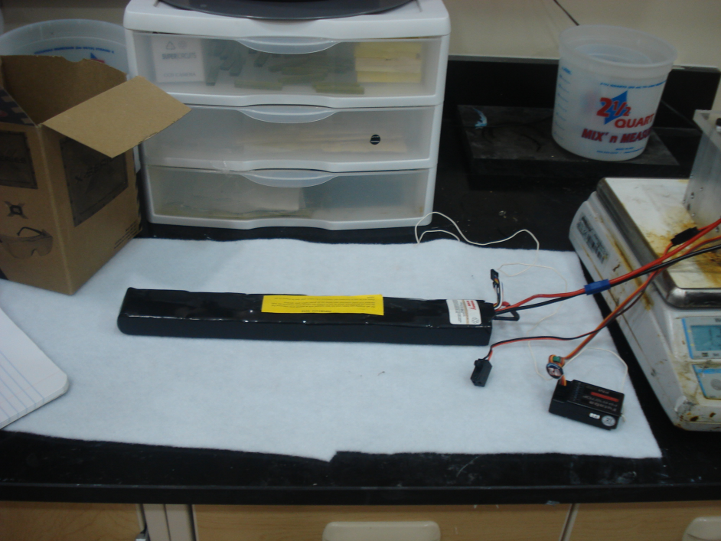
Figure 4: Lithium Polymer Battery

5.1.3 Electric Speed Control (ESC)
The team also found a sufficient speed controller from thunderpowerrc.com. When matching a speed controller, it was important that one was found that covers the maximum voltage and current drawn from the fan so that it can effectively adjust the vehicle’s flight speed. The ESC in the corresponding picture is rated to adjust up to 100A and 44.4 V. It is also a “Smart-Guide” speed controller, meaning that it contains an internal circuit that monitors the voltage of each cell and sends a signal to the user when the voltage of each cell drops to or below 3.4V and risks discharging to the point where it cannot be recharged. The combination of this speed controller with the 6S4PL lithium polymer battery and the 2.2 kg thrust fan we believe gives us the perfect balance between weight and power.
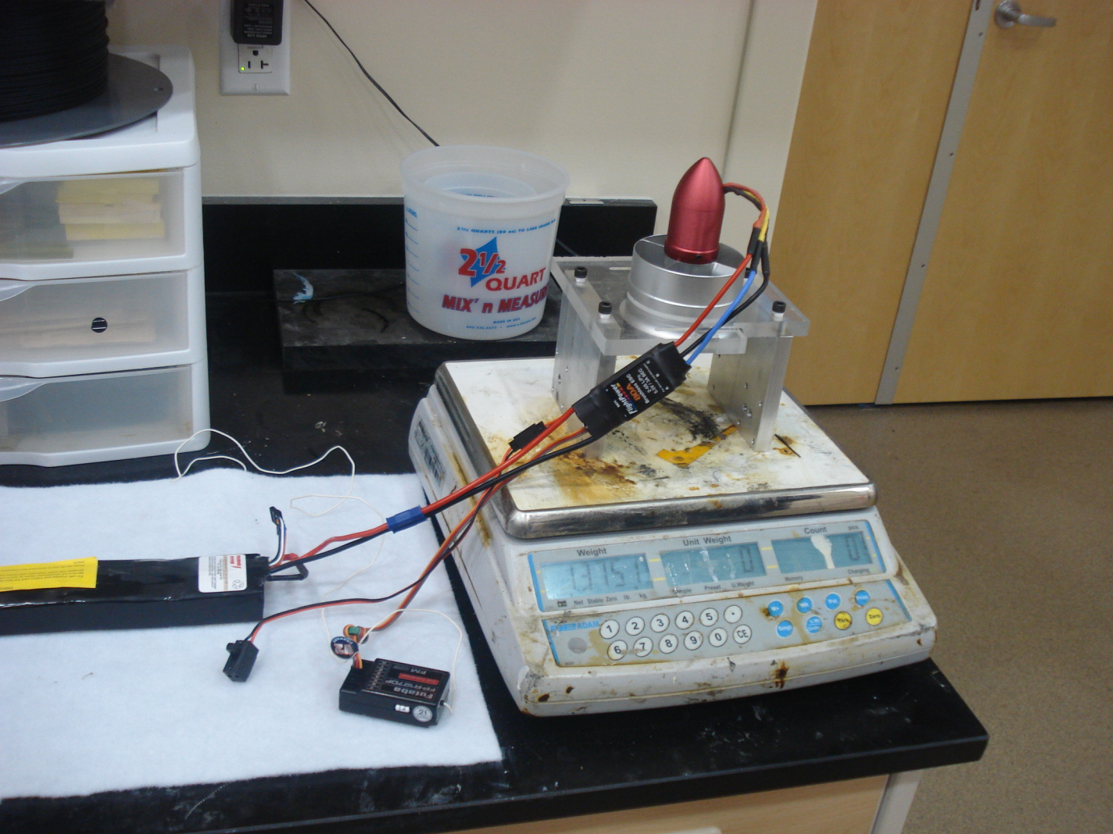
Figure 5: Electronic Speed Control

5.1.4 Material Selection
The fuselage frame of the MAV needs to be durable, light weight, and weather resistant so we decided to build the frame out of a carbon fiber composite. Carbon fiber composite is a carbon based cloth that has small fibers which are woven together and combined with a plastic resin to create a light weight and high strength material. The plastic resin that will be used to create the MAV is epoxy. Epoxy has a low density which will make the frame light weight but also durable.

5.2 Fuselage Design
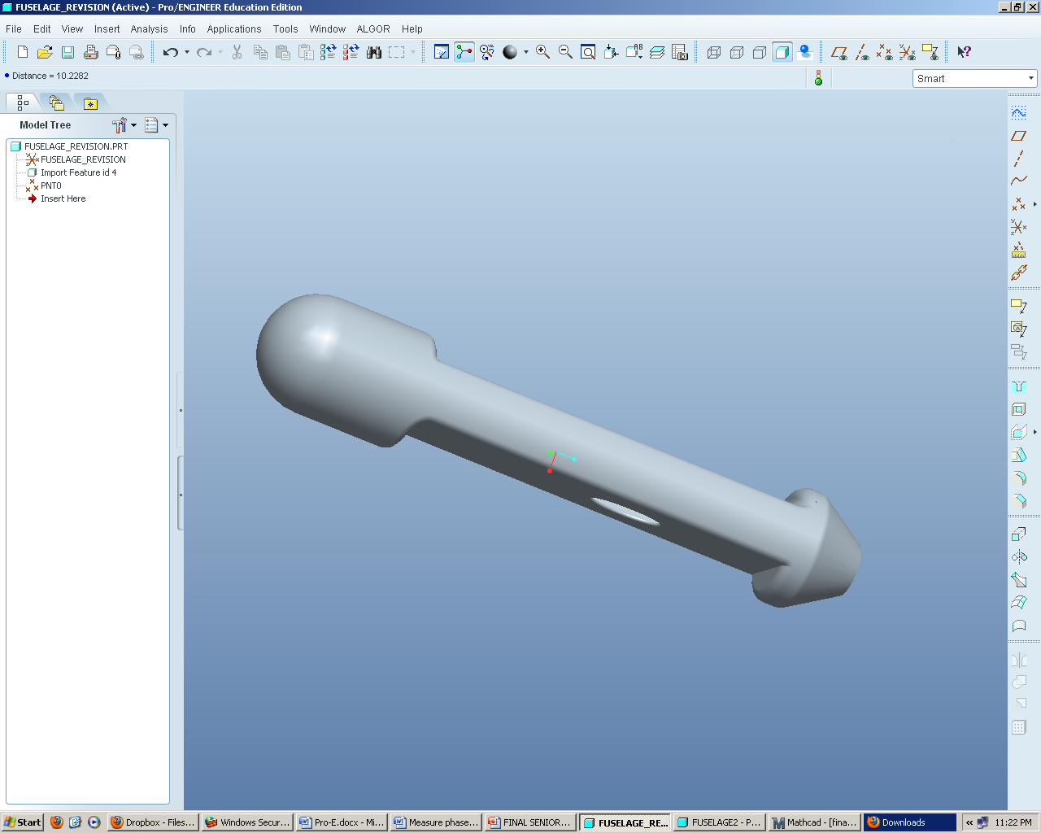
Even though the exterior fuselage shape was not the primary focus of the project, an exterior design that is usable for every duct design must be created. The fuselage is constrained to fit inside a cylinder with dimensions of six inches in diameter and 32 inches in length. The team decided it was the best option to make it as close to those dimensions as possible so that there would not be too much excess room for the fuselage to slide around and possibly be damaged. The position of the wings is known by the chord drawing our sponsor has supplied. Figure 3 illustrates the outer shell of the fuselage that the team designed for the project.
Figure 6: Fuselage Design
The fuselage seen above is 32 inches in length and has a maximum diameter of 6 inches. There is 8 inches of room at the front of the fuselage to allow for component storage. The wings will attach to the fuselage at the top and bottom in the area of smaller diameter. In order to actually mount the wings, there is a vertical wall of 0.95 inches in the front and back. The exhaust of the fuselage tapers down to 75% of the fan sweep area to further accelerate the flow out the back. An ellipse was the shape of choice for the intake to best accommodate the laminar flow running along the bottom side of the fuselage. Throughout the project the team will experiment with the location of the elliptical intake and judge where the most beneficial position is located with respect to internal friction and boundary layer development prior to the fan.

5.2.1 Changes to Fuselage

5.2.1.a Tail
For the MAV to be an effective design a tail was needed to be designed to fit onto the fuselage. A tail is required for the MAV so it can provide stability to usher that the fuselage has a steady and streamline flight. The design needed to be roughly 20 inches in area to allow for a steady flight according to the dimensions of the fuselage. The design that was chosen is a curved vertical tail that will be attached to the end of the fuselage. There are some complications with the design. The first complication is tail will be larger than the six inch restriction on the fuselage design. The plan is to create the tail out of bendable carbon fiber so that the tail will wrap around the fuselage and fit into the six inch tube for storage. The tail is require to be made out of carbon fiber since the fiber is strong and can bend but when it will return to its original shape for the flight. The second complication is attaching the tail to the fuselage. The tail cannot be attached to the removable end cap since the end cap needs to be separated from the main body of the fuselage. Our solution is to use a resin based adhesive and fasten it just to the top part of the fuselage top. This will provide for a sturdy base for the tail and effective stabilizer for the fuselage.
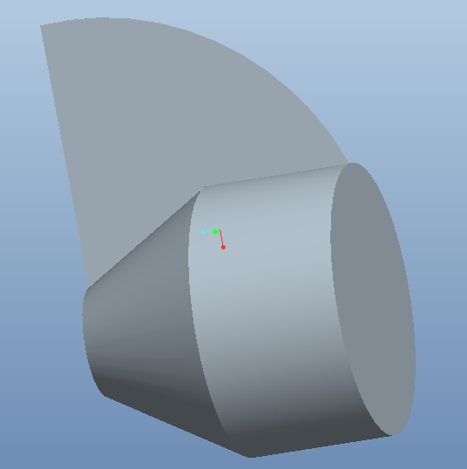

5.2.1.b Internal Duct

5.2.1.c Increase Inlet Area
The inlet area has been increased to the total area of the fan instead of the fan sweep area. Now that a separate internal duct is being used the area of the inlet needs to be increased to insure enough flow into the fan. After discussion with many RC plane enthusiasts it was decided that the inlet area should equal the fan area. From here an ellipse was created with major axis of 2.213 in and a minor axis of 1.106 in. resulting in 7.689 in² as the inlet area.

5.2.1.d Removable End Cap

5.2.1.e Component Arrangement

5.3 Testing

5.3.1 Static Thrust Test
Thrust
The group measured the static thrust to be 1.6 kg. The manufacturer claimed a maximum thrust of 2.2 kg, but did not specify if this was static or during flight. The stand the group made to test the fan may have restricted the air flow into the fan, resulting in the smaller thrust. Another possibility is that the fan was not warmed up and was therefore not performing at maximum specifications. Calculations in Appendix

5.3.2 Wind Tunnel

6.0 Manufacturing Analysis Plan
An important aspect to address is the manufacturing of the fuselage. Although the design might seem like a good idea, we must prove the manufacturability and affordability. Our team has been working closely with HPMI to come up with the best manufacturing plan for our fuselage. The mold for our fuselage will be provided by our sponsor. Below is a description of our mold design, details on the vacuum bagging process, and an overall cost analysis for the manufacturing of 3 fuselages. The calculations for the amount of material and individual cost of each fuselage can be found in Appendix A.3.

6.1 Mold Design

6.2 Vacuum Bagging Process
The manufacturing process we will be using to manufacture the three fuselage designs is the vacuum bagging process. Vacuum Bagging is widely used in the composites industry and is considered to be very common due to its relatively low cost. The materials we will be using for this manufacturing process are the following: Spray Adhesive, Carbon Fiber Fabric, Epoxy Resin, Peel Ply, Breather Cloth, Flow Media, Sealant Tape, Nylon Bagging Film, and Vacuum Tubes. The following is a detailed step by step process for manufacturing each fuselage follow by Figure 7, a flow chart to better illustrate the process.
Steps of Vacuum Bagging Process:
- Prepare materials needed for the manufacturing process.
  - Cut the carbon fiber fabric. (4 layers of 4.69 sq ft. each)
  - Cut the peel ply, flow media, and breather cloth. (1 layer each)
  - Cut the nylon bagging film. (8.67 sq ft. needed)
  - Prepared the required amount of epoxy resin.
- Apply the appropriate mold release.
- Releasing agent is sprayed on surface to ensure the material does not stick.
- Apply sealant tape to the mold perimeter using strong pressure and overlap the edges to avoid the possibility of gaps.
- Place the carbon fiber fabric in position in the mold.
- Place one layer of the peel ply.
- Place one layer of the flow media.
- Place one layer of the breather cloth.
- Place the vacuum tube in desired location.
- Place the vacuum bag over the mold and seal it to the mold’s perimeter.
  - Press the edge of the bag firmly onto the sealant tape while pulling the bag tightly in order to avoid wrinkles.
  - Make sure the vacuum tube is then properly sealed and properly attached to system in order to establish proper flow.
- Turn the vacuum pump on and begin evacuating air from the bag.
- Allow for pressure to build up and observe for any leaks.
- After the laminate has cured thoroughly, remove the vacuum bag, breather cloth, flow media, and peel ply.
- Separate the laminate from the mold.

Figure 7: Manufacturing Flow Chart

6.3 Manufacturing Cost
We will be manufacturing three different fuselage designs at the HPMI building. The process we chose for manufacturing these parts is called Vacuum Bagging or Vacuum Infusion. Vacuum Bagging is basically a clamping method which uses atmospheric pressure to hold resin coated components in the lamination until the adhesive cures.[2] The materials needed for this manufacturing process are the following: Spray Adhesive, Carbon Fiber Fabric, Epoxy Resin, Peel Ply, Breather Cloth, Flow Media, Sealant Tape, Nylon Bagging Film, and Vacuum Tubes. We have researched numerous sources online and found relatively low prices for these materials. Also, we will not be building the molds needed for the vacuum bagging process. We will provide our sponsor with the design specifications for the fuselages and he will then build the mold himself. The materials seen in Figure 8 through Figure 16 can be purchased from either Fibre Glast Developments Corporation (www.fibreglast.com) or US Composites (www.shopmaninc.com).
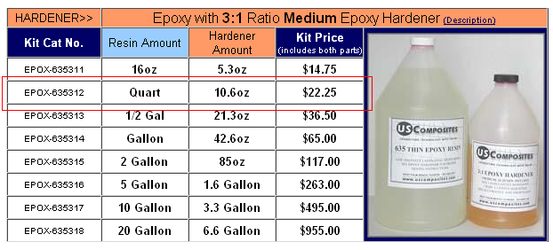
Figure 8: Epoxy Resin
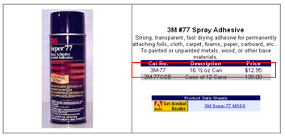
Figure 9: Spray Adhesive
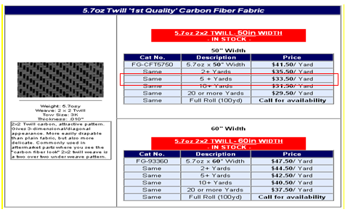
Figure 10: Carbon Fiber Fabric
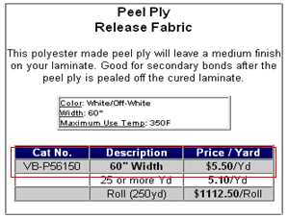
Figure 11: Peel Ply
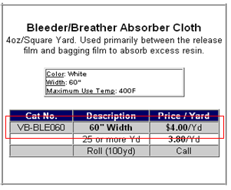
Figure 12: Breather Cloth
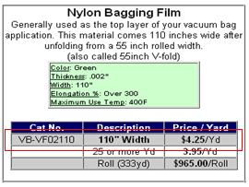
Figure 13: Nylon Bagging Film
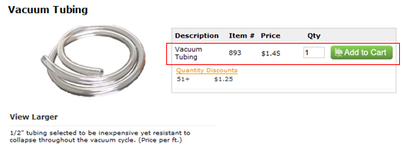
Figure 14: Vacuum Tubing
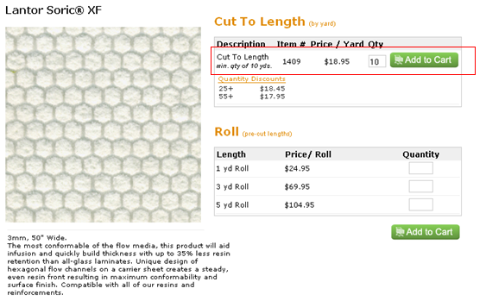
Figure 15: Flow Media
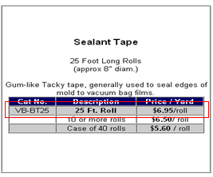
Figure 16: Sealant Tape

Table 2: Cost of Materials to Manufacture 3 Fuselages
Materials |  | Cost ($)
Carbon Fiber | 6 yards | 301.50
Resin | 1 quart | 22.25
Spray Adhesive | 1 can | 12.95
Peel Ply | 2 yards | 22.00
Breather Cloth | 2 yards | 16.00
Flow Media | 2 yards | 75.80
Nylon Bagging Film | 2 yards | 17.00
Vacuum Tubing | 6 ft | 4.35
Yellow Sealant Tape | 2 rolls | 27.80
 | TOTAL | 499.65

After calculating the right amount of materials needed to manufacture all the fuselages we computed the total material cost to be $499.65, seen in Table 2. The total manufacturing cost for the short duct fuselage is $137.67 and the total cost for the long duct fuselage is $141.03. The total cost for all three fuselages will be $419.73. As stated before, all the manufacturing costs can be seen in depth in Appendix A.4.

7.0 Total Weight and Cost Analysis
Similar to all projects, it is critical to stay within our budget. Our allocated budget is $2000, and thus far we are within budget. The breakdown below in Table 3 is the expected total cost. The only money spent thus far is on the components. As for the manufacturing cost, we were kindly offered help from HPMI. They will be covering the cost of the materials needed for the manufacturing of the 3 fuselages. Although this means we would still be within budget, it only leaves us with about $894.12 for the parts of the MAV that have still not been determined, such as the fasteners.
Table 3: Total Cost
Component | Cost ($)
EDF | 129.95
Battery | 509.99
Battery Charger | 109.98
Woodworks LipoSack (Storage) | 34.99
ESC | 120.00
Transmitter/Receiver | 179.97
Industrial Strength Velcro | 7.00
Connection Wires | 14.00
TOTAL | $1105.88

In the Analyze Phase, it is also critical to set-up a future data analysis plan where the data analyzed in the analyze phase could be used to create a decision matrix and be able to identify the best design. Once we have manufactured all three fuselages, we need to test their effectiveness and choose the final best design. In order to test their effectiveness, we decided to use a decision matrix. This decision matrix will include fuselage weight, efficiency, and velocity. The weight will be obtained using a scale. While the efficiency, will be measured using the wind tunnel. The fuselage will be set-up with all the components on a stand and left to run until the battery dies. The longer the fuselage can run the better the efficiency. And lastly, measurements of the velocity will also be obtained in the wind tunnel. A pitot-static tube will be used to compare pressures in the fuselage and obtain the velocity. Once all three measurements are obtained for the three fuselages, a decision matrix will be created where the fuselage with the highest score will be chosen as the best design. This analysis will be done in the following weeks followed by constructing the decision matrix which will identify which fuselage design is the most efficient.

8.0 Conclusion
Through the collection of Brewer’s MAV data, the design of experiment and the in depth manufacturing cost analysis, we developed a useful baseline for the entire project. The three final designs of our fuselage, we believe, effectively integrate the use of an electric ducted fan in the MAV. During our Measure Phase, we took several approaches to indentify critical measurements in the designs, in order serve as a basis in the Analyze Phase where we will be able to take further measurements once the fuselages are manufactured and prove the true efficiency of our fuselage.
Brewer’s MAV data serves as a comparison factor when analyzing the overall improvement of our final MAV design. Although his fuselage specifications were significantly smaller and his use of a propeller is not directly related to our project, in our Analyze Phase, we will be able to create a ratio to compare his data with our data of the three fuselage designs.
Initially we were asked to design three fuselages, but when we came across the idea of using design of experiments we realized we would need 2 variables. In order to account for the second variable, against our ME counter parts advice, we decided to include a fourth design that would use a short rod when the inlet was close to the fan. Our ME counterparts, believed the short rod design would be a failure and should not even be analyzed. For the purpose of our analysis we decided to include the fourth design and reached the conclusion that they were correct. The short rod design was producing the worst data. The design of experiments led us to conclude that the design that has the shortest distance between the inlet and the EDF will yield a larger velocity after the fan and the use of a rod will be unnecessary. Lastly, the manufacturing cost analysis provided us with an overall cost analysis for the project, and showed that we are within our allocated budget.

9.0 Acknowledgements
We would like to acknowledge John Brewer, our sponsor at Eglin Air Force Base, for his patience and advice while mentoring us throughout the project. We would also like to acknowledge Dr. Okenwa Okoli, Dr. Hovsapian, Dr. Kosaraju and the TAs for providing aid whenever we needed it. Dr. Englander and Dr. Ahmed also contributed much in guiding the team in the right direction and played a significant role in our progress.

10.0 References
- "76mm Aluminum Alloy Electric Ducted Fan." Nitro RC Planes, Inc. 2010. Web. 05 Oct. 2010. <http://www.nitroplanes.com/lealalel76du.html>.
- Brewer, John, Brandon Beir, and Damel Brown. Eglin AFB Composite Manufacturing. Tech. Print.
- Brewer, John. “MAV Specifications.” Personal Interview. 23 September 2010.
- Çengel, Yunus A., and Robert H. Turner. Fundamentals of Thermal-fluid Sciences. 3rd ed. Boston: McGraw-Hill, 2001. Print.
- Draganfly Innovations Inc. RCToys.com Sells RC Airplanes RC Blimps RC Helicopters & Parts. 2008. Web. 07 Oct. 2010. <http://www.rctoys.com/pr/category/rc-information/rc-hobby-parts-component-info/>.
- "Electric Ducted Fan Jet." RC Hobby Universe Guide to RC Airplanes, Helicopters, Boats, Cars and Trucks! 2006. Web. 07 Oct. 2010. <http://www.rc-hobby-universe.com/electric-ducted-fan-jet.html>.
- “Fibre Glast Developments.” 10 October 2010. <http://www.fibreglast.com/contentpages-molding+fibreglass-171.htm>.
- Fouquet, Chris “Vacuum Bagging” (21 September 1996). 10 October 2010. <http://www.pilotsguide.com/rc/vacbag.shtml>.
- “Integrating GPS with MAVs.”<http://www.mil.ufl.edu/~number9/mav/>.
- Marc De Piolenc, F. "Ducted Fan Design, Volume 1 (Revised)." Google Books. Web. 29 Nov. 2010. <http://books.google.com/books?id=YcAjcSSP4HMC&printsec=frontcover&dq=Ducted Fan Design Volume 1&source=bl&ots=WtfDi_ZHQZ&sig=4G6VIAKC63HnIZLlQMLFf56LTZ0&hl=en&ei=nYnoTID_GMP6lwewtLGcCw&sa=X&oi=book_result&ct=result&resnum=9&ved=0CEYQ6AEwCA#v=onepage&q=efficiency&f=false>.
- “RC Hobby Universe.”< http://www.rc-hobby universe.com/electric-ducted-fan-jet.html>.
- "US Composites." Fiberglass , Epoxy , Composites, Carbon Fiber - U.S. Composites, Inc. 2010. Web. 30 Nov. 2010. <http://www.shopmaninc.com/>.

Appendix A

A.1 Pro-E Drawings
Fixed Factors:
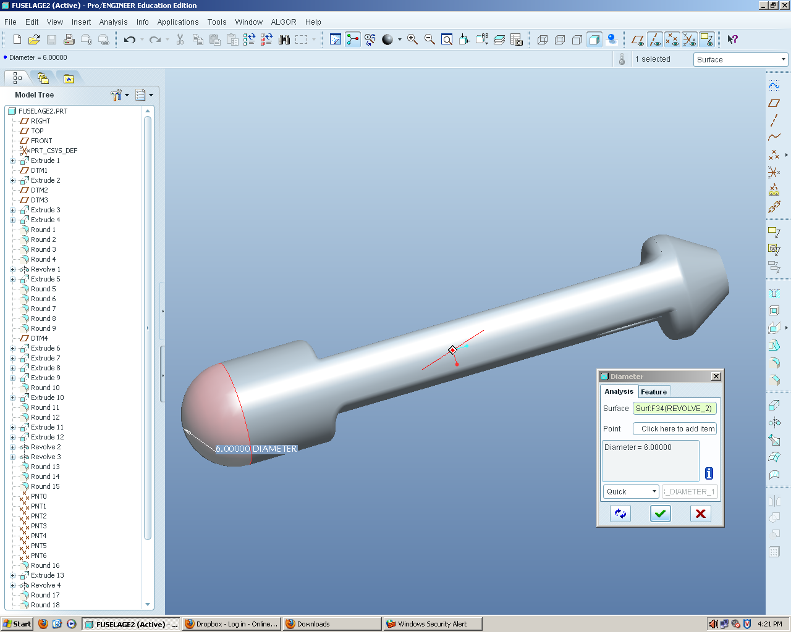
Figure 17: Diameter
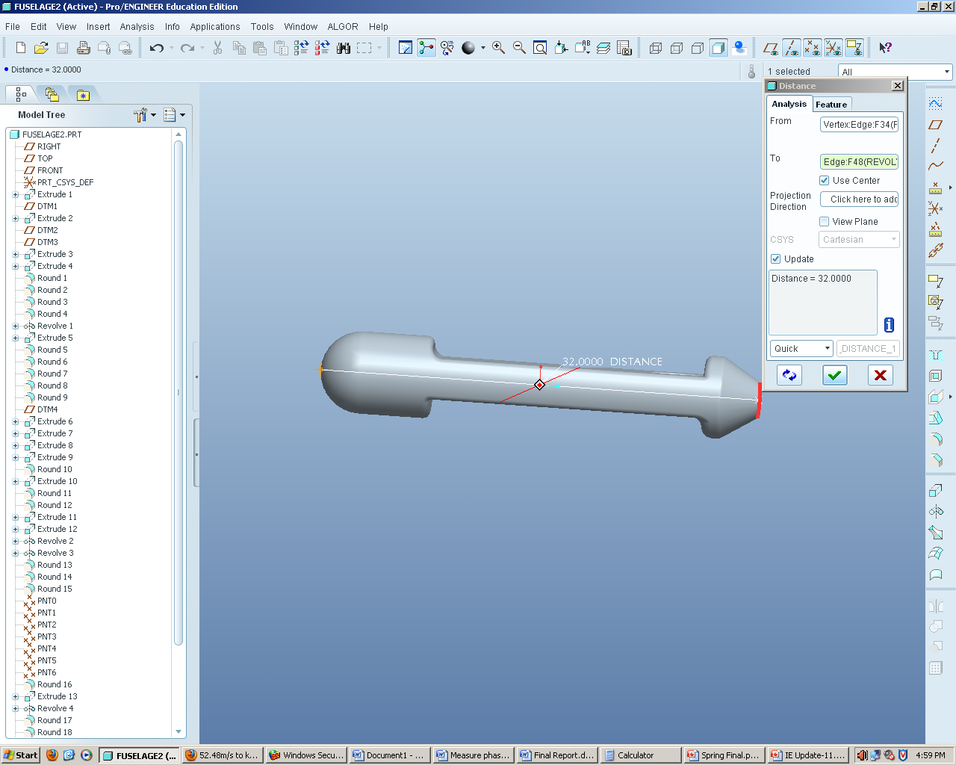
Figure 18: Length
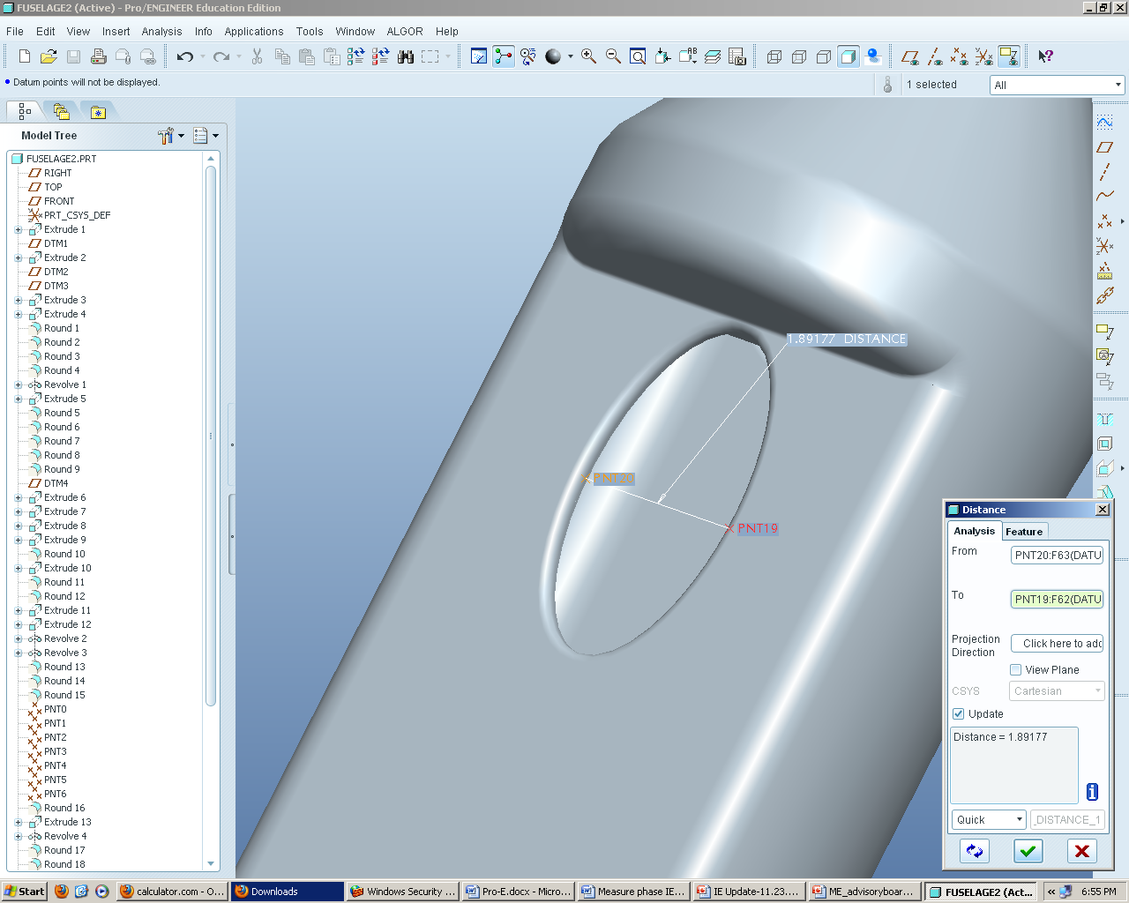
Figure 19: Inlet- Minor Axis
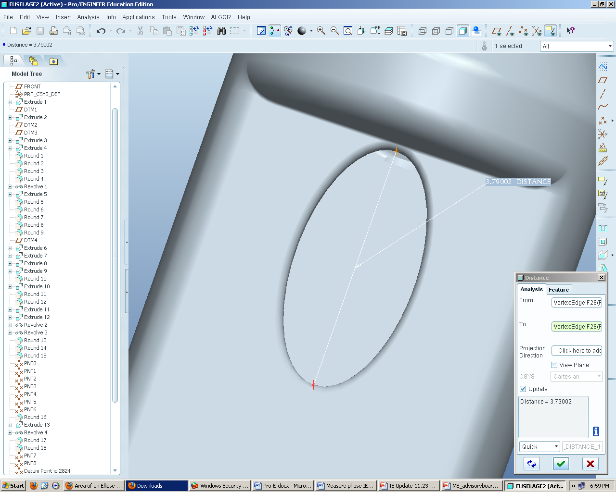
Figure 20: Inlet Major Axis
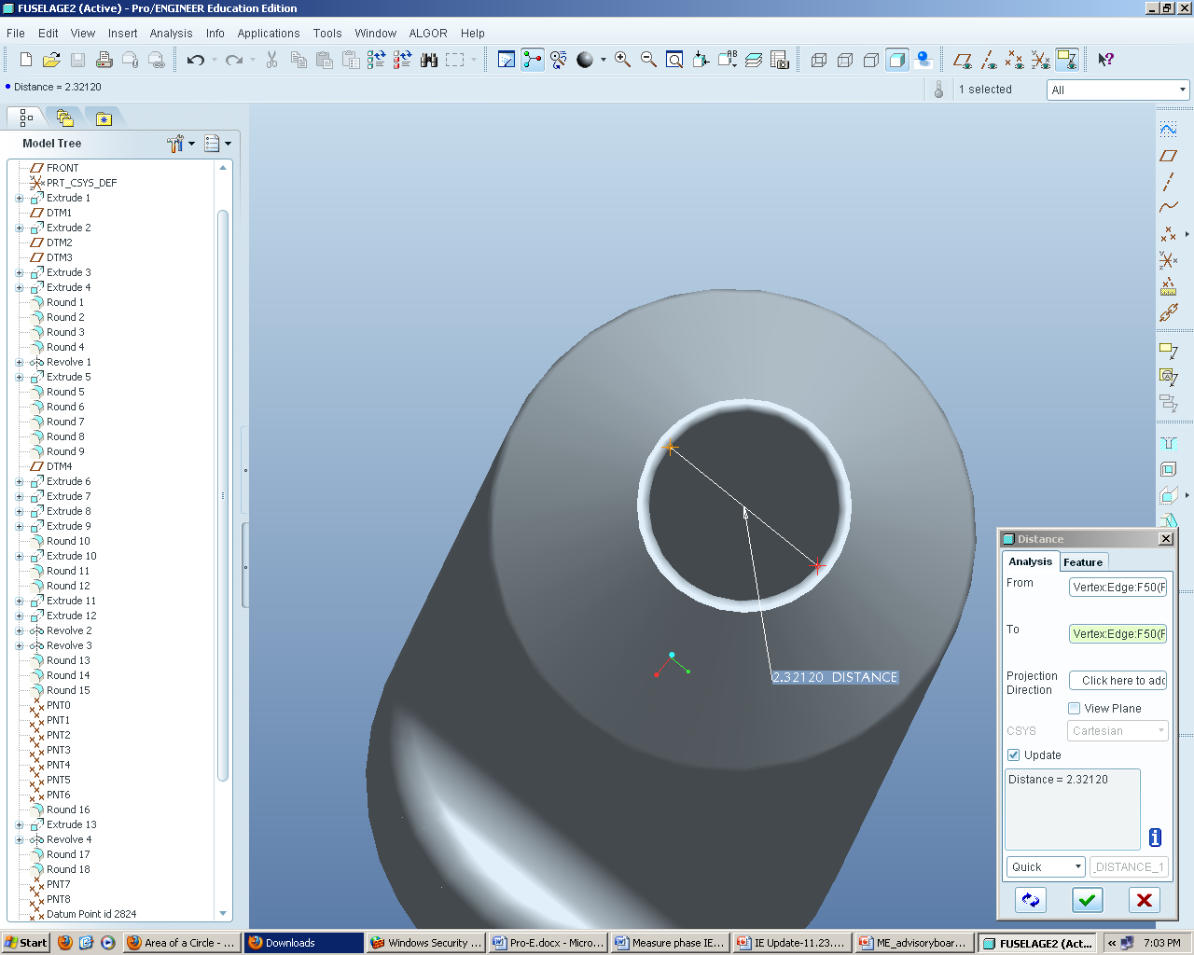
Figure 21: Exit Area
Figure 22: Design 1
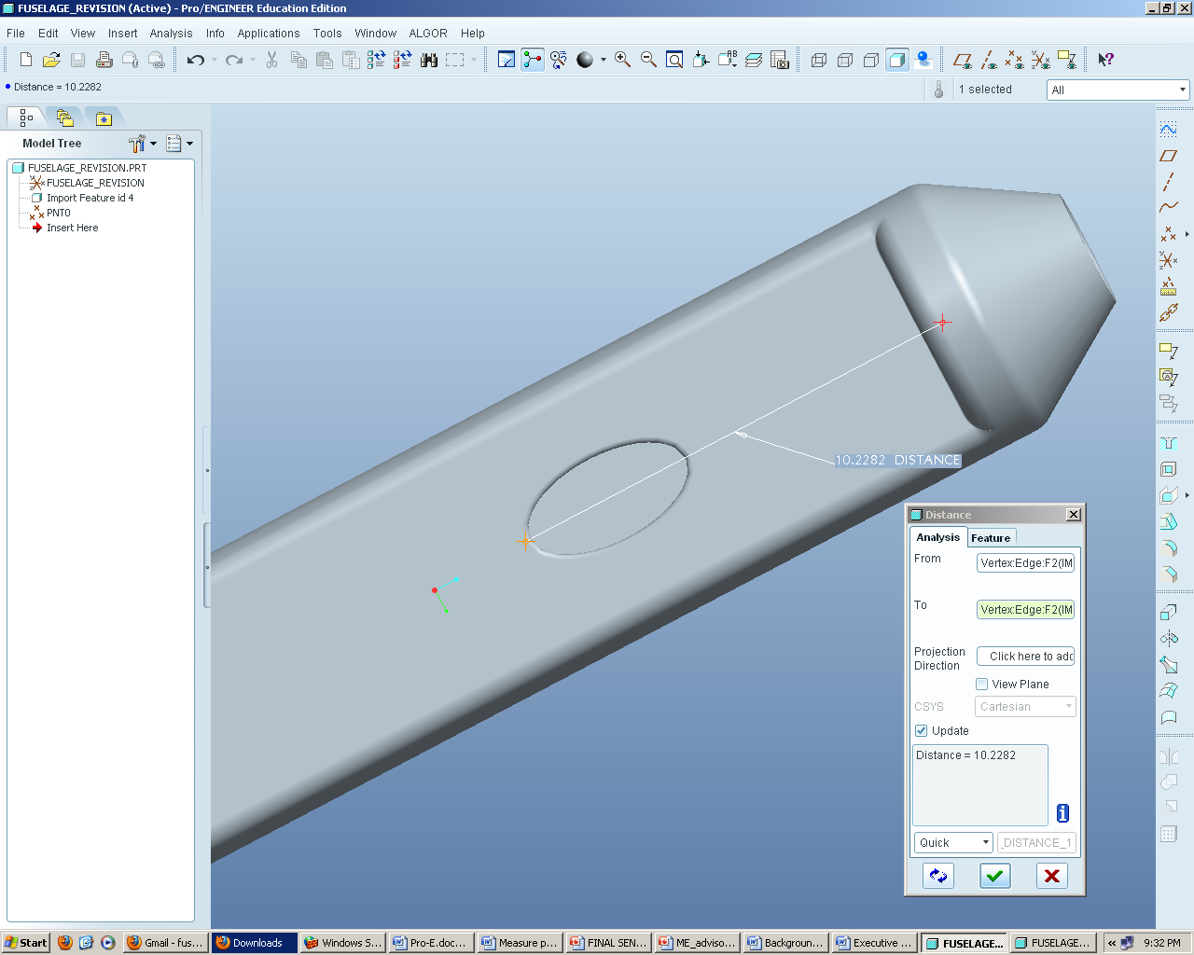
Figure 23: Design 1- Inlet Distance
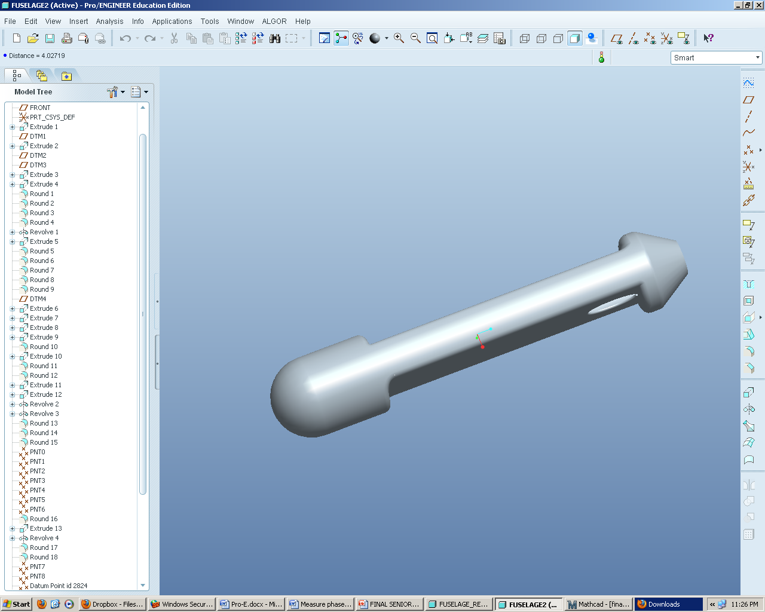
Figure 24: Design 2
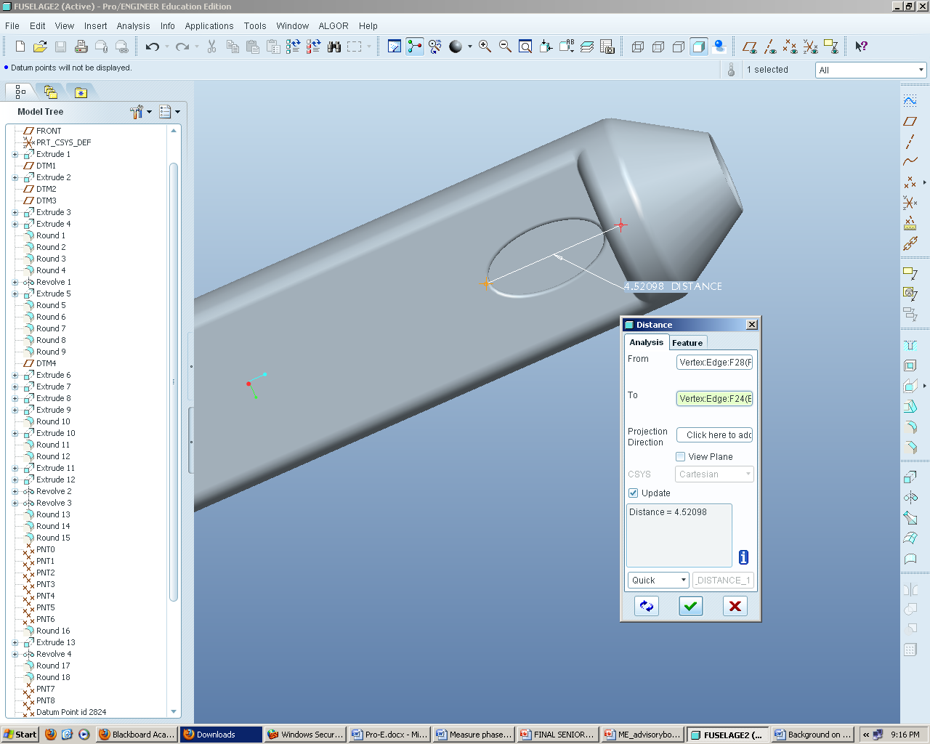
Figure 25: Design 2- Inlet Distance

A.2 COMSOL Results

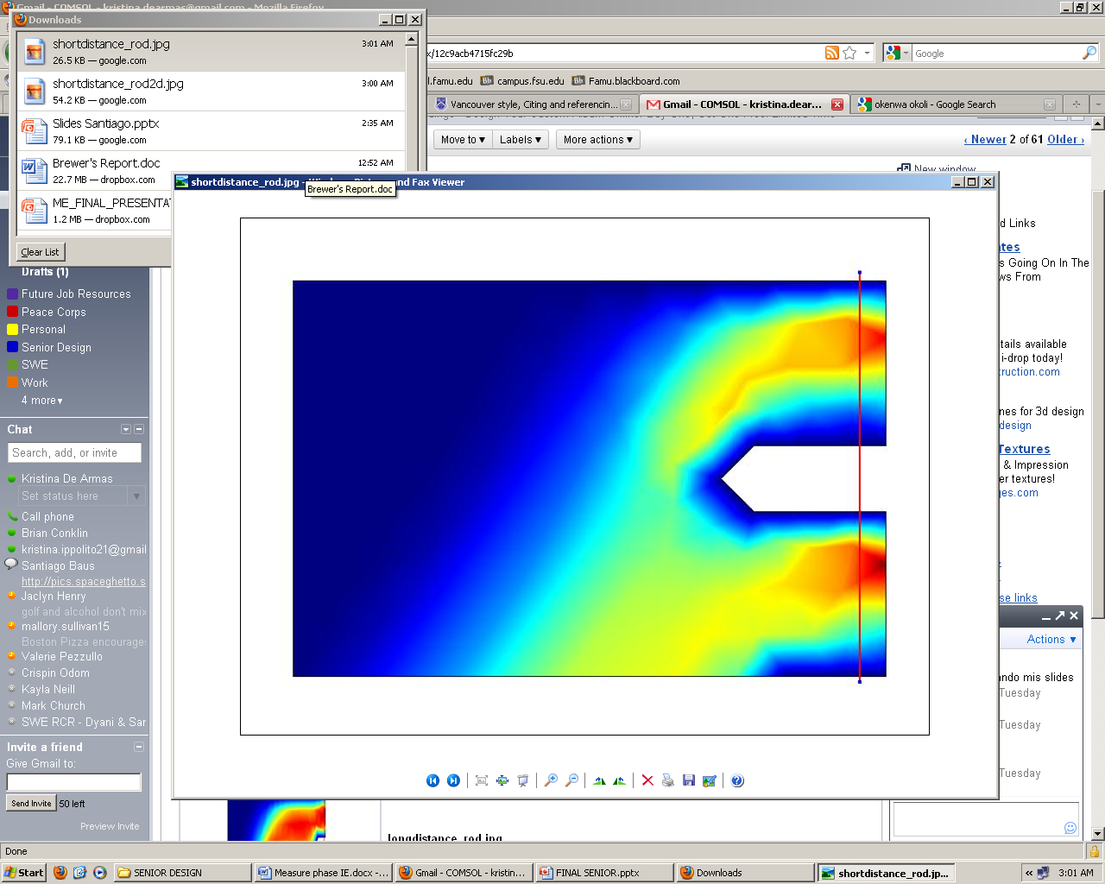
Figure 26: Short Rod COMSOL Representation of Flow
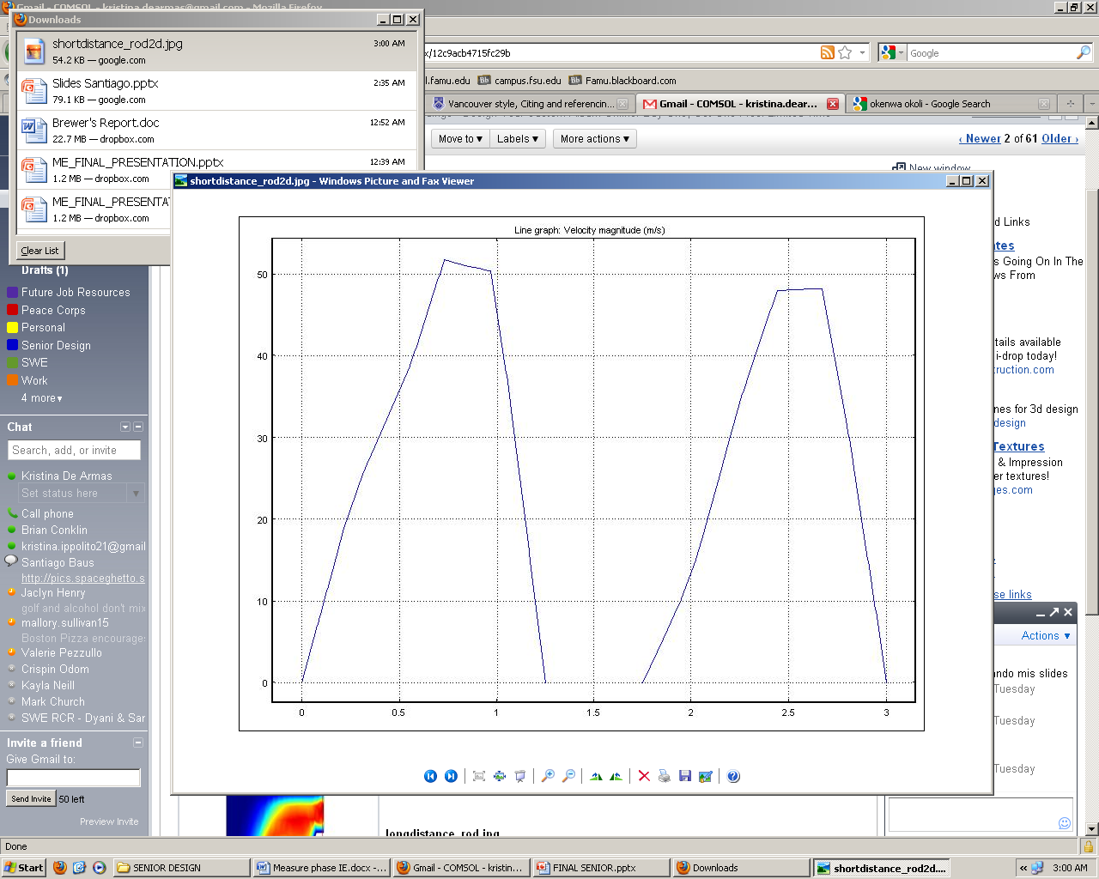
Figure 27: Short Rod Velocity Profile

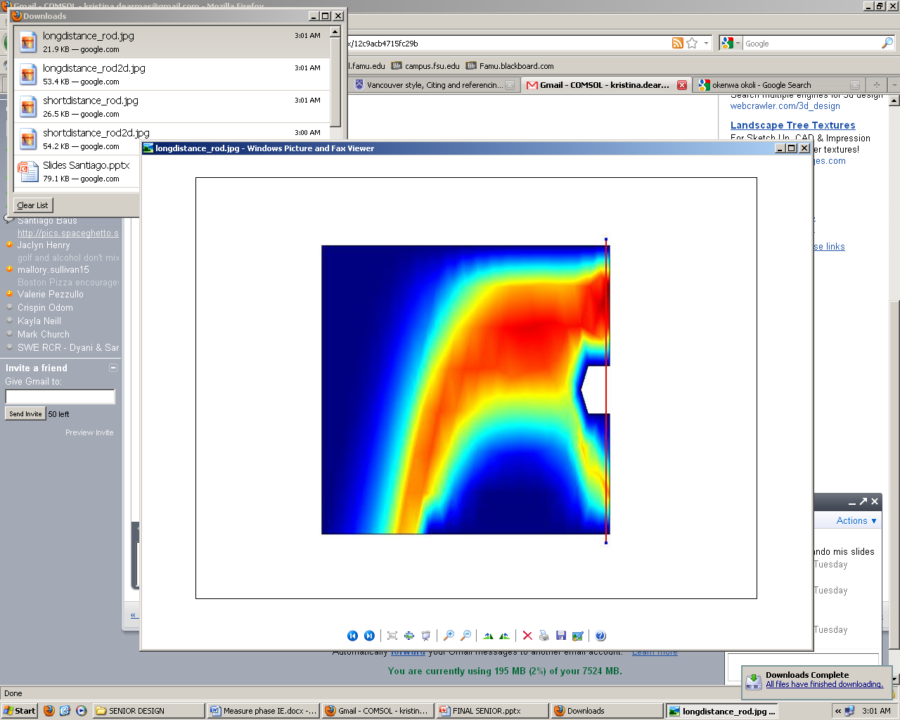
Figure 28: Long Rod COMSOL Representation of Flow

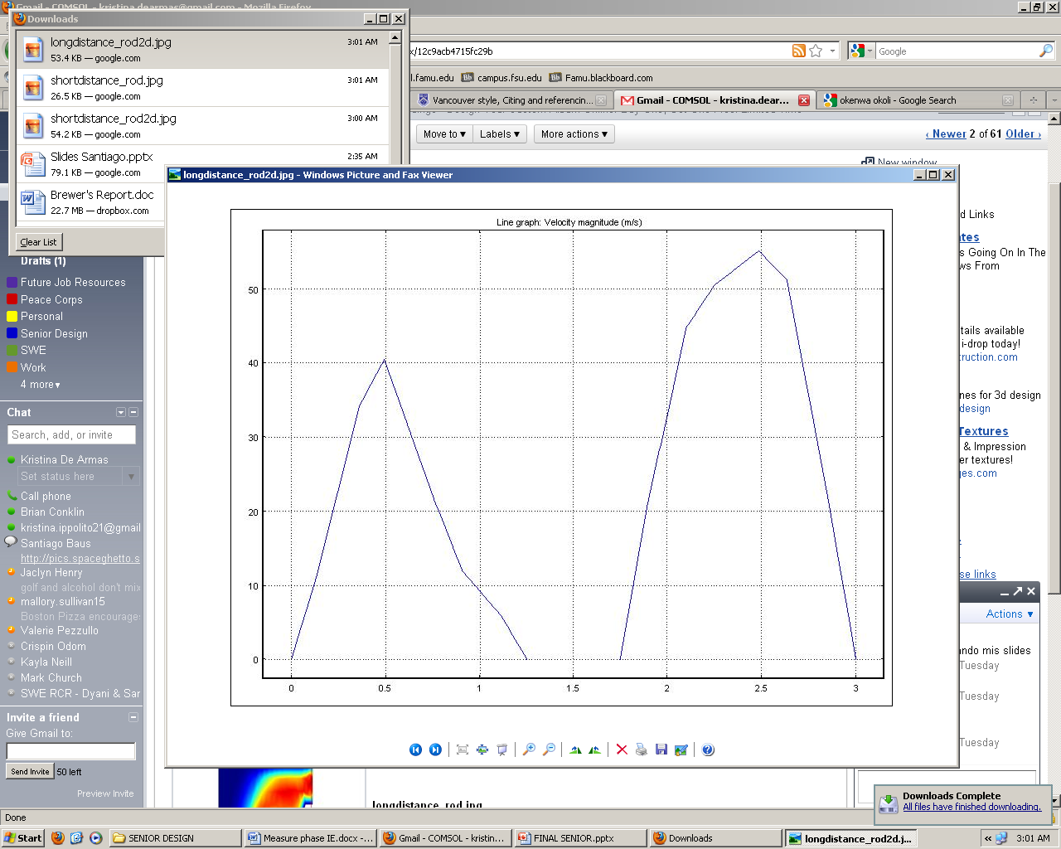
Figure 29: LongRod Velocity Profile

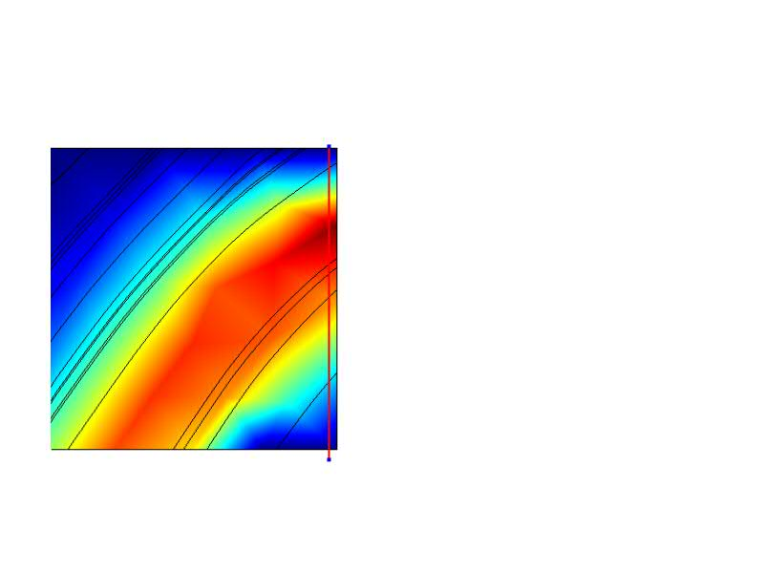
Figure 30: Hole Close to Fan COMSOL Representation of Flow

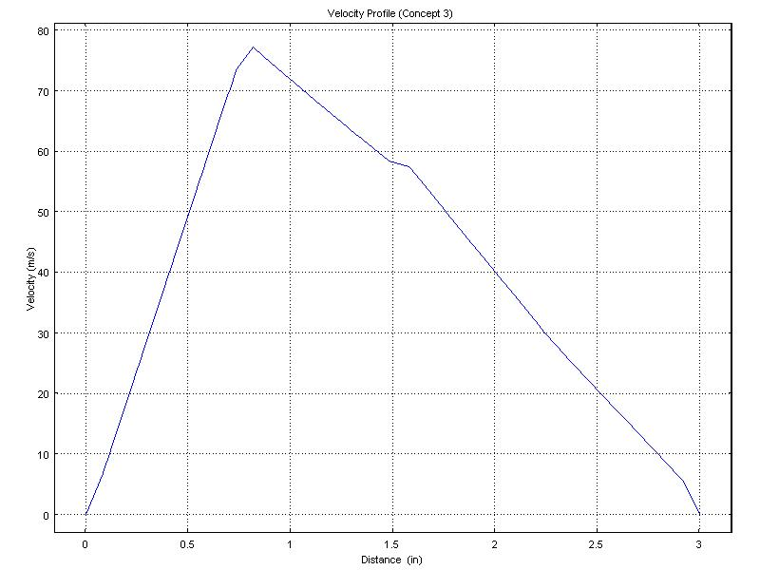
Figure 31: Hole Close to Fan Velocity Profile
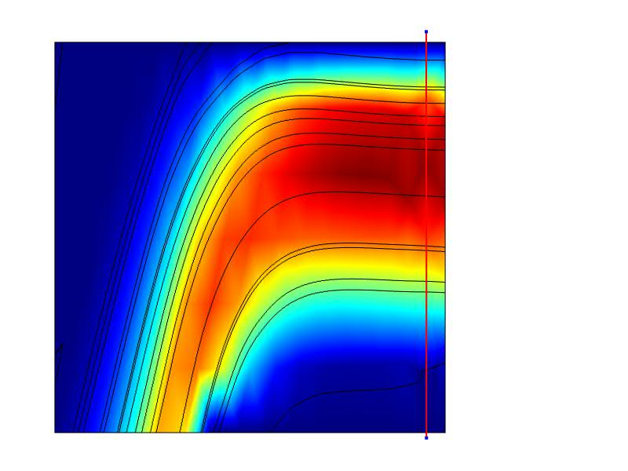
Figure 32: Hole Farther Away From Fan COMSOL Representation of Flow
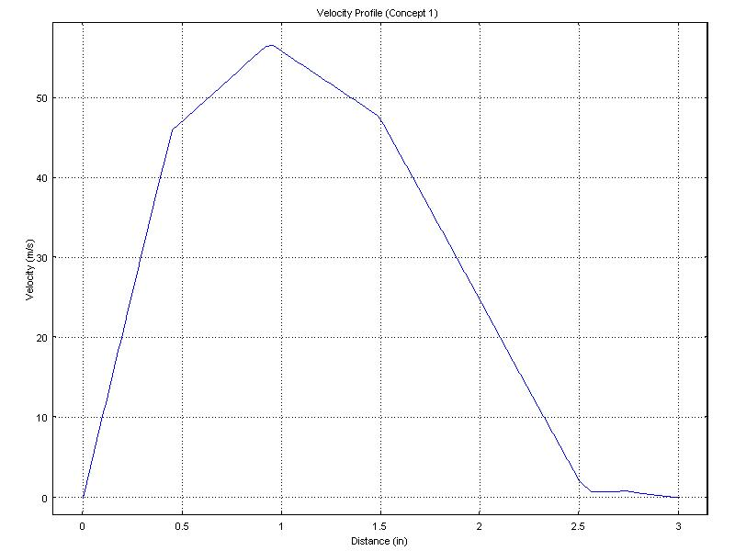
Figure 33:Hole Farther Away From Fan Velocity Profile

A.3 Design of Experiments Table

Table 4: DOE Results
I | X1 | X2 | Data | X1,X2
1 | -1 | -1 | 78.59 | 1
1 | 1 | -1 | 57.18 | -1
1 | -1 | 1 | 62.08 | -1
1 | 1 | 1 | 56.93 | 1
Contrast | -26.56 | -16.76 | 16.26
Beta | -6.64 | -4.19 | 4.065
Test Stat | -0.3252 | -0.20521 | 0.199086

A.4 Manufacturing Costs
Resin price per pound
Resin: $\frac{\$22.25 dollars}{quart} *$ $\frac{4 quarts}{1 gallon}*$ $\frac{1 gallon}{9.19 lbs}$→ $\frac{\$9.68 dollars}{lb}$
Carbon Fiber price per square ft.
Carbon Fiber (CF): $\frac{\$33.50 dollars}{1 yd. *{50}^{''}width}$ → $\frac{\$2.68 dollars}{sq ft}$
Peel Ply price per square ft.
Peel Ply (PP): $\frac{\$5.50 dollars}{1 yd*60" width}$ → $\frac{\$0.37 dollars}{sq ft}$
Flow Media price per square ft.
Flow Media (FM): $\frac{\$18.95 dollars}{1 yd*50" width}$ → $\frac{\$1.52 dollars}{sq ft}$
Yellow Sealant Tape price per roll
Tape: $\frac{\$6.95 dollars}{25 ft roll}$ → $\frac{\$0.28 dollars}{ft}$
Nylon Bagging Film price per square ft.
Vacuum Bag: $\frac{\$4.25 dollars}{1 yd*110" width}$ → $\frac{\$0.15 dollars}{sq ft}$
Breather Cloth price per square ft.
Breather Cloth (BC): $\frac{\$4.00 dollars}{1 yd*60" width}$ → $\frac{\$0.27 dollars}{sq ft}$
Vacuum Tubing price per ft.
Tube: $\frac{\$1.45 dollars}{ft}$
Fuselage:
Surface Area = 2$πr^{2}+ 2πrh$
= 659.734 ${in}^{2}$
Volume = Surface Area * Thickness of Carbon Fiber
= 659.734 ${in}^{2}$ * 0.01 $in$
= 6.59734 ${in}^{3}$
Total Surface Area = 659.734${ in}^{2}$ → 4.581 sq ft
Half Surface Area (HSA) = 2.29 sq ft

Surface Area of Material Used:
Dimensions of layer used for Fuselage (LF): 35 in x 12 in → 420 $in^{2}$→ 2.92 sq ft.
Dimensions of layer used for Long Duct (LLD): 10 in x 8 in → 80 $in^{2}$→ 0.5556 sq ft.
Dimensions of layer used for Short Duct (LSD): 8 in x 6 in → 48 $in^{2}$→ 0.3333 sq ft.
Dimensions of layer used for Tail (LT); 5 in x 5 in → 25 $in^{2}$ → 0.174 sq ft.
Dimensions of layer used for End Cap (EC); 7 in x 7 in → 49 $in^{2}$ → 0.340 sq ft.

Quantity of Materials Needed:
Resin = 6.59734 ${in}^{3}$→ .010499 lbs per fuselage
Resin (LD) = 1.64934 ${in}^{3}$→ .002625 lbs
Resin (SD) = 1.64934 ${in}^{3}$→ .002625 lbs
Resin (EC) = 1.64934 ${in}^{3}$→ .002625 lbs
Resin (Tail) = 0.82467 ${in}^{3}$→ .001313 lbs

Vacuum Bag = (52 in *24 in) → 8.67 sq ft
Vacuum Bag (LD) = (15 in *15in) → 1.56 sq ft
Vacuum Bag (SD) = (15 in *15in) → 1.56 sq ft
Vacuum Bag (EC) = (7 in *7 in) → 0.34 sq ft
Vacuum Bag (Tail) = (10 in *10in) → 0.69 sq ft

Tape = (2 *52 in + 2 * 24 in) → 152 in → 12.67 ft
Tape (LD) = (2 *15 in + 2 * 15 in) → 60 in → 5 ft
Tape (SD) = (2 *15 in + 2 * 15 in) → 60 in → 5 ft
Tape (EC) = (2 *7 in + 2 * 7 in) → 28 in → 2.33 ft
Tape (Tail) = (2 *5 in + 2 * 5 in) → 20 in → 1.67 ft

Tube = 3 ft
CF = 2.92 sq ft (4 layers)
CF (LD) = 0.556 sq ft (2 layers)
CF (SD) = 0.333 sq ft (2 layers)
CF (EC) = 0.340 sq ft (4 layers)
CF (Tail) = 0.174 sq ft (4 layers)

PP = 2.92 sq ft (1 layer)
PP (LD) = 0.556 sq ft (1 layer)
PP (SD) = 0.333 sq ft (1 layer)
PP (EC) = 0.340 sq ft (1 layer)
PP (Tail) = 0.174 sq ft (1 layer)

BC = 2.92 sq ft (1 layer)
BC (LD) = 0.556 sq ft (1 layer)
BC (SD) = 0.333 sq ft (1 layer)
BC (EC) = 0.340 sq ft (1 layer)
BC (Tail) = 0.174 sq ft (1 layer)

FM = 2.92 sq ft (1 layer)
FM (LD) = 0.556 sq ft (1 layer)
FM (SD) = 0.333 sq ft (1 layer)
FM (EC) = 0.340 sq ft (1 layer)
FM (Tail) = 0.174 sq ft (1 layer)

Total Manufacturing Cost:
End Cap: =$2\left[\left(Resin*.002625 lbs\right)+\left(Vacuum Bag*0.34 sq ft\right)+\left(Tape*2.33 ft\right)+ \left(Tube*3ft\right)+4\left(CF(EC)*EC\right)+\left(PP(EC)*EC\right)+\left(BC(EC)*EC\right)+ (FM(EC)*EC)\right]$
= 2[$9.46]
= $18.92

Long Duct: =$2\left[\left(Resin*.002625 lbs\right)+\left(Vacuum Bag*1.56 sq ft\right)+\left(Tape*5 ft\right)+ \left(Tube*3ft\right)+2\left(CF(LD)*LLD\right)+\left(PP(LD)*LLD\right)+\left(BC(LD)*LLD\right)+ (FM(LD)*LLD)\right]$
= 2[$10.19]
= $20.38
Short Duct: =$2\left[\left(Resin*.002625 lbs\right)+\left(Vacuum Bag*1.56 sq ft\right)+\left(Tape*5 ft\right)+ \left(Tube*3ft\right)+2\left(CF(SD)*LSD\right)+\left(PP(SD)*LSD\right)+\left(BC(SD)*LSD\right)+ (FM(SD)*LSD)\right]$
= 2[$8.51]
= $17.02
Tail: =$\left[\left(Resin*.001313 lbs\right)+\left(Vacuum Bag*0.69 sq ft\right)+\left(Tape*1.67 ft\right)+ \left(Tube*3ft\right)+4\left(CF(Tail)*LT\right)+\left(PP(Tail)*LT\right)+\left(BC(Tail)*LT\right)+ (FM(Tail)*LT)\right]$
= $7.91

Fuselage = $2\left[\left(Resin*.010499 lbs\right)+\left(Vacuum Bag*8.67 sq ft\right)+\left(Tape*12.67 ft\right)+ \left(Tube*3ft\right)+4\left(CF*LF\right)+\left(PP*LF\right)+\left(BC*LF\right)+(FM*LF)\right]$
= 2$\left[\$46.91\right]$
= $93.82 per fuselage
Total Cost of Fuselages:
Long Duct Fuselage: = Fuselage + Long Duct +Tail + End Cap
= $93.82 + $20.38 +$ 7.91 +$18.92
= $141.03
Short Duct Fuselage: = Fuselage + Short Duct +Tail + End Cap
= $93.82 + $17.02 +$ 7.91 + $18.92
= $137.67
Total Cost: = 1*Short Duct Fuselage + 2*Long Duct Fuselage
= $137.67 + 2*$141.03
= $419.73
Total Material Cost:
1. Resin → 1 quart → ($22.25 * 1) → $22.25
2. Spray Adhesive → 1 can → ($12.95 * 1) → $12.95
3. Carbon Fiber → 6 yards → ($33.50 * 9) → $301.50
4. Peel Ply → 2 yards → ($5.50 * 4) → $22.00
5. Breather Cloth → 2 yards → ($4.00 * 4) → $16.00
6. Flow Media → 2 yards → ($18.95 * 4) → $75.80
7. Nylon Bagging Film → 2 yards → ($4.25 * 4) → $17.00
8. Vacuum Tubing → 3 ft → ($1.45 * 3) → $4.35
9. Sealant Tape → 2 rolls → ($6.95 * 4) → $27.80
Total (1-9): $ 499.65

A.5 Calculations
