FAMU-FSU College of Engineering
Department of Electrical and Computer Engineering

EEL4911C – ECE Senior Design Project I

CONCEPTUAL DESIGN REVIEW

Project title: Autonomous Underwater Vehicle “RoboSub”
Team #: 4

Student team members:
− Victoria Jefferson, computer engineering (Email: jeffevi@eng.fsu.edu)
− Andy Jeanthenor, computer engineering (Email: jeantan@eng.fsu.edu)
− Kevin Miles, electrical engineering (Email: mileske@eng.fsu.edu)
− Tadamitsu Byrne, mechanical engineering (Email: byrneta@eng.fsu.edu)
− Reece Spencer, mechanical engineering (Email: spencree@eng.fsu.edu)
− Yanira Torres, mechanical engineering (Email: torreya@eng.fsu.edu)

Senior Design Project Instructor: Dr. Bruce Harvey

Submitted in partial fulfillment of the requirements for
EEL4911C – ECE Senior Design Project I

July 30, 2026

Projective Executive Summary

The Autonomous Underwater Vehicle (AUV), sponsored by the FAMU-FSU College of Engineering to compete in the 14th annual AUV Competition sponsored by the Office of Naval Research (ONR) and the AUVSI organization, is a fully autonomous vehicle that will maneuver in an underwater obstacle course. Competing in the AUVSI competition course requires our vehicle to autonomously execute a sequence of tasks while remaining fully submerged in a seawater environment.
The obstacle course will be in a 16ft deep salt-water pond, located at Camp TRANSDEC in San Diego, California. Vehicles are expected to pass through an underwater gate, follow colored paths, hit two out of three buoys, avoid obstacles, possibly fire projectiles, drop markers into primary and secondary weapons, track an acoustic pinger and finally surface within the designate “octagon” area with a PVC structure then release it. Based on the AUVSI competition rules, the vehicle is allocated a total of fifteen minutes to complete these varies task in the course.
Currently, some of the major components of the AUV have been finalized and are in the progress of getting ordered. The motors/thrusters that were chosen were SeaBotix, for low power consumption. For the AUV structure, 8020 framing will be used because of its ease with adjustability. For navigation and stability control, a 9-Axis inertial measurement unit (Phidget Spatial 3/3/3) will meet the needs for the AUV’s underwater inertial guidance. For underwater vision, 3 web cameras will be used. The top camera, to see the shape that the AUV is rising up in, will be a Unibrain Fire-I digital web camera. The front-positioned camera will be another Unibrain Fire-I digital web camera. The bottom camera will be a Dynex 1.3 mega pixel web camera. For underwater acoustic ability, four SQ-2601 hydrophones will be used and positioned accordingly for maximum sound detection.

The software aspect of the project has made great progress as well. Linux will be the operating system that will be used. Programming language options were narrowed down to C and C++ for readability. The microprocessor for the AUV is the OMAP3530 (on the BeagleBoard), which is in the hands of the computer engineers. The computer engineers are in the process of finalizing all of the cables needed to operate the BeagleBoard at its maximum ability.

For this AUV project, the main objectives are to maneuver underwater autonomously, recognize that there is a task to be done and execute that task. Since this is the first year performing in this competition, quality is better than quantity. Of course to perform autonomously underwater, the AUV is to be built in its completed proposed design, which will be completely waterproof, and programmed to maintain itself. If time permits, tasks will be added to the objectives as well.
Table of Contents
Project Executive Summary……………………………………………………………………………………………………….2
Table of Contents……………………………………………………………………..……………………………………………….3
1 Introduction 5
1.1 Acknowledgements 5
1.2 Problem Statement 5
1.3 Operating Environment 6
1.4 Intended Use(s) and Intended User(s) 6
1.5 Assumptions and Limitations 6
1.5.1 Assumptions 6
1.5.2 Limitations 7
1.6 Expected End Product and Other Deliverables 7
2 Proposed Design 8
2.1 Overview 9
2.2 Major Components of the System 9
2.2.1 Thruster Overview 9
2.2.2 Batteries Overview 10
2.2.3 Sensors 11
2.2.4 Microcontroller 12
2.2.5 Mechanical Grabber 17
2.2.6 Marker Dropper 17
2.2.7 Frame Overview 17
2.2.8 Diagrams 17
2.2.9 Hull 18
2.3 Performance Assessment 18
2.4 Design Process 19
3 Design of Major Components 21
3.1 Batteries 21
3.2 Processor 21
3.3 Hydrophone 22
3.4 Camera 22
3.4.1 Camera Housing 23
3.5 Inertial Measurement Unit 23
3.6 Hull 23
3.6.1 Frame 23
3.7 Thruster 24
3.8 Marker Dropper 24
3.9 Mechanical Grabber 25
4 Schedule 27
4.1 Proposed Schedule 27
4.2 Current Schedule 30
5 Budget Estimate 33
5.1 Proposed Budget 33
5.2 Current Budget 35
5.3 Budget Justification 36
6 Overall Risk Assessment 38
6.1 Technical Risks 38
6.1.1 Leaks 38
6.1.2 Malfunctioning External Components 39
6.1.3 Team Member Loss 42
6.1.4 Rules Change 43
6.1.5 Transportation 44
6.1.6 Technological Issues 44
6.2 Schedule Risks 48
6.2.1 Critical Scheduling Issues 48
6.3 Budget Risks 49
6.3.1 Insufficient Equipment Funds 49
6.3.2 Insufficient Travel Funds 50
6.4 Risk Status 51
7 Conclusion 52
8 References 53
9 Appendices 54

1 Introduction

Acknowledgements
Team 4 would like to thank Northrop Grumman as well as the FAMU/FSU College of Engineering Electrical/Computer and Mechanical Engineering departments for monetary contributions towards the project. The team would also like to thank ARM Holdings for donating a processor and microcontrollers for the automation of the vehicle, and finally we thank Dr. Bruce Harvey of the FAMU/FSU College of Engineering for his guidance and advice. Without these contributions the design and construction of the AUV would not be possible.

Problem Statement
The Association for Unmanned Vehicle Systems International (AUVSI) Foundation and the U.S. Office of Naval Research (ONR) has designed a competition to advance the development of Autonomous Underwater Vehicles (AUVs) by challenging a new generation of engineers to perform realistic missions in an underwater environment. The competition requires the design of a vehicle that operates autonomously in a self-contained unit. The AUV will be deployed in a large salt-water pool at Camp Transdec, CA, which has a maximum depth of 16 feet. The 2011 competition rules have not been released yet; however, based on the rules for 2010 we know that the AUV must not exceed dimensions of 6ft x 3ft x 3ft and that it must weigh less than 110 pounds. The competition generally has several objectives to complete, which usually require an optical sensor, for color and shape recognition, and an acoustic sensor for the identification and location of a pinger.
Mentioned here are the typical obstacles included in the competition and the maximum points awarded from year to year. Passing through a gate (100pts), following the marked path (50pts/segment), maintain fixed heading (150pts), striking a designated target (500-1500pts), dropping markers on designated target (2600pts), surface within designated area (2000pts), surface with rescue object (1000pts), release rescue object (500pts), finish mission early (t[minutes]*100pts).
The AUV will be battery powered and operate using an ARM processor/controller, which will interpret all data collected by the sensors to control the motors and directional heading of the vehicle. It will be designed to be as small as possible to save on weight and spatial dimension so that any last minute changes can be made without worry of disqualification due to physical constraints. Visual sensors will be used for color and shape recognition, which will allow the AUV to complete most of the objectives mentioned above. Acoustic sensors will be utilized to identify and locate an acoustic pinger at the bottom of the pool, which marks the rescue object. A mechanical arm attached to the AUV will provide a means to bring the rescue object to the surface while constraining the object in 3 degrees of freedom. Four thrusters will provide propulsion, two thrusters facing the rear of the AUV will provide lateral and turning movement, and two thrusters located on the front and back of the AUV will provide vertical translational control. The programming language has been narrowed down to either C or C++; both languages will possibly be used and the operating system will be Linux.

Operating Environment
The AUV operating environment will be a salt-water pool at Camp Transdec, California, the maximum depth of the pool is 16 feet and it will be hoisted into the pool and slowly lowered to avoid damage. The AUV will have 15 minutes to complete all tasks mentioned above which traverses a distance of 50 feet. The salinity of the water must be accounted for in the design process in order to establish 0.5% buoyancy and to ensure that all components are corrosion resistant.

Intended Use(s) and Intended User(s)
The AUV is intended to compete in the AUVSI 14th annual competition, which establishes very specific guidelines and will therefore be designed and programmed to operate in a salt-water pool. The vehicle is an example of how robotic submersibles complete tasks in harsh environments and can also be adapted for use in a zero gravity environment. The AUV is to be used only by team 4 and operation requires a push of a button and a pool since the vehicle is autonomous.

Assumptions and Limitations

Assumptions
- The AUV will be completely autonomous
- There will be a clearly identifiable kill switch to shut down the AUV
- The AUV will operate in a salt water pool
- The AUV will be battery powered
- The AUV will detect color, shape, and sound
- The AUV will automatically shut down after 15 minutes
- The AUV will have hoist points so that it can be slug and lowered into the water
- The AUV will have 4 thrusters to provide movement
- The AUV will be able to write to and read from shared memory
- The AUV will have an inertial guidance system to detect changes in orientation or position
- The AUV will have an emergency buoyancy system to float the vehicle to the surface in the event of a systems failure

Limitations
- The AUV will be less than 6ft x 3ft x 3ft in size
- The AUV will be less than 110 pounds
- The AUV has 15 minutes to complete all tasks
- The project budget is $9500
- The vehicle must be operating successfully by the end of the 2011 Spring semester
- The AUV must utilize a ARM processor/controller
- The markers on the AUV will not exceed 6.0in x 0.5in x 0.5 in
- The battery will not have an open source voltage exceeding 60VDC

Expected End Product and Other Deliverables
The end product is a vehicle that is fully autonomous and submersible that can complete all objectives outlined in the AUVSI competition rules and mission. Team 4 will provide an AUV that is compact, lightweight, and competitive. The product will require no input from the user to function properly, but it must be placed in an aquatic environment. A team journal paper is required with the submission of the AUV, which will highlight the mechanical, electrical, and computer systems, all hardware and software utilized, and the testing procedures of the final product. The final product will be available at the end of the Spring 2011 semester with minor adjustments and debugging continuing up to the competition day, which is July 12th, 2011.

Proposed Design
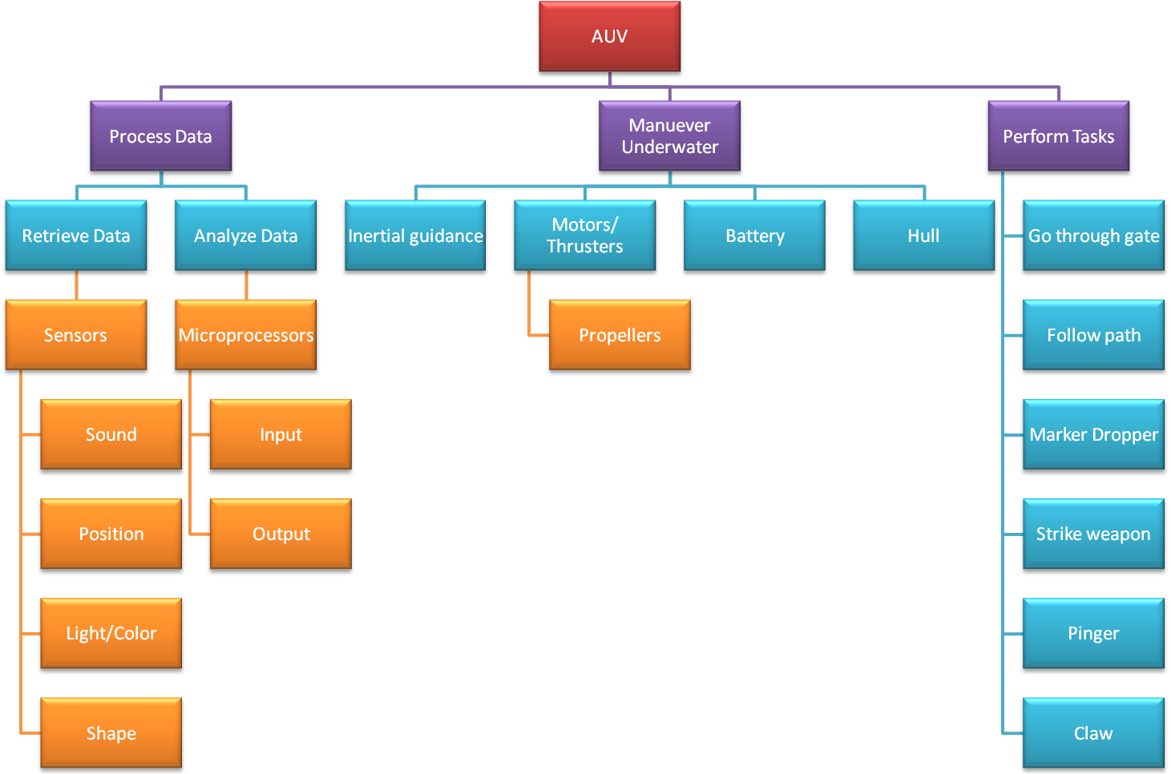

Overview
The design of the Autonomous Underwater Vehicle is a submarine with a few additions to complete the task required for the competition. The hull will be constructed of 80/20 framing and will somewhat resemble a rectangular box, except that the body will be filled with water. The design is not to exceed 6’ x 3’ x 3’. The electronics will be housed in a watertight pelican case, which will be seated inside of the hull.
Maneuver under water
Motors/Thrusters
Batteries
Hull
Propellers
Inertial guidance

Major Components of the System

Thruster Overview
There will be a total of four thrusters, all Seabotix SBT 150. These motors are engineered with additional components, which have made them an excellent choice for the AUVSI team. The motors come with attached propulsion fan blades, as well as a motor controller, which fits into the cylindrical hull of each unit. Each motor weighs approximately 1.5 lbs (686 grams) when dry and -0.866 lbs in fresh water. Each motor will be connected with an in-line 6A max barrel fuse, as well as a 10A rated diode (diode chosen for availability) to prevent back EMFs from the motor.

Thruster Motor Controller
The SBT 150 comes with motor controllers already connected with the internal motor. The controllers call for a nominal voltage of 28V DC. However, the motors will run with as low as a 20V input into the controllers. The motor controllers have built in voltage regulators, which give an actual supply voltage of 19.1V DC to the internal motor. When the motor controller receives less than 20V DC, or greater than 30.1V DC, it will shut itself off automatically to preserve the integrity of the motor. The wiring configuration for the motor controller calls for Vcc, GND, Data, and Clock. The VCC and GND will utilize a 14-gauge AWG wire, while the data and clock inputs will have no larger than a 18-gauge AWG wire.

Thruster Power Consumption
The max amperage consumption is 5.8A (30 second duration) as well as max continuous amperage consumption of 4.25A. The maximum power consumed by each motor is 150W. The motor is capable of handling higher currents of up to 6A, but will drastically shorten the life of the thruster when ran continuously in this mode. High current burst of less than 1 minute may be used, provided that the running average current is kept at 4A MAX. This will prevent the windings of the motor from building excessive heat. All of these numbers are given with a 10% tolerance on the motor specifications sheet and all data listed above is per motor.

Thruster Placement
Since the hull will be filled with water, the AUVSI team will have 4 motors with attached thrusters to control the direction and depth of the submarine. A thruster will be located on the left and right side of the submarine to control the turning as well as forward and reverse propulsion. Additionally, there will be two thrusters on the bottom of the unit, one on the front as well as one on the back. These are placed as such to alienate problems in the weight distribution of the vehicle.

Batteries Overview
Many batteries were considered for the design, but due to the extra weight it was decided that the lithium-ion would be the ideal candidate for the job. There will be two power units on board the AUV to power its components. One main power supply will be used for the thrusters, while another will power all other components on board. These batteries will be rechargeable and have a capacity to run the system for at least complete hour.

Thruster Batteries
The batteries chosen for the thrusters are custom Lithium Ion batteries. Two 14.8V DC batteries will be placed in series to combine for 29.6V DC working voltage. The batteries come with a build in protection circuit module maintains a voltage of between 20.8V and 33.6V. Anything outside of this range and the battery will be disconnected from any circuit. The PCM also protects from over drain of anything greater than 40A, however that is unlikely to come in to play. The chosen battery may be found on batteryspace.com and is product ID # 5237. The charger for each battery takes 10.1 hours for a full recharge. Lastly, the team must wait 30 minutes after charging the battery to use while the PCB evenly distributes the cells inside the battery.

Components Battery
The rest of the components on board will be powered with a 7.4V Lithium-ion battery, connected to a 5V regulator. The battery itself will have a 6AH span with a maximum discharge rate of up to 7A. Because all components selected run off of standard USB 2.0 power, the system is such forth simplified and all components will be connected in parallel to the battery itself. The battery requires 2.1 hours for a full recharge. All components will be connected with an inline fuse rated at its peak amperage consumption, and certainly no more than 2A.
Data Analysis
Retrieve Data
Analyze Data
Sensors
Sound
Position
Light/Color
Shape
Microprocessor
Input
Output

Sensors
Due to requirements of previous years’ competitions, we will need several sensors for the AUV. Some are specifically needed for specific task, while others will just be for general maneuverability and not necessarily associated to one task.

Camera
The cameras on board the AUV have two main purposes to serve. The first is color recognition. Because a colored 6” wide sheet of PVC will give our path, the camera must be able to pick out a specific color against other colors. Additionally, the cameras need to be housed in a watertight casing, due to the nature of the operating conditions of the vehicle. Secondly, the camera needs to have shape recognition. This is because it is required to recognize specific shapes in the competition. For example, it must be able to recognize a silhouette of a weapon against silhouettes of other objects. It is also possible that we may use the shape recognition to locate the path as well, but that is yet to be determined. The camera’s data will be input into the microcontroller for data analysis.

Hydrophone
Part of the competition includes a “pinger” secured to the bottom of the pool. Since the pinger will broadcast signals throughout the pool, the objective is to recognize the signal, and then determine its location. The proposed design is to use four parallel hydrophones that will assist in determining the location of the object, which is sending out the signals. The hydrophone’s data will be input into the microcontroller for data analysis.

Inertial Measurement Unit
Due to the nature of the competition, it is obvious that there will be stability and control requirements to even begin competing in the given task. The inertial measurement unit (IMU) will assist the team in stability control. The IMU’s data will be input into the microcontroller for data analysis.

Microcontroller
The microcontroller will serve as the entire functioning “brain” of the unit. The microprocessor will take the input from the different sensors, analyze the data, and then send output signals to the motors, claw, and markers as well. The motors will be powered through the batteries; however the directions and speed will be controlled through h-bridges and pulse width modulation, respectively. The microcontroller will be an ARM processor and has been generously donated to the project. The board runs off of 5 volts with a max current draw of 1 amp.
Navigate through obstacle course
Go through validation gate
Follow colored path
Marker Dropper
Pinger
Claw
Strike Weapon

Software
To program the microcontroller, C++ and C programming languages will be used. The operating systems will be Linux. The software engineers are in the process of finishing the pseudo code for performing the tasks and how the sensors will send information to the microprocessor. Below is a sample of the pseudo code for completing specified tasks:
Program Structure (Based on 2010 Competition Rules)
--Check Status--
IF status OK THEN --Check to see if microcontroller properly communicating with sensors
Begin Mission
ELSE --if complete communication is not established abort the mission
Abort Mission (deploy emergency shutdown mechanisms)
END IF
Begin Mission:
--Validation Gate--
DO { --continue to search for the validation gate until it is found
Read data from the camera/iMU
Locate validation gate
Compute data needed to pass validation gate
} WHILE Gate is not found
Send Data to Motor Controllers --after gate is found clear the gate
Drive through validation gate
Go to the Path
Path: --this code designates what is to be done when the AUV encounters the path
DO { --the AUV must first find the path
Read data from the Camera/IMU
Locate the path (Orange PVC Sheet)
Compute data needed to follow the path
} WHILE Path is not found
Send data to motor controllers --now that the path is found follow it
Follow the path
Read Value of N --Now that the path has been found go to the task
Go to task that corresponds to the current value of N
--N will be used as a counter to find out which task to execute
Life Vest: --N = 0 this code designates what is to be done when the AUV encounters the life vest
DO { --find the buoys which represent the life vest
Read data from the Camera/IMU
Locate the buoys
Compute data needed to get in striking range of buoys
} WHILE Buoys not found
Send data to motor controllers --now that the buoys are found the AUV can proceed to strike them
Strike the buoys
N = N + 1 --increment the task counter
Go to the path
Hedge: --N = 1 this code designates what is to be done when the AUV needs to cross the hedge
DO { --find the green risers which represent the hedge
Read data from the Camera/IMU
Locate the green risers
Compute data needed to cross the top of risers
} WHILE Risers not found
Send data to motor controllers --now that the risers are found the AUV can proceed to cross them
Cross the top of the risers
N = N + 1 --increment the task counter
Go to the path
Weapons: --N = 2 this code designates what is to be done when the AUV needs to drop markers
DO { --find the black bins which house the weapons
Read data from the Camera/IMU
Locate the black bin 1
Compute data needed to hover over black bin 1
} WHILE Black bin 1 not found
Send data to motor controllers --now that the black bin is found hover over it
Drive AUV over black bin 1
DO { --find the red silhouette which represents the weapons
Read data from the Camera/IMU
Locate the red silhouette
Compute data needed to drop marker
} WHILE Silhouette not found
Send data to motor controllers --now that the silhouette is found the AUV can drop the markers
Drop both markers --both markers will be dropped into one bin to simplify the task
N = N + 1 --increment the task counter
Go to the path
Window Panes: --N = 3 this code designates what is to be done when the AUV needs to fire weapons
DO { --find the correct window pane to fire into
Read data from the Camera/IMU
Locate the correct colored window pane
Compute data needed to fire into the window pane
} WHILE Window pane not found
Send data to motor controllers --now that the pane is found the AUV can proceed to fire into it
Fire weapon into window pane
N = N + 1 --increment the task counter
Go to the path
Counselor/Police Station: --N = 4 this code designates what is to be done when the AUV needs to rescue the object
DO { --find the acoustic pinger
Read data from the hydrophones
Analyze the signal and locate the pinger
Compute data needed to get to pinger
} WHILE Pinger not found
Send data to motor controllers --now that the pinger is found drive to it
Drive AUV over pinger
DO { --find the rescue object which represents the counselor
Read data from the Camera/IMU
Locate the rescue object
Compute data needed to reach and grab counselor
} WHILE Counselor not found
Send data to motor controllers --now that the counselor is found the AUV can grab it
Grab and hold counselor
DO { --rise to the top of the pool with the rescue object
Read data from the Camera/IMU
Locate the octagon and its boundaries
Compute data needed to rise within the octagon
} WHILE Octagon not found
Send data to motor controllers --now that the octagon is found the AUV rise to the top
Rise to the top of the pool within the octagon shape
Release the Counselor
STANDBY --end of pseudo code

Mechanical Grabber
The design of the grasp and release mechanism will be located at the bottom of the AUV. The proposed design is to have a mechanical claw attached to a solenoid that will attach to a provided object in the water and then contain the object as the AUV rises to the surface.

Marker Dropper
The marker release will consist of a permanent magnet and an electromagnet. The marker will be a small steel sphere. The permanent magnet will hold the steel sphere in a recessed area of the vehicle. When the electromagnet is activated, the magnetic field will be cancelled and the sphere will drop to the bottom of the pool.

Frame Overview
The frame is a rectangular design with weight and simplicity in mind. The outer part of the frame is constructed of 80/20 Aluminum. In the next section, you will find an image of the frame. The silver parts are the aluminum, and please note the rails that allow the AUV team to slide and maneuver the position of the motors as well as any other component connected to the frame.

Diagrams

General View of Design
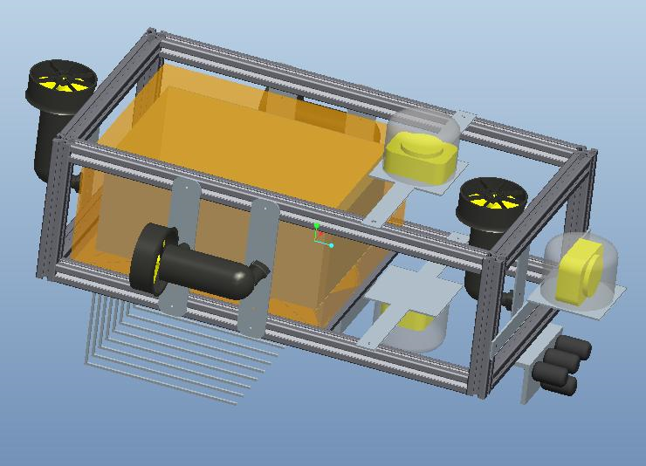

Side View of Design
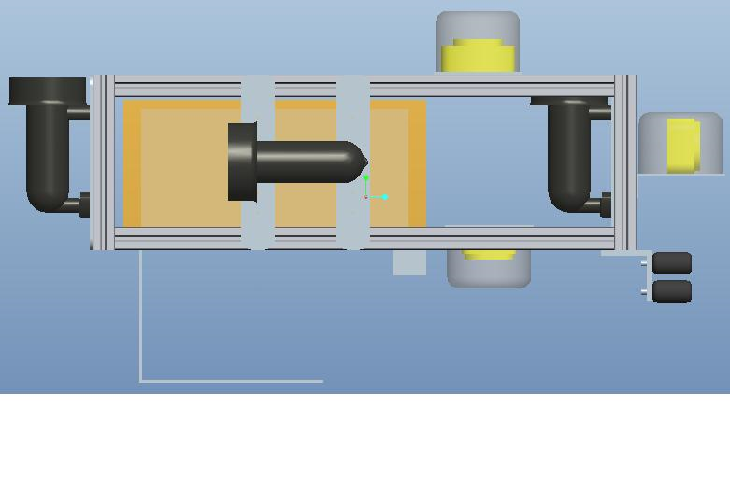

Hull
The hull will consist of a watertight Pelican box, which will be placed on moveable rails inside the frame. The hull is on a moveable rail to exercise weight stability. The pelican box is 16” X 12” X 8” (LxWxH). The hull will house the microprocessor, as well as all of the on board power management components. The inside of the box will house custom Fischer connectors to connect the inside of the box to the outside of the box, and the connections are water tight and waterproof up to 300 feet.

Performance Assessment
The objective of this project is to design, construct, and program a functional Autonomous Underwater Vehicle (AUV) capable of all operational parameters in the remaining 7 months to win the AUVSI RoboSub Competition. The AUV will be required to operate autonomously, maneuver underwater, and have abilities to read colors and recognize pining signals. Team 4’s AUV will meet the needs and requirements for the project, specified by the official competition rules. Since the 2011 competition rules have not been released as of yet, certain performance assessments are based on previous years’ rules.
Assessing how the system would meet the needs and requirements for the project took hard work by the members of Team 4. The AUV designed by Team 4 will be able to meet the needs and requirements due to the selection of equipment and software. The AUV will be able to maneuver underwater with its propulsion systems comprised of four (4) motors/thrusters. Underwater vision will be accomplished by the use of three (3) cameras, positioned frontally, upwardly and downwardly to maximize the view of the scenery. In order to recognize the underwater pinger, the use of four (4) hydrophones –2 positioned vertically and 2 positioned horizontally will achieve this. An inertial measurement unit will be used for navigation and stability control. Other competition components such as the marker dropper and batteries will not be finalized until after the official competition rules are released. In order to power the AUV, the right battery is critical. Team 4 has narrowed down choices for batteries, but depending on any additional tasks—the appropriate battery will be chosen. To meet the weight requirement, the team’s choices of equipment take into account its weight and to meet the size dimension limitation, the size dimensions of the equipment were also taken into account.

Design Process
At the beginning of this project, there were a lot of unknowns since this project was starting from scratch. In a mere two months, the majority of those unknowns are now known. After a team was put together, numerous decisions still remained. Decisions that needed to be made included how was the AUV going to look, how were we going to raise more money than what we had already, and what would each member’s task be within the project. After these decisions were made, more complex decisions arose that required more thought such as what equipment will the team use, will it be in the budget, if not, what alternatives will be feasible and will it affect the intended goals. These decisions required a lot of research, but the team as whole has successfully decided on some of the AUV’s major components.
Team 4 has made great progress including finalizing and purchasing equipment. Major components such as motors/thrusters, the hydrophones, framing and cameras have been chosen, some have already been purchased and some are in the process of being ordered. For the motors/thrusters, four SeaBotix SBT150 motors will be used, which have been purchased. Four (4) SensorTec SQ26-01 hydrophones, in the process of being ordered, will be used for underwater acoustic capabilities and 80/20 framing, which has already been ordered, will create the structure of the AUV. Not all of the major components have been finalized as of yet, but the final decision for these components is very close. The team still has to make final decisions on the interface for the microprocessor and the necessary cables as well as possible additional hardware.
Even though majority of the equipment is finalize and/or purchased, the journey has only just begun. As the equipment begin to arrive, the team needs to determine, after testing, if the decision made was the right one, if not, what can be done to make up for the difference that’s missing. The microprocessor was already supplied to the team, but the software engineers have a tough decision ahead of them. The software engineers are in the process of writing pseudo code and seeing how everything will communicate with each other. The electrical engineer in the team is in the process of researching power regulation and the mechanical engineers are creating design alternatives to be ready for when the official competition rules are released.

Design of Major Components
In order for the AUV to function properly it must process data, maneuver underwater, and perform mission tasks, which require a power source that is capable of powering all the systems on board the AUV. In order to accomplish data processing, the AUV will have to retrieve and analyze data through the use of sensors and processors. The sensors must detect sound, light/color, shape, and position. The processor must retrieve the inputs from the sensors and output the correct command to the components of the AUV to successfully compete in the AUVSI Foundation & ONR's 14th International RoboSub Competition. In addition to data processing the AUV must be able to maneuver underwater. This will be accomplished by placing a battery and inertial measurement unit (IMU) along with other water sensitive components in a watertight hull, and by using waterproof thrusters to move. Finally, the AUV must perform mission tasks such as dropping a marker and locating and hoisting a rescue object.

Batteries
The batteries on board the AUV must be able to power all the systems for a minimum of 15 minutes in order to compete. They must power the processor, all sensors, the thrusters, marker dropper, and mechanical grabber.
We chose a High Power Polymer Lithium-Ion battery to power the thrusters because they have a maximum voltage of 14.8V, a maximum capacity of 20Ah, and a maximum current draw of 30A. The batteries will be connected in series to provide 29.6V, which is within the allowable range of the voltage regulator on the thrusters. This battery was selected in order to give the AUV a run time of 1 hour at maximum amp draw so that we have an extended period of time to work on debugging and system calibration during the testing phase. A Lithium-Iron Phosphate battery was also considered for the AUV; however, it was more expensive and was considerably heavier. Nickel Metal Hydride batteries could not supply sufficient Amp hours while Nickel Cadmium batteries do not have sufficient voltage or amp hours. We are in the process of choosing a battery to power all other electrical systems on the AUV. For risk associated with the batteries see section 6.1.6.2.

Processor
The processor will have to analyze all inputs from the sensors on the AUV and output the correct commands to the thrusters, marker dropper, and mechanical grabber in order to function competitively. The processor will receive inputs from the cameras, hydrophones, and inertial measurement unit. An ARM processor has been donated to the project and will be used in order to cut cost associated with design.

Hydrophone
Four hydrophones will be utilized in our design to locate an acoustic pinger that will be placed on the bottom of the pool in Camp Transdec. Two of the hydrophones oriented horizontally will determine whether the pinger is to the left or right of the AUV while two of the hydrophones oriented vertically will determine the depth of the pinger. Figure 1 is a conceptual design of how the hydrophones will be oriented.

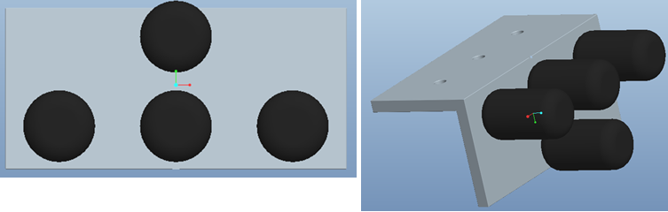
Figure 1: Hydrophone orientation

The SensorTec SQ26-01 hydrophone was chosen for our AUV because it performs in the required range of the pinger (20-30 kHz) and is substantially cheaper than our original choice. The SensorTec hydrophone does not have an amplifier built into it; however, the pinger operates at 187 decibels making an amplifier unnecessary. The Reson TC4013 hydrophones were our original choice but cost $1069 each, so we decided to use the SensorTec hydrophones, which are $220 each. For risks associated with the hydrophone see section 6.1.2.2.

Camera
Three cameras will be place on the AUV in order to detect light/color and shape of objects so that the AUV will know in which direction to travel and which mission task it is presented with.
The Unibrain Fire-i webcam was chosen for the AUV because it has a CCD lens, which allows it to operate in low light conditions. They range from $100-$130 and we will use two of them for shape and color recognition in forward and bottom configuration. The third upward facing camera will be a Dynex 1.3 Mega Pixel camera because it only needs to detect the octagon shape on the surface of the pool and because there is more light on the surface. We chose the Unibrain Fire-i because it is Linux compatible, which is the programming language we will use for the AUV, and because it is a cheap CCD lens camera. Most other CCD lens cameras cost $500-$1000 and we did not budget for this price range. The Dynex camera was chosen for its low cost, roughly $30. For risk associated with the cameras see section 6.1.2.1.

Camera Housing
The camera housing will be used to protect the cameras from water damage. We will use PVC pipes to house the cameras and we will machine aluminum end-caps to prevent leaks, as well as a viewing lens to allow the camera to view the surroundings. We require three camera housings and each one is expected to cost approximately $40. For risk associated with the camera housing see section 6.1.1.2.

Inertial Measurement Unit
An inertial measurement unit will be used to detect changes in the AUV orientation while underwater. IMUs typically include a combination of gyroscopes and accelerometers. The IMU will output a signal to the processor, which will determine whether the thrusters need to accelerate/decelerate, pitch up/down, or turn the AUV left/right.
A PhidgetSpatial 9 Axis inertial measurement unit was chosen for the AUV because it has a 3-axis gyroscope, accelerometer, and compass. We considered purchasing a different IMU that contained a gyroscope, accelerometer, and magnometer. However, the magnometer, which measures the magnetic field in its immediate surrounding is expected to have a large amount of interference due to the electronics inside the Pelican Box and was not chosen for this reason. We also considered purchasing an accelerometer and compass unit and a separate gyroscope, which would cost $130, however we chose the more expensive PhidgetSpatial 9 Axis IMU because it has all the components in a single unit, which will be easier to work. The PhidgetSpatial 9 Axis IMU will cost $150, which is the amount we set aside for purchasing an IMU. For risks associated with the IMU see section 6.1.6.4.

Hull
The hull will be a Pelican Box, which is a watertight case that is large enough to house all of the water sensitive components on the AUV. Utilizing a Pelican Box will be simpler that designing a watertight housing and costs $100-$150. By using a Pelican Box we reduce the risk of leaks developing throughout the testing phase and during transportation.

Frame
The frame of the AUV will be constructed out of 80/20 Aluminum. This allows for easy adjustability since this is the first attempt at building an AUV and we cannot design for all possible requirements and scenarios. The 80/20 is structurally sound and can support all components that make up the AUV. In addition, the design of 80/20 naturally mitigates vibrations, which will reduce noise in the hydrophones. The hull will be placed within the frame to prevent damage to the pelican box.

Thruster
Four thrusters will be placed on the AUV in a configuration to provide forward/reverse, left/right turning, and depth control. The processor will control the voltage to each thruster thus increasing the angular velocity of the propeller to provide the different modes of movement.
The SeaBotix SBT150 Thruster (see Appendix C section 9.1 for data sheet) was chosen because of its functional ability and water resistance, the fact that it has a built in motor controller and voltage regulator, and for its low power consumption. The input voltage for the voltage regulator is approximately 22-30V to supply the motor with the required 19V. The SeaBotix BTD150 was also considered for this project but was not chosen because it lacked a motor controller and was otherwise equivalent to the SBT150. For risk associated with the thrusters see section 6.1.2.3.
 | Cost | Thrust | Power Consumption | Dry Weight | Rank
Weighting Factor | 0.2 | 0.2 | 0.5 | 0.1
Seabotix BTD-150 | 7 | 6 | 9 | 9 | 8
Crust Crawler 400HFS | 5 | 10 | 4 | 10 | 6
Technadyne 260 | 6 | 8 | 5 | 8 | 6.1

Marker Dropper
In order to perform competitively at the next AUVSI competition we must have a marker dropper on the AUV. It will be used to identify a space or object that the AUV will be required to find. The marker dropper will be machined out of aluminum and will utilize a waterproof servomotor that will rotate clockwise or counter clockwise to release individual markers. The servomotors are made by Traxxas and were the most cost effective waterproof servos. See Figure 2 for a conceptualized marker dropper.

Figure 2: Marker dropper from the San Diego iBotics team

Mechanical Grabber
The mechanical grabber will be used to hoist a rescue object to the surface. The final design of the mechanical grabber has not been completed yet because the AUVSI 2011 rules have not been released yet. Based on previous years we have anticipated possible rescue objects and have established preliminary designs to accomplish the task.
For small rescue objects we have a “scoop” design. With this design the AUV will simply scoop up the object and bring it to the surface. Depicted in Figure 3 is a CAD rendering of the scoop.
For rescue objects constructed out of PVC (similar to the 2010 rescue object) an array of claws will be used to grasp the object, as seen in Figure 4. If the object to be rescued requires more dexterity, for example a brief case handle (2009 rescue object), then a 3-pronged mechanical grabber will be utilized, similar to the one shown in figure 5.
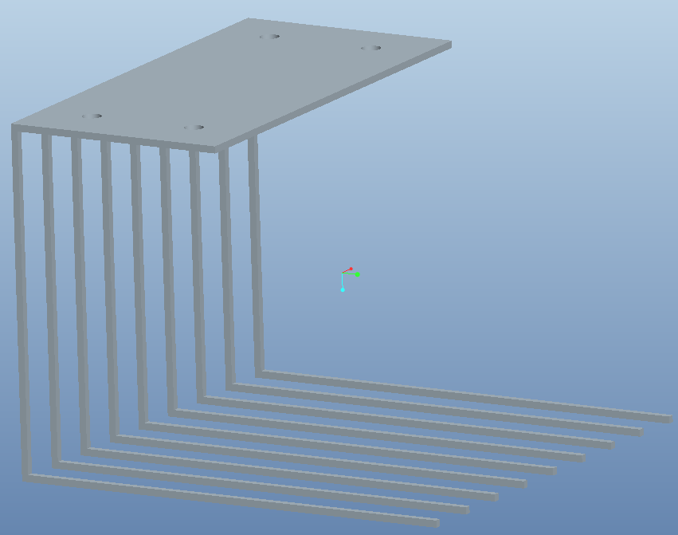
Figure 3: Scoop design

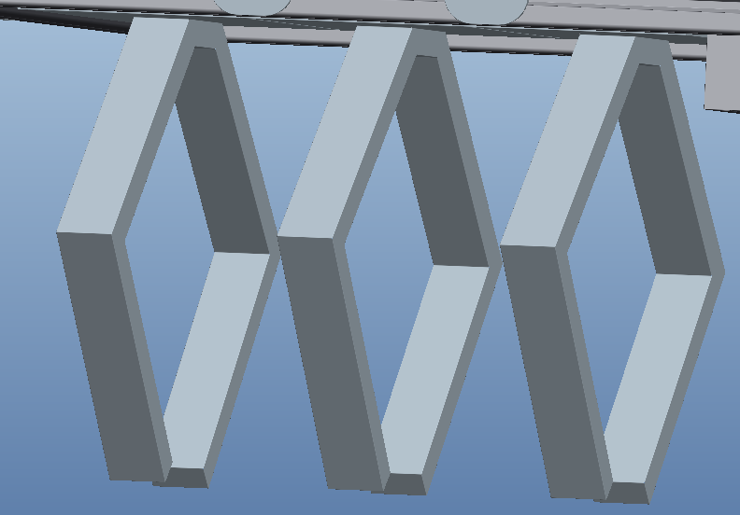
Figure 4: Array of Claws

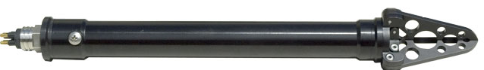
Figure 5: 3 pronged grabber

Schedule

Proposed Schedule
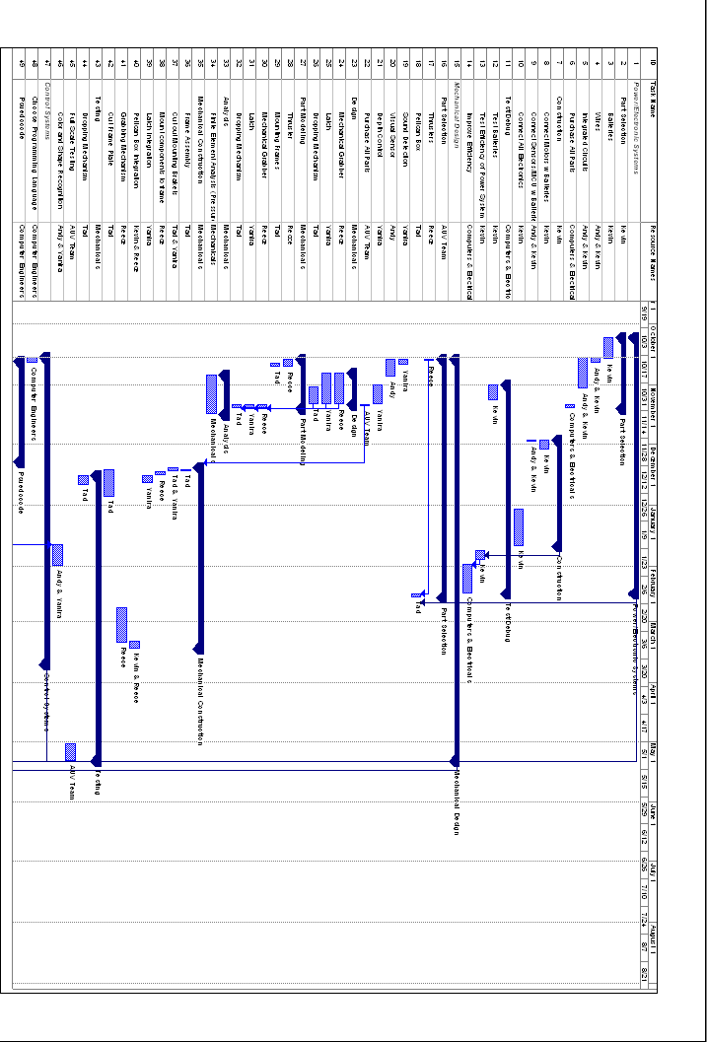
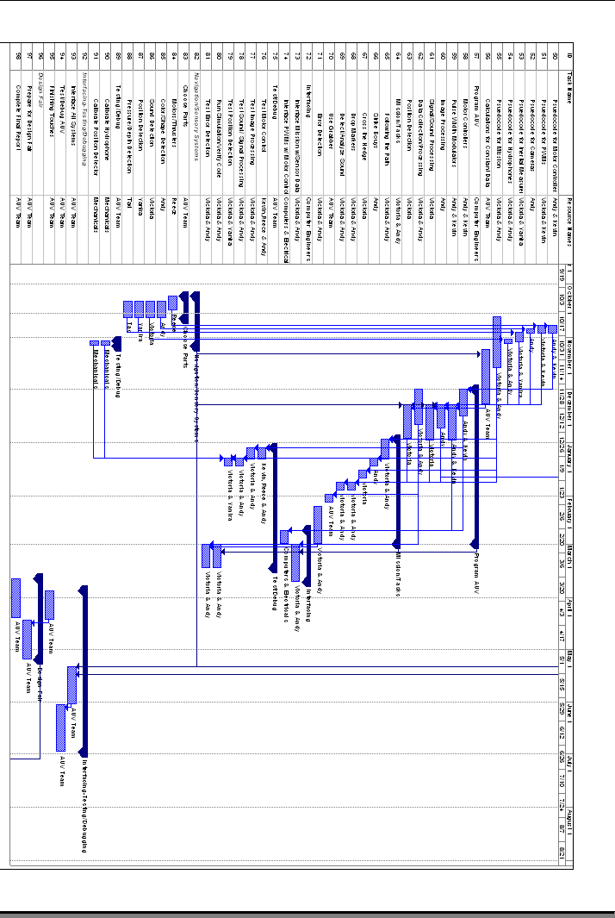
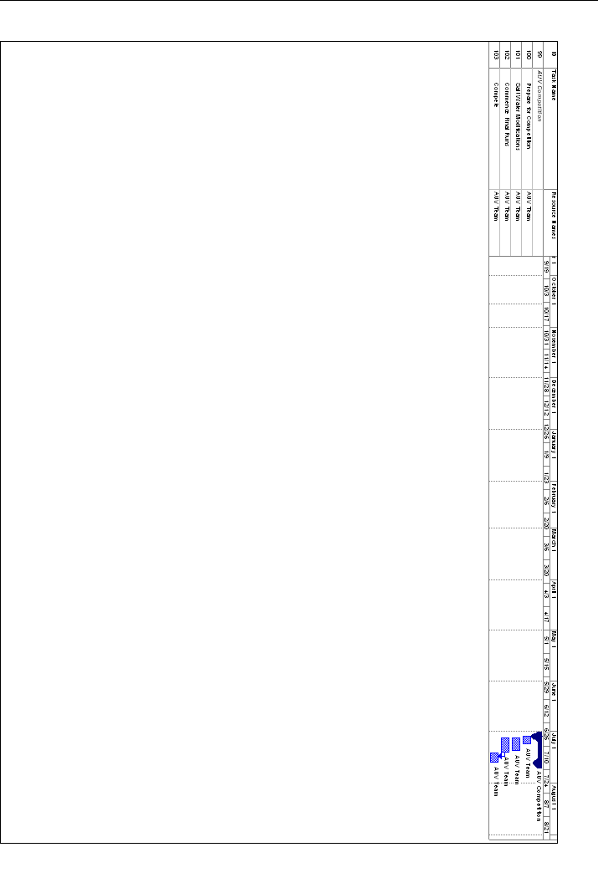

Current Schedule
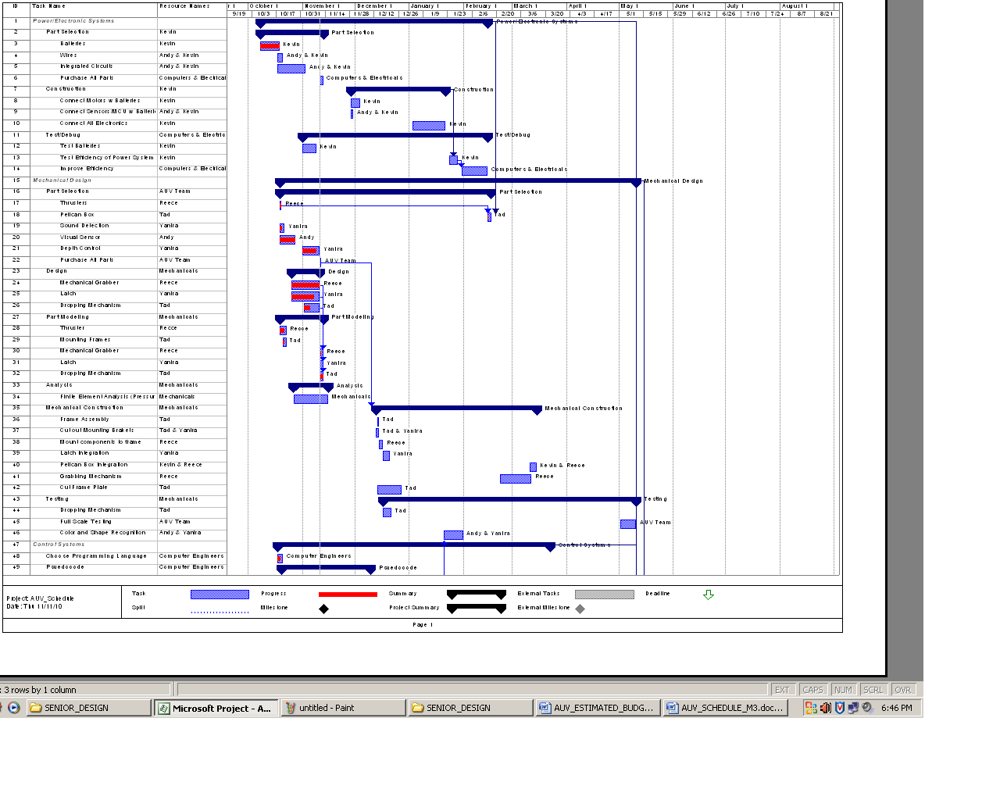
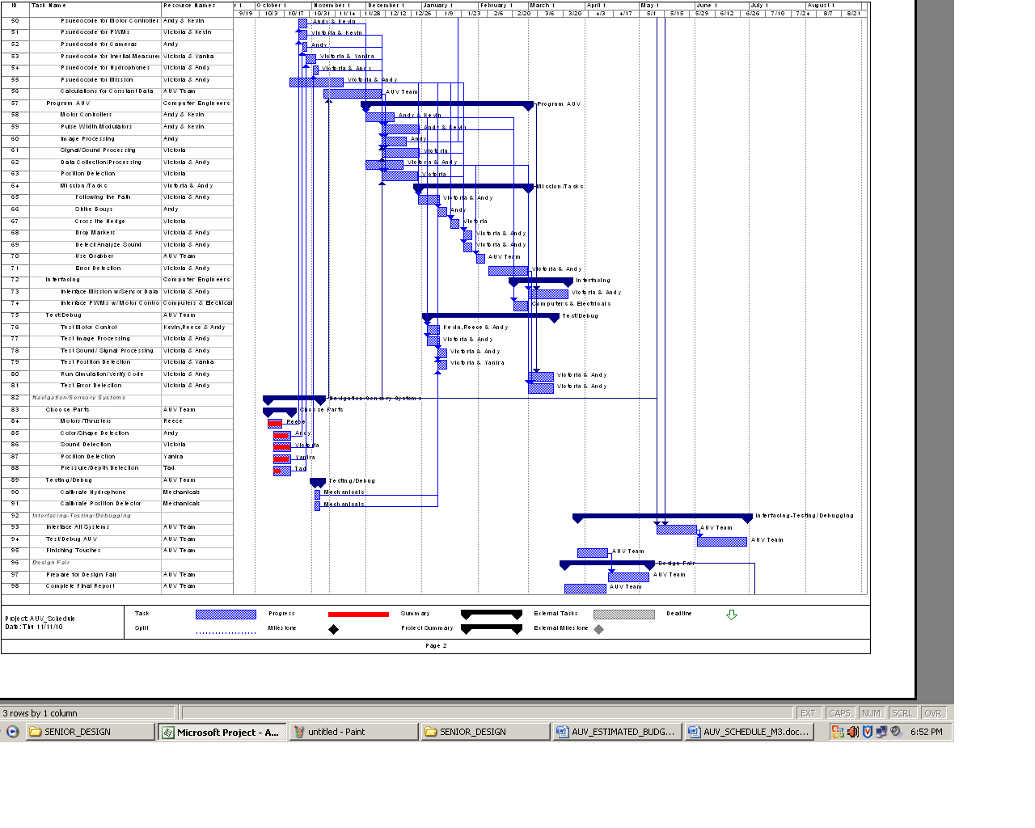
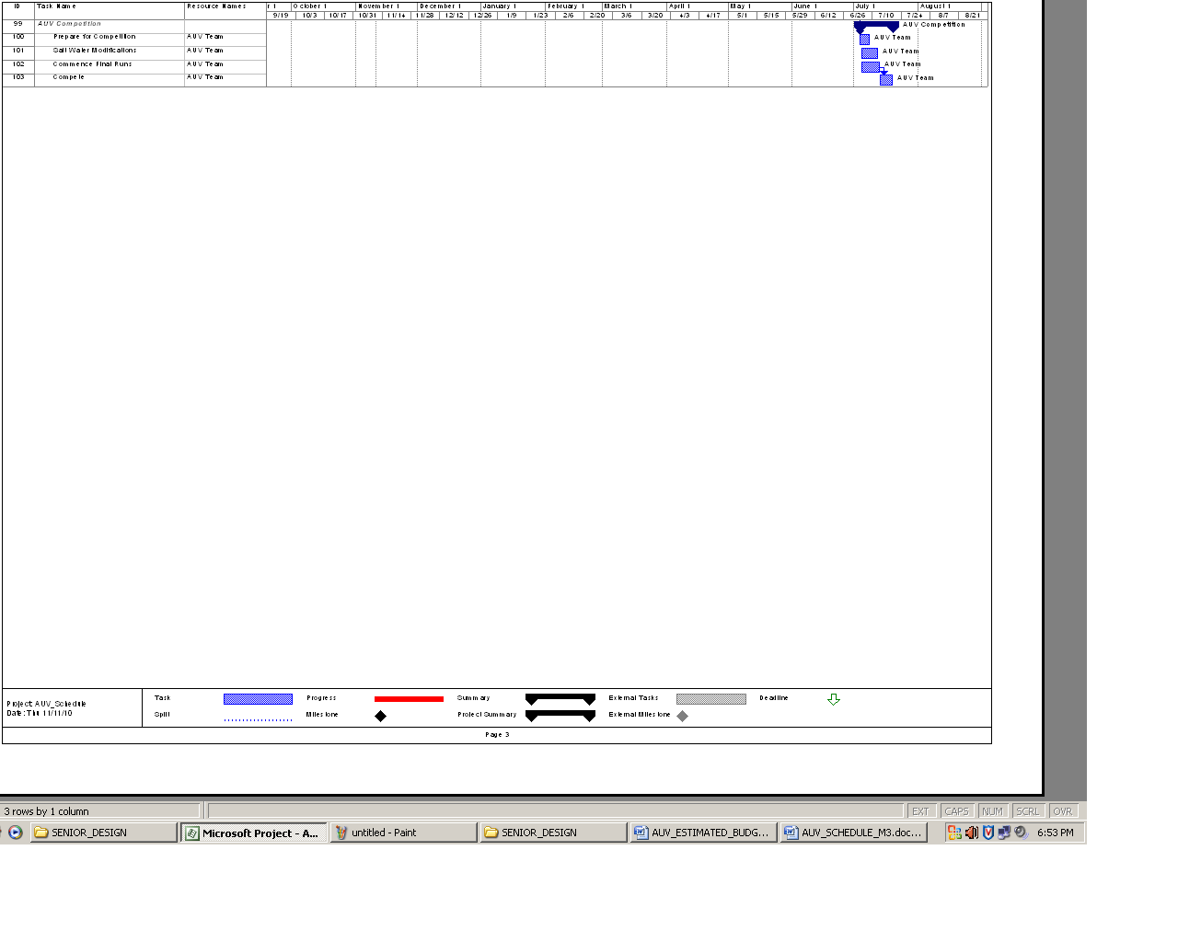

Budget Estimate

Proposed Budget
AUV ESTIMATED BUDGET(Proposed)
Expenses (S&H Estimated)
Name | Description | Price | Quantity | Total
Battery A | Batteries for motors | $800.00 | 2 | $1,600.00
Battery B | Batteries for microcontroller and other peripherals | $100.00 | 4 | $400.00
Battery Charger A | Charger for battery type A | $180.00 | 1 | $180.00
Battery Charger B | Charger for battery type B | $60.00 | 2 | $120.00
Motors/Thrusters | Seabotix BTD150 thrusters | $750.00 | 4 | $3,000.00
Hydrophones | Hydrophone package(includes hydrophone, amps, and cables) | $320.00 | 3 | $960.00
Microcontroller** | Beagle Board | $170.00 | 1 | $170.00
Camera | Webcam | $80.00 | 3 | $240.00
Pelican Case | Water tight casing | $150.00 | 1 | $150.00
Wires/Electronic Kits | Switches, wires, electronic kits | $750.00 | N/A | $750.00
30’’ 8020 10 Series Aluminum T-slot Framing | Frame | $ 14.00 | 4 | $56.00
7.75’’ 8020 10 Series Aluminum T-slot Framing | Frame | $4.00 | 4 | $16.00
8020 10 Series Aluminum T-slot Framing | Frame | $ 5.50 | 4 | $22.00
8020 Corner Bracket | Connects T-slot frame | $5.00 | 16 | $80.00
Aluminum Plate 14 in x 12 in x ¼ in | Frame | $70.00 | 1 | $70.00
8020 Corner Braket Fasteners (Screw & simple nut) | To assemble frame | $1.00 | 64 | $64.00
8020 Component Fasteners (Screw & Curved Nut) | To attach components to frame | $1.50 | 40 | $60.00
Inertial Measurement Unit | Navigation/Stability Control | $150.00 | 1 | $150.00
Total Expenses | Total estimated cost of all expenses |  |  | $8,088.00
Total Funds | Total estimated amount of sponsorships |  |  | $9,500.00
Total Remaining Balance | Total estimated remaining funds |  |  | $1,412.00
AUV ESTIMATED BUDGET
- Personnel
Name | Job Description | Base | Hours | Total
Andy Jeanthenor | Software Tech | $30.00/hr | 12hr/wk-28wks | $10,080.00
Kevin Miles | Electronics Tech | $30.00/hr | 12hr/wk-28wks | $10,080.00
Reece Spencer | Robotics Systems Tech | $30.00/hr | 12hr/wk-28wks | $10,080.00
Tad Byrne | Mechanical Design Tech | $30.00/hr | 12hr/wk-28wks | $10,080.00
Victoria Jefferson | Project Manager | $30.00/hr | 12hr/wk-28wks | $10,080.00
Yanira Torres | Equipment/Debug Tech | $30.00/hr | 12hr/wk-28wks | $10,080.00
Total Base Pay | Total pay of all engineers |  |  | $60,480.00
- Fringe Benefits | 29% of A |  |  | $17,540.00
- Total Salary | A + B |  |  | $78,020.00
- Expenses
Name | Description | Price | Quantity | Total
Battery A | Batteries for motors | $800.00 | 2 | $1,600.00
Battery B | Batteries for microcontroller and other peripherals | $100.00 | 4 | $400.00
Battery Charger A | Charger for battery type A | $180.00 | 1 | $180.00
Battery Charger B | Charger for battery type B | $60.00 | 2 | $120.00
Motors/Thrusters | Seabotix BTD150 thrusters | $750.00 | 4 | $3,000.00
Hydrophones | Hydrophone package(includes hydrophone, amps, and cables) | $320.00 | 3 | $960.00
Microcontroller** | Beagle Board | $170.00 | 1 | $170.00
Camera | Webcam | $80.00 | 3 | $240.00
Pelican Case | Water tight casing | $150.00 | 1 | $150.00
Wires/Electronic Kits | Switches, wires, electronic kits | $750.00 | N/A | $750.00
30’’ 8020 10 Series Aluminum T-slot Framing | Frame | $ 14.00 | 4 | $56.00
7.75’’ 8020 10 Series Aluminum T-slot Framing | Frame | $4.00 | 4 | $16.00
8020 10 Series Aluminum T-slot Framing | Frame | $ 5.50 | 4 | $22.00
8020 Corner Bracket | Connects T-slot frame | $5.00 | 16 | $80.00
Aluminum Plate 14 in x 12 in x ¼ in | Frame | $70.00 | 1 | $70.00
8020 Corner Braket Fasteners (Screw & simple nut) | To assemble frame | $1.00 | 64 | $64.00
8020 Component Fasteners (Screw & Curved Nut) | To attach components to frame | $1.50 | 40 | $60.00
Inertial Measurement Unit | Measures | $150.00 | 1 | $150.00
Total Expenses | Total estimated cost of all expenses |  |  | $8,088.00
- Total Direct Cost | C + D |  |  | $86,108.00
- Overhead Costs | 45% of total cost |  |  | $38,749.00
- Total Equipment Costs | Total estimated costs of equipment |  |  | $0.00
Total Cost | E + F + G |  |  | $124,857.00
Total Project Cost | Total estimated cost minus free items |  |  | $124,687.00

Current Budget
AUV ESTIMATED BUDGET(Current)
Expenses (S&H Estimated)
Name | Description | Price | Quantity | Total
Battery A | LiFePO₄ Batteries | $400.00 | 2 | $800.00
Battery B | Microcontroller and Control Board Battery | $100.00 | 3 | $300.00
Battery Charger A | Charger for Battery A | $80.00 | 1 | $80.00
Battery Charger B |  | $60.00 | 2 | $120.00
Motors/Thrusters | SeaBotix SBT 150 thrusters w/ motor controllers | $750.00 | 4 | $3,000.00
Hydrophones | Cetacean SQ26-01 | $240.00 | 4 | $960.00
Microcontroller** | BeagleBoard Rev. B7 | $170.00 | 1 | Free
Control Board | Interfaces the computer with the sensors | $120.00 | 1 | $120.00
Camera A | Unibrain Fire-I Digital Camera CCD Camera | $130.00 | 2 | $260.00
Camera B | Dynex 1.3 Megapixel Webcam | $50.00 | 1 | $50.00
Pelican Case | Water tight casing | $150.00 | 1 | $150.00
Wires/Electronic Kits/Cables & Connectors | All Electronic Kits/Parts, ICs, Water tight connectors, Computing/Sensor connections | $1,200.00 | N/A | $1,200.00
8020 Frame | 1" x 1" x 48.5" Extrusion (w/ 7005 cut charge), 1" x 1" x 36.25 Extrusion (w/ 7005 cut charge), 10 Series 1/4-20 T-Nut, 10 Series Anchor Fastener | $220.00 | N/A | $220.00
Aluminum Plate 14 in x 12 in x ¼ in | Frame | $70.00 | 1 | $70.00
Inertial Measurement Unit | Phidget Spatial 3/3/3, 9 Axis IMU (Navigation/Stability Control) | $170.00 | 1 | $170.00
Total Expenses | Total estimated cost of all expenses |  |  | $7,500.00
Total Funds | Total estimated amount of sponsorships |  |  | $9,500.00
Total Remaining Balance | Total estimated remaining funds |  |  | $2,000.00

AUV ESTIMATED BUDGET(Current)
Traveling/Competition Expenses
Name | Description | Price | Total
Transportation | Flight, Rental, Fuel Cost | $6,000.00 | $6,000.00
Hotel Accommodations | Room & Board | $4,000.00 | $4,000.00
Miscellaneous Expenses | Meals, low price emergency parts, other expenses | $2,000.00 | $2,000.00
Total Expenses | Total estimated cost of all expenses |  | $12,000.00
Total Funds | Total estimated amount of sponsorships |  | $0.00
Total Remaining Balance | Total estimated remaining funds |  | -$12,000.00

5.3 Budget Justification
This budget is an estimation of all the costs that will concur during the development of the FAMU/FSU College of Engineering AUV. The item in our budget with two asterisks is the donated BeagleBoard w/ an ARM Cortex A-8 processor. The first and most important items listed are our control and drive train items. We have decided to use two batteries to power the motors. We will also use a few smaller batteries to power the MCU and the other peripherals for our AUV. The motors will be SeaBotix BTD150s that include both motor controllers and thrusters with shroud surrounding the propellers. The microcontroller that we will use has been donated to us and meets the ARM requirement, which states that all computing equipment must be an ARM product. The microcontroller we will use is the BeagleBoard and it comes equipped with the ARM Cortex A-8 as well as the OMAP3530 application processor. All the electronic equipment will be held in a pelican case to protect the electronics from water damage and since this vehicle will be submerged we will also purchase watertight connectors to protect the wiring. The hydrophone listed is a kit, which also contains all the parts needed for the hydrophone, which will be used for sound detection. We have decided to use the cheaper alternative for image processing by using the webcam that can be utilized to observe and track color and shape. The last sensor we have listed is the inertial measurement unit, which contains the accelerometer, compass and gyroscope in one unit. This item will be used for position and orientation detection. All the other expenses are dealing with the design of the frame as well as the necessary materials for stabilizing all the components to the frame.

Overall Risk Assessment

Technical Risks

Leaks

Pelican Box: SubConn Connectors Leak

Risk | Improper integration of SubConn connectors
Probability | Low
Consequence | Catastrophic
Strategy | Extensive testing before integration of electrical components

If the SubConn connectors are integrated inappropriately through the pelican box the consequence would be catastrophic, as this would result in the exposure of corrosive salt water to water sensitive electronics and devices. The probability of this occurring is low. To prevent detrimental damage to several key components of our vehicle the group, after the SubConn connectors have been integrated into the pelican box and before all of the electrical components have been assembled the pelican box will be extensively tested to ensure there are no leaks where the connectors have been implemented. The empty pelican box will be submerged to the operational depth several times to simulate the operational requirements of the competition. The box will be examined to ensure that no leaks have occurred during testing, once confidence in the integration of SubConn connectors has been established the electrical components will be assembled inside.

Camera Housing Leak

Risk | Leak of camera housing
Probability | Moderate
Consequence | Serious
Strategy | 1. Extensive testing and analysis before integration of camera

There is a moderate probability of the camera housing fracturing or failing, inducing a leak, which would result in the malfunction or permanent damage of one or more cameras. The occurrence of this risk would be serious because the three cameras are used in several of the competition objectives tasks. To avoid the occurrence of this risk the AUV team will perform extensive analysis and testing on the camera housing to ensure it is effective at eliminating the threat of the camera's exposure to moisture. If the camera housing does fail and damages a camera the AUV team has minimization strategies and contingency plans to resolve these issues.

Malfunctioning External Components

Camera Failure

Risk | Failure, damage or malfunction
Probability | Moderate
Consequence | Serious
Strategy | 1. Develop alternative camera configuration for lack of camera  2. Replace damaged cameras.

The probability that a camera will fail, be damaged, or malfunction is moderate. If a camera is damaged before the competition, the team will examine the warranty of the camera to determine if the part can be returned and a replacement may be obtained in a timely manner. If warranty is voided, the immediate purchase of the replacement part is necessary. If the issue with the camera is repairable, the team will attempt to repair it.
If time does not permit the purchase of cameras, the remaining cameras may be reconfigured to accomplish some of the requisite tasks. If only one camera is unusable and time or budget constraints do not permit the purchase of replacement the other two cameras may be reconfigured with one camera on the front and bottom of the vehicle may be used. The camera on the top is needed to find an octagon and ascend within it; this task may be completed simply with a camera on the front of the vehicle by tilting the device at an angle to search for the octagon. The accuracy and precision of the ascension of the vehicle inside the octagon may be compromised in this case but will accomplish the requisite task. If two cameras are unusable then the remaining camera may be placed on the front of the device and will need to find the octagon and also be able to find the rescue object on the floor of the pool, using the same technique of tilting to view the area above and below the vehicle. During competition if one or two of the cameras malfunction, the remaining camera will be utilized to perform the remainder of the tasks. If budget does not permit purchase of additional cameras, see Budget Risk in Section 6.3.
If cameras are damaged during competition the vehicle will utilize the remaining cameras to perform the remainder of the tasks to the best of its capabilities. If the top and/or bottom camera are damaged the remainder of the tasks can be completed purely with the front camera. This can be accomplished by tilting the vehicle up and down to search for targets and the octagon. If the front camera is damaged the vehicle may still find the rescue object and rise inside of the octagon.

Hydrophones Failure

Risk | Failure of one or more hydrophones
Probability | Low
Consequence | Serious
Strategy | 1. Analyze damage, return or repair if possible  2. Reconfigure to accommodate for lack of single hydrophone.

The probability that a hydrophone will fail is low because they are developed for much more intense conditions than those observed during out competition. If one of the hydrophones fails the consequence will be tolerable but if more than one hydrophone fails the consequence will be serious. To prevent failure the team will be careful while integrating the hydrophones to vehicle, to ensure damage does not occur to any part of the component. Care will also be examined when testing and competing to ensure the parts are not damaged. If the hydrophones do fail the team will examine the warranty to determine if the part can be returned and a replacement may be obtained in a timely manner. If warranty is voided, the immediate purchase of the replacement part is necessary. If the issue with the hydrophone is repairable, the team will attempt to repair it. If time does not permit the purchase of replacement hydrophones, the remaining hydrophones may be reconfigured to accomplish the requisite task to the best of the vehicles ability. If only one hydrophone is damaged the remaining three hydrophones will be reconfigured to appropriately triangulate the position of the pinger. If two hydrophones are damaged the remaining two will be reconfigured to identify the depth and distance of the pinger by aligning the hydrophones vertically. The distance/direction of the pinger will be established by the change of the magnitude of the voltage output from the hydrophones, if there is a decrease in the magnitude of the voltage output the vehicle will be able to interpret this as it is going in the wrong direction while if there is an increase in the voltage it will know it is going in the right direction. The vertically placed pingers will be utilized to identify a time delay, which will indicate the depth of the pinger. Once the device is spotted the cameras will be able to complete the task. If budget does not permit purchase of replacement hydrophones see Budget Risk in section 6.3.

Thruster Failure

Risk | Failure of one or more thrusters
Probability | Low
Consequence | Serious
Strategy | 1. Analyze damage, return or repair if possible  2. Reconfigure to accommodate for lack of single thruster.  3. Float to surface for safe recovery.

There is a low probability of the failure of the thrusters; failure of thrusters would have a serious consequence because they are utilized for the vehicle maneuverability, which is required to complete all of the tasks. If a thruster is damaged before competition, the team will examine the warranty to determine if the part can be returned and a replacement may be obtained in a timely manner. If warranty is voided, the immediate purchase of the replacement part is necessary. If the issue with the thruster is repairable, the team will attempt to repair it. If time does not permit the purchase of replacement parts, the remaining thrusters may be reconfigured to accomplish some of the requisite tasks. If only one thruster is damaged the remaining three may be reconfigured without losing functionality, utilizing two thrusters to turn the vehicle and one to descend and maintain submersion. If thrusters fail during operation there will be an emergency system that will increase the buoyancy of the device and cause it to rise to the surface for safe recovery. If budget does not permit purchase of additional thruster see Budget Risks in section 6.3.

Team Member Loss

Temporary Loss of Member

Risk | Temporary loss of team member
Probability | Moderate
Consequence | Serious
Strategy | 1. Temporarily reallocate team member's work so that it is accomplished by deadlines.  2. Seek assistance from interested individuals in the engineering school to take on parts of team member's work and work with them when they return.  3. Keep member up to date on advancements of the project.

There is a moderate risk that a team member will be temporarily lost as a result of sickness, injury or absent due to unforeseeable circumstances and the consequence would be serious because the individual team member will be the most experienced with their technical focus area in the project. In the event of this occurrence adjustments will be made to compensate for the temporary loss of the member. The team member’s documents will be gathered and their work will be split among the team based on individuals’ areas of the strength. To avoid this issue, the AUV team is currently in the process of creating an AUVSI registered student organization to recruit interested students to assist in our project. These students will be kept up to date with the project so that if a situation arises they will be sufficiently knowledgeable about the topic and can effectively complete it in an acceptable amount of time. If there are sufficient amount of involvement each member will develop a committee compiled of students interested in their focus, this committee will be extremely knowledgeable in the inner workings of the committee leaders part of the project so that if an issue arises we will have interested and committed students ready to accommodate for the temporary loss of a team member. While the member is unavailable to work they will be kept up to date on advancements of the project so that when they return they can pick up where they left off and continue work effectively without being off schedule.

Permanent Loss of Member

Risk | Permanent loss of team member
Probability | Low
Consequence | Serious
Strategy | 1. Seek assistance from interested individuals in the engineering school to continue team member's work.  2. Reallocate team member's work to other team members.

There is a low risk that a team member will be permanently lost as a result of unforeseeable circumstances and the consequence would be serious because the individual team member will be the most experienced with their technical focus area in the project. In the event that a team member will not be able to return to complete the project adjustments will be made to compensate for the permanent loss of that member. The team member’s documents will be gathered and their work will be split among the team based on individuals’ areas of the strength. To avoid this being a major issue, the AUV team is currently in the process of creating an AUVSI registered student organization to recruit interested students to assist in our project. These students will be kept up to date with the project so that if a situation arises they will be sufficiently knowledgeable about the topic and can effectively complete the desired tasks. An ambitious and committed student will be reallocated all of the tasks associated with lost team member and, if sufficient participation from students, will lead a committee to assist in completion of said tasks.

Rules Change

Risk | Drastic rules change in late November
Probability | Moderate
Consequence | Catastrophic
Strategy | 1. Only prepare for objectives that have been consistently repeated  2. Reanalyze the budget, schedule, and system to determine feasibility of including more of the objectives required for competition.

Since the rules for next year’s competition have not been released yet there is a moderate probability that there will be substantial changes to the rules and objectives. The result of a drastic rules change would be catastrophic if we based our design on the previous year. To reduce the consequence of this risk the AUV team has researched several competition rules from previous years and included components and objectives that have consistently repeated to ensure that we do not include things that will not be required. If there is a drastic change in the rules the team will have to abandon any requirement that is not required to qualify for the competition and begin to reanalyze the budget and schedule to determine which components from the new rules can be included in the system in a timely manner, refer to sections 6.2 and 6.3 for budget and schedule risks.

Transportation

Risk | Vehicle damage due to transportation
Probability | High
Consequence | Catastrophic
Strategy | 1. Carefully package the vehicle.  2. Drive to California with the vehicle and ensure it is properly secured throughout the trip.

The probability of the vehicle being damaged during transportation is high due to the large distance that needs to be travelled the consequence would be catastrophic because it would result in the inability to compete. To reduce this risk the team will be driving to California with the vehicle instead of shipping it or taking it through an airline. The vehicle will be meticulously packaged and secured throughout the trip to further ensure the devices safe arrival in San Diego, California.

Technological Issues

Microcontroller Performance
Risk | Microcontroller not performing task properly
Probability | High
Consequence | Catastrophic
Strategy | Test and debug

There is a high probability that the microcontroller will not perform tasks properly, during competition the consequence would be catastrophic. To prevent this event during competition the entire AUV system will be tested and debugged repeatedly to ensure that it is capable of performing all desired tasks effectively. If the microcontroller is not performing a desired task, that specific area of the software will be reviewed. If no solution is found the software for the desired function will be rewritten and reintegrated into the main program. If drastic measures are required the entire program will be rewritten.

Battery issues

Risk | Battery over-discharging, overcharging, shorting terminal
Probability | Low
Consequence | Catastrophic
Strategy | Purchase battery with built in protection module

The risks associated with the battery over-discharging, overcharging, shorting terminal is low but the consequence is catastrophic as it would result in deterioration of the electrodes, reduced battery life, and/or a fire. To prevent the occurrence of any of these issues the AUV team purchased a battery with a built in protection circuit module. This protection circuit module keeps the 14.8V Li-Ion battery pack from overcharging and over-discharging while balancing each cell at a maximum of 4.22V/cell.

Compass Interference

Risk | Magnetic interference of compass
Probability | High
Consequence | Serious
Strategy | 1. Perform testing to ensure magnetic interference from electronics is minimal.  2. Utilize inertial measurement unit to compare values output by compass to ensure interference at competition does not mitigate performance and effectiveness

There is a high probability that the compass will experience magnetic interference, either from electrical components in the pelican box or from materials in the pool. To ensure that the magnetic interference from the electronics is not substantial and does not alter the compasses capabilities the compass will be tested with the electronics. Since the composition of the pool is unknown there may be magnetic material that could also interfere with this device, to ensure that the reading will in fact be accurate the gyroscope used to measure yaw will be related to the compass. When the device is placed in the water the two measurements will be in sync: the gyroscope will be calibrated to an initial angle, which will correlate to a certain compass heading. This relationship should remain consistent throughout the competition. If there is an error with the compass as a result of some interference these to values will no longer be in sync. Thus the gyroscope will act as a check for the compass, if the vehicle determines that these two values are not in sync then the output from the compass will be ignored and it will complete the remainder of the tasks without the compass.

Drift in Inertial Measurement Unit

Risk | “Drift” in Inertial Measurement Unit
Probability | Low
Consequence | Serious
Strategy | 1. Recalibrate IMU before use.  2. Test to ensure substantial error accumulation does not occur during competition time.

After prolonged use inertial measurement units (IMU) are subject to Abbe Error, accumulated error, which leads to drift in measurements. To reduce the accumulation of error the IMU will be recalibrated before competition, practices and testing. To prevent serious consequences during competition the system will be tested several times and the measurements output from the IMU will be analyzed to determine if a substantial amount of Abbe Error is induced during the length of time during competition, fifteen minutes. If substantial accumulation does occur the team will need to determine at what point it begins to occur and the amount of error. This information will be utilized to determine a correction factor to be implemented to the values output by the IMU after this point to ensure that the drift is accounted for and does not cause major errors and instabilities.

Camera Compatibility

Risk | Compatibility with programming language
Probability | Moderate
Consequence | Serious
Strategy | 1. Research camera compatibility, if possible  2. Test immediately once received.  3. Return camera and purchase known compatible camera

Two types of cameras will be utilized in the AUV design Unibrain Fire-I and Dynex cameras. Research was conducted on both to determine compatibility with the Linux operating system that will be utilized. From this research it was determined that the Unibrain Fire-I is Linux compatible but no information was available for the Dynex camera. Once received the Dynex camera will be tested immediately to establish compatibility. If it is not compatible it will be returned immediately and a camera with known compatibility, e.g. the Unibrain Fire-I, will be purchased and used for the top camera. If time does not permit the purchase of a new camera, the strategy for use of only two cameras expressed in section 6.1.2.1 about Camera Failure will be utilized.

Sensor or Component Communication
Risk | Errors in sensor-microcontroller communication
Probability | Moderate
Consequence | Serious
Strategy | 1. Reevaluate connections  2. Reevaluate programming  3. If possible, remove function  4. Explore alternative sensors as replacements

If the sensors are not communicating with the microcontroller correctly, the wired connections and programming will be reevaluated. If no solution is found the team will seek faculty assistance to establish the issue and determine a resolution. If that does not work the specific function will be excluded until further notice, if the sensor is necessary for successful completion of tasks an alternative sensors will be explored and purchased if the budget allows. If not, see Budget Risk in section 6.3.

Schedule Risks

Critical Scheduling Issues
Risk | The team is critically behind schedule
Probability | High
Consequence | Severe-Catastrophic(depending on severity of scheduling issues)
Strategy | - Reallocate man power  - Work Overtime  - Abandon Function/Task

In the event that production is vastly behind schedule the project manager is tasked with evaluating team performance. The probability of this occurring is very high and the consequences are not severe early on. As time progresses the problem will become worse and drastic measures will have to be taken. The team can get behind for a number of reasons. Some can be avoided and others may be inevitable, such as the fact that the rules for this year’s competition have yet to be released. The project manager will ensure that new methods of production will be put in place to increase efficiency. Every team member is required to work overtime without pay as well as extra hours on weekends. Depending on the severity of the issue sections of the design that are not very important will be scrapped. In an effort to present the sponsors and the FAMU/FSU College of Engineering with a finished product, portions of the design that are not feasible at that point will be delayed until further notice. The team will have to decide what portions of the design to continue to pursue and what to abandon. The team will be required to provide extensive documentation as to why this problem occurred and what can be done to prevent this problem for the next team working on the AUV.

Budget Risks

Insufficient Equipment Funds

Risk | More things needed to be purchased but no funds are available
Probability | Moderate
Consequence | Severe
Strategy | - Extensive research for pricing and efficiency of parts as well as careful attention to the welfare of all components  - Fundraising  - Sponsorships

The completion of this project hinges upon the ability of the team to make engineering related decisions. The team is working with a fixed budget, which means that there are some monetary risks associated with bad choices. The choice of parts will be decided by both the cost and the efficiency of the equipment. The current budget comes with a moderate risk of a deficit in funds. This risk can occur when if there are insufficient funds and the following events occur: parts malfunction, wrong parts have been chosen and if changes are made to the competition rules requiring new parts to be purchased. These problems can be prevented by properly estimating the budget from the beginning and making sure all the parts are cost efficient. The problems can be resolved by attempting to receive more sponsorship from corporations in which they will receive an incentive for their donation. Some sort of fundraising may also be considered to provide income in case additional funds are needed. The last option will be to either pool money together and open a bank account for the project or open a credit card account for the project.

Insufficient Travel Funds

Risk | Funds are not available for the team to travel to the competition
Probability | Very High
Consequence | Catastrophic
Strategy | - Fundraising  - Sponsorships

The purpose of this project is to enter the AUVSI Robosub Competition, which is located in San Diego, California. Upon completion of our design we plan to enter this year’s competition. This risk is dependent upon whether there are funds available for the team to travel to California. The current travel budget is estimated to account for the travel expenses of the entire team. This risk is very high because the team does not have any funds for the current travel budget. The consequence of this risk is catastrophic because the purpose of this project is to design a robot that will represent the FAMU/FSU College of Engineering at the AUVSI Robosub Competition. Obviously if there are no travel funds the team will not compete. Doing fundraisers and attempting to obtain sponsorships can avoid this. Also, reservations should be made as soon as possible to reduce the costs and the entire team may not travel to reduce the costs some more. The worst-case scenario would be that no funds are available and steps will be taken to ensure that the next FAMU/FSU COE AUV team will be able to travel to the next competition.

Risk Status
In this project there are technical, budget, and schedule risks that the team may encounter. Most of these risks have a moderate to low probability of occurring but in the case that issues do occur the risks are well understood and the team has developed a strategy to handle these dilemmas as they are encountered. There are some risks that are of higher concern, including the potential for damage of our vehicle during transport, compass interference, and rules change, because of their higher probability of occurrence. To ensure that these issues do not induce serious or catastrophic consequences the team has taken the necessary precautions to lessen the probability of occurrence and/or lessen the severity of the associated consequences. There are also certain risks in which the team may require additional help to manage, for example risks associated with sensor and microcontroller communication. Because of the vast amount of variables and issues associated with certain aspects and components of the vehicle, we may require additional help from faculty to identify and solve the problem in a timely and effective manner.

Conclusion
Conclusively, Team 4 has made great progress and is continuously working and researching to gain the upper hand on the competition. As mentioned, Team 4 has finalized intended goals, and the design of the AUV and potential alternatives, just in case the competition rules differ from previous years. Team 4 has also finalized and/or purchased the bulk of the major components, including framing, motors/thrusters, hydrophones, and cameras, just to name a few. Further progress in the software aspect of the project is forth coming. In that aspect, the operating system will be Linux and programming languages that will be used are C and C++. The project, as a whole, is proceeding well and the team is dedicated to satisfying the customer at all cost. Team 4 is capable of producing an exceptional product to compete in the AUVSI competition. The expected result of this project is to create a vehicle, which not only meets the design requirements, but also does so in a way, which is more precise and efficient than our competitors. Team 4 is in the process of achieving this outcome. Hard work and devotion makes Team 4 a worthy candidate for the continuation of this project.

References
Official Rules for 2010 competition:
"Official Rules and Mission AUVSI & ONR's 13th Annual International Autonomous Underwater Vehicle Competition." AUVSI Foundation. Web. Sept.-Oct. 2010. <http://www.auvsifoundation.org/AUVSI/FOUNDATION/UploadedImages/AUV_Mission_Final_2010.pdf>.
Barngrover, Chris. "Design of the 2010 Stingray Autonomous Underwater Vehicle." AUVSI Foundation. Office of Naval Research, 13 July 2010. Web. 09 Nov. 2010. <http://www.auvsifoundation.org/AUVSI/FOUNDATION/UploadedImages/SanDiegoiBotics.2010JournalPaper.pdf

Appendices

