**FAMU-FSU College of Engineering   
Department of Electrical and Computer Engineering**

**EEL4914C/4915C – ECE Senior Design Project II**

**Detailed Design Review and Test Plan**

Design Team #: **4**

Project title: **Autonomous Underwater Vehicle “RoboSub”**

Student team members:

− **Victoria Jefferson**, computer engineering (Email: jeffevi@eng.fsu.edu)

− **Andy Jeanthenor**, computer engineering (Email: jeantan@eng.fsu.edu)

− **Kevin Miles**, electrical engineering (Email: mileske@eng.fsu.edu)   
− **Tadamitsu Byrne**, mechanical engineering (Email: byrneta@eng.fsu.edu)   
− **Reece Spencer**, mechanical engineering (Email: spencree@eng.fsu.edu)   
− **Yanira Torres**, mechanical engineering (Email: [torreya@eng.fsu.edu](mailto:torreya@eng.fsu.edu))

Senior Design Project Instructor: **Dr. Bruce Harvey**

Submitted in partial fulfillment of the requirements for

EEL4914C/4915C – ECE Senior Design Project II

February 3, 2011

# Executive Summary

The Autonomous Underwater Vehicle (AUV), sponsored by the FAMU-FSU College of Engineering to compete in the 14th annual AUV Competition sponsored by the Office of Naval Research (ONR) and the AUVSI organization, is a fully autonomous vehicle that will maneuver in an underwater obstacle course. Competing in the AUVSI competition course requires our vehicle to autonomously execute a sequence of tasks while remaining fully submerged in a seawater environment.

The obstacle course will be in a 16ft deep salt-water pond, located at Camp TRANSDEC in San Diego, California. Vehicles are expected to pass through an underwater gate, follow colored paths, hit two out of three buoys, avoid obstacles, possibly fire projectiles or drop markers at or into primary and secondary love-related figures, track an acoustic pinger and finally surface within the designate “octagon” area with a PVC structure then release it. Based on the AUVSI competition rules, the vehicle is allocated a total of fifteen minutes to complete these varies task in the course.

Most of the major components of the AUV have been finalized and are ordered or in the progress of getting ordered. The motors/thrusters that were chosen were the SeaBotix SBT 150, for low power consumption. For the AUV structure, 80/20 framing will be used because of its ease with adjustability. For navigation and stability control, a 9-Axis inertial measurement unit (Phidget Spatial 3/3/3) will meet the needs for the AUV’s underwater inertial guidance. For underwater vision, 3 web cameras will be used. The top camera will be used to see the shape that the AUV is rising up in, the front-positioned camera will be used to detect any floating objects and the bottom camera will be used to see any objects on the floor of the pool. For underwater acoustic ability, four SQ-2601 hydrophones will be used and positioned accordingly for maximum sound detection. The software aspect of the project has made great progress as well. Linux will be the operating system that will be used. The programming languages are C and C++ due to the ease of readability. The microprocessor for the AUV is the OMAP3530 (on the BeagleBoard), which is in the hands of the software engineers.

Currently, the team is in the testing phase. The computer engineers are in the process of testing the cameras, IMU, and microprocessor. The electrical engineer is in the process of testing the batteries, motors and voltage regulator. While the mechanical engineers are in the process of finalizing the design for the mechanical grabber, camera housing, and material needed for the marker dropper.

# For this AUV project, the main objectives are to maneuver underwater autonomously, recognize that there is a task to be done and execute that task. Since this is the first year performing in this competition, quality is better than quantity. Of course to perform autonomously underwater, the AUV will be built in its design, which will be completely waterproof, and programmed to maintain itself. If time permits, tasks will be added to the objectives as well.Table of Contents

Executive Summary ii

Table of Contents iii

1 Introduction 1

1.1 Acknowledgements 1

1.2 Problem Statement 1

1.3 Operating Environment 2

1.4 Intended Use(s) and Intended User(s) 2

1.5 Assumptions and Limitations 2

1.5.1 Assumptions 2

1.5.2 Limitations 2

1.6 Expected End Product and Other Deliverables 3

2 System Design 4

2.1 Overview 4

2.2 Major Components of the System 4

2.2.1 Thrusters 4

2.2.1.1 Thruster Motor Controller 4

2.2.1.2 Thruster Power Consumption 5

2.2.1.3 Thruster Placement 5

2.2.2 Batteries Overview 5

2.2.2.1 Thruster Battery 6

2.2.2.2 Components Battery 6

2.2.3 Sensors 6

2.2.3.1 Cameras 7

2.2.3.2 Hydrophones 7

2.2.3.3 Inertial Measurement Unit 7

2.2.4 Microcontroller 7

2.2.4.1 Software 8

2.2.5 Mechanical Grabber 10

2.2.6 Marker Dropper 10

2.2.7 Frame Overview 11

2.2.8 Hull 11

2.2.9 Diagrams 11

2.2.9.1 Side View 11

2.2.9.2 Front View 12

2.3 Performance Assessment 12

2.4 Design Process 13

2.5 Overall Risk Assessment 13

2.5.1 Technical Risks 13

2.5.1.1 Leaks 13

2.5.1.1.1 Pelican Box: SubConn Connectors Leak 13

2.5.1.1.2 Camera Housing Leak 14

2.5.1.2 Malfunctioning External Components 15

2.5.1.2.1 Camera Failure 15

2.5.1.2.2 Hydrophones Failure 16

2.5.1.2.3 Thruster Failure 17

2.5.1.3 Team Member Loss 17

2.5.1.3.1 Temporary Loss of Member 17

2.5.1.3.2 Permanent Loss of Member 18

2.5.1.4 Rules Change 19

2.5.1.5 Transportation 20

2.5.1.6 Technological Issues 20

2.5.1.6.1 Microcontroller Performance 20

2.5.1.6.2 Battery issues 21

2.5.1.6.3 Compass Interference 21

2.5.1.6.4 Drift in Inertial Measurement Unit 22

2.5.1.6.5 Camera Compatibility 22

2.5.1.6.6 Sensor or Component Communication 23

2.5.2 Schedule Risks 24

2.5.2.1 Critical Scheduling Issues 24

2.5.3 Budget Risks 24

2.5.3.1 Insufficient Equipment Funds 24

2.5.3.2 Insufficient Travel Funds 25

2.6 Risk Status 26

3 Design of Major Components 27

3.1 Batteries 27

3.2 Microcontroller 27

3.3 Hydrophones 27

3.4 Cameras 28

3.4.1 Camera Housing 29

3.5 Inertial Measurement Unit 29

3.6 Hull 29

3.6.1 Frame 29

3.7 Thruster 29

3.8 Marker Dropper 30

3.9 Mechanical Grabber 30

4 Test Plan 32

4.1 System and Integration Test Plan 32

4.2 Test Plan for Major Components 32

4.2.1 Batteries 32

4.2.2 Cameras 32

4.2.3 Hydrophones 33

4.2.4 Humidity Module 33

4.2.5 Inertial Measurement Unit 33

4.2.6 Thermocouple 33

4.2.7 Marker Dropper 33

4.2.8 Motors 33

4.2.9 Pelican Box 34

4.2.10 Voltage Regulator 34

4.3 Summary of Test Plan Status 34

5 Schedule 35

6 Budget Estimate 38

6.1 Budget Justification 39

7 Conclusion 40

8 References 41

9 Appendices 42

9.1 Integration Tests 42

9.2 Major Components’ Tests 46

9.3 Data Sheet 58

# 1 Introduction

## Acknowledgements

Team 4 would like to thank Northrop Grumman as well as the FAMU/FSU College of Engineering Electrical/Computer and Mechanical Engineering departments for monetary contributions towards the project. The team would also like to thank ARM Holdings for donating a processor and microcontrollers for the automation of the vehicle, and finally we thank Dr. Bruce Harvey of the FAMU/FSU College of Engineering for his guidance and advice. Without these contributions the design and construction of the AUV would not be possible.

## Problem Statement

The Association for Unmanned Vehicle Systems International (AUVSI) Foundation and the U.S. Office of Naval Research (ONR) has designed a competition to advance the development of Autonomous Underwater Vehicles (AUVs) by challenging a new generation of engineers to perform realistic missions in an underwater environment. The competition requires the design of a vehicle that operates autonomously in a self-contained unit. The AUV will be deployed in a large salt-water pool at Camp Transdec, CA, which has a maximum depth of 16 feet. The 2011 competition rules have not been released yet; however, based on the preliminary rules for 2011 we know that the AUV must not exceed dimensions of 6ft x 3ft x 3ft and that it must weigh less than 110 pounds. The competition has several objectives to complete, which will require an optical sensor, for color and shape recognition, and an acoustic sensor for the identification and location of a pinger.

Mentioned here are the typical obstacles included in the competition and the maximum points awarded from year to year. Based on the previous year’s competition, passing through a gate (100pts), following the marked path (50pts/segment), maintain fixed heading (150pts), striking a designated target (500-1500pts), dropping markers on designated target (2600pts), surface within designated area (2000pts), surface with rescue object (1000pts), release rescue object (500pts), finish mission early (t[minutes]*100pts).

The AUV will be battery powered and operate using an ARM processor/controller, which will interpret all data collected by the sensors to control the motors and directional heading of the vehicle. It will be designed to be as small as possible to save on weight and spatial dimension so that any last minute changes can be made without worry of disqualification due to physical constraints. Visual sensors will be used for color and shape recognition, which will allow the AUV to complete most of the objectives mentioned above. Acoustic sensors will be utilized to identify and locate an acoustic pinger at the bottom of the pool, which marks the rescue object. A mechanical array of claws attached to the AUV will provide a means to bring the rescue object to the surface while constraining the object in 3 degrees of freedom. Four thrusters will provide propulsion, two thrusters facing the rear of the AUV will provide lateral and turning movement, and two thrusters located on the front and back of the AUV will provide vertical translational control. The programming language has been narrowed down to C and C++; both languages will be used and the operating system will be Linux.

## Operating Environment

The AUV operating environment will be a salt-water pool at Camp Transdec, California, the maximum depth of the pool is 16 feet and it will be hoisted into the pool and slowly lowered to avoid damage. The AUV will have 15 minutes to complete all tasks mentioned above which traverses a distance of 50 feet. The salinity of the water must be accounted for in the design process in order to establish 0.5% buoyancy and to ensure that all components are corrosion resistant.

## Intended Use(s) and Intended User(s)

The AUV is intended to compete in the AUVSI 14th annual competition, which establishes very specific guidelines and will therefore be designed and programmed to operate in a salt-water pool. The vehicle is an example of how robotic submersibles complete tasks in harsh environments and can also be adapted for use in a zero gravity environment. The AUV is to be used only by team 4 and operation requires a push of a button and a pool since the vehicle is autonomous.

## Assumptions and Limitations

### Assumptions

1. The AUV will be completely autonomous
2. There will be a clearly identifiable kill switch to shut down the AUV
3. The AUV will operate in a salt water pool
4. The AUV will be battery powered
5. The AUV will detect color, shape, and sound
6. The AUV will automatically shut down after 15 minutes
7. The AUV will have hoist points so that it can be slug and lowered into the water
8. The AUV will have 4 thrusters to provide movement
9. The AUV will be able to write to and read from shared memory
10. The AUV will have an inertial guidance system to detect changes in orientation or position
11. The AUV will have an emergency buoyancy system to float the vehicle to the surface in the event of a systems failure

### Limitations

1. The AUV will be less than 6ft x 3ft x 3ft in size
2. The AUV will be less than 110 pounds
3. The AUV has 15 minutes to complete all tasks
4. The project budget is $9500
5. The vehicle must be operating successfully by the end of the 2011 Spring semester
6. The AUV must utilize a ARM processor/controller
7. The markers on the AUV will not exceed 6.0in x 0.5in x 0.5 in
8. The battery will not have an open source voltage exceeding 60VDC

## Expected End Product and Other Deliverables

The end product is a vehicle that is fully autonomous and submersible that can complete all objectives outlined in the AUVSI competition rules and mission. Team 4 will provide an AUV that is compact, lightweight, and competitive. The product will require no input from the user to function properly, but it must be placed in an aquatic environment. A team journal paper is required with the submission of the AUV, which will highlight the mechanical, electrical, and computer systems, all hardware and software utilized, and the testing procedures of the final product. The final product will be available at the end of the Spring 2011 semester with minor adjustments and debugging continuing up to the competition day, which is July 12th, 2011.

# System Design

## Overview

The design of the Autonomous Underwater Vehicle is similar to a rectangular submarine with several additions in order to complete the tasks required for the competition. The frame will be constructed with 80/20 aluminum and the hull is a pelican box that will be in the middle of the frame. The design is not to exceed 6’ x 3’ x 3’. The electronics will be housed in the watertight hull.

## Major Components of the System

### Thrusters

There will be a total of four Seabotix SBT 150 thrusters. These motors are engineered with additional components, which have made them an excellent choice for the AUVSI team. The motors come with attached propulsion fan blades, as well as a motor controller, which fits into its cylindrical hull. Each motor weighs approximately 1.5 lbs (686 grams) when dry and -0.866 lbs in fresh water. Each motor will be connected with an in-line 6A max barrel fuse, as well as a 10A rated diode (diode chosen for availability) to prevent back EMFs from the motor.

#### Thruster Motor Controller

The SBT 150 comes with motor controllers already connected with the internal motor. The controllers call for a nominal voltage of 28V DC. However, the motors will run with as low as a 20V input into the controllers. The motor controllers have built in voltage regulators, which give an actual supply voltage of 19.1V DC to the internal motor. When the motor controller receives less than 20V DC, or greater than 30.1V DC, it will shut itself off automatically to preserve the integrity of the motor. The wiring configuration for the motor controller calls for Vcc, GND, Data, and Clock. The VCC and GND will utilize a 14-gauge AWG wire, while the data and clock inputs will have no larger than a 18-gauge AWG wire.

#### Thruster Power Consumption

The max amperage consumption is 5.8A (30 second duration) as well as max continuous amperage consumption of 4.25A. The maximum power consumed by each motor is 150W. The motor is capable of handling higher currents of up to 6A, but will drastically shorten the life of the thruster when ran continuously in this mode. High current burst of less than 1 minute may be used, provided that the running average current is kept at 4A MAX. This will prevent the windings of the motor from building excessive heat. All of these numbers are given with a 10% tolerance on the motor specifications sheet and all data listed above is per motor.

#### Thruster Placement

Since the hull will be filled with water, the AUVSI team will have 4 motors with attached thrusters to control the direction and depth of the submarine. A thruster will be located on the left and right side of the submarine to control the turning as well as forward and reverse propulsion. Additionally, there will be two thrusters on the bottom of the unit, one on the front as well as one on the back. These are placed as such to alienate problems in the weight distribution of the vehicle.

### Batteries Overview

Many batteries were considered for the design, but due to its light weight it was decided that the lithium-ion would be the ideal candidate for the job. There will be two power units on board the AUV to power its components. One main power supply will be used for the thrusters, while another will power all other electrical components on board. These batteries will be rechargeable and have a capacity to run the system for at least a complete hour.

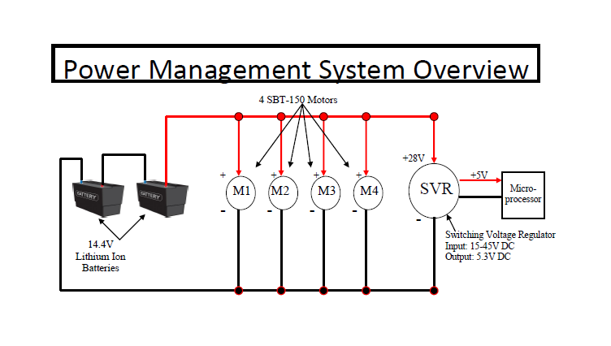

#### Thruster Battery

The batteries chosen for the thrusters were custom Lithium Ion batteries. Two 14.4V DC batteries will be placed in series for a total of 28.8 V DC that’s considered as working voltage. The batteries come with a built in protection circuit module which will maintain a voltage of between 20.8V and 30.6V. Anything outside of this range, the battery will disconnect from any circuit. The PCM also protects from over drain if the amperes exceed anything greater than 40A, however that will be unlikely. The charger for each battery takes 10.1 hours to supply a full recharge. After a full charge, it will take additional 30 minutes for the PCB to evenly distribute the cells inside the battery.

#### Components Battery

The rest of the components on board will be powered with the same two 14.4V Lithium Ion batteries, connected to a Hercules Switching Voltage Regulator (SVR). The SVR takes an input from 15-45V DC, and outputs 5.3 V DC. This output will provide current up to 6 amps for a tested 6 hour, 150 degrees Fahrenheit environment. This will supply USB 2.0 specification power to the microprocessor, which runs off of 5.3V and can consume a maximum of 2A. The system is simplified and all additional components such as the cameras will be powered by the USB connection to the microprocessor. All components will be connected with an inline fuse—rated at its peak amperage consumption, and certainly no more than 2A.

### Sensors

Due to the preliminary requirements of this year’s competition, there will be a need of several sensors for the AUV. Some are specifically needed for specific tasks, while others will just be for general maneuverability and not are necessarily associated with a specific task.

Computer System Structure

MARKER DROPPER

MOTORS

MOTOR CONTROLLERS

ARDUINO BOARD

CAMERA #3

CAMERA #2

CAMERA #1

IMU

USB HUB

BEAGLEBOARD (ON-BOARD COMPUTER)

HYDROPHONES

HYDROPHONE BOARD

#### Cameras

The cameras on board the AUV have two main functions in order to complete the tasks for the competition. The first is color recognition. An orange colored 6” wide sheet of PVC will serve as the path where the cameras need to be able to recognize the orange color among the other colors. Additionally, the cameras will need to be housed in a watertight casing, due to the nature of the operating conditions of the vehicle. Secondly, the camera need to be able to recognize varies shapes within the obstacle course. For example, it must be able to recognize a silhouette of X’s and O’s among other objects. It is also possible that we may use the shape recognition to locate the path as well, but that is yet to be determined. The camera’s data will be input into the microcontroller for data analysis.

#### Hydrophones

A part of the competition includes a “pinger” secured to the bottom of the pool. Since the pinger will broadcast signals throughout the pool, the objective is to recognize the signal, then determine its location. The design will consist of the use of four hydrophones that will assist in determining the location of the pinger. The hydrophone’s data will be input into the microcontroller for data analysis.

#### Inertial Measurement Unit

For the competition, it is obvious that there will be a need of stability and control before the AUV even begins completing any given task. The inertial measurement unit (IMU) will assist the team in stability control. The IMU’s data will be input into the microcontroller for data analysis.

### Microcontroller

The microcontroller will serve as the entire functioning “brain” of the AUV. The microprocessor will take the input from the different sensors, analyze the data, and then send output signals to the motors, mechanical grabber, and marker dropper as well. The motors will be powered through the batteries; however the directions and speed will be controlled through h-bridges and pulse width modulation, respectively. The microcontroller has an ARM processor and was generously donated for the project. The board runs off of 5 volts with a max current draw of 1 amp.

#### Software

To program the microcontroller, C++ and C programming languages will be used. The operating systems will be Linux. The software engineers have updated the pseudo code for performing the tasks and how the sensors will send information to the microprocessor based on the preliminary rules that were released late November. The software engineers are in the process of working with OpenCV and the IMU. Below is a sample of the pseudo code for completing specified tasks:

**Program Structure (Based on 2011 Preliminary Rules)**

--Check Status--

**IF** status OK **THEN** --Check to see if microcontroller properly communicating with sensors

Begin Mission

**ELSE** --if complete communication is not established abort the mission

Abort Mission (deploy emergency shutdown mechanisms)

**END IF**

**Begin Mission:**

--Validation Gate--

**DO** { --continue to search for the validation gate until it is found

Read data from the camera/iMU

Locate validation gate

Compute data needed to pass validation gate

} **WHILE** Gate is not found

Send Data to Motor Controllers --after gate is found clear the gate

Drive through validation gate

Go to the Path

**Path:** --this code designates what is to be done when the AUV encounters the path

**DO** { --the AUV must first find the path

Read data from the Camera/IMU

Locate the path (Orange PVC Sheet)

Compute data needed to follow the path

} **WHILE** Path is not found

Send data to motor controllers --now that the path is found follow it

Follow the path

Read Value of N --Now that the path has been found go to the task

Go to task that corresponds to the current value of N

--N will be used as a counter to find out which task to execute

**Flowers:** --N = 0 this code designates what is to be done when the AUV encounters the flowers

**DO** { --find the buoys which represent the flowers

Read data from the Camera/IMU

Locate the buoys

Compute data needed to get in striking range of buoys

} **WHILE** Buoys not found

Send data to motor controller --now that the buoys are found AUV can proceed to strike them

Strike the buoys

N = N + 1 --increment the task counter

Go to the path

**LoveLane:** --N = 1 this code designates what is to be done when the AUV needs to cross the “L”

**DO** { --find the L shaped PVC pipe

Read data from the Camera/IMU

Locate the “L”

Compute data needed to cross the top of risers

} **WHILE** “L” not found

Send data to motor controllers --now that the risers are found AUV can cross them

Cross the top of the “L”

N = N + 1 --increment the task counter

Go to the path

**LoveLetters:** --N = 2 this code is for when the AUV needs to drop markers

**DO** { --find the bins which house the letters

Read data from the Camera/IMU

Locate the correct bin

Compute data needed to hover over bin 1

} **WHILE** Black bin 1 not found

Send data to motor controllers --now that the bin is found hover over it

Drive AUV over black bin 1

**DO** { --find the correct bin

Read data from the Camera/IMU

Locate bin 1

Compute data needed to drop marker

} **WHILE** Correct bin not found

Send data to motor controllers --now that the bin is found the AUV can drop the markers

Drop both markers --both markers will be dropped into one bin to simplify the task

N = N + 1 --increment the task counter

Go to the path

**Cupid:** --N = 3 this code designates what is to be done when the AUV needs to rescue the object

**DO** { --find the acoustic pinger

Read data from the hydrophones

Analyze the signal and locate the pinger

Compute data needed to get to pinger

} **WHILE** Pinger not found

Send data to motor controllers --now that the pinger is found drive to it

Drive AUV over pinger

**DO** { --find the rescue object which represents the counselor

Read data from the Camera/IMU

Locate the box of candy

Compute data needed to reach and gab box of candy

} **WHILE** Box of Candy not found

Send data to motor controllers --now that the box of candy is found the AUV can grab it

Grab and hold box of candy

**DO** { --rise to the top of the pool with the box of candy

Read data from the Camera/IMU

Locate the octagon and its boundaries

Compute data needed to rise within the octagon

} **WHILE** Octagon not found

Send data to motor controllers --now that the octagon is found the AUV rise to the top

Rise to the top of the pool within the octagon shape

Release the box of candy

**STANDBY** --end of pseudo code

### **Mechanical Grabber**

The design of the grasp and release mechanism will be located at the bottom of the AUV. The design of the mechanical grabber consists of a mechanical claw attached to a solenoid that will attach to a specified object in the water and will bring it to the surface within the ocatagon.

### Marker Dropper

The marker dropper will be an aluminum housing which contains of a servo-motor, which will turn in both a clockwise and counter-clockwise direction and two small steel spheres, which will act as the markers. An aluminum arm will hold the markers in a recessed area of the vehicle. When the servo-motor is activated the aluminum arm will rotate in one direction and one of the markers will drop to the bottom of the pool, when the arm rotates in the opposite direction will drop the second marker.

### Frame Overview

The frame is a rectangular design with weight and simplicity in mind. The outer part of the frame is constructed of 80/20 Aluminum. In the next section, you will find an image of the AUV. The reason for the 80/20 Aluminum is for easy adjustability of any component connected to the frame.

### Hull

The hull will consist of a watertight Pelican box, which will be placed on moveable rails inside the frame. The hull will be on a moveable rail to exercise weight stability. The pelican box is 16”x12”x8” (LxWxH). The hull will house the microcontroller, batteries, humidity sensor, temperature sensor, and all of the on board power management components. The side of the box will house custom SubConn connectors to connect the inside of the box to the thrusters outside of the box and will be waterproof up to 300 feet. All other electrical components (cameras, marker dropper, and mechanical grabber) located outside of the Pelican box will be connected through a vinyl tube that will be clamped onto a brass fitting that will be attached to the side of the Pelican box, allowing all wiring to pass directly through the Pelican box and into the microcontroller.

### Diagrams

#### Side View

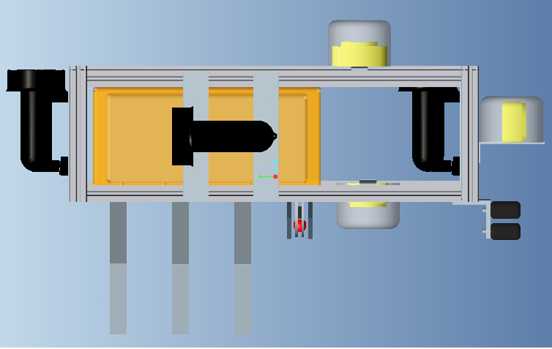

#### Front View

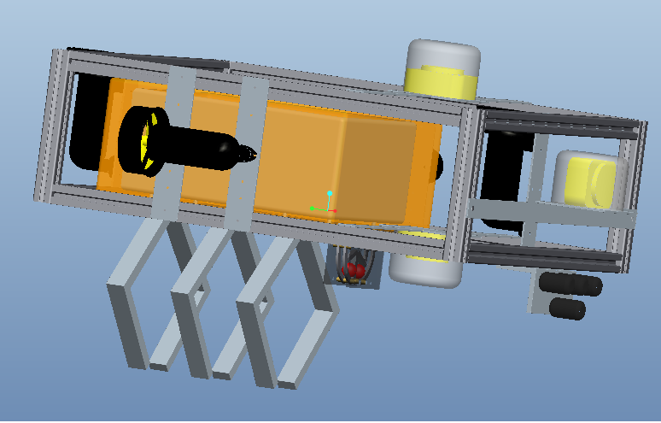

## Performance Assessment

The objective of this project is to design, construct, and program a functional Autonomous Underwater Vehicle (AUV) capable of all operational parameters in the remaining 5 months to win the AUVSI RoboSub Competition. The AUV will be required to operate autonomously, maneuver underwater, and have abilities to read colors and recognize pining signals. Team 4’s AUV will meet the needs and requirements for the project, specified by the official competition rules. Since the 2011 preliminary competition rules were released late November, certain performance assessments are based on the preliminary rules.

Assessing how the system would meet the needs and requirements for the project took hard work by the members of Team 4. The AUV designed by Team 4 will be able to meet the needs and requirements due to the selection of equipment and software. The AUV will be able to maneuver underwater with its propulsion systems comprised of four (4) motors/thrusters. Underwater vision will be accomplished by the use of three (3) cameras, positioned frontally, upwardly and downwardly to maximize the view of the scenery. In order to recognize the underwater pinger, the use of four (4) hydrophones –2 positioned vertically and 2 positioned horizontally will achieve this. An inertial measurement unit will be used for navigation and stability control. In order to power the AUV, the right battery is critical. Team 4 has received the batteries, and will be tested to make sure—the batteries are indeed to the right battery for the job. To meet the weight requirement, the team’s choices of equipment take into account its weight and to meet the size dimension limitation, the size dimensions of the equipment were also taken into account.

## Design Process

At the beginning of this project, there were a lot of unknowns since this project was starting from scratch. In a mere four months, the majority of those unknowns are now known. After a team was put together, numerous decisions still remained. Decisions that needed to be made included how was the AUV going to look, how were we going to raise more money than what we had already, and what would each member’s task be within the project. After these decisions were made, more complex decisions arose that required more thought such as what equipment will the team use, will it be in the budget, if not, what alternatives will be feasible and will it affect the intended goals. These decisions required a lot of research, but the team as whole has successfully decided on the majority of the AUV’s major components.

Team 4 has made great progress including finalizing and purchasing equipment. Major components such as motors/thrusters, the hydrophones, framing, batteries, humidity and temperature sensors have been chosen, some have already been purchased and some are in the process of being ordered. For the motors/thrusters, four SeaBotix SBT150 motors will be used, which have been purchased and are currently going through the testing phase. Four (4) SensorTec SQ26-01 hydrophones, in the process of being ordered, will be used for underwater acoustic capabilities and 80/20 framing, which has already been received, will create the structure of the AUV. The frame for the AUV has since been constructed and is going through testing. Not all of the major components have been finalized as of yet, but the final decision for these components is very close. The team still has to make final decisions on the interface for the microprocessor and cameras. Unfortunately, due to compatibility issues—the original cameras chosen will not suit the needs for this competition.

Even though the majority of the equipment is finalize and/or purchased, the journey is only midway—the remainder of the time will be vital to the AUV’s success. As the remaining equipment begin to arrive, the team needs to determine, after testing, if the decision made was the right one, if not, what can be done to make up for the difference that’s missing. The microprocessor was already supplied to the team, but the software engineers have a tough decision ahead of them. The software engineers are in the process of writing code and seeing how everything will communicate with each other as well as ordering the hydrophones. The electrical engineer in the team is in the process of researching power regulation and the mechanical engineers are in the process finalizing the material needed for the mechanical grabber and marker dropper.

## Overall Risk Assessment

### Technical Risks

#### Leaks

##### Pelican Box: SubConn Connectors Leak

|  |  |
| --- | --- |
| Risk | Improper integration of SubConn connectors |
| Probability | Low |
| Consequence | Catastrophic |
| Strategy | Extensive testing before integration of electrical components |

If the SubConn connectors are integrated inappropriately through the pelican box the consequence would be catastrophic, as this would result in the exposure of corrosive salt water to water sensitive electronics and devices. The probability of this occurring is low. To prevent detrimental damage to several key components of our vehicle the group, after the SubConn connectors have been integrated into the pelican box and before all of the electrical components have been assembled the pelican box will be extensively tested to ensure there are no leaks where the connectors have been implemented. The empty pelican box will be submerged to the operational depth several times to simulate the operational requirements of the competition. The box will be examined to ensure that no leaks have occurred during testing, once confidence in the integration of SubConn connectors has been established the electrical components will be assembled inside.

##### Camera Housing Leak

|  |  |
| --- | --- |
| Risk | Leak of camera housing |
| Probability | Moderate |
| Consequence | Serious |
| Strategy | 1. Extensive testing and analysis before integration of camera |

There is a moderate probability of the camera housing fracturing or failing, inducing a leak, which would result in the malfunction or permanent damage of one or more cameras. The occurrence of this risk would be serious because the three cameras are used in several of the competition objectives tasks. To avoid the occurrence of this risk the AUV team will perform extensive analysis and testing on the camera housing to ensure it is effective at eliminating the threat of the camera's exposure to moisture. If the camera housing does fail and damages a camera the AUV team has minimization strategies and contingency plans to resolve these issues.

#### Malfunctioning External Components

##### Camera Failure

|  |  |
| --- | --- |
| Risk | Failure, damage or malfunction |
| Probability | Moderate |
| Consequence | Serious |
| Strategy | 1. Develop alternative camera configuration for lack of camera  2. Replace damaged cameras. |

The probability that a camera will fail, be damaged, or malfunction is moderate. If a camera is damaged before the competition, the team will examine the warranty of the camera to determine if the part can be returned and a replacement may be obtained in a timely manner. If the warranty is void, the immediate purchase of the replacement part is necessary. If the issue with the camera is repairable, the team will attempt to repair it.

If time does not permit the purchase of cameras, the remaining cameras may be reconfigured to accomplish some of the requisite tasks. If only one camera is unusable and time or budget constraints do not permit the purchase of replacement the other two cameras may be reconfigured with one camera on the front and bottom of the vehicle may be used. The camera on the top is needed to find an octagon and ascend within it; this task may be completed simply with a camera on the front of the vehicle by tilting the device at an angle to search for the octagon. The accuracy and precision of the ascension of the vehicle inside the octagon may be compromised in this case but will accomplish the requisite task. If two cameras are unusable then the remaining camera may be placed on the front of the device and will need to find the octagon and also be able to find the rescue object on the floor of the pool, using the same technique of tilting to view the area above and below the vehicle. During competition if one or two of the cameras malfunction, the remaining camera will be utilized to perform the remainder of the tasks. If budget does not permit purchase of additional cameras, see Budget Risk in Section 2.5.3.

If cameras are damaged during competition the vehicle will utilize the remaining cameras to perform the remainder of the tasks to the best of its capabilities. If the top and/or bottom camera are damaged the remainder of the tasks can be completed purely with the front camera. This can be accomplished by tilting the vehicle up and down to search for targets and the octagon. If the front camera is damaged the vehicle may still find the rescue object and rise inside of the octagon.

##### Hydrophones Failure

|  |  |
| --- | --- |
| Risk | Failure of one or more hydrophones |
| Probability | Low |
| Consequence | Serious |
| Strategy | 1. Analyze damage, return or repair if possible  2. Reconfigure to accommodate for lack of single hydrophone. |

The probability that a hydrophone will fail is low because they are developed for much more intense conditions than those observed during out competition. If one of the hydrophones fails the consequence will be tolerable but if more than one hydrophone fails the consequence will be serious. To prevent failure the team will be careful while integrating the hydrophones to vehicle, to ensure damage does not occur to any part of the component. Care will also be examined when testing and competing to ensure the parts are not damaged. If the hydrophones do fail the team will examine the warranty to determine if the part can be returned and a replacement may be obtained in a timely manner. If the warranty is void, the immediate purchase of the replacement part is necessary. If the issue with the hydrophone is repairable, the team will attempt to repair it. If time does not permit the purchase of replacement hydrophones, the remaining hydrophones may be reconfigured to accomplish the requisite task to the best of the vehicles ability. If only one hydrophone is damaged the remaining three hydrophones will be reconfigured to appropriately triangulate the position of the pinger. If two hydrophones are damaged the remaining two will be reconfigured to identify the depth and distance of the pinger by aligning the hydrophones vertically. The distance/direction of the pinger will be established by the change of the magnitude of the voltage output from the hydrophones, if there is a decrease in the magnitude of the voltage output the vehicle will be able to interpret this as it is going in the wrong direction while if there is an increase in the voltage it will know it is going in the right direction. The vertically placed pingers will be utilized to identify a time delay, which will indicate the depth of the pinger. Once the device is spotted the cameras will be able to complete the task. If budget does not permit purchase of replacement hydrophones see Budget Risk in section 2.5.3.

##### Thruster Failure

|  |  |
| --- | --- |
| Risk | Failure of one or more thrusters |
| Probability | Low |
| Consequence | Serious |
| Strategy | 1. Analyze damage, return or repair if possible  2. Reconfigure to accommodate for lack of single thruster.  3. Float to surface for safe recovery. |

There is a low probability of the failure of the thrusters; failure of thrusters would have a serious consequence because they are utilized for the vehicle maneuverability, which is required to complete all of the tasks. If a thruster is damaged before competition, the team will examine the warranty to determine if the part can be returned and a replacement may be obtained in a timely manner. If warranty is voided, the immediate purchase of the replacement part is necessary. If the issue with the thruster is repairable, the team will attempt to repair it. If time does not permit the purchase of replacement parts, the remaining thrusters may be reconfigured to accomplish some of the requisite tasks. If only one thruster is damaged the remaining three may be reconfigured without losing functionality, utilizing two thrusters to turn the vehicle and one to descend and maintain submersion. If thrusters fail during operation there will be an emergency system that will increase the buoyancy of the device and cause it to rise to the surface for safe recovery. If budget does not permit purchase of additional thruster see Budget Risks in section 2.5.3.

#### Team Member Loss

##### Temporary Loss of Member

|  |  |
| --- | --- |
| Risk | Temporary loss of team member |
| Probability | Moderate |
| Consequence | Serious |
| Strategy | 1. Temporarily reallocate team member's work so that it is accomplished by deadlines.  2. Seek assistance from interested individuals in the engineering school to take on parts of team member's work and work with them when they return.  3. Keep member up to date on advancements of the project. |

There is a moderate risk that a team member will be temporarily lost as a result of sickness, injury or absent due to unforeseeable circumstances and the consequence would be serious because the individual team member will be the most experienced with their technical focus area in the project. In the event of this occurrence adjustments will be made to compensate for the temporary loss of the member. The team member’s documents will be gathered and their work will be split among the team based on individuals’ areas of the strength. To avoid this issue, the AUV team is currently in the process of creating an AUVSI registered student organization to recruit interested students to assist in our project. These students will be kept up to date with the project so that if a situation arises they will be sufficiently knowledgeable about the topic and can effectively complete it in an acceptable amount of time. If there are sufficient amount of involvement each member will develop a committee compiled of students interested in their focus, this committee will be extremely knowledgeable in the inner workings of the committee leaders part of the project so that if an issue arises we will have interested and committed students ready to accommodate for the temporary loss of a team member. While the member is unavailable to work they will be kept up to date on advancements of the project so that when they return they can pick up where they left off and continue work effectively without being off schedule.

##### Permanent Loss of Member

|  |  |
| --- | --- |
| Risk | Permanent loss of team member |
| Probability | Low |
| Consequence | Serious |
| Strategy | 1. Seek assistance from interested individuals in the engineering school to continue team member's work.  2. Reallocate team member's work to other team members. |

There is a low risk that a team member will be permanently lost as a result of unforeseeable circumstances and the consequence would be serious because the individual team member will be the most experienced with their technical focus area in the project. In the event that a team member will not be able to return to complete the project adjustments will be made to compensate for the permanent loss of that member. The team member’s documents will be gathered and their work will be split among the team based on individuals’ areas of the strength. To avoid this being a major issue, the AUV team is currently in the process of creating an AUVSI registered student organization to recruit interested students to assist in our project. These students will be kept up to date with the project so that if a situation arises they will be sufficiently knowledgeable about the topic and can effectively complete the desired tasks. An ambitious and committed student will be reallocated all of the tasks associated with lost team member and, if sufficient participation from students, will lead a committee to assist in completion of said tasks.

#### Rules Change

|  |  |
| --- | --- |
| Risk | Drastic rules change in late February |
| Probability | Low |
| Consequence | Catastrophic |
| Strategy | 1. Only prepare for objectives that have been consistently repeated  2. Reanalyze the budget, schedule, and system to determine feasibility of including more of the objectives required for competition. |

Since the preliminary rules for this year’s competition have been released there is a low probability that there will be substantial changes to the rules and objectives. The result of a drastic rules change would be catastrophic if we based our design on the previous year. To reduce the consequence of this risk the AUV team has researched several competition rules from previous years and included components and objectives that have consistently repeated to ensure that we do not include things that will not be required. If there is a drastic change in the rules the team will have to abandon any requirement that is not required to qualify for the competition and begin to reanalyze the budget and schedule to determine which components from the new rules can be included in the system in a timely manner, refer to sections 2.5.2 and 2.5.3 for budget and schedule risks.

#### Transportation

|  |  |
| --- | --- |
| Risk | Vehicle damage due to transportation |
| Probability | High |
| Consequence | Catastrophic |
| Strategy | 1. Carefully package the vehicle.  2. Drive to California with the vehicle and ensure it is properly secured throughout the trip. |

The probability of the vehicle being damaged during transportation is high due to the large distance that needs to be travelled the consequence would be catastrophic because it would result in the inability to compete. To reduce this risk the team will be driving to California with the vehicle instead of shipping it or taking it through an airline. The vehicle will be meticulously packaged and secured throughout the trip to further ensure the devices safe arrival in San Diego, California.

#### Technological Issues

##### Microcontroller Performance

|  |  |
| --- | --- |
| Risk | Microcontroller not performing task properly |
| Probability | High |
| Consequence | Catastrophic |
| Strategy | Test and debug |

There is a high probability that the microcontroller will not perform tasks properly, during competition the consequence would be catastrophic. To prevent this event during competition the entire AUV system will be tested and debugged repeatedly to ensure that it is capable of performing all desired tasks effectively. If the microcontroller is not performing a desired task, that specific area of the software will be reviewed. If no solution is found the software for the desired function will be rewritten and reintegrated into the main program. If drastic measures are required the entire program will be rewritten.

##### Battery issues

|  |  |
| --- | --- |
| Risk | Battery over-discharging, overcharging, shorting terminal |
| Probability | Low |
| Consequence | Catastrophic |
| Strategy | Purchase battery with built in protection module |

The risks associated with the battery over-discharging, overcharging, shorting terminal is low but the consequence is catastrophic as it would result in deterioration of the electrodes, reduced battery life, and/or a fire. To prevent the occurrence of any of these issues the AUV team purchased a battery with a built in protection circuit module. This protection circuit module keeps the 14.8V Li-Ion battery pack from overcharging and over-discharging while balancing each cell at a maximum of 4.22V/cell.

##### Compass Interference

|  |  |
| --- | --- |
| Risk | Magnetic interference of compass |
| Probability | High |
| Consequence | Serious |
| Strategy | 1. Perform testing to ensure magnetic interference from electronics is minimal.  2. Utilize inertial measurement unit to compare values output by compass to ensure interference at competition does not mitigate performance and effectiveness |

There is a high probability that the compass will experience magnetic interference, either from electrical components in the pelican box or from materials in the pool. To ensure that the magnetic interference from the electronics is not substantial and does not alter the compasses capabilities the compass will be tested with the electronics. Since the composition of the pool is unknown there may be magnetic material that could also interfere with this device, to ensure that the reading will in fact be accurate the gyroscope used to measure yaw will be related to the compass. When the device is placed in the water the two measurements will be in sync: the gyroscope will be calibrated to an initial angle, which will correlate to a certain compass heading. This relationship should remain consistent throughout the competition. If there is an error with the compass as a result of some interference these to values will no longer be in sync. Thus the gyroscope will act as a check for the compass, if the vehicle determines that these two values are not in sync then the output from the compass will be ignored and it will complete the remainder of the tasks without the compass.

##### Drift in Inertial Measurement Unit

|  |  |
| --- | --- |
| Risk | “Drift” in Inertial Measurement Unit |
| Probability | Low |
| Consequence | Serious |
| Strategy | 1. Recalibrate IMU before use.  2. Test to ensure substantial error accumulation does not occur during competition time. |

After prolonged use inertial measurement units (IMU) are subject to Abbe Error, accumulated error, which leads to drift in measurements. To reduce the accumulation of error the IMU will be recalibrated before competition, practices and testing. To prevent serious consequences during competition the system will be tested several times and the measurements output from the IMU will be analyzed to determine if a substantial amount of Abbe Error is induced during the length of time during competition, fifteen minutes. If substantial accumulation does occur the team will need to determine at what point it begins to occur and the amount of error. This information will be utilized to determine a correction factor to be implemented to the values output by the IMU after this point to ensure that the drift is accounted for and does not cause major errors and instabilities.

##### Camera Compatibility

|  |  |
| --- | --- |
| Risk | Compatibility with programming language |
| Probability | Moderate |
| Consequence | Serious |
| Strategy | 1. Research camera compatibility, if possible  2. Test immediately once received.  3. Return camera and purchase known compatible camera |

One type of camera will be utilized in the AUV design. Previous research was conducted on the previous camera that was chosen: Unibrain Fire-I, but due to compatibility issues—there is a possibility that this camera will not be used in the design. From this research it was determined that the Unibrain Fire-I is Linux compatible. Further research showed that the cameras needed to be UVC compatible as well, which the Unibrain Fire-I did not specify. Once received, the Unibrain Fire-I camera will be tested immediately to establish compatibility. If it is not compatible it will be returned immediately and a camera with known compatibility, possibly a LogiTech type webcam, will be purchased and used for the top, bottom and forward cameras.

##### Sensor or Component Communication

|  |  |
| --- | --- |
| Risk | Errors in sensor-microcontroller communication |
| Probability | Moderate |
| Consequence | Serious |
| Strategy | 1. Reevaluate connections  2. Reevaluate programming  3. If possible, remove function  4. Explore alternative sensors as replacements |

If the sensors are not communicating with the microcontroller correctly, the wired connections and programming will be reevaluated. If no solution is found the team will seek faculty assistance to establish the issue and determine a resolution. If that does not work the specific function will be excluded until further notice, if the sensor is necessary for successful completion of tasks an alternative sensors will be explored and purchased if the budget allows. If not, see Budget Risk in section 2.5.3.

### Schedule Risks

#### Critical Scheduling Issues

|  |  |
| --- | --- |
| Risk | The team is critically behind schedule |
| Probability | High |
| Consequence | Severe-Catastrophic(depending on severity of scheduling issues) |
| Strategy | 1. Reallocate man power 2. Work Overtime 3. Abandon Function/Task |

In the event that production is vastly behind schedule the project manager is tasked with evaluating team performance. The probability of this occurring is very high and the consequences are not severe early on. As time progresses the problem will become worse and drastic measures will have to be taken. The team can get behind for a number of reasons. Some can be avoided and others may be inevitable, such as the fact that the official rules for this year’s competition have yet to be released. The project manager will ensure that new methods of production will be put in place to increase efficiency. Every team member is required to work overtime without pay as well as extra hours on weekends. Depending on the severity of the issue sections of the design that are not very important will be scrapped. In an effort to present the sponsors and the FAMU/FSU College of Engineering with a finished product, portions of the design that are not feasible at that point will be delayed until further notice. The team will have to decide what portions of the design to continue to pursue and what to abandon. The team will be required to provide extensive documentation as to why this problem occurred and what can be done to prevent this problem for the next team working on the AUV.

### Budget Risks

#### Insufficient Equipment Funds

|  |  |
| --- | --- |
| Risk | More things needed to be purchased but no funds are available |
| Probability | Moderate |
| Consequence | Severe |
| Strategy | 1. Extensive research for pricing and efficiency of parts as well as careful attention to the welfare of all components 2. Fundraising 3. Sponsorships |

### The completion of this project hinges upon the ability of the team to make engineering related decisions. The team is working with a fixed budget, which means that there are some monetary risks associated with bad choices. The choice of parts will be decided by both the cost and the efficiency of the equipment. The current budget comes with a moderate risk of a deficit in funds. This risk can occur when if there are insufficient funds and the following events occur: parts malfunction, wrong parts have been chosen and if changes are made to the competition rules requiring new parts to be purchased. These problems can be prevented by properly estimating the budget from the beginning and making sure all the parts are cost efficient. The problems can be resolved by attempting to receive more sponsorship from corporations in which they will receive an incentive for their donation. Some sort of fundraising may also be considered to provide income in case additional funds are needed. The last option will be to either pool money together and open a bank account for the project or open a credit card account for the project.

#### Insufficient Travel Funds

|  |  |
| --- | --- |
| Risk | Funds are not available for the team to travel to the competition |
| Probability | Very High |
| Consequence | Catastrophic |
| Strategy | 1. Fundraising 2. Sponsorships |

The purpose of this project is to enter the AUVSI Robosub Competition, which is located in San Diego, California. Upon completion of our design we plan to enter this year’s competition. This risk is dependent upon whether there are funds available for the team to travel to California. The current travel budget is estimated to account for the travel expenses of the entire team. This risk is very high because the team does not have any funds for the current travel budget. The consequence of this risk is catastrophic because the purpose of this project is to design a robot that will represent the FAMU/FSU College of Engineering at the AUVSI Robosub Competition. Obviously if there are no travel funds the team will not compete. Doing fundraisers and attempting to obtain sponsorships can avoid this. Also, reservations should be made as soon as possible to reduce the costs and the entire team may not travel to reduce the costs some more. The worst-case scenario would be that no funds are available and steps will be taken to ensure that the next FAMU/FSU COE AUV team will be able to travel to the next competition.

## Risk Status

In this project there are technical, budget, and schedule risks that the team may encounter. Most of these risks have a moderate to low probability of occurring but in the case that issues do occur the risks are well understood and the team has developed a strategy to handle these dilemmas as they are encountered. There are some risks that are of higher concern, including the potential for damage of our vehicle during transport, compass interference, and rules change, because of their higher probability of occurrence. To ensure that these issues do not induce serious or catastrophic consequences the team has taken the necessary precautions to lessen the probability of occurrence and/or lessen the severity of the associated consequences. There are also certain risks in which the team may require additional help to manage, for example risks associated with sensor and microcontroller communication. Because of the vast amount of variables and issues associated with certain aspects and components of the vehicle, we may require additional help from faculty to identify and solve the problem in a timely and effective manner.

# Design of Major Components

In order for the AUV to function properly it must process data, maneuver underwater, and perform mission tasks, which require a power source that is capable of powering all the systems on board the AUV. In order to accomplish data processing, the AUV will have to retrieve and analyze data through the use of sensors and processors. The sensors must detect sound, light/color, shape, and position. The processor must retrieve the inputs from the sensors and output the correct command to the components of the AUV to successfully compete in the AUVSI Foundation & ONR's 14th International RoboSub Competition. In addition to data processing the AUV must be able to maneuver underwater. This will be accomplished by placing a battery and inertial measurement unit (IMU) along with other water sensitive components in a watertight hull, and by using waterproof thrusters to move. Finally, the AUV must perform mission tasks such as dropping a marker and locating and hoisting a rescue object.

## Batteries

The batteries on board the AUV must be able to power all the systems for a minimum of 15 minutes in order to compete. They must power the processor, all sensors, the thrusters, marker dropper, and mechanical grabber.

We chose a High Power Polymer Lithium-Ion battery to power the thrusters because they have a maximum voltage of 14.8V, a maximum capacity of 20Ah, and a maximum current draw of 30A. The batteries will be connected in series to provide 29.6V, which is within the allowable range of the voltage regulator on the thrusters. This battery was selected in order to give the AUV a run time of 1 hour at maximum amp so that we have an extended period of time to work on debugging and system calibration during the testing phase. A Lithium-Iron Phosphate battery was also considered for the AUV; however, it was more expensive and was considerably heavier. Nickel Metal Hydride batteries could not supply sufficient Amp hours while Nickel Cadmium batteries do not have sufficient voltage or amp hours. We are in the process of choosing a battery to power all other electrical systems on the AUV. For risk associated with the batteries see section 2.5.1.6.2.

## Microcontroller

The microcontroller will have to analyze all inputs from the sensors on the AUV and output the correct commands to the thrusters, marker dropper, and mechanical grabber in order to function competitively. The microprocessor will receive inputs from the cameras, hydrophones, and inertial measurement unit. An ARM processor has been donated to the project and will be used in order to cut cost associated with the design. For risks associated with the microcontroller see sections 2.5.1.6.1 and 2.5.1.6.6.

## Hydrophones

Four SenserTec SQ2601 hydrophones will be utilized in the vehicle design to locate an acoustic pinger that will be somewhere in the Camp Transdec anechoic pool. This will be accomplished using a concept similar to triangulation; there will be a time delay between the voltages output by the two horizontal hydrophones and the two vertical hydrophones which the microprocessor will be able to interpret. This time delay will be utilized to determine the direction of the sound source. The two hydrophones oriented horizontally will be used to determine whether the pinger is to the left or right of the AUV while the two hydrophones oriented vertically will determine the depth of the pinger. Since the magnitude of the sound input correlates to a magnitude of voltage output the hydrophones may also be utilized to determine the approximate distance of the pinger. Figure 1 is a conceptual design demonstrating the proposed orientation for the hydrophones. The effectiveness of this configuration will be determined during testing, if this configuration does not prove to be effective other configurations will be investigated.

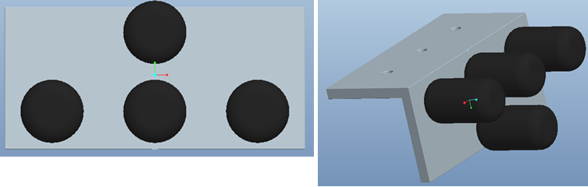

Figure 1: Hydrophone orientation

The SensorTec SQ26-01 hydrophone was chosen for our AUV because it performs in the required range of the pinger (22-40 kHz) and is relatively cheap, when compared to other hydrophones. The SensorTec hydrophone does not have an amplifier built into it so during testing the need for an amplifier, as well as the magnitude of amplification, will be determined. These hydrophones are priced at $200 each for a total of $800 for all hydrophones, which is within our budgeted amount. For risks associated with the hydrophone see section 2.5.1.2.2.

## Cameras

Three cameras will be place on the AUV in order to detect light/color and shape of objects so that the AUV will know in which direction to travel and which mission task it is presented with.

The original cameras that were chosen were the Unibrain Fire-I webcams for the AUV because it has a CCD lens, which allows it to operate in low light conditions. They ranged from $100-$130 and were going to be used for shape and color recognition in the upward, forward and downward configuration. We chose the Unibrain Fire-I because it is Linux compatible, which is the operating system we will use for the AUV, and because it is a cheap CCD lens camera. Unfortunately, they were not UVC compatible. Due to this fact, the Unibrain Fire-I webcams cannot be used. Most other CCD lens cameras cost $500-$1000 and the budget cannot withstand this expense, but the software engineers are currently looking for another webcam that’s affordable, Linux and UVC compatible. Right now, the software engineers are looking at the LogiTech webcams, but the finalized cameras will be forthcoming. For risk associated with the cameras see sections 2.5.1.2.1 and 2.5.1.6.5.

### Camera Housing

The camera housing will be used to protect the cameras from water damage. We will use PVC pipes to house the cameras and we will machine aluminum end-caps to prevent leaks, as well as a viewing lens to allow the camera to view the surroundings. We require three camera housings and each one is expected to cost approximately $30-$40. For risk associated with the camera housing see section 2.5.1.1.2.

## Inertial Measurement Unit

An inertial measurement unit will be used to detect changes in the AUV orientation while underwater. IMUs typically include a combination of gyroscopes and accelerometers. The IMU will output a signal to the processor, which will determine whether the thrusters need to accelerate/decelerate, pitch up/down, or turn the AUV left/right.

A PhidgetSpatial 9 Axis inertial measurement unit was chosen for the AUV because it has a 3-axis gyroscope, accelerometer, and compass. We considered purchasing a different IMU that contained a gyroscope, accelerometer, and magnometer. However, the magnometer, which measures the magnetic field in its immediate surrounding is expected to have a large amount of interference due to the electronics inside the Pelican Box and was not chosen for this reason. We also considered purchasing an accelerometer and compass unit and a separate gyroscope, which would cost $130, however we chose the more expensive PhidgetSpatial 9 Axis IMU because it has all the components in a single unit, which will be easier to work. The PhidgetSpatial 9 Axis IMU cost $150, which is the amount we set aside for purchasing an IMU. For risks associated with the IMU see sections 2.5.1.6.3 and 2.5.1.6.4.

## Hull

The hull will be a Pelican Box, which is a watertight case that is large enough to house all of the water sensitive components on the AUV. Utilizing a Pelican Box will be simpler that designing a watertight housing and costs $100-$150. By using a Pelican Box we reduce the risk of leaks developing throughout the testing phase and during transportation.

### Frame

The frame of the AUV will be constructed out of 80/20 Aluminum. This allows for easy adjustability since this is the first attempt at building an AUV and we cannot design for all possible requirements and scenarios. The 80/20 Aluminum is structurally sound and can support all components that make up the AUV. In addition, the design of 80/20 naturally mitigates vibrations, which will reduce noise in the hydrophones. The hull will be placed within the frame to prevent damage to the pelican box.

## Thruster

Four thrusters will be placed on the AUV in a configuration to provide forward/reverse, left/right turning, and depth control. The microprocessor will control the voltage to each thruster thus increasing the angular velocity of the propeller to provide the different modes of movement.

The SeaBotix SBT150 Thruster (see Appendix C section 9.3 for data sheet) was chosen because of its functional ability and water resistance, the fact that it has a built in motor controller and voltage regulator, and for its low power consumption. The input voltage for the voltage regulator is approximately 22-30V to supply the motor with the required 19V. The SeaBotix BTD150 was also considered for this project but was not chosen because it lacked a motor controller and was otherwise equivalent to the SBT150. For risk associated with the thrusters see section 2.5.1.2.3.

|  |  |  |  |  |  |
| --- | --- | --- | --- | --- | --- |
|  | Cost | Thrust | Power Consumption | Dry Weight | Rank |
| Weighting Factor | 0.2 | 0.2 | 0.5 | 0.1 |  |
| **Seabotix BTD-150** | 7 | 6 | 9 | 9 | **8** |
| Crust Crawler 400HFS | 5 | 10 | 4 | 10 | 6 |
| Technadyne 260 | 6 | 8 | 5 | 8 | 6.1 |

## Marker Dropper

In order to perform competitively at the next AUVSI competition we must have a marker dropper on the AUV. It will be used to identify a space or object that the AUV will be required to find. The marker dropper will be machined out of aluminum and will utilize a water proof servo motor that will rotate clockwise or counter clockwise to release individual markers. The servo motors are made by Traxxas and were the most cost effective water proof servos. See Figure 2 for a conceptualized marker dropper.

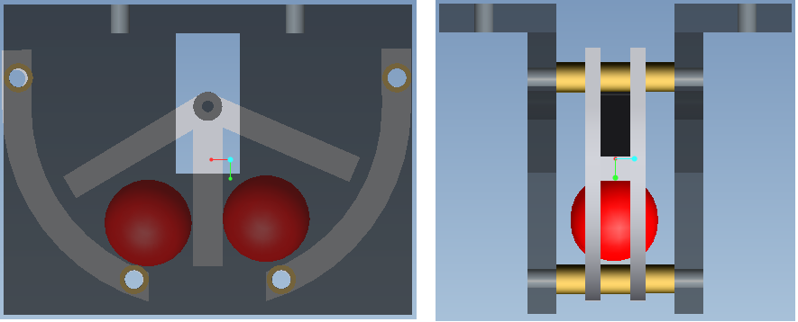Figure 2: Marker dropper

## Mechanical Grabber

The mechanical grabber will be used to hoist a rescue object to the surface. The final design of the mechanical grabber has not been completed yet. We plan to use an array of claws to grasp the object, as seen in Figure 3.

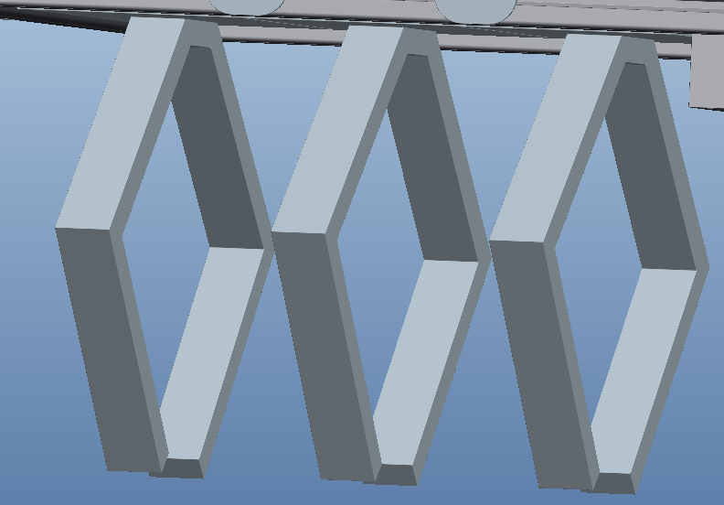

Figure 3: Array of Claws

# Test Plan

To ensure the effectiveness of our vehicle and its components our group will perform unit, integration, simulation, and prototype testing. As a part of the unit testing phase we will be evaluating all of the sensors (including the hydrophones, inertial measurement unit, humidity module, thermocouple and cameras), the power systems, the motors, the structural components (including the pelican box), marker dropper to ensure our device meets our functional requirements and constraints. If any test fails, it may be subject to retesting to ensure that it did not fail as a result of unexpected circumstances.

After all of the individual components have been tested we will proceed to the integration testing. The major integration factors to be tested will be pelican box connections, microprocessors and sensors, power system and thrusters, and the RoboSub.

## System and Integration Test Plan

The major system integration tests we have planned are for the microprocessor communication and RoboSub integration. Since all of the devices will be required to communicate with the microprocessor we will be testing the integration of these devices with the microprocessor to ensure effective communication. The microcontroller will be integrated with all of the devices individually and simultaneously to ensure that the work together properly as well as continue to work properly once they are all operating at concurrently.

Once all of the devices and parts have undergone unit testing, the entire device will be constructed, integrating all of the components. At this time full testing will begin to determine the overall effectiveness of the device. Full scale debugging will also be accomplished during this stage of testing. See appendix (section 9.1) for full test procedure.

## Test Plan for Major Components

### Batteries

The power sources will be tested to ensure that the current capacity as well as the lifespan is suitable for our vehicle operating conditions. This will be accomplished simulating power consumption, using the motors, well above our anticipated conditions to ensure that the batteries will be able to provide sufficient power for a worst case scenario. During this testing the effectiveness of the integration between the batteries and motors is established. See appendix (section 9.2) for full test procedure.

### Cameras

The cameras will be tested to ensure that it works effectively with the OpenCV software, which will be utilized for image processing. The cameras will also be tested to ensure that they are able to take acceptable quality photographs. See appendix (section 9.2) for full test procedure.

### Hydrophones

The hydrophones will undergo two separate tests through three phases of testing. The initial test will be to ensure that all sensors are manufactured correctly and work properly in out of water conditions. The second test will determine the appropriate spacing and positioning of the hydrophones on the mounting bracket. The last test will be to investigate the performance of the hydrophones in the optimal configuration while underwater. The last test will also serve as an integration test for integration of the hydrophones to the finalized mounting bracket. See appendix (section 9.2) for full test procedures.

### Humidity Module

The humidity module will undergo testing so that it can be accurately calibrated. This initial calibration will be performed by introducing the device to an environment where the humidity is known so that the output voltage can be correlated to the accurate humidity. See appendix (section 9.2) for full test procedure.

### Inertial Measurement Unit

The inertial measurement unit (IMU) will undergo two phases of testing: one on a Windows Operating system and another on the Linux operating system. The first test will be performed on the Windows operating system to ensure the operational capabilities of the device. Once the device has proven to be satisfactory it will be tested on the Linux operating system. See appendix (section 9.2) for full test procedure.

### Thermocouple

The thermocouple will also undergo testing so that it can be accurately calibrated. This initial calibration will be performed by introducing the device to an environment where the temperature is known so that the output voltage can be correlated to the accurate temperature. See appendix (section 9.2) for full test procedure.

### Marker Dropper

The marker dropper will undergo two phases of testing: on in and outside of water. The dropper will be tested to ensure that it is capable of releasing both marbles individually. It will initially be tested in air then again in water to ensure that there are no leaks present that will affect the performance. Ultimately the dropper will also be tested in the pool environment to ensure optimal performance. See appendix (section 9.2) for full test procedure.

### Motors

The motors will be tested to ensure that they will functions properly when integrated with the chosen motor controllers. They will also be tested to ensure that they were manufactured properly and can perform at desired capacity when underwater. Finally they will be tested to ensure that all thrusters work well when integrated together. See appendix (section 9.2) for full test procedure.

### Pelican Box

After holes have been drilled through the pelican box and waterproofing measures have been completed, the pelican box will be tested to ensure that it is still waterproof. This will be accomplished by utilizing the humidity module after it has been calibrated. The humidity level as the pelican box is submerged will be analyzed to ensure there is no increase in water content while the pelican box is in use. See appendix (section 9.2) for full test procedure.

### Voltage Regulator

The voltage regulator will be undergo two phases of testing: one to test the output voltage and another for the output current. This will be accomplished by using connecting the power source and measuring the desired quantity using a voltmeter or ammeter. See appendix (section 9.2) for full test procedure.

## Summary of Test Plan Status

As of now, no testing has been performed. All components will begin testing in the following weeks. Once testing has begun the results of all the tests will be documented in the test plan documents, which can be found in the Appendix. These documents also contain all the testing information, including procedure; date testing will be performed, etc.

# Schedule

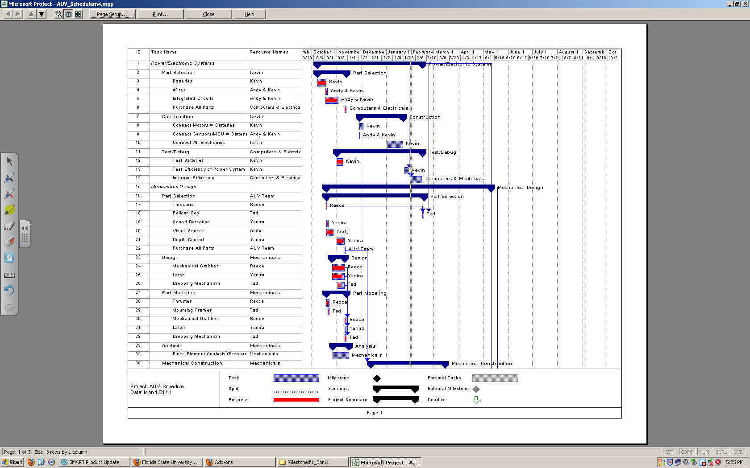

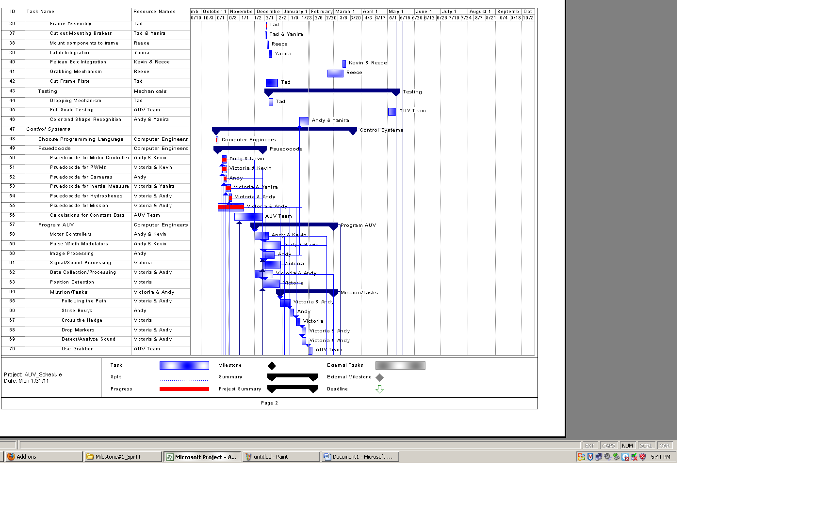

# 

# Budget Estimate

|  |  |  |  |  |
| --- | --- | --- | --- | --- |
| **AUV ESTIMATED BUDGET(Updated)** | | | | |
| **Expenses (S&H Estimated)** | | | | |
| **Name** | **Description** | **Price** | **Quantity** | **Total** |
| Main Batteries | LiFePO4 Batteries (Includes Chargers) | $450.00 | 2 | $900.00 |
| Voltage Regulators | Microcontroller and Sensors | $60.00 | 1 | $60.00 |
| Motors/Thrusters | SeaBotix SBT 150 thrusters w/ motor controllers | $750.00 | 4 | $3,000.00 |
| Hydrophones | Cetacean SQ26-01 | $220.00 | 4 | $880.00 |
| Microcontroller** | BeagleBoard Rev. B7 | $170.00 | 1 | Free |
| Control Board | Interfaces the computer with the sensors | $100.00 | 1 | $100.00 |
| Cameras | Unibrain Fire-I Digital Camera CCD Camera | $125.00 | 3 | $375.00 |
| Pelican Case | Water tight casing | $150.00 | 1 | $150.00 |
| Wires, Electronic Kits, Cables & Connectors, Small sensors | All Electronic Kits/Parts, ICs, Water tight connectors, Computing/Sensor connections | $1,200.00 | N/A | $1,200.00 |
| 80/20 Frame | 1" x 1" x 48.5" Extrusion (w/ 7005 cut charge), 1" x 1" x 36.25 Extrusion (w/ 7005 cut charge), 10 Series 1/4-20 T-Nut, 10 Series Anchor Fastener | $210.00 | N/A | $210.00 |
| Aluminum Plate 14 in x 12 in x ¼ in | Frame | $70.00 | 1 | $70.00 |
| Inertial Measurement Unit | Phidget Spatial 3/3/3, 9 Axis IMU (Navigation/Stability Control) | $150.00 | 1 | $150.00 |
| **Total Expenses** | Total estimated cost of all expenses | | | $7,095.00 |
| **Total Funds** | Total estimated amount of sponsorships | | | $9,500.00 |
| **Total Remaining Balance** | Total estimated remaining funds | | | $2,405.00 |

## Budget Justification

This budget is an estimation of all the costs that will concur during the development of the FAMU/FSU College of Engineering AUV. The item in our budget with two asterisks is the donated BeagleBoard w/ an ARM Cortex A-8 processor. The first and most important items listed are our control and drive train items. We have decided to use two batteries to power the motors. We will also use a few smaller batteries to power the MCU and the other peripherals for our AUV. The motors will be SeaBotix SBT150s that include both motor controllers and thrusters with shroud surrounding the propellers. The microcontroller that we will use has been donated to us and meets the ARM requirement, which states that all computing equipment must be an ARM product. The microcontroller we will use is the BeagleBoard and it comes equipped with the ARM Cortex A-8 as well as the OMAP3530 application processor. All the electronic equipment will be held in a pelican case to protect the electronics from water damage and since this vehicle will be submerged we will also purchase watertight connectors to protect the wiring. The hydrophone is still in question but we have budgeted for them. We have decided to use the cheaper alternative for image processing by using the webcam that can be utilized to observe and track color and shape. The last sensor we have listed is the inertial measurement unit, which contains the accelerometer, compass and gyroscope in one unit. This item will be used for position and orientation detection. We are going to use a cheap serial board for PWM and ADC outputs. There is also a voltage regulator that will be used to power the MCU and all of it’s sensors. All the other expenses are dealing with the design of the frame as well as the necessary materials for stabilizing all the components to the frame.

# Conclusion

Conclusively, Team 4 has made great progress and is continuously working and researching to gain the upper hand on the competition. As mentioned, Team 4 has finalized intended goals, and the design of the AUV and potential alternatives, just in case some goals need to be altered for unexpected reasons. Team 4 has also finalized and/or purchased the bulk of the major components, including framing, motors/thrusters, hydrophones, and cameras, just to name a few. Progress in the software aspect of the project is excelling. In that aspect, the operating system will be Linux and the programming languages that will be used are C and C++. The software engineers are working with the available sensors as well as prioritizing so the best product can be provided to the customer. The project, as a whole, is proceeding well and the team is dedicated to satisfying the customer at all cost. Team 4 is capable of producing an exceptional product to compete in the AUVSI competition. The expected result of this project is to create a vehicle, which not only meets the design requirements, but also does so in a way, which is more precise and efficient than our competitors. Team 4 is in the process of achieving this outcome. Hard work and devotion makes Team 4 a worthy candidate for providing the complete satisfication of the requirements associated with the competition as well as additional objectives as time permits.

# References

Official Rules for 2010 competition:

"Official Rules and Mission AUVSI & ONR's 13th Annual International Autonomous Underwater Vehicle Competition." *AUVSI Foundation*. Web. Sept.-Oct. 2010. <http://www.auvsifoundation.org/AUVSI/FOUNDATION/UploadedImages/AUV_Mission_Final_2010.pdf>.

Preliminary Rules for 2011 competition:

<https://campus.fsu.edu/courses/1/EEL4914C.sp11.web_cohort1/content/_4213146_1/PreliminaryMission_2011_RoboSub.pdf?bsession=156246546&bsession_str=session_id=156246546,user_id_pk1=526216,user_id_sos_id_pk2=1,one_time_token=>

Barngrover, Chris. "Design of the 2010 Stingray Autonomous Underwater Vehicle." *AUVSI Foundation*. Office of Naval Research, 13 July 2010. Web. 09 Nov. 2010. <http://www.auvsifoundation.org/AUVSI/FOUNDATION/UploadedImages/SanDiegoiBotics.2010JournalPaper.pdf

# Appendices

## Integration Tests

### Scheduled Test Reporting Form

Test Item: Autonomous Underwater Vehicle (as a whole)

Tester Name: Victoria Jefferson/ Whole Team Tester ID No: vcj07

Test Date: TBD Test No: 1

Test Time: TBD Test Type: Test

Test Location: FSU Outdoor Pool Test Result: TBA

Test Objective:

The objective of this test is to verify the completed RoboSub can operate autonomously, complete a mock obstacle course within 15 minutes and can remain underwater without losing power or suffering from water damage.

Test Description/Requirements:

Requirements:

1. The RoboSub
2. Body of water (salt or fresh water)
3. Stop Watch
4. Laptop
5. Team member that is certified diver

Process:

This test is the last test that will be done after the RoboSub has been completed. This test will be similar to a mock competition. The whole team will be present and will help lower the AUV in the water. Depending on if a fresh water or salt water pool is used for the duration of testing, corrosion is another problem that we would need to keep an eye on. When the RoboSub is powered and in the water on its own, all of its components will be tested. The Motors/thrusters will be tested to make sure they can move the RoboSub through the water. The batteries will be tested to make sure they can continue to produce power to the RoboSub and the other electronics. The microprocessor will be tested to make sure the RoboSub can operate autonomously and collect the data from all of the sensors (cameras, IMU and hydrophones) and process it accordingly. All of the sensors will be tested to make sure they can detect color, objects and sound underwater. To test of all of these components, a mock obstacle course will be created such as the one that will be in the actual competition. A diver will be underwater with the RoboSub throughout the duration of this test to monitor its action and if need be, pull it back to the surface. The kill switch will also be tested by the diver.

Anticipated Results:

The RoboSub should operate on its own, maintain power throughout the test, all components should operate as previously tested, and complete the tasks without any damage (water or physical). It is not expected to operate perfectly, but if the RoboSub can pass this final test—it would be a great accomplished for everyone involved.

Requirement for Success:

The minimum requirements for success are operating autonomously, realize different tasks, and maintain power throughout the duration of it being underwater and those components within the RoboSub remain dry. It is also desired, but not required, that the RoboSub completes all tasks in the specified time frame.

Actual Results:

TBA

Reason for Failure:

TBA

Recommended Fix:

TBA

Other Comments:

It is not required to accomplish all tasks in the competition, even though it is desired. Since this is the first year that FAMU/FSU RoboSub will be entered into the competition, settle steps forward are anticipated.

**Scheduled Test Reporting Form**

Test Item: Microcontroller with Sensors

Tester Name: Andy Jeanthenor Tester ID No: aj09

Test Date: TBD Test No: 2

Test Time: TBD Test Type: Test

Test Location: College of Engineering Lab Test Result: TBA

Test Objective:

The objective of this test is to test whether the microcontroller and the sensors perform the functions needed for AUV operation properly.

Test Description/Requirements:

Requirements:

1- Microprocessor

2- Sensors

1. Cameras
2. IMU
3. Hydrophones

3- Power Supply

Process:

The microcontroller will have to be integrated with all the sensors to make sure they are all working together properly. The sensors will be programmed individually and tested individually to make sure each sensor works independently of the other sensors. The integration will be tested by running software that will use all the sensors at the same time and will simulate AUV operation. The position, depth, pressure, temperature and humidity sensors will have to be tested during the test runs. This will be tested by storing the data received from the sensors and using a laptop to remotely monitor sensor activity. The cameras will be tested using a laptop as a host to observe if the software is accurately retrieving the correct data from the cameras. The motor controllers will be tested by using a motor control module of the software and observing the motors. The test runs will be documented and all errors will be addressed. This process will be repeated until all sensors are working properly with the microcontroller. Simulation tools will be used prior to physical testing to save time.

Anticipated Results:

The microcontroller properly communicates with purchased sensors and produces the desired results.

Requirement for Success:

The requirement for success is that the microcontroller is completely operational with the sensors and the microcontroller communicates properly and performs the desired functions.

Actual Results:

TBA

Reason for Failure:

TBA

Recommended Fix:

TBA

Other Comments:

**Scheduled Test Reporting Form**

Test Item: Hercules Voltage Regulator (WRL-HBECHC)

Tester Name: Kevin Miles Tester ID No: kdm06d

Test Date: 2/04/2011 Test No: 1

Test Time: 1:30 P.M. Test Type: Test

Test Location: College of Engineering Lab Test Result: TBA

Test Objective:

The objective of this test is to test the Switching Voltage Regulator (SVR). The test will analyze two important criteria of the switching voltage regulator, the current and the voltage output.

Test Description/Requirements:

Requirements:

1- 28V Lithium Ion Batteries (Fully Charged)

2- Voltage and current meter

3- Hercules Voltage Regulator (WRL-HBECHC)

4- 14 gauge wire

Process:

First, the output voltage of the SVR will be tested. The batteries will be connected to the VCC and GND inputs of the SVR the output VCC and GND will then be connected to a volt meter. The output voltage will be recorded.

Second, the output current will be tested. The batteries will be connected as before. Then, the output VCC of the SVR will be connected to a 1 ohm, 5W rated resistor, which is then connected to the positive input of the ammeter, then the negative input of the ammeter will be connected to the output ground of the SVR. Here, the ammeter will read the current passing through the circuit and ensure that 5 amps can be supplied from the SVR.

Anticipated Results:

We anticipate that the voltage regulator will output 5.3 V, and a current of 5 amps is achievable. Laboratory test from the company state that the SVR can sustain its maximum output for over an hour, the AUV group anticipates the same.

Requirement for Success:

The requirement for success is for the SVR to correctly output its stated output voltage and current levels for a sustained amount of time.

Actual Results:

TBA

Reason for Failure:

TBA

Recommended Fix:

TBA

Other Comments:

**Scheduled Test Reporting Form**

Test Item: Pelican Box

Tester Name: Tadamitsu Byrne Tester ID No: trb06e

Test Date: 2/28/2011 Test No: 1

Test Time: 5 PM Test Type: Test

Test Location: FSU Outdoor Pool Test Result: TBA

Test Objective:

The objective of this test is to determine whether the pelixan box is water tight to a depth of 15 feet by utilizing a HM1500LF - Relative Humidity Module.

Test Description/Requirements:

Requirements:

1- Pelixan Box

2- Pool with depth of 15ft

3- Vynl tubing

4- Brass fitting

5- Hose clamp

6- HM1500LF Humidity module

7- Multimeter

Process:

A hole will be machined in the pelican box that will allow wires to pass in and out. A brass fitting will be placed inside the hole and a vinyl tube will be placed over the brass fitting and sealed with 2 hose clamps. All wiring will be passed through the vinyl tube into the pelican box. To ensure that the outlet is water tight the pelican box will be submerged with the humidity module inside. The voltage output of the HM1500LF correlates directly with the relative humidity in the pelican box. The humidity module will be connected to a multimeter to monitor voltage output.

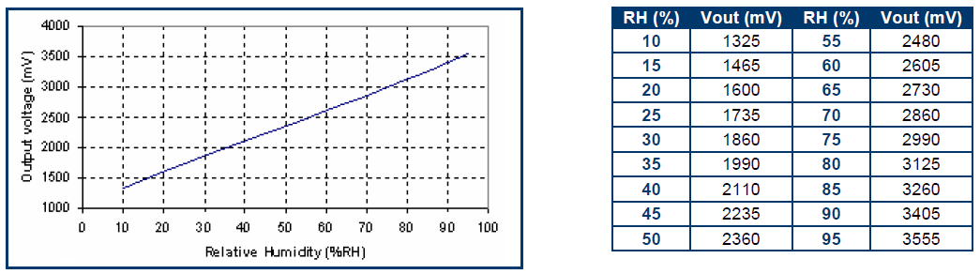

Anticipated Results:

The HM1500LF will relay output voltage corresponding to a safe humidity level for electronics operation.

Requirement for Success:

The pelican box is water tight and the HM1500LF indicates no change in voltage during the test.

Actual Results:

TBA

Reason for Failure:

TBA

Recommended Fix:

TBA

Other Comments:

## Major Components’ Tests

**Scheduled Test Reporting Form**

Test Item: Batteries

Tester Name: Kevin Miles Tester ID No: kdm06d

Test Date: 2/03/2011 Test No: 1

Test Time: 5 PM Test Type: Test

Test Location: College of Engineering Lab Test Result: TBA

Test Objective:

The objective of this test is to test the batteries current capacity and lifespan. We will test for the current draw as well as the amp-hours against the given specs to ensure accuracy

Test Description/Requirements:

Requirements:

1-SBT 150 Motors (4)

2-Lithium Ion 14.4V Batteries

3-14 Gauge wire

4-BeagleBoard

5-Hercules Switching Voltage Regulator

6- Timer

Process:

In this test, the AUV team will simulate real time power usage from the Switching Voltage Regulator and the SBT Motors. The Motors will be run at 70% (50% is the estimated needed power) and the simulation will be timed. This will give us a “worst-case” maximum amount of time we will be able to run our machine.

Anticipated Results:

It is believed that the AUV will be able to sustain power for over 1 hour. At max capacity, the system runs almost exactly 1 hour if the device is exactly as specified.

Requirement for Success:

The battery simulation must run for at least 1 hour to be considered a success.

Actual Results:

TBA

Reason for Failure:

TBA

Recommended Fix:

TBA

Other Comments:

**Scheduled Test Reporting Form**

Test Item: Cameras

Tester Name: Victoria Jefferson Tester ID No: vcj07

Test Date: TBD Test No: 1

Test Time: TBD Test Type: Test

Test Location: College of Engineering Lab Test Result: TBA

Test Objective:

The objective of this test is to verify that all of the cameras are operational and capable with the OpenCV software. After that objective is verified, cameras will be tested to verify that they are capable of taking still pictures and videos.

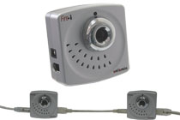

Test Description/Requirements:

Requirements:

1. 3 Fire-I web cameras
2. USB power supplies
3. ARM microprocessor
4. Monitor
5. Keyboard will be needed to complete this test

Process:

Each camera will be tested separately to verify the test objective and later all cameras will be tested as an integration test. For each camera, the USB power supply will be connected as well as connected with the microprocessor. The OpenCV software will be opened and verified that there is a connection. Tester will take a series of still pictures as well as videos.

Anticipated Results:

Each camera will successfully connect using its USB power supply to the microprocessor, monitor with the keyboard and capture still pictures as well as videos.

Requirement for Success:

The minimum requirements for success are to be able to configure with the other components and software as well as produce reasonable quality pictures and videos.

Actual Results:

TBA

Reason for Failure:

TBA

Recommended Fix:

TBA

Other Comments:

**Scheduled Test Reporting Form**

Test Item: HM1500LF Humidity Module

Tester Name: Tadamitsu Byrne Tester ID No:

Test Date: 2/20/11 Test No: 1

Test Time: 5 PM Test Type: Test

Test Location: TBD Test Result: TBA

Test Objective:

The objective of this test is to calibrate the HM1500LF - Relative Humidity Module.

Test Description/Requirements:

Requirements:

1- HM1500LF Humidity module

2- Multimeter

Process:

The HM1500LF will be introduced to an environment where the relative humidity is known. The output voltage will be measured and the %RH (percent relative humidity) will be calculated as follows:

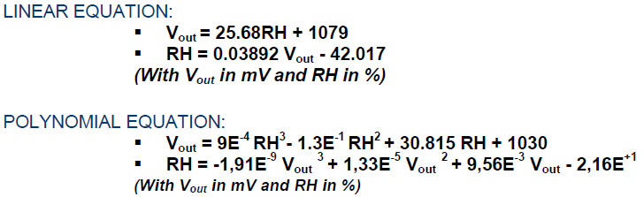

Anticipated Results:

The HM1500LF will relay output voltage corresponding to the known RH.

Requirement for Success:

The HM1500LF indicates the correct voltage corresponding to the RH.

Actual Results:

TBA

Reason for Failure:

TBA

Recommended Fix:

TBA

Other Comments:

**Scheduled Test Reporting Form**

Test Item: Hydrophones

Tester Name: Yanira Torres Tester ID No: ykt07

Test Date: TBD Test No: 1

Test Time: TBD Test Type: Test

Test Location: College of Engineering Lab Test Result: TBA

Test Objective:

Preliminary investigation to ensure that the SQ26-01 hydrophones were manufactured correctly, thus can output a voltage given a sound input within the 22 kHz to 40 kHz frequency range.

Test Description/Requirements:

Requirements:

1- Hydrophones

2- Sound source/pinger

3- ARM Microprocessor

4- Voltage source (batteries)

5- Waterproof casing

6- Analog to Digital converter

7- Computer

Process:

The microprocessor and voltage source will be set up and stored in the waterproof casing to which the hydrophones will be attached through. At this time the sound source will supply sound within the frequency range (22 kHz to 40 kHz). The spacing between the sound source and the hydrophones will begin at a distance of 10 ft, the spacing will be decreased 5 ft between each test until the hydrophones/case is reached. The voltage output will be analyzed to ensure that it is identifiable by the microprocessor. If no voltage is measured an amplifier will be added to the circuitry and the previous steps will be repeated.

Anticipated Results:

The hydrophones will function properly and effectively output an identifiable voltage at all distances.

Requirement for Success:

Hydrophones must receive input frequencies (between 22 kHz and 40 kHz) and output identifiable voltage

Actual Results:

TBA

Reason for Failure:

TBA

Recommended Fix:

TBA

Other Comments:

**Scheduled Test Reporting Form**

Test Item: Hydrophones

Tester Name: Yanira Torres Tester ID No: ykt07

Test Date: TBD Test No: 2

Test Time: TBD Test Type: Test

Test Location: College of Engineering Lab Test Result: TBA

Test Objective:

To determine optimal spacing between SQ26-01 hydrophones to produce identifiable time delay between horizontal and vertical hydrophones.



Test Description/Requirements:

Requirements:

1- Hydrophones

2- Sound source/pinger

3- ARM Microprocessor

4- Voltage source (batteries)

5- Cardboard

6- Analog to Digital converter

Process:

A cardboard material will be utilized to simulate the aluminum mounting plate, used to maintain spacing between hydrophones. Several cardboard simulations will be cut out, with holes the approximate size of the hydrophones, with varying spacing between horizontal (dx) and vertical (dy) hydrophones. Spacing on these cutouts will be a maximum of 8 in for dx and 6 in for dy while having a minimum of 3 in for both dimensions. The hydrophones will be integrated and tested in each of the hydrophone configurations. The horizontal hydrophones’ response will be examined by placing the sound source horizontally at a distance of 1 ft, 5 ft, and 10 ft away on both the right and left side for each test configuration, beginning at the largest spacing and proceeding inward. The hydrophones will be integrated and tested in each of the hydrophone configurations. The vertical hydrophones’ response will be examined by placing the sound source horizontally at a distance of 1 ft, 3 ft, and 6 ft away on both the top and bottom side for each test configuration. The bottom side will be tested by flipping the cardboard mounting frame over and preceding in the same manner the top side was performed. The time delay between the two hydrophones, both horizontal and vertical, will be examined to determine whether it is large enough to be identifiable by the microprocessor. The magnitude of the time delay at all test conditions will be recorded.

$d_{y}$

$d_{x}$

Anticipated Results:

Maximum distance between both horizontal and vertical hydrophones will produce largest time delay. One of the configurations will provide all individual hydrophones with negligible sound interference from any other hydrophone.

Requirement for Success:

One, or several, of the configurations will provide an identifiable time delay between both horizontal and vertical hydrophone arrays.

Actual Results:

TBA

Reason for Failure:

TBA

Recommended Fix:

TBA

Other Comments:

**Scheduled Test Reporting Form**

Test Item: Hydrophones

Tester Name: Yanira Torres Tester ID No: ykt07

Test Date: TBD Test No: 3

Test Time: TBD Test Type: Test

Test Location: FSU Outdoor Pool Test Result: TBA

Test Objective:

Test the chosen configuration from the SQ26-01 Hydrophone Test No. 2 in underwater conditions to ensure its effectiveness.

Test Description/Requirements:

Requirements:

1- Hydrophones

2- Sound source/pinger

3- ARM Microprocessor

4- Voltage source (batteries)

5- Waterproof Casing

6- Aluminum Mounting Bracket

7- Body of Water (chlorinated pool)

8- Analog to Digital converter

Process:

Chosen configuration will be integrated into the aluminum mounting bracket as well hooked up to the ARM Processor and voltage source in a waterproof casing. The sound source will be placed at a depth of 16 ft in the pool. The effectiveness will be determined by placing the hydrophone configuration at various positions in the pool, using a maximum distance determined in Test No. 1. The time delay will be re-examined in underwater conditions by using a written program on microprocessor to determine whether the location of the sound source is positively identified. The hydrophones will be held vertically, horizontally (facing opposite directions), and diagonally from the sound source in a particular order. After testing is complete the directions that the microprocessor identified and recorded will be analyzed and compared to the actual directions.

Anticipated Results:

The microprocessor will successfully identify the directions given the chosen configuration.

Requirement for Success:

The microprocessor must able to positively identify all directions (horizontal and vertical) given the chosen configuration.

Actual Results:

TBA

Reason for Failure:

TBA

Recommended Fix:

TBA

Other Comments:

**Scheduled Test Reporting Form**

Test Item: Inertial Measurement Unit (IMU)

Tester Name: Victoria Jefferson Tester ID No: vcj07

Test Date: 2/01/2011 Test No: 1

Test Time: 1 PM Test Type: Test

Test Location: College of Engineering Lab Test Result: TBA

Test Objective:

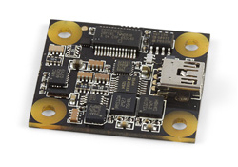The objective of this test is to verify that the inertial measurement unit (IMU) operates according to the product manual.

Test Description/Requirements:

Requirements:

1. IMU
2. USB power supply
3. Monitor
4. Keyboard

Process:

The IMU will be connected with all of the required pieces. Since there are no sample test programs written for Linux, the IMU will first be tested on the Windows operating system. The current version of the Phidget library will be installed and a sample test program will be run to verify that IMU is operational. After that is verified, the library will be uninstalled and the IMU will tested to see if it maintains the functionalities on the Linux operating system as it did on Windows.

Anticipated Results:

The IMU should operate on the Windows operating system; produce data such as compass data, acceleration data and gyro data. The IMU should also function on the Linux operating system and produce the same data as it did before.

Requirement for Success:

The minimum requirements for success are to operate on the Linux operating system and produce accurate data from its compass (magnetometer), accelerometer, and gyroscope.

Actual Results:

TBA

Reason for Failure:

TBA

Recommended Fix:

TBA

Other Comments:

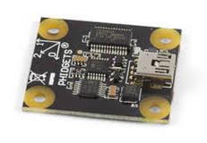**Scheduled Test Reporting Form**

Test Item: Marker Dropper

Tester Name: Reece Spencer Tester ID No: rus06

Test Date: 3/1/11 Test No: 1

Test Time: 5 PM Test Type: Test

Test Location: College of Engineering Lab Test Result: TBA

Test Objective:

The objective of this test is to test the marker dropper and ensure that it will run properly when connected to the microprocessor. The assembly must function properly in air and water.

Test Description/Requirements:

Requirements:

1- Marker Dropper Assembly

2- Traxxas Waterproof Servo Motor

3- ARM Microprocessor

4- Voltage source (batteries)

Process:

The servo motor will be attached to the marker dropper assembly, then connected to the processor and power supply. A program will be made to test the servo motor. The servo should rotate the shaft approximately 30° in each direction for proper functionality. The test will rotate the shaft to at least 60° each direction. After the servo is found to be working, two markers will be placed inside the assembly. The servo will be tested with the markers in place to make sure it can release each one individually. Once the whole assembly is working properly in air, the assembly will be placed in a bath of water and tested again to ensure that the dropper will work properly in the environment it will be ran in.

Anticipated Results:

The marker dropper will release each marker individually and will not leak.

Requirement for Success:

The requirement for success is that the marker dropper can successfully operate in dry and wet conditions.

Actual Results:

TBA

Reason for Failure:

TBA

Recommended Fix:

TBA

Other Comments:

**Scheduled Test Reporting Form**

Test Item: Microcontroller

Tester Name: Andy Jeanthenor Tester ID No: aj09

Test Date: 2/01/2011 Test No: 1

Test Time: 1 PM Test Type: Test

Test Location: College of Engineering Lab Test Result: TBA

Test Objective:

The objective of this test is to test the microcontroller and ensure that it performs the functions needed for AUV operation properly.

Test Description/Requirements:

Requirements:

1- Microprocessor

2- Power Supply

Process:

The proposed battery figuration will be run in some software like MultiSim to see if the simulation produces the desired results. Once the correct circuit is built the BeagleBoard will be connected to our proposed battery configuration and the tester will check to see if it is completely operational. The BeagleBoard will be left on for a specified amount of time and the tester will check to see if the BeagleBoard works properly for the entire duration. This process will be repeated until a passing grade is received. The ports will be tested by using the Board Verification instructions in the user manual. If the hardware is not working properly then a new board will have to be purchased since the board was donated to the project and a replacement board is most likely out of the question. The compatibility will be tested by running test software that uses the sensors through the BeagleBoard. Data will be recorded to determine whether proper communication was established.

Anticipated Results:

The microcontroller and the sensors are fully powered by the proposed battery configuration. The ports that will be needed for communication between the microcontroller and the sensors are operational. The BeagleBoard properly communicates with purchased sensors produces the desired results.

Requirement for Success:

The requirement for success is that the microcontroller is completely operational with the proposed battery configuration. The sensors and the microcontroller communicate properly and perform the desired functions.

Actual Results:

TBA

Reason for Failure:

TBA

Recommended Fix:

TBA

Other Comments:

**Scheduled Test Reporting Form**

Test Item: Thermocouple

Tester Name: Tadamitsu Byrne Tester ID No: trb06e

Test Date: 2/28/2011 Test No: 1

Test Time: 5 PM Test Type: Test

Test Location: College of Engineering Lab Test Result: TBA

Test Objective:

The objective of this test is to calibrate a thermocouple to determine the temperature inside the pelican box.

Test Description/Requirements:

Requirements:

1- Thermocouple

2- Multimeter

Process:

The thermocouple will be introduced to an environment where the temperature is known. The temperature will be calculated based on output voltage and will be calibrated beforehand.

Anticipated Results:

The thermocouple will relay output voltage corresponding to the known temperature.

Requirement for Success:

The thermocouple indicates the correct voltage corresponding to the temperature.

Actual Results:

TBA

Reason for Failure:

TBA

Recommended Fix:

TBA

Other Comments:

**Scheduled Test Reporting Form**

Test Item: Thrusters

Tester Name: Reece Spencer Tester ID No: rus06

Test Date: 2/01/2011 Test No: 1

Test Time: 5 PM Test Type: Test

Test Location: College of Engineering Lab Test Result: TBA

Test Objective:

The objective of this test is to test the thrusters and ensure that they will run properly with the motor controllers when connected to the microprocessor.

Test Description/Requirements:

Requirements:

1- SBT-150 Thrusters (4)

2- Microprocessor

3- Voltage source (batteries)

Process:

Each motor will be individually connected to the microprocessor and batteries. A program will be made to give the motors an input of 28V. An internal voltage regulator in the motors will reduce the voltage to 19V, which is their recommended running voltage. If the motors work successfully then a program will be made to use the motor controller and attempt different duty settings from 0-100% in increments of 10%. Once dry testing is completed, the motors will be checked to ensure that they are watertight, then will be placed into a small water bath and tested again to make sure they will work when submerged. After all motors have been tested individually, all four will be connected to the microprocessor and batteries to ensure that they will all work in unison.

Anticipated Results:

The motors will run with the anticipated duty from the motor controllers and will not leak.

Requirement for Success:

The requirement for success is that motors can successfully run in dry and wet conditions.

Actual Results:

TBA

Reason for Failure:

TBA

Recommended Fix:

TBA

Other Comments:

## Data Sheet

## 