FAMU-FSU College of Engineering
Department of Electrical and Computer Engineering

PROPOSAL

EEL4911C – ECE Senior Design Project I
Project title: Autonomous Underwater Vehicle “RoboSub”
Team #: 4

Student team members:
− Victoria Jefferson, computer engineering (Email: jeffevi@eng.fsu.edu)
− Andy Jeanthenor, computer engineering (Email: jeantan@eng.fsu.edu)
− Kevin Miles, electrical engineering (Email: mileske@eng.fsu.edu)
− Tadamitsu Byrne, mechanical engineering (Email: byrneta@eng.fsu.edu)
− Reece Spencer, mechanical engineering (Email: spencree@eng.fsu.edu)
− Yanira Torres, mechanical engineering (Email: torreya@eng.fsu.edu)

Senior Design Project Instructor: Dr. Bruce Harvey

Submitted in partial fulfillment of the requirements for
EEL4911C – ECE Senior Design Project I

July 29, 2026
Projective Executive Summary

The Autonomous Underwater Vehicle (AUV), sponsored by the FAMU-FSU College of Engineering to compete in the 14th annual AUV Competition sponsored by the Office of Naval Research (ONR) and the AUVSI organization, is a fully autonomous vehicle that will maneuver in an underwater obstacle course. Competing in the AUVSI competition course requires our vehicle to autonomously execute a sequence of tasks while remaining fully submerged in a seawater environment.
The obstacle course will be in a 16ft deep salt water pond, located at Camp TRANSDEC in San Diego, California. Vehicles are expected to pass through an underwater gate, follow colored paths, hit two out of three buoys, avoid obstacles, possibly fire projectiles, drop markers into primary and secondary weapons, track an acoustic pinger and finally surface within the designate “octagon” area with a PVC structure then release it. Based on the AUVSI competition rules, the vehicle is allocated a total of fifteen minutes to complete these varies task in the course.
In order to accomplish the previously listed tasks, the following design concepts will be implemented. Our AUV will have a 4 motor design with attached thrusters. This design will give better control of the direction and depth of the submarine. The motors and thrusters will be placed on the left and right as well as the front and back of the AUV. As positioned, the motors and thrusters will make the weight distribution of the vehicle more stable. Since the completion of the course will require our AUV to avoid obstacles, follow paths, and stay in designated areas, the design will be equipped with multiple sensors that will inform the AUV when it detects a certain color. This design will ensure team four the maximum amount of points to emerge victorious in its first year competing.
Table of Contents
Project Executive Summary 2
Table of Contents 3
1 Introduction 5
1.1 Acknowledgements 5
1.2 Problem Statement 5
1.3 Operating Environment 6
1.4 Intended Use(s) and Intended User(s) 6
1.5 Assumptions and Limitations 6
1.6 Expected End Product and Other Deliverables 7
2 Proposed Design 8
2.1 Overview 8
2.2 Motors 8
2.3 Batteries 9
2.4 Sensors 9
2.4.1 Camera 9
2.4.2 Hydrophone 9
2.4.3 Accelerometer 10
2.5 Microcontroller 10
2.5.1 Software 10
2.6 Markers 11
2.7 Claw 11
2.8 Diagrams 11
2.8.1 General View 11
2.8.2 Side View 12
3 Statement of Work (SOW) 13
3.1 Task 1: Problem Definition 13
3.1.1 Objectives 13
3.1.2 Approach 13
3.2 Task 2: Technology and Equipment Selection 13
3.2.1 Objectives 13
3.2.2 Approach 13
3.2.2.1 Subtask 2.1 14
3.2.2.1.1 Objectives 14
3.2.2.1.2 Approach 14
3.2.2.2 Subtask 2.2 14
3.2.2.2.1 Objectives 14
3.2.2.2.2 Approach 14
3.2.2.3 Subtask 2.3 14
3.2.2.3.1 Objectives 14
3.2.2.3.2 Approach 14
3.2.2.4 Subtask 2.4 14
3.2.2.4.1 Objectives 14
3.2.2.4.2 Approach 15
3.2.2.5 Subtask 2.5 15
3.2.2.5.1 Objectives 15
3.2.2.5.2 Approach 15
3.2.2.6 Subtask 2.6 15
3.2.2.6.1 Objectives 15
3.2.2.6.2 Approach 15
3.2.2.7 Subtask 2.7 15
3.2.2.7.1 Objectives 15
3.2.2.7.2 Approach 15
3.2.2.8 Subtask 2.8 15
3.2.2.8.1 Objectives 15
3.2.2.8.2 Approach 16
3.3 End-Project Design 16
3.4 End-Product Testing 18
3.5 End-Product Documentation 20
3.6 End-Product Demonstration 20
3.7 Project Reporting 20
4 Risk Assessment 21
4.1 Budget Miscalculations 21
4.2 Critical Scheduling Issues 21
4.3 Malfunctioning Parts 21
4.4 Loss of Team Member 21
4.5 Requirements/Specifications not met 22
4.6 Technological Issues 22
5 Qualifications and Responsibilities of Project Team 23
5.1 Task Assignments 23
5.2 Qualifications 23
5.2.1 Victoria Jefferson 23
5.2.2 Kevin Miles 24
5.2.3 Andy Jeanthenor 24
5.2.4 Reece Spencer 24
5.2.5 Tadamitsu Byrne 25
5.2.6 Yanira Torres 25
6 Schedule 26
7 Budget Estimate 29
7.1 Budget Justification 30
8 Deliverables 31
9 References 33

1 Introduction
1.1 Acknowledgements
Team 4 would like to thank Northrop Grumman as well as the FAMU/FSU College of Engineering Electrical/Computer and Mechanical Engineering departments for monetary contributions towards the project. The team would also like to thank ARM Holdings for donating a processor and microcontrollers for the automation of the vehicle, and finally we thank Dr. Bruce Harvey of the FAMU/FSU College of Engineering for his guidance and advice. Without these contributions the design and construction of the AUV would not be possible.
1.2 Problem Statement
The Association for Unmanned Vehicle Systems International (AUVSI) Foundation and the U.S. Office of Naval Research (ONR) has designed a competition to advance the development of Autonomous Underwater Vehicles (AUVs) by challenging a new generation of engineers to perform realistic missions in an underwater environment. The competition requires the design of a vehicle that operates autonomously in a self contained unit. The AUV will be deployed in a large salt water pool at Camp Transdec, CA, which has a maximum depth of 16 feet. The 2011 competition rules have not been released yet; however, based on the rules for 2010 we know that the AUV must not exceed dimensions of 6ft x 3ft x 3ft and that it must weigh less than 110 pounds. The competition generally has several objectives to complete, which usually require an optical sensor, for color and shape recognition, and an acoustic sensor for the identification and location of a pinger.
Mentioned here are the typical obstacles included in the competition and the maximum points awarded from year to year. Passing through a gate (100pts), following the marked path (50pts/segment), maintain fixed heading (150pts), striking a designated target (500-1500pts), dropping markers on designated target (2600pts), surface within designated area (2000pts), surface with rescue object (1000pts), release rescue object (500pts), finish mission early (t[minutes]*100pts).
The AUV will be battery powered and operate using an ARM processor/controller which will interpret all data collected by the sensors to control the motors and directional heading of the vehicle. It will be designed to be as small as possible to save on weight and spatial dimension so that any last minute changes can be made without worry of disqualification due to physical constraints. Visual sensors will be used for color and shape recognition which will allow the AUV to complete most of the objectives mentioned above. Acoustic sensors will be utilized to identify and locate an acoustic pinger at the bottom of the pool which marks the rescue object. A mechanical arm attached to the AUV will provide a means to bring the rescue object to the surface while constraining the object in 3 degrees of freedom. Propulsion will be provided by 4 thrusters, two thrusters facing the rear of the AUV will provide lateral and turning movement, and two thrusters located on the front and back of the AUV will provide vertical translational control. The programming language has yet to be selected, but it will either be C, C++, ARM assembly, or JAUS++.
1.3 Operating Environment
The AUV operating environment will be a salt water pool at Camp Transdec, California, the maximum depth of the pool is 16 feet and it will be hoisted into the pool and slowly lowered to avoid damage. The AUV will have 15 minutes to complete all tasks mentioned above which traverses a distance of 50 feet. The salinity of the water must be accounted for in the design process in order to establish 0.5% buoyancy and to ensure that all components are corrosion resistant.
1.4 Intended Use(s) and Intended User(s)
The AUV is intended to compete in the AUVSI 14th annual competition which establishes very specific guidelines and will therefore be designed and programmed to operate in a salt water pool. The vehicle is an example of how robotic submersibles complete tasks in harsh environments and can also be adapted for use in a zero gravity environment. The AUV is to be used only by team 4 and operation requires a push of a button and a pool since the vehicle is autonomous.
1.5 Assumptions and Limitations
1.5.1 Assumptions
- The AUV will be completely autonomous
- There will be a clearly identifiable kill switch to shut down the AUV
- The AUV will operate in a salt water pool
- The AUV will be battery powered
- The AUV will detect color, shape, and sound
- The AUV will automatically shut down after 15 minutes
- The AUV will have hoist points so that it can be slug and lowered into the water
- The AUV will have 4 thrusters to provide movement
- The AUV will be able to write to and read from shared memory
- The AUV will have an inertial guidance system to detect changes in orientation or position
- The AUV will have an emergency buoyancy system to float the vehicle to the surface in the event of a systems failure
1.5.2 Limitations
- The AUV will be less than 6ft x 3ft x 3ft in size
- The AUV will be less than 110 pounds
- The AUV has 15 minutes to complete all tasks
- The project budget is $9500
- The vehicle must be operating successfully by the end of the 2011 Spring semester
- The AUV must utilize a ARM processor/controller
- The markers on the AUV will not exceed 6.0in x 0.5in x 0.5 in
- The battery will not have an open source voltage exceeding 60VDC
1.6 Expected End Product and Other Deliverables
The end product is a vehicle that is fully autonomous and submersible that can complete all objectives outlined in the AUVSI competition rules and mission. Team 4 will provide an AUV that is compact, lightweight, and competitive. The product will require no input from the user to function properly, but it must be placed in an aquatic environment. A team journal paper is required with the submission of the AUV, which will highlight the mechanical, electrical, and computer systems, all hardware and software utilized, and the testing procedures of the final product. The final product will be available at the end of the Spring 2011 semester with minor adjustments and debugging continuing up to the competition day which is July 12th, 2011.
2 Proposed Design
Autonomous Underwater Vehicle
Data Analysis
Maneuver Underwater
Navigate through obstacle course
2.1 Overview
The design of the Autonomous Underwater Vehicle is a submarine with a few additions to complete the task required for the competition. The hull will be constructed of carbon fiber or 80/20 framing and somewhat resembles a rectangular box, except that the body will be filled with water. The design is not to exceed 6’ x 3’ x 3’. The electronics will be housed in a watertight pelican case, which will be seated inside of the hull.
Maneuver under water
Motors/Thrusters
Batteries
Hull
Propellers
Inertial guidance
2.2 Motors
Since the hull will be filled with water, we will have 4 motors with attached thrusters to control the direction and depth of the submarine. There will be thrusters on the left and right side of the submarine to control the turning as well as forward and reverse propulsion. Additionally, there will be two thrusters on the bottom of the unit, one on the front as well as one on the back. These are placed as such to alienate problems in the weight distribution of the vehicle. The four motors will be the same DC motors, which are capable of operating in forward and reverse. Each motor operates off of 19.1 V DC and has max amperage of 5.8 amps (30 second duration) as well as max continuous amperage of 4.25 amps. The max power consumed by each motor is 110 W. All of these numbers are given with a 10% tolerance on the motor specifications sheet.
2.3 Batteries
The batteries used in the design will be lithium-ion phosphate. Normal lead-acid batteries were considered for the design, but due to the extra weight it was decided that the lithium-ion would be the ideal candidate for the job. There will be one set of batteries to power the motors, one set for the markers and claw, and one for the microcontroller. These batteries will be rechargeable and have a capacity to run the system for one complete hour.
Data Analysis
Retrieve Data
Analyze Data
Sensors
Sound
Position
Light/Color
Shape
Microprocessor
Input
Output
2.4 Sensors
Because of the requirements for the competition, we will need several sensors for the AUV. Some are specifically needed for specific task, while others will just be for general maneuverability and not necessarily specific to one task.
2.4.1 Camera
The Camera on board the AUV has two main purposes to serve. The first is color recognition. Because our path will be given by a colored 6” wide sheet of PVC, the camera must be able to pick out a specific color against other colors. Additionally, the camera needs to be waterproof, due to the nature of the operating conditions of the vehicle. Secondly, the camera needs to have shape recognition. This is because it is required to recognize specific shapes in the competition. For example, it must be able to recognize a silhouette of a weapon against silhouettes of other objects. It is also possible that we may use the shape recognition to locate the path as well, but that is yet to be determined. The camera’s data will be input into the microcontroller for data analysis.
2.4.2 Hydrophone
Part of the competition includes a “pinger” secured to the bottom of the pool. Since the pinger will broadcast signals throughout the pool, our objective is to recognize the signal, and then determine its location. Our proposed design is to use four parallel hydrophones which will assist in the location determining of the object which is sending out the signals. The hydrophone’s data will be input into the microcontroller for data analysis.
2.4.3 Accelerometer
Due to the nature of the competition, it is obvious that there will be stability and control requirements to even begin competing in the given task. The accelerometer will assist us in stability control. The accelerometer’s data will be input into the microcontroller for data analysis.
2.5 Microcontroller
The microcontroller will serve as the entire functioning “brain” of the unit. The microprocessor will take the input from the different sensors, analyze the data, and then send output signals to the motors, claw, and markers as well. The motors will be powered through the batteries; however the directions and speed will be controlled through h-bridges and pulse width modulation, respectively. The microcontroller will be an ARM processor and has been generously donated to the project. The board runs off of 5 volts with a max current draw of 1 amp.
2.5.1 Software
To program the microcontroller, one of three computer languages will be used: C++, Joint Architecture for Unmanned Systems (JAUS), or ARM Assembly.
Navigate through obstacle course
Go through validation gate
Follow colored path
Marker Dropper
Pinger
Claw
Strike Weapon
2.6 Markers
The markers will be deployed over a specific bin once the correct bin is recognized. The design is to use two magnets. Once the correct bin is identified, a coil above the magnet will have a current above it which will in turn cancel out the magnetic field and cause the bottom part of the magnet to drop into the correct bin
2.7 Claw
The claw will be used to hoist an object out of a box. The design and implementation of the claw has not been finalized. The proposed design consists of a regular claw in waterproof casing.
2.8 Diagrams
2.8.1 General View of Design
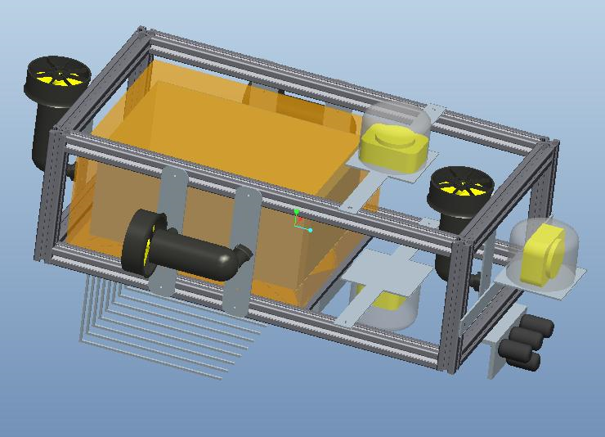

2.8.2 Side View of Design 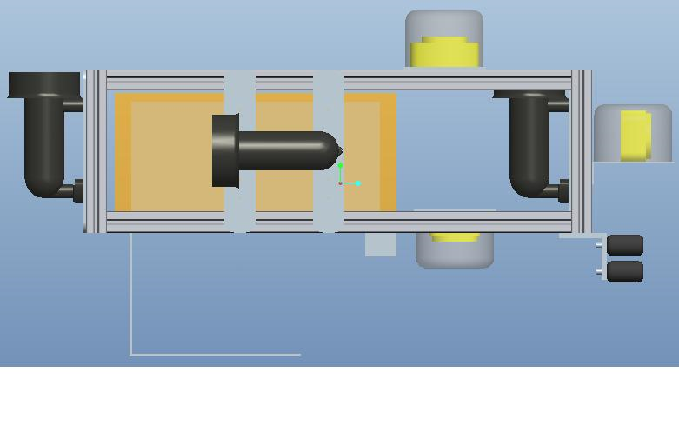

3 Statement of Work

Task 1: Problem Definition

3.1.1 Objective
The problem definition for this project is to design, create, test and demonstrate an autonomous underwater vehicle capable of following a marked path, maneuvering through a gate, dropping markers into a specified bin, locating a pinger, and grasping a structure all while submerged after which it should resurface inside of an octagon. The robot should be able to complete all of the required tasks within 15 minutes of being placed in the arena. The arena is located at the San Diego TRANSDEC Anechoic Pool which is filled with salt water obtained from the Pacific Ocean. The vehicle will be operating in a 16 feet deep section, with variable width, containing all of the competition obstacles. Although the specific obstacles for this year’s competition have not been released yet the primary tasks repeated from year to year are incorporated into our objectives.

Approach
To effectively complete this objective the tasks have been divided into five technical areas: propulsion system, sensors, micro processing and programming, power and electronics, and vehicle design. Each member in the group is given a specific technical focus area based on educational background as well as technical interests, knowledge, and/or experience. As a part of this project we have three different educational focuses (computer, electrical, and mechanical engineering) allowing our group to have a wide range of expertise and knowledge. Both technical and administrative responsibilities are described in detail in section 5.

Task 2: Technology and Equipment Selection

Objective
In this section, we will explore potential technologies and programming possibilities and methods on selecting the most effective for our problem definition.

Approach
The problem statement is divided into 8 subtasks that are explored individually to determine most effective method of approaching and completing. To maintain continuity all programming will be done in one computer language, either C++, Joint Architecture for Unmanned Systems (JAUS), or ARM Assembly. Due to unforeseen circumstances we have yet to decide what programming language we will use. The three languages we have listed all have different advantages. The use of C++ will decrease the complication of programming as well as increase the readability of the code as with all high-level languages. The use of JAUS will give us a point bonus at the competition as stated in the competition rules and give us an opportunity to work with state of the art technology. ARM assembly however will give us the ability to access the memory directly and work at a low-level programming stage. Ultimately the programming will be chosen based on effectiveness, simplicity, and programmer preference. Also, as a part of a stipulation designated by one our donors, our group is required to use ARM processors for our computing needs.
3.2.2.1 Subtask 2.1: Power Supply

Objective
The power supply must be capable of supplying a sufficient amount power for electronics, sensors, additional components and four thrusters.

Approach
Successful completion of this task will ensure that our vehicle will be capable of completing all objectives efficiently.

Subtask 2.2: Navigating Obstacle Course

Objective
Vehicle must be able to detect and differentiate between different obstacles. A variety of sensors will be utilized to complete this task. The vehicle must identify colored path and follow it to reach the next objective in obstacle course. Once all objectives are completed, vehicle will resurface in desired location.

Approach
Navigation will be described with greater detail in subtasks 2.3-2.8.

Subtask 2.3: Maneuver through a Gate

Objective
Vehicle must pass through a gate 10ft tall and 6ft wide.

Approach
The vehicle will detect the gate and then complete the subroutine to maneuver under the gate.

Subtask 2.4: Follow Marked Path

Objective
Vehicle must follow path to reach the next objective in obstacle course. The path will be a 6inch wide x 4ft long piece of colored PVC.

Approach
Vehicle will detect the path and travel in the direction of the path.

Subtask 2.5: Drop Marker

Objective
The vehicle must drop a marker into the correct box. The boundaries of the boxes will be color coded to differentiate between them.

Approach
The vehicle must detect the array of boxes and choose the correct one to position over and release the marker.

Subtask 2.6: Locate Pinger

Objective
The vehicle must locate an object that is broadcasting its location with an acoustic pinger.

Approach
A hydrophone will be used to detect the pinger location. The vehicle will travel to the location and proceed to the next task.

Subtask 2.7: Grasp Object

Objective
The vehicle must grasp an object and bring it to the surface, then release the object.

Approach
The vehicle will locate the pinger, then position over the object. The grasping mechanism will grasp the object and then surface. After surfacing, the vehicle will release the object and then submerge again to finish the last task.

Subtask 2.8: Resurface in Octagon

Objective
After completing all other tasks, the vehicle must surface in an octagon. Additional points will be gained if the vehicle surfaces in the correct octagon.

Approach
The vehicle will search for the octagon at the end of the course and travel towards it. After the vehicle is directly under the octagon, it will surface to complete the competition.

End-Product Design

Objective
In this section, we will describe the implementation of major components in our design.

Approach
The design process has been split into different stages to facilitate efficient use of time. Each member of the team has been selected to complete specific tasks in order to complete the project on time. The specific tasks of each member will be described below. Although each member will make decisions on certain tasks, these decisions must be approved by the entire group before implementation on the final design. The administrative and technical responsibilities are described in section 5.

Stage 1: Vehicle Design

Structural and Hull Design
The design of the frame and hull will be performed by Tadamitsu Byrne. The frame must be able to support and house all components of the vehicle. The hull will be designed to surround the frame and components to make the vehicle more streamlined. This will reduce drag and increase efficiency. The hull will be “wet” such that it is not watertight. All electronics and water sensitive components will be housed in a watertight box located inside the hull.

Propulsion System
The selection of a propulsion system will be performed by Reece Spencer. The propulsion system will consist of four thrusters. The thrusters chosen will be Seabotix BTD150 thrusters. These thrusters have low power consumption while providing adequate thrust. Two of the thrusters will be located in the rear of the vehicle to allow for forward and reverse lateral motion. These thrusters can be given different amounts of power to allow for turning motion. The other two thrusters will be located in the front and the back to allow for vertical translation. If the vehicle starts to pitch, the thrusters will be controlled individually to stabilize the vehicle.

Electrical Circuit Design
The AUV will have four motors on board. These motors will be connected in parallel to a single LiFePO4 Battery which will allow the motor to run just over 1 hour continuously. The max current drawn by the entire circuit will be 21.2 Amps with Voltage of 25.6 V. In addition, motor controllers will be utilized to control the speed of the motor. The motor controllers will consist of power, ground and enable. The enable will be a signal output from the microprocessor which is pulse width modulated. There will be an additional 5 V, 2A battery which will power the microprocessor. This will be independent of the motor circuit.

Battery Selection
The battery will be used to power all vehicle components. The research and selection of type and number of batteries will be performed by Kevin Miles. The thrusters are a large concern when deciding on a battery since they draw the greatest amount power. All onboard electronics, microprocessor and sensors must also be powered, but they consume much less power.

Sensor Selection
The sensors will be utilized to locate objectives in the arena, avoid or locate obstacles, and identify tasks by detecting objects, sounds, shapes and/or colors. The research and selection of the sensors will be performed by Yanira Torres. There are several types of sensors needed to complete the required tasks. Applicable sensors will be researched for each individual task to optimize performance.

Microprocessor
The microprocessor has been donated to team 4 by ARM.

Grasp/Release Mechanism Design
The design of the grasp and release mechanism will be performed by the mechanical side of the team. The mechanism must grasp an object and hold it for a certain period of time, then release the object. The mechanism will consist of a claw device that is powered by a solenoid that will close on the object.

Marker Release Design
The marker release will consist of a permanent magnet and an electromagnet. The marker will be a small steel sphere. The permanent magnet will hold the steel sphere in a recessed area of the vehicle. When the electromagnet is activated, the magnetic field will be cancelled and the sphere will drop to the bottom of the pool.

Stage 2: Component Synchronization

Microprocessor, Propulsion System and Structure
Once the propulsion system is attached to the structure, the processor and associated electronics will be hooked up. This will allow for testing of the propulsion system before the rest of the components are added.

Sensors and Microprocessor
Once the processor has been installed, the sensors will be attached to the processor. The processor will be programmed to read and act based on the outputs of the sensors.

Grasp/Release and Marker Release Mechanisms
The grasp and release mechanisms will be installed on the bottom side of the vehicle. The electromagnet and solenoid will be attached to the circuit to allow for control by the processor.

End-Product Testing

Objective
In this section, we will describe the tests that will be performed on the vehicle to ensure that it functions within our performance specifications.

Approach
The different components of the vehicle will be tested individually before synchronization. Once each component is determined to work properly, it will be attached to the controller. Once all components are attached to the controller, the vehicle will be tested to ensure all components are working properly. After the components are working properly, the vehicle will be tested for autonomy.

Subtask 4.1: Leak Testing

Objective
All electronics must be completely sealed from water intrusion.

Approach
All watertight components will have paper towels lining the inside. The components will be submerged and then checked for leaks. If any leak is present, the source can be identified and fixed.

Subtask 4.2: Moving in a Straight Line

Objective
The vehicle must be able to move in a straight line with very little deviation and no vertical movement.

Approach
A program will be uploaded that gives each forward thruster equal power. If the vehicle turns, the power to the thrusters will be changed to balance the thrust. If the vehicle moves in the vertical direction, the vertical thrusters must be given a small amount of power to balance the vehicle.

Subtask 4.3: Turning

Objective
The vehicle must be able to turn in the correct direction with no vertical movement.

Approach
A program that gives the forward thrusters different power will be uploaded. The vehicle should turn in the direction desired. If any vertical movement occurs, the vertical thrusters will be given power.

Subtask 4.4: Ascending and Descending

Objective
The vehicle must be able to travel in the vertical direction with little to no forward or sideways motion.

Approach
The vertical thrusters will be given equal amounts of power to ascend or descend. If the vehicle becomes off-center, power will be distributed to individual thrusters to regain balance.

Subtask 4.5: Sensors

Objective
All sensors must be function before full automation can occur.

Approach
Give specific inputs to each sensor so that analysis can be done on the feedback. Each sensor will be tuned to work according it its function. Initial testing will be in air, and then once sensors are working, final testing will be done in water.

Subtask 4.6: Full Automation

Objective
The vehicle must be able to function completely autonomously and complete all required tasks/obstacles.

Approach
An obstacle course will be set up in the pool to simulate the competition environment. The vehicle will run through the entire course to observe any miscalculations or mistakes. These errors will be fixed and another test run will be completed. This will be repeated till the vehicle completes all tasks efficiently.

End-Product Documentation
After successful completion of this vehicle our group will provide detailed documentation of several aspects of our project. For mechanical design we will provide three dimensional computer aided design drawings with specific vehicle component dimensions as well as detailed assembly of all components. For electrical/computer design we will provide a schematic demonstrating how each component and system in the vehicle is interconnected. For financial transactions, we will provide our final budget analysis with copies of receipts obtained from all purchases and orders. We will also provide the mechanical, electrical, and computer engineering notebooks with details of all project content and progression verified with dates and signatures.

End-Product Demonstration
The end product will be demonstrated at the AUVSI RoboSub Competition at the SSC Pacific TRANSDEC anechoic pool in San Diego, California during the week of July 12-17, 2011. All group members able to attend the competition will represent the FAMU-FSU College of Engineering while competing against students from across the world. The team will be given finalized tasks and the opportunity to practice the obstacle course before competition to make any last minute modifications to programming to account for differences in salinity and/or opacity of water. During competition the vehicle will demonstrate its ability to complete all of the desired objectives.

Project Reporting
There will be two major final reports for our project: the detailed design and test review report and the AUVSI Journal Papers. The AUVSI Journal Paper will cover all of the aspects of our project including mechanical design, electrical design, and methodology to completing all of the objectives including, but not limited to, the sensors utilized, programming logistics, and control algorithms. Details on mechanical design will incorporate details about the propulsion systems, hull and frame design, grasping and dropping mechanism design, construction and assembly of components, etc. Details on electrical design will include power systems, signal processing, circuit board, etc. The detailed design and test review report will include specific details on final design and its components and final budget analysis with receipts from all purchased parts. It will also include information on testing phase of project which will include test data and approach to problems, flaws, and errors encountered.
4 Risk Assessment
  - Budget Miscalculations
In the event that the budget is incorrectly estimated the treasurer is required to reevaluate all expenditures. The treasurer will reopen the parts/materials search process with the team and find cheaper parts to reduce expenses. The treasurer is also required to begin searching for new sponsors in an attempt to raise more money. These tasks should be done with extreme urgency. The team will be required to provide extensive documentation as to why this problem occurred and what can be done to prevent this problem for the next team working on the AUV.

  - Critical Scheduling Issues
In the event that production is vastly behind schedule the project manager is tasked with evaluating team performance. The project manager will ensure that new methods of production will be put in place to increase efficiency. Every team member is required to work overtime without pay as well as extra hours on weekends. Depending on the severity of the issue sections of the design that are not very important will be scrapped. In an effort to present the sponsors and the FAMU/FSU College of Engineering with a finished product, portions of the design that are not feasible at that point will be delayed until further notice. The team will have to decide what portions of the design to continue to pursue and what to abandon. The team will be required to provide extensive documentation as to why this problem occurred and what can be done to prevent this problem for the next team working on the AUV.

  - Malfunctioning Parts
In the event that components of the AUV malfunction there will be serious problems. If the part is repairable the team will attempt to repair it. The next solution will be to check and make sure the warranty had not been voided on the part. If the warranty holds the malfunctioning part will be returned in exchange for a working part. The alternative involves the estimated budget which estimates money left over for the equipment budget. If this holds true one spare part will be ordered for the important items when they are purchased. Otherwise money will have to be raised to purchase replacement parts.

  - Loss of Team Member
In the event that a team member is sick, injured, or has departed, adjustments will be made to compensate for the loss. The team member’s documents will be gathered and their work will be split among the team based on individuals’ areas of the strength. The team member will be kept ‘in the know’ so that upon their return the team member can get back to work. If the team member is unable to return the team will divide their part and ‘keep the ball rolling’.

  - Requirements/Specifications Not Met
In the event that all the requirements and specifications for the AUVSI competition are not met, adjustments to the current design will be made. The team will have to reevaluate how much of the design can be finished at that point. The team will have to abandon any requirement that is not required to qualify for the competition. The team will have to adjust their goals and try to deliver a finished product. The team will be required to provide extensive documentation as to why this problem occurred and what can be done to prevent this problem for the next team working on the AUV. The team will also lay the groundwork for the next team in meeting all requirements and specifications for the next competition.

  - Technological Issues
In the event that there are problems with the technological devices i.e. the microcontroller, the sensors, electronics, etc. many considerations will be taken. If the sensors are not communicating with the microcontroller correctly, the wired connections and programming will be reevaluated. If no solution is found the team will seek faculty assistance and if that does not work the specific function will be excluded until further notice. If the microcontroller is not performing a desired task, that specific area of the software will be reviewed. If no solutions are found the software for the desired function will be rewritten and reintegrated into the main program. If drastic measures are required the entire program will be rewritten. If electronics issues occur—all electronic equipment, connections and wires will be reviewed. Any faulty equipment will be discarded and replaced.

5 Qualifications and Responsibilities of Project Team
Team four is comprised of six exceptional Computer, Electrical and Mechanical seniors from the FAMU-FSU College of Engineering. The members of team four are faced with an exciting challenge. With their impressive knowledge and skills, along with their undeniable dedication and persistence—designing an autonomous underwater vehicle will be a challenge that can be easily accomplished.
5.1 Task Assignments
Task | Assignment | Skills and Knowledge
Project Manager, Documentation Secretary, Sensor/Microprocessor Programming | Victoria Jefferson | Object-Oriented Programming, Data Structures, Assembly Language, Electronics, Microprocessors
Technical Lead, Electronics, Power | Kevin Miles | Electronics, Power Systems
Financial Secretary, Electronics, Microprocessor Programming | Andy Jeanthenor | Data Structures, Assembly Language, Microprocessors, Electronics
Motors, Power, Propulsion System, Buoyancy Control | Reece Spencer | Mechanical Systems, Dynamic Systems, Boat Repair, Diving Experience
Mechanical, Propulsion System, Construction | Tad Byrne | Mechanical Systems, Thermal Fluids, Dynamic Systems
Mechanical, Sensors, Debugging | Yanira Torres | Sensors, Mechatronics

5.2 Qualifications
5.2.1 Victoria Jefferson
Victoria Jefferson is currently a senior in Computer Engineering at Florida State University. Victoria Jefferson is currently the Project Manager, Documentation Secretary, and an asset to the programming sector. Victoria Jefferson has victoriously mastered numerous programming-based classes associated with her major. Classes including Introduction to UNIX, Object-Oriented programming, Introduction to Field Programmable Logic Devices, Microprocessor Design distinguish her as a solid candidate for the tasks assigned to her. Besides her programming based classes, she has also completed Circuits I and II, Digital Logic, and numerous high-level math courses. She is currently enrolled in Data Structures, Computer Architecture, Signals and Systems, Microelectronics and the lab. In addition to her academics advancements, Victoria is an active member of Society of Women Engineers (SWE), National Society of Black Engineers (NSBE), and an inducting member of Eta Kappa Nu Honor Society. Victoria Jefferson has worked throughout college and has managed to excel in her major. Victoria Jefferson’s work experience, knowledge, and management skills make her a qualified Project Manager and Documentation Secretary.
5.2.2 Kevin Miles
Kevin Miles is currently a senior in Electrical Engineering at Florida State University. Kevin Miles is the Electrical Technical Lead for team four. Besides being the Technical Lead, he is also in charge of the electrical and power systems associated with the project. Kevin Miles has successfully completed numerous classes such as Microelectronics I and associated lab, Circuits I and II, Digital Logic, and Intro to Computer Programming. He is currently taking Microelectronics II lab, Introduction to Power Systems, as well as Signals and Systems. Kevin is MECP (Mobil Electronics Certification Program) certified and has been a Mobil Electronics Installer for two years. With Kevin Miles’s work experience and knowledge, the tasks assigned to him are achievable.
5.2.3 Andy Jeanthenor
Andy Jeanthenor is currently a senior in Computer Engineering at Florida Agricultural & Mechanical University (FAMU). Andy is currently the Financial Secretary and Software Technical Lead for the project. He is in charge of the microprocessor and its associated programming as well as assisting with the electrical system. Andy Jeanthenor has successfully taken several programming classes at FAMU including C programming, Fundamentals of C and Data Structures. Other programming-based classes taken in his major include Microprocessors, Introduction to Field Programmable Logic Devices, and DSPs with FPGAs. Andy Jeanthenor has also taken and successfully completed several engineering-based classes such as, Circuits I and II, Digital Logic, Engineering Mechanics, and Thermodynamics. Andy is currently taking Microelectronics and lab, Signals and Systems, and Computer Architecture.
5.2.4 Reece Spencer
Reece Spencer is currently a senior in Mechanical Engineering at Florida State University. Reece Spencer is currently the Mechanical Technical Lead for the project. He is in charge of the Mechanical aspects and Buoyancy Control as well as assisting with the power systems and propulsion system. Reece Spencer has taken numerous classes during his stay at the College of Engineering such as ME Tools, Thermal Fluids, Mechanical Systems, Mechanics and Materials, Gas Dynamics, and Mechatronics. Reece also has experience with boat repair where he worked with water propulsion systems and diving experience where he gained expertise in buoyancy control.
5.2.5 Tadamitsu Byrne
Tadamitsu Byrne is currently a senior in Mechanical Engineering at Florida State University. Tadamitsu Byrne is currently the Mechanical Design Technical Lead for the project. He is in charge of the construction associated with the project and the propulsion systems. Similarly, Tad Byrne has also taken numerous classes during his stay at the College of Engineering such as ME Tools, Thermal Fluids and associated lab, Mechanical Systems, Mechanics and Materials, Dynamic Systems. With Tad’s knowledge of mechanism design, bearing selection, controls, pressure analysis and vibrations—his responsibilities assigned to him are manageable.
5.2.6 Yanira Torres
Yanira Torres is currently a senior in Mechanical Engineering at Florida State University. Yanira has distinguished herself in the fields of sensors and mechanical features. Yanira Torres has taken numerous classes during his stay at the College of Engineering such as ME Tools, Thermal Fluids and associated lab, Mechanical Systems, Mechanics and Materials, Dynamic Systems, and Mechatronics. Yanira is currently taking Finite Element Analysis, which focuses on heat transfer, structural forces, mesh analysis and modeling. Besides her academic achievements, Yanira has conducted research. Yanira has conducted FCAAP (Florida Center for Advanced Aero Propulsion) and AFRL materials and Manufacturing research that emphasized Autodesk Inventor 3D design, Optics, Mechanical testing and Modeling. Yanira Torres is currently working as a teacher assistant. With Yanira Torres’s academic achievements, research opportunities and working experience—she will excel in her assigned responsibilities.

6 Schedule
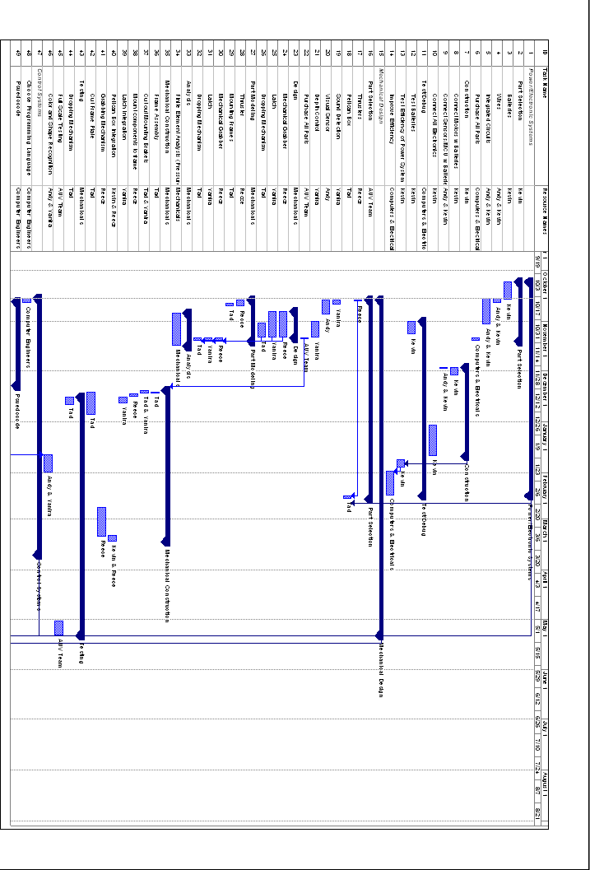
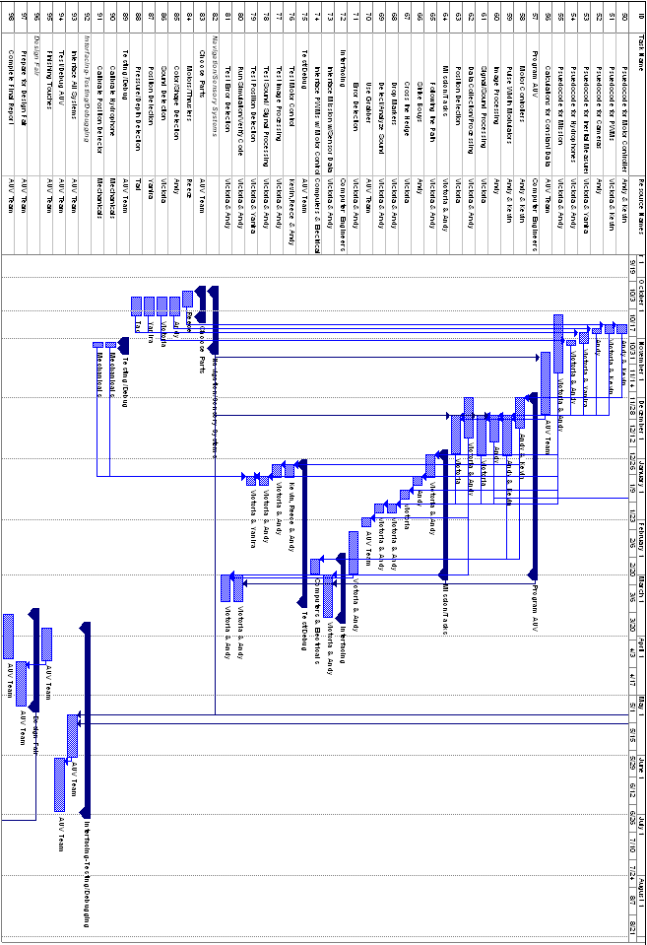
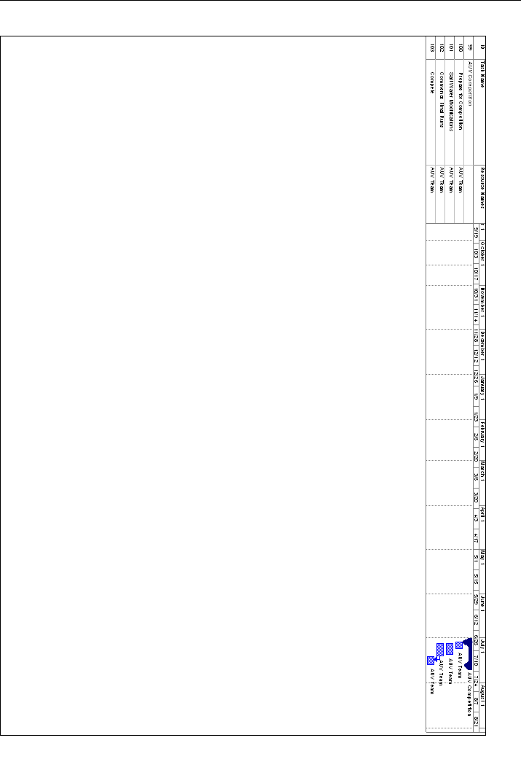
7 Budget Estimate
AUV ESTIMATED BUDGET
- Personnel
Name | Job Description | Base | Hours | Total
Andy Jeanthenor | Software Tech | $30.00/hr | 12hr/wk-28wks | $10,080.00
Kevin Miles | Electronics Tech | $30.00/hr | 12hr/wk-28wks | $10,080.00
Reece Spencer | Robotics Systems Tech | $30.00/hr | 12hr/wk-28wks | $10,080.00
Tad Byrne | Mechanical Design Tech | $30.00/hr | 12hr/wk-28wks | $10,080.00
Victoria Jefferson | Project Manager | $30.00/hr | 12hr/wk-28wks | $10,080.00
Yanira Torres | Equipment/Debug Tech | $30.00/hr | 12hr/wk-28wks | $10,080.00
Total Base Pay | Total pay of all engineers |  |  | $60,480.00
- Fringe Benefits | 29% of A |  |  | $17,540.00
- Total Salary | A + B |  |  | $78,020.00
- Expenses
Name | Description | Price | Quantity | Total
Battery A | Batteries for motors | $800.00 | 2 | $1,600.00
Battery B | Batteries for microcontroller and other peripherals | $100.00 | 4 | $400.00
Battery Charger A | Charger for battery type A | $180.00 | 1 | $180.00
Battery Charger B | Charger for battery type B | $60.00 | 2 | $120.00
Motors/Thrusters | Seabotix BTD150 thrusters | $750.00 | 4 | $3,000.00
Hydrophones | Hydrophone package(includes hydrophone, amps, and cables) | $320.00 | 3 | $960.00
Microcontroller** | Beagle Board | $170.00 | 1 | $170.00
Camera | Webcam | $80.00 | 3 | $240.00
Pelican Case | Water tight casing | $150.00 | 1 | $150.00
Wires/Electronic Kits | Switches, wires, electronic kits | $750.00 | N/A | $750.00
30’’ 8020 10 Series Aluminum T-slot Framing | Frame | $ 14.00 | 4 | $56.00
7.75’’ 8020 10 Series Aluminum T-slot Framing | Frame | $4.00 | 4 | $16.00
8020 10 Series Aluminum T-slot Framing | Frame | $ 5.50 | 4 | $22.00
8020 Corner Bracket | Connects T-slot frame | $5.00 | 16 | $80.00
Aluminum Plate 14 in x 12 in x ¼ in | Frame | $70.00 | 1 | $70.00
8020 Corner Braket Fasteners (Screw & simple nut) | To assemble frame | $1.00 | 64 | $64.00
8020 Component Fasteners (Screw & Curved Nut) | To attach components to frame | $1.50 | 40 | $60.00
Inertial Measurement Unit | Measures | $150.00 | 1 | $150.00
Total Expenses | Total estimated cost of all expenses |  |  | $8,088.00
- Total Direct Cost | C + D |  |  | $86,108.00
- Overhead Costs | 45% of total cost |  |  | $38,749.00
- Total Equipment Costs | Total estimated costs of equipment |  |  | $0.00
Total Cost | E + F + G |  |  | $124,857.00
Total Project Cost | Total estimated cost minus free items |  |  | $124,687.00

7.1 Budget Justification
This budget is an estimation of all the costs that will concur during the development of the FAMU/FSU College of Engineering AUV. The item in our budget with two asterisks is the donated BeagleBoard w/ an ARM Cortex A-8 processor. The first and most important items listed are our control and drive train items. We have decided to use two batteries to power the motors. We will also use a few smaller batteries to power the MCU and the other peripherals for our AUV. The motors will be SeaBotix BTD150s that include both motor controllers and thrusters with shroud surrounding the propellers. The microcontroller that we will use has been donated to us and meets the ARM requirement, which states that all computing equipment must be ARM products. The microcontroller we will use is the BeagleBoard and it comes equipped with the ARM Cortex A-8 as well as the OMAP3530 application processor. All the electronic equipment will be held in a pelican case to protect the electronics from water damage and since this vehicle will be submerged we will also purchase water tight connectors to protect the wiring. The hydrophone listed is a kit which also contains all the parts needed for the hydrophone which will be used for sound detection. We have decided to use the cheaper alternative for image processing by using the webcam which can be utilized to observe and track color and shape. The last sensor we have listed is the inertial measurement unit which contains the accelerometer, compass and gyroscope in one unit. This item will be used for position and orientation detection. All the other expenses are dealing with the design of the frame as well as the necessary materials for stabilizing all the components to the frame.
8 Deliverables

Hardware
The final product will be produced by the competition on July 12, 2010. When this project has been successfully completed our group will have constructed and programmed an autonomous underwater vehicle capable of completing all of the desired competition tasks and capabilities. The device will be capable of following a marked path, maneuvering through a gate, dropping markers into a specified bin, locating a pinger, and grasping a structure all while submerged after which it should resurface inside of an octagon in 15 minutes. The final product will also adhere to all AUVSI Competition Rules.

Reports

Project Proposal
The project proposal report presents the competition specifications as well as a description of the product, its components, design, assembly, and testing plan. It covers methodology for selecting components as well as a detailed schedule, budget, and each team member’s technical focus.

Detailed Design and Test Review
The detailed design and test review will provide a detailed description of the final product and testing results. It will include detailed information about the final design, the components included, programming, and interfaces.

Laboratory Notebooks
For our project our group will be keeping four separate notebooks to maintain documentation of the progression and information pertaining to the project. Each electrical and computer engineering student will maintain their own notebook while all mechanical engineering students will collect all information in one mechanical engineering notebook.

Weekly Meeting Minutes
Our group has group meetings as well as major specific meetings (electrical/computer meetings and mechanical). Details of topics covered in the meeting as well as individual tasks completed throughout the week are recorded at both of these meetings. Each week Victoria Jefferson, Project Manager, will provide a record of our weekly updates which will include details such as completed tasks, discussed topics, finalized ideas, and other project details. This will demonstrate the progression of tasks on our schedule.

AUVSI Journal Paper
For the AUVSI RoboSub competition we will write a journal paper that will be similar to the detailed design and test review paper. This journal paper will include details pertaining to our finalized product. It will include specific details on the mechanical design (e.g. propulsion system, hull and frame design, etc), electrical design (e.g. power system, the main board, etc) and computer design (e.g. software, controllers, etc.).

Schematic
The schematic will provide a detailed diagram demonstrating the relationship between each component and system. It will demonstrate how important components interact.

9 References
Official Rules for 2010 competition:
"Official Rules and Mission AUVSI & ONR's 13th Annual International Autonomous Underwater Vehicle Competition." AUVSI Foundation. Web. Sept.-Oct. 2010. <http://www.auvsifoundation.org/AUVSI/FOUNDATION/UploadedImages/AUV_Mission_Final_2010.pdf>.

