**FAMU-FSU College of Engineering   
Department of Electrical and Computer Engineering**

**EEL4914C/4915C – ECE Senior Design Project II**

**Detailed Design Review and Test Plan Report**

Project title: **Formula Hybrid Car 2010-2011**

Team #: 3

Student Team Members:

− **Israel Daramola**, Electrical Engineering (Email: iod07@fsu.edu)   
− **Thomas Emerick**, Mechanical engineering (Email: tme06@fsu.edu)   
− **Stephanie Medina**, Computer Engineering (Email: [sm07h@fsu.edu](mailto:sm07h@fsu.edu))

− **Lorenzo Neal**, Electrical Engineering (Email: lmn09@fsu.edu)   
− **Philip Young**, Mechanical Engineering (Email: pay07@fsu.edu)  
− **Ryan Zombek**, Mechanical Engineering (Email: [rmz07@fsu.edu](mailto:rmz07@fsu.edu))

Senior Design Project Instructor: **Dr. Bruce Harvey**

- Dr. Chris S. Edrington, Electrical Engineering Technical Advisor

- Dr. Chiang Shih, Mechanical Engineering Advisor

Submitted in partial fulfillment of the requirements for

EEL4911C – ECE Senior Design Project

February 2, 2011

# Executive Summary

The Formula Hybrid is an annual international collegiate competition striving to build a formula style, gas-electric hybrid vehicle. This year’s competition takes place in Louden, NH on May 1st, 2011 and is sponsored by IEEE, SAE, and many other corporate entities. The competition consists of a static portion and a dynamic portion, which includes acceleration, autocross, and an endurance race. The static portion will involve a series of in-depth questions that design judges will be asking to all team members. These questions will test all members’ knowledge on the analysis and reasoning of implementation on the vehicle. The acceleration, autocross, and endurance tests primarily consist of ranking the vehicles in order of time finished and suitably assigning points.

The current students working on this project are a combination of computer, electrical, and mechanical engineering students. In order to achieve the project’s main objectives being maximum fuel efficiency, the increase of vehicle performance, and the innovation of the drive-train configuration, major goals are being fulfilled. These goals involve the integration of the internal combustion engine(I.C.E), the implementation of the battery management system (B.M.S), the redesigning of the suspension, braking system, and I.C.E clutch, and the testing and incorporation of the cockpit sensors and paddle-shifting for the formula vehicle.

The team is presently in the progress of achieving several of these milestones. The computer engineer and one of the electrical engineers on the team are in the process of analyzing and integrating the Elithion-Lithiumate Battery Management System. The mechanical engineers have analyzed the suspension of the vehicle and have decided to modify the curved hollow-tubing with straight solid tubing to strengthen the struts of the car. The suspension will also be redesigned to be adjustable in order to facilitate any further use of the chassis. The braking system has been examined as well and the main alteration within this component will be the replacing of the calipers and rotors. The upright design has also been completed and a price quota is in process. The plan is to redesign a more lightweight version of the uprights from aluminum. The calipers and rotors have been delayed due to an unforeseen problem with the rear axle although currently a new rear axle, as well as calipers and rotors, are in the process of being ordered.

Cockpit sensors involve a combination of the speedometer, rpm sensors and radiator temperature gauge. The first three cockpit sensors have been purchased but are currently being tested to see if they will function into the integration of the vehicle. More so, pricing options are being analyzed from Summit Racing online, as it has been decided to utilize a thermal coupling probe for the radiator temperature gauge. In addition, the mechanicals received the response from Agni Motors Company and it was determined that the 6,000 rpm limit on the electric motor (E.M.) is due to mechanical failure. Therefore, in order for the coupling of the E.M. with the I.C.E to be accomplished, a one–way freewheel clutch bearing will be used on the E.M shaft. A price quota is currently in process from Boca Bearings to resolve this matter. The I.C.E clutch and paddle-shifting go hand in hand, as the I.C.E clutch will enable the changing of different gear levels in regards to the paddle-shifting.

Fortunately, one of the potential sponsors mentioned in the previous report approved the team for sponsorship with a value of $6,000, but one condition is that it is only for the completion of the vehicle. This led to another major challenge the team is currently dealing with being insufficient funds for travel expenses. Therefore, the engineers on the team are currently constructing a sponsorship proposal for Student Government Association,as well as researching potential sponsors.

**Table of Contents**

Project Executive Summary ii-iii

Table of Contents iv-v

1 Introduction 6-8

1.1 Acknowledgements 6

1.2 Problem Statement 6-7

1.3 Operating Environment 7

1.4 Intended Use(s) and Intended User(s) 8

1.5 Assumptions and Limitations 8

1.6 Expected End Product and Other Deliverables 8

2 System Design 8-25

2.1 Overview of the System 9-10

2.2 Major Components of the System.. 10-12

2.3 Performance Assessment 13

2.4 Design Process.. 13-14

2.4 Overall Risk Assessment.. 14-25

2.4.1 Technical Risks 14-20

2.4.2 Schedule Risks 20-22

2.4.3 Budget Risks 22-25

2.4.4 Summary of Risk Status 25

3 Design of Major Components 26-47

3.1 DriveTrain 26-29

3.2 Battery Management System.. 29-33

3.3 Chassis 34-47

4 Test Plan 47-53

4.1 System and Integration Test Plan 48-49

4.1.1 Drivetrain 48

4.1.2 Energy Management System 48

4.1.3 Chassis 48

4.1.4 Brake & Vehicle Assembly 48

4.1.5 Suspension & Uprights Assembly 48

4.1.6 Overall Vehicle Assembly 48-49

4.2 Test Plan for Major Components.. 49-53

4.2.1 I.C.E 49

4.2.2 One-Way Freewheel Clucth Bearing 49

4.2.3 Battle Kart Shifter 49

4.2.4 Battery Management System 49

4.2.5 Cockpit 49-50

4.2.6 Steering 50

4.2.7 Frame 50

4.2.8 Brakes 50-51

4.2.9 Axle & Hub Assembly 51

4.2.10 Suspension Characteristics 51

4.2.11 Uprights 51

4.2.12 Competition 51-52

4.3 Summary of Test Plan Status.. 52-53

5 Schedule 54-58

5.1 Original Schedule 54-55

5.2 Current Schedule.. 56-58

6 Budget Estimate 59-63

6.1 Original Budget 59-60

6.2 Current Budget.. 61-63

7 Conclusion 64

8 References 65

9 Appendices 66-96

9.1 Chassis Equations 66-67

9.2 Test Plan Forms.. 68-90

9.2 Resumes.. 91-96

# Introduction

## Acknowledgements

The 2010 Formula Hybrid Car team would like to thank Dr. Bruce Harvey and the team members of the 2009 Formula Hybrid Vehicle Team from the FAMU-FSU College of Engineering for their direction and general advising with regards to the vehicle design. Team 5 would also like to officially acknowledge Lei Wang and Xiaohu Liu for their research and guidance in the determination of the drive-train configuration for the vehicle the first year. The team would also like to thank Dr. Chris S. Edrington and Dr. Chiang Shih for their assistance in the fundraising and mentoring of the project. A special gratitude would also like to be extended towards Dr. Dave Cartes from IESES and to the SASE program at the Florida State University for their approval of sponsorship funds and assistance in developing a sponsorship plan for Student Government Association. The team has also received tremendous fabrication support and advice from Jeremy Phillips and John Rushing from the car shop and would therefore like to show their immense appreciation to them. A special thank you would like to be extended as well to the dean of the College of Engineering, Dr. Ching-Jen Chen, for paying the registration fee for the SAE 2010-2011 competition. In addition, the team of students would like to express their sense of gratitude to the following potential sponsors for their donations and support: Student Government Association and the FAMU Foundation. Without all of these potential sponsors, the project will be unable to achieve its’ success!

## Problem Statement

The 2011 FAMU-FSU Formula Hybrid Car Team believes in reducing, reusing and recycling. More so, the “GO GREEN” initiative is what is driving the team to continue the structure of a full hybrid-electric vehicle that will abide by the 2011 SAE/Dartmouth Formula Hybrid Competition rules and guidelines. This project consists of one computer engineering student, two electrical engineering students, and three mechanical engineering students. The team is engaging in the project to design and implement a fuel efficient hybrid vehicle to serve three main objectives : the reduction of fuel consumption, the improvement on the performance of the vehicle, and the innovation of the drive-train within the vehicle.

The SAE Dartmouth 2011 competition consists of three main tests in which the vehicle will need to perform exceptionally well in. The three main events of the competition will involve the acceleration, autocross, and endurance examinations. The previous year’s main challenge was the constructing of the hybrid-in progress vehicle. On the other hand, this year the team is concentrating on the incorporation of the internal combustion engine (I.C.E) along with the electric motor (E.M.) to make the vehicle a “full-hybrid car”.

In addition, a challenge the team endeavored last year was the uneven charging of batteries within the vehicle. This struggle along with the requirement of the end product having to be battery powered has led the team to implement the Battery Management System, which will manage the ability to recharge the battery pack by surveying, protecting, and balancing its’ state. The computer engineer and one of electrical engineers on the team are currently analyzing the Elithion-Lithiumate Battery Management System from Evolve Electronics. Methods of integration and testing are being constructed and will soon be fulfilled.

The mechanical engineers are facing challenges on their side of the team as well. They are currently analyzing the suspension and braking system of the vehicle. Not only have these students decided to change the curved hollow-tubing on the suspension to straight solid tubing but they have also come to the conclusion of making it adjustable, which will be quite a tedious task. These changes will facilitate the further use of the chassis and strengthen the struts on the vehicle. Calipers and uprights are being replaced in order to update the vehicle and reduce wheel weight. The final decisions for the brakes are being delayed due to an unforeseen problem with the rear axle of the vehicle, which will be discussed later. The uprights design has been completely finished and a quota is in process. The unexpected dilemma with the rear axle that was delaying the brakes and uprights was due to the fact that the CV joints at the end of the shaft were too short. Therefore, there was limited space for the mounting of the uprights and hub that were necessary in order to implement the outboard brakes. In order to resolve the issue, it was necessary to find new longer CV joints. A new axle with the required length CV joints has recently been ordered. Additionally, to efficiently fulfill the redesigning and replacing of the suspension, uprights, and calipers, Pro-ENGINEER and COMSOL programs are currently being utilized to visually comprehend and illustrate stress and deflection levels on the uprights

Other goals that are being delayed involve the I.C.E clutch and paddle-shifting incorporation. The mechanical engineer in charge of this task received the response of Agni Motors Company and it was confirmed that the 6,000 RPM limit on the E.M was due to a mechanical failure. Therefore, a one-way free clutch price quota is currently in process to resolve the matter. The I.C.E clutch and paddle-shifting go hand in hand, as the I.C.E clutch will enable the changing of different gear levels. In addition, a price quota for a Battle Kart Shifter is in process as well from Rising Sun Cycles. The Battle Kart Shifter will shift gears in the proper sequence to progress from neutral to sixth gear and from sixth gear to neutral. On the other hand, the electrical engineers on the team are presently exploring various pricing options for the radiator temperature gauge as this is the only sensor that has not been purchased thus far.

The type of radiator gauge that will be utilized will be a thermal coupling probe from Virtual Village to resolve the risk of the vehicle overheating. This probe will send the data and information to the temperature gauge and notify the driver if the temperature level is risky or not. The only BMS sensors, which are already integrated into the BMS that were purchased from Evolve Electronics, as mentioned earlier, are voltage sensors. Cockpit sensors include the speedometer, rpm sensors and speedometer, aside from the temperature gauge. These sensors are currently being tested as they were purchased last year but the wiring might change due to the integration of the temperature gauge. Upon the purchase and arrival of the final cockpit sensors and temperature gauge as well as the voltage sensors, the wiring between them and BMS will be analyzed.

Ideas that have been generated to resolve the problems or delays of these goals include analyzing the basic concepts behind all the main goals, while the company responses and quotas are received. Furthermore, the last main challenges besides lack of time and perhaps goals being setback due to their complexities include insufficient funds for travel expenses. Travel expenses for the competition are expected to be quite high and as of the moment, the team currently possesses just enough funds to successfully complete the formula vehicle. Therefore, the team is still locating potential sponsors, as well as thoroughly putting together a sponsorship proposal and presentation for Student Government Association.

## Operating Environment

The operating environment for the Formula Hybrid car is a flat racetrack or drag strip. The vehicle must and will be operable in a wide variety of climate conditions such as cold, hot, wet, dry, and dusty environments. The vehicle will not be driven off the road at any point. More so the vehicle must be able to operate under high acceleration turns and maintain the safety of the driver and vehicle integrity. One of the vehicles’s desired capabilities will involve the control displays being incorporated into the formula vehicle. Controls for ignition and emergency shutdown are being incorporated into the car. Additionally, the formula vehicle is not in danger of being dropped or thrown, however there is the risk of crashing the vehicle. This danger can lead to the puncturing of the batteries or gas tank and cause a serious hazard.

## Intended Use(s) and Intended User(s)

The intended user(s) of this product will be two team members who will perform as the drivers of the vehicle. Conversely, other team members will pilot the testing of the car. In accordance to the rules and regulations of the SAE rulebook, the vehicle must be designed to fit the largest 5th percentile of men and the smallest 5th percentile of women. The driver must fit the size constraints as set forth by the 2010-2011 Formula Hybrid Rules 3.3.4.1, have a valid driver’s license and motor skills prompt enough to navigate the flat track. The driver’s motor ability level will be measured by the team, although there is not an education requirement on the driver. Other user(s) of the vehicle may vary between the design judges in the actual competition and any potential or present sponsors.

The end uses for this project include competing in two static events and three dynamic events at the 2011 Formula Hybrid International Competition. As mentioned previously, the static events include a design inspection and team presentation. The dynamic events consist of a drag race (75m in ten seconds or less), an autocross and endurance race. This vehicle will also be utilized by the design team to stimulate the interest of students leading to further support, to perhaps gain further sponsoring within the SASE organization and for other potential sponsorship opportunities.

## Assumptions and Limitations

Assumptions: The maximum number of operators at one time will be one. The entire team will travel to Loudon, New Hampshire in May 2011 for the competition. Hybrid team sponsors will be displayed on the vehicle, apparel, banners and website that is currently under construction. The team has decided to do a series of tedious exams for the Elithion Battery Management System. Other decisions that have been determined include the purchasing of the radiator temperature gauge being a thermal coupling probe. Solid straight tubing will be used for the suspension, instead of the curved hollow tubing that is currently on the vehicle. The team is forming a group of students from the SASE organization to help develop the website for the formula project and prepare them for the business presentation to be given at the competition.

Limitations: The total project needs to be completed before May, 2011 and the total cost must fit within the final agreed budget. The total weight of the Formula Hybrid Vehicle should not exceed 700 lbs. The operator must fit within the 95th percentile of men and 5th percentile of women. The battery bank should deliver a minimum of 72 V to the electric motor (E.M) controller. The drive train system must fit within the dimensions of the chassis. The motor controller cannot attempt to draw more power than provided by the battery bank. The E.M and I.C.E must be in sync with one another when in operation. There are size limitations on the brake rotors due to the outboard brake design being custom-designed from the previous year’s team. More so this means that final decisions are being delayed due to the limited diameter and thickness that can be utilized on the rotors in order for them to fit inside the wheel wells of the vehicle.

## Expected End Product and Other Deliverables

The expected end product for this project will be a Full Hybrid vehicle, with a parallel drive train configuration. This vehicle will be able to accelerate 75 meters in less than 10 seconds and complete a 22 km track within a reasonable time to compete against the rest of the competitors. The end product will include an external charger, which will be utilized to charge the battery bank in the vehicle. It will fully charge the entire battery bank in less than 5 hours. A user manual will be provided along with all the design reports and milestone statuses of the progressing project. In addition, the final project reports and manual will be delivered on April 18, 2011.

# System Design

Currently, the 2011 Formula Hybrid team is just passed the midway point for the project. Although there is still a lot to be completed, the group has made tremendous progress towards the ultimate goal of the project; competing at the highest level possible and bringing recognition to FAMU-FSU COE as it deserves. To ensure that these goals are met, the team has analyzed the components of the vehicle that were given to the group via last year’s competition. Additionally, the team has made engineering judgments on what components needed to be further adjusted to aid the team in winning the upcoming event. From these judgments, sub-tasks were created and strategies were put in place to help focus the group’s attention on the main components to be changed this year and thus, giving the group the best chance at getting 1st place in the overall hybrid design in May 2011.

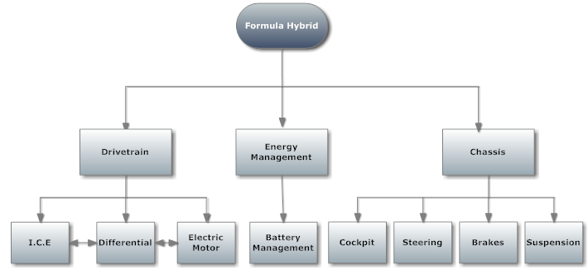

**Figure 1:** System Design

## Overview of the System

To give the FAMU-FSU COE an edge against the competition, the group decided a parallel hybrid would be the best decision. The advantages for a parallel system compared to a series system are that parallel systems are more energy-efficient and have better overall performance as compared to hybrids in series. The drawback pertains to the complication of coupling the two different energy sources and making sure that a smooth transition between the two is fast, safe and easy to accomplish. This task will be accomplished through a clutch on the electric motor that will disengage once a certain revolution number is reached and will allow the I.C.E to be the sole propulsion system onboard. With the aid of rpm gauges and an I.C.E clutch to guide the driver through the proper gear ratios of the transition, the coupling between both energy propulsions will be seamless and efficient.

As well as drivetrain additions, the group will also make significant suspension changes. These changes will allow for a more reliable system as well as the earning of style points in the design portion of the competition for having a fully adjustable suspension as well as a solid lightweight aluminum upright. Another major addition the group feels is necessary is a cockpit dashboard. It is potentially possible for the E.M to fail due to its’ maximum RPM limit. Driver error can occur and cause unnecessary failure if the driver is not properly informed on the vital signs of the propulsion systems. These sensors will aid the driver and will ensure that the proper use of the vehicle is being implemented. The most important of these sensors and one of the most innovative features being implemented this year is the Battery Management System. This system will not only allow the vehicle to be better managed during charging and discharging, but it will also greatly help the design portion of the competition with style points as well.

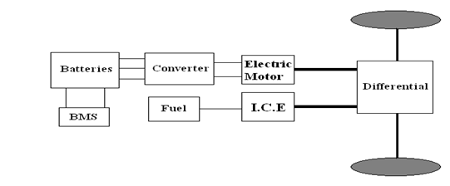

**Figure 2:** Overview of Parallel System Hybrid

## Major Components of the System

Being that this is a hybrid competition; two energy sources are required to be able to compete. The electric energy source has been designed and implemented already, thus leaving this year’s team the implementation of the internal combustion engine. Hence the I.C.E is one of the most important components of the hybrid system. With that being said, the group has to implement a Kawasaki Ninja 250 R engine into the vehicle. Even though this engine was inherited from last year, the decision was made to keep it because all the necessary add-ons have already been purchased and are functional, i.e. radiator, gauges, clutch and fuel tank. This engine was also chosen because its’ power to weight ratio is optimal and also serves as the maximum size allowable for the competition (250cc) and gives the group the best chance of winning. The methods to which the I.C.E will be coupled to the E.M are via the differential as well as a clutch on the E.M shaft itself. A chain and sprocket system will link the I.C.E’s output shaft directly to the differential housing itself. Through the proper gear ratios and clutch, the vehicle will be able to shift seamlessly from electric propulsion to combustion propulsion.

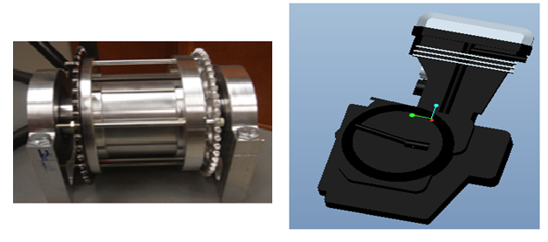

**Figure 3. Left:** The I.C.E sprocket coupled with the E.M via the differential.

**Right:** The Pro-Engineering model of the Kawasaki 250cc internal combustion engine being retrofitted into the vehicle.

Another major component of the vehicle is the Battery Management System. This system is responsible for taking individual voltage readings from the 120 individual batteries and sending that information to the BMS controller. The objective of the BMS is to manage the recharging of the battery packs within the vehicle as well as monitor, protect and balance the state of the Venom 5S 5000 mAh batteries. The Battery Management System will also include voltage and current sensors that will display the amount of voltage and current left. Currently, after doing some research and viewing funding options, the CPE/EE teammates were able to purchase the Elithion-Lithiumate Battery Management System. This system offers several attractive features to it which include versatility, relatively easy means of installation and safety. More so, the teammates are presently analyzing the Elithion Lithiumate BMS from Evolve Electronics in order to be able to integrate the system into the hybrid vehicle.

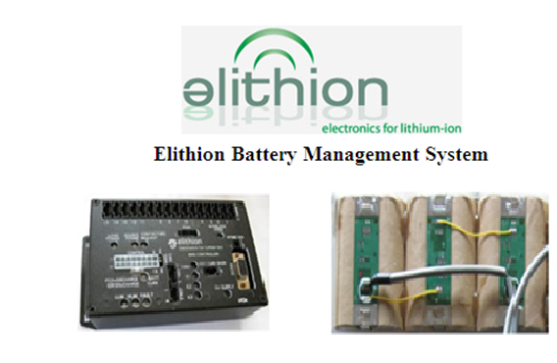

**Figure 4. Left:** The BMS Controller resposible for managing the active balancing of the battery cells through voltage and temperature rates.

**Right:** The picture is illustrating the three battery cells connected in series.

In addition to the BMS, the suspension is a major component of the vehicle that is presently being analyzed to great detail. Currently the tubing that is responsible for the frame is over ten years old and is comprised of hollow steel tubes with multiple bends in it. This year the group is implementing a much more innovative yet stronger design, straight solid tubing. The previous idea of A-arms was redesigned and now straight bars will be installed instead. Not to mention solid steel tubes will be used, as well as the ability to adjust the suspension on the fly. This is accomplished by installing opposite threading hind joints on each strut bar. With a notch cut in the center of the bars a wrench can be used to turn the bar along its parallel axis. By doing, so the opposite threaded hind joints will either extend in, when turned counter clockwise or contract in when turned clockwise. In either mode the length of the bar will change and thus the group can adjust the toe and camber of each tire with simple tools and effort. This should greatly impress the design judges and should help the group’s chances of winning for being the best overall hybrid engineering design. Another suspension modification will be implemented on the uprights for the vehicle. These uprights will be made of one solid 6061 lightweight aluminum billet and will a serve as a strong connection between the struts from the chassis to the tires of the vehicle. This modification alone will reduce the upright weight on each tire by 1/2 allowing for better acceleration and braking.

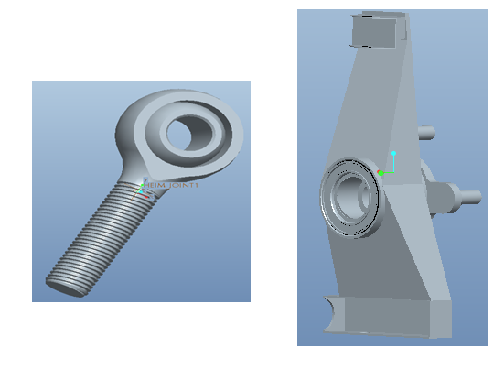

**Figure 5. Left:** An opposite threaded hind joint used for the suspension adjustment.

**Right:** The upright modeled with aluminum and extra support around the hind joints.

As mentioned previously, the brake system on the formula vehicle is being developed as well. As stated in the rulebook, the vehicle must be able to stop after an acceleration run and also have the ability of locking up all four tires. Previously, the vehicle had only one rear brake that acted on the differential. This was an acceptable design for the competition, however after engineering analysis it was found that the I.C.E sprocket will need to connect to the differential, where the current rear braking system is located. Hence, a new and innovative design was needed and the solution that arose was a duel rear braking system. This will free the space needed on the differential for the I.C.E sprocket, as well as meet the rulebook requirements for having the ability to lock all four wheels after a panic stop is executed.

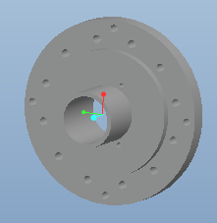

**Figure 6.** Pro-E drawing of the disc rotor needed for our system.

Additionally, steering stops are being added to the formula car. In order to limit driver error, steel blocks will be welded on the rack of the steering system to limit the travel of the pinion. By doing so, the wheels will not be able to overturn as the stops will be preventing the pinion to travel any further on the rack. Since this system is not required for the competition, the group is hoping to impress the design judges and stand out from the others in the competition. This implantation will also serve as an added safety feature, being the ability to overturn the steering wheel that will no longer exist.

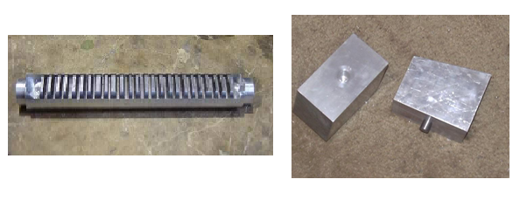

**Figure 7. Left**: The pinion of the Formula’s Hybrid steering system.

**Right:** The steering stops currently being implemented on the pinion.

One last major addition that will be added to the vehicle this year is the cockpit system. Being that the failure of the propulsion system can occur if the I.C.E is over driven, gauges monitoring these vital readings will be implemented into the cockpit for the driver to easily see. As well as an rpm sensor for the internal combustion engine, there will be several other gauges installed in the cockpit. These include a radiator temperature gauge and an rpm sensor for the E.M. These sensors will help ensure that the proper use of the vehicle is being maintained.

## Performance Assessment

## For the 2011 Hybrid Competition, there will be four categories for which the judges will be examining the overall performance of the vehicle. This includes an acceleration run, endurance run, autocross run as well as an overall engineering design portion. To ensure the highest possible score within each category, the team has implemented certain components specially designed to enhance these scores. For example, in the acceleration category, the group has implemented the maximum allowable combustion engine into the vehicle (250CC) with hopes of maximizing the vehicle’s overall performance. For the endurance run, the team will implement a Battery Management System that will monitor the battery’s performance, as well as prolong the overall life span of the batteries.

## Both are critical characteristics for a fuel efficient hybrid vehicle. Another major category in the competition is the autocross event. This year major improvements were made to ensure that the teams’ autocross lap times are better, as compared to last year’s competition. To accomplish this, the vehicle was retrofitted with a new suspension system, new front and rear brakes as well as improvements to the overall steering of the car. All of which will allow the car to have better high speed turning capabilities and allow a lower overall lap time.

## The last major category to which the judges will be reviewing the vehicle is the static design portion of the competition. This is where the judges give points for new and innovative ideas, as well as the overall engineering design of the vehicle. To ensure that the group performs outstandingly well in this category, several components are being installed on the vehicle to aid this idea. These systems include the Battery Management System, a newly designed brake system as well as a fully adjustable suspension, a cockpit system to display all the vital propulsion readings to the driver and a seamless means of coupling between the E.M and I.C.E. With the implementations of these systems, the group feels confident in the overall design of the vehicle and expects only the highest results from this competition.

## Design Process

Currently the hybrid team is in the position of making significant improvements to the overall vehicle’s performance. After a semester of research, major decisions have been made and are being implemented into the vehicle pending the ordering and installation process. These improvements should increase the overall performance of the vehicle, as well as impress the design judges with the team’s new and creative designs. The most important decision that the team had to tackle this year was the means of coupling between the I.C.E to the E.M.

Although this decision is decided, the group had two different concepts that would have worked and both had their own pros and cons. The easier of the two solutions involves two mechanical clutches, one to disengage the electric motor from the drivetrain and the other to shift through the I.C.E gears like a manual vehicle. Although the implementation is easy, the means to drive the vehicle becomes more complicated and adds a lot of unnecessary driver error into the vehicle. The latter of the two solutions involves a motor controller installed on the electric motor and I.C.E drivetrain to match the different torque outputs into a continuously uniform torque output. Although this solution sounds ideal, the lack of complete knowledge on this process as well as limited funds, made this solution more complicated than the previous. After engineering analysis it was found that solution one was the best for the group and is what is currently being installed on the hybrid vehicle. Through a one way bearing installed on the E.M output shaft as well as a clutch installed on the I.C.E for shifting, the transition between both propulsion systems will be effective and seamless.

Another decision that was made by the group was to keep the current frame of the vehicle the same without adding extra support; even through extra weight is being added to the system. To arrive at this conclusion, engineering analysis was performed and it was found that a 13% increase in weight with respect to the vehicle is negligible and can be neglected.

One of the most innovative decisions was that of choosing the Battery Management System, which shall be implemented onto the vehicle. Being the electric propulsion system was already installed on the vehicle, the decision in choosing a BMS system mainly relied on the ability for both systems to be compatible. After several contacts with Evolve Electronics, it was concluded that their Elithion Lithiumate BMS would be compatible with the system currently installed on the Formula Hybrid and the decision was made to implement this system. This system will greatly improve the overall life and performance of the battery cells, as well as impress the design judges with an innovative idea.

The last major decision which should help improve the group’s overall performance is the addition of a new suspension and braking system. After performing some necessary performance tests on the vehicle, it was concluded by the group that this addition was needed. Not only will the previous suspension be removed and reinstalled but the significant improvement of a fully adjustable suspension will be implemented. As well as the suspension, the braking system was also decided unanimously to be ineffective and to be lacking the performance needed to perform at a high level. As a result of this, a dual rear braking system will be implemented onto the vehicle, as well as bigger rotors and brake pads then were previously installed. This should greatly improve the vehicle’s ability to take turns at higher rates of speeds and will also assist in the overall design portion of the competition as well.

## Overall Risk Assessment

### *Technical Risks*

Being some of the major components of the hybrid vehicle are being redesigned with new and innovative technology, some technical risks are to be assumed. To name a few, the coupling between the I.C.E and the E.M poses a threat for success and is the main technical risk associated with the team this year. Another major new and innovative feature being installed is the Battery Management System. Due to the complicity of the system, this also poses a significant threat to the group and strategies must be employed to eliminate any threats that could hinder the group’s chances of winning the competition in New Hampshire come May 2011.

### *Technical Risk 1: BMS Failure*

|  |  |
| --- | --- |
| **Risk** | Faulty sensor information as well as improper charging &discharging of the batteries |
| **Probability** | Moderate |
| **Consequence** | Mild |
| **Strategy** | Proper installation and programming |

Description

The Battery Management System is responsible for making sure that the batteries in the vehicle are all charged and discharged equally. This means that no one battery will be used more than another and that over time the batteries will experience a prolonged life. In addition the BMS will provide a cockpit sensor that will indicate the battery voltage reaming, which in turn can be used to estimate the life left in the batteries. In the event of failure of this unit or parts of it, individual batteries may be overcharged or undercharged, which in turn could affect the vehicle’s overall performance in such events as the restricted electric only run or endurance run.

Probability: Moderate

Currently there are 120 individual cells all wired in series on the Formula Hybrid vehicle. With that many variables, the technical risk was labeled moderate for a failure of one of such component. In addition, the microcontroller will require rather complex computer programming to adjust for the added sensors installed on the cells.

Consequences: Mild

The consequence for a complete BMS failure is mild. Reduced battery life cycle and the inability to monitor charging capabilities will be the main consequences. Both of which will mildly affect the team’s results in the 2010-2011 Hybrid Competition.

Strategy

To alleviate the problems associated with a BMS failure, a programmable microcontroller with individual voltage and current sensors will be implemented on each battery unit. The voltage and current sensors will relay the levels of each battery back to the controllers. The programming of the controller will then dictate which batteries, if any, need to be charged or discharged first.

### *Technical Risk 2: Differential Failure*

|  |  |
| --- | --- |
| **Risk** | The inability to maneuver high speed turns effectively |
| **Probability** | Low |
| **Consequence** | Moderate |
| **Strategy** | Ensure the Hybrid vehicle is driven as required |

Description

Failure of the differential includes seizing of the gears due to lack of lubrication or the stripping of the chain belt that is connected to the differential via the sprocket. Both would occur in the event of human error and improperly using the vehicle.

Probability: Low

The probability of this occurrence is low due to the fact the differential was designed to withstand the forces generated by the coupling of the two different energy sources. All gear ratios have been designed and are in place so that the user error is at its minimum. Also proper lubrication will be regularly maintained by the mechanical engineers leading up to and during the competition.

Consequences: Moderate

Upon failure of the differential, the rear axle would no longer be able to transfer power to the rear tires effectively. Although the ability to drive will remain, the ability to apply different torques to each rear tire on turns will not. This will in turn cause the tires to slip and greatly reduce the vehicle’s ability to maneuver high speed turns effectively.

Strategy

Careful precautions will be implemented by all drivers of the vehicle to ensure the proper usage of the clutch and shifting paddles is used, as well as the ability to shift through the gears of the I.C.E smoothly and under the desired max RPMS. Also using an appropriate lubrication oil when needed, will help ensure that a differential failure does not occur.

***Technical Risk 3:*** ***I.C.E Failure***

|  |  |
| --- | --- |
| **Risk** | Complete shutdown of the I.C.E and its components |
| **Probability** | Mild |
| **Consequence** | Critical |
| **Strategy** | Install rpm and temperature sensors to monitor vital readings from the I.C.E during operation |

Description

There are many failures that can occur and are associated with the internal combustion engine. These include piston failure, the overheating of the coolant and exceeding the top end of the engine.

Probability: Mild

The probability of this event is mild due to the fact that every driver will be well informed on the operating conditions of the engine and only these specified drivers will be allowed to operate the vehicle, under full hybrid conditions. Also with the aid of dash gauges, the driver will be well aware of coolant temperature and other vital readings such as the rpms and speeds of both the I.C.E and the electric motor.

Consequences: Critical

If the I.C.E should fail and the team was unable to install a new one before the competition, the team would be unable to compete as a full hybrid. With this being the second year the vehicle will compete, the only category available is a full hybrid. Thus, just an electric vehicle would not sufficient to compete in the competition of May 2011.

Strategy

The strategy to prevent complete failure of the I.C.E will rely solely upon the driver of the vehicle. Being the internal combustion engine is a motorcycle engine, it’s capable of 13,000 RPM’s. To safely operate the vehicle, the user must ensure that the I.C.E doesn’t reach this limit. If this rpm limit is reached for the duration of time, catastrophic failure will be imminent. Also the driver must be aware of the dash gauge for engine temperature, ensuring it’s operating below its desired temperature.

***Technical Risk 4: Rear Brake Failure***

|  |  |
| --- | --- |
| **Risk** | Having the inability to lock all four wheels and stop in the required distance |
| **Probability** | Low |
| **Consequence** | Severe |
| **Strategy** | Professional Welding and the use of gussets to help reinforce the calipers to the uprights |

Description

Being the rear brake has been relocated to the back wheels, the connection between the disc brake mount and the uprights must be secure enough to ensure failure does not occur. Should failure occur, the vehicle would have the inability to lock all four wheels and would be disqualified from the competition.

Probability: Low

The possibility of the weld between the upright and disc brake mount failing is low because the group can lay multiple welds on top of each other for extra layer of redundancies.

Consequences: Severe

Consequences for brake failure would be severe if the group was unable to make changes before the competition. A weld failure could be fixed on site, permitting there be the appropriate tools available, allowing for re-entry into the competition.

Strategy

To reduce the risk of failure, gussets will be used to reinforce the connection between the caliper and the upright hub. The team will also employ a professional welder using modern technology to ensure the welds are of the utmost standard. Testing the vehicle under dynamic conditions should allow insight on whether failures will occur and if modifications are needed.

***Technical Risk 5: Faulty Sensors***

|  |  |
| --- | --- |
| **Risk** | Defective equipment and/or faulty connection |
| **Probability** | Low |
| **Consequence** | Moderate |
| **Strategy** | Correct installation as well as verification measurements to ensure the vehicle’s sensors are outputting the correct data |

Description

The cockpit sensors will relay vital information to the driver such as, voltage and current to the motor, rpm and temperature of the I.C.E, the speed of the vehicle as well as the miles traveled. If the sensors are returning false information to the driver, then the risk of over using the vehicle’s critical components will increase.

Probability: Low

The probability of faulty sensors causing critical damage to our vehicle and hurting our chances of winning the competition is mild. Experienced drivers will hear the wind up of the I.C.E and know intuitively when it’s appropriate to shift gears. In the event of catastrophic failure of the sensors, the group will still be able to compete in New Hampshire.

Consequences: Moderate

The consequences of faulty sensor information can lead to the overheating of the I.C.E, as well as exceeding the rpm’s on the electric motor. However, these conditions only exist when driving the vehicle in extreme conditions. An experienced driver knowing the capabilities and limitations of the vehicle would be able to drive the vehicle competitively, without the aid of sensors if need be.

Strategy

Each sensor will be installed accordingly to the manufacturer’s guide to ensure the proper setup is used. To ensure that the sensors are not reading false information, each sensor will be tested with similar devices. Results will be compared for accuracy.

***Technical Risk 6: Damaging Electric Motor (E.M)***

|  |  |
| --- | --- |
| **Risk** | Overheating and destroying the electric motor |
| **Probability** | Medium |
| **Consequence** | Severe |
| **Strategy** | As long as the electric motor is run under 6,000 rpm, catastrophic failure will not occur |

Description

Currently the hybrid vehicle has a 95 series Agni motor installed with a maximum revolution of 6,000 rpm. If this number was to be exceeded for a short duration of time, the electric motor could run the risk of overheating and even failing.

Probability: Medium

The probability of exceeding the capabilities of the Agni 95 motor is medium. This is due to the complicated methods to which the vehicle must be strictly driven. If the driver was to misread his rpm gauges mounted in the cockpit, or misuse the mechanical clutch, a damaged electric motor is probable.

Consequences: Severe

Being the Agni motor is one of the most expensive and critical components on the hybrid vehicle, a replacement would be unlikely. Depending on time and available funds, a replacement can be found and installed prior to the competition. However, the performance will be greatly reduced which will in turn hurt the team’s chances of winning this competition.

Strategy

To minimize the error associated with driving the vehicle, several gauges will be placed directly in front of the driver on the dashboard. Gauges such as, rpm’s of the I.C.E as well as the E.M, voltage and current supplied to the motor, radiator temperature and velocity of the vehicle will aid the driver to make the most informed decision on the proper timing to shift gears.

***Technical Risk 7: Chassis Failure***

|  |  |
| --- | --- |
| **Risk** | Failure of a structural member of the vehicle |
| **Probability** | Minimal |
| **Consequence** | Severe |
| **Strategy** | Structural analysis was performed on the frame of the vehicle taking in consideration for the added weight of the I.C.E and its components, consequently it was found safe and the weight can be neglected |

Description

The chassis is a component that was designed and implemented by last year’s team. The welds that hold the chassis together are critical to the results of the competition and thus will require some attention to ensure the structural integrity still remains. However, being last year’s team passed a full body inspection by a licensed formula hybrid judge and achieved 1st place in hybrid in progress, little if any modifications will be made to the frame itself.

Probability: Minimal

The probability of a chassis failure is minimal at best. If a failure was to occur on the frame due to faulting welds, visual evidence would be clear by now.

Consequences: Severe

Due to the fact that the chassis was one of the most complicated and expensive components on the vehicle, a complete failure would be disastrous. Little time or money is left to allow for such a major malfunction to occur and the consequences for this failure would be to officially withdraw from the competition which is out of the question.

Strategy

The chassis was modeled in Pro-ENGINEER taking in consideration for the added weight of the I.C.E and its components and it was found that a 13% increase in mass with respect to the car can be neglected. In turn, the chassis’s factor of safety using the added weight of the I.C.E was still safely over 2.0, which instills confidence that the frame will perform as designed.

***Technical Risk 8: Overcharging/Undercharging of Batteries***

|  |  |
| --- | --- |
| **Risk** | The risk of destroying one or more of the lithium batteries thru misuse or neglect |
| **Probability** | Mild |
| **Consequence** | Medium |
| **Strategy** | Installation of a Battery Management System to monitor and display vital battery measurements |

Description

As the main means of propulsion and acceleration for the Hybrid vehicle, the car relies on 120 individual lithium polymer batteries. These batteries have a maximum and minimum voltage level that needs to be maintained in order for the vehicle to run properly. If a failure was to occur in one or more components of the batteries, the overall performance of the vehicle and even our results in the competition could be altered.

Probability: Mild

Currently the 2010-2011 Hybrid group is working on installing a Battery Management System on the vehicle. This system will relay the voltage from every cell and display the amount of overall performance left in the batteries. These readings along with the attention to detail, the group feels the probability of overcharging/undercharging the batteries is mild at best.

Consequences : Medium

Depending on the magnitude of the failure, the group would still be able to compete in the Hybrid competition if one or two of the batteries would fail. However, if a catastrophic battery failure were to occur, the group would be unable to complete the electric only run of 75 yards in less than 10 seconds and thus eliminate the group from the competition.

Strategy

To ensure the batteries are being properly charged and discharged, a Battery Management System is currently in the process of being purchased and will then be installed onto the vehicle. This system will rely the voltage from the individual cells and draw power according to the voltage levels of each unit. This will ensure all batteries are discharging equally and that one battery is not being used than any other. In addition, an average voltage reading gauge will be installed in the cockpit to allow the driver to view his power level ensuring the minimum voltage value is not being reached.

***Technical Risk 9: Steering Failure***

|  |  |
| --- | --- |
| **Risk** | Failure of the welds on the pinion ensuring that over steering cannot occur |
| **Probability** | Mild |
| **Consequence** | Medium |
| **Strategy** | Proper installation and excessive welds will be used to ensure steering failure does not occur |

Description

Steering stops on the rack and pinion will be implemented to limit the movement of the front tires. These will ensure that the driver does not have the ability of overturning the wheels into the suspension causing chassis failure.

Probability: Mild

The overall probability of these welds failing is mild. Once installed, these stops will not experience great forces and thus should remain intact indefinitely.

Consequences: Medium

Should the welds fail, the ability for the driver to overturn the wheels into the suspension shall exist. For an inexperienced driver not familiar with this car this, a medium technical risk could arise. However, as long as the driver maintains the proper wheel angle throughout turns, the consequences for a steering stop failure are minimal.

Strategy

For redundancy, the group plans on laying an excessive amount of welds on each steering stop to the rack of the steering system. Being the stops will not be under any static or dynamic forces for the majority of its lifespan these welds should suffice.

### *Schedule Risks*

Being some of the major components of the Formula Hybrid, depend on factors that our out of the team’s control, schedule delays are inevitable. If a shipping error were to occur on a time sensitive component, a delay could occur that would halter the work of sequential parts and in turn cause a schedule delay. Another major schedule risk is having the availability to work on the vehicle when needed. Currently there are at least five projects coinciding with the Formula Hybrid and the availability for shop time can be limited and hence pose a schedule threat.

***Schedule Risk 1: Parts Arriving Late/Reorder***

|  |  |
| --- | --- |
| **Risk** | Critical components are unavailable for installation due to unforeseen shipping errors |
| **Probability** | Likely |
| **Consequence** | Moderate |
| **Strategy** | Taking in consideration for parts arriving late, time sensitive components will be ordered well in advance allowing for foreseen shipping errors to occur |

Description:

Due to the fact that the majorities of the parts needed for the vehicle are specialty parts and may not be carried in stock, amble time is needed for purchasing orders to ensure schedule delays do not occur. Also attention must be given to the accuracy of PO’s, as this could also lead to wrong parts and schedule delays.

Probability: Likely

Since most parts will be ordered over the busy holiday season, delays from the shipping process should be expected and compensated for. The specialty parts needed and the probability of parts arriving later than anticipated is likely.

Consequences: Moderate

The consequences for parts arriving late would be the delay in the schedule and the project as a whole. Some delays are manageable and easy to overcome, however more important aspects of the project cannot afford a shipping/ordering error and extreme caution must be taken when ordering these parts.

Strategy:

In order to eliminate the risks associated with purchase orders/shipping orders, time sensitive parts will be ordered well in advance and will take in consideration for the possibility of shipping delays to occur.

***Schedule Risk 2: Treasury Access***

|  |  |
| --- | --- |
| **Risk** | Having the inability to purchase necessary equipment due to the lack of vendors’ compliance with FAMU’s purchase ordering system |
| **Probability** | Definite |
| **Consequence** | Medium |
| **Strategy** | Ordering parts in advanced and purchasing the best option available to the group will be the best strategy to combat this schedule risk |

Description:

For the 2011 Hybrid competition, FAMU has placed $5,000 into a FAMU account. This poses a schedule risk because currently only one member of the Formula Hybrid team is a FAMU student. Hence, all purchase orders will have to be assigned to one student and that can complicate the reimbursement process, adding unnecessary delays into the schedule.

Probability: Definite

Being the group has already encountered this problem several times this semester, the probability of treasury access posing a schedule risk is definite.

Consequences: Medium

The consequences of having limited treasury access are a delay in the schedule and the possibility of not completing the vehicle before the competition is as well.

Strategy:

Although the consequences for this risk could be severe, the group understands the process well enough to leave amble time for purchase orders and reimbursements to take place.

***Schedule Risk 3: Sick or Absent Team Member***

|  |  |
| --- | --- |
| **Risk** | Losing a team member for an extended amount of time due to illness or unforeseen circumstances |
| **Probability** | Mild |
| **Consequence** | Medium |
| **Strategy** | The schedule risk associated with the loss of a team member would depend on the remaining tasks to be completed, measures would need to be taken by the remaining group members to ensure the ultimate goal of the hybrid project is executed |

Description:

Currently there are six engineers assigned to the Formula Hybrid Project. If one or more members became ill or had to leave town due to unforeseen circumstances, the extra load for the remaining engineers would in turn create a delay in the schedule and could possibly hinder the completion of the project.

Probability: Mild

The probability of one or group members becoming mildly ill is adequate. However, the probability of one or more group members becoming ill for a sustained amount of time is mild and therefore not a major concern.

Consequences: Medium

Being the Hybrid project is very complex project, a lost team member would result in a tremendous amount of work to do by the remaining group members. New tasks would need to be assigned and the overall scope of the project would have to be adjusted accordingly.

Strategy:

The strategy to ensure that the schedule stays on task in the event of a sick or absent group member would mainly rely on the students still assigned to the project. Depending on the tasks left to accomplish when the group member is absent, new goals and priorities may need to be set to ensure the ultimate goal of competing competitively in the competition come May, 2011.

***Schedule Risk 4: Availability of Support***

|  |  |
| --- | --- |
| **Risk** | Having the inability to access tools necessary to complete vitals task associated with the vehicle |
| **Probability** | Medium |
| **Consequence** | Severe |
| **Strategy** | Factor in the schedule the probability of the workshop being booked when the group needs to access it |

Description

Currently there is at least five multi-disciplinary projects going on that require the machines and tools located in the mechanical engineering shop to complete a project of this scope. Being the shop cannot handle the volume of all the groups at once, a conflict can arise. If the group was unable to use the tools needed to complete a task, a schedule delay could occur and hinder the progress of the project.

Probability: Medium

The probability of a schedule delay occurring from the inability to access the tools and machines needed to complete a task is medium. With limited tools and space and a handful of projects to complete in a short amount of time, it’s likely that multiple groups will want to work on their projects at similar times.

Consequences: Severe

Being certain components on the vehicle require specialty tools for installation, limited access to these resources would hinder the group’s ability to complete certain tasks crucial for the completion of the project. This would be a severe consequence and could alter the results of the competition.

Strategy

In order to ensure that the availability of support is not a schedule risk, the group has allotted extra time in the schedule for the anticipation of limited access to the workshop. For an unforeseen event to occur, the group could make new time/date arrangements for the workshop and still be on schedule.

### *Budget Risks*

As of currently, the budget for the hybrid project is $11,000. With such expensive components to purchase and not to mention the need for travel expenses, its obvious why the group is concerned with the budget. Not only is the risk of insufficient present but the risk of a component failure is as well. If one such component failed and the lack of funds to purchase a replacement existed, the group’s chances of winning this event would be diminished.

### *Budget Risk 1: Major Component Failure*

|  |  |
| --- | --- |
| Risk | Failure of major component can lead to an immense amount of money |
| Probability | Low |
| Consequence | Severe |
| Strategy | 1 .Components will be operated within nominal operating range |

Description

Any component failure requires that the team replaces the parts. For minor component failures and miscellaneous parts, the team has budgeted $2000. However, if major components (such as EM, I.C.E, or the BMS) fail, then the team would have to pay a substantial amount of money to replace any of the components.

Probability: Low

The probability of this occurrence is low, because the team is designing all of the components to easily handle the stress load. There should never be a time when a component will exceed its operating stress threshold.

Consequences: Severe

The consequences of having major component failures can lead to the withdrawing from the competition which can be quite severe. Other options include to replace these major component failures but to do so with require more funds with which the team doesn’t count with at the moment.

Strategy

In order to prevent major component failure, the components will always be operated well within their nominal operating range.

### *Budget Risk 2: Under Budgeting*

|  |  |
| --- | --- |
| Risk | Under budgeting due to underestimating costs of components |
| Probability | Low |
| Consequence | Severe |
| Strategy | 1 .Research several options for specific component  2. Order parts early  3. Test compatibility  4. Order components less than or equal to projected cost |

Description

There are many components that are involved with building a formula hybrid car. Many of these components can be extremely expensive or inexpensive. In order to initiate this project, the team was instructed to determine a budget for this year. The budget that was calculated was a total of estimated costs for some of the components to be implemented this school year. Since the expenses were an approximation, there remains the risk of components in the process of being purchased resulting to cost more than expected. Hence, if too many of the components cost more than assumed, the possibility of under budgeting is quite possible.

Probability: Low

The probability of this occurrence is low, because the team has already researched the components that they will be utilizing this year. Since the components and materials have already been researched and determined, the team has a more realistic idea of what the actual costs will be.

Consequences: Severe

If in fact the project does go over budget, then the difference comes out of the team’s pocket. This can be a major problem since all team members are college students and will therefore not have the necessary funds to pay for these components and materials.

Strategy

In order to prevent under budgeting, the engineers on the team will research several different options and order their proposed components and materials early. More so if the proposed materials or components are not compatible with the vehicle, then the team will only order items which are less than or equal to the projected cost.

### *Budget Risk 3: Lack of Donations*

|  |  |
| --- | --- |
| Risk | Potential sponsors declining to contribute to project |
| Probability | Moderate |
| Consequence | Severe |
| Strategy | 1 .Remain in continuous contact with potential sponsors  2. Provide monthly reports and all necessary factors sponsors require |

Description

There are a few potential sponsors that are willing to donate to this year’s Formula Hybrid Team. So far the team has $11,000 that was donated this year from FAMU. Although these funds are strictly for the vehicle only, the team still lacks funds for travel expenses. Since recently, Dr.Cartes’ sponsorship was approved for $6,000. The team hopefully won’t run the risk of insufficient funds for the vehicle itself, although unexpected occurrences can happen. More so, if Student Government Association does approve the current sponsorship request proposal the team is putting together, then the team should have enough for the competition expenses. Otherwise, the team could be obligated to forfeit the competition. In addition, Dr. Zheng and Dr. Wheatherspoon are also in the process of reviewing our vehicle proposal to possibly donate an additional $1,500 to the project. Based on all these possible donations, the team could potentially receive $7,500 in donations. If for some reason any of our sponsorship donators are unable or unwilling to donate to this project, the team will be unable to complete most of the objectives proposed for this year. Furthermore, not receiving these funds can prevent the team from performing successfully at the 2011 SAE Competition or from being able to compete at all.

Probability: Moderate

The probability of this occurrence is moderate for two main reasons. The main one being that although the team has been constantly researching potential sponsors either through technical competitions, the Dean of the College of Engineering or by contacting different professors possibly interested in the project ,several of these sponsors as mentioned previously are not 100 % for sure. One of the biggest contributors being Student Government Association will soon be in the process of reviewing the formula vehicle proposal. Another disappointment has been that the team still has not heard back from the technical paper competition entered back in August. More so Dr. Zheng and Dr. Weatherspoon are currently determining if they will donate as well.

Consequences: Severe

If the project happens to exceed the current budget of $5,000, the students will have to come up with the difference out of their own pockets. Perhaps even host a couple fundraisers to make up for the funds needed. The last consequence can lead to re-prioritizing the goals of the car and just leaving the objectives that can be fulfilled with just the $5,000. As one can see, if the team is unable to allocate the necessary funds for the current goals through either of these options, the project will suffer greatly.

Strategy

In order to prevent this risk from occurring, the team will continue to remain to be in continuous contact with the potential donators and be providing each one with a monthly report and any other necessary factors needed.

### *Summary of Risk Status*

To ensure that the 2011 Formula Hybrid vehicle competes at the highest level, all risks associated with the vehicle must be examined prior to the competition. These risks can include the technical risks of the vehicle, the budget risks and also the schedule risks of the vehicle, all of which pose a significant threat to the completion of the project, if not properly examined. The goal of examining the overall risk assessment of the vehicle is to ensure plans and strategies are in place to mitigating the problems that should arise throughout the project.

Technical risks by nature occur when the physical development begins. As parts arrive and are integrated into systems, the technical risks can develop into real problems. However, the groundwork for a future problem is laid out in the design process, the portion of the project that the team is in currently. By anticipating the risks from the previous sections in the design, the team can eliminate risks before they become an issue. Thus, the status of the technical risks is that they are still an inactive threat but steps are being taken to eliminate them.

Many of the current schedule risks are affected by ordering and shipping large scale items. Much of the scheduled work cannot occur after parts such as the battery management system and the paddle shifter. Thus, the success of the schedule depends heavily on how soon the parts are ordered and if there are any issues with the parts that were ordered. The current status of the schedule is that it is on time but the team is being cautious for schedule disruptions.

The current budget risks are associated with component failure, lack of donations and under budgeting. The current status of the budget is that due to a recently approved sponsor, the vehicle will be able to be completed successfully. More so, the budget’s main lacking section is travel expenses, mainly for the competition in May. Although, the risks remain mainly in the ordering, installation and unprecedented testing results of components. Additionally, the biggest risk of all being not having sufficient funds to travel to New Hampshire for the competition. Sponsorship proposals as well as potential sponsors for the competition are being contacted.

# Design of Major Components

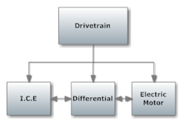

**Figure 8**. Block Diagram for the Drivetrain

## Drivetrain

A wide range of concepts have been generated to complete the task of coupling the E.M. with the I.C.E. The concepts that have been generated depend on multiple constraints, one of which is the maximum rpm that the electric motor can operate at before mechanical failure occurs. The possibility of burning up the E.M. by means of the I.C.E is another constraint that the team is designing the coupling around. Limiting the risks of the electrical motor failure is discussed in **Section 2.5.1: Technical Risk 6**.The simplification of the control and driver interaction of the operational features of the two motors is being considered during the design process. Ensuring a smooth transition from electric power to gas power and vice versa is desired in the coupling design.

The design concepts generated for the drivetrain involve the coupling of the E.M with the I.C.E through the differential. The current drivetrain has been designed so that the driven sprockets from the E.M and the I.C.E are installed on opposite sides of the differential. The gearing ratios have been chosen and the sprockets have been manufactured. **Table 3.1** shows the gear ratios for the electric motor (E.M) (52:10) and gas engine (I.C.E) (45:14). The gear ratio is dependent on the number of teeth on the driving and driven sprockets. This value corresponds to the first row of numbers in **Table 3.1.** The table shows the gear ratios for each of the six gears in the I.C.E’s transmission. **Table 3.1** displays the value of the rpm of the two driving and driven sprockets. Note that the driven sprockets on the differential have the same rpm value. In addition, in the table below, the operating conditions for the I.C.E are at a max rpm of 12,000 and a mid rpm of 7,000 are shown. The risks assessment for the I.C.E is further discussed in **Section 2.5.1: Technical Risk 3** in regards to any faulty components or errors within it.

**Table 3.1** Electric Motor (E.M) and Internal Combustion Engine (I.C.E) Gear Ratios

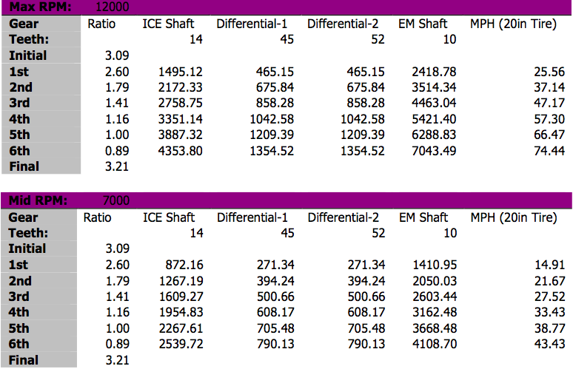

The team used the following decision matrix, shown below in **Table 3.2**, to choose an optimal design to couple the E.M. with the I.C.E. The most important factor for the design is performance. The performance aspect of the decision matrix includes the constraints stated earlier. The ease of implementation and operation are weighted equally and more importantly than total cost. These weighting factors were chosen due to the coupling requirement and the team being willing to allocate a substantial portion of the budget, if the implementation is ensured. The decision matrix reveals that the use of an electric motor clutch is the best coupling design. The use of an electric motor clutch did not rank the highest in any of the judging categories but had the greatest overall value.

**Table 3.2** Decision Matrix of Electric Motor and I.C.E Coupling

|  |  |  |  |  |  |
| --- | --- | --- | --- | --- | --- |
| Design Options | Total Cost | Ease of Implementation | Ease of Operation | Performance | Total |
| Weight | 10% | 15% | 15% | 60% | 100% |
| Automatic Rev Matching | 0 | 0 | 10 | 5 | 45 |
| No Clutch on Electric Motor | 10 | 10 | 8 | 5 | 67 |
| Electric Motor Clutch | 8 | 8 | 7 | 9 | 84.5 |
| Automatic Rev Matching with Clutch on EM | 0 | 0 | 8 | 10 | 72 |

The use of a motor controller to automatically match the rpm of the driven sprocket of the electric motor to the rpm of the driven sprocket of the I.C.E ranked last in the decision matrix. This is because the programming and implementation of a motor controller to compute the algorithms involving the rpm and six different gear ratios of the I.C.E and then functionally matching the RPM’s of the electric motor, involves complex programming. The complex programming poses a risk to the team’s limited schedule. The team members are also concerned that employing this method of coupling the I.C.E with the E.M. may be beyond current members’ knowledge and ability.

This method of coupling also ranks low in the performance category of the decision matrix. The driver would not be able to operate the I.C.E in a manner that would cause the electric motor to spin faster than its maximum rpm of 6,000. This effect will limit the I.C.E operating RPMs’ and cause it to be unable to reach its maximum power delivery potential.

The coupling of the E.M. and I.C.E. without the use of a clutch on the electric motor ranked second lowest on the decision matrix. This design concept requires that the driver does not operate the I.C.E to an rpm value greater than that which will cause the EM to reach its maximum rpm under any condition. This condition limits the performance of the vehicle.

A combination of the design ideas previously proposed ranked second best according to the decision matrix. This includes rev matching the motors using a motor controller and also the installment of a clutch on the electric motor. This design would allow the driver to operate the I.C.E to its’ full potential without burning up or causing mechanical failure to the electric motor. The same risks associated with rev matching using a motor controller are present.

The team has decided that the coupling of the E.M with the I.C.E will be accomplished using a one – way freewheel clutch bearing on the E.M shaft similar to the one shown in **Figure 9**. The bearing works by disengaging the driveshaft from the driven shaft, when the driven shaft rotates faster than the driveshaft. This feature will ensure that the electric motor will not be over revved and damaged by the I.C.E. The bearing is easy to operate because it acts automatically and does not require direct driver interaction to engage. The features of the bearing allow the driver to switch between electric power and gasoline power effortlessly.

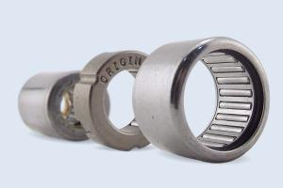

**Figure 9**. One – Way Bearing

The inner diameter of the driving sprocket on the E.M. shaft is smaller than the outside diameter of the bearing. For this reason, a simple cylindrical housing will be constructed to provide the connection between the bearing and the driving sprocket of the E.M. The bearing will be press fitted into the housing and then press fitted onto the E.M. shaft. The sprocket will be bolted to the housing.

***I.C.E Clutch and Throttle***

The I.C.E clutch and throttle acquired are pull chord actuated and will be converted from handle actuation to floor foot pedal actuation. The floor foot pedals have been installed into the vehicle and cable clutch and throttle lines will be connected. This approach was taken to simplify controls for the driver and to replicate the clutch and throttle layout in a standard vehicle.

***I.C.E Gear Shifting***

The I.C.E’s six gear manual transmission requires that the team implements a simple and easy to operate method of shifting gears. There are two approaches to shift gears for the I.C.E. The first being the use of a standard manual lever located in the cockpit. The other approach is to integrate paddle shifting to shift gears. Paddle shifting allows the driver to actuate an electrical solenoid by means of an electrical relay triggered by a pushbutton. A schematic of this is shown in **Figure 10.** The solenoid actuates a spline shaft that matches the spline shaft on the transmission of the I.C.E. The team had decided to implement paddle shifting and agreed that manually shifting the gears without the use of paddle shifting would be too difficult for the driver to control and race competitively at the same time. **Table 3.3** is a decision matrix that shows how the team came to this decision. The ease of operation and performance categories had the highest weighting factors.

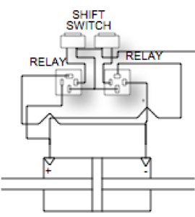

**Figure 10.** Paddle Shifting Schematic

**Table 3.3** Decision Matrix of Gear Shifting

|  |  |  |  |  |  |
| --- | --- | --- | --- | --- | --- |
| Design Options | Total Cost | Ease of Implementation | Ease of Operation | Performance | Total |
| Weight | 10% | 10% | 35% | 35% | 100% |
| Paddle Shifting | 0 | 10 | 10 | 10 | 80 |
| Standard Shifting | 10 | 10 | 0 | 10 | 55 |

## Battery Management System

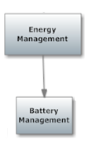

**Figure 11.** Block diagram for the battery management system.

The objective of the BMS is to manage the rechargeability of the battery packs within the vehicle. The BMS will basically monitor, protect and balance the state of the Venom 5S 5000mAh batteries. This also entails to no one battery being used more than another. This will be accomplished using a programmed microcontroller as well as voltage sensors. These voltage sensors will relay the levels of each battery cell back to the controller. In other words, the voltmeter checks the voltage from the battery cells and determines how much voltage is sent to the BMS.

The programming of the controller dictates which batteries, if any, need to be charged or discharged first. Options for the Battery Management System included purchasing one already programmed and adding minor details to it or designing and creating one as a team. The Battery Management System was started last year by Mark Church, one of the former members on the project from last year. He was trying to implement the system from scratch but had several difficulties and was unable to finish due to lack of time.

More so, aside from Mark Church’s step in the integration of the BMS**,** a wide range of concepts were considered when debating on which type to go with. Ultimately, since it was decided that the batteries used the previous year would be utilized this year, a Lithium-Ion BMS was chosen. Primarily, this type of BMS was chosen for two main reasons. One, lithium-ion type batteries currently on the vehicle are most compatible and function best with the Elithion Lithiumate BMS. In addition, these type batteries perform more efficiently than other batteries, although they are more costly. The manner in which the various options were weighed out are illustrated in **Figure 12.** below.

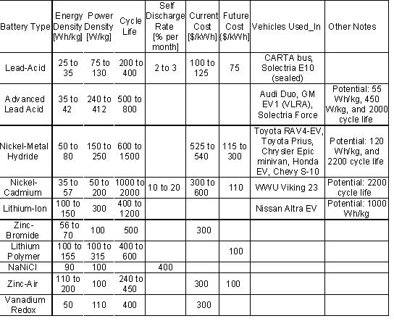

**Figure 12.** Different specifications for various batteries used in the BMS system.

The Elithion Lithiumate BMS displays characteristics that are much more attractive to the formula hybrid team, in the realm of energy, power and cycle life. The way the cells are set up in the battery is that the cells are shrink-wrapped in groups of 5 and the idea is that with the BMS, when one battery cell doesn’t have enough potential, it pulls from another cell that has a higher voltage. Once there isn’t enough voltage from the system to provide 12 V to the electric motor, the BMS should shut down the batteries’ system. The providing of 12 V comes from the electric motor since it’s what controls the BMS.

In order for the BMS to function appropriately with the car, a cell board needs to be wired to each cell. The only way to accomplish this would be to unwrap the cells and use each individual battery, so that each cell can have direct contact with the sensors. Basically, once the shrinkage of cells is unwrapped, there will be two big battery packs on opposite sides of the vehicle so that each pack contains 60 cells, giving a total of 120 cells on the vehicle.

Another alternative involved utilizing a non-distributive BMS system, which would allow the current system to remain the same. However, this would entail to not having each cell in direct contact with the BMS. This led to another major decision made based off several engineering options that were considered. When Elithion Electronics was contacted, it was brought to the team’s attention that their system would be incompatible with the vehicle since it required having direct contact with individual cells. As mentioned previously, the way the cells are arranged currently is that there are groups of 5 cells per battery, leaving a total of 120 cells in series. Therefore, it was suggested to determine whether the team would go with a Non-distributed BMS or Distributed BMS.

Basically, having cells in individual direct contact with the BMS controller is a Distributed BMS, while the packs of cells that were previously in the vehicle are for a Non-distributed BMS. The electrical and computer engineers in charge of this task determined that if a Non-Distributed BMS was purchased, then the BMS would be unable to monitor the temperature of the cells. This is a major aspect that the BMS must perform; therefore the Non-Distributed BMS was out of the question. In addition, it was concluded that if and when the shrinkage of cells was unwrapped, then the Distributed BMS being the Eltihion-Lithiumate BMS would be compatible with the vehicle.

To further analyze this decision, the two alternatives were contemplated via a decision matrix from a scale of 0-10. As shown below, a distributive BMS would be the best fit for the vehicle. This decision was based off the performance being the number one priority as shown in **Table 3.4** below.

**Table 3.4** Decision matrix for the BMS

|  |  |  |  |  |
| --- | --- | --- | --- | --- |
| Design Options | Total Cost | Ease of Implementation | Performance | Total |
| Weight | 20% | 20% | 60% | 100% |
| Distributive BMS | 3 | 5 | 7 | 58 |
| non-Distributive BMS | 5 | 6 | 2 | 34 |

In regards to the voltmeter, an LED display would be most preferred for its accurate readings, which is why a State of Charge Display is currently being integrated into the BMS Controller. Previously, the plan was to contact Elithion Electronics for Lithion-Ion in regards to the Elithion-Lithumate Battery Management System. Their system offered several attractive features to it being that the system is versatile, easy to install, safe and life prolonging. It’s fully configurable, supports all cell form factors, protects battery packs from over current, has few wires, and has single wire to adjacent cell boards. Most importantly of all, this system incorporates what Mark Church was trying to attempt being the monitoring of the batteries. In addition, the system will also balance the system’s state of charge by the cells in the batteries and will protect the packs from under and over voltage, charge and temperature. Elithion provides a Lithium-Ion BMS with the following characteristics:

* Ideally matched to work in high power Lithium-Ion battery packs
  + Up to 255 cells in series (~840 V), no limit to cells in parallel, isolated
  + No limit to cells in parallel, up to 600 A (higher currents available)
  + Includes a contactor drivers, a cooling fan interface and an interlock input
* Ideally matched to
  + Lithium-ion Polymer(LiPo)
  + Standard lithium-cobalt-oxide (LiCoO2)
  + Lithium-Manganese-Nickel-Cobalt (LiMnNiCo)
  + Nano-phosphate / lithium-iron-phosphate / lithium-ferro-phosphate (LiFePO4)
  + Lithium-manganese-oxide (LiMnO2)
  + (Not compatible with lithium-titanate cells)
* Compatible with [a range of chargers, motor drivers, displays](http://liionbms.com/php/std_bms_compatibility.php)
* Optimized for automotive applications
  + CAN bus, ignition line input, 12V power
* Performs monitoring, evaluation, communication, balancing and protection
  + Monitors the voltage and temperature of each set of parallel cells, and the pack current
  + Evaluates SOC (State Of Charge), DOD (Depth Of Discharge), and SOH (State Of Health)
  + Calculates the pack's internal resistance
  + Determines appropriate CCL (Charge Current Limit) and DCL (Discharge Current Limit)
  + Detects any abnormal conditions and sets a fault accordingly
  + Communicates through a serial port and through a CAN bus, reporting above data
  + Balances the charge through dissipation of excessive energy in most charged cells
  + Protects against over and under-voltage, over and under-temperature, over-current
  + Optional HV Front End tests for loss of isolation and end of precharge current (using a precharge resistor, not supplied)
* Plug and play (for "mules" and proof-of-concept products)
  + Lets you refine your product at your own convenience
* Distributed: electronic assemblies are mounted on cells
  + Consists of: one or more [Cell Boards](http://liionbms.com/php/cell_boards.php) and a [BMS controller](http://liionbms.com/php/controllers.php)
  + Mechanically matched with cylindrical, pouch or prismatic cells
  + Minimal wiring (no "spaghetti"); individual cell voltage and temperature
  + Controller communicates with Cell Boards on cells, and with external system

As well as the following specs show below in **Figure 13**.

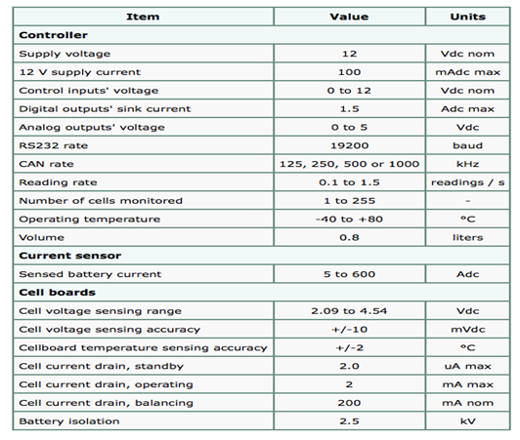

**Figure 13.** Specifications for the cell board for the BMS

More so the team contacted the company to learn of the compatibility of the system and type batteries. The cost for this BMS would have run the team around $6,229. This amount included the cost of 120 cells in series, the “volume compensating fee” of $1,500 and $1,000 for being a first time order. All this is in addition to $70 for an SOC Display. After being in continuous contact with Elithion Electronics, Evolve Electronics was mentioned to sell the exact BMS Eltihion did but at a much more reasonable price. After analyzing several design options such as Mark Church’s attempt last year and the Elthion BMS from Elithion Electronics, the team determined that the best option was the Elithion Lithiumate BMS from Evolve Electronics at a total of $1,920.63.

After contacting the company Elithion Lithiumate and confirming that our battery set up and type batteries were compatible with the vehicle, the BMS was purchased and the testing phase is currently being approached. Therefore, now the testing phase has shifted to the following steps. Subsequently, the computer and electrical engineers on the team determined that there were sufficient funds for the system based off a potential sponsor the team was able to get approval from. As mentioned earlier, since the sponsorship was approved, the team was able to proceed with the purchase of the BMS from Evolve Electronics and initiate the unwrapping of the cells. Now that the previous battery boxes along with the batteries were removed from the vehicle, the testing of the BMS can be completed.

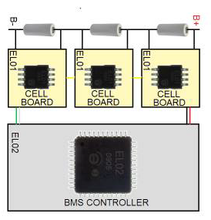

**Figure 14.** Overall BMS Schematic of cellboards, BMS Controller and battery cells.

The first phase of the testing involved measuring the exact voltage of each battery pack to be able to compare them to the new voltages once the BMS has been integrated into the formula vehicle. More so, the next phase that will be conducted is the connection of 10 battery cells in series. Note that five cells will be fully charged and will be at different potentials than the other 5 cells. The team will complete all necessary wiring to the power supply, BMS controller and cellboards in order to verify that all these cells are actively balanced. The second testing will consist of the same format with the difference that 20 cells will be examined and analyzed. The main goal of this test is again to ensure that the cells are also at the same potential.

The last testing phase will entail to examining all 120 cells. The electrical and computer engineers will then drive the vehicle and evaluate the BMS by testing the potential at each battery that wasn’t fully charged. Therefore, the BMS should once again rebalance them but with the difference that all the battery cells on the vehicle are being utilized.

Risk assessments for the BMS are considered critical risks. During the testing process there may be many complications either ranging from error testing to incorrect setup or faulty components/wiring in the BMS. Both of these issues can lead to the retesting of the system or the possibility of reordering components. This issue is further discussed under **Section 2.5.1: Technical Risk 1** and **2.5.1: Technical Risk 8.**

The outcomes of this BMS, if successful will be to prolong battery life and monitor the voltage outputs from each battery cell. More importantly, the system will resolve the two main issues being the uneven charging of cells within the batteries and the danger of the unacceptable voltage levels being reached. Based on the heavy analysis currently being done to the BMS, the formula hybrid team is coming to a coherent understanding of how it functions and what the best plan of action will be.

## Chassis

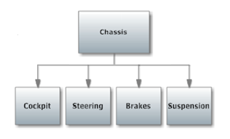

**Figure 15.** Block diagram for the Chassis.

***Cockpit***

The cockpit’s main goals are to contain at most four sensors: one rpm sensor for the I.C.E. and E.M each, a speedometer and a temperature sensor for the radiator. Since the dashboard has a specific height that it’s required to reach and not exceed, the sensors are limited in space. Due to this, height and size were important factors in choosing the types of sensors. Although, since most of these sensors function in the same manner, it was much more imperative that size and price be the vital factors to be considered.

The speedometer measures the instantaneous speed of the vehicle. For a speedometer, two different alternatives were analyzed, mechanical and electrical. For a mechanical speedometer, also known as an eddy-current speedometer, the transmission and driveshaft rotate at a speed that corresponds to the vehicle speed. Also the mandrel in the speedometer's drive cable -- because it's connected to the transmission via a set of gears -- also rotates at the same speed. Finally, the permanent magnet at the other end of the drive cable is rotates. As the magnet spins, it sets up a rotating magnetic field, creating forces that act on the speed cup. These forces cause electrical current to flow in the cup in small rotating eddies or eddy current.

For an electrical speedometer, data is gathered from a **vehicle speed sensor** (VSS), not a drive cable. The VSS is mounted to the transmission output shaft or crankshaft and consists of a toothed metal disk and stationary detector that covers a magnetic coil. As the teeth move past the coil, they disrupt the magnetic field, creating a series of pulses. For each 40,000 pulses from the VSS, the trip and total odometers increase by one mile. Speed is also determined from the input pulse frequency. The circuit electronics in the car is designed to display the speed either on a digital screen or on a typical analog system with a needle and dial.

In the original decision matrix it was implied that the mechanical speedometer would be the best fit for the car, but after some research and careful observation, this has changed. During the analysis of the speedometer with a scale of 0-10 this time, it is much more clear now as one can see below.

**Table 3.5** Decision Matrix for the Cockpit gauges

|  |  |  |  |  |
| --- | --- | --- | --- | --- |
| Design Options | Total Cost | Ease of Implementation | Performance | Total |
| Weight | 20% | 20% | 60% | 100% |
| Mechanical Speedometer | 8 | 4 | 8 | 20 |
| Electrical Speedometer | 6 | 8 | 9 | 23 |

When carefully evaluated, it is evident that the electrical speedometer is a much better choice and the one that was ultimately made. It is much easier to install and will perform slightly better. Although it’s a little more expensive, its’ functionality will work better with the vehicle. Recall that another one of the cockpit’s main goals includes the implementation of at least one RPM sensor and temperature sensor for the radiator. The RPM gauge, or tachometer, measures the number of revolutions per minute of the formula hybrid vehicle. In addition, the radiator temperature gauge determines the temperature of the fluid passing through the radiator, indicating when the vehicle is overheated.

For the radiator temperature, it was decided that a thermocouple probe would be used for the actual measurement and heat detection. This probe would then send the information to the temperature gauge to let the driver know whether the car was overheating or not. Both the tachometer and temperature gauge were found on Summit Racing online; a site dedicated to racing equipment. It came in as a 4-in-1 gauge that contained the tachometer and temperature gauge, as well as a voltmeter and oil pressure gauge. For the thermocouple probe, a site known as Virtual Village sells the device for a relatively cheap price. More so the actual device measures between 0 and 800 degrees (Celsius).

A decision matrix, with a scale of 0-10 was used to decide whether this particular 4-in-1 gauge would benefit the car or not. It was imperative that the gauge have a rating of at least 20 before it could be chosen. How it performed and how easy it could be implemented were the most important factors.

**Table 3.6** Decision Matrix of 4-in-1 Gauge

|  |  |  |  |  |
| --- | --- | --- | --- | --- |
| Design Options | Total Cost | Ease of Implementation | Performance | Total |
| Weight | 20% | 30% | 50% | 100% |
| 4-in-1 gauge | 5 | 7 | 9 | 21 |

As seen above, it’s not too complex to install and based on the information given about it, the gauge has the complete capability to perform well. The score of a 21 means that it passed the minimum requirements and has proven to be good enough to purchase, even though it’s a little expensive. A second decision matrix was created for the thermocouple option. The same rules as with the sensor gauge applied, although its ease of implementation and performance power were much more important this time.

**Table 3.7** Decision Matrix for Thermocouple Probe

|  |  |  |  |  |
| --- | --- | --- | --- | --- |
| Design Options | Total Cost | Ease of Implementation | Performance | Total |
| Weight | 10% | 40% | 50% | 100% |
| Thermocouple probe | 10 | 6 | 8 | 24 |

Once again, the thermocouple reached the minimum requirement by achieving a score of 24. It’s quite cheap and slightly harder to install but overall will perform just as well as the gauge would, as far as temperature was concerned.

Ultimately some of the gauges that were needed were found in the car shop already, which helped alleviate some of the funds that would’ve been needed for the speedometer and for one of the tachometers. With the second tachometer and the temperature gauge or probe, a price quota is currently being prepared for these two. Although it seems that a working temperature sensor may already be in our possession. The risk assessments for the cockpit sensors are pretty moderate. There may occur issues with faulty equipment or misreading from the gauges or devices installed. More so, issues due to the setup and wiring of the gauges to the dashboard may arise as well. For more detail on the risks for sensors, please refer to **Section 2.5.1: Technical Risk 5**.

***Rear Brakes***

The rear braking system on the vehicle was the main focus of the team as this is where the design options were. Since the front brakes can only be outboard brakes, there were no further decisions to be made on them, independent of the rear. Therefore, the rear brakes will be discussed and all conclusions will be applied to the front brakes as well. This block will be broken down with a discussion of an inboard design versus an outboard design followed by the discussion of each of the major components of the design.

***Overall Brake Design***

The functional requirements of the braking system were drawn from the competition rulebook. These requirements include the braking system needing to be adequate enough to lock all four wheels of the vehicle, immediately after an acceleration run. This task will be accomplished through the success of the components that make up the braking system and will be discussed in subsequent sections.

The most important constraint on the design of the braking system is cost. This is due to the amount of work that is desired to be completed and thus most tasks will have to be low cost. The other important constraint on the decision is the amount of effort and time that the design will require. Since the team has the major task of implementing the I.C.E within the vehicle this year, this is where most of the effort will be placed. Therefore, other tasks will have to be considered second to this and thus, won’t have as much time allotted to them.

The two design options that were available for the rear braking system of the vehicle include the inboard brake design or the outboard brake design. The inboard brake design is a design that has one brake acting on the differential, while the outboard brake design has one separate brake acting on each wheel. These two design options were evaluated using a decision matrix that can be seen below in **Table 3.8**.

The criteria included in the decision matrix include the price, ease of implementation and the performance, each with a weight decided by the team. A scale of 0 to 10 was used for the rating in each category, where a 10 is the best in that category and a 0 is the worst. In **Table 3.8**, it can be seen that the outboard brake design is the design that the team has decided to implement. This outboard brake design was chosen mainly because of its ease of implementation. The cost of the two designs were determined to be about equal, thus not having an effect on which design the team would move forward with. For the inboard brake design, the team would have had to redesign and rebuild differential parts. The redesigning of these differential parts would be necessary, if the inboard design was kept because the bolts that secure the brake caliper to the differential were not deemed thick enough to withstand the braking force.

Therefore, these bolts would need to be thickened and the differential plates that they connect to would also have to be remade to fit these new bolts. The cost of the materials alone that it would take to rebuild the necessary differential components would be about $100. On top of this cost, new sprockets for the I.C.E and E.M would have to be purchased in order to fit onto the new differential casing. This adds up to about the same cost of a new brake caliper and rotor set. Since the original brake rotor and caliper were already decided upon to be replaced by the team, this brings the total cost to about the same as for the outboard design.

The ease of implementation follows the same logic as the cost because the team does not have to take apart the differential, rebuild it and reassemble it if going with the outboard design as would be necessary if going with the inboard design. Finally, the inboard brake was decided to be the better design in terms of performance since it would decrease the amount of unsprung weight on the vehicle. This is because the inboard brake design is supported by the suspension as opposed to the outboard design, in which the brake calipers are not supported by the suspension. The more unsprung weight a vehicle has, the less handling and suspension performance it has.

**Table 3.9** Decision Matrix for the overall brake design

|  |  |  |  |  |  |
| --- | --- | --- | --- | --- | --- |
| Design Options | Total Cost | Ease of Implementation | Braking Performance | Handling  Performance | Total |
| Weight | 30% | 30% | 20% | 20% | 100% |
| Outboard Brakes | 5 | 5 | 8 | 4 | 54 |
| Inboard Brake | 4 | 5 | 4 | 8 | 51 |

Since this overview discussion for the braking system is only about making the decision to use inboard or outboard brakes, there is no analysis that is to be made here. The decision to use outboard brakes has been made, as show above in **Table 3.9** and the analysis and assumptions for each component of this system will be discussed in the following subsections. The assessment of the outboard design to satisfactorily meet the functional requirements assigned to it is also based on its’ subcomponents. If each of its subcomponents are able to meet their functional requirements, then the overall brake design will be a success. These individual assessments will be discussed in the following subsections.

The failure of the braking system is a great risk that the team has to consider when preparing for the competition. If the braking system were to fail, the team would most likely not be able to lock the wheels of the vehicle as required and would thus be disqualified from the competition. This is a low risk, due to the fact that the braking components are being purchased. This could have severe consequences. Please refer to **Section 2.5.1: Technical Risk 4** for more information.

***Master Cylinders***

The master cylinders that were purchased by the previous team are going to be utilized by the team this year, as they are sufficient in providing enough brake pressure to the calipers. This will be shown in the caliper section analysis, as these cylinders were used in making the calculations for the brake calipers that are to be utilized. Therefore, the calipers that will be utilized and their success, were based upon these master cylinder dimensions.

***Brake Rotors***

The brake rotors serve the purpose of converting the force provided by the brake calipers into a torque applied to the vehicle’s axle, while also dissipating the heat created by these pads. Therefore, their most important functional requirement is that they provide a long enough moment arm to create a large enough torque to lock the vehicle’s wheels as required by the competition rulebook.

As already mentioned in the overview discussion of the braking system, pricing is the major constraint on any decision that the team has to make. This is no different decision on which brake rotors the team is to use. The second most important constraint on the brake rotors is the size limitations. Since the outboard brake design was decided upon by the team, the brake rotors and calipers will be placed inside the wheel wells of the vehicle. This means that the rotors as well as the calipers must fit inside the wheel wells, thus limiting the diameter and thickness of the rotors that can be utilized.

Brake rotors are specially made to handle the high heat that is conducted to them through the brake pads. For the team, this means that the brake rotor is an item that must be purchased and not designed or fabricated. For this reason, the only design option that the team had to consider when deciding upon the brake rotors was the diameter of the rotor. Since the radius of the rotor is the length of the moment arm that the braking force is using to create the torque that stops the axle, the rotor with the largest possible diameter was chosen. This will provide the largest possible torque and thus, decrease the amount of force that the brake calipers need to supply. Given that the team is already purchasing its brake calipers from Wilwood Engineering, as mentioned in the following section, the rotor will be ordered from them as well to simplify the ordering process.

The analysis performed on the brake rotors is discussed in the analysis of the brake calipers in the following section. This analysis only consists of calculating the amount of torque that the rotors generate based upon the amount of force delivered to them by the brake calipers. Due to the rotors being purchased by a proven manufacturer, they can be deemed safe in terms of thermal and mechanical failure for the considered application. Therefore, the torque calculation is all that is necessary for the brake rotors in terms of analysis. As shown in the numerical calculations, found in the Appendix, it can be seen that the rotors provide a long enough moment arm to calculate the necessary torque needed to lock the wheels of the vehicle. This shows that the rotors will be very successful in fulfilling their functional requirements as defined by the team. The specific brake rotor selected by the team for this year’s vehicle is shown in **Figure 16** and is in the process of being ordered**.**

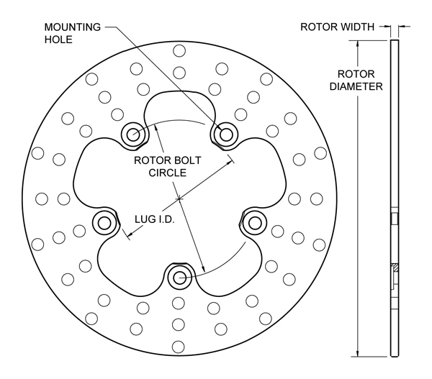

**Figure 16.** Drawing of the brake rotor to be used by the team

The brake rotors are not being considered in the risk assessment due to the fact that they are professionally manufactured and are not being used at the high level that they are designed for.

***Brake Calipers***

The most important requirement for the braking calipers is that they are able to apply enough force to the brake rotors in order to lock all four wheels of the vehicle immediately after an acceleration run. This was the key determinant in the selection of the calipers. The most important constraint on the brake calipers is the price, as stated previously. First-stage selection screening will also begin with price because mid-range calipers are all that is necessary. Higher end calipers will be excessive and unnecessary. The next most important constraint on caliper selection is rotor selection. Brake calipers are designed to operate up to a maximum rotor diameter and width. Therefore, rotor selection limits caliper selection greatly. The next most important constraint on brake caliper selection is the size of the calipers. Due to the limited amount of space inside the wheel wells, selection is limited to the calipers that will fit comfortably within the well, without interfering or making contact with any other components inside it. The current design, as employed by the previous team, had this dilemma as some of the calipers rub on the inside of the wheel well. This created undesirable wear on the calipers and wheel well along with unnecessary friction. The final constraint on the caliper selection is the least important and was a constraint that was imposed on by the team; this is the constraint on the number of pistons in the caliper. The calipers are limited to a maximum of two pistons per caliper as this is all that is necessary. Any caliper with more pistons than this will be redundant in terms of performance and will only add to the size and cost of the caliper.

When considering design options for the brake calipers, only two options are available. Brake calipers come in either the floating or fixed type. The decision matrix for choosing which type of caliper to use is shown below in **Table 3.10** and will be briefly explained. The decision criteria chosen for comparing the brake caliper types were price, ease of installation, user interaction and performance. Since price is a major constraint on the team, price was given a weight of 30%. Ease of installation is convenient but not a major deciding factor, thus it was given 10%. User interaction and performance are both major decision factors, due to their influence on performance and driver safety. Thus, they were weighted just as heavily as the price of the caliper. The team used the same scale from 0-10 as described earlier. For the scoring, floating calipers won the category for price and ease of installation. Floating calipers are usually easier to manufacture because of their larger manufacturing tolerances, hence they are generally cheaper. In addition, are also very forgiving during installation because their ability to float makes them very generous, when it comes to caliper-rotor alignment.

On the other hand, fixed calipers won the categories of user interaction and performance. Since fixed calipers have at least one piston on each side, they are less tolerant to caliper-rotor alignment. This results in the brake pedal having very little play and an almost perfectly linear relationship between pedal travel and fluid pressure. This gives the driver a high-quality feel in the brake pedal and allows for accurate braking.

**Table 3.10** Decision Matrix for caliper type.

|  |  |  |  |  |  |
| --- | --- | --- | --- | --- | --- |
| Type of Caliper | Total Cost | Ease of Install | User Interaction | Performance | **Total** |
| Weight | 30% | 10% | 30% | 30% | 100% |
| Floating Caliper | 8 | 8 | 4 | 4 | 56 |
| Fixed Caliper | 5 | 6 | 8 | 8 | 69 |

In order to verify that the chosen brake system would be adequate in meeting its’ functional requirements, the system had to be analyzed. This analytical process will be briefly described with the actual calculations given in the Appendix. In order to lock the wheels of the vehicle as required, the calipers would have to apply enough torque to the rear axle to match the torque created by the force responsible for stopping the vehicle. The only force that is responsible for stopping the vehicle when the brakes are applied is the frictional force between the tires and road. This can be seen below in **Equation 1**.

$F=μ_{s}∙N$ (**Equation 1**)

Where,

F is the force due to friction,

µs is the static coefficient of friction,

N is the normal force of the car

The static coefficient of friction was used to calculate this force because it yielded the largest value for the friction force, thus guaranteeing the maximum torque is accounted for. The total frictional force was then divided up between the front and rear axle. Then the left and right wheels based upon the vehicle’s dynamic weight distribution. The vehicle’s static weight distribution was determined using scales, whereas the dynamic weight distribution is determined using **Equation 2** below.

$W_{r}^{'}=W_{r}+\frac{m∙a∙h}{L}$ (**Equation 2**)

Where,

Wr is the static weight distribution of the vehicle,

m is the mass of the vehicle,

a is the acceleration due to braking,

L is the wheelbase of the vehicle

Dividing the dynamic weight by the total weight will give a percentage that is to be multiplied by the static friction force. This force is then multiplied by the distance to the center of the axle to give the amount of torque it generates on the axle. This is the torque that the calipers need to match in order to lock the wheels. This is given by the equation for torque shown in **Equation 3**.

$T=F∙d$ (**Equation 3**)

Where,

T is the torque created,

F is the force that is creating the torque,

d is the distance between the axle and the application of the braking force

To determine if the selected calipers can generate the necessary torque to counteract the friction torque, the analysis must now go to the pedal. Using a typical value for the force exerted by a driver during a panic stop and multiplying this by the mechanical advantage provided by the brake pedal, the force on the master cylinder was obtained. The pressure that this force creates inside the master cylinder was then calculated using **Equation 4** below.

$P=\frac{F}{A}$ (**Equation 4**)

Where,

P is the pressure of the brake fluid acting on the piston,

F is transmitted by the piston,

A is the cross sectional area of the piston

This pressure is then multiplied by the area of the brake pads and then multiplied by the number of pads that the caliper has. This value will give the total force of the calipers on the rotor. This force is then multiplied by the equivalent distance between the application of the caliper force and the axle, to yield the torque generated by the caliper. This torque equation for calipers is given below in **Equation 5**.

$T=\frac{F∙(D+d)}{4}$ (**Equation 5**)

Where,

T is the torque generated by the calipers,

F is the force created by the calipers,

D is the diameter to the top of the brake pad,

d is the diameter to the bottom of the brake pad

This equation takes into account the shape of the brake pad when considering where to apply the force created by the pad.

When performing the analysis on the braking system of the vehicle, several assumptions were made to allow for simplification. First of all, it was assumed that the frictional force slowing down the vehicle was purely static friction. This was assumed because it yielded the highest value of torque on the axle, thus ensuring that the calipers could lock the wheels if the calculations demonstrated they should. The second assumption made was that the coefficient of friction between the tires and the road was the same as the coefficient of friction between rubber and asphalt. This was assumed because the exact coefficient between the specific tires utilized and asphalt was not provided by the manufacturer. This value should be very close to the actual value and thus should not affect calculations by much. It was also assumed that the force created by the brake pads acted at the center of the pad itself. This simplified the calculations of the torque generated by the calipers without affecting the results very much. The final assumption in the analyzing of the brakes was that the force exerted by a driver on the brake pedal, while performing a panic stop is equal to 25 pounds. This is an average value that could be exerted by either a male or female driver.

Based on the calculations described above and shown in the Appendix, the team is very confident that the brake calipers chosen will perform as expected. For the rear brakes, the calculations of the torque generated by the frictional force acting on the rear axle yields a value of 1,565 in*lbf, while the torque generated by the brake calipers was calculated as 1,947 in*lbf. For the front brakes, the required torque is 1,847 in*lbf, while the torque created by the calipers is 2,010 in*lbf. This demonstrated that the brake calipers could provide the minimum amount of torque needed to lock the wheels of the vehicle as required by the competition.

The brake calipers chosen by the team are in the process of being ordered. They are shown below in **Figures 17.** and **18**.The calipers are provided by Wilwood Engineering.

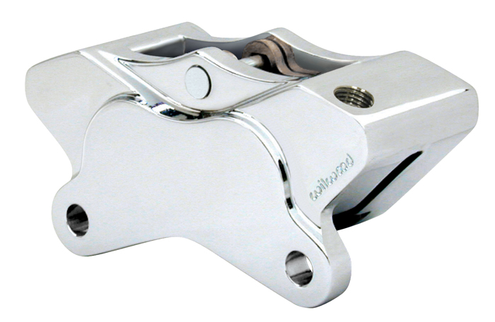

**Figure 17.** Picture of the brake caliper to be used by the team

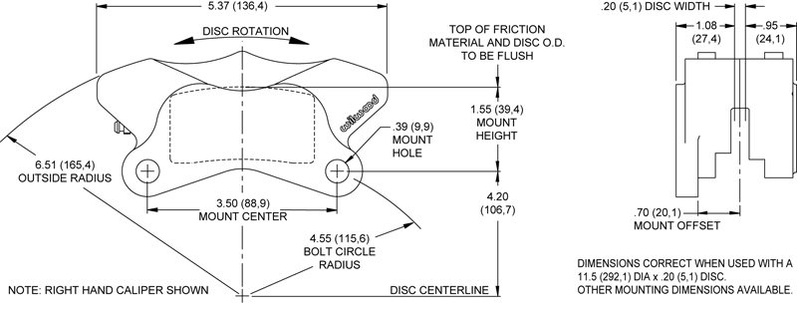

**Figure 18.** Drawing of the brake caliper to be used by the team

The risk assessment for the brake calipers are the same as for the overall brake designed and can be found in **Section 2.5.1: Technical Risk 4**.

***Uprights***

The uprights on the formula hybrid vehicle are responsible for connecting the wheel assembly of the vehicle to the suspension and strut arms of the frame. This is the most important functional requirement of the uprights and the main concern when designing the uprights. Another important factor is that the uprights also take a lot of load from the vehicle as its weight is shifting throughout the high speed turns and accelerations of the competition. This means that they must be durable enough to take these loads repetitively without inducing any plastic deformation during use.

The uprights are mainly constrained by the amount of space inside the wheel well because they fit completely inside it. Other than this, the uprights are also constrained by the calipers chosen by the team. This is because the brake calipers mount directly to the upright, thus requiring the uprights to be designed accordingly to allow for this. When designing the uprights, there were no real different options to consider. Every upright is the same in that they are simply a large piece of metal, which have mounting points for the suspension and brake calipers. Therefore, the team has simply designed an upright that is as small and lightweight as possible, which will allow for these necessary mountings accommodations.

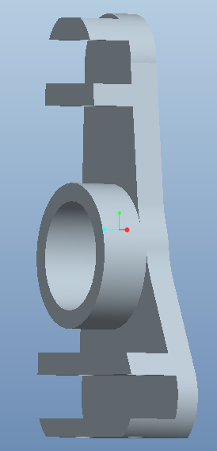

**Figure 19.** Picture of the brake caliper to be used by the team

After several models the group decided on **Figure 19.** above for several reasons. The main reason was because it will satisfy the hard point location for the suspension needed as well as to serve as the smallest and lightest model possible for this application. Instead of using a heavy steel alloy, these uprights will be machined out of lighter Aluminum 6061alloy, greatly reducing the un-sprung wheel mass of the vehicle. To ensure this lighter aluminum alloy with be able to withstand the forced generated by high speed turns and accelerations, the group ran the model through a computer simulator and generated similar forces that would be expected throughout the competition. To arrive at these similar forces, an assumption was made. This was that the vehicle would not experience turns with more than 1G of force. Knowing this acceleration and the weight of the vehicle, a force of 800lbf was calculated to be the maximum force exerted on the uprights themselves. As for the location of these maximum forces, it was found that the location between the hind joint connection and the upright itself was the weakest part of the design and that’s where the maximum forces were placed in the computer simulation model. After all the constraints were placed in the model, a Finite element analysis model was returned and studied. As seen below in **Figure 20 and Figure 21,** the maximum stress found was 26.27 MPa at the lower A-arm connection. Being Al 6061 starts to yield at 265 MPa these stress levels found can be deemed safe and inadequate.

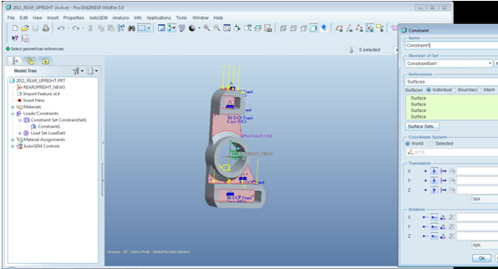

**Figure 20.** Constrained Front Face with Radial 800lbf applied

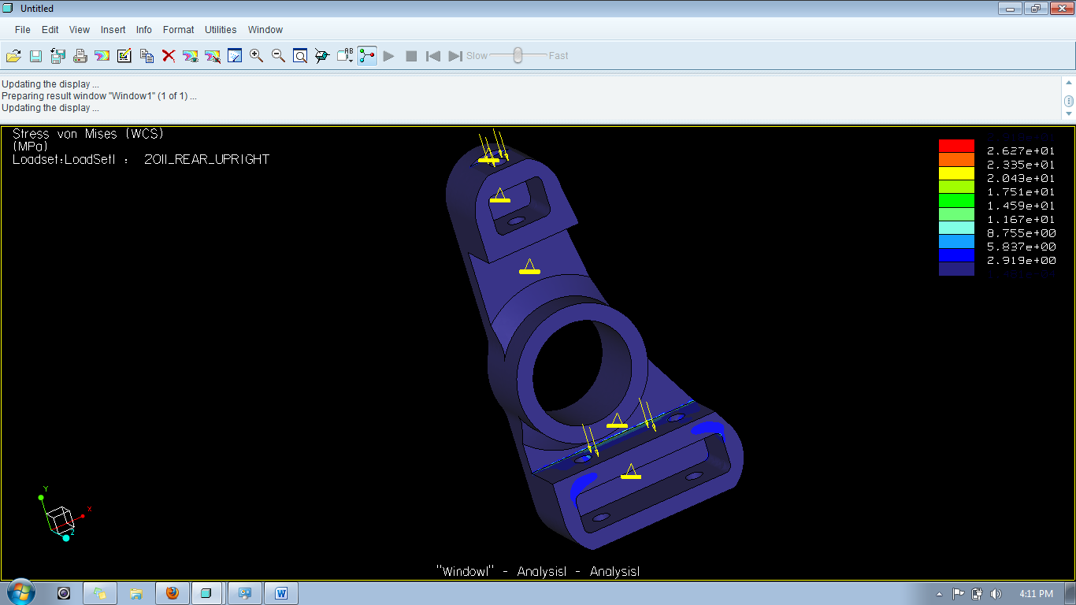

**Figure 21.** FEM Result from **Fig.20.**

As an extra safety measure a second FEA was ran of the same model, but this time the constraints were modified. Instead of having the front face constrained to be rigid as in the first model, the inner bearing housing for the upright was constrained and the same forces were applied. As seen below in **Figure 22 and Figure 23,** this model experiences more stress than the previous model, but even at 91.4 MPa, the factor of safety is still over 2 and proves this is an overall safe design for an upright under the conditions expected.

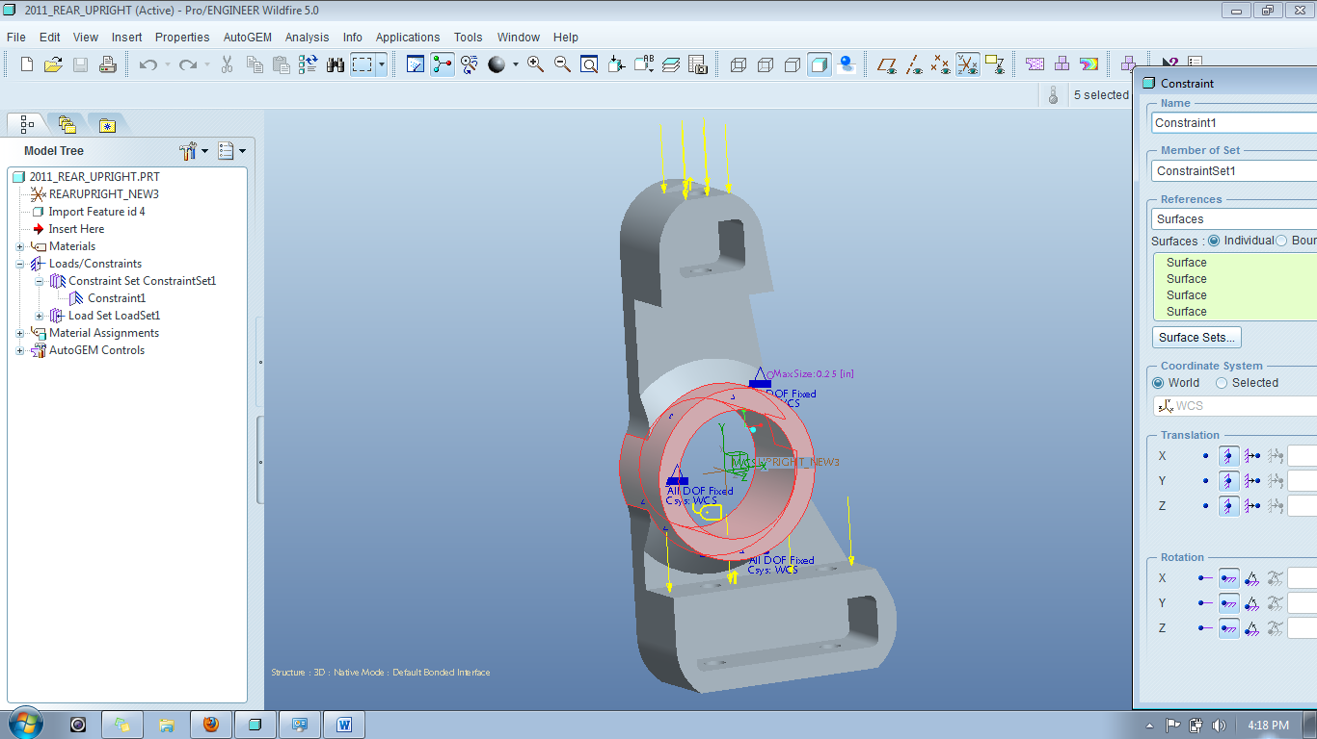

**Figure 22.** Constrained Inner Bearing Housing with Radial 800lbf applied

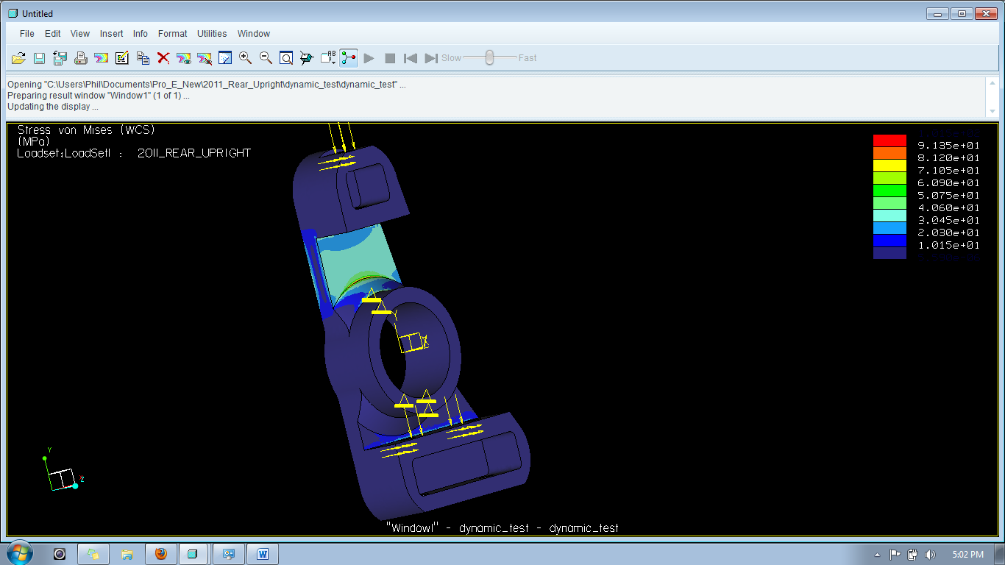

**Figure 23.** FEM Result from **Fig. 22.**

The main risk associated with the uprights on the vehicle is failure at the joints. This can occur at either the brake caliper joints or at the suspension joints. The effects of this risk would be severe but the probability of it happening is low. This is because the uprights will be thoroughly tested using a Finite element analysis, thus ensuring a sufficient design. Refer to **Section 2.5.1: Technical Risk 4** for more information, as this is applicable for the uprights as well as the brakes.

***Suspension***

The suspension on the formula hybrid vehicle serves the purpose of keeping the entire vehicle stable, while it undergoes the dynamic weight transfers created by the accelerations of racing. This is the single most important functional requirement and can be quantified by the team during testing. This quantification will be in terms of the amount of roll that the frame and everything inside it exhibits when the suspension is tested. This will be discussed further in later sections. Another very important functional requirement comes from the competition rulebook. This states that the suspension travel is limited to one inch of jounce and one inch of rebound. This means that the wheel cannot travel more than two total inches, with one inch in each direction. These are the two functional requirements of the suspension that will serve as benchmarks for evaluation.

When considering the redesigning of the suspension on the vehicle, research was done to determine what types of suspension are usually present in racing applications. Almost every source stated that the double wishbone design is the suspension that should be utilized in racing applications. This type of suspension is the same suspension that is used by Formula 1 racers across the world, as well as almost all of the competitors in the Formula Hybrid competition. The double wishbone suspension is so ideal for racing applications because it offers the most user-control out of any type of suspension. The geometry of the arms and the elasticity of the joints gives engineers superior control over a wide variety of aspects of the wheels and vehicle. They include the various angles of the wheel and the vehicle dynamics, such as squat and lift. Control is such an important factor for the hybrid vehicle’s suspension because of the high performance that is expected of it. With speeds of to 60 miles per hour and all of the braking and turning that is required by the competition, the suspension design that offers the most control is the smartest decision to go with. Due to all of these factors, the double wishbone suspension system is the design that will be implemented this year as it was last year. The dampers and springs in a Formula 1 suspension are also different from that of other suspension types in that they are placed along the length of the vehicle. To do this, they utilize a pushrod and ternary link to translate the up and down motion of the wheels into front and back motion. This placement of the springs and shocks offers the benefit of less drag. Since the Formula Hybrid competition rulebook states that each team’s vehicle must be open-wheel, this same placement strategy will be utilized by the current team. This will ensure that the suspension is as aerodynamic as possible.

The suspension design that the team has decided to utilize is that of last year’s team. This includes using the same mounting locations for the suspension on the uprights and the frame. The suspension this year will differ from last year’s design, in that last year the team used hollow steel rods for the arms, whereas this year the team will utilize solid aluminum arms. The solid rods will increase the strength of the system, while the aluminum will make it more lightweight. The rods used last year were also made from leftover material, found by the team, which was about 10 years old. As a result of the team not being certain of where the materials came from or what they have been through, it seems very unsafe to use them any longer.

The final design consideration for suspension is adjustability. Using opposite handed threads on either side of each of the suspension arms, the team will allow each suspension arm to be easily modified. Not only will this score significant points in the design phase of the competition, but it will also allow future teams to adjust the suspension by how they see it. These adjustments may be necessary if the suspension naturally strays from its initial settings over time or if the future teams decide they want to try different tire angles to get different performance out of the vehicle. Either way, adjustability is a good design option to implement.

The digital analysis of the suspension consisted of modeling and simulation using ADAMS software. This was done by the previous year’s team and thus their results were used to verify suitability for the competition. ADAMS verified the desired values of many suspension characteristics that are ideal for racing and led the team to the conclusion that the current suspension design could be utilized again.

The team has not yet begun fabrication of the suspension due to incompletion of other more important tasks. The metal for the suspension will be ordered within the next two weeks and fabrication will begin upon arrival of the materials. Fabrication of the suspension is expected to take about one week to complete.

The technical risk for the suspension is very low due to the high amount of analysis that the team will perform on the design before it is built. The only failure for the suspension will be in the joint connections between it and the uprights. Therefore, **Section 2.5.1: Technical Risk 4** can be referred to for the suspension.

In regards to the overall risks assessment for the Chassis which consists of all the previous parts discussed being the cockpit, uprights, overall brake system and suspension; these are discussed in **Section 2.5.1: Technical Risk 7.**

***Rear Axle***

The rear axle on the vehicle is responsible for transmitting the power from the differential to the wheels. It does this by connecting rigidly to the wheel hubs through a splined shaft. This splined shaft ensures that the axle and hub rotate as one unit. The team had recently run into an unforeseen problem with the rear axle that put a halt on the vehicle’s progress. The problem with the rear axle was that the CV joints at the end of the shaft were too short. This meant that the team did not have enough room to mount the uprights and hub that were necessary in order to implement outboard brakes. In order to resolve the issue, it was necessary to find a new axle with longer CV joints.

The constraints on the team when choosing a new axle were very minimal. The only constraint that was determining which axle to use was the length of the CV joints on the axle. The current CV joints had about 2.5 inches of usable shaft, whereas the team needed about 4 inches. Other than this, any axle could be chosen since all other components would be modified in order to fit the selected axle.

The team has recently found an appropriate axle that has long enough CV joints that allow for the mounting of the uprights and the hubs. The new axle has about 4 inches of usable shaft space, allowing for a 2 inch wide hub and a 2 inch wide upright. This is more than enough room and the team is confident that the progress on the rear brakes can be continued. The rear axle is from a Kawasaki Mule 4010 and can be seen below in **Figure 24.**

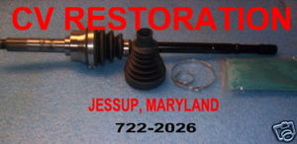

**Figure 24.** Kawasaki CV axle to be used in rear

# Test Plan

When undergoing a task of this magnitude, it’s essential to verify the operation of each component separately. By doing this it makes the project more manageable and should serve as extra precaution whereas testing the vehicle as a whole could miss the operational status of some vital components. To ensure accuracy and maintain organization, each team member was responsible for developing test plans for their respective technical areas and reported the results on a standard test form as shown below.

The test plans were divided in the following format. Section 4.1 illustrates the system and integration test plans. These test plans include a Drivetrain, Energy Management System, Chassis, Brake and Vehicle Suspension and Uprights and an Overall Formula Hybrid Vehicle tests, totaling a total of five test plans. The first part illustrates the top level portion of the block diagram in Section 2.1

Section 4.2 was divided into 12 test portions. They include the I.C.E, one-way free clutch bearing, Battle Kart Shifter, BMS, Cockpit, Steering, Frame, Brakes, Axle and Hub, Suspension, Uprights and Competition test plans. Since the differential and Electric motor are already integrated into the vehicle, separate test plans for each of these were not taken into consideration. The coupling of the I.C.E with the E.M is included in the I.C.E test plan. Since the Energy Management System only had one sub-block being the BMS, an overall test plan for the BMS was stated in Section 4.1.

The BMS subcomponents will have two main test plans. The 10 cells (2 battery- cell packs) that will be tested and will be performed one time and the 20 cells that will be examined as well. This 20 cells test ( 4 battery –cell packs) will be performed 6 times. The Cockpit was divided into two portions, the before and after installation test plans. An additional frame test was added. The Brake system was subdivided into three parts, giving a total of three main tests: Performance, Functionality and Assembly.

The competition test plans include the exams that will be performed at the competition in New Hampshire, 3 total. The Overall vehicle test plan in Section 4.1 refers to these as this is how the formula hybrid vehicle will be tested as a whole. As a total in both sections, there are a total of 18 test plans and a total of 23 exams that will be completed, due to some test plans being performed more than once as mentioned previously. Should there be anything subject to change such as newly added tests, then they will be implemented into the next report.

## System and Integration Test Plan

### *4.1.1 Drivetrain*

The drivetrain consisting of the coupling of the electric motor with the combustion engine will be tested to ensure that it generates power and delivers it to the road surface. It is important that the two different motors are able to function separately and simultaneously. The tests of the internal combustion engine and one way bearing will be conducted before testing the complete drivetrain. A test reporting form for the drivetrain can be found in **Appendix 9.2.**

### *Energy Management System*

This is an overall test plan for the Battery Management System. Since the only sub-component under the Energy Management System is the BMS, there is only one test plan for this component. This exam involves the testing of all 120 cells after the BMS and after all components have been installed into the vehicle. The goals of this test are to ensure that all 120 cells are being actively-balanced out while the car is being driven. This is the last testing phase of the BMS. Please refer to **Appendix 9.2** for the actual test form.

### *Chassis*

One of the most important factors that will determine the overall success of the hybrid vehicle is the chassis. The chassis consists of the cockpit, steering mechanisms, brakes and the suspension of the vehicle. To be competitive in this year’s competition all four of these components must be running properly and in sync. To ensure these goals are met, a test will be implemented on the system as a whole instead of testing each individual component. The simplest way to test the chassis of a vehicle is to drive it around with similar conditions expected throughout the life of the vehicle. Being the group is designing a formula car, the group can expect formula driving conditions and this is what the car will be tested under to ensure the chassis is truly race ready. Please refer to **Appendix 9.2** for the actual test form.

### *Brake and Vehicle Assembly*

This test serves to verify that the braking system and uprights can properly mount together and interact as expected. It will consist of mounting the brake system to the vehicle and verifying that no unwanted contact is present between any components. The test is anticipated to be a success because of the available customization of the mounting brackets. Please refer to **Appendix 9.2** for the actual test form.

### *Suspension and Uprights Assembly*

The final test of the suspension is to verify its design once physically built and mounted to the vehicle. This will be performed by measuring various tire angles. Since the suspension is going to be built to allow for adjustability, any incorrect tire angles can be corrected by the team. This will conclude the test for the suspension. Please refer to **Appendix 9.2** for the actual test form.

### *Overall Vehicle Assembly*

The test plans for the overall assembly of the vehicle can be found in **Section 4.2.12.** These tests will be used to verify the performance of the overall vehicle for the competition, but they will also serve as a test of the ability of all components of the vehicle to work together as a single unit. If the vehicle can successfully pass these tests, the team can be confident that all components are working together properly as they were designed to do so. If any component of the vehicle fails during one of these tests, the test will be a failure and the team will have to adjust accordingly. Please refer to **Appendix 9.2** for the actual test form.

## Test Plan for Major Components

### *I.C.E*

The internal combustion engine will act as a secondary source of power to the drivetrain and will make the vehicle a true hybrid. The engine and its components will be assembled and tested before installation. This approach will be taken to allow accessibility to the engine if any components are not functioning properly. A scheduled test reporting form can be found in **Appendix 9.2**.

### *One – Way Freewheel Clutch Bearing*

The bearing will encounter a maximum torque of 50 Nm. The risk of the bearing slipping on the E.M. shaft and/or the inside of the housing is a possibility. The risks of slipping of the bearing and of the bearing malfunctioning because of installation will be assessed and tested by ensuring proper single direction rotation. The test will be performed by hand initially during the installation phases from housing to shaft. The one way bearing will then be tested using the electric motor. A test reporting form can be found in **Appendix 9.2**.

### *Battle Kart Shifter*

The Battle Kart Shifter will be tested to ensure proper installation into the vehicle and that the proper current reduction delay has been chosen. The manufacturer indicates that the delay is too long if there is a detectable speed drop while changing gears and too short if there is a noticeable shock when changing gears. The component will also be tested to ensure that it’s changing gears in the proper sequence between neutral and sixth gear. A test reporting form can be found in **Appendix 9.2**.

### *Battery Management System*

***BMS: 10 Cells***

The Battery Management System’s first testing phase involves taking 10 cells (2 battery-cell packs) and testing that they’re being actively-balanced with the BMS. The goals of this test are to ensure that the BMS is functioning properly with 10 cells (2 battery-cell packs). The anticipated results are for the BMS to recognize that 5 cells are at a lower potential than the other 5 and as a result, the balancing will proceed. Please refer to **Appendix 9.2** for the actual test form.

***BMS: 20 Cells***

The Battery Management System’s second testing phase involves taking 20 cells (4 battery-cell packs) and testing that they’re being actively-balanced with the BMS. The goals of this test are to ensure that the BMS is functioning properly with 20 cells (4 battery-cell packs). The anticipated results are for the BMS to recognize that 10 cells are at a lower potential than the other 10 and as a result, the balancing will proceed. Please refer to **Appendix 9.2** for further details on the actual testing form.

### *Cockpit*

***Sensors Before Installation***

Testing for the sensors consist of initial procedures that take place before implementation into the car and tests done after implementation. Initial tests deal with troubleshooting for the sensors; making sure the equipment is compatible with the car and that none of it is faulty or bad, i.e. ticker doesn’t function right or there is a rattling sound inside the sensor. This is more of a product test for the devices and is only intended to ensure that the sensors purchased are capable of working and being compatible with the car. It’s only pertinent that the sensors have no damaged wires or body parts and that the ticker isn’t loose or shaky. Please refer to **Appendix 9.2** for further details on the actual testing form.

***Sensors After Installation***

After the sensors have been placed into the car, tests need to be done to ensure that the correct readings are being made while the car is in motion. The RPM of the car can be found mathematically or through the ammeter already in the car, the results found through this will be used to test if the tachometer is working properly. Using a multimeter to test the readings received from the engine at different velocities, whether or not the sensor works the way it should, will clearly be indicated. Please refer to **Appendix 9.2** for further details on the actual testing form.

### *Steering*

To effectively drive around a track and in-between cones the fastest, steering becomes a major role in how efficient the group can accomplish this task. Therefore careful testing of the system is vital with little room for error. After careful consideration the group believes the best way to test if the steering is working properly, is to drive it around in real life conditions and see how it performs. During our mock acceleration run it should be evident when accelerating for 75 yards in a straight line, if the steering is properly aligned and performing as expected. As for ensuring the inability of the driver to over steer causing damage to the wheel hub, that can be tested in a static test with minimal time and effort. Please refer to **Appendix 9.2** for further details on the actual testing form.

### *Frame*

According to the 2011 Formula Hybrid Rulebook, any team retrofitting a previous Formula Hybrid Electric only chassis into a full hybrid vehicle must perform stress analysis on the frame of the vehicle to ensure the added weight of the I.C.E and its’ components, can be safely attached to the preexisting frame. To test this, a computer simulation was needed and performed early in the engineering design phase. It was found through the aid of computer software that the added 50kg to the 430 kg mass of the vehicle can be neglected and didn’t affect the frames factor of two, which safely remained above 2. Please refer to **Appendix 9.2** for further details on the actual testing form.

### *Brakes*

***Brakes Assembly***

This test serves the purpose of verifying that the brake can be assembled correctly without any unintentional contact between the components. This will be performed by assembling the brake system before putting it on the vehicle. It is anticipated that the system will assemble correctly due to the amount of research and modeling performed prior to assembly. The test will be a success if there is no unwanted contact between the brake pads and rotor. Please refer to **Appendix 9.2** for further details on the actual testing form.

***Brakes Functionality***

The brake functionality test is to verify that the brake assembly performs as expected before assembling it to the vehicle. It will verify whether or not the pistons are able to move and contact the rotor when the pedal is pressed. The test is expected to be a success due to the fact that the test is fairly trivial. Once the test is passed, the brake system can be mounted to the vehicle. Please refer to **Appendix 9.2** for further details on the actual testing form.

***Brakes Performance***

This test serves the purpose of verifying the capability of the final brake system to perform in the competition. This means that the system must be mounted to the vehicle and then must be able to lock all four wheels of the vehicle at the end of an acceleration run. This test is anticipated to be a success due to the design calculations of the brake system. This is the final test to verify the success of the brake system. Please refer to **Appendix 9.2** for further details on the actual testing form.

### *4.2.9 Axle and Hub Assembly*

This test serves to verify the compatibility of the splines on the CV axle with the splines of the wheel hub. This will be tested by making sure that the two pieces can slide together and rotate together without any slippage between them. This test is anticipated to be a success because the wheel hubs are to be made custom, to fit the shaft. Please refer to **Appendix 9.2** for further details on the actual testing form.

### *4.2.10 Suspension Characteristics*

This test was performed in order to verify the design of the suspension. A digital simulation was made using ADAMS and simulation tests were ran. The tests verified that the suspension was designed in a suitable manner for the competition. This test was a success and the suspension has thus been approved to be rebuilt but not redesigned. Please refer to **Appendix 9.2** for further details on the actual testing form.

### *4.2.11 Uprights*

To securely fasten the wheel of the vehicle to the fame of the chassis a strong upright is needed. Not only must the upright be strong, it must also be as light as possible to reduce the un-sprung mass of the vehicle. This year, aluminum 6061 was chosen for its strength to weight ratio which will allow the upright to be less than two inches thick and yet still withstand 1g high speed turns. After completing the model and running it through high stress deformation, it was found to be a safe design while reducing the weight significantly. Please refer to **Appendix 9.2** for further details on the actual testing form.

### *4.2.12 Competition*

***Acceleration Test Plan***

To ensure the group will be able to compete in all of the events offered in the 2011 Formula Hybrid Competition, the group must be sure the vehicle can pass the entry level test given by the staff. This test is an electric only acceleration run and consists of a 75 meter drag strip that must be completed in less than 10 seconds to proceed with the competition. Being the results of this test are important and can greatly affect the outcome of the competition, the group decided that testing this important criteria is vital. To test this outcome similar drag strips will be created and raced on while taking the average of the trial runs. Once these times are calculated they can then be compared to FSU’s time of 7.972s and also the winner of this event last year University of Vermont with a time of 5.28s. The requirement to pass this test is a minimal of 10 seconds which is set by the Formula Hybrid Committee for entry into the competition. Although the group’s personal requirement will be less than 7.972 seconds as it was set by FSU last year. Please refer to **Appendix 9.2** for further details on the actual testing form.

***Endurance Test Plan***

Being this event is a hybrid competition, the main outcome is a fuel efficient vehicle that utilizes the power from two different energy sources efficiently. The only way to test fuel efficiency fairly is to give the same allotted energy to each group and see who can run their vehicle the longest. Knowing this, the group will use the 2011 Formula Hybrid Rulebook energy allocation of 20 MJ and see how many standard ¼ mile laps the vehicle can complete. From there the average amount of laps completed will be calculated and recorded. The requirement to pass this test is to complete at least 13 laps in 18 minutes and 48 seconds as FSU did last year. Please refer to **Appendix 9.2** for further details on the actual testing form.

***Auto-Cross Test Plan***

The autocross event is a compilation of all the other events combined. This event combines acceleration, braking, steering and suspension all into one event. Being major improvements were made to the vehicle tailored to this event, the group expects this event to be the group’s best. To ensure this is the case, numerous trial runs will be conducted while trial times are being recorded. Given the specifications from the 2011 Official Hybrid Rulebook, the group will build similar slaloms in the COE parking lot and run trial heats while recording the times. Each group member will perform their own run and the average of the six times will be calculated and recorded. The minimum time that is allowable for the group this year is the time set by the 2010 Hybrid group of 1 minute and 15 seconds. A more competitive time would be around 41 seconds per lap and is a personal goal for the group this year. Please refer to **Appendix 9.2** for further details on the actual testing form.

## Summary of Test Plan Status

Below is an overview of the current statuses of each component of the formula hybrid vehicle. The table serves as a checklist for each of the components of the vehicle, when they’re tested, and whether or not they have or will succeed and fail. Each component is allowed up to three tries in order to make sure it is properly tested and verified. These tests are intended to verify the performance of the overall vehicle for the competition, as well as test the integration and ability of all components which make up the formula vehicle.

|  |  |  |  |  |  |  |  |
| --- | --- | --- | --- | --- | --- | --- | --- |
| **Test** | **Date of 1st Test** | **Pass/Fail** | **Date of 2nd Test** | **Pass/Fail** | **Date of 3rd Test** | **Pass/Fail** | **Current Status** |
| **Drivetrain** | 2/29/2011 | TBD | TBD | N/A | TBD | N/A | TBD |
| Energy Management System | 3/25/2011 | TBD | TBD | N/A | TBD | N/A | TBD |
| Chassis | 3/10/2011 | TBD | TBD | N/A | TBD | N/A | TBD |
| **Brake and Vehicle Assembly** | 2/25/2011 | TBD | TBD | N/A | TBD | N/A | TBD |
| **Suspension and Uprights Assembly** | 3/05/2011 | TBD | TBD | N/A | TBD | N/A | TBD |
| **I.C.E** | 2/25/2011 | TBD | TBD | N/A | TBD | N/A | TBD |
| One–Way Freewheel Clutch Bearing | 2/30/2011 | TBD | TBD | N/A | TBD | N/A | TBD |
| BattlKart Shifter | 2/10/2011 | TBD | TBD | N/A | TBD | N/A | TBD |
| **BMS:10 Cells** | 2/04/2011 | TBD | TBD | N/A | TBD | N/A | TBD |
| **BMS:20 Cells** | 2/18/2011 | TBD | TBD | N/A | TBD | N/A | TBD |
| **Sensors Before Installation** | 2/21/2011 | TBD | TBD | N/A | TBD | N/A | TBD |
| **Sensors**  **After Installation** | 2/25/2011 | TBD | TBD | N/A | TBD | N/A | TBD |
| Steering | 3/1/2011 | TBD | TBD | N/A | TBD | N/A | TBD |
| Frame | 12/1/2010 | Pass | TBD | N/A | TBD | N/A | Frame computer simulation is successful |
| **Brakes Assembly** | 2/25/2011 | TBD | TBD | N/A | TBD | N/A | TBD |
| **Brakes Functionality** | 2/25/2011 | TBD | TBD | N/A | TBD | N/A | TBD |
| **Brakes Performance** | 2/26/2011 | TBD | TBD | N/A | TBD | N/A | TBD |
| **Axle and Hub Assembly** | 3/1/2011 | TBD | TBD | N/A | TBD | N/A | TBD |
| **Suspension Characteristic** | 10/05/2010 | Pass | TBD | N/A | TBD | N/A | Computer simulation shows success for the suspension |
| **Uprights** | 1/20/2011 | Pass | TBD | N/A | TBD | N/A | Computer simulation shows success for the uprights |
| **Acceleration Test Plan** | 4/1/2011 | TBD | TBD | N/A | TBD | N/A | TBD |
| **Endurance Test Plan** | 4/2/2011 | TBD | TBD | N/A | TBD | N/A | TBD |
| **Auto-Cross Test Plan** | 4/3/2011 | TBD | TBD | N/A | TBD | N/A | TBD |

# Schedule

## Original Schedule

# 

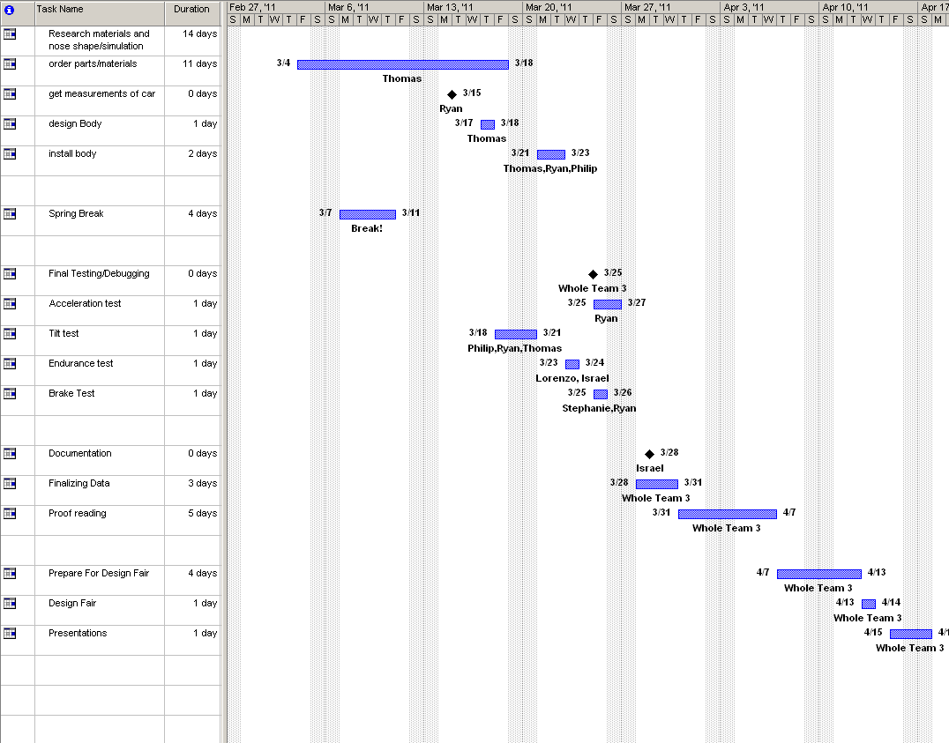

# Milestone 1: Needs Requirements and Specifications

**Milestone 2: Project Proposal and Proposal PowerPoint Presentation**

**Milestone 3: System Design Review Report and PowerPoint Presentation**

**Milestone 4: Detailed Design Review and Detailed Presentation**

**Milestone 5: Design Fair and Final Hardware Demo**

**Milestone 6: Final Oral Presentations and Competition**

## Current Schedule

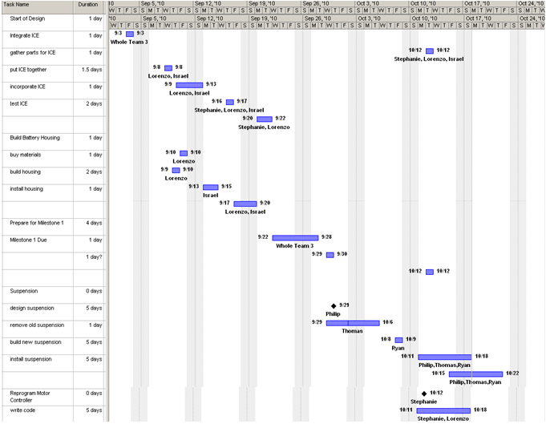

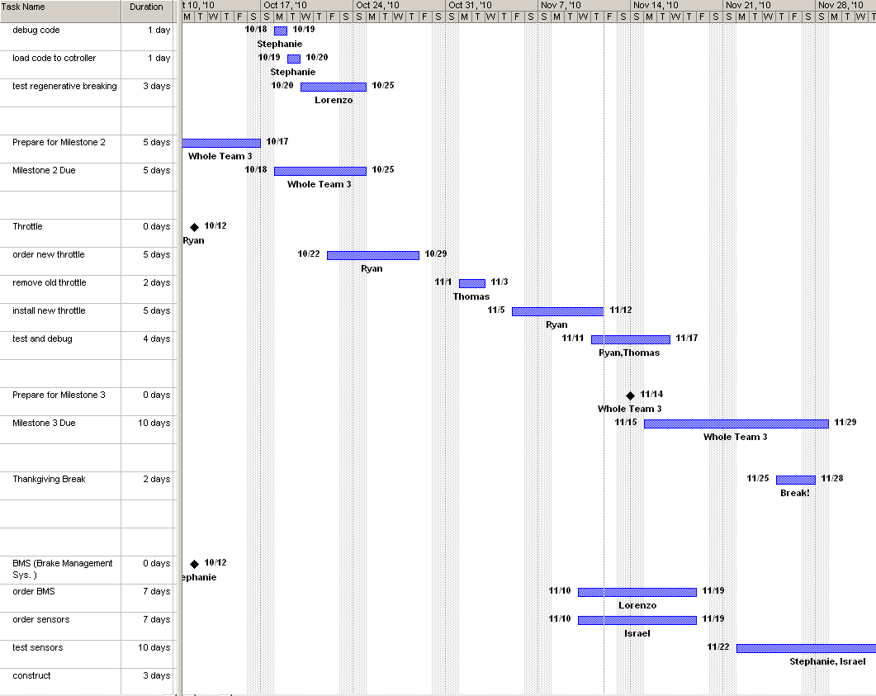

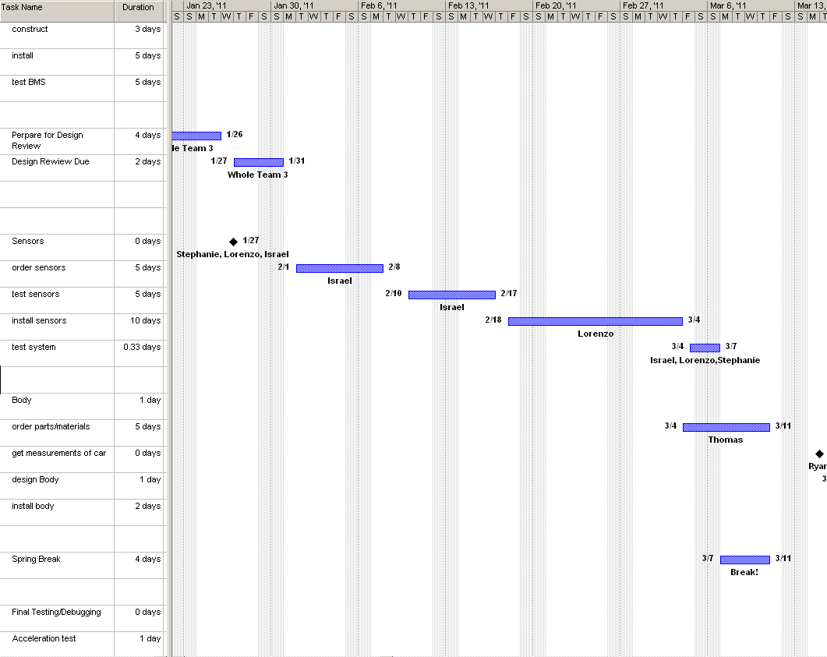

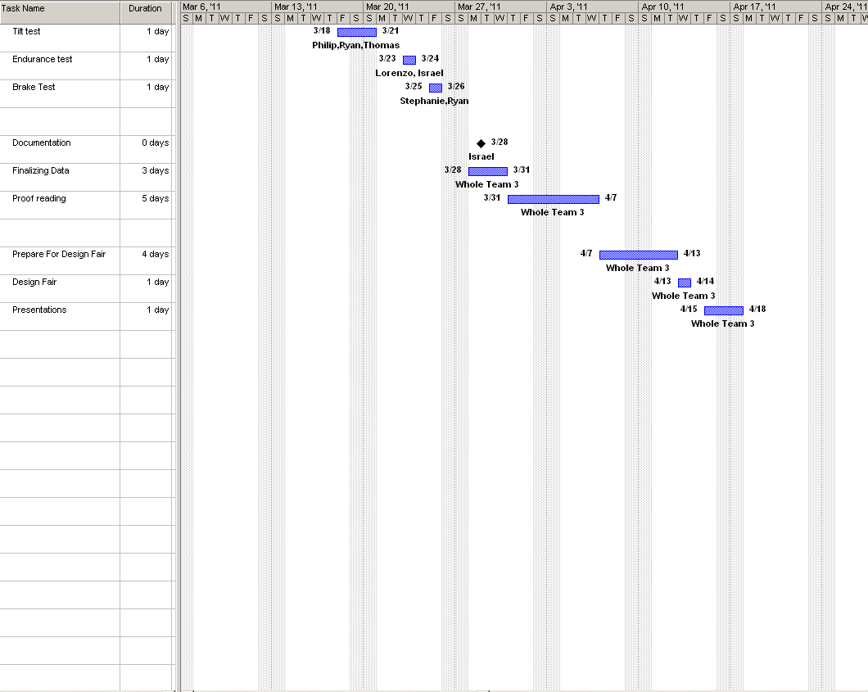

By analyzing the above schedule one will notice that the Formula Hybrid Car is approximately a month behind the originally proposed timeline. After the team proposed this timeline, more research was completed and the teammates agreed that there will not be enough time to complete all objectives as proposed. Many objectives were removed from the timeline such as the regenerative breaking. This was a major change due to the lack of time as it was a primary goal at one point. The reason that this objective was removed was due to the fact that there will not be enough time to complete this goal, and also that there will not be enough breaking to regenerate enough energy for the car. By removing the regenerative breaking from this year’s schedule, all the coding and debugging for the motor controller that was to be done to accommodate regenerative breaking was removed as well.

The removal of regenerative breaking opened up more time for the team to focus on major components such as the BMS, suspension, installing the I.C.E, sensors and other components. The installing of the BMS is being conducted by Lorenzo Neal and Stephanie Medina. The order for the BMS was supposed to have been done in November. Unfortunately, the team was unable to put the purchase order through due to insufficient funds for the purchasing of the system. The main sponsor for this goal is Dr. Cartes’ donation. The team also had to resubmit proposals to Dr. Cartes twice, along with trying to complete work for other classes. As a result of this, the team was unable to place the order on time. Once the proposal was accepted by Dr. Cartes, during the last week in November the team was able to achieve a purchase order and submit it the first week in December. The processing of the purchase order by Dr. Cartes and his staff took a month, longer than expected. The team didn’t receive the BMS until the second week in January. This long process of purchasing the BMS caused the timeline to delay in regards to BMS. The research and ordering of the suspension was supposed to have been done in October. Although in order for the correct measurements to be taken for the car, the mechanical engineers would have to actually have take portions of the car apart. This was unable to be done due to the car being locked in a small storage shed which didn’t provide enough room to work on the vehicle.

Also the team was not assigned a portable, where the car could’ve been worked on early enough. The team wasn’t assigned a portable until a few weeks later and due to final exams and winter break, the measurements were unable to be taken until the first week of January. Once the ME’s had an opportunity to take the wheels and calipers off the car, they noticed that some of the major components were custom-made from last year’s team. They also realized that it would be hard to find parts to fit the custom ones from last year, to accommodate the new brake calipers that the team wanted to integrate into the vehicle this year. So more time will be needed in order for the ME’s to be able to successfully complete their side of tasks.

There were many obstacles that the team has encountered throughout this year that has caused them to fall extremely behind. In order to compensate for the loss of time, the team is working hard on putting in additional working hours per week. The electrical engineers will be doing all testing for the BMS within the next two weeks to compensate for the lost time. The ME’s will be making their final decision regarding the suspension by the end of this week as well. At worst case scenario, if the mechanical engineers are unable to find compatible parts for the design, they will resort to leaving the break on the differential and coming up with creative ways to make the one brake in the rear more sturdy .

# Budget Estimate

## Original Budget

|  |  |  |  |
| --- | --- | --- | --- |
| **A: Engineers** | **Total Hours** | **Base Pay** | **Total Pay** |
| **Computer/Electrical** |  |  |  |
| Lorenzo Neal | 384 | $ 30.00 | $ 11,520.00 |
| Stephanie Medina | 384 | $ 30.00 | $ 11,520.00 |
| Isreal Daramola | 384 | $ 30.00 | $ 11,520.00 |
| **Mechanical** |  |  |  |
| Phillip Young | 384 | $ 30.00 | $ 11,520.00 |
| Thomas Emerick | 384 | $ 30.00 | $ 11,520.00 |
| Ryan Zombek | 384 | $ 30.00 | $ 11,520.00 |
|  |  |  |  |
| **Subtotal A** |  |  | $ 69,120.00 |
| **B: Fringe Benefits** |  | **29% of A** | $ 20,044.80 |
| **C: Total Personnel Costs** |  | **A+B** | $ 89,164.80 |
|  |  |  |  |
| **D. Expense** | **Quantity** | **Unit PrI.C.E** | **Total Cost** |
| **i) Braking** |  |  |  |
| 2) Servo Unit | 1 | $ 50.00 | $ 50.00 |
| 3) Master Cylinder | 1 | $ 200.00 | $ 200.00 |
| 4) Brake Lines | 4 | $ 62.50 | $ 250.00 |
| 5) Brake Hoses | 4 | $ 25.00 | $ 100.00 |
| 6) Brake Disks | 4 | $ 62.50 | $ 250.00 |
| **Subtotal** |  |  | $ 850.00 |
|  |  |  |  |
| **ii) Chassis** |  |  |  |
| 2) Labor | 1 | $ 1,300.00 | $ 1,300.00 |
| **iv) Suspension** |  |  |  |
| 1) Spring/Dampers | 1 | $ 1,000.00 | $ 1,000.00 |
| 2) Heim Joints | 8 | $ 10.00 | $ 80.00 |
| 3) Steel (for control arms) | 30 | $ 15.00 | $ 450.00 |
| 4)Bellcranks | 4 | $ 25.00 | $ 100.00 |
| **Subtotal** |  |  | $ 1,630.00 |
|  |  |  |  |
| **v) Fiberglass/Resin** | 1 | $ 500.00 | $ 500.00 |
| **vii) Charger** |  |  |  |
| 1) AC-DC Li-Ion Charger | 1 | $ 550.00 | $ 550.00 |
| **viii) Safety Equipment** |  |  |  |
| 1) Helmet | 1 | $ 150.00 | $ 150.00 |
| 2) 3-point harness | 1 | $ 120.00 | $ 120.00 |
| 3) ProFox Kit (suit, gloves, shoes) | 1 | $ 350.00 | $ 350.00 |
| 4) Hood | 1 | $ 30.00 | $ 30.00 |
| **Subtotal** |  |  | $ 650.00 |
|  |  |  |  |
| **ix) Wheels** |  |  |  |
| Tires | 4 | $ 100.00 | $ 400.00 |
| Rims | 4 | $ 100.00 | $ 400.00 |
| **Subtotal** |  |  | $ 800.00 |
|  |  |  |  |
| **x) Microcontroller** | 1 | $ 250.00 | $ 250.00 |
|  |  |  |  |
| **xi) Miscellaneous** | 1 | $ 2,000.00 | $ 2,000.00 |
|  |  |  |  |
| **xii) Travel** | 1 | $ 5,000.00 | $ 5,000.00 |
| **xiii) Registration** | 1 | $ 1,500.00 | $ 1,500.00 |
|  |  |  |  |
| **Subtotal of D** |  |  | $ 15,030.00 |
|  |  |  |  |
| **E. Total Direct Costs** |  |  | $ 104,194.80 |
|  |  |  |  |
| **F. Indirect Costs** |  | **45% of E** | $ 46,887.00 |
|  |  |  |  |
| **Equipment** |  |  |  |
| **i) Internal Combustion Engine** |  |  |  |
| 1) Engine/Transmission | 1 | $ 1,000.00 | $ 1,000.00 |
| 2) Cooling System | 1 | $ 150.00 | $ 150.00 |
| 3) Exhaust System | 1 | $ 300.00 | $ 300.00 |
| **Subtotal** |  |  | $ 1,450.00 |
|  |  |  |  |
| **ii) Electric Motor** |  |  |  |
| 1) Motor | 1 | $ 1,200.00 | $ 1,200.00 |
| 2) Motor Controller | 1 | $ 550.00 | $ 550.00 |
| **Subtotal** |  |  | $ 1,750.00 |
|  |  |  |  |
| **iii) Chassis** |  |  |  |
| 1) Steel Stock | 1 | $ 1,500.00 | $ 1,500.00 |
| **Subtotal** |  |  | $ 1,500.00 |
|  |  |  |  |
| **iv) Accumulator** |  |  |  |
| 1) Li-Ion Battery | 2 | $ 1,125.00 | $ 2,250.00 |
| 2) Housing | 1 | $ 75.00 | $ 75.00 |
| **Subtotal** |  |  | $ 2,325.00 |
|  |  |  |  |
| **G. Total OCO** |  |  | $ 7,025.00 |
|  |  |  |  |
| **H. Total Project Costs** |  | **E+F+G** | **$ 158,106.80** |
|  |  |  |  |
| **I. Donated Parts** |  |  |  |
| Internal Combustion Engine |  | $ 1,450.00 |  |
| Tires/rims |  | $ 800.00 |  |
| Microcontroller |  | $ 250.00 |  |
| Chasis |  | $ 1,300.00 |  |
| Charger |  | $ 550.00 |  |
| Electric Motor |  | $ 1,750.00 |  |
|  |  |  |  |
| **Subtotal** |  |  | $ 6,100.00 |
| **J. Overall Total Project Costs** |  | **E+F+G-I** | **$ 152,006.00** |

## Current Budget

|  |  |  |  |
| --- | --- | --- | --- |
| **A: Engineers** | **Total Hours** | **Base Pay** | **Total Pay** |
| **Electrical/ Computer** |  |  |  |
| Lorenzo Neal | 384 | $ 30.00 | $ 11,520.00 |
| Stephanie Medina | 384 | $ 30.00 | $ 11,520.00 |
| Isreal Daramola | 384 | $ 30.00 | $ 11,520.00 |
|  |  |  |  |
| **Mechanical** |  |  |  |
| Phillip Young | 384 | $ 30.00 | $ 11,520.00 |
| Thomas Emerick | 384 | $ 30.00 | $ 11,520.00 |
| Ryan Zombek | 384 | $ 30.00 | $ 11,520.00 |
|  |  |  |  |
| **Subtotal A** |  |  | $ 69,120.00 |
| **B: Fringe Benefits** |  | **29% of A** | $ 20,044.80 |
| **C: Total Personnel Costs** |  | **A+B** | $ 89,164.80 |
|  |  |  |  |
| **D. Expense** | **Quantity** | **Unit PrI.C.E** | **Total Cost** |
| **i) Braking** |  |  |  |
| 2) Servo Unit | 1 | $ 50.00 | $ 50.00 |
| 3) Master Cylinder | 1 | $ 200.00 | $ 200.00 |
| 4) Brake Lines | 4 | $ 62.50 | $ 250.00 |
| 5) Brake Hoses | 4 | $ 25.00 | $ 100.00 |
| 6) Brake Disks | 4 | $ 62.50 | $ 50.00 |
| **Subtotal** |  |  | $ 850.00 |
|  |  |  |  |
| **ii) Chassis** |  |  |  |
| 2) Labor | 1 | $1,300.00 | $ 1,300.00 |
| **iv) Suspension** |  |  |  |
| 1) Spring/Dampers | 1 | $ 1,000.00 | $ 1,000.00 |
| 2) Heim Joints | 8 | $ 10.00 | $ 80.00 |
| 3) Steel (for control arms) | 30 | $ 15.00 | $ 450.00 |
| 4)Bell cranks | 4 | $ 25.00 | $ 100.00 |
| **Subtotal** |  |  | $ 1,630.00 |
|  |  |  |  |
| **v) Fiberglass/Resin** | 1 | $ 500.00 | $ 500.00 |
|  |  |  |  |
| **vii) Charger** |  |  |  |
| 1) AC-DC Li-Ion Charger | 1 | $ 550.00 | $ 550.00 |
|  |  |  |  |
| **viii) Safety Equipment** |  |  |  |
| 1) Helmet | 1 | $ 150.00 | $ 150.00 |
| 2) 3-point harness | 1 | $ 120.00 | $ 120.00 |
| 3) ProFox Kit (suit, gloves, shoes) | 1 | $ 350.00 | $ 350.00 |
| 4) Hood | 1 | $ 30.00 | $ 30.00 |
| **Subtotal** |  |  | $ 650.00 |
|  |  |  |  |
| **ix) Wheels** |  |  |  |
| Tires | 4 | $ 100.00 | $ 400.00 |
| Rims | 4 | $ 100.00 | $ 400.00 |
| **Subtotal** |  |  | $ 800.00 |
|  |  |  |  |
| **x) Micro controller** | 1 | $ 250.00 | $ 250.00 |
|  |  |  |  |
| **xi) Miscellaneous** | 1 | $2,000.00 | $ 2,000.00 |
|  |  |  |  |
| **xii) Travel** | 1 | $5,000.00 | $ 5,000.00 |
|  |  |  |  |
| **xiii) *Registration** | 1 | $1,500.00 | $ 1,500.00 |
|  |  |  |  |
| **Subtotal of D** |  |  | $ 15,030.00 |
|  |  |  |  |
| **E. Total Direct Costs** |  |  | $ 104,194.80 |
|  |  |  |  |
| **F. Indirect Costs** |  | **45% of E** | $ 46,887.00 |
|  |  |  |  |
| **Equipment** |  |  |  |
| **i) Internal Combustion Engine** |  |  |  |
| 1) Engine/Transmission | 1 | $1,000.00 | $ 1,000.00 |
| 2) Cooling System | 1 | $ 150.00 | $ 150.00 |
| 3) Exhaust System | 1 | $ 300.00 | $ 300.00 |
| **Subtotal** |  |  | $ 1,450.00 |
|  |  |  |  |
| **ii) Electric Motor** |  |  |  |
| 1) Motor | 1 | $1,200.00 | $ 1,200.00 |
| 2) Motor Controller | 1 | $ 550.00 | $ 550.00 |
| **Subtotal** |  |  | $ 1,750.00 |
|  |  |  |  |
| **iii) Chassis** |  |  |  |
| 1) Steel Stock | 1 | $1,500.00 | $ 1,500.00 |
| **Subtotal** |  |  | $ 1,500.00 |
|  |  |  |  |
| **iv) Accumulator** |  |  |  |
| 1) Li-Ion Battery | 2 | $1,125.00 | $ 2,250.00 |
| 2) Housing | 1 | $ 75.00 | $ 75.00 |
| **Subtotal** |  |  | $ 2,325.00 |
|  |  |  |  |
| **v) Battery Management System** |  |  |  |
| *BMS | **1** | $1923.63 | $ 1923.63 |
| **Subtotal** |  |  | $ 1923.63 |
|  |  |  |  |
| **G. Total OCO** |  |  | $ 8948.63 |
| **H. Total Project Costs** |  | **E+F+G** | **$ 158,530.63** |
|  |  |  |  |
| **I. Donated parts** |  |  |  |
| Internal Combustion Engine |  | $1,450.00 |  |
| Tires/Rims |  | $ 800.00 |  |
| Microcontroller |  | $ 250.00 |  |
| Chasis |  | $1,300.00 |  |
| Charger |  | $ 550.00 |  |
| Electric Motor |  | $1,750.00 |  |
| **Subtotal** |  |  | $ 6,100.00 |
|  |  |  |  |
| **J. Overall Total Project Costs** |  | **E+F+G-I** | **$152,430.63** |

*Indicate that the components have been purchased this year

# Conclusion

The FAMU-FSU Hybrid Team is proceeding swiftly through the development of a competitive hybrid race vehicle. At the present moment, the vehicle’s top level designs are completely finished. Most of the sublevel designs and individual components are still being considered. The BMS has been acquired and is currently in the testing phase of the installation process. Other components are in the last phase of being ordered and will be tested upon arrival.

One of the main constraints on the project is insufficient funds for travel expenses. The team is still awaiting responses from potential sponsors including Student Government Association, for travel expenses, in order to be able to attend the competition in May. While waiting on the outcome of these responses, several other accomplishments have been made. These accomplishments include the registration fee that was paid for by the Dean of the COE and the recent sponsorship approval that was made by Dr. Cartes from IESES for $6,000. In addition, once the electrical and computer engineers fully determine the installation and integration process for the BMS, these engineers will be able to proceed with the handling of separating all individual cells to be compatible with the BMS. More so, once the electrical engineer determines if the sensors that were purchased from last year will be useful for this year, the quota for the sensors kit will be complete in addition to the thermal coupling probe for the radiator temperature gauge. The mechanical engineers have fully determined the uprights material and are in the process of fully resolving the dilemma with the rear axle for the brake system. In regards to the electrical and I.C.E clutch, a quota is in process for the one-way free clutch and Battle Kart Shifter to initiate the coupling between the I.C.E and E.M.

Aside from these goals, the engineers on the team are still researching potential sponsors at local sites. Furthermore, the Formula Hybrid Vehicle is well on its way to a complete design. With the help of the sponsors and team members on the project, the designs being created now will materialize into systems which can then be integrated with each other to create a fully functional hybrid race car that will hopefully win the 2010-2011 SAE Competition!

# References

[1] "Formula Hybrid Forums :: View Topic - Hybrid Powertrain Configurations." *Formula Hybrid*. SAE International IEEE, 26 Feb. 2008. Web. 13 Sept. 2010. <http://www.formula-hybrid.org/forums/viewtopic.php?t=160>

[2] Nice, Karim.  "How Differentials Work"  02 August 2000.  HowStuffWorks.com. 17 September 2010 <http://auto.howstuffworks.com/differential.htm>

# [3] SAE International. "2011 Formula Hybrid Rules." (2011): 1-124. Web. 24 Sept. 2010. <http://www.formula-hybrid.org/pdf/Formula-Hybrid-2011-Rules.pdf>

# [4]  "Elithion - Lithiumate™ - Distributed Li-Ion BMS." *Elithion - Electronics for Lithium-Ion*. 14 June 2010. Web. 26 Oct. 2010. <http://www.liionbms.com/php/liionbms.php>

[5] Boxall, By Andy. "How Does a Car Chassis Work? | DoItYourself.com." *DIY Home*

*Improvement Information | DoItYourself.com*. Web. 15 Nov. 2010 <http://www.doityourself.com/stry/how-does-a-car-chassis-work>

[6] *AGNI Motors*. 2009. Web. 15 Nov. 2010. <http://www.agnimotors.com/home/index.php?option=com_frontpage&Itemid=47>

[7] "1965 Scout Parts 152/T90/D20 Radiator/gauges/ Power Steering - Binder Bench." *Just Internationals*. 24 July 2009. Web. 15 Nov. 2010. <http://www.justinternationals.org/Binder-Bench/showthread.php?t=11617\>

# Appendix

## Chassis Equations

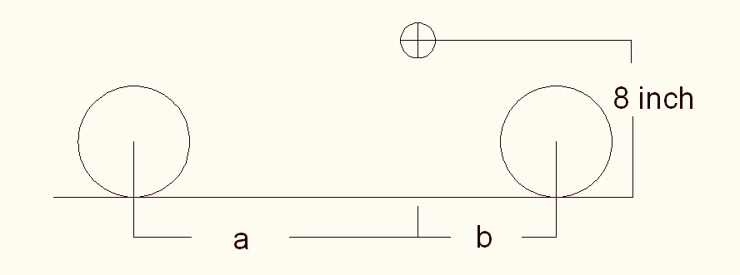













= (wheelbase)





**Static weight distributions**









**Dynamic Weight Distributions**









**Braking Forces on Front and Rear Wheels**





**Torque on Rear Wheels from Braking**







Starting from pedal



























## Test Plans Forms

***Scheduled Test Reporting Form***

Test Item: Drivetrain

Tester Name: Thomas Emerick Tester ID No: 5174

Test Date:02/29/2011 Test No: 1

Test Time:5:00 p.m. Test Type: Manual

Test Location: College of Engineering Test Result: N/A

Test Objective:

To ensure that the drivetrain of the formula hybrid vehicle generates power and delivers it to the road surface. Confirm that the combustion engine is unable to over rev the electric motor because of the one way bearing installment.

Test Description/Requirements:

The tests to confirm that the combustion engine is running properly and that the one way bearing is functioning properly will be completed before proceeding to the drivetrain testing. The chains between the driving and driven sprockets of the combustion engine and electric motor will be installed. The electric motor and the combustion engine will then be started and given power simultaneously and separately.

Anticipated Results:

The drivetrain will generate power and provide it to the road surface. The motors will start and the one way bearing will function properly. The motors will provide power simultaneously and separately.

Requirement for Success:

The test plans for the internal combustion engine and one way bearing will first be passed.

Actual Results:

N/A

Reason for Failure:

N/A

Recommended Fix:

N/A

Other Comments:

N/A

***Scheduled Test Reporting Form***

Test Item: 24 Lithium-Ion batteries (120 cells)

Tester Name: Stephanie Medina and Lorenzo Neal Tester ID No : 5174

Test Date: 03/25/2011 Test No: 2

Test Time: 2:00 p.m. Test Type: Test

Test Location: College of Engineering Test Result: N/A

Test Objective:

The objective of this test is to confirm that the twenty-four battery packs are at the same potentials and are equally balanced.

Test Description/Requirements:

The equipment required for this test is the Formula Hybrid Vehicle, Elithion BMS Controller , a portable voltmeter, gloves, twenty-four battery packs (120 cells),battery boxes, negative-end, mid-bank and postive-end cellboards, fuses, electrical tape, SOC meter, jumpers and several wiring harnesses. The Elithion BMS Controller will be connected to the 120 battery cells that are connected in series. Since there will be a cellboard per cell, by utilizing the jumpers, the 120 battery cellboards will be connected in series as well. The negative-end and positive-end cellboards will then be wired back to the BMS Controller. In addition, the BMS controller will be mounted on top of the previous housing, which contains the motor controller .

Anticipated Results:

Once the Formula Hybrid vehicle has been started, the BMS Controller will turn on. In addition, it will recognize that 75 battery cells will be at a lower potential than the other 45 battery cells. Once this has been confirmed, the BMS will pull energy from the higher potential to the lower potential and balance all 120 cells.

Requirement for Success:

Basically, each cell will be at an approximate potential of 3.7 V. In order for this test to be successful, the difference between the battery cells should be no greater than 0.35 V to one another which will give us a percentage error of less than 10 %.

Actual Results:

N/A

Reason for Failure:

N/A

Recommended Fix:

N/A

***Scheduled Test Reporting Form***

Test Item: Formula Hybrid’s Chassis

Tester Name: Formula Hybrid Team Tester ID No: 5174

Test Date: 3/10/11 Test No: 3

Test Time: 12:00 pm Test Type: Physical

Test Location: College of Engineering Test Result: T.B.D

Test Objective:

To ensure the Formula Hybrid’s chassis is performing as designed and is race ready to compete at the highest level possible.

Test Description/Requirements:

To test the chassis as a whole, real life driving conditions will be imposed on the vehicle in attempt to duplicate the racing conditions that will be present come competition time in May. Through a combination of autocross, endurance and acceleration mock runs in the COE parking lot, the chassis should be subjected to a fair amount of what is expected to come and any evidence of a chassis failure should be present at that time. As long as the chassis can pass each mock run under the desired time without failure, the test for the chassis is complete and successful.

Anticipated Results:

With the amount of time and effort put forth by the whole team this year, the group expects the chassis to perform fine with no flaws and better mock trial times than previous years.

Requirement for Success:

For the chassis to be labeled complete and successful the vehicle must pass each of three performance assessment times assigned by the group, endurance run, autocross and acceleration runs. Only once the vehicle can complete these events under the desired times without engineering failure can the chassis be labeled complete and successful.

Actual Results:

T.B.D

Reason for Failure:

T.B.D

Recommended Fix:

T.B.D

Other Comments

T.B.D

***Scheduled Test Reporting Form***

Test Item: Brake System and Uprights

Tester Name: Philip Young Tester ID No:5174

Test Date: 2/25/11 Test No: 4

Test Time: 5:00 p.m. Test Type: Physical

Test Location: College of Engineering Test Result: N/A

Test Objective:

To ensure that the braking system as a whole is capable of being properly secured to the vehicle. This includes fitting the braking system together with the uprights.

Test Description/Requirements:

This test will involve connecting the entire brake assembly to the vehicle and verifying that it interacts with the vehicle as expected. This includes mounting the calipers to the uprights.

Anticipated Results:

The brake system is anticipated to pass the test because of the customization that is available when mounting the system. Mounts for the attachment points between the components and the vehicle can be custom made to fit the assembly as needed.

Requirement for Success:

The brake system must be able to be attached to the vehicle without any unwanted contact between the system and the vehicle. Unwanted contact includes contact between the calipers and the wheel well and between the brake pads and the brake rotor.

Actual Results:

N/A

Reason for Failure:

N/A

Recommended Fix:

N/A

Other Comments:

N/A

***Scheduled Test Reporting Form***

Test Item: Suspension and Uprights

Tester Name: Philip Young Tester ID No: 5174

Test Date: 3/05/11 Test No: 5

Test Time: 12:00 p.m. Test Type: Physical

Test Location: College of Engineering Test Result: N/A

Test Objective:

To physically verify the suspension characteristics throughout wheel travel once it has been attached to the uprights and frame.

Test Description/Requirements:

The suspension will be analyzed in order to verify the correct values for important suspension characteristics.

Anticipated Results:

The suspension is anticipated to have desirable characteristics due to the success of the digital simulation of the suspension.

Requirement for Success:

The suspension must exhibit desirable values for a number of suspension characteristics, as defined by the automotive industry. The characteristics that are of importance have previously been defined under the suspension category of Major Components.

Actual Results:

N/A

Reason for Failure:

N/A

Recommended Fix:

The suspension is going to be designed to allow for constant adjustability, if the suspension is not tuned how the team sees fit it can be adjust accordingly.

Other Comments:

N/A

***Scheduled Test Reporting Form***

Test Item: Internal Combustion Engine

Tester Name: Thomas Emerick Tester ID No: 5174

Test Date: 02/ 22/2011 Test No: 1.1

Test Time: 2:00 p.m. Test Type: Manual

Test Location: College of Engineering Test Result: N/A

Test Objective:

To ensure that the internal combustion engine and its components are running properly.

Test Description/Requirements:

The carburetors, radiator, intake, and exhaust will be assembled onto the engine. The engine will be filled with gasoline and oil and the radiator will be filled with the water. The ignition button on the internal combustion engine will then be pressed to see if the engine will turn over and run. The throttle and clutch cables to the engine will be tested to confirm that they are functioning.

Anticipated Results:

The internal combustion engine will start and run properly.

Requirement for Success:

Proper assembling of the combustion engine’s components is required for the engine to run correctly. The engine must be filled with all of the required fluids, gasoline, oil, and water.

Actual Results:

Reason for Failure:

N/A

Recommended Fix:

N/A

Other Comments:

N/A

***Scheduled Test Reporting Form***

Test Item: One – Way Freewheel Clutch Bearing

Tester Name: Thomas Emerick Tester ID No: 5174

Test Date:02/30/2011 Test No: 1.2

Test Time: 1:00 p.m. Test Type: Manual

Test Location: College of Engineering Test Result: N/A

Test Objective:

To ensure that the one way bearing operates properly by free spinning in one direction and locking in the opposing direction after installation. To ensure that the bearing does not slip in the housing or on the E.M. shaft.

Test Description/Requirements:

The bearing will be pressed fitted into the bearing housing. The rotational features of the bearing will first be tested using the tester’s hand. The bearing will then be press fitted onto the shaft of the electric motor. The rotational features of the bearing will be tested a second time by hand. The rotational features of the bearing will then be tested a final time by providing the maximum amount of 50 Nm of torque from the electric motor.

Anticipated Results:

The bearing will function properly by free spinning in one direction and locking in the opposing direction and will not slip in the housing or on the E.M. shaft.

Requirement for Success:

Proper installation is required for the bearing to operate properly. This includes placement of the bearing so that it locks in the correct direction, proper sizing of the bearing, and exact dimensioning of the hub of the housing.

Actual Results:

Reason for Failure:

N/A

Recommended Fix:

N/A

Other Comments:

N/A

***Scheduled Test Reporting Form***

Test Item: Battle Kart Shifter

Tester Name: Thomas Emerick Tester ID No: 5174

Test Date:02/10/2011 Test No: 1.3

Test Time: 2:00 p.m. Test Type: Manual Test

Test Location: College of Engineering Test Result: N/A

Test Objective:

Confirm that the paddle shifter operates in the proper sequence and changes gears smoothly.

Test Description/Requirements:

The Battle Kart Shifter will be tested prior to installation to ensure that it will shift gears in the proper sequence to progress from neutral to sixth gear and from sixth gear to neutral. The paddle shifting components will be installed and properly adjusted for smooth shifting. The manufacturer indicates that the current delay is too long if there is a detectable speed drop while changing gears and too short if there is a noticeable shock when changing gears.

Anticipated Results:

The battle Kart Shifter will shift gears smoothly and in the proper sequence.

Requirement for Success:

The Battle Kart Shifter is properly installed and tuned.

Actual Results:

Reason for Failure:

N/A

Recommended Fix:

N/A

Other Comments:

N/A

***BMS: 10 Cells***

***Scheduled Test Reporting Form***

Test Item: 2 Lithium-Ion batteries (10 cells)

Tester Name: Stephanie Medina and Lorenzo Neal Tester ID No : 5174

Test Date: 02/04/2011 Test No: 2.1.1

Test Time: 2:00 p.m. Test Type: Test

Test Location: College of Engineering Test Result: N/A

Test Objective:

The objective of this test is to confirm that the two battery packs each at different potentials are equally balanced. In other words, that they will be at the same potential.

Test Description/Requirements:

The equipment required for this test is the Elithion BMS Controller with a power supply, digital multimeter, cable cords, gloves, two battery packs(10 cells), negative-end, mid-bank and postive-end cellboards, jumpers and a wiring harness. The Elithion BMS Controller will be connected to the power supply which will power the BMS. There will be a cellboard per cell. By utilizing the jumpers, the 10 battery cellboards will be connected in series. The negative-end and positive-end cellboards will then be wired back to the BMS Controller.

Anticipated Results:

The BMS Controller will turn on. In addition, it will recognize that 5 cells will be at a lower potential than the other 5 cells. Once this has been confirmed, the BMS will pull energy from the higher potential to the lower potential and balance all 10 cells.

Requirement for Success:

Ideally, each cell will be at an approximate potential of 3.7 V. In order for this test to be successful, the difference between the battery cells should be no greater than 0.35 V to one another which will give us a percentage error of less than 10 %.

Actual Results:

N/A

Reason for Failure:

N/A

Recommended Fix:

N/A

Other Comments:

N/A

***BMS: 20 Cells***

***Scheduled Test Reporting Form***

Test Item: 4 Lithium-Ion batteries (20 cells)

Tester Name: Stephanie Medina and Lorenzo Neal Tester ID No : 5174

Test Date: 02/18/2011 Test No: 2.1.2

Test Time: 2:00 p.m. Test Type: Test

Test Location: College of Engineering Test Result: N/A

Test Objective:

The objective of this test is to confirm that the four battery packs each at different potentials are equally balanced. In other words, that they will be at the same potential.

Test Description/Requirements:

The equipment required for this test is the Elithion BMS Controller with a power supply, digital multimeter, cable cords, gloves, four battery packs(20 cells), negative-end, mid-bank and postive-end cellboards, jumpers and a wiring harness. The Elithion BMS Controller will be connected to the power supply which will power the BMS. There will be a cellboard per cell. By utilizing the jumpers, the 20 battery cellboards will be connected in series. The negative-end and positive-end cellboards will then be wired back to the BMS Controller.

Anticipated Results:

The BMS Controller will turn on. In addition, it will recognize that 10 cells will be at a lower potential than the other 10 cells. Once this has been confirmed, the BMS will pull energy from the higher potential to the lower potential and balance all 20 cells.

Requirement for Success:

Basically, each cell will be at an approximate potential of 3.7 V. In order for this test to be successful, the difference between the battery cells should be no greater than 0.35 V to one another which will give us a percentage error of less than 10 %.

Actual Results:

N/A

Reason for Failure:

N/A

Recommended Fix:

N/A

Other Comments:

N/A

***Scheduled Test Reporting Form***

***Sensors Before Installation***

Test Item: Sensor Gauge- Tachometer/Temperature

Tester Name: Israel Daramola Tester ID No: 5174

Test Date: 2/21/2011 Test No: 3.1

Test Time: 2:00 p.m. Test Type: Test

Test Location: College of Engineering Portable Test Result: N/A

Test Objective:

The objective of this test is to ensure that the tachometer is in good condition and that there are no faults found either in it’s wires or on the actual device.

Test Description/Requirements:

There is no equipment necessary for this type of test; it’s only to ensure that the device is in good condition.

Anticipated Results:

Everything on the sensors will be in tiptop form and shape; no overt problems found with the wires or the shell of the device.

Requirement for Success:

No rattling noises heard inside of the sensor, the ticker on the gauge should not be able to move as a result of shaking or turning it and the wires should not look frayed or damaged.

Actual Results:

N/A

Reason for Failure:

N/A

Recommended Fix:

N/A

Other Comments:

N/A

***Scheduled Test Reporting Form***

Test Item: Sensor Gauge- Tachometer/Temperature

Tester Name: Israel Daramola Tester ID No: 5174

Test Date: 2/25/11 Test No: 3.1.1

Test Time: 4PM Test Type: Test

Test Location: College of Engineering Portable Test Result: N/A

Test Objective:

The objective of this test is to ensure that the tachometer and temperature gauge are functioning properly.

Test Description/Requirements:

Variable Resistance Potentiometer (0-500 ohms)

Test Leads

Anticipated Results:

When connected to the potentiometer, the readings made from the gauge will be compared to the set of resistor/temperature matches. The readings from the gauges should be close to the expected values from the resistor-temperature chart.

Requirement for Success:

Gauge behaves normally and changes appropriately as temperature rises or the car moves.

Actual Results:

N/A

Reason for Failure:

N/A

Recommended Fix:

N/A

Other Comments:

N/A

***Scheduled Test Reporting Form***

Test Item: Ryan Zombek

Tester Name: Team 3 Tester ID No: 5174

Test Date: 3/1/2011 Test No: 3.1.3

Test Time: 12:00 pm Test Type: Physical

Test Location: College of Engineering Test Result: TBD

Test Objective:

To ensure the vehicle can no longer over steer causing damage inside the wheel hub, as well as testing the overall steering components to confirm a proper alignment.

Test Description/Requirements:

As stated in the Formula Hybrid Rulebook the vehicle can only have eleven degrees of freedom at the wheel. With this in mind the group will weld aluminum blocks onto the steering pinion at precise locations to ensure this maximum of eleven degrees is not passed. These blocks will also serve another purpose as the will block the driver from being able to turn the wheel so far that damaged is occurred in the wheel hub from over steering. To test these blocks are performing correctly they will be first tack welded into place temporarily, that way measurements can be taken while the steering wheel is being turned and manipulated. Only when the total degree of freedom for the steering wheel is measured to be less than eleven degrees will the aluminum blocks be permanently welded into place.

Anticipated Results:

Being this is a simple task, the group fully expects the results to go as plan and the steering system for the vehicle to be working properly with correct alignment.

Requirement for Success:

As long as the maximum of eleven degrees is not reached and the ability to over steer is no longer present then the steering of the formula vehicle will be complete and race ready.

Actual Results:

T.B.D

Reason for Failure:

T.B.D

Recommended Fix:

T.B.D

Other Comments:

T.B.D

***Scheduled Test Reporting Form***

Test Item: Formula Hybrid’s Frame

Tester Name: Ryan Zombek Tester ID No: 5174

Test Date: 12/1/2010 Test No:3.1.4

Test Time: 12:00 pm Test Type: Computer Simulation

Test Location: College of Engineering Test Result: Pass

Test Objective:

To ensure the Formula Hybrid’s frame can withstand the added weight of the internal combustion engine and its components.

Test Description/Requirements:

The only real way to test this requirement is through the aid of computer design. Once the frame of the vehicle is completely modeled in COMSOL, forces can be added near the rear of the model to simulate the weight of the I.C.E. Once these forces are modeled the maximum stress found in the frame can be deduced and compared to its maximum yield stress, giving the designers the important factor of safety for the design. For the frame to pass this test the factor of safety must be over 2.0 when taking in consideration for the added weight to the vehicle.

Anticipated Results:

Being the frame is made from steel tubing, the group would suspect that the added mass to the vehicle will be trivial and the factor of safety will remain above 4.0 as it is now without the I.C.E or any of its components.

Requirement for Success:

For the frame to be considered a safe design, the standard engineering factor of safety of two will be implemented in this test. That is, the maximum yield stress found in the design with all the weight added will only be half that of what the material’s maximum yield stress is.

Actual Results:

As anticipated the addition of 45 kg to the overall mass of the vehicle 267kg was trivial and the factor of safety was still above 3.0, well above the requirement to pass this test. Now the formula hybrid’s frame will be considered a safe design, even with all the added weight to the system.

Reason for Failure:

N.A

Recommended Fix:

N.A

Other Comments

N.A

***Scheduled Test Reporting Form***

Test Item: Entire Brake System

Tester Name: Philip Young Tester ID No: 5174

Test Date: 2/25/2011 Test No: 3.2

Test Time: 2:00 p.m. Test Type: Physical

Test Location: College of Engineering Test Result: N/A

Test Objective:

To ensure that all of the brake components; including the calipers, rotor, brake lines, and pistons; assemble correctly together.

Test Description/Requirements:

This test will consist of the team assembling the entire brake system before attaching it to the car and verifying that all components fit properly together.

Anticipated Results:

The brake system is anticipated to pass this test because it will be designed with each separate component in mind. Therefore, parts will be chosen based upon each other and according to manufacture recommendation. 3D modeling of the assembly will also verify proper fitting between components.

Requirement for Success:

The braking system must be able to be assembled properly without any unwanted contact between components. This includes unintended contact between brake pads and rotors.

Actual Results:

N/A

Reason for Failure:

N/A

Recommended Fix:

N/A

Other Comments:

N/A

***Scheduled Test Reporting Form***

Test Item: Entire Brake System

Tester Name: Philip Young Tester ID No: 5174

Test Date: 2/25/2011 Test No: 3.2.1

Test Time: 4 PM Test Type: Physical

Test Location: College of Engineering Test Result: N/A

Test Objective: To ensure that the braking system as a whole functions as expected.

Test Description/Requirements:

This test will consist of a team member pressing on the brake pedal and verifying that all brake components move and interact as expected.

Anticipated Results:

The brake assembly is anticipated to pass this test due to the simplicity of the test. Connecting a brake assembly is a straightforward process that should turn out to be a trivial task given the success of the brake assembly test.

Requirement for Success:

The first requirement for success is that the system passes the brake assembly test. Then, all components of the brake assembly must move as expected and interact appropriately in order to pass this test. This includes brake fluid filling up the master cylinders when connected, brake piston movement with pedal movement, and brake pad movement with piston movement. The system must perform this motion without any errors or unwanted contact.

Actual Results:

N/A

Reason for Failure:

N/A

Recommended Fix:

N/A

Other Comments:

N/A

***Scheduled Test Reporting Form***

Test Item: Entire Brake System

Tester Name: Philip Young Tester ID No: 5174

Test Date: 2/26/2011 Test No: 3.2.3

Test Time: 2:00 p.m. Test Type: Physical

Test Location: College of Engineering Test Result: N/A

Test Objective:

To ensure that the braking system as a whole is capable of locking all four wheels of the vehicle.

Test Description/Requirements:

The system must first pass the brake assembly, functionality, and vehicle assembly tests in order to perform this one. The test will consist of performing an acceleration run similar to that required by the competition followed by panic stop braking. This will be the exact same scenario that will be seen during the competition and will thus provide a valid result. The braking system must be able to lock all four wheels of the vehicle in order to pass the test.

Anticipated Results:

The brake system is anticipated to pass the test due to the rough calculations showing its performance. The calculations were based on components that the team is planning on using and showed that the braking system would be able to successfully match the torque on all four wheels, thus locking the wheels.

Requirement for Success:

The braking system must be able to bring the car to a stop while locking all four of its wheels in order to pass the test.

Actual Results:

N/A

Reason for Failure:

N/A

Recommended Fix:

N/A

Other Comments:

N/A

***Scheduled Test Reporting Form***

Test Item: Axle and Wheel Hub

Tester Name: Philip Young Tester ID No: 5174

Test Date: 3/1/2011 Test No: 3.2.3

Test Time: 5:00 p.m. Test Type: Physical

Test Location: College of Engineering Test Result: N/A

Test Objective:

To ensure that the CV axle and the wheel hub fit together and do not exhibit any slippage when rotated.

Test Description/Requirements:

This test will consist of sliding the CV joint into the wheel hub and turning the axle. The axle and hub must fit together and not slip when rotated.

Anticipated Results:

The test is expected to be a success since the wheel hubs are to be custom made to fit the spline shaft of the CV joints.

Requirement for Success:

The CV joint must be able to slide completely into the wheel hub without getting stuck at any point. There must also be no slipping between the wheel hub and the CV joint when one of the two is rotated while connected to the other.

Actual Results:

N/A

Reason for Failure:

N/A

Recommended Fix:

N/A

Other Comments:

N/A

***Scheduled Test Reporting Form***

Test Item: Suspension

Tester Name: Philip Young Tester ID No: 5174

Test Date: 10/05/2010 Test No: 3.3

Test Time: 12:00 p.m. Test Type: Simulation

Test Location: College of Engineering Test Result: Pass

Test Objective:

To digitally verify the suspension characteristics throughout wheel travel.

Test Description/Requirements:

A digital version of the vehicle’s suspension was simulated using ADAMS software and then put through wheel travel tests. The software then calculates all important characteristics of the suspension as a function of the wheel travel. Important characteristics include wheel camber and toe among others.

Anticipated Results:

The important characteristics of the suspension are expected to fall in the desirable range due to the proper construction of the suspension just one year ago.

Requirement for Success:

The suspension must exhibit desirable values for a number of suspension characteristics, as defined by the automotive industry. The characteristics that are of importance have previously been defined under the suspension category of Major Components.

Actual Results:

The suspension simulation yielded desirable results for all suspension parameters of importance. This led the team to the decision that the suspension design is appropriate for the vehicle and will be utilized again.

Reason for Failure:

N/A

Recommended Fix:

N/A

Other Comments:

N/A

***Scheduled Test Reporting Form***

Test Item: Uprights

Tester Name: Ryan Zombek Tester ID No: 5174

Test Date: 1/202011 Test No: 3.3.2

Test Time: 1:00 p.m. Test Type: Computer Simulation

Test Location: College of Engineering Test Result: Pass

Test Objective:

To ensure the upright can withstand the stresses generated from high speed turns and braking.

Test Description/Requirements:

A standard high speed turn should result in an acceleration of the vehicle of around 1g. Knowing this acceleration and the mass of the vehicle, the subsequently forces generated on a standard upright can be deduced. From this, the computer model of the upright can be subjected to these forces and analyzed. The requirement to pass this test is a minimal factor of safety of 2. That is, the maximum stresses found in the computer model will be half of that of the material’s maximum yield stress.

Anticipated Results:

The upright will have more than enough strength to endure 1g turns and the factor of safety will be over 2 while the weight it at its minimum.

Requirement for Success:

For the upright to pass this test it must be the lightest possible model while still having at least a factor of safety of 2 in a computer simulation model.

Actual Results:

After subjecting the upright to an axial and radial load of 131234 N, the model performed fine. The maximum stress was found in the connection between the upright and suspension as accepted and the highest stress found in that region where only 32423N. That means the factor of safety for this model is 4.3 which is plenty over the 2.0 requirement for the upright to pass this test.

Reason for Failure:

N/A

Recommended Fix:

N/A

Other Comments:

N/A

***Scheduled Test Reporting Form***

Test Item: Acceleration Test

Tester Name: Ryan Zombek Tester ID No: 5174

Test Date: 4/1/2011 Test No: 3.4

Test Time: 1:00 p.m. Test Type: Physical

Test Location: College of Engineering Test Result: TBD

Test Objective:

To ensure the hybrid vehicle can pass the 10 second, 75 yard drag strip part of the competition.

Test Description/Requirements:

A 75 yard drag strip will be measured outside the COE and each group member will do their own trial run for a total of six runs. Using a stop watch, each time will be clocked and recorded. After all the runs have concluded an average time will be calculated and this number will be compared to the time from last year’s competition; mainly FSU’s time of 7.972 seconds and also the winner of this event last year, University of Vermont with a time of 5.28s. The requirement to pass this test is a minimal of 10 seconds which is set by the Formula Hybrid Committee for entry into the competition. Although the group’s personal requirement will be less than 7.972 seconds set by FSU last year.

Anticipated Results:

With the reduced weight of the vehicle from this year’s competition to last year’s, the group expects there also should be a significant reduction in the acceleration times as well. With this said, the group expects the vehicle to pass this test with a time well under nine seconds, and the main goal is to get a time under six seconds to be among the top three in the competition this year.

Requirement for Success:

To gain entry into the Formula Hybrid 2011 competition, each vehicle must pass a 75 yard electric only acceleration run under ten seconds to proceed with the competition. Being so, the group has set the requirement for success for this test under ten seconds.

Actual Results: TBD

Reason for Failure:

TBD

Recommended Fix:

TBD

Other Comments:

N/A

***Scheduled Test Reporting Form***

Test Item: Endurance Test

Tester Name: Ryan Zombek Tester ID No: 5174

Test Date: 4/2/2011 Test No: 3.4.2

Test Time: 1:00 p.m. Test Type: Physical

Test Location: College of Engineering Test Result: TBD

Test Objective:

Given 20 MJ of energy, determine how many quarter mile laps the hybrid vehicle can complete using both energy propulsion systems onboard.

Test Description/Requirements:

Once the batteries are fully charged with a know amount of energy, the remainder of the energy will be converted to gasoline and added to the fuel tank onboard. Once all the energy is onboard, a quarter mile track will be built in the parking lot of the COE. Two members will each do their own separate runs around the track till all the energy onboard is depleted. From there the average amount of laps completed will be calculated and recorded. The requirement to pass this test is to complete at least 13 laps in 18 minutes and 48 seconds as did FSU last year.

Anticipated Results:

This year significant improvements were made on the vehicle tailored to this event. The most drastic is the addition of the I.C.E, this will greatly improve the endurance of the vehicle because at high speeds the E.M can shut off and the more efficient I.C.E can take over at high speeds, allowing for better fuel consumption. Another addition is the Battery Management System, which will monitor the use of the electric batteries and ensure they are running at optimal efficiency. With these additions the group expects to exceed the 13 laps set by FSU last year and be in the range of 18 to 20 laps to be able to compete among the top three of the competition this year.

Requirement for Success:

The minimum requirement for this test is 13 laps around a quarter mile track given 20MJ of energy. To win this event this year a more competitive number will be needed like 18 laps and that is a personal group requirement that will be implemented into this test.

Actual Results:

TBD

Reason for Failure:

TBD

Recommended Fix:

TBD

Other Comments:

N/A

***Scheduled Test Reporting Form***

Test Item: Auto-Cross Test

Tester Name: Ryan Zombek Tester ID No: 5174

Test Date: 4/3/2011 Test No: 3.4.3

Test Time: 1:00 p.m. Test Type: Physical

Test Location: College of Engineering Test Result: TBD

Test Objective:

To ensure the formula hybrid can maneuver high speed turns effectively as well as high speed braking.

Test Description/Requirements:

Given the specifications from the 2011 Official Hybrid Rulebook the group will build similar slaloms in the COE parking lot and run trial heats while recoding the times. Each group member will perform their own run and the average of the six times will be calculated and recorded. The minimum time that is allowable for the group this year is the time set by the 2010 Hybrid group of 1 minute and 15 seconds. A more competitive time would be around 41 seconds per lap.

Anticipated Results:

Given all the improvements made this year on the vehicle, the group expects the autocross event to be the best of all the events. Significant improvements were made this year just for this event and they include brakes, suspension, lightweight uprights as well as added a second propulsion system onboard the vehicle. With all these improvements, the group drastically expects to reduce FSU’s time of 1:15 per lap and be around 41 seconds a lap like the winner Texas A&M was last year.

Requirement for Success:

To pass this test the hybrid vehicle must be able to complete a quarter mile autocross track in less than 1 minute and 15 seconds. A personal group goal is a lap time of under 50 seconds to be more competitive in the 2011 competition but is not required to pass this test.

Actual Results:

TBD

Reason for Failure:

TBD

Recommended Fix:

TBD

Other Comments:

N/A

## Resumes

**STEPHANIE MEDINA**

1325 West Tharpe St. #912 Tallahassee, FL 32303

[**sm07h@fsu.edu**](mailto:sm07h@fsu.edu)

(239) 398 – 0996

**OBJECTIVE:** Seeking to obtain a challenging internship position in the field of Computer Engineering and be a valuable asset to a company.

**EDUCATION:**

**Bachelor of Science in Computer Engineering December 2011**

College of Engineering; Florida State University; Tallahassee, FL

G.P.A: **3.13**

**SKILLS:**

* C++,Visual Basic, MATLAB, PSPICE, Exam DiffPro, Beyond Compare, Razor
* Microsoft Word, PowerPoint, Excel, Outlook
* Bilingual (Spanish)

**RELEVANT COURSES:**

* Senior Design1 & II, Circuits 1-2, Electronics
* Object-Oriented Programming, Data Structures
* Microprocessors, FPLDS, Computer Architecture,Operating Systems,DSP w/ FPGA’s
* Signals & Systems, Communications, Statistical Topics in CPE/EE, Fields

**EXPERIENCE:**

**Senior Design (Formula Hybrid Car), Tallahassee, FL Program Manager/Lead Engineer August 2010 - April 2011**

* Lead team of six to compete in the 2011 Formula Hybrid International Competition
* Responsible along with an electrical engineer to implement a Battery Management System

**Lockheed Martin MFC, Orlando, FL INROADS Software &Systems Intern May 2010 - August 2010**

* Designed and developed software solutions for 10 *JASSM Mission Planning* problems
* Performed testing to verify compliance of the system’s requirements for the JASSM missile
* Interfaced with various missile programs to gain a better understanding of daily operations
* Maintained communication with team members to accomplish assigned tasks
* Obtained a DoD Secret Security Clearance

**FAMU-FSU College of Engineering, Tallahassee, FL Undergraduate Research Assistant May 2009 - August 2009**

* Learned about different functions in MATLAB and applied them
* Created and wrote a program in MATLAB based on the Pattern Recognition System

**ACTIVITIES / AWARDS:**

* SHPE Conference/HENAAC Scholarship : Lockheed Martin recipient **August 2009 - Present**
* Hispanic College Fund Scholarship : Lockheed Martin recipient **August 2007 - Present**
* Society of Hispanic Professional Engineers : Outreach, Fundraising,

Corporate Sponsorship Chairs **September 2007 - Present**

* Phi Eta Sigma Honor Society : member **August 2009 - Present**
* Women in Math, Science and Engineering Program : member **August 2007 - Present**
* CARE Summer Bridge Program : member **June 2007 - Present**
* Bright Futures Scholarship recipient **May 2007 - Present**
* PEO Scholarship recipient **May 2007 - April 2009**
* Titan Way Scholarship recipient **May 2007 - April 2008**
* Naples Yacht Blue Gavel Scholarship recipient **May 2007 - April 2008**
* Scholars Club Scholarship recipient **May 2007 - April 2008**
* Golden Gate Women’s Club Scholarship recipient **May 2007 - April 2008**

Philip Young

12153 Monroe Street, Wellington, FL, 33414 • (561) 319-3985 •pay07@fsu.edu • U.S. Citizen

## OBJECTIVE:

To obtain a full time or internship position at a respectable engineering firm where my skills and knowledge of mechanical engineering can be utilized and challenged to further increase productivity and success of the company.

### EDUCATION:

Florida State University, Tallahassee, FL 08/2007-Present

### Bachelors of Science in Mechanical Engineering • Graduation: April 2011

### Overall GPA: 3.644, Engineering GPA: 3.615

Dean’s List - 5 Semesters

**Technical Elective Courses**: Design Using Finite Element Method, Vehicle Design (Graduate Level),

Gas Dynamics, Energy Conversion Systems for a Sustainable Future

**SENIOR DESIGN PROJECT:**

***Society of Automotive Engineers (SAE) Hybrid Formula Racer*** 08/2010-Present

FAMU-FSU College of Engineering; Tallahassee, FL

* Continue design and construction of a hybrid formula racer to participate in the nationwide SAE competition.
  + Mechanical Engineering Team Lead
  + Integrate and couple internal combustion engine with electric motor.
  + Redesign and analyze vehicle suspension, braking system, and differential.

### EXPERIENCE:

***Teaching Assistant*** 09/2009-Present

Mechanical Engineering Help Center; FAMU-FSU College of Engineering; Tallahassee, FL

* Assist students with academics by explaining difficult topics, helping with coursework, and preparing them for exams and presentations in various mechanical engineering courses.

***Research Intern*** 05/2010-08/2010

Keuka Wind/Center for Advanced Power Systems**;** Interlachen, FL

* Collaborated with fabricators and machinists to develop various 3D models using Pro/ENGINEER including company construction barge, compressed air storage tank, and multi-blade wind turbine (U.S. Patent Number 7399162).
* Developed MathCAD spreadsheets to calculate drag forces on multiple wind turbine designs at various wind speeds and pressure forces on the inside of compressed air storage vessels.
* Employed calculated forces in Pro/MECHANICA to perform finite element analysis on created models in order to determine stress and deflection levels given various conditions.
* Produced various presentations on progress and presented these to supervisors and superiors.

***Research Volunteer*** 11/2009-05/2010

Scansorial and Terrestrial Robotics and Integrated Design Laboratory; FAMU-FSU College of Engineering

Tallahassee, FL

* Assisted in construction of iSprawl robot and Integrated Climbing Arboreal Robotic Ornithopter System (I.C.A.R.O.S.) project.
* Utilized Pro/ENGINEER to construct 3D computer models of robot components.
* Analyzed fluid flow over different wing designs to determine optimal design for performance.

**EXTRACURRICULAR ACTIVITIES:**

Society of Automotive Engineers, Member 08/2010-Present

Tau Beta Pi, Engineering Honor Society; Member 01/2009-Present

* Professor Recognition Committee; Coordinator 01/2010-5/2010

Pi Tau Sigma, Mechanical Engineering Honor Society; Member 08/2009-Present

* Fundraising Committee; Coordinator 08/2010-Present

**TECHNICAL SKILLS:**

Pro/ENGINEER, MathCAD, LabVIEW, MATLAB, CodeBlocks, CodeWarrior, Working Model 2D, Microsoft OffI.C.E 2003/2007

*References available upon request.*

**Ryan M. Zombek**

913 Barrie Ave Tallahassee, Florida 32303 (561) 289-9391  rmz07@fsu.edu

## OBJECTIVE:

## Full time mechanical engineering position that will allow me to utilize the skills I have accumulated over the course of my college career. Open to relocate.

## SUMMARY:

* Mechanical Engineering internship with Teligent EMS Technologies in Havana Fl.
* Proficient with Office, CorelDraw, Mathlab, Comsol, Pro Engineering, MathCAD and Matlab.

## EDUCATION:

## Tallahassee Community College, Tallahassee FL

## AA Degree, General Transfer 2007.GPA 3.2 from Fall 2004-Summer 2007.

## Florida State University, College of Engineering, Tallahassee FL B.S. Mechanical Engineering with a Minor in Physics, April 2011.

*Relevant Courses*:

-Finite Element Analysis -Design of Fluid Thermal Systems

-Engineering Math -Mechanical Systems

-Material Science -Dynamic Systems

-Computer Programming -Computer Aided Design

*Relevant Projects*:

* + Drafted, built and tested a stirling engine.
  + Drafted, built and tested a basic solar heating system.
  + Programmed, tested and ran a robot using Dragon-Board code in spring 2009.
  + Design, built and competed a Hybrid Formula Racecar in the A.S.E competition in New Hampshire for my Senior Design Project.

*Educational Strong Points:*

* Finite element modeling 1D or 2D systems with or without Comsol.
* One or two dimension heat transfer with open or closed systems.
* Design of thermal fluid systems such as HVAC.
* Dynamics, Vibrations and Controls.
* Equations of motion for mechanical, electrical, and electromechanical systems.
* Statics, standard deviation and Optimal Design.

## EXPERIENCE:

**Teligent EMS Technologies (Havana, FL) 01/09 – 01/10**

### *Mechanical EngineeringInternship*

* Responsible for editing and insuring accuracy for the company’s Class 4 Military MPIs.
* Assisted with manufacturing Class 3 Military mechanical builds.
* Assisted with the design, procurement, and assembly for the department’s new manufacturing prep area.
* Head lead for printing all serial numbers on each of the company’s electronic circuit boards.

From the desk of

(850)766-5434 israel daramola iodaramola@gmail.com

2700 W. Pensacola st. Tallahassee, Florida 32304

# Education BACHELORS OF SCIENCE; ELECTRICAL ENGINEERING

## Florida State University; Tallahassee, FLMay 2011

Learned circuitry, computer programming, and completed an electric RC plane

# Experience OPS Research intern

## Florida A&M University; Tallahassee, FLJun2009-Present

Working with the computer program GENIE 3000, a gamma acquisition program that inspects spectroscopy data from medical patients; Making frequent trips to the Tallahassee Memorial Hospital facility in Quincy, Florida to complete this task; Researching gamma rays, their purpose and what they tell about the subject giving off these rays.

# Cashier

## TEMOJ International; Tallahassee, FLAug 2005- May 2009

Working the cash register and answering the telephone for TEMOJ, an African clothing boutique. I would also fill in for the managers during emergency situations when they could not be at work.

# Computer Research Student

## National Oceanic & Atmospheric Administration; Tallahassee, FLJan 2006- Aug 2007

Using computer programs to so research and studies on the environment and ocean life. I, along with a few other students also worked together on a presentation for the NOAA committee which earned us a higher pay raise.

# SOFTWARE SKILLS

## Microsoft Works, Microsoft Office, Microsoft Publisher, Adobe Photoshop, Adobe Illustrator, C++, Binary Language

RELEVANT COURSES

Calculus 1,2,3; Physics 1,2; Chemistry; Engineering Math 1,2; Circuits 1,2; Electronics; Digital Logic Design; Signals and Systems; Communications; Thermodynamics; All-Electric Aircraft

LEADERSHIP EXPERIENCE

HISTORIAN

*PROGRESSIVE BLACK MEN, INC.*Jun 2009- Apr 2010 Revived a dying position within the organization, remade the the organization scrapbook and was rewarded with the Committee Of The Year award. PHOTOGRAPHER *SYNERGY* Jan 2010-current Helped organize the Synergy Unity Walk on FSU’s campus.

MENTOR *BSU FRESHMEN FIRST* Sept 2009- Apr 2010 Mentored first year students at FSU MENTOR *FAIRVIEW MIDDLE SCHOOL* Sept 2009 Helped kids with their homework or projects and studying for tests

|  |  |
| --- | --- |
| 2125 Jackson Bluff Rd. Apt J202 Tallahassee, FL 32304 | (803)553-3409 Neal_Lorenzo@yahoo.com |

Lorenzo Neal

|  |  |
| --- | --- |
| Professional Profile | Seeking for an entry level position of electrical engineer where I can use my skills to develop my career. Able to display and video circuit designs. As well as to work independently and able to manage priorities and tasks. Excellent ability to express ideas. Able to build, customize and troubleshoot electrical designs.  Excellent communication, organizational and interposal skills. |
| Experience | June 2010-present **Gate Petroleum** Tallahassee,FL  **Cashier**   * Two time employee of the month * In charge of keeping an accurate cash drawer and safe * Maintaining a clean and well kept store   May 2008-August 2009 **Picture Me Portrait Studio** Columbia, SC  Studio Manager  Second place in regional sales average  Managed 3 employees  Maintained a profitable studio |
|  | October 2007-Janurary 2008 **Champs Sports Store** Tampa, FL  Stockroom Manager  Managed 2 employees  Checking in new shipments  Maintaining neat and well organized stockroom |
|  |  |
|  |  |
| Education | 2004-present Florida A&M University Tallahassee, FL  Electrical Engineering |
| Interests | IEEE, running, fishing, family, computers. |
| References | Available upon request |

**Thomas Michael Emerick II**

tme06@fsu.edu

**Present Address Permanent Address**

306 Lipona Road 465 12th Place SE

Tallahassee, Fl 32304 Vero Beach, Fl 32962

(772) 633-7345 (772) 569-5153

**Objective**: Masters Degree in Mechanical Engineering

**EDUCATION**

FLORIDA STATE UNIVERSITY, Tallahassee, Fl

Major: Mechanical Engineering

G.P.A : 3.37

Dean’s List

ASME Member

Sigma Alpha Lambda honor society member

**Interests**

* Aerodynamics
* Flow Visualization and Experimentation

**Computer skills**

* Pro Engineering, MathCad, MatLab, LabView, Programming in C

**WORK EXPERIENCE**

**Florida Center for Advanced Air Propulsions** May 2010-Present

*Fluid Flow Visualization*

* Develop techniques for shock shaping

**Eclipse Marketing** Summer 2008

*Door to Door Sales Contractor*

* Collect payment, assist customer’s needs, schedule service dates
* Overcome rejection and fine tune communication skills