

**One Box Gunnery Trainer**

**Operations Manual**

***Sponsored by Lockheed Martin***

***Donation by Pelican-Hardigg***

***Group 10***

***Anthony Muller***

***Gerald Tyberghein***

***Joshua Wood***

***Submitted on April 12th, 2011***

# Table of Contents

Table of Contents 2

Warnings Cautions and Notes 3

Parts List 4

Routine Operations 5

Initial Setup/Teardown 5

Deploying/Stowing Handle 5

Maintenance Operations 6

Monitor Removal/Installation 6

Computer Removal/Installation 6

Ancillary Component Removal/Installation 7

# Warnings Cautions and Notes

 WARNING

Warning indicates a potentially hazardous situation which, if not avoided, could result in death or serious injury.

 CAUTION

Caution indicates a potentially hazardous situation which, if not avoided, could result in minor or moderate injury or damage to equipment.

NOTE

A Note is used to notify the user of a practice or procedure that is not hazardous but is important

# Parts List

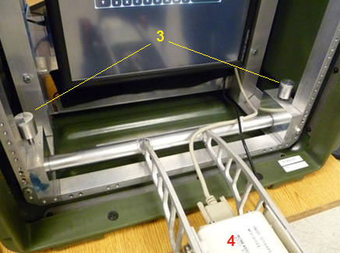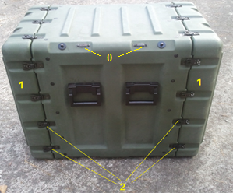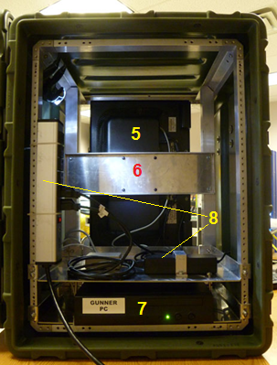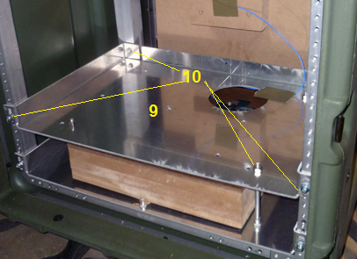

# Parts Key:

0: Holding Clasps  
1: Lids 7: Computer  
2: Clasps 8: Ancillary Components  
3: Retaining Pins 9: Ancillary Shelf  
4: Gunner Handle 10: Ancillary Shelf Mounting Hardware  
5: Monitor  
6: Monitor Mount Screws

# Routine Operations

## Initial Setup/Teardown

CAUTION *Two man lift should be used when lifting case.*



1. In a suitable location place case on a table with front of case facing desired user location.

 CAUTION *Tip hazard may be present if exceeding 15 degrees*

NOTE: Three clasps for each lid located on bottom   
case must be lifted at each end to gain access

NOTE: Retainers are attached to each side of case  
on which the lid can be attached while removed.

1. Locate and unlatch 14 clasps on front lid.
2. Remove lid and stow.
3. Repeat 2 and 3 for rear lid.
4. Locate end connector for power strip and connect to building power.
5. For teardown follow these instructions in reverse order.

## Deploying/Stowing Handle

Deploying

1. Locate and remove retaining pins.
2. Pull handle towards operator slightly and replace one pin.
3. Push handle down into operational position (replaced pin will fall into position when handle reaches full down position.)
4. Replace second pin and tighten both.

Stowing

1. Locate and remove retaining pins.
2. Pull handle upwards slightly and replace one pin.
3. Push handle up into stowed position (replaced pin will fall into position when handle reaches fully stowed position.)
4. Replace second pin and tighten both.

# Maintenance Operations

## Monitor Removal/Installation

 WARNING: *Never work on electrical equipment with power applied shock hazard exists.*

CAUTION: *Have second person assist holding monitor to prevent damage to equipment.*



Removal

1. Perform initial setup and remove power.
2. From rear access locate and remove four mounting screws for monitor
3. Slowly bring monitor out of front of case.
4. When able to access disconnect wiring from back of monitor.

Installation

1. Connect new monitor to existing wiring.
2. Move monitor into appropriate position.
3. Have a second person install four mounting screws into monitor.
4. Perform an operation check of the system.
   1. Apply power to system.
   2. Turn power of monitor on.
   3. Turn computer power on.
   4. Observe output of screen.
   5. When logon screen presents itself test output of touch screen.
   6. Power all equipment down.

## Computer Removal/Installation

WARNING: *Never work on electrical equipment with power applied shock hazard exists.*



1. Perform initial setup and remove power.
2. Remove all ancillary components in accordance with appropriate procedures.
3. Remove four nuts from top of ancillary shelf.
4. Remove four screws connecting ancillary shelf to vertical supports and frame.
5. Remove ancillary shelf.
6. Disconnect computer wiring.
7. Remove computer.
8. Perform steps 1 through 7 in reverse order to install computer.
9. Perform an operation check of the system as listed in monitor installation section.

## Ancillary Component Removal/Installation

WARNING: *Never work on electrical equipment with power applied shock hazard exists.*



Removal

1. Perform initial setup and remove power.
2. Locate particular ancillary component to be removed.
3. Disconnect wiring to particular component.
4. Remove mounting bracket.
5. Remove component.

Installation

1. Place component in correct position.
2. Install mounting bracket.
3. Connect applicable wiring.
4. Perform an operation check of the system as listed in monitor installation section.