FAMU/FSU College of Engineering

Department of Mechanical Engineering

Final Report

Team 1
James Augustin
Benjamin Cole
Daniel Hammer
Trenton Johnson
Ricardo Martinez

04/07/2011

Abstract

In the United States, nearly two-thirds of people will experience neck pain, the most frequently reported injury to insurance companies, at some point in their life. Current options to assess such injuries are inaccurate and prone to human error, or very costly and cumbersome. This indicates a major need for a product that can help patients claim disability and recover from neck injury, all while reducing their cost as well as the cost to insurers.
The main emphasis of this project is to create a sensory device and interface to record and output the movement of the head using the Nintendo Wii controller, infra-red (IR) LEDs, and Bluetooth compatible devices to communicate between the Wii controller and the receiver. In essence, it is a sensory device for patients recovering from neck injuries and/or surgery. It monitors healthcare rehabilitation exercises and records measurement of range of motion for insurance and disability. This product will replace conventional methods for such analysis by eliminating error and increasing accuracy, being low cost, portable, and easily used by both the physician and patient.
Meeting with both a physical therapist, and the vision team at Harris Corporation helped to optimize the design of this product. The system is comprised of a helmet with four infra-red LEDs which are tracked by the filtered camera in the Wii remote and transferred via Bluetooth to a processing device. The data, which is referenced to both the Wii-motes is analyzed, recalled, and displayed on screen by the developed software which is coded in java. It operates with a maximum error of ±15 degrees and ±0.77 inches within a standard reference frame. This product reaches the ultimate goal of being a low cost, light-weight, transportable, wireless, and easily implementable product that allows for physical rehabilitation exercises of the head to be completed from the patient’s home and office, or any location with a computer system. The results allow for critical determination of head movement range, deficiencies, and progress.

Table of Contents
Abstract 2
Table of Figures 5
Introduction 7
Problem Statement 7
Objective 7
Constraints 7
Current Market Solutions 9
Evolution of Design Concepts 11
Concept 1 - 1 Wii Controller Monitoring LEDs on Patient 11
Concept 2 – Wii Controller Attached to Patient 13
Concept 3 - Multiple Wii Controllers 15
Two Wii Controllers 15
Three Wii Controllers 17
Concept 4 – More Than 4 LEDs 18
Blinking 18
Filter 18
Concept 5 – LED Array and Reflective Device 20
Decision Matrix 21
Therapist and Sponsor Consultation 22
Design Generations 24
Changes Made- I 24
Phase-II 24
Changes Made-II 25
Phase-III 25
Final Product 27
Hardware 27
Headgear 27
Mounting Hardware 30
Laser 32
Timer 34
Decade counter 35
Improvements 38
Software 40
Processing and Storage 40
Interaction Style and Display 42
Data Presentation 43
Programming Language(s) 43
Performance 44
Code Generation 45
Java and Bluetooth 46
Calibration 47
Algorithm 48
Error 50
Design for Manufacturing/Economics 50
Operational Manual 52
Hardware 52
Software 52
Environmental/Health and Safety Issues 53
Other Applications 54
Conclusion 55
Acknowledgements 58
References 59
Appendices 60
Error Propagation 60
Error Analysis 60
Z-mapping Data 60
Material and Item Selection 62
Programming Code 65
Wii_CareMain.Java 65
Wii_Care.Java 67
WiimoteIRBehavior.java 79
Panel3D.java 80
LineChart.Java 87
GraphPanel.Java 90
BarGraph.Java 92
Original.Java 97
Drawings 100

Table of Figures
Figure 1: Patient Using an Inclinometer to get Flexion and Extension Angles 9
Figure 2: Ultrasound 9
Figure 3: Goniometer Being Used on a Patient 10
Figure 4: Outside and Inside view of Wiimote showing infra-red Camera 11
Figure 5: Product diagram for mounting LEDs which the Wii controller can track 11
Figure 6: Illustration of Controller attached to patient. In actuality, the controller would be placed vertically on the back of the head. 13
Figure 7: Directions the accelerometer acquires data. 13
Figure 8: Diagram of 2 Wii Controllers and target 15
Figure 9: Diagram of 2 Wii Controllers and target 16
Figure 10: Diagram of various positioning options for 2 Wii Controllers 16
Figure 11: Diagram of various placement options for 3 Wii Controllers 17
Figure 12: Infrared LED and Wii-Mote Housing 18
Figure 13: INFRA-RED Camera on the Wii controller and examples of INFRA-RED pass filters 19
Figure 14: INFRA-RED LED Array 20
Figure 15: INFRA-RED LED Array with single Wii controller 20
Figure 16: Headband with Reflector and Micro-Glass Bead Reflective Tape 20
Figure 17: Example of Head Flexion/Extension; Lateral Flexion/Extension; Head Rotation 22
Figure 18: Picture of Acromioclavicular Joint 23
Figure 19- First Generation Cap 27
Figure 20- Various shots of the football helmet with 4 LEDs 28
Figure 21- Various shots of helmet with blinking LEDs and sample use 29
Figure 22- Microphone Stand Adapters 30
Figure 23-Wii-Mote Mounts 30
Figure 24- Microphone Stand Configuration with the fabricated metal parts 31
Figure 25-Selection of Open Sights for Laser 32
Figure 26- Selected Laser and Mount 33
Figure 27- Configuration of Wii-Motes and Laser with mount 33
Figure 28- Timer Chip and Circuity 35
Figure 29- Decade Counter Pins and Pin Names 36
Figure 30-Example Circuit 36
Figure 31-Top of helmet Figure 32- Inside compartment (Aerial View) 36
Figure 33- Actual circuit Figure 34- Close Up of Circuit 37
Figure 35- Connections inside helmet Figure 36- Close up of connections 37
Figure 37- Infrared LEDS inside helmet Figure 38- Complete Assembly 37
Figure 39- Square LEDS, LED Diffuser, Metal Constraints 38
Figure 40- Pro-E Drawing of Wii-Mote Mounting Assembly 39
Figure 41- Block Diagram 40
Figure 42- EEPROM Chip inside the Wii Controller 41
Figure 43-Illustration of the different interaction styles: GUI vs Command Line Interface 42
Figure 44-Rough mockup of the conceptualized virtual image 42
Figure 45-Data can be displayed in horizontal bar graphs. 43
Figure 46-Block Diagram of Design Process 45
Figure 47-Flow Chart of Bluetooth & Java Interaction 46
Figure 48-Calibration Square 47
Figure 49-Stereoscopic Calibration Results 48
Figure 50-Depth Mapping Graph 49

Introduction

Problem Statement
The purpose of this project was to create a sensory device and interface to record and output the movement of the head using the Nintendo Wii controller, infra-red (IR) LEDs, and Bluetooth compatible devices to interface communication between the Wii controller and the receiver. The sensory device would be utilized for monitoring of healthcare rehabilitation of patients recovering from neck injuries and/or surgery. The device would also be low cost, easily transportable, wireless, and easily used by both the physician and patient.

Objective
Based upon the problem it was decided to construct a device to house the infra-red LEDs, which the Wii controller will track. This device would be adaptable for use on the head of the patient; such design will also consider adaptation for other body parts such as arms, legs, etc. The team would need to: design the code which will interpret the tracking data from the infra-red camera into a format that is easily comprehensible by a third program. The team would also need to design an interface to record and visually display orientation of the selected body part within maximum error of 5 degrees angularly and 0.25 inches vertically/horizontally within a standard reference frame. The ultimate goal was to create a low cost, light-weight, transportable, wireless, and easily implementable product that will allow for physical rehabilitation exercises of the head to be completed from the patient’s home or any location with the ability to package and transport the results easily from patient to physician or physical therapist. The results would allow for easy determination of head movement range and deficiencies.

Constraints
Certain constraints existed in this project as with any other engineering work. There were few key limiting factors which influenced the designing and implementing phase of this particular project.
- All goals must be accomplished with a budget of $2500.
- With a system involving a Wii, there is a certain field of view that must be considered. The infrared LED camera (in the controller) has to be within a 45 degree angle range of the LED source.
- The Infrared camera embedded in the Wii controller can only track up to 4 objects at a time; minimizing the number of infra-red LEDs is imperative.
- If a device is to be placed on various parts of the body, then it must be compact enough to be attached comfortably and unobtrusively, especially in a healthcare setting; the device may not be the only object that a patient is connected to.
- According to Nintendo’s Wii - Health and Safety Precautions page online, “The Wii console and Wii Remote can emit radio waves that can affect the operation of nearby electronics, including cardiac pacemakers.” The device’s use should not interfere with surrounding medical equipment.
- The final system will not be effective if accurate measurements are not provided to the user console. The sensing mechanisms must be sensitive enough to measure:
  - vertical and horizontal position within a 0.25 inches
  - angular orientation within 5 degrees

Current Market Solutions
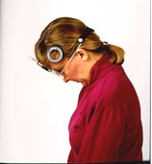
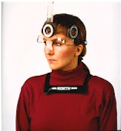
There are currently many devices available to assist physical therapists in measuring range of motion. One example is inclinometer. This instrument uses a compass and measures the tilt of the head with respect to gravity. Its cost of approximately $400 can detract potential users. The price also serves as a disadvantage when compared to the low cost attribute of this project.
Another tool for range of motion measurement is a process that uses Tape measurements. The user’s sternal notch is used as a reference point. The measurement is taken from the chin to quantify flexion and extension. Next, the acromion process becomes a reference point to the chin in order to measure rotation. Finally, the chin is replaced by the bottom tip of the earlobe when measuring lateral flexion and extension. In this approach, human error is prevalent and accuracy lacks the precision that this project needs.
Figure 1: Patient Using an Inclinometer to get Flexion and Extension Angles
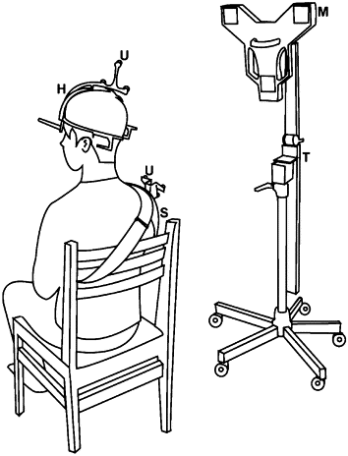
Yet another device is the Ultrasound-based motion system that works similar to the tape measurement approach in that the shoulder is used as a reference point. The shoulder strap houses three small ultrasound transmitters while a stand lateral to the seated user houses three microphone transducer sensors. This approach can be high maintenance, expensive to purchase and reproduce, and lacks the transportability factor that this project is aiming for.
Figure 2: Ultrasound

A commonly used device is the Goniometer. It aligns with a joint or a solid point of reference and measures range of motion like a pivoting protractor. In this process, the therapist aligns the hinge to some stationary reference point on the patient and extends the measuring arm as far as the patient’s range of motion. Again, this approach requires practice for efficient utilization of the tool and lacks the precision required for this project.
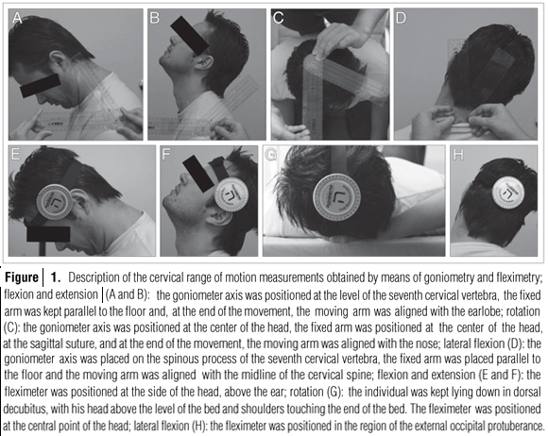
Figure 3: Goniometer Being Used on a Patient
The journeys through the aforementioned devices demonstrate the demand and necessity of this project’s objective. In creating a sensory device and interface that records and displays cervical movements of the head using Bluetooth compatible devices and technology of Nintendo Wii, the client’s interest of a low cost, adaptable, transportable, low maintenance system can be readily available. Additional goals of this $2500 budgeted project that increases its competitive nature in the market is a visual display of the head’ orientation to a maximum error of 5 degrees angularly and ¼ inch vertically/horizontally project budget of, which can underscore inconsistencies with the prescribed motion.

Evolution of Design Concepts
The purpose of this section is to highlight all the concepts that led to making of the final product. This section also discusses the external influences on the final design.

Concept 1 - 1 Wii Controller Monitoring LEDs on Patient
The Wii Remote, also known as the Wiimote, is continually being modified to perform beyond its intended purpose. Many companies are looking to reprogram and incorporate Wiimotes into more formal settings. One example is a low cost dry eraser board made from a Wiimote and other peripherals to better engage audiences during a presentation. In this project, the application of interest is a head tracking device for rehabilitation purposes where a physician is able to prescribe therapeutic movements to a patient recovering from head/neck injury, utilizing assistance of the Wiimote.
The Wiimote is traditionally the Wii's main input device that communicates to the console using standard Bluetooth technology which makes it compatible with standard Bluetooth hosts. It encompasses a 128x96 monochrome camera with an Infrared filter that detects sources with Infrared wavelengths (750-1000nm) and a built in image processor that provides pixel resolution of 1024x768.
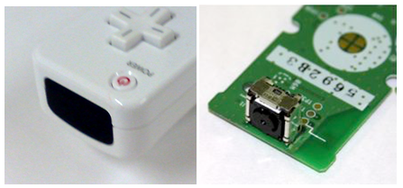
Figure 4: Outside and Inside view of Wiimote showing infra-red Camera
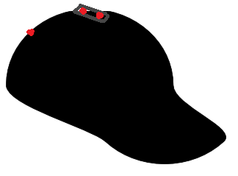
As mentioned before the role reversal of these two components is realized through the concept where up to 4 LEDs is mounted on a head piece worn by the user whom moves in front of the stationary Wii remote. Their motion is tracked by the infra-red intensity rating of the LEDs. Naturally everything emits infrared radiation because of the black body phenomenon. In this case however, the infrared filter in the stationary Wiimote records the location of the user through the emitted wavelength range of the LEDs affixed on the user’s device. This helps create depth perception on the display when the user is moving towards and away from the Wiimote. The LED apparatus, or sensor bar, is aesthetically modified in order to present an unobtrusive device that can be comfortably worn. It is simply made up of a small circuit consisting of resistors, diodes, and a battery. There is also a push button switch to control the power source to the elements when the device is not in use.

Figure 5: Product diagram for mounting LEDs which the Wii controller can track

Concept 2 – Wii Controller Attached to Patient
This concept is centered around placing the Wiimote directly on the patient to take advantage of its 3-axis accelerometer. The Wiimote would be placed vertically at the back of the patient’s head so its accelerometer can measure motions in all translations and rotations. Using integration of the accelerations would generate the velocities; an additional integration would provide the position, making it a very simple way of evaluating the data. The angles of the head can also be determined by simple vector analysis, acquiring the angle between two vectors. This data would be sent via Bluetooth and interpreted through the code to output the data in graphical format.
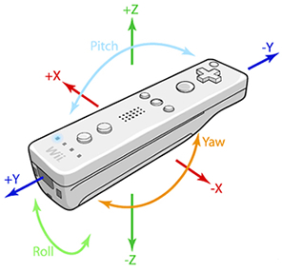
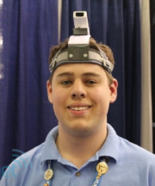
Figure 6: Illustration of Controller attached to patient. In actuality, the controller would be placed vertically on the back of the head.

Figure 7: Directions the accelerometer acquires data.

This would be the lowest cost of all the concepts. The Wiimote would be about $40 and the Bluetooth software and dongle would be about $70. This would be a total of $110 not including material costs for the head strap holding the Wiimote.
This simple design requires only the Wiimote and a Bluetooth connection. The data is also easy to understand and interpret to acquire range-of-motion values from. Simple vector analysis also allows getting angular values. However, this approach has not been done before and so there is no foundation from which to work upon. Thus more work may be spent on creating this new system than using an existing foundation.
As illustrated in the diagram, having the Wiimote placed on the patient’s head may make the patient feel uncomfortable. They may feel either embarrassed or they may not be able to hold a Wiimote on their head due to muscle weakness. There is also the possibility of damage to the Wiimote due to its handling by either the user or the therapist. Minimizing this contact would extend the lifetime of the Wiimote.
While this provides the necessary data, it does not completely fulfill the requirements of the project. It would not allow for determining the height of the head; that would have to be measured directly for each individual person. It also does not provide information about initial head positions, which would be necessary for an individual suffering from a neck injury (such as cervical dystonia) where their head may be contorted in a painful position. Such data would have to be determined manually and inputted into the program. This could also be eliminated by using the infra-red camera and infra-red LEDs to determine these values. This would then mean there is no advantage in using the Wiimote accelerometer directly to measure the position and angle of the head.

Concept 3 - Multiple Wii Controllers
The second concept of design deals with using multiple Wii controllers to enable the tracking of multiple infra-red sources. The Wii controller’s infra-red camera is only capable of tracking up to four moving infra-red sources at once. Therefore, by utilizing a range of 2-4 controllers data can be pulled and analyzed for up to sixteen infra-red sources. Using multiple infra-red sources allows for certain sources to be used for specific tasks such as acting as reference points. There are other advantages of having multiple infra-red sources which will be discussed in a later section. It is not practical to use more than four controllers because the layout and positioning of the controllers as well as the infra-red sources must be taken into account. Though unconfirmed, there is a risk of the camera being unable to track the same four sources each time because there are too many infra-red sources interfering with each other. Overall, the slight increase in accuracy of having more than controllers is not worth the added complexity that it brings.
The options of using 2-4 controllers have been examined more closely. It is important to note that the analysis done for each scenario assumes that elevation and tilt of each controller camera is the same. In reality, the elevation and tilt of the camera can be varied in order to eliminate some of the problems that are presented in each case which could also lead to the use of more than four Wii controllers. In addition, using certain sensors for references can also eliminate some of the problems associated with using multiple controllers.

Two Wii Controllers
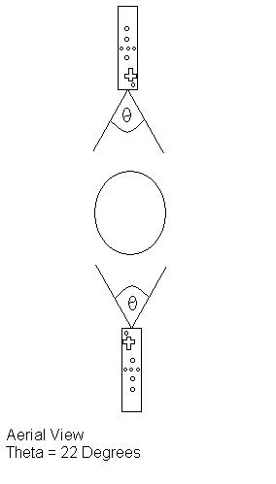
The option of having two controllers allows for a maximum of 8 infra-red sources. Although there is a wide range of placement options for having just two controllers, the infra-red camera is limited to a 33° vertical field of view and a 22° horizontal field of view. The most basic layout is having one controller positioned directly in front of the user, while the other is directly behind the person as seen in figure 8. Figure 9 is a simple variation of figure 8 where one controller is placed at the left side of the user while the other is on the right. Figure 10 shows how the two controllers and be angled differently to face the user. The benefits of having two controllers are an increased total field of view, and multiple sources for data tracking. The cons of having two controllers are that the total field of view may not be large enough and sources might end up off the grid if they escape the field of view. The cost will also be increased by having more sources and controllers.
Figure 8: Diagram of 2 Wii Controllers and target

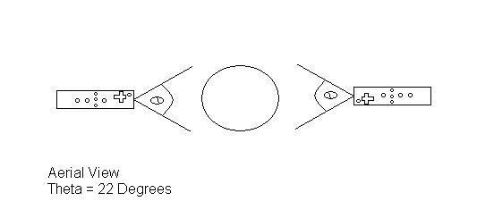
Figure 9: Diagram of 2 Wii Controllers and target

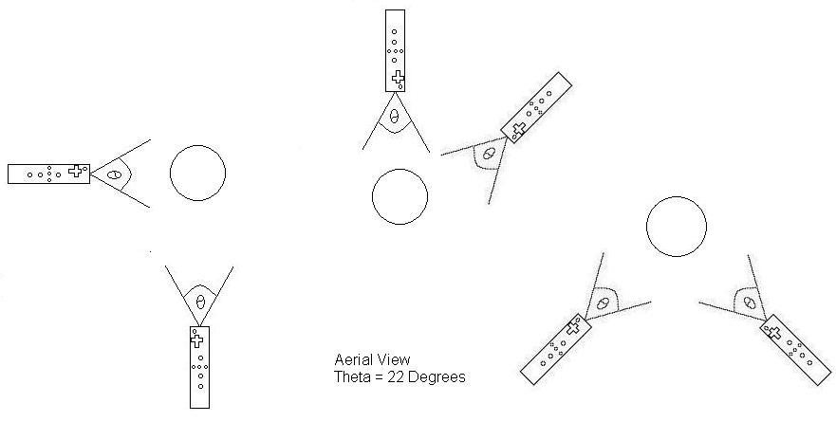
Figure 10: Diagram of various positioning options for 2 Wii Controllers

Three Wii Controllers
The option of having three controllers allows for a maximum of 12 infra-red sources. The range of placement options for having three controllers is smaller than having just two controllers because all options would the variation of triangle. Figure 11 shows examples of the various placement options for the controllers. Three Wii controllers can achieve an increased total field of view of the user, and multiple sources for data tracking when compared to that of just two controllers. The downside of having three controllers is a restricted infra-red source placement due to the fact that the total field of view may be too large and sources might end up off the field of view of one controller and enter another. There is a chance that one controller will interpret this as the source is “jumping” from one end of the field to the other. This will add complexities to the data analyzing and manipulating process as well as the programming. Finally, the cost will be increased by having more sources and controllers.
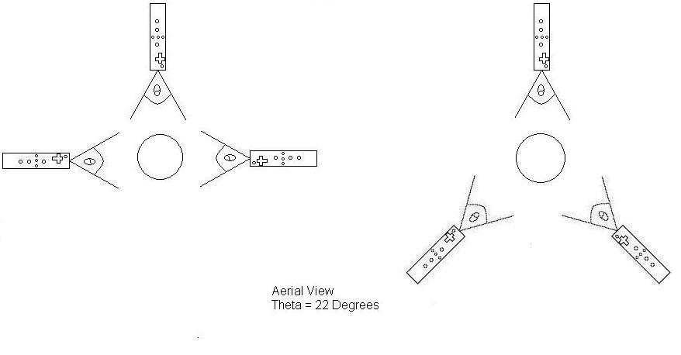
Figure 11: Diagram of various placement options for 3 Wii Controllers

Concept 4 – More Than 4 LEDs
Taking previously discussed designs into consideration, the product can be enhanced by the inclusion of extra LEDs. Extra LEDs will provide monitoring of more areas for more accurate tracking and could even be used to give size and shape data of the patient’s face. Due to the infra-red camera in the Wii remote being limited to tracking 4 objects at a time, depending on the number of controllers used, there will be two options.

Blinking

This option was initially thought of for use with the single Wii Remote, however, could be incorporated in to use with multiple remotes as well. This concept would yield potential use of a large number of LEDs minimized down to as little as 1 remote.
The Wii Remote includes a 128x96 monochrome camera with built-in image processing and a 100Hz refresh rate. It is however limited to tracking up to 4 moving object at a time. The theory behind this design is that by creating a sequence of blinking LEDs using a slightly lower frequency, new LEDs will appear and disappear allowing tracking of more than 4 regions by the same IR camera. This frequency is so fast (100Hz = 100 times a second) that visually, the human eye will not be able to pick it up, while the camera can, allowing for the rendering of more LED data sets while still keeping a high level of accuracy.

Filter
This option would be for the use of multiple remotes. If 2 remotes are used, 8 LEDs will be incorporated; if 3 remotes are used, 12 LEDs will be incorporated; if 4 remotes are used, 16 LEDs will be incorporated.
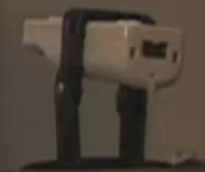
The Wii Remote includes a 128x96 monochrome camera with built-in image processing. The camera looks through an infrared pass filter in the remote's plastic casing and detects 940nm sources at nearly twice the intensity of 850nm sources. Therefore, by changing this pass filter, and possibly editing some of the code for the camera’s data acquisition, the intensity/wavelength the camera can see can be edited. Having each camera view a different intensity parameter will allow the use of more LEDs with constant glow as long as there are only maximum of 4 at a specific intensity/wavelength. This option would be for the use of multiple remotes. If 2 remotes are used, 8 LEDs will be incorporated; if 3 remotes are used, 12 LEDs will be incorporated; if 4 remotes are used, 16 LEDs will be incorporated.

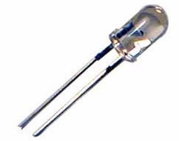
Figure 12: Infrared LED and Wii-Mote Housing
The use of more LEDs while benefitting us with better accuracy and more data types, will significantly increase the complexity of the design. Not only in the physical nature where as proper placement and orientation of the LEDs will be crucial, yielding more apparatuses that the patient must wear and therefore creating a less user friendly and comfortable environment, but the programming and comparison aspect as well. It will also yield a likely less cosmetically appealing and less durable over product as it increase components and over size and power consumption of the head-piece.

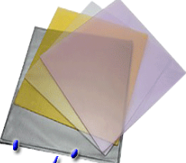
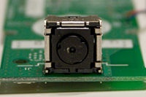

Figure 13: INFRA-RED Camera on the Wii controller and examples of INFRA-RED pass filters

Concept 5 – LED Array and Reflective Device

This concept somewhat couples the way the Wii was designed to work, along with having a mounted controller camera to view the patient’s movements. An infrared LED array is built, the more LEDs/higher intensity of the array, the better this will work. The shape of the array is unimportant, but requires a center cut-out for which the remote’s camera can view through. The array is placed facing the patient and the camera is placed behind the array, peering through the hole, also facing the patient. It is important for the hole to be big enough as to not obstruct the camera’s view. At this point, if the patient is close enough, the infra-red camera can pick up most movements by received infrared light reflections off the skin, but it is highly delocalized and inaccurate largely due to interference. To focus the data acquisition of the camera, the reflection of the infrared light off the body needs to become centralized about significant locations, in this case, the head. This is done by application of reflective tape or another form of reflective device. This design could be adaptable for a second remote for further accuracy and better depth perception. The second remote would not need a LED array system as it would pick up reflections from the main system, as the array is designed to fill the room with infrared light.
This design is user friends and simple. The setup of the array and the Wii remote(s) could be packaged into a single unit, and the user would simply have to put on a head band with a reflective band on the forehead. This will yield a lightweight and stylish package that is easy to use with no worry of complications due to sensitive electronics on the headpiece.
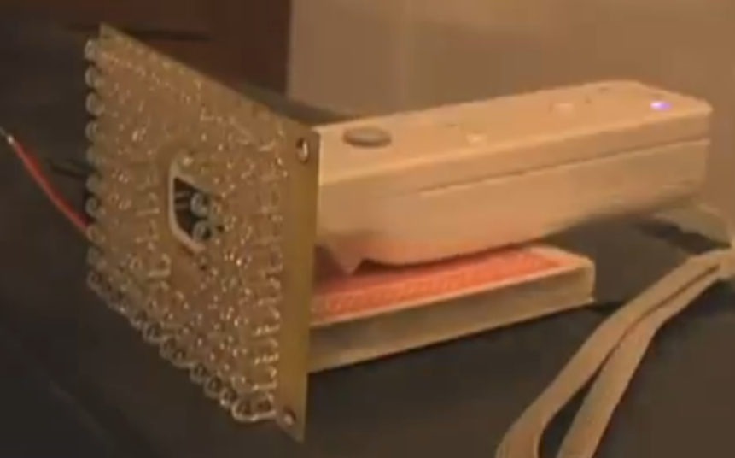
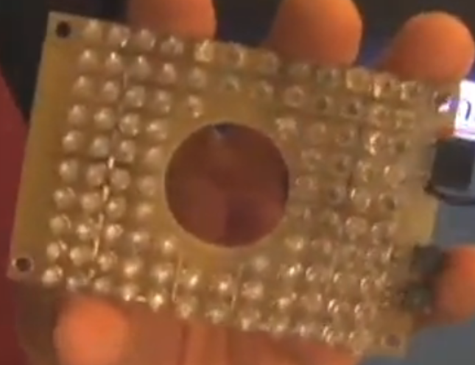

Figure 14: INFRA-RED LED Array
Figure 15: INFRA-RED LED Array with single Wii controller
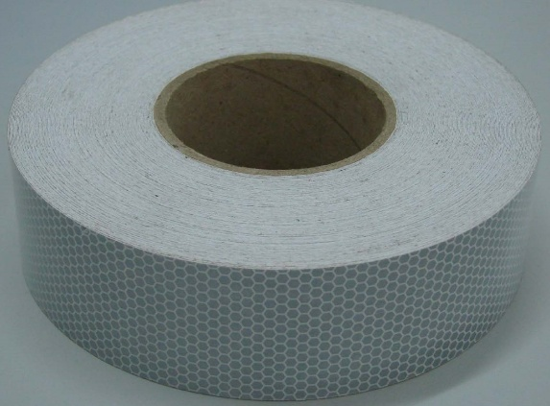
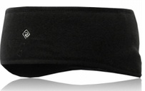

Figure 16: Headband with Reflector and Micro-Glass Bead Reflective Tape

Decision Matrix

With a multitude of different and similar concepts to accomplish our goal, a decision matrix was required to determine the best design. Nine different criteria were selected and each one assigned a weighing factor to designate the more important criteria for the design. Each concept is ranked in a scale from 1-10 with higher being desirable and lower being undesirable (for example, a higher rank in Cost means a lower cost). As can be seen in the following table, the most important factors were designated to be the Adaptability/Versatility and the Design Complexity. This was based on the goal of moving this project for other limbs and to reduce the complexity in designing a final product.

Criteria | Weighing Factor | 1 Wiimote |  |  | Multiple Wiimotes |  |  | Accelerometer
 |  | 1-4 LEDs | 4+ LEDS | Array | 1-4 LEDs | 4+LEDs | Array
Cost | 0.1 | 9 | 8 | 7 | 7 | 6 | 5 | 9
Durability | 0.1 | 8 | 8 | 6 | 8 | 8 | 6 | 4
Adaptability/Versatility | 0.2 | 6 | 6 | 6 | 9 | 9 | 9 | 7
Efficiency | 0.05 | 7 | 7 | 6 | 5 | 5 | 4 | 9
Portability/Lightweight | 0.1 | 8 | 8 | 9 | 7 | 7 | 8 | 5
Ease of Use/Setup | 0.1 | 8 | 8 | 9 | 8 | 8 | 7 | 9
Accuracy | 0.1 | 9 | 9 | 8 | 10 | 10 | 8 | 7
Design Complexity | 0.2 | 9 | 5 | 9 | 8 | 6 | 7 | 9
Aesthetics | 0.05 | 9 | 9 | 9 | 8 | 8 | 8 | 9
Total |  | 8 | 7.1 | 7.65 | 8.05 | 7.55 | 7.2 | 7.5
Table 1: Decision Matrix
The decision matrix revealed that the best design, according to the criteria set, is to use multiple Wii controllers and up to 4 LEDs. This was only marginally better than the single Wii controller and up to 4 LEDs, so it is decided that the goal is to create a final product consisting of multiple Wii controllers and up to 4 LEDs but if during the build process it proves to be impractical the switch can easily be made to using 1 Wii controller which had a better ranking in terms of Design Complexity.

Therapist and Sponsor Consultation
Throughout the course of this project, numerous consultations were made with our sponsor, a physical therapist, and a computer vision expert.
Our sponsor, Harris, provided numerous invaluable technical suggestions which greatly aided in the design process. One of the key issues that were brought up early on was the accuracy of using luminosity to determine the distance of an object from a camera. This turned out to be an inaccurate method of acquiring depth and thus needed to be changed. This fundamentally led to the stereoscopic design which was used as the final product. Another important issue brought to attention was the need to differentiate the infrared LEDs from one another. The solution was to use a set of blinking LEDs set on a timer that would allow for having just one LED on at a time, eliminating the need to programmatically differentiate between the LEDs. This would later not be used in the final design due to issues with the JAVA Wiimote library. Later consultations with Harris gave technical information on stereoscopic vision.
Tyressa Judge proved to be an invaluable asset as a physical therapist. She provided many valuable insights on how she performs tests on actual patients with cervical injuries. These tests are depicted in Figure 17. Each motion of the head is a combination of these three motions: head extension/flexion, lateral extension/flexion, and rotation. When measuring each of the three parameters the physical therapist uses the acromioclavicular joint (shown in Figure 18) of scapula as a reference point because this point does not move in relation to the head and neck. This vital piece of information was taken into consideration when coming up with the final design however the team did not implement a shoulder reference point in the end. Tyressa also explained that she uses a goniometer (a tool that measures angle and is similar to a protractor) when measuring head rotation in conjunction with the patient’s nose to track the rotation. As far as cervical exercises for rehabilitation are concerned, there were not any exercises one can do as it depends on the nature of the injury. However, she explained that a disability is determined by measuring flexion, extension, and rotation. The patient’s range of motion can be tracked overtime to determine the progress made in the healing process which influenced the programming aspect of this project.
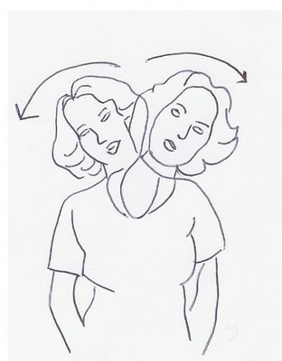
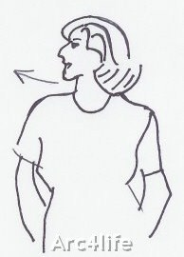
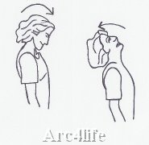
Figure 17: Example of Head Flexion/Extension; Lateral Flexion/Extension; Head Rotation
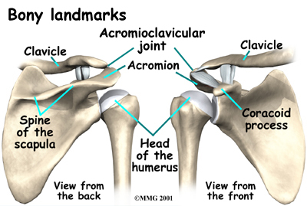

Figure 18: Picture of Acromioclavicular Joint

Dr. Xiuwen Liu of Florida State’s Computer Vision Department proved to be just as valuable as our sponsor and the therapist. Dr. Liu has a vast knowledge of computer vision and determining angular and linear data from separate camera views and shared this knowledge with the team in order to grant us the best chance of succeeding in this project. He provided us with the general equations

Design Generations

Changes Made- I
After Phase 1, during the Fall semester, a meeting was held with both a physical therapist, Ms. Tyressa Judge, and our contact at our sponsor Harris, Mr. John Rust. With Ms. Tyressa Judge, a number of key points were made, such as using the acromioclavicular joint as a reference point and also the current technology being used to conduct such measurements. She also indicated to us that this type of device can be used to great effect in diagnosing certain injuries or diseases, among them cervical dystonia, as they are diagnosed based on a set of criteria on the angles of flexion/extension, lateral flexion/extension, and rotation that the patient can achieve.
Our meeting with John Rust brought about a number of issues which had, up to this point, been unforeseen. Specifically:
- Will the infrared camera on the Wii controller be sensitive enough to changes in luminosity?
The vision experts with whom Mr. Rust works with on a regular basis expressed their concerns that using luminosity will not be accurate enough in determining the z-value or ‘depth’ of the image in the Wii infrared camera.
- How to differentiate the infrared LEDs from each other. This is an important issue as it is uncertain how the Wii controller will store these values and whether it will be a simple matter to choose the LEDs which we want.
- How do we plan on getting all 6-degrees of motion if the luminosity may not be accurate?
Each of these was of great concern and resulted in a number of changes, which will be outlined in the next section, Phase 2. Fortunately, they did not affect the schedule in a significant way.

Phase-II
In this section, only what has changed from the previous phase will be expressed.

Objective
Refit the headpiece to house the infra-red LEDs, which the three Wii controllers will track. This device would be for specific use on the head of the patient. Design chair-assembly by which the three Wii controllers will be attached. The results will allow for easy determination of head movement range and deficiencies. Such knowledge of head movement range will allow for the determination of specific injury or disease that an individual may have based on certain diagnostic criteria.

Constraints
- The Infrared camera embedded in the Wii controller can only track up to 4 objects at a time; there must only be 3 LEDs on the refitted headwear as the fourth will be on the acromioclavicular joint.
- The chair assembly must allow for various body types but also be grounded so as to prevent any vibrations which may cause errors in the data acquisition.
- Chair assembly must not be obstructive to the physical therapist or the patient while still being able to gather data on all the LED points.

Expected Results
By the end of this senior design project, a fully capable sensor packaging system will be developed. This includes a refitted headwear to be used as an LED housing unit that will be comfortable for the patient to wear while not interfering with the data acquisition and easy maintenance. An operable chair-assembly, which the Wii controllers will be attached to, will also be complete, comfortable for the patient to sit in, and inconspicuous enough for the therapist/physician to perform the necessary exercises or diagnostic evaluation.

Changes Made-II
After Phase 2, another meeting was held with our contact at Harris and a vision expert who works closely with our contact, Mr. John Rust. During that meeting, our Phase 2 design was evaluated by the vision expert and certain suggestions were made. Such suggestions were:
- Implement stereoscopic vision to acquire depth data
- Use more than four infrared LEDs and have them blinking one at a time to acquire better data
- Continue with Phase 2 design as a proof-of-concept and experimentation platform
With these suggestions at hand, we worked on the concept of developing a 2nd Generation design for our Phase 3. These additions had a significant impact in shortening the time available in the building and debugging of our Phase 2 design (hereafter known as 1st Generation) down to only a single month, but hopefully it will give us a better end-product.

Phase-III
In this section, only the additions of the 2nd Generation design will be expressed. There were no changes to the 1st Generation design.

Objective
Repurpose a helmet to house infrared LEDs and timers to facilitate their blinking. Determine software and mathematical background needed for stereovision. Reduce the number of Wii controllers necessary to 2 and determine optimal location away from the patient while still being inconspicuous for the physician/therapist to perform their exercises or diagnostic evaluations on the patient.

Constraints
- The Infrared camera embedded in the Wii controller can only track up to 4 objects at a time; the LEDs must blink in succession such that there is only one or two infrared LEDs activated at a time.
- The Wii controllers must be mounted such that there is very little error-propagation.
- The programming involved must allow for determination of which specific LED is activated at specific moments.

Expected Results
By the end of this senior design project, a fully capable sensor packaging system will be developed. This includes a refitted helmet to be used as an LED housing unit that will be comfortable for the patient to wear while not interfering with the data acquisition. Ease of maintenance as well as preventing error propagation due to its firmness and lack of plasticity are also key considerations. The number of Wii controllers will be reduced to 2 while still allowing for very accurate displacement and angular measurements with errors no larger than ±5mm and ±2°, respectively.

Final Product

Hardware

Headgear
The first generation design using the soft cap with 3 LEDs. While this setup could potentially be used in the second generation product incorporating stereo vision, two other helmets were developed to optimize results and user comfort.

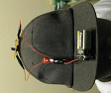
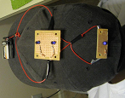
Figure 19- First Generation Cap
When considering useable headgear, the fact that the patient likely has an injured/sore neck must be taking into account. Any device that is too heavy and cumbersome or that requires force to be pushed down on it for the headpiece to fit snugly could potentially irritate the injury, not only making this harmful to use, but would likely yield the patient unable to complete the prescription due to such pain. While a lightweight, flexible, and adjustable baseball hat, as seen from our first generation design scored high in this category. However, this same constraint can potentially yield movement on LEDs from patient to patient and even during the prescription run, adding to the intrinsic error of the device. Therefore a hard helmet, allowing for rigid, fixed LED positions was chosen
The first helmet started as a Riggings football helmet. The football helmet was chosen due to incorporating easy button snap padding size adjustment as well as a chin strap to keep the helmet it on place against the head. Extensive modifications were then made. Firstly, the metal face cage was removed in order to reduce weight. The back portion of the helmet was also cut out to allow for full range of flexion and extension exercises. This also doubled as another weight reducer. However, due to the nature of a football helmet and its fit, it required downward force to put it on which would cause strain on any neck or head injury the patient may be exhibiting. Therefore the front portion of the helmet in front of the ear pieces was cut and a 1” standard hinge was installed flush on the top. A closing/locking device for this portion then had to be fabricated. Hook, ball and socket, and magnets were all considered for use. 1/8” diameter by 1/8” depth cylindrical neodymium magnets were choses due to ease of use and availability. Each magnet has approximately 1.5 pounds of pull. Four brackets, one set for each side were fabricated in al6061 to house 2 magnets each. This yields about a 6 pound pull per side, allowing enough force for the helmet to lock close, fitting snugly against the head. Front padding sizes can be easily swapped for larger and smaller heads. The magnets were inserted into the brackets using an epoxy, creating a vacuum and adhesive setting. Drawings can be referenced in the appendix. This helmet design calls for 4 LEDs placed on the back portion of the helmet at about 3 inches apart to assure the cameras do not confuse the LEDs as a single hotspot. These were placed in using a plastic outer housing epoxied into the helmet. An inner housing which holds the LEDs then fits inside using pressure and texture to hold it in place. This allows for easy LED replacement if one burns out. The LEDs were placed in parallel each with 30 ohm resistance and run on a 2 double A battery pack is affixed via velcro to the top center of the helmet for balance. All the wires are routed through separate routing channels and under the padding. The completed design allows for accurate tracking of fixed reference LEDs as well as a safe design for the patient to use. Due to cutout back portion and the adjustable front padding, this helmet can wobble slightly if the chin strap is not adjusted properly. This lead to the need for another design to eliminate the wobble while keeping other constraints in mind.
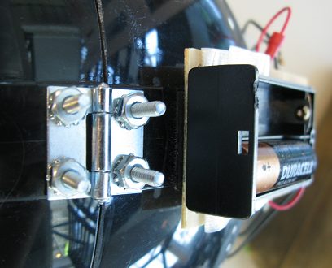
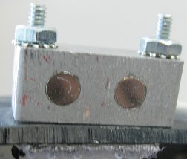

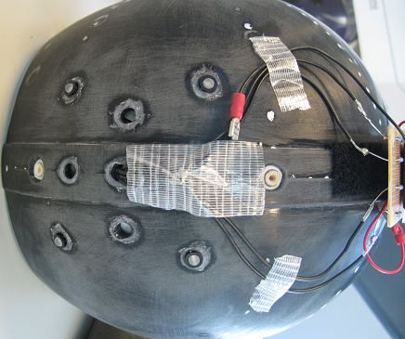
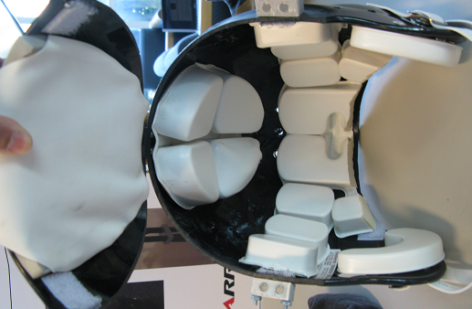

s

Figure 20- Various shots of the football helmet with 4 LEDs
The second helmet, fashioned from a Pro-Tec skateboard helmet, was fashioned specifically for use with the 5-5-5 timer using 9 blinking LEDs discussed in another section, however could easily be converted for use with the 4 LED design. The Pro-Tec is a top rated skateboard helmet known for its lightweight, safety, and comfort. The foam inserts are again, interchangeable to accommodate user head size. In addition the foam is soft and flexible making practice of putting it on and taking it off, near effortless –no strain on neck or head– while keeping a snug fit. In addition, the read of the helmet where the LEDs are place is less rounded than a football helmet, and is actually almost flat. This will provide a better base for LED and housing installation as well as providing better accuracy as all the LEDs will be viewed as similar depth-related light intensities. The helmet uses a standard clip chin strap to further secure it, albeit it could potentially be omitted due to the fit and style of the helmet and the means of use. Its main purpose is to keep it on the user’s head during a hard fall. The LEDs were installed in an ‘x-shaped’ cluster in the middle with 4 outer LEDs placed in a square shape. The LEDs were placed as close as possible in the cluster and the outside LEDs are about 3 inches apart to allow for no camera confusion. Due to the timer, LED positioning can be minimized in order to place the cameras closer, reducing disparity and error into an optimal field. LEDs are mounted in the same fashion in the previous helmet, using the same fiberglass epoxy and housings. The timer is affixed to the top of the helmet for balance via Velcro and the wires are routed through the pre-cut helmet holes and under the foam padding. This helmet provided the best fit, and best consistency of the concepts while keeping the needs and injuries of the users in mind.
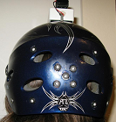
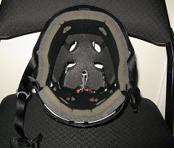

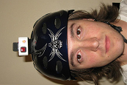

Figure 21- Various shots of helmet with blinking LEDs and sample use
An improved design would be a lightweight, hinged, custom mold with a built in electronic housing and wire routing channels along with adjustable padding inserts for multiple head sizes. This will be discussed in a later section.

Mounting Hardware
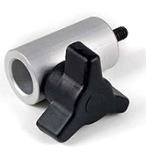
In order to develop and test concepts for the design, a mounting system was developed to attach to the camera stands. For initial testing, a simple set of adapters was purchased to convert the male end on the microphone stands to something that the Wii-motes could attach to. Novatron 5/8 Female to 1/4-20 Male Mounting Adapters purchased for $11.95 from adorama.com was a readily available, easy to implement option. It allows for easy rotational adjustability, ideal for testing.

Figure 22- Microphone Stand Adapters

To mount the wii motes to the above ¼-20 adaptation, ‘the spot wii mount’ were purchased from wiiteacher.com for $14.95 wiiteacher.com. These allowed for quick, snap in/out mounting of wii-motes to the camera stands. A layer of fiberglass epoxy was applied to the base of the mounts that comes into contact with the wii-motes to assure a fixed, non-flexing, snug fit to assure consistency in setup. Additionally, the plastic around the female ¼ -20 threading was leveled in order to have the cameras sit perpendicular to the camera stand.
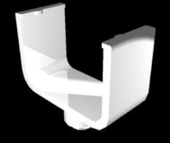

Figure 23-Wii-Mote Mounts

The above mentioned adapter and mount provided the ability to run testing, simulations, and begin work on the first generation design. However, when considering the use of two cameras for the second generation design involving stereo vision, addition mounts had to be fabricated.
For the second generation design involving stereo vision, the setup called for fixed setting of 2 wii-motes. The wii-motes were required to sit parallel to each other, at the same depth and along the same vertical axis. In order to do so a second camera stand, an additional arm attachment to one camera stand, and double wii-mote mounting bracket designed were considered. The double camera stand did not allow for simple fine adjustment and was thrown out immediately upon the first attempt of setup. The second two options would certainly yield better results. Solely due to simplicity and ease of fabrication to be able to start testing immediately and help keep our scheduled delivery date the additional arm attachment was chosen. This called for use of the previously discussed ‘novatron’ and ‘the spot’ brackets and incorporated the vertical arm of a second camera stand. Only 3 basic parts had to be fabricated. Two brackets were machined to hold the arm in place while still allowing vertical adjustment. The third part was machined as the offset from the second arm to position the second camera directly above the first. The drawings for these parts can be referenced in the appendix. Although this setup is fully functional it still requires tweaking in order to align the x-values. This can be done in factory, but with a simple test program, the user would simply have to rotate the second camera until the two values match within a +/- 1 pixel accuracy. This is less tedious than it sounds and takes a mere minute or two and at our desired distance of 24 to 28 inches, will not affect the result significantly if alignment is off by a pixel or two in either direction.

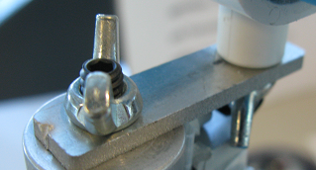
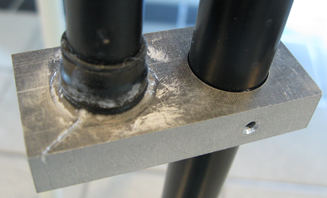

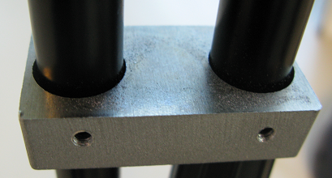
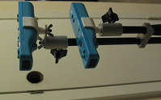

Figure 24- Microphone Stand Configuration with the fabricated metal parts

An improved design would be to have a full constrained and aligned, pre-drilled dual axis bracket system for both the cameras and laser, allowing for fixed, fully constrained positioning for all components. This has already been designed in pro engineer and will be discussed in a later section.

Laser
A major aspect considered for this design was ease of use and setup. This device will fill in for therapeutic office visits for patients and therefore may be operated by non-technical people. One of the most important setup instructions requires the cameras to face the LEDs on the helmet. For optimal performance and greatest viewing space to capture all IR LED movement of the head, the middle LED of the ‘X-shaped’ 5-LED cluster must line up in the middle with a parallel light beam to the camera views. Having a user estimate a center point without a specified aiming system proved to be inaccurate and inconsistent during testing. It was then when it became apparent that some form of aiming or bracket and arm system was needed.
After consideration of mounting options of a folding and interlocking bracket and arm system on both the chair and the camera stand, it was decided it would add to the bulk and require a specified chair or many bracket types to mount to the customers’ to be offered with the system, taking away from the specification for a portable, aesthetically pleasing design. More conventional sighting systems were considered, specifically those of firearms. Iron sights, to be sighted in at the factory, could easily be affixed to one of the wii-motes or the camera stand.
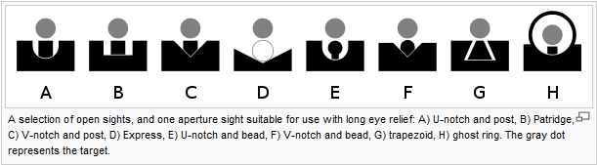
Figure 25-Selection of Open Sights for Laser
Seen above are Iron sights that were considered. You have your standard sights on the left to your ghost ring peep sights on the right. Accuracy varies slightly among all of them, however this is mainly attributed to user error. These sights can be pin-point accurate if sighted in and used properly. In order to not require prior experience or practice with such sights, in addition to avoid length factory setup, a laser was chosen as the ideal sighting tool.
Lasers are common in many products are the market today including but not limited to: children’s and pet toys, levels and power-tools, entertainment equipment, and defensive and safety gear. With a push of a button, a user could check and set alignment and positioning of camera angles with minimal error as long as it was sighted at factory. A low intensity laser is preferred in order to limit potential injury as much as possible. Components were taken for a ‘SmartKat Loco! Laser’ cat toy purchased for $3.95 from a local Walmart. The mouse shape housing was cut, and laser diode and holder along with the resistor was repositioned on top of the standard CR44 battery case and made into the small pushbutton sighting system seen below.

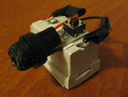
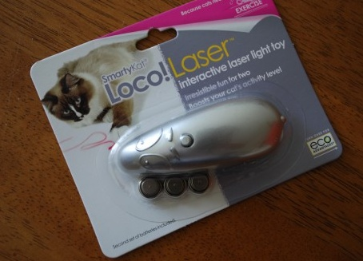

Figure 26- Selected Laser and Mount
While any laser can be dangerous if pointed at the eyes for extended periods of time, the resulting laser, designed for use with pets, has reduced output due to the supplied resistor and is safe when being used properly. In addition, since it is red, the cameras can pick the light being reflected off a wall or flat plate, allowing for simple and easy sighting by aligning the x-values. This could be performed at factory or on user setup if proper test software and instructions are included. For our design the laser was mounted, aligned as previously described, and then epoxied in place on the camera stand. Now all that is required for setup is placement of the camera stand at the proper viewing distance of about 28 inches, pressing the button on the laser sight, and aligning it with the center LED of the x-shaped cluster on the Helmet. Height, adjustable by the set screws and twisting clamp on the stand, and direction, adjustable by rotating the stand, should only have to be done once per use per user as a safety of 1.5x viewable area on each side of the helmet is present. If the system is left standing, untouched in a room for the same user of one of similar height, it should never need adjustment for use.

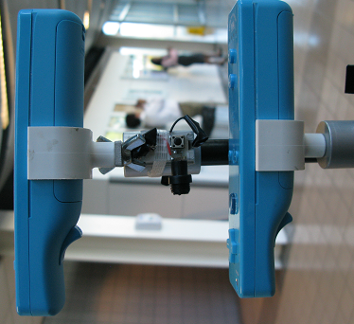

Figure 27- Configuration of Wii-Motes and Laser with mount

An improved design would be to have a fully constrained and aligned, pre-drilled dual axis bracket system for the cameras and laser, allowing for fixed, fully constrained positioning for all components. This will be discussed in a later section.

Timer
555 timer chips can be used in three modes: bistable, monostable or astable. In monostable mode whenever the 555 timer is triggered, the output goes high for a specified amount of time and returns low, awaiting another trigger signal. In the astable mode, the timer triggers itself periodically like an oscillator, sending out a train of square waves. The circuit is called astable because it is not stable in any state; the output continually changes between LOW and HIGH. The latter mode is of importance for the design of this project in that LEDs would need to be cycled through sequentially within a given time. The maximum allowable supply voltage for this chip is 15V and a minimum of 4.5V. The maximum rated current is 15mA. The range of resistors for RA and RB, seen in the diagram below, that produces accurate readings are between 1kΩ to 100kΩ.

Inputs:
Trigger (pin 2): when < 0.333 Vs ('active low') this makes the output high (+Vs). It monitors the discharging of the timing capacitor.
Reset (pin 4): when < 0.7V ('active low') this makes the output low (0V). When not required it should be connected to +Vs.
Control (pin 5): Usually this function is not required and the control input is connected to 0V with a 0.01µF capacitor to eliminate electrical noise.
Threshold (pin 6): when > ²/₃ Vs ('active high') this makes the output low (0V). It monitors the charging of the timing capacitor in astable and monostable circuits.
Discharge (pin 7) It is connected to 0V when the timer output is low and is used to discharge the timing capacitor .

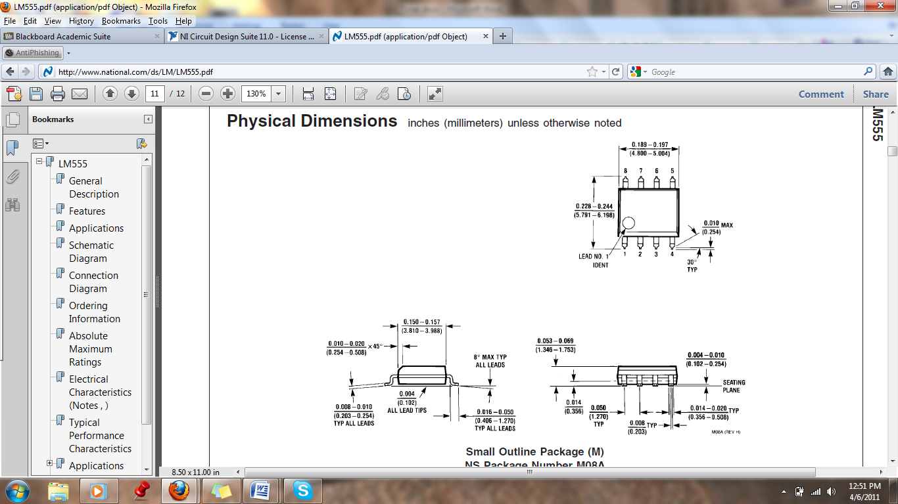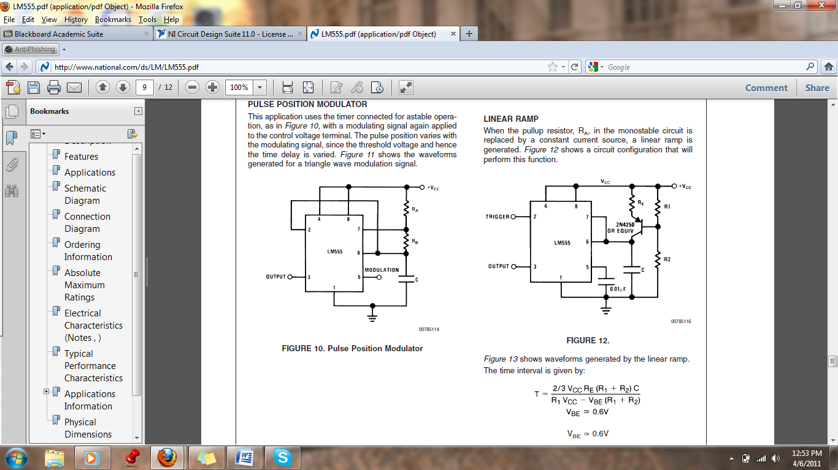
Figure 28- Timer Chip and Circuity
As mentioned earlier an astable circuit produces a train of square waves that transitions between low (0V) and high (+Vs). The durations of the low and high states may differ.
The time period (T) of the square wave is the time it takes to complete one full cycle. However, because astable mode produces a train of cycles, it is better to consider frequency (F), the number of cycles per second. The frequency is a result of the combination of two resistors, Ra and Rb, along with a capacitor C. Given the range of the resistors, 1kΩ-100kΩ, values for the capacitor range from 1µF – 1pF. Below it the equation for computing the frequency of the timer’s ouput:
F = 1.4 / [(R1 + 2R2) x C]

Decade counter
The 4017B is an integrated circuit designed to send incoming pulses to it outputs sequentially. It has 16 pins of which ten are outputs. Counters can be used in timing circuits as well as switching LEDs and motors on and off. Maximum ratings for the counter are 15V and 20mA, and minimum ratings are 5V and 5mA. The 4017B is very useful when combined with a timer such as a 555 timer as described earlier. The pulse from the 555 timer activates the 4017B circuit and causes the ten outputs to go HIGH in sequence. The 4017 chip is designed to drive higher current loads, therefore allowing LEDs in series with resistors to be directly connected to its outputs. In addition to the incoming pulses connected to the counter’s CLOCK pin, suitable logic levels should be applied to the RESET and ENABLE inputs as well. The following is a diagram of the 4017b’s pins.
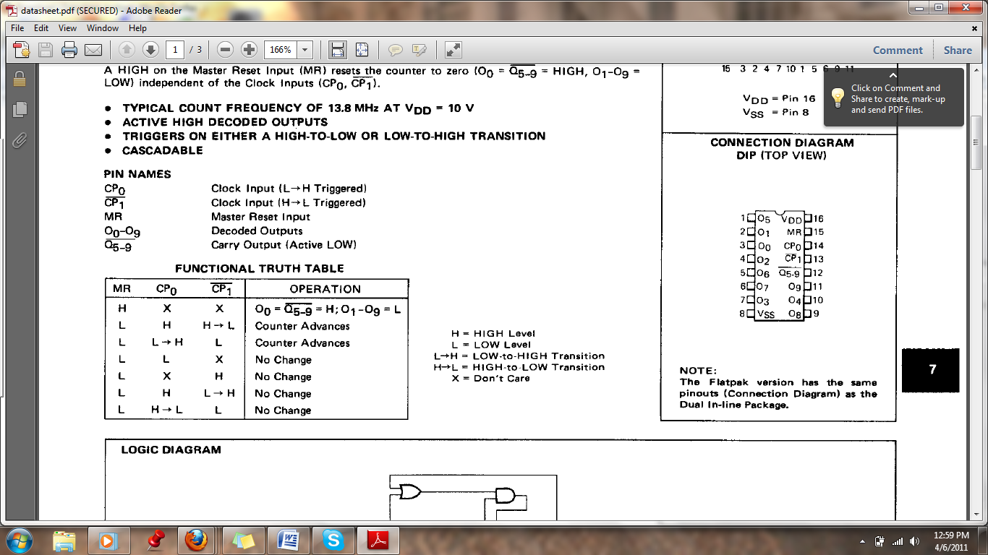
Figure 29- Decade Counter Pins and Pin Names
An example circuit of the two aforementioned chips combined is provided below. This circuit cycles through outputs 0 – 9 and resets until the timer’s supply voltage is disconnected.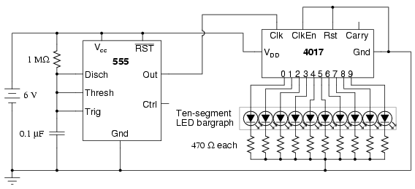
Figure 30-Example Circuit

In order to implement this circuit into this design it would have to be placed in a small and unobtrusive compartment on the helmet. One approach is to place the circuit in a 3x5 in plastic compartment with an ON/OFF switch, power indicator light, and a multi-stranded cable with each strand serving as a connection between the circuit’s, or counter’s, output and the actual LEDs mounted on the helmet. The following pictures demonstrate such an idea.

Figure 31-Top of helmet Figure 32- Inside compartment (Aerial View)

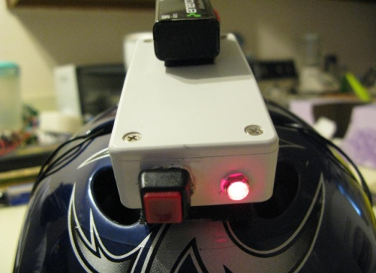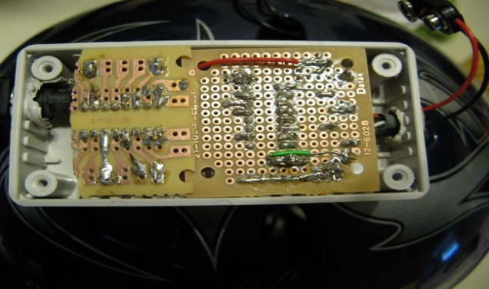
Figure 33- Actual circuit Figure 34- Close Up of Circuit
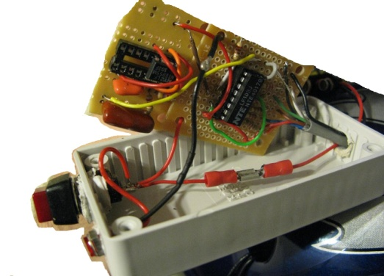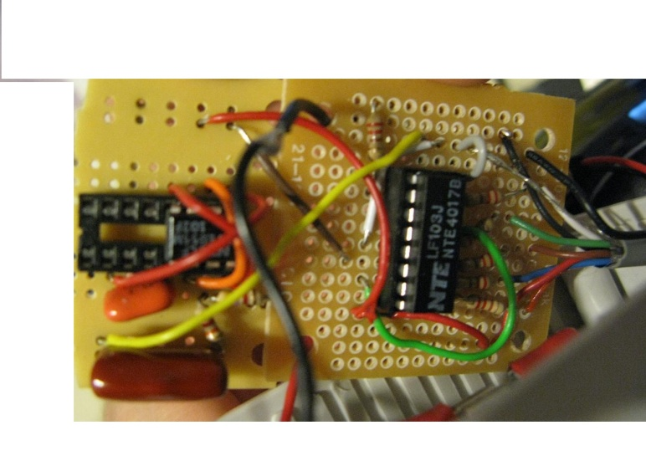

Figure 35- Connections inside helmet Figure 36- Close up of connections

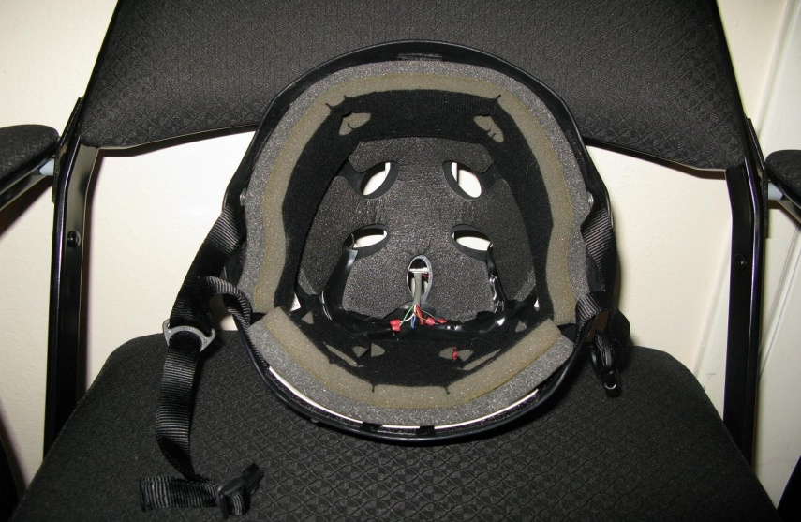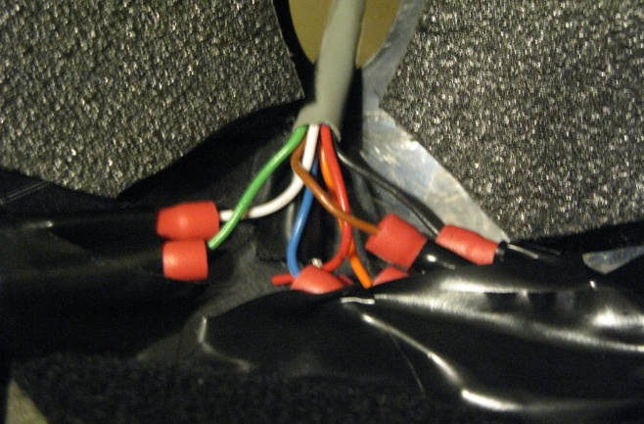

Figure 37- Infrared LEDS inside helmet Figure 38- Complete Assembly

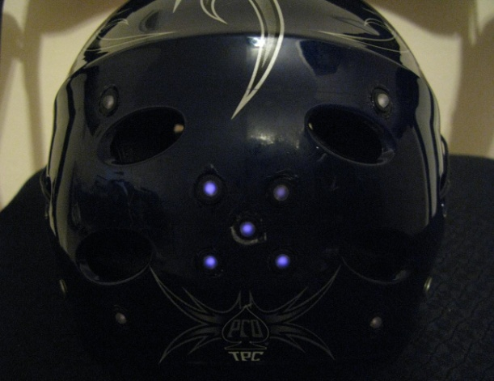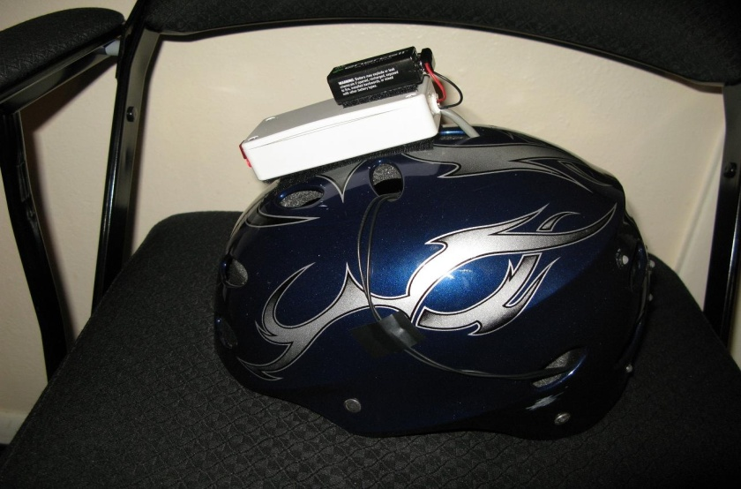

The IC chips are mounted unto sockets which are soldered unto the protoboard. The board has other components such as resistors, capacitors, and jumper wires soldered unto it so that the only extremity of the board is the cable of output wires, figure 4, with one end soldered to the “negative” end of the resistors, “positive” end to decade counter outputs, and the other end soldered to female connector terminals. The male connector terminals are soldered to the end of the wires coming from the LEDs mounted on the helmet. All the connections are made inside the helmet as shown in figure 6. The whole unit is powered by a 9V battery source which is velcroed unto the top of the circuit enclosure.
The purpose of adapting the cycling lights is to demonstrate an innovative way of acquiring more accurate data. As the lights sequence through fast enough to light each LED multiple times in a given second, its positional displacement can be recorded through a customized software program and disclose the range of motion that is performed by a patient performing cervical exercises in rehabilitation. The “blinking” is there to help the program decipher between each LED lighting which in turn helps decrease erroneous readings. The sequence runs through the cluster and then to 4 outside LEDs. The program recognizes the multiple LEDs at once and resets back to first LED placement.
Unfortunately due to the event driven nature of the wii-library available to the design team, it was not possible to sync up the timer and the analysis software. Too much processing lag ensued for the desired speed and time did not permit for further debugging. A further improvement would be to implement the timer and have the program and LED timing sync up either by rewriting the wii-library or progression testing.

Improvements
There are a few potential improvements that should be made on the next generation or production model. Firstly, the LEDs themselves. LEDs emit light in a beam and therefore have low viewing angles of about 35 to 45 degrees. To improve upon this the LEDs were sanded, creating a textured surface for the light to diffuse. A better or more reproducible solution to this would be to use square LEDs which generally have a view angle of about 140 degrees or purchase LED diffuser caps. Neither of the above were able to be ordered through our electrical equipment provider and may not be 100% readily available in IR specific form. On the same subject of LEDs, the housings used were plastic and the internal part that holds the LEDs simply rests against the outer encasing. This allows for some movements of the internal housing position, requiring the user to make sure nothing has popped out or moved before use. Metal holders that thread in to eachother would be optimal. These also often have mirrored bases which would further increase dispersion of the light.
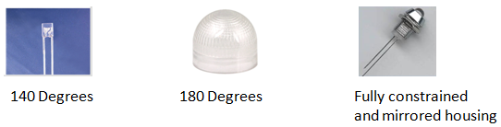

Figure 39- Square LEDS, LED Diffuser, Metal Constraints

Another mentioned improvement area is the helmet. Multiple designs were contemplated for the system and three were produced. The ideal helmet lies somewhere within all of them. A soft helmet is the lightest and easiest on a user with a head/neck injury. The hard helmets allow for best LED placement and data collection. A custom mold possibly similar to a leather cap styled rugby helmet may be the best option. It would allow for a lightweight, adjustable, comfortable fit while providing a thickness for wire routing. Another option would be a blend between the two hard helmets developed. The skateboard helmet is of the proper shape and weight, however implementing a hinge system and built in wire routing and electrical housing would be best. It even could potentially be a band-type head unit which might be more easily adaptable to other body parts.
There is always room for improvement upon accuracy. More LEDs equal more data which corresponds directly to error. However, since the wii-motes can only see 4 hotspots at a time, a timer was desired to blink the LEDs at a specified frequency and one was developed. It runs at 30 Hz allowing reading from each LED 5 times a second, well within the combined camera rate of about 50 Hz. However due to unforeseen error caused by the event driven library, it did not get implemented as of April 7th and further work beyond the year long efforts may be needed.
The final recommended improvement is the mounting hardware. This has also already been drawn up by the design team. Drawings can be referenced in the appendix. This system incorporated full constrained, dual axis, fixed brackets. The wii-mote brackets and LED brackets are still positioned along the same vertical axis with 4 inches of translation, however they will no longer need any adjusting. Addition the laser is fixed similarly allowing for pre-sighted deployment. Finally it incorporates a large C-bracket threading directly on to the camera stand. Everything is constrained and setup can be done by anyone is seconds by tightening bolts around the camera and laser components and sighting the laser to the helmet.

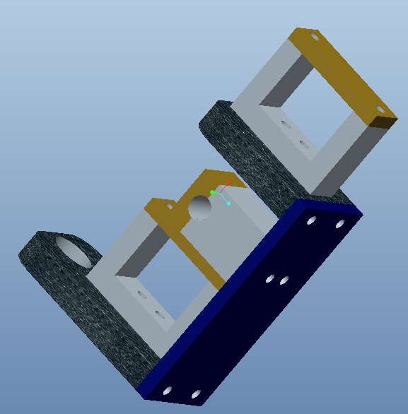
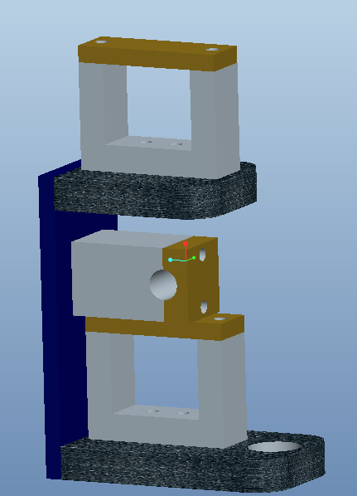

Figure 40- Pro-E Drawing of Wii-Mote Mounting Assembly

Software

Processing and Storage

Inside of the Wii Remote, the processing is done by a microcontroller unit (MCU) because of its low cost, high-efficiency, all-inclusive nature, and its optimization for specific purposes. Nintendo opted to use the Broadcom BCM2042 microcontroller for the Wii Remote’s main processing. It was likely used because of its dedicated Bluetooth integration and capabilities. A microcontroller of this sort is openly available to the public and to other manufacturers for purchase and product incorporation, unlike the proprietary IBM microprocessor (codenamed “Broadway”) that is found in the actual body of the Wii console. On the manufacturer’s website, the BCM2042 is actually advertised as a wireless keyboard/mouse Bluetooth solution, so it certainly isn’t only available to Nintendo for Wii purposes.
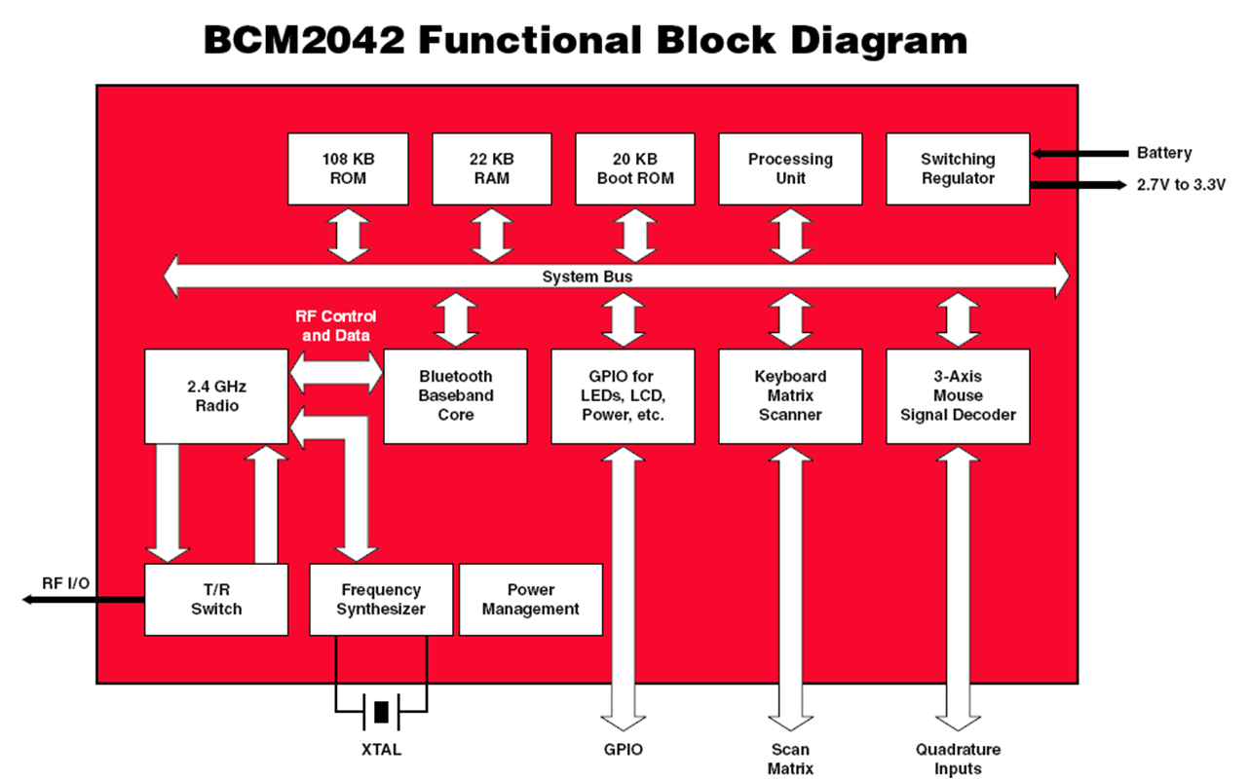
Figure 41- Block Diagram
The bulk of the set of instructions that actually define that Wii Remote’s functionality have already been constructed and well tested. In that case, little to no new code has to be developed for the purposes of updating the device’s “firmware.” However, if a blank BCM2042 is used and original code is necessary, the proper development resources are available and well-documented.
The BCM2042 System-on-a-Chip (SoC) is based on the 8-bit 8051 architecture, first developed by Intel in the 1980s for the popular MCS-81 μC. Development for the 8051 architecture, or the Intel 8051 as it is referred to at times, can be done in assembly language or C, using freely available and open source software. The AS31 Assembler is a free assembler for code written in 8051 assembly. A free and popular C compiler, not just for the 8051, but a wide range of MCUs, is the Small Device C Compiler (SDCC). Source code for 8051 devices can be produced in any pure ASCII editor, but they must, of course, be assembled or compiled before programs can be executed on the chip.
Speaking of programs, Nintendo engineers have seemingly developed an unexpected way of storing and loading programs to the chip in the Wii Remote. They did not exactly utilize the provided 108 KB ROM block in the BCM2042 to store the device’s functionality. Instead, there is a separate electrically erasable programmable read-only memory (EEPROM) unit (model number M24128, made by STMicroelectronics) on a different part of the board that is used to store permanent information. When the system powers up, the Broadcom chip simply fetches the functionality code from the EEPROM (circled below), loads it to the on-chip RAM, and executes it in that fashion.
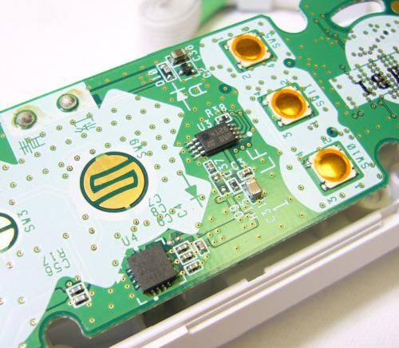
Figure 42- EEPROM Chip inside the Wii Controller
The physical processing and storage aspects of the system’s display component don’t need to be evaluated as painstakingly. Most computers nowadays run on one of three operating systems: Windows (x86 or x64 chips), Mac OS (x86 or legacy PowerPC chip), or Linux (variable processors).
After the information received via Bluetooth from the patient is processed it will translate into data visible by the user on a computer screen. The results will graphically mimic the pitch, yaw, and roll of the patient’s head movements by the corresponding x, y, and z-axis. It will also show the contrasts and differences between the movements prescribed by the physician and the user’s motions. In addition, it would be able to display numerical data, extremes and outliers, time scales, and instruction. Programs such as MATLAB could be used for this 3D vector analysis. This will help correct the user during their unsupervised sessions, while allowing the physician to keep up with the progress of the patient condition especially when face to face meetings are not possible.
As far as session memory goes, the display application stores quantitative records of the patients’ medical performance. In the case of our rehabilitation application, these records can be in the form of a graphical progress report. It will be a collection of screenshot images of the graphical data from the session.

Interaction Style and Display

The system’s user interface is an especially important component. It essentially acts as the face of the entire product. Since the technical skill, medical knowledge, and physical ability of each potential user will be different from the next, the interface must be easy to understand and interpret across a wide range of demographics. A graphical interface approach is the best way to implement the current concept. Graphical user interfaces (GUIs), when designed properly and judiciously, are much more intuitive than command line interfaces in terms of operation, and they give the user an increased feeling of control. A command line interface would most likely intimidate a user of limited knowledge.
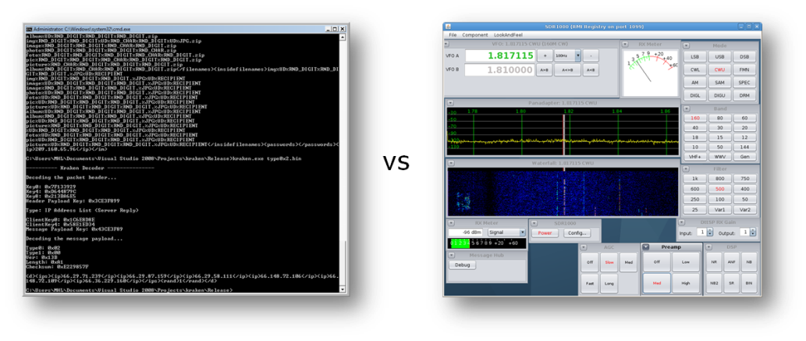
Figure 43-Illustration of the different interaction styles: GUI vs Command Line Interface
GUIs also take advantage of the spatial and visual cues of the environment. A graphical interface will also, and perhaps most importantly, allow streaming data from the device to be illustrated onscreen in a representative way. A three-dimensional head will appear in a virtual space and will react to changes as the wearer actually moves his/her head.
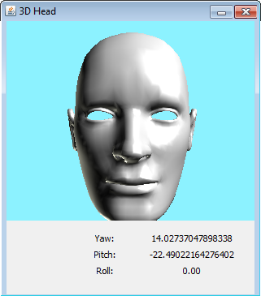
Figure 44-Rough mockup of the conceptualized virtual image
Raw data that is sent from the device to the user console will manifest itself graphically on screen. This will help the display interface spatially illustrate the data and instruct the user. The previous screenshot is a mockup of the way visual data can be represented. Measurements like yaw, pitch, and roll can perhaps be displayed in a more interpretive manner. That is, not all medical professionals have knowledge of such terms.

Data Presentation

The features of the application that quantify and record data must also be discussed. The current concept involves definitely using a graph to chart the physical performance of the patient at a given session. The data points that are taken from the patients’ actions would be in x-, y-, and z-coordinate triplets.
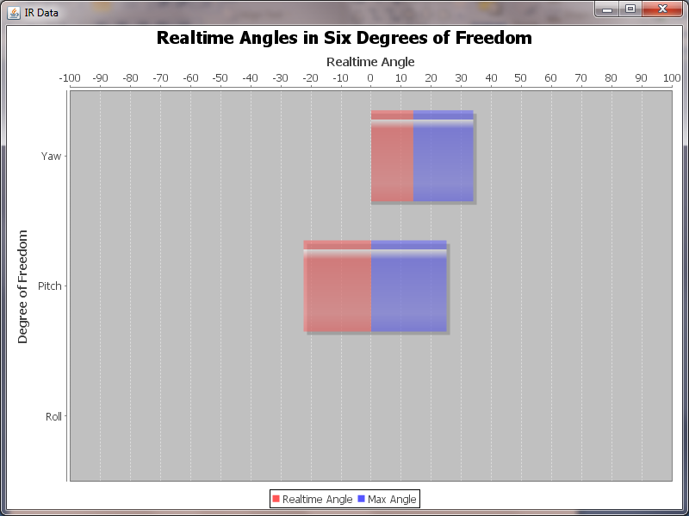
Figure 45-Data can be displayed in horizontal bar graphs.

To handle all of the data and present it in a readable chart, the points could be plotted on horizontal bar graphs, with each bar representing a different rotational degree of freedom, and each bar would respond in real time to the angle at which the head is positioned.

Programming Language(s)

After defining the desired capabilities of the application and the general characteristics of the interface, it becomes easier to determine what programming language(s) would best suit the development. Several languages have the proper tools available to create a graphical user interface. Popular languages like Visual Basic, C++, and C♯ are all competent options for this purpose. Creating graphical applications in C and C++ isn’t as uncomplicated as doing so with other languages that have features specifically built in to accomplish such a goal. Visual Basic is well-known for being a very easy to learn language. Popping out a simple working graphical application in a couple of hours isn’t unusual at all for first time users of VB. One disadvantage of learning Visual Basic comes from the fact that its syntax and structure are very different from already popular, influential and ubiquitous languages like C and C++. C♯ is a more robust fully object-oriented programming (OOP) language that is heavily influenced by popular OOP languages like C++ and Java in terms of syntax.
However, C♯ and VB both share a major disadvantage that will affect application compatibility. Programs written in these particular languages (and others not mentioned here) can only be executed on a runtime engine called the Common Language Runtime (CLR). The CLR is, in actuality, another software application in itself that must be present on the machine that this system’s software will run on. This is because C♯ and VB are Microsoft-developed languages that are a part of its .NET technology, which requires all .NET languages to run on the CLR. The .NET technology has proven its worth in countless arenas. However, the main inconvenience of .NET (and indirectly C♯ and VB) lies in the fact that the CLR is only available for the Windows platform. At this point in concept development, it would be ill advised to restrict the system domain to only one type of platform. Since little knowledge is known beforehand about the end type of platform, the display application should, ideally, be run on any readily available personal computer or server.
Enter Java. Software developed in Java has the benefit of being executed exactly the same on any system due to its Write Once, Run Anywhere (WORA) mantra; it would not have to be compiled for three, or even more, different systems. Like .NET languages, the technology behind Java is also based on a runtime engine, the Java Runtime Environment (JRE). However, the Java platform is available for several different underlying architectures, operating systems, and it has even been implemented right on the hardware.
Java is an especially attractive option because, currently, no information is known about the type of computer this display application will eventually run on. By generalizing the software development as much as possible, more flexibility is achieved. Another benefit of using Java is the availability of its flexible Java 3D library, which is an API based around 3D graphics.

Performance

One of the key drawbacks of Java versus a language whose programs get run natively on the machine (like C and C++) is the performance. It’s obvious that Java programs will ultimately run a little slower than other programs, simply because of the underlying technology. Java programs will have to be compiled into bytecode before it can be executed as machine-understandable instructions. All these translations must happen on the fly. As a result, the application ends up being a little slower, not noticeably though. Computers execute millions of instructions per second. “A little slower” is an acceptable trade off for portability. Even though this application may be slightly graphics oriented, the level of intensity may not require performance to be overly optimized. Besides, Java has made numerous strides in its performance department.

Code Generation

Two very capable and freely available Wii Remote libraries were explored and tested. One was for C♯, and the other was for Java. The C♯ (or .NET to be specific) library, WiimoteLib, was developed by Brian Peek for use in the Wiimote development community and conveniently makes very complicated connection methods simple one-line statements. Using WiimoteLib, test applications were developed and successfully executed in Visual Studio 2008. The Java library, WiiRemoteJ, was developed by Michael Diamond for similar purposes. A test application that uses this Java library was developed in the Eclipse Integrated Development Environment (IDE). However, after several runtime errors were thrown, it was gradually realized that more than the implementation file and the library were needed to make the application work. More detail is given in the next section.
Here is a general overview of the data flow in the application:
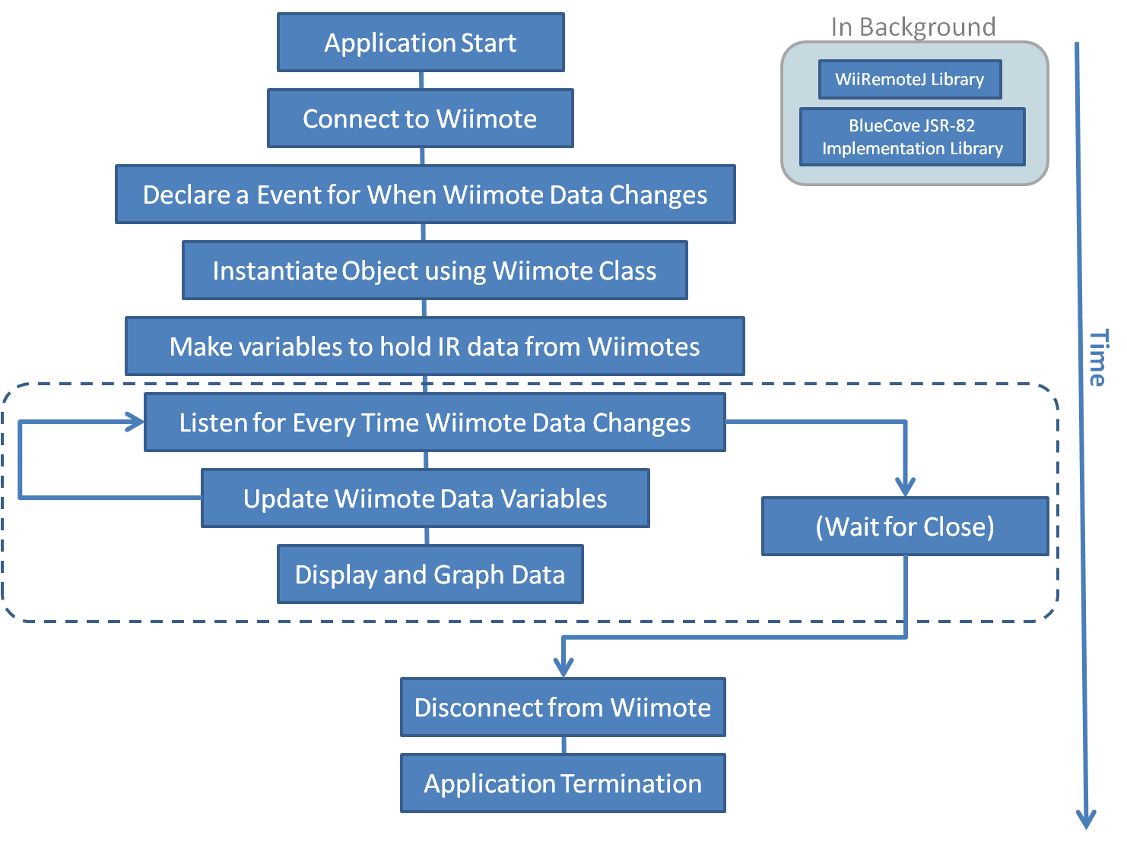
Figure 46-Block Diagram of Design Process

Java and Bluetooth

In order for Java applications to use Bluetooth, there must be something called "an implementation of the JSR-82 specification" included in the project. This is basically a Java library that implements all the relevant protocols and profiles and other communication entities that make Bluetooth work. This library contains the connection methods and functions that get referenced by the WiiRemoteJ in its code. Once the JSR-82 implementation is added to the project, it doesn’t have to be touched, but it is necessary in order for the Bluetooth to work.
There are not a lot of JSR-82 implementations already in existence that are widely available, and there are far fewer free and/or open source ones. Only two free ones for testing on Windows were found: BlueCove and BlueSock. BlueCove is promising in particular because it works on all major operating systems. Both are supposed to do what’s needed, but after “installing” them, more errors were found. The main problem was discovered to be the installed Bluetooth stack that was on the testing computer (a Bluetooth stack is just a driver that makes the physical Bluetooth radio hardware work). The testing computer was using the native Microsoft Windows Bluetooth stack (AKA Winsock) that came with it. The Winsock driver does not support L2CAP, nor is it available for other operating systems. L2CAP is one of many different types of Bluetooth protocols and one in particular that WiiRemoteJ needs to work properly.
A more compatible stack for WiiRemoteJ is the WIDCOMM stack, produced by Broadcom (the same company that makes the Bluetooth hardware). It works better than the other third-party stacks (BlueSoleil for example) and has less JSR-82 limitations than the others. The system’s final software includes a BlueCove JSR-82 implementation and a WIDCOMM Bluetooth stack. The following chart gives a comprehensive illustration of how all these components interact.
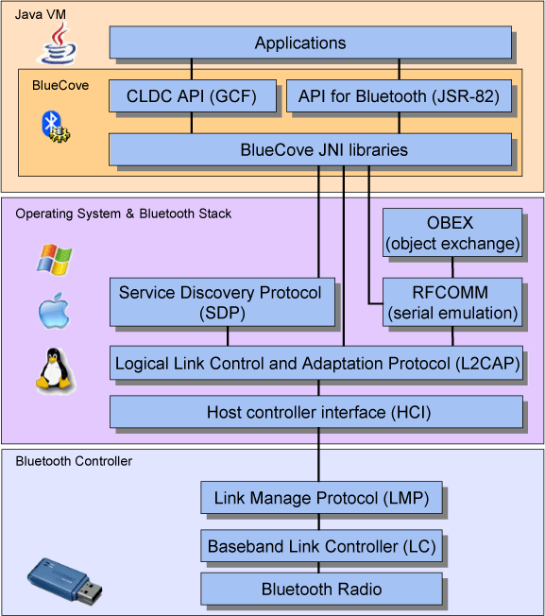
Figure 47-Flow Chart of Bluetooth & Java Interaction
After running tests on a number of machines, if a computer had the Windows default stack on installed and then installed WIDCOMM on it later, the system would, by default, use the Winsock stack first and then WIDCOMM If the Winsock stack failed. However, in order to get WIDCOMM to be the first stack, a line of code has to be used:

System.setProperty("bluecove.stack.first", "widcomm");

Calibration
The calibration of the Wii controllers is a pivotal part of this product. The infrared cameras were specially manufactured by Pixart Imaging Inc in a lucrative deal with Nintendo, however the datasheet of the cameras has, as of this date, not been formally published. This is the reason why calibrating the Wii controllers is important as the intrinsic parameters are not easily available and must thus be acquired through other means. The calibration process was greatly aided through use of the MATLAB Camera Calibration Toolbox created by Jean-Yves Bouguet of CalTech. This toolbox allows one to calibrate a camera (or multiple cameras) in a relatively simple and straightforward manner through the use of various images of a calibration pattern. Traditionally, the calibration pattern is a checkerboard pattern but this needed to be adjusted as the Wii controller can only see 4 points at a time. The following figure is an image of the calibration square with the infrared LEDs evenly spaced at 10 centimeters.
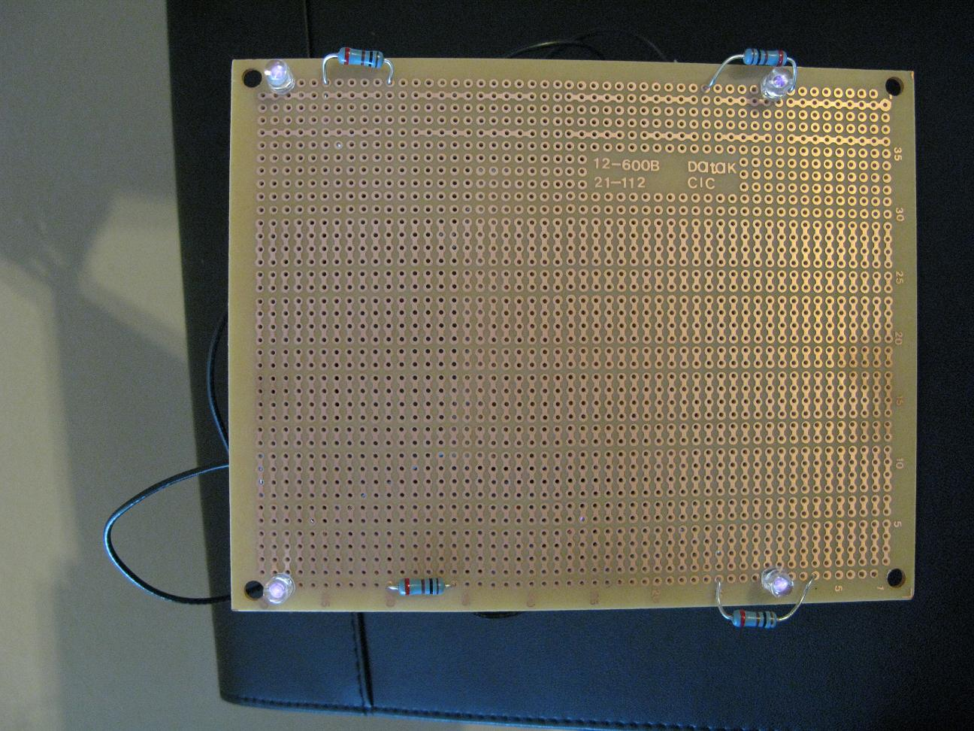
Figure 48-Calibration Square
To more accurately conduct calibration, 15 separate images were created, each of different poses of the calibration square. In saying images, these images were created in MS Paint based on the resolution of the Wii controllers and the pixel data of the calibration square provided by the controllers and inputted into the Camera Calibration program. The toolbox allows for stereoscopic calibration after conducting calibration of the individual Wii controllers and the following intrinsic parameters as well as extrinsic parameters (the translation and pose of the cameras relative to each other) were arrived at:
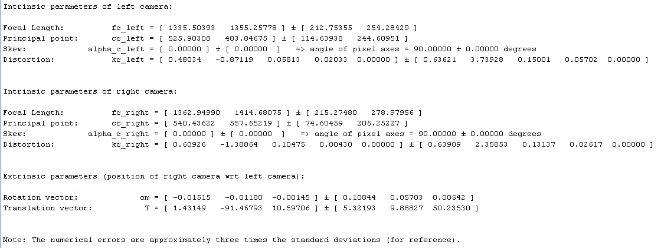
Figure 49-Stereoscopic Calibration Results
As can be seen, the focal lengths are consistent and the rotation vectors show negligible amounts of rotation which means it is safe to assume equal pose for both Wii controllers.

Algorithm
The assumption of equal pose is important for the equations that provide us the derivation of the X, Y, and Depth relative to one of the Wii controllers. The following equations are “Thale's Formulae for Determining Real Space Coordinates.”
$$Z=\frac{f×B}{d}$$
$$X=\frac{u×Z}{f}$$
$$Y=\frac{v×Z}{f}$$
In the equations f is the focal length, [X Y Z] are the coordinates of the object in real space, [u v] are the camera coordinate positions of the object, B is the translation distance between the camera centers, and d is the disparity in pixel values. Since the Wii controllers are positioned on top of one another, the x pixel values in both will be equal for any object and the disparity will be in the y pixel values.
The first equation in the previous figure, the Z depth equation, is non-linear as the closer the object gets to the Wii controllers the greater the y pixel disparity becomes in an almost exponential manner. To correctly determine the depth it is necessary to map the disparity to the actual distance. To do this, a single infrared LED was turned on and the disparity and measured distance was recorded at a distance from 12-64 inches. Doing this shows that the relationship is actually an inverse one with the data matching very closely. The following figure is the result of this experimentation as well as the equation of the trend line which would then be used in calculating the depth.

Figure 50-Depth Mapping Graph
After having derived a reliable method of evaluating the depth of an object from the disparity it would then be possible to get the X and Y positional data. As was mentioned earlier, the x and y camera coordinates would be needed which can be determined in the following matrix equation. The follow equations are the matrices used in determining X and Y spatial coordinates.
$${\left[\begin{matrix}f & 0 & CCx \\ 0 & f & CCy \\ 0 & 0 & 1\end{matrix}\right]}^{-1}×\left[\begin{matrix}x \\ y \\ 1\end{matrix}\right]=\left[\begin{matrix}x_{norm-cam} \\ y_{norm-cam} \\ 1\end{matrix}\right]$$
$${\left[\begin{matrix}1/f & 0 & 0 \\ 0 & 1/f & 0 \\ 0 & 0 & 1\end{matrix}\right]}^{-1}×\left[\begin{matrix}x_{norm-cam} \\ y_{norm-cam} \\ 1\end{matrix}\right]=\left[\begin{matrix}u \\ v \\ 1\end{matrix}\right]$$
$$X=\frac{u×Z}{f}$$
$$Y=\frac{v×Z}{f}$$
Using these equations provides a simple and quick way of determining the position of any particular point visible by both Wii controllers. This would constitute part of our algorithm. The rest consists of getting the actual angular values. This is done by calculating the angle between two vectors. The first vector would be the vector predefined as the starting position and the second vector being the current position. This angle is calculated through the use of the definition of the dot product. The following equation is the method used for determining the angle between two vectors.
$$θ=\cos^{-1}\left(\frac{V1⋅V2}{\left|V1\right|\left|V2\right|}\right)$$

Error
Error in this project was determined by comparing measured values to the calculated values derived in the algorithm section. In conducting various tests with a single LED placed at varying distances, the linear error was at first determined to range between 1 to 5 percent. In an effort to reduce this error further, a correction factor was used to reduce it to between 0.5 to 1.5 percent.
The angular error was determined to range up to 15 degrees error. Efforts are being made to reduce this to within acceptable levels

Design for Manufacturing/Economics

The ability to reproduce this product played an important role in the design selection. Based on this, it was decided to make this product out of a combination of purchasable items such as the bicycle helmet, microphone stand, batteries, and chair. These items can all be purchased from local stores for a very reasonable price. The electrical components such as the LEDs, wires, timer, breadboards, Bluetooth stacks, and Wii-motes would have to be purchased from a specialty store or online but the prices are relatively low as well. Certain components of this project had to be specially ordered or created such as the mounts to hold the Wii-motes in place, the microphone stand adapters, as well as the aluminum sheet metal. The following table shows which items and what quantity would be needed to reproduce one unit as well as the cost. Tools used in the manufacturing process such as solder, screwdrivers, epoxy, drills etc. were not included in this list. In addition to the assumption that all tools required were readily available, there is also the assumption that there is an available computer system with all necessary software and rights for configuration.

Item | Quantity | Cost
Wii Controller | 2 | $80.00
LEDS | 10 | $8.99
Wire- 50ft reel | 1 | $4.19
Bluetooth Dongle/Stack | 1 of each | $30
Plastic Housing | 1 | $5
Male/Female Clips | 10 | $5
Microphone Stand | 2 | $20
Microphone Adapters | 2 | $20
Wii Controller Mount | 2 | $15
Aluminum 6061 | 1 | $50
Protoboard | 1 | $1.99
Decade Timer & Counter | 1 of each | $4.00
Helmet | 1 | $20.49
Batteries | 2 AA | $1
Chair | 1 | $149.99
Total | - | $415.65
Table 2- List of items necessary for one unit
Considering the total project budget of $2500 the cost of $415.65 for one unit is very low. The cost for this project was higher due to the fact that there was an inventory of replacement parts to be kept in order to prevent delays and for each designer to have a remote and LED pen for testing and development. After prototyping and testing along with the infra-red sensitivity and viewing distance optimization, additional funds and parts were required to further debug the device, and the final total for our entire project came out to $700. A complete list of all the items used in the creation of this product is listed in the appendix.

Operational Manual

Hardware
All the materials bought were used as is except for certain parts. The infrared LEDs used were sanded down using very fine sandpaper in order to achieve a higher visibility range of infrared-light. The LEDs were placed in the holes that were drilled into the back of the helmet using epoxy and housings. As stated previously the infrared LEDs were wired together and the wiring was threaded behind the padding of the helmet and into a plastic container on top of the helmet. The plastic container houses a circuit board that connects the timer and counter to resistors and capacitors which help create a blinking sequence for the infrared LEDs. The batteries as well as a switch and LED are also wired together to determine if the circuit is open or closed. The al6061 metal was cut to create unique pieces that would join the boom of one microphone stand to the connector portion of another stand (this can be seen in the photos in the appendix). In addition, the aluminum pieces stabilize the stands as well as prevent them from slanting. The Wii-motes are able to be placed on the same axis at different heights by joining the boom of one microphone stand to another stand. Joining the two stands was also necessary in order to provide a level horizontal platform for the both the cameras.
There are several preliminary tasks which must be completed before this product can be used. First, both the Wiimote cameras must be calibrated in order to determine the focal length. To do this, a square LED arrangement must be positioned in various ways in front of both cameras and the pixel data must be extracted in order to create image files. The image files are then used as part of the MATLAB Camera Calibration tool that determines the focal length. The cameras must also be aligned once they are mounted onto the microphone stands using the provided test software. Once the cameras have been calibrated and aligned the chair should be placed approximately 28 inches feet in front of the cameras. The cameras should line up directly in the middle of the chair and focus on the center of the helmet using the provide laser sighting. This way, when the user sits in the chair and wears the helmet, the LEDs in the back of the helmet will be visible to the cameras.

Software
The software used should run on any PC that has Java Runtime 1.5 or higher installed. The most recent Java update (version 1.7 as of this paper’s publishing) is recommended. Currently, more than 70% of all systems meet this specification, and if they don’t, the Java Runtime Environment is easily and freely downloadable. Other recommended system requirements include:
-1 GB RAM
-1.2 GHz processor
In addition to these basic system requirements, a few external Java libraries are needed in the Java classpath in order for the code to compile and execute. The main library that allows the application to interface with the Wiimotes is called WiiRemoteJ, and it written purely in Java, which adds to portability. As mentioned earlier in the “Java and Bluetooth” section under “Software”, there needs to be a JSR-82 implementation included in the project in order for the Java application to access to Bluetooth stack and use it. The JSR-82 library selected for this project was BlueCove because of its cross-platform operability and general reliability.
For graphing purposes, the open source JFreeChart library was the best option for development. Because it is a freely available, well-documented library and has been available since 2000, there is a large community of users who have contributed to the project and made it a very robust tool. The API is written in such a way that it allows for complete customization and flexibility. The best characteristic (whether intentional or not) of the library is its ability to be used with real-time data. This allows the graphs in the application’s interface to update continuously with the user’s motion and give immediate, natural feedback about angle measurements.
The final external library that was used to great effect in the GUI was the Java 3D library, first implemented by Oracle, but discontinued by the company since 2004. It is under development by the Java Community Process, and its last stable release was in 2008. Java 3D was used to create the virtual head that users will see mirroring their head movements onscreen. Java 3D was used as opposed to a dedicated third party game engine simply because Java 3D was originally created by the minds that created Java itself. They know their platform, and they know the best ways to display images, process threads, and create interactive behaviors for scenes developed with their technology. Not to mention, Java 3D is as robust as any of the relevant competition.
As far as usability goes, the system was designed to be a simple as possible. To connect the hardware to the application, a user would have to simply click “Connect to Wiimote” in the menu bar, and then press the “1” and “2” buttons on the Wiimote at the same time. The application automatically finds the Wiimotes and connects. Once they’re connected, everything is up and ready for the patient to start using it. The patient should have to deal with as little confusion as possible when operating

Environmental/Health and Safety Issues

There are no feasible environmental implications of this project. However, there are several safety concerns that we took into consideration when designing the components of this product. It was collectively decided to utilize some sort of helmet as it would the best fit for a headpiece to hold the infra-red LEDs. Originally, a football helmet with a hinge attachment was chosen in order to alleviate the process of putting the helmet. However, a later decision to switch to skateboard helmet was made based on the fact that this product was intended for patient use and it would lower the risk of inflicting more damage on a patient who was recovering from a cervical injury. Additional benefits of using the skateboarding helmet include it being lightweight, adjustable, and more comfortable. For future implications, a similar but lighter material can be used for the headpiece instead of a skateboarding helmet which was only used to show functionality. Another safety consideration was the wiring used to light the LEDs. The wires were threaded through the holes in the bicycle helmet and into a plastic housing in order to reduce the risk of electric shock to the user. If for some strange reason the user was shocked, it would not be life threatening since a 9 volt battery is powering the LEDs. The microphone stand attachment is safe as there is no real interaction between the patient and the stand. The chair purchased for this project is safe as well and can tolerate the weight of an average person but should not exceed 275lbs.

Other Applications

The theories and concepts behind this design allows for adaptations in many different industries. These include personal and professional healthcare, 3-D entertainment, robotics and simulation, animation, and anything there body capture is useful or necessary. Expansion is limitless.
After considering and focusing the design on cervical injuries, which is what led to the initial first generation concept, the design was converted to stereovision. By using stereovision, any body part can be measured without modification beyond a housing for LEDs for that specific body part. Shoulders, elbows, wrists, knees, hips, torso and etc can all be measure by simply placing IR LEDs on those body parts in optimized positions. This would allow for replacement of all other measure hardware therapists normally use and allow for therapy and rehabilitation in the healthcare offices or at home. This innovation could potentially replace frequent and expensive office visits for many patients.
Considering the implementation for body parts outside of the head and neck, full body capture would be possible. As long as the body is kept in view of the cameras, the timer was implemented properly, and a sufficient number of LEDs are used, every motion a user make could be documented by the software included. This has potential in both the field of robotics and animation. A similar concept but different approach is already in use in moviemaking involving the use of a blue-screen and motion actors in body suits with points of focus. IN addition, imagine being able to control a robotic arm with such precision that a human can offer, or being able to control a bipedal robot from a remote location. All is possible with further evolution of the design concepts.
The newest big thing to hit the entertainment market is 3-D televisions and movies. Dr. Johnny Chung Lee and others have already begun experimented with using IR LEDs and cameras to determine location and movement of a viewers head and therefore eyes. While likely only possible for individual users, a user can navigate or control a game or movie by their head position. For example, a set of targets on screen would allow orientation change with ducking and moving and would even allow the user to pass the front most targets programmed to be passable. Or a picture of a stadium for a football game can be worked like looking through a window. The closer the user gets to the screen, the more they can see; if they moved to the right they can see more to the left and vice versa. It is a very adaptable system that has potential need and innovation in many industries.

Conclusion
Harris Corporation wants to break into the healthcare market with an innovative, new product. They presented us with a problem focusing around physical therapy and rehabilitation. Head and neck injuries are the most widely reported injuries in the United States to insurance companies for disability claims. The patient currently must go to a therapist for diagnosis and initial measurements. It is important to note that the neck is not a ball and socket joint, and that range of motion is comprised of three basic exercises: rotation, flexion and extension, and lateral flexion and extension. These measurements are generally taken using a goniometer, a protractor like device which the therapist references to major facial features and the acromioclavicular joint on the shoulder, tape measurements, or an inclinometer, a compass like device that acts in respect to gravity. These unfortunately yield somewhat arbitrary measurements due to human error and inconsistency as they are based solely on the therapists positioning and reading. The patient then has to go through the drawn out process of attending periodic appointments in order to document improvement of their range of motion. Harris Corporation wants to remedy both of these situations with a simple, precise, low cost, portable alternative.
Proposed to us by Harris Corporation was to design and develop such a device using components from the highly popular, motion sensing Wii video gaming console. Objectified, the scope was to construct a device to monitor range of motion via head tracking. This included creating a housing to mount the infra-red LEDs, which the camera in the Wii controller could track. The device needed to be adaptable for use on the head of the patient while considering potential expansion to other body parts such as arms, legs, and etc. In addition software needed to be developed which will interpret and transfer the tracking data from the infra-red camera into a format that is easily comprehensible a processing and analysis unit as well as a display program. Harris Corporation expressed the need for the design of an interface to record and visually display orientation of the selected body part with a maximum error of 5 degrees angularly and ¼ inch vertically/horizontally within a standard reference frame. The ultimate goal was to create a low cost, light-weight, transportable, wireless, and easily implementable product that will allow for physical rehabilitation exercises of the head to be completed from the patient’s home, office, or any location a computer system that has the ability to package and transport the results from the patient to physician or physical therapist. These results will allow for easy determination of head movement range and deficiencies for purposes of insurance and disability claims, therapeutic and emotional needs to see progress, and in most cases, eliminate the need for frequent therapy visits.
The Wii video game console uses a ‘sensor bar’ comprised of two hotspots of 5 infra-red LEDs at the ends of a 20cm long housing. Inside the wii-mote there is a camera with a 33 degree horizontal, 22 degree vertical viewing angle that is filtered for approximately 750nm to 940nm wavelengths of light. In reality, the LED hotspots have nothing to do with being a sensory, the actual sensory device is the camera and the accelerometer in the controller. The LEDs simply act as a reference point. After considering such possible designs as using an infrared array to reflect off of highlighted areas, using the accelerometer from the controller attached to the patient, we decided on a concept that essentially reverses the roles that the Wii console uses. By mounting a set of LEDs on the patient, and using a set of controllers as stationary viewing and tracking devices, we will achieve the desired results.
The concept later evolved into our final design concept through testing, elimination of problematic features, and improvement upon others. To accompany the wii-motes, LEDs, chair, and other small items purchased on the market, team inputs include camera stand and mounts, laser sighting, helmet and housing options, and software including recording, recalling, testing, data analysis, interface, memory and display programs as well as optimization of the system. The system is comprised of a lightweight, hard-shelled helmet provided fixed LED positioning with four infra-red LEDs which are tracked by the cameras in the wii-motes set up parallel to each other with 4 inches of translation between. This provides the base requirements of the stereovision concept. The camera-view pixel position data of the target approximately 28 inches away is then transferred via Bluetooth to a computer processing device which implements our java coded relation algorithm, mathematical calculations, and display software. This yields an interactive user environment displayed on screen with numerical, graphical, and simulated head representation that is quickly implementable at either the home or office. `
A major part of this project was to design a reliable way to get both linear and angular measurements which was accomplished through the use of the algorithm designed. The linear errors were able to be reduced to an acceptable ±0.77” which is just slightly more than the error Harris had desired to reach. The angular error came out to be ±15° which is significantly larger than the error of ±5° Harris had desired for this project. Both of these results can be further reduced with additional testing and usage of compensation factors. These steps will continue in order to reach the desired error ranges.
There are a few reasons why these errors came about. One is the fact that the controllers are not directly connected to one-another through a single piece, but rather separate parts attempt to connect the two Wii controllers into the same position and pose with only a y-translation vector. Such a design will most definitely cause some error in the position of the Wii controllers relative to each other and these errors will magnify the level of error already inherent in using stereoscopic vision. Another source of error is the fact that the Wii controllers do not have sub-pixel accuracy. Though there is no way to remedy this particular error, the other source of error can indeed be remedied through the careful design of a housing structure for both of the Wii controllers.
The team encountered several problems which had a huge impact not only on the outcome of this project but the project schedule. A major problem was the fact that the previous Wii-Motes purchased offline were knock off. Due to this a vast amount of the time was spent trying to calibrate these cameras as well as figuring out why the calibration and calculation of the focal length was wrong so offset. As soon as this was realized, the team purchased authentic Nintendo Wii-Motes from Gamestop which were easily calibrated. During the testing phase many of the LEDs were also burning out which was resolved through the use of resistors in the circuitry. The team faced Bluetooth compatibility issues early on but this was resolved by downloading driver software for the Bluetooth stack. These problems led to the project schedule being changed from the initial 4-Phase plan to just a 3-Phase plan (both of which can be seen in the appendix). Lastly, there was the Event-driven problem of receiving too much data for the Java program to handle which inevitably led to the team focusing more on showing function ability without the blinking lights.
Even with all these problems occurring, the team still received positive feedback from the Physical Therapist Tyressa Judge when demonstrating the features of the product. She stated that “the product was concise and user friendly enough.” She also mentioned that the product was “leaps and bounds” above using a goniometer which is prone to human error. Tyressa made some suggestions for making the product more valuable such as implementing the program to test for a patient’s speed as well as endurance. Her suggestion to change the 3-D face to follow the movement of the patient was also implemented.
Taking all the issues into consideration, this project is still a success for a number of reasons. First, a stable and reliable algorithm was developed that could use the Wii controllers in order to recall linear and angular measurements. Though the errors were higher than desired, they can be largely remedied through machining of better quality housing structures. Next, an easy to understand and follow Graphical User Interface was designed which can empower patients to actively review their own data and seek to work harder at improving their health. It is also easy for therapists to use and review the data as well. For these reasons, the project is a success as it opens wide the door for further improvements in the set-up and even algorithm which can provide finer and finer levels of details and thus lowers the error to within desired limits. In the end, the ultimate success comes from those patients who make great recoveries of their cervical muscles with the aid of the Wii-care project.

Acknowledgements

We would like to thank some individuals for their help and assistance in providing valuable knowledge and direction for our project.
First, we’d like to thank Mr. John Rust for being open, available, and insightful in guiding us on this project and what Harris wants. Without him, this project may have faltered long ago.
We would also like to thank Tyressa Judge for her time in explaining to us how the neck works and how we can go about tracking those motions. We will continue to use her knowledge and will make sure to set up an appointment next time we need her wisdom.
Also on our list are Dr. Shih, Dr. Joe Yeol, Dr. Harvey, and Dr. Hovsapian for providing constructive criticisms to our presentations and to our reports as well as providing information to help in the process of designing this project. We thank Dr. Shih especially for providing this project for our group to work on.
Finally, we would also like to thank Dr. Johnny Chung Lee for breaking wide open the interest and fervor in using the Wii controller for varied purposes. Due to his work using the Wii controller, the whole world has gone into frenzy in trying new and exciting things with the Wii controller, including both hobbyists and corporations.

References
http://en.wikipedia.org/wiki/Propagation_of_uncertainty#Example_calculation:_Inverse_tangent_function
http://teacher.pas.rochester.edu/PHY_LABS/AppendixB/AppendixB.html
http://www.wiiteachers.com/
http://www.apta.org/AM/Template.cfm?Section=History_and_Information&Template=/TaggedPage/TaggedPageDisplay.cfm&TPLID=48&ContentID=14772
http://www.medicalnewstoday.com/articles/98345.php
http://www.nintendo.com/whatsnew/detail/qfrIa8wP7kqnwa_l2Y2uLYfAbO820FI6
http://www.rehaboutlet.com/1028_2.htm
www.jospt.org/members/getfile.asp?id=3866
http://www.scielo.br/scielo.php?pid=S1413-35552008000400006&script=sci_arttext&tlng=en
www.bluecove.org
https://bluesock.dev.java.net/
http://library.forum.nokia.com/index.jsp?topic=/Java_Developers_Library/GUID-2BAD1AE3-B218-4F24-9467-42D0B334DA87.html
http://www.wiimoteproject.com/bluetooth-and-connectivity-knowledge-center/a-summary-of-windows-bluetooth-stacks-and-their-connection/?PHPSESSID=2fba19432f28d6e27f0b860485fc263b
http://www.nitehawk.com/w3sz/dttspw3sz.htm
http://mnin.blogspot.com/2008/04/kraken-encryption-algorithm.html
http://www.mathworks.com/matlabcentral/fileexchange/11169-frenet
http://www.broadcom.com/products/Bluetooth/Bluetooth-RF-Silicon-and-Software-Solutions/BCM2042
http://wiibrew.org/wiki/Wiimot
http://www.tomchrane.com/Architecture/Body2.html
http://www.sparkfun.com/commerce/tutorial_info.php?tutorials_id=43&page=
http://www.8052.com/faqs
http://www.alldatasheet.com/datasheet-pdf/pdf/175090/BOARDCOM/BCM2042.html
http://icg.cityu.edu.hk/ICGers/William/index.htm
http://www.sparkfun.com/commerce/tutorial_info.php?tutorials_id=43&page=

Appendices

Error Propagation
Error in position = ±2mm
$$∆Z=\sqrt{{\left(2\right)}^{2}+{\left(2\right)}^{2}}=±2\sqrt{2}$$

$$\frac{∆Z}{1}=\sqrt{{\left(\frac{2\sqrt{2}}{1}\right)}^{2}+{\left(\frac{2\sqrt{2}}{1}\right)}^{2}}=±4$$

$$∆Z=\frac{4}{1+1^{2}}=±2°$$

Error Analysis
Disparity | Calculated Distance (m) | Measured Distance (in) | Measured distance (m) | Error %
150 | 1.029713626 | 39 | 0.9906 | 3.948478283
138 | 1.116457684 | 42.25 | 1.07315 | 4.035566709
130 | 1.183041363 | 45.125 | 1.146175 | 3.21646894
233 | 0.671722255 | 25.375 | 0.644525 | 4.219736309
After Correction Factor
204 | 0.733592617 | 29 | 0.7366 | 0.408279051
130 | 1.135719708 | 45.125 | 1.146175 | 0.912189817

Z-mapping Data
Actual Distance (in) | Actual Distance (m) | Pixel Disparity | Focal Length | B (meters)
65.0625 | 1.6525875 | 90 | 1349.2 | 0.1
62.375 | 1.584325 | 93
60.5 | 1.5367 | 95
58.25 | 1.47955 | 100
56.4375 | 1.4335125 | 104
54.4375 | 1.3827125 | 107
52.4375 | 1.3319125 | 111
50.25 | 1.27635 | 115
48.4375 | 1.2303125 | 120
46.6875 | 1.1858625 | 124
44.5 | 1.1303 | 133
42.625 | 1.082675 | 137
40.625 | 1.031875 | 144
38.75 | 0.98425 | 151
36.875 | 0.936625 | 158
34.875 | 0.885825 | 168
32.875 | 0.835025 | 178
30.6875 | 0.7794625 | 190
28.75 | 0.73025 | 204
26.625 | 0.676275 | 220
24.625 | 0.625475 | 239
22.875 | 0.581025 | 260
20.9375 | 0.5318125 | 284
18.9375 | 0.4810125 | 315
16.8125 | 0.4270375 | 357
14.5625 | 0.3698875 | 415

Material and Item Selection
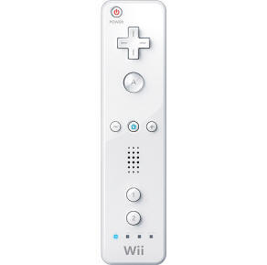
To accomplish the goals of this project, a number of items and materials are needed. Paramount to all are the essentials:
- Wii remote controllers
- Wiimote mounts
- Infrared LEDs
These are the necessary components which will allow for conducting head tracking of a patient. Other components that will become necessary for accomplishing are the following:
- Microphone Stand and Booms
  - The Wiimote mounts will be attached to these via a ¼-20 threaded screw
- Chair with armrests
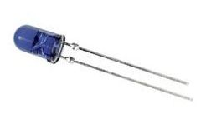
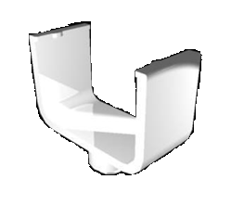
  - These will allow for comfort for the patient and be a stable platform by which to attach the microphone stands from which the Wii controllers will be pointing
- WIDCOMM Bluetooth Stack
  - This is the stack by which a computer will be communicating with the Wii controllers. This is the stack that is compatible with the Java implementation and library
- Kensington Bluetooth Dongle
  - This dongle was determined to be most compatible with the Wii controller, the WIDCOMM stack, and also possesses the necessary Bluetooth protocol (L2CAP) for communication using the Java library
- Hat
  - This will serve as the mounting location of the infrared LEDs placed at the positions described earlier.
Using this collection of items will allow us to accomplish the goal of creating a low cost method of head tracking for use by both patients and therapists. These items are plentiful and available at relatively low costs and are reliable.

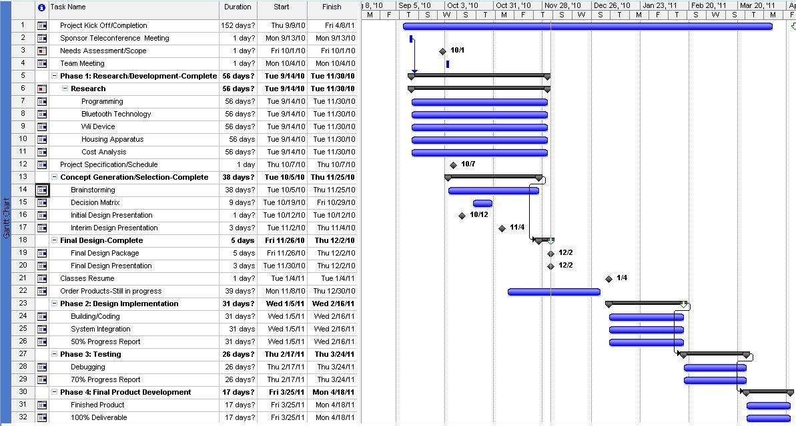
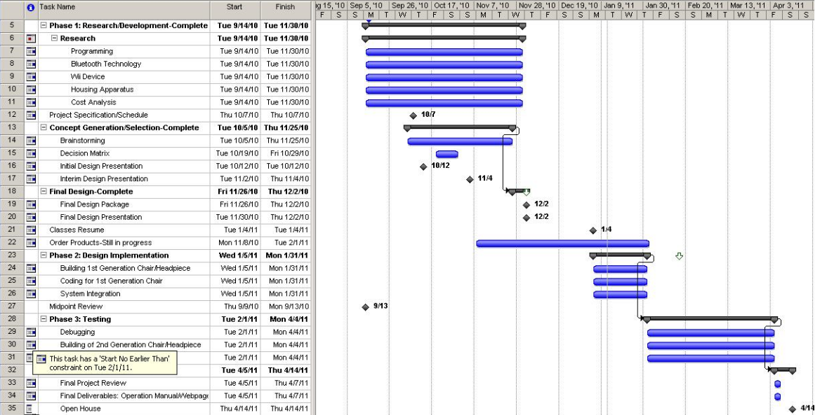

Programming Code

Wii_CareMain.Java
package com.seniordesign.wiicare;
import javax.swing.SwingUtilities;

import wiiremotej.WiiRemote;
import wiiremotej.WiiRemoteExtension;
import wiiremotej.WiiRemoteJ;
import wiiremotej.event.WRAccelerationEvent;
import wiiremotej.event.WRButtonEvent;
import wiiremotej.event.WRExtensionEvent;
import wiiremotej.event.WRIREvent;
import wiiremotej.event.WRStatusEvent;
import wiiremotej.event.WiiRemoteAdapter;

public class Wii_CareMain extends WiiRemoteAdapter {
private static Wii_Care inst;

public static void main(String[] args) {
System.setProperty("bluecove.stack.first", "widcomm");
System.setProperty("bluecove.jsr82.psm_minimum_off", "true");
WiiRemoteJ.setConsoleLoggingAll();

SwingUtilities.invokeLater(new Runnable() {
public void run() {
inst = new Wii_Care();
inst.setLocationRelativeTo(null);
inst.setVisible(true);
}
});
}

public void disconnected()
{
inst.disconnected();
}

public void statusReported(WRStatusEvent evt)
{
inst.statusReported(evt);
}

public void IRInputReceived(WRIREvent evt)
{
inst.IRInputReceived(evt);
}

public void accelerationInputReceived(WRAccelerationEvent evt)
{
inst.accelerationInputReceived(evt);
}

public void extensionInputReceived(WRExtensionEvent evt)
{
inst.extensionInputReceived(evt);
}

public void extensionConnected(WiiRemoteExtension extension)
{
inst.extensionConnected(extension);
}

public void extensionPartiallyInserted()
{
inst.extensionPartiallyInserted();
}

public void extensionUnknown()
{
inst.extensionUnknown();
}

public void extensionDisconnected(WiiRemoteExtension extension)
{
inst.extensionDisconnected(extension);
}

public void buttonInputReceived(WRButtonEvent evt)
{
inst.buttonInputReceived(evt);
}

}

Wii_Care.Java
package com.seniordesign.wiicare;
import java.awt.BorderLayout;
import java.awt.event.ActionEvent;
import java.awt.event.ActionListener;
import java.io.Console;

import javax.swing.JDesktopPane;
import javax.swing.JInternalFrame;
import javax.swing.JLayeredPane;
import javax.swing.JMenu;
import javax.swing.JMenuBar;
import javax.swing.JMenuItem;
import javax.swing.Timer;
import javax.swing.WindowConstants;

import wiiremotej.IRLight;
import wiiremotej.WiiRemote;
import wiiremotej.WiiRemoteExtension;
import wiiremotej.WiiRemoteJ;
import wiiremotej.event.WRAccelerationEvent;
import wiiremotej.event.WRButtonEvent;
import wiiremotej.event.WRExtensionEvent;
import wiiremotej.event.WRIREvent;
import wiiremotej.event.WRStatusEvent;

/**
* This code was edited or generated using CloudGarden's Jigloo
* SWT/Swing GUI Builder, which is free for non-commercial
* use. If Jigloo is being used commercially (ie, by a corporation,
* company or business for any purpose whatever) then you
* should purchase a license for each developer using Jigloo.
* Please visit www.cloudgarden.com for details.
* Use of Jigloo implies acceptance of these licensing terms.
* A COMMERCIAL LICENSE HAS NOT BEEN PURCHASED FOR
* THIS MACHINE, SO JIGLOO OR THIS CODE CANNOT BE USED
* LEGALLY FOR ANY CORPORATE OR COMMERCIAL PURPOSE.
*/
/**
* This is the main WiiCare window.
*/
public class Wii_Care extends javax.swing.JFrame implements ActionListener {

{
//Set Look & Feel
try {
javax.swing.UIManager.setLookAndFeel(javax.swing.UIManager.getSystemLookAndFeelClassName());
} catch(Exception e) {
e.printStackTrace();
}
}

private JMenuBar menuBar;
private JMenuItem connectItem1;
private JMenu jMenu4;
private JMenu jMenu3;
private JMenu jMenu2;
private GraphPanel graphPanel;
private JInternalFrame graphFrame;
private JInternalFrame window3d;
private Panel3D panel3D;
private JDesktopPane desktop;
private JMenu jMenu1;
private WiiRemote remote;
private WiiRemote remote2;
private IRLight[] lights;
private IRLight light;
private double angleX, angleY, angleZ = 0;
private double distX, distY, distZ = 0;
private double rollAngle, yawAngle, pitchAngle;
private double[][] remoteLights;
private double[][] helmetLights;
private LineChart LG;
private BarGraph BG;
private long start, end;
private int delay = 33; //milliseconds
private int count, timerCount = 0;
private WRIREvent IREvent;
private Timer timer;
private Console console;

public Wii_Care() {
super();
initGUI();
}

private void initGUI() {
try {
remoteLights = new double[8][2]; /* Array of lights WR1:Pt 1[X, Y]
Pt 2[X, Y]
Pt 3[X, Y]
Pt 4[X, Y]
WR2:Pt 1[X, Y]
Pt 2[X, Y]
Pt 3[X, Y]
Pt 4[X, Y]
*/
//---Timer Related---helmetLights = new double[6][2];
start = System.currentTimeMillis();
setDefaultCloseOperation(WindowConstants.DISPOSE_ON_CLOSE);
this.setTitle("WiiCare");
{
desktop = new JDesktopPane();
getContentPane().add(desktop, BorderLayout.CENTER);
desktop.setPreferredSize(new java.awt.Dimension(805, 527));
{
//make3DWindow();
}
/*{
graphFrame = new JInternalFrame("Graph", true, true, false, true);
desktop.add(graphFrame, JLayeredPane.DEFAULT_LAYER);
graphFrame.setBounds(10, 4, 816, 629);
graphFrame.setVisible(true);
{
graphPanel = new GraphPanel();
graphFrame.getContentPane().add(graphPanel, BorderLayout.CENTER);
}
}*/
}
{
menuBar = new JMenuBar();
setJMenuBar(menuBar);
{
jMenu1 = new JMenu();
menuBar.add(jMenu1);
jMenu1.setText("File");
}
{
jMenu2 = new JMenu();
menuBar.add(jMenu2);
jMenu2.setText("View");
}
{
jMenu3 = new JMenu();
menuBar.add(jMenu3);
jMenu3.setText("Help");
}
{
jMenu4 = new JMenu();
menuBar.add(jMenu4);
jMenu4.setText("Connect");
{
connectItem1 = new JMenuItem();
jMenu4.add(connectItem1);
connectItem1.setText("Connect to Wiimote");
connectItem1.addActionListener(this);
}
}
}
/*{
LG = new LineChart("Accelerometer Data", "Accelerometer vs Direction");
LG.setVisible(true);
LG.setSize(800, 600);
}*/
{
BG = new BarGraph("IR Data", "Realtime Angles in Three Rotational Degrees of Freedom");
BG.setVisible(true);
BG.setSize(800, 600);
}

//---------------------------------------Timer Related-------------------------------------------
/*ActionListener taskPerformer = new ActionListener() {
public void actionPerformed(ActionEvent evt) {

timerCount++;

/*count++;
count = count % 6;
if (IREvent != null)
{
//doIRProcess(IREvent);

if(remoteLights != null && count != 5)
{
helmetLights[count][0] = remoteLights[0][0];
helmetLights[count][1] = remoteLights[0][1];
System.out.println("Light " + count + "- " +
"X: " + helmetLights[count][0] +
" Y: " + helmetLights[count][1]);
}
}
}
};
timer = new Timer(delay, taskPerformer);
timer.start();*/
//---------------------------------------Timer Related-------------------------------------------

pack();
this.setSize(1155, 707);
} catch (Exception e) {
e.printStackTrace(); //add your error handling code here
}
}

public void make3DWindow() {
window3d = new JInternalFrame("3D Head", false, true, false, true);
desktop.add(window3d, JLayeredPane.DEFAULT_LAYER);
window3d.setBounds(825, 13, 321, 366);
window3d.setVisible(true);
{
panel3D = new Panel3D();
//window3d.getContentPane().add(panel3D, BorderLayout.CENTER);
}
}

public void show3DHead() {
window3d.getContentPane().add(panel3D, BorderLayout.CENTER);
}

public void disconnected()
{
System.out.println("Remote disconnected... Please Wii again.");
System.exit(0);
}

public void statusReported(WRStatusEvent evt)
{
System.out.println("Battery level: " + (double)evt.getBatteryLevel()/2+ "%");
System.out.println("Continuous: " + evt.isContinuousEnabled());
System.out.println("Remote continuous: " + remote.isContinuousEnabled());
}

public void IRInputReceived(WRIREvent evt)
{
//-------------------------Timer Related-----------------------------------
/*
IREvent = evt;
if (timerCount >= 1)
{
timer.restart();
doIRProcess(evt);
timerCount = 0;
}*/
//-------------------------Timer Related-----------------------------------
doIRProcess(evt);
}

public void accelerationInputReceived(WRAccelerationEvent evt)
{
/*if (evt.getSource() == remote)
{
graphPanel.updateXYZ();

graphPanel.x = (int)(evt.getXAcceleration()/5*300)+300;
graphPanel.y = (int)(evt.getYAcceleration()/5*300)+300;
graphPanel.z = (int)(evt.getZAcceleration()/5*300)+300;

if (LG.getSeries().getItemCount() >= 800)
{
LG.resetChart();
LG.setTime(0);
}

LG.getDataset().getSeries(LineChart.X_AXIS).add(LG.getTime(),(evt.getXAcceleration()/5*300));
LG.getDataset().getSeries(LineChart.Y_AXIS).add(LG.getTime(),(evt.getYAcceleration()/5*300));
LG.getDataset().getSeries(LineChart.Z_AXIS).add(LG.getTime(),(evt.getZAcceleration()/5*300));

LG.setTime(LG.getTime() + 1);
graphPanel.t++;
graphPanel.repaint();
}*/
}

public void extensionInputReceived(WRExtensionEvent evt)
{

}

public void extensionConnected(WiiRemoteExtension extension)
{

}

public void extensionPartiallyInserted()
{

}

public void extensionUnknown()
{

}

public void extensionDisconnected(WiiRemoteExtension extension)
{

}

private void mouseCycle()
{

}

public void buttonInputReceived(WRButtonEvent evt)
{

}

public void actionPerformed(ActionEvent action) {
if(action.getSource() == connectItem1)
{
connectToWiimote();
}
}

public void connectToWiimote() {
try {
if (remote == null)
{
remote = WiiRemoteJ.findRemote();
//WiiRemote remote = WiiRemoteJ.connectToRemote("btl2cap://0017AB29BB7B");
remote.addWiiRemoteListener(new Wii_CareMain());
remote.setAccelerometerEnabled(true);
remote.setSpeakerEnabled(true);
remote.setIRSensorEnabled(true, WRIREvent.BASIC);
remote.setLEDIlluminated(0, true);
make3DWindow();
show3DHead();
}
else
{
remote2 = WiiRemoteJ.findRemote();
remote2.addWiiRemoteListener(new Wii_CareMain());
remote2.setAccelerometerEnabled(true);
remote2.setSpeakerEnabled(true);
remote2.setIRSensorEnabled(true, WRIREvent.BASIC);
remote2.setLEDIlluminated(0, true);
}

//show3Dhead();
} catch (Exception e){e.printStackTrace();}
}

private void doIRProcess(WRIREvent evt) {

//-------------------------Timer Related-----------------------------------
//count++;
//count = count % 6;
//-------------------------Timer Related-----------------------------------

lights = evt.getIRLights();

if (lights[0] != null || lights[1] != null || lights[2] != null || lights[3] != null)
{

if (evt.getSource() == remote)
{
//-------------------------Timer Related-----------------------------------
//int nullcount = 0;
//-------------------------Timer Related-----------------------------------

for (int i = 0; i < 4; i++)
{
if (lights[i] == null)
{
//-------------------------Timer Related-----------------------------------
//nullcount++;
//-------------------------Timer Related-----------------------------------
//System.out.println("Light " + i + "- null");
continue;
}
remoteLights[i][0] = lights[i].getX();
remoteLights[i][1] = lights[i].getY();
//System.out.println("Light " + i + "- X: " + remoteLights[i][0] + " and Y: " + remoteLights[i][1]);
}

//-------------------------Timer Related-----------------------------------
//if (nullcount >= 1) // if it finds one or more null lights, then all four base lights are on. start over count
//count = 5;
//-------------------------Timer Related-----------------------------------
}
else if (evt.getSource() == remote2)
{
for (int i = 0; i < 4; i++)
{
if (lights[i] == null)
continue;
remoteLights[i+4][0] = lights[i].getX();
remoteLights[i+4][1] = lights[i].getY();
//System.out.println("Remote2:" + remoteLights[0][4]);
}
}

if (lights[0] != null)
{
angleX = lights[0].getX();
angleX = angleX-0.5;

angleY = lights[0].getY();
angleY = 0.5-angleY;

angleZ = 4*(2000)/(Math.abs(remoteLights[0][1] - remoteLights[4][1]));

angleX = angleX*BarGraph.MAX_IR;
angleY = angleY*BarGraph.MAX_IR;

BG.getDataset().setValue(angleX, BarGraph.Y_AXIS, "Yaw");
BG.getDataset().setValue(angleY, BarGraph.Y_AXIS, "Pitch");

if (angleX < 0)
BG.getDataset().setValue(BG.getYawMAX(), BarGraph.Y_AXIS2, "Yaw");
else if (angleX >= 0)
{
if (angleX > BG.getYawMAX())
{
BG.setYawMAX(angleX);
BG.getDataset().setValue(BG.getYawMAX() - angleX, BarGraph.Y_AXIS2, "Yaw");
}
else
BG.getDataset().setValue(BG.getYawMAX() - angleX, BarGraph.Y_AXIS2, "Yaw");
}

if (angleY < 0)
BG.getDataset().setValue(BG.getPitchMAX(), BarGraph.Y_AXIS2, "Pitch");
else if (angleY >= 0)
{
if (angleY > BG.getPitchMAX())
{
BG.setPitchMAX(angleY);
BG.getDataset().setValue(BG.getPitchMAX() - angleY, BarGraph.Y_AXIS2, "Pitch");
}
else
BG.getDataset().setValue(BG.getPitchMAX() - angleY, BarGraph.Y_AXIS2, "Pitch");
}

//BG.getDataset().setValue(angleY*BarGraph.MAX_IR, BarGraph.Y_AXIS2, "Pitch");

if (panel3D != null)
{
if (evt.getSource() == remote)
{
panel3D.setEvt(evt);
panel3D.getYawDisp().setText(Double.toString(angleX));
panel3D.getPitchDisp().setText(Double.toString(angleY));
}
}

if (evt.getIRLights()[0] != null)
{
//System.out.println(evt.getSource().getBluetoothAddress());
/*end = System.currentTimeMillis();
System.out.println(end - start);
start = end;*/
for (IRLight light : evt.getIRLights())
{
//if (light != null)
//System.out.println("X: " + light.getX()*1024 + " and Y: " + light.getY()*768 + " and Z: " + angleZ);
}
//System.out.println("----------------");
}

//-------------------------Timer Related-----------------------------------
/*if (IREvent != null)
{
//doIRProcess(IREvent);

if(remoteLights != null && count != 5)
{
helmetLights[count][0] = remoteLights[0][0];
helmetLights[count][1] = remoteLights[0][1];
//System.out.println("Light " + count + "- " +
// "X: " + helmetLights[count][0] +
// " Y: " + helmetLights[count][1]);
}
}*/
//-------------------------Timer Related-----------------------------------
}
}
}
}

WiimoteIRBehavior.java
package com.seniordesign.wiicare;
import javax.media.j3d.*;

import wiiremotej.IRLight;
import wiiremotej.event.WRIREvent;
import java.util.*;

public class WiimoteIRBehavior extends Behavior {

private WakeupOnElapsedFrames conditions = new WakeupOnElapsedFrames(0);
private Transform3D rotation = new Transform3D();
private Transform3D rotationTemp_Y = new Transform3D();
private double angleX = 0.0;
private double angleY = 0.0;
private Panel3D panel3D;
private IRLight[] lights;
private IRLight light;

private TransformGroup transformGroup;

public WiimoteIRBehavior(TransformGroup transformGroup) {
this.transformGroup = transformGroup;
}

public WiimoteIRBehavior(TransformGroup transformGroup, Panel3D panel3D) {
this.transformGroup = transformGroup;
this.panel3D = panel3D;
}

public void initialize() {
wakeupOn(this.conditions);
}

public void processStimulus(Enumeration criteria) {
doProcess();
wakeupOn(this.conditions);
}

void doProcess() {
if (panel3D.getEvt() != null)
{
lights = panel3D.getEvt().getIRLights();

light = lights[0];
if (light != null)
{
angleX = light.getX();
angleX = 0.5-angleX;

angleY = light.getY();
angleY = 0.5-angleY;

rotation.rotY(angleX); // This controls the yaw.
rotationTemp_Y.rotX(angleY); // This controls the pitch.

rotation.mul(rotationTemp_Y);

transformGroup.setTransform(rotation);
}
}
}

public double getAngleX() {
return angleX;
}

public double getAngleY() {
return angleY;
}
}

Panel3D.java

package com.seniordesign.wiicare;

import java.awt.GraphicsConfiguration;
import java.awt.GridBagConstraints;
import java.awt.GridBagLayout;
import java.awt.Insets;
import java.io.FileNotFoundException;
import java.net.MalformedURLException;
import java.net.URL;

import javax.media.j3d.Alpha;
import javax.media.j3d.AmbientLight;
import javax.media.j3d.Background;
import javax.media.j3d.BoundingSphere;
import javax.media.j3d.BranchGroup;
import javax.media.j3d.Canvas3D;
import javax.media.j3d.DirectionalLight;
import javax.media.j3d.RotationInterpolator;
import javax.media.j3d.Transform3D;
import javax.media.j3d.TransformGroup;
import javax.swing.JLabel;
import javax.swing.JPanel;
import javax.vecmath.Color3f;
import javax.vecmath.Point3d;
import javax.vecmath.Vector3f;

import wiiremotej.event.WRIREvent;

import com.sun.j3d.loaders.IncorrectFormatException;
import com.sun.j3d.loaders.ParsingErrorException;
import com.sun.j3d.loaders.Scene;
import com.sun.j3d.loaders.objectfile.ObjectFile;
import com.sun.j3d.utils.behaviors.vp.OrbitBehavior;
import com.sun.j3d.utils.universe.PlatformGeometry;
import com.sun.j3d.utils.universe.SimpleUniverse;
import com.sun.j3d.utils.universe.ViewingPlatform;

/**
* This code was edited or generated using CloudGarden's Jigloo
* SWT/Swing GUI Builder, which is free for non-commercial
* use. If Jigloo is being used commercially (ie, by a corporation,
* company or business for any purpose whatever) then you
* should purchase a license for each developer using Jigloo.
* Please visit www.cloudgarden.com for details.
* Use of Jigloo implies acceptance of these licensing terms.
* A COMMERCIAL LICENSE HAS NOT BEEN PURCHASED FOR
* THIS MACHINE, SO JIGLOO OR THIS CODE CANNOT BE USED
* LEGALLY FOR ANY CORPORATE OR COMMERCIAL PURPOSE.
*/
public class Panel3D extends javax.swing.JPanel {

private final String FILENAME = "MaleHead.obj";

private boolean spin = false;
private boolean noTriangulate = false;
private boolean noStripify = false;
private double creaseAngle = 60.0;
private URL filename = null;
private SimpleUniverse u;
private BoundingSphere bounds;

public JLabel rollDisp;
public JLabel pitchDisp;
public JLabel rollLabel;
public JLabel pitchLabel;
public JLabel yawDisp;
public JPanel infoPanel;
public JLabel yawLabel;
private Canvas3D canvas3d;

public TransformGroup objTrans;
public WiimoteIRBehavior myIRBehavior;

public WRIREvent evt;
/**
* Auto-generated main method to display this
* JPanel inside a new JFrame.
*/

public Panel3D() {
super();
initGUI();
}

private void initGUI() {
try {
this.setLayout(null);
GraphicsConfiguration config = SimpleUniverse.getPreferredConfiguration();

{
canvas3d = new Canvas3D(config);
this.add(canvas3d, "Center");
canvas3d.setBounds(0, 0, 309, 246);

init3D();
}
{
infoPanel = new JPanel();
this.add(infoPanel, "West");
GridBagLayout infoPanelLayout = new GridBagLayout();
infoPanel.setLayout(infoPanelLayout);
infoPanel.setBounds(96, 257, 214, 62);
infoPanelLayout.rowWeights = new double[] {0.1, 0.1, 0.1};
infoPanelLayout.rowHeights = new int[] {7, 7, 7};
infoPanelLayout.columnWeights = new double[] {0.0, 0.1};
infoPanelLayout.columnWidths = new int[] {51, 7};
{
yawLabel = new JLabel();
infoPanel.add(yawLabel, new GridBagConstraints(0, 0, 1, 1, 0.0, 0.0, GridBagConstraints.CENTER, GridBagConstraints.NONE, new Insets(0, 0, 0, 0), 0, 0));
yawLabel.setText("Yaw:");
}
{
yawDisp = new JLabel();
infoPanel.add(yawDisp, new GridBagConstraints(1, 0, 1, 1, 0.0, 0.0, GridBagConstraints.CENTER, GridBagConstraints.NONE, new Insets(0, 0, 0, 0), 0, 0));
yawDisp.setText("0.00");
}
{
pitchLabel = new JLabel();
infoPanel.add(pitchLabel, new GridBagConstraints(0, 1, 1, 1, 0.0, 0.0, GridBagConstraints.CENTER, GridBagConstraints.NONE, new Insets(0, 0, 0, 0), 0, 0));
pitchLabel.setText("Pitch:");
}
{
pitchDisp = new JLabel();
infoPanel.add(pitchDisp, new GridBagConstraints(1, 1, 1, 1, 0.0, 0.0, GridBagConstraints.CENTER, GridBagConstraints.NONE, new Insets(0, 0, 0, 0), 0, 0));
pitchDisp.setText("0.00");
}
{
rollLabel = new JLabel();
infoPanel.add(rollLabel, new GridBagConstraints(0, 2, 1, 1, 0.0, 0.0, GridBagConstraints.CENTER, GridBagConstraints.NONE, new Insets(0, 0, 0, 0), 0, 0));
rollLabel.setText("Roll:");
}
{
rollDisp = new JLabel();
infoPanel.add(rollDisp, new GridBagConstraints(1, 2, 1, 1, 0.0, 0.0, GridBagConstraints.CENTER, GridBagConstraints.NONE, new Insets(0, 0, 0, 0), 0, 0));
rollDisp.setText("0.00");
}
}
this.setPreferredSize(new java.awt.Dimension(309, 321));
} catch (Exception e) {
e.printStackTrace();
}
}

private void init3D() {
if (filename == null) {
// Applet
try {
//URL path = getCodeBase();
URL path = getClass().getProtectionDomain().getCodeSource().getLocation();
filename = new URL(path.toString() + FILENAME);
} catch (MalformedURLException e) {
System.err.println(e);
System.exit(1);
}
}

//canvas3d.setBounds(200, 0, 180, 300);
// Create a simple scene and attach it to the virtual universe
BranchGroup scene = createSceneGraph();
u = new SimpleUniverse(canvas3d);

// add mouse behaviors to the ViewingPlatform
ViewingPlatform viewingPlatform = u.getViewingPlatform();

PlatformGeometry pg = new PlatformGeometry();

// Set up the ambient light
Color3f ambientColor = new Color3f(0.1f, 0.1f, 0.1f);
AmbientLight ambientLightNode = new AmbientLight(ambientColor);
ambientLightNode.setInfluencingBounds(bounds);
pg.addChild(ambientLightNode);

// Set up the directional lights
Color3f light1Color = new Color3f(1.0f, 1.0f, 0.9f);
Vector3f light1Direction = new Vector3f(1.0f, 1.0f, 1.0f);
Color3f light2Color = new Color3f(1.0f, 1.0f, 1.0f);
Vector3f light2Direction = new Vector3f(-1.0f, -1.0f, -1.0f);

DirectionalLight light1 = new DirectionalLight(light1Color, light1Direction);
light1.setInfluencingBounds(bounds);
pg.addChild(light1);

DirectionalLight light2 = new DirectionalLight(light2Color, light2Direction);
light2.setInfluencingBounds(bounds);
pg.addChild(light2);

viewingPlatform.setPlatformGeometry(pg);

// This will move the ViewPlatform back a bit so the
// objects in the scene can be viewed.
viewingPlatform.setNominalViewingTransform();

if (!spin) {
OrbitBehavior orbit = new OrbitBehavior(canvas3d, OrbitBehavior.REVERSE_ALL);
BoundingSphere bounds = new BoundingSphere(new Point3d(0.0, 0.0, 0.0), 100.0);
orbit.setSchedulingBounds(bounds);
viewingPlatform.setViewPlatformBehavior(orbit);
}

u.addBranchGraph(scene);
}

public BranchGroup createSceneGraph() {
// Create the root of the branch graph
BranchGroup objRoot = new BranchGroup();

// Create a Transformgroup to scale all objects so they
// appear in the scene.
TransformGroup objScale = new TransformGroup();
Transform3D t3d = new Transform3D();
t3d.setScale(0.7);
objScale.setTransform(t3d);
objRoot.addChild(objScale);

// Create the transform group node and initialize it to the
// identity. Enable the TRANSFORM_WRITE capability so that
// our behavior code can modify it at runtime. Add it to the
// root of the subgraph.
objTrans = new TransformGroup();
objTrans.setCapability(TransformGroup.ALLOW_TRANSFORM_WRITE);
objTrans.setCapability(TransformGroup.ALLOW_TRANSFORM_READ);
objScale.addChild(objTrans);

//Adding Behavior
myIRBehavior = new WiimoteIRBehavior(objTrans, this);
myIRBehavior.setSchedulingBounds(new BoundingSphere());
objRoot.addChild(myIRBehavior);

int flags = ObjectFile.RESIZE;
if (!noTriangulate)
flags |= ObjectFile.TRIANGULATE;
if (!noStripify)
flags |= ObjectFile.STRIPIFY;
ObjectFile f = new ObjectFile(flags, (float) (creaseAngle * Math.PI / 180.0));
Scene s = null;
try {
s = f.load(filename);
} catch (FileNotFoundException e) {
System.err.println(e);
System.exit(1);
} catch (ParsingErrorException e) {
System.err.println(e);
System.exit(1);
} catch (IncorrectFormatException e) {
System.err.println(e);
System.exit(1);
}

objTrans.addChild(s.getSceneGroup());

bounds = new BoundingSphere(new Point3d(0.0, 0.0, 0.0), 100.0);

if (spin) {
Transform3D yAxis = new Transform3D();
Alpha rotationAlpha = new Alpha(-1, Alpha.INCREASING_ENABLE, 0, 0, 4000, 0, 0, 0, 0, 0);

RotationInterpolator rotator = new RotationInterpolator(rotationAlpha, objTrans, yAxis, 0.0f, (float) Math.PI * 2.0f);
rotator.setSchedulingBounds(bounds);
objTrans.addChild(rotator);
}

// Set up the background
Color3f bgColor = new Color3f(0.55f, 0.95f, 1.0f); //originally 0.05, 0.05, 0.5
Background bgNode = new Background(bgColor);
bgNode.setApplicationBounds(bounds);
objRoot.addChild(bgNode);

//System.out.println(this.getClass().getName() + " is loaded from " + getClass().getProtectionDomain().getCodeSource().getLocation());

return objRoot;
}

public JLabel getYawDisp() {
return yawDisp;
}

public JLabel getPitchDisp() {
return pitchDisp;
}

public JLabel getRollDisp() {
return rollDisp;
}

public WRIREvent getEvt() {
return evt;
}

public void setEvt(WRIREvent evtArg) {
this.evt = evtArg;
}
}

LineChart.Java

package com.seniordesign.wiicare;
import java.awt.Color;

import javax.swing.JFrame;

import org.jfree.chart.ChartFactory;
import org.jfree.chart.ChartPanel;
import org.jfree.chart.JFreeChart;
import org.jfree.chart.axis.ValueAxis;
import org.jfree.chart.plot.PlotOrientation;
import org.jfree.chart.plot.XYPlot;
import org.jfree.data.xy.XYSeries;
import org.jfree.data.xy.XYSeriesCollection;

public class LineChart extends JFrame {

private static final long serialVersionUID = 1L;

private XYSeries series;
private XYSeries series2;
private XYSeries series3;
private XYSeriesCollection dataset;
private JFreeChart chart;
private int time;
public static final int MAX_ACCEL = 300;

public static final int X_AXIS = 0;
public static final int Y_AXIS = 1;
public static final int Z_AXIS = 2;

public LineChart(String applicationTitle, String chartTitle) {
super(applicationTitle);

time = 0;

dataset = createDataset(); // This will create the dataset
chart = createChart(dataset, chartTitle, "Time", "Accelerometer"); // based on the dataset we create the chart

ChartPanel chartPanel = new ChartPanel(chart); // we put the chart into a panel
chartPanel.setPreferredSize(new java.awt.Dimension(500, 270)); // default size

setContentPane(chartPanel); // add it to our application
}

/**
* Creates a sample dataset
*/
private XYSeriesCollection createDataset() {
series = new XYSeries("X Axis Series");
series2 = new XYSeries("Y Axis Series");
series3 = new XYSeries("Z Axis Series");
//series.add(800, null);
XYSeriesCollection dataset = new XYSeriesCollection();
dataset.addSeries(series);
dataset.addSeries(series2);
dataset.addSeries(series3);
return dataset;
}

/**
* Creates a chart
*/
private JFreeChart createChart(XYSeriesCollection dataset, String title, String categoryLabel, String valueLabel) {

JFreeChart chart = ChartFactory.createXYLineChart(
title, // chart title
categoryLabel,
valueLabel,
dataset, // data
PlotOrientation.VERTICAL,
true, // include legend
true,
false
);

XYPlot plot = (XYPlot) chart.getPlot();

plot.getRenderer().setSeriesPaint(X_AXIS, new Color(255, 0, 0));
plot.getRenderer().setSeriesPaint(Y_AXIS, new Color(0, 255, 0));
plot.getRenderer().setSeriesPaint(Z_AXIS, new Color(0, 0, 255));

ValueAxis domainAxis = plot.getDomainAxis();
domainAxis.setUpperBound(800);

ValueAxis rangeAxis = plot.getRangeAxis();
rangeAxis.setUpperBound(MAX_ACCEL);
rangeAxis.setLowerBound(-MAX_ACCEL);

plot.setBackgroundPaint(Color.BLACK);

return chart;
}

public int getTime() {
return time;
}

public void setTime(int t) {
this.time = t;
}

public XYSeries getSeries() {
return series;
}

public XYSeriesCollection getDataset() {
return dataset;
}

public JFreeChart getChart() {
return chart;
}

public void resetChart() {
series.clear();
series2.clear();
series3.clear();
//series.add(800, null);
}

}

GraphPanel.Java

package com.seniordesign.wiicare;

import java.awt.Color;
import java.awt.Dimension;
import java.awt.Graphics;

public class GraphPanel extends javax.swing.JPanel {

private final int WIDTH = 800;
private final int HEIGHT = 600;

public boolean accelerometerSource = true; //true = wii remote, false = nunchuk
public boolean lastSource = true;

public int t = 0;
public int x = 0;
public int y = 0;
public int z = 0;

public int lastX = 0;
public int lastY = 0;
public int lastZ = 0;

/**
* Auto-generated main method to display this
* JPanel inside a new JFrame.
*/

public GraphPanel() {
super();
initGUI();
}

private void initGUI() {
try {
t = WIDTH + 1;
setPreferredSize(new Dimension(WIDTH, HEIGHT));
} catch (Exception e) {
e.printStackTrace();
}
}

public void paint(Graphics graphics)
{
Dimension size = getSize();
if (t >= size.width)
{
t = 0;
graphics.clearRect(0, 0, size.width, size.height);
graphics.setColor(Color.BLACK);
graphics.fillRect(0, 0, size.width, size.height);
graphics.setColor(Color.WHITE);
graphics.drawLine(0, (size.height/2), size.width, (size.height/2));
}

graphics.setColor(Color.RED);
graphics.drawLine(t, lastX, t, x);
graphics.setColor(Color.GREEN);
graphics.drawLine(t, lastY, t, y);
graphics.setColor(Color.BLUE);
graphics.drawLine(t, lastZ, t, z);
}

public void updateXYZ() {
lastX = x;
lastY = y;
lastZ = z;
}

}

BarGraph.Java

package com.seniordesign.wiicare;
import java.io.File;
import java.io.IOException;

import javax.swing.JFrame;
import javax.swing.JMenu;
import javax.swing.JMenuBar;

import org.jfree.chart.ChartFactory;
import org.jfree.chart.ChartPanel;
import org.jfree.chart.ChartUtilities;
import org.jfree.chart.JFreeChart;
import org.jfree.chart.axis.ValueAxis;
import org.jfree.chart.plot.CategoryPlot;
import org.jfree.chart.plot.PlotOrientation;
import org.jfree.data.category.DefaultCategoryDataset;

/**
* This code was edited or generated using CloudGarden's Jigloo
* SWT/Swing GUI Builder, which is free for non-commercial
* use. If Jigloo is being used commercially (ie, by a corporation,
* company or business for any purpose whatever) then you
* should purchase a license for each developer using Jigloo.
* Please visit www.cloudgarden.com for details.
* Use of Jigloo implies acceptance of these licensing terms.
* A COMMERCIAL LICENSE HAS NOT BEEN PURCHASED FOR
* THIS MACHINE, SO JIGLOO OR THIS CODE CANNOT BE USED
* LEGALLY FOR ANY CORPORATE OR COMMERCIAL PURPOSE.
*/
public class BarGraph extends JFrame {

private static final long serialVersionUID = 1L;

private DefaultCategoryDataset dataset;
private JFreeChart chart;
public static final String Y_AXIS = "Realtime Angle";
public static final String Y_AXIS2 = "Max Angle";
public static final int MAX_IR = 100;
public double yawMAX = 0;
public double pitchMAX = 0;
public double rollMAX = 0;
public double yawMIN = 0;
private JMenu jMenu1;
private JMenuBar jMenuBar1;
public double pitchMIN = 0;
public double rollMIN = 0;

public DefaultCategoryDataset getDataset() {
return dataset;
}

public JFreeChart getChart() {
return chart;
}

public BarGraph(String applicationTitle, String chartTitle) {
super(applicationTitle);

dataset = createDataset();// This will create the dataset
chart = createChart(dataset, chartTitle, "Degree of Freedom", Y_AXIS); // based on the dataset we create the chart

ChartPanel chartPanel = new ChartPanel(chart); // we put the chart into a panel
chartPanel.setPreferredSize(new java.awt.Dimension(500, 270)); // default size

setContentPane(chartPanel); // add it to our application
}

/**
* Creates a sample dataset
*/
private DefaultCategoryDataset createDataset() {
dataset = new DefaultCategoryDataset();
dataset.setValue(0, Y_AXIS, "Yaw");
dataset.setValue(0, Y_AXIS, "Pitch");
dataset.setValue(0, Y_AXIS, "Roll");
dataset.setValue(yawMAX, Y_AXIS2, "Yaw");
dataset.setValue(pitchMAX, Y_AXIS2, "Pitch");
dataset.setValue(rollMAX, Y_AXIS2, "Roll");

return dataset;
}

/**
* Creates a chart
*/
private JFreeChart createChart(DefaultCategoryDataset dataset, String title, String categoryLabel, String valueLabel) {

JFreeChart chart = ChartFactory.createStackedBarChart(
title, // chart title
categoryLabel,
valueLabel,
dataset, // data
PlotOrientation.HORIZONTAL,
true, // include legend
true,
false
);

CategoryPlot plot = (CategoryPlot) chart.getPlot();

/*final CategoryItemRenderer renderer = new CustomRenderer(
new Paint[] {Color.red, Color.blue, Color.green,
Color.yellow, Color.orange, Color.cyan,
Color.magenta, Color.blue}
);

plot.setRenderer(renderer);*/

plot.setForegroundAlpha(0.5f);

ValueAxis rangeAxis = plot.getRangeAxis();
rangeAxis.setUpperBound(MAX_IR);
rangeAxis.setLowerBound(-MAX_IR);

return chart;
}

public void saveChartAsImage() {
// Create a simple Bar chart
try {
ChartUtilities.saveChartAsJPEG(new File("C:\\Users\\Scholar\\Desktop\\chart.jpg"), chart, 500,
300);
} catch (IOException e) {
System.err.println("Problem occurred creating chart.");
}
}

public double getYawMAX() {
return yawMAX;
}

public double getPitchMAX() {
return pitchMAX;
}

public double getRollMAX() {
return rollMAX;
}

public void setYawMAX(double newMAX) {
yawMAX = newMAX;
}

public void setPitchMAX(double newMAX) {
pitchMAX = newMAX;
}

public void setRollMAX(double newMAX) {
rollMAX = newMAX;
}

public double getYawMIN() {
return yawMIN;
}

public double getPitchMIN() {
return pitchMIN;
}

public double getRollMIN() {
return rollMIN;
}

public void setYawMIN(double newMIN) {
yawMIN = newMIN;
}

public void setPitchMIN(double newMIN) {
pitchMIN = newMIN;
}

public void setRollMIN(double newMIN) {
rollMIN = newMIN;
}

private void initGUI() {
try {
{
jMenuBar1 = new JMenuBar();
setJMenuBar(jMenuBar1);
{
jMenu1 = new JMenu();
jMenuBar1.add(jMenu1);
jMenu1.setText("Save");
}
}
} catch(Exception e) {
e.printStackTrace();
}
}

}

Original.Java
using System;
using System.Collections.Generic;
using System.ComponentModel;
using System.Data;
using System.Drawing;
using System.Linq;
using System.Text;
using System.Windows.Forms;
using System.Threading;
using WiimoteLib;

using System.IO;

namespace WiiCareDraft
{
public partial class WiiCareDraft : Form
{

Wiimote myWiimote1;
Wiimote myWiimote2;

WiimoteCollection mWC;
String text;
Mutex m = new Mutex();
TextWriter tw = new StreamWriter("Wiimote_Data.txt");

float myX, myY, myZ;
int acX, acY, pt1X, pt1Y, pt2X, pt2Y, pt3X, pt3Y, pt4X, pt4Y;

public WiiCareDraft()
{
InitializeComponent();
mWC = new WiimoteCollection();

try
{
mWC.FindAllWiimotes();
}
catch(WiimoteNotFoundException ex)
{
MessageBox.Show(ex.Message, "Wiimote not found error", MessageBoxButtons.OK, MessageBoxIcon.Error);
}
catch(WiimoteException ex)
{
MessageBox.Show(ex.Message, "Wiimote error", MessageBoxButtons.OK, MessageBoxIcon.Error);
}
catch(Exception ex)
{
MessageBox.Show(ex.Message, "Unknown error", MessageBoxButtons.OK, MessageBoxIcon.Error);
}

mWC[0].Connect();
myWiimote1 = mWC[0];
myWiimote1.SetReportType(InputReport.IRAccel, false);
myWiimote1.WiimoteChanged += new EventHandler<WiimoteChangedEventArgs>(wm_WiimoteChanged);

mWC[1].Connect();
myWiimote2 = mWC[1];
myWiimote2.SetReportType(InputReport.IRAccel, false);
myWiimote2.WiimoteChanged += new EventHandler<WiimoteChangedEventArgs>(wm_WiimoteChanged);

myWiimote1.SetLEDs(true, true, false, false);
myWiimote2.SetLEDs(false, false, true, true);

}

public void wm_WiimoteChanged(object sender, WiimoteChangedEventArgs args)
{
Wiimote wiimoteSonny = (Wiimote)sender;

m.WaitOne();

WiimoteState myWS = new WiimoteState();
IRState myIRState = new IRState();
IRSensor myIRSensor = new IRSensor();

myWS = args.WiimoteState;

pt1X = myWS.IRState.IRSensors.ElementAt(0).RawPosition.X;
pt1Y = myWS.IRState.IRSensors.ElementAt(0).RawPosition.Y;
pt2X = myWS.IRState.IRSensors.ElementAt(1).RawPosition.X;
pt2Y = myWS.IRState.IRSensors.ElementAt(1).RawPosition.Y;
pt3X = myWS.IRState.IRSensors.ElementAt(2).RawPosition.X;
pt3Y = myWS.IRState.IRSensors.ElementAt(2).RawPosition.Y;
pt4X = myWS.IRState.IRSensors.ElementAt(3).RawPosition.X;
pt4Y = myWS.IRState.IRSensors.ElementAt(3).RawPosition.Y;

System.Console.WriteLine("------------------------------");
if (wiimoteSonny.ID == myWiimote1.ID)
System.Console.WriteLine("Wiimote 1");
else System.Console.WriteLine("Wiimote 2");

if (myWS.IRState.IRSensors.ElementAt(0).Found)
System.Console.WriteLine("IR Source 1: X = {0}; Y = {1};", pt1X, pt1Y);
if (myWS.IRState.IRSensors.ElementAt(1).Found)
System.Console.WriteLine("IR Source 2: X = {0}; Y = {1};", pt2X, pt2Y);
if (myWS.IRState.IRSensors.ElementAt(2).Found)
System.Console.WriteLine("IR Source 3: X = {0}; Y = {1};", pt3X, pt3Y);
if (myWS.IRState.IRSensors.ElementAt(3).Found)
System.Console.WriteLine("IR Source 4: X = {0}; Y = {1};", pt4X, pt4Y);

if (myWS.ButtonState.A == false)
{
}

m.ReleaseMutex();

}

public void display(object sender, EventArgs e)
{
x_value.Text = myX.ToString();
y_value.Text = myY.ToString();
z_value.Text = myZ.ToString();

}
}
}

Drawings
