**FAMU/FSU College of Engineering**

**Department of Mechanical Engineering**

**Final Design**

Team 1

James Augustin

Benjamin Cole

Daniel Hammer

Trenton Johnson

Ricardo Martinez

10/11/2010

# Abstract

In the United States, nearly two-thirds of people will experience neck pain, the most frequently reported injury to insurance companies, at some point in their life. Current options to assess such injuries are inaccurate and prone to human error, or very costly and cumbersome. This indicates a major need for a product that can help patients claim disability and recover from neck injury, all while reducing their cost as well as the cost to insurers.

The main emphasis of this project is to create a sensory device and interface to record and output the movement of the head using the Nintendo Wii controller, infra-red (IR) LEDs, and Bluetooth compatible devices to communicate between the Wii controller and the receiver. In essence, it is a sensory device for patients recovering from neck injuries and/or surgery. It monitors healthcare rehabilitation exercises and records measurement of range of motion for insurance and disability. The product will replace conventional methods for such analysis by eliminating error and increasing accuracy, being low cost, portable, and easily used by both the physician and patient.

Meeting with both a physical therapist, and the vision team at Harris Corporation optimized our design. The system is comprised of a headset with three infra-red LED hotspots, which are tracked by the filtered camera in the Wii remote and transferred via Bluetooth to a processing device. The data, which is referenced to both the Wii-mote and a fourth infra-red LED hotspot on the shoulder, can be analyzed, recalled, and displayed by any system with the developed software, coded in java, installed. It operates with a maximum error of 2 degrees angularly and 2 millimeters vertically/horizontally within a standard reference frame. The ultimate goal reached is a low cost, light-weight, transportable, wireless, and easily implementable product that allows for physical rehabilitation exercises of the head to be completed from the patient’s home and office, or any location with a computer system. The results will allow for critical determination of head movement range, deficiencies, and progress.

Table of Contents

Abstract 2

Introduction 5

Project Scope 7

Background 9

About the Wii Components 11

Wii Camera 11

Bluetooth communication 12

Problem definition 13

Product Specifications 15

Concept Design and Selection 17

Concept 1 - 1 Wii Controller Monitoring LEDs on Patient 17

Concept 2 – Wii Controller Attached to Patient 18

Concept 3 - Multiple Wii Controllers 20

Two Wii Controllers 20

Three Wii Controllers 22

Concept 4 – More Than 4 LEDs 23

Blinking 23

Filter 23

Concept 5 – LED Array and Reflective Device 25

Decision Matrix 26

Meeting With 27

Therapist Consultation 28

Updated Design 29

Equations and Calculations 32

Error Propagation 33

Processing and Storage 34

Interaction Style and Display 37

Data Presentation 38

Programming Language(s) 39

Performance 40

Data Presentation (Revisited) 40

Code Generation 41

Java and Bluetooth 41

Material and Item Selection 43

Cost Analysis 44

Conclusion 45

Acknowledgements 49

References 50

Appendices 52

# 

# Introduction

Harris’ interest in the health care industry has been the motivation and generation behind this project of developing a sensory device that measures and tracks the range of cervical movements. In order to better understand and adequately supply the demand of the client, it is necessary to have a general understanding of the industry of Physiotherapy.

Physical therapy is believed to have ancient origins with Hippocrates but the first professional association formed by physical therapists dates back to 1921. It was called the American Women's Physical Therapeutic Association. Decades later, men were admitted into the executive committee and the name was changed to American Physiotherapy Association.



Figure : Mary McMillan, led committee of American Women’s Physical Therapeutic Association

World War II and a nationwide epidemic increased the demand for physical therapists during the 1940s and 1950s. Membership continued to rise and bought about another name change in the association that would carry on to the twenty-first century. Now known as American Physical Therapy Association (APTA), it is headquartered in Alexandria, Virginia with a membership of 74,000 throughout the United States. This continual rise in the field demonstrates the fascination and embracing of physical therapy. Physical therapists are also important resources for insurance claims on disability. Quantify the range of motion of a patient can become a vital part of this process. Therefore as the demand grows so must the facilities and technology in order to better assist the practice of physical therapy.

The need for physical rehabilitation can be the result of a stroke, prolonged bed rest, vehicular accident or other unfortunate circumstance. There are many methods available to assist physical therapists and health care practitioners with helping patients regain motor skills. This project focuses on a low cost, rehabilitating inertial-orientation sensor that will remotely record the progression of an impaired limb. In particular, it will examine head movement and orientation and track and save the information for later evaluation for the recovery of neck injuries such as whiplash. It will also help correct undesired range of motions performed during the recovery period. This device can serve as an economical solution for therapists who lack the resources, such as personnel and facility space, to meet a high influx of patients. Doctors and therapists will also be able to write “prescriptions” for the type of exercise the patient needs to do. Customers can benefit from the convenience of having this rehabilitation system in the comfort of their home while building their confidence through an unsupervised regimen.

# Project Scope

**Problem Statement**

The main emphasis of this project is to create a sensory device and interface to record and output the movement of the head using the Nintendo Wii controller, infra-red (IR) LEDs, and Bluetooth compatible devices to interface communication between the Wii controller and the receiver. In essence, it will be a sensory device for monitoring of healthcare rehabilitation of patients recovering from neck injuries and/or surgery. The product will be low cost, easily transportable, wireless, and easily used by both the physician and patient.

**Objective**

Construct a device to house the infra-red LEDs, which the Wii controller will track. This device should be adaptable for use on the head of the patient; such design will also consider adaptation for other body parts such as arms, legs, etc.. Design the code which will interpret the tracking data from the infra-red camera into a format that is easily comprehensible by a third program. Design an interface to record and visually display orientation of the selected body part within maximum error of 5 degrees angularly and ¼ inch vertically/horizontally within a standard reference frame. The ultimate goal is to create a low cost, light-weight, transportable, wireless, and easily implementable product that will allow for physical rehabilitation exercises of the head to be completed from the patient’s home or any location with the ability to package and transport the results easily from patient to physician or physical therapist. The results will allow for easy determination of head movement range and deficiencies.

**Constraints**

Along with any innovative project come ambitions to make *the* best product. However, constraints exist with any engineering undertaking. There are a few key limiting factors to keep in mind while designing and implementing this particular solution.

* All goals must be accomplished with a budget of $2500.
* With a system involving a Wii, there is a certain field of view that must be considered. The infrared LED camera (in the controller) has to be within a 45 degree angle range of the LED source.
* The Infrared camera embedded in the Wii controller can only track up to 4 objects at a time; minimizing the number of infra-red LEDs is imperative.
* If a device is to be placed on various parts of the body, then it must be compact enough to be attached comfortably and unobtrusively, especially in a healthcare setting; the device may not be the only object that a patient is connected to.
* According to Nintendo’s Wii - Health and Safety Precautions page online, “The Wii console and Wii Remote can emit radio waves that can affect the operation of nearby electronics, including cardiac pacemakers.” The device’s use should not interfere with surrounding medical equipment.
* The final system will not be effective if accurate measurements are not provided to the user console. The sensing mechanisms must be sensitive enough to measure:
  + vertical and horizontal position within a ¼ inch
  + angular orientation within 5 degrees

**Expected Results**

By the end of this senior design project, a fully capable sensor packaging system will be developed. This includes an LED housing unit that will be comfortable for the patient to wear while not interfering with the data acquisition and easy maintenance. It will also mean an optimum Bluetooth stack, dongle, and programming code. It is our hope that the product will be very low cost, but innovative nonetheless. The product should be easy to use and easy to reproduce. Viewing of the data results should be intuitive and understandable. The group is fully aware that there are unforeseen circumstances that can have both a positive and negative role in this project. The only way to combat this is to work in a time efficient manner. Deliverables will help to ensure clear communication on what is being done, and track the general progression of the project.

# Background

In the United States, nearly two-thirds of people will experience neck pain at some point in their life. Most pain occurs in middle age and most sufferers of neck pain are women. Annually there are 120,000 cases of whiplash which can leave people feeling pain even 15 years after the incident which caused it. In Canada 30% of all chiropractic referrals are for neck pain and 15% of all hospital based physiotherapies in the UK are for neck pain. It is also estimated that in 1997, 66% of claims under bodily injury liability coverage and 59% of claims under personal injury protection coverage reported a minor neck injury. This makes neck injury the most frequently reported injury in insurance claims. These numbers indicate a major need for a product that can help patients recover from neck injury and reduce their cost as well as the cost of insurers.

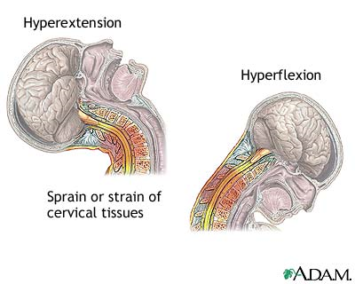

Figure 2- Illustration for cause of neck pain and strain

Physiotherapy can sometimes serve as a low cost alternative to surgical treatment and/or medication. For instance, a published study, *Journal of the American Medical Association (JAMA),* suggested that spine-related expenditures continue to increase without positive results of improvement. However, APTA suggests that patients who receive physical therapy for musculoskeletal disorders experience better outcomes at a lower cost than the use of medication drugs. Physical therapists also work with individuals through early intervention treatment where chronic ailments can be avoided. This is accomplished through Fitness and wellness-oriented programs that promote healthy, active lifestyles.

This notion of stabilizing one’s well-being is seemingly shared with Nintendo’s game developers and manifested through the Wii. They continue to make more genial and interactive gaming environments for both children and adults, while incorporating physical activity in the game play that garnishes support from American Heart Association.

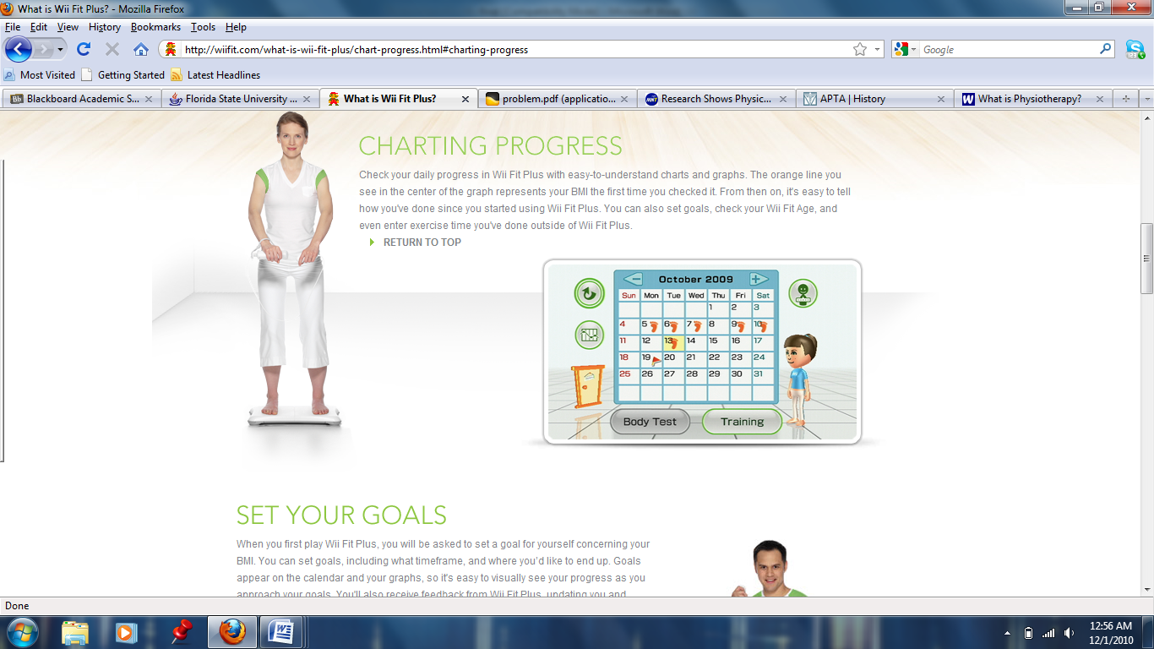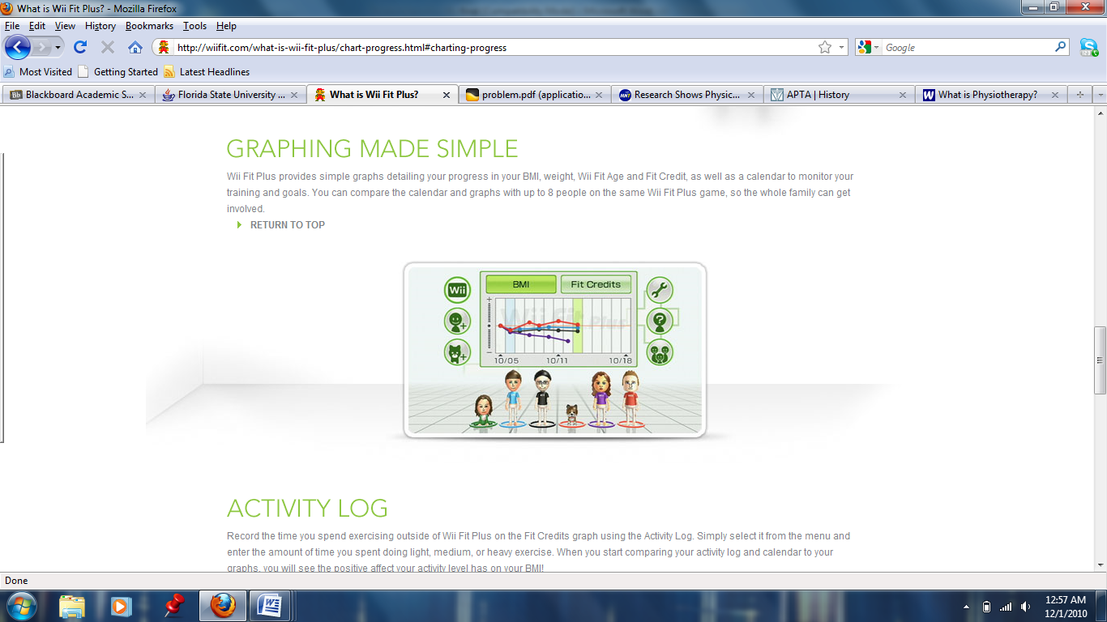It is important for the physical therapist to document the patient's progress so that the physician can modify the care plan, if needed. This documentation is typically given to the physician every 30 days or before the patient sees the physician for a follow-up visit. The Wii fit is an example of how easily the adaptation and organization can be with a system like that of this project’s.

Programs can be altered based on desired attributes. The two screenshots shows how data is logged and how a calendar organizes days of activity. In terms of this project, the physical therapists is able to keep up with the progress of patient. This data is stored on the memory chip inside the Wii-mote.

Figure 3: Wii Fit Screenshots

Currently, the only way to recover and reduce pain from neck injury is through a physical therapist. Skillfully trained, it is still very subjective with no existing method to acquire specific data for each patient. Providing such a method for therapists, doctors, and even patients is the primary goal of this project.

To accomplish the goal of providing a low cost system which can allow patients to perform cervical exercises and allow doctors and therapists to analytically see the range of motion the patient can perform, a number of concepts were designed using the Wii remote control. These concepts range from the number of Wii controllers, the placement of the Wii controllers, the number of LEDs, and the structure of the programming involved. In the end, a decision matrix will be used to determine the best design and the cost of developing the concept.

# About the Wii Components

### Wii Camera

The Wii controller has an onboard infrared camera with surprising capabilities for its size and cost. Presented are some of the characteristics of the IR camera.

|  |  |  |
| --- | --- | --- |
| Wii IR Camera Characteristics | |  |
| Sensitivity | 128x96 |  |
| Image Type | Monochrome |  |
| Resolution | 1024x768 |  |
| Light Intensity | 940nm |  |
| Field of View |  |  |
|  | Vertical | 33° |
|  | Horizontal | 22° |
| Clock speed | 24 MHz |  |

Figure 4: Wii camera

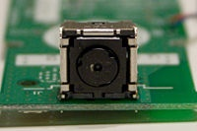

Table 1: Camera Characteristics

As shown in the table, it is a 128x96 monochrome camera. The IR camera is also equipped with a built in image processor which allows it to track up to 4 moving objects at a time. The Wii controller itself has an IR filter which makes the IR camera most sensitive to light at wavelengths of 940 nm. At lower wavelengths, such as 850 nm, it is not detected as intensely but it is resolved much better at closer distances.

The built in processor only provides data for tracking the IR objects (up to 4) and not raw pixel data and with the built in processor it can attain resolutions of 1024x768 by using an 8x subpixel analysis.

There are also 3 modes by which the camera can send data: Basic, Extended, and Full. The Basic mode sends data of just the *X* and *Y* coordinates of the IR sources. The Extended mode sends the same data as the Basic but also adds a rough size value. The Full mode sends the same data as the Extended mode with the addition of an intensity value.

### Bluetooth communication

The Wii controller uses Bluetooth to send information to a receiver. Specifically, it uses a Broadcom BCM2042 Bluetooth System-on-a-chip. It requires no decryption or authentication code to connect so it can easily be connected to by any Bluetooth HID driver. As such, it uses the standard Bluetooth HID protocol to communicate to the receiver. Requesting the Bluetooth Service Discovery Protocol reports back the following information:

|  |  |
| --- | --- |
| Name | Nintendo RVL-CNT-01 |
| Vendor ID | 0x057e |
| Product ID | 0x0306 |
| Major Device Class | 1280 |
| Minor Device Class | 4 |
| Service Class | 0 |
| (Summary of all Class Values) | 0x002504 |

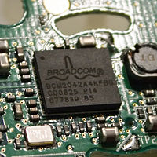

Figure 5: Wii Fit Screenshots

Table 2: Bluetooth Information

# Problem definition

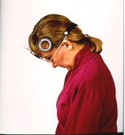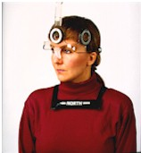There are currently many devices available to assist physical therapists in measuring range of motion. One example is inclinometer. This instrument uses a compass and measures the tilt of the head with respect to gravity. Its cost of approximately $400 can detract potential users. The price also serves as a disadvantage when compared to the low cost attribute of this project.

Another tool for range of motion measurement is a process that uses Tape measurements. The user’s sternal notch is used as a reference point. The measurement is taken from the chin to quantify flexion and extension. Next, the acromion process becomes a reference point to the chin in order to measure rotation. Finally, the chin is replaced by the bottom tip of the earlobe when measuring lateral flexion and extension. In this approach, human error is prevalent and accuracy lacks the precision that this project needs.

Figure 6: Patient Using an Inclinometer to get Flexion and Extension Angles

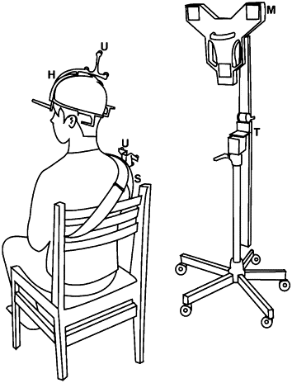Yet another device is the Ultrasound-based motion system that works similar to the tape measurement approach in that the shoulder is used as a reference point. The shoulder strap houses three small ultrasound transmitters while a stand lateral to the seated user houses three microphone transducer sensors. This approach can be high maintenance, expensive to purchase and reproduce, and lacks the transportability factor that this project is aiming for.

Figure 7: Ultrasound

A commonly used device is the Goniometer. It aligns with a joint or a solid point of reference and measures range of motion like a pivoting protractor. In this process, the therapist aligns the hinge to some stationary reference point on the patient and extends the measuring arm as far as the patient’s range of motion. Again, this approach requires practice for efficient utilization of the tool and lacks the precision required for this project.

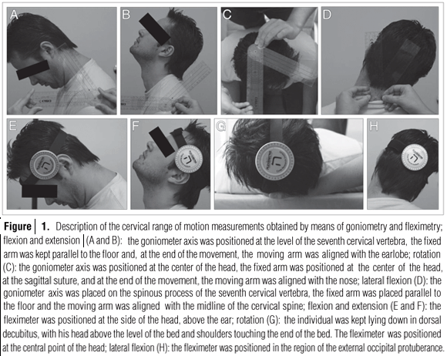

Figure 8: Goniometer Being Used on a Patient

The journeys through the aforementioned devices demonstrate the demand and necessity of this project’s objective. In creating a sensory device and interface that records and displays cervical movements of the head using Bluetooth compatible devices and technology of Nintendo Wii, the client’s interest of a low cost, adaptable, transportable, low maintenance system can be readily available. Additional goals of this $2500 budgeted project that increases its competitive nature in the market is a visual display of the head’ orientation to a maximum error of 5 degrees angularly and ¼ inch vertically/horizontally project budget of, which can underscore inconsistencies with the prescribed motion.

# Product Specifications

There are a few key limiting factors to keep in mind while designing and implementing this particular solution. With a system involving a Wii, there is a certain field of view that must be considered. The infrared LED camera (in the controller) has to be within a 45 degree angle range of the LED source. In addition, the camera can only track up to 4 objects at a time yielding imperative minimization of the number of infra-red LEDs. The environment must also be considered. Interference, both from and to the system from surrounding electronics must also be minimized while still being sensitive enough to yield a maximum vertical and horizontal position error of ¼ inch and maximum angular orientation error of 5 degrees. An important factor to also note is that a major constraint of the above is to keep the unit small and transportable, easily set up and used, and comprehensive and useful for both a physician/therapist and a patient

This project consists of 6 major physical components that include: *LEDS* mounted in a housing which will be attached to the subject, *IR CAMERA* to receive positioning from the LEDs, *BLUETOOTH* devices to transport the data to *STORAGE*. The data is then translated by the *PROCESSOR* within a computer and is viewable on a *DISPLAY*. However, program development of the *interface*, *processing*, and *display* is another major component. The flow of the physical components can be seen in the following block diagram seen on the next page.

.

Figure 9: Flow Diagram



# Concept Design and Selection

## Concept 1 - 1 Wii Controller Monitoring LEDs on Patient

The Wii Remote, also known as the Wiimote, is continually being modified to perform beyond its intended purpose. Many companies are looking to reprogram and incorporate Wiimotes into more formal settings. One example is a low cost dry eraser board made from a Wiimote and other peripherals to better engage audiences during a presentation. In this project, the application of interest is a head tracking device for rehabilitation purposes where a physician is able to prescribe therapeutic movements to a patient recovering from head/neck injury, utilizing assistance of the Wiimote.

The Wiimote is traditionally the Wii's main input device that communicates to the console using standard Bluetooth technology which makes it compatible with standard Bluetooth hosts. It encompasses a 128x96 monochrome camera with an Infrared filter that detects sources with Infrared wavelengths (750-1000nm) and a built in image processor that provides pixel resolution of 1024x768.

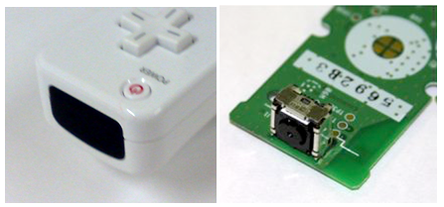

Figure 10- Outside and Inside view of Wiimote showing infra-red Camera

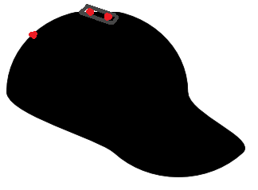As mentioned before the role reversal of these two components is realized through the concept where up to 4 LEDs is mounted on a head piece worn by the user whom moves in front of the stationary Wii remote. Their motion is tracked by the infra-red intensity rating of the LEDs. Naturally everything emits infrared radiation because of the black body phenomenon. In this case however, the infrared filter in the stationary Wiimote records the location of the user through the emitted wavelength range of the LEDs affixed on the user’s device. This helps create depth perception on the display when the user is moving towards and away from the Wiimote. The LED apparatus, or sensor bar, is aesthetically modified in order to present an unobtrusive device that can be comfortably worn. It is simply made up of a small circuit consisting of resistors, diodes, and a battery. There is also a push button switch to control the power source to the elements when the device is not in use.

Figure 11 - Product diagram for mounting LEDs which the Wii controller can track

## Concept ­2 – Wii Controller Attached to Patient

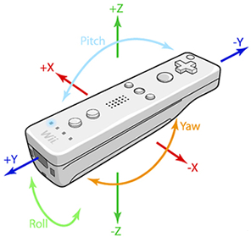 This concept is centered around placing the Wiimote directly on the patient to take advantage of its 3-axis accelerometer. The Wiimote would be placed vertically at the back of the patient’s head so its accelerometer can measure motions in all translations and rotations. Using integration of the accelerations would generate the velocities; an additional integration would provide the position, making it a very simple way of evaluating the data. The angles of the head can also be determined by simple vector analysis, acquiring the angle between two vectors. This data would be sent via Bluetooth and interpreted through the code to output the data in graphical format.

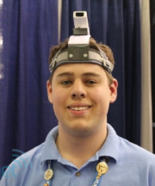

Figure 13 - Directions the accelerometer acquires data.

Figure 12 - Illustration of Controller attached to patient. In actuality, the controller would be placed vertically on the back of the head.

This would be the lowest cost of all the concepts. The Wiimote would be about $40 and the Bluetooth software and dongle would be about $70. This would be a total of $110 not including material costs for the head strap holding the Wiimote.

This simple design requires only the Wiimote and a Bluetooth connection. The data is also easy to understand and interpret to acquire range-of-motion values from. Simple vector analysis also allows getting angular values. However, this approach has not been done before and so there is no foundation from which to work upon. Thus more work may be spent on creating this new system than using an existing foundation.

As illustrated in the diagram, having the Wiimote placed on the patient’s head may make the patient feel uncomfortable. They may feel either embarrassed or they may not be able to hold a Wiimote on their head due to muscle weakness. There is also the possibility of damage to the Wiimote due to its handling by either the user or the therapist. Minimizing this contact would extend the lifetime of the Wiimote.

While this provides the necessary data, it does not completely fulfill the requirements of the project. It would not allow for determining the height of the head; that would have to be measured directly for each individual person. It also does not provide information about initial head positions, which would be necessary for an individual suffering from a neck injury (such as cervical dystonia) where their head may be contorted in a painful position. Such data would have to be determined manually and inputted into the program. This could also be eliminated by using the infra-red camera and infra-red LEDs to determine these values. This would then mean there is no advantage in using the Wiimote accelerometer directly to measure the position and angle of the head.

## Concept 3 - Multiple Wii Controllers

The second concept of design deals with using multiple Wii controllers to enable the tracking of multiple infra-red sources. The Wii controller’s infra-red camera is only capable of tracking up to four moving infra-red sources at once. Therefore, by utilizing a range of 2-4 controllers data can be pulled and analyzed for up to sixteen infra-red sources. Using multiple infra-red sources allows for certain sources to be used for specific tasks such as acting as reference points. There are other advantages of having multiple infra-red sources which will be discussed in a later section. It is not practical to use more than four controllers because the layout and positioning of the controllers as well as the infra-red sources must be taken into account. Though unconfirmed, there is a risk of the camera being unable to track the same four sources each time because there are too many infra-red sources interfering with each other. Overall, the slight increase in accuracy of having more than controllers is not worth the added complexity that it brings.

The options of using 2-4 controllers have been examined more closely. It is important to note that the analysis done for each scenario assumes that elevation and tilt of each controller camera is the same. In reality, the elevation and tilt of the camera can be varied in order to eliminate some of the problems that are presented in each case which could also lead to the use of more than four Wii controllers. In addition, using certain sensors for references can also eliminate some of the problems associated with using multiple controllers.

### Two Wii Controllers

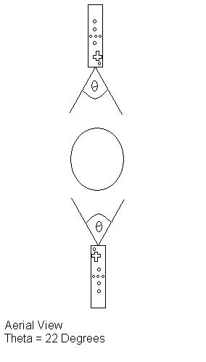 The option of having two controllers allows for a maximum of 8 infra-red sources. Although there is a wide range of placement options for having just two controllers, the infra-red camera is limited to a 33° vertical field of view and a 22° horizontal field of view. The most basic layout is having one controller positioned directly in front of the user, while the other is directly behind the person as seen in figure 8. Figure 9 is a simple variation of figure 8 where one controller is placed at the left side of the user while the other is on the right. Figure 10 shows how the two controllers and be angled differently to face the user. The benefits of having two controllers are an increased total field of view, and multiple sources for data tracking. The cons of having two controllers are that the total field of view may not be large enough and sources might end up off the grid if they escape the field of view. The cost will also be increased by having more sources and controllers.

Figure 14 - Diagram of 2 Wii Controllers and target

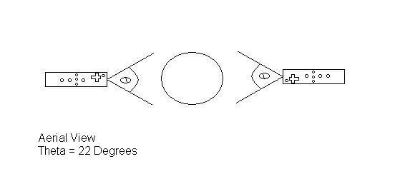

Figure 15 - Diagram of 2 Wii Controllers and target

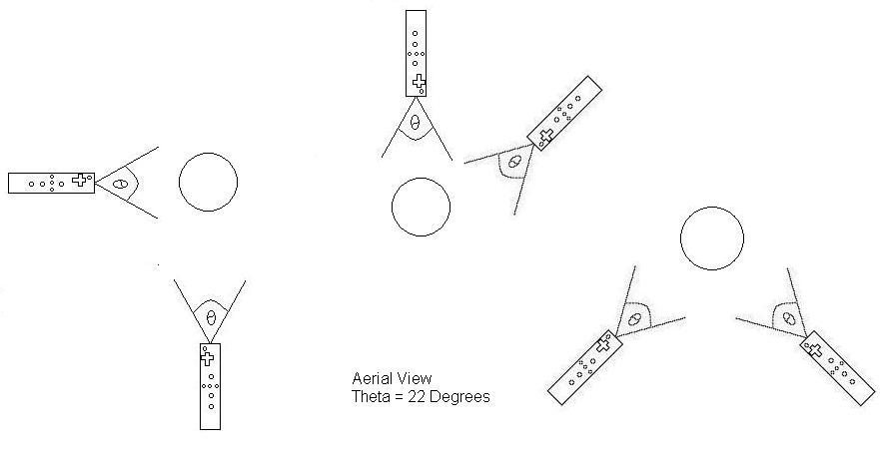

Figure 16 - Diagram of various positioning options for 2 Wii Controllers

### Three Wii Controllers

The option of having three controllers allows for a maximum of 12 infra-red sources. The range of placement options for having three controllers is smaller than having just two controllers because all options would the variation of triangle. Figure 11 shows examples of the various placement options for the controllers. Three Wii controllers can achieve an increased total field of view of the user, and multiple sources for data tracking when compared to that of just two controllers. The downside of having three controllers is a restricted infra-red source placement due to the fact that the total field of view may be too large and sources might end up off the field of view of one controller and enter another. There is a chance that one controller will interpret this as the source is “jumping” from one end of the field to the other. This will add complexities to the data analyzing and manipulating process as well as the programming. Finally, the cost will be increased by having more sources and controllers.

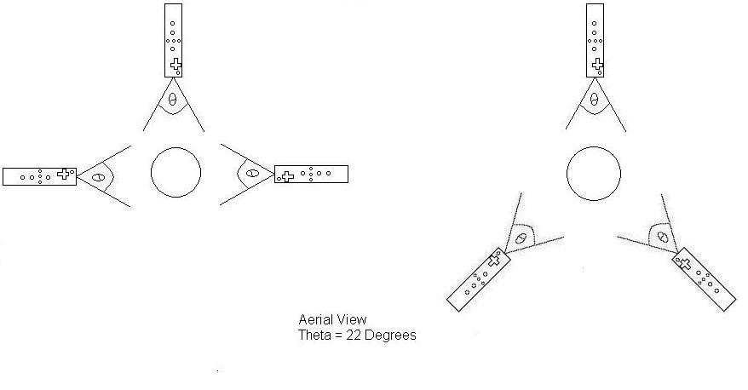

Figure 17 - Diagram of various placement options for 3 Wii Controllers

## Concept ­4 – More Than 4 LEDs

Taking previously discussed designs into consideration, the product can be enhanced by the inclusion of extra LEDs. Extra LEDs will provide monitoring of more areas for more accurate tracking and could even be used to give size and shape data of the patient’s face. Due to the infra-red camera in the Wii remote being limited to tracking 4 objects at a time, depending on the number of controllers used, there will be two options.

### Blinking

This option was initially thought of for use with the single Wii Remote, however, could be incorporated in to use with multiple remotes as well. This concept would yield potential use of a large number of LEDs minimized down to as little as 1 remote.

The Wii Remote includes a 128x96 monochrome camera with built-in image processing and a 100Hz refresh rate. It is however limited to tracking up to 4 moving object at a time. The theory behind this design is that by creating a sequence of blinking LEDs using a slightly lower frequency, new LEDs will appear and disappear allowing tracking of more than 4 regions by the same IR camera. This frequency is so fast (100Hz = 100 times a second) that visually, the human eye will not be able to pick it up, while the camera can, allowing for the rendering of more LED data sets while still keeping a high level of accuracy.

### Filter

This option would be for the use of multiple remotes. If 2 remotes are used, 8 LEDs will be incorporated; if 3 remotes are used, 12 LEDs will be incorporated; if 4 remotes are used, 16 LEDs will be incorporated.

The Wii Remote includes a 128x96 monochrome camera with built-in image processing. The camera looks through an infrared pass filter in the remote's plastic casing and detects 940nm sources at nearly twice the intensity of 850nm sources. Therefore, by changing this pass filter, and possibly editing some of the code for the camera’s data acquisition, the intensity/wavelength the camera can see can be edited. Having each camera view a different intensity parameter will allow the use of more LEDs with constant glow as long as there are only maximum of 4 at a specific intensity/wavelength. This option would be for the use of multiple remotes. If 2 remotes are used, 8 LEDs will be incorporated; if 3 remotes are used, 12 LEDs will be incorporated; if 4 remotes are used, 16 LEDs will be incorporated.

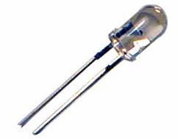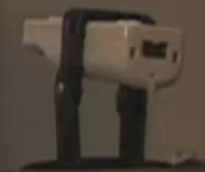

Figure 18- Infrared LED and Wii-Mote Housing

The use of more LEDs while benefitting us with better accuracy and more data types, will significantly increase the complexity of the design. Not only in the physical nature where as proper placement and orientation of the LEDs will be crucial, yielding more apparatuses that the patient must wear and therefore creating a less user friendly and comfortable environment, but the programming and comparison aspect as well. It will also yield a likely less cosmetically appealing and less durable over product as it increase components and over size and power consumption of the head-piece.

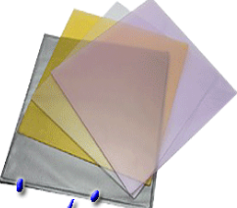

Figure 19 - INFRA-RED Camera on the Wii controller and examples of INFRA-RED pass filters

## Concept ­5 – LED Array and Reflective Device

This concept somewhat couples the way the Wii was designed to work, along with having a mounted controller camera to view the patient’s movements. An infrared LED array is built, the more LEDs/higher intensity of the array, the better this will work. The shape of the array is unimportant, but requires a center cut-out for which the remote’s camera can view through. The array is placed facing the patient and the camera is placed behind the array, peering through the hole, also facing the patient. It is important for the hole to be big enough as to not obstruct the camera’s view. At this point, if the patient is close enough, the infra-red camera can pick up most movements by received infrared light reflections off the skin, but it is highly delocalized and inaccurate largely due to interference. To focus the data acquisition of the camera, the reflection of the infrared light off the body needs to become centralized about significant locations, in this case, the head. This is done by application of reflective tape or another form of reflective device. This design could be adaptable for a second remote for further accuracy and better depth perception. The second remote would not need a LED array system as it would pick up reflections from the main system, as the array is designed to fill the room with infrared light.

This design is user friends and simple. The setup of the array and the Wii remote(s) could be packaged into a single unit, and the user would simply have to put on a head band with a reflective band on the forehead. This will yield a lightweight and stylish package that is easy to use with no worry of complications due to sensitive electronics on the headpiece.

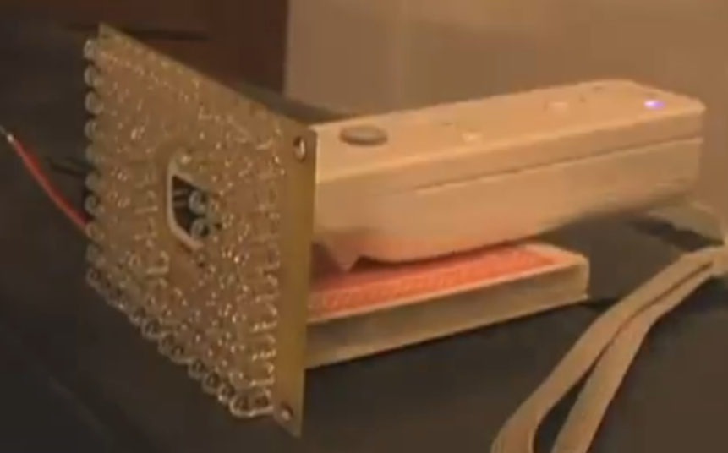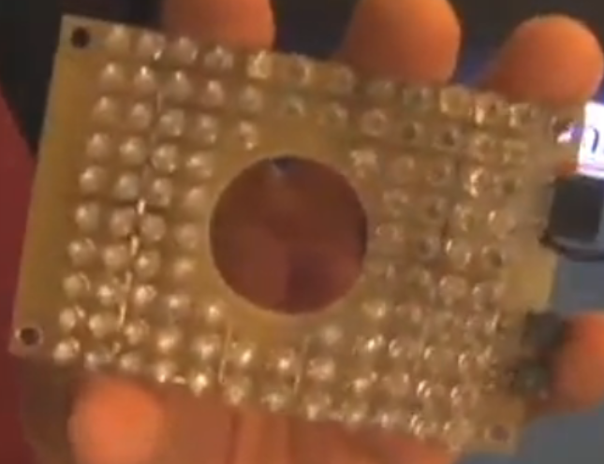

Figure 21 - INFRA-RED LED Array with single Wii controller

Figure 20 - INFRA-RED LED Array

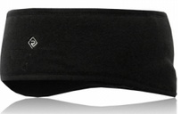

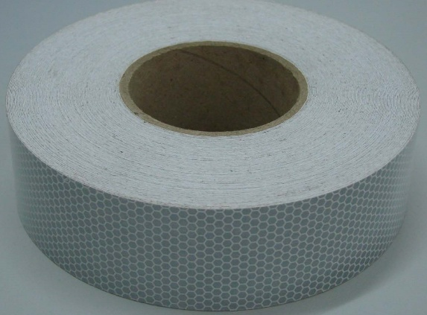

Figure 23 - Headband with Reflector

Figure 22 - Micro-Glass Bead Reflective Tape

# Decision Matrix

With a multitude of different and similar concepts to accomplish our goal, a decision matrix was required to determine the best design. Nine different criteria were selected and each one assigned a weighing factor to designate the more important criteria for the design. Each concept is ranked in a scale from 1-10 with higher being desirable and lower being undesirable (for example, a higher rank in Cost means a lower cost). As can be seen in the following table, the most important factors were designated to be the Adaptability/Versatility and the Design Complexity. This was based on the goal of moving this project for other limbs and to reduce the complexity in designing a final product.

|  |  |  |  |  |  |  |  |  |
| --- | --- | --- | --- | --- | --- | --- | --- | --- |
| Criteria | Weighing Factor | 1 Wiimote | | | Multiple Wiimotes | | | Accelerometer |
| 1-4 LEDs | 4+ LEDS | Array | 1-4 LEDs | 4+LEDs | Array |
| Cost | 0.1 | 9 | 8 | 7 | 7 | 6 | 5 | 9 |
| Durability | 0.1 | 8 | 8 | 6 | 8 | 8 | 6 | 4 |
| Adaptability/Versatility | 0.2 | 6 | 6 | 6 | 9 | 9 | 9 | 7 |
| Efficiency | 0.05 | 7 | 7 | 6 | 5 | 5 | 4 | 9 |
| Portability/Lightweight | 0.1 | 8 | 8 | 9 | 7 | 7 | 8 | 5 |
| Ease of Use/Setup | 0.1 | 8 | 8 | 9 | 8 | 8 | 7 | 9 |
| Accuracy | 0.1 | 9 | 9 | 8 | 10 | 10 | 8 | 7 |
| Design Complexity | 0.2 | 9 | 5 | 9 | 8 | 6 | 7 | 9 |
| Aesthetics | 0.05 | 9 | 9 | 9 | 8 | 8 | 8 | 9 |
| Total | | 8 | 7.1 | 7.65 | 8.05 | 7.55 | 7.2 | 7.5 |

Table 3 - Decision Matrix

The decision matrix revealed that the best design, according to the criteria set, is to use multiple Wii controllers and up to 4 LEDs. This was only marginally better than the single Wii controller and up to 4 LEDs, so it is decided that the goal is to create a final product consisting of multiple Wii controllers and up to 4 LEDs but if during the build process it proves to be impractical the switch can easily be made to using 1 Wii controller which had a better ranking in terms of Design Complexity.

# Meeting With

On November 19th, 2010, our group had met with our Harris contact, Mr. John Rust. Mr. Rust is one of their most experienced design engineers and his insight was invaluable. After exchanging initial pleasantries, we got down to business with our design. Two key issues were brought up in our discussion.

1. Will the infrared camera on the Wii controller be sensitive enough to changes in luminosity?  
   The vision experts with whom Mr. Rust works with on a regular basis expressed their concerns that using luminosity will not be accurate enough in determining the z-value or ‘depth’ of the image in the Wii infrared camera.
2. How to differentiate the infrared LEDs from each other.  
   This is an important issue as it is uncertain how the Wii controller will store these values and whether it will be a simple matter to choose the LEDs which we want.
3. How do we plan on getting all 6-degrees of motion if the luminosity may not be accurate?

The end result of this meeting was to bring to mind the importance of doing rigorous testing on the capabilities of the Wii controller. Though our research indicated that the Wii controller is capable of determining depth, our group will need to determine what the accuracy it possesses in doing so is. In the meantime, design changes will need to be made to account for these issues and circumvent possible problems due to these issues.

The issue of determining how the Wii infrared camera differentiates the various infrared LEDs is unknown at the moment. A meeting has been set up with the vision experts at Harris Corporation so we may gain insight into how to solve this problem as well as how to acquire depth data if luminosity proves to not be accurate enough.

Overall, the message at the end of the meeting was this: rigorous testing must be conducted on the Wii controller’s infrared camera to determine its accuracy in getting depth data and in how to differentiate the LEDs. These tests will be conducted at the start of the spring semester and will be paramount to what our final product will look like.

# Therapist Consultation

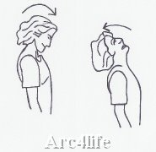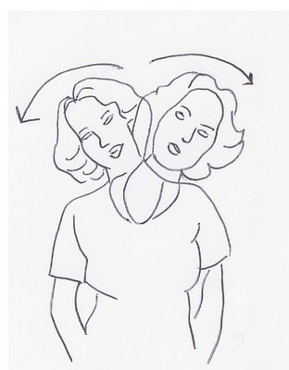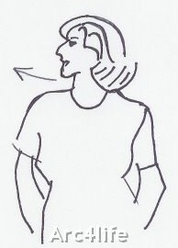 On November 19th, 2011 we met with Tyressa Judge who is a Physical Therapist for the FSU Thagard. After giving her a brief explanation of the nature of our project, she helped to explain just how a physical therapist tracks head motion manually. The key motions that a physical therapist measures for patients needing cervical care are head extension/flexion, lateral extension/flexion, and rotation. Each of these is depicted in the figures 1-3. Any other type of movement involving the head is a combination of the three different movements. When measuring each of the three parameters the physical therapist uses the acromioclavicular joint (shown in figure 4) of scapula as a reference point because this point does not move in relation to the head and neck. This is a vital piece of information that will influence where the reference LED will be placed. Since each patient is not the same build or height, it would not be feasible to expect a certain reference point to work for all patients. However, if the reference LED is placed on the acromioclavicular joint of scapula, then we will have a good reference point that will be specific to each patient. Tyressa also explained that she uses a goniometer (a tool that measures angle and is similar to a protractor) when measuring head rotation in conjunction with the patient’s nose to track the rotation. As far as cervical exercises for rehabilitation are concerned, there are not many exercises one can do as it depends on the nature of the injury. However, Tyressa explained that a disability is determined by measuring flexion, extension, and rotation. The patient’s range of motion can be tracked overtime to determine the progress made in the healing process.

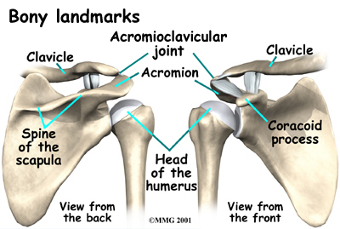

Figure 27-Picture of Acromioclavicular Joint

Figure 26- Example of Head Rotation.

Figure 24- Example of Head Flexion/Extension

Figure 25- Example of Lateral Flexion/Extension

# Updated Design

The consultation with the physical therapist as well as our meeting with John Rust, influenced several changes to the design of our Wii-Mote station. Tyressa stated that she has the patient sit in a chair when measuring the range of motion for the three motions. Thus, we implemented a chair design where the patient will sit as seen in figure 6 instead of the microphone station as seen in figure 5. This eliminates the need for a reference point in the Wii-Mote station where the patient will have to stand. Instead, the patient can now sit in the seat, assuring that they will be in the same position each time. The handles are for additional support in ensuring the acromioclavicular joint does not move. One additional change is the implementation of 3 Wii-motes as opposed to just 2 from the previous design. The benefit of using 3 Wii-motes in this positioning is the elimination of using luminosity to determine the depth of an LED as it will be seen as an X-Y coordinate for another camera. The possible complications of using luminosity to attain the depth value of an LED hotspot were brought to our attention during the meeting with John. The address this problem, the updated design positions each Wii-mote so it can capture a specific motion. By implementing this solution, the depth of an LED will simply be the X/Y coordinate read from a different Wii-mote. The Wii-mote above the patient will capture head rotation, the Wii-mote behind the patient will capture lateral extension/flexion, and the side Wii-mote will capture regular extension/flexion. The Wii-motes will still be attached to the microphone stands, which will be welded to the back of the chair. It is important to note that all the Wii-motes are pointed at 90⁰ angles to the patient, focusing on a single plane of motion.

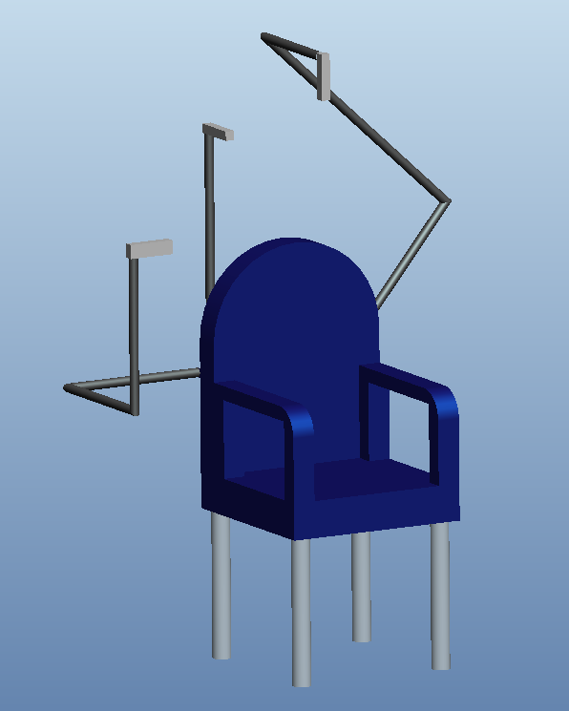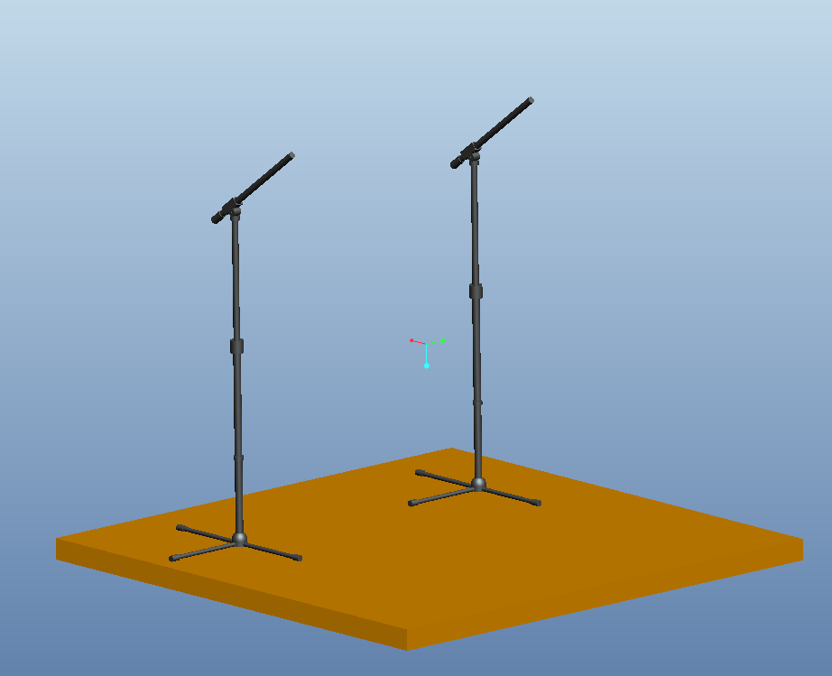

Figure 29- Updated Design for Wii-Station

Figure 28- Interim Wii-Station Design

The second part of our updated design is focused on the LED placement. Our meeting with John Rust brought about the concern of disappearing LEDs and LED differentiation from the camera view. Our original design incorporated LED hotspots mounted on the side of glasses by the temple or on a wraparound headphone style headset on the ears. While these are great points of reference, turning or rotation of the head can easily block the camera from seeing both LED hotspots. This would cause confusion and render an error, likely crashing the software, and in the least would yield an incomplete dataset for motion and extremity analysis.

Therefore, in collaboration with the previous design update to three Wii-motes, we optimized our LED placement and headset. First of all, in addition to referencing points to the Wii-mote itself, like the Wii console does, we are mounting an LED hotspot using a generic housing with putty on the base to the acromioclavicular joint of the shoulder. Then, by using a standard baseball cap we can create a line of LED hotspots that will emit light in all directions for the cameras to view and reference against this point. Mounting a battery source and circuitry to the brim of the hat for stability and to drive the system, there will be two LED hotspots mounted on a plate attached to the center pin of the ballcap, seen in figure 9. This line created by the LEDs, when sitting and looking straight forward will yield a parallel axis to the ground, seen in figure 8. Therefore the camera view from above can easily capture the angle of rotation. A third hotspot will be positioned in line with the first two, but on the back portion of the hat. This is so that the rear view camera, which focuses on lateral extension/flexion, will have two points to track in reference to the point on the acromioclavicular joint of the shoulder, seen in figure 7. These points will also satisfy the side-view camera in measuring the standard head extension/flexion. Further explanation of how the angles of movement required for therapeutic analysis are calculated will be explained in the following section. In this way, under proper use, the required LED hotspots will stay in plain view of the necessary camera and there can be no LED differentiation issues while still maintaining the ability to measure both the extremities of the range of motion and track the motion itself for the pre-described exercises, and any combination of the three.

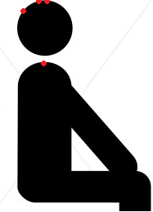

Figure 32- headset with LED placement

Figure 31- front view of LED placement

Figure 30- side view of LED placement

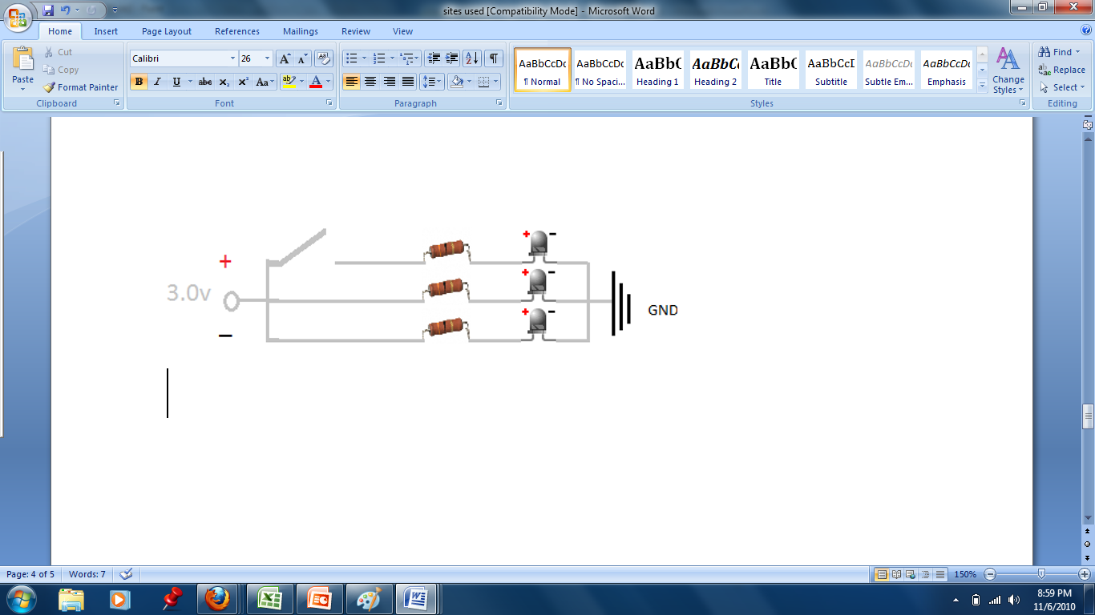

Figure 33: Circuit Design for LEDs

The figure above shows the circuit design for the infrared LEDs. These LEDs will be positioned on the hat as shown in figure 28 on the previous page. The design is simple and thus allows for easy replacement and repair for even someone with little technical expertise such as may be the case with a therapist or a patient. The design requires very little power and so the batteries of choice are AAs as they are light and give the most run time for the LEDs as shown in the next diagram.

Figure 34: Run Time of LED Circuit Utilizing Different Batteries

# Equations and Calculations

Equation : Equations for Acquiring Angular Changes in Cervical Position

The equations above are those we plan on using to determine the various angles of the rotation and flexion and extension of the head. The first equation in Equation 1 above is the angle acquired from the flexion and extension of the head. This is the up-and-down motion one does with the neck. The second equation acquires the angle of lateral flexion and extension, the side-to-side tilting of one’s neck and head. The final equation determines the rotational angles of the head and neck. This is the left-to-right motion. As can be seen, one LED point will essentially remain unmoving since it is positioned at the top of the patient’s head, providing a stable point by which to get the rotational angle.

Essentially the angle of the slopes of two LEDs is calculated using simple trigonometry. The individual points are referenced to the LED positioned at the acromioclavicular joint. The equations are simple, but capable of determining the angles we wish to acquire.

## Error Propagation

There is some error associated with this, but that can be determined using the equations of error propagation. The errors associated with addition, division, and inverse tangents are as follows:

$$∆Z=\sqrt{{\left(∆A\right)}^{2}+{\left(∆B\right)}^{2}}$$

Equation : Error propagation of addition

$$\frac{∆Z}{Z}=\sqrt{{\left(\frac{∆A}{A}\right)}^{2}+{\left(\frac{∆B}{B}\right)}^{2}}$$

Equation : Error propagation of division

$$∆Z=\frac{∆A}{1+x^{2}}$$

Equation : Error propagation of arctangents

Throughout our research, it was determined that the error in position of the Wii controller’s infrared camera is 2 millimeters. This is well within the ¼ inch constraint that Harris set forth for us. We can use Equations 2-4, assuming worst case scenarios, in succession to determine what the maximum angular error we can expect is. Using these equations, it was determined that the maximum expected error in determining the angle would be ±2°. This is also well within the constraint set by Harris.

# Processing and Storage

Inside of the device, the processing will likely be done by a microcontroller unit (MCU) because of its low cost, high-efficiency, all-inclusive nature, and its optimization for specific purposes. The device that will be attached to a patient and used to sense orientation will carry out this basic function and do nothing else (besides transmit this data). In this respect, the processing should not be very intensive, and a microcontroller will provide all of the necessary computing power. Microcontrollers, unlike general purpose microprocessors, also tend to have RAM storage for data and ROM storage for programs in dedicated units already on the chip.

Nintendo opted to use the Broadcom BCM2042 microcontroller for the Wii Remote’s main processing. It was likely used because of its dedicated Bluetooth integration and capabilities. A microcontroller of this sort is openly available to the public and to other manufacturers for purchase and product incorporation, unlike the proprietary IBM *microprocessor* (codenamed “Broadway”) that is found in the actual body of the Wii console. On the manufacturer’s website, the BCM2042 is actually advertised as a wireless keyboard/mouse Bluetooth solution, so it certainly isn’t only available to Nintendo for Wii purposes.

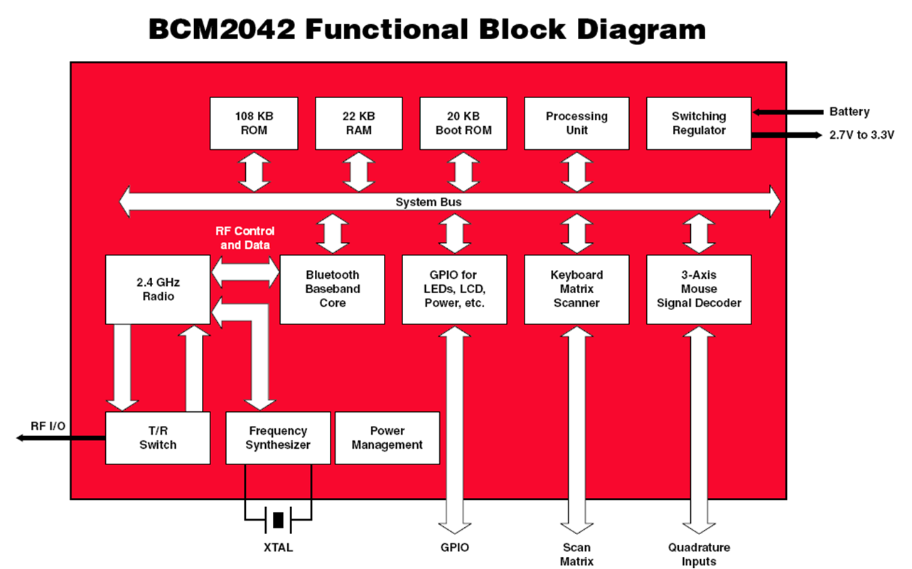

The bulk of the set of instructions that actually define that Wii Remote’s functionality have already been constructed and well tested. In that case, little to no new code has to be developed for the purposes of updating the device’s “firmware.” However, if a blank BCM2042 is used and original code is necessary, the proper development resources are available and well-documented.

The BCM2042 System-on-a-Chip (SoC) is based on the 8-bit 8051 architecture, first developed by Intel in the 1980s for the popular MCS-81 μC. Development for the 8051 architecture, or the *Intel 8051* as it is referred to at times, can be done in assembly language or C, using freely available and open source software. The AS31 Assembler is a free assembler for code written in 8051 assembly. A free and popular C compiler, not just for the 8051, but a wide range of MCUs, is the Small Device C Compiler (SDCC). Source code for 8051 devices can be produced in any pure ASCII editor, but they must, of course, be assembled or compiled before programs can be executed on the chip.

Speaking of programs, Nintendo engineers have seemingly developed an unexpected way of storing and loading programs to the chip in the Wii Remote. They did not exactly utilize the provided 108 KB ROM block in the BCM2042 to store the device’s functionality. Instead, there is a separate electrically erasable programmable read-only memory (EEPROM) unit (model number M24128, made by STMicroelectronics) on a different part of the board that is used to store permanent information. When the system powers up, the Broadcom chip simply fetches the functionality code from the EEPROM (circled below), loads it to the on-chip RAM, and executes it in that fashion.

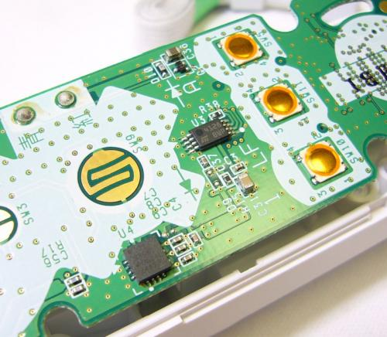

Figure 35: EEPROM Chip inside the Wii Controller

The *physical* processing and storage aspects of the system’s *display* component don’t need to be evaluated as painstakingly. Most computers nowadays run on one of three operating systems: Windows (x86 or x64 chips), Mac OS (x86 or legacy PowerPC chip), or Linux (variable processors).

As far as storage goes, the display application will most likely store quantitative records of the patients’ medical performance. In the case of a rehabilitation application, these records can be in the form of a progress report (text file). In the case of a real-time patient monitoring application, these records can be in the form of an activity log (another text file). Text files can generally be read similarly in all computing environments.

After the information received via Bluetooth from the patient is processed it will translate into data visible by the user on a computer screen. The results will graphically mimic the pitch, yaw, and roll of the patient’s head movements by the corresponding x, y, and z-axis. It will also show the contrasts and differences between the movements prescribed by the physician and the user’s motions. In addition, it would be able to display numerical data, extremes and outliers, time scales, and instruction. Programs such as MATLAB could be used for this 3D vector analysis. This will help correct the user during their unsupervised sessions, while allowing the physician to keep up with the progress of the patient condition especially when face to face meetings are not possible.

# Interaction Style and Display

The system’s user interface is an especially important component. It essentially acts as the face of the entire product. Since the technical skill, medical knowledge, and physical ability of each potential user will be different from the next, the interface must be easy to understand and interpret across a wide range of demographics. A graphical interface approach is the best way to implement the current concept. Graphical user interfaces (GUIs), when designed properly and judiciously, are much more intuitive than command line interfaces in terms of operation, and they give the user an increased feeling of control. A command line interface would most likely intimidate a user of limited knowledge.

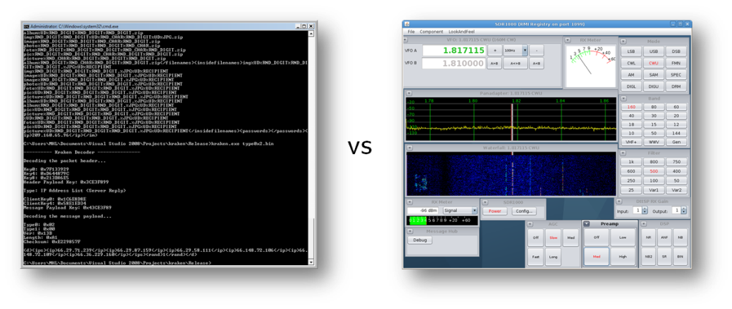

Figure 36 – Illustration of the different interaction styles: GUI vs Command Line Interface

GUIs also take advantage of the spatial and visual cues of the environment. A graphical interface will also, and perhaps most importantly, allow streaming data from the device to be illustrated onscreen in a representative way. A three-dimensional *head* will appear in a virtual space and will react to changes as the wearer actually moves his/her head.

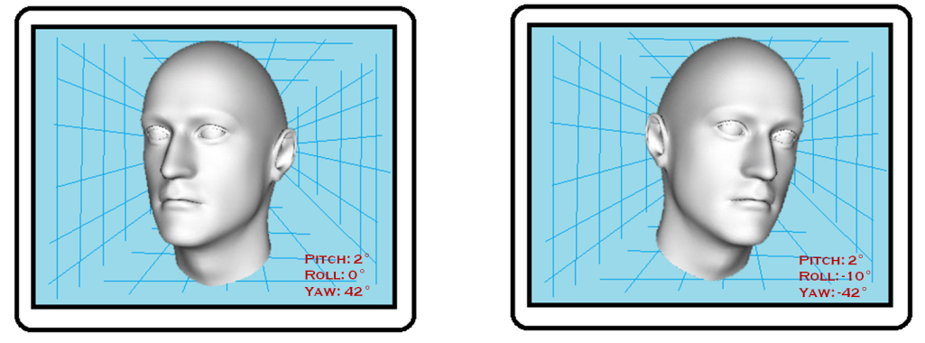

Figure 37 – Rough mockup of the conceptualized virtual image

Raw data that is sent from the device to the user console will manifest itself graphically on screen. This will help the display interface spatially illustrate the data and instruct the user. The previous diagram is a rough mockup of the way visual data can be represented. Measurements like yaw, pitch, and roll can perhaps be displayed in a more interpretive manner. That is, not all medical professionals have knowledge of such terms.

# Data Presentation

The features of the application that quantify and record data must also be discussed. The current concept involves definitely using a graph to chart the physical performance of the patient at a given session. The data points that are taken from the patients’ actions would be in x-, y-, and z-coordinate triplets. To handle all of the data and present it in a readable chart, the points could be plotted in a 3D graph. For easier understanding, the points could even be connected with a line to simulate the path around a point of origin that the points take while attached to the moving head, shoulders, etc.

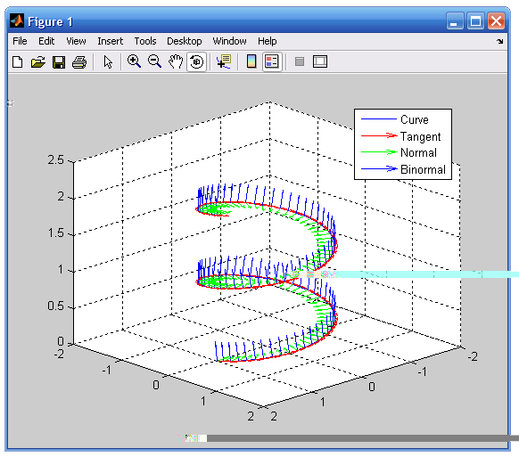

Figure 38 – Data can be displayed in a 3D graph

Another way to present the recorded data would be to plot the points in three different 2D graphs, one graph for each dimension in space. Each graph would have a “coordinate versus time” layout. In each graph, the value of the dimension’s respective coordinate (corresponding to the vertical, dependent axis) would vary as data points progress sequentially (with the horizontal, independent axis). Presenting data in this way will allow movement in each dimension to be analyzed individually. This approach is actually probably truer the ultimate design because the head (and neck) won’t be treated as a ball-and-socket joint, and the three directions of movement will need to be focused on more closely individually than on a whole.

# Programming Language(s)

After defining the desired capabilities of the application and the general characteristics of the interface, it becomes easier to determine what programming language(s) would best suit the development. Several languages have the proper tools available to create a graphical user interface. Popular languages like Visual Basic, C++, and C♯ are all competent options for this purpose. Creating graphical applications in C and C++ isn’t as uncomplicated as doing so with other languages that have features specifically built in to accomplish such a goal. Visual Basic is well-known for being a very easy to learn language. Popping out a simple working graphical application in a couple of hours isn’t unusual at all for first time users of VB. One disadvantage of learning Visual Basic comes from the fact that its syntax and structure are very different from already popular, influential and ubiquitous languages like C and C++. C♯ is a more robust fully object-oriented programming (OOP) language that is heavily influenced by popular OOP languages like C++ and Java in terms of syntax.

However, C♯ and VB both share a major disadvantage that will affect application compatibility. Programs written in these particular languages (and others not mentioned here) can only be executed on a runtime engine called the Common Language Runtime (CLR). The CLR is, in actuality, another software application in itself that must be present on the machine that this system’s software will run on. This is because C♯ and VB are Microsoft-developed languages that are a part of its .NET technology, which requires all .NET languages to run on the CLR. The .NET technology has proven its worth in countless arenas. However, the main inconvenience of .NET (and indirectly C♯ and VB) lies in the fact that the CLR is only available for the Windows platform. At this point in concept development, it would be ill advised to restrict the system domain to only one type of platform. Since little knowledge is known beforehand about the end type of platform, the display application should, ideally, be run on any readily available personal computer or server.

Enter Java. Software developed in Java has the benefit of being executed exactly the same on any system due to its Write Once, Run Anywhere (WORA) mantra; it would not have to be compiled for three, or even more, different systems. Like .NET languages, the technology behind Java is also based on a runtime engine, the Java Runtime Environment (JRE). However, the Java platform is available for several different underlying architectures, operating systems, and it has even been implemented right on the hardware.



Figure 39 – Simple diagram that shows the Java platform

Java is an especially attractive option because, currently, no information is known about the type of computer this display application will eventually run on. By generalizing the software development as much as possible, more flexibility is achieved. Another benefit of using Java is the availability of its flexible Java 3D library, which is an API based around 3D graphics.

## Performance

One of the key drawbacks of Java versus a language whose programs get run natively on the machine (like C and C++) is the performance. It’s obvious that Java programs will ultimately run a little slower than other programs, simply because of the underlying technology. Java programs will have to be compiled into bytecode before it can be executed as machine-understandable instructions. All these translations must happen on the fly. As a result, the application ends up being a little slower, not noticeably though. Computers execute millions of instructions per second. “A little slower” is an acceptable trade off for portability. Even though this application may be slightly graphics oriented, the level of intensity may not require performance to be overly optimized. Besides, Java has made numerous strides in its performance department.

## Data Presentation (Revisited)

For the graphing capabilities of the system, a robust Java library would be necessary. There are several out there to be readily downloaded, many of which are free such as the Java Universal Network Graphic (JUNG) Framework, JGraphT, and JFreeChart. Another quite attractive option would be to use a component that builds on current knowledge of a particular type of data visualization platform. Specifically speaking, it would be handy if the application could be developed by integrating the plotting capabilities of MATLAB right in the code. MATLAB is a ubiquitous engineering staple with very useful graphing capabilities built in.

It turns out that there is, in fact, a tool called the MATLAB BuilderTM JA that effectively takes programs written in MATLAB and ports them to Java as classes. As useful as this solution could prove to be, it also turns out that MathWorks, the company that makes MATLAB, loves significantly overpricing its products (granted, they are high quality products). A 2009 MathWorks Family of Products Sheet listed the MATLAB BuilderTM at $4,000. That’s $1,500 more than the proposed budget of this project. Needless to say, that option must be discarded. However, as stated earlier, there are plenty of free graphing libraries out there that can be taken advantage of.

## Code Generation

Two very capable and freely available Wii Remote libraries were explored and tested. One was for C♯, and the other was for Java. The C♯ (or .NET to be specific) library, WiimoteLib, was developed by Brian Peek for use in the Wiimote development community and conveniently makes very complicated connection methods simple one-line statements. Using WiimoteLib, test applications were developed and successfully executed in Visual Studio 2008. The Java library, WiiRemoteJ, was developed by Michael Diamond for similar purposes. A test application that uses this Java library was developed in the Eclipse Integrated Development Environment (IDE). However, after several runtime errors were thrown, it was gradually realized that more than the implementation file and the library were needed to make the application work. More detail is given in the next section.

Here is a general overview of the data flow in the application:

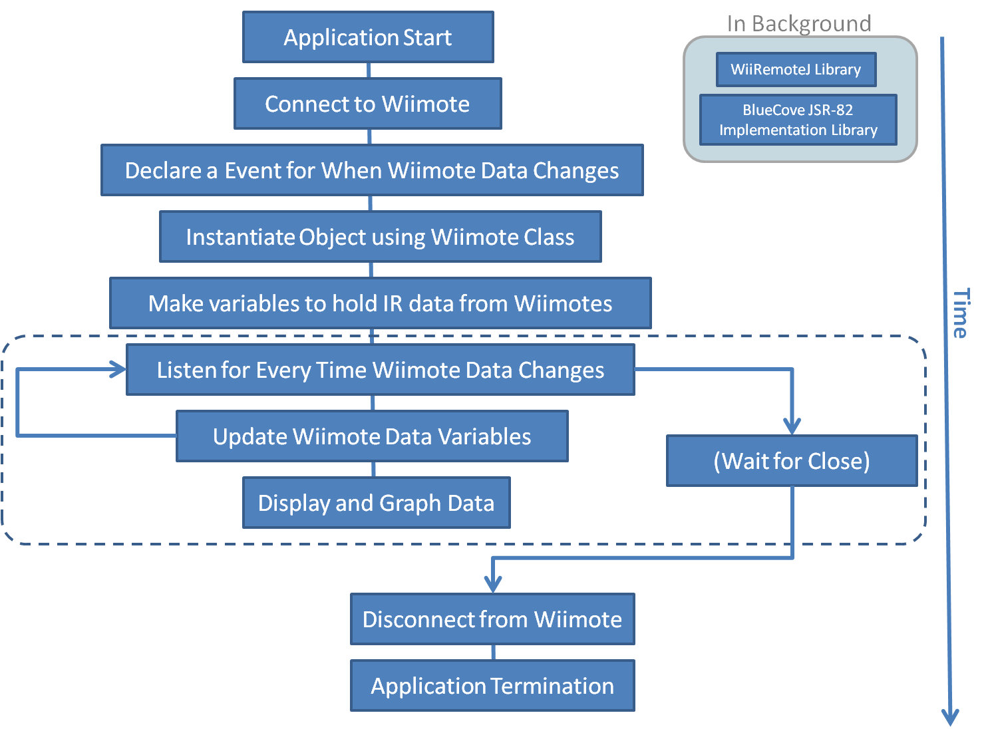

Figure 40: Block Diagram of Design Process

## Java and Bluetooth

In order for Java applications to use Bluetooth, there must be something called "an implementation of the JSR-82 specification". This is basically a Java library that implements all the relevant protocols and profiles and other communication entities that make Bluetooth work. This library contains the connection methods and functions that get referenced by the WiiRemoteJ in its code. Once the JSR-82 implementation is added to the project, it doesn’t have to be touched, but it *is* necessary in order for the Bluetooth to work.

There are not a lot of JSR-82 implementations already in existence that are widely available, and there are far fewer free and/or open source ones. Only two free ones for testing on Windows were found: BlueCove and BlueSock. BlueCove is promising in particular because it works on all major operating systems. Both are supposed to do what’s needed, but after “installing” them, more errors were found. The main problem was discovered to be the installed Bluetooth stack that was on the testing computer (a Bluetooth stack is just a driver that makes the physical Bluetooth radio hardware work). The testing computer was using the native Microsoft Windows Bluetooth stack (AKA Winsock) that came with it. The Winsock driver does not support L2CAP, nor is it available for other operating systems. L2CAP is one of many different types of Bluetooth protocols and one in particular that WiiRemoteJ needs to work properly.

A more compatible stack for WiimoteJ is the WIDCOMM stack, produced by Broadcom (the same company that makes the Bluetooth hardware). It works better than the other third-party stacks (BlueSoleil for example) and has less JSR-82 limitations than the others. The system’s final software will include a BlueCove JSR-82 implementation and a WIDCOMM Bluetooth stack. The following chart gives a comprehensive illustration of how all these components interact.

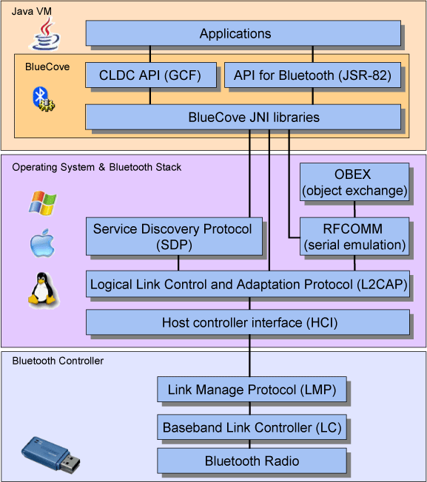

Figure 41: Java and Bluetooth Hierarchy Structure

# Material and Item Selection

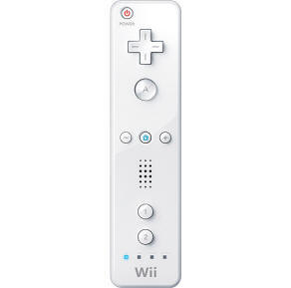 To accomplish the goals of this project, a number of items and materials are needed. Paramount to all are the essentials:

* Wii remote controllers
* Wiimote mounts
* Infrared LEDs

These are the necessary components which will allow for conducting head tracking of a patient. Other components that will become necessary for accomplishing are the following:

* Microphone Stand and Booms
  + The Wiimote mounts will be attached to these via a ¼-20 threaded screw
* Chair with armrests
  + 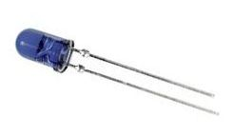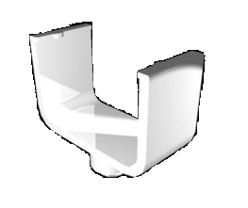These will allow for comfort for the patient and be a stable platform by which to attach the microphone stands from which the Wii controllers will be pointing
* WIDCOMM Bluetooth Stack
  + This is the stack by which a computer will be communicating with the Wii controllers. This is the stack that is compatible with the Java implementation and library
* Kensington Bluetooth Dongle
  + This dongle was determined to be most compatible with the Wii controller, the WIDCOMM stack, and also possesses the necessary Bluetooth protocol (L2CAP) for communication using the Java library
* Hat
  + This will serve as the mounting location of the infrared LEDs placed at the positions described earlier.

Using this collection of items will allow us to accomplish the goal of creating a low cost method of head tracking for use by both patients and therapists. These items are plentiful and available at relatively low costs and are reliable.

# Cost Analysis

|  |  |  |
| --- | --- | --- |
| **Item** | **Quantity** | **Cost** |
| Wii Controller | 7 | $300 |
| LEDS | 20 | $17.98 |
| Bluetooth Dongle | 2 | $30 |
| Microphone Stand and Booms | 3 | $60 |
| Wiimote Mount | 4 | $59.80 |
| Hat, Batteries, and Chair | 1/14/1 | $0 |
|  |  |  |
| **Total** |  | **$467.78** |

Table 4: Cost Analysis

Considering the customer’s request of a low cost system and a project budget of $2500, above is a cost analysis summary. The analysis assumes all tools required are readily available which includes, but is not limited to: a computer system with all necessary software and rights for configuration. It also allows an inventory of replacement parts to be kept in order to prevent delays and for each designer to have a remote and LED pen for testing and development. After prototyping and testing along with the infra-red sensitivity and viewing distance optimization, additional funds may be required to further debug the device, but a current expected total is listed at $467.78. It is important to not, that reproduction cost to the customer will be significantly less at about $200 a unit. Following this accordingly will meet and exceed customer satisfaction and keep the project on schedule, well within budget.

# Conclusion

Harris Corporation wants to break into the healthcare market with an innovative, new product. They presented us with a problem focusing around physical therapy and rehabilitation. Head and neck injuries are the most widely reported injuries in the United States to insurance companies for disability claims. The patient currently must go to a therapist for diagnosis and initial measurements. It is important to note that the neck is not a ball and socket joint, and that range of motion is comprised of three basic exercises: rotation, flexion and extension, and lateral flexion and extension. These measurements are generally taken using a goniometer, a protractor like device which the therapist references to major facial features and the acromioclavicular joint on the shoulder, tape measurements, or an inclinometer, a compass like device that acts in respect to gravity. These unfortunately yield somewhat arbitrary measurements due to human error and inconsistency as they are based solely on the therapists positioning and reading. The patient then has to go through the drawn out process of attending periodic appointments in order to document improvement of their range of motion. Harris Corporation wants to remedy both of these situations with a simple, precise, low cost, portable alternative.

Proposed to us by Harris Corporation was to design and develop such a device using components from the highly popular, motion sensing Wii video gaming console. Objectified, the scope was to construct a device to monitor range of motion via head tracking. This included creating a housing to mount the infra-red LEDs, which the camera in the Wii controller could track. The device needed to be adaptable for use on the head of the patient while considering potential expansion to other body parts such as arms, legs, and etc. In addition software needed to be developed which will interpret and transfer the tracking data from the infra-red camera into a format that is easily comprehensible a processing and analysis unit as well as a display program. Harris Corporation expressed the need for the design of an interface to record and visually display orientation of the selected body part with a maximum error of 5 degrees angularly and ¼ inch vertically/horizontally within a standard reference frame. The ultimate goal was to create a low cost, light-weight, transportable, wireless, and easily implementable product that will allow for physical rehabilitation exercises of the head to be completed from the patient’s home, office, or any location a computer system that has the ability to package and transport the results from the patient to physician or physical therapist. These results will allow for easy determination of head movement range and deficiencies for purposes of insurance and disability claims, therapeutic and emotional needs to see progress, and in most cases, eliminate the need for frequent therapy visits.

The Wii video game console uses a ‘sensor bar’ comprised of two hotspots of 5 infra-red LEDs at the ends of a 20cm long housing. Inside the wii-mote there is a camera with a 33 degree horizontal, 22 degree vertical viewing angle that is filtered for approximately 750nm to 940nm wavelengths of light. In reality, the LED hotspots have nothing to do with being a sensory, the actual sensory device is the camera and the accelerometer in the controller. The LEDs simply act as a reference point. After considering such possible designs as using an infrared array to reflect off of highlighted areas, using the accelerometer from the controller attached to the patient, we decided on a concept that essentially reverses the roles that the Wii console uses. By mounting a set of LEDs on the patient, and using a set of controllers as stationary viewing and tracking devices, we will achieve the desired results.

Further focusing our concept after input from both John Rust, a design engineer from Harris Corporation, and from Tyressa Judge, a physical therapist at FSU’s Thaggard Health center, we come to the optimized design concept we have today. First, let’s consider the station. It has to be such that it minimizes excess movement while providing a comfortable environment for the user. We have chosen to base this off of a folding chair with included fold-up/fold-down armrests. As stated previously, a good reference point for cervical range of motion is the acromioclavicular joint . Using armrests properly will eliminate motion in this area, which is a must considering that the product may be used from home without therapist supervision. In addition, the cushions and standard everyday appearance will make the patient feel comfort in his or her vulnerable state. The chair’s frame allows accessible mounting points for the microphone boom stands, which will hold our wii-motes. The boom-stands allow a wide range of motion and viewing angles for testing purposes and implementation for alternate motion monitoring, as well as yielding a collapsible, portable framework. For the head tracking, the microphone stands will position the wii-motes’ camera at 90 degree angles to the plane they are referencing. A view from the side of the head will measure flexion and extension; a view from the back of the head will measure lateral flexion and extension; a view from the top of the head will measure rotation. To take these measurements, a headpiece, built off of a standard baseball cap is used. A AA battery source and circuitry is mounted to the brim of the cap, and a line of three LED hotspots will be present on the top, two on a flat plate connected to the center pin and the third on the back center. The hat will have an adjustable strap on the back to fit most head sizes without compromising LED positioning. In addition, a fourth hotspot in its own housing will be placed via paste on the shoulder for reference. With this, all necessary LED hotspots stay in view of the necessary camera, while yielding a suitable environment for the patient to record their recover.

The data recorded by the cameras, is written and stored in a text file at 4-byte-long integers as was expressed by the developed test programs. This data can then be transferred via bluetooth to any standard computer with proper software installed. Currently, we have developed programs to record the data received by the controllers and are delving in to the transfer interface. A WIDCOMM stack and BlueCove JSR-82 imp was chosen for Java compatibility on any system, low cost, and ease of access. The java library used for the wii-mote is WiiRemoteJ and a graphing interface is in progress. If necessary, we can revert back to the C# library in which graphing simulations have already been developed, however it will then only be compatible on PCs and Windows machines. Considering their hold on the computer market, this should not pose much of an issue, but a system fully compatible with all machines is desired. In addition, we again have chosen a Java framework for the display and instruction to the user due to it allowing the most versatility and greater visual appeal.

Currently, referenced against our schedule attached in the appendix, we are on time for completion in March of 2011. Upcoming this December, the final parts – Bluetooth dongle and wii-mote stands – will be received which will complete our parts inventory for the build. After receiving these parts and being able to physically view and measure what we have to work with, we will design a coupling system for the stand attachments which allows fold-up portability and/or disassembly transport options. In addition, we are in the process of scheduling a phone conference for December 13th to speak again with the Harris Vision Team regarding our updated design. We hope to receive positive feedback and further insight on our approach, testing, and software development. From here we can begin further testing and analysis on the system. By the second week of January, using our already developed test programs, we intend to have a basic prototype and LED luminosity and camera sensitivity will be optimized to the camera’s viewing distance. This will be done by running a series of simulations and finding the correlation between the data sets. Within the programming aspect of our design, we are currently working on modeling the graphing environment. This is being somewhat inhibited due to the use of Java, as a compatible WIDCOMM stack, while available, I posing difficulty in overwriting the Windows stack; C# graphing has already been developed. On the Java front, we need to explore Java compatible Bluetooth software that we have selected and in addition model our 3D environment for the display and user instructions. This will go hand in hand with the completion of the calibration, interface, and display software discussed in the write-up. After prototyping of both the mechanical aspect and programming aspect is completed, Tyressa Judge, the physical therapist, she has expressed a great interest in the device and wants to implement our prototype in her everyday therapy sessions in order to give us a larger dataset full review to help optimize our device.

In conclusion, we have developed a concept to satisfy the needs of the therapist, the patient, and of Harris Corporation. Using components from the Wii video gaming system, a head tracking and motion extremity measurement device was developed with keeping portability, low cost, ease of maintenance and use, and accuracy in mind. The final concept operates well within restricted parameters, yielding a maximum error of +/- 2mm in the x and y axis, and +/- 2 degrees angularly. Our current design cost estimate of $467.78 is well within our budget of $2500, and the reproduction cost to the customer for such a device is about $200. This is significantly less than most current options and yields a much more precise and enjoyable user experience. The concept is implementable at the home or office and has the ability to recall and transfer data at any time necessary. It has been expressed that there is high demand for such an implementation, and come March of 2011, a full scale option will be delivered to our sponsor. Despite the various obstacles that arose, we are still on time in relation to the project schedule which is included in the appendix. The project schedule has been updated to show that Phase 1 has been completed. The only task that is still in progress is the ordering of the microphone stands, and the Bluetooth dongles and stack. Once the remaining parts have been ordered and received we will be ready to begin Phase 2 at the beginning of next semester.

# Acknowledgements

We would like to thank some individuals for their help and assistance in providing valuable knowledge and direction for our project.

First, we’d like to thank Mr. John Rust for being open, available, and insightful in guiding us on this project and what Harris wants. Without him, this project may have faltered long ago.

We would also like to thank Tyressa Judge for her time in explaining to us how the neck works and how we can go about tracking those motions. We will continue to use her knowledge and will make sure to set up an appointment next time we need her wisdom.

Also on our list are Dr. Shih, Dr. Joe Yeol, Dr. Harvey, and Dr. Hovsapian for providing constructive criticisms to our presentations and to our reports as well as providing information to help in the process of designing this project. We thank Dr. Shih especially for providing this project for our group to work on.

Finally, we would also like to thank Dr. Johnny Chung Lee for breaking wide open the interest and fervor in using the Wii controller for varied purposes. Due to his work using the Wii controller, the whole world has gone into frenzy in trying new and exciting things with the Wii controller, including both hobbyists and corporations.

# References

<http://en.wikipedia.org/wiki/Propagation_of_uncertainty#Example_calculation:_Inverse_tangent_function>

<http://teacher.pas.rochester.edu/PHY_LABS/AppendixB/AppendixB.html>

<http://www.wiiteachers.com/>

<http://www.apta.org/AM/Template.cfm?Section=History_and_Information&Template=/TaggedPage/TaggedPageDisplay.cfm&TPLID=48&ContentID=14772>

<http://www.medicalnewstoday.com/articles/98345.php>

<http://www.nintendo.com/whatsnew/detail/qfrIa8wP7kqnwa_l2Y2uLYfAbO820FI6>

<http://www.rehaboutlet.com/1028_2.htm>

[www.jospt.org/members/getfile.asp?id=3866](http://www.jospt.org/members/getfile.asp?id=3866)

<http://www.sciencedirect.com/science?_ob=ArticleURL&_udi=B6WN0-4DTTDG1-2&_user=2139768&_coverDate=02%2F01%2F2005&_rdoc=1&_fmt=high&_orig=search&_origin=search&_sort=d&_docanchor=&view=c&_searchStrId=1563449544&_rerunOrigin=google&_acct=C000054272&_version=1&_urlVersion=0&_userid=2139768&md5=7dc0d24799ea9bb3c1e0ba52a4bcda88&searchtype=a#fig1>

<http://www.scielo.br/scielo.php?pid=S1413-35552008000400006&script=sci_arttext&tlng=en>

<http://www.google.com/imgres?imgurl=http://racingseatsimulators.com/images/2009/12/WiiRemote21.jpg&imgrefurl=http://racingseatsimulators.com/nintendo-wii-remote-gaming-controller.html&usg=__x1EdaOvsA_kzARZpSRreKOKEYHw=&h=497&w=363&sz=18&hl=en&start=343&zoom=1&tbnid=otb-Pzzp5k2HTM:&tbnh=132&tbnw=102&prev=/images%3Fq%3Dwiimote%26um%3D1%26hl%3Den%26client%3Dfirefox-a%26rls%3Dorg.mozilla:en-US:official%26channel%3Ds%26biw%3D1024%26bih%3D581%26tbs%3Disch:10%2C10719&um=1&itbs=1&iact=hc&vpx=659&vpy=208&dur=381&hovh=263&hovw=192&tx=91&ty=136&ei=SLb2TJuIK4uz8QO9_vz4Cg&oei=U7X2TIynDs2YOuiOvdsG&esq=26&page=24&ndsp=15&ved=1t:429,r:8,s:343&biw=1024&bih=581>

[www.bluecove.org](http://www.bluecove.org)

<https://bluesock.dev.java.net/>

<http://library.forum.nokia.com/index.jsp?topic=/Java_Developers_Library/GUID-2BAD1AE3-B218-4F24-9467-42D0B334DA87.html>

<http://www.wiimoteproject.com/bluetooth-and-connectivity-knowledge-center/a-summary-of-windows-bluetooth-stacks-and-their-connection/?PHPSESSID=2fba19432f28d6e27f0b860485fc263b>

<http://www.nitehawk.com/w3sz/dttspw3sz.htm>

<http://mnin.blogspot.com/2008/04/kraken-encryption-algorithm.html>

<http://www.mathworks.com/matlabcentral/fileexchange/11169-frenet>

<http://www.broadcom.com/products/Bluetooth/Bluetooth-RF-Silicon-and-Software-Solutions/BCM2042>

<http://wiibrew.org/wiki/Wiimot>

<http://www.tomchrane.com/Architecture/Body2.html>

<http://www.sparkfun.com/commerce/tutorial_info.php?tutorials_id=43&page>=

<http://www.8052.com/faqs>

<http://www.alldatasheet.com/datasheet-pdf/pdf/175090/BOARDCOM/BCM2042.html>

<http://icg.cityu.edu.hk/ICGers/William/index.htm>

<http://www.sparkfun.com/commerce/tutorial_info.php?tutorials_id=43&page>=

# Appendices

**Error Propagation**

Error in position = ±2mm

$$∆Z=\sqrt{{\left(2\right)}^{2}+{\left(2\right)}^{2}}=±2\sqrt{2}$$

$$\frac{∆Z}{1}=\sqrt{{\left(\frac{2\sqrt{2}}{1}\right)}^{2}+{\left(\frac{2\sqrt{2}}{1}\right)}^{2}}=±4$$

$$∆Z=\frac{4}{1+1^{2}}=±2°$$

**Programming Code**

using System;

using System.Collections.Generic;

using System.ComponentModel;

using System.Data;

using System.Drawing;

using System.Linq;

using System.Text;

using System.Windows.Forms;

using System.Threading;

using WiimoteLib;

namespace WiiCareDraft

{

public partial class WiiCareDraft : Form

{

Wiimote myWiimote;

Mutex m = new Mutex();

float myX, myY, myZ;

int acX, acY;

public WiiCareDraft()

{

InitializeComponent();

myWiimote = new Wiimote();

myWiimote.Connect();

myWiimote.SetReportType(InputReport.IRAccel, false);

myWiimote.SetLEDs(false, false, false, false);

myWiimote.WiimoteChanged += new EventHandler<WiimoteChangedEventArgs>(myWiimote_WiimoteChanged);

}

public void myWiimote_WiimoteChanged(object sender, WiimoteChangedEventArgs args)

{

m.WaitOne();

WiimoteState myWS = new WiimoteState();

myWS = args.WiimoteState;

myX = myWS.AccelState.Values.X;

myY = myWS.AccelState.Values.Y;

myZ = myWS.AccelState.Values.Z;

acX = myWS.IRState.RawMidpoint.X;

acY = myWS.IRState.RawMidpoint.Y;

System.Console.WriteLine("X = {0}; Y = {1}; Z = {2};", myX.ToString(), myY.ToString(), myZ.ToString());

System.Console.WriteLine("X = {0}; Y = {1};", acX.ToString(), acY.ToString());

m.ReleaseMutex();

//label1.Text = Convert.ToString(acX);

}

public void display(object sender, EventArgs e)

{

x_value.Text = myX.ToString();

y_value.Text = myY.ToString();

z_value.Text = myZ.ToString();

}

}

}

