**FAMU/FSU College of Engineering**

**Department of Mechanical Engineering**

**Concept Development and Selection**

Team 1

James Augustin

Benjamin Cole

Daniel Hammer

Trenton Johnson

Ricardo Martinez

10/11/2010

Table of Contents

Introduction 3

Concept 1 - 1 Wii Controller Monitoring LEDs on Patient 4

Concept 2 – Wii Controller Attached to Patient 6

Concept 3 - Multiple Wii Controllers 8

Two Wii Controllers 8

Three Wii Controllers 9

Four Wii Controllers 10

Concept 4 – More Than 4 LEDs 11

Blinking: 11

Filter: 11

Concept 5 – LED Array and Reflective Device 13

Programming 14

Interaction Style 14

Data Presentation 15

Programming Language(s) 15

Performance 17

Data Presentation (Revisited) 17

Wired vs. Wireless 18

Decision Matrix 19

Conclusion 20

References 21

# Introduction

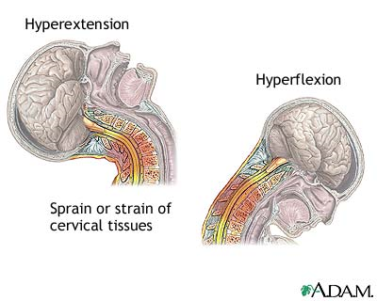 In the United States, nearly two-thirds of people will experience neck pain at some point in their life. Most pain occurs in middle age and most sufferers of neck pain are women. Annually there are 120,000 cases of whiplash which can leave people feeling pain even 15 years after the incident which caused it. In Canada 30% of all chiropractic referrals are for neck pain and 15% of all hospital based physiotherapies in the UK are for neck pain. It is also estimated that in 1997, 66% of claims under bodily injury liability coverage and 59% of claims under personal injury protection coverage reported a minor neck injury. This makes neck injury the most frequently reported injury in insurance claims. These numbers indicate a major need for a product that can help patients recover from neck injury and reduce their cost as well as the cost of insurers.

Figure - Illustration for cause of neck pain and strain

Currently, the only way to recover and reduce pain from neck injury is through a physical therapist. Skillfully trained, it is still very subjective with no existing method to acquire specific data for each patient. Providing such a method for therapists, doctors, and even patients is the primary goal of this project.

To accomplish the goal of providing a low cost system which can allow patients to perform cervical exercises and allow doctors and therapists to analytically see the range of motion the patient can perform, a number of concepts were designed using the Wii remote control. These concepts range from the number of Wii controllers, the placement of the Wii controllers, the number of LEDs, and the structure of the programming involved. In the end, a decision matrix will be used to determine the best design and the cost of developing the concept.

# Concept 1 - 1 Wii Controller Monitoring LEDs on Patient

The Wii Remote, also known as the Wiimote, is continually being modified to perform beyond its intended purpose. Many companies are looking to reprogram and incorporate Wiimotes into more formal settings. One example is a low cost dry eraser board made from a Wiimote and other peripherals to better engage audiences during a presentation. In this project, the application of interest is a head tracking device for rehabilitation purposes where a physician is able to prescribe therapeutic movements to a patient recovering from head/neck injury, utilizing assistance of the Wiimote.

The original setup of the Wii system consists of a console, a sensor bar, a remote and a display device. In this scenario only two components are necessary for the aforementioned application; the Wiimote and the sensor bar. In order to better understand the interaction between the two one must briefly explore the interiors of these components.

The Wiimote is traditionally the Wii's main input device that communicates to the console using standard Bluetooth technology which makes it compatible with standard Bluetooth hosts. It encompasses a 128x96 monochrome camera with an Infrared filter that detects sources with Infrared wavelengths (750-1000nm) and a built in image processor that provides pixel resolution of 1024x768.

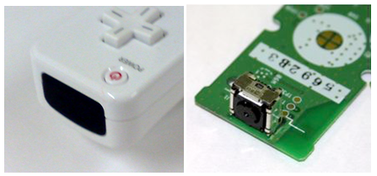

Figure 2- Outside and Inside view of Wiimote showing infra-red Camera

The sensor bar consists of two quintets of infrared LEDs positioned at opposite ends of a 20cm long bar. Distance between the sensor bar and the Wiimote is calculated through triangulation where each cluster of the sensor bar’s LEDs is understood as two separate points by the Wiimote’s image sensor.

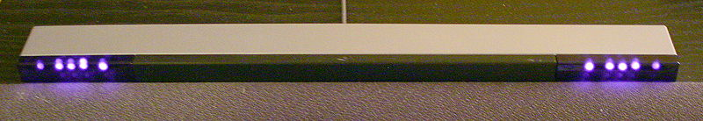

Figure 3- IR LEDs of Wii Sensor Bar

As mentioned before the role reversal of these two components is realized through the concept where up to 4 LEDs is mounted on a head piece worn by the user whom moves in front of the stationary Wii remote. Their motion is tracked by the infra-red intensity rating of the LEDs. Naturally everything emits infrared radiation because of the black body phenomenon. In this case however, the infrared filter in the stationary Wiimote records the location of the user through the emitted wavelength range of the LEDs affixed on the user’s device. This helps create depth perception on the display when the user is moving towards and away from the Wiimote. The LED apparatus, or sensor bar, is aesthetically modified in order to present an unobtrusive device that can be comfortably worn. It is simply made up of a small circuit consisting of resistors, diodes, and a battery. There is also a push button switch to control the power source to the elements when the device is not in use.

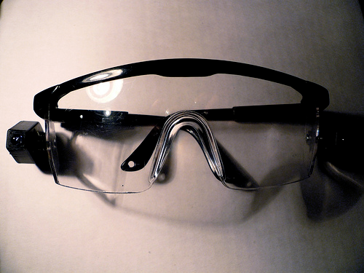

Figure 4 - Existing product for mounting LEDs which the Wii controller can track

# Concept ­2 – Wii Controller Attached to Patient

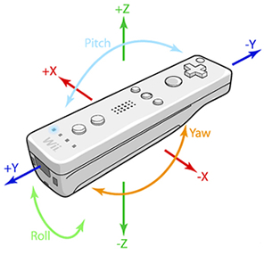 This concept is centered around placing the Wiimote directly on the patient to take advantage of its 3-axis accelerometer. The Wiimote would be placed vertically at the back of the patient’s head so its accelerometer can measure motions in all translations and rotations. Using integration of the accelerations would generate the velocities; an additional integration would provide the position, making it a very simple way of evaluating the data. The angles of the head can also be determined by simple vector analysis, acquiring the angle between two vectors. This data would be sent via Bluetooth and interpreted through the code to output the data in graphical format.

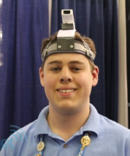

Figure 6 - Directions the accelerometer acquires data.

Figure 5 - Illustration of Controller attached to patient. In actuality, the controller would be placed vertically on the back of the head.

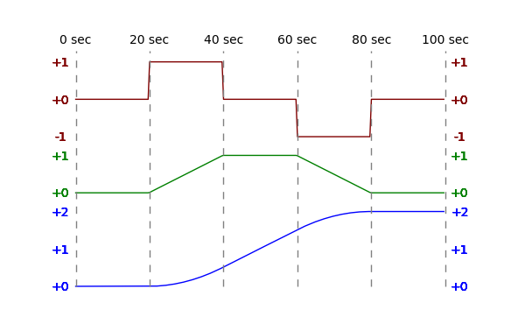

Figure 7 - Relationship diagram of acceleration (red), velocity (green), and position (blue). A very simple relationship.

This would be the lowest cost of all the concepts. The Wiimote would be about $40 and the Bluetooth software and dongle would be about $70. This would be a total of $110 not including material costs for the head strap holding the Wiimote.

This simple design requires only the Wiimote and a Bluetooth connection. The data is also easy to understand and interpret to acquire range-of-motion values from. Simple vector analysis also allows getting angular values. However, this approach has not been done before and so there is no foundation from which to work upon. Thus more work may be spent on creating this new system than using an existing foundation.

As illustrated in the diagram, having the Wiimote placed on the patient’s head may make the patient feel uncomfortable. They may feel either embarrassed or they may not be able to hold a Wiimote on their head due to muscle weakness. There is also the possibility of damage to the Wiimote due to its handling by either the user or the therapist. Minimizing this contact would extend the lifetime of the Wiimote.

While this provides the necessary data, it does not completely fulfill the requirements of the project. It would not allow for determining the height of the head; that would have to be measured directly for each individual person. It also does not provide information about initial head positions, which would be necessary for an individual suffering from a neck injury (such as cervical dystonia) where their head may be contorted in a painful position. Such data would have to be determined manually and inputted into the program. This could also be eliminated by using the infra-red camera and infra-red LEDs to determine these values. This would then mean there is no advantage in using the Wiimote accelerometer directly to measure the position and angle of the head.

# Concept 3 - Multiple Wii Controllers

The second concept of design deals with using multiple Wii controllers to enable the tracking of multiple infra-red sources. The Wii controller’s infra-red camera is only capable of tracking up to four moving infra-red sources at once. Therefore, by utilizing a range of 2-4 controllers data can be pulled and analyzed for up to sixteen infra-red sources. Using multiple infra-red sources allows for certain sources to be used for specific tasks such as acting as reference points. There are other advantages of having multiple infra-red sources which will be discussed in a later section. It is not practical to use more than four controllers because the layout and positioning of the controllers as well as the infra-red sources must be taken into account. Though unconfirmed, there is a risk of the camera being unable to track the same four sources each time because there are too many infra-red sources interfering with each other. Overall, the slight increase in accuracy of having more than controllers is not worth the added complexity that it brings.

The options of using 2-4 controllers have been examined more closely. It is important to note that the analysis done for each scenario assumes that elevation and tilt of each controller camera is the same. In reality, the elevation and tilt of the camera can be varied in order to eliminate some of the problems that are presented in each case which could also lead to the use of more than four Wii controllers. In addition, using certain sensors for references can also eliminate some of the problems associated with using multiple controllers.

## Two Wii Controllers

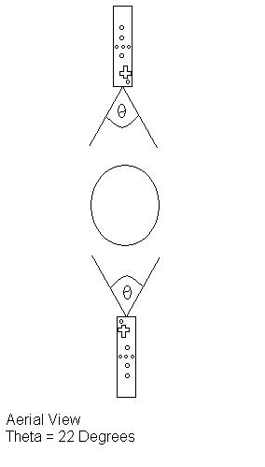 The option of having two controllers allows for a maximum of 8 infra-red sources. Although there is a wide range of placement options for having just two controllers, the infra-red camera is limited to a 33° vertical field of view and a 22° horizontal field of view. The most basic layout is having one controller positioned directly in front of the user, while the other is directly behind the person as seen in figure 8. Figure 9 is a simple variation of figure 8 where one controller is placed at the left side of the user while the other is on the right. Figure 10 shows how the two controllers and be angled differently to face the user. The benefits of having two controllers are an increased total field of view, and multiple sources for data tracking. The cons of having two controllers are that the total field of view may not be large enough and sources might end up off the grid if they escape the field of view. The cost will also be increased by having more sources and controllers.

Figure 8 - Diagram of 2 Wii Controllers and target

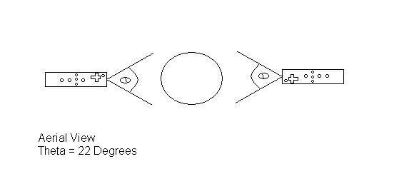

Figure 9 - Diagram of 2 Wii Controllers and target

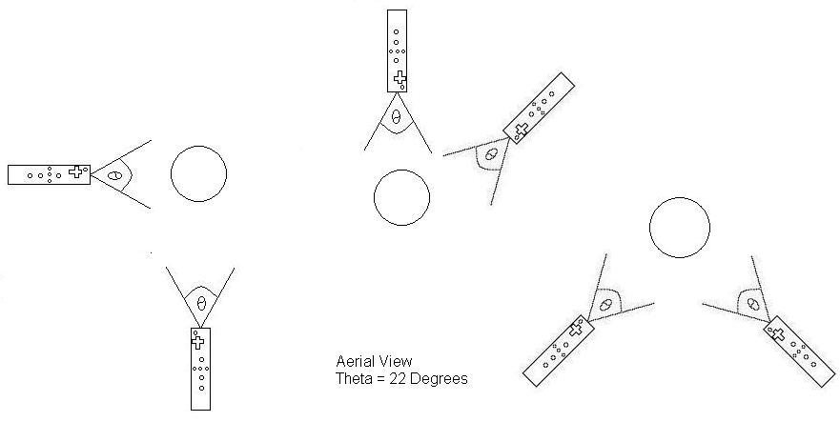

Figure 10 - Diagram of various positioning options for 2 Wii Controllers

## Three Wii Controllers

The option of having three controllers allows for a maximum of 12 infra-red sources. The range of placement options for having three controllers is smaller than having just two controllers because all options would the variation of triangle. Figure 11 shows examples of the various placement options for the controllers. Three Wii controllers can achieve an increased total field of view of the user, and multiple sources for data tracking when compared to that of just two controllers. The downside of having three controllers is a restricted infra-red source placement due to the fact that the total field of view may be too large and sources might end up off the field of view of one controller and enter another. There is a chance that one controller will interpret this as the source is “jumping” from one end of the field to the other. This will add complexities to the data analyzing and manipulating process as well as the programming. Finally, the cost will be increased by having more sources and controllers.

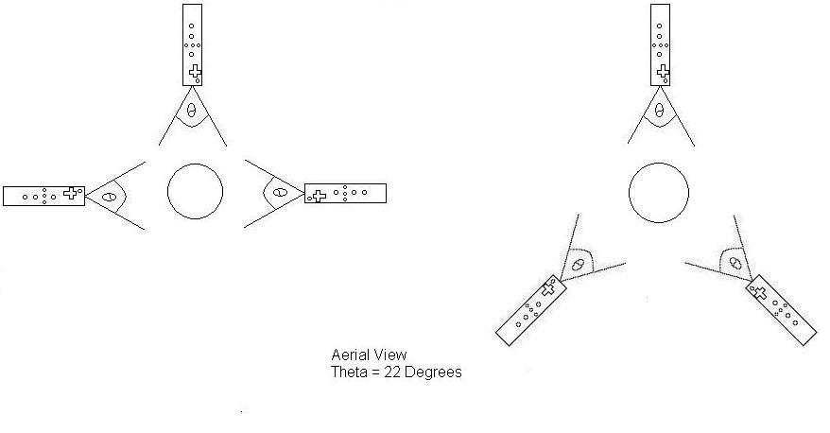

Figure 11 - Diagram of various placement options for 3 Wii Controllers

## Four Wii Controllers

The final option of having four Wii controllers allows for a maximum of 16 infra-red sources. The range of placement options for having four controllers is the smallest because of the increased risk of shared fields of view and “sensor jumping”. Figure 12 shows examples of the various placement options for the implementation of four controllers. Four controllers can achieve an increased total field of view of the user, and multiple sources for data tracking when compared to that of lesser controllers. However, having four controllers requires much stricter sensor placement than with just three controllers. Utilizing four controllers will add the same complexities to the data analyzing, manipulating, and programming process. The cost will be increased as well.

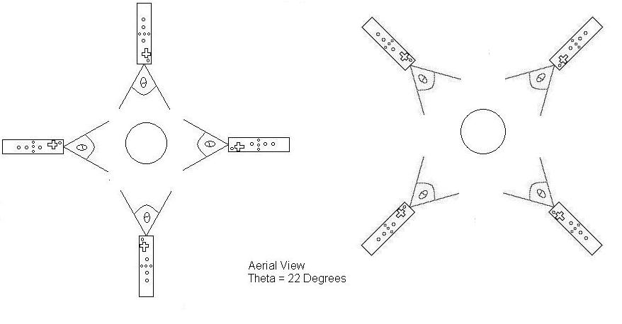 Figure 12 - Diagram of various placement options for 4 Wii Controllers

# Concept ­4 – More Than 4 LEDs

Taking previously discussed designs into consideration, the product can be enhanced by the inclusion of extra LEDs. Extra LEDs will provide monitoring of more areas for more accurate tracking and could even be used to give size and shape data of the patient’s face. Due to the infra-red camera in the Wii remote being limited to tracking 4 objects at a time, depending on the number of controllers used, there will be two options.

## Blinking

This option was initially thought of for use with the single Wii Remote, however, could be incorporated in to use with multiple remotes as well. This concept would yield potential use of a large number of LEDs minimized down to as little as 1 remote.

The Wii Remote includes a 128x96 monochrome camera with built-in image processing and a 100Hz refresh rate. It is however limited to tracking up to 4 moving object at a time. The theory behind this design is that by creating a sequence of blinking LEDs using a slightly lower frequency, new LEDs will appear and disappear allowing tracking of more than 4 regions by the same IR camera. This frequency is so fast (100Hz = 100 times a second) that visually, the human eye will not be able to pick it up, while the camera can, allowing for the rendering of more LED data sets while still keeping a high level of accuracy.

## Filter

This option would be for the use of multiple remotes. If 2 remotes are used, 8 LEDs will be incorporated; if 3 remotes are used, 12 LEDs will be incorporated; if 4 remotes are used, 16 LEDs will be incorporated.

The Wii Remote includes a 128x96 monochrome camera with built-in image processing. The camera looks through an infrared pass filter in the remote's plastic casing and detects 940nm sources at nearly twice the intensity of 850nm sources. Therefore, by changing this pass filter, and possibly editing some of the code for the camera’s data acquisition, the intensity/wavelength the camera can see can be edited. Having each camera view a different intensity parameter will allow the use of more LEDs with constant glow as long as there are only maximum of 4 at a specific intensity/wavelength. This option would be for the use of multiple remotes. If 2 remotes are used, 8 LEDs will be incorporated; if 3 remotes are used, 12 LEDs will be incorporated; if 4 remotes are used, 16 LEDs will be incorporated.

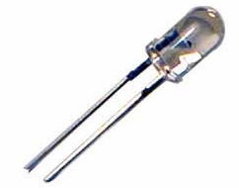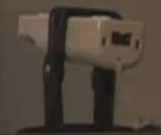

Figure 13- Infrared LED and Wii-Mote Housing

The use of more LEDs while benefitting us with better accuracy and more data types, will significantly increase the complexity of the design. Not only in the physical nature where as proper placement and orientation of the LEDs will be crucial, yielding more apparatuses that the patient must wear and therefore creating a less user friendly and comfortable environment, but the programming and comparison aspect as well. It will also yield a likely less cosmetically appealing and less durable over product as it increase components and over size and power consumption of the head-piece.

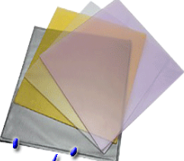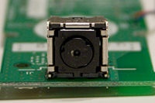

Figure 14 - INFRA-RED Camera on the Wii controller and examples of INFRA-RED pass filters

# Concept ­5 – LED Array and Reflective Device

This concept somewhat couples the way the Wii was designed to work, along with having a mounted controller camera to view the patient’s movements. An infrared LED array is built, the more LEDs/higher intensity of the array, the better this will work. The shape of the array is unimportant, but requires a center cut-out for which the remote’s camera can view through. The array is placed facing the patient and the camera is placed behind the array, peering through the hole, also facing the patient. It is important for the hole to be big enough as to not obstruct the camera’s view. At this point, if the patient is close enough, the infra-red camera can pick up most movements by received infrared light reflections off the skin, but it is highly delocalized and inaccurate largely due to interference. To focus the data acquisition of the camera, the reflection of the infrared light off the body needs to become centralized about significant locations, in this case, the head. This is done by application of reflective tape or another form of reflective device. This design could be adaptable for a second remote for further accuracy and better depth perception. The second remote would not need a LED array system as it would pick up reflections from the main system, as the array is designed to fill the room with infrared light.

This design is user friends and simple. The setup of the array and the Wii remote(s) could be packaged into a single unit, and the user would simply have to put on a head band with a reflective band on the forehead. This will yield a lightweight and stylish package that is easy to use with no worry of complications due to sensitive electronics on the headpiece.

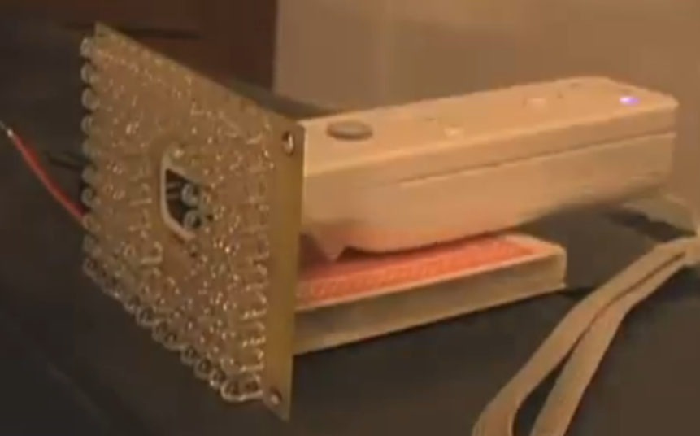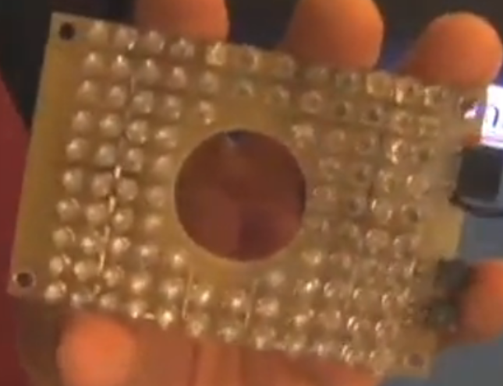

Figure 16 - INFRA-RED LED Array with single Wii controller

Figure 15 - INFRA-RED LED Array

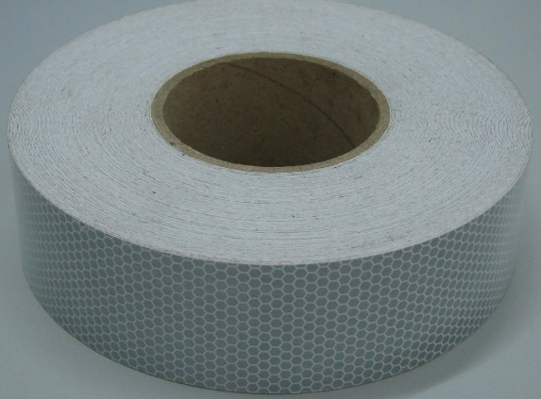

Figure 17 - Micro-Glass Bead Reflective Tape

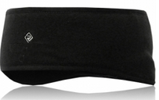

Figure 18 - Headband with Reflector

# Programming

A great deal of the thought involved in this project lies in the programming and presentation of information aspects of the system. Everything from the programming languages used to the layout of the interface controls on screen have to be considered with great attention.

## Interaction Style

The system’s user interface is an especially important component. It essentially acts as the face of the entire product. Since the technical skill, medical knowledge, and physical ability of each potential user will be different from the next, the interface must be easy to understand and interpret across a wide range of demographics. A graphical interface approach is the best way to implement the current concept. Graphical user interfaces (GUIs), when designed properly and judiciously, are much more intuitive than command line interfaces in terms of operation, and they give the user an increased feeling of control. A command line interface would most likely intimidate a user of limited knowledge.

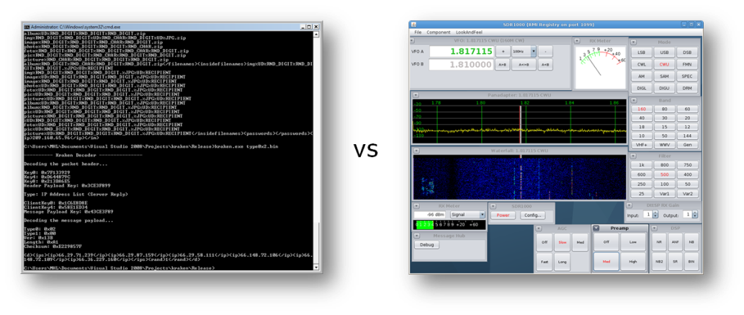

Figure 19 – Illustration of the different interaction styles: GUI vs Command Line Interface

GUIs also take advantage of the spatial and visual cues of the environment. A graphical interface will also, and perhaps most importantly, allow streaming data from the device to be illustrated onscreen in a representative way. For example, if accouchements are attached to a wearer’s head, a three-dimensional *head* will appear in a virtual space and will react to changes as the wearer actually moves his/her head. Likewise, if the wearer has the device on his/her shoulder, the virtual space will focus on a virtual *shoulder*.

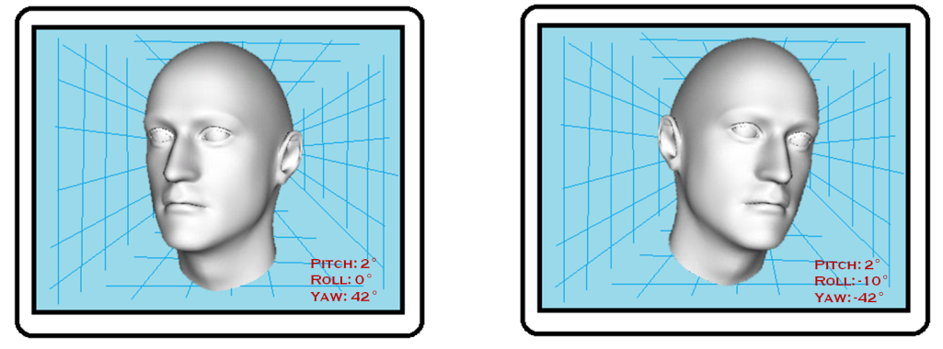

Figure 20 – Rough mockup of the conceptualized virtual image

## Data Presentation

The features of the application that quantify and record data must also be discussed. The current concept involves definitely using a graph to chart the physical performance of the patient at a given session. The data points that are taken from the patients’ actions would be in x-, y-, and z-coordinate triplets. To handle all of the data and present it in a readable chart, the points could be plotted in a 3D graph. For easier understanding, the points could even be connected with a line to simulate the path around a point of origin that the points take while attached to the moving head, shoulders, etc.

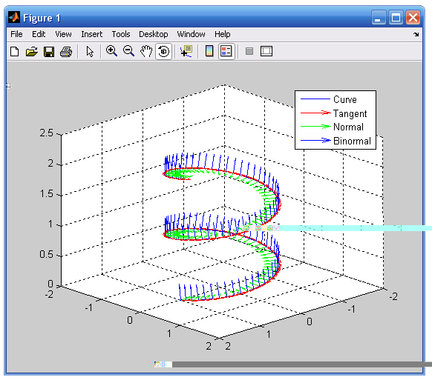

Figure 21 – Data can be displayed in a 3D graph

Another way to present the recorded data would be to plot the points in three different 2D graphs, one graph for each dimension in space. Each graph would have a “coordinate versus time” layout. In each graph, the value of the dimension’s respective coordinate (corresponding to the vertical, dependent axis) would vary as data points progress sequentially (with the horizontal, independent axis). Presenting data in this way will allow movement in each dimension to be analyzed individually.

## Programming Language(s)

After defining the desired capabilities of the application and the general characteristics of the interface, it becomes easier to determine what programming language(s) would best suit the development. Several languages have the proper tools available to create a graphical user interface. Popular languages like Visual Basic, C++, and C# are all competent options for this purpose. Creating graphical applications in C and C++ isn’t as uncomplicated as doing so with other languages that have features specifically built in to accomplish such a goal. Visual Basic is well-known for being a very easy to learn language. Popping out a simple working graphical application in a couple of hours isn’t unusual at all for first time users of VB. One disadvantage of learning Visual Basic comes from the fact that its syntax and structure are very different from already popular, influential and ubiquitous languages like C and C++. C# is a more robust fully object-oriented programming (OOP) language that is heavily influenced by popular OOP languages like C++ and Java in terms of syntax.

However, C# and VB both share a major disadvantage that will affect application compatibility. Programs written in these particular languages (and others not mentioned here) can only be executed on a runtime engine called the Common Language Runtime (CLR). The CLR is, in actuality, another software application in itself that must be present on the machine that this system’s software will run on. This is because C# and VB are Microsoft-developed languages that are a part of its .NET technology, which requires all .NET languages to run on the CLR. The .NET technology has proven its worth in countless arenas. However, the main inconvenience of .NET (and indirectly C# and VB) lies in the fact that the CLR is only available for the Windows platform. At this point in concept development, it would be ill advised to restrict the system domain to only one type of platform. Since little knowledge is known beforehand about the end type of platform, the display application should, ideally, be run on any readily available personal computer or server.

Enter Java. Software developed in Java has the benefit of being executed exactly the same on any system due to its Write Once, Run Anywhere (WORA) mantra; it would not have to be compiled for three, or even more, different systems. Like .NET languages, the technology behind Java is also based on a runtime engine, the Java Runtime Environment (JRE). However, the Java platform is available for several different underlying architectures, operating systems, and it has even been implemented right on the hardware.

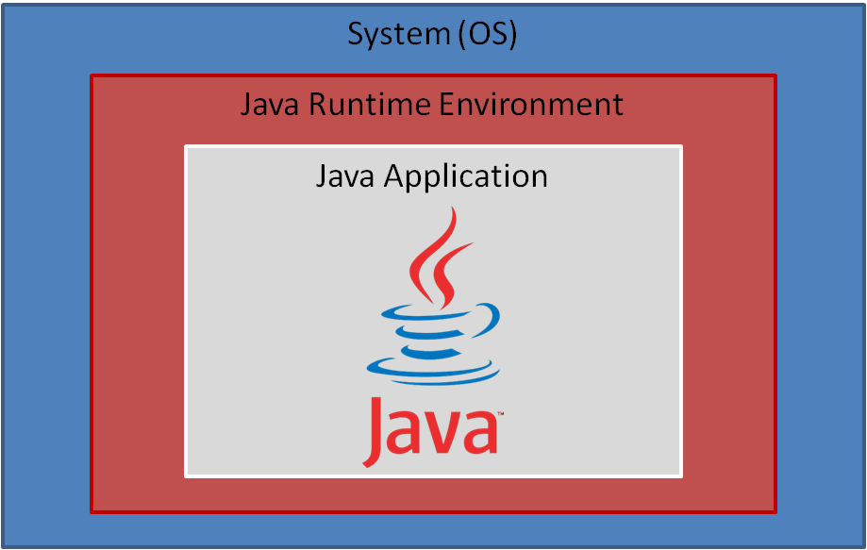

Figure 22 – Simple diagram that shows the Java platform

Java is an especially attractive option because, currently, no information is known about the type of computer this display application will eventually run on. By generalizing the software development as much as possible, more flexibility is achieved. Another benefit of using Java is the availability of its flexible Java 3D library, which is an API based around 3D graphics.

## Performance

One of the key drawbacks of Java versus a language whose programs get run natively on the machine (like C and C++) is the performance. It’s obvious that Java programs will ultimately run a little slower than other programs, simply because of the underlying technology. Java programs will have to be compiled into bytecode before it can be executed as machine-understandable instructions. All these translations must happen on the fly. As a result, the application ends up being a little slower, not noticeably though. Computers execute millions of instructions per second. “A little slower” is an acceptable trade off for portability. Even though this application may be slightly graphics oriented, the level of intensity may not require performance to be overly optimized. Besides, Java has made numerous strides in its performance department, and, according to some sources, Java can potentially outperform other languages like C++.

## Data Presentation (Revisited)

For the graphing capabilities of the system, a robust Java library would be necessary. There are several out there to be readily downloaded, many of which are free such as the Java Universal Network Graphic (JUNG) Framework, JGraphT, and JFreeChart. Another quite attractive option would be to use a component that builds on current knowledge of a particular type of data visualization platform. Specifically speaking, it would be handy if the application could be developed by integrating the plotting capabilities of MATLAB right in the code. MATLAB is a ubiquitous engineering staple with very useful graphing capabilities built in.

It turns out that there is, in fact, a tool called the MATLAB BuilderTM JA that effectively takes programs written in MATLAB and ports them to Java as classes. As useful as this solution could prove to be, it also turns out that MathWorks, the company that makes MATLAB, loves significantly overpricing its products (granted, they are high quality products). A 2009 MathWorks Family of Products Sheet listed the MATLAB BuilderTM at $4,000. That’s $1,500 more than the proposed budget of this project. Needless to say, that option must be discarded. However, as stated earlier, there are plenty of free graphing libraries out there that can be taken advantage of. None have been decided on at this point.

# Wired vs. Wireless

Another design application that must be considered is whether the Wii Remote will be synced up to the computer system via a wireless device, or if it will be wired in. While attaching the device via a wired link, like USB 2.0, would be ideal for transfer speed and to minimize possible interference, a current option to attach Wii devices as such does not exist. In addition, it would limit the mobility and ease of setup of the device. The Wii remote has a Broadcom BCM2042 Bluetooth System-on-a-chip built in to the device. This can be easily picked up by any Bluetooth compatible receiver/computer. There do exist other options for wireless compatibility, but when considering the reliability, ease of use, transfer rate, network, and connectivity options, there is no other better option for wireless use.

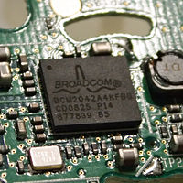

Figure 23 - Broadcom Bluetooth chip embedded in Wii controller

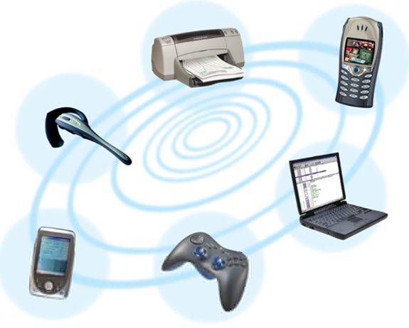

Figure 24 - A Wireless World

# Decision Matrix

With a multitude of different and similar concepts to accomplish our goal, a decision matrix was required to determine the best design. Nine different criteria were selected and each one assigned a weighing factor to designate the more important criteria for the design. Each concept is ranked in a scale from 1-10 with higher being desirable and lower being undesirable (for example, a higher rank in Cost means a lower cost). As can be seen in the following table, the most important factors were designated to be the Adaptability/Versatility and the Design Complexity. This was based on the goal of moving this project for other limbs and to reduce the complexity in designing a final product.

Table - Decision Matrix

|  |  |  |  |  |  |  |  |  |
| --- | --- | --- | --- | --- | --- | --- | --- | --- |
| Criteria | Weighing Factor | 1 Wiimote | | | Multiple Wiimotes | | | Accelerometer |
| 1-4 LEDs | 4+ LEDS | Array | 1-4 LEDs | 4+LEDs | Array |
| Cost | 0.1 | 9 | 8 | 7 | 7 | 6 | 5 | 9 |
| Durability | 0.1 | 8 | 8 | 6 | 8 | 8 | 6 | 4 |
| Adaptability/Versatility | 0.2 | 6 | 6 | 6 | 9 | 9 | 9 | 7 |
| Efficiency | 0.05 | 7 | 7 | 6 | 5 | 5 | 4 | 9 |
| Portability/Lightweight | 0.1 | 8 | 8 | 9 | 7 | 7 | 8 | 5 |
| Ease of Use/Setup | 0.1 | 8 | 8 | 9 | 8 | 8 | 7 | 9 |
| Accuracy | 0.1 | 9 | 9 | 8 | 10 | 10 | 8 | 7 |
| Design Complexity | 0.2 | 9 | 5 | 9 | 8 | 6 | 7 | 9 |
| Aesthetics | 0.05 | 9 | 9 | 9 | 8 | 8 | 8 | 9 |
| Total | | 8 | 7.1 | 7.65 | 8.05 | 7.55 | 7.2 | 7.5 |

The decision matrix revealed that the best design, according to the criteria set, is to use multiple Wii controllers and up to 4 LEDs. This was only marginally better than the single Wii controller and up to 4 LEDs, so it is decided that the goal is to create a final product consisting of multiple Wii controllers and up to 4 LEDs but if during the build process it proves to be impractical the switch can easily be made to using 1 Wii controller which had a better ranking in terms of Design Complexity.

# Conclusion

A multitude of concepts were designed to accomplish one goal: providing a low cost system which can allow patients to perform cervical exercises and allow doctors and therapists to analytically see the range of motion the patient can perform. These concepts varied using all the components of the Wii controller; from using a single or multiple Wii controllers, the number of LEDs, using the accelerometer versus the infra-red camera, and the structure of the programming. To differentiate the benefits of each concept, a decision matrix was compiled with nine criteria ranked from 1-10 (10 being most desirable) of each concept. Using the decision matrix, the final design was chosen to be multiple Wii controllers (at least 2) and using up to 4 infra-red LEDs. Since this concept scored only marginally better (a difference of 0.05) than the 1 Wii controller and 4 infra-red LEDs, it is decided that should complications arise interfacing 2 Wii controllers then it can be easily changed to using a single Wii controller to accomplish the goal.

# References

<http://johnnylee.net/projects/wii/>

<http://www.wiibrew.org/wiki/Wiimote>

<http://www.flickr.com/photos/collinmel/2200426283/sizes/m/in/photostream/>

<http://en.wikipedia.org/wiki/File:Nintendo_Wii_Sensor_Bar.jpg>

<http://www.michael-jones.name/content/publications/42-meng-dissertation-optical-comms-link/64-section2-background-theory>