Sand Sampling Apparatus

Sponsor: Eglin AFRL
Group #4

Richard Klimas
Dan Mortensen
Ruben De Sousa
Gina Teofilak

October 14, 2008

Table of Contents

Project Statement: 2

Most Important Project Objectives from Customer: 2

CONCEPT GENERATION 3

Constraints 7

Combined concepts and ideas 8

CONCEPT SELECTION 13

Cost consideration 15

References 16

Appendices 17

Project Statement:
Warhead design engineers and material scientists require mechanical property information under high deformation rates of loading on a wide variety of materials that have military significance. Over the past decade, a new class of materials has begun to receive attention because it affects the performance of most all warhead designs. This new class is called “particulate materials” and includes a diverse collection of materials such as sand, explosive grains and potting materials. One technique used to probe the behavior of such materials is to fill a large “box” with sand and fire a hemispherical-nosed projectile into it. The hemispherical nose provides a spectrum of loading conditions and the rapid projectile deceleration provides a velocity spectrum. During such events, the projectile disturbs and crushes the sand. It has been noted that the disturbed/crushed state of the sand correlates with the conditions that affected it. However, there is no good technique for extracting sand samples making so many measurements not very definitive or useful. The Damage Mechanisms Branch has a requirement to develop a new technique for extracting sand samples from the target.

Most Important Project Objectives from Customer:
  - A sand sampling technique/apparatus is required that allows sand samples to be obtained from the target.
  - The sample location must be precisely known.
  - The sand location, density, and local arrangement must be preserved
Design/Results Expected from Customer:
Initial Phase:
    - Evaluate the technique currently used to extract sand samples from the target—the “archaeologist” technique.
    - Become familiar with the experimental conditions and the project constraints.
    - Develop an initial design for the sand sampling technique/apparatus.
Final Phase:
    - Design, fabricate, rehearse, document and implement the sand sampling technique/apparatus.
    - Evaluate the practical application of the team’s ideas.
Prototype Expectation from Customer:
The team’s technique/apparatus will be implemented as part of an actual experimental series at the AFRL Site C-64 Range B. Optimally the team will have the opportunity to evaluate both the current and the proposed techniques. Note that sand target modifications could be made, being mindful of the size and weight of the heavy steel target.

CONCEPT GENERATION

Focus and expectations

The project is open ended and it is just one step of a large scale project. The group and the sponsor have agreed to focus on an ultimate goal to get samples with accuracy of the position of the particles with respect to the path of the projectile. Important issues that they currently have with their method are that they disrupt the sand when digging in search for the crushed sand, their sampling technique is too simple and inaccurate, and ultimately it takes too much time and effort to get the samples. We expect to:

- Locate the projectile and its path before touching the sand
- Clear the sand that is not in interest
- Open space for accurate acquisition of a sample
- Obtain the sample
- Reduce the total time of the experiment

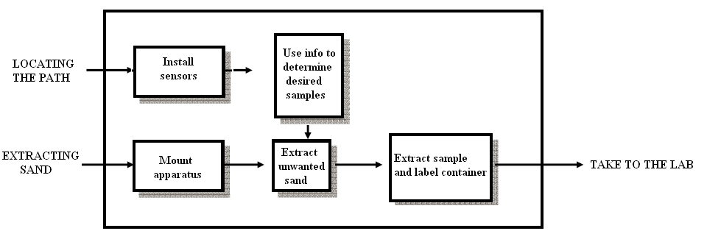
Figure 1: Process of the experiment

Subdivisions and existing solutions

To achieve these goals the design will be divided into three components. The first should locate the path of the projectile, the second should get the sand ready for extraction of a sample, and the third should obtain the sample. The first component could be a method or mechanism to locate the path of the projectile. Currently, they do not know the path of the projectile until they dig and find the crushed sand. Many times they disrupt the sand when digging to find the path. It would be helpful to know it from the place the target made contact until it stopped. The technicians that run this experiment use the path as a reference instead of parts of the target. The problem is that the path is different every time the experiment is performed. Some type of sensors will be installed in the target and the idea is to detect the path of the target without removing any sand. About 20% of the total budget of the project is available for this component. This step is dependent of the second component given that the second component might not need the identification of the path.

There are a few concepts considered for use in the first component of the project. Currently there is no method to locate the path of the projectile without removing sand from the target. Locating the path of the projectile and the projectile have become an important part of the project because it is thought in order to speed up the process of extracting samples one must know the exact location of the projectile path without removing any sand. The three possible concepts considered to locate the path of the projectile are to use ground penetrating radar (GPR), temperature sensors or pressure sensors.

Ground-penetrating radar (GPR) is a geophysical method used in the industrial and research fields that uses radar pulses to image objects underground. This non-destructive method uses electromagnetic radiation in the microwave band (UHF/VHF frequencies) and detects the reflected signals from underground objects. GPR can be used in a variety of materials including rock, soil, ice, fresh water, pavements and structures. GPR can detect objects, changes in material, and voids and cracks. GPR uses transmitting and receiving antennas. The transmitting antenna radiates short pulses of the high-frequency radio waves into the ground. When a radio wave hits an object or a boundary with different dielectric properties the wave get reflected back to the receiving antenna and the receiving antenna records variations in the reflected signal. The figure below shows a technician using a GPR system to locate materials in the concrete wall. The picture to the right shows what the GPR finds in the wall. Using GPR to locate the different densities of sand after the projectile moves through the sand is the idea behind using GPR to locate the path of the projectile.

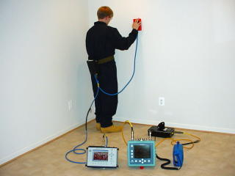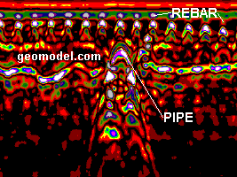
Figure 2: GPR equipment and the result of the scan -Courtesy of Geomodel.com

Infrared Thermography, thermal imaging, or thermal video, is a type of infrared imaging science. Thermographic cameras detect radiation in the infrared range of the electromagnetic spectrum (0.9–14 µm) and produce images of that radiation. The amount of radiation emitted by an object increases with temperature; therefore thermography allows one to see variations in temperature. When viewed by thermographic camera, warm objects stand out well against cooler backgrounds. Humans and other warm-blooded animals become easily visible against the environment. As a result, thermography is use in the military and security services. Thermal imaging photography finds many other uses as well in other areas. For example, firefighters use it to see through smoke, find persons, and localize the base of a fire (Figure 3 below). With thermal imaging, power lines maintenance technicians locate overheating joints and parts, to eliminate potential hazards. Where thermal insulation becomes faulty, building construction technicians can see heat leaks to improve the efficiencies of cooling or heating air-conditioning. After the projectile moves through the sand there is a large temperature increase in the local area of the path of the projectile. Using the thermal camera, it would be possible to locate the path of the projectile.

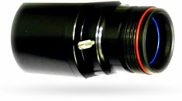
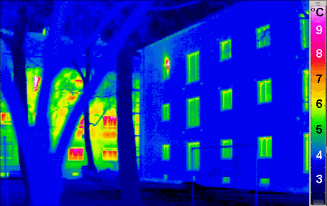
Figure 3: Thermal Camera and a picture of what it records

A pressure sensor generates a signal related to the pressure imposed. Normally the signal is electrical, but optic, visual, and auditory signals are not uncommon. Pressure sensors are used for control and monitoring in thousands of everyday applications. Pressure sensors can also be used to indirectly measure other variables such as fluid/gas flow, speed, water level, and altitude. Pressure sensors can alternatively be called pressure transducers, pressure transmitters, pressure senders and pressure indicators. Pressure sensors can vary drastically in technology, design, performance, application suitability and cost. An example application for a sensor would be in the measuring of combustion pressure in an engine cylinder or in a gas turbine. These sensors are commonly manufactured out of piezoelectric materials such as quartz. After the projectile moves through the target there are pressure waves that move through the target. By using multiple pressure sensors throughout the target the position of the projectile pat can be estimated.
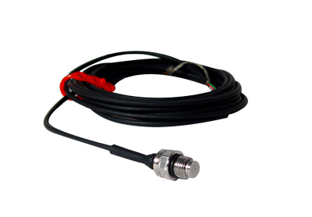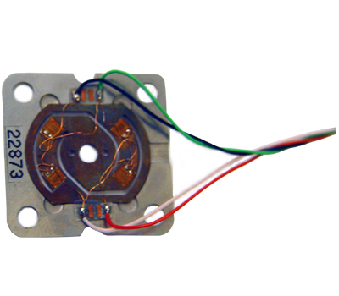
Figure 4: Pressure Sensors
The second component is the mechanism to extract the unwanted sand. Currently they use the “archeologist” method which means they dig down to the estimated depth and brush away the uncrushed sand. This mechanism has to reach into the sand and get to the location where a sample is desired. Regardless of the final design the mechanism should move such that the third component can get samples from any (h,w,L) position in the target. It must be removable and fairly light since it will be placed and removed for every trial of the experiment. Two common methods of extracting sand from the ground in various industries are using vacuum machines and excavators. The concept of vacuuming and shoveling will be base for this part of the design.

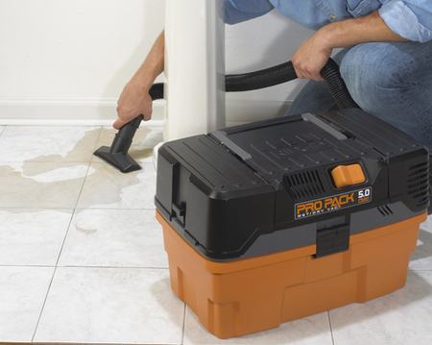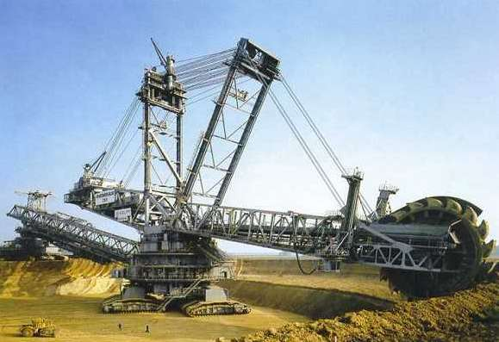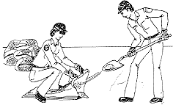
Figure 5: Pictures of concepts for sand extraction from top left: vacuuming, excavation, and shoveling.

The third component must extract the sample. Currently, they stab the sand horizontally with a pocket knife in random locations and put the sand from the knife into a Ziploc bag. This design must include a method of identifying the exact location (h,w,L) from where the sample was obtained. It must safely put the sample into a container that will be taken into the lab. One concept widely used in biology and geology is core sampling. A tube is inserted into the desired area and sealed at the top creating a vacuum effect and then the tube is raised with the sample of material. The advantage of this concept is that it is easy to preserve the position of the particles. The disadvantage is that this is mostly used when the sample is wet and can maintain its shape. Another concept could be to get the sand to stick on to another material. Often sand samples are glued to special tape and coated with some metals prior to being placed under a microscope. If the concept of core sampling is used the second component might not be necessary.

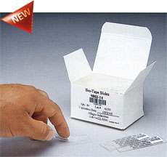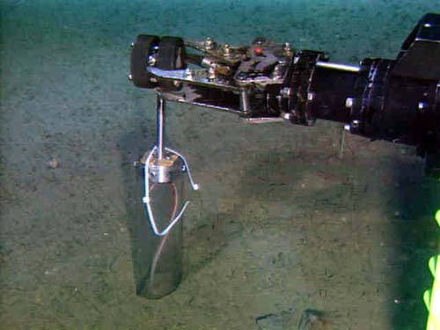

Figure 6: Pictures of concepts for sampling the sand from the left: sampling tape, core sampling.

Constraints

For the first component of the mechanism there are a few constraints that were found for use with this project. The depth range of GPR is limited by the electrical conductivity of the ground and the transmitting frequency. Optimal depth penetration is achieved in dry sandy soils or massive dry materials such as granite, limestone, and concrete where the depth of penetration could be up to 15 m. Since the experiment is done with dry sand most of the time the limits of GPR are not an issue however the cost of a system does remove the possibilities of using a GPR system with a $1500 budget. A manufactured GPR system’s price can range from $10,000 to $30,000. The thermal imaging method possibility is also removed because the price of a quality camera is $6000 or above and that a thermal camera can only detect surface temperatures. Pressure sensors are the cheapest of the three possibilities separately at $900 a piece but the amount of pressure sensor need in the target would make it too expensive to use pressure sensors. After receiving the research on the amount of money needed to successfully complete the first component of the mechanism the first component has been removed from the design.

Since this is a new experiment the target is constantly under construction. The mechanism has to be flexible enough to allow for changes in the box. For example, our sponsor recently revealed that a series of devises are being installed on top of the target to pack the sand tighter. This means that the top edges can no longer be used for installing non removable parts of the sand sampling mechanism. Another concern is that eleven make screens are dipped in the sand with the purpose of measuring the changes in velocity of the projectile. These make screens are eventually going to be removed from the experiment and sometimes the experiment is run without them. They currently do not have a set size of the screens that the consistently use. The mechanism has to be able to go above the make screens and get samples from both sides of each one of them which can restrict the size of the screens.
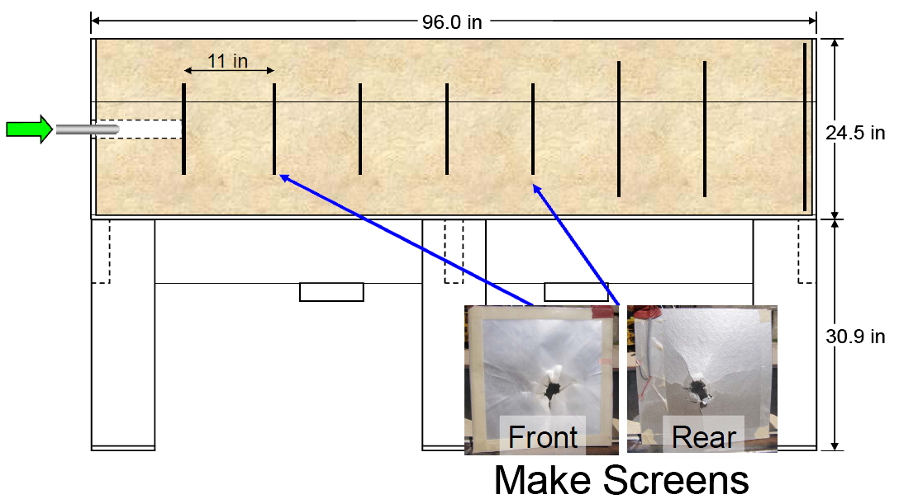
Figure 7: Target schematic courtesy of Egline AFRL

Combined concepts and ideas

A simple way to make sure that the mechanism can reach all parts of the box with good accuracy is to make a location system with three degrees of freedom that digitally displays the location of the attachment touching the sand. All the design ideas have been chosen to be able to adapt to this location system. The system shown in Figure 8 consists on the following: A rail will be attached to the target to allow motion in the L direction. That rail is marked to indicate the length and it is connected a platform. The platform is on top of a linear motion actuator (rack and pinion, belt, or chain) that allows precise translation in the W direction. Another linear motion actuator is connected in the vertical extension of the tip of the attachment that makes contact with the sand. This tube has a lever allowing motion in the H direction (not shown on the picture). The vertical part that holds the last attachment must have a range so that the tip of the attachment goes as far as touching the bottom of the target and retracts to avoid the make screens used in the experiment.

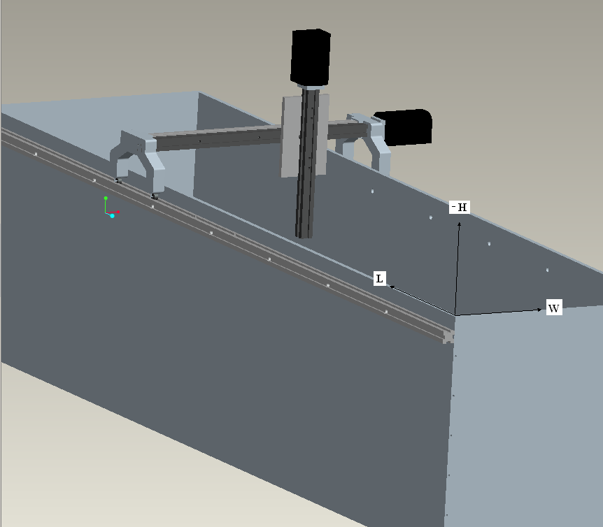
Figure 8: Location system attached to the target.

Concept 1: Vacuuming to get to the sample and the sample will be obtained with sampling tape.

The mechanism:
The extension of the tip of the tube coming from the vacuum machine will be attached to the vertical linear motion actuator. This tube could use a lever as the linear allowing motion in the H direction. The tip of the tube is designed with some type of edge so that layers of sand can be extracted putting minimal vertical force on the sand. The tube reaches from the tip laying on the sand to the vacuum machine on the ground outside of the target.

The method:
After impact the platform is slidden into the rail. The vacuum machined is turned on and layers of sand are extracted until the desired height. Sampling tape is then laid on the sand. A thin layer of sand sticks to the tape, the tape is removed and placed in a labeled container.

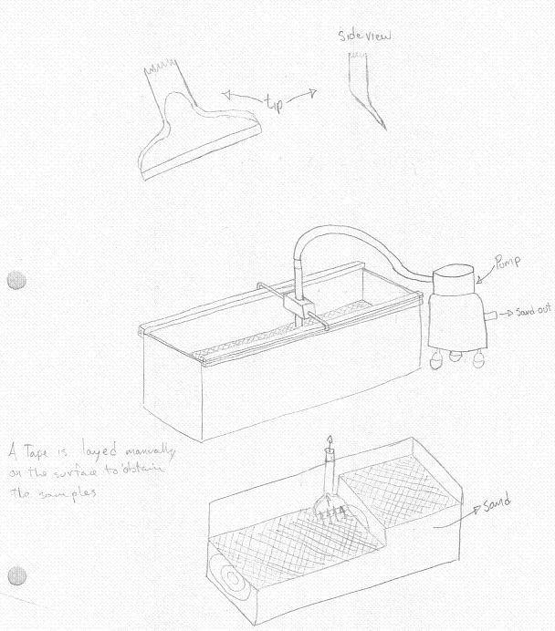
Figure 9: Hand drawings of concept 1.
Concept 2: Gear blade shovel

The structure for this apparatus is based off of the two eight foot pieces of aluminum extrusion that run the length of the box, as seen in idea one. The mechanism desired in this idea is kind of like an old fashioned lawn mower, with three or four blades. It will consistently “mow” a top layer off the top of the sand, and bring the sand to the center between the blades and suctioned outside of the box. The blades will be driven by gears and a motor, and the sand will be suctioned by vacuum.
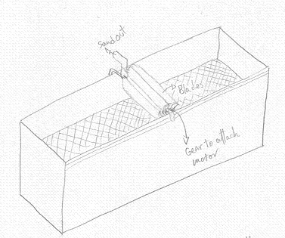
Figure 10: Hand drawing of concept 2
Concept 3: Core Sampling Tube

The core sampling idea is based off of the same structure as the vacuum and tape method. On each side of the box is two eight foot pieces of aluminum extrusion which have rollers to allow for motion in the x direction. The rollers are attached by another piece of extrusion in the y direction, spanning the two foot width of the box as shown in the picture of idea one. A linear motion actuator will be attached to the y direction span of extrusion to create the desired motion. Another actuator will be attached vertically to the y direction actuator, which will provide the desired z motion. A core sampling apparatus made from clear piping will then be attached to the z direction actuator.

After the projectile shot has been fired, the apparatus can be easily secured into place on the box as stated in idea one. Wherever a sample is desired, the apparatus can be moved manually in the x direction and locked in place. Then, the y and z motion can be achieved by a hand crank, such as a mill, or can have a computer controlled motor. The core sampling device will be placed wherever the sample is desired, and will take a core from the top layer of sand all the way to the bottom.
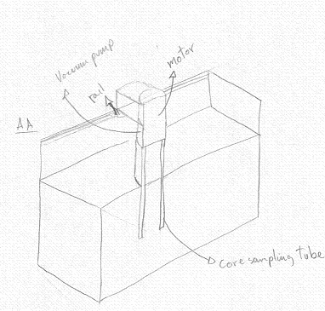
Figure 11: Hand drawing of concept 3

Concept 4: Core sampling with vacuum

This concept is based off of the same idea as concept 3, the core sampling tube. The only difference is that it will use a vacuum to create suction to take out the core of sand. Once the core sample is removed, a piece of tape will be placed under the sample to catch whichever part of the core is desired.

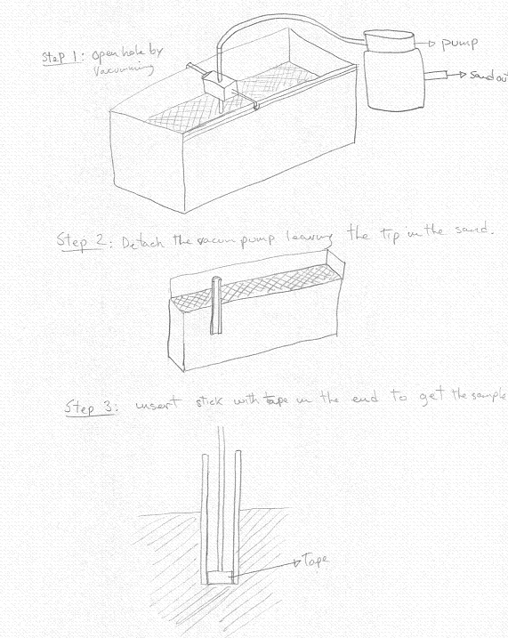
Figure 12: Hand drawing of concept 4
Concept 5:

This concept uses a fine tip on the end of the tube coming from the vacuum machine. Between the vacuum pump and the tip there is a vortex tube that will separate the suctioned materials based on density. In this experiment the fluid is a air and sand mixture. Since the sand is denser than air, centrifugal force will force the sand particles towards the inner diameter of the tube and the air will remain in the center of the tube. The sand can exit and be collected on the outside of the tube while the air will continue moving towards the vacuum pump. A long fine tip will allow getting samples from deep places on the target without removing any sand from the top. A disadvantage from this concept is that without knowledge of the path of the projectile it will be pointless to dig blindly from the top, therefore the path must be known or a few layers have to be extracted before taking any samples.

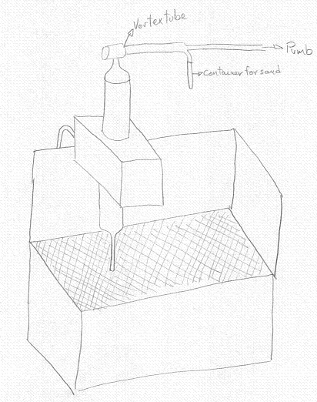
Figure 13: Hand drawing of concept 5

CONCEPT SELECTION
 |  | Concepts
 |  | Apparatus  with vacuum |  | Gear blade  shovel |  | Core Sampling |  | Vortex  tube |  | Vacuum  core sampling
Specifications | Importance  Weight | Rating | Weighted  score | Rating | Weighted  score | Rating | Weighted  score | Rating | Weighted  score | Rating | Weighted  score
Portability | 15% | 3 | 0.45 | 1 | 0.15 | 3 | 0.45 | 4 | 0.6 | 3 | 0.45
Lightweight | 20% | 3 | 0.6 | 1 | 0.2 | 2 | 0.4 | 4 | 0.8 | 2 | 0.4
User Friendly | 5% | 4 | 0.2 | 3 | 0.15 | 3 | 0.15 | 2 | 0.1 | 4 | 0.2
Accuracy | 30% | 4 | 1.2 | 2 | 0.6 | 4 | 1.2 | 1 | 0.3 | 1 | 0.3
Ease of construction | 10% | 2 | 0.2 | 1 | 0.1 | 2 | 0.2 | 1 | 0.1 | 2 | 0.2
Budget | 15% | 2 | 0.3 | 4 | 0.6 | 2 | 0.3 | 1 | 0.15 | 2 | 0.3
Time | 5% | 1 | 0.05 | 3 | 0.15 | 4 | 0.2 | 3 | 0.15 | 1 | 0.05
 | Score |  | 3 |  | 1.95 |  | 2.9 |  | 2.2 |  | 1.9
 | Selection |  | Yes |  | No |  | No |  | No |  | No

The chart above is the concept generation table to decide which of the ideas is most feasible. The criteria for ranking our concepts is based on seven specifications that we feel are of highest importance to our project: portability, weight of apparatus, user friendliness, accuracy, ease of design and construction, budget, and time to perform experiment. The rankings are based on a one to five scale, with one being the least important, and five being the most important. One each specification is ranked, it is then multiplied by an importance factor, which is out of 100%. The most important specifications to our project are given the higher weight percentage, with accuracy and lightweight ability being the most important. After each rating was given a weighted score, the scores were added up. As shown in the chart, the vacuum and tape apparatus, concept number one, was chosen because it had the highest feasibility rating.

It was decided that this concept meets all the needs of the sponsor and give them room for improvement in case they decide to keep developing the study of these particles. The location of the shot line will be known when it becomes visible after taking a few layers of sand from the top. The sample tape gives them a fine layer of sand which will give them the flexibility to take as many samples as they want and generate a computer modeled 3D version of the target after impact. The tape is also very easy to label and to carry to the lab. The methodology is simple enough to use that it will only take them a couple of runs to get used to it and no intensive training. It is also a concept that will give us experience in the fields of statics, mechanics, dynamics, fluid design/ piping systems, and material selection. It is feasible to build it ourselves in four months and staying very close to the budget of $1500. Figure 14 illustrates the general idea from where this design will be based.

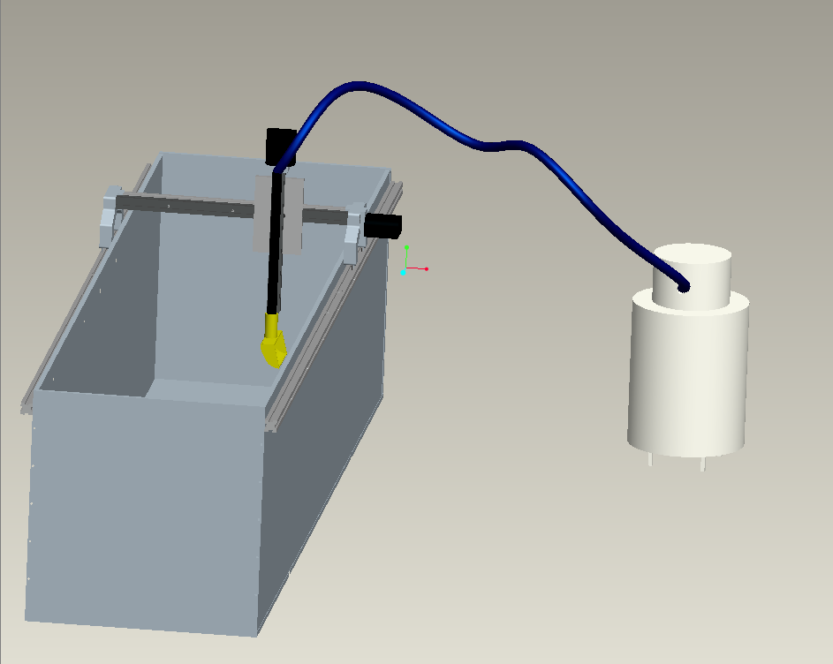

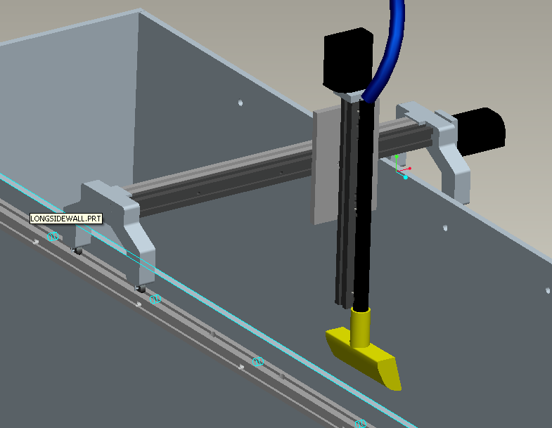
Figure 14: General Idea of selected design concept

Cost consideration

This design has several components, such as the vacuum machine and the linear motion actuators, which can be both purchased or made. The cost of the vacuum machine will depend on the power required. There is a very wide range of prices for available vacuum machines but a portion of the price is in features other than the vacuum pump and motor. In the case that there is need for a very powerful vacuum machine the cost can be lowered by buying a pump and a motor and designing the piping system and case for the pump. The linear motion actuators in the drawings are mostly out of the budget of $1500, but there are simple chain or belt actuators that can serve the same purpose. The design will allow for easy transition to the more expensive equipment in the case the sponsor wants to upgrade to those in the future.

Component | Qty. | Price (USD)
80-20 Aluminum extrusion | 40 ft | 200
1/4-20 screws | 50 | 20
Vacuum Machine | 1 | 200-800
Linear motion actuator | 2 | 25-100

References
AAS2 Thermal Imaging. (n.d.). Retrieved from http://www.aas2.com/products/axt100/index.htm

BWC. (n.d.). Retrieved from http://www.bwc.com/product_selector.php?category=3

Controllers. (n.d.). Retrieved from http://www.whithner.com/breakscreen.htm

Eagle Power Vacuums. (n.d.). Retrieved from http://www.eaglepower.com/PD

Futek. (n.d.). Retrieved from http://www.futek.com/prod

Geomodel. (n.d.). Retrieved from http://www.geomodel.com/uct.aspx?t=pressure&m=pft510

Pressure Sensors. (n.d.). Retrieved from http://en.wikipedia.org/wiki/Pressure_sensor

RT Clark GPR. (n.d.). Retrieved from http://www.rtclark.com/PAGE/equipment%20list/EquipmentForSaleBody.htm#ENERGY

Temperatures. (n.d.). Retrieved from http://www.temperatures.com/ti.html

Thermography. (n.d.). Retrieved from http://en.wikipedia.org/wiki/Thermography

Appendices

Appendix A
Power point Presentation

Appendix B
Team Meeting Log sheets

