Maple Seed Reconnaissance Project Status Report

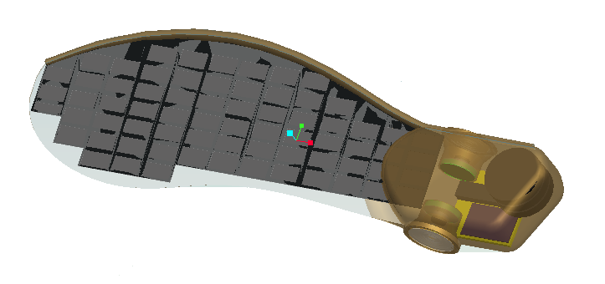

FAMU-FSU College of Engineering

Group 17:

Clinton Bencsik
Mark Brosche
Christopher Kulinka
Christopher Redcay

March 21, 2009

Current Tasks

- Currently building a FDM (Fused Deposition Modeling) mold in order to cast maple seeds more efficiently

  - A mold is currently being printed in the 3-D printer.
  - This will allow for a more precise and repeatable cast of our prototype.
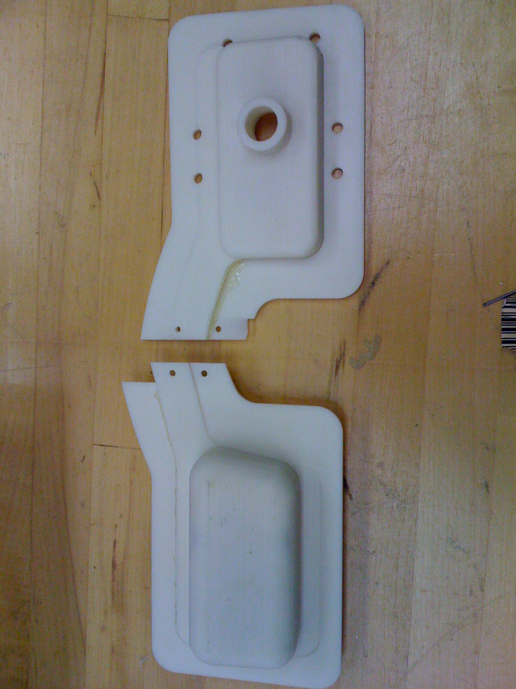

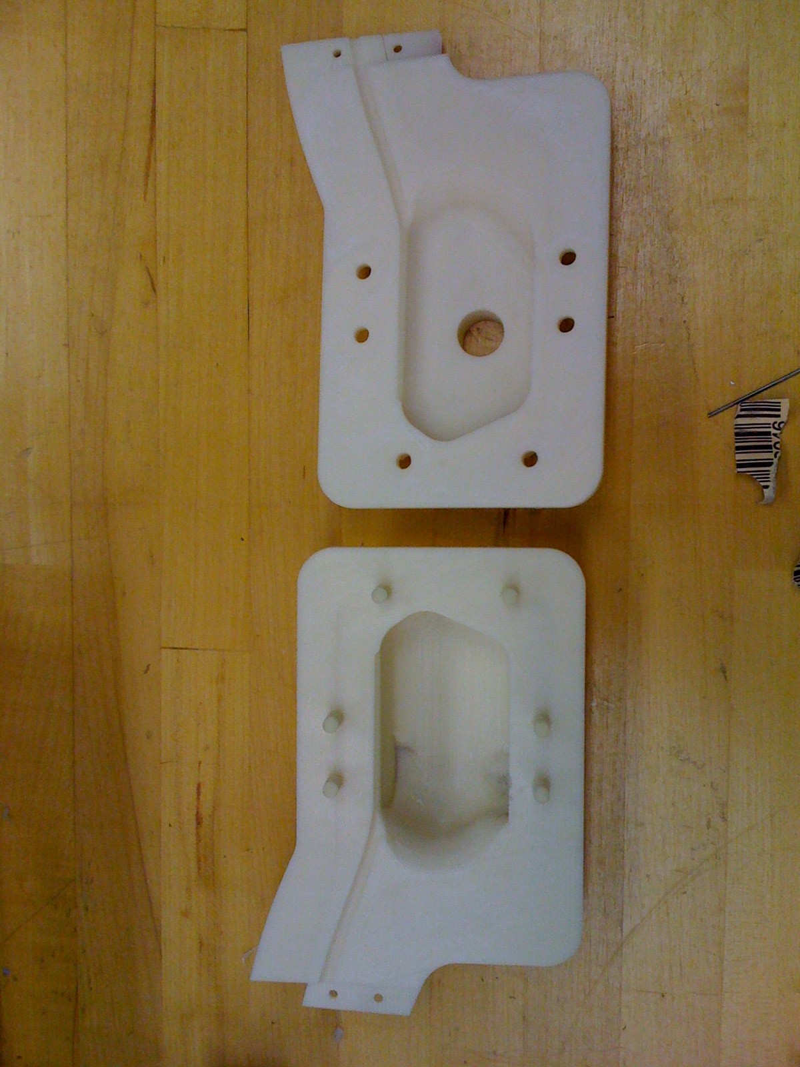

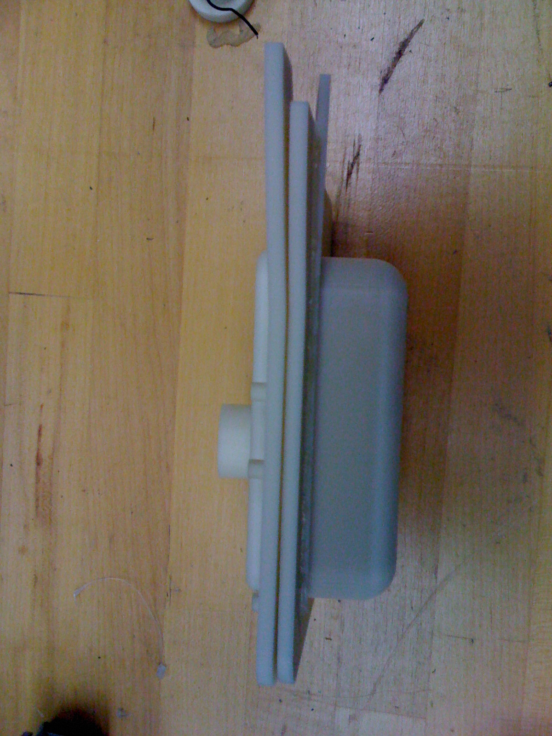
Maple seed head mold

- Infrared housing pieces are also being printed in the 3-D printer

  - These housings hold the IR sensors and the Fresnel lenses in place.
  - The housings create a space in between the Fresnel lenses and the IR sensors at the correct focal length.
  - These housings will be mounted inside the maple seed head.

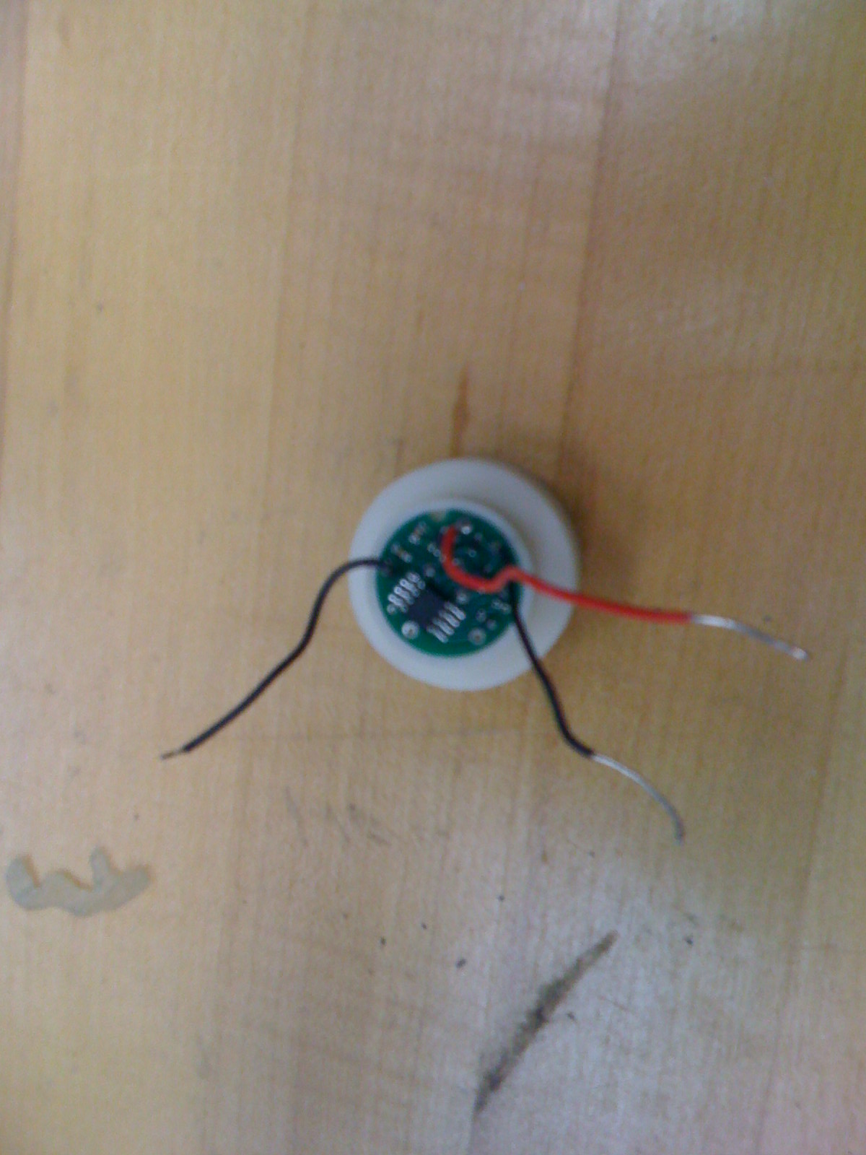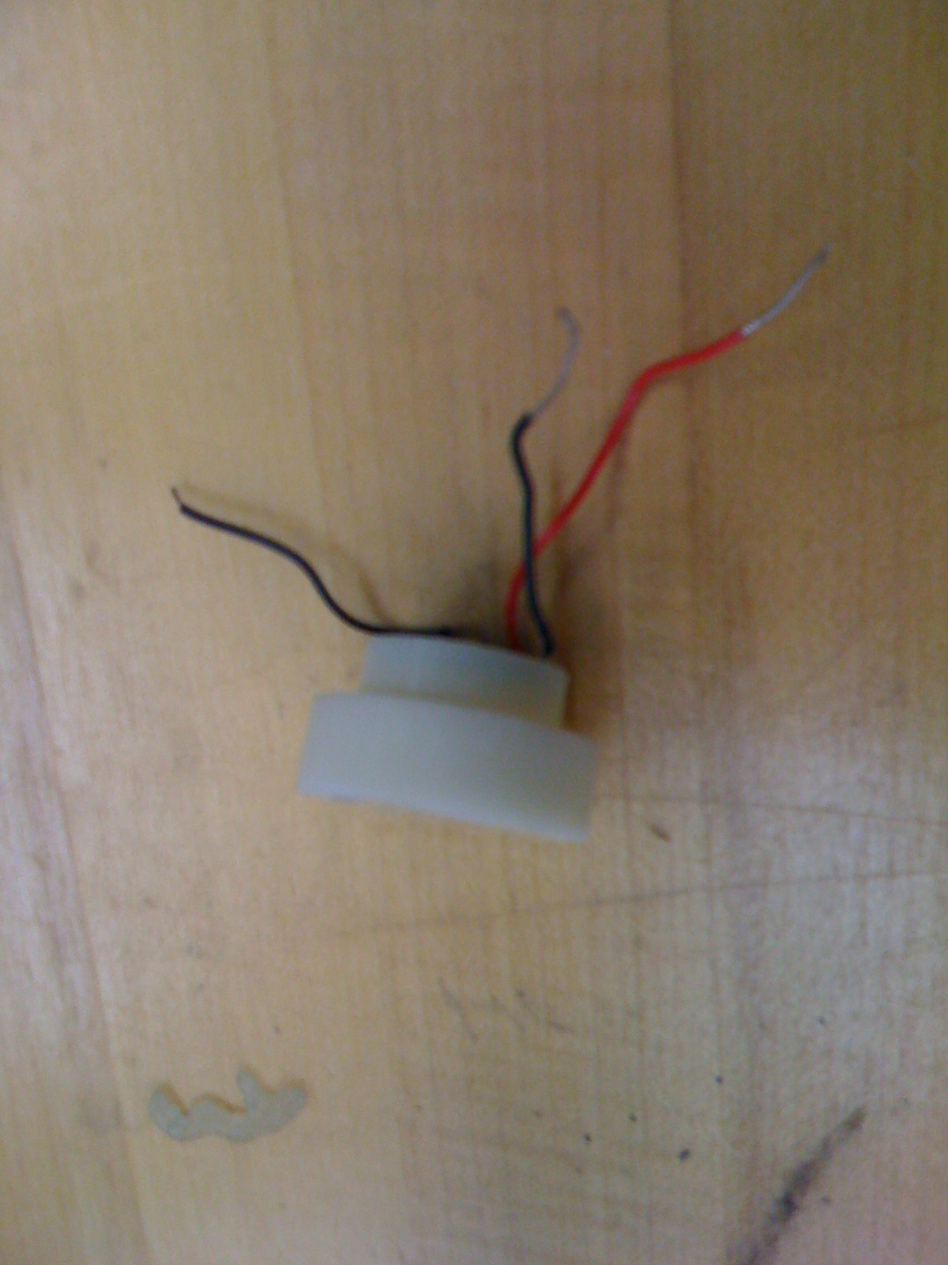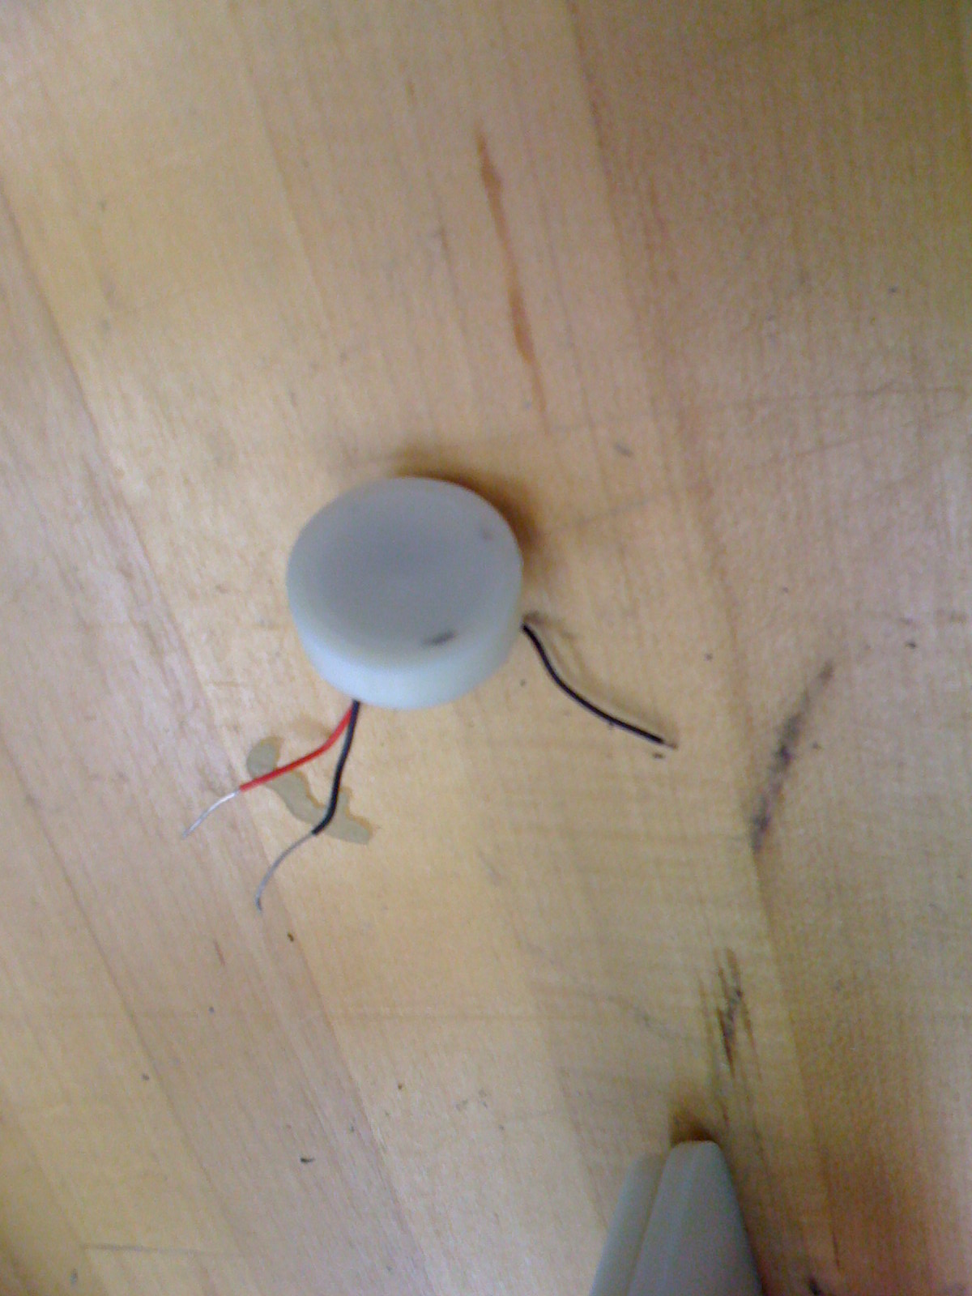
IR Sensor with white FDM mount and flat Fresnel lens

- New microcontrollers are on order to solve several problems with the current MCU.

  - The initial microcontrollers we ordered could only be programmed in an assembly language while the new microcontrollers that are on order can be written in C programming.
  - One of our group members has experience writing in C which will allow us to program the microcontroller in house.
  - The new MCU is smaller.

Future Tasks

- Program microcontroller

  - Write code for the microcontroller .

- Connect entire circuit and submerge into maple seed mold

  - Once we receive a mold release agent, which is on order, we will connect our circuit, pour the mold, and then test the flight and electrical components.

- Conduct final flight tests

  - We hope to drop final maple seeds from an airplane at varying heights to show the seeds in outdoor conditions.

- Problems encountered during build/manufacture (Spring 2009)

  - Initial MCU was found to take badly to code written in languages other than assembly. This is a significant challenge for a group containing only mechanical engineers.
  - FDM printer hardware problems have caused fairly extensive delays.
  - Fresnel lens shape differed from what was expected, requiring a seed head redesign along with IR sensor mount design.

