

FAMU/ FSU College of Engineering

Mechanical Engineering Department

Senior Design

Maple Seed Sensor Housing for Desert Reconnaissance

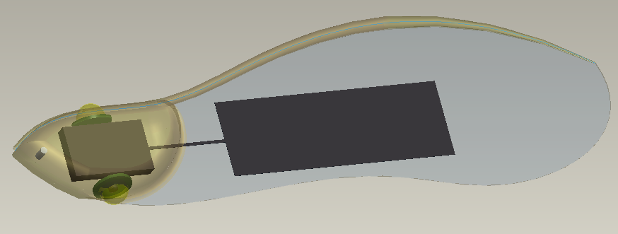

Group 17:

Clinton Bencsik
Mark Brosche
Christopher Kulinka
Christopher Redcay

Table of Contents

1 Executive Summary………………………………………………………………..1
2 Introduction………………………………………………………………………….2
3 Problem Definition………………………………………………………………….3
4 Background…………………………………………………………………………4
5 Design and Analysis……………………………………………………………….5
5.1 Concept Generation and Selection………………………………………5
5.2 Design 1……………………………………………………………………..8
5.3 Design 2……………………………………………………………………10
5.4 Design 3……………………………………………………………………12
5.5 Final Design……………………………………………………………….15
5.6 Bill of Materials and Cost Analysis……………………………………...18
5.7 Modeling and Analysis…………………………………………………...19
5.7.1 COMSOL 2-D Modeling and Analysis...................................19
5.7.2 3-D Modeling.........................................................................21
5.7.3 Thermal Analysis………………………………………………..22
5.8 Optimization……………………………………………………………….24
5.9 Prototypes…………………………………………………………………26
5.10 Material Selection……………………………………………………….28
6 Acknowledgements……………………………………………………………….29
7 References………………………………………………………………………...30
8. Appendix…………………………………………………………………………..31
8.1 Maple Seed Morphology…………………………………………………31
8.2 Ratio Calculations………………………………………………………...31
8.3 Lift Calculations…………………………………………………………...34
8.4 Natural Maple Seed Dimensions…....................................................35
8.5 Pro-E Drawings………………………………………………………..

Table of Figures

Figure 2.1………………………………………………………………………………2
Figure 4.1………………………………………………………………………………5
Figure 5.1.1…………………………………………………………………………….6
Figure 5.2.1…………………………………………………………………………….8
Figure 5.2.2…………………………………………………………………………….9
Figure 5.3.1……………………………………………………………………………11
Figure 5.4.1……………………………………………………………………………13
Figure 5.4.2……………………………………………………………………………14
Figure 5.4.3……………………………………………………………………………15
Figure 5.5.1……………………………………………………………………………16
Figure 5.5.2……………………………………………………………………………17
Figure 5.5.3……………………………………………………………………………18
Figure 5.7.1.1………………………………………………………………………….20
Figure 5.7.1.2………………………………………………………………………….20
Figure 5.7.2.1………………………………………………………………………….21
Figure 5.7.2.2………………………………………………………………………….22
Figure 5.7.3.1………………………………………………………………………….23
Figure 5.8.1……………………………………………………………………………25
Figure 5.9.1……………………………………………………………………………26
Figure 5.9.2……………………………………………………………………………26
Figure 5.9.3……………………………………………………………………………27
Figure 5.9.4……………………………………………………………………………28

Table of Tables

Table 5.1.1……………………………………………………………………………….7
Table 5.5.1……………………………………………………………………………...18

Table of Equations

Equation 5.2.1…………………………………………………………………………9
Equation 5.2.2…………………………………………………………………………9
Equation 5.2.3………………………………………………………………………..10

1 Executive Summary
The Maple Seed Sensor project is sponsored by Harris Corporation. The working concept behind the sensors are maple trees whose seeds use auto-rotating flight to disperse themselves over a large area. The seeds have a single wing attached to them which allows for auto-rotating flight. The same flight characteristics can be used for battlefield sensors. These sensors could be dropped from a height using an Unmanned Air Vehicle, use auto-rotation to descend slowly, and upon landing safely provide useful information on enemy vehicles or personnel locations. Using this method of detection keeps soldiers out of harm but still allows for reconnaissance.
The design is directly modeled after a maple seed as a specification from our sponsor. Modeling our sensor housing to behave similar to a maple seed in flight was our first objective. Designs were made in Pro-Engineer/Wildfire 3.0. Using a Fused Deposition Modeling (FDM) printer, small scaled versions were created. Drop tests were done on these designs. Following an analysis of the properties of each of our designs such as terminal velocity, seed weight to wing weight ratio, and wing area, a final shape design was chosen.
After the shape and flight characteristics were confirmed, the sensors and electronics had to be implemented into our design. As specified by Harris Corporation, we were to use at least one vibration sensor and infrared sensor to detect enemy presence. The sensors and electronics will have to draw very small amounts of power, be miniature in size, and survive desert conditions. While they are actively sensing, data will be sent by a wireless transmitter to central computer a safe distance away. All these systems will be powered by one or two batteries that will be recharged by small solar cells embedded within the wing. The electronics in the seed will also be embedded using a form of Shape

Deposition Manufacturing (SDM) polyurethane. This allows for the design to be free of attachment points for the electronics within the seed.
We will begin our build during the spring semester of 2009. Tests will be done on all the electronics to make sure the system is operational before applying the polyurethane housing. Field tests will be done on the completed housing to verify the final design meets all of our expectations.

2 Introduction
Reconnaissance has always been a valuable aspect of warfare. Receiving that information safely has become a commodity in today’s military. Methods for achieving this include receiving information from planes that are either unmanned or positioned at a safe altitude. The problem is that the information obtained only spans a short amount of time. What if an area of interest could be monitored twenty-four hours a day using sensors with no risk to human life? This is a goal that our senior design group hopes to achieve by the end of the spring 2009 school semester.
A maple seed design for the sensor housing was specified to our group. The main advantages to a maple seed design are the flight and the dispersal characteristics. The auto-rotating flight allows the sensors to fall to the ground at a safe velocity. The wide dispersal of the sensors will help cover a larger area of interest. A maple seed can be seen below in Figure 2.1.
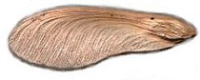
Figure 2.1Maple Seed

After landing on the ground, sensors will relay any presence of vehicles or persons in the vicinity of each seed. When the sensors are not relaying information they will remain dormant, thereby reducing the amount of power consumed. Solar cells positioned within the wing will help recharge the battery during daylight hours.
During our initial research on maple seeds, a scholarly journal article was discovered with research on maple seed flight. The American Journal of Botany had published an article of scientific analysis on maple seed flight characteristics. Terminology from that paper was adopted by our group and will be used for this paper. The term seed refers to the entire body, wing and seed. The head refers to the seed itself, and the wing is just called the wing.
A working prototype will be created by the end of the spring 2009 semester. Our largest obstacles at this time are wiring the electronic circuit and the process of embedding the components in SDM material.

3 Problem Definition
The project goal is to create a sensor housing in the likeness of a maple seed that will duplicate auto-rotating flight, detect the presence of people or vehicles once on the ground, and survive adverse weather conditions. The concept of duplicating auto-rotating flight has already been verified by our preliminary tests. All the components within our maple seed sensor design are specified to withstand the impact force generated when landing and the extreme temperatures of desert conditions. Our objective is to now have a wired maple seed sensor that will still mimic auto-rotating flight. We expect to have a working prototype of our design by April 2009.

4 Background
The principles of flight at work for a maple seed are not that much dissimilar to that of an airplane wing. As the seed begins to fall, air rushes over the wing. The leading edge of the wing causes the air to divide so that some of the air flows over the top and some of the air flows under the wing. This leading edge acts as the front of an airfoil causing the air flowing on the top to travel faster than the air flowing underneath. This creates a low pressure above the wing. Since the pressure below the wing is greater than the pressure above the wing, a force pushing upward is created. This force is lift. The wing rotates about the center of gravity which lies closer to the head. This is why a maple seed spins as it falls.
Previous work done on the subject of maple seed inspired sensors is very limited. The most prominent attempt came from Lockheed Martin in 2006. They attempted to develop a self propelled maple seed reconnaissance device that could be remote controlled and also produce lift using a jet thruster. It was also designed to complete missions of twenty minutes in duration, have a range of a kilometer, and drop a 2 gram payload. They called it an NAV or Nano Air Vehicle. Figure 4.1 shows a model of the NAV. The project was quietly cancelled in 2008.

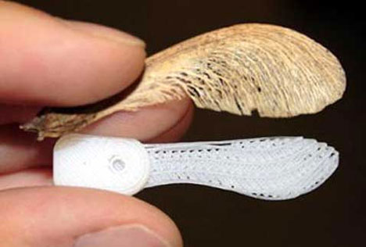
Figure 4.1Lockheed Martin NAV with maple seed
Helicopters use auto-rotating flight during power or engine failures. The pilot can control the pitch of the rotor blades so the airflow generates blade rotation. The rotation then creates enough lift to allow the helicopter to glide to the ground safely.
Any other work on this subject is rare. Maple seed inspired sensors are not that common making this project a very unique one.

5 Design and Analysis

5.1 Concept Generation and Selection
Our design is directly taken from a maple seeds shape which was specified. Alternate shape designs were considered such as a double wing configuration. The single wing configuration was quickly decided upon due to the unnecessary added weight and size of the double wing. An article on maple seeds written in the American Journal of Botany was referenced in deciding wing shape. This article provided in depth analysis on six different wing shapes. Properties researched included wing weight, head weight, wing area, wing loading, descent rate, and dispersal area ratio. We decided to use the quillpen wing shape because of its large wing area, slow descent rate, and dispersal area ratio.
The quillpen seed shape is displayed in Figure 5.1.1 below. All other general wing shapes that were considered are available in Appendix 8.1.

Figure 5.1.1 Quillpen maple seed morphology
Sensor type was also specified by our sponsor. Vibration sensors and infrared sensors are to be the devices used for detection. Theoretically the vibration sensors will be able to pick up vehicle movement or human footfalls from vibrations transmitted through the ground. The infrared sensors should detect changes in heat signature within their ranges.
Using a screening matrix, our group listed all the possible concepts for the subsystems of our prototype. Topics listed included design shape, sensor type, manufacturing material, power source, and transmission type. These concepts were weighted with the project criteria specified by our sponsor. A rank to each concept was calculated and our design concepts, as follows, were chosen. The screening matrix is located on the following page (Table 5.1.1).
A rechargeable battery will be the main power source. The battery will be recharged by miniature solar cells positioned within the wing. An A to D converter will be used to convert the analog signal to digital so it can be easily transmitted. A wireless transmitter will send out the signal using Zigbee (radio frequency) communication protocols. All of these systems will be fixed in place using Shape Deposition Manufacturing techniques. A polyurethane material, high in durability and strength properties, is poured into a wax mold and dried. This material is ideal for the environmental conditions and allows us to embed all the electronics in the head.

Table 5.1.1
Screening Matrix

 |  | Concepts
 |  | Single Wing | Double Wing | Sonar Sensor | Vibra-  tion Sensor | IR Sensor | Micro  phone | Accelerometer | FDM | SDM | Carbon Fiber | Solar Charged Battery | Solar Charged Capacitor | Wi-Fi  Trans-  mission | Radio Trans-  mission
C  R  I  T  E  R  I  A | Fall slowly | + | + | 0 | 0 | 0 | 0 | 0 | 0 | 0 | 0 | 0 | 0 | 0 | 0
C  R  I  T  E  R  I  A | Controllable Spread | + | + | 0 | 0 | 0 | 0 | 0 | 0 | 0 | 0 | 0 | 0 | 0 | 0
C  R  I  T  E  R  I  A | Detect Stationary Vehicle | 0 | 0 | - | + | + | - | + | 0 | 0 | 0 | 0 | 0 | 0 | 0
C  R  I  T  E  R  I  A | Detect Moving Vehicle | 0 | 0 | + | ++ | + | + | + | 0 | 0 | 0 | 0 | 0 | 0 | 0
C  R  I  T  E  R  I  A | Detect Stationary Human | 0 | 0 | - | - | ++ | + | - | 0 | 0 | 0 | 0 | 0 | 0 | 0
C  R  I  T  E  R  I  A | Detect Moving Human | 0 | 0 | + | ++ | + | + | + | 0 | 0 | 0 | 0 | 0 | 0 | 0
C  R  I  T  E  R  I  A | Sensor Range | 0 | 0 | - | + | - | + | + | 0 | 0 | 0 | 0 | 0 | 0 | 0
C  R  I  T  E  R  I  A | Durability | 0 | 0 | - | - | - | - | - | + | + | + | - | + | 0 | 0
C  R  I  T  E  R  I  A | Lightweight | + | - | + | ++ | + | + | + | + | + | ++ | + | + | + | +
C  R  I  T  E  R  I  A | Strength | + | ++ | 0 | 0 | 0 | 0 | 0 | - | + | + | 0 | 0 | 0 | 0
C  R  I  T  E  R  I  A | Transmission Range | 0 | 0 | 0 | 0 | 0 | 0 | 0 | 0 | 0 | 0 | 0 | 0 | - | +
C  R  I  T  E  R  I  A | Cost | + | + | + | - | + | - | + | ++ | + | - | + | - | + | +
 | Sum of + | 5 | 5 | 4 | 8 | 7 | 5 | 6 | 4 | 4 | 4 | 2 | 2 | 2 | 3
 | Sum of - | 0 | 1 | 4 | 3 | 2 | 3 | 2 | 1 | 0 | 1 | 1 | 1 | 1 | 0
 | Sum of 0 | 7 | 7 | 4 | 4 | 4 | 4 | 4 | 8 | 8 | 8 | 9 | 9 | 9 | 9
 | Net Score | 5 | 4 | 0 | 5 | 5 | 2 | 4 | 3 | 4 | 3 | 1 | 1 | 1 | 3
 | Rank | 2 | 3 | 6 | 2 | 2 | 6 | 3 | 4 | 3 | 4 | 5 | 5 | 7 | 5
 | Continue? | Yes | No | No | Yes | Yes | No | No | No | Yes | No | Yes | No | No | Yes

5.2 Design 1
The initial maple seed design was based purely on physical observation of the shape of a maple seed and was created while the project was focused only on flight characteristics. A very rough 3-D model was made in Pro-Engineer/Wildfire 3.0 and was printed using Fused Deposition Manufacturing. This model was an attempt both to discern whether or not the flight characteristics of a maple seed were inherent to the exact shape of a maple seed and to see if a shape only roughly similar to a maple seed would still auto-rotate and create lift in the same way. This first maple seed prototype, shown in Figure 5.2.1 displayed none of the auto-rotating flight characteristics of a maple seed. When dropped from a height of 10 meters it simply fell head end first and crashed into the ground. This prompted several questions concerning why this happened.
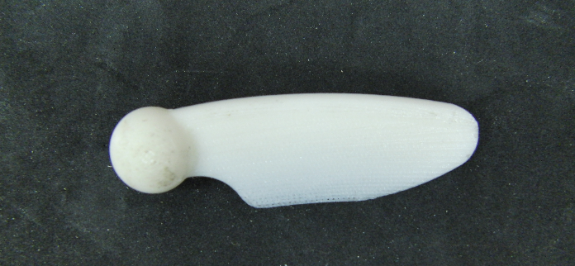
Figure 5.2.1 Initial Design Shape

The first theory concerned the most likely aspect; the shape and size of the head in relation to the wing. Because overall size was a large concern, the initial designs had a head to wing ratio larger than that of naturally occurring maple seeds. This was an attempt to design for the as-yet-unknown size of the sensors that were eventually going into the seed without designing an absurdly large seed. The data from The American Journal of Botany describe the average head weight to wing area ratio to be 2.512 kg/m², as defined in Equation 5.2.1 below. This differed greatly from the original prototype

design, whose head weight to wing area ratio was 1.678 kg/m², even without embedded sensors. This proved that the doubts about the size of the head were well-founded.
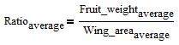
Equation 5.2.1

Next, the shape of the head itself was examined. Natural maple seeds display a seed that is in the shape of a modified ellipse with an average ratio of a to b, defined in Figure 5.2.2 of 2.318. This again differed from the test prototype, whose spherical head had a ratio of 1. In addition, the relative thickness of the prototype’s head was much larger than the relative thickness of the naturally occurring head. The naturally occurring maple seeds have an average relative thickness, as defined in Equation 5.2.2 of approximately 318, while the test prototype had a relative thickness of approximately 21.
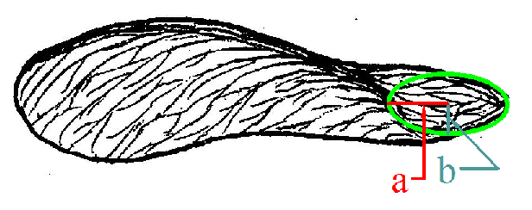
Figure 5.2.2 Elliptical Seed Shape Diagram

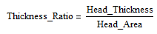
Equation 5.2.2

Finally, the size and shape of the wing was analyzed. The test prototype seed had a wing which was thick at the spine and curved down smoothly to a thin bottom. This is similar to an actual maple seed in that the natural seed has a thicker spine and a thin wing, but in the prototype the thickness of the spine had been exaggerated to ensure strength, as had the thickness of the wing. This caused the head weight to wing weight ratio, which turns out to be one of the most important design characteristics, to be far too low. This ratio, defined in Equation 5.2.3, has an average value of 5.807 for actual maple seeds, while the first prototype seed had a ratio of 0.6. Too heavy a wing causes the seed to fall more horizontally and less vertically before auto-rotation, which results in a significantly longer delay before auto-rotating flight begins and can even result in the seed never entering auto-rotating flight.
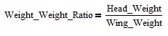
Equation 5.2.3

The length of the wing was also found to be too short to provide sufficient lift for the seed. The lift calculation (Appendix 8.3) shows that the longer the wing, the higher the lift generated. This must be balanced with the head weight to wing weight ratio to ensure that the seed still auto-rotates and produces enough lift to slow the seed down.

5.3 Design 2
The second design iteration remained focused on flight characteristics. Based on the study by The American Journal of Botany, flight characteristics of six distinct seed shapes were analyzed to determine the shape most applicable for the sensor housing design. The “quillpen” morphology was chosen because it displayed the lowest average

descent rate, 0.89 meters per second (Sipe and Linerooth, p. 1414). The projection of the seed shape was placed in AutoCAD and measured to determine size characteristics and was then drawn in Pro-Engineer/Wildfire 3.0 while adhering to the required shape characteristics discovered during the initial testing in the first design phase. A small, round spine more similar to a natural maple seed was added and the wing thickness was decreased significantly. The slope of the wing was removed and the wing shape became a simple thin sheet with a thickness of 0.39 millimeters topped by the spine, as shown in Figure 5.3.1.
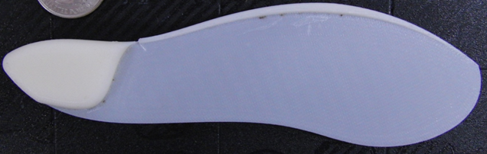
Figure 5.3.1 Second Design Shape

This design was a huge step forward. When dropped from the same height as the first design this seed entered auto-rotating flight after approximately two meters of free fall and glided down to the ground at a much slower speed. However, this design did have several faults. The spine of the seed did not connect all the way to the head, resulting in a section just behind the head where there were huge stress concentrations, leading to fracture both at the top and bottom of the spine. In addition, the spine itself was somewhat flimsy and bent too easily, feeling fragile and delicate when held. Because this seed is meant to be used in abrasive, rough environments and could be stepped on or collide with other objects during flight, this weakness was unacceptable.

5.4 Design 3
This stage in the design process began with a redefinition of the design parameters. While the first two designs were based on an emphasis only on the flight characteristics, this design temporarily abandoned flight and began with an extension into the realm of sensors and power systems. It was decided that the head would have to contain both a vibration and an infrared sensor and research showed that a pre-made circuit of the correct size would be very difficult to acquire and would likely bring the project beyond budget restrictions. Instead, the circuit would be designed and built in-house and this design focused purely on the design of that circuit.
A vibration sensor from SignalQuest, model SQ-SEN-200, was chosen. This sensor is perfect for the application because of its small size, low weight, and high sensitivity. It is able to pick up very low amplitude vibrations by using a small, omni-directional rolling ball switch which is at rest when stationary but chatters open and closed when vibrated. As shown in Figure 5.4.1 it is only 3.3 mm x 6.9 mm in size and weighs less than half of one gram. In addition, the SQ-SEN-200 can operate using only 0.25 μA. This allows more power to be used for the infrared sensor and transmitter.

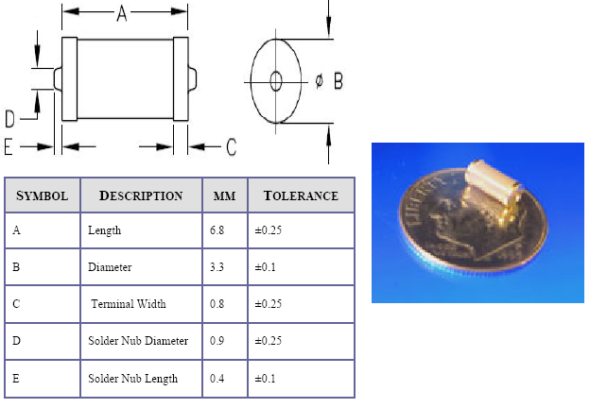
Figure 5.4.1 Vibration Sensor

Straight line infrared sensors were considered for this design because of their availability in small sizes and fairly low power consumption options. It was theorized that four of these sensors, each facing outward from the seed and offset by 90 degrees from each other would provide adequate, though not ideal, coverage. The biggest downside to this design was the lack of detection between those sensors. While the sensors would provide exceptional detection if a subject were walking past a seed to one side or another, they would not provide accurate detection if the subject were walking directly toward the seed. In this case, the subject could go unnoticed by the infrared sensor until almost passing over the seed. This consideration resulted in a change of design to passive infrared sensors for the final design.
This design stage was also centered about transmitting via IEEE802.11g in the 2.4 GHz frequency. This is a good choice because IEEE802.11g transmitters are common and inexpensive and have an outdoor range of up to 2000 meters at 11Mbps.

While this range would be largely restricted by the power use restrictions placed on our sensors by the onboard power supply, this range would be more than adequate for this project. Unfortunately, IEEE802.11g transmitters are fairly large and would require a seed considerably larger than the target size. The smallest easily available IEEE802.11g transmitted available was fairly expensive at $149.99 from Rabbit and was 47mm x 72mm x 13mm. Shown in Figure 5.4.2, this was actually larger than the target total size of the seed. The lack of IEEE802.11g transmitters of a very small (less than 30mm square) size resulted in the choice to move away from IEEE802.11g transmission for future designs.
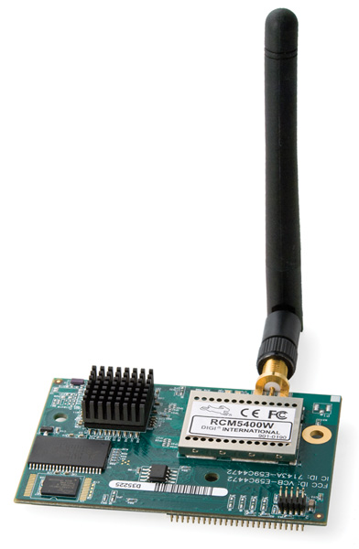
Figure 5.4.2 Wi-Fi transmitter

Finally, a flexible solar cell was chosen for the wing of the seed. In order to run for a time period on the order of weeks and still remain within size constraints, the power source for the seed must be recharged. As shown in Figure 5.4.3, this was accomplished by item number 05-1284 from Silicon Solar. This incredibly durable solar cell can provide 3 Volts, measures 4.5 inches (114.3mm) in length by 1.5 inches (38.1mm) in

width and fit nearly perfectly within the wing chosen for this design. In addition, it is made to be “suitable for rain, winds, and cold, [and] they can even be walked on” and is very lightweight. These characteristics make this type of solar cell perfect for this application.

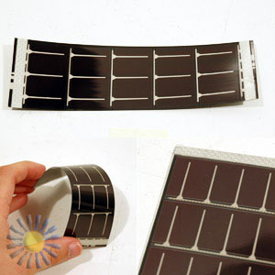
Figure 5.4.3 Flexible Solar Cells

5.5 Final Design
The final design iteration worked to combine the changes that were needed in the second and third design iterations into a final, viable design, shown in Figure 5.5.1. This current design consists of the SQ-SEN-200 Omni-directional Vibration Sensor from SignalQuest and a flexible solar cell from Silicon Solar, both of which were found to be very viable options during the third design iteration. Unfortunately, the straight line infrared sensor and the IEEE802.11g transmitter needed to be replaced with equipment which was both more useful and more practical.

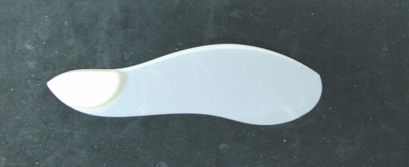
Figure 5.5.1 Final Design Shape

A passive infrared area sensor was chosen to replace the straight line infrared sensor and required a slight redesign of the seed housing to account for the Fresnel lens covering the sensor. This sensor, model DP-001 from Glolab, is housed on a 19.05mm diameter round board, is only 9.6mm thick, and is capable of detecting “a moving human or animal both in daylight and at night.” (http://www.glolab.com/dp-001/dp-001.pdf) This sensor, when equipped with a Fresnel lens also available from Glolab, is capable of detection at a range up to 27 meters. The sensor housing required a redesign to allow the Fresnel lens to both face outward and not be covered by any of the housing material, and results in a small, bubble-like extrusion on the top and bottom of the seed.

IEEE802.15.4 communications protocol was chosen to replace the impractical IEEE802.11g standard which was dismissed in the third design step. IEEE802.15.4, commonly known as ZigBee, is a low-power, low bit-rate transmission protocol with a 100kbit/sec maximum speed. Similarly to IEEE802.11g, ZigBee operates in the 2.4GHz frequency, has an outdoor range up to 1000 meters (restricted in this case by power use) and is a very viable alternative. A ZigBee transmitter from Microchip, item number MRF24J40MA, was chosen and has a transmission range of up to 400 feet (122 meters).
Vibration sensor, infrared sensor, and transmitter in hand, a choice had to be made for the microcontroller to run this system. Attachment of the transmitter was the

largest concern and became the defining factor for microcontroller use. Any of Microchip’s PIC16 controller boards were sufficient for use with this transmitter, so a board was sought which had at least three built-in analog to digital channels and preference was given to those with a low power variant. The PIC16F726 from Microchip was chosen for its 11 channel 8bit analog to digital conversion, allowing for the addition of further sensors or inputs at a later date, and its 1.8 Volt – 3.6 Volt low power variant, PIC16LF726. The addition of this controller and the changes, above, resulted in the final design, shown in Figure 5.5.2 and Figure 5.5.3 with circuitry included. The Bill of Materials is included in Table 5.5.1 below.

Figure 5.5.2 Pro-E Model of Final Design

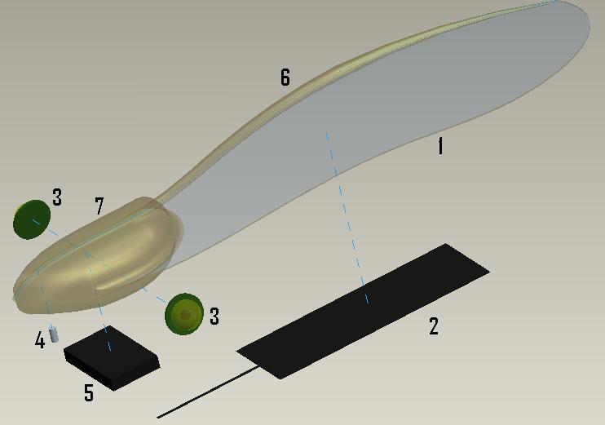
Figure 5.5.3 Exploded View of Pro-E Model of Final Design

5.6 Bill of Materials and Cost Analysis

Table 5.5.1
# | Company | Model Number | Function | Qty | Size (LxWxH) (mm) | Voltage (V) | Cost ($)
4 | SignalQuest | SQ-SEN-200 | Omni-directional  Vibration  Sensor | 1 | 3.3x3.3x6.9 | .5-12  (3 suggested) | $4.58
3 | Glolab | DP-001 | Infrared Sensor | 2 | 19dia.x9.6 | 4.0-15.0 | $22.95
5 | Microchip | MRF24J40MA | 802.15.4™  RF Transceiver Module | 1 | 17.8x27.9 | 2.4-3.6 | $8.99
5 | Microchip | PIC16F726 | Microcontroller | 1 | 12x20 | 1.8-5.5 | $1.99
2 | Silicon Solar | 05-1284 | Flexible Solar Panel | 2 | 114.3x38.1x~2.5 | 3 | $5.50
5 | Sanyo | RLITH-5 | Battery | 1 | 20x3 | 3 | $9.99
5 | Panasonic | EECS5R5H105 | Capacitor | 1 | 19x5 | 5.5 | $5.07
1,7 | Innovative Polymers | TP-4004 | SDM Seed Body | NA | 170x50x15 | NA | $5.00
 |  |  |  |  |  | Total Cost= | $92.52

5.7 Modeling and Analysis

5.7.1 COMSOL 2-D Modeling and Analysis

The 2-D modeling was done via COMSOL finite element analysis software. For the model, only wing loading from lift was analyzed and we used a standard COMSOL template for 2-D plan stress. The material properties for Young’s modulus, Poisson’s ratio, and density were required to compute the analysis. The model is a side view of the maple seed in order to observe the lift forces on the wing as it auto-rotates to the ground. The model is shown in Figure 5.7.1.1 and Figure 5.7.1.2 The larger end is the seed head and the long thin end is the wing. Since we did not know the actual wing loading force, we approximated the force simply to prove the concept. The force was approximated as 1 N/m loaded at the tip of the wing. It is understood that there would be a force gradient starting at 0 N/m and increasing to the edge of the wing, but unfortunately this was impossible to model as such. This proof of concept model shows that deflection will occur closer to the very edge of the wing tip and stress will be concentrated on the wing near the seed head. In our models the maximum displacement and von Mises stress were 2.8 in. and 355 Pa respectively. During a real flight it is not expected that a maple seed would endure such a large deformation or stress concentration.

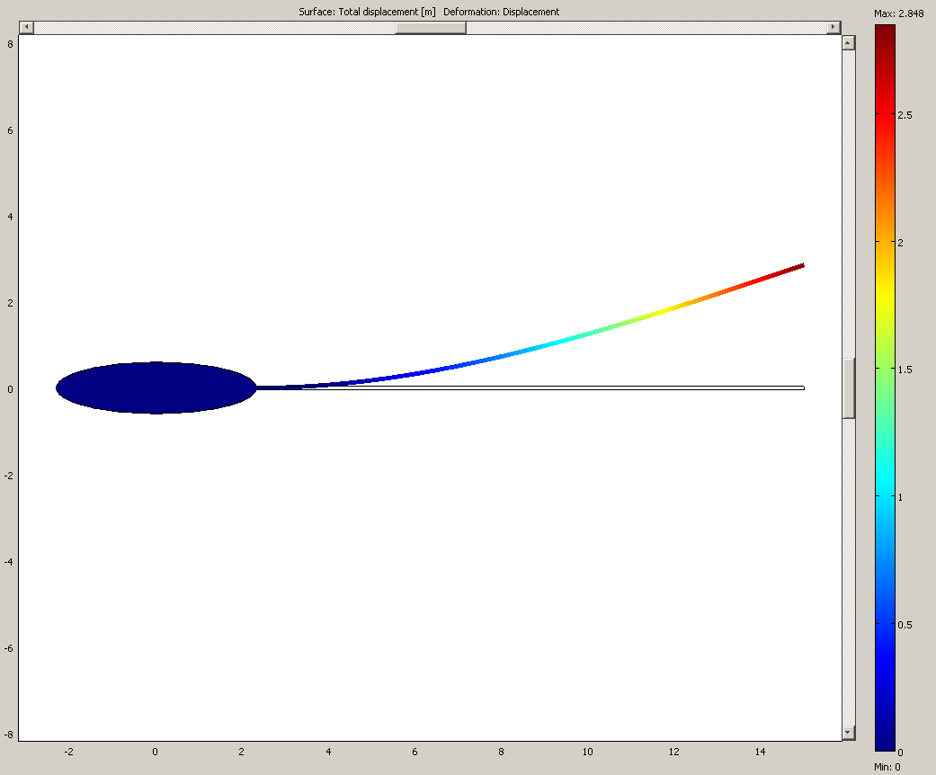
Figure 5.7.1.1 Total Displacement Analysis

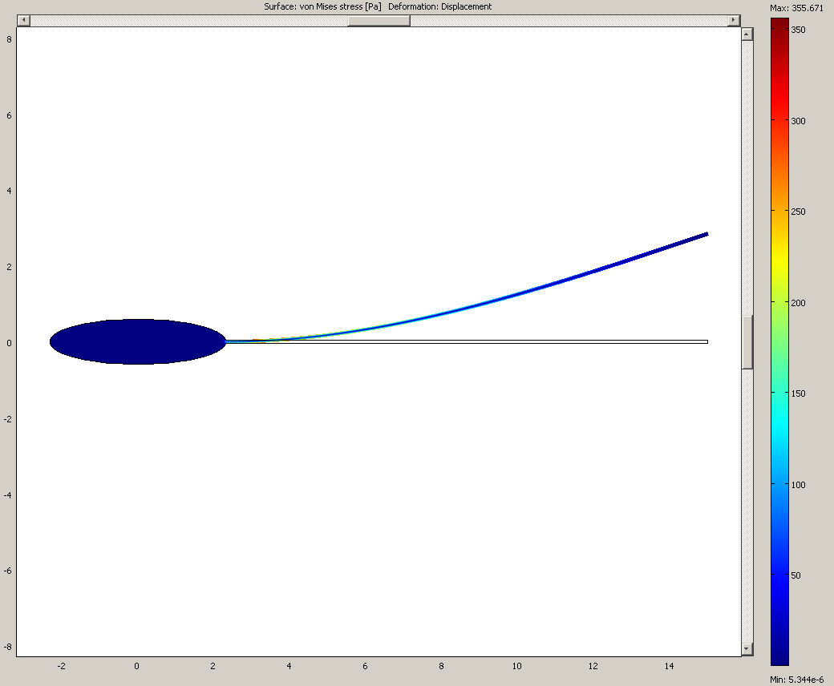
Figure 5.7.1.2 Von Mises Stress Analysis

5.7.2 3-D Modeling

COMSOL was used to create the 3-D modeling for a maple seed as well. Templates for plane stress and also for heat transfer were used to compute the 3-D modeling. The program was unable to accept the complex drawings from our Pro-Engineer/Wildfire 3.0 modeling and therefore a simplified version was required to create a semblance of what a maple seed would undergo. Notice, in Figure 5.7.2.1, that deflection is very small which reflects evidence that it will be near zero from the high speed videos of maple seeds in flight. Stresses again are present a long the spine and where the wing connects to the seed head as shown in Figure 5.7.2.2. These stress concentrations are consistent with where the maple seed prototypes have failed on impact or in handling.

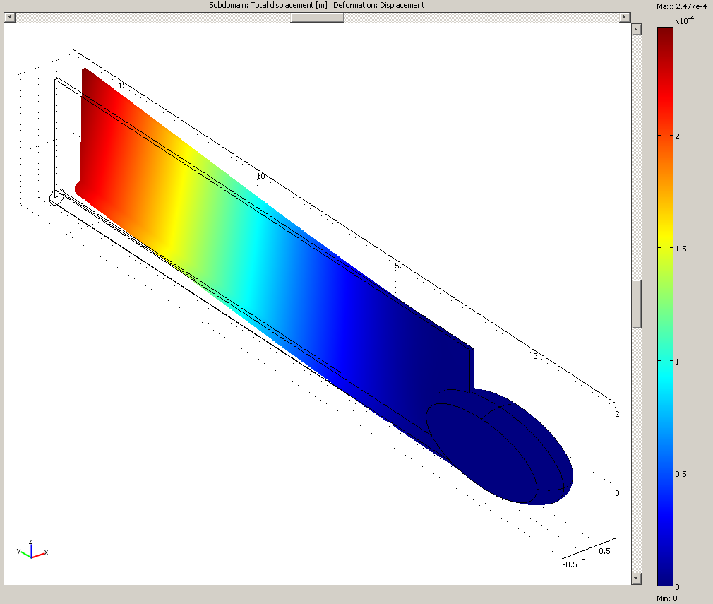
Figure 5.7.2.1 Total Displacement Analysis

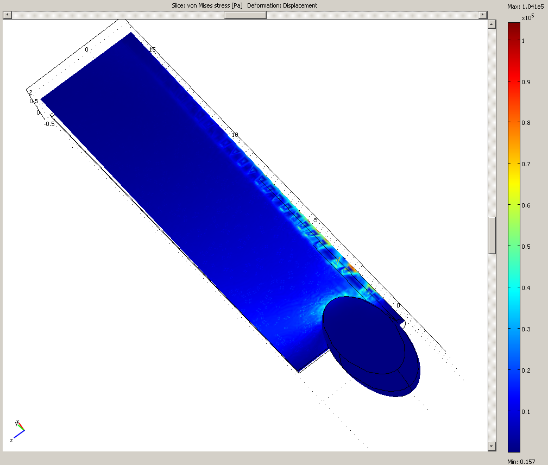
Figure 5.7.2.2 Von Mises Stress Analysis

5.7.3 Thermal Analysis
Thermal analysis was also done using COMSOL finite element package. The purpose of doing a thermal analysis for the maple seed design was to determine how the seed material will perform in the desert and whether electronic failures due to heat should be expected. Using the material properties given by the polyurethane manufacturer and an ambient temperature of about 160°F the analysis was done. The temperature gradient chart, as seen in Figure 5.7.3.1, shows that once the seed is exposed, the temperature will be roughly uniform throughout. This implies that seed material will not apply any kind of heat protection for the electronics inside and necessitates further examination through experimentation.

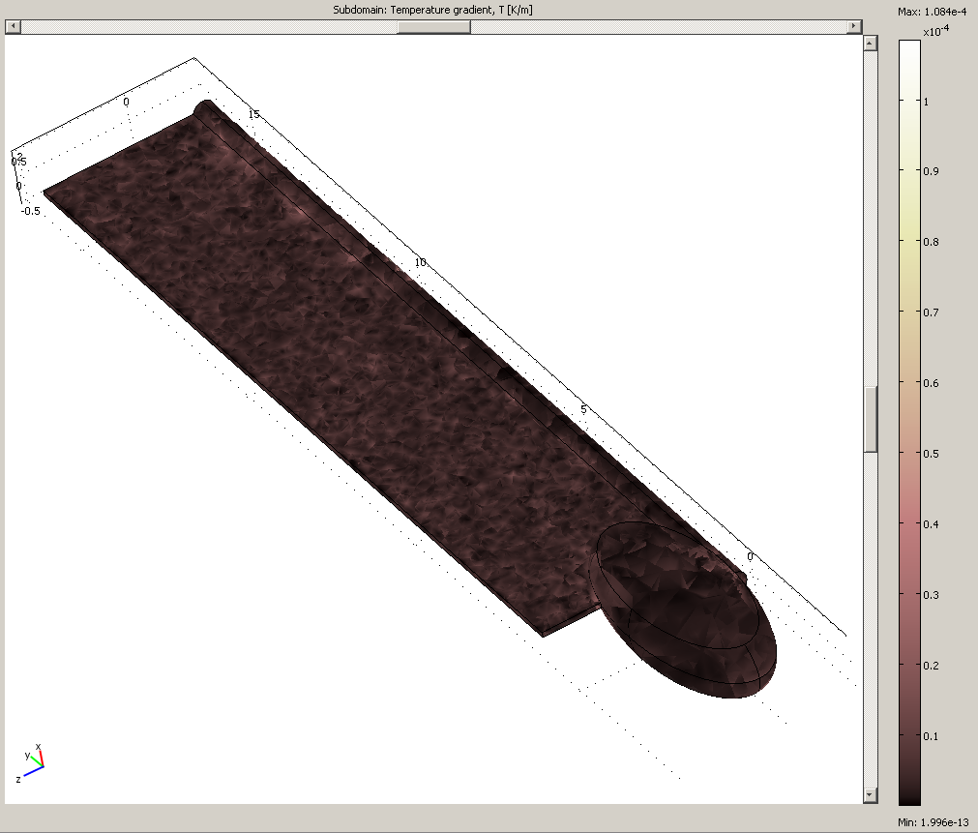
Figure 5.7.3.1 Temperature gradient on a Maple Seed at 160°F

5.8 Optimization
Creating a working final design is only the first step in producing a quality product. The concepts that are chosen can often be optimized to further increase the products performance. These improvements can essentially continue indefinitely until the results come close to being perfect. The limit to this process is often set by the amount of money the customer wishes to spend. The other limiting factor is the amount of time. Given these two parameters for our senior design project being relatively low, we must decide what imperfections will be accepted and what must be improved upon.
For any design that needs to maintain flight, natural or man made, weight is one of the most important factors that need to be considered. The lower the weight is, the lower the required lift by the wing area will be. For our project, two parameters will affect the overall weight of the seed.
The material that was chosen to mold the seed was carefully considered. High density materials can increase the weight of the seed without having any improved strength characteristics over those of lower density composite materials. Some of the lower density materials lacked durability and the qualities required to withstand harsh environments for a long period of time.
The internal components greatly affect the weight of our final product. The solar panel, micro-processor, battery, transmitter, infrared and vibration detectors all have a relatively low mass. We have found that when you combine those items, the resulting mass has a very significant impact weight of the maple seed. As a result, we have chosen the smallest parts possible and limited the number of components to the absolute bare minimum.

Virtually every design has a common parameter that cannot be overlooked. As in the case of our project, size plays a large role in the design process and is a part of our design specifications. The size of our maple seed will not greatly affect its ability to fly, as our design can be scaled to any reasonable value and still maintain auto-rotation capability. Still, optimizing the size of the seed to be as small as possible was near the top of the priority list. The size plays a role in how the seeds will be transported and how they will function once they are on the ground. Similar to the weight issues, finding internal components that are as small as possible was a seemingly never ending task. The size of the components was what ultimately decided the scale of our final design.
A detail of our design that was not obvious to us at first was the location of the center of gravity for the seed. Optimizing this parameter was the pinnacle of obtaining auto-rotation. We learned by trial and error what did not work and from that information, discovered what needed to be done to maintain flight. The center of gravity needs to be just past the wing inside of the head so the wing can rotate around that point as shown in Figure 5.8.1. If the center is somewhere on the wing, the seed will rotate around that point and lose any available lift that portion of the wing could produce.
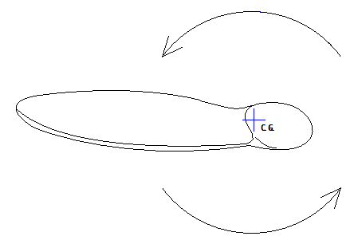
Figure 5.8.1 Rotation of Maple Seed in Flight

5.9 Prototypes
In any design process, creating prototypes can help to guide your design as well as provide an excellent visual aid for the customer. The first prototypes were made from card board and paper as seen below in Figure 5.9.1. These were produced to help us understand some of the fundamental characteristics of the maple seed. The thicker spine coupled with a thin wing was found to be an essential design requirement.
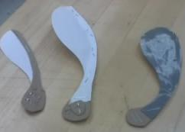
Figure 5.9.1 Cardboard Maple Seed Designs

The purpose of the next prototype was to test the 3-D printing capability as well as produce a first rough draft for what the seed would ultimately look like shown below in Figure 5.9.2. This version did not achieve auto-rotation due to its unbalanced head to wing weight ratio of 0.6. Which means the wing was heavier than the head. From this we learned to set the ideal head to weight ratio to 6.0.
Figure 5.9.2 Initial Design Shape

The second FDM prototype met the head to wing weight ratio but revealed a very important detail that was obtained by testing this prototype. What was learned was to avoid stress concentrations that are produced by sharp angles where two perpendicular surfaces meet. These sharp angles caused the wing to crack as seen below in Figure 5.9.3. We found that creating rounds in these locations greatly increased the strength and flexibility of the seeds.
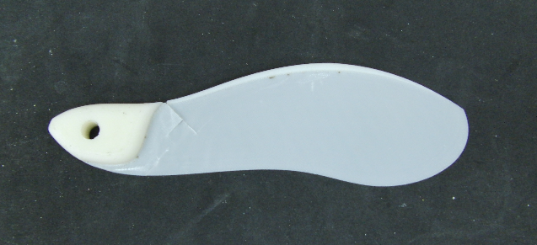
Figure 5.9.3 Second Design Shape

Our final prototype met the previous requirements and proved to be a successful model for the type of flight we were trying to achieve. This model released from 35ft and reached auto-rotation after about 20ft. The terminal velocity was determined using video and was found to be 3.6m/s (8mph). The weight of the prototype at this length (6.75”) was 0.35oz. The rounded edges performed as expected against numerous impacts with hard tile flooring. After experimentation and data analysis, the decision was that this would be the basic blue print for our final product. This final shape design can be seen in Figure 5.9.4.

Figure 5.9.4 Final Design Shape

5.10 Material Selection
As discussed in the optimization portion of this report, weight and durability are of the utmost importance. The only material that needed to be considered was the body of the maple seed. All of the other parts are pre-assembled electrical components. The material that we would choose needed to satisfy a few criteria. It had to be light weight to maintain auto-rotation. Flexibility became an apparent requirement after prototype testing. Since the solar cells are to be mounted inside the wing, translucence was necessary to allow sunlight to reach the panels. Temperatures will exceed 140 deg F in the environment which the seeds will be operating, so the material needed to be impervious to that range of heat. The last characteristic of the chosen material was the ability to keep out water and moisture. The sensitive internal components would need a dry environment to function properly.
Our original selection was VA-273 SDM material. After careful consideration, it was determined that the final product would be too brittle and could easily fracture. The decision was made to use a stronger material of the same type TP-4004 SDM material.

6 Acknowledgements

- Matt Christensen – Harris Corporation
  - For valuable advice during this semester

- Dr. Jonathan Clark – FAMU/FSU College of Engineering
  - Use of the STRIDe lab
  - Valuable advice during this semester

7 References

- http://www.tryhuntington.com/detail.asp?PRODUCT_ID=SEEDPODS
- http://blog.wired.com/defense/2008/08/samarai-killed.html
- http://www.ubergizmo.com/fr/archives/2007/09/camera_espion_en_forme_de_graine_derable.php
- Sipe, Timothy W., and Amy R. Linnerooth. “Intraspecific Variation in Samara Morphology and Flight Behavior in Acer Saccharinum.” American Journal of Botany 82.11 (1995): 1412-18. JSTOR. Florida State University. 3 Dec. 2008 <http://www.jstor.org/stable/2445868>.
- http://www.signalquest.com/product_selection.htm
- http://www.rabbit.com/products/RCM5400W/index.shtml
- http://www.siliconsolar.com/flexible-solar-panels-3v-p-16159.html
- http://www.glolab.com/dp-001/dp-001.html

8 Appendix
8.1 Maple Seed Morphology
Figure 8.1 Maple seed morphology considered

8.2 Ratio Calculation

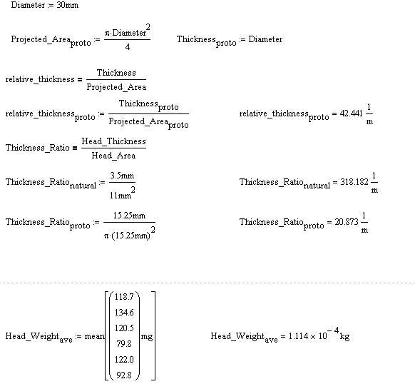

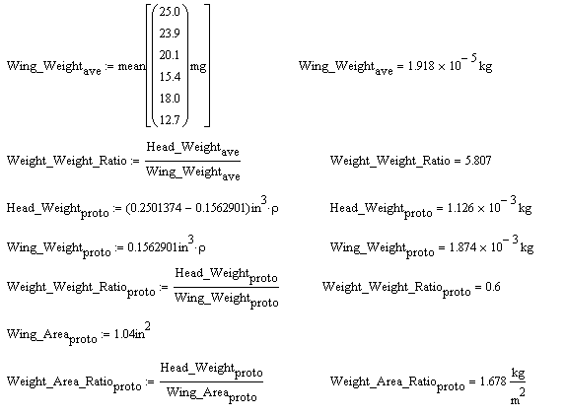

8.3 Lift Calculations

C.1 is the area factor
L is the overall length
W is the width of the wing at its widest point
=>
C.2 is the ratio of total length to seed width
Point 1
Point 2
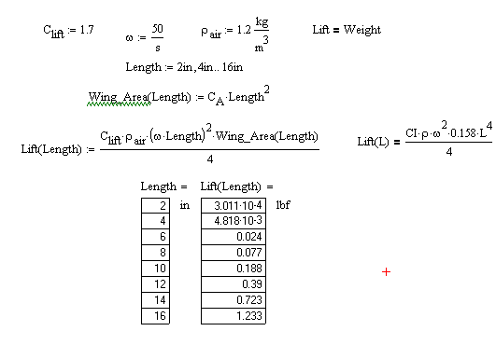

8.4 Natural Maple Seed Dimensions

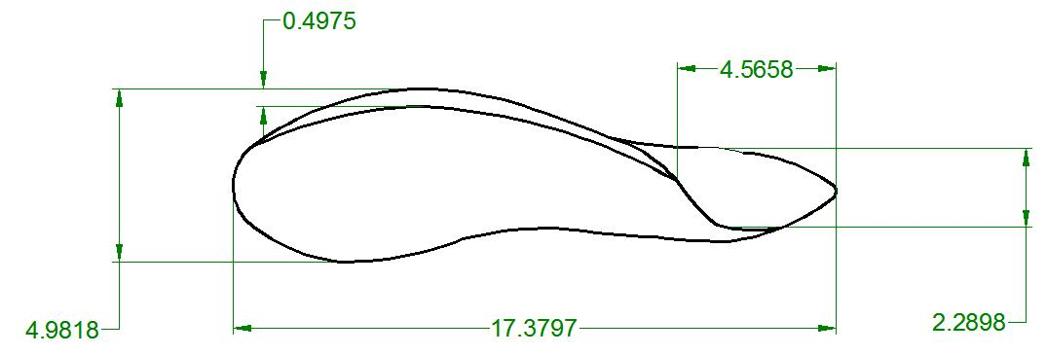

Dimensions in millimeters

8.5 Pro-E Drawings

